Lesson 19: Directed Line Segments and Vectors

Student Outcomes
- Students find the components of a vector by subtracting the coordinates of an initial point from the coordinates of a terminal point.
- Students add vectors end-to-end using the parallelogram rule or component-wise. They understand vector arithmetic from a geometric perspective.

Lesson Notes
This lesson introduces students to directed line segments and how to subtract initial point coordinates from terminal point coordinates to find the components of a vector. Vector arithmetic operations are reviewed and the parallelogram rule is introduced. Students should be able to do much of this lesson without the aid of technology. Continue to emphasize the connections between vector arithmetic and transformations.

Classwork
Discussion (3 minutes)
Start this lesson by introducing the new terminology relating to directed line segments. Have students read the text in the student materials, and then use the discussion questions below to clarify their understanding of vectors defined by an initial point and a terminal point.
Scaffolding:
- Revise the Frayer model from Lesson 17 to include information about directed line segments, initial point, terminal point, and how to find the components by subtracting coordinates.
- For advanced learners, give them a vector in three dimensions and have them determine an initial point, terminal point, and magnitude.
$$A\left(3, -2, 1\right), B(-1, 4, -3)$$
A vector can be used to represent a translation that takes one point to an image point. The starting point is called the initial point, and the image point under the translation is called the terminal point.
If we know the coordinates of both points, we can easily determine the horizontal and vertical components of the vector.

Show the diagram below, and ask students the following questions:
- Which point is the initial point? Which point is the terminal point? How do you know?
  - The initial point is $A$ and the terminal point is $B$. The end without the arrow tip is the initial point.
The arrow indicates the direction of the translation of point $A$ to its new location at $B$.
- How many units is the initial point translated horizontally? How many units vertically? How do you know?
  - $4$ units horizontally and $2$ units vertically. You can subtract corresponding coordinates or count the units on the grid.
- What are the components of the vector?
  - $v=〈4,2〉$
- What is the magnitude of the vector?
  - The magnitude is $\sqrt{20}=2\sqrt{5}$.

Exercises 1–3 (9 minutes)
Start students on the next exercise. Have them work independently for a few minutes, and then have them team up with a partner to share their work. Call on individual students to explain how they got each answer. Emphasize that we must calculate the components by starting from the initial point and ending at the terminal point. The signs of the components matter because they indicate direction.

Exercises 1–3
- Several vectors, represented by arrows, are shown below. For each vector, state the initial point, terminal point, component form of the vector and magnitude.
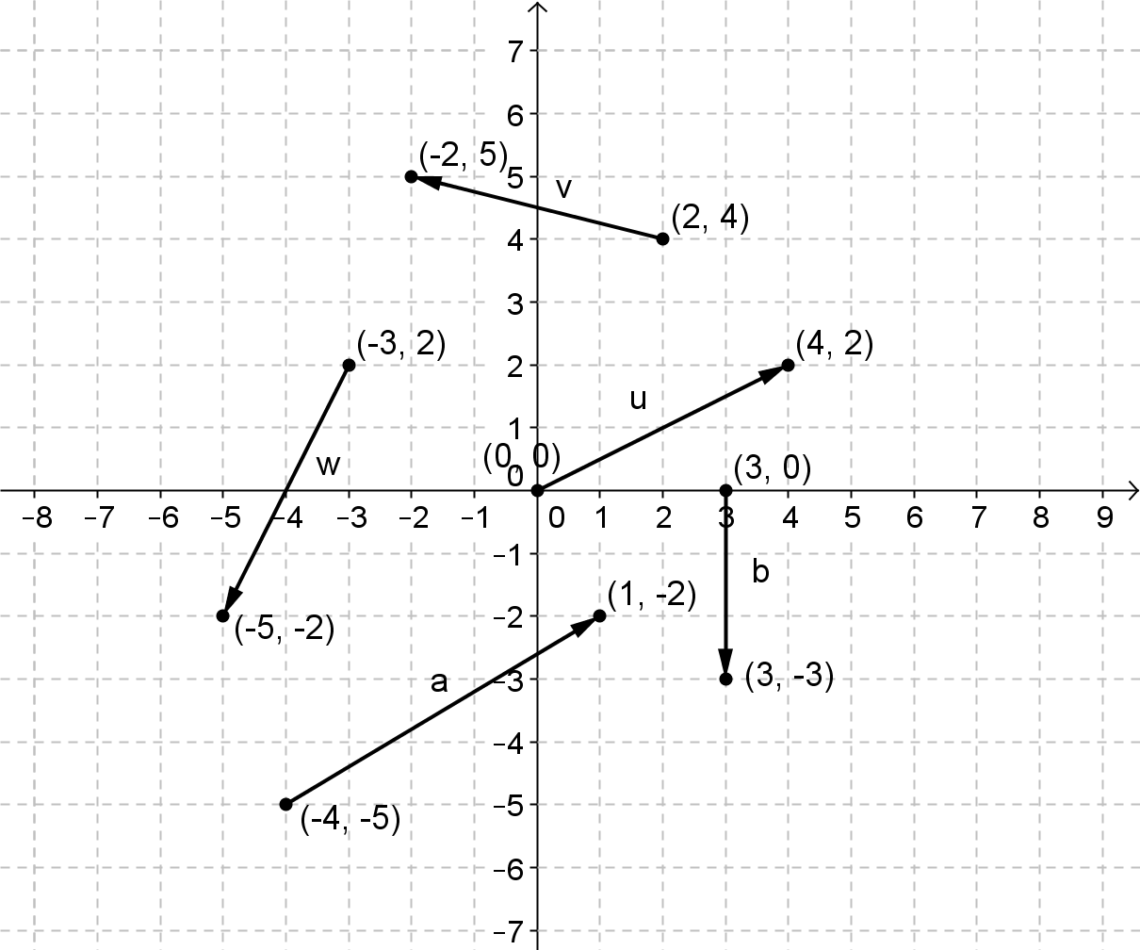

MP.6
&
MP.7

For $v$,
Initial point $(2,4)$ and terminal point $(-2,5)$; $v=〈-4,1〉$ and $\left\|v\right\|=\sqrt{17}$
For $u$,
Initial point $(0,0)$ and terminal point $(4,2)$; $u=〈4,2〉$ and $\left\|u\right\|=\sqrt{20}=2\sqrt{5}$
For $w$,
Initial point $(-3,2)$ and terminal point $(-5,-2)$; $w=〈-2,-4〉$ and $\left\|w\right\|=\sqrt{20}=2\sqrt{5}$
For $a$,
Initial point $(-4,-5)$ and terminal point $(1,-2)$; $a=〈5,3〉$ and $\left\|a\right\|=\sqrt{34}$
For $b$,
Initial point $(3,0)$ and terminal point $(3,-3)$; $b=〈0,-3〉$ and $\left\|b\right\|=3$

If students did not struggle with Exercise 1, move them on to the next exercise which takes away their ability to count segments on the grid to determine the components of the vectors. Exercises 1–3 are designed to lead students to knowing that they can find the components by subtracting the coordinates of the initial point from the coordinates of the terminal point.

- Several vectors, represented by arrows, are shown below. For each vector, state the initial point, terminal point, component form of the vector, and magnitude.
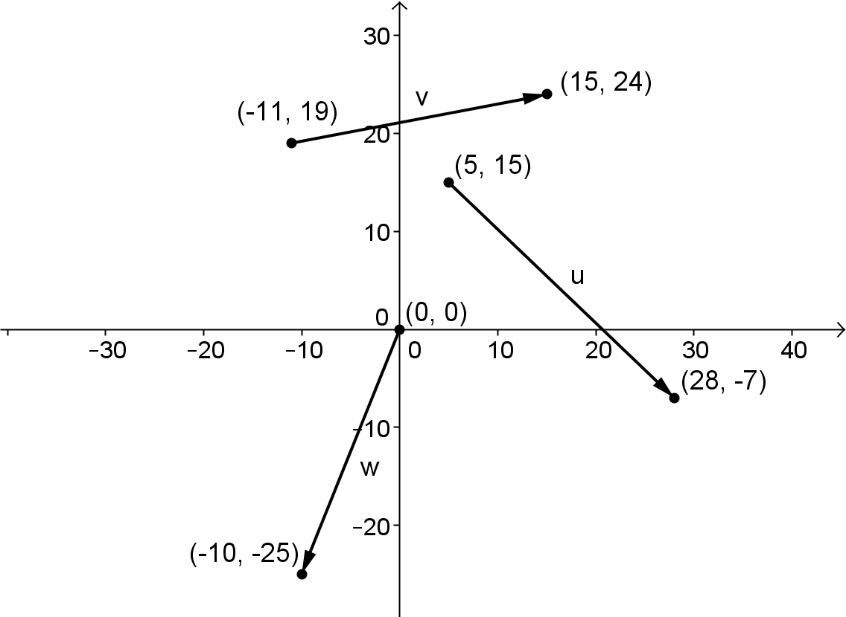

For $v$,
Initial point $(-11,19)$ and terminal point $(15,24)$; $v=〈26,5〉$ and $\left\|v\right\|=\sqrt{701}$
For $u$,
Initial point $(5,15)$ and terminal point $(28,-7)$; $u=〈23,-22〉$ and $\left\|u\right\|=\sqrt{1013}$
MP.6
&
MP.7
For $w$,
Initial point $(0,0)$ and terminal point $(-10,-25)$; $w=〈-10,-25〉$ and $\left\|w\right\|=\sqrt{725}$

- Write a rule for the component form of the vector $v$ shown in the diagram. Explain how you got your answer.

The component form is $v=〈x_{2}-x_{1},y_{2}-y_{1}〉$ The components of the vector are the distance $A$ is translated vertically and horizontally to get to$B$. To find the horizontal distance from $A$ to $B,$ subtract the $x$-coordinates. To find the vertical distance from $A$ to $B$, subtract the $y$-coordinates.

Give students time to struggle with Exercise 3 before intervening. Emphasize that they must generalize the process used in Exercises 1 and 2 to write a rule in Exercise 3.

Discussion (3 minutes)
Introduce the term directed line segment before students begin Exercises 4–6. Students use the results of Exercise 3 to find the components of vectors. The next exercises use the directed line segment notation.

When we use the initial and terminal points to describe a vector, we often refer to the vector as a directed line segment. A vector or directed line segment with initial point A and terminal point B is denoted $\vec{AB}$.

Exercises 4–7 (8 minutes)

Exercises 4–7
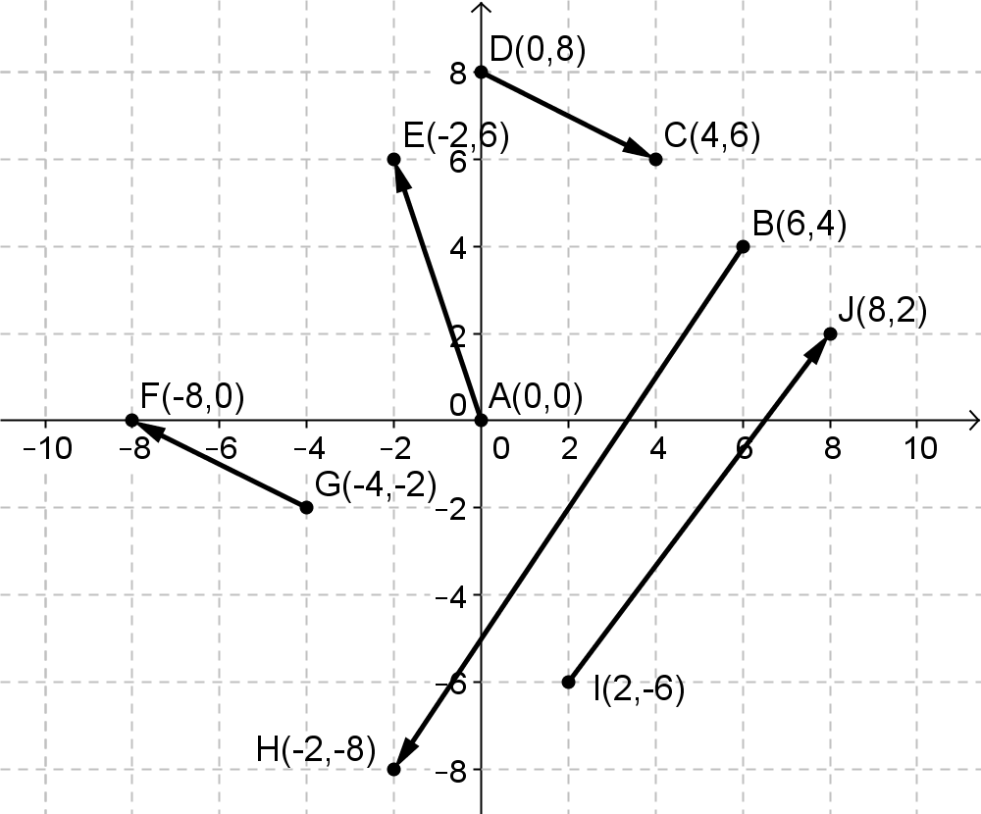
- Write each vector in component form.
  - $\vec{AE}$
$\vec{AE}=〈-2,6〉$

  - $\vec{BH}$
$\vec{BH}=〈-8,-12〉$

  - $\vec{DC}$
$\vec{DC}=〈4,-2〉$

  - $\vec{GF}$
$\vec{GF}=〈-4,2〉$

  - $\vec{IJ}$
$\vec{IJ}=〈6,8〉$

- Consider points $P(2,1)$, $Q(-3,3)$ and $R(1,4$).
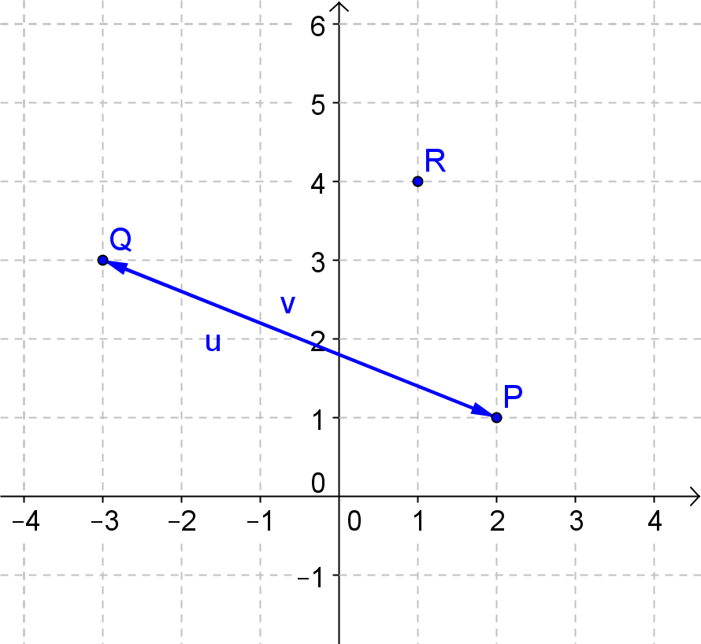
  - Compute$\vec{PQ}$ and $\vec{QP}$ and show that $\vec{PQ}+\vec{QP}$is the zero vector. Draw a diagram to show why this makes sense geometrically.
$\vec{PQ}=〈-5,2〉$ and $\overset{⃑}{QP}=〈5,-2〉$
$$\vec{PQ}+\vec{QP}=〈-5+5,2-2〉=〈0,0〉$$

This makes sense because one vector translates $P$ to $Q$ and then the other vector translates the point back from $Q$ to $P$. The sum would be the zero vector because the original point is returned to its starting location.

  - Plot the points $P$, $Q$, and $R$. Use the diagram to explain why $\vec{PQ}+\vec{QR}+\vec{RP}$ is the zero vector. Show that this is true by computing the sum$\vec{PQ}+\vec{QR}+\vec{RP}$.
The diagram shows that the sum should be the zero vector because point $P$ is translated back to its original coordinates when you add the three vectors.
$$\vec{PQ}+\vec{QR}+\vec{RP}=〈-5+4+1,2+1-3〉=〈0,0〉$$
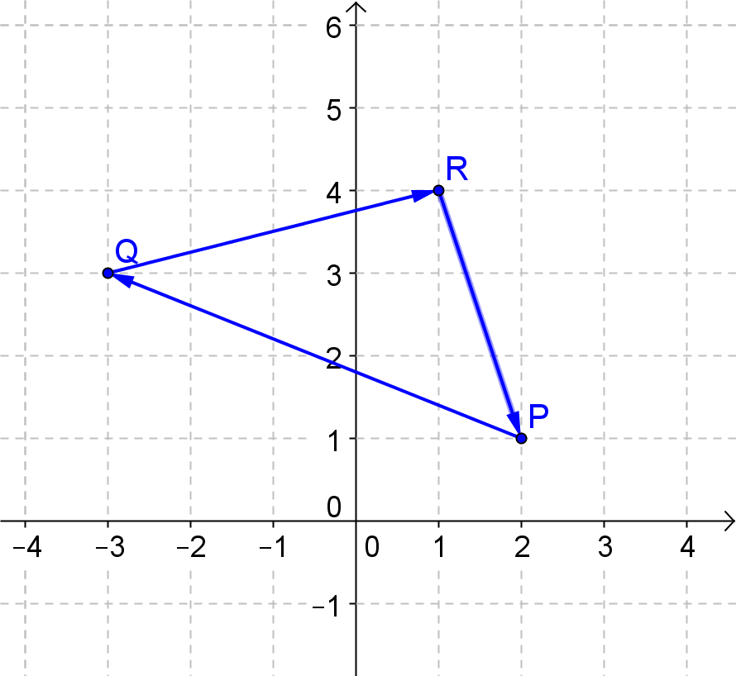

- Show for any two points $A$ and $B$ that $-\vec{AB}=\vec{BA}$.
Consider $A\left(x_{1},y_{1}\right)$ and $B\left(x_{2},y_{2}\right)$. Then$\vec{ AB}=〈x_{2}-x_{1},y_{2}-y_{2}〉$
and $-\vec{AB}=〈{-x}_{2}+x_{1},{-y}_{2}+y_{2}〉=〈x_{1}-x_{2},y_{1}-y_{2}〉$
This is the component form of $\vec{BA}=〈x_{1}-x_{2},y_{1}-y_{2}〉$.

- Given the vectors $v=〈2,-3〉$, $w=〈-5,1〉$, $u=〈4,-2〉$ and $t=〈-1,4〉$.
  - Verify that the sum of these four vectors is the zero vector.
$v+w=〈-3,-2〉$ and $v+w+u=〈1,-4〉$ and $v+w+u+t=〈0,0〉$

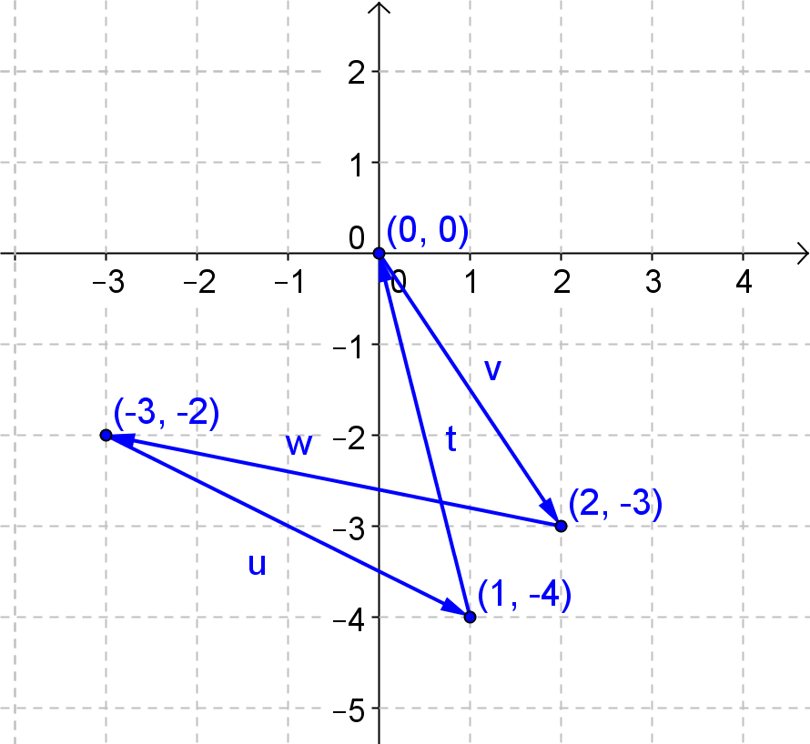
  - Draw a diagram representing the vectors as arrows placed end-to-end to support why their sum would be the zero vector.
If we position $v$ to have an initial point at $(0,0)$ then $v$ translates the point $(0,0)$ to $(2,-3)$. Each additional vector translates the point by its components. The result of all four translations returns the point back to the origin.

Example 1 (5 minutes): The Parallelogram Rule for Vector Addition
This exercise introduces the parallelogram rule for vector addition. Depending on the level of your students, you can provide more or less support with this example. Point out the use of the word position vector to denote a vector whose initial point is the origin, and then point out that the terminal point coordinates are the same as the horizontal and vertical components of the vector.
Example 1: The Parallelogram Rule for Vector Addition
When the initial point of a vector is the origin, then the coordinates of the terminal point will correspond to the horizontal and vertical components of the vector. This type of vector, with initial point at the origin, is often called a position vector.
  - Draw arrows to represent the vectors $v=〈5,3〉$ and $u=〈1,7〉$ with the initial point of each vector at $(0,0)$.
  - Add $v+u$ end-to-end. What is $v+u$? Draw the arrow that represents $v+u$ with initial point at the origin.
  - Add $u+v$ end-to-end. What is $u+v$? Draw the arrow that represents $u+v$ with an initial point at the origin.
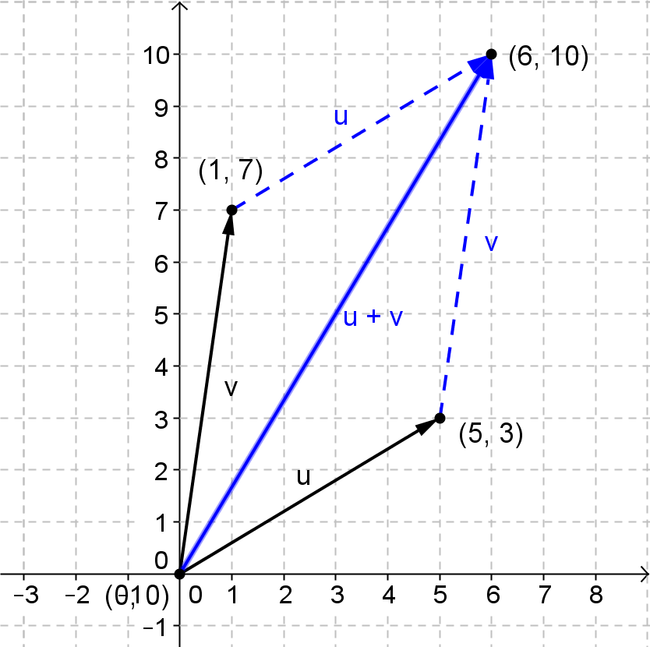

Lead a discussion to introduce the parallelogram rule for adding two vectors. Make sure students’ diagrams clearly show the parallelogram.
- Notice that the vectors lie on the sides of a parallelogram and the sum of the two vectors is the diagonal of this parallelogram with initial point at the same location as the original two vectors.
- How do you know the vectors would lie on the sides of a parallelogram?
  - We can calculate the slope of the arrow that represents the vector. You can see that opposite sides would have the same slope and thus lie on parallel lines so the opposite sides of the quadrilateral are parallel, which gives us a parallelogram.
- How does this example support the fact that the operation (i.e., vector addition) is commutative?
  - We got the same result regardless of the order in which we added the two vectors.
- Suppose we translated all these vectors by another vector $t$. Would the components of $v+u$ change? Explain your reasoning.
  - No. Translation is a rigid transformation so the size and shape would be preserved, which means the components would remain the same.
- Explain how to use the parallelogram rule to add two vectors.
  - To use the parallelogram rule, draw both vectors with the same initial point, and then construct a parallelogram with adjacent sides corresponding to the arrows that represent each vector. The vector sum will be the diagonal from the initial point.

Exercise 8 (5 minutes)
Exercises 8–10
- Let $u=〈-2,5〉$ and $v=〈4,3〉$.
  - Draw a diagram to illustrate $v$ and $u$ and then find $v+u$ using the parallelogram rule.
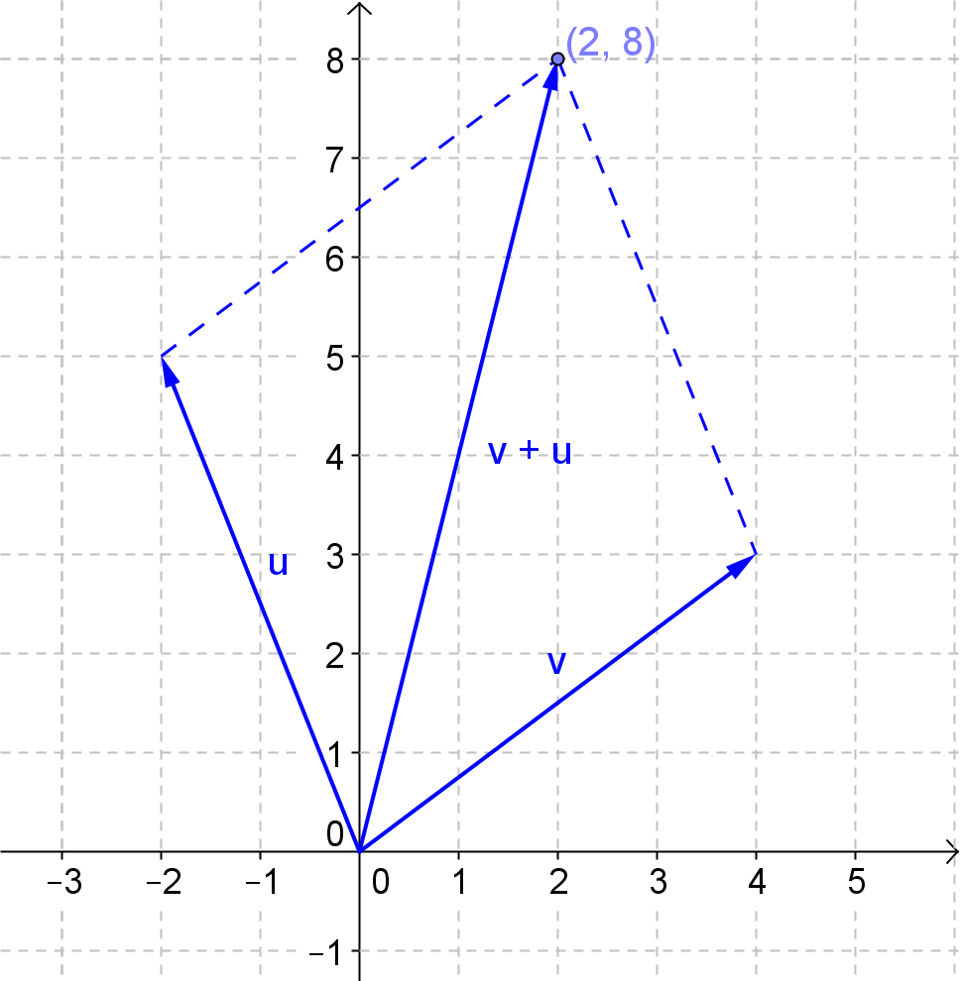

$$v+u=〈2,8〉$$

  - Draw a diagram to illustrate $2v$ and then find $2v+u$ using the parallelogram rule.
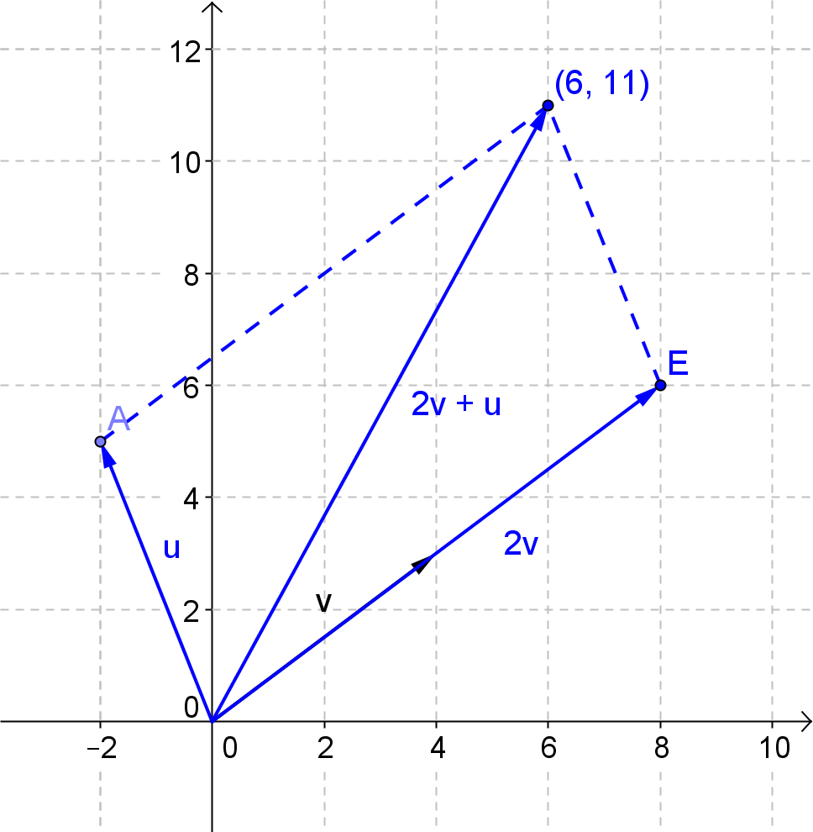

$$2v+u=〈6,11〉$$

  - Draw a diagram to illustrate $–v$ and then find $u-v$ using the parallelogram rule.
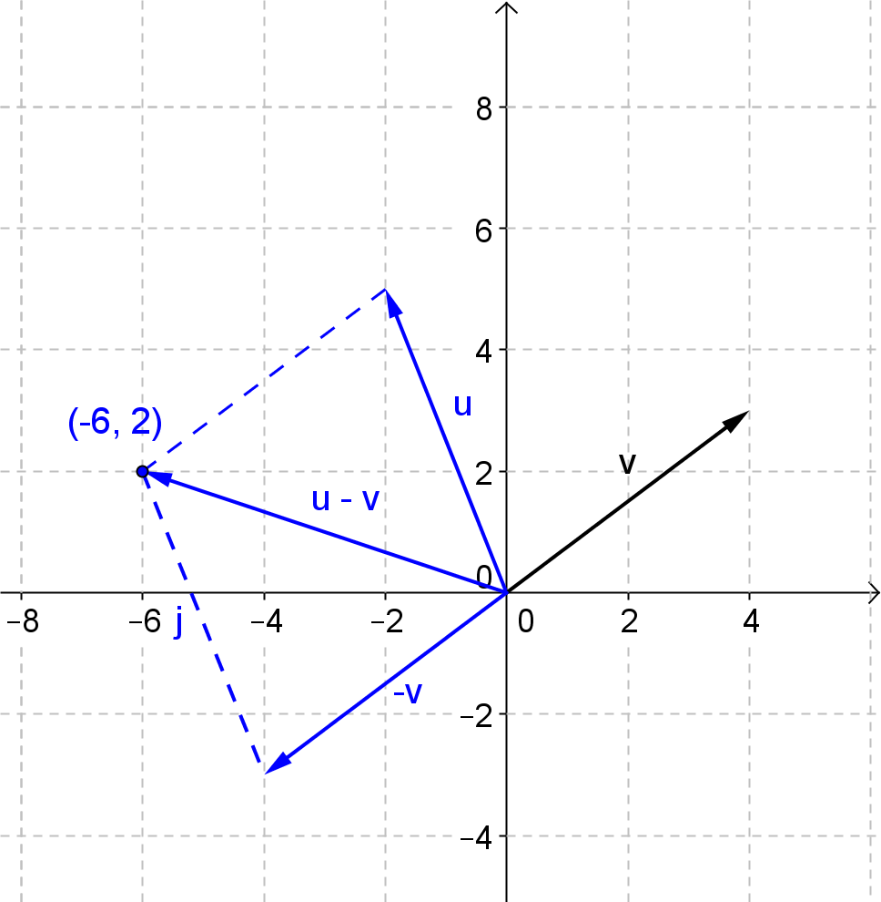

$$u-v=〈-6,2〉$$

  - Draw a diagram to illustrate $3v$ and $-3v$.
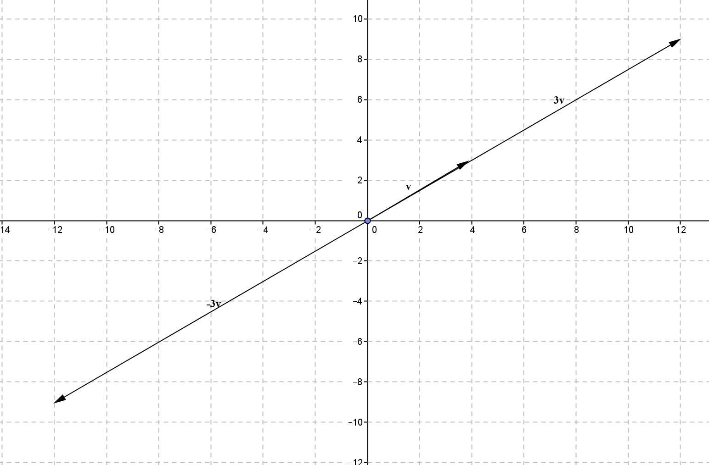

    - How do the magnitudes of these vectors compare to one another and to that of $v$?
The magnitude of $3\text{v}$ and $-3\text{v}$ are the same. The magnitude of these vectors is $3$ times the magnitude of $\text{v}$. You can see that because scalar multiplication dilates the vector by the scalar multiple.

    - How do the directions of $3v$ and $-3v$ compare to the direction of $v$?
When the scalar is positive the direction of the scalar multiple is the same going along $\text{v}$. When the scalar is negative, the direction is opposite the direction of $v$ going against $\text{v}$.

Discussion (3 minutes)
Have students read the paragraph in their student materials and summarize it with a partner in their own words. Then lead a brief discussion before starting students on the exercises that follow.
- How are directed line segments in $R^{2}$ the same as directed line segments in $R^{3}$?
  - They still have an initial point and a terminal point. The components are still found by subtracting the initial point coordinates from the terminal point coordinates.
- How are directed line segments in $R^{2}$ different from directed line segments in $R^{3}$?
  - Instead of a point being described by an ordered pair we must use an ordered triple.

Directed line segments can also be represented in $R^{3}$. Instead of two coordinates like we use in $R^{2}$, we simply use three to locate a point in space relative to the origin, denoted $(0,0,0)$. Thus the vector $\overset{⃑}{\vec{AB} }$ with initial point $A(x_{1},y_{1},z_{1})$ and terminal point $B\left(x_{2},y_{2},z_{2}\right)$ would have component form
$$\overset{⃑}{AB}=〈x_{2}-x_{1},y_{2}-y_{1},z_{2}-z_{1}〉.$$

Exercises 9–10 (3 minutes)
Exercises 9–10
- Consider points $A\left(1,0,-5\right)$ and $B\left(2,-3,6\right)$.
  - What is the component form of $\vec{AB}$?
$$\overset{⃑}{AB}=〈2-1,-3-0,6-(-5)〉=〈1,-3,11〉$$

  - What is the magnitude of $\overset{⃑}{AB}$?
$$\left\|\overset{⃑}{AB}\right\|=\sqrt{1^{2}+{\left(-3\right)}^{2}+{11}^{2}}=\sqrt{131}$$

- Consider points $A\left(1,0,-5\right)$, $B\left(2,-3,6\right)$, and $C(3,1,-2)$.
  - Show that $\vec{AB}+\vec{BA}=0$. Explain your answer using geometric reasoning.
$\vec{AB}=〈1,-3,11〉$ and $\vec{BA}=〈-1,3,-11〉$
$$\vec{AB}+\vec{BA}=〈1-1,-3+3,11-11〉=〈0,0,0〉$$
$\vec{AB}$ translates $A$ to $B$ and the $\vec{BA}$ translates $B$ back to $A$. The net translation effect is zero.

  - Show that $\vec{AB}+\vec{BC}+\vec{CA}=0$. Explain your answer using geometric reasoning.
We have $\vec{AB}=〈1,-3,11〉$, $\vec{BC}=〈1,4,-8〉$, and $\vec{CA}=〈-2,-1,-3〉$
Adding all the respective components together gives
$$\vec{AB}+\vec{BC}+\vec{CA}=〈1+1-2,-3+4-1,11-8-3〉=〈0,0,0〉$$
The sum of these three vectors translates $A$ to $B$, the $B$ to $C$ and then $C$ to $A$. The net translation effect is zero.

Closing (3 minutes)
Have students respond to these questions in writing or with a partner to summarize their learning for this lesson.
- How do you use the parallelogram rule to add vectors?
  - Construct a parallelogram with the added vectors along adjacent sides. The sum will be the diagonal from the initial points of opposite vertex on the parallelogram.
- How do you find the components of a vector when you know the coordinates of the initial and terminal points?
  - You subtract the initial $x$-coordinate from the terminal $x$-coordinate to find the horizontal components. You subtract the initial $y$-coordinate from the terminal $y$-coordinate to find the vertical components.
- Why when you add the vectors that represent the directed line segments between the three vertices of a triangle do you get the zero vector?
  - The net effect of the transformations that result from adding these three vectors takes the initial point of the first vector back to its original location in the coordinate plane.
Lesson Summary
A vector $v$ can be used to represent a directed line segment $\overset{⃑}{AB}$. If the initial point is $A(x_{1},y_{1})$ and the terminal point is $B\left(x_{2},y_{2}\right),$then the component form of the vector is $v=\overset{⃑}{AB}=〈x_{2}-x_{1},y_{2}-y_{1}〉$
Vectors can be added end-to-end or using the parallelogram rule.

Exit Ticket (3 minutes)

Name Date
Lesson 19: Directed Line Segments and Vectors
Exit Ticket

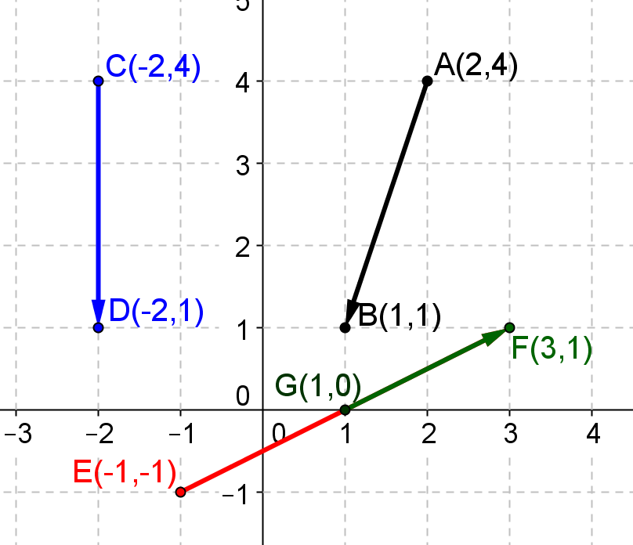
- Consider vectors with their initial and terminal points as shown below. Find the components of the specified vectors and their magnitudes.
  - $u=\vec{EF}$and$\left\|u\right\|$

  - $v=\vec{AB}$and $\left\|v\right\|$

  - $w=\vec{CD}$and$\left\|w\right\|$

  - $t=\vec{GF}$and $\left\|t\right\|$

- For vectors $u$ and $v$ as in Question 1, explain how to find $u+v$ using the parallelogram rule. Support your answer graphically below.
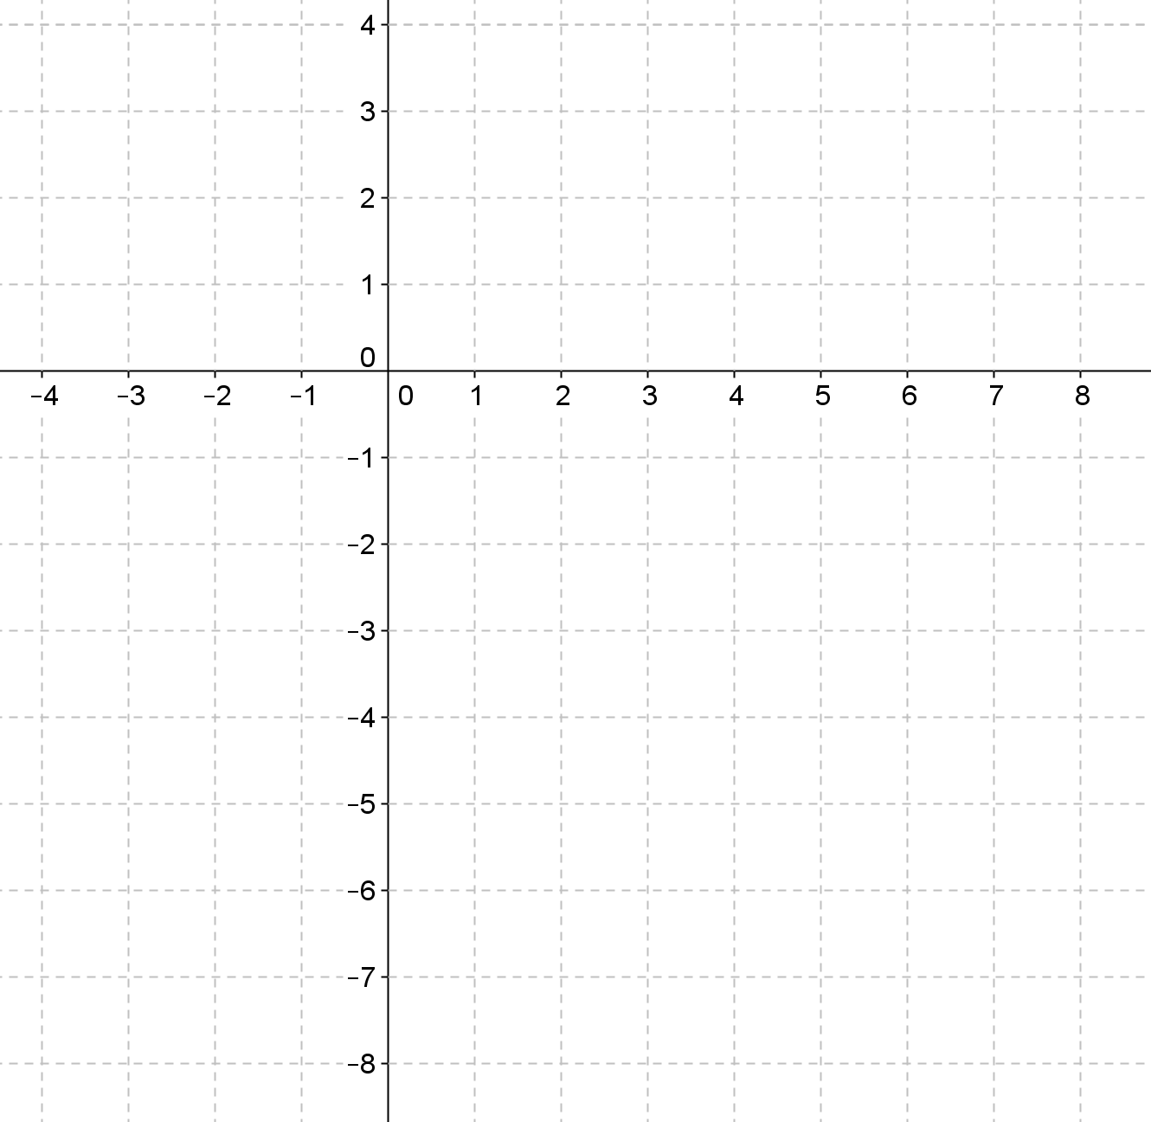

Exit Ticket Sample Solutions

- Consider vectors with their initial and terminal points as shown below. Find the components of the specified vectors and their magnitudes.
  - $u=\vec{EF }$and $\left\|u\right\|$
$\text{u}=〈4,2〉$,$\left\|\text{u}\right\|=2\sqrt{5}$

  - $v=\vec{AB}$and $\left\|v\right\|$
$\text{v}=〈-1,-3〉$, $\left\|\text{v}\right\|=\sqrt{10}$

  - $w=\vec{CD}$and$\left\|w\right\|$
$\text{w}=〈0,-3〉$,$\left\|\text{w}\right\|=3$

  - $t=\vec{GF}$and$\left\|t\right\|$
$\text{t}=〈2,1〉$,$\left\|\text{t}\right\|=\sqrt{5}$

- For vectors $u$ and $v$ as in Question 1, explain how to find $u+v$ using the parallelogram rule. Support your answer graphically below.
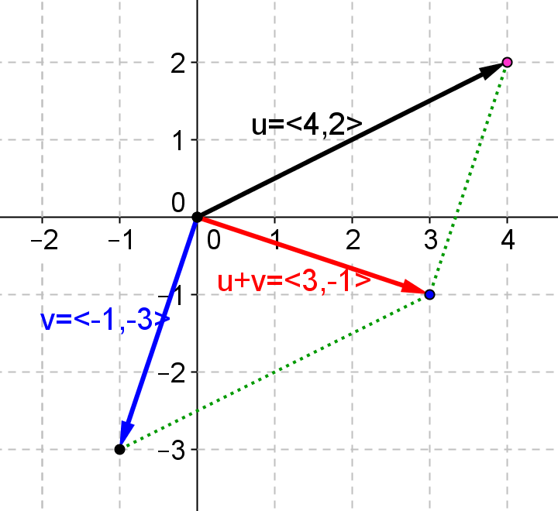
To find $\text{u}+\text{v}$ using the parallelogram rule, form a parallelogram with vectors $\text{u}$ and $\text{v}$as sides. The diagonal of the parallelogram is the sum of the two vectors.

Problem Set Sample Solutions

- Vectors $u$,$v$,$w$,$a$, and $b$ are shown at right.
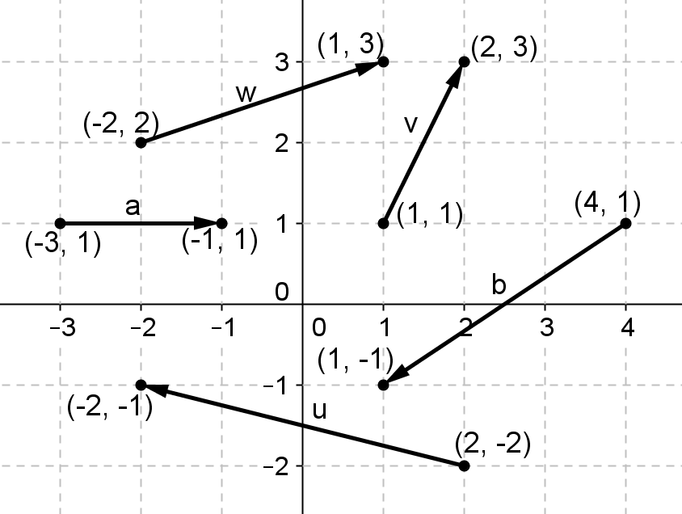
  - Find the component form of $u$,$v$,$w$,$a$, and $b$.
$\text{u}=〈-4, 1〉$,$\text{v}=〈1,2〉$,$\text{w}=〈3,1〉$, $\text{a}=〈2,0〉$,$\text{ b}=〈-3, -2〉$

  - Find the magnitudes $\left\|u\right\|$,$\left\|v\right\|$,$\left\|w\right\|$,$\left\|a\right\|$, and $\left\|b\right\|$.
$\left\|\text{u}\right\|=\sqrt{17}$,$\left\|\text{v}\right\|=\sqrt{5}$,$\left\|\text{w}\right\|=\sqrt{10}$, $\left\|\text{a}\right\|=2$,$\left\|\text{b}\right\|=\sqrt{13}$

  - Find the component form of $u+v$ and calculate $\left\|u+v\right\|$.
$〈-3,3〉$,$\left\|\text{u}+\text{v}\right\|=3\sqrt{2}$

  - Find the component form of $w-b$ and calculate $\left\|w-b\right\|$.
$〈6,3〉, \left\|\text{w}-\text{b}\right\|=3\sqrt{5}$

  - Find the component form of $3u-2v$.
$〈-14,-1〉$

  - Find the component form of $v-2(u+b)$.
$〈15,4〉$

  - Find the component form of $2\left(u-3v\right)-a$.
$〈-16,-10〉$

  - Find the component form of $u+v+w+a+b$.
$〈-1,2〉$

  - Find the component form of $u-v-w-a+b$.
$〈-13,-4〉$

  - Find the component form of $2\left(u+4v\right)-3(w-3a+2b)$.
$〈27,27〉$

- Given points $A(1,2,3)$,$B(-3,2,-4)$, $C(-2,1,5)$, find component forms of the following vectors.
  - $\vec{AB}$and $\vec{BA}$.
$\vec{AB}=〈-4, 0, -7〉$,$\vec{BA}=〈4, 0, 7〉$

  - $\vec{BC}$and $\vec{CB}$
$\vec{BC}=〈1-1,9〉$,$\vec{CB}=〈1,1,-9〉$
  - $\vec{CA}$and $\vec{AC}$
$\vec{CA}=〈3, 1, -2〉$,$\vec{AC}=〈-3,-1,2〉$

  - $\vec{AB}+\vec{BC}-\vec{AC}$
$〈0,0,0〉$

  - $-\vec{BC}+\vec{BA}+\vec{AC}$
$〈0,0,0〉$

  - $\vec{AB}-\vec{CB}+\vec{\overset{⃑}{CA} }$
$〈0,0,0〉$

- Given points $A(1,2,3)$, $B(-3,2,-4)$, $C(-2,1,5)$, find the following magnitudes.
  - $\left\|\vec{AB} \right\|$
$\left\|\vec{AB}\right\|=\sqrt{65}$

  - $\left\|\vec{AB}+\vec{BC} \right\|$.
$\left\|\vec{AB}+\vec{BC}\right\|=\sqrt{14}$

  - $\left\|\vec{AB}+\vec{BC}+\vec{CA}\right\|$
$0$

- Given vectors$u=〈-3, 2〉$,$v=〈2,4〉$,$w=〈5,-3〉$, use the parallelogram rule to graph the following vectors.
  - $u+v$
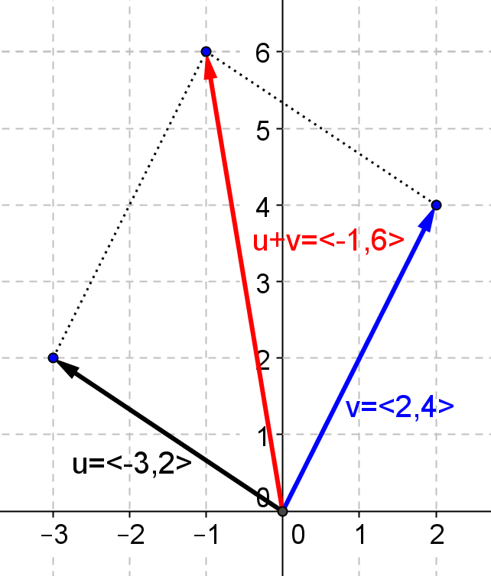

  - $v+w$
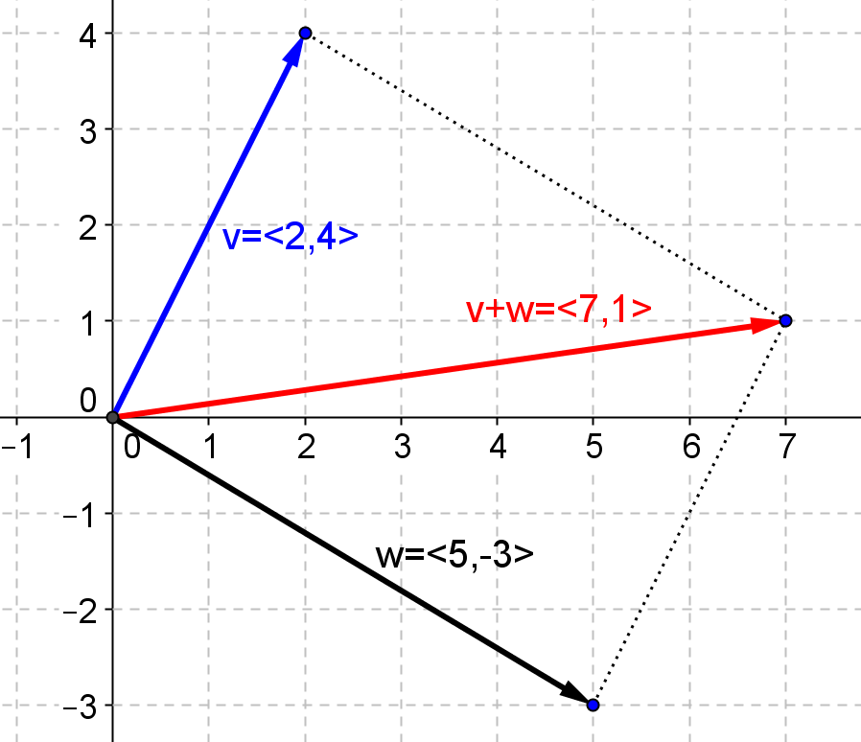

  - $u-v$
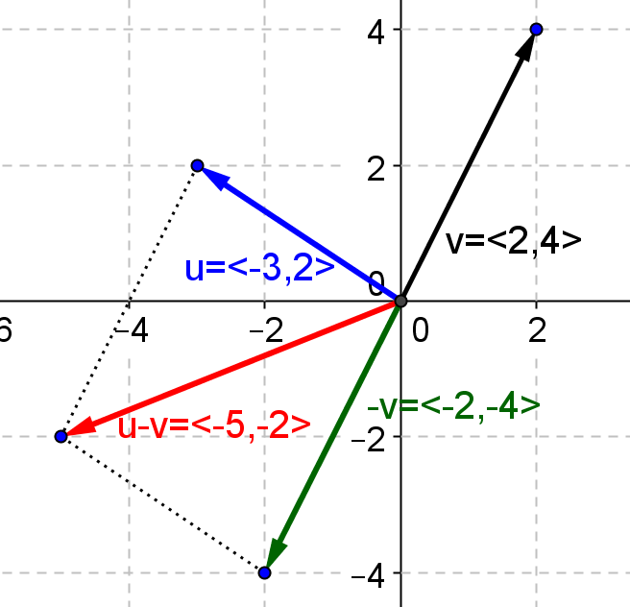

  - $v-w$
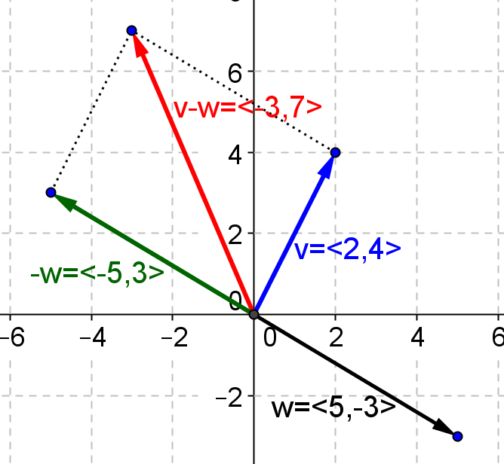

  - $2w+u$
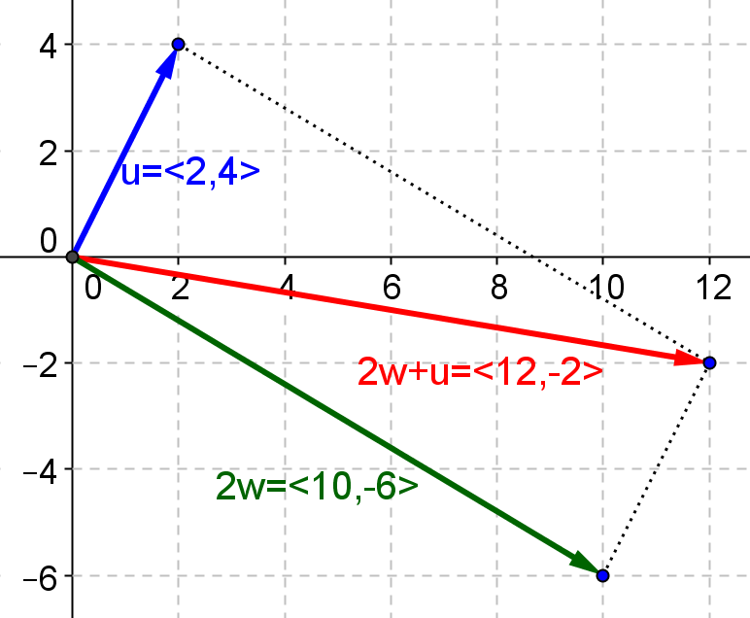

  - $3u-2v$
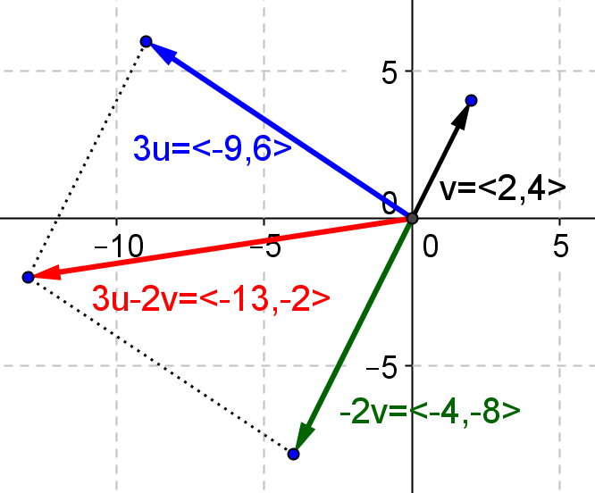

  - $u+v+w$
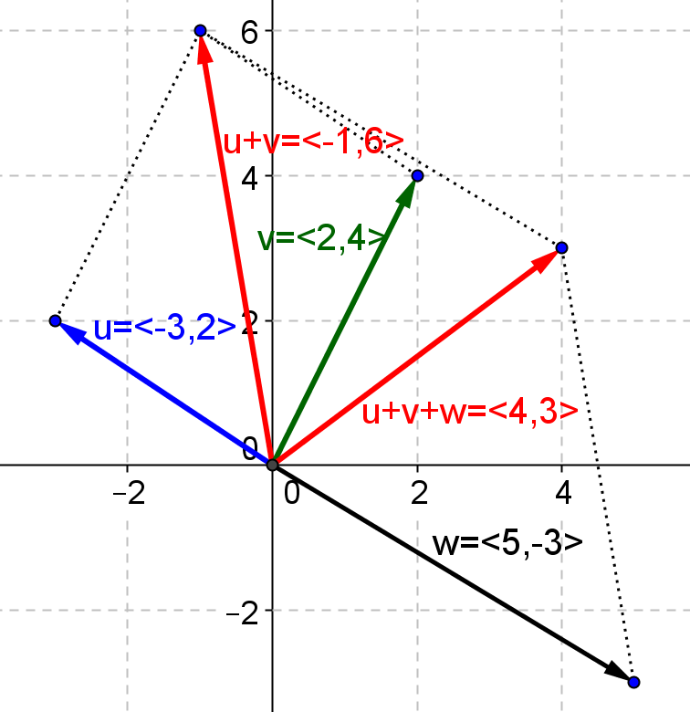

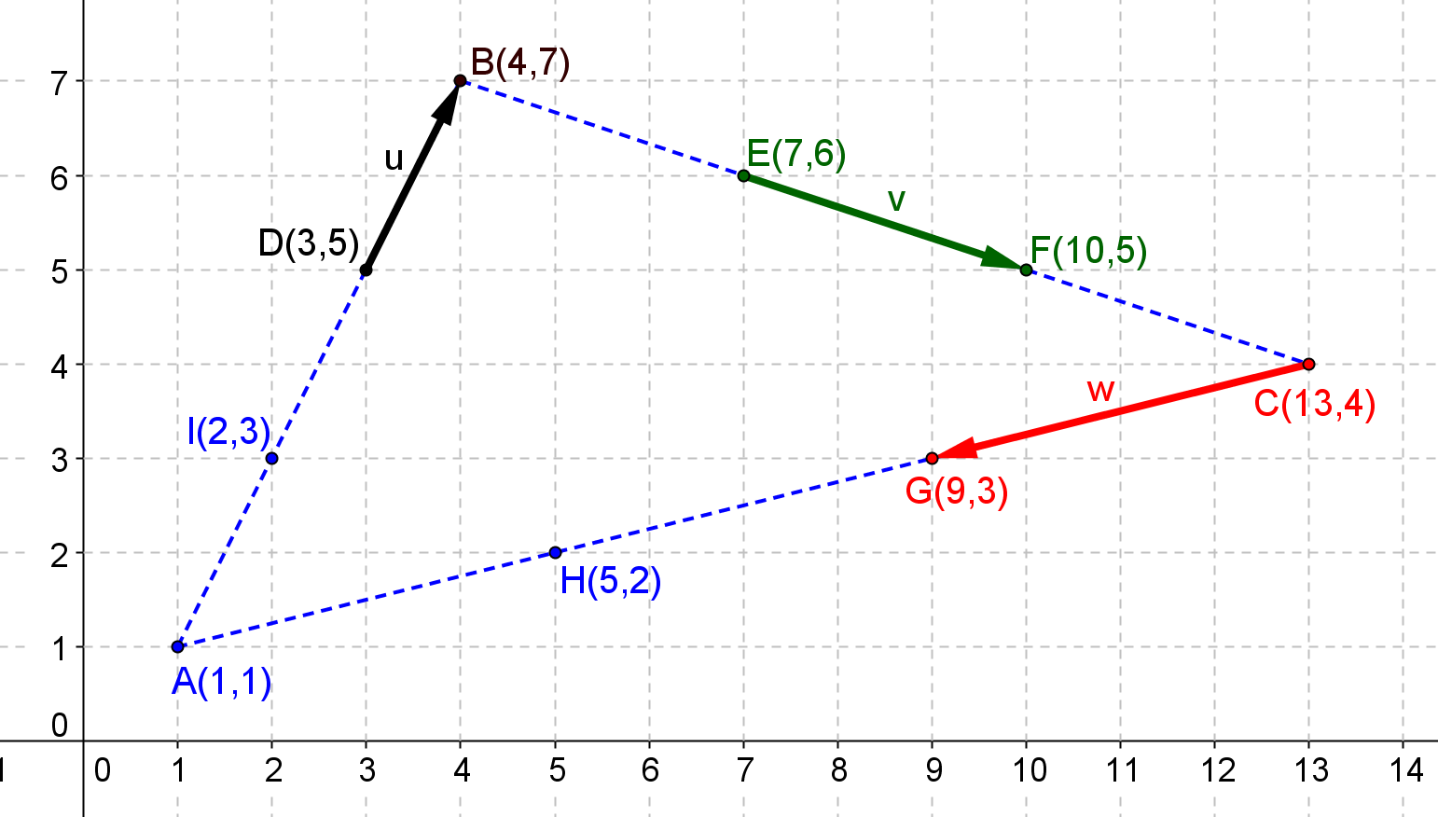
- Points $A, B, C, D, E, F, G$ and $H$ and vectors $u, v$ and $w$ are shown below. Find the components of the following vectors.

  - $\vec{AB}+\vec{BC}+\vec{CA}$
$\vec{AB}=〈3,6〉$,$\vec{BC}=〈9,-3〉$,$\vec{CA}=〈-12, -3〉$,$\vec{ AB}+\vec{BC}+\vec{CA}=0$

  - $u+v+w$
$u=〈1,2〉$,$v=〈3,-1〉$,$w=〈-4,-1〉$,$u+v+w=0$

  - $\vec{AD}+\vec{BE}+\vec{CG}$
$\vec{AD}=〈2,4〉, \vec{BE}=〈3,-1〉, \vec{CG}=〈-4, -1〉, \vec{AB}+\vec{BC}+\vec{CA}=〈1,2〉$

- Consider Example 5, part (b) in the lesson and Problem 5, part (a) above. What can you conclude about three vectors that form a triangle when placed tip-to-tail? Explain by graphing.
If three vectors form a triangle when placed tip-to-tail, then the sum of those three vectors is zero.
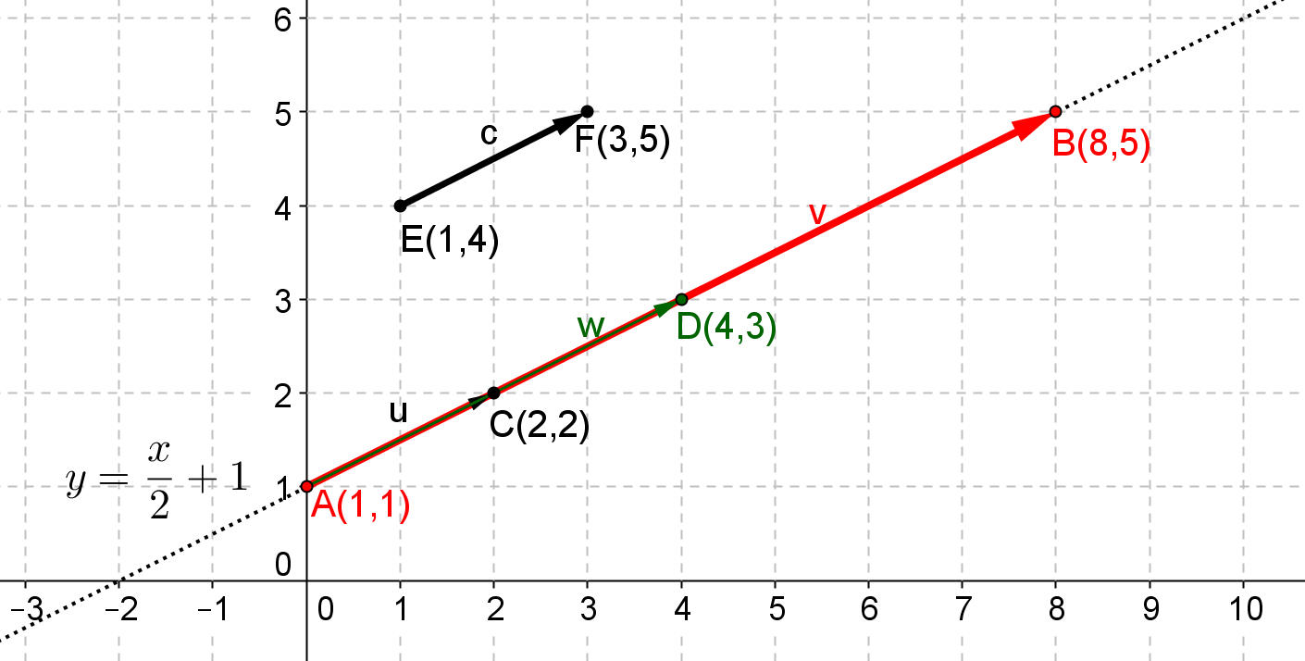

- Consider the vectors shown below.
  - Find the components of vectors$u=\vec{AC}$,$w=\vec{AD}$,$v=\vec{AB}$, and $c=\vec{EF}$.
$u=\vec{AC}=〈2,1〉$, $w= \vec{AD}=〈4,2〉$,$v=\vec{AB}=〈8,4〉$,$c=\vec{EF}=〈2,1〉$.

  - Is vector $u$ equal to vector $c$?
Yes, $u=〈2,1〉=c$, they have the same components and direction.

  - Jens says that if two vectors $u$ and $v$ have the same initial point $A$ and lie on the same line, then one vector is a scalar multiple of the other. Do you agree with him? Explain how you know. Given an example to support your answer.
Yes. Suppose that the terminal point of $u$ is $C$ and the terminal point of $v$ is $B.$ Then $u$ has length $AC≠0$
and $v$ has magnitude $AB$, where $AB≠0$. If $u$ and$v$ point in the same direction, then $v=\left(\frac{AB}{AC}\right)u$. If $u$ and$v$ point in opposite directions, then $v=-\left(\frac{AB}{AC}\right)u$ For example in the diagram above, vector $u=\overset{⃑}{AC}=〈2,1〉$ and vector $v=\vec{AB}=〈8,4〉$, and we have $v=\frac{\sqrt{80}}{\sqrt{5}}u=4u$.

