Lesson 19: Directed Line Segments and Vectors

Classwork
A vector can be used to represent a translation that takes one point to an image point. The starting point is called the initial point, and the image point under the translation is called the terminal point.
If we know the coordinates of both points, we can easily determine the horizontal and vertical components of the vector.

Exercises 1–3
- Several vectors, represented by arrows, are shown below. For each vector, state the initial point, terminal point, component form of the vector and magnitude.
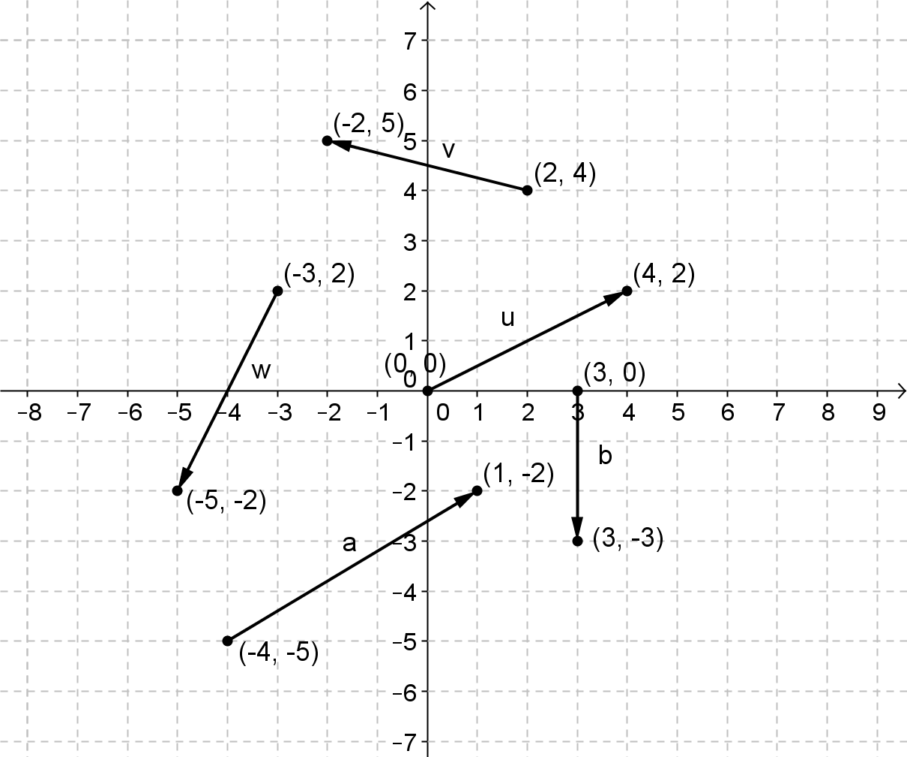

- Several vectors, represented by arrows, are shown below. For each vector, state the initial point, terminal point, component form of the vector, and magnitude.
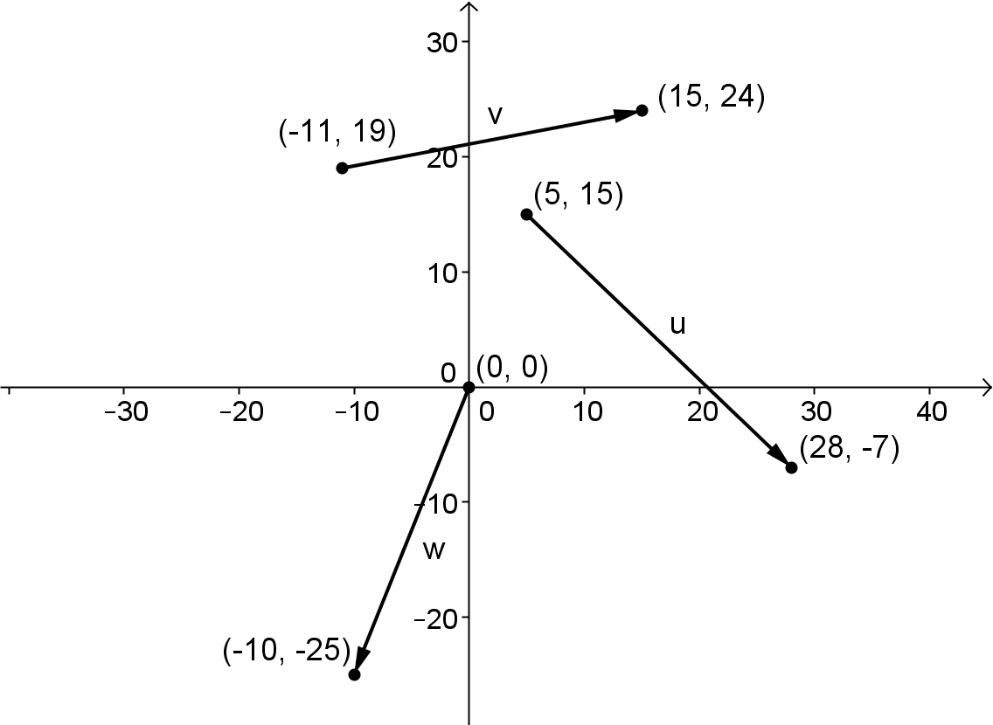

- Write a rule for the component form of the vector $v$ shown in the diagram. Explain how you got your answer.

When we use the initial and terminal points to describe a vector, we often refer to the vector as a directed line segment. A vector or directed line segment with initial point A and terminal point B is denoted $\vec{AB}$.

Exercises 4–7
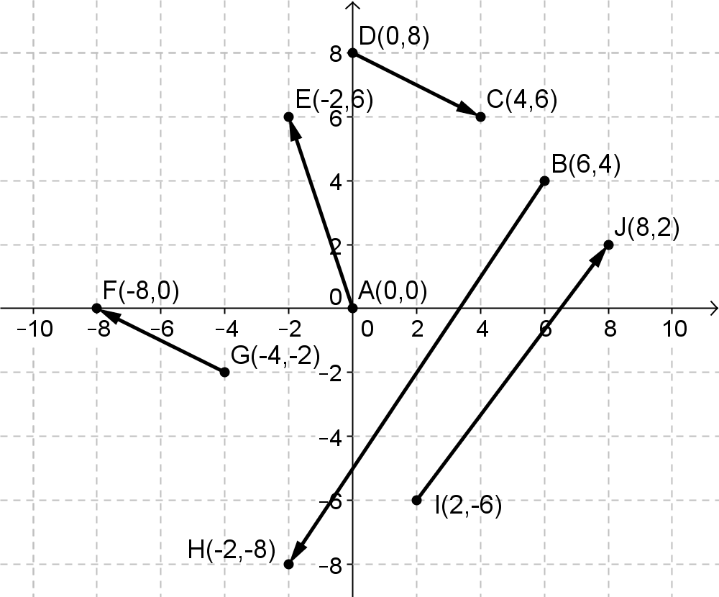
- Write each vector in component form.
  - $\vec{AE}$

  - $\vec{BH}$

  - $\vec{DC}$

  - $\vec{GF}$

  - $\vec{IJ}$

- Consider points $P(2,1)$, $Q(-3,3)$ and $R(1,4$).
  - Compute$\vec{PQ}$ and $\vec{QP}$ and show that $\vec{PQ}+\vec{QP}$is the zero vector. Draw a diagram to show why this makes sense geometrically.

  - Plot the points $P$, $Q$, and $R$. Use the diagram to explain why $\vec{PQ}+\vec{QR}+\vec{RP}$ is the zero vector. Show that this is true by computing the sum$\vec{PQ}+\vec{QR}+\vec{RP}$.

- Show for any two points $A$ and $B$ that $-\vec{AB}=\vec{BA}$.

- Given the vectors $v=〈2,-3〉$, $w=〈-5,1〉$, $u=〈4,-2〉$ and $t=〈-1,4〉$.
  - Verify that the sum of these four vectors is the zero vector.

  - Draw a diagram representing the vectors as arrows placed end-to-end to support why their sum would be the zero vector.

Example 1: The Parallelogram Rule for Vector Addition
When the initial point of a vector is the origin, then the coordinates of the terminal point will correspond to the horizontal and vertical components of the vector. This type of vector, with initial point at the origin, is often called a position vector.
  - Draw arrows to represent the vectors $v=〈5,3〉$ and $u=〈1,7〉$ with the initial point of each vector at $(0,0)$.
  - Add $v+u$ end-to-end. What is $v+u$? Draw the arrow that represents $v+u$ with initial point at the origin.
  - Add $u+v$ end-to-end. What is $u+v$? Draw the arrow that represents $u+v$ with an initial point at the origin.
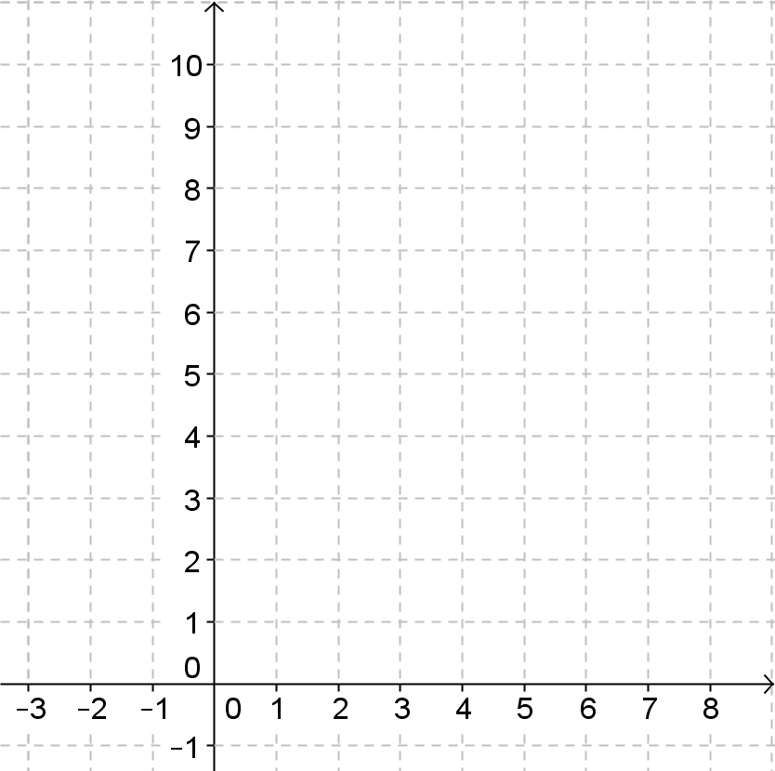

Exercises 8
- Let $u=〈-2,5〉$ and $v=〈4,3〉$.
  - Draw a diagram to illustrate $v$ and $u$ and then find $v+u$ using the parallelogram rule.

  - Draw a diagram to illustrate $2v$ and then find $2v+u$ using the parallelogram rule.

  - Draw a diagram to illustrate $–v$ and then find $u-v$ using the parallelogram rule.

  - Draw a diagram to illustrate $3v$ and $-3v$.

    - How do the magnitudes of these vectors compare to one another and to that of $v$?

    - How do the directions of $3v$ and $-3v$ compare to the direction of $v$?

Directed line segments can also be represented in $R^{3}$. Instead of two coordinates like we use in $R^{2}$, we simply use three to locate a point in space relative to the origin, denoted $(0,0,0)$. Thus the vector $\overset{⃑}{\vec{AB} }$ with initial point $A(x_{1},y_{1},z_{1})$ and terminal point $B\left(x_{2},y_{2},z_{2}\right)$ would have component form
$$\overset{⃑}{AB}=〈x_{2}-x_{1},y_{2}-y_{1},z_{2}-z_{1}〉.$$

Exercises 9–10
- Consider points $A\left(1,0,-5\right)$ and $B\left(2,-3,6\right)$.
  - What is the component form of $\vec{AB}$?

  - What is the magnitude of $\overset{⃑}{AB}$?

- Consider points $A\left(1,0,-5\right)$, $B\left(2,-3,6\right)$, and $C(3,1,-2)$.
  - Show that $\vec{AB}+\vec{BA}=0$. Explain your answer using geometric reasoning.

  - Show that $\vec{AB}+\vec{BC}+\vec{CA}=0$. Explain your answer using geometric reasoning.

Lesson Summary
A vector $v$ can be used to represent a directed line segment $\overset{⃑}{AB}$. If the initial point is $A(x_{1},y_{1})$ and the terminal point is $B\left(x_{2},y_{2}\right),$then the component form of the vector is $v=\overset{⃑}{AB}=〈x_{2}-x_{1},y_{2}-y_{1}〉$
Vectors can be added end-to-end or using the parallelogram rule.

Problem Set

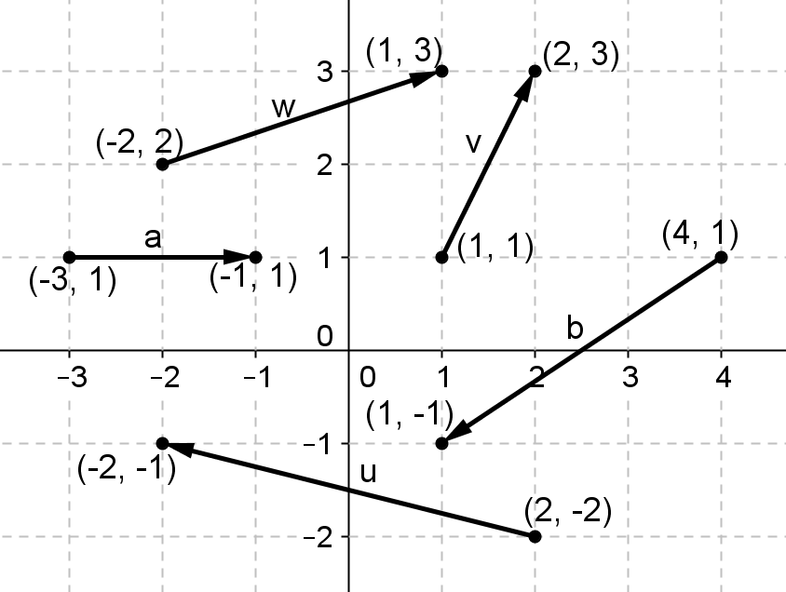
- Vectors $u$,$v, w$,$a$, and $b$ are shown at right.
  - Find the component form of $u, v, w, a,$ and $b$.
  - Find the magnitudes $\left\|u\right\|$,$\left\|v\right\|$,$\left\|w\right\|$,$\left\|a\right\|$, and $\left\|b\right\|$.
  - Find the component form of $u+v$ and calculate $\left\|u+v\right\|$.
  - Find the component form of $w-b$ and calculate $\left\|w-b\right\|$.
  - Find the component form of $3u-2v$.
  - Find the component form of $v-2(u+b)$.
  - Find the component form of $2\left(u-3v\right)-a$.
  - Find the component form of $u+v+w+a+b$.
  - Find the component form of $u-v-w-a+b$.
  - Find the component form of $2\left(u+4v\right)-3(w-3a+2b)$.

- Given points $A(1,2,3), B(-3,2,-4), C(-2,1,5)$, find component forms of the following vectors.
  - $\vec{AB}$and $\vec{BA}$.
  - $\vec{BC}$and $\vec{CB}$
  - $\vec{CA}$and $\vec{AC}$
  - $\vec{AB}+\vec{BC}-\vec{AC}$
  - $-\vec{BC}+\vec{BA}+\vec{AC}$
  - $\vec{AB}-\vec{CB}+\vec{\overset{⃑}{CA} }$

- Given points $A(1,2,3)$, $B(-3,2,-4)$, $C(-2,1,5)$, find the following magnitudes.
  - $\left\|\vec{AB} \right\|$
  - $\left\|\vec{AB}+\vec{BC} \right\|$.
  - $\left\|\vec{AB}+\vec{BC}+\vec{CA}\right\|$

- Given vectors$u=〈-3, 2〉$,$v=〈2,4〉$, $w=〈5,-3〉$, use the parallelogram rule to graph the following vectors.
  - $u+v$
  - $v+w$
  - $u-v$
  - $v-w$
  - $2w+u$
  - $3u-2v$
  - $u+v+w$

- Points $A, B, C, D, E, F, G$ and $H$ and vectors $u, v$ and $w$ are shown below. Find the components of the following vectors.
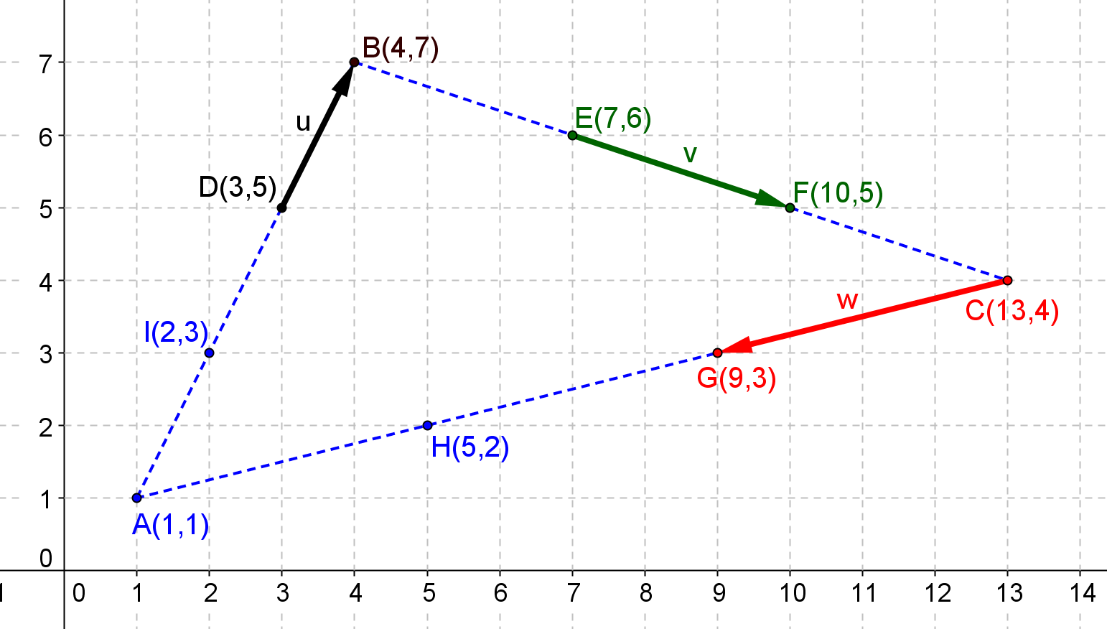

  - $\vec{AB}+\vec{BC}+\vec{CA}$
  - $u+v+w$
  - $\vec{AD}+\vec{BE}+\vec{CG}$

- Consider Example 5, part (b) in the lesson and Problem 5, part (a) above. What can you conclude about three vectors that form a triangle when placed tip-to-tail? Explain by graphing.

- Consider the vectors shown below.
  - Find the components of vectors$u=\vec{AC}$,$w=\vec{AD}$,$v=\vec{AB}$, and $c=\vec{EF}$.
  - Is vector $u$ equal to vector $c$?
  - Jens says that if two vectors $u$ and $v$ have the same initial point $A$ and lie on the same line, then one vector is a scalar multiple of the other. Do you agree with him? Explain how you know. Given an example to support your answer.

