Lesson 18: Vectors and Translation Maps

Student Outcomes
- Students use vectors to define a translation map and translate geometric figures in $R^{2}$ and $R^{3}$.
- Students represent and perform calculations with three-dimensional vectors and understand operations in three dimensions that are analogous to operations in two dimensions.

Lesson Notes
This lesson builds on the use of vectors to represent shifts by using vectors to define translation maps studied in prior lessons. The connection between matrices and vectors should become more apparent in this lesson, and we even use a notation for vectors that recalls matrix notation. This lesson focuses on several N.VM standards including N-VM.A.1,
N-VM.A.3, N-VM.B.4a, N-VM.V.4c, and N-VM.B.5, extending vector addition, subtraction, and scalar multiplication to $R^{3}$. This lesson lends itself to working in a program capable of creating three-dimensional graphs, such as GeoGebra (v5.0 or later). You can model these lessons on one computer or, if you have access to a lab, have students work on their own computers in the latter portion of this lesson.

Classwork
Opening Exercise (5 minutes)
Activate student knowledge about the previous day’s lesson with this short Opening Exercise. Students should work independently at first, and then check their solutions with a partner. Students could draw their vectors using GeoGebra. If using GeoGebra, type vector[(a,b)] in the input box where $a$ and $b$ are the horizontal and vertical components of the vector. In GeoGebra, the vector $v=〈1,2〉$ would be shown as $v=\left(\begin{matrix}1 \\ 2\end{matrix}\right)$.
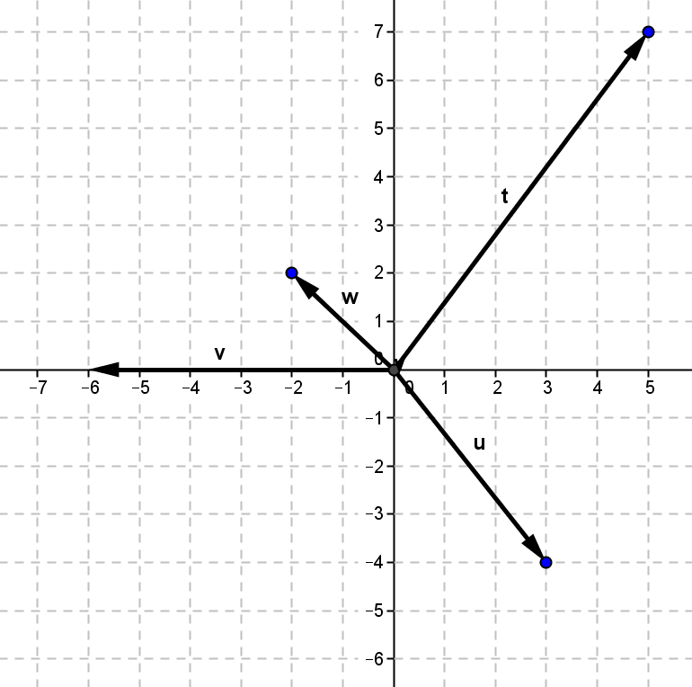
Opening Exercise
Write each vector described below in component form and find its magnitude. Draw an arrow originating from $(0,0)$ to represent each vector’s magnitude and direction.
  - Translate $3$ units right and $4$ units down.
$$\text{u}=〈3.-4〉\text{,} \left\|u\right\|=5$$

  - Translate $6$ units left.
$$\text{v}=〈-6,0〉\text{,} \left\|\text{v}\right\|=6$$

  - Translate $2$ units left and $2$ units up.
$$\text{w}=〈-2,2〉\text{,} \left\|\text{w}\right\|=2\sqrt{2}$$

  - Translate $5$ units right and $7$ units up.
$t=〈5,7〉$, $\left\|t\right\|=\sqrt{25+49}=\sqrt{74}$

Discussion (5 minutes)
Lead a short discussion to model how to write a vector as a translation map. Introduce the column notation for vectors and ask students to recall when they have seen something similar in previous lessons. They should recall it from Module 1 and from the beginning of this module.
Scaffolding:
- GeoGebra or other graphing software can be a powerful tool for scaffolding this lesson, particularly for students who are struggling to quickly sketch graphs of circles and lines by hand
- Post the formulas for a line and a circle on the board prior to this lesson and have students pair share with a partner what they recall about these equations and the related graphs.
- A line with slope $-\frac{a}{b}$ and $y$-intercept $\left(0,\frac{c}{b}\right)$ is given by $ax+by=c$.
- A circle with radius $r$ and center $(h,k)$ is given by
$${\left(x-h\right)}^{2}+{\left(y-k\right)}^{2}=r^{2}$$
- For the following equations, have students sketch the graph and state the key features.
$$2x-6y=12$$
$$x+2y=-5$$
$${\left(x-1\right)}^{2}+{\left(y-3\right)}^{2}=9$$
$${\left(x+3\right)}^{2}+{\left(y-2\right)}^{2}=5$$
- We can use a translation map to represent a vector. In fact, we can make this the definition of a vector: A vector is a translation map.
- For example, the vector $v=〈2,1〉$ is identified with the translation map, $T_{v}$ that maps a point $x=\left[\begin{matrix}x \\ y\end{matrix}\right]$ to the point $x+\left[\begin{matrix}2 \\ 1\end{matrix}\right]=\left[\begin{matrix}x \\ y\end{matrix}\right]+\left[\begin{matrix}2 \\ 1\end{matrix}\right]=\left[\begin{matrix}x+2 \\ y+1\end{matrix}\right]$; thus
$$T_{v}\left(\left[\begin{matrix}x \\ y\end{matrix}\right]\right)=\left[\begin{matrix}x+2 \\ y+1\end{matrix}\right].$$
- Why would it make sense to think of a vector as a translation map?
  - Because vectors accomplish the same thing as a translation map. An object is translated by the components of the vector in the horizontal and vertical direction. The object’s size and shape would remain unchanged under this type of transformation.
- Explain how writing vectors in a column makes it easier to think of them as translation maps.
  - We are using the same kind of notation we used when working with translation maps and linear transformations in the previous module and earlier in this module.
Give students time to summarize this information in their notes or on the student materials.

Exercises 1–3 (5 minutes)
Provide students with the opportunity to work in small groups on the next exercises. Check for precision and accuracy in their work with the translation map notation applied to vectors. Make sure they are thinking carefully about the transformations of the circle under the mapping in Exercises 2 and 3 and check to make sure they are creating the equations of the image figures correctly.

Exercises 1–3
- Write a translation map defined by each vector from the opening.
Consider the vector $v=〈-2,5〉$, and its associated translation map:
$T_{v}\left(\left[\begin{matrix}x \\ y\end{matrix}\right]\right)=\left[\begin{matrix}x-2 \\ y+5\end{matrix}\right]$

Vector in Component Form | Translation Map, $T_{v}$
$$u=〈3.-4〉$$ | $$T_{u}\left(\left[\begin{matrix}x \\ y\end{matrix}\right]\right)=\left[\begin{matrix}x+3 \\ y-4\end{matrix}\right]$$
$$v=〈-6.0〉$$ | $$T_{v}\left(\left[\begin{matrix}x \\ y\end{matrix}\right]\right)=\left[\begin{matrix}x-6 \\ y\end{matrix}\right]$$
$$w=〈-2.2〉$$ | $$T_{w}\left(\left[\begin{matrix}x \\ y\end{matrix}\right]\right)=\left[\begin{matrix}x-2 \\ y+2\end{matrix}\right]$$
$$t=〈5,7〉$$ | $$T_{t}\left(\left[\begin{matrix}x \\ y\end{matrix}\right]\right)=\left[\begin{matrix}x+5 \\ y+7\end{matrix}\right]$$

- Suppose we apply the translation map $T_{v}$ to each point on the circle ${\left(x+4\right)}^{2}+{\left(y-3\right)}^{2}=25$.
  - What is the radius and center of the original circle?
The radius is $5$ and the center is $(-4,3)$.

  - Show that the image points satisfy the equation of another circle.
Suppose that $T_{v}\left(\left[\begin{matrix}x \\ y\end{matrix}\right]\right)=\left[\begin{aligned}x^{'} \\ y'\end{aligned}\right]$. Then $x^{'}=x-2$ and $y^{'}=y+5$, so $x=x^{'}+2$ and $y=y^{'}-5$.
Since ${\left(x+4\right)}^{2}+{\left(y-3\right)}^{2}=25$, we have
$${\left(x+4\right)}^{2}+{\left(y-3\right)}^{2}=25 \\ {\left(\left(x^{'}+2\right)+4\right)}^{2}+{\left(\left(y^{'}-5\right)-3\right)}^{2}=25 \\ {\left(x^{'}+6\right)}^{2}+{\left(y^{'}-8\right)}^{2}=25$$
So the image points $\left[\begin{aligned}x^{'} \\ y'\end{aligned}\right]$ lie on a circle.

  - What is center and radius of this image circle?
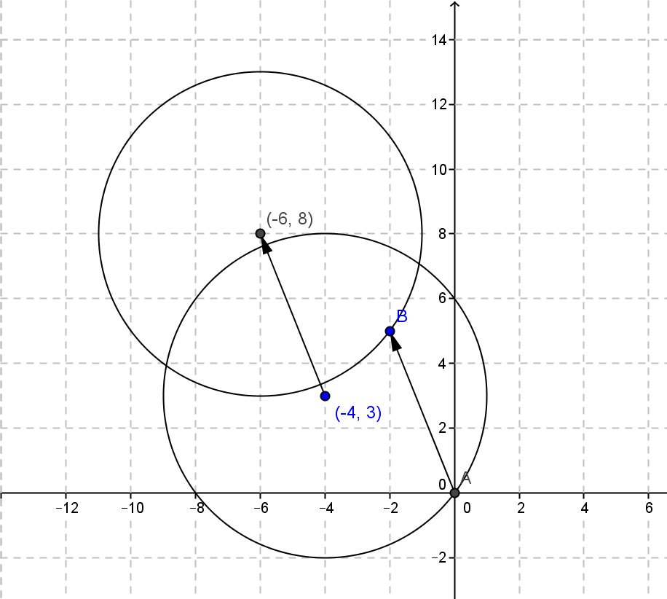
The radius of $5$ will remain unchanged. The new center will be $(-6,8)$.
- Suppose we apply the translation map $T_{v}$to each point on the line $2x-3y=10$.
  - What are the slope and $y$-intercept of the original line?
The slope is $\frac{2}{3}$ and the $y$-intercept is $\left(0, -\frac{10}{3}\right)$.

  - Show that the image points satisfy the equation of another line.
Suppose that $T_{v}\left(\left[\begin{matrix}x \\ y\end{matrix}\right]\right)=\left[\begin{aligned}x^{'} \\ y'\end{aligned}\right]$. Then $x^{'}=x-2$ and $y^{'}=y+5$, so $x=x^{'}+2$ and $y=y^{'}-5$.
Since$2x-3y=10,$ we have
$$2\left(x^{'}+2\right)-3\left(y^{'}-5\right)=10$$
$$2x^{'}+4-3y^{'}+15=10$$
$$2x^{'}-3y=-9$$

  - What are the slope and $y$-intercept of this image line?
The slope is $\frac{2}{3}$ and the $y$-intercept is $(0,3)$.
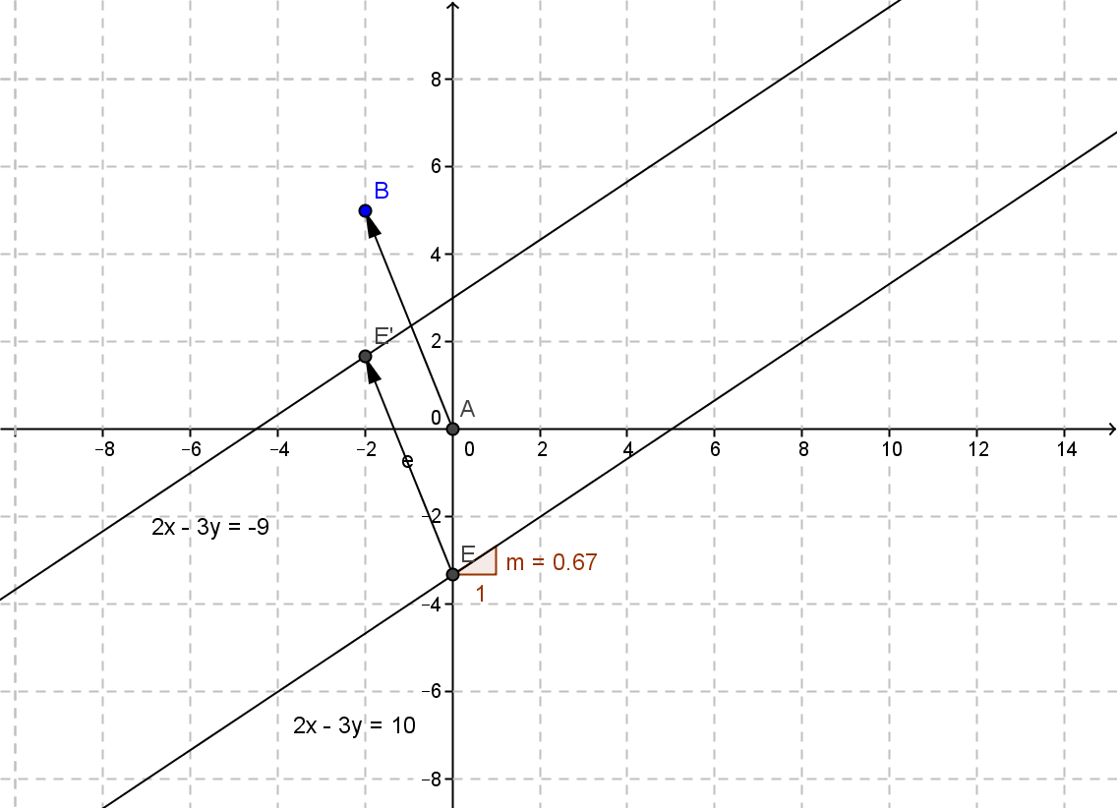

Discussion (5 minutes): Vectors in Three Dimensions
A vector in two dimensions can be used to define a translation map that translates objects in the coordinate plane by the horizontal and vertical components of the vector.
- What types of objects could we translate by a vector in two dimensions?
  - Any geometric figure could be translated by a vector.
This idea is easily extended to $R^{3}$, the Cartesian coordinate system in three dimensions. For example, the vector $v=〈1,3,5〉$ is a translation in space $1$ unit in the $x$ direction, $3$ units in the $y$ direction and $5$ units in the $z$ direction.
- What would be the associated translation map for the vector $v=〈1,3,5〉$?
  - The associated translation map would be $T_{v}\left(\left[\begin{matrix}x \\ y \\ z\end{matrix}\right]\right)=\left[\begin{matrix}x+1 \\ y+3 \\ z+5\end{matrix}\right]$.
- What types of objects could we represent in three dimensions?
  - Points, planes, spheres, cubes, cylinders, pyramids, or other solid figures could be represented in three dimensions. Two-dimensional figures can also be represented in three dimensions.
Give students an opportunity to summarize this information in their notes or on the student pages before starting the exercises that follow.

Example 1 (8 minutes): Vectors and Translation Maps in $R^{3}$
If technology is available, you can model this example using GeoGebra by selecting 3-D Graphs from the view menu. Type each figure into the input bar and then type in vector[(1,3,5)]. Use the “translate by vector” feature in the translate menu. Students will be able to see the equations updating and the image graph displayed along with the pre-image when you use this feature. If technology is not available, use 3-dimensional graph paper or isometric graph paper. 3-D graph paper is included in Lesson 5 or can be downloaded for free at http://www.waterproofpaper.com/graph-paper/isometric-graphing-paper.pdf.
Scaffolding:
Help students graph in 3-D by using 3-D or isometric graph paper. 3-D graph paper is included in Lesson 5.
Take time to help students make sense of the graphs they are seeing of each object. Point out the similarities between points, planes, and spheres in three dimensions and points, lines, and circles in two dimensions.
- How do the coordinates of a point in two dimensions compare to coordinates in three dimensions?
  - You just add another coordinate for the distance from the origin in the $z$ direction.
- How does the equation of a line in two dimensions compare to the equation of a plane in three dimensions?
  - You just add another linear term using the variable $z$. The intercepts are similar with two coordinates being $0$ and the third coordinate giving the point where the plane crosses the given axis.
- How does the equation of a circle in two dimensions compare to the equation of a sphere in three dimensions?
  - You just add another quadratic term using the variable $z$. The radius is the cube root of the constant and the center is the same except three coordinates.

Example 1: Vectors and Translation Maps in $R^{3}$
Translate by the vector $v=〈1,3,5〉$by applying the translation map $T_{v}$ to the following objects in $R^{3}$. A sketch of the original object and the vector is shown. Sketch the image.
$$T_{v}\left(\left[\begin{matrix}x \\ y \\ z\end{matrix}\right]\right)=\left[\begin{matrix}x+1 \\ y+3 \\ z+5\end{matrix}\right]$$
  - The point $A\left(2,-2,4\right)$
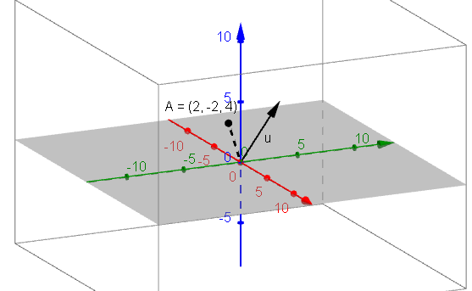

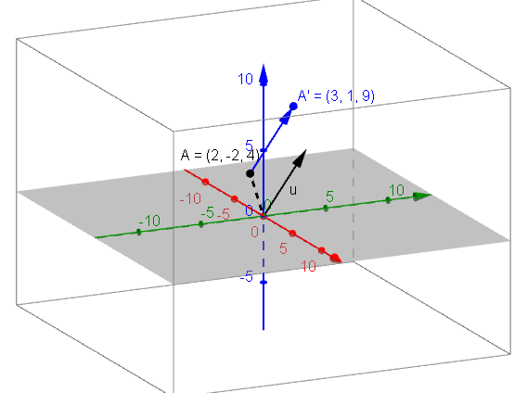

The new point will be $\left(2+1,-2+3,4+5\right)=(3,1,9)$

  - The plane $2x+3y-z=0$
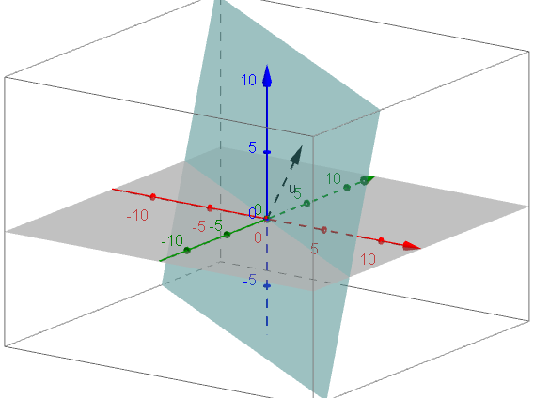

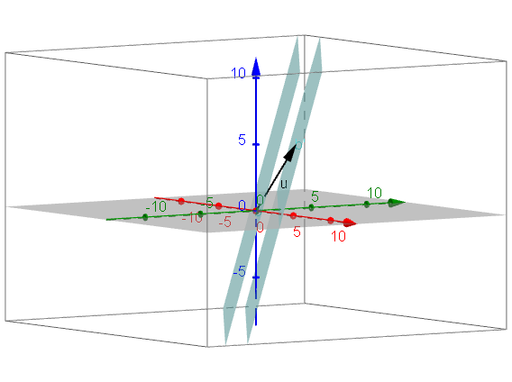

The new plane will be $2\left(x-1\right)+3\left(y-3\right)-\left(z-5\right)=0$, which is equivalent to $2x+3y-z=6$.

  - The sphere ${\left(x-1\right)}^{2}+{\left(y-3\right)}^{2}+z^{2}=9$.
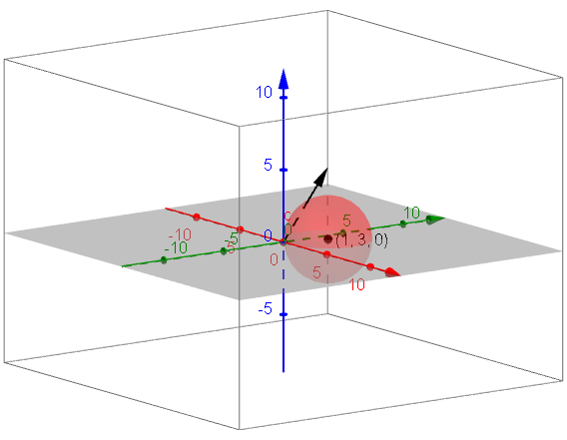

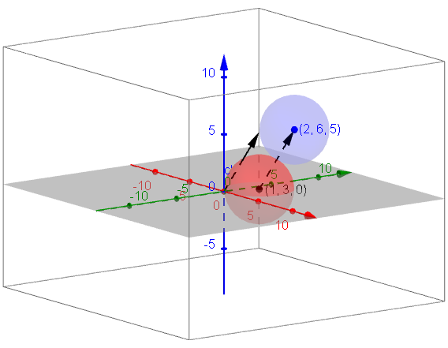

The new sphere will be ${\left(x-\left(1+1\right)\right)}^{2}+{\left(y-\left(3+3\right)\right)}^{2}+{\left(z-\left(0+5\right)\right)}^{2}=9$, which is equivalent to ${\left(x-2\right)}^{2}+{\left(y-6\right)}^{2}+{\left(x-5\right)}^{2}=9$.

After sharing the discussing the solutions to Example 1, conclude with a brief discussion of the results.
- When we translated a line by a vector, why was the image parallel to the original line?
  - All points in the plane were moved by the same amount in the same direction due to the translation map.
- Why does it make sense that when you translate a plane by a vector the image plane is parallel to the pre-image?
  - If every point moves the same distance in the same direction, then the planes will have the same orientation in space but a different location.
- When translating any geometric figure by a vector will the image be congruent to the pre-image? Explain how you know.
  - Since translations are rigid transformations, the image will be congruent to the pre-image.

Exercise 4 (2 minutes)
This short exercise will allow you to determine whether or not students are able to extend their thinking about vectors to three dimensions.
Exercise 4
- Given the sphere ${\left(x+3\right)}^{2}+{\left(y-1\right)}^{2}+{\left(z-3\right)}^{2}=10$.
  - What are its center and radius?
The center is $(-3,1,3)$, and the radius is $\sqrt{10}$.

  - Write a vector and its associated translation map that would take this sphere to its image centered at the origin.
We need to translate the center from the point $(-3,1,3)$ to the point $(0,0,0)$. This represents a translation of $3$ units in the $x$ direction, $-1$ unit in the $y$ direction, and $-3$ units in the $z$ direction.
The vector is $v=〈3,-1,-3〉$ and the translation map would be
$$T_{v}\left(\left[\begin{matrix}x \\ y \\ z\end{matrix}\right]\right)=\left[\begin{matrix}x+3 \\ y-1 \\ z-3\end{matrix}\right]$$

Example 2 (5 minutes): What is the Magnitude of a Vector in $R^{3}$?
You can provide less scaffolding by asking students to determine an expression for the magnitude of $v$ shown in the diagram below by simply showing the diagram on the board or document camera without the additional questions. Notice that $v$ is a vector, but that $x, y, z,$ and $w$ are real numbers that represent lengths. For students that need a more concrete approach, label the terminal point of the vector $v$ with an actual set of coordinates such as $(2, 8,6)$ and then model how to find the magnitude of the vector before working through the problem in general.
- Use the Pythagorean theorem to write an equation relating $x, y, and w$.
  - $x^{2}+y^{2}=w^{2}$
- Use the Pythagorean theorem to write an equation relating $w, z, and \left\|v\right\|$.
  - $w^{2}+z^{2}={\left\|v\right\|}^{2}$
- Now write an equation relating $\left\|v\right\|, x, y, and z$.
  - $x^{2}+y^{2}=w^{2}$
  - $w^{2}={\left\|v\right\|}^{2}-z^{2}$
  - $x^{2}+y^{2}={\left\|v\right\|}^{2}-z^{2}$
  - $x^{2}+y^{2}+z^{2}={\left\|v\right\|}^{2}$

Example 2: What is the Magnitude of a Vector in $R^{3}$?

MP.7
        - Find a general formula for ${\left\|v\right\|}^{2}$.
$${\left\|v\right\|}^{2}=x^{2}+y^{2}+z^{2}$$

        - Solve this equation for $\left\|v\right\|$ to find the magnitude of the vector.
$$\left\|v\right\|=\sqrt{x^{2}+y^{2}+z^{2}}$$

Exercises 5–8 (5 minutes)
In Exercise 5, students practice finding the magnitude of a vector in three dimensions. Direct students to work independently on Exercise 5 first, and then have them work with a partner to check their results.
Exercises 5–8
- Which vector has greater magnitude, $v=〈0,5,-4〉$ or $u=〈3,-4,4〉$? Show work to support your answer.
$$\left\|v\right\|=\sqrt{0^{2}+5^{2}+{\left(-4\right)}^{2}}=\sqrt{41}$$
$$\left\|u\right\|=\sqrt{3^{2}+{\left(-4\right)}^{2}+4^{2}}=\sqrt{41}$$
These vectors have equal magnitude.

- Explain why vectors can have equal magnitude but not be the same vector.
A vector has both a magnitude and a direction. If you graphed the vectors from Exercise 5, you can see they point in different directions so they cannot be the same even though they had equal magnitude.

Give students time to consider how the rules and representations learned in the previous lesson extend to three dimensions. If needed, scaffold this exercise by providing specific example of vectors for students to work with such as those shown in the table below before asking them to write general rules.

 | Vectors in $R^{2}$ | Vectors in $R^{3}$
Component Form | $$〈2,3〉$$ | $$〈2,3,4〉$$
Column Form | $$\left[\begin{matrix}2 \\ 3\end{matrix}\right]$$ | $$\left[\begin{matrix}2 \\ 3 \\ 4\end{matrix}\right]$$
Magnitude | $$\left\|v\right\|=\sqrt{2^{2}+3^{2}}=\sqrt{13}$$ | $$\left\|v\right\|=\sqrt{2^{2}+3^{2}+4^{2}}=\sqrt{29}$$
Addition | If $v=〈2,3〉$ and $u=〈2,-4〉$,  Then  $$v+u=〈2+2,3+(-4)〉=〈4,-1〉$$ | If $v=〈2,3,4〉$ and $u=〈2,-4,1〉$,  Then  $$v+u=〈2+2,3+(-4),4+1〉=〈4,-1,5〉$$
Subtraction | If $v=〈2,3〉$ and $u=〈2,-4〉$,  Then $v+u=〈2-2,3-(-4)〉=〈0,7〉$ | If $v=〈2,3,4〉$ and $u=〈2,-4,1〉$,  Then  $v+u=〈2-2,3-\left(-4\right),4-1〉=〈0,7,3〉$
Scalar Multiplication | If $v=〈2,3〉$ then  $$2v=〈2∙2,2∙3〉=〈4,6〉$$ | If $v=〈2,3,4〉$ then  $$2v=〈2∙2,2∙3,2∙4〉=〈4,6,8〉$$

- Vector arithmetic in $R^{3}$ is analogous to vector arithmetic in $R^{2}$. Complete the graphic organizer to illustrate these ideas.
 | Vectors in $R^{2}$ | Vectors in $R^{3}$
Component Form | $$〈a,b〉$$ | $$〈a,b,c〉$$
Column Form | $$\left[\begin{matrix}a \\ b\end{matrix}\right]$$ | $$\left[\begin{matrix}a \\ b \\ c\end{matrix}\right]$$
Magnitude | $$\left\|v\right\|=\sqrt{a^{2}+b^{2}}$$ | $$\left\|v\right\|=\sqrt{a^{2}+b^{2}+c^{2}}$$
Addition | If $v=〈a,b〉$ and $u=〈c,d〉$,  Then $v+u=〈a+c,b+d〉$ | If $v=〈a,b,c〉$ and $u=〈d,e,f〉$,  Then $v+u=〈a+d,b+e,c+f〉$
Subtraction | If $v=〈a,b〉$ and $u=〈c,d〉$,  Then $v-u=〈a-c,b-d〉$ | If $v=〈a,b,c〉$ and $u=〈d,e,f〉$,  Then $v-u=〈a-d,b-e,c-f〉$
Scalar Multiplication | If $v=〈a,b〉$ and$k$ is a real number  $$kv=〈ka,kb〉$$ | If $v=〈a,b,c〉$ and$k$ is a real number  $kv=〈ka,kb,kc〉$

Before starting Exercise 8, make sure students have correct information in the graphic organizer. You can show a completed one to the class and if time permits have different groups explain how they got their answers for each row. Allow students time to correct any errors they may have made.
- Given $v=〈2,0,-4〉$ and $u=〈-1,5,3〉$.
  - Calculate the following.
    - $v+u$
$$v+u=〈2+\left(-1\right), 0+5,-4+3〉=〈1,5,-1〉$$

    - $2v-u$
$$2v-u=〈2∙2-\left(-1\right),2∙0-5,2∙\left(-4\right)-3〉=〈5,-5,-11〉$$

    - $\left\|v\right\|$
$$\left\|v\right\|=\sqrt{{\left(-1\right)}^{2}+5^{2}+3^{2}}=\sqrt{35}$$

  - Suppose the point $(1,3,5)$ is translated by $v$ and then by $u$. Determine a vector $w$ that would return the point back to its original location $(1,3,5)$.
From part (a), we have $v+u=〈1,5,-1〉$. The point will be translated from $(1,3,5)$ to $(2,8,4)$
since $1+1=2$, $5+3=8$, and $5-1=4$. The vector that will return this point to its original location will be the opposite of $v+u$.
$$-\left(v+u\right)=〈-1,-5,1〉$$
And this vector will translate $\left(2,8,4\right)$back to $(1,3,5)$ because $2-1=1$, $8-5=3$, and $4+1=5$.

Closing (2 minutes)
Give students time to respond to the questions below individually in writing or with a partner.
- Why can we represent vectors as translation maps?
  - They mean the same thing geometrically.
- How are two-dimensional vectors the same as three-dimensional vectors, and how are they different?
  - Either dimension has a magnitude and direction and represents a translation or shift. They are different because you need one additional component to describe a vector in three dimensions.
The graphic organizer in Exercise 7 can serve as a lesson summary of vector arithmetic in three dimensions along with the information about translation maps shown below.
Lesson Summary
A vector $v$ can define a translation map $T_{v}$ that takes a point to its image under the translation. Applying the map to the set of all points that make up a geometric figure serves to translate the figure by the vector.

Exit Ticket (3 minutes)

Name Date
Lesson 18: Vectors and Translation Maps

Exit Ticket

- Given the vector $v=〈2,-1〉$, find the image of the line $3x-2y=2$ under the translation map $T_{v}$. Graph the original line and its image, and explain the geometric effect of the map $T_{v}$.

- Given the vector $v=〈-1,2〉$, find the image of the circle ${\left(x-2\right)}^{2}+{\left(y+1\right)}^{2}=4$ under the translation
map $T_{v}.$Graph the original circle and its image, and then explain the geometric effect of the map $T_{v}$.
Exit Ticket Sample Solutions

- Given the vector $v=〈2,-1〉$, find the image of the line $3x-2y=2$ under the translation map $T_{v}$. Graph the original line and its image, and explain the geometric effect of the map $T_{v}$.
$T_{v}\left(\left[\begin{aligned}x \\ y\end{aligned}\right]\right)=\left(\begin{matrix}x-2 \\ y+1\end{matrix}\right)$; image of the original line: $3\left(x+2\right)-2\left(y-1\right)=2.$
$3x+6-2y+2=2$,$3x-2y=-6$.
Every point on the line is shifted $2$ units to the left and $1$ unit upward.
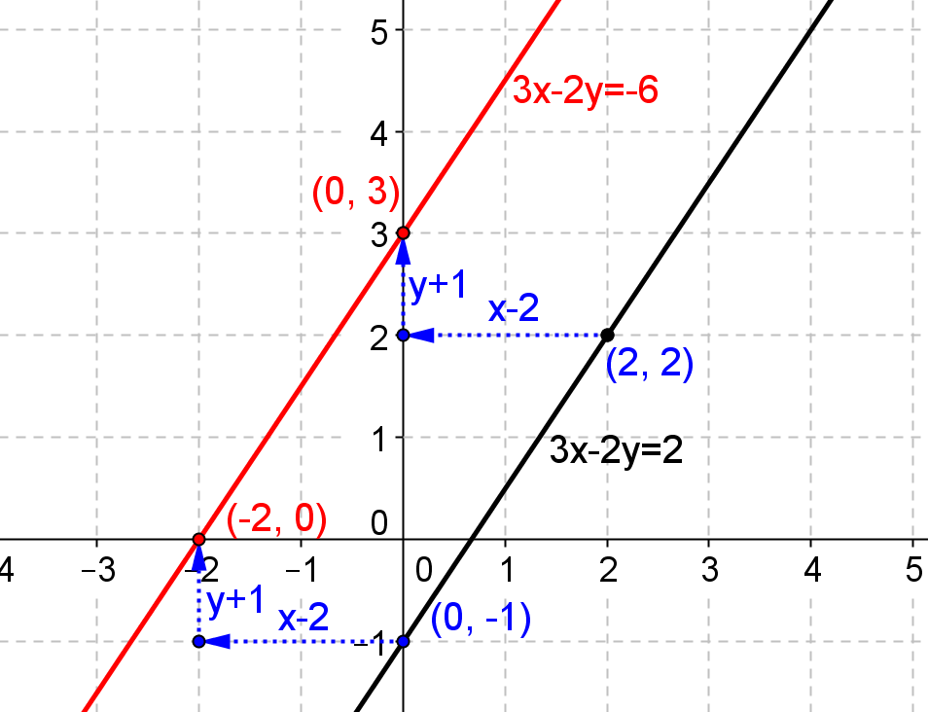

- Given the vector $v=〈-1,2〉$, find the image of the circle ${\left(x-2\right)}^{2}+{\left(y+1\right)}^{2}=4$ under the translation map $T_{v}.$Graph the original circle and its image, and explain the geometric effect of the map $T_{v}$.
$T_{v}\left(\left[\begin{aligned}x \\ y\end{aligned}\right]\right)=\left(\begin{matrix}x-1 \\ y+2\end{matrix}\right)\text{;}$image of original circle:${\left(x-1\right)}^{3}+{\left(y-1\right)}^{2}=4$.
Every point on the circle is shifted one unit to the left and two units upward. The new center is $(1,1)$ and the
radius $r=2$ stays the same.
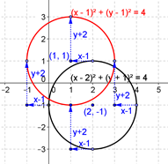

Problem Set Sample Solutions

- Myishia says that when applying the translation map $T_{v}\left(\left[\begin{aligned}x \\ y\end{aligned}\right]\right)=\left[\begin{matrix}x+1 \\ y-2\end{matrix}\right]$ to a set of points given by an equation relating $x$ and $y$, we should replace every $x$ that is in the equation by $x+1$, and $y$ by $y-2$. For example, the equation of the parabola $y=x^{2}$ would become $y-2={\left(x+1\right)}^{2}$. Is she correct? Explain your answer.
No, she is not correct. What she did will translate the points on the parabola$y=x^{2}$ in the opposite direction—one unit to the left and 2 units upward, which is not the geometric effect of $T_{v}\left(\left[\begin{aligned}x \\ y\end{aligned}\right]\right)=\left[\begin{matrix}x+1 \\ y-2\end{matrix}\right]$. In order to have the correct translation based on$T_{v}\left(\left[\begin{aligned}x \\ y\end{aligned}\right]\right)=\left[\begin{matrix}x+1 \\ y-2\end{matrix}\right]$, we need to set $x^{'}=x+1$ and $y^{'}=y-2$, which is equivalent to $x=x^{'}-1$ and $y=y’+2$. This process gives the transformed equation $y'+2={\left(x'-1\right)}^{2}$, which we write as
$$y+2={\left(x-1\right)}^{2}.$$
- Given the vector $v=〈-1, 3〉,$find the image of the line $x+y=1$ under the translation map $T_{v}.$ Graph the original line and its image, and explain the geometric effect of the map $T_{v}$ on the line.

$$T_{v}\left(\left[\begin{aligned}x \\ y\end{aligned}\right]\right)=\left[\begin{matrix}x-1 \\ y+3\end{matrix}\right]\text{,} \left(x-\left(-1\right)\right)+\left(y-\left(3\right)\right)=1\text{,} x+1+y-3=1\text{, }x+y=3$$
Every point on the line is shifted one unit left and three units upward. The slopes of the lines remain $-1.$
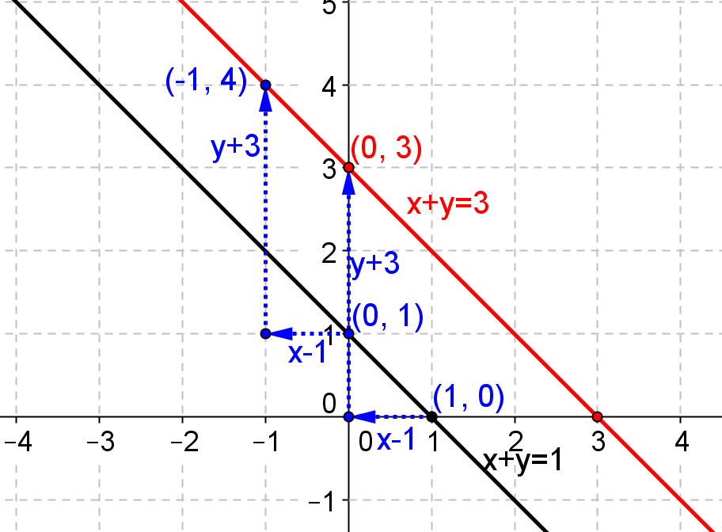

- Given the vector $v=〈2,1〉$, find the image of the parabola $y-1=x^{2}$ under the translation map $T_{v} .$Draw a graph of the original parabola and its image, and explain the geometric effect of the map $T_{v}$ on the parabola. Find the vertex and $x$-intercepts of the graph of the image.
$$T_{v}\left(\left[\begin{aligned}x \\ y\end{aligned}\right]\right)=\left[\begin{matrix}x+2 \\ y+1\end{matrix}\right]\text{,} y-2={\left(x-2\right)}^{2}$$Every point on the parabola is shifted two units to the right and one unit upward.
The vertex is $(2, 2)$, and there are no $x$-intercepts.
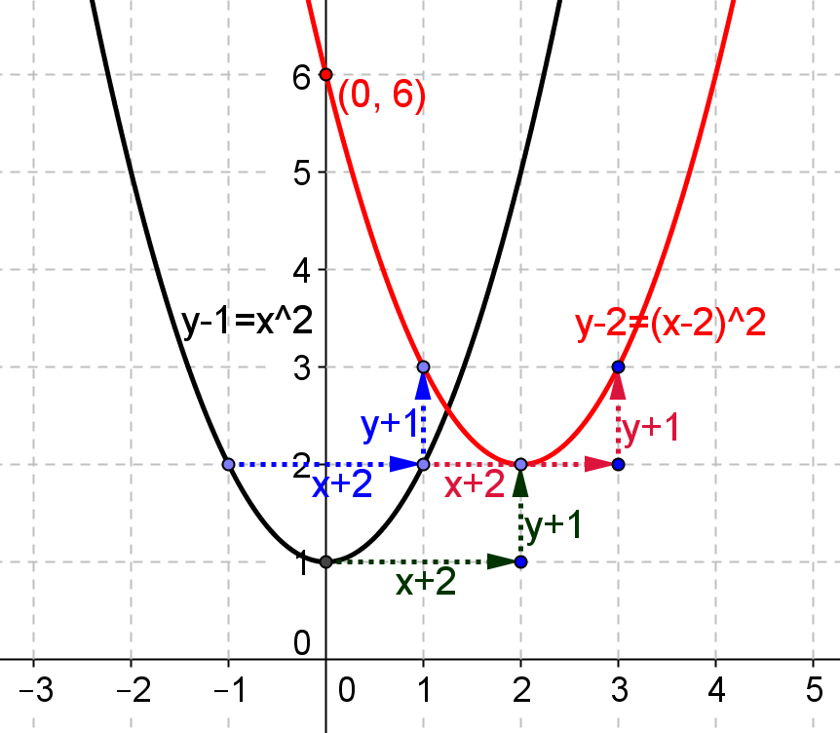

- Given the vector $v=〈3,2〉$, find the image of the graph of $y+1={(x+1)}^{3}$ under the translation map $T_{v}.$ Draw the original graph and its image, and explain the geometric effect of the map $T_{v}$ on the graph. Find the $x$-intercepts of the graph of the image.
$$T_{v}\left(\left[\begin{aligned}x \\ y\end{aligned}\right]\right)=\left[\begin{matrix}x+3 \\ y+2\end{matrix}\right]\text{,} y-1={\left(x-2\right)}^{3}$$Every point on the curve is shifted three units to the right and two units upward.
The $x$-intercept is $1$.
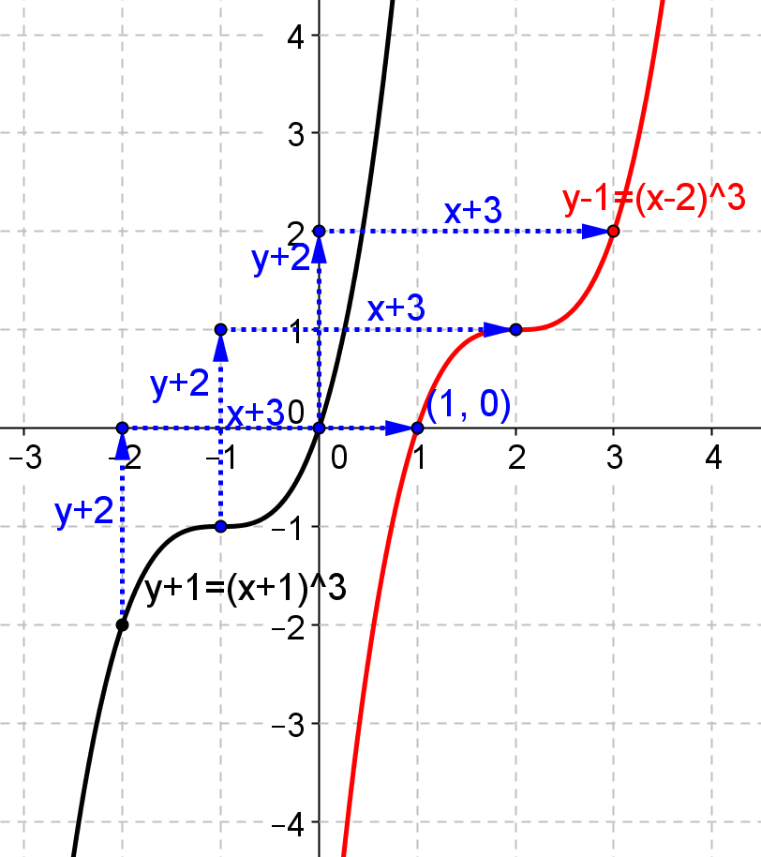

- Given the vector $v=〈3,-3〉$, find the image of the graph of$y+2=\sqrt{x+1}$ under the translation map $T_{v}.$ Draw the original graph and its image, and explain the geometric effect of the map $T_{v}$ on the graph. Find the $x$-intercepts of the graph of the image.
$$T_{v}\left(\left[\begin{aligned}x \\ y\end{aligned}\right]\right)=\left[\begin{matrix}x+3 \\ y-3\end{matrix}\right]\text{,} y+5=\sqrt{x-2}$$Every point on the curve is shifted three units to the right and three units downward.
The $x$-intercept is $27$.
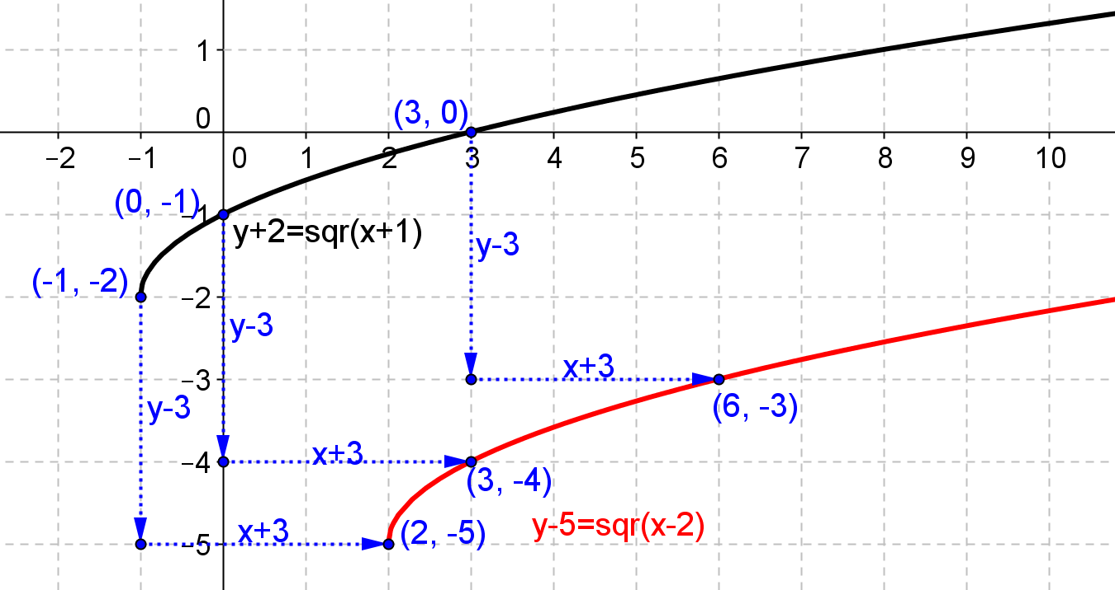

- Given the vector $v=〈-1,-2〉$, find the image of the graph of $y=\sqrt{9-x^{2}}$ under the translation map $T_{v}.$ Draw the original graph and its image, and explain the geometric effect of the map $T_{v}$ on the graph. Find the $x$-intercepts of the graph of the image.
$$T_{v}\left(\left[\begin{aligned}x \\ y\end{aligned}\right]\right)=\left[\begin{matrix}x-1 \\ y-2\end{matrix}\right]\text{,} y+2=\sqrt{9-{\left(x+1\right)}^{2}}$$Every point on the semicircle is shifted one unit to the left and two units downward.
$x$-intercepts: $1±\sqrt{5}.$
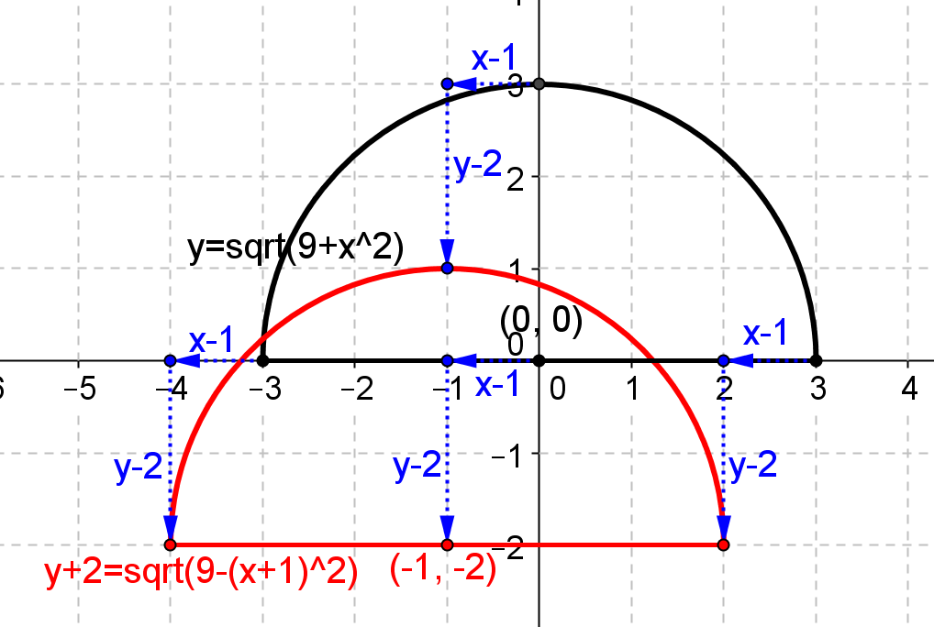

- Given the vector $v=〈1,3〉$, find the image of the graph of $y=\frac{1}{x+2}+1$ under the translation map $T_{v}.$Draw the original graph and its image, and explain the geometric effect of the map $T_{v}$ on the graph. Find the equations of the asymptotes of the graph of the image.
$$T_{v}\left(\left[\begin{aligned}x \\ y\end{aligned}\right]\right)=\left[\begin{matrix}x+1 \\ y+3\end{matrix}\right]\text{,} y=\frac{1}{x+1}+4$$Every point on the curve is shifted one unit to the right and three units upward.
The new vertical asymptote is $x=-1$, the new horizontal asymptote is $y=4$.
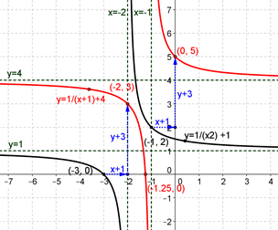

- Given the vector $v=〈-1,2〉$, find the image of the graph of$y=\left|x+2\right|+1$ under the translation map $T_{v}.$Draw the original graph and its image, and explain the geometric effect of the map $T_{v}$ on the graph. Find the $x$-intercepts of the graph of the image.
$$T_{v}\left(\left[\begin{aligned}x \\ y\end{aligned}\right]\right)=\left[\begin{matrix}x-1 \\ y+2\end{matrix}\right]\text{,} y=\left|x+3\right|+3$$Every point on the graph is shifted one unit to the left and two units upward.
There are no $x$-intercepts.
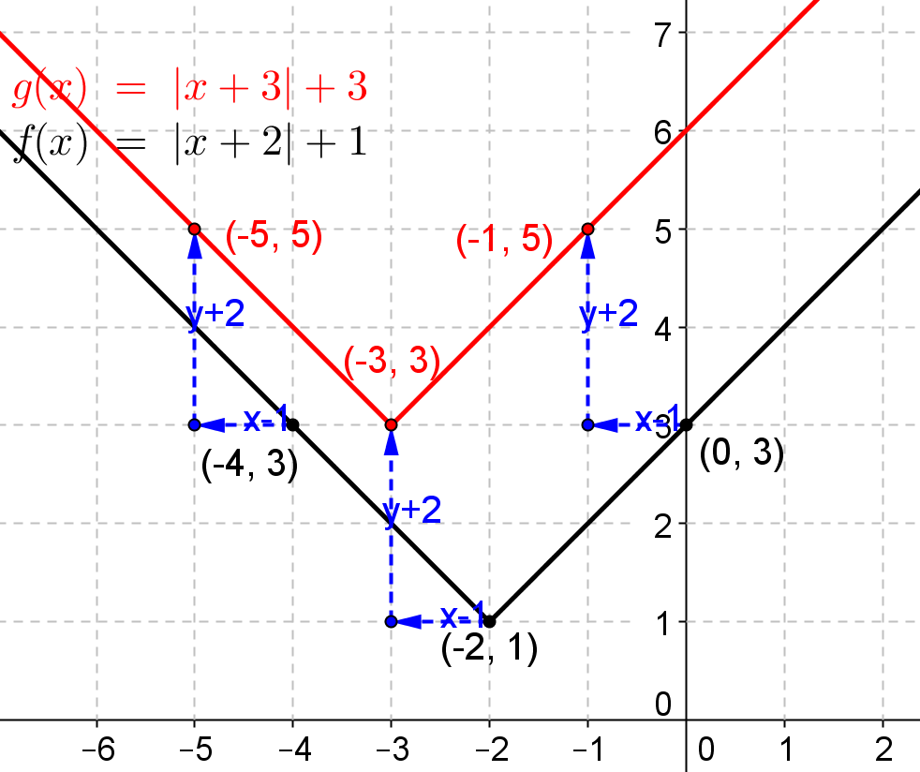

- Given the vector $v=〈1,-2〉$, find the image of the graph of$y=2^{x}$ under the translation map $T_{v}.$Draw the original graph and its image, and explain the geometric effect of the map $T_{v}$ on the graph. Find the $x$-intercepts of the graph of the image.
$$T_{v}\left(\left[\begin{aligned}x \\ y\end{aligned}\right]\right)=\left[\begin{matrix}x+1 \\ y-2\end{matrix}\right]\text{,} y=2^{x-1}-2.$$Every point on the curve is shifted one unit to the right and two units downward.
$x$-intercept is$2$.
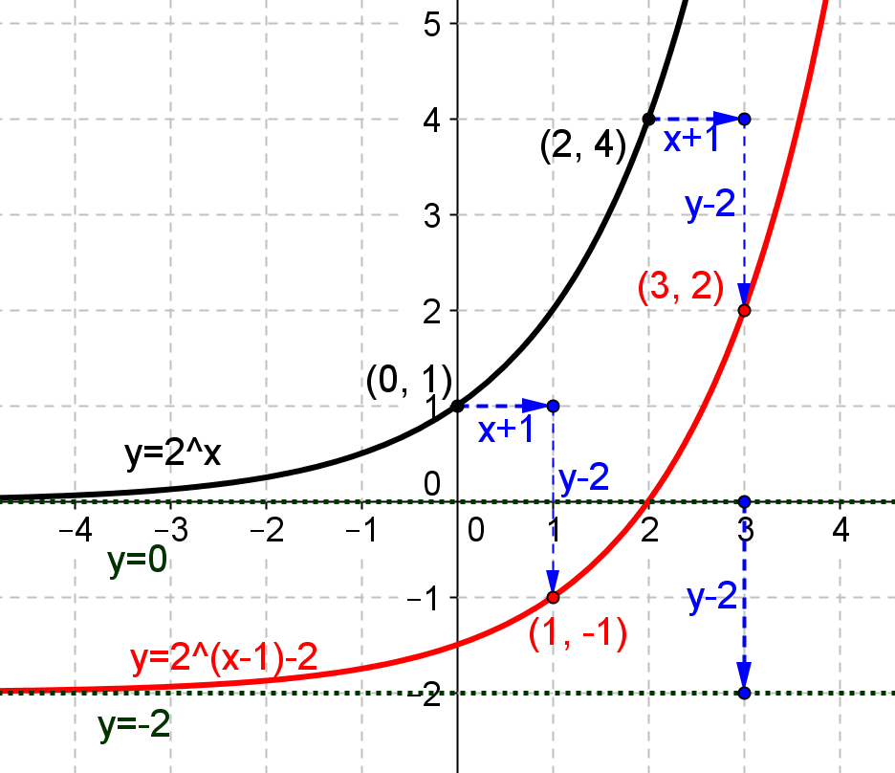

- Given the vector $v=〈-1,3〉$, find the image of the graph of$y=\log_{2}{x}$, under the translation map $T_{v}.$ Draw the original graph and its image, and explain the geometric effect of the map $T_{v}$ on the graph. Find the $x$-intercepts of the graph of the image.
$$T_{v}\left(\left[\begin{aligned}x \\ y\end{aligned}\right]\right)=\left[\begin{matrix}x-1 \\ y+3\end{matrix}\right]\text{,} y=\log_{2}\left(x+1\right)+3$$Every point on the curve is shifted one unit to the left and three units upward.
$x$-intercept: $-\frac{7}{8}$.
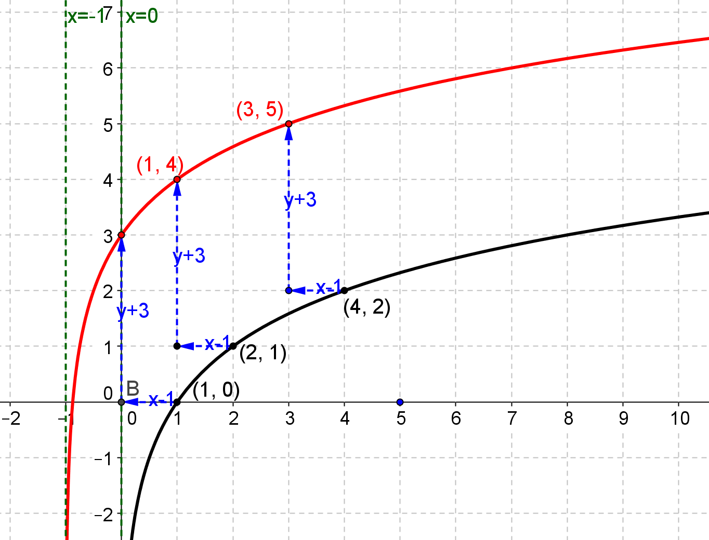

- Given the vector $v=〈2,-3〉$, find the image of the graph of$\frac{ x^{2}}{4 }+\frac{ y^{2}}{16}=1$ under the translation map $T_{v}.$ Draw the original graph and its image, and explain the geometric effect of the map $T_{v}$ on the graph. Find the new center, major and minor axis of the graph of the image.
$$T_{v}\left(\left[\begin{aligned}x \\ y\end{aligned}\right]\right)=\left[\begin{matrix}x+2 \\ y-3\end{matrix}\right]\text{,} \frac{{\left(x-2\right)}^{2}}{4}+\frac{{\left(y+3\right)}^{2}}{16}=1$$
Every point on the ellipse is shifted two units to the right and three units downward.
The new center is $(2, -3)$, the major axis is $4$, minor axis is $2$.
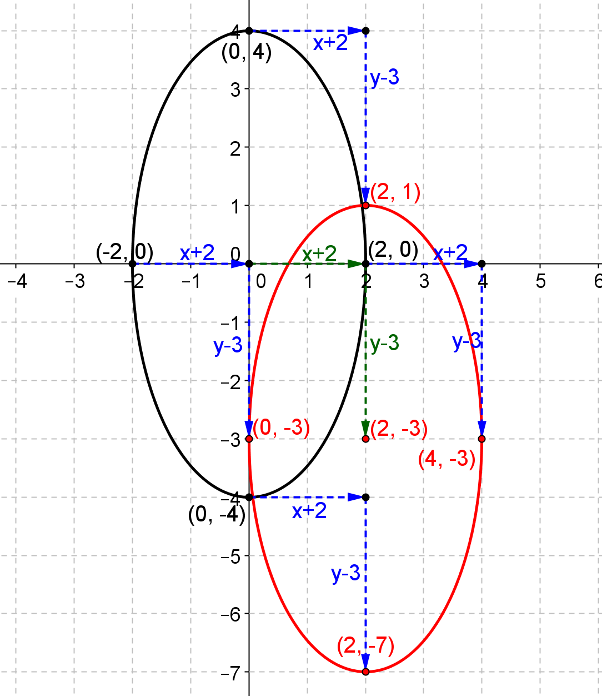

- Given the vector $v$, find the image of the given point $P$ under the translation map $T_{v}$. Graph $P$ and its image.
  - $v=〈3,2,1〉$, $P=\left[\begin{matrix}1 \\ 2 \\ 3\end{matrix}\right]$
$T_{v}\left(\left[\begin{aligned}x \\ y \\ z\end{aligned}\right]\right)=\left[\begin{matrix}x+3 \\ y+2 \\ z+1\end{matrix}\right]$, the new image: $\left[\begin{matrix}4 \\ 4 \\ 4\end{matrix}\right]$.
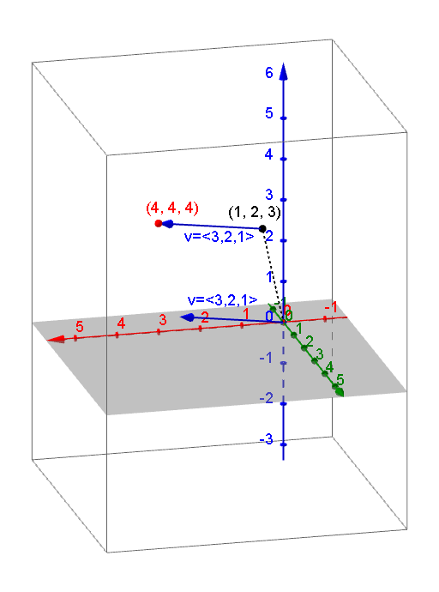

  - $v=〈-2,1,-1〉$, $P=\left[\begin{matrix}2 \\ -1 \\ -4\end{matrix}\right]$
$T_{v}\left(\left[\begin{aligned}x \\ y \\ z\end{aligned}\right]\right)=\left[\begin{matrix}x-2 \\ y+1 \\ z-1\end{matrix}\right]$, the new image: $\left[\begin{matrix}0 \\ 0 \\ -5\end{matrix}\right]$.
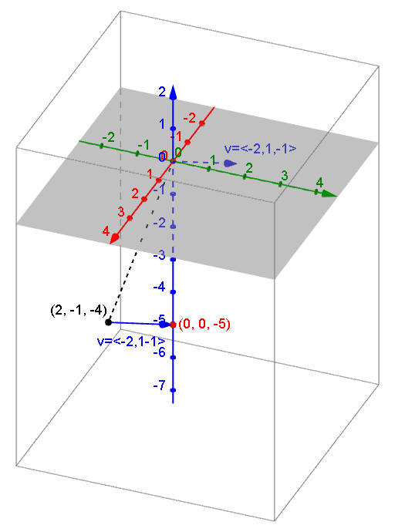

- Given the vector $v$, find the image of the given plane under the translation map $T_{v}$. Sketch the original vector and its image.
  - $v=〈2,-1,3〉$,$3x-2y-z=0$,
$$T_{v}\left(\left[\begin{aligned}x \\ y \\ z\end{aligned}\right]\right)=\left[\begin{matrix}x+2 \\ y-1 \\ z+3\end{matrix}\right]\text{,} 3x-2y-z=5.$$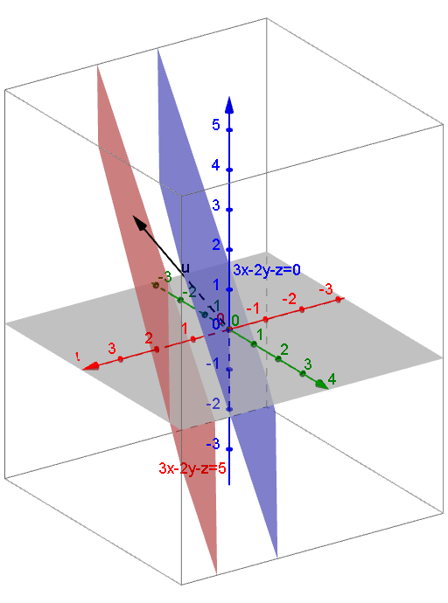

  - $v=〈-1,2,-1〉$,$2x-y+z=1$.
$$T_{v}\left(\left[\begin{aligned}x \\ y \\ z\end{aligned}\right]\right)=\left[\begin{matrix}x+2 \\ y-1 \\ z+3\end{matrix}\right]\text{,} 3x-y+z=-4$$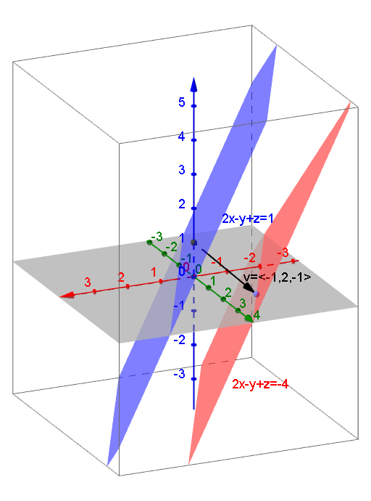

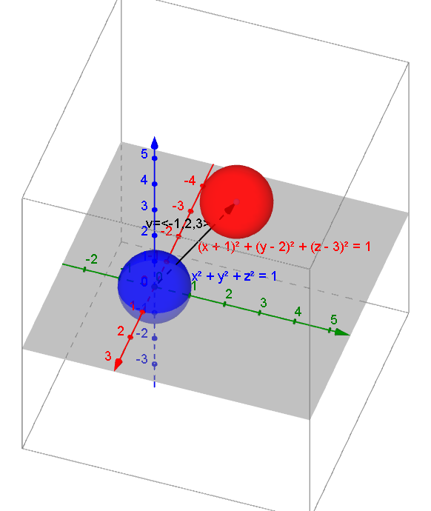
- Given the vector $v$, find the image of the given sphere under the translation map $T_{v}$. Sketch the original sphere and its image.
  - $v=〈-1,2,3〉$,$x^{2}+y^{2}+z^{2}=9$.
$$T_{v}\left(\left[\begin{aligned}x \\ y \\ z\end{aligned}\right]\right)=\left[\begin{matrix}x-1 \\ y+2 \\ z+3\end{matrix}\right]\text{,}{\left(x+1\right)}^{2}+{\left(y-2\right)}^{2}+{\left(z-3\right)}^{2}=9$$

  - $v=〈-3,-2,1〉$,${(x+2)}^{2}+{(y-3)}^{2}+{(z+1)}^{2}=1$ .
$T_{v}\left(\left[\begin{aligned}x \\ y \\ z\end{aligned}\right]\right)=\left[\begin{matrix}x-3 \\ y-2 \\ z+1\end{matrix}\right]\text{,} {\left(x+5\right)}^{2}+{\left(y-1\right)}^{2}+{\left(z\right)}^{2}=1$.
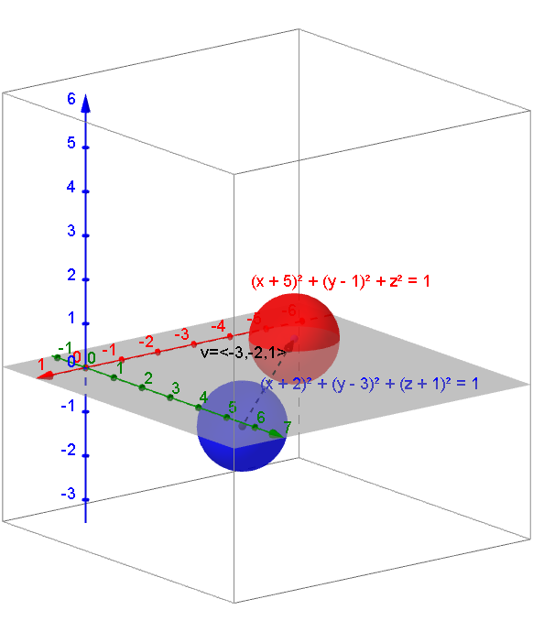

- Find a vector $v$ and translation map $T_{v}$ that will translate the line $x-y=1$ to the line $x-y=-3$. Sketch the original vector and its image.
Answers vary. For example,$v=\left[\begin{aligned}0 \\ 4\end{aligned}\right]$ and $T_{v}\left(\left[\begin{aligned}x \\ y\end{aligned}\right]\right)=\left[\begin{matrix}x+0 \\ y+4\end{matrix}\right]$.
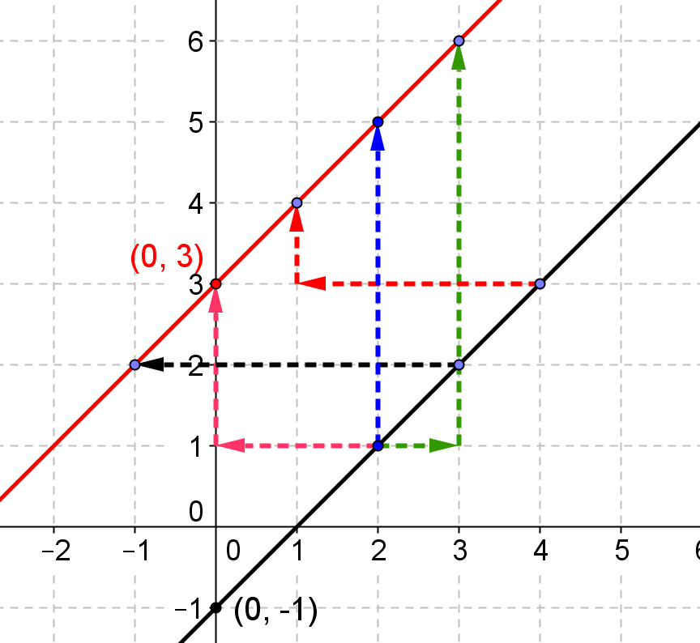

- Find a vector $v$ and translation map $T_{v}$ that will translate the parabola $y=x^{2}+4x+1$ to the parabola $y=x^{2}$
Because$y=x^{2}+4x+1$can be written as $y+3={\left(x+2\right)}^{2}$,$v=\left[\begin{aligned}-2 \\ 3\end{aligned}\right]$and$T_{v}\left(\left[\begin{aligned}x \\ y\end{aligned}\right]\right)=\left[\begin{matrix}x+2 \\ y-3\end{matrix}\right].$

- Find a vector $v$ and translation map $T_{v}$ that will translate the circle with equation $x^{2}+y^{2}-4x+2y-4=0$ to the circle with equation${(x+3)}^{2}+{(y-4)}^{2}=9$
Because $x^{2}-4x+y^{2}+2y=4$can be written as ${\left(x-2\right)}^{2}+{\left(y+1\right)}^{2}=9, v=\left[\begin{aligned}5 \\ -5\end{aligned}\right]$and$T_{v}\left(\left[\begin{aligned}x \\ y\end{aligned}\right]\right)=\left[\begin{matrix}x-5 \\ y+5\end{matrix}\right]$.

- Find a vector $v$ and translation map $T_{v}$ that will translate the graph of $y=\sqrt{x-3}+2$ to the graph
of $y=\sqrt{x+2}-3$.
$v=\left[\begin{aligned}5 \\ -5\end{aligned}\right]$and $T_{v}\left(\left[\begin{aligned}x \\ y\end{aligned}\right]\right)=\left[\begin{matrix}x-5 \\ y+5\end{matrix}\right]$

- Find a vector $v$ and translation map $T_{v}$ that will translate the sphere ${\left(x+2\right)}^{2}+{\left(y-3\right)}^{2}+{\left(z+1\right)}^{2}=1$ to the sphere ${\left(x-3\right)}^{2}+{\left(y+1\right)}^{2}+{\left(z+2\right)}^{2}=1$
$v=\left[\begin{aligned}-5 \\ 4 \\ 1\end{aligned}\right]$and $T_{v}\left(\left[\begin{aligned}\begin{aligned}x \\ y\end{aligned} \\ z\end{aligned}\right]\right)=\left[\begin{matrix}x+5 \\ y-4 \\ z-1\end{matrix}\right]$

- Given vectors $u=〈2,-1,3〉$,$v=〈2,0,-2〉$, and $w=〈-3,6,0〉$, find the following.
  - $3u+v+w$
$$〈5,4,7〉$$

  - $w-2v-u$
$$〈-9,7,1〉$$

  - $3\left(2u-\frac{1}{2} v\right)-\frac{1}{3}w$
$$〈10, -8, 21〉$$

  - $-2u-3(5v-3w)$.
$$〈-61, 56, 24〉$$
  - $\left\|u\right\|$, $\left\|v\right\|$, and $\left\|w\right\|$.
$$\left\|u\right\|=\sqrt{14}, \left\|v\right\|=2\sqrt{2}, \left\|w\right\|=\sqrt{45}$$

  - Show that $2\left\|v\right\|=\left\|2v\right\|$.
$$2\left\|v\right\|=2 \left(2\sqrt{2}\right)=4\sqrt{2}, \left\|2v\right\|=\left\|〈4,0,-4〉\right\|=\sqrt{32}=4\sqrt{2}$$
  - Show that $\left\|u+v\right\|≠\left\|u\right\|+\left\|v\right\|$.
$$\left\|u+v\right\|= \left\|〈4,-1,1〉\right\|=\sqrt{18}, \left\|u\right\|+\left\|v\right\|=\sqrt{14}+2\sqrt{2}$$

  - Show that $\left\|v-w\right\|≠\left\|v\right\|-\left\|w\right\|$.
$$\left\|v-w\right\|= \left\|〈5,-6,-2〉\right\|=\sqrt{65}, \left\|v\right\|-\left\|w\right\|=2\sqrt{2}-\sqrt{45}$$

  - $\frac{1}{\left\|u\right\|}u$ and $\left\|\frac{1}{\left\|u\right\|}u\right\|$.
$$\frac{1}{\left\|u\right\|}u=\frac{〈2,-1,3〉}{\sqrt{14}}=〈\frac{2}{\sqrt{14}}, -\frac{1}{\sqrt{14}},\frac{3}{\sqrt{14}}〉, \left\|\frac{1}{\left\|u\right\|}u\right\|=\sqrt{{\left(\frac{2}{\sqrt{14}}\right)}^{2}+{\left(-\frac{1}{\sqrt{14}}\right)}^{2}+{\left(\frac{3}{\sqrt{14}}\right)}^{2}}=\sqrt{\frac{4}{14}+\frac{1}{14}+\frac{9}{14}}=1$$

