Lesson 18: Vectors and Translation Maps

Classwork
Opening Exercise
Write each vector described below in component form and find its magnitude. Draw an arrow originating from $(0,0)$ to represent each vector’s magnitude and direction.
  - Translate $3$ units right and $4$ units down.

  - Translate $6$ units left.

  - Translate $2$ units left and $2$ units up.

  - Translate $5$ units right and $7$ units up.

Exercises 1–3
- Write a translation map defined by each vector from the opening.
Consider the vector $v=〈-2,5〉$, and its associated translation map:
$$T_{v}\left(\left[\begin{matrix}x \\ y\end{matrix}\right]\right)=\left[\begin{matrix}x-2 \\ y+5\end{matrix}\right]$$

- Suppose we apply the translation map $T_{v}$ to each point on the circle ${\left(x+4\right)}^{2}+{\left(y-3\right)}^{2}=25$.
  - What is the radius and center of the original circle?

  - Show that the image points satisfy the equation of another circle.

  - What is center and radius of this image circle?

- Suppose we apply the translation map $T_{v}$to each point on the line $2x-3y=10$.
  - What are the slope and $y$-intercept of the original line?

  - Show that the image points satisfy the equation of another line.

  - What are the slope and $y$-intercept of this image line?

Example 1: Vectors and Translation Maps in $R^{3}$
Translate by the vector $v=〈1,3,5〉$by applying the translation map $T_{v}$ to the following objects in $R^{3}$. A sketch of the original object and the vector is shown. Sketch the image.
$$T_{v}\left(\left[\begin{matrix}x \\ y \\ z\end{matrix}\right]\right)=\left[\begin{matrix}x+1 \\ y+3 \\ z+5\end{matrix}\right]$$
  - The point $A\left(2,-2,4\right)$

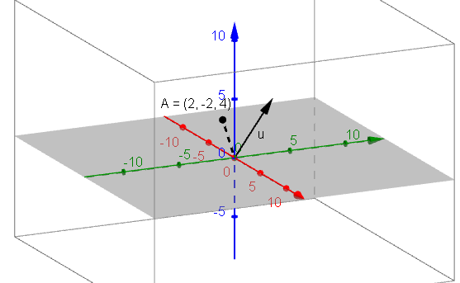

  - The plane $2x+3y-z=0$

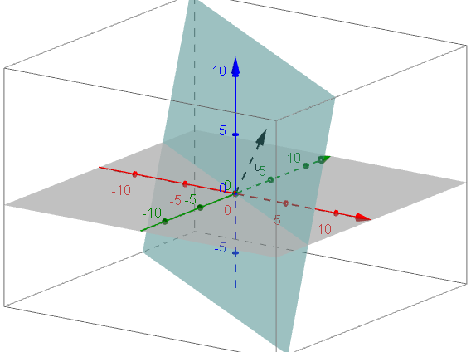

  - The sphere ${\left(x-1\right)}^{2}+{\left(y-3\right)}^{2}+z^{2}=9$.
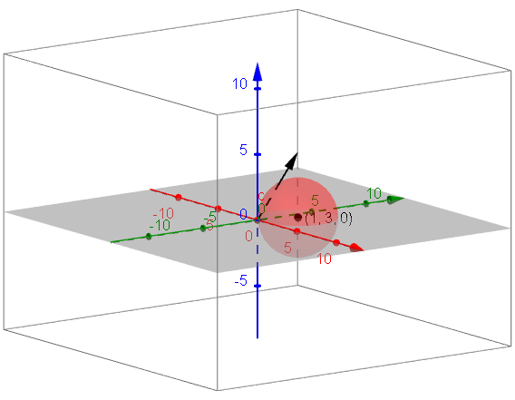

Exercise 4
- Given the sphere ${\left(x+3\right)}^{2}+{\left(y-1\right)}^{2}+{\left(z-3\right)}^{2}=10$.
  - What are its center and radius?

  - Write a vector and its associated translation map that would take this sphere to its image centered at the origin.

Example 2: What is the Magnitude of a Vector in $R^{3}$?

  - Find a general formula for ${\left\|v\right\|}^{2}$.

  - Solve this equation for $\left\|v\right\|$ to find the magnitude of the vector.

Exercises 5–8
- Which vector has greater magnitude, $v=〈0,5,-4〉$ or $u=〈3,-4,4〉$? Show work to support your answer.

- Explain why vectors can have equal magnitude but not be the same vector.

- Vector arithmetic in $R^{3}$ is analogous to vector arithmetic in $R^{2}$. Complete the graphic organizer to illustrate these ideas.

 | Vectors in $R^{2}$ | Vectors in $R^{3}$
Component Form | $$〈a,b〉$$ | $$〈a,b,c〉$$
Column Form | $$\left[\begin{matrix}a \\ b\end{matrix}\right]$$
Magnitude | $$\left\|v\right\|=\sqrt{a^{2}+b^{2}}$$
Addition | If $v=〈a,b〉$ and $u=〈c,d〉$,  Then $v+u=〈a+c,b+d〉$
Subtraction | If $v=〈a,b〉$ and $u=〈c,d〉$,  Then $v-u=〈a-c,b-d〉$
Scalar Multiplication | If $v=〈a,b〉$ and$k$ is a real number  $$kv=〈ka,kb〉$$

- Given $v=〈2,0,-4〉$ and $u=〈-1,5,3〉$.
  - Calculate the following.
    - $v+u$

    - $2v-u$

    - $\left\|v\right\|$

  - Suppose the point $(1,3,5)$ is translated by $v$ and then by $u$. Determine a vector $w$ that would return the point back to its original location $(1,3,5)$.

Lesson Summary
A vector $v$ can define a translation map $T_{v}$ that takes a point to its image under the translation. Applying the map to the set of all points that make up a geometric figure serves to translate the figure by the vector.

Problem Set

- Myishia says that when applying the translation map $T_{v}\left(\left[\begin{aligned}x \\ y\end{aligned}\right]\right)=\left[\begin{matrix}x+1 \\ y-2\end{matrix}\right]$ to a set of points given by an equation relating $x$ and $y$, we should replace every $x$ that is in the equation by $x+1$, and $y$ by $y-2$. For example, the equation of the parabola $y=x^{2}$ would become $y-2={\left(x+1\right)}^{2}$. Is she correct? Explain your answer.

- Given the vector $v=〈-1, 3〉,$find the image of the line $x+y=1$ under the translation map $T_{v}.$ Graph the original line and its image, and explain the geometric effect of the map $T_{v}$ on the line.

- Given the vector $v=〈2,1〉$, find the image of the parabola $y-1=x^{2}$ under the translation map $T_{v} .$Draw a graph of the original parabola and its image, and explain the geometric effect of the map $T_{v}$ on the parabola. Find the vertex and $x$-intercepts of the graph of the image.

- Given the vector $v=〈3,2〉$, find the image of the graph of $y+1={(x+1)}^{3}$ under the translation map $T_{v}.$ Draw the original graph and its image, and explain the geometric effect of the map $T_{v}$ on the graph. Find the $x$-intercepts of the graph of the image.

- Given the vector $v=〈3,-3〉$, find the image of the graph of$y+2=\sqrt{x+1}$ under the translation map $T_{v}.$ Draw the original graph and its image, and explain the geometric effect of the map $T_{v}$ on the graph. Find the $x$-intercepts of the graph of the image.

- Given the vector $v=〈-1,-2〉$, find the image of the graph of $y=\sqrt{9-x^{2}}$ under the translation map $T_{v}.$ Draw the original graph and its image, and explain the geometric effect of the map $T_{v}$ on the graph. Find the $x$-intercepts of the graph of the image.

- Given the vector $v=〈1,3〉$, find the image of the graph of $y=\frac{1}{x+2}+1$under the translation map $T_{v}.$Draw the original graph and its image, and explain the geometric effect of the map $T_{v}$ on the graph. Find the equations of the asymptotes of the graph of the image.

- Given the vector $v=〈-1,2〉$, find the image of the graph of$y=\left|x+2\right|+1$ under the translation map $T_{v}.$Draw the original graph and its image, and explain the geometric effect of the map $T_{v}$ on the graph. Find the $x$-intercepts of the graph of the image.
- Given the vector $v=〈1,-2〉$, find the image of the graph of$y=2^{x}$ under the translation map $T_{v}.$Draw the original graph and its image, and explain the geometric effect of the map $T_{v}$ on the graph. Find the $x$-intercepts of the graph of the image.

- Given the vector $v=〈-1,3〉$, find the image of the graph of$y=\log_{2}{x}$, under the translation map $T_{v}.$ Draw the original graph and its image, and explain the geometric effect of the map $T_{v}$ on the graph. Find the $x$-intercepts of the graph of the image.

- Given the vector $v=〈2,-3〉$, find the image of the graph of$\frac{ x^{2}}{4 }+\frac{ y^{2}}{16}=1$ under the translation map $T_{v}.$ Draw the original graph and its image, and explain the geometric effect of the map $T_{v}$ on the graph. Find the new center, major and minor axis of the graph of the image.

- Given the vector $v$, find the image of the given point $P$ under the translation map $T_{v}$. Graph $P$ and its image.
  - $v=〈3,2,1〉,$ $P=\left[\begin{matrix}1 \\ 2 \\ 3\end{matrix}\right]$,
  - $v=〈-2,1,-1〉,$ $P=\left[\begin{matrix}2 \\ -1 \\ -4\end{matrix}\right]$

- Given the vector $v$, find the image of the given plane under the translation map $T_{v}$. Sketch the original vector and its image.
  - $v=〈2,-1,3〉, 3x-2y-z=0$.
  - $v=〈-1,2,-1〉, 2x-y+z=1$.

- Given the vector $v$, find the image of the given sphere under the translation map $T_{v}$. Sketch the original sphere and its image.
  - $v=〈-1,2,3〉, x^{2}+y^{2}+z^{2}=9$.
  - $v=〈-3,-2,1〉, {(x+2)}^{2}+{(y-3)}^{2}+{(z+1)}^{2}=1$ .

- Find a vector $v$ and translation map $T_{v}$ that will translate the line $x-y=1$ to the line $x-y=-3$. Sketch the original vector and its image.

- Find a vector $v$ and translation map $T_{v}$ that will translate the parabola $y=x^{2}+4x+1$ to the parabola $y=x^{2}$

- Find a vector $v$ and translation map $T_{v}$ that will translate the circle with equation $x^{2}+y^{2}-4x+2y-4=0$ to the circle with equation${(x+3)}^{2}+{(y-4)}^{2}=9$

- Find a vector $v$ and translation map $T_{v}$ that will translate the graph of $y=\sqrt{x-3}+2$ to the graph of
$y=\sqrt{x+2}-3$.

- Find a vector $v$ and translation map $T_{v}$ that will translate the sphere ${\left(x+2\right)}^{2}+{\left(y-3\right)}^{2}+{\left(z+1\right)}^{2}=1$ to the sphere ${\left(x-3\right)}^{2}+{\left(y+1\right)}^{2}+{\left(z+2\right)}^{2}=1$

- Given vectors $u=〈2,-1,3〉$,$v=〈2,0,-2〉$, and $w=〈-3,6,0〉$, find the following.
  - $3u+v+w$
  - $w-2v-u$
  - $3\left(2u-\frac{1}{2} v\right)-\frac{1}{3}w$
  - $-2u-3(5v-3w)$.
  - $\left\|u\right\|, \left\|v\right\|$ and $\left\|w\right\|$.
  - Show that $2\left\|v\right\|=\left\|2v\right\|$.
  - Show that $\left\|u+v\right\|≠\left\|u\right\|+\left\|v\right\|$.
  - Show that $\left\|v-w\right\|≠\left\|v\right\|-\left\|w\right\|$.
  - .$\frac{1}{\left\|u\right\|}u$ and $\left\|\frac{1}{\left\|u\right\|}u\right\|$.

