Lesson 17: Vectors in the Coordinate Plane

Student Outcomes
- Students add and subtract vectors and understand those operations geometrically and component-wise.
- Students understand scalar multiplication graphically and perform it component-wise.

Lesson Notes
This lesson introduces translation by a vector in the coordinate plane. In this lesson, we represent a vector as an arrow with an initial point and a terminal point. Students learn vector notation and the idea that a vector can represent a shift (i.e., a translation). They calculate the magnitude of a vector, add and subtract vectors, and multiply a vector by a scalar. Students interpret these operations geometrically and compute them component-wise. This lesson focuses on several N.VM standards including N-VM.A.1, N-VM.A.3, N-VM.B.4a and N-VM.B.4c, and N-VM.B.5. However, students are not yet working with directed line segments or vectors in $R^{3}$. Later lessons will also represent vectors in magnitude and direction form. Students are making sense of vectors and relating them to a real-world situation (MP.2). Later, the lesson focuses on vector arithmetic and making sense of why the operations work the way that they do (MP.6 and MP.3)
The study of vectors is a vital part of this course; notation for vectors varies across different contexts and curricula. These materials will refer to a vector as $v$ (lowercase, bold, non-italicized); or as $〈4, 5〉$ which, in column format is
$\left(\begin{matrix}4 \\ 5\end{matrix}\right)$ or $\left[\begin{matrix}4 \\ 5\end{matrix}\right]$.
We will use “let $v=〈4,5〉$” to establish a name for the vector $〈4, 5〉$.
When naming a vector, this curriculum will avoid stating $v=〈4,5〉$ without the word “let” preceding the equation, unless it is absolutely clear from the context that we are naming a vector. However, as we have done in other grades, we will continue using $=$ to describe vector equations, such as $v+w=w+v$.
We will refer to the vector from $A$ to $B$ as vector $\vec{AB}$; notice that this is a ray with a full arrow. This notation is consistent with how vectors were introduced in Grade 8 and is also widely used in post-secondary textbooks to describe both rays and vectors, depending on the context. To avoid confusion, this curriculum will provide (or strongly imply) the context, to make it clear whether the full arrow indicates a vector or a ray. For example, when referring to a ray from $A$ passing through $B$, we will say “ray $\vec{AB}$,” and when referring to a vector from $A$ to $B$, we will say “vector $\vec{AB}$.” Students should be encouraged to think about the context of the problem and not just rely on a hasty inference based on the symbol.
The magnitude of a vector will be signified as $\left\|v\right\|$ (lowercase, bold, non-italicized).
Since Grade 6, we have been using the term vector in two slightly different ways. Up until now, the difference was subtle and didn’t matter where the term was used in the discussions. However, in Precalculus and Advanced Topics, we need to distinguish between a bound vector and a free vector:
Bound vector: A bound vector is a directed line segment (i.e., an “arrow”). For example, the directed line segment $\vec{AB}$ is a bound vector whose initial point (i.e., tail) is $A$ and terminal point (i.e., tip) is $B$.

Bound vectors are “bound” to a particular location in space. A bound vector$\vec{AB}$has a magnitude given by the length of segment $\overline{AB}$ and direction given by the ray $\vec{AB}$. Many times only the magnitude and direction of a bound vector matters, not its position in space. In such a case, we consider any translation of that bound vector to represent the same free vector.
Free vector: A free vector is the equivalence class of all directed line segments (i.e., arrows) that are equivalent to each other by translation. For example, scientists often use free vectors to describe physical quantities that have magnitude and direction only, “freely” placing an arrow with the given magnitude and direction anywhere it is needed in a diagram. For any directed line segment in the equivalence class defining a free vector, the directed line segment is said to be a representation of the free vector (i.e., it represents the free vector).
Free vectors are usually notated by a lowercase letter with an arrow $\vec{v}$ or by a boldface lowercase letter $v$. Any other representation of a free vector is also labeled by the same lowercase letter (i.e., any two arrows in a diagram/Euclidean plane/Cartesian plane with the same magnitude and direction are labeled $v$). The notation $\vec{AB}$ can also be used to represent a free vector$v$, but it still is the specific directed line segment from $A$ to $B$. (One wouldn’t label another representation of the free vector $v$ at a different location by $\vec{AB}$, for example).
Unless specifically stated, the term “vector” will refer to free vector throughout this module.
Cartesian coordinates are useful for representing free vectors as points in coordinate space. Such representations provide simple formulas for adding/subtracting vectors and for finding a scalar multiple of a vector, as well as making it easy to write formulas for translations.

Classwork
Opening (2 minutes)
Have students read the opening paragraph, and then ask them what they know about earthquakes. Hold a brief discussion to activate prior knowledge. Emphasize the shifting ground that can occur during an earthquake, and explain that in this lesson, we will consider a way to represent such a shift mathematically. You may want to reference this article (http://www.cnn.com/2011/WORLD/asiapcf/03/12/japan.earthquake.tsunami.earth/) that discusses the 2011 Japan earthquake that shifted the coastline by eight feet.

Opening Exercise (2 minutes)
Students should complete this exercise working with a partner. Have one or two students share their responses with the whole class. The idea is to help students see that the shift is independent of a starting point and that all points in the plane are shifted by the same amount. If students mention the force of the earthquake, make a connection back to that language when discussing magnitude.

Opening Exercise
Scaffolding:
- Use a graphic organizer (like a Frayer model) to help students make sense of this new concept, vector. See Precalculus and Advanced Topics, Module 1, Lesson 5 for an example of a Frayer diagram.
- Have advanced students draw vectors that represent different shifts that are not whole numbers such as
S ($2.25$ feet) and W ($7$ feet)
N ($9$ feet) and E ($1.5$ feet)
S ($1.75$ feet) and E ($5.5$feet)
When an earthquake hits, the ground shifts abruptly due to forces created when the tectonic plates along fault lines rub together. As the tectonic plates shift and move, the intense shaking can even cause the physical movement of objects as large as buildings.
Suppose an earthquake causes all points in a town to shift $10$ feet to the north and $5$ feet to the east.
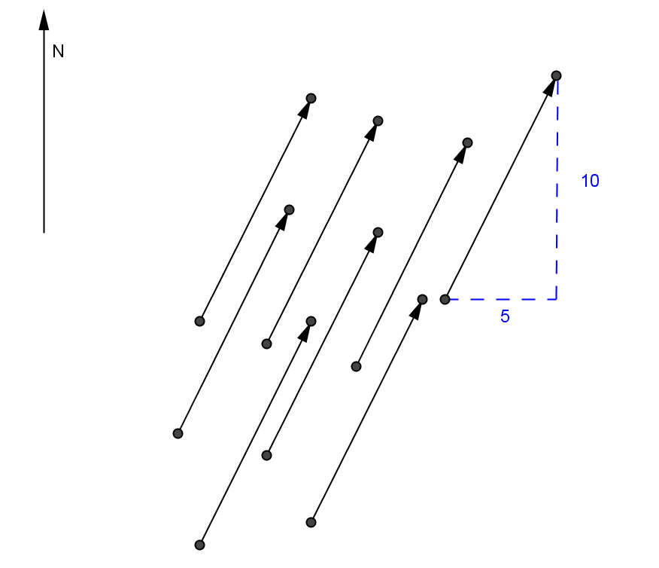

  - Explain how the diagram shown above could be said to represent the shifting caused by the earthquake.
The arrows show the amount and direction of the shift. Each point, not just the ones represented in this diagram, would be shifted $5$ feet east and $10$ feet north.

  - Draw another arrow that shows the same shift. Explain how you drew your arrow.
The new arrow would be shifted $5$ feet east and $10$ feet north from its initial point.

Discussion (5 minutes)
Lead a brief discussion to introduce the notion and notation of a vector. Clarify the vector notation used in this Module. Vectors are denoted by a letter bold in text with the components enclosed in angled brackets. Some texts simply use parentheses. When writing a vector by hand, direct students to draw an arrow over the symbol that represents the vector.
In mathematics, a shift like the one described in the Opening can be represented by a vector. This vector has a horizontal component of $5$ and a vertical component of $10$.
We use the following notation for a vector:
$$v=〈5,10〉$$
When writing a vector that starts at point $A$ and goes through point $B$, use this notation:
$$\vec{AB}=〈5,10〉$$
- Are the points in the diagram above the only points that were shifted during the earthquake? Explain your thinking.
  - No, every point in the area affected by the earthquake would have been shifted. In reality, how far a point shifts depends on how far it is from a quake’s epicenter
- When we consider vectors, the precise location of the arrow that represents the vector does not matter because the vector represents the translation of an object (in this case points in the plane) by the given horizontal and vertical components. What other objects could be translated by a vector?
  - You could shift any figure by a vector, such as a line, a circle, or another geometric figure.

Exercises 1–3 (10 minutes)
The next exercises let students compare different vectors in the coordinate plane. These exercises show students that vectors are defined as having both a magnitude and a direction, and that two arrows with the same magnitude and direction represent the same vector. Students will explore the notion of magnitude in Exercise 3, and the example that follows will formally define the magnitude of a vector. Have students work in small groups or with a partner, but give them time to work individually first so that each student has a chance to think and make sense of these ideas.
Exercises 1–3
Several vectors are represented in the coordinate plane below using arrows.
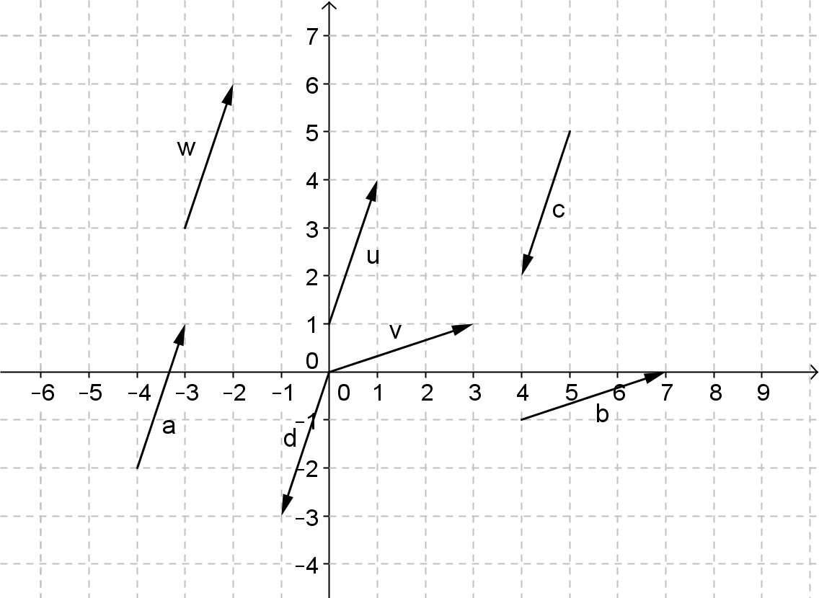

- Which arrows represent the same vector? Explain how you know.
Arrows $w$, $u$, and $a$ represent the same vector because they indicate a translation of $1$ unit right and $3$ units up. Arrows $v$ and $b$ represent the same vector because these arrows indicate a translation of $3$ units right and $1$ unit up. Arrows $c$ and $d$ represent the same vector because they represent a translation of $1$ unit left and $3$ units down.

- Why do arrows $c$ and $u$ not represent the same vector?
These arrows have the same magnitude but opposite directions.

Discuss the following questions after Exercise 2 with your students.
- How many different vectors are in the diagram? What are the components of each one?
  - There are really just three vectors: $u=〈1,3〉$, $v=〈3,1〉$, and $d=〈-1,-3〉$
- Why might we only draw one arrow to represent a vector even though all points are shifting by the components of the vector?
  - Since a vector represents a translation, no matter where in the coordinate plane we represent it, it will still describe the same shifting.
- Why does the location of the tip of the arrow matter when representing a vector in the coordinate plane?
  - The tip is used to indicate direction. Otherwise vectors like $u=〈1,3〉$ and $d=〈-1,-3〉$ would appear to be the same.
If needed, before starting Exercise 3, redirect students’ attention to the Opening. Give students time to collaborate on their approach to part (b) in groups or with a partner. Students may benefit from guided questioning like that listed below if they appear stuck.
- What quantities would you need to measure to determine which earthquake shifted the points further?
  - For each earthquake, you would need to find the distance between the starting location and the stopping location for one point, since all points shifted the same amount.
- How could you use a familiar formula to determine these quantities?
  - Since we know the horizontal and vertical displacement, we can use the Pythagorean theorem (or distance formula) to calculate the distance, which is represented by the length of the arrow.
MP.2
&
MP.3
- After the first earthquake shifted points $5$ feet east and $10$ feet north, suppose a second earthquake hits the town and all points shift $6$ feet east and $9$ feet south.
  - Write and draw a vector $t$ that represents this shift caused by the second earthquake.
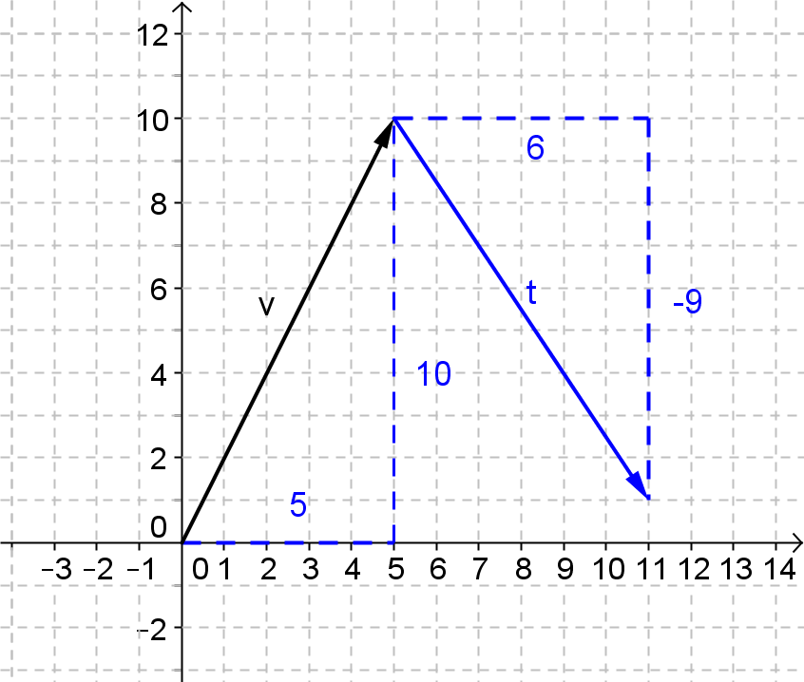

  - Which earthquake, the first one or the second one, shifted all the points in the town further? Explain your reasoning.
MP.2
&
MP.3
The length of the arrow that represents the vector $v$ is $\sqrt{5^{2}+{10}^{2}}=\sqrt{125}$ feet. The length of the arrow that represents the vector $t$ is $\sqrt{6^{2}+{\left(-9\right)}^{2}}=\sqrt{117}$ feet. The first quake shifted the points further. You can also see from the diagram that if we rotated $t$ from the tip of $v$ to align with $v$ that $t$ would be slightly shorter.

- Explain what you have just learned to your neighbor. Use this as an informal way to check student understanding.

Example 1: The Magnitude of a Vector (3 minutes)
This example introduces the formula to calculate the magnitude of a vector. Students already likely used the Pythagorean theorem in their work in Exercise 3. This example provides a way to formalize what we mean when we refer to the magnitude of a vector. For now, the direction of a vector will simply be indicated by the arrow tip showing the direction as well as the sign and size of the components. Later in this module students will use trigonometry to calculate an angle that represents the direction of a vector.
Example 1: The Magnitude of a Vector
The magnitude of a vector $v=〈a,b〉$ is the length of the line segment from the origin to the point $(a,b)$ in the coordinate plane, which we denote by $\left\|v\right\|$. Using the language of translation, the magnitude of $v$ is the distance between any point and its image under the translation $a$ units horizontally and $b$ units vertically. It is denoted $\left\|v\right\|$.
  - Find the magnitude of $v=〈5,10〉$ and $t=〈6,-9〉$. Explain your reasoning.
$$\left\|v\right\|=\sqrt{5^{2}+{10}^{2}}=\sqrt{125}$$
$$\left\|t\right\|=\sqrt{{\left(6\right)}^{2}+{\left(-9\right)}^{2}}=\sqrt{117}$$
We use the Pythagorean theorem (or distance formula) to find the length of the hypotenuse of a triangle with sides of length $a$ and $b$.

  - Write the general formula for the magnitude of a vector.
MP.7
$$\left\|v\right\|=\sqrt{a^{2}+b^{2}}$$

- How does this example confirm or refute your work in Exercise 3, part (b)?
  - We got the same results and we can now see that the magnitude of a vector is a measure of how much shifting occurred.

Discussion: Vector Addition (5 minutes)
- Explain why this drawing shows the overall shifting caused by both earthquakes.
  - The points shift from the starting point or pre-image to the image translated $5$ right and $10$ up and then those points are translated again, $6$ right and $9$ down to their final location.
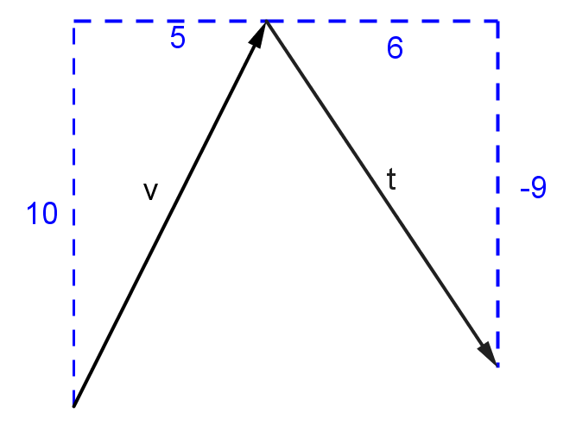

- What is the resulting vector that represents the new location of all the points? Explain how you got your answer.
  - The components of the new vector $e$ are $〈11,1〉$. You can see that the total horizontal shift is 11 units right and the total vertical shift is $1$ unit up.
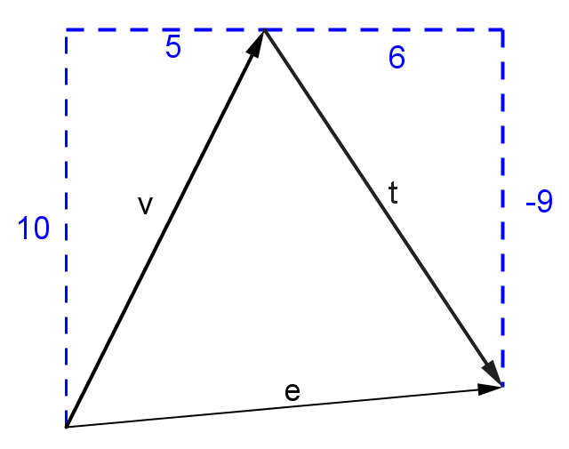

- Did you need to grid lines to calculate the components of the overall shift caused by the two earthquakes? Explain why or why not.
MP.7
  - No. We can simply add the horizontal components together followed by the vertical components to find the resulting components of the final vector.

Next, introduce the idea of vector addition. Students can add this information to their notes.
Vector addition is defined by the rule:
If $v=〈a,b〉$ and $w=〈c,d〉$ then $v+w=〈a+c,b+d〉$.
The rule stated above shows that to add two vectors you simply add their horizontal and vertical components. Explain the definition of vector addition geometrically using transformations and by modeling, in general, that the addition of two vectors has the same effect as two horizontal and two vertical translations of a point or other object in the coordinate plane. The diagram shown below illustrates this idea. The CCSS-M refers to this method of adding vectors as end-to-end (See N-VM.B.4a). The parallelogram rule for adding vectors will be presented in Lesson 19.

Exercises 4–7 (5 minutes)
Students should work these exercises with their small group. As students are working, circulate around the room to check their progress. Lead a short debriefing by having one or two students share their answers with the group. Students should realize that, as with matrices and complex numbers, properties of arithmetic such as the associative property can be extended to vector operations. The next lesson makes these connections even more explicit. College-level mathematics courses use matrices frequently to represent higher dimension vectors because they make calculations simpler and more efficient.
Exercises 4–10
- Given that $v=〈3,7〉$ and $t=〈-5,2〉$.
  - What is $v+t$?
$$v+t=〈3+\left(-5\right),7+2)〉=〈-2,9〉$$

  - Draw a diagram that represents this addition and shows the resulting sum of the two vectors.
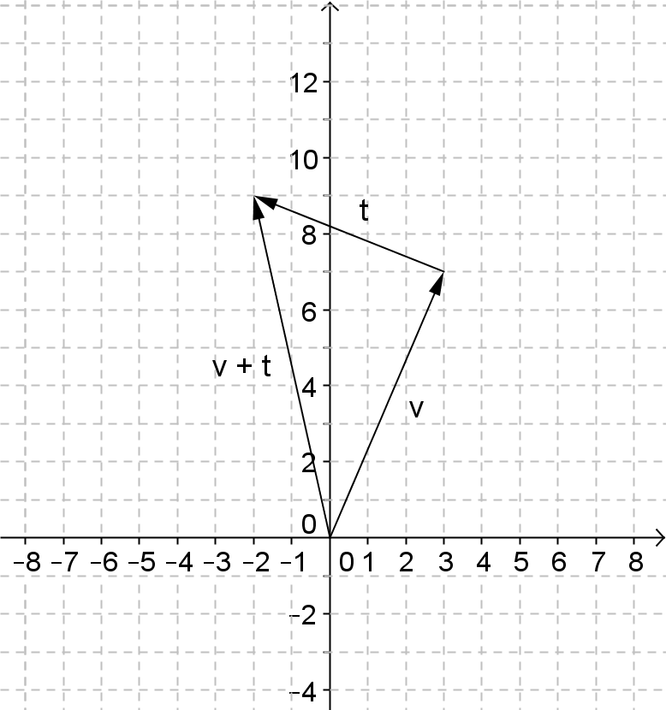

  - What is $t+v$?
$t+v=〈-2,9〉$

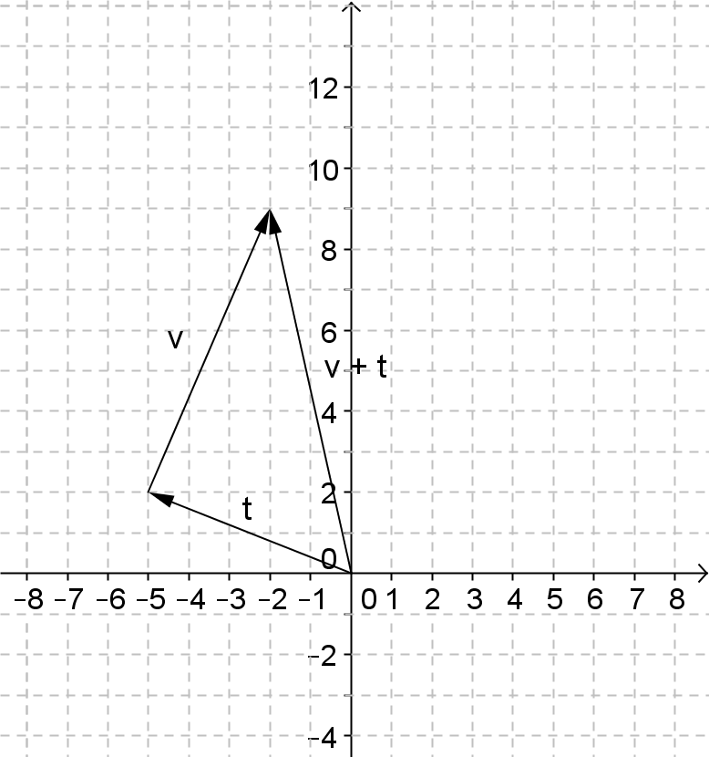
  - Draw a diagram that represents this addition and shows the resulting sum of the two vectors.

- Explain why vector addition is commutative.
Since we are combining two horizontal and two vertical translations when we add vectors, the end result will be the same regardless of the order in which we apply the translations. Thus, when we add two vectors it doesn’t matter which comes first and which comes second. Using the rule we were given, we can see that the components represent real numbers and thus the associative property should apply to each component of the resulting sum vector.

- Given $v=〈3,7〉$ and $t=〈-5,2〉$.
  - Show numerically that $\left\|v\right\|+\left\|t\right\|≠\left\|v+t\right\|$.
$\left\|v\right\|=\sqrt{3^{2}+7^{2}}=\sqrt{58}$ and $\left\|t\right\|=\sqrt{{(-5)}^{2}+2^{2}}=\sqrt{29}$
$v+t=〈-2,9〉$ and $\left\|v+t\right\|=\sqrt{{(-2)}^{2}+{(9)}^{2}}=\sqrt{85}$
$\sqrt{58}+\sqrt{29}≠\sqrt{85}$. This can be confirmed quickly using approximations for each square root.
MP.3
&
MP.6
  - Provide a geometric argument to explain in general, why the sum of the magnitudes of two vectors is not equal to the magnitude of the sum of the vectors.
When added end to end, two vectors and the resulting sum vector lie on the sides of a triangle. Since the sum of any two sides of a triangle must be longer than the third side and the magnitude of the vectors would correspond to the lengths of the sides of the triangle, this statement cannot be true.

  - Can you think of an example when the statement would be true? Justify your reasoning.
This statement would be true of one of the vectors had a magnitude of $0$. The sum of the vectors would be equal to the original non-zero vector so they would have the same magnitude.

- Why is the vector $o=〈0,0〉$ called the zero vector? Describe its geometric effect when added to another vector.
The magnitude of this vector is o$,$ and its components are $0$. It maps the pre-image vector onto itself and essentially have no translational effect on the original vector. It has the same effect as adding the real-number $0$ to any other real number.

Exercises 8–10 (8 minutes)
These problems introduce the scalar multiplication of a vector. Students have already examined the effect of scalar multiplication with complex numbers and matrices. They should be familiar with the idea of dilation from their work in Grade 8 and Geometry. We want them to see that if we multiply a vector $v$ by a scalar $c$, that it produces a new vector $cv$ which is a dilation of the vector $v$ by a scale factor $c$. This effect maintains the direction of the vector and multiplies its magnitude by a factor of $c$. Students may need the terminology ‘initial point’ clarified before you begin. Explain that when the initial point is $(0,0)$ then the components of the vector $〈a,b〉$ correspond to the point in the Cartesian plane $(a,b)$. For this reason, we often draw arrows that represent vectors from the origin.
Exercises 8–10
- Given the vectors shown below.
$$v=〈3,6〉$$
$$u=〈9,18〉$$
$$w=〈-3,-6〉$$
$$s=〈1,2〉$$
$$t=〈-1.5,-3〉$$
$$r=〈6,12〉$$

  - Draw each vector with its initial point located at $(0,0)$. The vector $v$ is already shown. How are all of these vectors related?

All of these vectors lie on the same line that passes through the origin. If you dilate with center $\left(0,0\right)$, then each vector is a dilation of every other vector in the list.

  - Which vector is $2v$? Explain how you know.
The vector $2v$ is twice as long as $v$ and points in the same direction. The components would be doubled so $r=2v$.

Introduce scalar multiplication at this point. Have students record the rule in their notes.
Vector multiplication by a scalar is defined by the rule:
If $v=〈a,b〉$ and $c$ is a real number, then $cv=〈ca,cb〉$.
If time permits, early finishers can be asked to show that $\left\|cv\right\|=c\sqrt{a^{2}+b^{2}}$ by showing the following:
If $cv=〈ca,cb〉$ then by the definition of magnitude of a vector, the properties of real numbers and the properties of radicals,
$$\left\|cv\right\|=\sqrt{{\left(ca\right)}^{2}+{\left(cb\right)}^{2}} \\ =\sqrt{c^{2}\left(a^{2}+b^{2}\right)} \\ =c\sqrt{a^{2}+b^{2}}$$

  - Describe the remaining vectors as a scalar multiple of $v=〈3,6〉$ and explain your reasoning.
$$u=3v$$
$$w=-v$$
$$s=\frac{1}{3}v$$
$$t=-\frac{1}{2}v$$

  - Is the vector $p=〈3\sqrt{2},6\sqrt{2}〉$ a scalar multiple of $v$? Explain.
Yes; $p=\sqrt{2} v$. You can see that if the initial point were located at $(0,0)$ then the vector $p$ would also lie on the line through the origin that contains the other vectors in this exercise.

- Which vector from Exercise 8 would it make sense to call the opposite of $v=〈3,6〉$?
You could call $w$ the opposite of $v$, because $w$ has the same length as $v$ and it has the opposite direction.

- Describe a rule that defines vector subtraction. Use the vectors $v=〈5,7〉$ and $u=〈6,3〉$ to support your reasoning.
Just like addition of two real numbers is adding the opposite of the second number to the first number, it would make sense that vector subtraction would work in a similar way. To subtract two vectors, you add the opposite of the second vector or more simply, just subtract the components.
We can create the opposite of$v$ by multiplying by the scalar $-1$.
$$v-u=v+(-u)=〈5+\left(-6\right),7+(-3)〉=〈-1,4〉$$
Or, simply subtracting the components gives
$$v-u=〈5-6,7-3〉=〈-1,4〉$$

If time permits you can discuss the geometric effect of subtraction as adding the opposite of the second vector when placing the vectors end to end.

Closing (2 minutes)
Give students one minute to brainstorm the top three things they learned about vectors in this lesson. Have them share briefly with a partner, and then ask for a few volunteers to share with the entire class. Use the Lesson Summary below to clarify any misunderstandings that may arise when students report out.

Lesson Summary
A vector can be used to describe a translation of an object. It has a magnitude and a direction based on its horizontal and vertical components. A vector $v=〈a,b〉$ can represent a translation of $a$ units horizontally and $b$ units vertically with magnitude given by $\left\|v\right\|=\sqrt{a^{2}+b^{2}}$.
- To add two vectors, add their respective horizontal and vertical components.
- To subtract two vectors, subtract their respective horizontal and vertical components.
- Multiplication of a vector by a scalar multiplies the horizontal and vertical components of the vector by the value of the scalar.

Exit Ticket (3 minutes)
Name Date
Lesson 17: Vectors in the Coordinate Plane

Exit Ticket

- Vector $v=〈3,4〉$, and the vector $u$is represented by the arrow shown below. How are the vectors the same? How are they different?

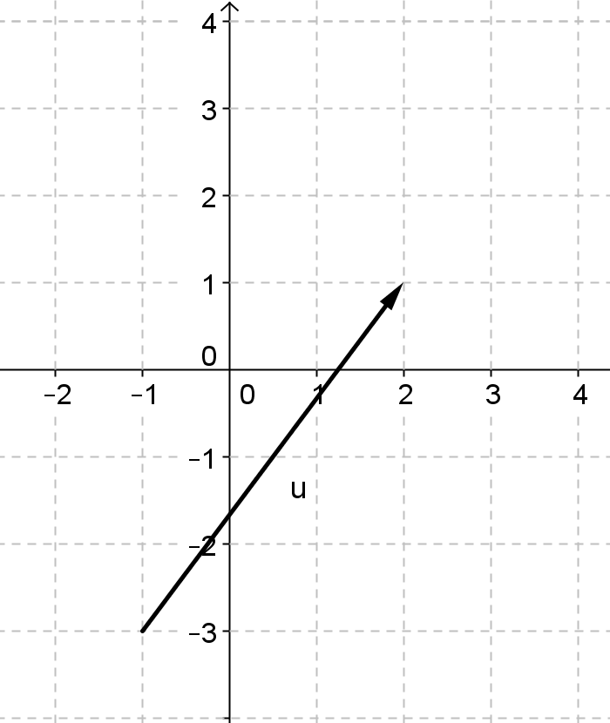

- Let $u=〈1,5〉$ and $v=〈3,-2〉$. Write each vector in component form and draw an arrow to represent the vector.
  - $u+v$

  - $u-v$

  - $2u+3v$

- For $u=〈1,5〉$ and $v=〈3,-2〉$ as in 2(a), what is the magnitude of $u+v$?

Exit Ticket Sample Solutions

- Vector $v=〈3,4〉$ and the vector $u$is represented by the arrow shown below. How are the vectors the same? How are they different?
Both $u$ and $v$ have the same length and direction, so they are different representations of the same vector. They both represent a translation of $3$ units right and $4$ units up.

- Let $u=〈1,5〉$ and $v=〈3,-2〉.$Write each vector in component form and draw an arrow to represent the vector.
  - $u+v$
$$u+v=〈4,3〉$$
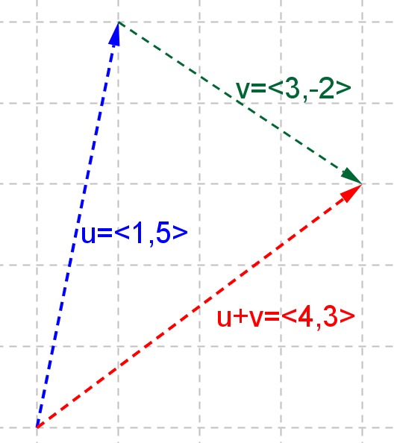

  - $u-v$
$$u-v=u+\left(-v\right)=〈-2,7〉$$
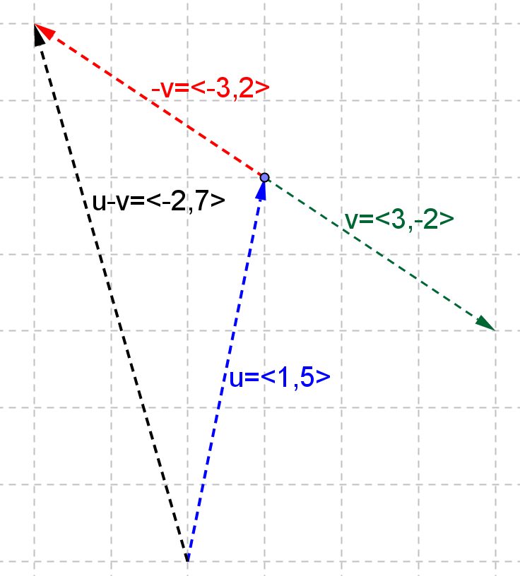
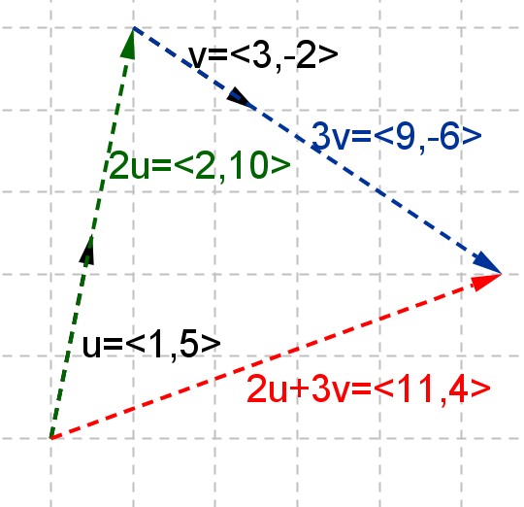
  - $2u+3v$
$2u+3v=〈11,4〉$
- For $u=〈1,5〉$ and $v=〈3,-2〉$ as in Problem 2, part (a), what is the magnitude of $+v$ ?
$$\left\|u+v\right\|=\left\|〈4,3〉\right\|=5$$

Problem Set Sample Solutions

- Sasha says that a vector has a direction component in it; therefore, we cannot add two vectors or subtract one from the other. His argument is that we cannot add “east” to “north” nor subtract “east” from “north,” for instance. Therefore, he claims, we cannot add or subtract vectors.
  - Is he correct? Explain your reasons.
No, Sasha is not correct. Although a vector has a magnitude and direction, and it is numerically suited to do translation of an object, it has horizontal and vertical components indicating how many units for translation. Therefore, we can add and subtract vectors.

  - What would you do if you need to add two vectors, $u$ and $v$, or subtract vector $v$ from vector $u$arithmetically?
For addition, we add the same corresponding vector components. For example, $u=〈u_{1},u_{2}〉, v=〈v_{1},v_{2} 〉$
$u+ v=〈u_{1}+v_{1},u_{2}+v_{2}〉.$
For subtraction $u-v=u+\left(-v\right)=〈u_{1}+\left(-v_{1}\right),u_{2}+\left(-v_{2}\right)〉=〈u_{1}-v_{1},u_{2}-v_{2}〉$.

- Given $u=〈3,1〉$ and $v=〈-4,2〉$, write each vector in component form, graph it, and explain the geometric effect.
  - $3u$
$$3u=〈9,3〉$$
The vector is dilated by a factor of $3$ and the direction stays the same.
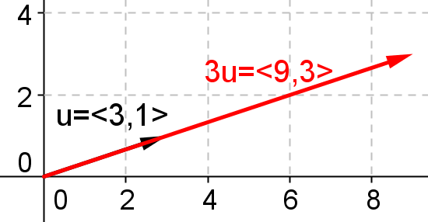

  - $\frac{1}{2}v$
$$\frac{1}{2}v=〈-2,1〉$$The vector is dilated by a factor of $\frac{1}{2}$, and the direction stays the same.
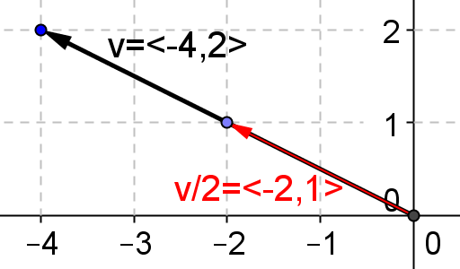

  - $–2u$
$$2u=〈-6,-2〉$$The vector is dilated by a factor of $2$ and the direction is reversed.
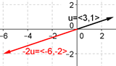

  - $-v$
$$-v=〈4,-2〉.$$The length of the vector is unchanged, and the direction is reversed.
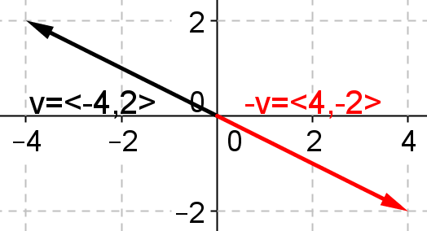

  - $u+v$
$$u+v=〈-1,3〉$$When adding vector $u=〈3,1〉$ onto vector $v=〈-4,2〉$, from the tip of vector $v$, we move $3$ units to the right and $1$ unit upward, and the resultant vector is $〈-1,3〉$.
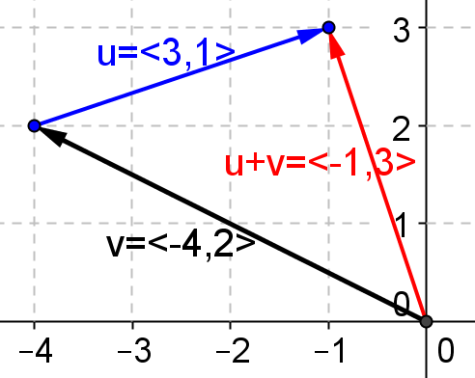

  - $2u+3v$
$$2u+3v=〈-6,8〉$$When adding vector $2u=〈6,2〉$ onto vector $3v=〈-12,6〉$, from the tip of vector $3v$, we move $6$ units to the right and $2$ units upward, and the resultant vector is $〈-6,8〉$.
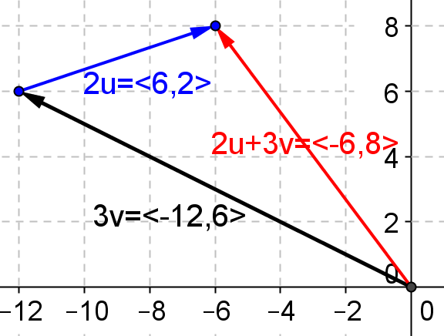

  - $4u-3v$
$$4u-3v=4u+\left(-3v\right)=〈24,-2〉$$When adding vector $4u=〈12,4〉$ onto vector $-3v=〈12,-6〉$, from the tip of vector $-3v$, we move $12$ units to the right and $4$units upward. The resultant vector is $〈24,-2〉$.
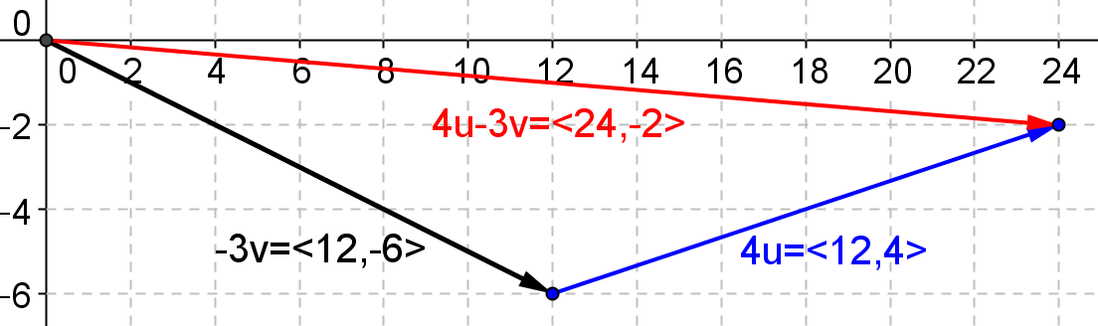

  - $\frac{1}{2}u-\frac{1}{3}v$
$$\frac{1}{2}u-\frac{1}{3}v=\frac{1}{2}u+\left(-\frac{1}{3}v\right)=〈\frac{17}{6}, -\frac{1}{6}〉$$
When adding vector $\frac{1}{2}u=〈\frac{3}{2},\frac{1}{2}〉$ onto vector$-\frac{1}{3}v =〈-\frac{4}{3},1 〉$, from the tip of vector$-\frac{1}{3}v$ , we move $\frac{3}{2}$ units to the right and $\frac{1}{2}$ unit upward, and the resultant vector is $〈\frac{17}{6}, -\frac{1}{6}〉$
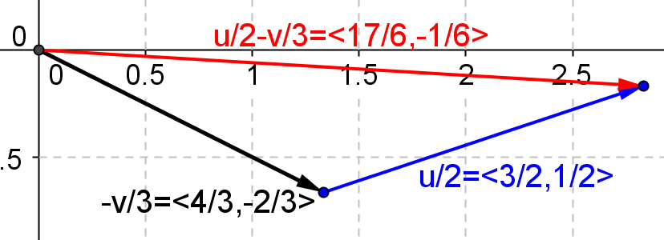

- Given $u=〈3,1〉$ and $v=〈-4,2〉$, find the following.
  - $\left\|u\right\|$.
$$\sqrt{10}$$
  - $\left\|v\right\|$.
$$2\sqrt{5}$$
  - $\left\|2u\right\|$ and $2\left\|u\right\|$.
$$\left\|2\text{u}\right\|=\left\|6,2\right\|=\sqrt{40}=2\sqrt{10}. 2\left\|\text{u}\right\|=2\sqrt{10}.$$

  - $\left\|\frac{1}{2}v\right\|$ and $\frac{1}{2}\left\|v\right\|$
$$\frac{1}{2}v=〈-2,1〉\text{,} \left\|\frac{1}{2}v\right\|=\sqrt{5}\text{.} \frac{1}{2}\left\|v\right\|=\frac{1}{2}\sqrt{5}$$

  - Is $\left\|u+u\right\|$ equal to $\left\|u\right\|+\left\|u\right\|$? Explain how you know.
Yes. We have
$$\left\|u+u\right\|=\left\|2u\right\|=2\sqrt{10}$$and
$$\left\|u\right\|+\left\|u\right\|=2\left\|u\right\|=2\sqrt{10}.$$
  - Is $\left\|u+v\right\|$ equal to $\left\|u\right\|+\left\|v\right\|$? Explain how you know.
No. We have
$\text{u}+\text{v}=〈-1,3〉 \left\|u+v\right\|=\sqrt{10}$and$\left\|u\right\|+\left\|v\right\|=\sqrt{10}+2\sqrt{5}$

  - Is $\left\|u-v\right\|$ equal to $\left\|u\right\|-\left\|v\right\|$? Explain how you know.
No. We have
$$\text{u}-\text{v}=〈7,-1〉$$

- Given $u=〈1,2〉$,$v=〈3,-4〉$, and $w=〈-4,6〉$, show that $\left(u+v\right)+w=u+(v+w)$.
$$\left(u+v\right)+w=〈4,-2〉+〈-4,6〉=〈0,4〉 \\ u+(v+w)=〈1,2〉+〈-1,2〉=〈0,4〉$$
- Tyiesha says that if the magnitude of a vector $u$ is zero, then $u$ has to be a zero vector. Is she correct? Explain how you know.
Yes. Suppose that $u=〈u_{1},u_{2}〉$, and$\left\|u\right\|=\sqrt{{\left(u_{1}\right)}^{2}+{\left(u_{2}\right)}^{2}}=0$, so ${\left(u_{1}\right)}^{2}+{\left(u_{2}\right)}^{2}=0.$ Then ${\left(u_{1}\right)}^{2}$ and${\left(u_{2}\right)}^{2}$ are positive numbers, and if two positive numbers sum to zero then both numbers must be zero. Then $u_{1}=0$and
$u_{2}=0$, which proves $u$ is a zero vector.

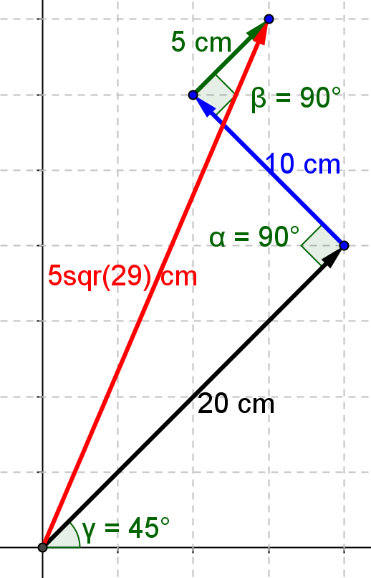
- Sergei experienced one of the biggest earthquakes when visiting Taiwan in 1999. He noticed that his refrigerator moved on the wooden floor and made marks on it. By measuring the marks he was able to trace how the refrigerator moved. The first move was northeast with a distance of $20 cm$. The second move was northwest with a distance of $10 cm$. The final move was northeast with a distance of $5 cm$. Find the vectors that would re-create the refrigerator’s movement on the floor and find the distance that the refrigerator moved from its original spot to its resting place. Draw a diagram of these vectors.
The first vector is
$$v_{1}=〈10\sqrt{2}, 10\sqrt{2}〉$$the second vector is
$$v_{2}=〈-5\sqrt{2}, 5\sqrt{2}〉$$the third vector is
$$v_{3}=〈\frac{5\sqrt{2}}{2},\frac{5\sqrt{2}}{2}〉$$
The resultant vector is
$$v=v_{1}+v_{2}+v_{3}=〈\frac{15\sqrt{2}}{2},\frac{35\sqrt{2}}{2}〉$$
the magnitude is
$$\left\|v\right\|=\sqrt{{\left(\frac{15\sqrt{2}}{2}\right)}^{2}+{\left(\frac{35\sqrt{2}}{2}\right)}^{2}}=5\sqrt{29} cm.$$

