Lesson 17: Vectors in the Coordinate Plane

Classwork
Opening Exercise
When an earthquake hits, the ground shifts abruptly due to forces created when the tectonic plates along fault lines rub together. As the tectonic plates shift and move, the intense shaking can even cause the physical movement of objects as large as buildings.
Suppose an earthquake causes all points in a town to shift $10$ feet to the north and $5$ feet to the east.
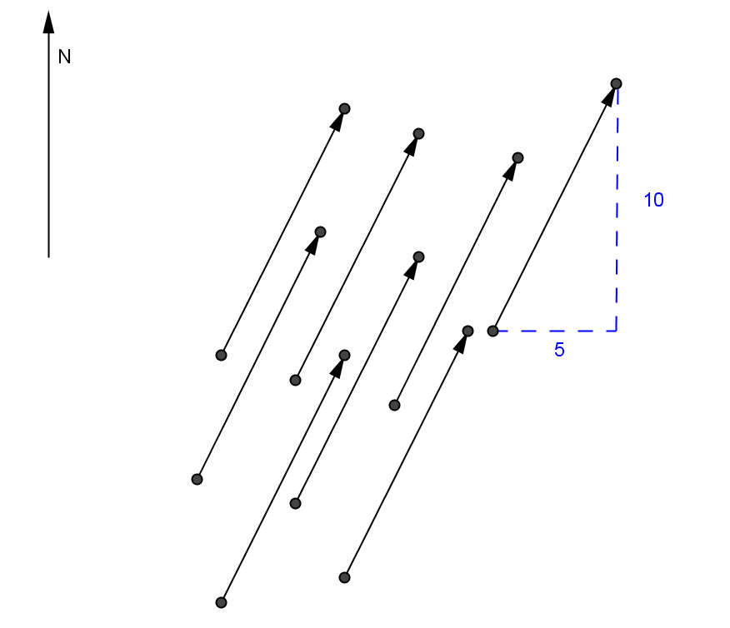

  - Explain how the diagram shown above could be said to represent the shifting caused by the earthquake.

  - Draw another arrow that shows the same shift. Explain how you drew your arrow.

Exercises 1–3
Several vectors are represented in the coordinate plane below using arrows.
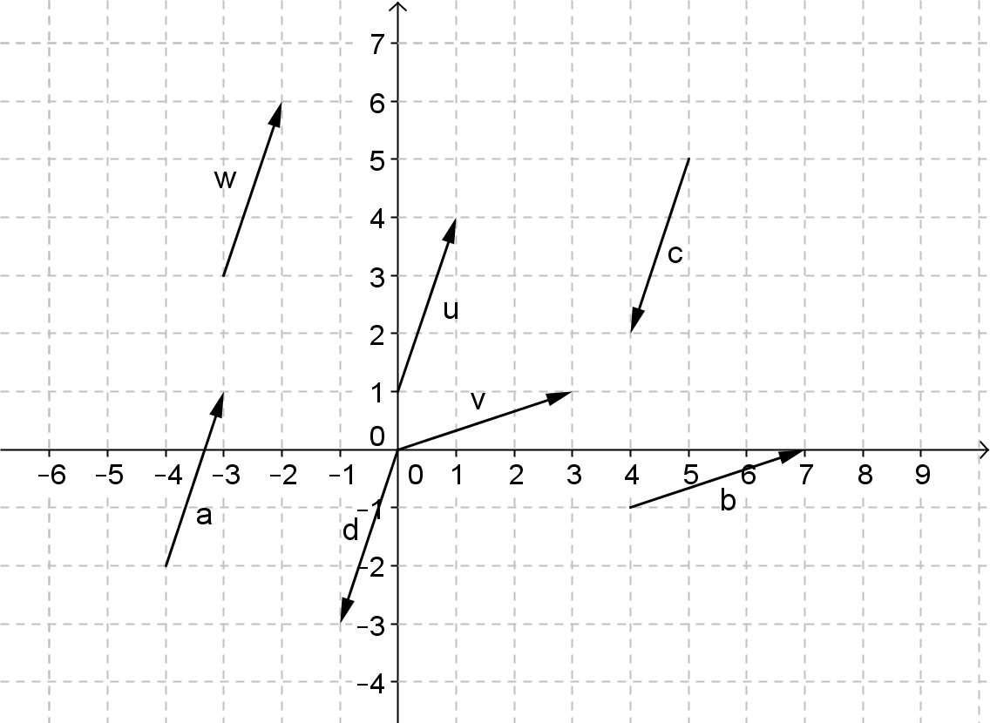

- Which arrows represent the same vector? Explain how you know.

- Why do arrows $c$ and $u$ not represent the same vector?

- After the first earthquake shifted points $5$ feet east and $10$ feet north, suppose a second earthquake hits the town and all points shift $6$ feet east and $9$ feet south.
  - Write and draw a vector $t$ that represents this shift caused by the second earthquake.

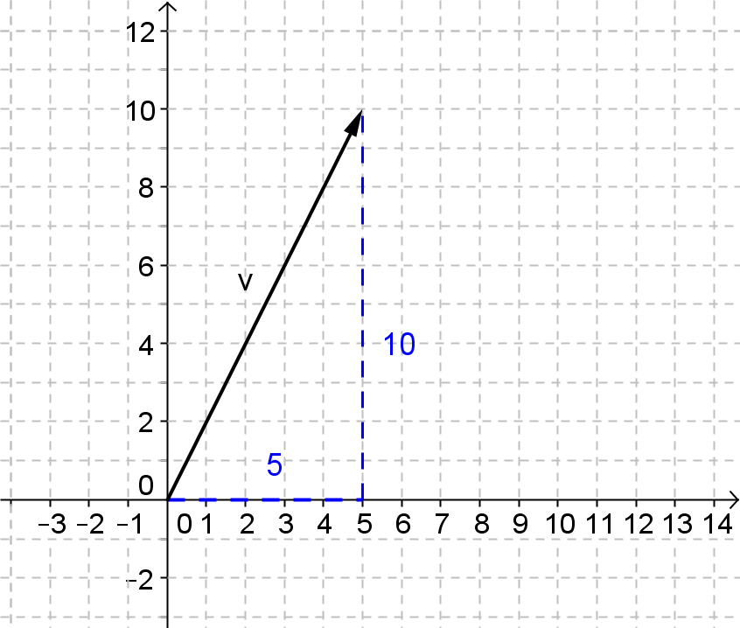

  - Which earthquake, the first one or the second one, shifted all the points in the town further? Explain your reasoning.

Example 1: The Magnitude of a Vector
The magnitude of a vector $v=〈a,b〉$ is the length of the line segment from the origin to the point $(a,b)$ in the coordinate plane, which we denote by $\left\|v\right\|$. Using the language of translation, the magnitude of $v$ is the distance between any point and its image under the translation $a$ units horizontally and $b$ units vertically. It is denoted $\left\|v\right\|$.

  - Find the magnitude of $v=〈5,10〉$ and $t=〈6,-9〉$. Explain your reasoning.

  - Write the general formula for the magnitude of a vector.

Exercises 4–10
- Given that $v=〈3,7〉$ and $t=〈-5,2〉$.
  - What is $v+t$?

  - Draw a diagram that represents this addition and shows the resulting sum of the two vectors.

  - What is $t+v$?

  - Draw a diagram that represents this addition and shows the resulting sum of the two vectors.

- Explain why vector addition is commutative.

- Given $v=〈3,7〉$ and $t=〈-5,2〉$.
  - Show numerically that $\left\|v\right\|+\left\|t\right\|≠\left\|v+t\right\|$.

  - Provide a geometric argument to explain in general, why the sum of the magnitudes of two vectors is not equal to the magnitude of the sum of the vectors.

  - Can you think of an example when the statement would be true? Justify your reasoning.

- Why is the vector $o=〈0,0〉$ called the zero vector? Describe its geometric effect when added to another vector.

- Given the vectors shown below.
$$v=〈3,6〉$$
$$u=〈9,18〉$$
$$w=〈-3,-6〉$$
$$s=〈1,2〉$$
$$t=〈-1.5,-3〉$$
$$r=〈6,12〉$$

  - Draw each vector with its initial point located at $(0,0)$. The vector $v$ is already shown. How are all of these vectors related?

  - Which vector is $2v$? Explain how you know.

  - Describe the remaining vectors as a scalar multiple of $v=〈3,6〉$ and explain your reasoning.

  - Is the vector $p=〈3\sqrt{2},6\sqrt{2}〉$ a scalar multiple of $v$? Explain.

- Which vector from Exercise 8 would it make sense to call the opposite of $v=〈3,6〉$?

- Describe a rule that defines vector subtraction. Use the vectors $v=〈5,7〉$ and $u=〈6,3〉$ to support your reasoning.

Lesson Summary
A vector can be used to describe a translation of an object. It has a magnitude and a direction based on its horizontal and vertical components. A vector $v=〈a,b〉$ can represent a translation of $a$ units horizontally and $b$ units vertically with magnitude given by $\left\|v\right\|=\sqrt{a^{2}+b^{2}}$.
- To add two vectors, add their respective horizontal and vertical components.
- To subtract two vectors, subtract their respective horizontal and vertical components.
- Multiplication of a vector by a scalar multiplies the horizontal and vertical components of the vector by the value of the scalar.

Problem Set

- Sasha says that a vector has a direction component in it; therefore, we cannot add two vectors or subtract one from the other. His argument is that we cannot add “east” to “north” nor subtract “east” from “north,” for instance. Therefore, he claims, we cannot add or subtract vectors.
  - Is he correct? Explain your reasons.
  - What would you do if you need to add two vectors, $u$ and $v$, or subtract vector $v$ from vector $u$arithmetically?

- Given $u=〈3,1〉$ and $v=〈-4,2〉$, write each vector in component form, graph it, and explain the geometric effect.
  - $3u$
  - $\frac{1}{2}v$
  - $-2u$
  - $-v$
  - $u+v$
  - $2u+3v$
  - $4u-3v$
  - $\frac{1}{2}u-\frac{1}{3}v$

- Given $u=〈3,1〉$ and $v=〈-4,2〉$, find the following.
  - $\left\|u\right\|$.
  - $\left\|v\right\|$.
  - $\left\|2u\right\|$ and $2\left\|u\right\|$.
  - $\left\|\frac{1}{2}v\right\|$and $\frac{1}{2}\left\|v\right\|$
  - Is $\left\|u+u\right\|$ equal to $\left\|u\right\|+\left\|u\right\|$? Explain how you know.
  - Is $\left\|u+v\right\|$ equal to $\left\|u\right\|+\left\|v\right\|$? Explain how you know.
  - Is $\left\|u-v\right\|$ equal to $\left\|u\right\|-\left\|v\right\|$? Explain how you know.

- Given $u=〈1,2〉$,$v=〈3,-4〉$, and $w=〈-4,6〉$, show that $\left(u+v\right)+w=u+(v+w)$.

- Tyiesha says that if the magnitude of a vector $u$ is zero, then $u$ has to be a zero vector. Is she correct? Explain how you know.

- Sergei experienced one of the biggest earthquakes when visiting Taiwan in 1999. He noticed that his refrigerator moved on the wooden floor and made marks on it. By measuring the marks he was able to trace how the refrigerator moved. The first move was northeast with a distance of 20 cm. The second move was northwest with a distance of $10 cm$. The final move was northeast with a distance of $5 cm$. Find the vectors that would re-create the refrigerator’s movement on the floor and find the distance that the refrigerator moved from its original spot to its resting place. Draw a diagram of these vectors.

