Lesson 11: Matrix Addition Is Commutative

Student Outcomes
- Students prove both geometrically and algebraically that matrix addition is commutative.

Lesson Notes
In Topic A, we interpreted matrices as representing network diagrams. In that context, an arithmetic system for matrices was natural. Given two matrices $A$ and $B$ of equal dimensions, we defined the matrix product $AB$ and the matrix sum $A+B$. Both of these operations had a meaning within the context of networks. In Topic B, we returned to our interpretation of matrices as representing the geometric effect of linear transformations from Module 1. We have found that the matrix product $AB$ has meaning in this context; it is the composition of transformations. In this lesson, we will explore the question, “Can we give matrix addition meaning in the setting of geometric transformations?”

Classwork
Opening Exercise (5 minutes)
Allow students time to work on the Opening Exercise independently before discussing as a class.

Opening Exercise
MP.3
Kiamba thinks $A+B=B+A$ for all $2×2$ matrices. Rachel thinks it is not always true. Who is correct? Explain.
Scaffolding:
Provide students with concrete examples if necessary.
$A=\left(\begin{matrix}-2 & 1 \\ 3 & 2\end{matrix}\right)$ and $B=\left(\begin{matrix}4 & 0 \\ -1 & 6\end{matrix}\right)$
$A+B=B+A=\left(\begin{matrix}2 & 1 \\ 2 & 8\end{matrix}\right)$
Let $A=\left(\begin{matrix}a_{11} & a_{12} \\ a_{21} & a_{22}\end{matrix}\right)$ and $B=\left(\begin{matrix}b_{11} & b_{12} \\ b_{21} & b_{22}\end{matrix}\right)$.
What is the sum of $A+B$?
$A+B=\left(\begin{matrix}a_{11}+b_{11} & a_{12}+b_{12} \\ a_{21}+b_{21} & a_{22}+b_{22}\end{matrix}\right)$
$B+A=\left(\begin{matrix}b_{11}+a_{11} & b_{12}{+a}_{12} \\ b_{21}{+a}_{21} & b_{22}+a_{22}\end{matrix}\right)$
The two matrices must be equal because each of the sums must be equal according to the commutative property of addition of real numbers. Kiamba is correct.

- Can we say that matrix addition is commutative?
  - Yes. The order in which we add the matrices does not change the sum.
- Will this hold true if we change the dimensions of the matrices being added?
  - Yes. Regardless of the size of the matrices, the two sums ($A+B$ and $B+A$) would still be the same. [Note: Demonstrate with two $3×3$ matrices if students seem unsure.]
- So we see that matrix addition is commutative, but we still have not determined the geometric meaning of matrix addition.
Exercise 1 (12 minutes)
Allow students time to work in groups on Exercise 1. Optionally, give students colored pencils or a transparency and fine-point dry erase marker to mark their points.

Exercises 1–6
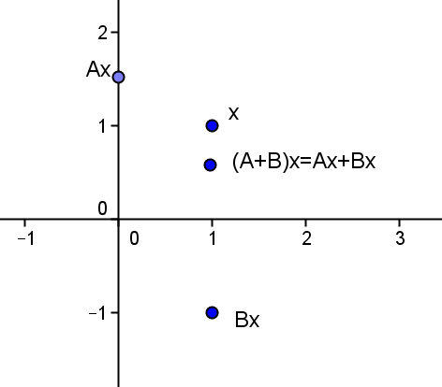
- In two-dimensional space, let $A$ be the matrix representing a rotation about the origin through an angle of $45°$, and let $B$ be the matrix representing a reflection about the $x$-axis. Let $x$ be the point $\left(\begin{matrix}1 \\ 1\end{matrix}\right)$.
  - Write down the matrices$A$,$B$, and $A+B.$
$A=\left(\begin{matrix}\frac{\sqrt{2}}{2} & -\frac{\sqrt{2}}{2} \\ \frac{\sqrt{2}}{2} & \frac{\sqrt{2}}{2}\end{matrix}\right)$ $B=\left(\begin{matrix}1 & 0 \\ 0 & -1\end{matrix}\right)$
$A+B=\left(\begin{matrix}\frac{\sqrt{2}}{2}+1 & -\frac{\sqrt{2}}{2} \\ \frac{\sqrt{2}}{2} & \frac{\sqrt{2}}{2}-1\end{matrix}\right)$

  - Write down the image points of $Ax, Bx$, and $\left(A+B\right)x$, and plot them on graph paper.
$Ax=\left(\begin{matrix}0 \\ \sqrt{2}\end{matrix}\right)$ $Bx=\left(\begin{matrix}1 \\ -1\end{matrix}\right)$ $\left(A+B\right)x=\left(\begin{matrix}1 \\ \sqrt{2}-1\end{matrix}\right)$

  - What do you notice about $\left(A+B\right)x$ compared to $Ax$ and $Bx$?
The point $\left(A+B\right)x$ is equal to the sum of the points $Ax$ and $Bx$ by the distributive property.

- Since $Ax+Bx=\left(A+B\right)\left(x\right)$, does it follow that $Bx+Ax=\left(B+A\right)\left(x\right)=\left(A+B\right)\left(x\right)$?
  - Yes, $Ax+Bx$ and $Bx+Ax$ must both map to the same point since we know that the addition of points is commutative. Since $Ax+Bx$ maps to the point $\left(A+B\right)\left(x\right)$ by the distributive property, $Bx+Ax$ must also map to the point $\left(A+B\right)\left(x\right)$ since $Ax+Bx=Bx+Ax$.
- What does this say about matrix addition?
  - It confirms what we saw in the opening exercise. Matrix addition is commutative.

Exercise 2 (13 minutes)
Allow students time to work in groups on Exercise 2 before discussing as a class.

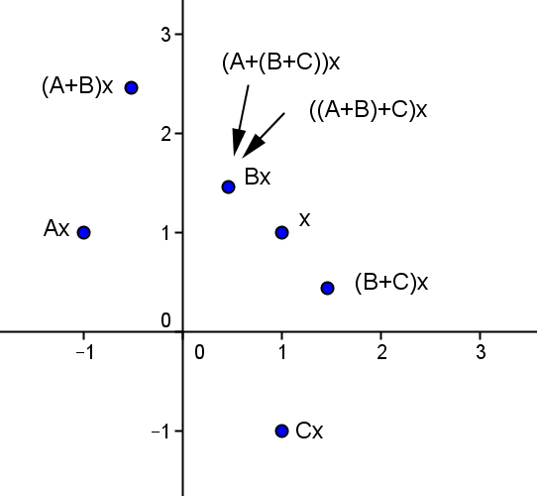
- For three matrices of equal size, $A$,$B$, and$C,$does it follow that $A+\left(B+C\right)=\left(A+B\right)+C?$
  - Determine if the statement is true geometrically. Let $A$ be the matrix representing a reflection across the $y$-axis. Let $B$ be the matrix representing a counterclockwise rotation of $30°$. Let $C$ be the matrix representing a reflection about the $x$-axis. Let $x$ be the point $\left(\begin{matrix}1 \\ 1\end{matrix}\right)$.
$A=\left(\begin{matrix}-1 & 0 \\ 0 & 1\end{matrix}\right)$ $B=\left(\begin{matrix}\frac{\sqrt{3}}{2} & -\frac{1}{2} \\ \frac{1}{2} & \frac{\sqrt{3}}{2}\end{matrix}\right)$
$C=\left(\begin{matrix}1 & 0 \\ 0 & -1\end{matrix}\right)$
$A+B=\left(\begin{matrix}\frac{\sqrt{3}-2}{2} & -\frac{1}{2} \\ \frac{1}{2} & \frac{\sqrt{3}+2}{2}\end{matrix}\right)$
$B+C=\left(\begin{matrix}\frac{\sqrt{3}+2}{2} & -\frac{1}{2} \\ \frac{1}{2} & \frac{\sqrt{3}-2}{2}\end{matrix}\right)$
From the graph, we see that $Ax+(Bx+Cx) = (Ax+Bx)+Cx$.

  - Confirm your results algebraically.
$$A+\left(B+C\right)=\left(\begin{matrix}-1 & 0 \\ 0 & 1\end{matrix}\right)+\left(\begin{matrix}\frac{\sqrt{3}+2}{2} & -\frac{1}{2} \\ \frac{1}{2} & \frac{\sqrt{3}-2}{2}\end{matrix}\right)=\left(\begin{matrix}\frac{\sqrt{3}}{2} & -\frac{1}{2} \\ \frac{1}{2} & \frac{\sqrt{3}}{2}\end{matrix}\right)$$
$$\left(A+B\right)+C=\left(\begin{matrix}\frac{\sqrt{3}-2}{2} & -\frac{1}{2} \\ \frac{1}{2} & \frac{\sqrt{3}+2}{2}\end{matrix}\right)+\left(\begin{matrix}1 & 0 \\ 0 & -1\end{matrix}\right)=\left(\begin{matrix}\frac{\sqrt{3}}{2} & -\frac{1}{2} \\ \frac{1}{2} & \frac{\sqrt{3}}{2}\end{matrix}\right)$$

  - What do your results say about matrix addition?
Matrix addition is associative.

- What does this exercise tell us about matrix addition?
  - It is associative.

- How did the graph support the idea that matrix addition is associative?
MP.2
  - $(A+\left(B+C\right))x$ and $\left(\left(A+B\right)+C\right)x$ mapped to the same point.
- Would this still be true if we used matrices of different (but still equal) dimensions?
  - Yes. The addition would still be associative. For example, we could do the same type of operations using $3×3$ matrices, but geometrically it would represent points in 3-D space rather than on a coordinate plane.
- Could we say $A+\left(B+C\right)=C+\left(A+B\right)$?
  - Yes. We just demonstrated that $A+\left(B+C\right)=\left(A+B\right)+C$. We can then say that
$\left(A+B\right)+C=C+\left(A+B\right)$because we know that matrix addition is commutative.

Exercises 3–6 (5 minutes)
Allow students time to work in groups on Exercises 3–6 before discussing as a class.

- If $x=\left(\begin{matrix}x \\ y \\ z\end{matrix}\right)$, what are the coordinates of a point $y$ with the property $x+y$ is the origin $O=\left(\begin{matrix}0 \\ 0 \\ 0\end{matrix}\right)$?
$$y=\left(\begin{matrix}-x \\ -y \\ -z\end{matrix}\right)$$

- Suppose $A=\left(\begin{matrix}11 & -5 & 2 \\ -34 & 6 & 19 \\ 8 & -542 & 0\end{matrix}\right)$, and matrix $B$ has the property that $Ax+Bx$ is the origin. What is the matrix $B?$
$$B=\left(\begin{matrix}-11 & 5 & -2 \\ 34 & -6 & -19 \\ -8 & 542 & 0\end{matrix}\right)$$

- For three matrices of equal size, $A$,$B$, and$C,$where $A$ represents a reflection across the line $y=x$, $B$ represents a counterclockwise rotation of $45°$, $C$ represents a reflection across the $y$-axis, and $x=\left(\begin{matrix}1 \\ 2\end{matrix}\right):$
  - Show that matrix addition is commutative: $Ax+Bx=Bx+Cx$.
$$Ax= \left(\begin{matrix}0 & -1 \\ 1 & 0\end{matrix}\right)\left(\begin{matrix}1 \\ 2\end{matrix}\right)=\left(\begin{matrix}-2 \\ 1\end{matrix}\right)$$
$$Bx= \left(\begin{matrix}\frac{\sqrt{2}}{2} & -\frac{\sqrt{2}}{2} \\ \frac{\sqrt{2}}{2} & \frac{\sqrt{2}}{2}\end{matrix}\right)\left(\begin{matrix}1 \\ 2\end{matrix}\right)=\left(\begin{matrix}\frac{\sqrt{2}}{2}-\sqrt{2} \\ \frac{\sqrt{2}}{2}+\sqrt{2}\end{matrix}\right)$$
$$Ax+Bx= \left(\begin{matrix}-2+\frac{\sqrt{2}}{2}-\sqrt{2} \\ 1+\frac{\sqrt{2}}{2}+\sqrt{2}\end{matrix}\right)=Bx+Ax$$

  - Show that matrix addition is associative: $Ax+\left(Bx+Cx\right)=\left(Ax+Bx\right)+Cx$.
Scaffolding:
Provide early finishers with this challenge question.
If $Ax=0$ for all $x$, must every entry of $A$ be $0$?
$$Cx= \left(\begin{matrix}-1 & 0 \\ 0 & 1\end{matrix}\right)\left(\begin{matrix}1 \\ 2\end{matrix}\right)=\left(\begin{matrix}-1 \\ 2\end{matrix}\right) \\ Ax+\left(Bx+Cx\right)= \left(\begin{matrix}-2 \\ 1\end{matrix}\right)+\left(\begin{matrix}\frac{\sqrt{2}}{2}-\sqrt{2}-1 \\ \frac{\sqrt{2}}{2}+\sqrt{2}+2\end{matrix}\right) \\ \left(Ax+Bx\right)+Cx=\left(\begin{matrix}-2+\frac{\sqrt{2}}{2}-\sqrt{2} \\ 1+\frac{\sqrt{2}}{2}+\sqrt{2}\end{matrix}\right)+\left(\begin{matrix}-1 \\ 2\end{matrix}\right)\text{;} \\ Ax+\left(Bx+Cx\right)=\left(Ax+Bx\right)+Cx=\left(\begin{matrix}-3+\frac{\sqrt{2}}{2}-\sqrt{2} \\ 3+\frac{\sqrt{2}}{2}+\sqrt{2}\end{matrix}\right)$$

- Let $A,B,C,$ and$D$ be matrices of the same dimensions. Use the commutative property of addition of two matrices to prove $A+B+C=C+B+A$.
If we treat $A+B$ as one matrix, then
$$\left(A+B\right)+C=C+\left(A+B\right) \\ =C+\left(B+A\right) \\ =C+B+A.$$

Closing (5 minutes)
Discuss the key points of the lesson as a class.
- What can be said about matrix addition?
  - Matrix addition, like addition of numbers, is both commutative and associative.
- What is the geometric meaning of matrix addition? Illustrate with an example.
  - $(A+B)x$ maps to the same point as $Ax + Bx$.
  - Answers may vary. $A=\left(\begin{matrix}1 & 0 \\ 0 & -1\end{matrix}\right)$,$B=\left(\begin{matrix}1 & 0 \\ 0 & -1\end{matrix}\right)$, and$x= \left(\begin{matrix}1 \\ 1\end{matrix}\right)$. $A+B=\left(\begin{matrix}2 & 0 \\ 0 & -2\end{matrix}\right)$,$\left(A+B\right)x=\left(\begin{matrix}2 \\ -2\end{matrix}\right)$,$Ax=\left(\begin{matrix}1 \\ -1\end{matrix}\right)$,$Bx=\left(\begin{matrix}1 \\ -1\end{matrix}\right)$, and$Ax+Bx=\left(\begin{matrix}2 \\ -2\end{matrix}\right).$Therefore,
$\left(A+B\right)x=Ax+Bx$.

Exit Ticket (5 minutes)

Name Date
Lesson 11: Matrix Addition Is Commutative

Exit Ticket

- Let $x=\left(\begin{matrix}3 \\ -1\end{matrix}\right)$, $A=\left(\begin{matrix}2 & 2 \\ 2 & 0\end{matrix}\right),$and$B=\left(\begin{matrix}-1 & 0 \\ 0 & -1\end{matrix}\right)$.
  - Find and plot the points $Ax$, $Bx$, and $\left(A+B\right)x$ on the axes below.

  - Show algebraically that matrix addition is commutative, $Ax+Bx=Bx+Ax$.

- Let $A=\left(\begin{matrix}a & b \\ c & d\end{matrix}\right)$and$B=\left(\begin{matrix}x & y \\ z & w\end{matrix}\right)$. Prove $A+B=B+A$.
Exit Ticket Sample Solutions

- Let $x=\left(\begin{matrix}3 \\ -1\end{matrix}\right)$, $A=\left(\begin{matrix}2 & 2 \\ 2 & 0\end{matrix}\right),$and$B=\left(\begin{matrix}-1 & 0 \\ 0 & -1\end{matrix}\right)$.
  - Find and plot the points $Ax$, $Bx$, and $\left(A+B\right)x$ on the axes below.

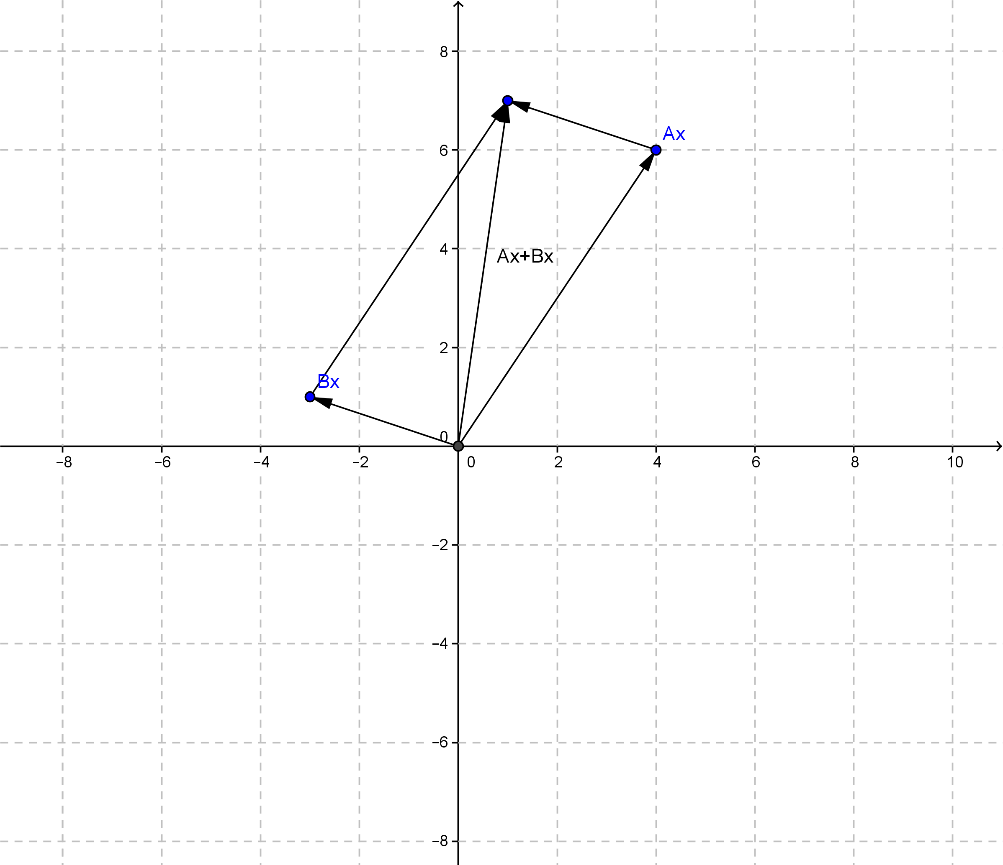

  - Show algebraically that matrix addition is commutative, $Ax+Bx=Bx+Ax$.
$Ax= \left(\begin{matrix}4 \\ 6\end{matrix}\right)$,$Bx=\left(\begin{matrix}-3 \\ 1\end{matrix}\right)\text{,} Ax+Bx=\left(\begin{matrix}1 \\ 7\end{matrix}\right)$, and$Bx+Ax=\left(\begin{matrix}1 \\ 7\end{matrix}\right)$.$Ax+Bx=Bx+Ax$.

- Let $A=\left(\begin{matrix}a & b \\ c & d\end{matrix}\right)$and$B=\left(\begin{matrix}x & y \\ z & w\end{matrix}\right)$. Prove $A+B=B+A$.
$$A+B=\left(\begin{matrix}a & b \\ c & d\end{matrix}\right)+\left(\begin{matrix}x & y \\ z & w\end{matrix}\right) \\ =\left(\begin{matrix}a+x & b+y \\ c+d & z+w\end{matrix}\right) \\ =\left(\begin{matrix}x+a & y+b \\ d+c & w+z\end{matrix}\right) \\ =\left(\begin{matrix}x & y \\ z & w\end{matrix}\right)+\left(\begin{matrix}a & b \\ c & d\end{matrix}\right) \\ =B+A$$
Problem Set Sample Solutions

- Let $A$ be matrix transformation representing a rotation of $45°$ about the origin and $B$ be a reflection across the
$y$-axis. Let $x=(3,4)$.
  - Represent $A$and$B$ as matrices, and find $A+B.$
$$A=\left(\begin{matrix}\frac{\sqrt{2}}{2} & -\frac{\sqrt{2}}{2} \\ \frac{\sqrt{2}}{2} & \frac{\sqrt{2}}{2}\end{matrix}\right)\text{;} B=\left(\begin{matrix}-1 & 0 \\ 0 & 1\end{matrix}\right)\text{;} A+B=\left(\begin{matrix}-1+\frac{\sqrt{2}}{2} & -\frac{\sqrt{2}}{2} \\ \frac{\sqrt{2}}{2} & 1+\frac{\sqrt{2}}{2}\end{matrix}\right)$$

  - Represent $Ax$and $Bx$ as matrices, and find $(A+B)x$.
$$Ax=\left(\begin{matrix}-\frac{\sqrt{2}}{2} \\ \frac{7\sqrt{2}}{2}\end{matrix}\right)\text{;} Bx=\left(\begin{matrix}-3 \\ 4\end{matrix}\right)\text{;}\left(A+B\right)x=\left(\begin{matrix}-3-\frac{\sqrt{2}}{2} \\ 4+\frac{7\sqrt{2}}{2}\end{matrix}\right)$$

  - Graph your answer to part (b).
See graph in part (d).

  - Draw the parallelogram containing $Ax$, $Bx$, and $(A+B)x$.

- Let $A$ be matrix transformation representing a rotation of $300°$ about the origin and $B$ be a reflection across the
$x$-axis. Let $x=(2,-5)$.
  - Represent $A$and$B$ as matrices, and find $A+B.$

$$A=\left(\begin{matrix}\frac{1}{2} & \frac{\sqrt{3}}{2} \\ -\frac{\sqrt{3}}{2} & \frac{1}{2}\end{matrix}\right)\text{;} B=\left(\begin{matrix}1 & 0 \\ 0 & -1\end{matrix}\right)\text{;} A+B=\left(\begin{matrix}\frac{3}{2} & \frac{\sqrt{3}}{2} \\ -\frac{\sqrt{3}}{2} & -\frac{1}{2}\end{matrix}\right)$$

  - Represent $Ax$and $Bx$ as matrices, and find $(A+B)x$.
$$Ax=\left(\begin{matrix}1-\frac{5\sqrt{3}}{2} \\ \frac{-5-2\sqrt{3}}{2}\end{matrix}\right)\text{;} Bx=\left(\begin{matrix}2 \\ 5\end{matrix}\right)\text{; }\left(A+B\right)x=\left(\begin{matrix}3-\frac{5\sqrt{3}}{2} \\ \frac{5-2\sqrt{3}}{2}\end{matrix}\right)$$

  - Graph your answer to part (b).
See graph in part (d).

  - Draw the parallelogram containing $Ax$, $Bx$, and $(A+B)x$.

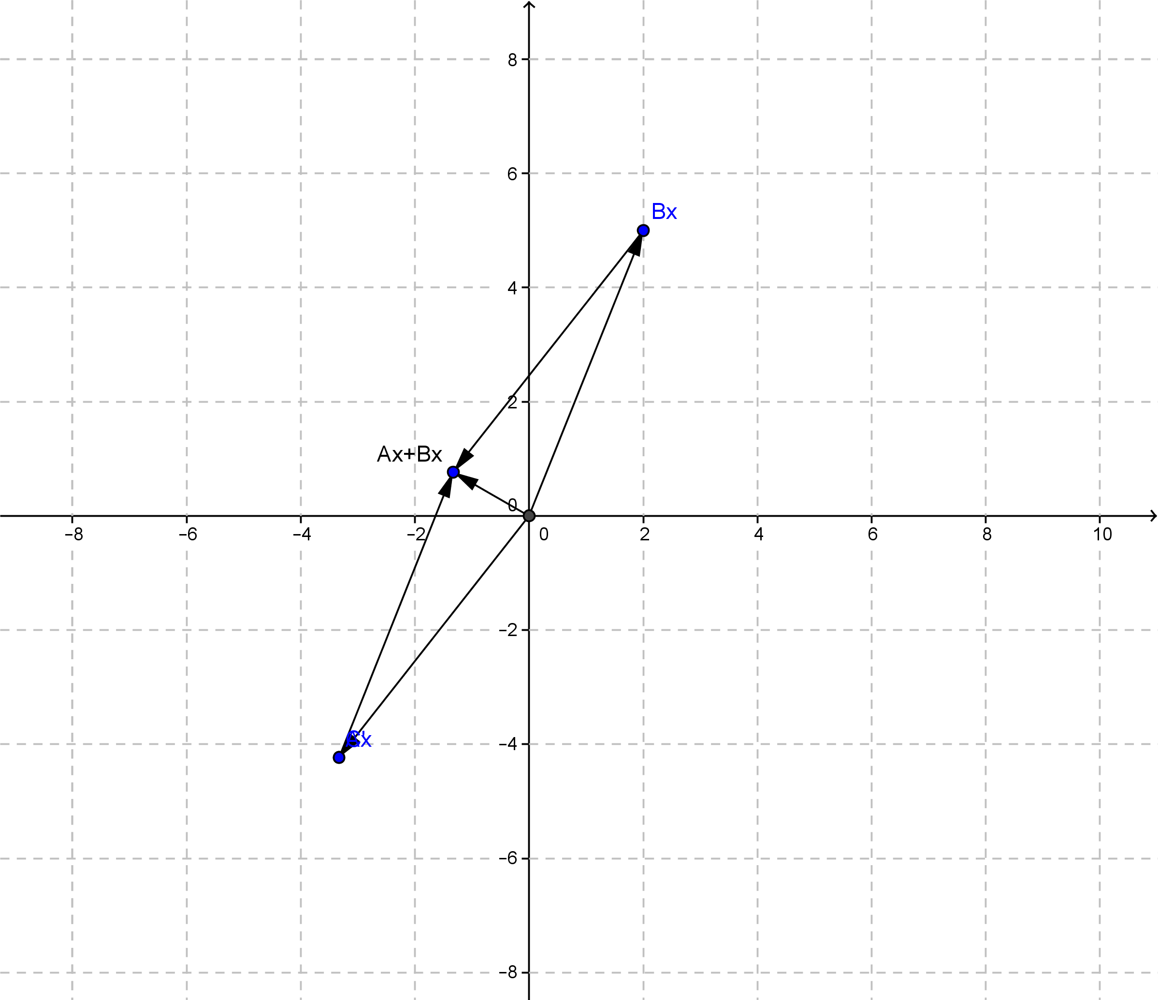

- Let $A,B,C,$and$D$ be matrices of the same dimensions.
  - Use the associative property of addition for three matrices to prove $\left(A+B\right)+\left(C+D\right)=A+\left(B+C\right)+D$.
If we treat $C+D$ as one matrix, then
$$\left(A+B\right)+\left(C+D\right)=\left(A+B\right)+\left(C+D\right) \\ =A+\left(B+\left(C+D\right)\right) \\ =A+\left(\left(B+C\right)+D\right) \\ =A+\left(B+C\right)+D\text{.}$$

  - Make an argument for the associative and commutative properties of addition of matrices to be true for finitely many matrices being added.
For finitely many matrices, we can always use the formula that has been proven already and break the rest of the problem down into that many pieces, just like we did in part (a). Since this is true for any finite number, we could also use the formula that has been proven for one less than whatever number we are trying to prove the property true for.

- Let $A$ be an $m×n$ matrix with element in the $i$^{th} row, $j$^{th} column $a_{ij}$, and $B$ be an $m×n$ matrix with element in the $i$^{th} row, $j$^{th} column $b_{ij}$. Present an argument that $A+B=B+A$.
The entry in the $i$^{th} row, $j$^{th} column of $A+B$ will be $a_{ij}+b_{ij}$, which is equal to $b_{ij}+a_{ij}$, which is the entry in the $i$^{th} row, $j$^{th} column of $B+A$. Since this is true for any element of $A+B$, we have that $A+B=B+A$ for any two matrices of equal dimensions.

- For integers $x, y$, define $x⊕y=x⋅y+1$, read “$x$ plus $y$” where $x⋅y$ is defined normally.
  - Is this form of addition commutative? Explain why or why not.
Yes. $x⊕y=xy+1=yx+1=y⊕x$.

  - Is this form of addition associative? Explain why or why not.
No.
$$x⊕\left(y⊕z\right)=x⊕\left(yz+1\right)=x\left(yz+1\right)+1=xyz+x+1.$$
$$\left(x⊕y\right)⊕z=\left(xy+1\right)⊕z=\left(xy+1\right)z+1=xyz+z+1.$$

- For integers $x, y$, define $x⊕y=x$.
  - Is this form of addition commutative? Explain why or why not.
No. $x⊕y=x$, and $y⊕x=y$.

  - Is this form of addition associative? Explain why or why not.
Yes. $x⊕\left(y⊕z\right)=x⊕y=x$, and $\left(x⊕y\right)⊕z=x⊕z=x$.

