Lesson 9: Composition of Linear Transformations

Student Outcomes
- Students use technology to perform compositions of linear transformations in $R^{3}$.

Lesson Notes
In Lesson 8, students discovered that if they compose two linear transformations in the plane, $L_{A}$ and $L_{B}$, represented by matrices $A$ and $B$ respectively, then the resulting transformation can be produced using a single matrix $AB$. In this lesson, we extend this result from transformations in the plane to transformations in three-dimensional space, $R^{3}$. This lesson was designed to be implemented using the GeoGebra applet TransformCubes (http://eureka-math.org/G12M2L9/geogebra-TransformCubes), which allows students to visualize the transformation of the cube.

Classwork
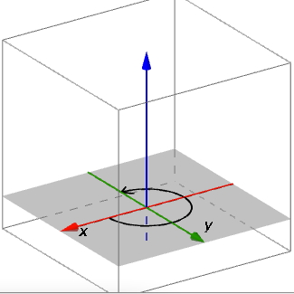
Opening Exercise (10 minutes)
The Opening Exercise reviews the discovery from the Problem Set in Lesson 7 that the matrix of a transformation in $R^{3}$ is determined by the images of the three points $(1,0,0)$, $(0,1,0)$, and $\left(0,0,1\right)$. This fact will be needed to construct matrices of transformations in this lesson before we compose them. Students may question what is meant by counterclockwise rotation in space; if this happens, let them know that we consider a rotation about the $z$-axis to be a counterclockwise rotation if it rotates the $xy$-plane counterclockwise when placed in its standard orientation as shown to the right.
Students should work these exercises with pencil and paper.
Opening Exercise
Scaffolding:
- Encourage struggling students to draw the image of a cube before and after the transformation to find the images of the points $(1,0,0)$, $(0,1,0)$, and $\left(0,0,1\right)$in space.
Recall from Problem 1, part (d) of the Problem Set of Lesson 7 that if you know what a linear transformation does to the three points $(1,0,0)$, $(0,1,0)$, and $(0,0,1)$, you can find the matrix of the transformation. How do the images of these three points lead to the matrix of the transformation?
  - Suppose that a linear transformation $L_{1}$ rotates the unit cube by $90°$ counterclockwise about the $z$-axis. Find the matrix $A_{1}$ of the transformation $L_{1}$.
Since this transformation rotates by $90°$ counterclockwise in the $xy$-plane, a vector along the positive $x$-axis will be transformed to lie along the positive $y$-axis, a vector along the positive $y$-axis will be transformed to lie along the negative $y$-axis, and a vector along the $z$-axis will be left alone. Thus,
$L_{1}\left(\left[\begin{aligned}1 \\ 0 \\ 0\end{aligned}\right]\right)=\left[\begin{matrix}0 \\ 1 \\ 0\end{matrix}\right]$,$L_{1}\left(\left[\begin{aligned}0 \\ 1 \\ 0\end{aligned}\right]\right)=\left[\begin{matrix}-1 \\ 0 \\ 0\end{matrix}\right]$, and $L_{1}\left(\left[\begin{aligned}0 \\ 0 \\ 1\end{aligned}\right]\right)=\left[\begin{matrix}0 \\ 0 \\ 1\end{matrix}\right]$,
so the matrix of the transformation is $A_{1}=\left[\begin{matrix}0 & -1 & 0 \\ 1 & 0 & 0 \\ 0 & 0 & 1\end{matrix}\right]$.
  - Suppose that a linear transformation $L_{2}$ rotates the unit cube by $90°$ counterclockwise about the $y$-axis. Find the matrix $A_{2}$ of the transformation $L_{2}$.
Since this transformation rotates by $90°$ counterclockwise in the $xz$-plane, a vector along the positive $x$-axis will be transformed to lie along the positive $z$-axis, a vector along the $y$-axis will be left alone, and a vector along the positive $z$-axis will be transformed to lie along the negative $x$-axis. Thus,
$L_{2}\left(\left[\begin{aligned}1 \\ 0 \\ 0\end{aligned}\right]\right)=\left[\begin{matrix}0 \\ 0 \\ 1\end{matrix}\right]$,$L_{2}\left(\left[\begin{aligned}0 \\ 1 \\ 0\end{aligned}\right]\right)=\left[\begin{matrix}0 \\ 1 \\ 0\end{matrix}\right]$, and $L_{2}\left(\left[\begin{aligned}0 \\ 0 \\ 1\end{aligned}\right]\right)=\left[\begin{matrix}-1 \\ 0 \\ 0\end{matrix}\right]$,
so the matrix of the transformation is $A_{2}=\left[\begin{matrix}0 & 0 & -1 \\ 0 & 1 & 0 \\ 1 & 0 & 0\end{matrix}\right]$.

  - Suppose that a linear transformation $L_{3}$ scales by $2$ in the $x$-direction, scales by $3$ in the $y$-direction, and scales by $4$ in the $z$-direction. Find the matrix $A_{3}$ of the transformation $L_{3}$.
Since this transformation scales by $2$ in the $x$-direction, by 3 in the $y$-direction, and by 4 in the$z$-direction , a vector along the $x$-axis will be multiplied by 2, a vector along the $y$-axis will be multiplied by $3$, and a vector along the $z$-axis will be multiplied by $4$. Thus,
$L_{3}\left(\left[\begin{aligned}1 \\ 0 \\ 0\end{aligned}\right]\right)=\left[\begin{matrix}2 \\ 0 \\ 0\end{matrix}\right]$,$L_{3}\left(\left[\begin{aligned}0 \\ 1 \\ 0\end{aligned}\right]\right)=\left[\begin{matrix}0 \\ 3 \\ 0\end{matrix}\right]$, and $L_{3}\left(\left[\begin{aligned}0 \\ 0 \\ 1\end{aligned}\right]\right)=\left[\begin{matrix}0 \\ 0 \\ 4\end{matrix}\right]$,
so the matrix of the transformation is $A_{3}=\left[\begin{matrix}2 & 0 & 0 \\ 0 & 3 & 0 \\ 0 & 0 & 4\end{matrix}\right]$.

  - Suppose that a linear transformation $L_{4}$ projects onto the $xy$-plane. Find the matrix $A_{4}$ of the transformation $L_{4}$.
Since this transformation projects onto the $xy$-plane, a vector along the $x$-axis will be left alone, a vector along the $y$-axis will be left alone, and a vector along the $z$-axis will be transformed into the zero vector. Thus,
$L_{4}\left(\left[\begin{aligned}1 \\ 0 \\ 0\end{aligned}\right]\right)=\left[\begin{matrix}1 \\ 0 \\ 0\end{matrix}\right]$,$L_{4}\left(\left[\begin{aligned}0 \\ 1 \\ 0\end{aligned}\right]\right)=\left[\begin{matrix}0 \\ 1 \\ 0\end{matrix}\right]$, and $L_{4}\left(\left[\begin{aligned}0 \\ 0 \\ 1\end{aligned}\right]\right)=\left[\begin{matrix}0 \\ 0 \\ 0\end{matrix}\right]$,
so the matrix of the transformation is $A_{4}=\left[\begin{matrix}1 & 0 & 0 \\ 0 & 1 & 0 \\ 0 & 0 & 0\end{matrix}\right]$.

  - Suppose that a linear transformation $L_{5}$ projects onto the $xz$-plane. Find the matrix $A_{5}$ of the transformation $L_{5}$.
Since this transformation projects onto the $xz$-plane, a vector along the $x$-axis will left alone, a vector along the $y$-axis will be transformed into the zero vector, and a vector along the $z$-axis will be left alone. Thus,
$L_{5}\left(\left[\begin{aligned}1 \\ 0 \\ 0\end{aligned}\right]\right)=\left[\begin{matrix}1 \\ 0 \\ 0\end{matrix}\right]$,$L_{5}\left(\left[\begin{aligned}0 \\ 1 \\ 0\end{aligned}\right]\right)=\left[\begin{matrix}0 \\ 0 \\ 0\end{matrix}\right]$, and $L_{5}\left(\left[\begin{aligned}0 \\ 0 \\ 1\end{aligned}\right]\right)=\left[\begin{matrix}0 \\ 0 \\ 1\end{matrix}\right]$,
so the matrix of the transformation is $A_{5}=\left[\begin{matrix}1 & 0 & 0 \\ 0 & 0 & 0 \\ 0 & 0 & 1\end{matrix}\right]$.

  - Suppose that a linear transformation $L_{6}$ reflects across the plane with equation $y=x$. Find the matrix $A_{6}$ of the transformation $L_{6}$.
Since this transformation reflects across the plane $y=x$, a vector along the positive $x$-axis will be transformed into a vector along the positive $y$-axis with the same length, a vector along the positive $y$-axis will be transformed into a vector along the positive $x$-axis, and a vector along the $z$-axis will be left alone. Thus,
$L_{6}\left(\left[\begin{aligned}1 \\ 0 \\ 0\end{aligned}\right]\right)=\left[\begin{matrix}0 \\ 1 \\ 0\end{matrix}\right]$,$L_{6}\left(\left[\begin{aligned}0 \\ 1 \\ 0\end{aligned}\right]\right)=\left[\begin{matrix}1 \\ 0 \\ 0\end{matrix}\right]$, and $L_{6}\left(\left[\begin{aligned}0 \\ 0 \\ 1\end{aligned}\right]\right)=\left[\begin{matrix}0 \\ 0 \\ 1\end{matrix}\right]$,
so the matrix of the transformation is $A_{6}=\left[\begin{matrix}0 & 1 & 0 \\ 1 & 0 & 0 \\ 0 & 0 & 1\end{matrix}\right]$.
  - Suppose that a linear transformation $L_{7}$ satisfies $L_{7}\left(\left[\begin{aligned}1 \\ 0 \\ 0\end{aligned}\right]\right)=\left[\begin{matrix}2 \\ 0 \\ 0\end{matrix}\right]$,$L_{7}\left(\left[\begin{aligned}0 \\ 1 \\ 0\end{aligned}\right]\right)=\left[\begin{matrix}0 \\ 1 \\ 0\end{matrix}\right]$, and $L_{7}\left(\left[\begin{aligned}0 \\ 0 \\ 1\end{aligned}\right]\right)=\left[\begin{matrix}0 \\ 0 \\ \frac{1}{2}\end{matrix}\right]$. Find the matrix $A_{7}$ of the transformation $L_{7}$. What is the geometric effect of this transformation?
The matrix of this transformation is $A_{7}=\left[\begin{matrix}2 & 0 & 0 \\ 0 & 1 & 0 \\ 0 & 0 & \frac{1}{2}\end{matrix}\right]$. The geometric effect of $L_{7}$ is to stretch by a factor of $2$ in the $x$-direction and scale by a factor of $\frac{1}{2}$ in the $z$-direction.

  - Suppose that a linear transformation $L_{8}$ satisfies $L_{8}\left(\left[\begin{aligned}1 \\ 0 \\ 0\end{aligned}\right]\right)=\left[\begin{matrix}1 \\ 1 \\ 0\end{matrix}\right], L_{8}\left(\left[\begin{aligned}0 \\ 1 \\ 0\end{aligned}\right]\right)=\left[\begin{matrix}-1 \\ 1 \\ 0\end{matrix}\right]$, and $L_{8}\left(\left[\begin{aligned}0 \\ 0 \\ 1\end{aligned}\right]\right)=\left[\begin{matrix}0 \\ 0 \\ 1\end{matrix}\right]$. Find the matrix of the transformation $L_{8}$. What is the geometric effect of this transformation?
The matrix of this transformation is $A_{8}=\left[\begin{matrix}1 & -1 & 0 \\ 1 & 1 & 0 \\ 0 & 0 & 1\end{matrix}\right]$. The geometric effect of $L_{8}$ is to rotate by $45°$ in the $xy$-plane, scale by $\sqrt{2}$ in both the $x$ and $y$ directions, and to not change in the $z$-direction.

Once students have completed the Opening Exercise with pencil and paper, allow them to use the GeoGebra applet TransformCubes.ggb to check their work before continuing. The remaining exercises rely on the matrices $A_{1}$-$A_{8}$, so ensure that students have found the correct matrices before proceeding with the lesson.

Discussion (2 minutes)
- In Lesson 8, we saw that for linear transformations in the plane, if $L_{A}$ is a linear transformation represented by a $2×2$ matrix $A$ and $L_{B}$ is a linear transformation represented by a $2×2$ matrix $B$, then the $2×2$ matrix $AB$ is the matrix of the composition of $L_{B}$ followed by $L_{A}$. Today we will explore composition of linear transformations in $R^{3}$ to see whether the same result extends to the case when $A$, $B$, and $AB$are $3×3$ matrices.

Exploratory Challenge 1 (25 minutes)
In the Exploratory Challenge, students predict the geometric effect of composing pairs of transformations from the Opening Exercise and then check their predictions with the GeoGebra applet TransformCubes.ggb.
Exploratory Challenge 1
Transformations $L_{1}$-$L_{8}$ refer to the linear transformations from the Opening Exercise. For each pair,
MP.3
    - Make a conjecture to predict the geometric effect of performing the two transformations in the order specified.
    - Find the product of the corresponding matrices, in the order that corresponds to the indicated order of composition. Remember that if we perform a transformation $L_{B}$ with matrix $B$ and then $L_{A}$ with matrix $A$, the matrix that corresponds to the composition $L_{A}∘L_{B}$ is $AB$. That is, $L_{B}$ is applied first, but matrix $B$ is written second.
    - Use the GeoGebra applet TransformCubes.ggb to draw the image of the unit cube under the transformation induced by the matrix product in part (ii). Was your conjecture in part (i) correct?
  - Perform $L_{6}$ and then $L_{6}$.
    - Since $L_{6}$ reflects across the plane through $y=x$ that is perpendicular to the $xy$-plane, performing $L_{6}$ twice in succession will result in the identity transformation.
    - $A_{6}⋅A_{6}=\left[\begin{matrix}0 & 1 & 0 \\ 1 & 0 & 0 \\ 0 & 0 & 1\end{matrix}\right]⋅\left[\begin{matrix}0 & 1 & 0 \\ 1 & 0 & 0 \\ 0 & 0 & 1\end{matrix}\right]=\left[\begin{matrix}1 & 0 & 0 \\ 0 & 1 & 0 \\ 0 & 0 & 1\end{matrix}\right]$. Since $A_{6}⋅A_{6}$ is the identity matrix, we know that $L_{6}∘L_{6}$ is the identity transformation.
    - The conjecture was correct.
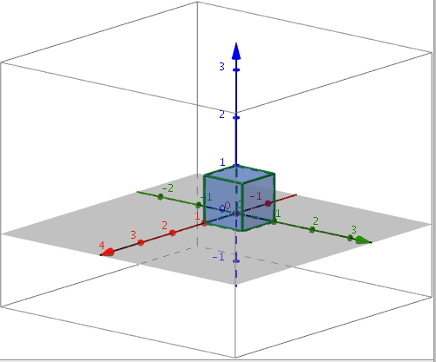

  - Perform $L_{1}$ and then $L_{2}$.
    - Sample student response: Since $L_{1}$ rotates $90°$ about the $z$-axis and $L_{2}$ rotates $90°$ about the $y$-axis, the composition $L_{2}∘L_{1}$ should rotate $180°$ about the line $y=-x$ in the $xy$-plane.
    - $A_{2}⋅A_{1}=\left[\begin{matrix}0 & 0 & -1 \\ 0 & 1 & 0 \\ 1 & 0 & 0\end{matrix}\right]⋅\left[\begin{matrix}0 & -1 & 0 \\ 1 & 0 & 0 \\ 0 & 0 & 1\end{matrix}\right]=\left[\begin{matrix}0 & 0 & -1 \\ 1 & 0 & 0 \\ 0 & -1 & 0\end{matrix}\right]$.
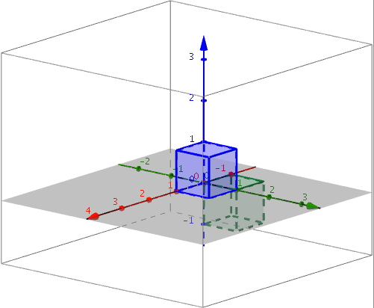
    - The conjecture in part (i) is not correct. While it appears that the composition $L_{2}∘L_{1}$ is a rotation by $180°$ about the $y$-axis, it is not because, for example, point $\left(0,1,0\right)$ is transformed to point $(-1,0,0)$ and does not remain on the $y$-axis after the transformation. Thus, this cannot be a rotation around the $y$-axis.

  - Perform $L_{4}$ and then $L_{5}$.
    - Since $L_{4}$ projects onto the $xy$-plane and $L_{5}$ projects onto the $xz$-plane, the composition $L_{5}∘L_{4}$ will project onto the $x$-axis.
    - $A_{5}⋅A_{4}=\left[\begin{matrix}1 & 0 & 0 \\ 0 & 0 & 0 \\ 0 & 0 & 1\end{matrix}\right]⋅\left[\begin{matrix}1 & 0 & 0 \\ 0 & 1 & 0 \\ 0 & 0 & 0\end{matrix}\right]=\left[\begin{matrix}1 & 0 & 0 \\ 0 & 0 & 0 \\ 0 & 0 & 0\end{matrix}\right]$.
    - The conjecture in part (i) is correct. The cube is first transformed to a square in the $xy$-plane and then transformed onto a segment on the $x$-axis.
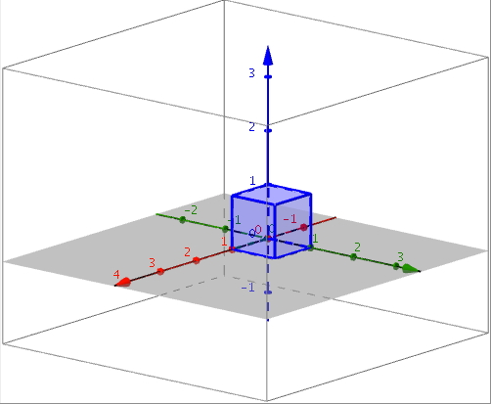

  - Perform $L_{4}$ and then $L_{3}$.
    - Since $L_{4}$ projects onto the $xy$-plane and $L_{3}$ scales in the $x$, $y$, and $z$ directions, the composition $L_{3}∘L_{4}$ will project onto the $xy$-plane and scale in the $x$ and $y$ directions.
    - $A_{3}⋅A_{4}=\left[\begin{matrix}2 & 0 & 0 \\ 0 & 3 & 0 \\ 0 & 0 & 4\end{matrix}\right]⋅\left[\begin{matrix}1 & 0 & 0 \\ 0 & 1 & 0 \\ 0 & 0 & 0\end{matrix}\right]=\left[\begin{matrix}2 & 0 & 0 \\ 0 & 3 & 0 \\ 0 & 0 & 0\end{matrix}\right]$.
    - The conjecture in part (i) is correct.
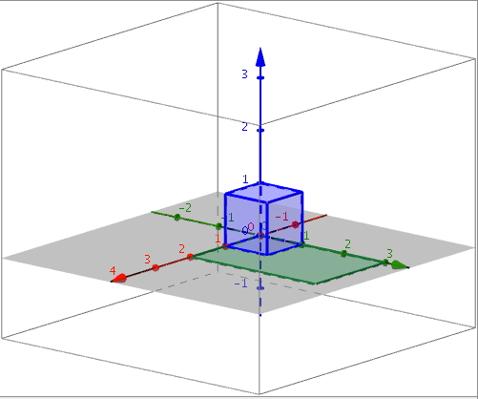

  - Perform $L_{3}$ and then $L_{7}$.
    - Since $L_{3}$ scales in the $x, y,$ and $z$ directions and so does $L_{7}$, the composition will be a transformation that also scales in all three directions but with different scale factors.
    - $A_{7}⋅A_{3}= \left[\begin{matrix}2 & 0 & 0 \\ 0 & 1 & 0 \\ 0 & 0 & \frac{1}{2}\end{matrix}\right]⋅\left[\begin{matrix}2 & 0 & 0 \\ 0 & 3 & 0 \\ 0 & 0 & 4\end{matrix}\right]=\left[\begin{matrix}4 & 0 & 0 \\ 0 & 3 & 0 \\ 0 & 0 & 2\end{matrix}\right]$.
    - The conjecture from (i) is correct.
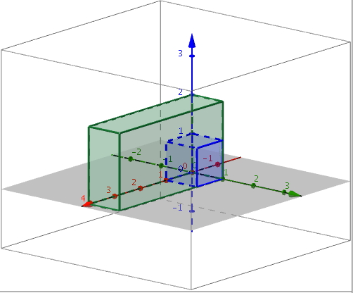

  - Perform $L_{8}$ and then $L_{4}$.
    - Transformation $L_{8}$ rotates the unit cube by $45°$ about the $z$-axis and stretches by a factor of $\sqrt{2}$ in both the $x$ and $y$ directions, while $L_{4}$ projects the image onto the $xy$-plane. The composition will transform the unit cube into a larger square that has been rotated $45°$ in the $xy$-plane.
    - $A_{4}⋅A_{8}= \left[\begin{matrix}1 & 0 & 0 \\ 0 & 1 & 0 \\ 0 & 0 & 0\end{matrix}\right]⋅\left[\begin{matrix}1 & -1 & 0 \\ 1 & 1 & 0 \\ 0 & 0 & 1\end{matrix}\right]=\left[\begin{matrix}1 & -1 & 0 \\ 1 & 1 & 0 \\ 0 & 0 & 0\end{matrix}\right]$.

    - The conjecture from part (i) is correct.
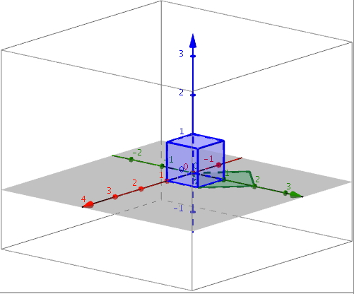

  - Perform $L_{4}$ and then $L_{6}$.
    - Transformation $L_{4}$ projects onto the $xy$-plane, and transformation $L_{6}$ reflects across the plane through the line $y=x$ in the $xy$-plane and is perpendicular to the $xy$-plane, so the composition $L_{6}∘L_{4}$ will appear to be the reflection in the $xy$-plane across the line $y=x$.
    - $A_{6}⋅A_{4}=\left[\begin{matrix}0 & 1 & 0 \\ 1 & 0 & 0 \\ 0 & 0 & 1\end{matrix}\right]⋅\left[\begin{matrix}1 & 0 & 0 \\ 0 & 1 & 0 \\ 0 & 0 & 0\end{matrix}\right]=\left[\begin{matrix}0 & 1 & 0 \\ 1 & 0 & 0 \\ 0 & 0 & 0\end{matrix}\right]$.
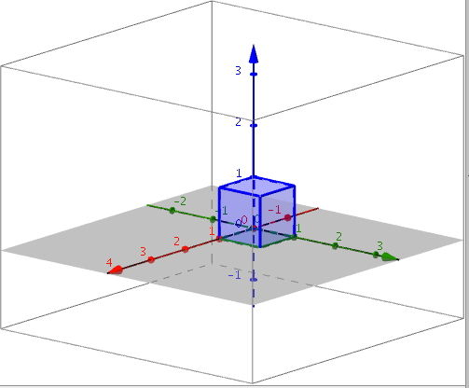
    - The conjecture in part (i) is correct.

  - Perform $L_{2}$ and then $L_{7}$.
    - Since $L_{2}$ rotates $90°$ around the $y$-axis and $L_{7}$ scales in the $x$ and $z$ directions, the composition $L_{7}∘L_{2}$ will rotate and scale simultaneously.
    - $A_{7}⋅A_{2}= \left[\begin{matrix}2 & 0 & 0 \\ 0 & 1 & 0 \\ 0 & 0 & \frac{1}{2}\end{matrix}\right]⋅\left[\begin{matrix}0 & 0 & -1 \\ 0 & 1 & 0 \\ 1 & 0 & 0\end{matrix}\right]=\left[\begin{matrix}0 & 0 & -2 \\ 0 & 1 & 0 \\ \frac{1}{2} & 0 & 0\end{matrix}\right]$.
    - The conjecture in part (i) is correct.
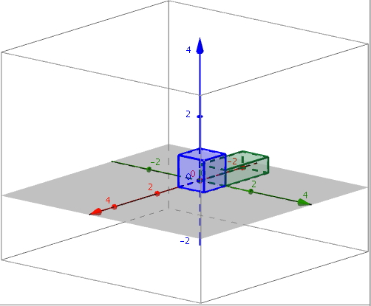

  - Perform $L_{8}$ and then $L_{8}$.
    - Since $L_{8}$ rotates by $45°$ about the $z$-axis and scales by $\sqrt{2}$ in the $x$ and $y$ directions, performing this transformation twice will rotate by $90°$ about the $z$-axis and scale by $2$ in the $x$ and $y$ directions.
    - $A_{8}⋅A_{8}=\left[\begin{matrix}1 & -1 & 0 \\ 1 & 1 & 0 \\ 0 & 0 & 1\end{matrix}\right]⋅\left[\begin{matrix}1 & -1 & 0 \\ 1 & 1 & 0 \\ 0 & 0 & 1\end{matrix}\right]=\left[\begin{matrix}0 & -2 & 0 \\ 2 & 0 & 0 \\ 0 & 0 & 1\end{matrix}\right]$.
    - The conjecture in part (i) is correct.
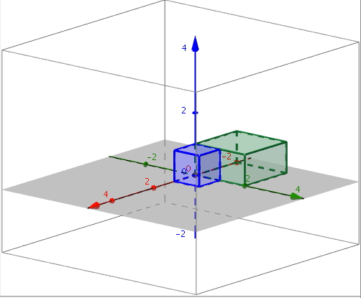

- Do a 30-second Quick Write on what we have discovered in Exploratory Challenge 1, and share with your neighbor.

Exploratory Challenge 2 (Optional)
This optional challenge is for students who finished Exploratory Challenge 1 early. The challenge below is designed to prompt the question of whether or not order matters when composing two linear transformations, a question that is definitively answered in the next lesson and demonstrates that matrix multiplication is in general not commutative. Students are asked to compose two linear transformations $L_{A}$ and $L_{B}$, with matrices $A$ and $B$ respectively, and to compare $L_{A}∘L_{B}$ with $L_{B}∘L_{A}$. The directions for this challenge are left intentionally vague so that students may use either an algebraic or a geometric approach to answer the question.
Exploratory Challenge 2
Transformations $L_{1}$-$L_{8}$ refer to the transformations from the Opening Exercise. For each of the following pairs of matrices $A$ and $B$ below, compare the transformations $L_{A}∘L_{B}$ and $L_{B}∘L_{A}$.
  - $L_{4}$ and $L_{5}$
Transformation $L_{4}∘L_{5}$ has matrix representation $A_{4}⋅A_{5}=\left[\begin{matrix}1 & 0 & 0 \\ 0 & 1 & 0 \\ 0 & 0 & 0\end{matrix}\right]⋅\left[\begin{matrix}1 & 0 & 0 \\ 0 & 0 & 0 \\ 0 & 0 & 1\end{matrix}\right]=\left[\begin{matrix}1 & 0 & 0 \\ 0 & 0 & 0 \\ 0 & 0 & 0\end{matrix}\right]$, and transformation $L_{5}∘L_{4}$ has matrix representation ${A_{5}∘A}_{4}=\left[\begin{matrix}1 & 0 & 0 \\ 0 & 0 & 0 \\ 0 & 0 & 1\end{matrix}\right]⋅\left[\begin{matrix}1 & 0 & 0 \\ 0 & 1 & 0 \\ 0 & 0 & 0\end{matrix}\right]=\left[\begin{matrix}1 & 0 & 0 \\ 0 & 0 & 0 \\ 0 & 0 & 0\end{matrix}\right]$. Since the two transformations have the same matrix representation, they are the same transformation:
$L_{5}∘L_{4}=L_{4}∘L_{5}$.

  - $L_{2}$ and $L_{5}$
Transformation $L_{2}∘L_{5}$ has matrix representation $A_{2}⋅A_{5}=\left[\begin{matrix}0 & 0 & -1 \\ 0 & 1 & 0 \\ 1 & 0 & 0\end{matrix}\right]⋅\left[\begin{matrix}1 & 0 & 0 \\ 0 & 0 & 0 \\ 0 & 0 & 1\end{matrix}\right]=\left[\begin{matrix}0 & 0 & -1 \\ 0 & 0 & 0 \\ 1 & 0 & 0\end{matrix}\right]$, and transformation $L_{5}∘L_{2}$ has matrix representation $A_{5}⋅A_{2}=\left[\begin{matrix}1 & 0 & 0 \\ 0 & 0 & 0 \\ 0 & 0 & 1\end{matrix}\right]⋅\left[\begin{matrix}0 & 0 & -1 \\ 0 & 1 & 0 \\ 1 & 0 & 0\end{matrix}\right]=\left[\begin{matrix}0 & 0 & -1 \\ 0 & 0 & 0 \\ 1 & 0 & 0\end{matrix}\right]$. Since the two transformations have the same matrix representation, they are the same transformation:
$L_{2}∘L_{5}=L_{5}∘L_{2}$.

  - $L_{3}$ and $L_{7}$
Transformation $L_{3}∘L_{7}$ has matrix representation $A_{3}⋅A_{7}=\left[\begin{matrix}2 & 0 & 0 \\ 0 & 3 & 0 \\ 0 & 0 & 4\end{matrix}\right]⋅\left[\begin{matrix}2 & 0 & 0 \\ 0 & 1 & 0 \\ 0 & 0 & \frac{1}{2}\end{matrix}\right]=\left[\begin{matrix}4 & 0 & 0 \\ 0 & 3 & 0 \\ 0 & 0 & 2\end{matrix}\right]$, and transformation $L_{7}∘L_{3}$ has matrix representation $A_{7}⋅A_{3}=\left[\begin{matrix}2 & 0 & 0 \\ 0 & 1 & 0 \\ 0 & 0 & \frac{1}{2}\end{matrix}\right]⋅\left[\begin{matrix}2 & 0 & 0 \\ 0 & 3 & 0 \\ 0 & 0 & 4\end{matrix}\right]=\left[\begin{matrix}4 & 0 & 0 \\ 0 & 3 & 0 \\ 0 & 0 & 2\end{matrix}\right]$.
Since the two transformations have the same matrix representation, they are the same transformation:
$L_{3}∘L_{7}=L_{7}∘L_{3}$.

  - $L_{3}$ and $L_{6}$
Transformation $L_{3}∘L_{6}$ has matrix representation $A_{3}⋅A_{6}=\left[\begin{matrix}2 & 0 & 0 \\ 0 & 3 & 0 \\ 0 & 0 & 4\end{matrix}\right]⋅\left[\begin{matrix}0 & 1 & 0 \\ 1 & 0 & 0 \\ 0 & 0 & 1\end{matrix}\right]=\left[\begin{matrix}0 & 2 & 0 \\ 3 & 0 & 0 \\ 0 & 0 & 4\end{matrix}\right]$, and transformation $L_{6}∘L_{3}$ has matrix representation $A_{6}⋅A_{3}=\left[\begin{matrix}0 & 1 & 0 \\ 1 & 0 & 0 \\ 0 & 0 & 1\end{matrix}\right]⋅\left[\begin{matrix}2 & 0 & 0 \\ 0 & 3 & 0 \\ 0 & 0 & 4\end{matrix}\right]=\left[\begin{matrix}0 & 3 & 0 \\ 2 & 0 & 0 \\ 0 & 0 & 4\end{matrix}\right]$.
Since the two transformations have different matrix representations, they are not the same transformation: $L_{3}∘L_{6}≠L_{6}∘L_{3}$.

  - $L_{7}$ and $L_{1}$
Transformation $L_{7}∘L_{1}$ has matrix representation $A_{7}⋅A_{1}=\left[\begin{matrix}2 & 0 & 0 \\ 0 & 1 & 0 \\ 0 & 0 & \frac{1}{2}\end{matrix}\right]⋅\left[\begin{matrix}0 & -1 & 0 \\ 1 & 0 & 0 \\ 0 & 0 & 1\end{matrix}\right]=\left[\begin{matrix}0 & -2 & 0 \\ 1 & 0 & 0 \\ 0 & 0 & \frac{1}{2}\end{matrix}\right]$, and transformation $L_{1}∘L_{7}$ has matrix representation $A_{1}⋅A_{7}=\left[\begin{matrix}0 & -1 & 0 \\ 1 & 0 & 0 \\ 0 & 0 & 1\end{matrix}\right]⋅\left[\begin{matrix}2 & 0 & 0 \\ 0 & 1 & 0 \\ 0 & 0 & \frac{1}{2}\end{matrix}\right]=\left[\begin{matrix}0 & -1 & 0 \\ 2 & 0 & 0 \\ 0 & 0 & \frac{1}{2}\end{matrix}\right]$. Since the two transformations have different matrix representations, they are not the same transformation: $L_{1}∘L_{7}≠L_{7}∘L_{1}$.

  - What can you conclude about the order in which you compose two linear transformations?
In some cases, the order of composition of two linear transformations matters: for two matrices $A$ and $B$, the transformation $L_{A}∘L_{B}$ is not always the same transformation as $L_{B}∘L_{A}$.

Closing (4 minutes)
Ask students to summarize the key points of the lesson in writing or to a partner. Some important summary elements are listed below.
Lesson Summary
- The linear transformation induced by a $3×3$matrix $AB$ has the same geometric effect as the sequence of the linear transformation induced by the $3×3$matrix $B$ followed by the linear transformation induced by the $3×3$matrix $A$.
- That is, if matrices $A$ and $B$induce linear transformations $L_{A}$ and $L_{B}$ in $R^{3}$, respectively, then the linear transformation $L_{AB}$ induced by the matrix $AB$ satisfies $L_{AB}\left(\left[\begin{aligned}x \\ y \\ z\end{aligned}\right]\right)=L_{A}\left(L_{B}\left(\left[\begin{aligned}x \\ y \\ z\end{aligned}\right]\right)\right)$.

$$.$$

Exit Ticket (4 minutes)

Name Date
Lesson 9: Composition of Linear Transformations

Exit Ticket

Let $A$ be the matrix representing a rotation about the $z$-axis of $45°$ and $B$ be the matrix representing a dilation of $2$.
  - Write down $A$ and $B$.

  - Let $x=\left[\begin{matrix}3 \\ -1 \\ 2\end{matrix}\right]$. Find the matrix representing a dilation of $x$ by $2$ followed by a rotation about the $z$-axis of $45°$.

  - Do your best to sketch a picture of $x$, $x$ after the first transformation, and $x$ after both transformations. You may use technology to help you.
Exit Ticket Sample Solutions

Let $A$ be the matrix representing a rotation about the $z$-axis of $45°$ and $B$ be the matrix representing a dilation of $2$.
  - Write down $A$ and $B$.
$$A=\left[\begin{matrix}\frac{\sqrt{2}}{2} & -\frac{\sqrt{2}}{2} & 0 \\ \frac{\sqrt{2}}{2} & \frac{\sqrt{2}}{2} & 0 \\ 0 & 0 & 1\end{matrix}\right]\text{,} B=\left[\begin{matrix}2 & 0 & 0 \\ 0 & 2 & 0 \\ 0 & 0 & 2\end{matrix}\right]$$

  - Let $x=\left[\begin{matrix}3 \\ -1 \\ 2\end{matrix}\right]$. Find the matrix representing a dilation of $x$ by $2$ followed by a rotation about the $z$-axis of $45°$.
$$AB=\left[\begin{matrix}\sqrt{2} & -\sqrt{2} & 0 \\ \sqrt{2} & \sqrt{2} & 0 \\ 0 & 0 & 2\end{matrix}\right]$$

  - Do your best to sketch a picture of $x$, $x$ after the first transformation, and $x$ after both transformations. You may use technology to help you.
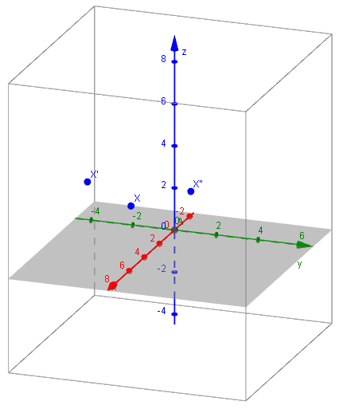

Problem Set Sample Solutions

- Let $A$ be the matrix representing a dilation of $\frac{1}{2}$, and let $B$ be the matrix representing a reflection across the $yz$-plane.
  - Write $A$ and $B$.
$$A=\left[\begin{matrix}\frac{1}{2} & 0 & 0 \\ 0 & \frac{1}{2} & 0 \\ 0 & 0 & \frac{1}{2}\end{matrix}\right], B=\left[\begin{matrix}-1 & 0 & 0 \\ 0 & 1 & 0 \\ 0 & 0 & 1\end{matrix}\right]$$

  - Evaluate $AB$. What does this matrix represent?
$$AB=\left[\begin{matrix}-\frac{1}{2} & 0 & 0 \\ 0 & \frac{1}{2} & 0 \\ 0 & 0 & \frac{1}{2}\end{matrix}\right]$$
$AB$ is a reflection across the $yz$-plane followed by a dilation of $\frac{1}{2}$.

  - Let $x=\left[\begin{matrix}5 \\ 6 \\ 4\end{matrix}\right]$,$y=\left[\begin{matrix}-1 \\ 3 \\ 2\end{matrix}\right]$, and $z=\left[\begin{matrix}8 \\ -2 \\ -4\end{matrix}\right]$. Find $\left(AB\right)x, \left(AB\right)y,$ and $(AB) z$ .
$$\left(AB\right)x=\left[\begin{matrix}-\frac{5}{2} \\ 3 \\ 2\end{matrix}\right]\text{,} \left(AB\right)y=\left[\begin{matrix}\frac{1}{2} \\ \frac{3}{2} \\ 1\end{matrix}\right]\text{,} \left(AB\right)z=\left[\begin{matrix}4 \\ -1 \\ -2\end{matrix}\right]$$

- Let $A$ be the matrix representing a rotation of $30°$ about the $x$-axis, and let $B$ be the matrix representing a dilation of $5$.
  - Write $A$ and $B$.
$$A=\left[\begin{matrix}1 & 0 & 0 \\ 0 & \frac{\sqrt{3}}{2} & -\frac{1}{2} \\ 0 & \frac{1}{2} & \frac{\sqrt{3}}{2}\end{matrix}\right]\text{,} B=\left[\begin{matrix}5 & 0 & 0 \\ 0 & 5 & 0 \\ 0 & 0 & 5\end{matrix}\right]$$

  - Evaluate $AB$. What does this matrix represent?
$$AB=\left[\begin{matrix}5 & 0 & 0 \\ 0 & \frac{5\sqrt{3}}{2} & -\frac{5}{2} \\ 0 & \frac{5}{2} & \frac{5\sqrt{3}}{2}\end{matrix}\right]$$
$AB$ is a dilation of $5$ followed by a rotation of $30°$ about the $x$-axis.

  - Let $x=\left[\begin{matrix}1 \\ 0 \\ 0\end{matrix}\right]\text{,} y=\left[\begin{matrix}0 \\ 1 \\ 0\end{matrix}\right]\text{,} z=\left[\begin{matrix}0 \\ 0 \\ 1\end{matrix}\right]$. Find $\left(AB\right)x\text{,} \left(AB\right)y\text{,} \text{and} \left(AB\right)z$.
$$\left(AB\right)x=\left[\begin{matrix}5 \\ 0 \\ 0\end{matrix}\right]$$
$$\left(AB\right)y=\left[\begin{matrix}0 \\ \frac{5\sqrt{3}}{2} \\ \frac{5}{2}\end{matrix}\right]$$
$$\left(AB\right)z=\left[\begin{matrix}0 \\ \frac{5}{2} \\ \frac{5\sqrt{3}}{2}\end{matrix}\right]$$

- Let $A$ be the matrix representing a dilation of $3$, and let $B$ be the matrix representing a reflection across the plane $y=x$.
  - Write $A$ and $B$.
$$A=\left[\begin{matrix}3 & 0 & 0 \\ 0 & 3 & 0 \\ 0 & 0 & 3\end{matrix}\right], B=\left[\begin{matrix}0 & 1 & 0 \\ 1 & 0 & 0 \\ 0 & 0 & 1\end{matrix}\right]$$

  - Evaluate $AB$. What does this matrix represent?
$$AB=\left[\begin{matrix}0 & 3 & 0 \\ 3 & 0 & 0 \\ 0 & 0 & 3\end{matrix}\right]$$
$AB$ is a reflection across the $y=x$ plane followed by a dilation of $3$.

  - Let $x=\left[\begin{matrix}-2 \\ 7 \\ 3\end{matrix}\right]$. Find $\left(AB\right)x$.
$$\left(AB\right)x=\left[\begin{matrix}21 \\ -6 \\ 9\end{matrix}\right]$$

- Let $A=\left[\begin{matrix}3 & 0 & 0 \\ 3 & 3 & 0 \\ 0 & 0 & 1\end{matrix}\right], B=\left[\begin{matrix}0 & -1 & 0 \\ 1 & 0 & 0 \\ 0 & 0 & 1\end{matrix}\right]$.
  - Evaluate $AB$.
$$\left[\begin{matrix}0 & -3 & 0 \\ 3 & -3 & 0 \\ 0 & 0 & 1\end{matrix}\right]$$

  - Let $x=\left[\begin{matrix}-2 \\ 2 \\ 5\end{matrix}\right]$. Find $\left(AB\right)x$.
$$\left[\begin{matrix}-6 \\ -12 \\ 5\end{matrix}\right]$$

  - Graph $x$ and $\left(AB\right)x$.
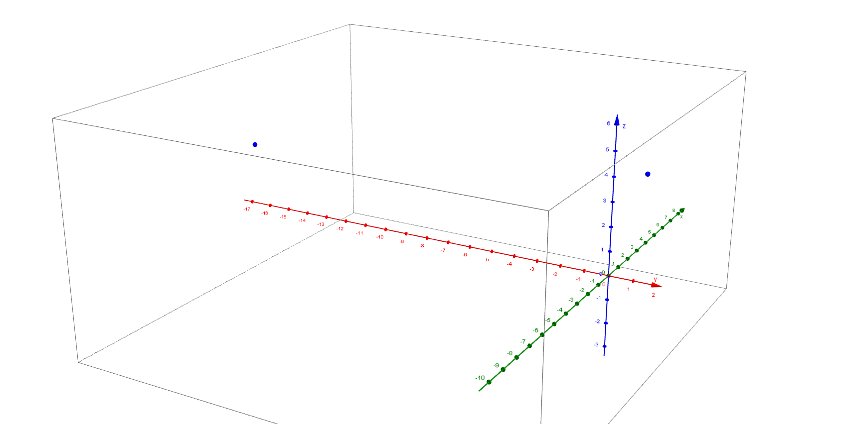
$$x$$
$$(AB)x$$

- Let $A=\left[\begin{matrix}\frac{1}{3} & 0 & 0 \\ 0 & 1 & 0 \\ 2 & 0 & \frac{1}{3}\end{matrix}\right]$,$B=\left[\begin{matrix}3 & 1 & 0 \\ 1 & -3 & 0 \\ 0 & 0 & 1\end{matrix}\right]$.
  - Evaluate $AB$.
$$\left[\begin{matrix}1 & \frac{1}{3} & 0 \\ 1 & -3 & 0 \\ 6 & 2 & \frac{1}{3}\end{matrix}\right]$$

  - Let $x=\left[\begin{matrix}0 \\ 3 \\ 2\end{matrix}\right]$. Find $\left(AB\right)x$.
$$\left[\begin{matrix}1 \\ -9 \\ \frac{20}{3}\end{matrix}\right]$$

  - Graph $x$ and $\left(AB\right)x$.
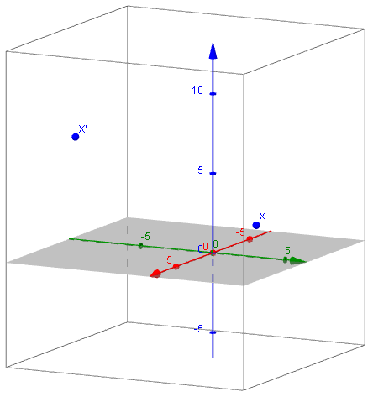

- Let $A=\left[\begin{matrix}2 & 0 & 0 \\ 0 & 3 & 0 \\ 0 & 0 & 8\end{matrix}\right]$,$B=\left[\begin{matrix}1 & 0 & 0 \\ 0 & 1 & 0 \\ 0 & 0 & 0\end{matrix}\right]$.
  - Evaluate $AB$.
$$\left[\begin{matrix}2 & 0 & 0 \\ 0 & 3 & 0 \\ 0 & 0 & 0\end{matrix}\right]$$

  - Let $x=\left[\begin{matrix}1 \\ -2 \\ 4\end{matrix}\right]$. Find $\left(AB\right)x$.
$$\left[\begin{matrix}2 \\ -6 \\ 0\end{matrix}\right]$$

  - Graph $x$ and $\left(AB\right)x$.
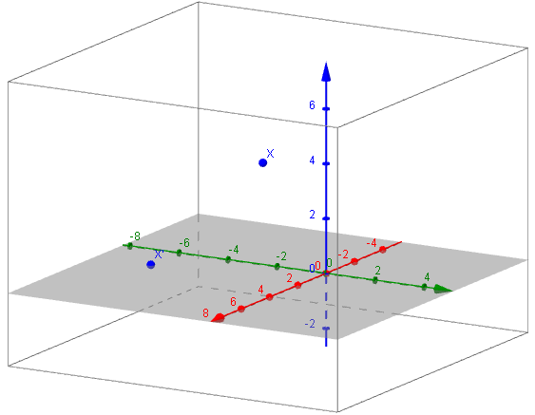

  - What does $AB$ represent geometrically?
AB represents a dilation of $2$ in the $x$-direction, $3$ in the $y$-direction, and a projection onto the $xy$-plane.

- Let $A,B,C$ be $3×3$ matrices representing linear transformations.
  - What does $A(BC)$ represent?
The linear transformation of applying the linear transformation that $C$ represents followed by the transformation that $B$ represents, followed by the transformation that $A$ represents.
MP.7

  - Will the pattern established in part (a) be true no matter how many matrices are multiplied on the left?
Yes, in general. When you multiply by a matrix on the left, you are applying a linear transformation after all linear transformations to the right have been applied.

  - Does $\left(AB\right)C$ represent something different from $A(BC)$? Explain.
No, it does not. This is the linear transformation obtained by applying C then $AB$, which is $B$ followed by $A$.

- Let $AB$ represent any composition of linear transformations in $R^{3}$. What is the value of $(AB)x$ where $x=\left[\begin{matrix}0 \\ 0 \\ 0\end{matrix}\right]$?
Since a composition of linear transformations in $R^{3}$is also a linear transformation, we know that applying it to the origin will result in no change.

