Lesson 8: Composition of Linear Transformations

Student Outcomes
- Students compose two linear transformations in the plane by multiplying the associated matrices.
- Students visualize composition of linear transformations in the plane.

Lesson Notes
In this lesson, students will examine the geometric effects of performing a sequence of two linear transformations in $R^{2}$ produced by various $2×2$ matrices on the unit square. The GeoGebra demo TransformSquare (http://eureka-math.org/G12M2L8/geogebra-TransformSquare) may be used in this lesson but is not necessary. This GeoGebra demo will allow the students to input values in $2×2$ matrices $A$ between $-5$ and $5$ in increments of $0.1$and visually see the effect of the transformation produced by the matrix $A$ on the unit square. If there aren’t enough computers for students to access the demos in pairs or small groups, modify the lesson. The teacher could have students work in groups on transformations, and then as parts of the Exploratory Challenge are finished, the teacher could show specific transformations to the entire class using the teacher computer. Another option would be to have different groups come up and show the transformation that they created by hand and then use the teacher computer to show that transformation using software.

Classwork
Opening (3 minutes)
In this lesson, we will consider the transformation that arises from doing two linear transformations in sequence.
Display each transformation matrix below on the board, and ask students what transformation the matrix represents.
$\left[\begin{matrix}2 & 0 \\ 0 & 2\end{matrix}\right]$ A dilation with a scale factor of $2$.
$\left[\begin{matrix}0 & 1 \\ 1 & 0\end{matrix}\right]$ A reflection across the line $y=x$.
$\left[\begin{matrix}2 & -1 \\ 1 & 2\end{matrix}\right]$ A rotation about the origin by $θ=\tan^{-1}\left(\frac{2}{1}\right)$ and a dilation with a scale factor of $\sqrt{2^{2}+1^{2}}=\sqrt{5}$.

- How could we represent a composition of two of these transformations?

Opening Exercise (5 minutes)
The focus of this lesson is on students recognizing that a matrix produced by a composition of two linear transformations in the plane is the product of the matrices of each transformation. Thus, we need students to review the process of multiplying $2×2$ matrices. The products used in this Opening Exercise will appear later in the lesson.
Opening Exercise
Compute the product $AB$ for the following pairs of matrices.
  - $A=\left[\begin{matrix}0 & -1 \\ 1 & 0\end{matrix}\right]$, $B=\left[\begin{matrix}0 & -1 \\ 1 & 0\end{matrix}\right]$
$$AB=\left[\begin{matrix}-1 & 0 \\ 0 & -1\end{matrix}\right]$$

  - $A=\left[\begin{matrix}1 & 0 \\ 0 & -1\end{matrix}\right]$, $B=\left[\begin{matrix}-1 & 0 \\ 0 & 1\end{matrix}\right]$
$$AB=\left[\begin{matrix}-1 & 0 \\ 0 & -1\end{matrix}\right]$$

  - $A=\left[\begin{matrix}\frac{\sqrt{2}}{2} & -\frac{\sqrt{2}}{2} \\ \frac{\sqrt{2}}{2} & \frac{\sqrt{2}}{2}\end{matrix}\right]$, $B=\left[\begin{matrix}4 & 0 \\ 0 & 4\end{matrix}\right]$
$$AB=\left[\begin{matrix}2\sqrt{2} & -2\sqrt{2} \\ 2\sqrt{2} & 2\sqrt{2}\end{matrix}\right]$$

  - $A=\left[\begin{matrix}1 & 1 \\ 0 & 1\end{matrix}\right]$, $B=\left[\begin{matrix}2 & 0 \\ 0 & 2\end{matrix}\right]$
$$AB=\left[\begin{matrix}2 & 2 \\ 0 & 2\end{matrix}\right]$$

  - $A=\left[\begin{matrix}\frac{1}{2} & \frac{\sqrt{3}}{2} \\ -\frac{\sqrt{3}}{2} & \frac{1}{2}\end{matrix}\right]$, $B=\left[\begin{matrix}\frac{\sqrt{3}}{2} & -\frac{1}{2} \\ \frac{1}{2} & \frac{\sqrt{3}}{2}\end{matrix}\right]$
$AB=\left[\begin{matrix}\frac{\sqrt{3}}{2} & \frac{1}{2} \\ -\frac{1}{2} & \frac{\sqrt{3}}{2}\end{matrix}\right]$
Scaffolding:
- Provide struggling students with colored pencils or markers to use to identify the three figures. For example, use blue for the original square, green for the square transformed by $L_{B}$, and red for the square transformed by $L_{B}$ and then $L_{A}$.
- Ask early finishers to figure out whether or not the geometric effect of performing first $L_{A}$ then $L_{B}$ is the same as performing first $L_{B}$ and then $L_{A}$.

Exploratory Challenge (25 minutes)
For this challenge, students use the GeoGebra demo TransformSquare.ggb to transform a unit square in the plane in order to explore the geometric effects of performing a sequence of two linear transformations defined by matrix multiplication for different matrices $A$ and $B$. While the software will illustrate a single transformation via matrix multiplication, students will have to reason through the effects of doing two transformations in sequence. If possible, allow students to access the software themselves. If there is no way for students to access the software themselves, have them plot the transformed vertices of the unit square and draw conclusions from there.

Exploratory Challenge
- For each pair of matrices $A$ and $B$ given below:
    - Describe the geometric effect of the transformation $L_{B}\left(\left[\begin{aligned}x \\ y\end{aligned}\right]\right)=B⋅\left[\begin{aligned}x \\ y\end{aligned}\right]$.
    - Describe the geometric effect of the transformation $L_{A}\left(\left[\begin{aligned}x \\ y\end{aligned}\right]\right)=A⋅\left[\begin{aligned}x \\ y\end{aligned}\right]$.
    - Draw the image of the unit square under the transformation $L_{B}\left(\left[\begin{aligned}x \\ y\end{aligned}\right]\right)=B⋅\left[\begin{aligned}x \\ y\end{aligned}\right]$.
    - Draw the image of the transformed square under the transformation $L_{A}\left(\left[\begin{aligned}x \\ y\end{aligned}\right]\right)=A⋅\left[\begin{aligned}x \\ y\end{aligned}\right]$.
    - Describe the geometric effect on the unit square of performing first $L_{B}$ then $L_{A}$.
    - Compute the matrix product $AB$.
    - Describe the geometric effect of the transformation $L_{AB}\left(\left[\begin{aligned}x \\ y\end{aligned}\right]\right)=AB⋅\left[\begin{aligned}x \\ y\end{aligned}\right]$.

  - $A=\left[\begin{matrix}0 & -1 \\ 1 & 0\end{matrix}\right]$, $B=\left[\begin{matrix}0 & -1 \\ 1 & 0\end{matrix}\right]$
    - The transformation produced by matrix $B$has the effect of rotation by $90°$ counterclockwise.
    - The transformation produced by matrix $A$ has the effect of rotation by $90°$ counterclockwise.
    - The green square in the second quadrant is the image of the original square under the transformation produced by $B$.

    - The red square in the third quadrant is the image of the square after transforming with matrix $A$then matrix $B$.

    - If we rotate twice by $90°$, then the net effect is a rotation by $180°$.
    - The matrix product is $AB=\left[\begin{matrix}-1 & 0 \\ 0 & -1\end{matrix}\right]$.
    - The transformation produced by matrix $AB$ has the effect of rotation by $180°$.

  - $A=\left[\begin{matrix}1 & 0 \\ 0 & -1\end{matrix}\right]$, $B=\left[\begin{matrix}-1 & 0 \\ 0 & 1\end{matrix}\right]$
    - The transformation produced by matrix $B$has the effect of reflection across the $y$-axis.
    - The transformation produced by matrix $A$ has the effect of reflection across the $x$-axis.
    - The green square in the second quadrant is the image of the original square under the transformation produced by $B.$

    - The red square in the third quadrant is the image of the square after transforming with matrix $A$and then matrix $B$.

    - If we reflect across the $y$-axis and then reflect across the $x$-axis, the net effect is a rotation by $180°$.
    - The matrix product is $AB=\left[\begin{matrix}-1 & 0 \\ 0 & -1\end{matrix}\right]$.
    - The transformation produced by matrix $AB$ has the effect of rotation by $180°$.

  - $A=\left[\begin{matrix}\frac{\sqrt{2}}{2} & -\frac{\sqrt{2}}{2} \\ \frac{\sqrt{2}}{2} & \frac{\sqrt{2}}{2}\end{matrix}\right]$, $B=\left[\begin{matrix}4 & 0 \\ 0 & 4\end{matrix}\right]$
    - The transformation produced by matrix $B$has the effect of dilation from the origin with scale factor $4$.
    - The transformation produced by matrix $A$ has the effect of rotation by $45°$.
    - The large green square is the image of the original unit square under the transformation produced by $B$.

    - The tilted red square is the image of the green square under the transformation produced by $A$.

    - If we dilate with factor $4$ and then rotate by $45°,$ the net effect is a rotation by $45°$ and dilation with scale factor $4$.
    - The matrix product is $AB=\left[\begin{matrix}2\sqrt{2} & -2\sqrt{2} \\ 2\sqrt{2} & 2\sqrt{2}\end{matrix}\right]$.
    - The transformation produced by matrix $AB$ has the effect of rotation by $45°$ while scaling by $4$.

  - $A=\left[\begin{matrix}1 & 1 \\ 0 & 1\end{matrix}\right]$, $B=\left[\begin{matrix}2 & 0 \\ 0 & 2\end{matrix}\right]$
    - The transformation produced by matrix $B$has the effect of dilation with scale factor $2$.
    - The transformation produced by matrix $A$ has the effect of shearing parallel to the $y$-axis.
    - The large green square is the image of the original unit square under the transformation produced by $B$.

    - The red parallelogram is the image of the green square under the transformation produced by $A.$
    - If we dilate and then shear, the net effect is a dilated shear.
    - The matrix product is $AB=\left[\begin{matrix}2 & 2 \\ 0 & 2\end{matrix}\right]$.
    - The transformation produced by matrix $AB$ has the effect of a dilated shear.

  - $A=\left[\begin{matrix}\frac{1}{2} & \frac{\sqrt{3}}{2} \\ -\frac{\sqrt{3}}{2} & \frac{1}{2}\end{matrix}\right]$, $B=\left[\begin{matrix}\frac{\sqrt{3}}{2} & -\frac{1}{2} \\ \frac{1}{2} & \frac{\sqrt{3}}{2}\end{matrix}\right]$
    - The transformation produced by matrix $B$has the effect of rotation by $30°$.
    - The transformation produced by matrix $A$ has the effect of rotation by $–60°$.

    - The tilted green square is the image of the original unit square under the transformation produced by $B.$

    - The tilted red square is the image of the green square under the transformation produced by $A$.

    - If we rotate by $30°$ counterclockwise and then rotate by $60°$ clockwise, the net result is a rotation by $30°$ counterclockwise.
    - The matrix product is $AB=\left[\begin{matrix}\frac{\sqrt{3}}{2} & \frac{1}{2} \\ -\frac{1}{2} & \frac{\sqrt{3}}{2}\end{matrix}\right]$
    - The transformation produced by matrix $AB$ has the effect of rotation by $–30°$.

- Make a conjecture about the geometric effect of the linear transformation produced by the matrix $AB$. Justify your answer.
MP.3
&
MP.2
The linear transformation produced by matrix $AB$ has the same geometric effect of the sequence of the linear transformation produced by matrix $B$ followed by the linear transformation produced by matrix $A$. We have seen in previous work that if we multiply by $AB$, we get the same transformation as when we multiplied by $A$ first and then multiplied the result by $B$ .

Discussion (5 minutes)
In this discussion, we justify why the conjecture the students made at the end of Exploratory Challenge is valid.
- What was the conjecture you made at the end of the Exploratory Challenge?
  - The transformation that comes from the matrix $AB$ has the same geometric effect as the sequence of transformations that come from the matrix $B$ first and then $A$.
- Why does matrix $AB$ represent $B$ first and then $A?$ Doesn’t that seem backwards?
- If we look at this as multiplication, we are multiplying
$$L_{AB}\left(\left[\begin{aligned}x \\ y\end{aligned}\right]\right)=\left(AB\right)⋅\left[\begin{aligned}x \\ y\end{aligned}\right] \\ =A\left(B⋅\left[\begin{aligned}x \\ y\end{aligned}\right]\right) \\ =L_{A}\left(L_{B}\left(\left[\begin{aligned}x \\ y\end{aligned}\right]\right)\right),$$so the point $(x,y)$ is transformed first by $L_{B}$, and then the result is transformed by $L_{A}$. It looks backwards, but the transformation on the right happens to our point first. We saw this phenomenon in Geometry when we represented a rotation by $θ$ about the origin by $R_{0,θ}$ and a reflection across line $l$ by $r_{l}$. Then doing the rotation and then the reflection is denoted by $r_{l}∘R_{O, θ}$, which represents the combined effect of first performing the rotation $R_{O,θ}$ and then the reflection $r_{l}$.

Closing (3 minutes)
Ask students to summarize the key points of the lesson in writing or to a partner. Some important summary elements are listed below.
Lesson Summary
The linear transformation produced by matrix $AB$ has the same geometric effect as the sequence of the linear transformation produced by matrix $B$ followed by the linear transformation produced by matrix $A$.
That is, if matrices $A$ and $B$produce linear transformations $L_{A}$ and $L_{B}$ in the plane, respectively, then the linear transformation $L_{AB}$ produced by the matrix $AB$ satisfies
$L_{AB}\left(\left[\begin{aligned}x \\ y\end{aligned}\right]\right)=L_{A}\left(L_{B}\left(\left[\begin{aligned}x \\ y\end{aligned}\right]\right)\right)$.

$$.$$

Exit Ticket (4 minutes)

Name Date
Lesson 8: Composition of Linear Transformations

Exit Ticket

Let $A$ be the matrix representing a rotation about the origin $135°$ and $B$ be the matrix representing a dilation of $6$. Let $x=\left[\begin{matrix}-1 \\ \frac{1}{2}\end{matrix}\right]$.
  - Write down $A$ and $B$.

  - Find the matrix representing a dilation of $x$ by $6$, followed by a rotation about the origin of $135°$.

  - Graph and label $x$, $x$ after a dilation of $6$, and $x$ after both transformations have been applied.

Exit Ticket Sample Solutions

Let $A$ be the matrix representing a rotation about the origin $135°$ and $B$ be the matrix representing a dilation of $6$. Let $x=\left[\begin{matrix}-1 \\ \frac{1}{2}\end{matrix}\right]$.
  - Write down $A$ and $B$.
$$A=\left[\begin{matrix}-\frac{\sqrt{2}}{2} & -\frac{\sqrt{2}}{2} \\ \frac{\sqrt{2}}{2} & -\frac{\sqrt{2}}{2}\end{matrix}\right], B=\left[\begin{matrix}6 & 0 \\ 0 & 6\end{matrix}\right]$$

  - Find the matrix representing a dilation $x$ by $6$, followed by a rotation about the origin of $135°$.
$$AB=\left[\begin{matrix}-3\sqrt{2} & -3\sqrt{2} \\ 3\sqrt{2} & -3\sqrt{2}\end{matrix}\right]$$

  - Graph and label $x$, $x$ after a dilation of $6$, and $x$ after both transformations have been applied.
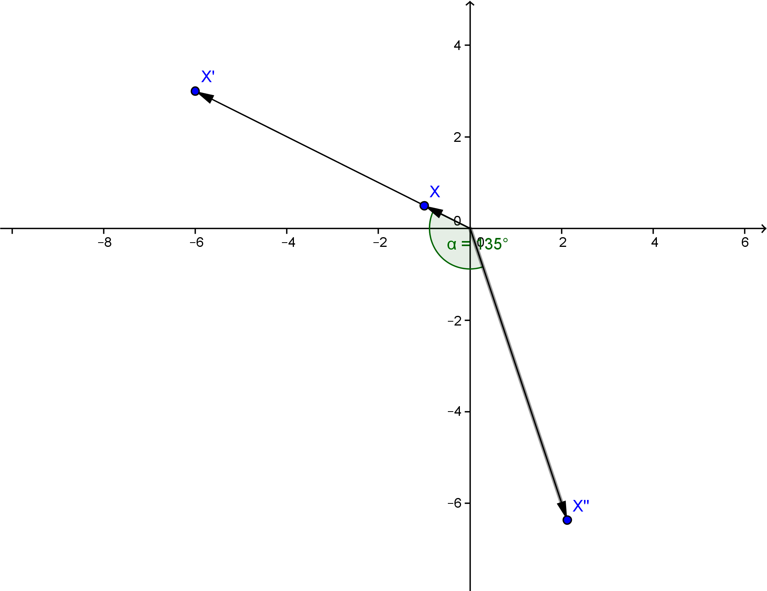

Problem Set Sample Solutions

- Let $A$ be the matrix representing a dilation of $\frac{1}{2}$, and let $B$ be the matrix representing a reflection across the $y$-axis.
  - Write $A$ and $B$.
$$A=\left[\begin{matrix}\frac{1}{2} & 0 \\ 0 & \frac{1}{2}\end{matrix}\right]\text{,} B=\left[\begin{matrix}-1 & 0 \\ 0 & 1\end{matrix}\right]$$

  - Evaluate $AB$. What does this matrix represent?
$$AB=\left[\begin{matrix}-\frac{1}{2} & 0 \\ 0 & \frac{1}{2}\end{matrix}\right]$$
$AB$ is a reflection across the $y$-axis followed by a dilation of $\frac{1}{2}$.

  - Let $x=\left[\begin{matrix}5 \\ 6\end{matrix}\right]$,$y=\left[\begin{matrix}-1 \\ 3\end{matrix}\right]$, and $z=\left[\begin{matrix}8 \\ -2\end{matrix}\right]$. Find $\left(AB\right)x$,$\left(AB\right)y$, and $(AB)$z.
$$\left(AB\right)x=\left[\begin{matrix}-\frac{5}{2} \\ 3\end{matrix}\right]\text{,} \left(AB\right)y=\left[\begin{matrix}\frac{1}{2} \\ \frac{3}{2}\end{matrix}\right]\text{,} \left(AB\right)z=\left[\begin{matrix}4 \\ -1\end{matrix}\right]$$

- Let $A$ be the matrix representing a rotation of $30°$, and let $B$ be the matrix representing a dilation of $5$.
  - Write $A$ and $B$.
$$A=\left[\begin{matrix}\frac{\sqrt{3}}{2} & -\frac{1}{2} \\ \frac{1}{2} & \frac{\sqrt{3}}{2}\end{matrix}\right]\text{,} B=\left[\begin{matrix}5 & 0 \\ 0 & 5\end{matrix}\right]$$

  - Evaluate $AB$. What does this matrix represent?
$$AB=\left[\begin{matrix}\frac{5\sqrt{3}}{2} & -\frac{5}{2} \\ \frac{5}{2} & \frac{5\sqrt{3}}{2}\end{matrix}\right]$$
$AB$ is a dilation of $5$ followed by a rotation of $30°$.

  - Let $x=\left[\begin{matrix}1 \\ 0\end{matrix}\right]$. Find $\left(AB\right)x$.
$$\left(AB\right)x=\left[\begin{matrix}\frac{5\sqrt{3}}{2} \\ \frac{5}{2}\end{matrix}\right]$$

- Let $A$ be the matrix representing a dilation of $3$, and let $B$ be the matrix representing a reflection across the line
$y=x$.
  - Write $A$ and $B$.
$$A=\left[\begin{matrix}3 & 0 \\ 0 & 3\end{matrix}\right]\text{,} B=\left[\begin{matrix}0 & 1 \\ 1 & 0\end{matrix}\right]$$

  - Evaluate $AB$. What does this matrix represent?
$$AB=\left[\begin{matrix}0 & 3 \\ 3 & 0\end{matrix}\right]$$
$AB$ is a reflection across the line $y=x$ followed by a dilation of $3$.

  - Let $x=\left[\begin{matrix}-2 \\ 7\end{matrix}\right]$. Find $\left(AB\right)x$.
$$\left(AB\right)x=\left[\begin{matrix}21 \\ -6\end{matrix}\right]$$

- Let $A=\left[\begin{matrix}3 & 0 \\ 3 & 3\end{matrix}\right]and B=\left[\begin{matrix}0 & -1 \\ 1 & 0\end{matrix}\right]$.
  - Evaluate $AB$.
$$\left[\begin{matrix}0 & -3 \\ 3 & -3\end{matrix}\right]$$

  - Let $x=\left[\begin{matrix}-2 \\ 2\end{matrix}\right]$. Find $\left(AB\right)x$.
$$\left[\begin{matrix}-6 \\ -12\end{matrix}\right]$$

  - Graph $x$ and $\left(AB\right)x$.
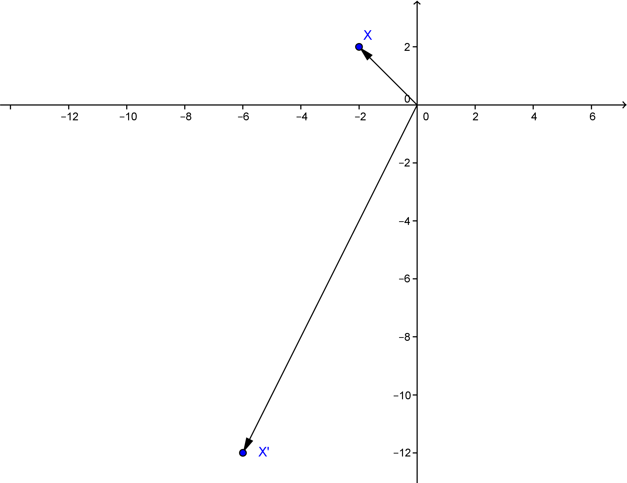

- Let $A=\left[\begin{matrix}\frac{1}{3} & 0 \\ 2 & \frac{1}{3}\end{matrix}\right]\text{and} B=\left[\begin{matrix}3 & 1 \\ 1 & -3\end{matrix}\right]$.
  - Evaluate $AB$.
$$\left[\begin{matrix}1 & \frac{1}{3} \\ \frac{19}{3} & 1\end{matrix}\right]$$

  - Let $x=\left[\begin{matrix}0 \\ 3\end{matrix}\right]$. Find $\left(AB\right)x$.
$$\left[\begin{matrix}1 \\ 3\end{matrix}\right]$$

  - Graph $x$ and $\left(AB\right)x$.
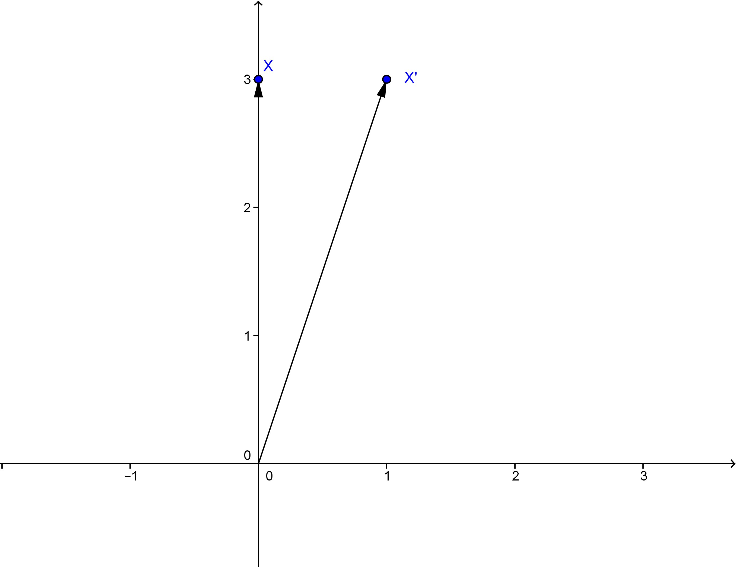

- Let $A=\left[\begin{matrix}2 & 2 \\ 2 & 0\end{matrix}\right] and B=\left[\begin{matrix}0 & 2 \\ 2 & 2\end{matrix}\right]$.
  - Evaluate $AB$.
$$\left[\begin{matrix}4 & 8 \\ 0 & 4\end{matrix}\right]$$

  - Let $x=\left[\begin{matrix}3 \\ -2\end{matrix}\right]$. Find $\left(AB\right)x$.
$$\left[\begin{matrix}-4 \\ -8\end{matrix}\right]$$

  - Graph $x$ and $\left(AB\right)$.
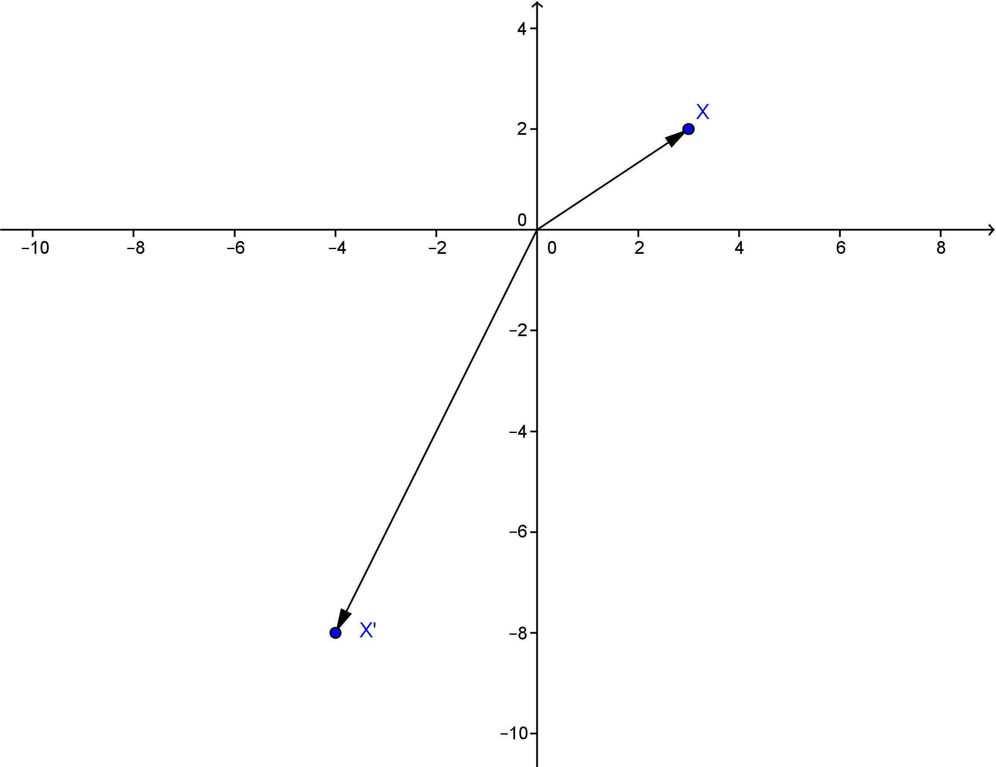

- Let $A$,$B$, $C$ be $2×2$ matrices representing linear transformations.
  - What does $A(BC)$ represent?
$A(BC)$ represents the linear transformation of applying the transformation that $C$ represents followed by the transformation that $B$ represents, followed by the transformation that $A$ represents.
MP.7
  - Will the pattern established in part (a) be true no matter how many matrices are multiplied on the left?
Yes, in general. When you multiply by a matrix on the left, you are applying a linear transformation after all linear transformations to the right have been applied.

  - Does $\left(AB\right)C$ represent something different from $A(BC)$? Explain.
No, it does not. This is the linear transformation obtained by applying C and then $AB$, which is $B$ followed by $A$.

- Let $AB$ represent any composition of linear transformations in $R^{2}$. What is the value of $(AB)x$ where $x=\left[\begin{matrix}0 \\ 0\end{matrix}\right]$?
Since a composition of linear transformations in $R^{2}$is also a linear transformation, we know that applying it to the origin will result in no change.

