Lesson 7: Linear Transformations Applied to Cubes

Student Outcomes
- Students construct $3×3$ matrices $A$ so that the linear transformation $L\left(\left[\begin{matrix}x \\ y \\ z\end{matrix}\right]\right)=A\left[\begin{matrix}x \\ y \\ z\end{matrix}\right]$ has a desired geometric effect.
- Students identify the geometric effect of the linear transformation $L\left(\left[\begin{matrix}x \\ y \\ z\end{matrix}\right]\right)=A\left[\begin{matrix}x \\ y \\ z\end{matrix}\right]$ based on the structure of the $3×3$ matrix $A$.

Lesson Notes
In this lesson, students will examine the geometric effects of linear transformations in $R^{3}$ induced by various $3×3$ matrices on the unit cube. This lesson extends work done in Module 1 in which students studied analogous transformations in $R^{2}$ using $2×2$ matrices. This lesson is written for classes that have access to the GeoGebra demo TransformCubes (http://eureka-math.org/G12M2L7/geogebra-TransformCubes). This GeoGebra demo will allow the students to input values in a $3×3$ matrix between $-5$ and $5$ in increments of $0.1$and visually see the effect of the transformation induced by the matrix on the unit cube. If there aren’t enough computers for students to access the demo in pairs or small groups, then the lesson will need to be modified accordingly. If the demo is not available, students can come to the same conclusion by plotting points in 3-dimensional space. In this case, teachers may want to have students plot points and then show visuals from the teacher pages of actual screen shots from the demo to help students visualize the transformations. In addition to the tasks included in the lesson, students are encouraged to explore and play with the demo file to discover the connections between the structure of a $3×3$ matrix and the geometric effect of the transformation induced by the matrix.

Classwork
Opening Exercise (10 minutes)
The Opening Exercise allows students to review the geometric effects of linear transformations in the plane induced by various $2×2$matrices. Students will then extend this idea to transformations in space induced by $3×3$ matrices.
Opening Exercise
Consider the following matrices: $A=\left[\begin{matrix}1 & 2 \\ 2 & 4\end{matrix}\right]$,$B=\left[\begin{matrix}2 & 0 \\ 0 & 0\end{matrix}\right]$, and $C=\left[\begin{matrix}2 & -2 \\ 2 & 2\end{matrix}\right]$
  - Compute the following determinants.
    - $det\left(A\right)$
$det\left(A\right)=4-4=0$
    - $det\left(B\right)$
$det\left(B\right)=0-0=0$

    - $det\left(C\right)$
$det\left(C\right)=4-(-4)=8$

  - Sketch the image of the unit square after being transformed by each transformation.
    - $L_{A}\left(\left[\begin{matrix}x \\ y\end{matrix}\right]\right)=\left[\begin{matrix}1 & 2 \\ 2 & 4\end{matrix}\right]\left[\begin{matrix}x \\ y\end{matrix}\right]$
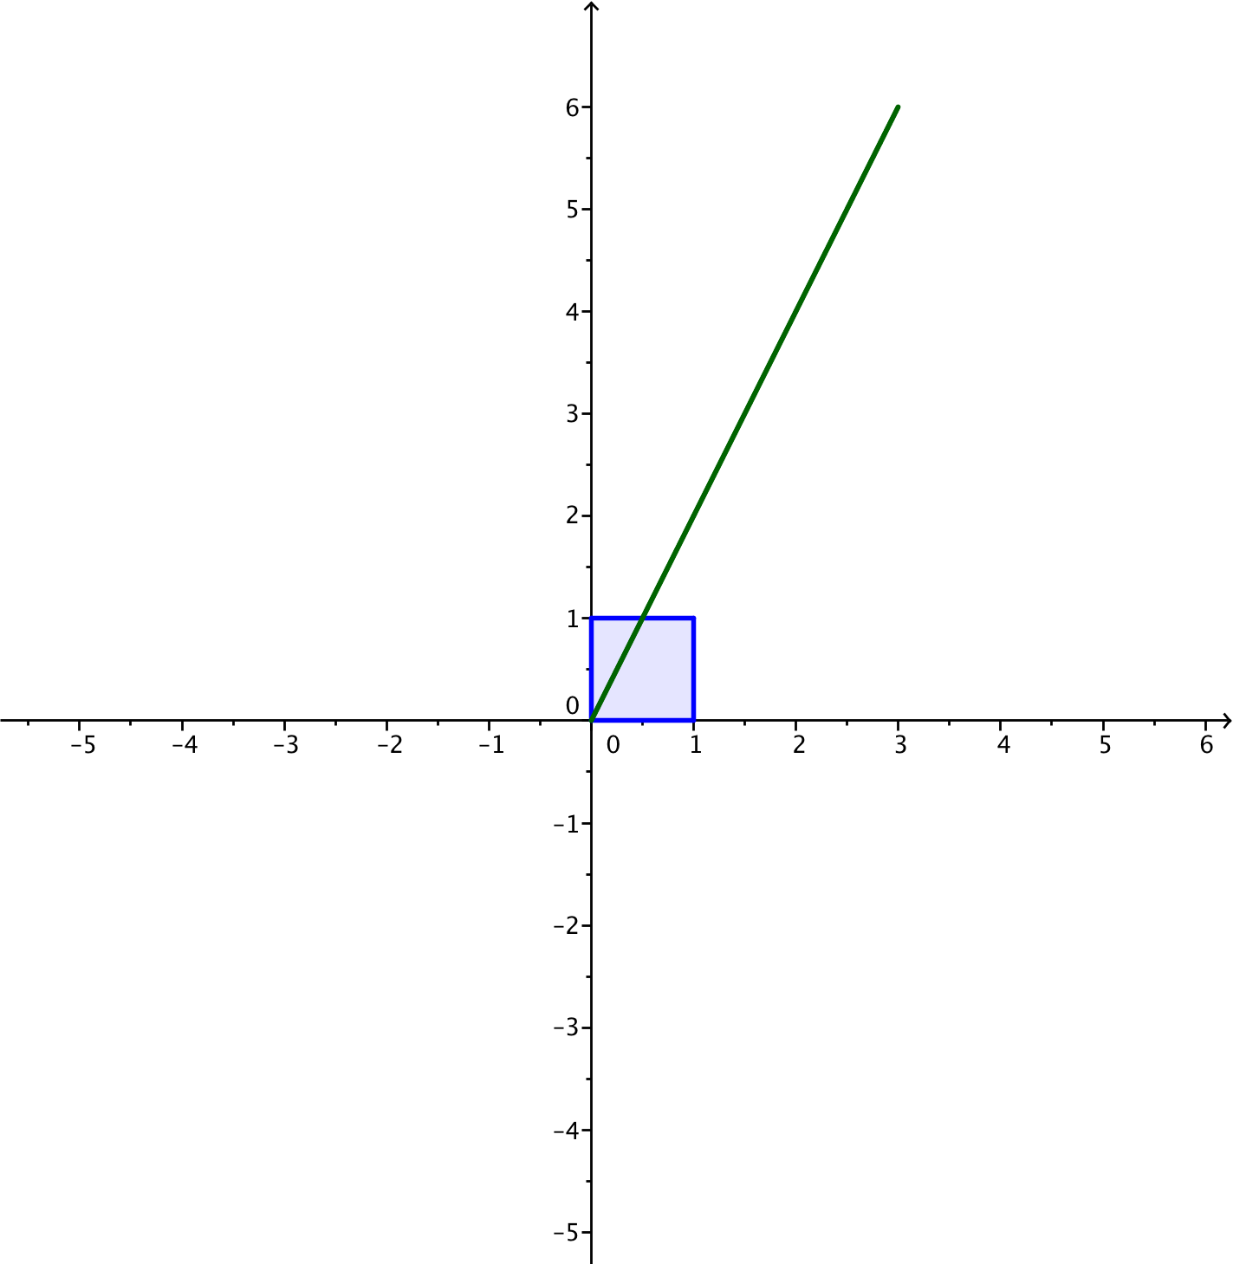
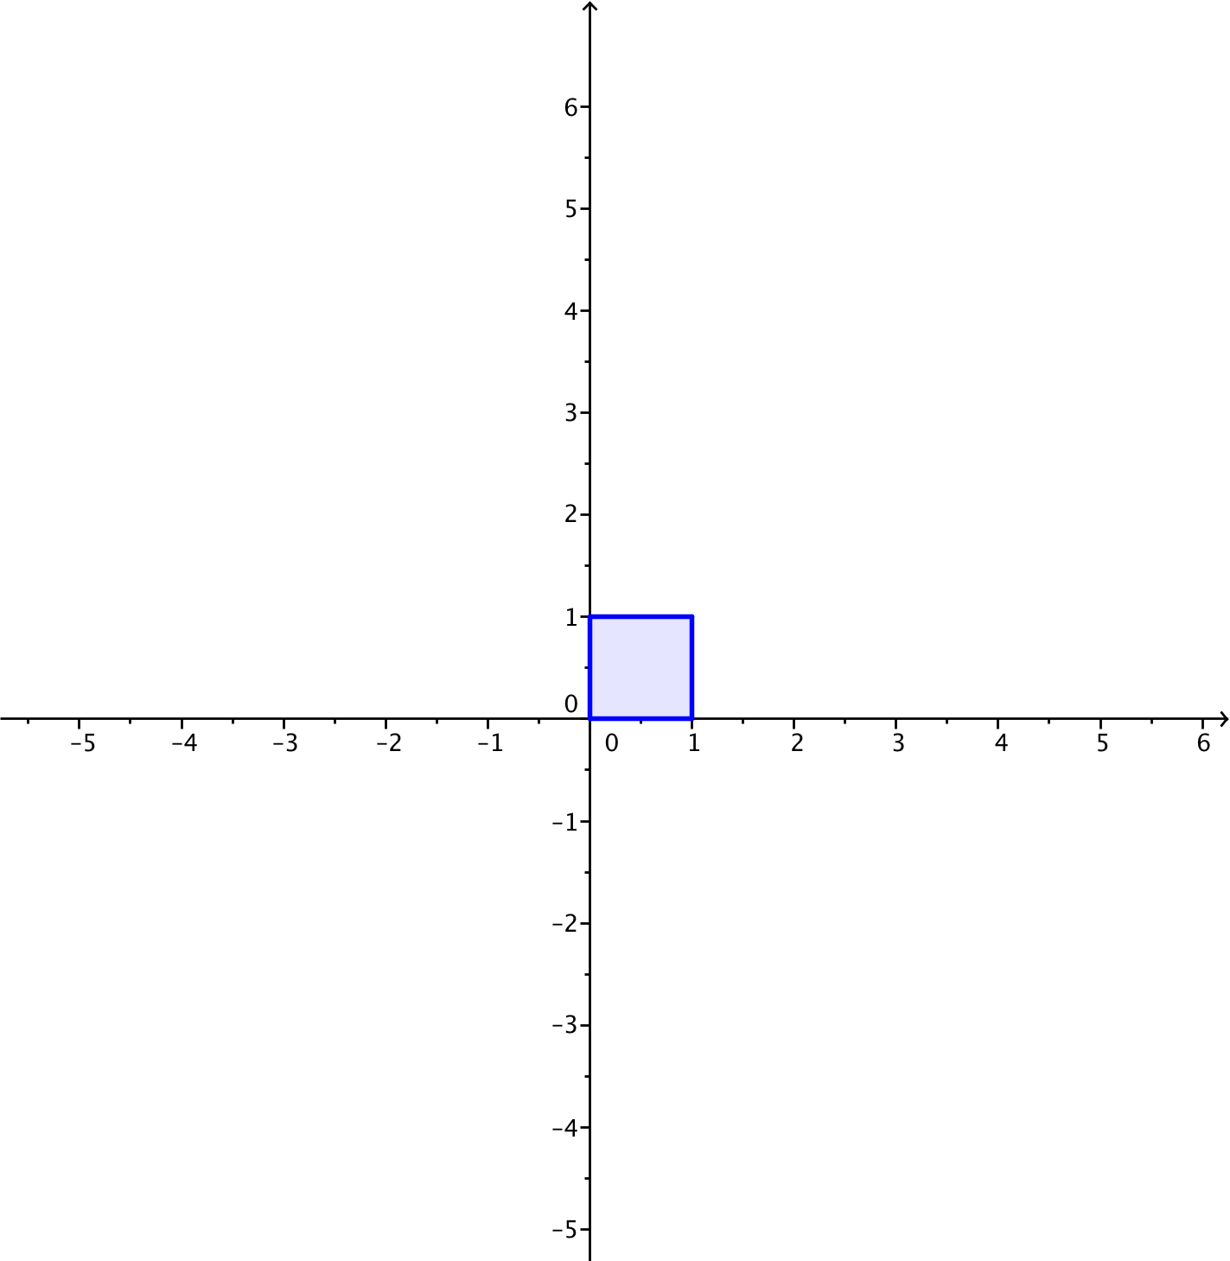

    - $L_{B}\left(\left[\begin{matrix}x \\ y\end{matrix}\right]\right)=\left[\begin{matrix}2 & 0 \\ 0 & 0\end{matrix}\right]\left[\begin{matrix}x \\ y\end{matrix}\right]$

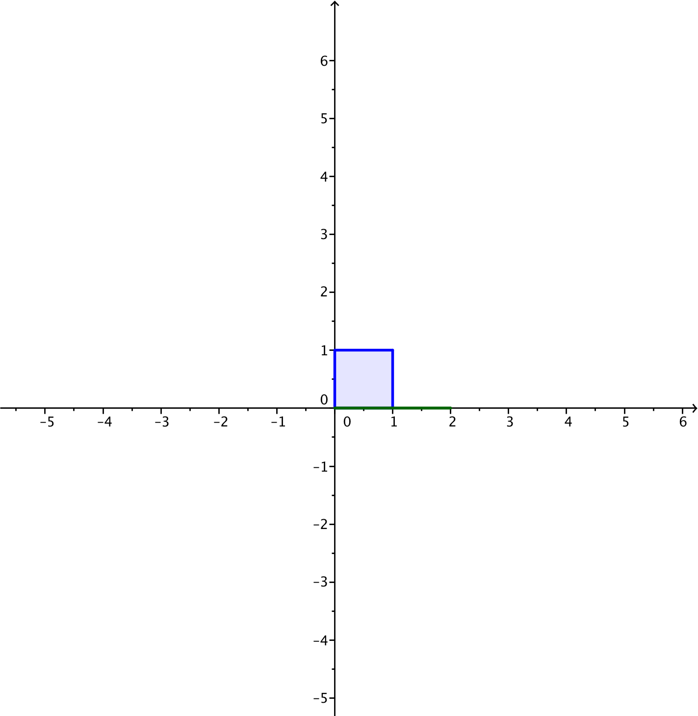

    - $L_{C}\left(\left[\begin{matrix}x \\ y\end{matrix}\right]\right)=\left[\begin{matrix}2 & -2 \\ 2 & 2\end{matrix}\right]\left[\begin{matrix}x \\ y\end{matrix}\right]$

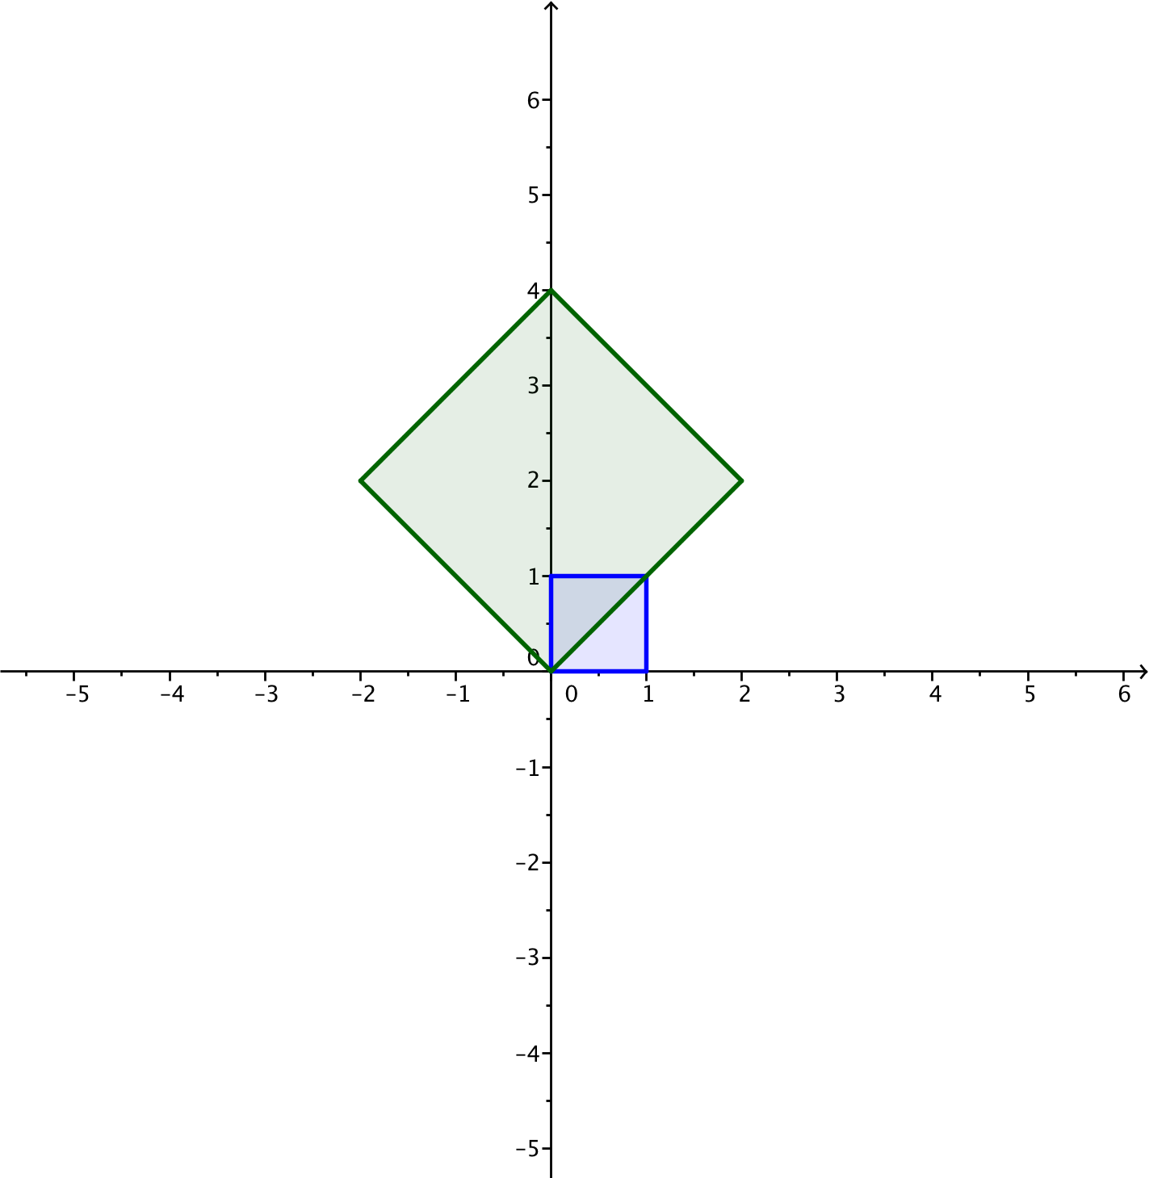

Scaffolding:
- Pair students so that students who can easily see the transformations are paired with students who struggle.
- Give students with spatial difficulties pictures of the transformed images, and have them label the transformed points.
- Have advanced learners create transformations and the accompanying matrix on their own and present different transformations to the class.

  - Find the area of each image of the unit square in Part 2.
The first two have no area because each image is a line segment. The third one is a square with sides of length $2\sqrt{2}$, so its area is ${\left(2\sqrt{2}\right)}^{2}=8$.
MP.2
&
MP.7
  - Explain the connection between the responses to Parts 1 and 3.
The determinant of the matrix $A$ is the area of the image of the unit square under the transformation induced by $A$.

Discussion (2 minutes)
Use this discussion to have students share the connections they made in part (d) of the Opening Exercise.
- What happens to the unit square under a transformation $L\left(\left[\begin{aligned}x \\ y\end{aligned}\right]\right)=A⋅\left[\begin{aligned}x \\ y\end{aligned}\right]$ when the matrix $A$has a determinant of 0?
  - The square is transformed into a line segment.
- Does such a transformation have an inverse?
  - No. There is no way to undo this transformation because we don’t know where it came from.
- In the same way, we want to explore the geometric effect of a linear transformation induced by matrix multiplication on the unit cube.

Example 1 (5 minutes)
If the program is not available, have students plot the original image and the transformation in 3 dimensions and color code them. You can also show the images in the teacher materials below to help students visualize the transformations at first and then have them draw different transformations.
- What do we expect the geometric effect of the transformation $L\left(\left[\begin{aligned}x \\ y \\ z\end{aligned}\right]\right)=\left[\begin{matrix}1 & 0 & 0 \\ 0 & -1 & 0 \\ 0 & 0 & -1\end{matrix}\right]⋅\left[\begin{aligned}x \\ y \\ z\end{aligned}\right]$ will be on the unit cube?
- One way to find out would be to transform the vertices of the cube. If we do that, we find the following transformed points.
$$\left(0,0,0\right)→(0,0,0)$$ | $\left(1,1,0\right)→(1,-1,0)$
$\left(1,0,0\right)→\left(1,0,0\right)$ | $\left(1,0,1\right)→(-1,0,-1)$
$\left(0,1,0\right)→(0,-1,0)$ | $\left(0,1,1\right)→(0,-1,-1)$
$\left(0,0,1\right)→(0,0,-1)$ | $$\left(1,1,1\right)→\left(1,-1,-1\right)$$
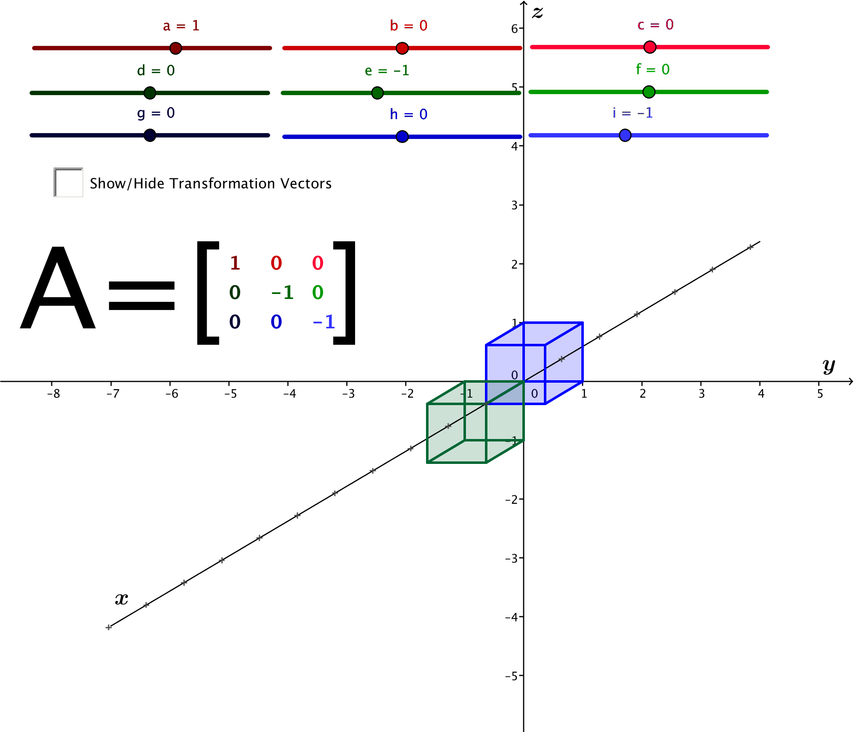

- It can be hard to truly see the image when plotting these points in three dimensions. Instead, let’s use GeoGebra. Project the GeoGebra demo “TransformCubes.ggb” so that all students can see it. Use the sliders to set $a=1$, $e=-1,$ $i=-1,$ and the remaining entries in the matrix to $0$ as shown below. The image above is an exact copy of the file screen that students and teachers can use to make sure they are using the correct settings.
- Using the software, we can see the blue cube before the transformation using matrix $A,$ and the green figure is the image of the original cube after the transformation using matrix $A$. What appears to be the geometric effect of multiplication by the matrix $A$?
  - The green cube is the result of rotating $180°$ about the $x$-axis.
It may not be obvious that the green cube is the result of rotating and not from translating, but remind students that a linear transformation never changes the origin. In this case, $L\left(\left[\begin{aligned}0 \\ 0 \\ 0\end{aligned}\right]\right)=\left[\begin{aligned}0 \\ 0 \\ 0\end{aligned}\right]$. Knowing that the origin doesn’t change makes it more obvious that the transformation $L\left(\left[\begin{aligned}x \\ y \\ z\end{aligned}\right]\right)=\left[\begin{matrix}1 & 0 & 0 \\ 0 & -1 & 0 \\ 0 & 0 & -1\end{matrix}\right]⋅\left[\begin{aligned}x \\ y \\ z\end{aligned}\right]$ has the geometric effect of rotation about the $x$-axis.

Exploratory Challenge 1 (10 minutes)
For this Exploratory Challenge, students use the GeoGebra demo TransformCubes.ggb to explore the geometric effects of a linear transformation defined by matrix multiplication for different matrices $A$. Screen shots of the GeoGebra file is shown in the steps below so students can see transformations and matrices. If possible, allow students to access the software themselves. If there is no way for students to access the software themselves, have them plot the transformed vertices of the unit cube, color coding the original image and its transformation, and draw conclusions from there. Students plotted points in 3 dimensions in the previous lessons. Students may need a quick reminder that if a transformation has an inverse, then each point in the image came from exactly one point on the cube, so that we can undo the function in a well-defined way.
Exploratory Challenge 1
For each matrix $A$ given below:
    - Plot the image of the unit cube under the transformation.
    - Find the volume of the image of the unit cube from part (i).
    - Does the transformation have an inverse? If so, what is the matrix that induces the inverse transformation?

  - $A=\left[\begin{matrix}2 & 0 & 0 \\ 0 & 2 & 0 \\ 0 & 0 & 2\end{matrix}\right]$

    - The image of the unit cube is a cube with sides of length $2$. Thus, the volume of the image of the unit cube is $2⋅2⋅2=8$.

    - This transformation has an inverse. To undo dilation by $2$, we need to dilate by $\frac{1}{2}$. The matrix that represents the inverse transformation is $B=\left[\begin{matrix}\frac{1}{2} & 0 & 0 \\ 0 & \frac{1}{2} & 0 \\ 0 & 0 & \frac{1}{2}\end{matrix}\right]$.

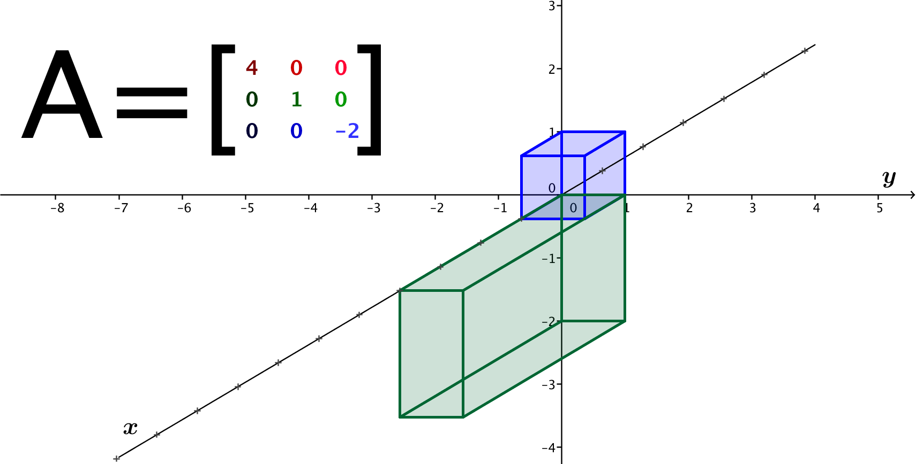
  - $A=\left[\begin{matrix}4 & 0 & 0 \\ 0 & 1 & 0 \\ 0 & 0 & -2\end{matrix}\right]$

    - The image of the unit cube is a box with sides of length $4$, $1,$ and $2$. Thus, the volume of the image of the unit cube is $4⋅1⋅2=8$.
    - This transformation is also invertible. To undo this transformation, we need to scale by $\frac{1}{4}$ in the $x$-direction, by $1$ in the $y$-direction, and by $–\frac{1}{2}$ in the $z$-direction. The matrix that will induce this inverse transformation is $B=\left[\begin{matrix}\frac{1}{4} & 0 & 0 \\ 0 & 1 & 0 \\ 0 & 0 & -\frac{1}{2}\end{matrix}\right]$.
  - $A=\left[\begin{matrix}4 & 0 & 0 \\ 0 & 0 & 0 \\ 0 & 0 & 2\end{matrix}\right]$
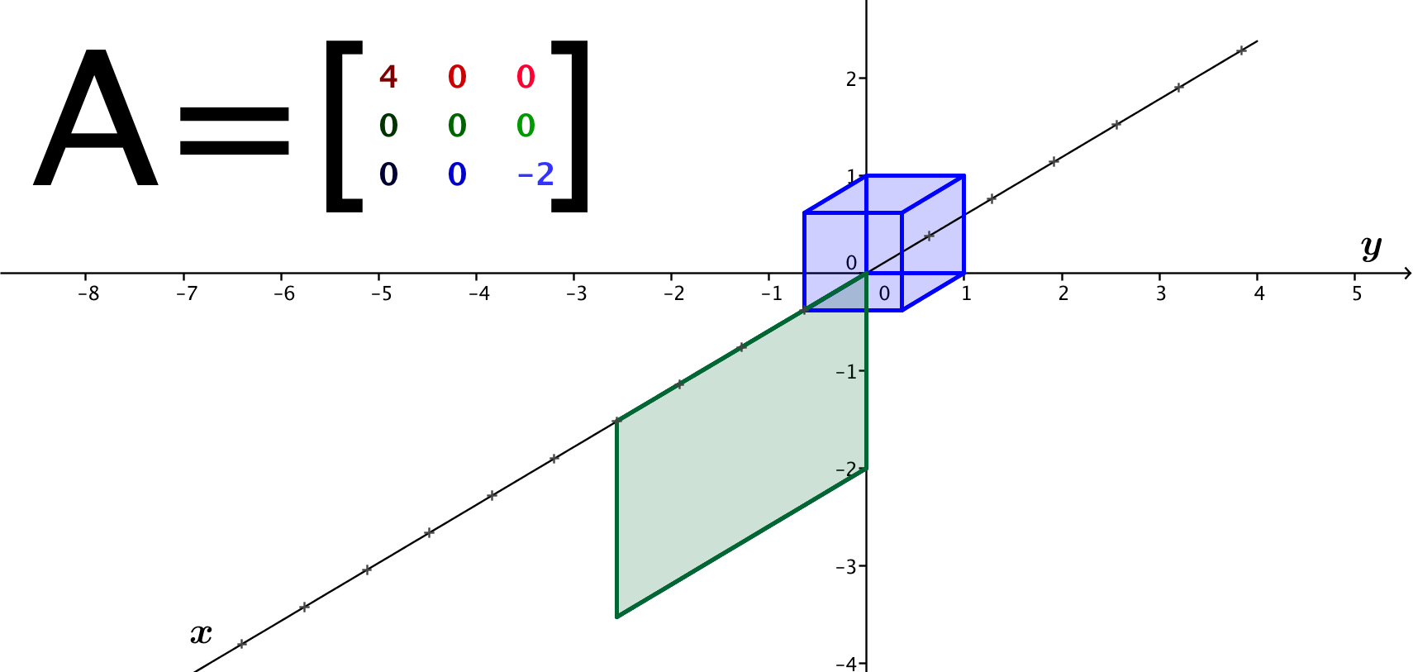

    - The image of the unit cube is a rectangle with sides of length $2$ and $4$. Thus, the volume of the image of the unit cube is $4⋅0⋅2=0$.
    - This transformation is not invertible, since the image was collapsed from a cube onto a rectangle. Many points get sent to the same point on the rectangle, so we cannot undo the transformation in a clear way.

  - Describe the geometric effect of a transformation $L\left(\left[\begin{aligned}x \\ y \\ z\end{aligned}\right]\right)=\left[\begin{matrix}a & 0 & 0 \\ 0 & b & 0 \\ 0 & 0 & c\end{matrix}\right]⋅\left[\begin{aligned}x \\ y \\ z\end{aligned}\right]$ for numbers $a$, $b$, and $c$. Describe when such a transformation is invertible.
The transformation $L$ scales the side of the cube along the $x$-axis by $a$, the side of the cube along the $y$-axis by $b$, and the side of the cube along the $z$-axis by $c$. If any of the numbers $a$, $b,$ and $c$ are zero, then the image is no longer a three-dimensional figure, so the transformation will not be invertible. Thus, the transformation is invertible only when $a≠0$, $b≠0$, and $c≠0$.

Exploratory Challenge 2 (10 minutes)
For this challenge, students continue to use the GeoGebra demo TransformCubes.ggb to explore the geometric effects of a linear transformation defined by matrix multiplication. A screen shot of the file is shown below. In this case, students are asked to discover how matrix multiplication can produce rotation about an axis. Encourage the students to play with the software and explore how different geometric effects arise from different matrix structures.
Exploratory Challenge 2
  - Make a prediction: What would be the geometric effect of the transformation
$L\left(\left[\begin{aligned}x \\ y \\ z\end{aligned}\right]\right)=\left[\begin{matrix}1 & 0 & 0 \\ 0 & cos(45°) & -sin(45°) \\ 0 & sin(45°) & cos(45°)\end{matrix}\right]⋅\left[\begin{aligned}x \\ y \\ z\end{aligned}\right]$ on the unit cube? Use the GeoGebra demo to test your conjecture.

Students should recognize that this transformation should have something to do with rotation. However, they will most likely need to see the resulting image before identifying it as rotation by $45°$ about the $x$-axis.
  - For each geometric transformation below, find a matrix $A$ so that the geometric effect of $L\left(\left[\begin{aligned}x \\ y \\ z\end{aligned}\right]\right)=A⋅\left[\begin{aligned}x \\ y \\ z\end{aligned}\right]$ is the specified transformation.
    - Rotation by $–45°$ about the $x$-axis.
$$A=\left[\begin{matrix}1 & 0 & 0 \\ 0 & cos\left(-45°\right) & sin\left(-45°\right) \\ 0 & sin\left(-45°\right) & cos\left(-45°\right)\end{matrix}\right]=\left[\begin{matrix}1 & 0 & 0 \\ 0 & \frac{\sqrt{2}}{2} & \frac{\sqrt{2}}{2} \\ 0 & -\frac{\sqrt{2}}{2} & \frac{\sqrt{2}}{2}\end{matrix}\right]$$

    - Rotation by $45°$ about the $y$-axis.
$$A=\left[\begin{matrix}cos(45°) & 0 & -sin\left(45°\right) \\ 0 & 1 & 0 \\ sin\left(45°\right) & 0 & cos\left(45°\right)\end{matrix}\right]=\left[\begin{matrix}\frac{\sqrt{2}}{2} & 0 & -\frac{\sqrt{2}}{2} \\ 0 & 1 & 0 \\ \frac{\sqrt{2}}{2} & 0 & \frac{\sqrt{2}}{2}\end{matrix}\right]$$

    - Rotation by $45°$ about the $z$-axis.
$$A=\left[\begin{matrix}cos\left(45°\right) & -sin\left(45°\right) & 0 \\ sin\left(45°\right) & cos\left(45°\right) & 0 \\ 0 & 0 & 1\end{matrix}\right]=\left[\begin{matrix}\frac{\sqrt{2}}{2} & -\frac{\sqrt{2}}{2} & 0 \\ \frac{\sqrt{2}}{2} & \frac{\sqrt{2}}{2} & 0 \\ 0 & 0 & 1\end{matrix}\right]$$

    - Rotation by $90°$ about the $x$-axis.
$$A=\left[\begin{matrix}1 & 0 & 0 \\ 0 & cos\left(90°\right) & -sin\left(90°\right) \\ 0 & sin\left(90°\right) & cos\left(90°\right)\end{matrix}\right]=\left[\begin{matrix}1 & 0 & 0 \\ 0 & 0 & -1 \\ 0 & 1 & 0\end{matrix}\right]$$

    - Rotation by $90°$ about the $y$-axis.
$$A=\left[\begin{matrix}cos(90°) & 0 & -sin\left(90°\right) \\ 0 & 1 & 0 \\ sin\left(90°\right) & 0 & cos\left(90°\right)\end{matrix}\right]=\left[\begin{matrix}0 & 0 & -1 \\ 0 & 1 & 0 \\ 1 & 0 & 0\end{matrix}\right]$$

    - Rotation by $90°$ about the $z$-axis.
$$A=\left[\begin{matrix}cos\left(90°\right) & -sin\left(90°\right) & 0 \\ sin\left(90°\right) & cos\left(90°\right) & 0 \\ 0 & 0 & 1\end{matrix}\right]=\left[\begin{matrix}0 & -1 & 0 \\ 1 & 0 & 0 \\ 0 & 0 & 1\end{matrix}\right]$$

    - Rotation by $θ$ about the $x$-axis.
$$A=\left[\begin{matrix}1 & 0 & 0 \\ 0 & cos\left(θ\right) & -sin\left(θ\right) \\ 0 & sin\left(θ\right) & cos\left(θ\right)\end{matrix}\right]$$

    - Rotation by $θ$ about the $y$-axis.
$$A=\left[\begin{matrix}cos(θ) & 0 & -sin\left(θ\right) \\ 0 & 1 & 0 \\ sin\left(θ\right) & 0 & cos\left(θ\right)\end{matrix}\right]$$

    - Rotation by $θ$ about the $z$-axis.
$$A=\left[\begin{matrix}cos\left(θ\right) & -sin\left(θ\right) & 0 \\ sin\left(θ\right) & cos\left(θ\right) & 0 \\ 0 & 0 & 1\end{matrix}\right]$$

Exploratory Challenge 3 (Optional)
This challenge is for students who have completed the other challenges quickly. Allow students to play with the software and try to describe the geometric transformations that arise from $L\left(\left[\begin{aligned}x \\ y \\ z\end{aligned}\right]\right)=A⋅\left[\begin{aligned}x \\ y \\ z\end{aligned}\right]$ for the following matrices $A$. Exact pictures of file screens are shown below to help students and teachers.
Exploratory Challenge 3
Describe the geometric effect of each transformation $L\left(\left[\begin{aligned}x \\ y \\ z\end{aligned}\right]\right)=A⋅\left[\begin{aligned}x \\ y \\ z\end{aligned}\right]$ for the given matrices $A$. Be as specific as you can.
  - $A=\left[\begin{matrix}1 & 0 & 0 \\ 0 & 0 & 1 \\ 0 & 1 & 0\end{matrix}\right]$

The images of the two cubes coincide; this transformation reflects across the plane through the points $(1,0,0)$, $(1,1,1)$, $\left(0,1,1\right)$, and $\left(0,0,0\right)$.

  - $A=\left[\begin{matrix}2 & 1 & 0 \\ 2 & 1 & 0 \\ 2 & 1 & 0\end{matrix}\right]$

This transformation collapses the cube onto a line segment from $(0,0,0)$ to $(3,3,3)$.

  - $A=\left[\begin{matrix}2 & 2 & 0 \\ -2 & 2 & 0 \\ 0 & 0 & 1\end{matrix}\right]$

This transformation stretches the cube in the $x$ and $y$ directions and then rotates by $–45°$.

Closing (3 minutes)
Ask students to summarize the key points of the lesson in writing or to a partner. Some important summary elements are listed below.

Lesson Summary
- For a matrix $A$, the transformation $L\left(\left[\begin{aligned}x \\ y \\ z\end{aligned}\right]\right)=A⋅\left[\begin{aligned}x \\ y \\ z\end{aligned}\right]$ is a function from points in space to points in space.
- Different matrices induce transformations such as rotation, dilation, and reflection.
- The transformation induced by a diagonal matrix $A=\left[\begin{matrix}a & 0 & 0 \\ 0 & b & 0 \\ 0 & 0 & c\end{matrix}\right]$ will scale by $a$ in the direction parallel to the $x$-axis, by $b$ in the direction parallel to the $y$-axis, and by $c$ in the direction parallel to the $z$-axis.
- The matrices $\left[\begin{matrix}1 & 0 & 0 \\ 0 & cos\left(θ\right) & -sin\left(θ\right) \\ 0 & sin\left(θ\right) & cos\left(θ\right)\end{matrix}\right]$, $\left[\begin{matrix}cos\left(θ\right) & 0 & -sin\left(θ\right) \\ 0 & 1 & 0 \\ sin\left(θ\right) & 0 & cos\left(θ\right)\end{matrix}\right]$ , and $\left[\begin{matrix}cos\left(θ\right) & -sin\left(θ\right) & 0 \\ sin\left(θ\right) & cos\left(θ\right) & 0 \\ 0 & 0 & 1\end{matrix}\right]$ induce rotation by $θ$ about the $x$, $y,$ and $z$ axes, respectively.
$$.$$

Exit Ticket (5 minutes)

Name Date
Lesson 7: Linear Transformations Applied to Cubes

Exit Ticket

- Sketch the image of the unit cube under the transformation $L\left(\left[\begin{aligned}x \\ y \\ z\end{aligned}\right]\right)=\left[\begin{matrix}3 & 0 & 0 \\ 0 & -2 & 0 \\ 0 & 0 & 0\end{matrix}\right]⋅\left[\begin{aligned}x \\ y \\ z\end{aligned}\right]$ on the axes provided.
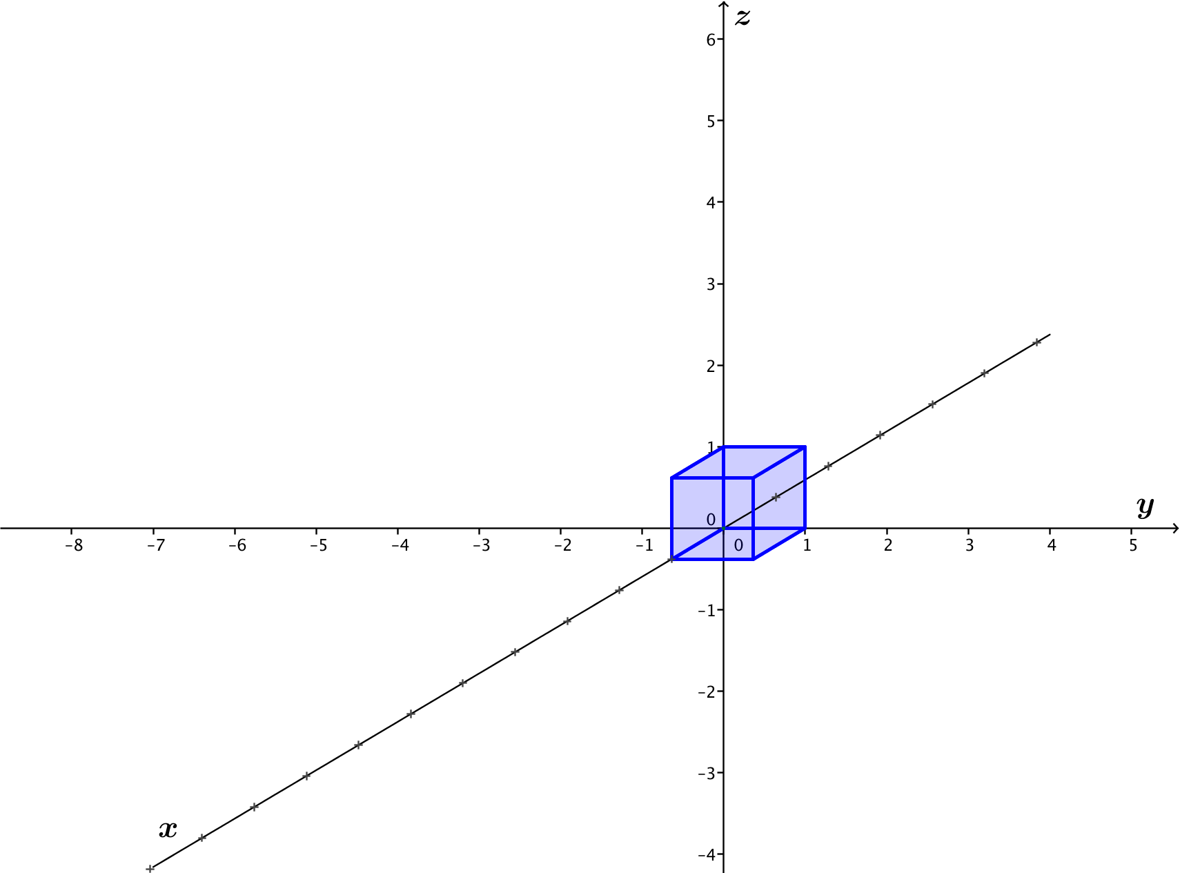

- Does the transformation from Question 1 have an inverse? Explain how you know.
Exit Ticket Sample Solutions

- Sketch the image of the unit cube under the transformation $L\left(\left[\begin{aligned}x \\ y \\ z\end{aligned}\right]\right)=\left[\begin{matrix}3 & 0 & 0 \\ 0 & -2 & 0 \\ 0 & 0 & 0\end{matrix}\right]⋅\left[\begin{aligned}x \\ y \\ z\end{aligned}\right]$ on the axes provided.

- Does the transformation from Question 1 have an inverse? Explain how you know.
No, this transformation does not have an inverse. The entry in the matrix in the lower right corner is 0, leading to a collapse of the image of the cube onto a rectangle. Since multiple points on the cube were transformed to the same point on the rectangle, there is no way to undo this transformation.

Problem Set Sample Solutions
Problems 1 and 2 continue to develop the theory of linear transformations represented by matrix multiplication. Problem 3 can be done with or without access to the GeoGebra demo used in the lesson.

- Suppose that we have a linear transformation $\left(\left[\begin{aligned}x \\ y \\ z\end{aligned}\right]\right)=\left[\begin{matrix}a & d & g \\ b & e & h \\ c & f & i\end{matrix}\right]⋅\left[\begin{aligned}x \\ y \\ z\end{aligned}\right]$ , for some matrix $A=\left[\begin{matrix}a & d & g \\ b & e & h \\ c & f & i\end{matrix}\right]$.
  - Evaluate $L\left(\left[\begin{aligned}1 \\ 0 \\ 0\end{aligned}\right]\right)$. How does the result relate to the matrix $A?$
$L\left(\left[\begin{aligned}1 \\ 0 \\ 0\end{aligned}\right]\right)=\left[\begin{matrix}a \\ b \\ c\end{matrix}\right]$ It is the first column of matrix $A.$

  - Evaluate $L\left(\left[\begin{aligned}0 \\ 1 \\ 0\end{aligned}\right]\right)$. How does the result relate to the matrix $A?$
$L\left(\left[\begin{aligned}0 \\ 1 \\ 0\end{aligned}\right]\right)=\left[\begin{matrix}d \\ e \\ f\end{matrix}\right]$ It is the second column of matrix $A$.

  - Evaluate $L\left(\left[\begin{aligned}0 \\ 0 \\ 1\end{aligned}\right]\right)$. How does the result relate to the matrix $A?$
$L\left(\left[\begin{aligned}0 \\ 0 \\ 1\end{aligned}\right]\right)=\left[\begin{matrix}g \\ h \\ i\end{matrix}\right]$ It is the third column of matrix $A$.

  - James correctly said that if you know what a linear transformation does to the three points $(1,0,0)$, $(0,1,0)$, and $(0,0,1)$, you can find the matrix of the transformation. Explain how you can find the matrix of the transformation given the image of these three points.
Create a matrix with $L\left(\left[\begin{aligned}1 \\ 0 \\ 0\end{aligned}\right]\right)$ in the first column, $L\left(\left[\begin{aligned}0 \\ 1 \\ 0\end{aligned}\right]\right)$ in the second column, and $L\left(\left[\begin{aligned}0 \\ 1 \\ 0\end{aligned}\right]\right)$ in the third column.

- Use the result from Problem 1(d) to answer the following questions.
  - Suppose a transformation $L:R^{3}→R^{3}$ satisfies $L\left(\left[\begin{aligned}1 \\ 0 \\ 0\end{aligned}\right]\right)=\left[\begin{matrix}3 \\ 0 \\ 0\end{matrix}\right]$,$L\left(\left[\begin{aligned}0 \\ 1 \\ 0\end{aligned}\right]\right)=\left[\begin{matrix}0 \\ 3 \\ 0\end{matrix}\right]$, and $L\left(\left[\begin{aligned}0 \\ 0 \\ 1\end{aligned}\right]\right)=\left[\begin{matrix}0 \\ 0 \\ 3\end{matrix}\right]$.
    - What is the matrix $A$ that represents the transformation $L$?
$$A=\left[\begin{matrix}3 & 0 & 0 \\ 0 & 3 & 0 \\ 0 & 0 & 3\end{matrix}\right]$$

    - What is the geometric effect of the transformation $L$?
The transformation $L$ has the geometric effect of dilation by a factor of $3$.

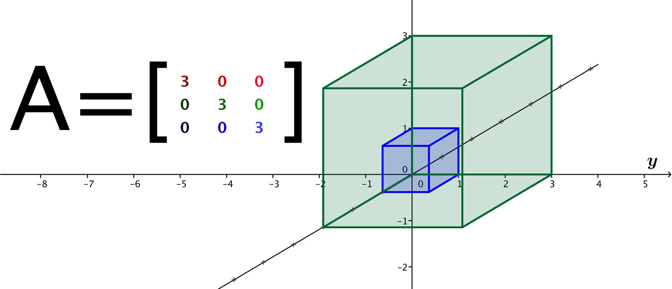
    - Sketch the image of the unit cube after the transformation by $L$.

  - Suppose a transformation $L:R^{3}→R^{3}$ satisfies $L\left(\left[\begin{aligned}1 \\ 0 \\ 0\end{aligned}\right]\right)=\left[\begin{matrix}1 \\ 0 \\ 0\end{matrix}\right]$,$L\left(\left[\begin{aligned}0 \\ 1 \\ 0\end{aligned}\right]\right)=\left[\begin{matrix}0 \\ 1 \\ 0\end{matrix}\right]$, and $L\left(\left[\begin{aligned}0 \\ 0 \\ 1\end{aligned}\right]\right)=\left[\begin{matrix}0 \\ 0 \\ -4\end{matrix}\right]$.
    - What is the matrix $A$ that represents the transformation $L$?
$$A=\left[\begin{matrix}1 & 0 & 0 \\ 0 & 1 & 0 \\ 0 & 0 & -4\end{matrix}\right]$$

    - What is the geometric effect of the transformation $L$?
The transformation $L$ has the geometric effect of stretching by a factor of $–4$ in the $z$-direction.

    - Sketch the image of the unit cube after the transformation by $L$.
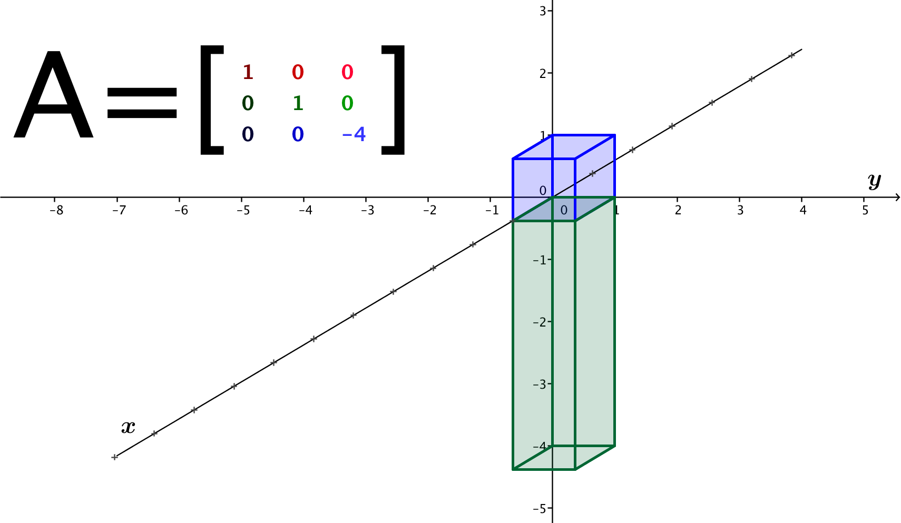

  - Suppose a transformation $L:R^{3}→R^{3}$ satisfies $L\left(\left[\begin{aligned}1 \\ 0 \\ 0\end{aligned}\right]\right)=\left[\begin{matrix}-2 \\ 0 \\ 0\end{matrix}\right]$,$L\left(\left[\begin{aligned}0 \\ 1 \\ 0\end{aligned}\right]\right)=\left[\begin{matrix}0 \\ 1 \\ 0\end{matrix}\right]$, and $L\left(\left[\begin{aligned}0 \\ 0 \\ 1\end{aligned}\right]\right)=\left[\begin{matrix}0 \\ 0 \\ -2\end{matrix}\right]$.
    - What is the matrix $A$ that represents the transformation $L$?
$$A=\left[\begin{matrix}-2 & 0 & 0 \\ 0 & 1 & 0 \\ 0 & 0 & -2\end{matrix}\right]$$

    - What is the geometric effect of the transformation $L$?
The transformation $L$ has the geometric effect of rotating about the $y$-axis by $180°$ and stretching by a factor of $2$ in the $x$ and $z$ directions.

    - Sketch the image of the unit cube after transformation by $L$.
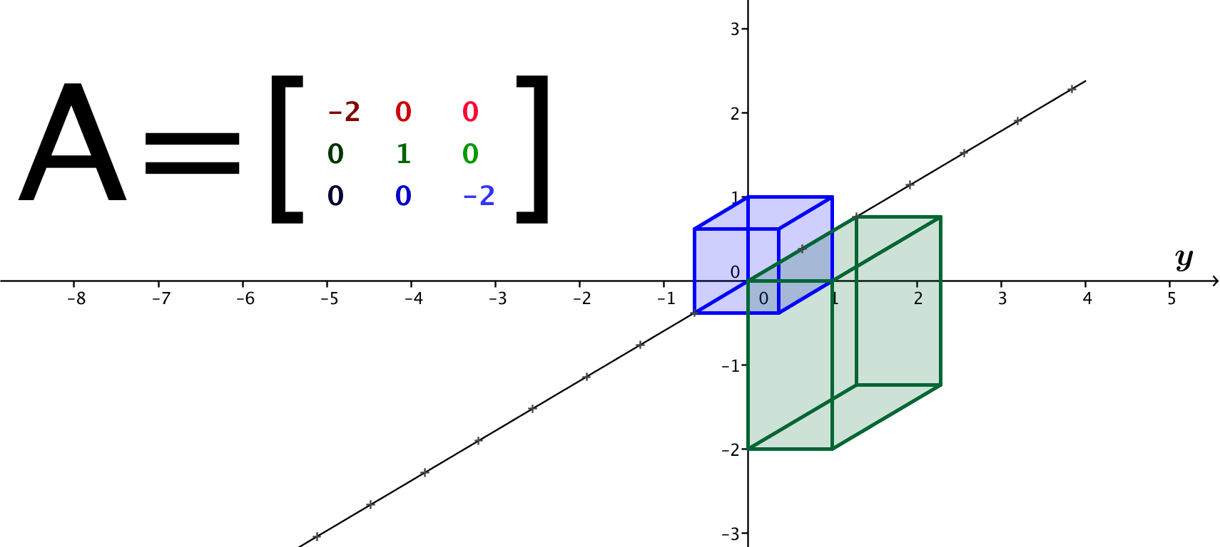

- Find the matrix of the transformation that will produce the following images of the unit cube. Describe the geometric effect of the transformation.
a.
The geometric effect of this transformation is reflection across the $xy$-plane. The matrix that represents this transformation is $A=\left[\begin{matrix}1 & 0 & 0 \\ 0 & 1 & 0 \\ 0 & 0 & -1\end{matrix}\right]$.

b.
The geometric effect of this transformation is a stretch in the $y$-direction by a factor of $3$. The matrix that represents this transformation is $A=\left[\begin{matrix}1 & 0 & 0 \\ 0 & 3 & 0 \\ 0 & 0 & 1\end{matrix}\right]$.

c.
The geometric effect of this transformation is a stretch in the $x$- and $z$-directions by a factor of $2$ and projection onto the $xz$-plane. The matrix that represents this transformation is $A=\left[\begin{matrix}2 & 0 & 0 \\ 0 & 0 & 0 \\ 0 & 0 & 2\end{matrix}\right]$.

d.
The geometric effect of this transformation is a shear parallel to the $xz$-plane. The matrix that represents this transformation is $A=\left[\begin{matrix}1 & 0 & 0 \\ 0 & 1 & 0 \\ 0 & 1 & 1\end{matrix}\right]$.

