|  |
| --- |
|  |

Lesson 6: Linear Transformations as Matrices

Student Outcomes

* Students verify that matrices represent linear transformations from . Students investigate the matrices associated with transformations such as dilations and reflections in a coordinate plane.
* Students explore properties of vector arithmetic, including the commutative, associative, and distributive properties.

Classwork

**Opening Exercise (3 minutes)**

In the Opening Exercise, students are reminded of their work with matrices and prove that the matrix given represents a linear transformation.

Opening Exercise

Let ,, and . Does this represent a linear transformation? Explain how you know.

A linear transformation satisfies the following conditions: and.

**MP.3**

by the distributive property.

**Discussion: Linear Transformations (7 minutes)**

* In previous lessons, we have seen that matrices represent linear transformations from . Do you think that a matrix would represent a linear transformation from Can you prove it?
* Let , and let and be points in . Show that .
  + *We can see that by the distributive property.*
* Now show that , where represents a real number.
  + *We see that .*
* Let’s briefly take a closer look at the reasoning used here. What properties of arithmetic are involved in comparing, for example, with ? In other words, how exactly do we know these are the same number?

*Scaffolding:*

* For students still struggling with matrix multiplication, give them a matrix with blanks to complete, so they can see how many terms they should have in each row such as

. Students would fill in the entry for each blank. For example,

.

* Advanced learners can instead work with a general matrix as linearity conditions are explored. The reasoning is exactly the same.
  + *We can use the associative property and the commutative property to know these are the same number.*
* Okay, now we’ve proved that the transformation does indeed represent a linear transformation, at least for this particular matrix. We could use exactly the same reasoning to show that this is also true for any matrix. In fact, mathematicians showed in the 1800s that every linear transformation from can be represented by a matrix! This is one reason why the theory of matrices is so powerful.

**Exploratory Challenge 1: The Geometry of 3D Matrix Transformations (10 minutes)**

In this activity, students work in groups of four on each of the challenges below. The teacher should monitor the progress of the class as they work independently. For each challenge, the teacher should select a particular group to present their findings to the class at the conclusion of the activity. The teacher should allow approximately 7 minutes for students to work in their groups, and approximately 3 minutes for students to present their findings.

**Exploratory Challenge 1: The Geometry of 3D Matrix Transformations**

* 1. **What matrix in serves the role of in the real number system? What is that role?**

**MP.3**

**serves the role of the multiplicative identity.**

* Find a matrix such that for each point in . Describe the geometric effect of this transformation. How might we call such a matrix?
  + *We can choose .*
  + *The name identity matrix makes sense since the output is identical to the input.*
  1. **What matrix in serves the role of in the real number system? What is that role?**

**serves the role of the additive identity.**

* Find a matrix such that for each point in . Describe the geometric effect of this transformation.
  + *. This transformation takes every point in space and maps it to the origin.*
  1. **What is the result of scalar multiplication in ?**

**Multiplying by a scalar, , dilates each point in by a factor of .**

* Find a matrix such that the mapping dilates each point in by a factor of .
  + *. Thus each point in is dilated by a factor of .*
  1. **Given a complex number , what represents the transformation of that point across the real axis?**

**The conjugate, .**

* Investigate the geometric effects of the transformation . Illustrate your findings with one or more specific examples.
  + *This transformation induces a reflection across the -plane.*



**MP.3**

**Exploratory Challenge 2: Properties of Vector Arithmetic (18 minutes)**

In this activity, students work in groups of four on one of the challenges below. The teacher should assign different challenges to different groups. When a group finishes one of the challenges, they may choose one of the other challenges to work on as time allows.

The teacher should monitor the progress of the class as they work independently. For each challenge, the teacher should select a particular group to present their findings to the class at the conclusion of the activity.

For each challenge, students should explore the question (a) from an algebraic point of view and (b) from a geometric point of view.

The teacher should allow approximately 10 minutes for students to work in their groups and organize their presentations. Allow approximately 9 minutes for students to present their findings.

**Exploratory Challenge 2: Properties of Vector Arithmetic**

* 1. **Is vector addition commutative? That is, does for each pair of points in ? What about points in ?**

**MP.3**

**We want to show that . First let’s look at this problem algebraically.**

**When we compute , we get .**

**Now let’s compute . This time we get .**

**The commutative property guarantees that the two components of these vectors are equal. For example, . Since both components are equal, the vectors themselves must be equal. We can make a similar argument to show that vector addition in is commutative.**

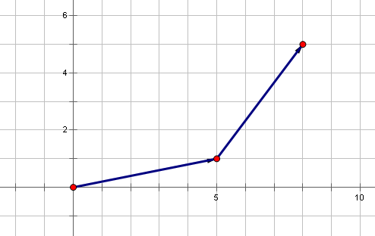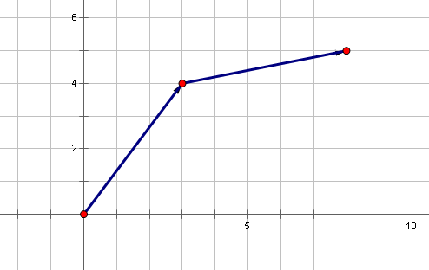**Next let’s see what all of this means geometrically. Let’s examine the points and .**

**Thinking in terms of translations, the sum amounts to moving right and up, followed by a movement that takes us right and up.**

**On the other hand, the sum amounts to moving right and up, followed by a movement that takes us right and up.**

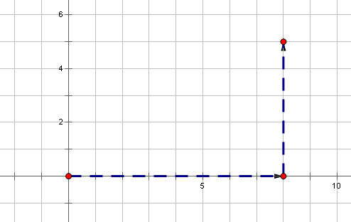**It should be clear that, in both cases, we’ve moved a total of units to the right and units up. So it makes sense that, when viewed as translations, these two sums are the same.**

**Lastly, let’s consider vector addition in from a geometric point of view.**

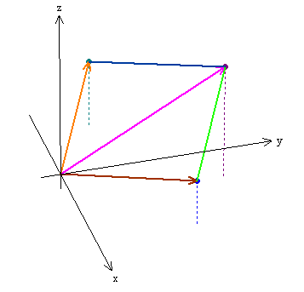

**Let’s consider the vectors and . To show that addition is commutative, let’s imagine that Jack and Jill are moving around a building. We’ll send them on two different journeys and see if they reach the same destination.**

**MP.3**

**Jack’s movements will model the sum . He walks units east, units north, and then goes up two flights of stairs. Next, he goes units west, units north, and then goes up flights of stairs.**

**Jill starts at the same place as Jack. Her movements will model the sum . She walks units west, units north, and then goes up flights of stairs. Then she goes units east, units north, and then climbs flights of stairs. It should be clear from this description that Jack and Jill both end up in a location that is units east, units north, and stories above their starting point. In particular, they end up in the same spot!**

* 1. **Is vector addition associative? That is, does for any three points in ? What about points in ?**

**Let’s check to see if for points in .**

**The associative property guarantees that each of the components are equal. Let’s look at the first coordinate. For example, we have , which is indeed the same as . We can make a similar argument for vectors in .**

**Next let’s examine the problem from a geometric point of view.**

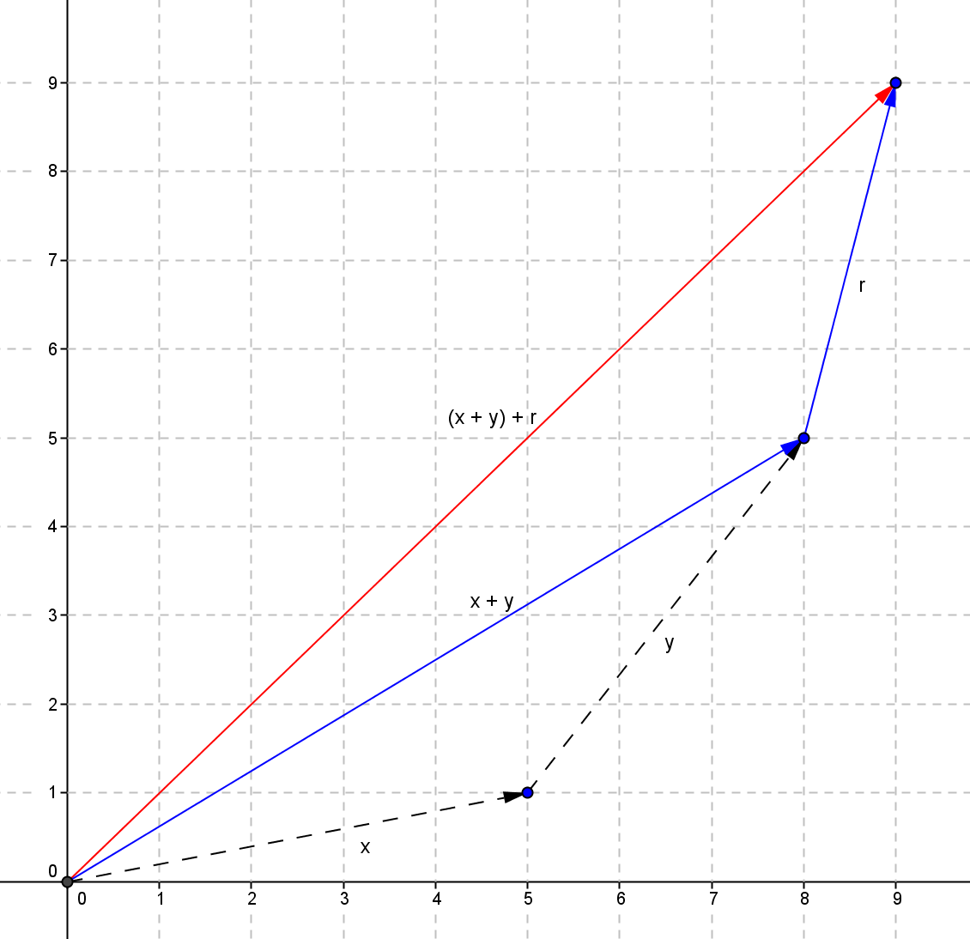 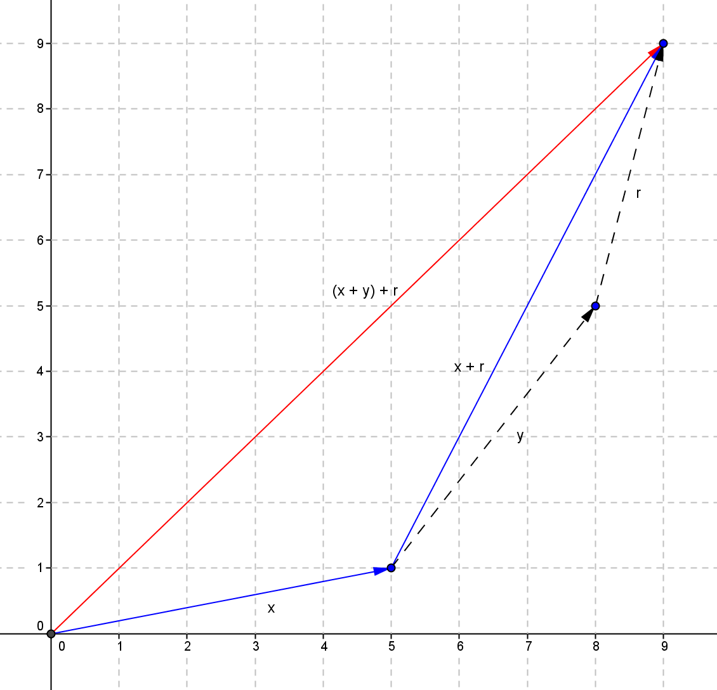

**MP.3**

**These pictures make it clear that these two sums should be the same. In both cases, the overall journey is equivalent to following each of the three paths separately. Now let’s look at the 3-dimensional case.**

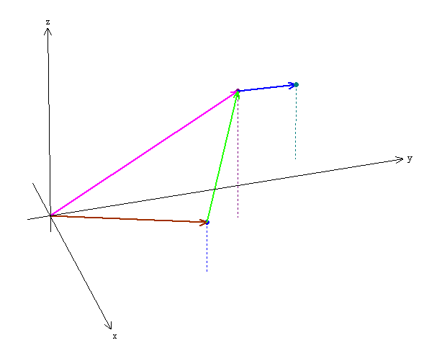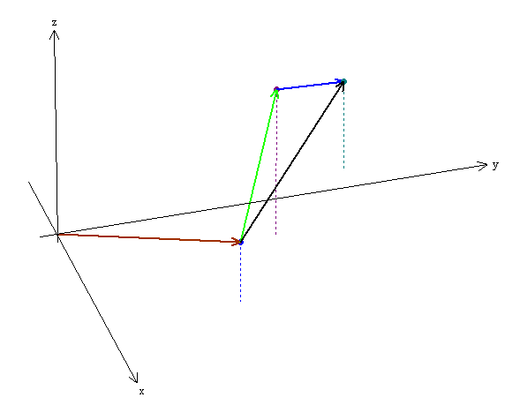

**As in the 2-dimsensional case, we are simply reaching the same location in two different ways, both of which are equivalent to following the three individual paths separately.**

* 1. **Does the distributive property apply to vector arithmetic? That is, does for each pair of points in ? What about points in ?**

**We want to show that .**

**We have .**

**Next we have .**

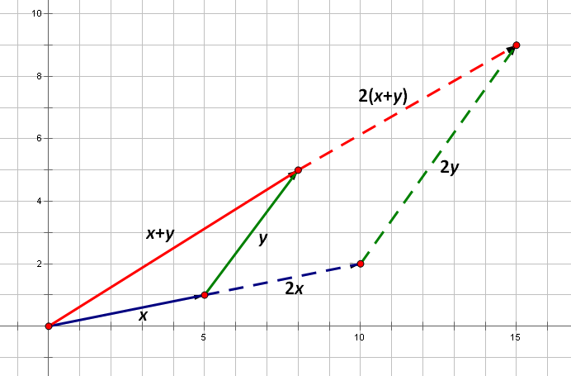**The distributive property guarantees that each of the components are equal. For example, . This means that the vectors themselves are equal. A similar argument can be used to show that this property holds for vectors in .**

**Now let’s examine this property geometrically.**

**Suppose that Jack walks to the point marked and then walks that distance again, ending at the spot marked . Now suppose Jill walks to the spot marked and then follows the path labeled . The picture makes it clear that Jack and Jill end up at the same spot.**

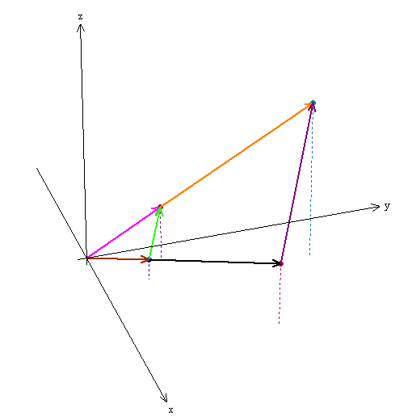**Next let’s examine the three-dimensional case. Again, the picture makes it clear that the distributive property holds.**

* 1. **Is there an identity element for vector addition? That is, can you find a point in such that for every point in ? What about for?**

**We have .**

**If this sum is equal to , then we have . This means that , which implies that . In the same way, we can show that .**

**Thus the identity element for is . Similarly, the identity element for is .**

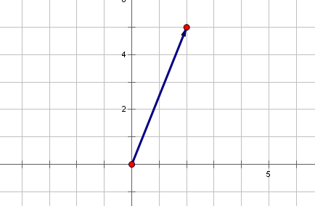**Let’s think about this geometrically. means to go to and translate by . That is, we don’t translate at all.**

* 1. **Does each element in have an additive inverse? That is, if you take a point in , can you find a second point such that ?**

**We have . If this sum is equal to , then , which means that . We can conclude that . Similarly, .**

**Thus the additive inverse of is . For instance, the additive inverse of is . Geometrically, we see that these vectors have the same length but point in opposite directions. Thus, their sum is . This makes sense because if Jack walks towards a spot that is miles east and 5 miles north of the origin, and then walks towards the spot that is miles west and miles south of the origin, then he’ll end up right back at the origin!**

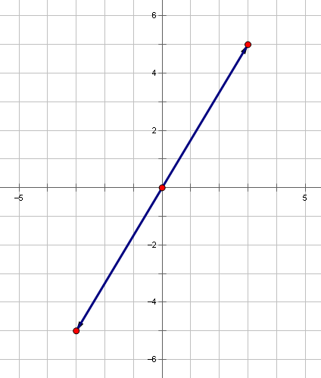

Closing (2 minutes)

Students should write a brief response to the following questions in their notebooks.

* How can we represent linear transformations from ?
  + *These transformations can be represented using matrices.*
* Which properties of real numbers are true for vectors in and ?
  + *Vector addition is commutative and associative. There is a vector, and every vector has an additive inverse. Scalar multiplication distributes over vector addition.*

Exit Ticket (5 minutes)

Name Date

Lesson 6: Linear Transformations as Matrices

Exit Ticket

1. Given , and .
   1. Verify the associative property holds: .
   2. Verify the distributive property holds: .
2. Describe the geometric effect of the transformation on the identity matrix given by the following matrices.

Exit Ticket Sample Solutions

1. Given , and .
   1. Verify the associative property holds: .
   2. Verify the distributive property holds: .
2. Describe the geometric effect of the transformation on the identity matrix given by the following matrices.

It dilates the point by a factor of .

It reflects the point about the -plane.

It reflects the point about the -plane.

* 1. .

It reflects the point about the -plane.

Problem Set Sample Solutions

1. Show that the associative property, *,* holds for the following.
   1. ,,
   2. ,,
2. Show that the distributive property, , holds for the following.
   1. ,,
   2. ,,
3. Compute the following.
4. 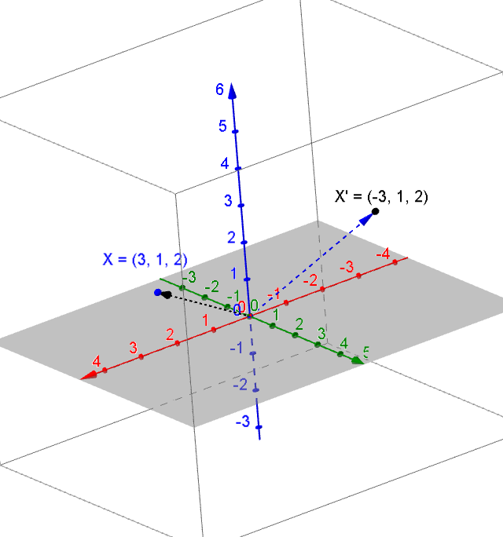Let . Compute , plot the points, and describe the geometric effect to .

. It is reflected about the -plane.

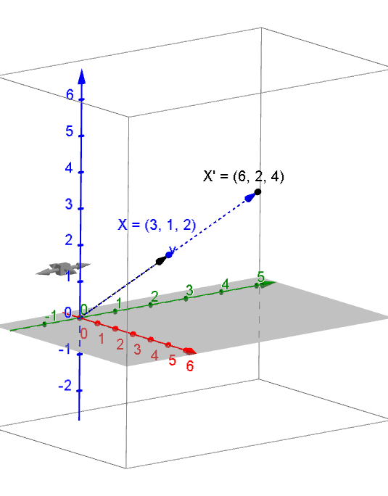

. It is dilated by a factor of .

. It is reflected about the vertical plane through the line on the -plane.

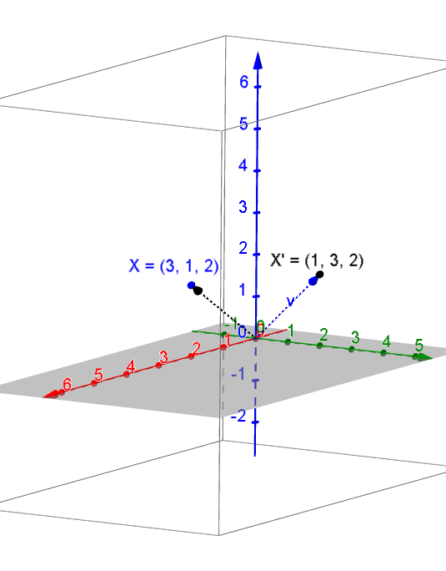

* 1. 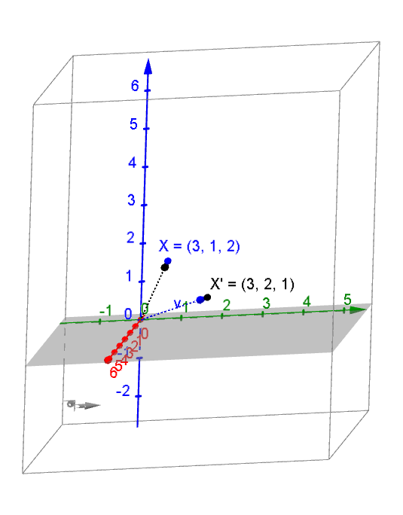

. It is reflected about the vertical plane through the line  
 on the -plane.

1. Let . Compute . Describe the geometric effect to .

. It is mapped to the origin.

. It is dilated by a factor of .

. It is mapped to the opposite side of the origin on the same line that is equal distance from the origin.

. It is reflected about the -plane.

. It is reflected about the -plane.

. It is reflected about the -plane.



. It is reflected about the vertical plane through the line on the -plane.

. It is reflected about the vertical plane through the line on the -plane.

. It is reflected about the vertical plane through the line on the -plane.

1. Find the matrix that will transform the point to the following point:
2. Find the matrix/matrices that will transform the point to the following point:

|  |  |
| --- | --- |
|  |  |
|  |  |