|  |
| --- |
|  |

Lesson 5: Coordinates of Points in Space

Student Outcomes

* Students use parallelograms to interpret the sum of two points in geometrically. Students make a similar interpretation for the sum of two points in .
* Students recognize that scalar multiplication of points in corresponds to a dilation. Students make a similar interpretation for scaling points in .

Lesson Notes

In the Opening Exercise, students perform addition and scalar multiplication, first on complex numbers and then on ordered pairs. This leads into the discussion portion of the lesson, in which students explore geometric interpretations for these operations, first for points in and then for points in . This lesson focuses on MP.3 and MP.7 as students construct arguments and make use of structure while studying points in space.

This is the first of several lessons that will have students graph in three-dimensional space. This may be difficult for some students to visualize, but you can make it easier by using a corner of your room. Allow the wall seam to be the   
-axis, and one seam between the wall and the floor to be the -axis while the other is the -axis. You can even set up a tape with a number line in each direction. Have students experiment with plotting different points to get the feel of what graphing in 3-D looks like. It is important for students to understand that since we live in a 3-D world, we must have a way to explain points, objects, etc., in this 3-D space. There are many computer graphics programs that are available free of charge that can support student learning on 3-D graphing such as GeoGebra. Additionally, blank 3-D coordinate axes are supplied at the end of this lesson for use throughout this module.

The study of vectors will form a vital part of this course; notation for vectors varies across different contexts and curricula. These materials will refer to a vector as (lowercase, bold, non-italicized) or or in column format,  
 or .

We will use “let ” to establish a name for the vector .

This curriculum will avoid stating without the word “let” preceding the equation when naming a vector unless it is absolutely clear from the context that we are naming a vector. However, we will continue to use the “=” to describe vector equations, like , as we have done with equations throughout all other grades.

We will refer to the vector from to as “vector ” – notice, this is a ray with a full arrow. This notation is consistent with the way vectors are introduced in Grade 8 and is also widely used in post-secondary textbooks to describe both a ray and a vector depending on the context. To avoid confusion in this curriculum, the context will be provided or strongly implied, so it will be clear whether the full arrow indicates a vector or a ray. For example, when referring to a ray from passing through , we will say “ray ” and when referring to a vector from to , we will say “vector ”. Students should be encouraged to think about the context of the problem and not just rely on a hasty inference based on the symbol.

The magnitude of a vector will be signified as (lowercase, bold, non-italicized).

Classwork

In the Opening Exercise, students practice adding and multiplying complex numbers then ordered pairs displayed as matrices. This allows students to review previously taught skills and then explore the geometric interpretation of these operations in the lesson.

Opening Exercise (2 minutes)

Opening Exercise

Compute:

*Scaffolding:*

* To help students visualize the results, have them color code each vector always having the resulting vector a standard color. For example, the first vector could always be blue, the second vector green, and so on, but the resulting vector always red. This will help students visualize.
* When plotting in 3-D, continue color coding. Give students only positive values, and use the corners of the classroom to represent 3-D space having students create the 3 number lines, , , and .
* For advanced learners, once they have shown understanding of 2-D, allow them to move to 3-D graphing, and try it without scaffolding. Challenge them to create a physical model of 3-D space using a shoe box or something in the classroom – this can be used later for all students.

Discussion (8 minutes): Addition Viewed Geometrically

Here are two questions to ponder:

* When we add two points and , we produce a third point . How do you think is related geometrically to and ?
* When we multiply a point by a scalar (say 3), we produce another point   
  . How do you think is related to geometrically?
* Take a moment to write down any conjectures you may have about these questions, and then share your thinking with a partner. We’ll explore these questions in detail in the upcoming discussion.
* Let and let . Compute .
* To discover the geometric relationships between , , and , it’s helpful to picture the box shown below.   
  Note that the width of this rectangle is , which is the first coordinate of , and the height of the rectangle is , which is the second coordinate of . We can associate with the diagonal of this box. In fact, we might even go so far as to say that the diagonal is . In some contexts it’s useful to think of an ordered pair as a vector, which in this case means an arrow that originates at and terminates at .

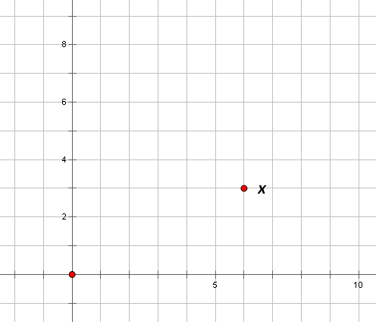 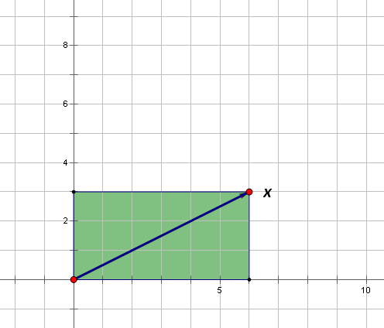

* When we add to , we are effectively performing a translation. Let’s draw a picture of this:

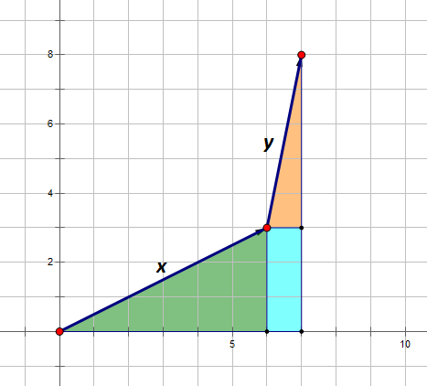 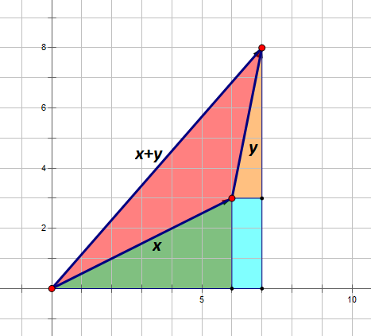

* So the question still remains: how exactly are these three arrows related? Take a moment to discuss your thoughts with a partner, and then we’ll continue.
* Let’s see what happens when we perform the addition the other way around; that is, when we compute :

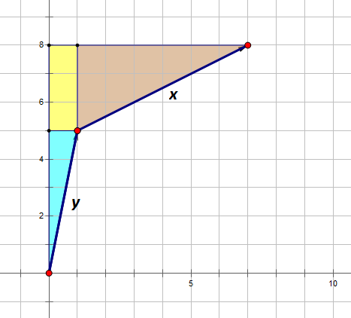 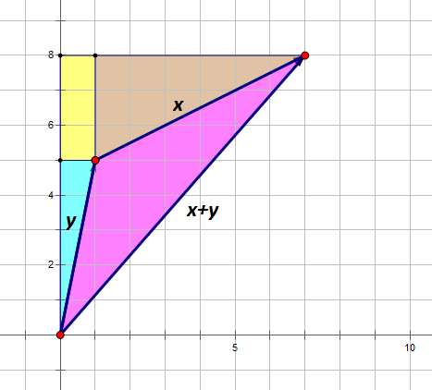

* To really see what’s going on, let’s look at and together in the same picture:

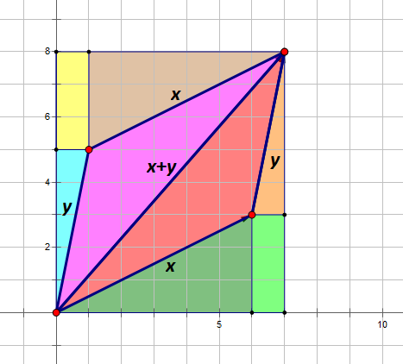 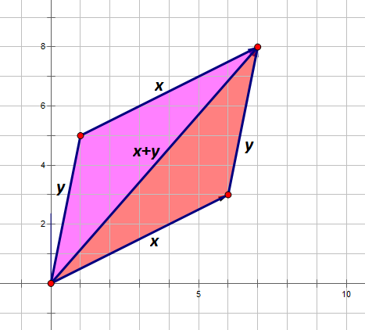

* Now a clear picture is starting to emerge. Make a conjecture and share it with a partner. What strikes you about this figure?
  + *It looks as though the points in the figure form a parallelogram.*

**MP.3**

**&**

**MP.7**

* Can you make an argument showing that this is indeed a parallelogram?
  + *The upper and lower sides both have a rise-to-run ratio of , which means they must be parallel.*
  + *The left and right sides both have a rise-to-run ratio of , which means they must also be parallel.*
  + *Since both pairs of opposite sides of the figure are parallel, the figure is indeed a parallelogram.*

Exercises 1–3 (3 minutes)

Exercises

1. 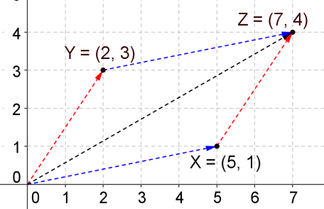Let ,. Compute , and draw the associated parallelogram.

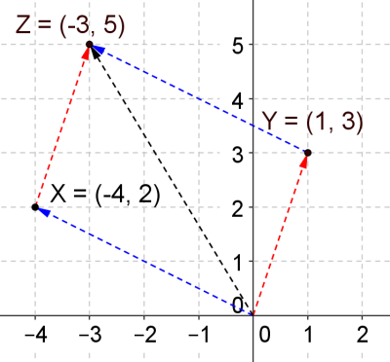

1. Let ,.Compute and draw the associated parallelogram.
2. 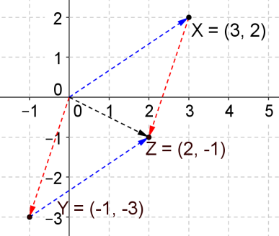Let ,Compute and draw the associated parallelogram.

Example 1 (3 minutes): Degenerate Parallelograms

* We’ve seen that adding two points gives a third point which lies at the vertex of a parallelogram. Can you think of a case where no parallelogram is produced? Think for a moment about this.
  + *Answers will vary. Take two points that lie on a line through the origin. These cases do not produce proper parallelograms.*
* We call these “degenerate parallelograms.”
* Let’s try a few examples. For each problem below, compute the sum of the given points, and draw the associated picture.

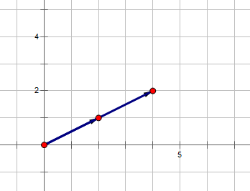 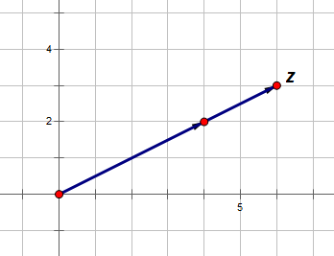

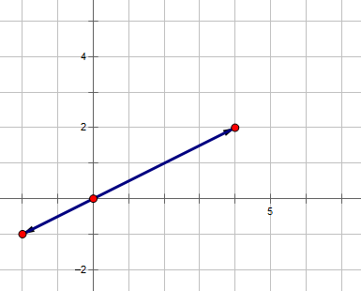 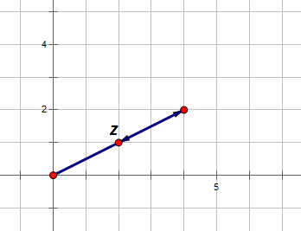

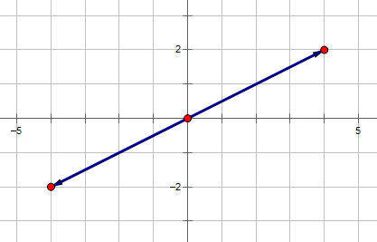 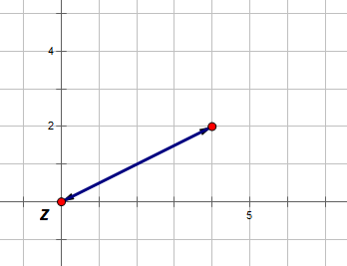

Discussion (6 minutes): Scalar Multiplication

* Now let’s turn our attention to scalar multiplication. What is the geometric effect of taking and scaling it by a factor of ? Compute , and then plot and in the plane.
  + 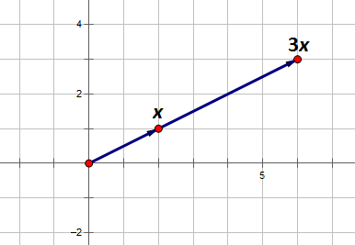*We have .*
* Describe the relationship between and .
  + *It appears that and lie on a line through the origin and that the length of the arrow to is times as long as the arrow to .*
* 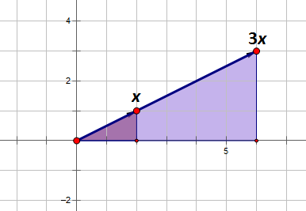Does the picture below add to your understanding of the nature of scalar multiplication? Discuss what you see with a partner. Try to make connections between the picture and the underlying arithmetic involved in computing .
  + *The -coordinate is scaled from to , so the widths of the triangles are in a ratio.*
  + *The -coordinate is scaled from to , so the heights of the triangles are also in a ratio.*
  + *Since both of these triangles have a right angle, they are similar to each other by the SAS principle. This means that the lengths of the arrows to and to are indeed in a ratio and that , , and do lie on a common line.*
* What do you suppose would happen if we scaled by instead? Plot and in the plane, and then describe the geometric relationship between these two vectors.
  + 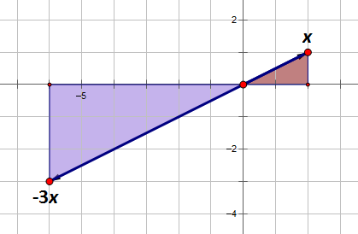*Now we have .*
  + *The vector is times as long as , but it lies on the opposite side of the origin.*
* We call the new vector produced the **resultant**. Can you state the previous result using the word “resultant”?
  + *The resultant is times as long as , but it lies on the opposite side of the origin.*

Exercises 4–6 (2 minutes)

1. 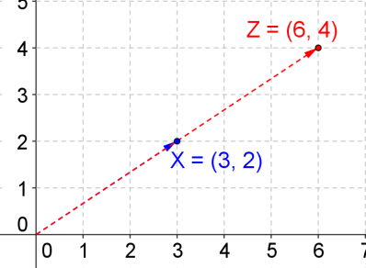Let . Compute , and plot and in the plane.
2. 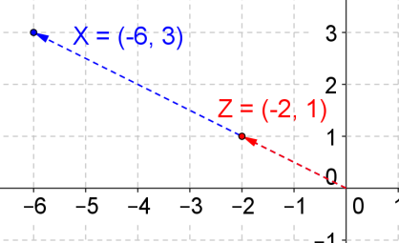Let . Compute , and plot and in the plane.
3. 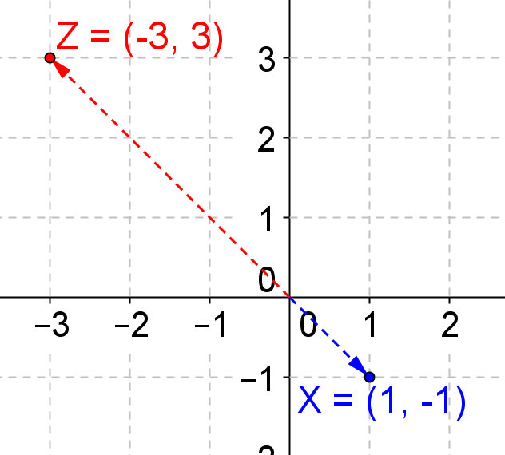Let . Compute , and plot and in the plane.

Example 2 (5 minutes): 3D Addition Viewed Geometrically

* Now that we’ve discussed the geometric interpretation of adding and scaling points in , let’s turn our attention to . What do you think adding points in will mean from a geometric point of view? What will scaling points mean? Make a conjecture, and then quickly share your thinking with a partner. We’ll pursue these questions in detail in the upcoming discussion. If graphing software is available, demonstrate plotting points in 3-D space for the class, and then allow students to try. Being able to visualize points in 3-D space is difficult for students, and they will need lots of practice. Blank 3-D axes are included for teacher and student use at the end of this lesson.
* Let and . Compute , and then plot each of these three points.



* Can you tell how , , and are related? This picture should help:



**MP.7**

* + *In the resultant, the –value of is translated in the direction units, the –value of is translated in the direction units, and the –value of is translated in the direction units. .*

Exercises 7–8 (2 minutes)

1. 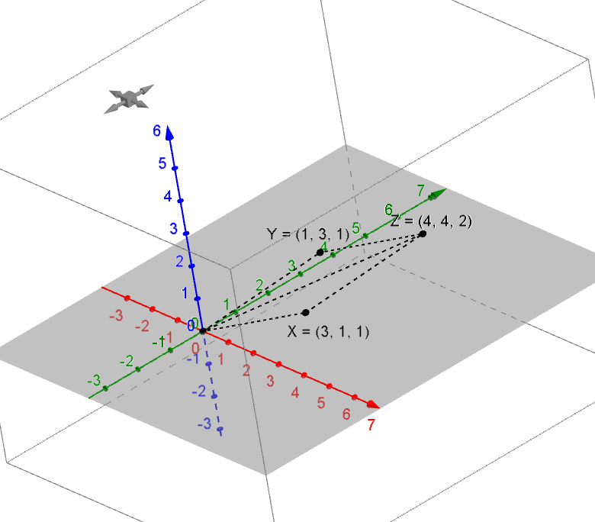Let and . Compute , and then plot each of these three points.
2. 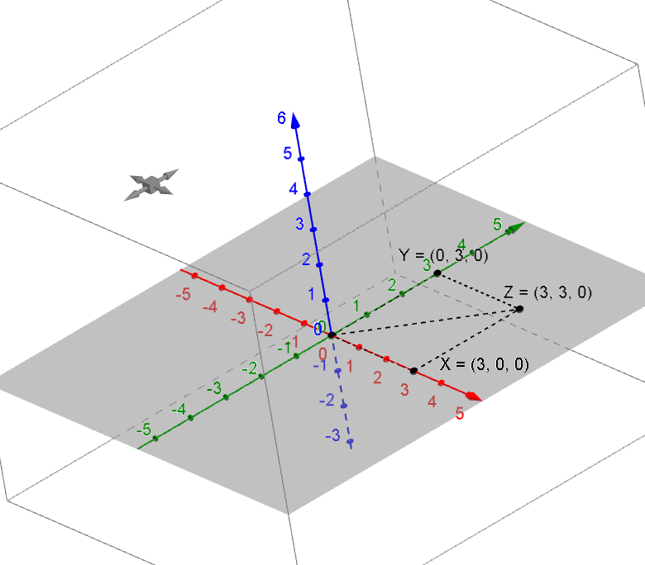Let and . Compute , and then plot each of these three points.

Example 3 (5 minutes): Scalar Multiplication in 3D

* What do you suppose it means to perform scalar multiplication in a three-dimensional setting? Make a conjecture and briefly share it with a partner.
* Let . Compute , and then plot each of these points. Describe what you see.

 

* + *The resultant was dilated by a factor of . The resultant lies on the same line through the origin as the vector.*
* What do you suppose would happen if we scaled by a factor of ? What if the scale factor   
  were ?
  + *When we scale by , we get . The resultant is the same length as , but it points in the opposite direction.*
  + *When we scale by , we get . The resultant is twice as long as , but again it points in the opposite direction.*



Exercises 9–10 (2 minutes)

1. 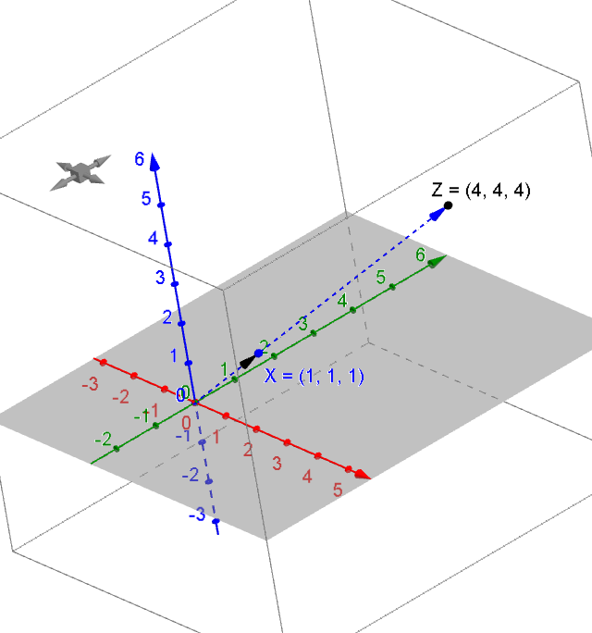Let . Compute , and then plot each of the three points.
2. 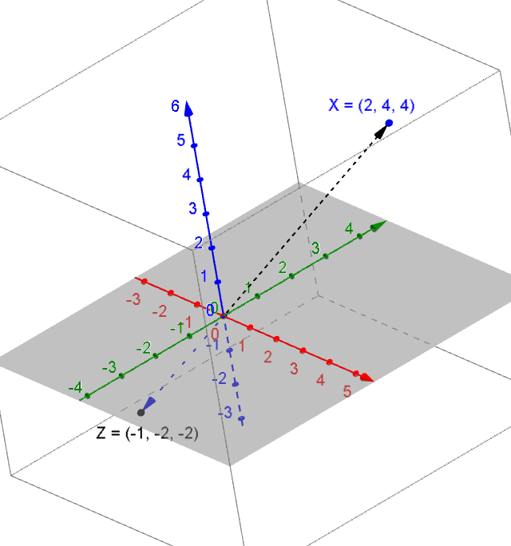Let . Compute , and then plot each of the three points. Describe what you see.

In the resultant, the direction has reversed, and the length of the ray is half the original.

Closing (2 minutes)

Write a brief response to the following questions in your notebook, and then share your responses with a partner.

* What did you learn about the geometry of vector addition in and ?
  + *We can use the diagonal of a parallelogram to visualize the resultant vector of the sum of two vectors.*
* What did you learn about the geometry of scalar multiplication of vectors in and ?
  + *Multiplying a vector by a scalar produces a resultant that is a dilation of the original vector.*

Exit Ticket (5 minutes)

Name Date

Lesson 5: Coordinates of Points in Space

Exit Ticket

1. Find the sum of the following, and plot the points and the resultant. Describe the geometric interpretation.
2. Find the sum of the following.

Exit Ticket Sample Solutions

1. 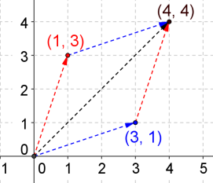Find the sum of the following, and plot the points and the resultant. Describe the geometric interpretation.

The two points, the resultant, and the origin formed a parallelogram.

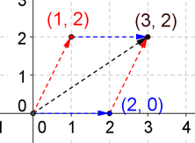

The two points, the resultant, and the origin formed a parallelogram.

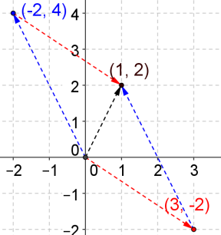

The two points, the resultant, and the origin formed a parallelogram.

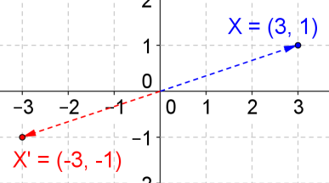

The resultant is a vector of the same magnitude in the opposite direction.

1. Find the sum of the following.

Problem Set Sample Solutions

1. 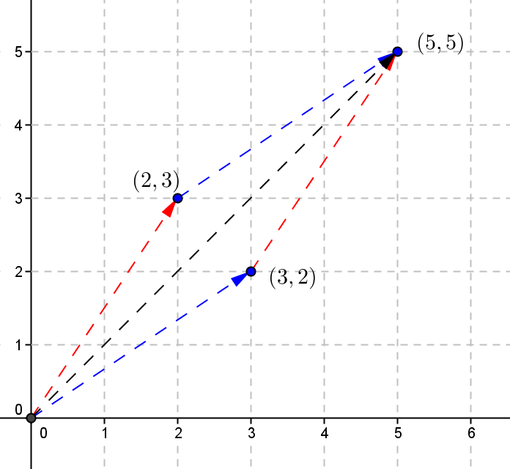Find the sum of the following complex numbers, and graph them on the complex plane. Trace the parallelogram that is formed by those two complex numbers, the resultant, and the origin. Describe the geometric interpretation.
   1. ,

The two points, the resultant, and the origin formed a parallelogram.

* 1. 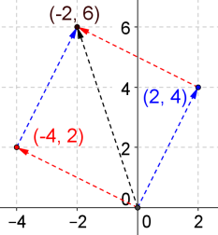,.

The two points, the resultant, and the origin formed a parallelogram.

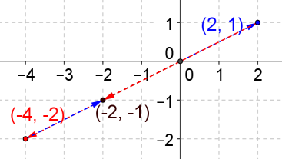

* 1. ,.

The resultant is double the magnitude of the original vector in the opposite direction.

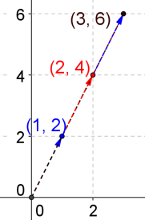

* 1. ,.

The resultant is triple the length of the original vector in the same direction.

1. 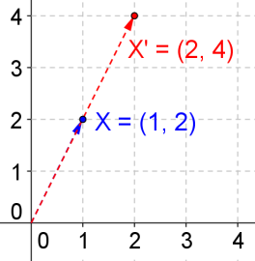Simplify and graph the complex number and the resultant. Describe the geometric effect on the complex number.
   1. ,,

The point is dilated by a factor of .

* 1. 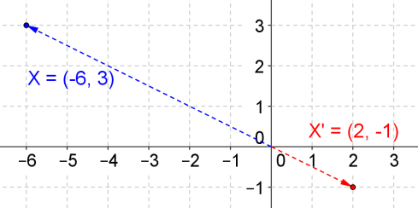,,

The point is dilated by a factor of and mapped to the other side of the origin on the same line.

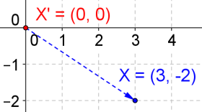

* 1. ,,

The point is mapped to the origin, .

1. 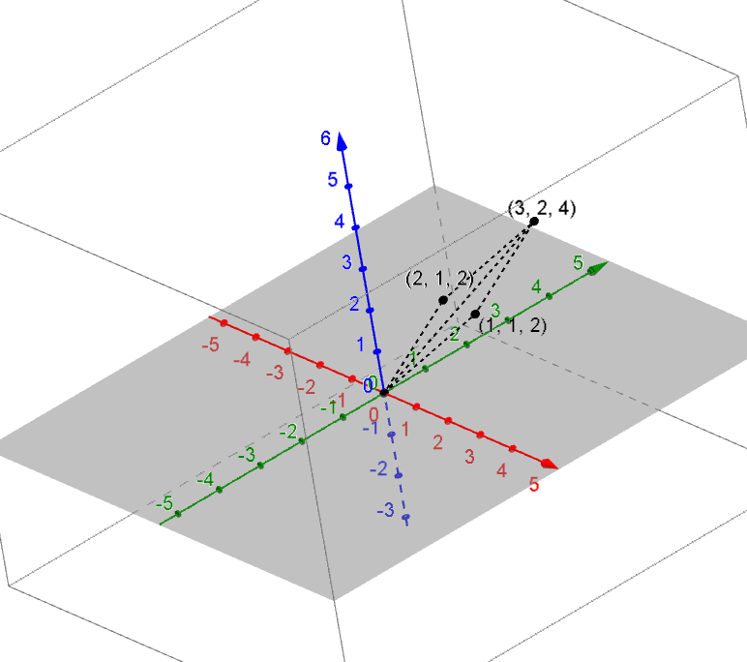Find the sum of the following points, graph the points and the resultant on a 3-dimensional coordinate plane, and describe the geometric interpretation.
   1. ,.

The two points, the resultant, and the origin are on the same plane and formed a parallelogram.

* 1. 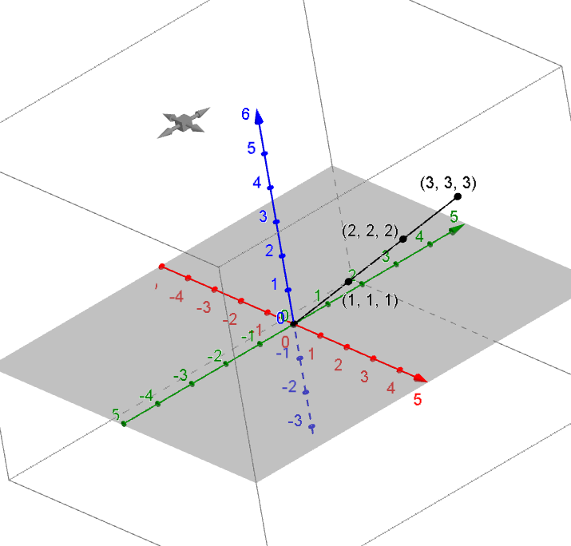,.

Three points all collapse onto the same line in space.

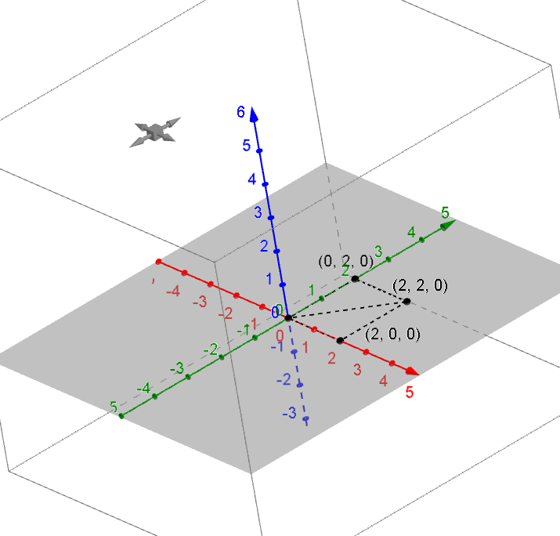

* 1. ,.

The two points, the resultant, and the origin are on the same plane and formed a parallelogram.

1. 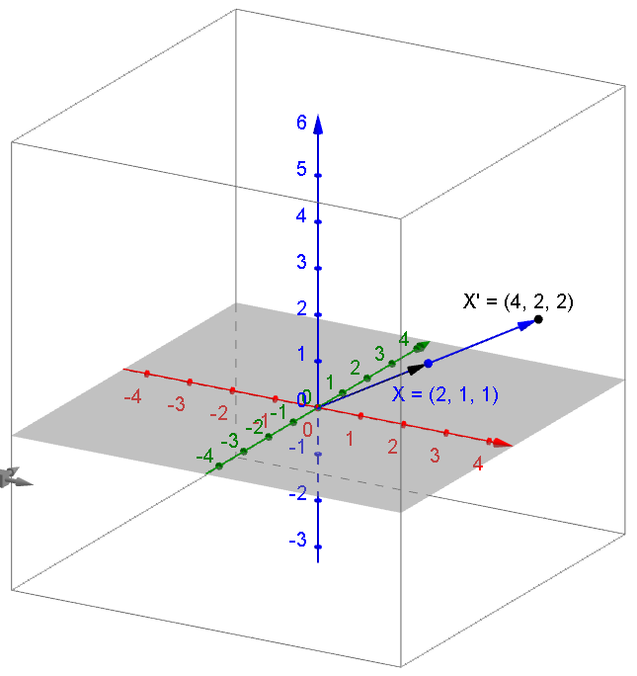Simplify the following, graph the point and the resultant on a 3-dimensional coordinate plane, and describe the geometric effect.
   1. ,,

The point is dilated by a factor of .

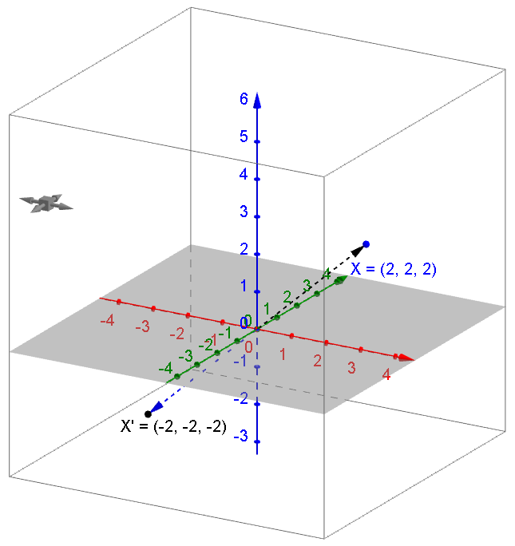

* 1. ,,

The point is mapped to the other side of the origin on the same line.

1. Find
   1. Any two different points whose sum is .

Answers vary. ,

* 1. Any two different points in 3 dimensions whose sum is .

Answers vary. ,

* 1. Any two different complex numbers and their sum will create the degenerate parallelogram.

Answers vary. ,, as long as this answers are in the relation of

* 1. Any two different points in 3 dimensions that their sum lie on the same line.

Answers vary. ,

* 1. A point that is mapped to after multiplying .
  2. A point that is mapped to after multiplying .

1. Given and
   1. 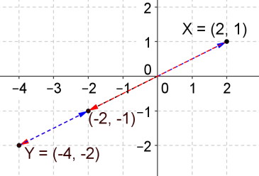Find and graph parallelogram that is formed by and the origin.
   2. 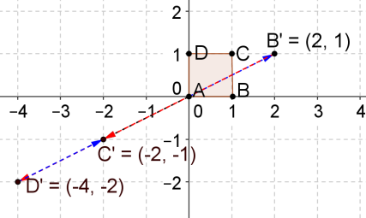Transform the unit square by multiplying it by the matrix , and graph the result.

,,,

* 1. What did you find from parts (a) and (b)?

They both have degenerate parallelograms.

* 1. What is the area of the parallelogram that is formed by part (a)?

The area is .

* 1. What is the determinant of the matrix ?

. The determinant is .

* 1. Based on observation, what can you say about the degenerate parallelograms in part (a) and part (b)?

For two complex numbers, if and the determinant of the matrix is , then they will produce degenerate parallelograms.

1. We learned that when multiplying to a complex number , for example , the resulting complex number will be on the same line but on the opposite side of the origin. What matrix will produce the same effect? Verify your answer.

The matrix that will rotate radians is .

1. A point is transformed to . The final step of the transformation is adding the complex number . Describe a possible transformation that can get this result.

, from to , a radians counterclockwise rotation and a dilation with a factor of are needed.

a radians counterclockwise rotation: ; dilation with a factor of :

