Lesson 4: Linear Transformations Review

Student Outcome
- Students will review their understanding of linear transformations on real and complex numbers as well as linear transformations in two-dimensional space. They will use their understanding to form conjectures about linear transformations in three-dimensional space.

Lesson Notes
In this lesson, students will respond to questions to demonstrate what they understand about linear transformations performed on real and complex numbers, as well as those performed in two-dimensional space and three-dimensional space. They will describe special cases of linear transformations for real and complex numbers. They will also verify the conditions for linear transformations in two-dimensional space and make conjectures about how to define and represent linear transformations in three-dimensional space.

Classwork
Discussion (5 minutes): Linear Transformations $R→R$
During this discussion, call on a variety of students to answer the questions as they are posed.
- Recall that when we write $L:R→R$, we mean that $L$ is a function that takes real numbers as inputs and produces real numbers as outputs.
- Let’s recall the conditions a function $L:R→R$ must meet to be a called a linear transformation. What are they?
Scaffolding:
- Show the following examples:
$$f\left(x\right)=2x$$
$$g\left(x\right)=2x+1$$
$$h\left(x\right)= \frac{1}{2}x$$
$$j\left(x\right)= \frac{1}{2}x-1$$
Which are linear transformations? Explain your answer.
- Advanced students can be challenged to explore the questions about the geometric implications of different values of $a$ without any additional cueing.

  - First, we need $L\left(x+y\right)=L\left(x\right)+L(y)$.
  - Second, we need $L\left(a∙x\right)=a∙L\left(x\right)$.
- Good. And what exactly are $a$, $x$, and $y$ in this case?
  - Each of these symbols represents a real number.
- Okay. Now give three examples of formulas that you know represent linear transformations from $R$ to $R$.
  - $L\left(x\right)=2∙x$
  - $L\left(x\right)=3∙x$
  - $L\left(x\right)=4∙x$
- Good. So we see that a linear transformation $L:R→R$ must have the form $L\left(x\right)=a∙x$ for some real number $a$. Now let’s explore the geometric effect that linear transformations have on the real number line. The value of $a$ could be positive, negative, or zero, and the size of $a$ could be big or small. How are these cases different geometrically? Let’s explore together.

- Consider the interval $[-2, 2]$. What is the image of the interval under the rule $L\left(x\right)=3∙x$?
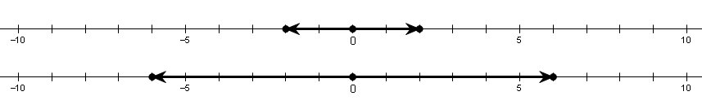
  - We have $L\left(-2\right)=3∙-2=-6$, and $L\left(2\right)=3∙2=6$. It looks as though the image of $[-2, 2]$
is $[-6, 6]$.
- When we use a scale factor of $3$, the interval expands to $3$ times its original size. Now let’s try a role reversal: can you think of a mapping would take the interval at the bottom of the figure and map it to the one at the top? Explain your answer.
  - The inverse map is $L\left(x\right)=\left(\frac{1}{3}\right)∙x$. This makes sense because we are contracting the interval so that it ends up being $\frac{1}{3}$ of its original size.
- In some cases, the transformation $L\left(x\right)=a∙x$ expands an interval, and in other cases it contracts the interval. Can you think of a mapping that leaves the size of the interval unchanged?
  - $L\left(x\right)=1∙x$ does not change the size of the interval.
- Can you see why mathematicians refer to $L\left(x\right)=1∙x$ as the identity mapping? Try to make sense of this phrase.
  - Under the identity mapping, each point on the number line is mapped to a location that is identical to its original location.
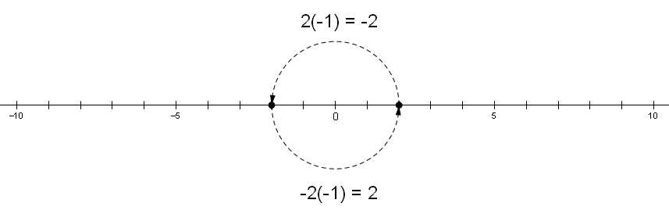
- Now let’s consider some cases where $a$ is a negative number. What is the image of $[-2, 2]$ under the rule $L\left(x\right)=-1∙x$?
  - In this case, each point on the number line is reflected across the origin. The result is the same interval we started with, but each point has been taken to the opposite side of the number $0$.
- Describe what happens after the application of $L\left(x\right)=-2∙x$ or $L\left(x\right)=\left(-\frac{1}{2}\right)∙x$.
  - First, each interval gets reflected across the origin, and then a dilation gets applied. In the first case, each interval dilates to twice its original size, and in the second case, each interval dilates to half its original size.
- Now let’s consider the only remaining case. What happens when we apply the zero map, $L\left(x\right)=0∙x$?
  - Since $L\left(x\right)=0∙x=0$ for every real number $x$, the entire number line gets mapped to a single point, namely $0$!
- Perhaps we should call this kind of transformation a collapse, since what used to be a line has now collapsed to a single point.
- Write a quick summary of this discussion in your notebook, and then share what you wrote with a partner.
Scaffolding:
Students could create a graphic organizer listing the matrix in one column and transformation represented in the next column.
  - Every linear transformation $L:R→R$ has the form $L\left(x\right)=a∙x$ for some real number $a$. Each of these transformations is essentially a dilation with scale factor $a$. Special cases include $a=0$, which causes the whole number line to collapse to the origin; $a=1$, which leaves the whole number line unchanged; and $a=-1$, which causes each point on the number line to undergo a reflection through the origin.

Exercises 1–2 (3 minutes)
The students should complete the exercises in pairs. One pair should be asked to share each solution. The presenting pair could represent the mapping geometrically on the board to aid students who are strong visual learners.
Exercises 1–2
Scaffolding:
Provide a specific interval that students can use when solving Exercise 1 (e.g., have students explain the effect of the transformations on the interval $[-1,1]$).
- Describe the geometric effect of each mapping.
  - $L\left(x\right)=9∙x$
Dilates the interval by a factor of $9$
MP.2

  - $L\left(x\right)=-\frac{1}{2}∙x$
Reflects the interval over the origin and then applies a dilation with a scale factor of $\frac{1}{2}$

- Write the formula for the mappings described.
  - A dilation that expands each interval to $5$ times its original size.
$$L\left(x\right)=5∙x$$

  - A collapse of the interval to the number $0$.
$$L\left(x\right)=0∙x$$

Discussion (10 minutes): Linear Transformations $C→C$
- In addition to transformations from $R$ to $R$, in the previous module we also studied transformations that take complex numbers as inputs and produce complex numbers as outputs, and we used the symbol $L: C→C$ to denote this.
- As we did for functions from $R$ to $R$, let’s recall the conditions a function $L:C→C$ must meet to be a called a linear transformation. What are they?
  - Just as before, we need $L\left(x+y\right)=L\left(x\right)+L(y)$ and $L\left(a∙x\right)=a∙L\left(x\right)$.
- What exactly do $a$, $x$, and $y$ represent in this case?
  - Each of these symbols represents a complex number.
- Give three examples of formulas that you know represent linear transformations from $C$ to $C$.
  - $L\left(x\right)=2∙x$
  - $L\left(x\right)=i∙x$
  - $L\left(x\right)=(3+5i)∙x$
- So we see that a linear transformation $L:C→C$ must have the form $L\left(x\right)=a∙x$ for some complex number $a$. As we did above with functions from $R$ to $R$, let’s explore the geometric effect of some special linear transformations from $C$ to $C$.
- What do you remember about the result of multiplying $a+bi$ by $c+di$?
  - We know that $\left(a+bi\right)∙\left(c+di\right)=ac-bd+\left(ad+bc\right)∙i$.
- Recall that we visualize complex numbers as points in the complex plane. What do you remember about the geometric effect of multiplying one complex number by another?
  - Multiplication by a complex number induces a rotation and a dilation.
- Now let’s get back to the subject of linear transformations. Discuss the following questions with another student. Analyze each question both algebraically and geometrically. Be prepared to share your analysis with the whole class in a few minutes.
- Is there a linear transformation $L:C→C$ that leaves each point in the complex plane unchanged? That is, is there an identity map from $C→C$?
  - Yes. If we take $a=1+0i$ and $x=c+di$, we get this:
    - $L\left(x\right)=ax=\left(1+0i\right)(c+di)=1∙c-0∙d+\left(1∙d+0∙c\right)i=c+di=x$.
  - Geometrically, multiplying by the complex number $1+0i$ is the same thing as multiplying by the real number $1$, so it makes sense that this action leaves points unchanged.
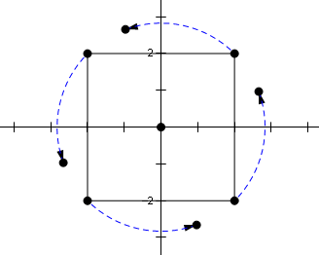
- Describe the set of linear transformations $L:C→C$ that induce a pure rotation of points in the complex plane.
  - We know that multiplication by a complex number $a$ induces a rotation through the argument of $a$, as well as a dilation by the modulus of $a$. So if we want a pure rotation, then we need to have $\left|a\right|=1$. Thus, if $a$ is any point on the unit circle surrounding the origin, then $L\left(x\right)=ax$ will induce a pure rotation of the complex plane.

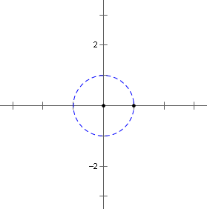
- Describe the set of linear transformations $L:C→C$ that induce a pure dilation of points in the complex plane.
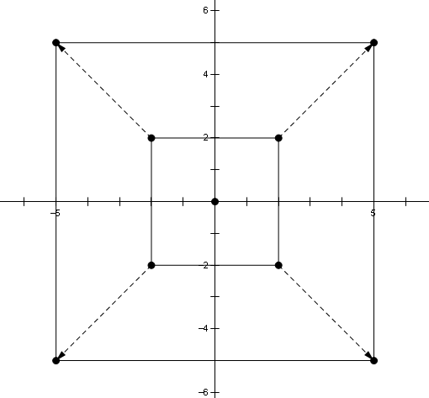
  - If $L\left(x\right)=ax$ induces a pure dilation, then the argument of $a$ must be $0$. This means that $a$ is, in fact, a real number.
- Is there a linear transformation $L:C→C$ that collapses the entire complex plane into a single point?
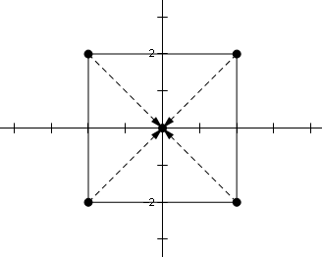
  - Yes. If we choose $a=0+0i$, then we get $L\left(x\right)=ax=\left(0+0i\right)x=0+0i$ for every $x$. Thus, every point in the complex plane gets mapped to the origin.

- Is there a linear transformation $L:C→C$ that induces a reflection across the real axis? In particular, where would such a transformation take $5+2i$? Where would it take $1+0i$? Where would it take $0+1i$?
  - Since $(5,2)$ maps to $(5,-2)$, the image of $5+2i$ must be $5-2i$.
  - Since $(1,0)$ maps to $(1,0)$, the image of $1+0i$ must be $1+0i$.
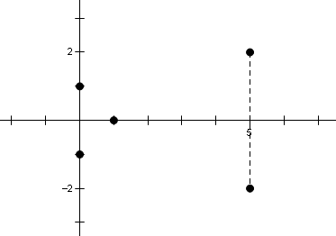
  - Since $(0,1)$ maps to $(0,-1)$, the image of $0+1i$ must be $0-1i$.
- If there is a complex number $a$ such that $L\left(x\right)=ax$ induces a reflection across the real axis, then what would its argument have to be? Analyze your work above carefully.
  - Since points on the real axis map to themselves, it would appear that the argument of $a$ would have to be $0$. In other words, there must be no rotational component.
  - On the other hand, points on the imaginary axis get rotated through $180°$. But this is irreconcilable with the statement above. Thus, it appears that there is no complex number $a$ that meets the necessary requirements, so we conclude that reflection across the real axis is not a linear transformation from $C$ to $C$.

Discussion (7 minutes): Linear Transformations $R^{2}→R^{2}$
- Recall that we can visualize complex numbers as points in the complex plane. Let’s briefly review some arithmetic with complex numbers.
- Let $z_{1}=3+4i$, and let $z_{2}=5-2i$. What is $z_{1}+z_{2}?$
  - $z_{1}+z_{2}=\left(3+5\right)+\left(4-2\right)i=8+2i$
- Thinking of these two complex numbers as points in the coordinate plane, we can write $z_{1}=\left(\begin{matrix}3 \\ 4\end{matrix}\right)$ and
$z_{2}=\left(\begin{matrix}5 \\ -2\end{matrix}\right)$. Thus, we could just as well write $z_{1}+z_{2}=\left(\begin{matrix}3 \\ 4\end{matrix}\right)+\left(\begin{matrix}5 \\ -2\end{matrix}\right)=\left(\begin{matrix}8 \\ 2\end{matrix}\right)$. In fact, we can even abandon the
context of complex numbers and let addition of ordered pairs take on a life of its own.
- With this in mind, what is $\left(\begin{matrix}9 \\ -1\end{matrix}\right)+\left(\begin{matrix}3 \\ 6\end{matrix}\right)$?
  - $\left(\begin{matrix}9 \\ -1\end{matrix}\right)+\left(\begin{matrix}3 \\ 6\end{matrix}\right)=\left(\begin{matrix}9+3 \\ -1+6\end{matrix}\right)=\left(\begin{matrix}12 \\ 5\end{matrix}\right)$
- Now let’s review scalar multiplication. With $z=3+5i$, what is $10z?$
  - $10z=10\left(3+5i\right)=30+50i$

- Thinking of $z$ as a point in the coordinate plane, we have $z=\left(\begin{matrix}3 \\ 5\end{matrix}\right)$, and $10z=10\left(\begin{matrix}3 \\ 5\end{matrix}\right)=\left(\begin{matrix}30 \\ 50\end{matrix}\right)$. Once again we
can set complex numbers to the side and let scalar multiplication of ordered pairs be an operation in its own right.
- With this in mind, what is $5\left(\begin{matrix}4 \\ -2\end{matrix}\right)$?
  - $5\left(\begin{matrix}4 \\ -2\end{matrix}\right)=\left(\begin{matrix}5∙4 \\ 5∙-2\end{matrix}\right)=\left(\begin{matrix}20 \\ -10\end{matrix}\right)$
- We saw in Module 1 that multiplication by a complex number is a linear transformation that can be modeled
using matrices. For instance, to model the product $(3+4i)∙(x+yi)$, we can write $L\left(\begin{matrix}x \\ y\end{matrix}\right)=\left(\begin{matrix}3 & -4 \\ 4 & 3\end{matrix}\right)\left(\begin{matrix}x \\ y\end{matrix}\right)$. Describe the geometric effect of this transformation on points in the plane.
  - Each point $\left(\begin{matrix}x \\ y\end{matrix}\right)$ is dilated by a factor of $\sqrt{3^{2}+4^{2}}=5$ and rotated through an angle that is given by $\arctan{\frac{4}{3}}$.
- When a matrix is used to model complex-number multiplication, it will always have the form $\left(\begin{matrix}a & -b \\ b & a\end{matrix}\right)$, and we
already know that these matrices represent linear transformations. Now let’s consider a more general matrix
transformation $A\left(\begin{matrix}x \\ y\end{matrix}\right)=\left(\begin{matrix}-3 & 2 \\ 1 & 4\end{matrix}\right)\left(\begin{matrix}x \\ y\end{matrix}\right)$. Does this also represent a linear transformation? Let’s begin by
checking the addition requirement.
  - $A\left(\left(\begin{matrix}x_{1} \\ y_{1}\end{matrix}\right)+\left(\begin{matrix}x_{2} \\ y_{2}\end{matrix}\right)\right)=A\left(\begin{matrix}x_{1}+x_{2} \\ y_{1}+y_{2}\end{matrix}\right)=\left(\begin{matrix}-3 & 2 \\ 1 & 4\end{matrix}\right)\left(\begin{matrix}x_{1}+x_{2} \\ y_{1}+y_{2}\end{matrix}\right)=\left(\begin{matrix}-3\left(x_{1}+x_{2}\right)+2\left(y_{1}+y_{2}\right) \\ \left(x_{1}+x_{2}\right)+4{(y}_{1}+y_{2})\end{matrix}\right)$
  - $A\left(\left(\begin{matrix}x_{1} \\ y_{1}\end{matrix}\right)+\left(\begin{matrix}x_{2} \\ y_{2}\end{matrix}\right)\right)=\left(\begin{matrix}-3x_{1}-3x_{2}+2y_{1}+2y_{2} \\ x_{1}+x_{2}+4y_{1}+4y_{2}\end{matrix}\right)$
  - $A\left(\begin{matrix}x_{1} \\ y_{1}\end{matrix}\right)=\left(\begin{matrix}-3 & 2 \\ 1 & 4\end{matrix}\right)\left(\begin{matrix}x_{1} \\ y_{1}\end{matrix}\right)=\left(\begin{matrix}{-3x}_{1}+2y_{1} \\ {x_{1}+4y}_{1}\end{matrix}\right)$
  - $A\left(\begin{matrix}x_{2} \\ y_{2}\end{matrix}\right)=\left(\begin{matrix}-3 & 2 \\ 1 & 4\end{matrix}\right)\left(\begin{matrix}x_{2} \\ y_{2}\end{matrix}\right)=\left(\begin{matrix}{-3x}_{2}+2y_{2} \\ {x_{2}+4y}_{2}\end{matrix}\right)$
  - $A\left(\begin{matrix}x_{1} \\ y_{1}\end{matrix}\right)+A\left(\begin{matrix}x_{2} \\ y_{2}\end{matrix}\right)=\left(\begin{matrix}{-3x}_{1}+2y_{1} \\ {x_{1}+4y}_{1}\end{matrix}\right)+\left(\begin{matrix}{-3x}_{2}+2y_{2} \\ {x_{2}+4y}_{2}\end{matrix}\right)=\left(\begin{matrix}{{-3x}_{1}+2y_{1}-3x}_{2}+2y_{2} \\ {x_{1}+4y}_{1}+{x_{2}+4y}_{2}\end{matrix}\right)$
  - When we compare $A\left(\left(\begin{matrix}x_{1} \\ y_{1}\end{matrix}\right)+\left(\begin{matrix}x_{2} \\ y_{2}\end{matrix}\right)\right)$ with $A\left(\begin{matrix}x_{1} \\ y_{1}\end{matrix}\right)+A\left(\begin{matrix}x_{2} \\ y_{2}\end{matrix}\right),$ we see that the results are the same.
- Now let’s check the scalar multiplication requirement.
  - $A\left(k\left(\begin{matrix}x \\ y\end{matrix}\right)\right)=A\left(\begin{matrix}kx \\ ky\end{matrix}\right)=\left(\begin{matrix}-3 & 2 \\ 1 & 4\end{matrix}\right)\left(\begin{matrix}kx \\ ky\end{matrix}\right)=\left(\begin{matrix}-3∙kx+2∙ky \\ 1∙kx+4∙ky\end{matrix}\right)$
  - $k∙A\left(\begin{matrix}x \\ y\end{matrix}\right)=k∙\left(\begin{matrix}-3 & 2 \\ 1 & 4\end{matrix}\right)\left(\begin{matrix}x \\ y\end{matrix}\right)=k∙\left(\begin{matrix}-3∙x+2∙y \\ 1∙x+4∙y\end{matrix}\right)=\left(\begin{matrix}-3∙kx+2∙ky \\ 1∙kx+4∙ky\end{matrix}\right)$
  - When we compare $A\left(k\left(\begin{matrix}x \\ y\end{matrix}\right)\right)$ with $k∙A\left(\begin{matrix}x \\ y\end{matrix}\right)$, we see that they are the same.
- So we see that the matrix mapping $A\left(\begin{matrix}x \\ y\end{matrix}\right)=\left(\begin{matrix}-3 & 2 \\ 1 & 4\end{matrix}\right)\left(\begin{matrix}x \\ y\end{matrix}\right)$ is indeed a linear transformation. In fact, we could
use the same technique to prove in general that $A\left(\begin{matrix}x \\ y\end{matrix}\right)=\left(\begin{matrix}a & c \\ b & d\end{matrix}\right)\left(\begin{matrix}x \\ y\end{matrix}\right)$ is a linear transformation also.
- So if $x=\left(\begin{matrix}x_{1} \\ x_{2}\end{matrix}\right)$ and $y=\left(\begin{matrix}y_{1} \\ y_{2}\end{matrix}\right)$, then we can summarize the linearity requirements as follows:
1. $A\left(x+y\right)=Ax+Ay$
2. $A\left(k∙x\right)=k∙Ax$
- This is much cleaner and easier to handle!
- Suppose that the determinant of $\left(\begin{matrix}a & c \\ b & d\end{matrix}\right)$ is zero. What can we say about the mapping $\left(\begin{matrix}x \\ y\end{matrix}\right)⟼\left(\begin{matrix}a & c \\ b & d\end{matrix}\right)\left(\begin{matrix}x \\ y\end{matrix}\right)$ in this case?
  - In Module 1, we learned that the determinant of a matrix represents the area of the image of the unit square. If this area is $0$, then the transformation represents a collapse of some kind. This implies that the transformation is not invertible.

Discussion (5 minutes): Linear Transformations $R^{3}→R^{3}$
- We saw that points in $R^{2}$ can be represented as ordered pairs $\left(\begin{matrix}x_{1} \\ x_{2}\end{matrix}\right)$. How do you suppose we might represent points in three-dimensional space?
  - Points in $R^{3}$ can be represented as ordered triples $\left(\begin{matrix}x_{1} \\ x_{2} \\ x_{3}\end{matrix}\right)$.
- How would you guess to define addition and scalar multiplication of points in a three-dimensional setting?
  - $\left(\begin{matrix}x_{1} \\ x_{2} \\ x_{3}\end{matrix}\right)+\left(\begin{matrix}y_{1} \\ y_{2} \\ y_{3}\end{matrix}\right)=\left(\begin{matrix}x_{1}+y_{1} \\ x_{2}+y_{2} \\ x_{3}+y_{3}\end{matrix}\right)$
  - $k∙\left(\begin{matrix}x_{1} \\ x_{2} \\ x_{3}\end{matrix}\right)=\left(\begin{matrix}{k∙x}_{1} \\ {k∙x}_{2} \\ {k∙x}_{3}\end{matrix}\right)$
- What might it mean for a function $L:R^{3}{→R}^{3}$ to be a linear transformation?
  - If $x$ and $y$ are points in $R^{3}$ and $k$ is any real number, then we should have $L\left(x+y\right)=L\left(x\right)+L(y)$ and $L\left(k∙x\right)=k∙L\left(x\right)$.
- Any ideas about how to represent such transformations?
  - Perhaps a $3×3$ matrix will come into play!
- One last point to ponder: we’ve explored the geometric effects of linear transformations in one and two dimensions. Give some thought to what effects linear transformations might have in a three-dimensional setting. We’ll take up this issue further in the next lesson!
Closing (10 minutes)
The students should complete a graphic organizer that summarizes their understanding of linear transformations. They can work for a few minutes independently, and then compare their results with a partner. During the last few minutes, volunteers can share the information they included in their graphic organizers. They can share this information aloud or display it on the board so that students can make revisions to their organizers. A suggested format for the organizer is shown.
 | $$L: R→R$$ | $$L: C→C$$ | $${L: R}^{2}→R^{2}$$ | $${L: R}^{3}→R^{3}$$
Conditions for L
General form of L
What L represents
Note: Students will form conjectures about linear transformations in three-dimensional space, which will be discussed further in later lessons.

Exit Ticket (5 minutes)
Name Date
Lesson 4: Linear Transformations Review

Exit Ticket

- In Module 1, we learned about linear transformations for any real-number functions. What are the conditions of a linear transformation? If a real-number function is a linear transformation, what is its form? What are the two characteristics of the function?

- Describe the geometric effect of each mapping:
  - $L\left(x\right)=3x$

  - $L\left(z\right)=(\sqrt{2}+\sqrt{2}i)∙z$

  - $L\left(z\right)=\left(\begin{matrix}0 & -1 \\ 1 & 0\end{matrix}\right)\left(\begin{matrix}x \\ y\end{matrix}\right)$, where $z$is a complex number

  - $L\left(z\right)=\left(\begin{matrix}2 & 0 \\ 0 & 2\end{matrix}\right)\left(\begin{matrix}x \\ y\end{matrix}\right)$, where $z$is a complex number

Exit Ticket Sample Solutions

- In Module 1, we learned about linear transformations for any real-number functions. What are the conditions of a linear transformation? If a real-number function is a linear transformation, what is its form? What are the two characteristics of the function?
$L\left(x+y\right)=L\left(x\right)+L\left(y\right), L\left(kx\right)=kL\left(x\right)$, where $x, y$, and $k$ are real numbers.
It is in the form of $L\left(x\right)=mx$, and its graph is a straight line going through the origin. It is an odd function.

- Describe the geometric effect of each mapping:
  - $L\left(x\right)=3x$
Dilate the interval by a factor of $3$.

  - $L\left(z\right)=(\sqrt{2}+\sqrt{2}i)∙z$
Rotate $\frac{π}{4}$ radians counterclockwise about the origin.

  - $L\left(z\right)=\left(\begin{matrix}0 & -1 \\ 1 & 0\end{matrix}\right)\left(\begin{matrix}x \\ y\end{matrix}\right)$, where $z$is a complex number
Rotate $π$ radians counterclockwise about the origin.

  - $L\left(z\right)=\left(\begin{matrix}2 & 0 \\ 0 & 2\end{matrix}\right)\left(\begin{matrix}x \\ y\end{matrix}\right)$, where $z$is a complex number
Dilate $z$ by a factor of $2$.

Problem Set Sample Solutions

- Suppose you have a linear transformation $L:R→R$, where $L\left(3\right)=6, L\left(5\right)=10$.
  - Use the addition property to find $L\left(6\right), L\left(8\right), L(10)$, and $L(13)$.
$$L\left(6\right)=L\left(3+3\right)=L\left(3\right)+L\left(3\right)=6+6=12$$
$$L\left(8\right)=L\left(3+5\right)=L\left(3\right)+L\left(5\right)=6+10=16$$
$$L\left(10\right)=L\left(5\right)+L\left(5\right)=10+10=20$$
$$L\left(13\right)=L\left(10+3\right)=L\left(10\right)+L\left(3\right)=20+6=26$$

  - Use the multiplication property to find $L\left(15\right), L\left(18\right)$, and$L(30)$.
$$L\left(15\right)=L\left(3∙5\right)=3∙L\left(5\right)=3∙10=30$$
$$L\left(18\right)=L\left(3∙6\right)=3∙L\left(6\right)=3∙12=36$$
$$L\left(30\right)=L\left(5∙6\right)=5∙L\left(6\right)=5∙12=60$$

  - Find $L\left(-3\right), L\left(-8\right)$, and $L(-15)$
$$L\left(-3\right)=L\left(-1∙3\right)=-1∙L\left(3\right)=-6$$
$$L\left(-8\right)=L\left(-1∙8\right)=-1∙L\left(8\right)=-16$$
$$L\left(-15\right)=L\left(-3∙5\right)=-3∙L\left(5\right)=-3∙10=-30$$

  - Find the formula for $L\left(x\right)$.
Given $L\left(x\right)$ is a linear transformation; therefore, it must have a form of $L\left(x\right)=mx,$where $m$ is real number.
Given $L\left(3\right)=6$; therefore, $3m=6, m=2.$ $L\left(x\right)=2x$.

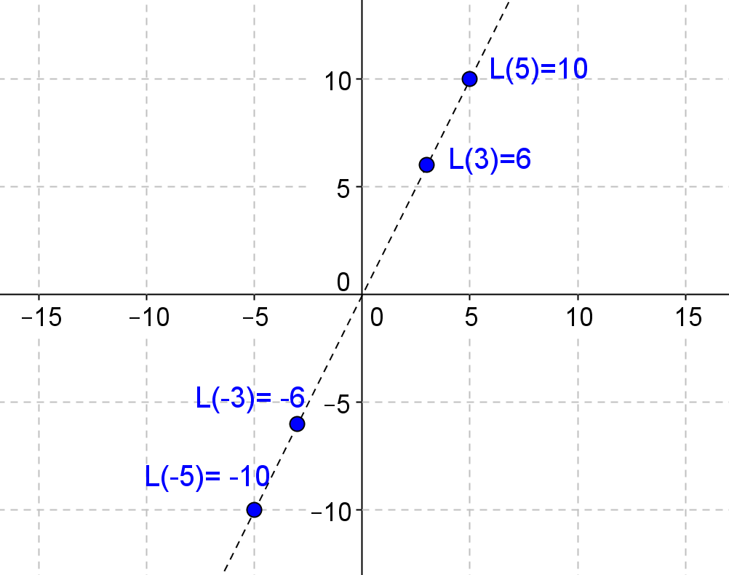
  - Draw the graph of the function $L(x)$.

- A linear transformation $L: R→R$ must have the form of $L\left(x\right)=ax$ for some real number $a$. Consider the
interval $\left[-5,2\right]$. Describe the geometric effect of the following, and find the new interval.
  - $L\left(x\right)=5x$
It dilates the interval by a scale factor of $5$; $\left[-25, 10\right].$

  - $L\left(x\right)=-2x$
It reflects the interval over the origin and then dilates it with a scale factor of $2$; $\left[-4, 10\right].$

- A linear transformation $L: R→R$ must have the form of $L\left(x\right)=ax$ for some real number $a$. Consider the interval $\left[-2,6\right]$. Write the formula for the mapping described, and find the new interval.
  - A reflection over the origin.
$L\left(x\right)=-x$,$\left[-6, 2\right]$

  - A dilation with a scale of $\sqrt{2}$.
$L\left(x\right)=\sqrt{2}∙x$,$\left[-2\sqrt{2}, 6\sqrt{2}\right]$

  - A reflection over the origin and a dilation with a scale of $\frac{1}{2}$.
$L\left(x\right)=-\frac{1}{2}x$,$\left[-3, 1\right]$

  - A collapse of the interval to the number $0$.
$L\left(x\right)=0x$,$[0,0]$

- In Module 1, we used $2×2$ matrices to do transformations on a square, such as a pure rotation, a pure reflection, a pure dilation, and a rotation with a dilation. Now use those matrices to do transformations on this complex number: $z=2+i$. For each transformation below, graph your answers.
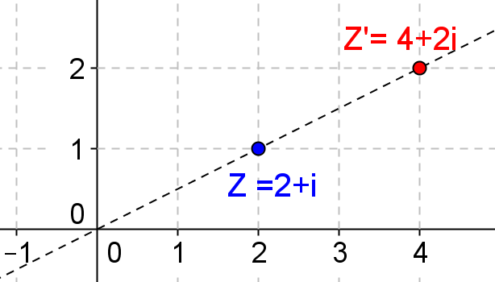
  - A pure dilation with a factor of $2$.
$\left(\begin{matrix}2 & 0 \\ 0 & 2\end{matrix}\right)$,$L\left(z\right)=\left(\begin{matrix}2 & 0 \\ 0 & 2\end{matrix}\right)\left(\begin{matrix}2 \\ 1\end{matrix}\right)=\left(\begin{matrix}4 \\ 2\end{matrix}\right)$

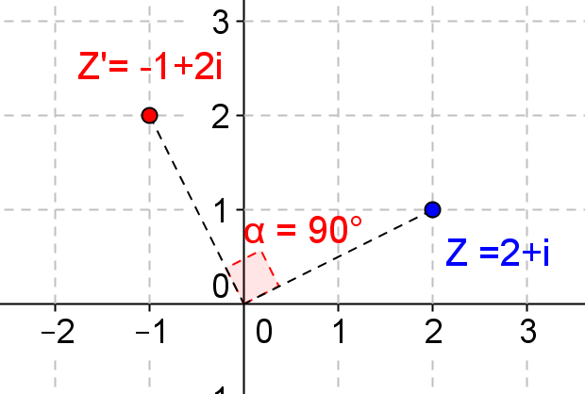
  - A pure $\frac{π}{2}$ radians counterclockwise rotation about the origin.
$\left(\begin{matrix}0 & -1 \\ 1 & 0\end{matrix}\right)$,$L\left(z\right)=\left(\begin{matrix}0 & -1 \\ 1 & 0\end{matrix}\right)\left(\begin{matrix}2 \\ 1\end{matrix}\right)=\left(\begin{matrix}-1 \\ 2\end{matrix}\right)$

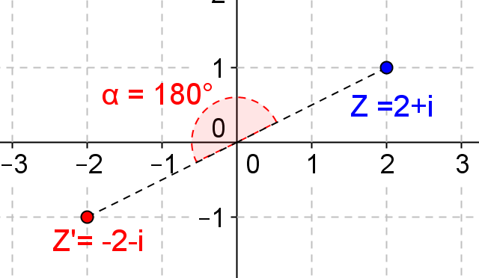
  - A pure $π$ radians counterclockwise rotation about the origin.
$\left(\begin{matrix}-1 & 0 \\ 0 & -1\end{matrix}\right)$,$L\left(z\right)=\left(\begin{matrix}-1 & 0 \\ 0 & -1\end{matrix}\right)\left(\begin{matrix}2 \\ 1\end{matrix}\right)=\left(\begin{matrix}-2 \\ -1\end{matrix}\right)$

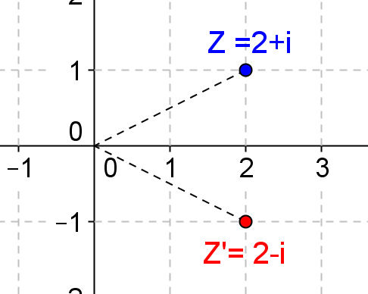
  - A pure reflection about the real axis.
$\left(\begin{matrix}1 & 0 \\ 0 & -1\end{matrix}\right)$,$L\left(z\right)=\left(\begin{matrix}1 & 0 \\ 0 & -1\end{matrix}\right)\left(\begin{matrix}2 \\ 1\end{matrix}\right)=\left(\begin{matrix}2 \\ -1\end{matrix}\right)$

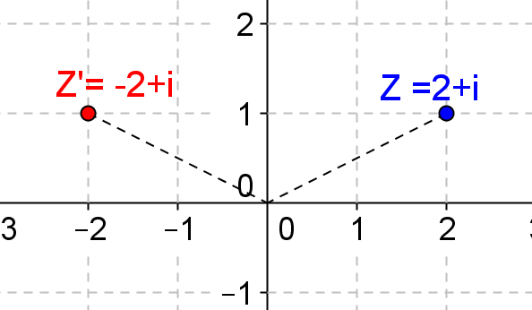
  - A pure reflection about the imaginary axis.
$\left(\begin{matrix}-1 & 0 \\ 0 & 1\end{matrix}\right)$,$L\left(z\right)=\left(\begin{matrix}-1 & 0 \\ 0 & 1\end{matrix}\right)\left(\begin{matrix}2 \\ 1\end{matrix}\right)=\left(\begin{matrix}-2 \\ 1\end{matrix}\right)$

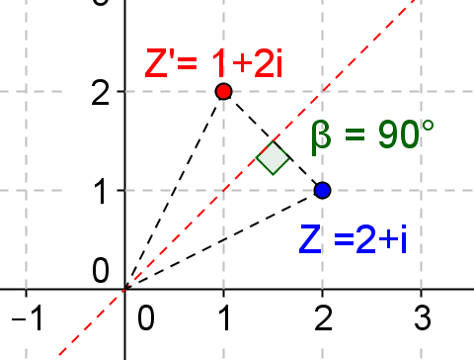
  - A pure reflection about the line $y=x$.
$\left(\begin{matrix}0 & 1 \\ 1 & 0\end{matrix}\right)$,$L\left(z\right)=\left(\begin{matrix}0 & 1 \\ 1 & 0\end{matrix}\right)\left(\begin{matrix}2 \\ 1\end{matrix}\right)=\left(\begin{matrix}1 \\ 2\end{matrix}\right)$

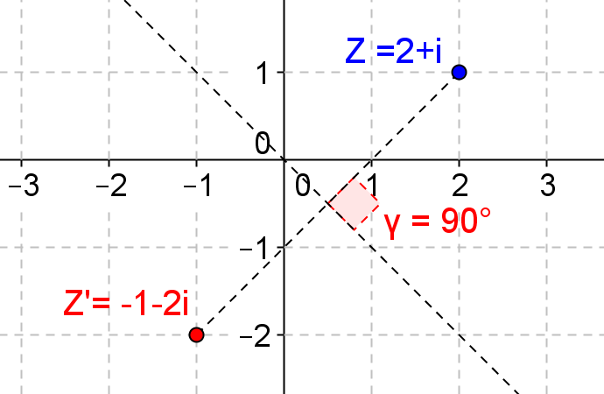
  - A pure reflection about the line $y=-x$.
$\left(\begin{matrix}0 & -1 \\ -1 & 0\end{matrix}\right)$,$L\left(z\right)=\left(\begin{matrix}0 & -1 \\ -1 & 0\end{matrix}\right)\left(\begin{matrix}2 \\ 1\end{matrix}\right)=\left(\begin{matrix}-1 \\ -2\end{matrix}\right)$

- Wesley noticed that by multiplying the matrix $\left(\begin{matrix}0 & -1 \\ 1 & 0\end{matrix}\right)$ by a complex number $z$ produces a pure $\frac{π}{2}$ radians
counterclockwise rotation, and multiplying by $\left(\begin{matrix}2 & 0 \\ 0 & 2\end{matrix}\right)$ produces a pure dilation with a factor of $2$. So, he thinks he
can add these two matrices, which will produce $\left(\begin{matrix}2 & -1 \\ 1 & 2\end{matrix}\right)$ and will rotate $z$ by $\frac{π}{2}$ radians counterclockwise and dilate
$z$ with a factor of $2$. Is he correct? Explain your reason.
No, he is not correct. For the general transformation of complex numbers, the form is $L\left(Z\right)=\left(\begin{matrix}a & -b \\ b & a\end{matrix}\right)\left(\begin{matrix}x \\ y\end{matrix}\right)$.
By multiplying the matrix $\left(\begin{matrix}a & -b \\ b & a\end{matrix}\right)$ to $z$, it rotates $z$ an angle $arctan\left(\frac{b}{a}\right)$, and dilates $z$ with a factor of $\sqrt{a^{2}+b^{2}}$.
$arctan\left(\frac{1}{2}\right)= 26.565° ,$and $\sqrt{{\left(1\right)}^{2}+{(2)}^{2}}=\sqrt{5}$, which is not $\frac{π}{2}$ radians or a dilation of a factor of $2$.

- In Module 1, we learned that there is not any real number that will satisfy $\frac{1}{a+b}=\frac{1}{a}+\frac{1}{b}$, which is the addtition property of linear transformation. However, we discussed that some fixed complex numbers might work. Can you find two pairs of complex numbers that will work? Show you work.
Given $\frac{1}{a+b}=\frac{1}{a}+\frac{1}{b}$,$a, b≠0,\frac{1}{a+b}=\frac{b+a}{ab}$,$ab={\left(a+b\right)}^{2}$,$ab=a^{2}+2ab+b^{2}$,
$a^{2}+ab+b^{2}=0$,$a^{2}+ad+\frac{1}{4}b^{2}=-\frac{3}{4}b^{2}$,${\left(a+\frac{1}{2} b\right)}^{2}=-\frac{3}{4}b^{2}$,$a+\frac{1}{2}b=±\frac{\sqrt{3}}{2}b∙i$
$a=\frac{-1±\sqrt{3}∙i}{2}b$, for example, $b=2$ and $a=-1+\sqrt{3}∙i$, $b=4$ and $a=-2+2\sqrt{3}∙i$

- Suppose $L$is a complex-number function that satisfies the dream conditions: $L\left(z+w\right)=L\left(z\right)+L\left(w\right)$ and
$L\left(kz\right)=k(z)$ for all complex numbers $z, w$, and $k$. Show $L\left(z\right)=mz$ for a fixed complex-number $m$, the only type of complex-number function that satisfies these conditions?
Let $z=a+bi, w=c+di$, for addition property:
$L\left(z+w\right)=L\left(z\right)+L\left(w\right)=m\left(a+bi\right)+m\left(c+di\right)=m\left[\left(a+c\right)+(b+d\right)i]$
$L\left(z+w\right)=L\left(a+bi+c+di\right)=L\left(\left(a+c\right)+\left(b+d\right)i\right)=m\left(\left(a+c\right)+\left(b+d\right)i\right)$; they are the same.
For multiplication property:
$$L\left(kz\right)=kL\left(z\right)=kmz=km(a+bi)$$
$L\left(kz\right)=L\left(k\left(a+bi\right)\right)=mk\left(a+bi\right)$; they are the same.

- For complex numbers, the linear transformation requires $L\left(x+y\right)=L\left(x\right)+L\left(y\right), L\left(a∙x\right)=a∙x$. Prove that in general $L\left(\begin{matrix}x \\ y\end{matrix}\right)=\left(\begin{matrix}a & b \\ c & d\end{matrix}\right)\left(\begin{matrix}x \\ y\end{matrix}\right)$ is a linear transformation, where $\left(\begin{matrix}x \\ y\end{matrix}\right)$ represents $z=x+yi$.
For the addition property: $L\left(z_{1}+z_{2}\right)=L\left(\left(\begin{matrix}x_{1} \\ y_{1}\end{matrix}\right)+\left(\begin{matrix}x_{2} \\ y_{2}\end{matrix}\right)\right)=L\left(\begin{matrix}x_{1}+x_{2} \\ y_{1}+y_{2}\end{matrix}\right)=\left(\begin{matrix}a & c \\ b & d\end{matrix}\right)\left(\begin{matrix}x_{1}+x_{2} \\ y_{1}+y_{2}\end{matrix}\right)=\left(\begin{matrix}a\left(x_{1}+x_{2}\right)+c(y_{1}+y_{2}) \\ b\left(x_{1}+x_{2}\right)+d(y_{1}+y_{2})\end{matrix}\right)$
$L\left(z_{1}+z_{2}\right)=L\left(z_{1}\right)+L\left(z_{2}\right)=\left(\begin{matrix}a & c \\ b & d\end{matrix}\right)\left(\begin{matrix}x_{1} \\ y_{1}\end{matrix}\right)+\left(\begin{matrix}a & c \\ b & d\end{matrix}\right)\left(\begin{matrix}x_{2} \\ y_{2}\end{matrix}\right)=\left(\begin{matrix}ax_{1}+cy_{1} \\ bx_{1}+dy_{1}\end{matrix}\right)+\left(\begin{matrix}ax_{2}+cy_{2} \\ bx_{2}+dy_{2}\end{matrix}\right)=\left(\begin{matrix}ax_{1}+cy_{1}+ax_{2}+cy_{2} \\ bx_{1}+dy_{1}+bx_{2}+dy_{2}\end{matrix}\right)=\left(\begin{matrix}a\left(x_{1}+x_{2}\right)+c(y_{1}+y_{2}) \\ b\left(x_{1}+x_{2}\right)+d(y_{1}+y_{2})\end{matrix}\right)$, the result is the same.
Now we need to prove the multiplication property.
$L\left(kz\right)=L\left(k\left(\begin{matrix}x \\ y\end{matrix}\right)\right)=L\left(\begin{matrix}kx \\ ky\end{matrix}\right)=\left(\begin{matrix}a & c \\ b & d\end{matrix}\right)\left(\begin{matrix}kx \\ ky\end{matrix}\right)=\left(\begin{matrix}akx+cky \\ bkx+dky\end{matrix}\right)$
$L\left(kz\right)=kL\left(z\right)=k\left(\begin{matrix}a & c \\ b & d\end{matrix}\right)\left(\begin{matrix}x \\ y\end{matrix}\right)=k\left(\begin{matrix}ax+cy \\ bx+dy\end{matrix}\right)=\left(\begin{matrix}akx+cky \\ bkx+dky\end{matrix}\right)$; the result is the same.

