Lesson 3: Matrix Arithmetic in its Own Right

Student Outcomes
- Students will use matrices to represent data based on transportation networks.
- Students will multiply matrices of appropriate dimensions and interpret the meaning of this arithmetic in terms of transportation networks.

Lesson Notes
This lesson builds on the work in the previous lesson by considering a transportation network with two different types of public transportation. This situation will be used to help students discover and define multiplication of two matrices
(N-VM.C.8). Students will understand the meaning of this matrix arithmetic. They will begin to discover that matrix multiplication is not commutative. Matrix arithmetic and the properties of matrix arithmetic will be explored further in this lesson as well. Throughout this lesson, students will be making sense of transportation network diagrams and matrices (MP.1), reasoning about contextual and abstract situations (MP.2), and using matrices as tools to represent network diagrams (MP.5) with care and precision (MP.6).

Classwork
Opening Exercise (5 minutes)
Students will begin to explore the concept of matrix multiplication by calculating the total number of ways to travel from City 2 to City 1 if the first leg of the trip is by bus and the second leg is by subway. This activity will help students understand how to determine the number of available routes that use two modes of transportation in a particular order. The table will help students understand how to calculate the elements in the product of two matrices and to understand the meaning of that product.
- What do the rows in this table represent?
  - Each row is the number of ways to travel from City 2 to City 1 via one of the four cities.
- Why are the total ways to travel between City 2 to City 1 through City 1 equal to $0$?
  - The exercise asks us to find the routes from City 2 to City 1 with the first leg being by bus and the second leg being by subway. There is one way to travel from City 2 to City 1 via bus, but there are no ways to travel from City 1 to City 1 by subway. That would require the diagram to have a dashed loop from City 1 to City 1. Therefore, there are no routes from City 2 to City 1 that use a bus for the first leg of the trip and the subway for the second leg.
- How did you complete the table below?
  - We counted the routes between each city and then multiplied the number of bus routes by the number of subway routes. Finally, we had to add all the numbers in the last column to determine the total possible routes.

- How does this table ensure that you counted all the possible routes?
  - We counted all the bus routes from City 2 to another city (including itself), and then we counted all the subway routes from one of the four cities to City 1. We considered all possible paths.
Opening Exercise
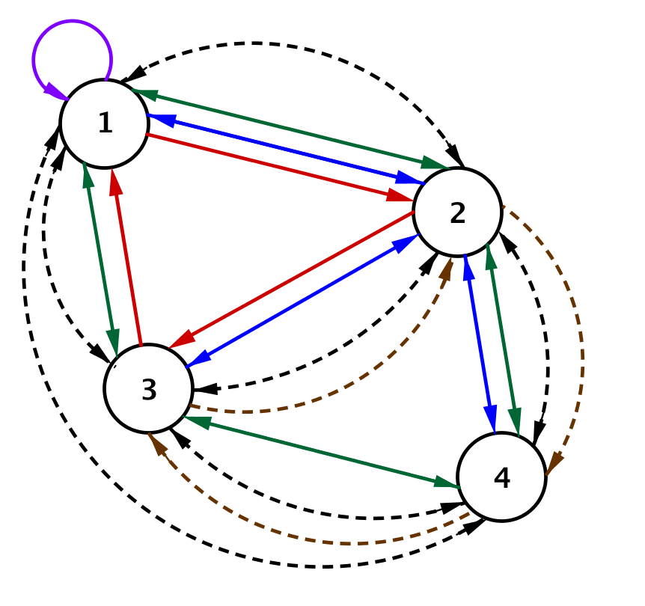
The subway and bus line network connecting four cities that we used in Lesson 2 is shown below. The bus routes connecting the cities are represented by solid lines, and the subway routes are represented by dashed lines.
Scaffolding:
- Challenge advanced students to create a matrix to represent this network.
- Struggling students can use the diagram below that contains fewer bus routes and subway lines.
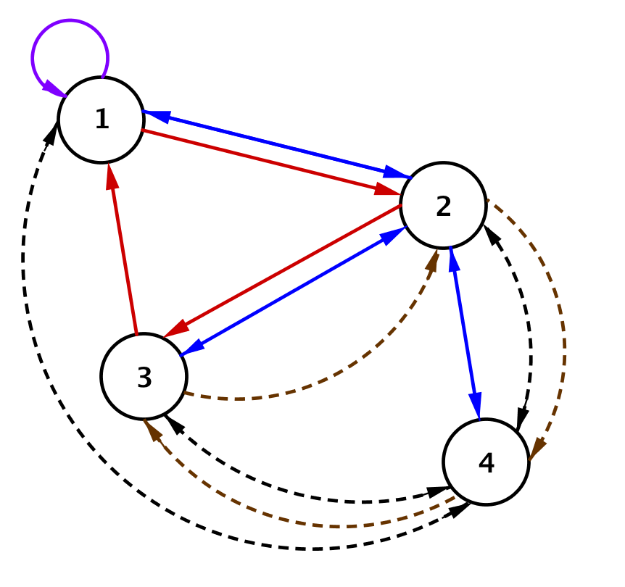
Suppose we want to travel from City 2 to City 1, first by bus and then by subway, with no more than one connecting stop.
  - Complete the chart below showing the number of ways to travel from City 2 to City 1 using first a bus and then the subway. The first row has been completed for you.

First Leg (BUS) |  | Second Leg (SUBWAY) |  | Total Ways to Travel
City 2 to City 1: | $$2$$ | City 1 to City 1: | $$0$$ | $$2∙0=0$$
City 2 to City 2: | $$0$$ | City 2 to City 1: | $$1$$ | $$0∙1=0$$
City 2 to City 3: | $$2$$ | City 3 to City 1: | $$1$$ | $$2∙1=2$$
City 2 to City 4: | $$2$$ | City 4 to City 1: | $$1$$ | $$2∙1=2$$

  - How many ways are there to travel from City 2 to City 1, first on a bus and then on a subway? How do you know?
The total number of ways is the sum numbers in the last column. There are $4$ ways.

Exploratory Challenge/Exercises 1–12 (20 minutes): The Meaning of Matrix Multiplication
This challenge continues to introduce the notion of matrix multiplication in a meaningful situation. Students will consider travel routes if we use two different means of transportation in a particular order and have at most one connecting city for all pairs of cities.
Exploratory Challenge/Exercises 1–12: The Meaning of Matrix Multiplication
Suppose we want to travel between all cities, traveling first by bus and then by subway, with no more than one connecting stop.
- Use a chart like the one in the Opening Exercise to help you determine the total number of ways to travel from
City 1 to City 4 using first a bus and then the subway.
First Leg (BUS) |  | Second Leg (SUBWAY) |  | Total Ways to Travel
City 1 to City 1: | $$1$$ | City 1 to City 4: | $$1$$ | $$1∙1=1$$
City 1 to City 2: | $$3$$ | City 2 to City 4: | $$2$$ | $$3∙2=6$$
City 1 to City 3: | $$1$$ | City 3 to City 4: | $$1$$ | $$1∙1=1$$
City 1 to City 4: | $$0$$ | City 4 to City 4: | $$0$$ | $$0∙0=0$$
Summing the entries in the last column shows that there are eight different ways to travel from City 1 to City 4 using first a bus and then the subway.

- Suppose we create a new matrix $P$ to show the number of ways to travel between the cities, first by bus and then by subway, with no more than one connecting stop. Record your answers to Opening Exercise, part (b) and Exercise 1 in this matrix in the appropriate row and column location. We do not yet have enough information to complete the entire matrix. Explain how you decided where to record these numbers in the matrix shown below.
$$P=\left[\begin{matrix}___ & ___ & ___ & ___ \\ ___ & ___ & ___ & ___ \\ ___ & ___ & ___ & ___ \\ ___ & ___ & ___ & ___\end{matrix}\right]$$

$$P=\left[\begin{matrix}___ & ___ & ___ & 8 \\ 4 & ___ & ___ & ___ \\ ___ & ___ & ___ & ___ \\ ___ & ___ & ___ & ___\end{matrix}\right]$$
If the rows represent the starting city and the columns represent the destination city, then the ways to travel from City 2 to City 1 would be $p_{2,1},$ and the ways to travel from City 1 to City 4 would be $p_{1,4}$.

At this point, circulate around the room to check for understanding by making sure that groups are recording the correct entries in the proper locations in the matrix. Debrief as a whole class if a majority of students are struggling. You may want to review matrix notation, especially since students are going to use it in upcoming exercises. For example, if $P$ is a matrix then $p_{i,j}$ is the element in the $i$^{th} row and $j$^{th} column of the matrix. In Exercise 5, some groups may continue to use a table, while some may simply create a list. Make sure that students are recording a written explanation of how they calculated their answers. If students can describe the process of multiplying and summing verbally or in writing, then they will be able to calculate the product of two matrices without difficulty.

- What is the total number of ways to travel from City $3$ to City $2$ first by bus and then by subway with no more than one connecting stop? Explain how you got your answer and where you would record it in matrix $P$ above.
Find the ways to travel by bus from City 3 to each of the other cities, including City 3 itself. Then for each city, find the ways to travel by subway from that city to City 2. Multiply the number of ways from City 2 to the connecting city by the number of ways from the connecting city to City 2. Finally, add the result of the number of ways through each connecting city.
City 3 to City 2 via City 1: $2∙1=2$
City 3 to City 2 via City 2: $1∙0=0$
City 3 to City 2 via City 3: $0∙2=0$
City 3 to City 2 via City 4: $1∙1=1$
There are $2+0+0+1=3$ ways to travel from City 3 to City 2, using first a bus and then the subway. This would be entered in the 3rd row and 2nd column of matrix $P$.
Recall matrix $B$, which shows the number of bus lines connecting the cities in this transportation network, and matrix $S$, which represents the number of subway lines connecting the cities in this transportation network.
$B=\left[\begin{matrix}1 & 3 & 1 & 0 \\ 2 & 0 & 2 & 2 \\ 2 & 1 & 0 & 1 \\ 0 & 2 & 1 & 0\end{matrix}\right]$ and $S=\left[\begin{matrix}0 & 1 & 1 & 1 \\ 1 & 0 & 1 & 2 \\ 1 & 2 & 0 & 1 \\ 1 & 1 & 2 & 0\end{matrix}\right]$
- What does the product $b_{1,2}s_{2,4}$ represent in this situation? What is the value of this product?
The product $b_{1,2}s_{2,4}$ represents the number of ways to travel from City 1 to City 4 via City 2, first by bus and then by subway.
$$b_{1,2}s_{2,4}=3∙2=6$$

- What does $b_{1,4}s_{4,4}$ represent in this situation? What is the value of this product? Does this make sense?
The product $b_{1,4}s_{4,4}$ represents the number of ways to travel from City 1 to City 4 via City 4, first by bus and then by subway.
$$b_{1,4}s_{4,4}=0∙0=0$$
Since there is no bus route from City 1 to City 4 and no subway route from City 4 to City 4, it is impossible to travel from City 1 to City 4 using first a bus and then a subway. Thus, there are no possible routes.

- Calculate the value of the expression $b_{1,1}s_{1,4}+b_{1,2}s_{2,4}+b_{1,3}s_{3,4}+b_{1,4}s_{4,4}$. What is the meaning of this expression in this situation?
$$b_{1,1}s_{1,4}+b_{1,2}s_{2,4}+b_{1,3}s_{3,4}+b_{1,4}s_{4,4}=1∙1+3∙2+1∙1+0∙0=8$$
Thus, there are $8$ total ways to travel from City 1 to City 4 via any one of the cities, first by bus and then by subway.

- Circle the first row of $B$ and the second column of $S$. How are these entries related to the expression above and your work in Exercise 1?
We multiplied the first element in the row by the first element in the column, the second by the second, third by third and so on, and then we found the sum of those products. This is the same as the sum of the entries in the last column of the table in Exercise 1.

- Write an expression that represents the total number of ways you can travel between City $2$ and City $1,$first by bus and then by subway, with no more than one connecting stop. What is the value of this expression? What is the meaning of the result?
$$b_{2,1}s_{1,1}+b_{2,2}s_{2,1}+b_{2,3}s_{3,1}+b_{2,4}s_{4,1}=2∙0+0∙1+2∙1+2∙1=4$$
Thus, there are$4$ total ways to travel from City 2 to City 1 via any one of the cities, first by bus and then by subway.

- Write an expression that represents the total number of ways you can travel between City 4 and City 1$,$ first by bus and then by subway, with no more than one connecting stop. What is the value of this expression? What is the meaning of the result?
$$b_{4,1}s_{1,1}+b_{4,2}s_{2,1}+b_{4,3}s_{3,1}+b_{4,4}s_{4,1}=0∙0+2∙1+1∙1+0∙1=3$$
Thus, there are $3$ total ways to travel from City 4 to City 1 via any one of the cities, first by bus and then by subway.

At this point, you should stop and debrief. Have several students share their results with the whole class. Have different groups present different portions of the Exploratory Challenge on the board or on a document camera. Use these questions that follow to focus the discussion. Have students answer them with a partner or in their small groups before asking for volunteers to share the answer with the entire class.
- What does each element of matrix $P$ represent?
  - Entry $p_{i,j}$ represents the number of ways to travel from the $i$^{th} city to the $j$^{th} city, changing from a bus to the subway one time.
- What patterns do you notice in the expression in Exercise 6 and the expressions you wrote for Exercises 8
and 9?
  - In the indices, there is a pattern where the first number is the starting city and the last number is the ending city, and the middle indices are the same.
- Complete this sentence: To calculate the element of matrix $P$ in the 2nd row and 4th column, you would…
  - Multiply each element in the 2nd row of $B$by each corresponding element in the 4th column of $S$, and then add the resulting products.
- Complete the sentence: The element of matrix $P$ in the 4th row and 2nd column represents the number of ways to travel…
  - From City 4 to City 2 first via bus and then changing to a subway in the connecting city.
- Describe how to calculate any element in matrix $P$.
  - You multiply each element in the $i^{th}$ row of the first matrix by the corresponding element in the $j$^{th} column of the second matrix, and then add the resulting products.
The last two exercises have students construct the complete matrix. Allow them time to work through the process. There are many opportunities for careless errors, so taking the time to be accurate and precise is essential (MP.6).

- Complete matrix $P$ that represents the routes connecting the four cities if you travel first by bus and then by subway.
$$P=\left[\begin{matrix}4 & 3 & 4 & 8 \\ 4 & 8 & 6 & 4 \\ 2 & 3 & 5 & 4 \\ 3 & 2 & 2 & 5\end{matrix}\right]$$

- Construct a matrix $M$ that represents the routes connecting the four cities if you travel first by subway and then by bus.
$$M=\left[\begin{matrix}4 & 3 & 3 & 3 \\ 3 & 8 & 3 & 1 \\ 5 & 5 & 6 & 4 \\ 7 & 5 & 3 & 4\end{matrix}\right]$$

- Should these two matrices be the same? Explain your reasoning.
This transportation network has different numbers of routes connecting cities in each direction. Traveling from
City 1 to City 4 will not have the same number of options as traveling from City 4 to City 1. Therefore, the order in which you select your method of travel makes a difference, which is why the matrices $M$ and $P$ are not equal.

Discussion (5 minutes)
Use this time to finish debriefing the exercises in the Exploratory Challenge. Define and describe the product of two matrices more formally, and give students an opportunity to take notes on the process.
- During this Exploratory Challenge, you have been calculating what mathematicians define to be the product of two matrices. Does this matrix arithmetic operation seem to relate back to real number multiplication in any way?
  - We are working with an array and doing some multiplying when working with real number multiplication. We do not really find products and then add the results.
- Our examples used square $4×4$ matrices, but matrix multiplication can also be applied to matrices of different dimensions. Consider matrices $A=\left[\begin{matrix}1 & 2 \\ 3 & 1\end{matrix}\right]$ and $B=\left[\begin{matrix}2 & 1 & 0 \\ 1 & -2 & 1\end{matrix}\right]$. Would it make sense to compute $A⋅B$? Why or why not?
  - We could compute $A⋅B,$ and we would get $A⋅B=\left[\begin{matrix}1⋅2+2⋅1 & 1⋅1+2⋅(-2) & 1⋅0+2⋅1 \\ 3⋅2+1⋅1 & 3⋅1+1⋅(-2) & 3⋅0+1⋅1\end{matrix}\right]$, so $A⋅B=\left[\begin{matrix}4 & -3 & 2 \\ 7 & 1 & 1\end{matrix}\right]$.
- What about the product $B⋅A?$
  - Our multiplication process fails if we try to compute $B⋅A$ because there are a different number of entries in the columns of $B$ than in the rows of $A$.
- You described how to calculate each element of the product matrix in words. Using symbols, if $P=A∙B$, then element $p_{i,j}=a_{i,1}b_{1,j}+a_{i,2}b_{2,j}+a_{i,3}b_{3,j}+…+a_{i,n}b_{m,j}$, where $n$ is the number of columns in $A$ and $m$ is the number of rows in $B$. What must be true about the dimensions of two matrices if we wish to find their product?
  - This implies that you can only multiply two matrices if the number of columns in the first matrix is equal to the number of rows in the second matrix.
Have students record this information in their notes to show examples of the product of two matrices. Have them color code a few entries as shown below to highlight the process.
$$B∙S=P$$
$$\left[\begin{matrix}1 & 3 & 1 & 0 \\ 2 & 0 & 2 & 2 \\ 2 & 1 & 0 & 1 \\ 0 & 2 & 1 & 0\end{matrix}\right]∙\left[\begin{matrix}0 & 1 & 1 & 1 \\ 1 & 0 & 1 & 2 \\ 1 & 2 & 0 & 1 \\ 1 & 1 & 2 & 0\end{matrix}\right]=\left[\begin{matrix}4 & 3 & 4 & 8 \\ 4 & 8 & 6 & 4 \\ 2 & 3 & 5 & 4 \\ 3 & 2 & 2 & 5\end{matrix}\right]$$
$p_{1,2}=1∙1+3∙0+1∙2+0∙1=3$
$$S∙B=M$$
$$\left[\begin{matrix}0 & 1 & 1 & 1 \\ 1 & 0 & 1 & 2 \\ 1 & 2 & 0 & 1 \\ 1 & 1 & 2 & 0\end{matrix}\right]\left[\begin{matrix}1 & 3 & 1 & 0 \\ 2 & 0 & 2 & 2 \\ 2 & 1 & 0 & 1 \\ 0 & 2 & 1 & 0\end{matrix}\right]=\left[\begin{matrix}4 & 3 & 3 & 3 \\ 3 & 8 & 3 & 1 \\ 5 & 5 & 6 & 4 \\ 7 & 5 & 3 & 4\end{matrix}\right]$$

- When we multiply two matrices together, such as an $m×n$ matrix by an $n×p$ matrix, what is the size of the resulting matrix?
  - The resulting matrix has size $m×p.$
Inner numbers match
$$\left(m × n\right)⋅(n × p)$$
Size of final product
- In Exercises 10 and 11, you showed that matrix $P$ and matrix $M$ were not the same. In real number arithmetic, the operation of multiplication is commutative. What does that mean?
  - It means that $a∙b=b∙a$ when $a$ and $b$ are real numbers.
- Is matrix multiplication commutative? Explain your reasoning.
  - The results of Exercises 10–12 and the meaning of the product matrix in this situation implies that even if the two matrices being multiplied are square matrices (equal number of rows and columns), matrix multiplication is not commutative.

Exercises 13-16 (5 minutes)
These exercises talk about arithmetic operations with matrices. Students are beginning to think abstractly about the properties of matrices and how they compare to properties of real numbers. Three by three matrices are used in the example, and square matrices are used in these exercises, but advanced students could be asked to show that these properties hold regardless of the size of the matrices, as long as added matrices are of equal dimensions and multiplied matrices have appropriate dimensions.
Exercises 13–16
- Let $A=\left[\begin{matrix}2 & 3 & -1 \\ 0 & 1 & 2 \\ 1 & 0 & 0\end{matrix}\right]$
  - Construct a matrix $Z$ such that $A+Z=A$. Explain how you got your answer.
$$Z=\left[\begin{matrix}0 & 0 & 0 \\ 0 & 0 & 0 \\ 0 & 0 & 0\end{matrix}\right]$$
We would need to add $0$ to each element of $A$ to get the same matrix, so each element of $Z$ must be equal
to $0$. Also, $Z$ must have the same dimensions as $A$ so we can add corresponding elements.

  - Explain why $k∙Z=Z$ for any real number $k$.
Any number multiplied by $0$ is equal to $0$. Scalar multiplication multiplies each element of $Z$ by $k$.

  - The real number $0$ has the properties that $a+0=0$ and $a∙0=0$ for all real numbers $a$. Why would mathematicians call $Z$ a zero matrix?
The matrix $Z$ has the same properties in matrix addition as the real number $0$ has with real number addition.

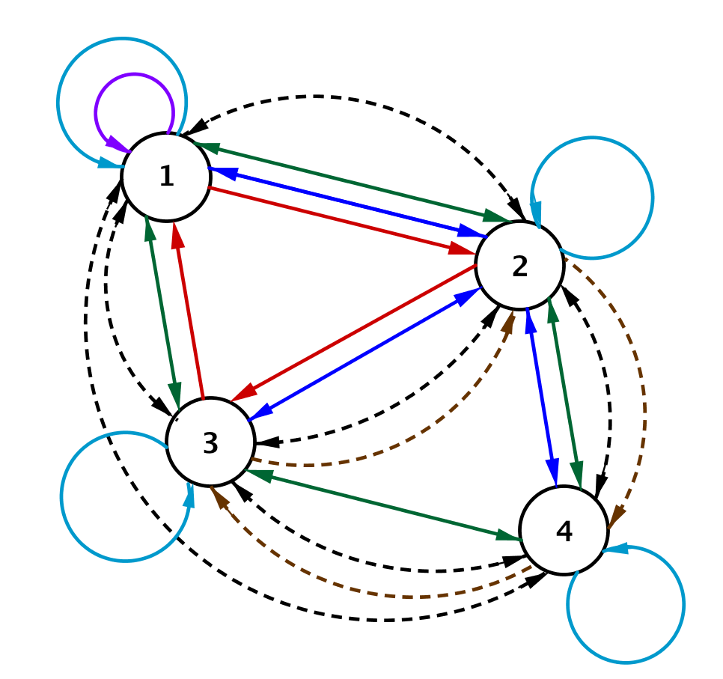
- Suppose each city had a trolley car that ran a route between tourist destinations. The blue loops represent the trolley car routes. Remember that straight lines indicate bus routes, and dotted lines indicate subway routes.
MP.2

  - Explain why the matrix $I$ shown below would represent the number of routes connecting cities by trolley car in this transportation network.
$$I=\left[\begin{matrix}1 & 0 & 0 & 0 \\ 0 & 1 & 0 & 0 \\ 0 & 0 & 1 & 0 \\ 0 & 0 & 0 & 1\end{matrix}\right]$$
It shows that you can travel on the trolley from City 1 to City 1, City 2 to City 2, City 3 to City 3$,$ and City 4 to City 4 but not between cities.

  - Recall that $B$ is the bus route matrix. Show that $I∙B=B$. Explain why this makes sense in terms of the transportation network.
MP.2
The entries in matrix $I∙B$ represent the number of ways to travel from city to city, first on a trolley and then on the bus. Since there is only one way in each city to travel by trolley and there are no ways to travel by trolley between cities, the number of routes will be the same as the number of bus routes.

  - The real number $1$ has the property that $1∙a=a$ for all real numbers $a$, and we call $1$ the multiplicative identity. Why would mathematicians call $I$ an identity matrix?
Matrix$I$ has the same property under matrix multiplication that the real number $1$ does for real number multiplication, so it makes sense to call $I$ an identity matrix.

  - What would be the form of a $2×2$ identity matrix? What about a $3×3$ identity matrix?
A $2×2$identity matrix would be $I=\left[\begin{matrix}1 & 0 \\ 0 & 1\end{matrix}\right],$ and a $3×3$ identity matrix would be $I=\left[\begin{matrix}1 & 0 & 0 \\ 0 & 1 & 0 \\ 0 & 0 & 1\end{matrix}\right].$

- In this lesson you learned that the commutative property does not hold for matrix multiplication. This exercise asks you to consider other properties of real numbers applied to matrix arithmetic.
  - Is matrix addition associative? That is, does $\left(A+B\right)+C=A+(B+C)$ for matrices $A$, $B$, and $C$ that have the same dimensions? Explain your reasoning.
Yes. Because all three matrices have the same dimensions, we will add corresponding entries. The entries are real numbers. Since the associative property holds for adding real numbers, it would make sense to hold for the addition of matrices.
MP.3

  - Is matrix multiplication associative? That is, does $\left(A∙B\right)∙C∙=A∙(B∙C)$ for matrices $A$, $B$, and $C$ for which the multiplication is defined? Explain your reasoning.
Yes. As long as the dimensions of the matrices are such that the multiplications are all defined, computing the products requires that we add and multiply real numbers. Since these operations are associative for real numbers, multiplication will be associative for matrices. It would be like finding the number of routes if we had three modes of transportation and changed modes twice. We can count those totals in different groupings as long as we maintain the order of the transportation modes (e.g. bus to subway to train).

  - Is matrix addition commutative? That is, does $A+B=B+A$ for matrices $A$ and $B$ with the same dimensions?
Yes, because addition of the individual elements is commutative.

- Complete the graphic organizer to summarize your understanding of the product of two matrices.
Operation | Symbols | Describe How to Calculate | Example Using $3×3$ Matrices
Matrix Multiplication | $$A∙B$$ | To find the element in the $i$^{th} row and $j$^{th} column of the product matrix, multiply corresponding elements from the $i$^{th} row of the first matrix by the $j$^{th} column of the second matrix, and then add the results. Repeat this process for each element in the product matrix. | $$\left[\begin{matrix}2 & 0 & 2 \\ 2 & 2 & -1 \\ 1 & -3 & 0\end{matrix}\right]\left[\begin{matrix}1 & 1 & 2 \\ 2 & 2 & 4 \\ 3 & 0 & 0\end{matrix}\right]=\left[\begin{matrix}8 & 2 & 4 \\ 3 & 6 & 12 \\ -5 & -5 & -10\end{matrix}\right]$$

Closing (5 minutes)
Have students review their graphic organizer entries in Exercise 16 with a partner, and then ask one or two students to share their responses with the entire class. Take a minute to clarify any questions students have about the notation used in the Lesson Summary shown below.
Lesson Summary
Matrix Product: Let $A$ be an $m×n$ matrix whose entry in row $i$ and column $j$ is $a_{i,j},$and let $B$ be an $n×p$ matrix whose entry in row $i$ and column $j$ is $b_{i,j}$. Then the matrix product $AB$ is the $m×p$ matrix whose entry in row $i$ and column $j$ is $a_{i,1}b_{1,j}+a_{i,2}b_{2,j}+⋯+a_{i,n}b_{n,j}$.

Identity Matrix: The $n×n$ identity matrix is the matrix whose entry in row $i$ and column $i$ for
$1≤i≤n$ is 1, and whose entries in row $i$ and column $j$ for $1≤i, j≤n$ and $i≠j$ are all zero. The identity matrix is denoted by $I$. The $2×2$ identity matrix is $\left[\begin{matrix}1 & 0 \\ 0 & 1\end{matrix}\right]$, and the $3×3$ identity matrix is $\left[\begin{matrix}1 & 0 & 0 \\ 0 & 1 & 0 \\ 0 & 0 & 1\end{matrix}\right]$. If the size of the identity matrix is not explicitly stated, then the size is implied by context.

Zero Matrix: The $m×n$ zero matrix is the $m×n$ matrix in which all entries are equal to zero.
For example, the $2×2$ zero matrix is $\left[\begin{matrix}0 & 0 \\ 0 & 0\end{matrix}\right]$, and the $3×3$ zero matrix is $\left[\begin{matrix}0 & 0 & 0 \\ 0 & 0 & 0 \\ 0 & 0 & 0\end{matrix}\right]$. If the size of the zero matrix is not specified explicitly, then the size is implied by context.

Exit Ticket (5 minutes)

Name Date
Lesson 3: Matrix Arithmetic in its Own Right

Exit Ticket

Matrix $A$ represents the number of major highways connecting three cities. Matrix $B$ represents the number of railways connecting the same three cities.
$A=\left[\begin{matrix}0 & 3 & 0 \\ 2 & 0 & 2 \\ 1 & 1 & 2\end{matrix}\right]$ and $B=\left[\begin{matrix}0 & 1 & 1 \\ 1 & 0 & 1 \\ 1 & 1 & 0\end{matrix}\right]$
- Draw a network diagram for the transportation network of highways and railways between these cities. Use solid lines for highways and dotted lines for railways.
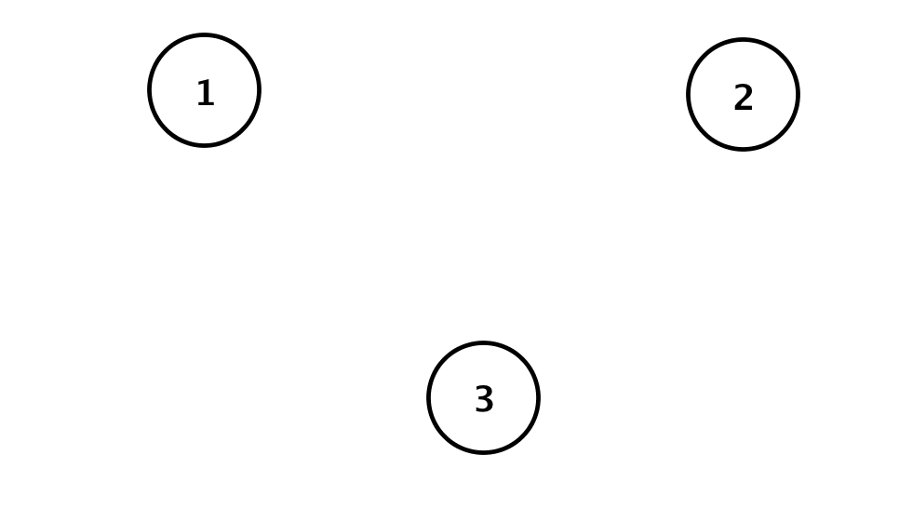

- Calculate and interpret the meaning of each matrix in this situation.
  - $A⋅B$

  - $B⋅A$

- In this situation, why does it make sense that $A⋅B≠B⋅A$?

Exit Ticket Sample Solutions
Matrix $A$ represents the number of major highways connecting three cities. Matrix $B$ represents the number of railways connecting the same three cities.
$A=\left[\begin{matrix}0 & 3 & 0 \\ 2 & 0 & 2 \\ 1 & 1 & 2\end{matrix}\right]$ and $B=\left[\begin{matrix}0 & 1 & 1 \\ 1 & 0 & 1 \\ 1 & 1 & 0\end{matrix}\right]$
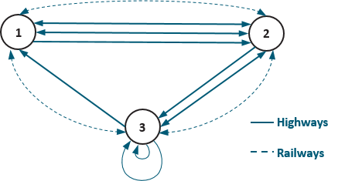
- Draw a network diagram for the transportation network of highways and railways between these cities. Use solid lines for highways and dotted lines for railways.

- Calculate and interpret the meaning of each matrix in this situation.
  - $A⋅B$
$AB=\left[\begin{matrix}3 & 0 & 3 \\ 2 & 4 & 2 \\ 3 & 3 & 2\end{matrix}\right]$. It indicates the number of ways to get around between three cities by taking highways
first and then railways second.

  - $B⋅A$
$BA=\left[\begin{matrix}3 & 1 & 4 \\ 1 & 4 & 2 \\ 2 & 3 & 2\end{matrix}\right]$. It indicates the number of ways to get around between three cities by taking railways first
and then highways second.

- In this situation, why does it make sense that $A⋅B≠B⋅A$?
It makes sense because both transportation networks have a different number of routes connecting cities in each direction. Not every route goes both directions. For example, there are a different number of possible routes from City 1 to City 2 than from City 2 to City 1.

Problem Set Sample Solutions

- Let $A=\left[\begin{matrix}1 & 3 \\ 2 & 0\end{matrix}\right]$ and $B=\left[\begin{matrix}1 & 2 \\ 4 & 3\end{matrix}\right]$represent the bus routes of two companies between $2$ cities. Find the product
$A⋅B,$ and explain the meaning of the entry in row 1, column 2 of $A⋅B$in the context of this scenario.
The product is $A⋅B=\left[\begin{matrix}1 & 3 \\ 2 & 0\end{matrix}\right]⋅\left[\begin{matrix}1 & 2 \\ 4 & 3\end{matrix}\right]=\left[\begin{matrix}13 & 11 \\ 2 & 4\end{matrix}\right].$ The entry in row 1, column 2 to $11$, which means that there
are $11$ possible routes from the first city to the second city, taking first a bus from Company A and then a bus from Company B.
- Let $A=\left[\begin{matrix}1 & 3 & 2 \\ 3 & 1 & 2 \\ 4 & 3 & 2\end{matrix}\right]$and$B=\left[\begin{matrix}2 & 1 & 3 \\ 2 & 2 & 1 \\ 1 & 3 & 1\end{matrix}\right]$ represent the bus routes of two companies between three cities.
  - Let $C=A⋅B$. Find matrix $C,$and explain the meaning of entry$c_{1,3}$.
The product is $C=\left[\begin{matrix}10 & 13 & 8 \\ 10 & 11 & 12 \\ 16 & 16 & 17\end{matrix}\right],$ and$c_{1,3}=8$ means that there are $8$ different ways to travel to City 3 from
City 1 by taking a bus from Company A and then a bus from Company B.

  - Nina wants to travel from City 3 to City 1 and back home to City 3 by taking a direct bus from Company A on the way to City 1 and a bus from Company B on the way back home to City 3. How many different ways are there for her to make this trip?
Since $C=A⋅B=\left[\begin{matrix}10 & 13 & 8 \\ 10 & 11 & 12 \\ 16 & 16 & 17\end{matrix}\right],$and Nina wants to travel from City 3 back to City 3, entry $c_{3,3}=17$means
that she has $17$ ways to make the trip.

  - Oliver wants to travel from City 2 to City 3 by taking first a bus from Company A and then taking a bus from Company B. How many different ways can he do this?
Since $C=A⋅B=\left[\begin{matrix}10 & 13 & 8 \\ 10 & 11 & 12 \\ 16 & 16 & 17\end{matrix}\right],$and Oliver wants to travel from City 2 to City 3, he has $c_{2,3}=12$ ways to
make the trip.

  - How many routes can Oliver choose from if travels from City 2 to City 3 by first taking a bus from Company B and then taking a bus from Company A?
Since $B⋅A=\left[\begin{matrix}17 & 16 & 12 \\ 12 & 11 & 10 \\ 14 & 9 & 10\end{matrix}\right],$and the entry in row 2 , column 3 is $10$, which means that there are $10$ ways to
get from City 2 to City 3 by taking a bus from Company B first and then a bus from Company A.

- Recall the bus and trolley matrices from the lesson:
$B=\left[\begin{matrix}1 & 3 & 1 & 0 \\ 2 & 0 & 2 & 2 \\ 2 & 1 & 0 & 1 \\ 0 & 2 & 1 & 0\end{matrix}\right]$ and $I=\left[\begin{matrix}1 & 0 & 0 & 0 \\ 0 & 1 & 0 & 0 \\ 0 & 0 & 1 & 0 \\ 0 & 0 & 0 & 1\end{matrix}\right]$
  - Explain why it makes sense that $BI=IB$ in the context of the problem.
Since there is only one way to take a trolley in each city, no matter whether you take the trolley before you take the bus or if you take the bus first, the result is the same number of ways as there are bus routes.

  - Multiply out $BI$ and $IB$ to show $BI=IB$.
$$BI=\left[\begin{matrix}1 & 3 & 1 & 0 \\ 2 & 0 & 2 & 2 \\ 2 & 1 & 0 & 1 \\ 0 & 2 & 1 & 0\end{matrix}\right], IB=\left[\begin{matrix}1 & 3 & 1 & 0 \\ 2 & 0 & 2 & 2 \\ 2 & 1 & 0 & 1 \\ 0 & 2 & 1 & 0\end{matrix}\right]$$

  - Consider the multiplication that you did in part (b). What about the arrangement of the entries in the identity matrix causes $BI=B$?
When you multiply $BI$, you are multiplying the rows of $B$ by the columns of $I$; since every entry in the columns of $I$ but the row that you are currently multiplying by is $0$, you only get a single value of $B$ to carry over, and it is carried over in the same position. A similar thing happens with $IB$, but this time it is because the rows of the identity are zero everywhere except at the position you want to carry over.

- Consider the matrices
$$A=\left[\begin{matrix}3 & 1 & -\frac{1}{2} \\ 2 & \frac{2}{3} & 4\end{matrix}\right] \text{and} B=\left[\begin{matrix}1 & 0 \\ 0 & 1 \\ 0 & 0\end{matrix}\right]$$
  - Multiply $AB$ and $BA$ or explain why you cannot.
$$AB=\left[\begin{matrix}3 & 1 \\ 2 & \frac{2}{3}\end{matrix}\right], BA=\left[\begin{matrix}3 & 1 & -\frac{1}{2} \\ 2 & \frac{2}{3} & 4 \\ 0 & 0 & 0\end{matrix}\right]$$

  - Would you consider $B$ to be an identity matrix for $A$? Why or why not?
No. $AB$ has all of the same entries as $A$ for those entries that $AB$ has, but $A$ possesses an additional column that $AB$ does not. $BA$ possesses all of the same entries as $A$ for those that exist in $A$, but it also possesses a row of zeros that did not exist in $A$; all three matrices have different dimensions.

  - Would you consider $I_{2}=\left[\begin{matrix}1 & 0 \\ 0 & 1\end{matrix}\right]$ or $I_{3}=\left[\begin{matrix}1 & 0 & 0 \\ 0 & 1 & 0 \\ 0 & 0 & 1\end{matrix}\right]$ an identity matrix for $A$? Why or why not?
Answers may vary. It is true that $I_{2}A=A$ and $AI_{3}=A$, but neither of these can commute with $A$ based on their dimensions. We can say that $I_{2}$ is an identity for $A$ on the left, and $I_{3}$ is an identity for $A$ on the right.

- We’ve shown that matrix multiplication is generally not commutative, meaning that as a general rule for two matrices $A$ and $B$, $A⋅B≠B⋅A.$Explain why $F⋅G=G⋅F$ in each of the following examples.
  - $F=\left[\begin{matrix}1 & 3 \\ 2 & 0\end{matrix}\right], G=\left[\begin{matrix}2 & 6 \\ 4 & 0\end{matrix}\right]$.
We see that $F⋅G=\left[\begin{matrix}14 & 6 \\ 4 & 12\end{matrix}\right]$and$G⋅F=\left[\begin{matrix}14 & 6 \\ 4 & 12\end{matrix}\right].$ Because $G=2F$, we have
$$F⋅G=F⋅\left(2F\right)= 2\left(F⋅F\right)=\left(2F\right)⋅F=G⋅F.$$

  - $F=\left[\begin{matrix}1 & 3 & 2 \\ 3 & 1 & 2 \\ 4 & 3 & 2\end{matrix}\right], G=\left[\begin{matrix}0 & 0 & 0 \\ 0 & 0 & 0 \\ 0 & 0 & 0\end{matrix}\right]$.
We see that $F⋅G=\left[\begin{matrix}0 & 0 & 0 \\ 0 & 0 & 0 \\ 0 & 0 & 0\end{matrix}\right]$and$G⋅F=\left[\begin{matrix}0 & 0 & 0 \\ 0 & 0 & 0 \\ 0 & 0 & 0\end{matrix}\right]$. The matrix $G$ is the zero matrix, and any matrix
multiplied by a zero matrix will result in the zero matrix.

  - $F=\left[\begin{matrix}1 & 3 & 2 \\ 3 & 1 & 2 \\ 4 & 3 & 2\end{matrix}\right], G=\left[\begin{matrix}1 & 0 & 0 \\ 0 & 1 & 0 \\ 0 & 0 & 1\end{matrix}\right]$.
We see that $F⋅G=\left[\begin{matrix}1 & 3 & 2 \\ 3 & 1 & 2 \\ 4 & 3 & 2\end{matrix}\right]$and$G⋅F=\left[\begin{matrix}1 & 3 & 2 \\ 3 & 1 & 2 \\ 4 & 3 & 2\end{matrix}\right]$. The matrix $G$ is an identity matrix. Any square
matrix multiplied by an identity matrix will result in the original matrix.

  - $F=\left[\begin{matrix}1 & 3 & 2 \\ 3 & 1 & 2 \\ 4 & 3 & 2\end{matrix}\right], G=\left[\begin{matrix}3 & 0 & 0 \\ 0 & 3 & 0 \\ 0 & 0 & 3\end{matrix}\right]$.
We see that $F⋅G=\left[\begin{matrix}3 & 9 & 6 \\ 9 & 3 & 6 \\ 12 & 9 & 6\end{matrix}\right]$and $G⋅F=\left[\begin{matrix}3 & 9 & 6 \\ 9 & 3 & 6 \\ 12 & 9 & 6\end{matrix}\right].$ Because $G=3I,$ we have
$$F⋅G=F⋅\left(3I\right)= 3\left(F⋅I\right)= 3IF=3\left(I⋅F\right)=\left(3I\right)⋅F=G⋅F.$$

- Let $I_{n}$ be the $n×n$ identity matrix. For the matrices given below, perform each of the following calculations or explain why the calculation is not possible:
$$A=\left[\begin{matrix}\frac{1}{2} & 3 \\ 2 & \frac{2}{3}\end{matrix}\right]$$ | $$B=\left[\begin{matrix}9 & -1 & 2 \\ -3 & 4 & 1\end{matrix}\right]$$
$$C=\left[\begin{matrix}3 & 1 & 3 \\ 1 & 0 & 1 \\ 3 & 1 & 3\end{matrix}\right]$$ | $$D=\left[\begin{matrix}2 & \sqrt{2} & \begin{matrix}-2 & \frac{1}{2}\end{matrix} \\ 3 & 2 & \begin{matrix}1 & 0\end{matrix}\end{matrix}\right]$$

  - $AB$
$$\left[\begin{matrix}-\frac{9}{2} & \frac{23}{2} & 4 \\ 16 & \frac{2}{3} & \frac{14}{3}\end{matrix}\right]$$

  - $BA$
These matrices have incompatible dimensions multiplied this way.

  - $AC$
$A$ has $2$ columns, and $C$ has $3$ rows, which means we cannot multiply them.

  - $ABC$
$$\left[\begin{matrix}10 & -\frac{1}{2} & 10 \\ \frac{188}{3} & \frac{62}{3} & \frac{188}{3}\end{matrix}\right]$$

  - $ABCD$
Matrix $ABC$ is a $2×3$ matrix, and matrix $D$ is a $2×4$ matrix, which means we cannot multiply them.

  - $AD$
$$\left[\begin{matrix}10 & \frac{\sqrt{2}}{2}+6 & \begin{matrix}2 & \frac{1}{4}\end{matrix} \\ 6 & 2\sqrt{2}+\frac{4}{3} & \begin{matrix}-\frac{10}{3} & 1\end{matrix}\end{matrix}\right]$$

  - $A^{2}$
$$\left[\begin{matrix}\frac{25}{4} & \frac{7}{2} \\ \frac{7}{3} & \frac{58}{9}\end{matrix}\right]$$

  - $C^{2}$
$$\left[\begin{matrix}19 & 6 & 19 \\ 6 & 2 & 6 \\ 19 & 6 & 19\end{matrix}\right]$$

  - $BC^{2}$
$$\left[\begin{matrix}203 & 64 & 203 \\ -14 & -4 & -14\end{matrix}\right]$$

  - $ABC+AD$
$ABC$ and $AD$ have different dimensions, so they cannot be added.

  - $ABI_{2}$
$B$ is $2×3$ and $I_{2}$ is $2×2$, so they cannot be multiplied in this order.

  - $AI_{2}B$
This is the same as
$$AB=\left[\begin{matrix}-\frac{9}{2} & \frac{23}{2} & 4 \\ 16 & \frac{2}{3} & \frac{14}{3}\end{matrix}\right]$$
  - $CI_{3}B$
$CI_{3}=C$, so this is $CB$, but these have incompatible dimensions and cannot be multiplied.

  - $I_{2}BC$
This is the same as
$$BC=\left[\begin{matrix}32 & 11 & 32 \\ -2 & -2 & -2\end{matrix}\right]$$

  - $2A+B$
$2A$ and $B$ have different dimensions, so they cannot be added.

  - $B(I_{3}+C)$
$$I_{3}+C=\left[\begin{matrix}4 & 1 & 3 \\ 1 & 1 & 1 \\ 3 & 1 & 4\end{matrix}\right]$$
$$B\left(I_{3}+C\right)=\left[\begin{matrix}41 & 10 & 34 \\ -5 & 2 & -1\end{matrix}\right]$$

  - $B+BC$
$$\left[\begin{matrix}41 & 10 & 34 \\ -5 & 2 & -1\end{matrix}\right]$$

  - $4DI_{4}$
$$\left[\begin{matrix}8 & 4\sqrt{2} & \begin{matrix}-8 & 2\end{matrix} \\ 12 & 8 & \begin{matrix}4 & 0\end{matrix}\end{matrix}\right]$$

- Let $F$ be an $m×n$ matrix. Then what do you know about the dimensions of matrix $G$ in the problems below if each expression has a value?
  - $F+G$
$G$ must have the exact same dimensions as $F$ in order to add them together. That is, the dimensions of $G$ are $m×n$.

  - $FG$
Here we know that the rows of $G$ must be the same as the columns of $F$; that is, $G$ has $n$ rows.

  - $GF$
We know that $G$ has $m$ columns.

  - $FHG$ for some matrix $H$.
We know nothing about the dimensions of matrix $G$ based on the dimensions of $F$.

- Consider an $m×n$ matrix $A$ such that $m≠n$. Explain why you cannot evaluate $A^{2}$.
The only way to evaluate $A^{2}$ is to multiply $AA$, which implies that $A$ has the same number of rows as it does columns. Since $m≠n$, then $A^{2}$ does not exist.

- Let $A=\left[\begin{matrix}0 & 1 & 2 \\ 2 & 0 & 1 \\ 1 & 2 & 0\end{matrix}\right], B=\left[\begin{matrix}0 & 2 & 1 \\ 1 & 0 & 1 \\ 2 & 2 & 0\end{matrix}\right], C=\left[\begin{matrix}0 & 2 & 1 \\ 0 & 0 & 1 \\ 1 & 2 & 0\end{matrix}\right]$ represent the routes of three airlines $A, B$, and $C$ between
three cities.
  - Zane wants to fly from City 1 to City 3 by taking Airline $A$ first and then Airline $B$ second. How many different ways are there for him to travel?
Since $A⋅B=\left[\begin{matrix}5 & 4 & 1 \\ 2 & 6 & 2 \\ 2 & 2 & 3\end{matrix}\right]$, and the entry in row 1, column 3 is $1$, there is only $1$ way for Zane to travel.

  - Zane did not like Airline $A$ after the trip to City 3, so on the way home, Zane decides to fly Airline $C$ first and then Airline $B$ second. How many different ways are there for him to travel?
Since$C⋅B=\left[\begin{matrix}4 & 2 & 2 \\ 2 & 2 & 0 \\ 2 & 2 & 3\end{matrix}\right],$and the entry in row 3, column 1 is $2$, there are two ways for Zane to travel.

- Let $A=\left[\begin{matrix}\begin{matrix}0 \\ 1 \\ 2\end{matrix} & \begin{matrix}1 & 1 & 2 \\ 0 & 2 & 1 \\ 1 & 0 & 2\end{matrix} \\ 1 & \begin{matrix}2 & 1 & 0\end{matrix}\end{matrix}\right]$represent airline flights of one airline between $4$ cities.
  - We use the notation $A^{2}$ to represent the product $A⋅A$. Calculate $A^{2}.$ What do the entries in matrix $A^{2}$ represent?
We see that $A^{2}=\left[\begin{matrix}\begin{matrix}5 \\ 5 \\ 3\end{matrix} & \begin{matrix}5 & 4 & 3 \\ 5 & 2 & 6 \\ 6 & 6 & 5\end{matrix} \\ 4 & \begin{matrix}2 & 5 & 6\end{matrix}\end{matrix}\right].$ The entry in row $i$, column $j$ of matrix $A^{2}$ is the number of ways to get from
City $i$ to City $j$ with one stop in between at one of the other cities.

  - Jade wants to fly from City 1 to City 4 with exactly one stop. How many different ways are there for her to travel?
Since ${{(A}^{2})}_{1,4}=3$, Jade can choose between three different ways to travel.

  - Now Jade wants to fly from City 1 to City 4 with exactly two stops. How many different ways are there for her to choose?
Since $A^{3}=A^{2}⋅A=\left[\begin{matrix}\begin{matrix}16 \\ 15 \\ 23\end{matrix} & \begin{matrix}15 & 18 & 23 \\ 19 & 21 & 19 \\ 19 & 20 & 24\end{matrix} \\ 18 & \begin{matrix}21 & 14 & 20\end{matrix}\end{matrix}\right],$and ${{(A}^{3})}_{1,4}=23$, there are $23$ different ways for Jade to travel

