Lesson 3: Matrix Arithmetic in its Own Right
Classwork
Opening Exercise
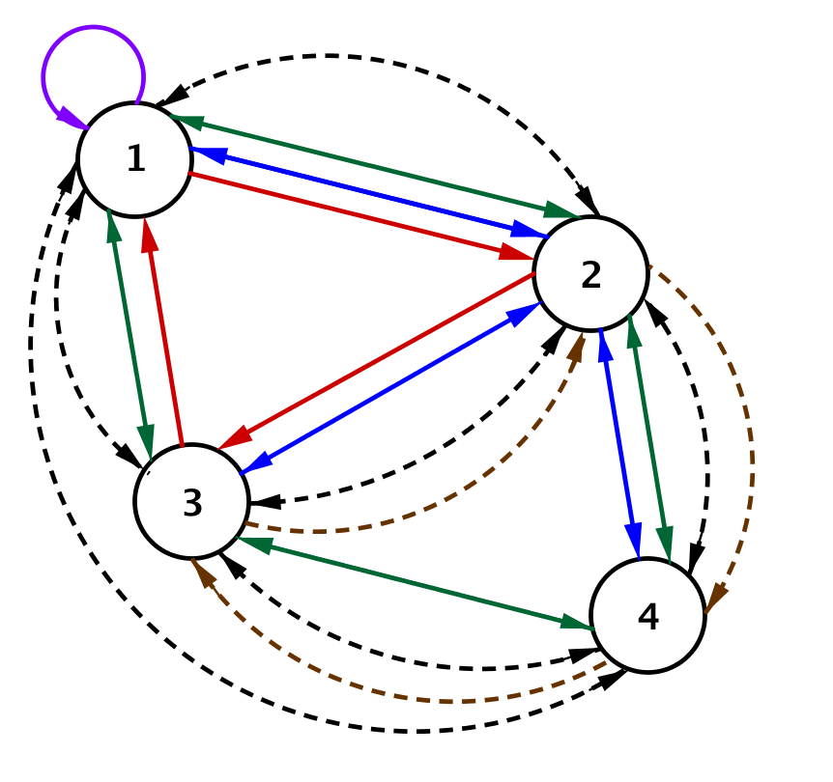
The subway and bus line network connecting four cities that we used in Lesson 2 is shown below. The bus routes connecting the cities are represented by solid lines, and the subway routes are represented by dashed lines.
Suppose we want to travel from City 2 to City 1, first by bus and then by subway, with no more than one connecting stop.
  - Complete the chart below showing the number of ways to travel from City 2 to City 1 using first a bus and then the subway. The first row has been completed for you.
First Leg (BUS) |  | Second Leg (SUBWAY) |  | Total Ways to Travel
City 2 to City 1: | $$2$$ | City 1 to City 1: | $$0$$ | $$2∙0=0$$
City 2 to City 2: |  | City 2 to City 1:
City 2 to City 3: |  | City 3 to City 1:
City 2 to City 4: |  | City 4 to City 1:

  - How many ways are there to travel from City 2 to City 1, first on a bus and then on a subway? How do you know?

Exploratory Challenge/Exercises 1–12: The Meaning of Matrix Multiplication
Suppose we want to travel between all cities, traveling first by bus and then by subway, with no more than one connecting stop.
- Use a chart like the one in the Opening Exercise to help you determine the total number of ways to travel from
City 1 to City 4 using first a bus and then the subway.

- Suppose we create a new matrix $P$ to show the number of ways to travel between the cities, first by bus and then by subway, with no more than one connecting stop. Record your answers to Opening Exercises, part (b) and Exercise 1 in this matrix in the appropriate row and column location. We do not yet have enough information to complete the entire matrix. Explain how you decided where to record these numbers in the matrix shown below.

$$P=\left[\begin{matrix}___ & ___ & ___ & ___ \\ ___ & ___ & ___ & ___ \\ ___ & ___ & ___ & ___ \\ ___ & ___ & ___ & ___\end{matrix}\right]$$

- What is the total number of ways to travel from City 3 to City 2 first by bus and then by subway with no more than one connecting stop? Explain how you got your answer and where you would record it in matrix $P$ above.

Recall matrix $B$, which shows the number of bus lines connecting the cities in this transportation network, and matrix $S$, which represents the number of subway lines connecting the cities in this transportation network.
$B=\left[\begin{matrix}1 & 3 & 1 & 0 \\ 2 & 0 & 2 & 2 \\ 2 & 1 & 0 & 1 \\ 0 & 2 & 1 & 0\end{matrix}\right]$ and $S=\left[\begin{matrix}0 & 1 & 1 & 1 \\ 1 & 0 & 1 & 2 \\ 1 & 2 & 0 & 1 \\ 1 & 1 & 2 & 0\end{matrix}\right]$

- What does the product $b_{1,2}s_{2,4}$ represent in this situation? What is the value of this product?

- What does $b_{1,4}s_{4,4}$ represent in this situation? What is the value of this product? Does this make sense?

- Calculate the value of the expression $b_{1,1}s_{1,4}+b_{1,2}s_{2,4}+b_{1,3}s_{3,4}+b_{1,4}s_{4,4}$. What is the meaning of this expression in this situation?

- Circle the first row of $B$ and the second column of $S$. How are these entries related to the expression above and your work in Exercise 1?

- Write an expression that represents the total number of ways you can travel between City 2 and City 1, first by bus and then by subway, with no more than one connecting stop. What is the value of this expression? What is the meaning of the result?

- Write an expression that represents the total number of ways you can travel between City 4 and City 1$,$ first by bus and then by subway, with no more than one connecting stop. What is the value of this expression? What is the meaning of the result?

- Complete matrix $P$ that represents the routes connecting the four cities if you travel first by bus and then by subway.

- Construct a matrix $M$ that represents the routes connecting the four cities if you travel first by subway and then by bus.

- Should these two matrices be the same? Explain your reasoning.

Exercises 13–16
- Let $A=\left[\begin{matrix}2 & 3 & -1 \\ 0 & 1 & 2 \\ 1 & 0 & 0\end{matrix}\right]$
  - Construct a matrix $Z$ such that $A+Z=A$. Explain how you got your answer.

  - Explain why $k∙Z=Z$ for any real number $k$.

  - The real number $0$ has the properties that $a+0=0$ and $a∙0=0$ for all real numbers $a$. Why would mathematicians call $Z$ a zero matrix?

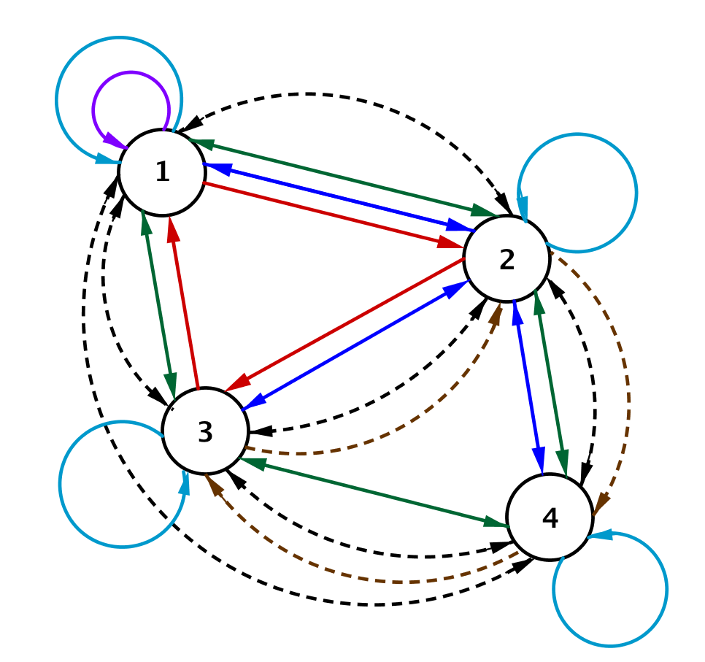
- Suppose each city had a trolley car that ran a route between tourist destinations. The blue loops represent the trolley car routes. Remember that straight lines indicate bus routes, and dotted lines indicate subway routes.
  - Explain why the matrix $I$ shown below would represent the number of routes connecting cities by trolley car in this transportation network.
$$I=\left[\begin{matrix}1 & 0 & 0 & 0 \\ 0 & 1 & 0 & 0 \\ 0 & 0 & 1 & 0 \\ 0 & 0 & 0 & 1\end{matrix}\right]$$

  - Recall that $B$ is the bus route matrix. Show that $I∙B=B$. Explain why this makes sense in terms of the transportation network.

  - The real number $1$ has the property that $1∙a=a$ for all real numbers $a$, and we call $1$ the multiplicative identity. Why would mathematicians call $I$ an identity matrix?

  - What would be the form of a $2×2$ identity matrix? What about a $3×3$ identity matrix?

- In this lesson you learned that the commutative property does not hold for matrix multiplication. This exercise asks you to consider other properties of real numbers applied to matrix arithmetic.
  - Is matrix addition associative? That is, does $\left(A+B\right)+C=A+(B+C)$ for matrices $A$, $B$, and $C$ that have the same dimensions? Explain your reasoning.

  - Is matrix multiplication associative? That is, does $\left(A∙B\right)∙C∙=A∙(B∙C)$ for matrices $A$, $B$, and $C$ for which the multiplication is defined? Explain your reasoning.

  - Is matrix addition commutative? That is, does $A+B=B+A$ for matrices $A$ and $B$ with the same dimensions?

- Complete the graphic organizer to summarize your understanding of the product of two matrices.
Operation | Symbols | Describe How to Calculate | Example Using $3×3$ Matrices
Matrix Multiplication | $$A∙B$$

Lesson Summary
Matrix Product: Let $A$ be an $m×n$ matrix whose entry in row $i$ and column $j$ is $a_{i,j},$and let $B$ be an $n×p$ matrix whose entry in row $i$ and column $j$ is $b_{i,j}$. Then the matrix product $AB$ is the $m×p$ matrix whose entry in row $i$ and column $j$ is $a_{i,1}b_{1,j}+a_{i,2}b_{2,j}+⋯+a_{i,n}b_{n,j}$.

Identity Matrix: The $n×n$ identity matrix is the matrix whose entry in row $i$ and column $i$ for
$1≤i≤n$ is 1, and whose entries in row $i$ and column $j$ for $1≤i, j≤n$ and $i≠j$ are all zero. The identity matrix is denoted by $I$. The $2×2$ identity matrix is $\left[\begin{matrix}1 & 0 \\ 0 & 1\end{matrix}\right]$, and the $3×3$ identity matrix is $\left[\begin{matrix}1 & 0 & 0 \\ 0 & 1 & 0 \\ 0 & 0 & 1\end{matrix}\right]$. If the size of the identity matrix is not explicitly stated, then the size is implied by context.

Zero Matrix: The $m×n$ zero matrix is the $m×n$ matrix in which all entries are equal to zero.
For example, the $2×2$ zero matrix is $\left[\begin{matrix}0 & 0 \\ 0 & 0\end{matrix}\right]$, and the $3×3$ zero matrix is $\left[\begin{matrix}0 & 0 & 0 \\ 0 & 0 & 0 \\ 0 & 0 & 0\end{matrix}\right]$. If the size of the zero matrix is not specified explicitly, then the size is implied by context.

Problem Set

- Let $A=\left[\begin{matrix}1 & 3 \\ 2 & 0\end{matrix}\right]$ and $B=\left[\begin{matrix}1 & 2 \\ 4 & 3\end{matrix}\right]$represent the bus routes of two companies between $2$ cities. Find the product $A⋅B,$ and explain the meaning of the entry in row 1, column 2 of $A⋅B$in the context of this scenario.

- Let $A=\left[\begin{matrix}1 & 3 & 2 \\ 3 & 1 & 2 \\ 4 & 3 & 2\end{matrix}\right]$and$B=\left[\begin{matrix}2 & 1 & 3 \\ 2 & 2 & 1 \\ 1 & 3 & 1\end{matrix}\right]$ represent the bus routes of two companies between three cities.
  - Let $C=A⋅B$. Find matrix $C,$and explain the meaning of entry$c_{1,3}$.
  - Nina wants to travel from City 3 to City 1 and back home to City 3 by taking a direct bus from Company A on the way to City 1 and a bus from Company B on the way back home to City 3. How many different ways are there for her to make this trip?
  - Oliver wants to travel from City 2 to City 3 by taking first a bus from Company A and then taking a bus from Company B. How many different ways can he do this?
  - How many routes can Oliver choose from if travels from City 2 to City 3 by first taking a bus from Company B and then taking a bus from Company A?

- Recall the bus and trolley matrices from the lesson:
$B=\left[\begin{matrix}1 & 3 & 1 & 0 \\ 2 & 0 & 2 & 2 \\ 2 & 1 & 0 & 1 \\ 0 & 2 & 1 & 0\end{matrix}\right]$ and $I=\left[\begin{matrix}1 & 0 & 0 & 0 \\ 0 & 1 & 0 & 0 \\ 0 & 0 & 1 & 0 \\ 0 & 0 & 0 & 1\end{matrix}\right]$
  - Explain why it makes sense that $BI=IB$ in the context of the problem.
  - Multiply out $BI$ and $IB$ to show $BI=IB$.
  - Consider the multiplication that you did in part (b). What about the arrangement of the entries in the identity matrix causes $BI=B$?

- Consider the matrices
$$A=\left[\begin{matrix}3 & 1 & -\frac{1}{2} \\ 2 & \frac{2}{3} & 4\end{matrix}\right] and B=\left[\begin{matrix}1 & 0 \\ 0 & 1 \\ 0 & 0\end{matrix}\right]$$
  - Multiply $AB$ and $BA$ or explain why you cannot.
  - Would you consider $B$ to be an identity matrix for $A$? Why or why not?
  - Would you consider $I_{2}=\left[\begin{matrix}1 & 0 \\ 0 & 1\end{matrix}\right]$ or $I_{3}=\left[\begin{matrix}1 & 0 & 0 \\ 0 & 1 & 0 \\ 0 & 0 & 1\end{matrix}\right]$ an identity matrix for $A$? Why or why not?

- We’ve shown that matrix multiplication is generally not commutative, meaning that as a general rule for two matrices $A$ and $B$, $A⋅B≠B⋅A.$Explain why $F⋅G=G⋅F$ in each of the following examples.
  - $F=\left[\begin{matrix}1 & 3 \\ 2 & 0\end{matrix}\right], G=\left[\begin{matrix}2 & 6 \\ 4 & 0\end{matrix}\right]$.
  - $F=\left[\begin{matrix}1 & 3 & 2 \\ 3 & 1 & 2 \\ 4 & 3 & 2\end{matrix}\right], G=\left[\begin{matrix}0 & 0 & 0 \\ 0 & 0 & 0 \\ 0 & 0 & 0\end{matrix}\right]$.
  - $F=\left[\begin{matrix}1 & 3 & 2 \\ 3 & 1 & 2 \\ 4 & 3 & 2\end{matrix}\right], G=\left[\begin{matrix}1 & 0 & 0 \\ 0 & 1 & 0 \\ 0 & 0 & 1\end{matrix}\right]$.
  - $F=\left[\begin{matrix}1 & 3 & 2 \\ 3 & 1 & 2 \\ 4 & 3 & 2\end{matrix}\right], G=\left[\begin{matrix}3 & 0 & 0 \\ 0 & 3 & 0 \\ 0 & 0 & 3\end{matrix}\right]$.

- Let $I_{n}$ be the $n×n$ identity matrix. For the matrices given below, perform each of the following calculations or explain why the calculation is not possible:
$$A=\left[\begin{matrix}\frac{1}{2} & 3 \\ 2 & \frac{2}{3}\end{matrix}\right]$$ | $$B=\left[\begin{matrix}9 & -1 & 2 \\ -3 & 4 & 1\end{matrix}\right]$$
$$C=\left[\begin{matrix}3 & 1 & 3 \\ 1 & 0 & 1 \\ 3 & 1 & 3\end{matrix}\right]$$ | $$D=\left[\begin{matrix}2 & \sqrt{2} & \begin{matrix}-2 & \frac{1}{2}\end{matrix} \\ 3 & 2 & \begin{matrix}1 & 0\end{matrix}\end{matrix}\right]$$
  - $AB$
  - $BA$
  - $AC$
  - $ABC$
  - $ABCD$
  - $AD$
  - $A^{2}$
  - $C^{2}$
  - $BC^{2}$
  - $ABC+AD$
  - $ABI_{2}$
  - $AI_{2}B$
  - $CI_{3}B$
  - $I_{2}BC$
  - $2A+B$
  - $B(I_{3}+C)$
  - $B+BC$
  - $4DI_{4}$

- Let $F$ be an $m×n$ matrix. Then what do you know about the dimensions of matrix $G$ in the problems below if each expression has a value?
  - $F+G$
  - $FG$
  - $GF$
  - $FHG$ for some matrix $H$.

- Consider an $m×n$ matrix $A$ such that $m≠n$. Explain why you cannot evaluate $A^{2}$.

- Let $A=\left[\begin{matrix}0 & 1 & 2 \\ 2 & 0 & 1 \\ 1 & 2 & 0\end{matrix}\right], B=\left[\begin{matrix}0 & 2 & 1 \\ 1 & 0 & 1 \\ 2 & 2 & 0\end{matrix}\right], C=\left[\begin{matrix}0 & 2 & 1 \\ 0 & 0 & 1 \\ 1 & 2 & 0\end{matrix}\right]$ represent the routes of three airlines $A, B$, and $C$ between three cities.
  - Zane wants to fly from City 1 to City 3 by taking Airline $A$ first and then Airline $B$ second. How many different ways are there for him to travel?
  - Zane did not like Airline $A$ after the trip to City $3$, so on the way home, Zane decides to fly Airline $C$ first and then Airline $B$ second. How many different ways are there for him to travel?

- Let $A=\left[\begin{matrix}\begin{matrix}0 \\ 1 \\ 2\end{matrix} & \begin{matrix}1 & 1 & 2 \\ 0 & 2 & 1 \\ 1 & 0 & 2\end{matrix} \\ 1 & \begin{matrix}2 & 1 & 0\end{matrix}\end{matrix}\right]$represent airline flights of one airline between $4$ cities.
  - We use the notation $A^{2}$ to represent the product $A⋅A$. Calculate $A^{2}.$ What do the entries in matrix $A^{2}$ represent?
  - Jade wants to fly from City 1 to City 4 with exactly one stop. How many different ways are there for her to travel?
  - Now Jade wants to fly from City 1 to City 4 with exactly two stops. How many different ways are there for her to choose?

