Name Date
- An equilateral triangle is drawn within the unit circle centered at the origin as shown.
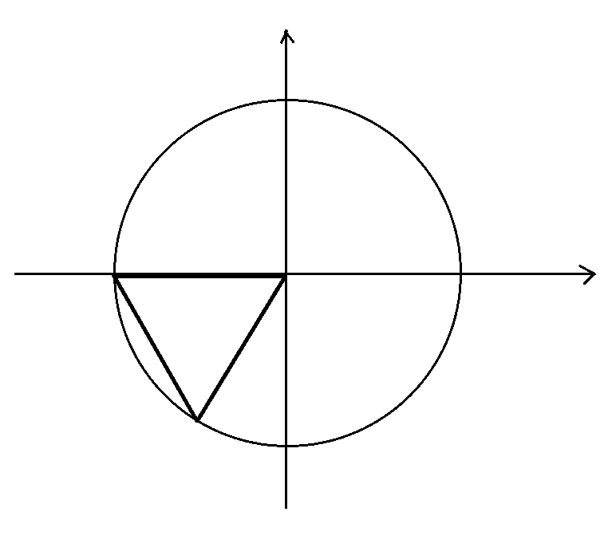
Explain how one can use this diagram to determine the values of $\sin\left(\frac{4π}{3}\right)\text{,}\cos\left(\frac{4π}{3}\right)$, and $\tan{(\frac{4π}{3})}$.

- Suppose $x$ is a real number with $0<x<\frac{π}{4}$.

  - Set $a=sin(π-x)$, $b=cos(π+x)$, $c=sin(x-π)$, and $d=cos(2π-x)$.
Arrange the values $a$, $b$, $c$, and $d$ in increasing order, and explain how you determined their order.

  - Use the unit circle to explain why $\tan\left(π-x\right)=-\tan{(x)}$.

  - Using a diagram of the unit circle centered at the origin, explain why $f(x){=\cos{(x)}}$ is an even function.

  - Using a diagram of the unit circle centered at the origin, explain why $\sin\left(x-2π\right)=\sin{(x)}$ for all real values $x$.

  - Explain why $\tan{(x+π)=\tan{(x)}}$ for all real values $x$.

- The point $P$ shown lies outside the circle with center $O$. Point $M$ is the midpoint of the line segment $\overline{OP}$.

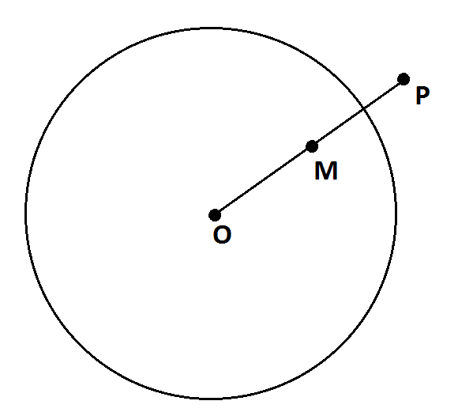

  - Use a ruler and compass to construct a line through $P$ that is tangent to the circle.

  - Explain how you know that your construction does indeed produce a tangent line.

- Each rectangular diagram below contains two pairs of right triangles, each having a hypotenuse of
length $1$. One pair of triangles has an acute angle measuring $x$ radians. The other pair of triangles has an acute angle measuring $y$ radians.

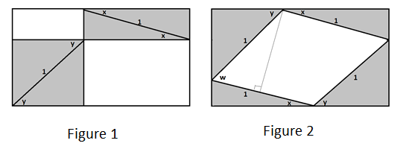

  - Using Figure 1, write an expression, in terms of $x$ and $y$, for the area of the non-shaded region.

  - Figure 2 contains a quadrilateral which is not shaded and contains angle w. Write an expression, in terms of $x$ and $y$, for the measure of angle $w$.

  - Using Figure 2, write an expression, in terms of $w$, for the non-shaded area. Explain your work.

  - Use the results of parts (a), (b), and (c) to show why $\sin\left(x+y\right)=\sin\left(x\right)\cos\left(y\right)+\sin\left(y\right)\cos{(x)}$ is a valid formula.

  - Suppose $α$ is a real number between $\frac{π}{2}$ and $π$ and $y$ is a real number between $0$ and $\frac{π}{2}$. Use your result from part (d) to show the following:

$\cos\left(α+y\right)=\cos\left(α\right)\cos\left(y\right)-\sin\left(α\right)\sin{(y)}$.
Explain your work.

- A rectangle is drawn in a semicircle of radius $3$ with its base along the base of the semicircle as shown.

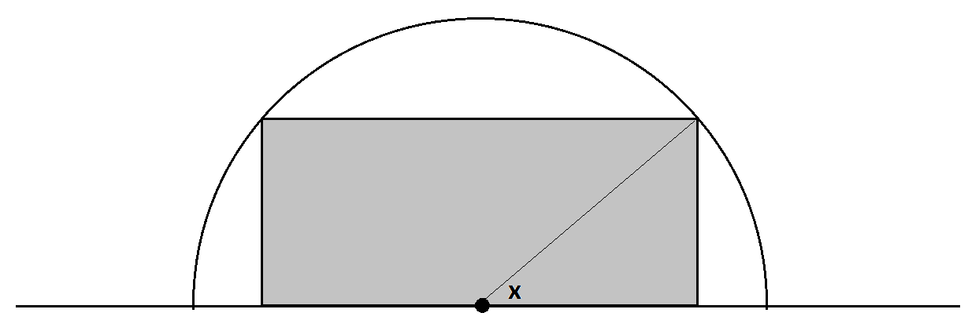

Find, to two decimal places, values for real numbers $a$ and $b$ so that $a\cos{(x+b)}$ represents the perimeter of the rectangle if the real number $x$ is the measure of the angle shown.

A Progression Toward Mastery
Assessment  Task Item |  | STEP 1  Missing or incorrect answer and little evidence of reasoning or application of mathematics to solve the problem. | STEP 2  Missing or incorrect answer but evidence of some reasoning or application of mathematics to solve the problem. | STEP 3  A correct answer with some evidence of reasoning or application of mathematics to solve the problem, or an incorrect answer with substantial evidence of solid reasoning or application of mathematics to solve the problem. | STEP 4  A correct answer supported by substantial evidence of solid reasoning or application of mathematics to solve the problem.
1 | F-TF.A.3 | Student shows little or no understanding of finding the angle. | Student shows some understanding of finding the angle and knows that the triangle is equilateral. | Student shows understanding of finding the angle using equilateral triangles and the Pythagorean theorem in his explanation but makes a mathematical error leading to an incorrect answer. | Student completely and correctly shows understanding of finding the angle by using equilateral triangles and the Pythagorean theorem in his explanation and makes no mathematical errors.
2 | a  F-TF.A.3 | Student shows little or no understanding of the values of trigonometric functions. | Student correctly orders at least two of the values of $a$, $b$, $c$, or $d$. | Student orders $a$, $b$, c, and $d$ correctly but lists them in increasing order  OR  Student orders $a$, $b$, $c$, and $d$ correctly and lists them in increasing order, but with a missing or an incorrect explanation | Student orders $a$, $b$, $c$, and $d$ correctly and lists them in increasing order with a correct explanation.
 | b  F-TF.A.3 | Student shows little or no understanding of the periodicity of trigonometric functions. | Student attempts to use periodicity of trigonometric functions but only sine or cosine is correct. | Student understands the periodicity of sine and cosine but does not relate it to tangent. | Student understands the periodicity of sine and cosine and correctly relates it to tangent.
3 | a  F-TF.A.4 | Student shows little or no understanding of the properties of trigonometric functions. | Student draws the unit circle diagram but not correctly. | Student draws the unit circle diagram correctly but does not clearly explain how symmetry guarantees this result. | Student draws the unit circle diagram correctly and clearly explains the result using symmetry.
 | b  F-TF.A.4 | Student shows little or no understanding of the properties of trigonometric functions. | Student draws the unit circle diagram but not correctly. | Student draws the unit circle diagram correctly but does not clearly explain how periodicity guarantees this result. | Student draws the unit circle diagram correctly and clearly explains the result using periodicity.
 | c  F-TF.A.4 | Student shows little or no understanding of the properties of trigonometric functions. | Student draws the unit circle diagram but not correctly. | Student draws the unit circle diagram correctly but does not clearly explain how symmetry guarantees this result. | Student draws the unit circle diagram correctly and clearly explains the result using symmetry.
4 | a  G-C.A.4 | Student shows little or no understanding of tangent line construction. | Student completes one step of the construction correctly. | Student completes two steps of the construction correctly. | Student correctly constructs the tangent line to the circle.
 | b  G-C.A.4 | Student shows little or no understanding of the tangent line to a circle. | Student attempts to explain why the line is tangent to the circle but with major mathematical errors. | Students explains why the line is tangent to the circle but does not explain that the tangent line is perpendicular to the radius at the point of tangency. | Students explains why the line is tangent to the circle and explains that the tangent line is perpendicular to the radius at the point of tangency.
5 | a  F-TF.C.9 | Student shows little or no understanding of the area of the rectangle. | Student attempts to find the area but with major mathematical errors. | Student finds the correct area in terms of $x$ and $y$ but the explanation is not complete. | Student correctly finds the area in terms of $x$ and $y$, and the explanation is complete.
 | b  F-TF.C.9 | Students shows little or no understanding of the angles in the diagram. | Student attempts to find the angle measure in terms of $x$ and $y$ but with major mathematical errors. | Student finds the correct angle measure in terms of $x$ and $y$ but the explanation is not complete. | Student correctly finds the angle measure in terms of $x$ and $y$, and the explanation is complete.
 | c  F-TF.C.9 | Student shows little or no understanding of the area of the rectangle. | Student attempts to find the area but with major mathematical errors. | Student finds the correct area in terms of $w$ but the explanation is not complete. | Student correctly finds the area in terms of $w$, and the explanation is complete.
 | d  F-TF.C.9 | Student shows little or no understanding of the sum of angles of a trigonometric function. | Student attempts to write a formula but with major mathematical errors. | Student writes the correct formula but the explanation is not complete. | Student correctly writes the formula, and the explanation is complete.
 | e  F-TF.C.9 | Student shows little or no understanding of the sum of angles of a trigonometric function. | Student attempts to prove the formula is valid but with major mathematical errors. | Student attempts to prove the formula is valid but with minor mathematical errors. | Student correctly proves the formula is valid and the explanation is complete.
6 | F-TF.C.9 | Student shows little or no understanding of trigonometric functions or perimeter. | Student sets up the correct perimeter formula in terms of sine and cosine but does not complete the problem. | Student finds either the value of $a$ or $b$ correctly with supporting work. | Student finds the values of both $a$ and $b$ correctly with supporting work.

Name Date
- An equilateral triangle is drawn within the unit circle centered at the origin as shown.

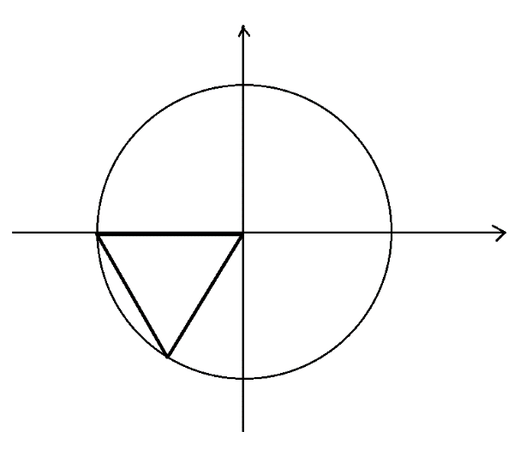
Explain how one can use this diagram to determine the values of $\sin\left(\frac{4π}{3}\right)\text{,}\cos\left(\frac{4π}{3}\right)$, and $\tan{(\frac{4π}{3})}$.
An interior angle of an equilateral triangle has a measure of $\frac{\text{π}}{\text{3}}$ and so the measure of the angle $\text{x}$ shown is $\text{π} \text{+} \frac{\text{π}}{\text{3}} \text{=} \frac{\text{4π}}{\text{3}}$.
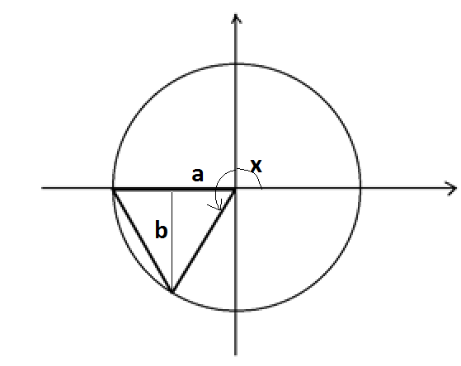
Draw the altitude of the equilateral triangle, and mark the indicated lengths $\text{a}$ and $\text{b}$ as shown. We have that $\text{cos}\left(\text{x}\right) \text{=} \text{-a}$ and $\text{sin}\left(\text{x}\right) \text{=} \text{-b}$.

Now $\text{a}$ is half the base of an equilateral triangle of side-length $\text{1}$, so $\text{a} \text{=} \frac{\text{1}}{\text{2}}$. By the Pythagorean theorem,
$\text{b} \text{=} \sqrt{{\text{a}}^{\text{2}}\text{-} {\left(\frac{\text{1}}{\text{2}}\right)}^{\text{2}}} \text{=} \sqrt{\frac{\text{3}}{\text{4}}} \text{=} \frac{\sqrt{\text{3}}}{\text{2}}$. Thus, we have the following:
$$\text{cos}\left(\frac{\text{4π}}{\text{3}}\right) \text{=} \text{-}\frac{\text{1}}{\text{2}} \\ \text{sin}\left(\frac{\text{4π}}{\text{3}}\right) \text{=} \text{-}\frac{\sqrt{\text{3}}}{\text{2}} \\ \text{tan}\left(\frac{\text{4π}}{\text{3}}\right) \text{=} \frac{\text{sin}\left(\frac{\text{4π}}{\text{3}}\right)}{\text{cos}\left(\frac{\text{4π}}{\text{3}}\right)} \text{=} \frac{\text{-}\frac{\sqrt{\text{3}}}{\text{2}}}{\text{-}\frac{\text{1}}{\text{2}}} \text{=} \sqrt{\text{3}}$$
- Suppose $x$ is a real number with $0<x<\frac{π}{4}$.

  - Set $a=sin(π-x)$, $b=cos(π+x)$, $c=sin(x-π)$, and $d=cos(2π-x)$.
Arrange the values $a$, $b$, $c$, and $d$ in increasing order, and explain how you determined their order.
Draw the unit circle and the point $\text{P}$ on the circle with coordinates $\text{(}\text{cos}\left(\text{x}\right)\text{,}\text{sin}{\text{(x))}}$. Because $\text{0} \text{<} \text{x} \text{<} \frac{\text{π}}{\text{4}}$, we have that both $\text{sin}{\text{(x)}}$ and $\text{cos}{\text{(x)}}$ are positive numbers with $\text{sin}\left(\text{x}\right) \text{<} \text{cos}{\text{(x)}}$.
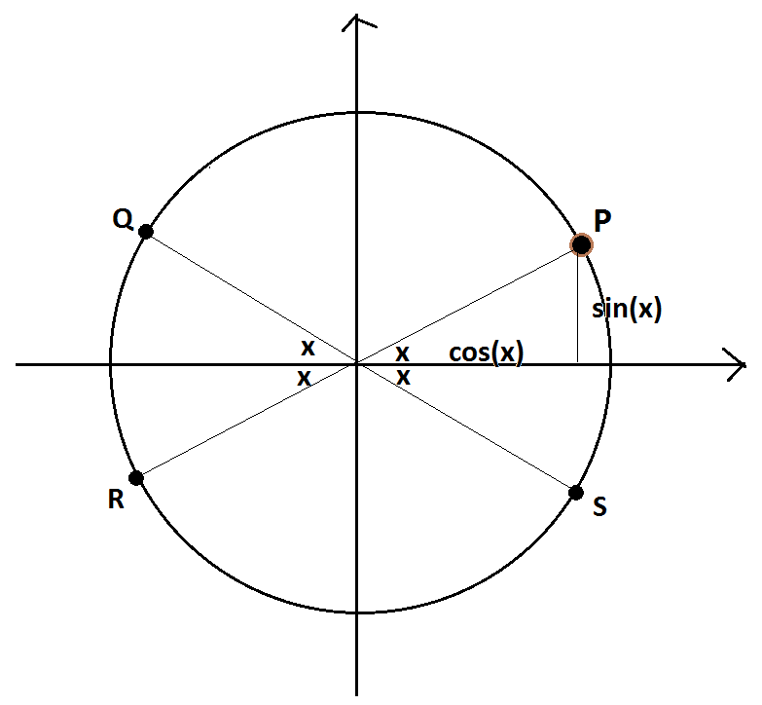
The points $\text{Q, R}$, and $\text{S}$ on the diagram have coordinates:
$$\text{Q} \text{=} \text{(}\text{cos}\left(\text{π} \text{-} \text{x}\right)\text{,} \text{(π} \text{-} \text{x))} \\ \text{R} \text{=} \text{(}\text{cos}{\text{(π} \text{+} \text{x), sin(π} \text{+} \text{x))}} \\ \text{S} \text{=} \text{(}\text{cos}\left(\text{2π} \text{-} \text{x}\right)\text{,}\text{sin}{\text{(2π} \text{-} \text{x))}}$$
We also see from the diagram that $\text{(}\text{cos}\left(\text{x} \text{-} \text{π}\right)\text{,}\text{sin}{\text{(x} \text{-} \text{π))}}$ is also the point $\text{R}$.
From the diagram we have
$\text{a} \text{=} \text{sin}\left(\text{π} \text{-} \text{x}\right) \text{=} \text{sin}{\text{(x)}}$ (looking at the point $\text{Q}$),
$\text{b} \text{=} \text{cos }\left(\text{π} \text{+} \text{x}\right) \text{=} \text{-cos}{\text{(x)}}$ (looking at the point $\text{R}$),
$\text{c} \text{=} \text{sin}\left(\text{x} \text{-} \text{π}\right) \text{=} \text{-sin}{\text{(x)}}$ (looking at the point $\text{R}$),
$\text{d} \text{=} \text{cos}\left(\text{2π} \text{-} \text{x}\right) \text{=} \text{cos}{\text{(x)}}$ (looking at the point $\text{S}$).
Since $\text{sin}\left(\text{x}\right) \text{<} \text{cos}{\text{(x)}}$ it follows that $\text{b} \text{<} \text{c} \text{<} \text{a} \text{<} \text{d}$.

  - Use the unit circle to explain why $\tan\left(π-x\right)=-\tan{(x)}$.
Look at the diagram of the four points on the unit circle from the previous question.
We are interested in $\text{tan}\left(\text{π} \text{-} \text{x}\right) \text{=} \frac{\text{sin}{\text{(π} \text{-} \text{x)}}}{\text{cos}{\text{(π} \text{-} \text{x)}}}$. The point $\text{Q}$ has coordinates $\text{(cos}\left(\text{π} \text{-} \text{x}\right)\text{,} \text{sin}{\text{(π} \text{-} \text{x))}}$ and we see, in relation to the point $\text{P}$, that $\text{sin}\left(\text{π} \text{-} \text{x}\right) \text{=} \text{sin}{\text{(x)}}$ and $\text{cos}\left(\text{π} \text{-} \text{x}\right) \text{=} \text{ -}\text{cos}{\text{(x)}}$. Thus,
$\text{tan}\left(\text{π} \text{-} \text{x}\right) \text{=} \frac{\text{sin}{\text{(}\text{π} \text{-} \text{x}\text{)}}}{\text{cos}{\text{(}\text{π} \text{-} \text{x}\text{)}}} \text{=} \frac{\text{sin}{\text{(}\text{x}\text{)}}}{\text{-}\text{cos}{\text{(}\text{x}\text{)}}} \text{=} \text{-}\frac{\text{sin}\left(\text{x}\right)}{\text{cos}\left(\text{x}\right)} \text{=} \text{-}\text{tan}{\text{(}\text{x}\text{)}}$.

  - Using a diagram of the unit circle centered at the origin, explain why $f(x)=cos(x)$ is an even function.
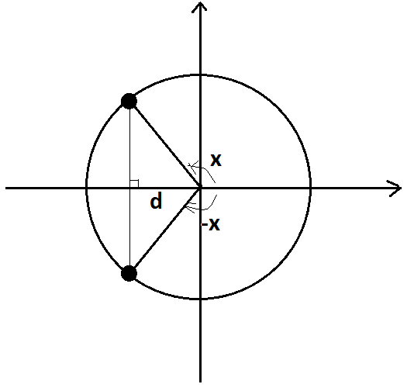
We need to show that $\text{f(-x)} \text{=} \text{f(x)}$, that is, $\text{cos(-x)} \text{=} \text{cos(x)}$ for all real numbers $\text{x}$.
Let $\text{d}$ represent the length of the segment shown in the diagram. We see symmetry in the diagram.
From the diagram, $\text{cos}\text{(}\text{x}\text{) = -}\text{d}$ and $\text{cos}\text{(-}\text{x}\text{) = -}\text{d}$, that is, $\text{cos}\text{(}\text{x}\text{) = }\text{cos}\text{(-}\text{x}\text{)}$.

Note: Here we drew a diagram with $\text{x}$ representing the measure of an obtuse angle. The same symmetry applies to all types of angles.

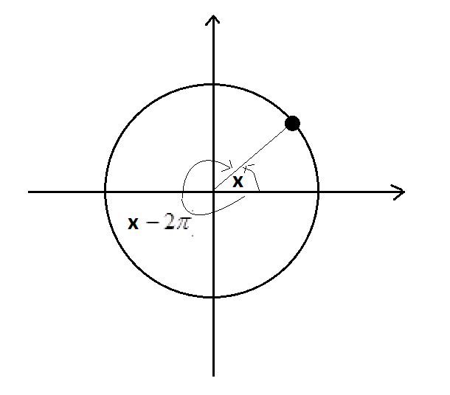
  - Using a diagram of the unit circle centered at the origin, explain why $\sin\left(x-2π\right)=\sin{(x)}$ for all real values $x$.
We see from a diagram that the points on the unit circle with coordinates $\text{(}\text{cos}\left(\text{x}\right)\text{,}\text{sin}{\text{(x))}}$ and $\text{(}\text{cos}\left(\text{x} \text{-} \text{2π}\right)\text{,}\text{sin}{\text{(x} \text{-} \text{2π))}}$ coincide.

Thus, $\text{sin}\left(\text{x} \text{-} \text{2}\text{π}\right) \text{=} \text{sin}{\text{(}\text{x}\text{)}}$.

  - Explain why $\tan{(x+π)=\tan{(x)}}$ for all real values $x$.
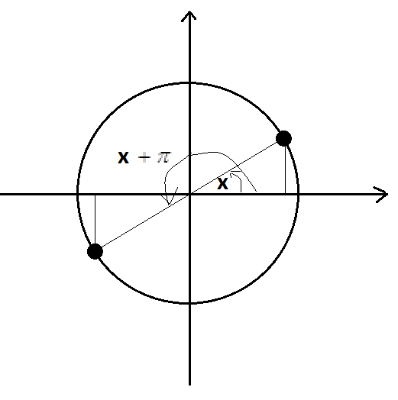
The symmetry of the following diagram shows that $\text{sin}\left(\text{x} \text{+} \text{π}\right) \text{= -}\text{sin}{\text{(x)}}$ and $\text{cos}\left(\text{x} \text{+ π}\right) \text{= -}\text{cos}{\text{(x)}}$.

Thus, $\text{tan}\left(\text{x} \text{+ }\text{π}\right)\text{=}\frac{\text{sin}{\text{(}\text{x} \text{+ }\text{π}\text{)}}}{\text{cos}{\text{(}\text{x} \text{+ }\text{π}\text{)}}} \text{=} \frac{\text{-}\text{sin}{\text{(}\text{x}\text{)}}}{\text{-}\text{cos}{\text{(}\text{x}\text{)}}} \text{=} \frac{\text{sin}{\text{(}\text{x}\text{)}}}{\text{cos}\left(\text{x}\right)} \text{=} \text{tan}{\text{(}\text{x}\text{)}}$.
- The point $P$ shown lies outside the circle with center $O$. Point $M$ is the midpoint of the line segment $\overline{OP}$.

  - Use a ruler and compass to construct a line through $P$ that is tangent to the circle.
Draw a circle with center $\text{M}$ and with radius set to the length $\text{OM}$. This new circle intersects the original circle at two points. Call one of those two points $\text{Q}$.
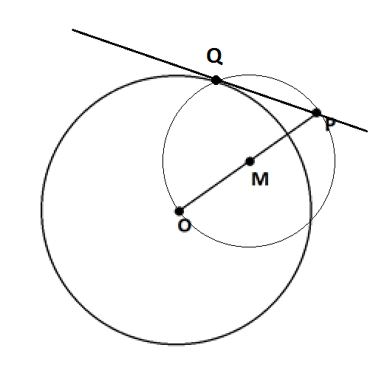
Draw the line through $\text{P}$ and $\text{Q}$. This is a line through $\text{P}$ and tangent to the circle.
  - Explain how you know that your construction does indeed produce a tangent line.
Reason: Since we drew a circle with center $\text{M}$, we have $\text{MO} \text{=} \text{MQ} \text{=} \text{MP}$. Call this common length $\text{r}$. Thus, we have a diagram containing two isosceles triangles.

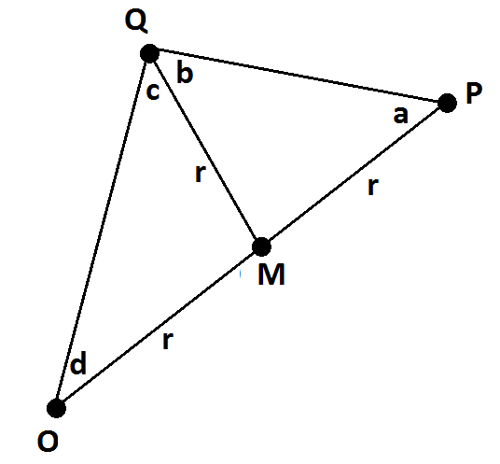
Mark the angles $\text{a}$, $\text{b}$, $\text{c}$, and $\text{d}$ as shown.
Because they are base angles of an isosceles triangle, $\text{a = b}$.
Because they are base angles of an isosceles triangle, $\text{d = c}$.
Because angles in a triangle sum to $\text{π}$ radian,
$\text{a} \text{+} \text{b} \text{+} \text{c} \text{+} \text{d} \text{=} \text{π}$.
That is, $\text{2b} \text{+} \text{2c} \text{=} \text{π}$ giving
$\text{b} \text{+} \text{c} \text{=} \frac{\text{π}}{\text{2}}$.
Thus, the radius $\overline{\text{OQ}}$ in the original circle meets line $\overset{⃡}{\text{PQ}}$ at a right angle. It must be then that $\overset{⃡}{\text{PQ}}$ is indeed a tangent line to the original circle.

- Each rectangular diagram below contains two pairs of right triangles, each having a hypotenuse of
length $1$. One pair of triangles has an acute angle measuring $x$ radians. The other pair of triangles has an acute angle measuring $y$ radians.

  - Using Figure 1, write an expression, in terms of $x$ and $y$, for the area of the non-shaded region.
The right triangles used in the diagrams have side-lengths as shown:
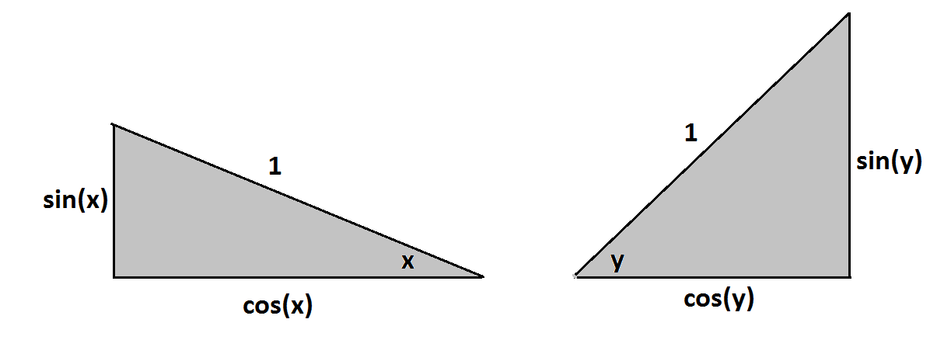
In Figure 1, the area we seek is the sum of areas of two rectangles: a $\text{sin}{\text{(x)}}$-by-$\text{cos}{\text{(y)}}$ rectangle and a $\text{sin}{\text{(y)}}$-by-$\text{cos}{\text{(x)}}$ rectangle.
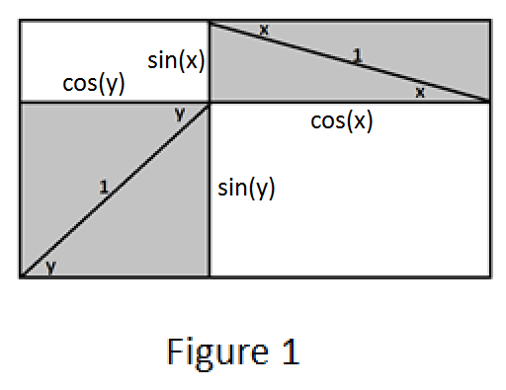
Thus, the area under consideration is given by $\text{sin}\left(\text{x}\right)\text{cos}\left(\text{y}\right) \text{+} \text{sin}\left(\text{y}\right)\text{cos}{\text{(}\text{x}\text{)}}$.

  - Figure 2 contains a quadrilateral which is not shaded and contains angle $w$. Write an expression, in terms of $x$ and $y$, for the measure of angle w.
In Figure 2, we see that three angles of measures $\frac{\text{π}}{\text{2}}\text{-} \text{x}$, $\text{w}$, and $\frac{\text{π}}{\text{2}}\text{-} \text{y}$ form a straight angle:
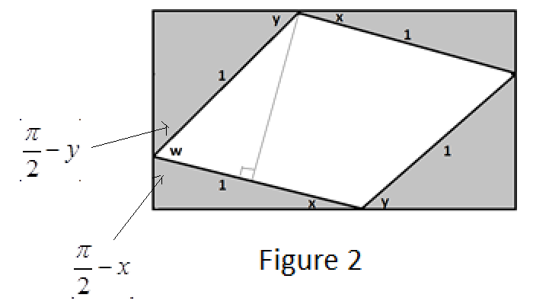
Thus, $\text{w} \text{=} \text{π} \text{-} \left(\frac{\text{π}}{\text{2}}\text{-} \text{x}\right)\text{-} \left(\frac{\text{π}}{\text{2}}\text{-} \text{y}\right) \text{=} \text{x} \text{+} \text{y}$.

  - Using Figure 2, write an expression, in terms of $w$, for the non-shaded area. Explain your work.
We seek the area of a rhombus with a side-length of $\text{1}$. The area of a rhombus (or any parallelogram) is given by “base times height.” Here the base is $\text{1}$.

Now $\text{w}$ is an angle in a right triangle with hypotenuse $\text{1}$. Noting this, we see that the height of our rhombus is $\text{sin}{\text{(w)}}$. Thus, the area we seek is $\text{1} \text{×} \text{sin}\left(\text{w}\right) \text{=} \text{sin}{\text{(w)}}$ .

  - Use the results of parts (a), (b), and (c) to show why $\sin\left(x+y\right)=\sin\left(x\right)\cos\left(y\right)+\sin\left(y\right)\cos{(x)}$ is a valid formula.
The area inside the rectangle but outside the four right triangles is the same for both diagrams. Thus, our two different computations for this common area must be the same. We have the following
$\text{sin}\left(\text{x}\right)\text{cos}\left(\text{y}\right) \text{+} \text{cos}\left(\text{x}\right)\text{sin}\left(\text{y}\right) \text{=} \text{sin}{\text{(w)}}$.

But $\text{w} \text{=} \text{x} \text{+} \text{y}$. So this reads
$\text{sin}\left(\text{x} \text{+} \text{y}\right) \text{=} \text{sin}\left(\text{x}\right)\text{cos}\left(\text{y}\right) \text{+} \text{cos}\left(\text{x}\right)\text{sin}{\text{(y)}}$.

  - Suppose $α$ is a real number between $\frac{π}{2}$ and $π$, and $y$ is a real number between $0$ and $\frac{π}{2}$. Use your result from part (d) to show the following:

$\cos\left(α+y\right)=\cos\left(α\right)\cos\left(y\right)-\sin\left(α\right)\sin{(y)}$.
Explain your work.
The formula we derived in part (d) is valid for any two real numbers $x$ and $y$ that represent the measures of acute angles. If $\frac{\text{π}}{\text{2}} \text{<} \text{a} \text{<} \text{π}$, then $\text{0} \text{<} \text{α} \text{-} \frac{\text{π}}{\text{2}} \text{<} \frac{\text{π}}{\text{2}}$. Let’s set $\text{x} \text{=} \text{α} \text{-} \frac{\text{π}}{\text{2}}$. Then $\text{x}$ and $\text{y}$ are two real numbers representing the measures of acute angles, and so we have the following:
$\text{sin}\left(\text{x} \text{+} \text{y}\right) \text{=} \text{sin}\left(\text{x}\right)\text{cos}\left(\text{y}\right) \text{+} \text{cos}\left(\text{x}\right)\text{sin}{\text{(}\text{y}\text{)}}$.

This reads
$\text{sin}\left(\text{α} \text{+} \text{y} \text{-} \frac{\text{π}}{\text{2}}\right) \text{=} \text{sin}\left(\text{α} \text{-} \frac{\text{π}}{\text{2}}\right)\text{cos}\left(\text{y}\right) \text{+} \text{cos}\left(\text{α} \text{-} \frac{\text{π}}{\text{2}}\right)\text{sin}{\text{(y)}}$.

Using $\text{sin}\left(\text{θ} \text{-} \frac{\text{π}}{\text{2}}\right) \text{=} \text{-}\text{cos}{\text{(θ)}}$ and $\text{cos}\left(\text{θ} \text{-} \frac{\text{π}}{\text{2}}\right) \text{=} \text{sin}{\text{(θ)}}$, we see the following:
$\text{-}\text{cos}\left(\text{α} \text{+} \text{y}\right) \text{=} \text{-}\text{cos}\left(\text{α}\right)\text{cos}\left(\text{y}\right) \text{+} \text{sin}\left(\text{α}\right)\text{sin}{\text{(y)}}$.

Multiplying through by $\text{-1}$ gives the result stated in the question.

- A rectangle is drawn in a semicircle of radius $3$ with its base along the base of the semicircle as shown.

Find, to two decimal places, values for real numbers $a$ and $b$ so that $a\cos{(x+b)}$ represents the perimeter of the rectangle if the real number $x$ is the measure of the angle shown.
We see that the perimeter of the rectangle is
$\text{2} \text{∙} \text{3}\text{sin}\left(\text{x}\right) \text{+} \text{4} \text{∙} \text{3}\text{cos}\left(\text{x}\right) \text{=} \text{6}\text{sin}\left(\text{x}\right) \text{+} \text{12}\text{cos}{\text{(x)}}$.

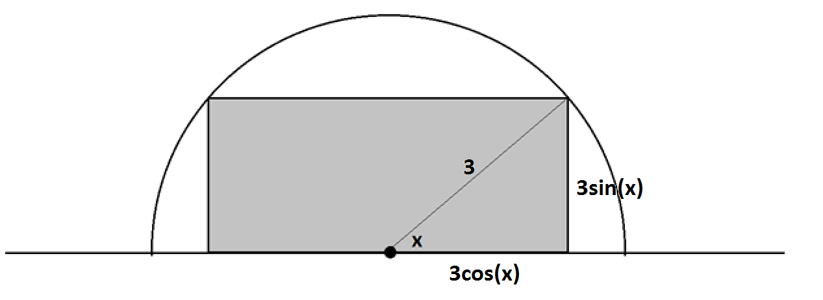
We wish to write this expression in the form $\text{a}\text{cos}{\text{(x} \text{+} \text{b)}}$.

Now,
$\text{a}\text{cos}\left(\text{x} \text{+} \text{b}\right) \text{=} \text{a}\text{cos}\left(\text{x}\right)\text{cos}\left(\text{b}\right)\text{-} \text{a}\text{sin}\left(\text{x}\right)\text{sin}{\text{(}\text{b}\text{)}}$.
This suggests setting
$$\text{a}\text{cos}\left(\text{b}\right) \text{=} \text{12}$$
$$\text{-a}\text{sin}\left(\text{b}\right) \text{=} \text{6}$$

Using ${\text{sin}}^{\text{2}}\left(\text{b}\right) \text{+} {\text{cos}}^{\text{2}}\left(\text{b}\right) \text{=} \text{1}$ this gives $\frac{\text{144}}{{\text{a}}^{\text{2}}} \text{+} \frac{\text{36}}{{\text{a}}^{\text{2}}} \text{=} \text{1}$
So $\text{a} \text{=} \sqrt{\text{180}} \text{≈} \text{13.42}$ is a candidate value for $\text{a}$.

Also,
$\frac{\text{6}}{\text{12}} \text{=} \frac{\text{-}\text{a}\text{sin}{\text{(}\text{b}\text{)}}}{\text{a}\text{cos}{\text{(}\text{b}\text{)}}} \text{=} \text{-}\text{tan}{\text{(}\text{b}\text{)}}$,
suggesting we take $\text{b} \text{=} {\text{tan}}^{\text{-1}}\left(\text{-}\frac{\text{1}}{\text{2}}\right) \text{≈} \text{-0.46}$. Thus $\text{b}$, here, is the measure of an angle in the fourth quadrant.
So let’s examine $\text{13.42}\text{cos}{\text{(x} \text{-} \text{0.46)}}$. We have
$$\text{13.42}\text{ cos}\left(\text{x - 0.46}\right)\text{ = 13.42}\text{ cos}\left(\text{x}\right)\text{cos}\left(\text{-0.46}\right)\text{ - 13.42}\text{ sin}\left(\text{x}\right)\text{sin}{\text{(-0.46)}} \\ \text{≈ 13.42 × }\text{cos}\left(\text{x}\right)\text{ × 0.90 - 13.42 × }\text{sin}{\text{(x) × (-0.44)}} \\ \text{≈ 12}\text{cos}\left(\text{x}\right)\text{ + 6}\text{sin}{\text{(x)}}$$
Choosing $\text{a = 13.42}$ and $\text{b = -0.46}$ does the trick.

