Lesson 2: Networks and Matrix Arithmetic

Student Outcomes
- Students use matrices to represent data based on transportation networks.
- Students multiply a matrix by a scalar, add and subtract matrices of appropriate dimensions, and interpret the meaning of this arithmetic in terms of transportation networks.

Lesson Notes
This lesson builds on the work in the previous lesson in which students modeled transportation networks with matrices. The primary example used in Lesson 1 was a set of bus routes that connect four cities. This situation will be used to help students discover and define multiplication by a scalar (N-VM.C.7) and matrix addition and subtraction (N-VM.C.8). This lesson helps students understand the meaning of this matrix arithmetic. Matrix multiplication and the properties of matrix arithmetic will be explored further in Lesson 3. Throughout this lesson, students make sense of transportation network diagrams and matrices (MP.1), reason about contextual and abstract situations (MP.2), and use matrices as tools to represent network diagrams (MP.5) with care and precision (MP.6).

Classwork
Scaffolding:
Teachers can offer a simplified task for the Opening Exercise by displaying the network diagram and the matrix representation side-by-side and asking:
- Explain why $b_{2,3}=1$.
- Explain why $s_{4,4}=0$.
Opening Exercise (5 minutes)
Have students turn and talk to a partner about the following questions to activate prior knowledge about different types of transportation networks and to remind them of yesterday’s scenario.
- In yesterday’s lesson, you looked at bus routes and roads that connected four cities. What other types of transportation might connect cities?
  - Other types of transportation could include trains, airplanes, boats, walking, or biking routes.
Use this exercise to check for student understanding about how to create a matrix from a network diagram. Students should work independently on this exercise and then confirm their answers with a partner. If time is a factor, you could have half of the class create the matrix for the subway line and the other half for the bus line. Ask one or two students to share their answers with the class. Take time to review the meaning of the arrows and to make sure students are distinguishing between bus routes (solid) and subway routes (dashed).

Opening Exercise
MP.2
&
MP.6
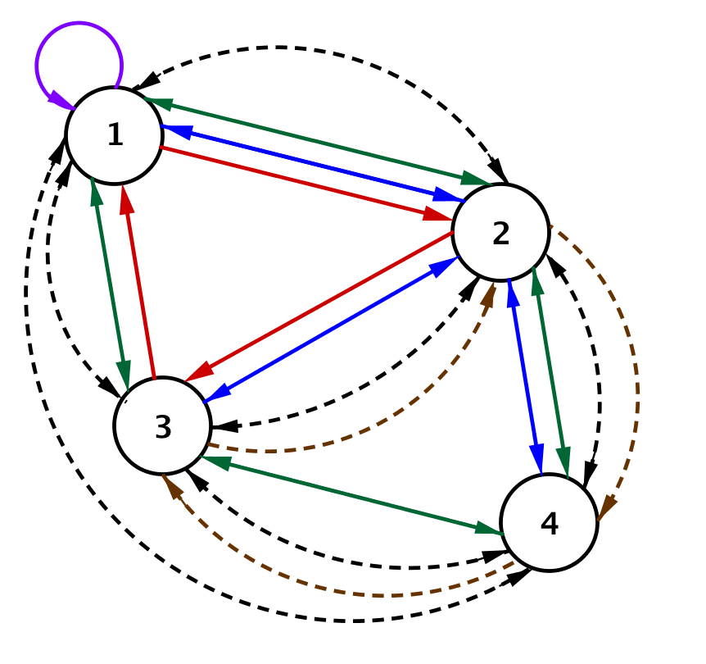
Suppose a subway line also connects the four cities. Here is the subway and bus line network. The bus routes connecting the cities are represented by solid lines, and the subway routes are represented by dashed arcs.
Write a matrix $B$ to represent the bus routes and a matrix $S$ to represent the subway lines connecting the four cities.
MP.1
&
MP.5
Scaffolding:
Teachers can offer a simplified diagram if students are struggling with the one presented.
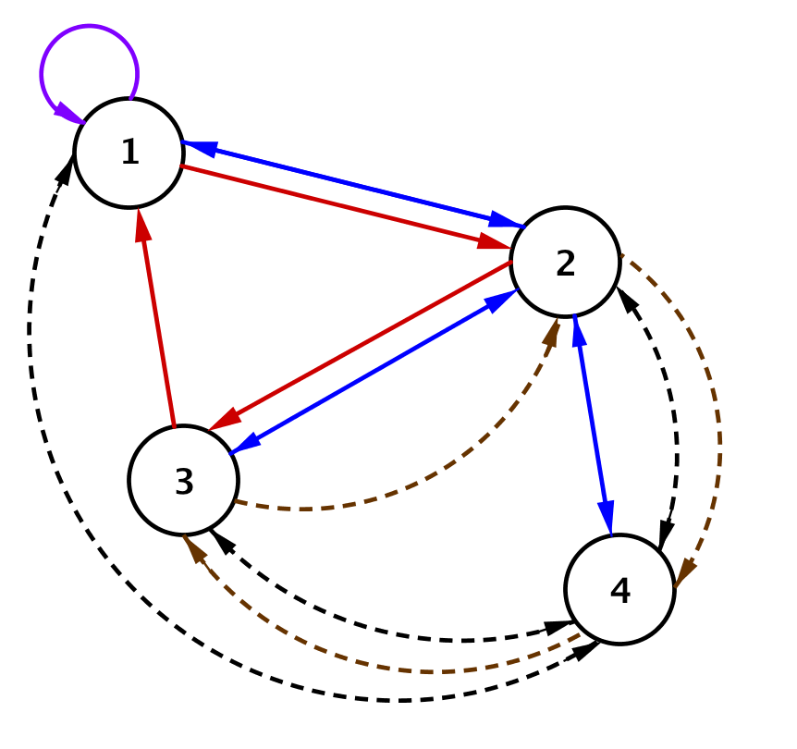
$B=\left[\begin{matrix}1 & 3 & 1 & 0 \\ 2 & 0 & 2 & 2 \\ 2 & 1 & 0 & 1 \\ 0 & 2 & 1 & 0\end{matrix}\right]$ and $S=\left[\begin{matrix}0 & 1 & 1 & 1 \\ 1 & 0 & 1 & 2 \\ 1 & 2 & 0 & 1 \\ 1 & 1 & 2 & 0\end{matrix}\right]$

Exploratory Challenge/Exercises 1–6 (15 minutes): Matrix Arithmetic
MP.3
&
MP.4
Organize students into small groups, and invite them to work through the exercises in this Exploratory Challenge. Students will create new matrices and interpret them in terms of the situation. They will consider the product of a scalar and a matrix and the sum of two matrices. At the end of this challenge, you will lead a discussion debriefing the results and then give students time to work with group members to start populating a graphic organizer for these matrix arithmetic operations.
Exploratory Challenge/Exercises 1–6: Matrix Arithmetic
Use the network diagram from the Opening Exercise and your answers to help you complete this challenge with your group.
- Suppose the number of bus routes between each city were doubled.
MP.2
&
MP.6
  - What would the new bus route matrix be?
$$\left[\begin{matrix}2 & 6 & 2 & 0 \\ 4 & 0 & 4 & 4 \\ 4 & 2 & 0 & 2 \\ 0 & 4 & 2 & 0\end{matrix}\right]$$

  - Mathematicians call this matrix $2B$. Why do you think they call it that?
Each entry is multiplied by $2$, so the values are twice what they were before.

- What would be the meaning of $10B$ in this situation?
It would mean each entry in matrix $B$ is multiplied by $10$, so the city now has $10$ times as many bus routes as before connecting the cities.

- Write the matrix $10B$.
$$10B=\left[\begin{matrix}10 & 30 & 10 & 0 \\ 20 & 0 & 20 & 20 \\ 20 & 10 & 0 & 10 \\ 0 & 20 & 10 & 0\end{matrix}\right]$$
MP.2
&
MP.6
- Ignore whether or not a line connecting cities represents a bus or subway route.
  - Create one matrix that represents all the routes between the cities in this transportation network.
$$\left[\begin{matrix}1 & 4 & 2 & 1 \\ 3 & 0 & 3 & 4 \\ 3 & 3 & 0 & 2 \\ 1 & 3 & 3 & 0\end{matrix}\right]$$

  - Why would it be appropriate to call this matrix $B+S$? Explain your reasoning.
The total number of routes regardless of transportation mode is found by counting the total routes. We can also find that by adding the number of bus and subway lines between each pair of cities.

- What would be the meaning of $4B+2S$ in this situation?
It would mean the total routes connecting the cities if the number of bus lines were increased by a factor of $4$ and the number of subway lines were doubled.

- Write the matrix $4B+2S$. Show work and explain how you found your answer.
First multiply each entry in $B$ by $4$, and then multiply each entry in $S$ by $2$.
$$4B=4\left[\begin{matrix}1 & 3 & 1 & 0 \\ 2 & 0 & 2 & 2 \\ 2 & 1 & 0 & 1 \\ 0 & 2 & 1 & 0\end{matrix}\right]=\left[\begin{matrix}4 & 12 & 4 & 0 \\ 8 & 0 & 8 & 8 \\ 8 & 4 & 0 & 4 \\ 0 & 8 & 4 & 0\end{matrix}\right]$$
$$2S=2\left[\begin{matrix}0 & 1 & 1 & 1 \\ 1 & 0 & 1 & 2 \\ 1 & 2 & 0 & 1 \\ 1 & 1 & 2 & 0\end{matrix}\right]=\left[\begin{matrix}0 & 2 & 2 & 2 \\ 2 & 0 & 2 & 4 \\ 2 & 4 & 0 & 2 \\ 2 & 2 & 4 & 0\end{matrix}\right]$$
Finally, add these two new matrices together by adding corresponding entries.
$$4B+2S=\left[\begin{matrix}4 & 12 & 4 & 0 \\ 8 & 0 & 8 & 8 \\ 8 & 4 & 0 & 4 \\ 0 & 8 & 4 & 0\end{matrix}\right]+\left[\begin{matrix}0 & 2 & 2 & 2 \\ 2 & 0 & 2 & 4 \\ 2 & 4 & 0 & 2 \\ 2 & 2 & 4 & 0\end{matrix}\right]=\left[\begin{matrix}4+0 & 12+2 & 4+2 & 0+2 \\ 8+2 & 0+0 & 8+2 & 8+4 \\ 8+2 & 4+4 & 0+0 & 4+2 \\ 0+2 & 8+2 & 4+4 & 0+0\end{matrix}\right]=\left[\begin{matrix}4 & 14 & 6 & 2 \\ 10 & 0 & 10 & 12 \\ 10 & 8 & 0 & 6 \\ 2 & 10 & 8 & 0\end{matrix}\right]$$

To debrief these exercises, have groups present their solutions to the class. As they present, encourage them to explain how they created the new matrices and what they mean in this situation. Assign each group in your class to present a portion of these exercises. For example, have one or two groups present their solutions to Exercise 3, have another group present Exercises 4 and 5, and then have one or two groups present Exercise 6.

Discussion (10 minutes)
Here you will introduce matrix arithmetic vocabulary and discuss how we might define matrix subtraction.
- How would you describe the process you used to create the matrix $10B$ in Exercise 4?
  - To create this matrix, multiply each element that represents the number of bus lines by $10$.
- This operation is called scalar multiplication. Describe in words how to create the matrix $kA$ where $k$ is a real number and $A$ is a matrix.
  - You would multiply each element in matrix $A$ by the real number $k$.
Scaffolding:
If students are having trouble describing the abstract operations (e.g. $kA$), you can provide them with concrete examples like the ones shown below.
- If $A=\left[\begin{matrix}2 & 2 \\ 3 & 1\end{matrix}\right],$ describe
how to create $2A,3A$, and $kA$.
- If $A=\left[\begin{matrix}2 & 2 \\ 3 & 1\end{matrix}\right]$ and
$B=\left[\begin{matrix}2 & 1 \\ 5 & 0\end{matrix}\right]$, describe how
to create $A+B$ and $-B$ and $A-B$.
You can also model using technology (graphing calculators or software) so students have a means to check their work or to help them to accurately calculate when working with larger matrices.
- How would you describe the process you used to create the matrix $B+S$ in Exercise 5?
  - To create this matrix, you would count (or add) the corresponding entries for bus and subway routes to find the total between each pair of cities and then record these in a new matrix.
- This operation is called matrix addition. Describe in words how to create a matrix $A+B$ where $A$ and $B$ are matrices with equal dimensions.
  - Add each entry in matrix $A$ to its corresponding entry in matrix $B$.
- Why would $A$ and $B$ need to have the same dimensions in order to find their sum?
  - Because we have to add corresponding elements, the matrices $A$ and $B$ must have the same dimensions or the operation will not make sense.
- How would we use addition to represent the difference between 5 and 3?
  - You add the opposite of the second number. For example,
$5-3=5+\left(-3\right)=2$.
- How could we create the opposite of a matrix?
  - Multiply it by the scalar $-1$.
- How could you produce a matrix $A-B$ if $A$ and $B$ are matrices with equal dimensions?
  - You would simply subtract each element in matrix $B$ from its corresponding element in matrix $A.$ More formally, you would compute the sum $A+\left(-1\right)B$.

Exercise 7 (5 minutes)
Now give students time to work with their groups to complete the first two rows of the graphic organizer in Exercise 7. If you would like, you can provide students with sample matrices to work from in the example column.

Exercise 7
- Complete this graphic organizer.
Matrix Operations Graphic Organizer
Operation | Symbols | Describe How to Calculate | Example Using $3×3$ Matrices
Scalar Multiplication | $$kA$$ | Multiply each element of matrix $A$ by the real number $k$. | $$2\left[\begin{matrix}1 & 1 & 2 \\ 2 & 2 & 4 \\ 3 & 0 & 0\end{matrix}\right]=\left[\begin{matrix}2 & 2 & 4 \\ 4 & 4 & 8 \\ 6 & 0 & 0\end{matrix}\right]$$
The Sum of Two Matrices | $$A+B$$ | Add corresponding elements in each row and column of $A$ and $B$. Matrices $A$ and $B$ must have the same dimensions. | $$\left[\begin{matrix}1 & 1 & 2 \\ 2 & 2 & 4 \\ 3 & 0 & 0\end{matrix}\right]+\left[\begin{matrix}2 & 2 & 4 \\ 4 & 4 & 8 \\ 6 & 0 & 0\end{matrix}\right]=\left[\begin{matrix}3 & 3 & 6 \\ 6 & 6 & 12 \\ 9 & 0 & 0\end{matrix}\right]$$
The Difference of Two Matrices | $$A-B$$  $$= A + (-1)B$$ | Subtract corresponding elements in each row and column of $A$ and $B$. The matrices must have the same dimensions. | $$\left[\begin{matrix}1 & 1 & 2 \\ 2 & 2 & 4 \\ 3 & 0 & 0\end{matrix}\right]-\left[\begin{matrix}2 & 2 & 4 \\ 4 & 4 & 8 \\ 6 & 0 & 0\end{matrix}\right]=\left[\begin{matrix}-1 & -1 & -2 \\ -2 & -2 & -4 \\ -3 & 0 & 0\end{matrix}\right]$$  Or  $$\left[\begin{matrix}1 & 1 & 2 \\ 2 & 2 & 4 \\ 3 & 0 & 0\end{matrix}\right]+(-1)\left[\begin{matrix}2 & 2 & 4 \\ 4 & 4 & 8 \\ 6 & 0 & 0\end{matrix}\right]=\left[\begin{matrix}-1 & -1 & -2 \\ -2 & -2 & -4 \\ -3 & 0 & 0\end{matrix}\right]$$

Closing (5 minutes)
Have students review their entries in Exercise 7 with a partner, and then ask one or two students to share their responses with the entire class. Take a minute to clarify any questions students have about the notation used in the Lesson Summary shown below. Be sure to emphasize that the processes of matrix addition, subtraction, and scalar multiplication apply to matrices that are not square, even though the examples in this section used only square matrices. We can add or subtract any two matrices that have the same dimensions, and we can multiply any matrix by a real number.
Lesson Summary
Matrix Scalar Multiplication: Let $k$ be a real number, and let $A$ be an $m×n$ matrix whose entry in row $i$ and column $j$ is $a_{i,j}$. Then the scalar product $k⋅A$ is the $m×n$ matrix whose entry in row $i$ and column $j$ is $k⋅a_{i,j}.$
Matrix Sum: Let $A$ be an $m×n$ matrix whose entry in row $i$ and column $j$ is $a_{i,j},$and let $B$ be an $m×n$ matrix whose entry in row $i$ and column $j$ is $b_{i,j}$. Then the matrix sum $A+B$ is the $m×n$ matrix whose entry in
row $i$ and column $j$ is $a_{i,j}+b_{i,j}.$
Matrix Difference: Let $A$ be an $m×n$ matrix whose entry in row $i$ and column $j$ is $a_{i,j},$and let $B$ be an $m×n$ matrix whose entry in row $i$ and column $j$ is $b_{i,j}$. Then the matrix difference $A-B$ is the $m×n$ matrix whose entry in row $i$ and column $j$ is $a_{i,j}-b_{i,j}.$

Exit Ticket (5 minutes)
Name Date
Lesson 2: Networks and Matrix Arithmetic

Exit Ticket

The diagram below represents a network of highways and railways between three cities. Highways are represented by black lines, and railways are represented by red lines.
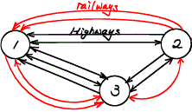
- Create matrix $A$ that represents the number of major highways connecting the three cities and matrix $B$ that represents the number of railways connecting the three cities.

- Calculate and interpret the meaning of each matrix in this situation.
  - $A+B$

  - $3B$

- Find $A-B$. Does the matrix $A-B$ have any meaning in this situation? Explain your reasoning.

Exit Ticket Sample Solutions
The diagram below represents a network of highways and railways between three cities. Highways are represented by black lines, and railways are represented by red lines.
- Create matrix $A$ that represents the number of major highways connecting the three cities and matrix $B$ that represents the number of railways connecting the three cities.
$$A=\left[\begin{matrix}0 & 1 & 2 \\ 2 & 0 & 2 \\ 3 & 1 & 0\end{matrix}\right]$$
$$B=\left[\begin{matrix}0 & 0 & 2 \\ 2 & 0 & 1 \\ 1 & 1 & 0\end{matrix}\right]$$

- Calculate and interpret the meaning of each matrix in this situation
  - $A+B$
$A+B=\left[\begin{matrix}0 & 1 & 4 \\ 4 & 0 & 3 \\ 4 & 2 & 0\end{matrix}\right]$. The resulting matrix represents the numbers of ways that a person can travel between
the three cities by taking any of the major highway or railways.

  - $3B$
$3B=\left[\begin{matrix}0 & 0 & 6 \\ 6 & 0 & 3 \\ 3 & 3 & 0\end{matrix}\right]$. The resulting matrix means the number of trains between the three cities has tripled.

- Find $-B$ . Does the matrix $A-B$ have any meaning in this situation? Explain your reasoning.
$A-B=\left[\begin{matrix}0 & 1 & 0 \\ 0 & 0 & 1 \\ 2 & 0 & 0\end{matrix}\right].$ The entries in matrix $A-B$ represent how many more routes there are by highway than there
are by train between two cities. For example, the $2$ in the third row and first column indicates that there are two more ways to get from City 3 to City 1 by highway than there are by rail.

Problem Set Sample Solutions

- For the matrices given below, perform each of the following calculations or explain why the calculation is not possible.
$$A=\left[\begin{matrix}1 & 2 \\ 0 & 1\end{matrix}\right]$$ |  | $B=\left[\begin{matrix}2 & 1 \\ -1 & 4\end{matrix}\right]$
$$C=\left[\begin{matrix}5 & 2 & 9 \\ 6 & 1 & 3 \\ -1 & 1 & 0\end{matrix}\right]$$ |  | $D=\left[\begin{matrix}1 & 6 & 0 \\ 3 & 0 & 2 \\ 1 & 3 & -2\end{matrix}\right]$

  - $A+B$
$$\left[\begin{matrix}3 & 3 \\ -1 & 5\end{matrix}\right]$$

  - $2A-B$
$$\left[\begin{matrix}0 & 3 \\ 1 & -2\end{matrix}\right]$$

  - $A+C$
Matrices $A$ and $C$ cannot be added together because they do not have the same dimensions.

  - $–2C$
$$\left[\begin{matrix}-10 & -4 & -18 \\ -12 & -2 & -6 \\ 2 & -2 & 0\end{matrix}\right]$$

  - $4D-2C$
$$\left[\begin{matrix}-6 & 20 & -18 \\ 0 & -2 & 2 \\ 6 & 10 & -8\end{matrix}\right]$$

  - $3B-3B$
$$\left[\begin{matrix}0 & 0 \\ 0 & 0\end{matrix}\right]$$

  - $5B-C$
Matrix $C$ cannot be subtracted from $5B$ because they do not have the same dimensions.

  - $B-3A$
$$\left[\begin{matrix}-1 & -5 \\ -1 & 1\end{matrix}\right]$$

  - $C+10D$
$$\left[\begin{matrix}15 & 62 & 9 \\ 36 & 1 & 23 \\ 9 & 31 & -20\end{matrix}\right]$$
  - $\frac{1}{2}C+D$
$$\left[\begin{matrix}\frac{7}{2} & 7 & \frac{9}{2} \\ 6 & \frac{1}{2} & \frac{7}{2} \\ \frac{1}{2} & \frac{7}{2} & -2 \end{matrix}\right]$$

  - $\frac{1}{4}B$
$$\left[\begin{matrix}\frac{1}{2} & \frac{1}{4} \\ -\frac{1}{4} & 1\end{matrix}\right]$$

  - $3D-4A$
Matrix $4A$ cannot be subtracted from $3D$ because they do not have the same dimensions.

  - $\frac{1}{3}B-\frac{2}{3}A$
$$\left[\begin{matrix}0 & -1 \\ -\frac{1}{3} & \frac{2}{3}\end{matrix}\right]$$

- For the matrices given below, perform each of the following calculations or explain why the calculation is not possible.
$$A=\left[\begin{matrix}1 & 2 & 1 \\ 3 & 0 & 2\end{matrix}\right]$$ |  | $B=\left[\begin{matrix}2 & 1 \\ 3 & 6 \\ 1 & 0\end{matrix}\right]$
$$C=\left[\begin{matrix}1 & -2 & 3 \\ 1 & 1 & 4\end{matrix}\right]$$ |  | $D=\left[\begin{matrix}2 & -1 \\ -1 & 0 \\ 4 & 1\end{matrix}\right]$

  - $A+2B$
Matrices $A$and $2B$ cannot be added together because they do not have the same dimensions.

  - $2A-C$
$$\left[\begin{matrix}1 & 6 & -1 \\ 5 & -1 & 0\end{matrix}\right]$$

  - $A+C$
$$\left[\begin{matrix}2 & 0 & 4 \\ 4 & 1 & 6\end{matrix}\right]$$

  - $–2C$
$$\left[\begin{matrix}-2 & 4 & -6 \\ -2 & -2 & -8\end{matrix}\right]$$

  - $4D-2C$
Matrix $2C$ cannot be subtracted from $4D$ because the matrices do not have the same dimensions.

  - $3D-3D$
$$\left[\begin{matrix}0 & 0 \\ 0 & 0 \\ 0 & 0\end{matrix}\right]$$

  - $5B-D$
$$\left[\begin{matrix}8 & 6 \\ 16 & 30 \\ 1 & -1\end{matrix}\right]$$

  - $C-3A$
$$\left[\begin{matrix}-2 & -8 & 0 \\ -8 & 1 & -2\end{matrix}\right]$$

  - $B+10D$
$$\left[\begin{matrix}22 & -9 \\ -7 & 6 \\ 41 & 10\end{matrix}\right]$$

  - $\frac{1}{2}C+A$
$$\left[\begin{matrix}\frac{3}{2} & 1 & \frac{5}{2} \\ \frac{7}{2} & \frac{1}{2} & 4\end{matrix}\right]$$

  - $\frac{1}{4}B$
$$\left[\begin{matrix}\frac{1}{2} & \frac{1}{4} \\ \frac{3}{4} & \frac{3}{2} \\ \frac{1}{4} & 0\end{matrix}\right]$$

  - $3A+3B$
Matrices $3A$ and $3B$ cannot be added together because they do not have the same dimension.

  - $\frac{1}{3}B-\frac{2}{3}D$
$$\left[\begin{matrix}-\frac{2}{3} & 1 \\ \frac{5}{3} & 2 \\ -\frac{7}{3} & -\frac{2}{3}\end{matrix}\right]$$
- Let
$$A=\left[\begin{matrix}3 & \frac{2}{3} \\ -1 & 5\end{matrix}\right]$$and
$$B=\left[\begin{matrix}\frac{1}{2} & \frac{3}{2} \\ 4 & 1\end{matrix}\right]$$
  - Let $C=6A+6B$. Find matrix $C$.
$$C=\left[\begin{matrix}21 & 13 \\ 18 & 36\end{matrix}\right]$$

  - Let $D=6(A+B)$. Find matrix $D$.
$$D=\left[\begin{matrix}21 & 13 \\ 18 & 36\end{matrix}\right]$$

  - What is the relationship between matrices $C$ and $D$? Why do you think that is?
The matrices are the same. Multiplying by a scalar appears to be distributive with matrices.

- Let $A=\left[\begin{matrix}3 & 2 \\ -1 & 5 \\ 3 & -4\end{matrix}\right]$ and $X$ be a $3×2$ matrix. If $A+X=\left[\begin{matrix}-2 & 3 \\ 4 & 1 \\ 1 & -5\end{matrix}\right]$, then find $X$.
$$X=\left[\begin{matrix}-5 & 1 \\ 5 & -4 \\ -2 & -1\end{matrix}\right]$$

- Let $A=\left[\begin{matrix}1 & 3 & 2 \\ 3 & 1 & 2 \\ 4 & 3 & 2\end{matrix}\right]$and $B=\left[\begin{matrix}2 & 1 & 3 \\ 2 & 2 & 1 \\ 1 & 3 & 1\end{matrix}\right]$ represent the bus routes of two companies between three cities.
  - Let $C=A+B$. Find matrix $C.$Explain what the resulting matrix and entry $c_{1,3}$ mean in this context.
$C=\left[\begin{matrix}3 & 4 & 5 \\ 5 & 3 & 3 \\ 5 & 6 & 3\end{matrix}\right].$ Entry$c_{1,3}=5$ means that there are $5$ ways to get from City 1 to City 3 using either bus
company.

  - Let $D=B+A$. Find matrix $D.$Explain what the resulting matrix and entry $d_{1,3}$ mean in this context.
$D=\left[\begin{matrix}3 & 4 & 5 \\ 5 & 3 & 3 \\ 5 & 6 & 3\end{matrix}\right].$Entry $d_{1,3}=5$ means that there are $5$ ways to get from City 1 to City 3 using either bus
company.

  - What is the relationship between matrices $C$ and $D$? Why do you think that is?
Matrices $C$ and $D$ are equal. When we add two matrices, we add the real numbers in the corresponding spots. When two real numbers are added, the order doesn’t matter, so it makes sense that it doesn’t matter the order in which we add matrices.

- Suppose that April’s Pet Supply has three stores in Cities 1, 2, and 3. Ben’s Pet Mart has two stores in Cities 1 and 2. Each shop sells the same type of dog crates in size 1 (small), 2 (medium), 3 (large), and 4 (extra large).
April’s and Ben’s inventory in each city are stored in the tables below.

 | April’s Pet Supply |  |  |  |  | Ben’s Pet Mart
 | City 1 | City 2 | City 3 |  |  | City 1 | City 2
Size 1 | $$3$$ | $$5$$ | $$1$$ |  | Size 1 | $$2$$ | $$3$$
Size 2 | $$4$$ | $$2$$ | $$9$$ |  | Size 2 | $$0$$ | $$2$$
Size 3 | $$1$$ | $$4$$ | $$2$$ |  | Size 3 | $$4$$ | $$1$$
Size 4 | $$0$$ | $$0$$ | $$1$$ |  | Size 4 | $$0$$ | $$0$$

  - Create a matrix $A$ so that $a_{i,j}$ represents the number of crates of size $i$ available in April’s store $j$.
$$A=\left[\begin{matrix}3 & 5 & 1 \\ 4 & 2 & 9 \\ 1 & 4 & 2 \\ 0 & 0 & 1\end{matrix}\right]$$

  - Explain how the matrix $B=\left[\begin{matrix}2 & 3 & 0 \\ 0 & 2 & 0 \\ 4 & 1 & 0 \\ 0 & 0 & 0\end{matrix}\right]$ can represent the dog crate inventory at Ben’s Pet Mart.
The first two columns represent the inventory in Ben’s stores in Cities 1 and 2. Since there is no store in City 3. Ben has no inventory of dog crates in this city, which is represented by the zeros in the third column of
matrix $B$.

  - Suppose that April and Ben merge their inventories. Find a matrix that represents their combined inventory in each of the three cities.
Matrix $A+B=\left[\begin{matrix}5 & 8 & 1 \\ 4 & 4 & 9 \\ 5 & 5 & 2 \\ 0 & 0 & 1\end{matrix}\right]$ represents the combined inventory in each of the three cities. For example, since
the entry in row 4, column 1 is $0$, there are no extra large dog crates in either store in City 1. And, since the entry in row 1, column 2 is $8$, there are a combined $8$ small crates between the stores in City 2.

- Jackie has two businesses she is considering buying and a business plan that could work for both. Consider the tables below, and answer the questions following.
 | Horus’s One-Stop Warehouse Supply |  |  |  | Re’s 24-Hour Distributions
 | If business stays the same | If business improves as projected |  |  | If business stays the same | If business improves as projected
Expand to Multiple States | $$-\$75,000,000$$ | $$\$45,000,000$$ |  | Expand to Multiple States | $$-\$99,000,000$$ | $$\$62,500,000$$
Invest in Drone Delivery | $$-\$33,000,000$$ | $$\$30,000,000$$ |  | Invest in Drone Delivery | $$-\$49,000,000$$ | $$\$29,000,000$$
Close and Sell Out | $$\$20,000,000$$ | $$\$20,000,000$$ |  | Close and Sell Out | $$\$35,000,000$$ | $$\$35,000,000$$

  - Create matrices $H$ and $R$ representing the values in the tables above such that the rows represent the different options and the columns represent the different outcomes of each option.
$$H=\left[\begin{matrix}-75 & 45 \\ -33 & 30 \\ 20 & 20\end{matrix}\right]$$
$$R=\left[\begin{matrix}-99 & 62.5 \\ -49 & 29 \\ 35 & 35\end{matrix}\right]$$

  - Calculate $R-H$. What does $R-H$ represent?
$$\left[\begin{matrix}-99 & 62.5 \\ -49 & 29 \\ 35 & 35\end{matrix}\right]-\left[\begin{matrix}-75 & 45 \\ -33 & 30 \\ 20 & 20\end{matrix}\right]=\left[\begin{matrix}-24 & 17.5 \\ -16 & -1 \\ 15 & 15\end{matrix}\right]$$
$R-H$ represents how much more money Jackie will make buying the second business instead of the first in each situation. Note that negative values mean that Jackie will lose more money with those choices.

  - Calculate $H+R$. What does $H+R$ represent?
$$\left[\begin{matrix}-75 & 45 \\ -33 & 30 \\ 20 & 20\end{matrix}\right]+\left[\begin{matrix}-99 & 62.5 \\ -49 & 29 \\ 35 & 35\end{matrix}\right]=\left[\begin{matrix}-174 & 107.5 \\ -82 & 59 \\ 55 & 55\end{matrix}\right]$$
$H+R$ represents what could happen if Jackie buys both businesses.

  - Jackie estimates that the economy could cause fluctuations in her numbers by as much as $5\%$ both ways. Find matrices to represent the best and worst case scenarios for Jackie.
$$0.95H=\left[\begin{matrix}-71.25 & 42.75 \\ -31.25 & 28.5 \\ 19 & 19\end{matrix}\right]$$
$$1.05H=\left[\begin{matrix}-78.75 & 47.25 \\ -34.65 & 31.5 \\ 21 & 21\end{matrix}\right]$$
$$0.95R=\left[\begin{matrix}-94.05 & 59.375 \\ -46.55 & 27.55 \\ 33.25 & 33.25\end{matrix}\right]$$
$$1.05R=\left[\begin{matrix}-103.95 & 65.625 \\ -51.45 & 30.45 \\ 36.75 & 36.75\end{matrix}\right]$$

  - Which business should Jackie buy? Which of the three options should she choose? Explain your choices.
Answers will vary depending on how students feel about risk and income. There are two poor choices. If Jackie is planning to sell out the business she buys, then Re’s business results in a guaranteed increase of $\$15$ million. Also, if Jackie is planning to invest in drones, then she should buy Horus’s business since it is both less risky and results in a greater return.

