Lesson 2: Networks and Matrix Arithmetic
Classwork
Opening Exercise
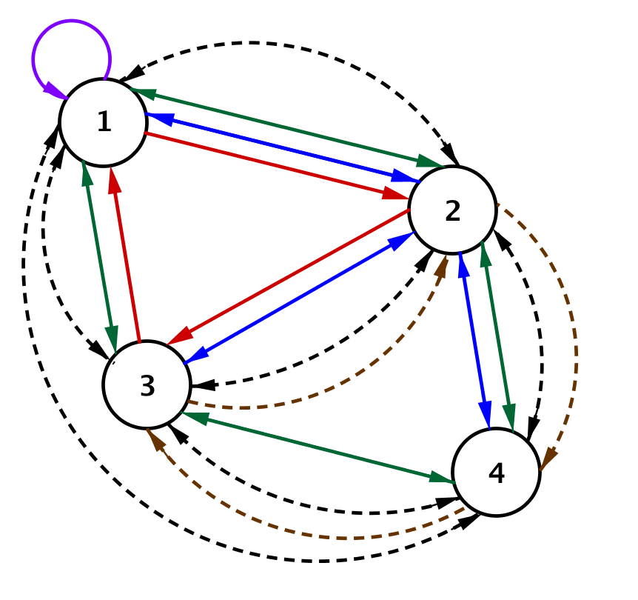
Suppose a subway line also connects the four cities. Here is the subway and bus line network. The bus routes connecting the cities are represented by solid lines, and the subway routes are represented by dashed arcs.

Write a matrix $B$ to represent the bus routes and a matrix $S$ to represent the subway lines connecting the four cities.

Exploratory Challenge/Exercises 1–6: Matrix Arithmetic
Use the network diagram from the Opening Exercise and your answers to help you complete this challenge with your group.
- Suppose the number of bus routes between each city were doubled.
  - What would the new bus route matrix be?

  - Mathematicians call this matrix $2B$. Why do you think they call it that?

- What would be the meaning of $10B$ in this situation?

- Write the matrix $10B$.

- Ignore whether or not a line connecting cities represents a bus or subway route.
  - Create one matrix that represents all the routes between the cities in this transportation network.

  - Why would it be appropriate to call this matrix $B+S$? Explain your reasoning.

- What would be the meaning of $4B+2S$ in this situation?

- Write the matrix $4B+2S$. Show work and explain how you found your answer.

Exercise 7
- Complete this graphic organizer.
Matrix Operations Graphic Organizer
Operation | Symbols | Describe How to Calculate | Example Using $3×3$ Matrices
Scalar Multiplication | $$kA$$
The Sum of Two Matrices | $$A+B$$
The Difference of Two Matrices | $$A-B$$  $$= A + (-1)B$$

Lesson Summary
Matrix Scalar Multiplication: Let $k$ be a real number, and let $A$ be an $m×n$ matrix whose entry in row $i$ and column $j$ is $a_{i,j}$. Then the scalar product $k⋅A$ is the $m×n$ matrix whose entry in row $i$ and column $j$ is $k⋅a_{i,j}.$
Matrix Sum: Let $A$ be an $m×n$ matrix whose entry in row $i$ and column $j$ is $a_{i,j},$and let
$B$ be an $m×n$ matrix whose entry in row $i$ and column $j$ is $b_{i,j}$. Then the matrix sum $A+B$ is the $m×n$ matrix whose entry in row $i$ and column $j$ is $a_{i,j}+b_{i,j}.$
Matrix Difference: Let $A$ be an $m×n$ matrix whose entry in row $i$ and column $j$ is $a_{i,j},$and let $B$ be an $m×n$ matrix whose entry in row $i$ and column $j$ is $b_{i,j}$. Then the matrix difference $A-B$ is the $m×n$ matrix whose entry in row $i$ and column $j$ is $a_{i,j}-b_{i,j}.$

Problem Set

- For the matrices given below, perform each of the following calculations or explain why the calculation is not possible.
$$A=\left[\begin{matrix}1 & 2 \\ 0 & 1\end{matrix}\right]$$ |  | $B=\left[\begin{matrix}2 & 1 \\ -1 & 4\end{matrix}\right]$
$$C=\left[\begin{matrix}5 & 2 & 9 \\ 6 & 1 & 3 \\ -1 & 1 & 0\end{matrix}\right]$$ |  | $D=\left[\begin{matrix}1 & 6 & 0 \\ 3 & 0 & 2 \\ 1 & 3 & -2\end{matrix}\right]$
  - $A+B$
  - $2A-B$
  - $A+C$
  - $–2C$
  - $4D-2C$
  - $3B-3B$
  - $5B-C$
  - $B-3A$
  - $C+10D$
  - $\frac{1}{2}C+D$
  - $\frac{1}{4}B$
  - $3D-4A$
  - $\frac{1}{3}B-\frac{2}{3}A$

- For the matrices given below, perform each of the following calculations or explain why the calculation is not possible.
$$A=\left[\begin{matrix}1 & 2 & 1 \\ 3 & 0 & 2\end{matrix}\right]$$ |  | $B=\left[\begin{matrix}2 & 1 \\ 3 & 6 \\ 1 & 0\end{matrix}\right]$
$$C=\left[\begin{matrix}1 & -2 & 3 \\ 1 & 1 & 4\end{matrix}\right]$$ |  | $D=\left[\begin{matrix}2 & -1 \\ -1 & 0 \\ 4 & 1\end{matrix}\right]$
  - $A+2B$
  - $2A-C$
  - $A+C$
  - $–2C$
  - $4D-2C$
  - $3D-3D$
  - $5B-D$
  - $C-3A$
  - $B+10D$
  - $\frac{1}{2}C+A$
  - $\frac{1}{4}B$
  - $3A+3B$
  - $\frac{1}{3}B-\frac{2}{3}D$

- Let
$$A=\left[\begin{matrix}3 & \frac{2}{3} \\ -1 & 5\end{matrix}\right]$$and
$$B=\left[\begin{matrix}\frac{1}{2} & \frac{3}{2} \\ 4 & 1\end{matrix}\right]$$
  - Let $C=6A+6B$. Find matrix $C$.
  - Let $D=6(A+B)$. Find matrix $D$.
  - What is the relationship between matrices $C$ and $D$? Why do you think that is?

- Let $A=\left[\begin{matrix}3 & 2 \\ -1 & 5 \\ 3 & -4\end{matrix}\right]$ and $X$ be a $3×2$ matrix. If $A+X=\left[\begin{matrix}-2 & 3 \\ 4 & 1 \\ 1 & -5\end{matrix}\right]$, then find $X$.

- Let $A=\left[\begin{matrix}1 & 3 & 2 \\ 3 & 1 & 2 \\ 4 & 3 & 2\end{matrix}\right]$and $B=\left[\begin{matrix}2 & 1 & 3 \\ 2 & 2 & 1 \\ 1 & 3 & 1\end{matrix}\right]$ represent the bus routes of two companies between three cities.
  - Let $C=A+B$. Find matrix $C.$Explain what the resulting matrix and entry $c_{1,3}$ mean in this context.
  - Let $D=B+A$. Find matrix $D.$Explain what the resulting matrix and entry $d_{1,3}$ mean in this context.
  - What is the relationship between matrices $C$ and $D$? Why do you think that is?

- Suppose that April’s Pet Supply has three stores in Cities 1, 2, and 3. Ben’s Pet Mart has two stores in Cities 1 and 2. Each shop sells the same type of dog crates in size 1 (small), 2 (medium), 3 (large), and 4 (extra large).
April’s and Ben’s inventory in each city are stored in the tables below.
 | April’s Pet Supply |  |  |  |  | Ben’s Pet Mart
 | City 1 | City 2 | City 3 |  |  | City 1 | City 2
Size 1 | $$3$$ | $$5$$ | $$1$$ |  | Size 1 | $$2$$ | $$3$$
Size 2 | $$4$$ | $$2$$ | $$9$$ |  | Size 2 | $$0$$ | $$2$$
Size 3 | $$1$$ | $$4$$ | $$2$$ |  | Size 3 | $$4$$ | $$1$$
Size 4 | $$0$$ | $$0$$ | $$1$$ |  | Size 4 | $$0$$ | $$0$$
  - Create a matrix $A$ so that $a_{i,j}$ represents the number of crates of size $i$ available in April’s store $j$.
  - Explain how the matrix $B=\left[\begin{matrix}2 & 3 & 0 \\ 0 & 2 & 0 \\ 4 & 1 & 0 \\ 0 & 0 & 0\end{matrix}\right]$ can represent the dog crate inventory at Ben’s Pet Mart.
  - Suppose that April and Ben merge their inventories. Find a matrix that represents their combined inventory in each of the three cities.

- Jackie has two businesses she is considering buying and a business plan that could work for both. Consider the tables below, and answer the questions following.
 | Horus’s One-Stop Warehouse Supply |  |  |  | Re’s 24-Hour Distributions
 | If business stays the same | If business improves as projected |  |  | If business stays the same | If business improves as projected
Expand to Multiple States | $$-\$75,000,000$$ | $$\$45,000,000$$ |  | Expand to Multiple States | $$-\$99,000,000$$ | $$\$62,500,000$$
Invest in Drone Delivery | $$-\$33,000,000$$ | $$\$30,000,000$$ |  | Invest in Drone Delivery | $$-\$49,000,000$$ | $$\$29,000,000$$
Close and Sell Out | $$\$20,000,000$$ | $$\$20,000,000$$ |  | Close and Sell Out | $$\$35,000,000$$ | $$\$35,000,000$$
  - Create matrices $H$ and $R$ representing the values in the tables above such that the rows represent the different options and the columns represent the different outcomes of each option.
  - Calculate $R-H$. What does $R-H$ represent?
  - Calculate $H+R$. What does $H+R$ represent?
  - Jackie estimates that the economy could cause fluctuations in her numbers by as much as $5\%$ both ways. Find matrices to represent the best and worst case scenarios for Jackie.
  - Which business should Jackie buy? Which of the three options should she choose? Explain your choices.

