Lesson 1: Introduction to Networks

Student Outcomes
- Students use matrices to represent and manipulate data from network diagrams.

Lesson Notes
In Module 1, students used matrix multiplication to perform a linear transformation in the plane or in space. In this module, we use matrices to model new phenomena, starting with networks and graphs, and we develop arithmetic operations on matrices in this context. Students will extend their understanding of the usefulness of matrices from representing functions to representing connections between people and places as they represent and solve a wide variety of problems using matrices.
The emphasis in these lessons is on understanding matrix arithmetic in authentic situations and then performing appropriate calculations to solve problems. Technology can be incorporated to perform arithmetic operations on large matrices. These lessons will address representing and manipulating data using matrices (N-VM.C.6), understanding multiplication by a scalar (N-VM.C.7), and performing arithmetic operations on matrices of appropriate dimensions
(N-VM.C.7).
Network diagram: A network diagram is a graph in which the vertices are represented by circles and the vertices are connected by segments, edges, or arcs. A directed graph, or digraph, is a network diagram in which the edges have arrows indicating the direction being traversed.
Note: The term “arc” is being used differently in this definition than the way it is used in geometry. Here it means any curve that connects one vertex to another vertex (or a vertex to itself). Also, sometimes the vertices are represented by circles with the number of the node written inside the circle. The directed edges can intersect each other.
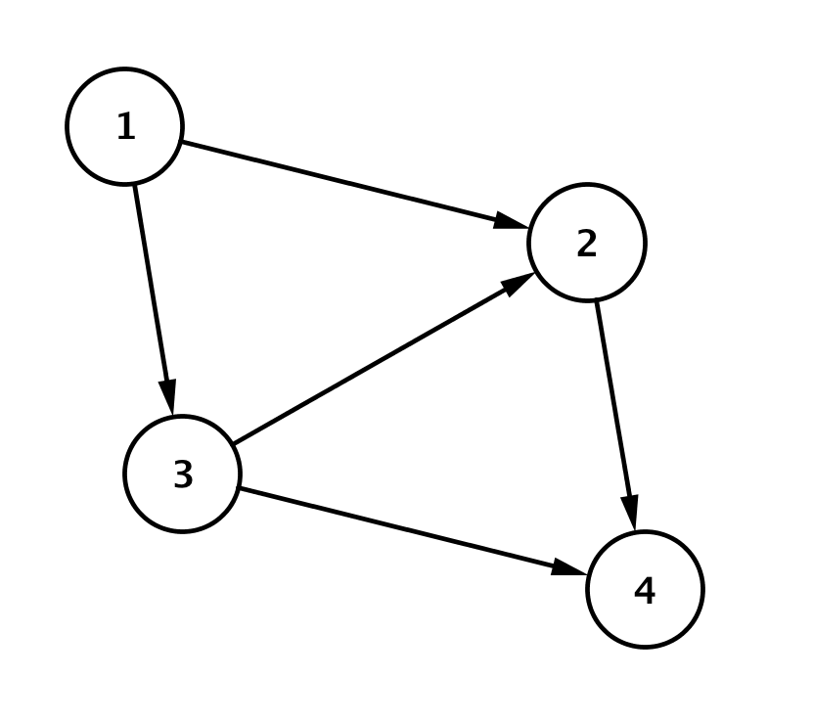
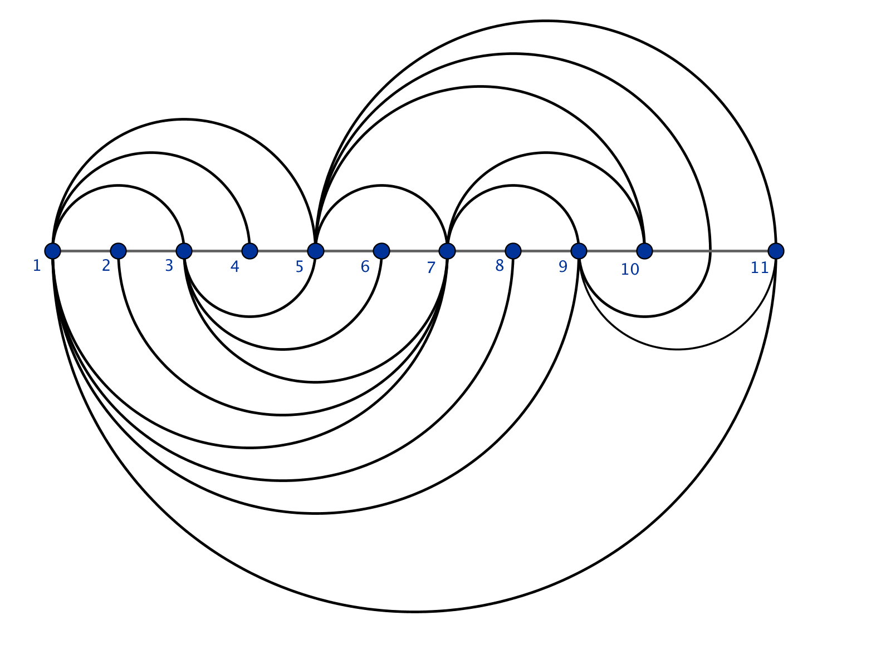
The figure at left is a specific type of network diagram that has arrows indicating direction. This is the more specific network diagram, which can also be called a directed graph. The figure at right is a network diagram.
In these lessons, a network is any system that can be described by a network diagram, which represents the connections between the parts of the system. Matrices are used as a tool that allows us to organize information from these networks and to perform calculations (MP.5).
Classwork
Opening (5 minutes)
Scaffolding:
- Use a word wall to support English Language Learners in your classroom when you introduce new vocabulary.
- The word “network” can be posted on your word wall after you complete the opening.
- Create a Frayer Diagram for Networks – see Precalculus and Advanced Topics, Module 1, Lesson 5 for an example.

Open this lesson by asking students to share what they think of when they hear the word “network.” This will activate their prior knowledge about every day usage of this word, which can then be used to transition to the mathematical meaning of a network. Give students a minute of silent thinking time, and then have students turn and talk to a partner about their responses. Ask one or two students to share their responses with the entire class.
- What do you think of when you hear the word network?
  - I think of social networks, a computer network, a television network, networking with professionals in a particular career field or group.
- For our purposes, a network will be a system of interrelated objects (such as people or places) that we can represent using a network diagram, as shown below.

Exploratory Challenges 1–3 (15 minutes)
Introduce the network diagram representing bus routes shown in the student materials. Have students read silently and then summarize with a partner the information on the student materials. Ask them to point out the four cities and the bus routes connecting them. Use the terminology of “vertices” for the cities and “edges” for the routes. Organize students into small groups, and have them respond to Exercises 1–7. These exercises provide a fairly simple context to explore the number of bus lines that connect four cities. However, students are being presented with an entirely new representation of information so they will have to make sense and persevere when working on this with their group members.
Exploratory Challenge 1
A network diagram depicts interrelated objects by circles that represent the objects and directed edges drawn as segments or arcs between related objects with arrows to denote direction. The network diagram below shows the bus routes that run between four cities, forming a network. The arrows indicate the direction the buses travel.
MP.1
Figure 1
How many ways can you travel from City 1 to City 4? Explain how you know.
There are three ways to travel from City 1 to City 4. According to the arrows, you can travel from City 1 to City 2 to City 4, from City 1 to City 3 to City 4, or from City 1 to City 3 to City 2 to City 4.

What about these bus routes doesn’t make sense?
It is not possible to leave City 4. The direction of the arrows show that there are no bus routes that lead from City 4 to any other city in this network. It is not possible to travel to City 1. The direction of the arrows show that there are no bus routes that lead to City 1.

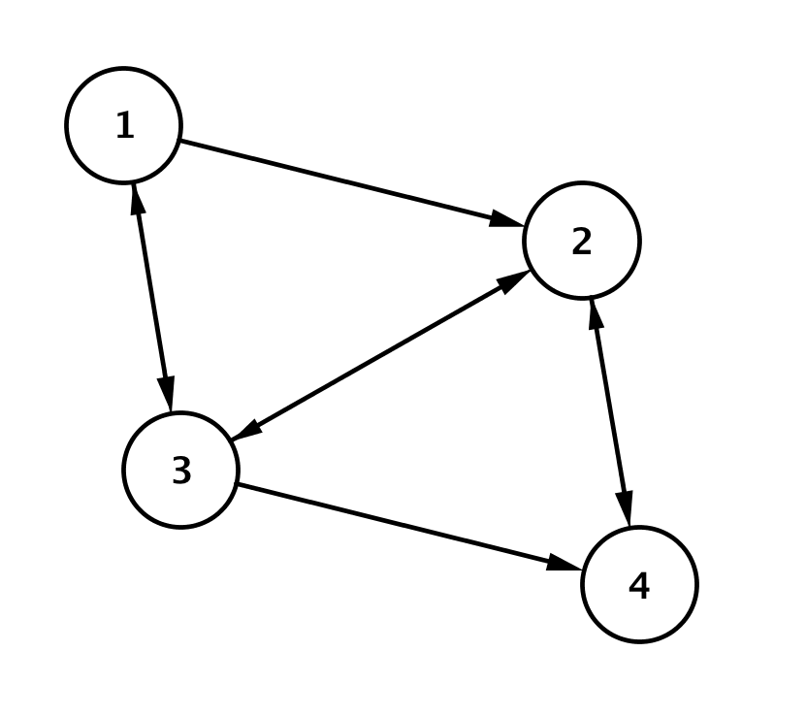
It turns out there was an error in printing the first route map. An updated network diagram showing the bus routes that connect the four cities is shown below in Figure 2. Arrows on both ends of an edge indicate that buses travel in both directions.
Figure 2
How many ways can you reasonably travel from City 4 to City 1 using the route map in Figure 2? Explain how you know.
MP.1
There is only one reasonable way. You must go from City 4 to City 2 to City 3 to City 1. The arrows indicate that there is only one route to City 1, which comes from City 3. However, it is possible to travel from City 4 to City 2 to City 3 as many times as desired before traveling from City 4 to City 2 to City 1.

Exploratory Challenge 2
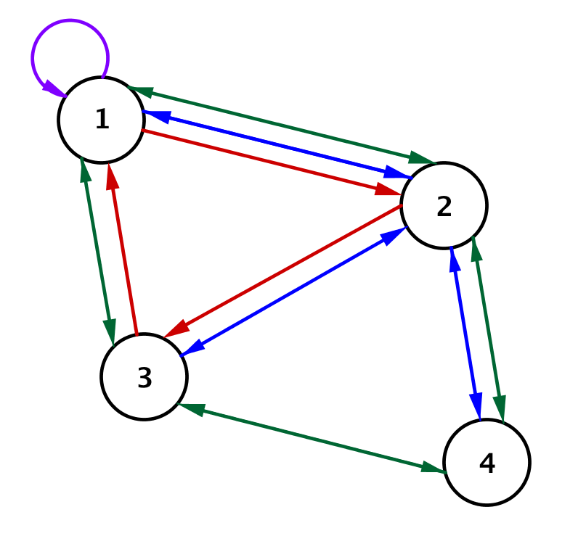
A rival bus company offers more routes connecting these four cities as shown in the network diagram in Figure 3.
Figure 3
What might the loop at City 1 represent?
This loop could represent a tour bus that takes visitors around City 1 but does not leave the city limits.

How many ways can you travel from City 1 to City 4 if you want to stop in City 2 and make no other stops?
There are three bus routes from City 1 to City 2 and two bus routes from City 2 to City 4, so there are $6$ possible ways to travel from City 1 to City 4.

How many possible ways are there to travel from City 1 to City 4 without repeating a city?
City 1 to City 4 with no stops: No routes.
MP.1
City 1 to City 4 with a stop in City 2: 6 routes.
City 1 to City 4 with a stop in City 3: 1 route.
City 1 to City 4 via City 3 then City 2: 2 routes.
City 1 to City 4 via City 2 then City 3: 6 routes.
Total ways: $0+6+1+2+6=15$ possible ways to travel from City 1 to City 4 without visiting a city more than once.

Pause here to debrief student work so far. Have different groups present their findings, and use the discussion questions that follow to make sure students begin to understand that as networks become more complicated, an organized, numeric representation may be beneficial. The next discussion focuses students on using a table as a tool to organize information.
- As a transportation network grows, these diagrams become more complicated, and keeping track of all of the information can be challenging. People that work with complicated networks use computers to manage and manipulate this information. Provide students with an example of a more complex network diagram by displaying a visual representation of the New York City subway system, an airline flight map, or show a computer networking diagram.
- What challenges did you encounter as you tried to answer Exercises 1–6?
  - We had to keep track to the different routes in an organized manner to make sure our answers were accurate.
MP.5
- How might we represent the possible routes in a more organized manner?
  - You could make a list or a table.
- Organizing information in a table can make things easier, especially if computers are used to count and keep track of routes and schedules. What if we wanted to represent a count of ALL the routes that connect ALL the cities? How could we best organize that information?
  - We need a grid or table to show connections from city to city.
Have students return to their groups to complete this exercise to conclude the Exploratory Challenge 3 using the table below.
Exploratory Challenge 3
We will consider a “direct route” to be a route from one city to another without going through any other city. Organize the number of direct routes from each city into the table shown below. The first row showing the direct routes between City 1 and the other cities is complete for you.
MP.5
 | Cities of Origin |  | Destination Cities
 |  |  | $$1$$ | $$2$$ | $$3$$ | $$4$$
 |  | $$1$$ | $$1$$ | $$3$$ | $$1$$ | $$0$$
 |  | $$2$$ | $$2$$ | $$0$$ | $$2$$ | $$2$$
 |  | $$3$$ | $$2$$ | $$1$$ | $$0$$ | $$1$$
 |  | $$4$$ | $$0$$ | $$2$$ | $$1$$ | $$0$$

Discussion (5 minutes)
After students have had a few minutes to complete this exercise, copy the table onto a whiteboard, and lead this next discussion to connect the tabular representation of the network to a matrix.
Circulate to check for understanding. In particular, ensure that your students understand what is meant by a direct route: a route from one city to another without going through any other city.
- If we agree that the rows represent the cities of origin and the columns represent the destination cities, then we do not really need the additional labels.
At this point, erase or display the same table with the row and column labels removed. The new table is shown below.
 | $$1$$ | $$2$$ | $$3$$ | $$4$$
$$1$$ | $$1$$ | $$3$$ | $$1$$ | $$0$$
$$2$$ | $$2$$ | $$0$$ | $$2$$ | $$2$$
$$3$$ | $$2$$ | $$1$$ | $$0$$ | $$1$$
$$4$$ | $$0$$ | $$2$$ | $$1$$ | $$0$$
- Next, if we agree that we will list the cities in numerical order from top to bottom and left to right, then we don’t need the individual row or column labels.
At this point, erase the city number labels or display the table shown below.
$$1$$ | $$3$$ | $$1$$ | $$0$$
$$2$$ | $$0$$ | $$2$$ | $$2$$
$$2$$ | $$1$$ | $$0$$ | $$1$$
$$0$$ | $$2$$ | $$1$$ | $$0$$
- Does this array of numbers written like this look familiar to you? What about if we erase the lines bordering the table?
  - It looks like a matrix.

Now erase the lines and just show the numbers.
$$1$$ | $$3$$ | $$1$$ | $$0$$
$$2$$ | $$0$$ | $$2$$ | $$2$$
$$2$$ | $$1$$ | $$0$$ | $$1$$
$$0$$ | $$2$$ | $$1$$ | $$0$$
$$1$$ | $$3$$ | $$1$$ | $$0$$
$$2$$ | $$0$$ | $$2$$ | $$2$$
$$2$$ | $$1$$ | $$0$$ | $$1$$
$$0$$ | $$2$$ | $$1$$ | $$0$$
- In the last module, we used matrices to represent transformations, but they are useful in a wide variety of mathematical situations. What do you recall about matrices from Module 1?
Scaffolding:
For struggling students, emphasize that the entry in row $i$ and column $j$ of the matrix counts the number of direct routes from the City $i$ to City $j$. Illustrate with a concrete example.
  - A matrix is an array of numbers organized into $m$ rows and $n$ columns.
A matrix containing $m$ rows and $n$ columns has dimensions $m×n$. The entry in the first row and first column is referred to as $a_{1,1}$. In general, the entry in the $i$^{th} row and $j$^{th} column would be denoted $a_{i,j}$.

Exercises 1–7 (12 minutes)
These exercises can be done as a whole class or within small groups depending on how much students recall about matrix terminology from the previous module.
Exercises 1–7
- Use the network diagram in Figure 3 to represent the number of direct routes between the four cities in a matrix $R$.
$$R=\left[\begin{matrix}1 & 3 & 1 & 0 \\ 2 & 0 & 2 & 2 \\ 2 & 1 & 0 & 1 \\ 0 & 2 & 1 & 0\end{matrix}\right]$$

- What is the value of $r_{2,3}$? What does it represent in this situation?
The value is $2$. It is the number of direct routes from City 2 to City 3.

- What is the value of $r_{2,3}∙r_{3,1}$, and what does it represent in this situation?
The value is $4$. It represents the number of one-stop routes between City 2 and City 1 that pass through City 3.

- Write an expression for the total number of one-stop routes from City 4 and City 1, and determine the number of routes stopping in one city.
$$r_{4,2}∙r_{2,1}+r_{4,3}∙r_{3,1}=2∙2+1∙2=6$$

- Do you notice any patterns in the expression for the total number of one-stop routes from City 4 and City 1?
The middle indices in each expression are the same in each term and represent the cities where a stop was made.

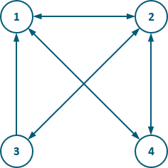
- Create a network diagram for the matrices shown below. Each matrix represents the number of transportation routes that connect four cities. The rows are the cities you travel from, and the columns are the cities you travel to.
  - $R=\left[\begin{matrix}0 & 1 & 0 & 1 \\ 1 & 0 & 1 & 1 \\ 1 & 1 & 0 & 0 \\ 1 & 1 & 0 & 0\end{matrix}\right]$

  - $R=\left[\begin{matrix}0 & 1 & 0 & 0 \\ 0 & 1 & 2 & 1 \\ 1 & 0 & 0 & 2 \\ 0 & 1 & 2 & 0\end{matrix}\right]$
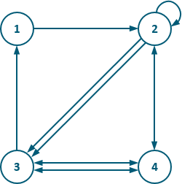
This last exercise introduces a new type of network diagram. This exercise will help students understand that networks can be used to represent a wide variety of situations where tracking connections between a number of entities is important. If time is running short, this exercise could be used as an additional Problem Set exercise.
Here is a type of network diagram called an arc diagram.

Suppose the points represent eleven students in your mathematics class, numbered 1 through 11. Suppose the arcs above and below the line of vertices 1–11 are the people who are friends on a social network.
- Complete the matrix that shows which students are friends with each other on this social network. The first row has been completed for you.
$$\left[\begin{matrix}0 & 0 & 1 & 1 & 1 & 0 & 1 & 1 & 1 & 0 & 1 \\ __ & __ & __ & __ & __ & __ & __ & __ & __ & __ & __ \\ __ & __ & __ & __ & __ & __ & __ & __ & __ & __ & __ \\ __ & __ & __ & __ & __ & __ & __ & __ & __ & __ & __ \\ __ & __ & __ & __ & __ & __ & __ & __ & __ & __ & __ \\ __ & __ & __ & __ & __ & __ & __ & __ & __ & __ & __ \\ __ & __ & __ & __ & __ & __ & __ & __ & __ & __ & __ \\ __ & __ & __ & __ & __ & __ & __ & __ & __ & __ & __ \\ __ & __ & __ & __ & __ & __ & __ & __ & __ & __ & __ \\ __ & __ & __ & __ & __ & __ & __ & __ & __ & __ & __ \\ __ & __ & __ & __ & __ & __ & __ & __ & __ & __ & __\end{matrix}\right]$$
MP.2
$$\left[\begin{matrix}0 & 0 & 1 & 1 & 1 & 0 & 1 & 1 & 1 & 0 & 1 \\ 0 & 0 & 0 & 0 & 0 & 0 & 1 & 0 & 0 & 0 & 0 \\ 1 & 0 & 0 & 0 & 1 & 1 & 1 & 0 & 0 & 0 & 0 \\ 1 & 0 & 0 & 0 & 0 & 0 & 0 & 0 & 0 & 0 & 0 \\ 1 & 0 & 1 & 0 & 0 & 0 & 1 & 0 & 1 & 1 & 1 \\ 0 & 0 & 1 & 0 & 0 & 0 & 0 & 0 & 0 & 0 & 0 \\ 1 & 1 & 1 & 0 & 1 & 0 & 0 & 0 & 1 & 1 & 0 \\ 1 & 0 & 0 & 0 & 0 & 0 & 0 & 0 & 0 & 0 & 0 \\ 1 & 0 & 0 & 0 & 1 & 0 & 1 & 0 & 0 & 0 & 1 \\ 0 & 0 & 0 & 0 & 1 & 0 & 1 & 0 & 0 & 0 & 0 \\ 1 & 0 & 0 & 0 & 1 & 0 & 0 & 0 & 1 & 0 & 0\end{matrix}\right]$$

Number 1 is not friends with Number 10. How many ways could Number 1 get a message to 10 by only going through one other friend?
  - Who has the most friends in this network? Explain how you know.
Number 1 is friends with $7$ people, and that’s more than anyone else, so Number 1 has the most friends in this network.

  - Is everyone in this network connected at least as a friend of a friend? Explain how you know.
No. Number 2 is not connected to Number 4 as a friend of a friend because Number 2 is only friends with Number 7, and Number 7 and Number 4 are not friends.

  - What is entry $A_{2,3}$? Explain its meaning in this context.
The entry is $0$. Number 3 is not friends with Number 2.
Closing (3 minutes)
Ask students to summarize their work from this lesson with a partner or on their own in writing.
- How can you find the total number of possible routes between two locations in a network?
  - Multiply the number of routes from each city stopping at common cities and add the products.
- How does a matrix help you to organize and represent information in a network?
  - A matrix allows for succinct numerical representations which are advantageous when network diagrams are complex and contain many nodes and edges.
- How does a network diagram help you to organize and represent information?
  - It shows connections between points to help you see the data before organizing it.
Lesson Summary
Students organize data and use matrices to represent data in an organized way.
A network diagram is a graphical representation of a directed graph where the $n$ vertices are drawn as circles with each circle labeled by a number $1$ through $n$, and the directed edges are drawn as segments or arcs with an arrow pointing from the tail vertex to the head vertex.
A matrix is an array of numbers organized into $m$ rows and $n$ columns. A matrix containing $m$ rows and $n$ columns has dimensions $m×n$. The entry in the first row and first column is referred to as $a_{1,1}$. In general, the entry in the $i$^{th} row and $j$^{th} column would be denoted $a_{i,j}$.

Exit Ticket (5 minutes)

Name Date
Lesson 1: Introduction to Networks
Exit Ticket

The following directed graph shows the major roads that connect four cities.
1
1
2
2
3

4

- Create a matrix $C$ that shows the direct routes connecting the four cities.

- Use the matrix to determine how many ways are there to travel from City 1 to City 4 with one stop in City 2.

- What is the meaning of $c_{2,3}$?

- Write an expression that represents the total number of ways to travel between City 2 and City 3 without passing through the same city twice (you can travel through another city on the way from City 2 to City 3).

Exit Ticket Sample Solutions
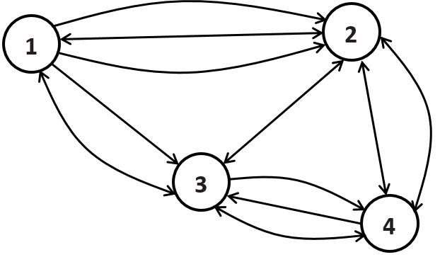
The following directed graph shows the major roads that connect four cities.
- Create a matrix $C$ that shows the direct routes connecting the four cities.
$$C=\left[\begin{matrix}0 & 3 & \begin{matrix}2 & 0\end{matrix} \\ 1 & 0 & \begin{matrix}1 & 2\end{matrix} \\ \begin{matrix}1 \\ 0\end{matrix} & \begin{matrix}1 \\ 2\end{matrix} & \begin{matrix}\begin{matrix}0 & 2\end{matrix} \\ \begin{matrix}2 & 0\end{matrix}\end{matrix}\end{matrix}\right]$$

- Use the matrix to determine how many ways are there to travel from City 1 to City 4 with one stop in City 2.
$$c_{1,2}⋅c_{2,4}=3⋅2=6$$

- What is the meaning of $c_{2,3}$?
Since $c_{2,3}=1$, it means that there is just one road that goes to City 3 from City 2 without going through the other cities.

- Write an expression that represents the total number of ways to travel between City 2 and City 3 without passing through the same city twice (you can travel through another city on the way from City 2 to City 3).
We will count the routes by the number of stops in intermediate cities.
Direct routes between City 2 and City 3: $c_{2,3}=1$
One-stop routes through City 1: $c_{2,1}⋅c_{1,3}=1⋅2=2$
One-stop routes through City 4: $c_{2,4}⋅c_{4,3}=2⋅2=4$
Two-stop routes through City 1 then City 4: $c_{2,1}⋅c_{1,4}⋅c_{4,3}=1⋅0⋅2=0$
Two-stop routes through City 4 then City 1: $c_{2,4}⋅c_{4,1}⋅c_{1,3}=2⋅0⋅2=0$
So there are $c_{2,3}+c_{2,1}⋅c_{1,3}+c_{2,4}⋅c_{4,3}+c_{2,1}⋅c_{1,4}⋅c_{4,3}+c_{2,4}⋅c_{4,1}⋅c_{1,3}=1+2+4+0+0=7$ ways to travel between City 2 and City 3 without passing through the same city twice.

Problem Set Sample Solutions

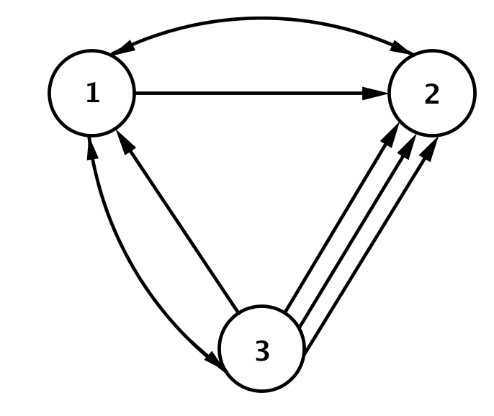
- Consider the railroad map between Cities 1, 2, and 3, as shown.
  - Create a matrix $R$to represent the railroad map between
Cities 1, 2 and 3.
$$R=\left[\begin{matrix}0 & 2 & 1 \\ 1 & 0 & 0 \\ 2 & 3 & 0\end{matrix}\right]$$

  - How many different ways can you travel from City 1 to City 3 without passing through the same city twice?
$$r_{1,2}∙r_{2,3}+r_{1,1}∙r_{1,3}+r_{1,3}=2⋅0+0⋅1+1=1$$

  - How many different ways can you travel from City 2 to City 3 without passing through the same city twice?
$$r_{2,3}+r_{2,1}∙r_{1,3}=0+1⋅1=1$$

  - How many different ways can you travel from City 1 to City 2 with exactly one connecting stop?
$$r_{1,3}∙r_{3,2}=1⋅3=3$$

  - Why is this not a reasonable network diagram for a railroad?
More trains arrive in City 2 than leave, and more trains leave City 3 than arrive.

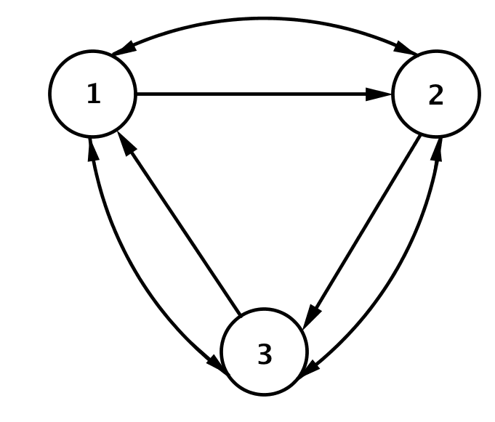
- Consider the subway map between stations 1, 2, and 3, as shown.
  - Create a matrix $S$to represent the subway map between stations
1, 2, and 3.
$$S=\left[\begin{matrix}0 & 2 & 1 \\ 1 & 0 & 2 \\ 2 & 1 & 0\end{matrix}\right]$$

  - How many different ways can you travel from station 1 to station 3 without passing through the same station twice?
$$s_{1,3}+s_{1,2}∙s_{2,3}=1+2∙2=5$$

  - How many different ways can you travel directly from station 1 to station 3 with no stops?
$$s_{1,3}=1$$

  - How many different ways can you travel from station 1 to station 3 with exactly one stop?
$$s_{1,2}∙s_{2,3}=2⋅2=4$$

  - How many different ways can you travel from station 1 to station 3 with exactly two stops? Allow for stops at repeated stations.
$$s_{1,2}⋅s_{2,1}⋅s_{1,3}+{s_{1,3}⋅s_{3,2}⋅s_{2,3}+s}_{1,3}⋅s_{3,1}⋅s_{1,3}=2∙1∙1+1∙1∙2+1∙2∙1=6$$

- Suppose the matrix $R$ represents a railroad map between cities 1, 2, 3, 4, and 5.
$$R=\left[\begin{matrix}\begin{matrix}0 & 1\end{matrix} & \begin{matrix}2 & 1\end{matrix} & 1 \\ \begin{matrix}2 & 0 \\ 1 & 1\end{matrix} & \begin{matrix}1 & 1 \\ 0 & 2\end{matrix} & \begin{matrix}0 \\ 2\end{matrix} \\ \begin{matrix}1 & 1 \\ 1 & 1\end{matrix} & \begin{matrix}0 & 0 \\ 3 & 0\end{matrix} & \begin{matrix}2 \\ 0\end{matrix}\end{matrix}\right]$$

  - How many different ways can you travel from City 1 to City 3 with exactly one connection?
$$r_{1,2}⋅r_{2,3}+r_{1,4}{⋅r}_{4,3}+r_{1,5}{⋅r}_{5,3}=1∙1+1∙0+1∙3=4$$

  - How many different ways can you travel from City 1 to City 5 with exactly one connection?
$$r_{1,2}⋅r_{2,5}+r_{1,3}⋅r_{3,5}+r_{1,4}{⋅r}_{4,5}=1∙0+2∙2+1∙2=6$$

  - How many different ways can you travel from City 2 to City 5 with exactly one connection?
$$r_{2,1}{⋅r}_{1,5}+r_{2,3}{⋅r}_{3,5}+r_{2,4}⋅r_{4,5}=2∙1+1∙2+1∙2=6$$

- Let $B=\left[\begin{matrix}0 & 2 & 1 \\ 1 & 1 & 2 \\ 2 & 1 & 1\end{matrix}\right]$ represent the bus routes between $3$ cities.
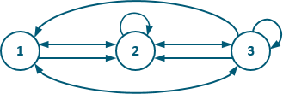
  - Draw an example of a network diagram represented by this matrix.

  - Calculate the matrix $B^{2}=BB.$
$$B^{2}=\left[\begin{matrix}4 & 3 & 5 \\ 5 & 5 & 5 \\ 3 & 6 & 5\end{matrix}\right]$$

  - How many routes are there between City 1 and City 2 with one stop in between?
$$b_{1,1}b_{1,2}+b_{1,2}b_{2,2}+b_{1,3}b_{3,2}=0⋅1+2⋅1+1⋅1=3$$

  - How many routes are there between City 2 and City 2 with one stop in between?
$$b_{2,1}b_{1,2}+b_{2,2}b_{2,2}+b_{2,3}b_{3,2}=1⋅2+1⋅1+2⋅1=5$$

  - How many routes are there between City 3 and City 2 with one stop in between?
$$b_{3,1}b_{1,2}+b_{3,2}b_{2,2}+b_{3,3}b_{3,2}=2⋅2+ 1⋅1+1⋅1=6$$

  - What is the relationship between your answers to parts (b)-(e)? Formulate a conjecture.
The numbers $3$, $5$, $6$ appear in the second column of the matrix $B^{2}$. It seems that the entry in row $i$ and column $j$ of matrix $B^{2}$ is the number of ways to get from city $i$ to city $j$ with one stop.

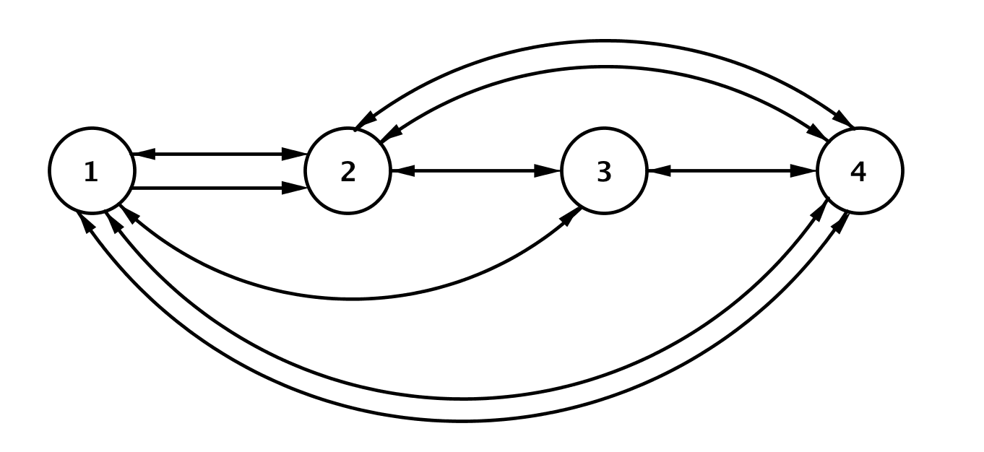
- Consider the airline flight routes between Cities 1, 2, 3, and 4, as shown.

  - Create a matrix $F$to represent the flight map between Cities 1, 2, 3, and 4.
$$F=\left[\begin{matrix}0 & \begin{matrix}2 & 1\end{matrix} & 2 \\ \begin{matrix}1 \\ 1\end{matrix} & \begin{matrix}0 & 1 \\ 1 & 0\end{matrix} & \begin{matrix}2 \\ 1\end{matrix} \\ 2 & \begin{matrix}2 & 1\end{matrix} & 0\end{matrix}\right]$$

  - How many different routes can you take from City 1 to City 4 with no stops?
$$f_{1,4}=2$$

  - How many different routes can you take from City 1 to City 4 with exactly one stop?
$$f_{1,2}f_{2,4}+f_{1,3}f_{3,4}=2⋅2+1⋅1=5$$

  - How many different routes can you take from City 3 to City 4 with exactly one stop?
$$f_{3,1}f_{1,4}+f_{3,2}f_{2,4}=1∙2+1∙2=4$$

  - How many different routes can you take from City 1 to City 4 with exactly two stops? Allow for routes that include repeated cities.
$${f_{1,2}f_{2,1}f_{1,4}+f}_{1,2}f_{2,3}f_{3,4}+{f_{1,3}f_{3,1}f_{1,4}+f}_{1,3}f_{3,2}f_{2,4}+f_{1,4}f_{4,1}f_{1,4}+f_{1,4}f_{4,2}f_{2,4}+f_{1,4}f_{4,3}f_{3,4}=$$
$$(2⋅1⋅2)+(2⋅1⋅1)+(1⋅1⋅2)+\left(1⋅1⋅2\right)+\left(2⋅2⋅2\right)+\left(2⋅2⋅2\right)+(2⋅1⋅1)=28$$

  - How many different routes can you take from City 2 to City 4 with exactly two stops? Allow for routes that include repeated cities.
$$f_{2,1}f_{1,2}f_{2,4}+f_{2,1}f_{1,3}f_{3,4}+f_{2,3}f_{3,1}f_{1,4}+f_{2,3}f_{3,2}f_{2,4}+f_{2,4}f_{4,1}f_{1,4}+f_{2,4}f_{4,2}f_{2,4}+f_{2,4}f_{4,3}f_{3,4}=$$
$$\left(1∙2∙2\right)+\left(1∙1∙1\right)+\left(1∙1∙2\right)+\left(1∙1∙2\right)+\left(\dot{2⋅}2⋅2\right)+\left(2⋅2⋅2\right)+\left(2⋅1⋅1\right)=27$$

- Consider the following directed graph representing the number of ways Trenton can get dressed in the morning (only visible options are shown):
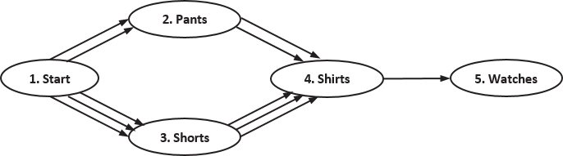

  - What reasons could there be for there to be three choices for shirts after “traveling” to shorts but only two after traveling to pants?
It could be that Trenton has shirts that only make sense to wear with one or the other. For instance, maybe he does not want to wear a button-up shirt with a pair of shorts.

  - What could the order of the vertices mean in this situation?
The order of the vertices is probably the order Trenton gets dressed in.

  - Write a matrix $A$ representing this directed graph.
$$A=\left[\begin{matrix}\begin{matrix}0 \\ 0 \\ \begin{matrix}0 \\ 0 \\ 0\end{matrix}\end{matrix} & \begin{matrix}2 \\ 0 \\ \begin{matrix}0 \\ 0 \\ 0\end{matrix}\end{matrix} & \begin{matrix}\begin{matrix}3 \\ 0 \\ \begin{matrix}0 \\ 0 \\ 0\end{matrix}\end{matrix} & \begin{matrix}0 \\ 2 \\ \begin{matrix}3 \\ 0 \\ 0\end{matrix}\end{matrix} & \begin{matrix}0 \\ 0 \\ \begin{matrix}0 \\ 1 \\ 0\end{matrix}\end{matrix}\end{matrix}\end{matrix}\right]$$

  - Delete any rows of zeros in matrix $A,$ and write the new matrix as matrix $B$. Does deleting this row change the meaning of any of the entries of $B$? If you had deleted the first column, would the meaning of the entries change? Explain.
$$B=\left[\begin{matrix}\begin{matrix}0 \\ 0 \\ \begin{matrix}0 \\ 0\end{matrix}\end{matrix} & \begin{matrix}2 \\ 0 \\ \begin{matrix}0 \\ 0\end{matrix}\end{matrix} & \begin{matrix}\begin{matrix}3 \\ 0 \\ \begin{matrix}0 \\ 0\end{matrix}\end{matrix} & \begin{matrix}0 \\ 2 \\ \begin{matrix}3 \\ 0\end{matrix}\end{matrix} & \begin{matrix}0 \\ 0 \\ \begin{matrix}0 \\ 1\end{matrix}\end{matrix}\end{matrix}\end{matrix}\right]$$
Deleting the row did not change the meaning of any of the other entries. Each entry $b_{i,j}$ still says how to get from article of clothing $i$ to article of clothing $j$. If we had deleted the first column, then each entry $b_{i,j}$ would represent how to get from article of clothing $i-1$ to article of clothing $j$.

  - Calculate $b_{1,2}⋅b_{2,4}⋅b_{4,5}$. What does this product represent?
$$2⋅2⋅1=4$$
The number of outfits that Trenton can wear assuming he wears pants instead of shorts.

  - How many different outfits can Trenton wear assuming he always wears a watch?
$$b_{1,2}⋅b_{2,4}⋅b_{4,5}+b_{1,3}⋅b_{3,4}⋅b_{4,5}=4+9=13$$

- Recall the network representing bus routes used at the start of the lesson:
Faced with competition from rival companies, you have been tasked with considering the option of building a toll road going directly from City 1 to City 4. Once built, the road will provide income in the form of tolls and also enable the implementation of a non-stop bus route to and from City 1 and City 4.

Analysts have provided you with the following information (values are in millions of dollars):
 | Start-up costs (expressed as profit) | Projected minimum profit per year | Projected maximum profit per year
Road | $$-\$63$$ | $$\$65$$ | $$\$100$$
New bus route | $$-\$5$$ | $$\$0.75$$ | $$\$1.25$$
  - Express this information in a matrix $P$.
$$\left[\begin{matrix}-63 & 65 & 100 \\ -5 & 0.75 & 1.25\end{matrix}\right]$$

  - What are the dimensions of the matrix?
$$2×3$$

  - Evaluate $p_{1,1}+p_{1,2}$. What does this sum represent?
$$-63+65=2$$
$\$2,000$ is the worst-case profit of the road after one year.

  - Solve $p_{1,1}+t⋅p_{1,2}=0$ for $t$. What does the solution represent?
$$-63+65t=0 \\ 65t=63 \\ t=\frac{63}{65}≈0.9692$$
It will take about $1$ year for the road to break even if we assume the worst-case profit.

  - Solve $p_{1,1}+t⋅p_{1,3}=0$ for $t$. What does the solution represent?
$$-63+100t=0 \\ 100t=63 \\ t=0.63$$
It will take about $7.5$ months for the road to break even if we assume the best-case every year.

  - Summarize your results to part (d) and (e).
It will take between $7.5$ months and $1$ year for the road to break even.

  - Evaluate $p_{1,1}+p_{2,1}$. What does this sum represent?
$$-63+-5=-68$$
The total cost of the new road and new bus route is $\$68,000$.

  - Solve $p_{1,1}+p_{2,1}+t\left(p_{1,2}+p_{2,2}\right)=0$ for $t$. What does the solution represent?
$$-68+65.75t=0 \\ 65.75t=68 \\ t=\frac{68}{65.75}≈1.034$$
It will take about $1$ year for the road and new bus route to break even assuming the worst-case scenario for profit.

  - Make your recommendation. Should the company invest in building the toll road or not? If they build the road, should they also put in a new bus route? Explain your answer.
Answers will vary but should include the length of time it will take for the company to be profitable after the initial investment. Other factors can include considering the positive press for the company from building and maintaining a non-stop route between the cities as well as how this would affect the other routes of their buses.
MP.3

