Lesson 1: Introduction to Networks

Classwork

Exploratory Challenge 1
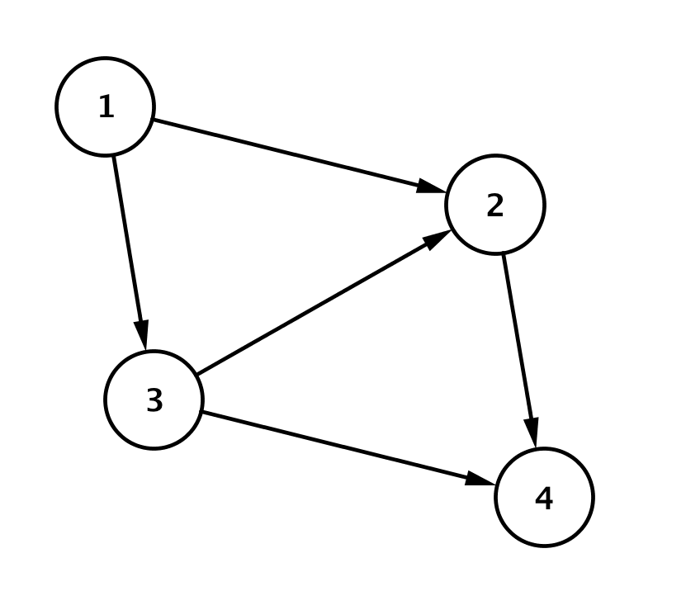
A network diagram depicts interrelated objects by circles that represent the objects and directed edges drawn as segments or arcs between related objects with arrows to denote direction. The network diagram below shows the bus routes that run between four cities, forming a network. The arrows indicate the direction the buses travel.
Figure 1

How many ways can you travel from City 1 to City 4? Explain how you know.

What about these bus routes doesn’t make sense?

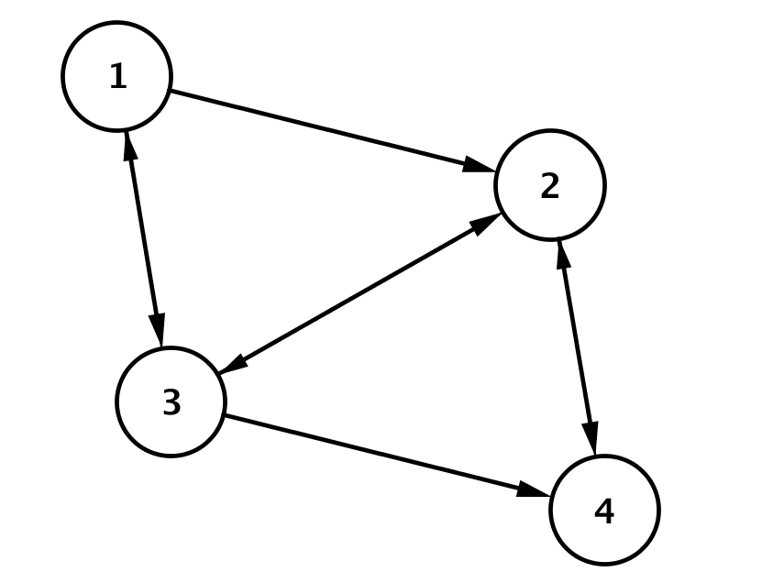
It turns out there was an error in printing the first route map. An updated network diagram showing the bus routes that connect the four cities is shown below in Figure 2. Arrows on both ends of an edge indicate that buses travel in both directions.
Figure 2
How many ways can you reasonably travel from City 4 to City 1 using the route map in Figure 2? Explain how you know.

Exploratory Challenge 2
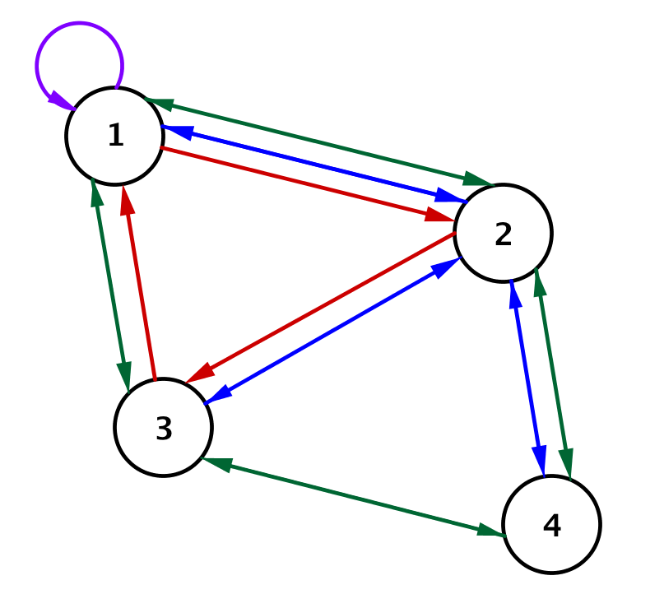
A rival bus company offers more routes connecting these four cities as shown in the network diagram in Figure 3.
Figure 3

What might the loop at City 1 represent?

How many ways can you travel from City 1 to City 4 if you want to stop in City 2 and make no other stops?

How many possible ways are there to travel from City 1 to City 4 without repeating a city?

Exploratory Challenge 3
We will consider a “direct route” to be a route from one city to another without going through any other city. Organize the number of direct routes from each city into the table shown below. The first row showing the direct routes between City 1 and the other cities is complete for you.
 | Cities of Origin |  | Destination Cities
 |  |  |  | $$1$$ | $$2$$ | $$3$$ | $$4$$
 |  | $$1$$ |  | $$1$$ | $$3$$ | $$1$$ | $$0$$
 |  | $$2$$
 |  | $$3$$
 |  | $$4$$

Exercises 1–7
- Use the network diagram in Figure 3 to represent the number of direct routes between the four cities in a matrix $R$.

- What is the value of $r_{2,3}$? What does it represent in this situation?

- What is the value of $r_{2,3}∙r_{3,1}$, and what does it represent in this situation?

- Write an expression for the total number of one-stop routes from City 4 and City 1, and determine the number of routes stopping in one city.

- Do you notice any patterns in the expression for the total number of one-stop routes from City 4 and City 1?

- Create a network diagram for the matrices shown below. Each matrix represents the number of transportation routes that connect four cities. The rows are the cities you travel from, and the columns are the cities you travel to.
  - $R=\left[\begin{matrix}0 & 1 & 0 & 1 \\ 1 & 0 & 1 & 1 \\ 1 & 1 & 0 & 0 \\ 1 & 1 & 0 & 0\end{matrix}\right]$

  - $R=\left[\begin{matrix}0 & 1 & 0 & 0 \\ 0 & 1 & 2 & 1 \\ 1 & 0 & 0 & 2 \\ 0 & 1 & 2 & 0\end{matrix}\right]$

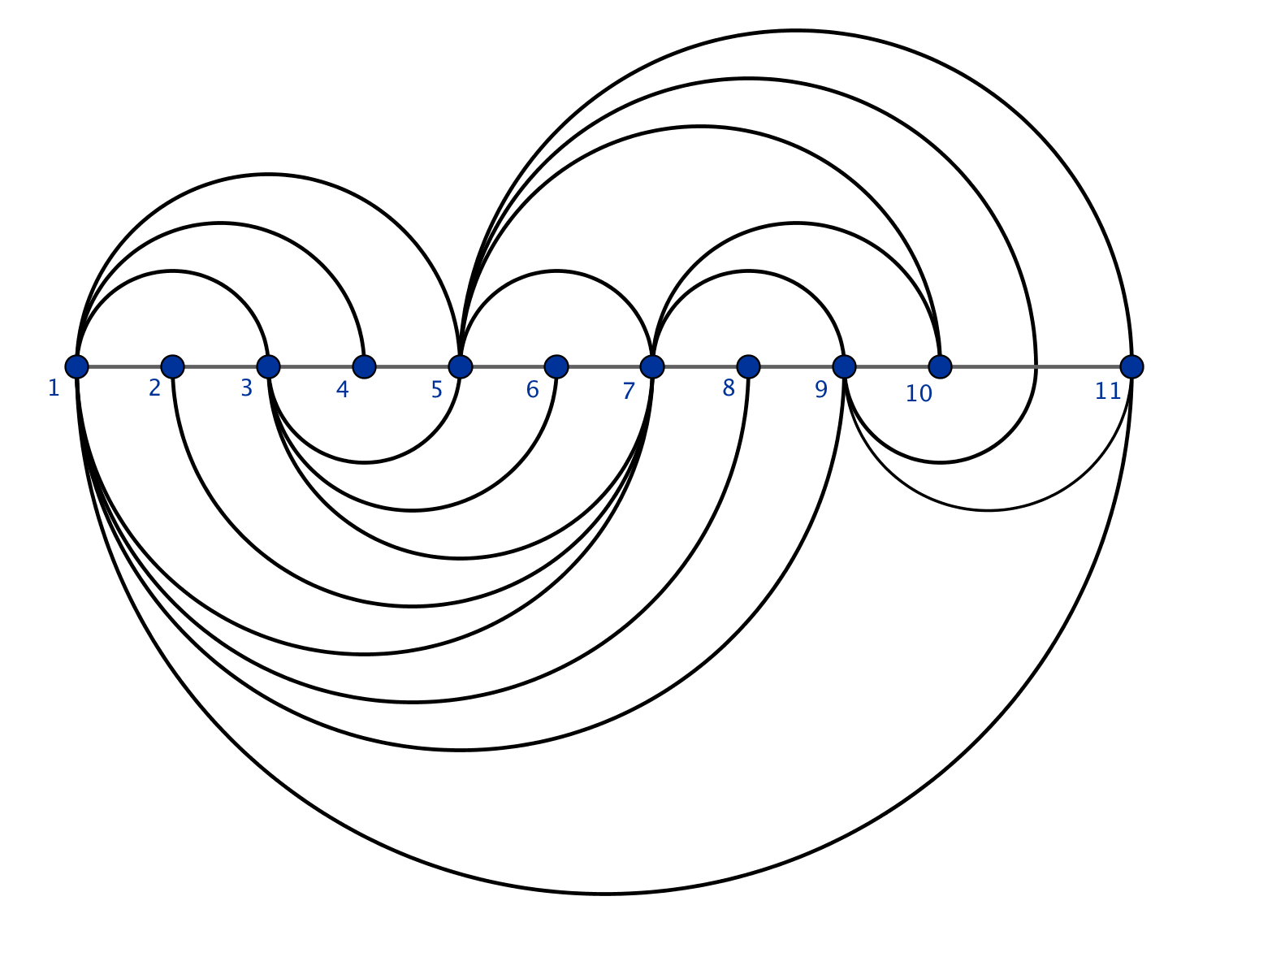
Here is a type of network diagram called an arc diagram.

Suppose the points represent eleven students in your mathematics class, numbered 1 through 11. Suppose the arcs above and below the line of vertices 1–11 are the people who are friends on a social network.
- Complete the matrix that shows which students are friends with each other on this social network. The first row has been completed for you.
$$\left[\begin{matrix}0 & 0 & 1 & 1 & 1 & 0 & 1 & 1 & 1 & 0 & 1 \\ __ & __ & __ & __ & __ & __ & __ & __ & __ & __ & __ \\ __ & __ & __ & __ & __ & __ & __ & __ & __ & __ & __ \\ __ & __ & __ & __ & __ & __ & __ & __ & __ & __ & __ \\ __ & __ & __ & __ & __ & __ & __ & __ & __ & __ & __ \\ __ & __ & __ & __ & __ & __ & __ & __ & __ & __ & __ \\ __ & __ & __ & __ & __ & __ & __ & __ & __ & __ & __ \\ __ & __ & __ & __ & __ & __ & __ & __ & __ & __ & __ \\ __ & __ & __ & __ & __ & __ & __ & __ & __ & __ & __ \\ __ & __ & __ & __ & __ & __ & __ & __ & __ & __ & __ \\ __ & __ & __ & __ & __ & __ & __ & __ & __ & __ & __\end{matrix}\right]$$

Number 1 is not friends with number 10. How many ways could number 1 get a message to 10 by only going through one other friend?
  - Who has the most friends in this network? Explain how you know.

  - Is everyone in this network connected at least as a friend of a friend? Explain how you know.

  - What is entry $A_{2,3}$? Explain its meaning in this context.

Lesson Summary
Students organize data and use matrices to represent data in an organized way.
A network diagram is a graphical representation of a directed graph where the $n$ vertices are drawn as circles with each circle labeled by a number 1 through $n$, and the directed edges are drawn as segments or arcs with an arrow pointing from the tail vertex to the head vertex.

A matrix is an array of numbers organized into $m$ rows and $n$ columns. A matrix containing $m$ rows and $n$ columns has dimensions $m×n$. The entry in the first row and first column is referred to as $a_{1,1}$. In general, the entry in the $i^{th}$ row and $j^{th}$ column would be denoted $a_{i,j}$.

Problem Set

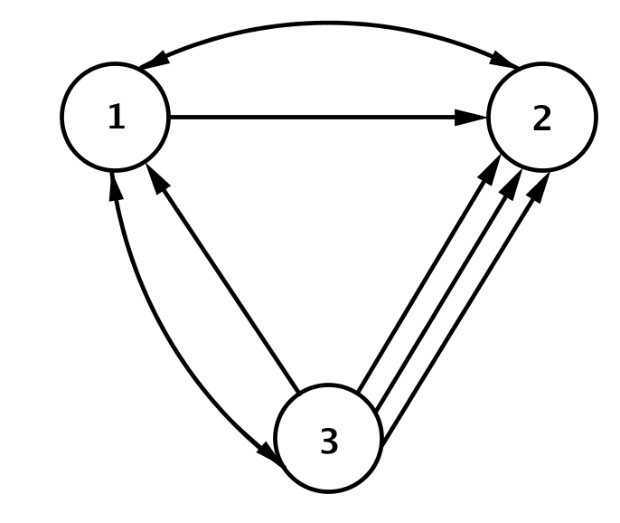
- Consider the railroad map between Cities 1, 2, and 3, as shown.
  - Create a matrix $R$to represent the railroad map between Cities 1, 2, and 3.
  - How many different ways can you travel from City 1 to City 3 without passing through the same city twice?
  - How many different ways can you travel from City 2 to City 3 without passing through the same city twice?
  - How many different ways can you travel from City 1 to City 2 with exactly one connecting stop?
  - Why is this not a reasonable network diagram for a railroad?
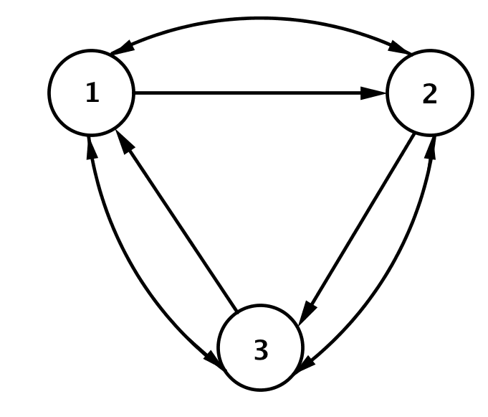
- Consider the subway map between stations 1, 2, and 3, as shown.
  - Create a matrix $S$to represent the subway map between stations 1, 2, and 3.
  - How many different ways can you travel from station 1 to station 3 without passing through the same station twice?
  - How many different ways can you travel directly from station 1 to station 3 with no stops?
  - How many different ways can you travel from station 1 to station 3 with exactly one stop?
  - How many different ways can you travel from station 1 to station 3 with exactly two stops? Allow for stops at repeated stations.

- Suppose the matrix $R$ represents a railroad map between cities 1, 2, 3, 4, and 5.
$$R=\left[\begin{matrix}\begin{matrix}0 & 1\end{matrix} & \begin{matrix}2 & 1\end{matrix} & 1 \\ \begin{matrix}2 & 0 \\ 1 & 1\end{matrix} & \begin{matrix}1 & 1 \\ 0 & 2\end{matrix} & \begin{matrix}0 \\ 2\end{matrix} \\ \begin{matrix}1 & 1 \\ 1 & 1\end{matrix} & \begin{matrix}0 & 0 \\ 3 & 0\end{matrix} & \begin{matrix}2 \\ 0\end{matrix}\end{matrix}\right]$$
  - How many different ways can you travel from City 1 to City 3 with exactly one connection?
  - How many different ways can you travel from City 1 to City 5 with exactly one connection?
  - How many different ways can you travel from City 2 to City 5 with exactly one connection?

- Let $B=\left[\begin{matrix}0 & 2 & 1 \\ 1 & 1 & 2 \\ 2 & 1 & 1\end{matrix}\right]$ represent the bus routes between 3 cities.
  - Draw an example of a network diagram represented by this matrix.
  - Calculate the matrix $B^{2}=BB.$
  - How many routes are there between City 1 and City 2 with one stop in between?
  - How many routes are there between City 2 and City 2 with one stop in between?
  - How many routes are there between City 3 and City 2 with one stop in between?
  - What is the relationship between your answers to parts (b)-(e)? Formulate a conjecture.

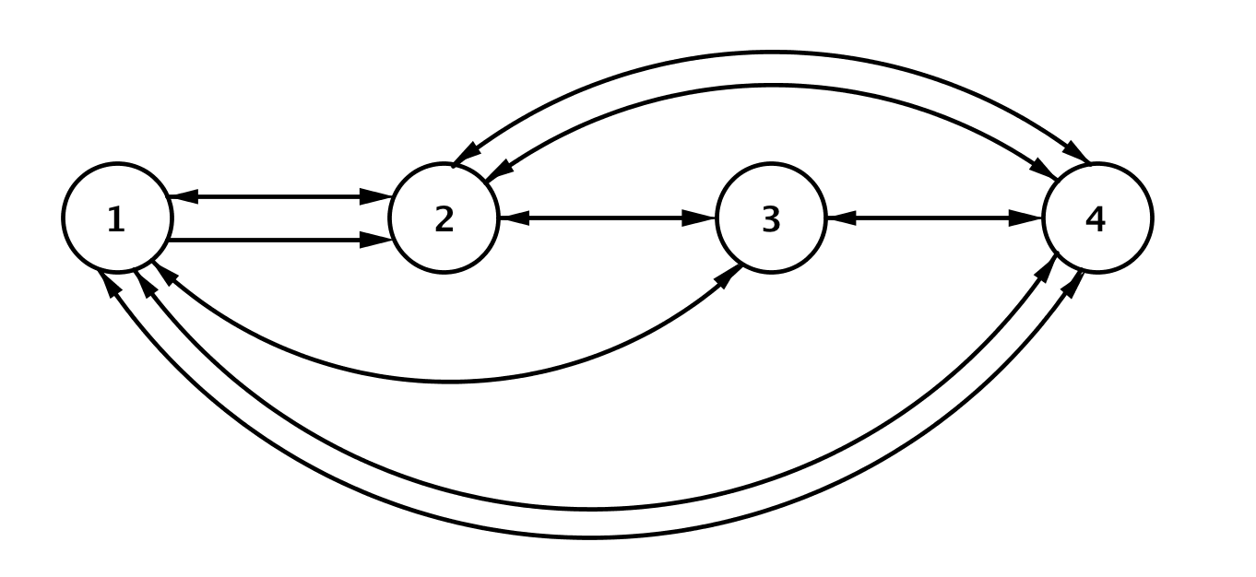
- Consider the airline flight routes between Cities 1, 2, 3, and 4, as shown.
  - Create a matrix $F$to represent the flight map between Cities 1, 2, 3, and 4.
  - How many different routes can you take from City 1 to City 4 with no stops?
  - How many different routes can you take from City 1 to City 4 with exactly one stop?
  - How many different routes can you take from City 3 to City 4 with exactly one stop?
  - How many different routes can you take from City 1 to City 4 with exactly two stops? Allow for routes that include repeated cities.
  - How many different routes can you take from City 2 to City 4 with exactly two stops? Allow for routes that include repeated cities.

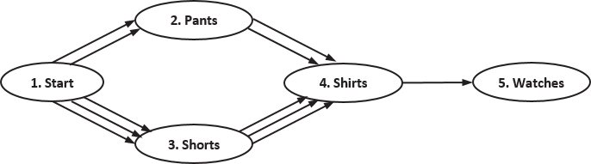
- Consider the following directed graph representing the number of ways Trenton can get dressed in the morning (only visible options are shown):
  - What reasons could there be for there to be three choices for shirts after “traveling” to shorts but only two after traveling to pants?
  - What could the order of the vertices mean in this situation?
  - Write a matrix $A$ representing this directed graph.
  - Delete any rows of zeros in matrix $A,$ and write the new matrix as matrix $B$. Does deleting this row change the meaning of any of the entries of $B$? If you had deleted the first column, would the meaning of the entries change? Explain.
  - Calculate $b_{1,2}⋅b_{2,4}⋅b_{4,5}$. What does this product represent?
  - How many different outfits can Trenton wear assuming he always wears a watch?

- Recall the network representing bus routes used at the start of the lesson:
Faced with competition from rival companies, you have been tasked with considering the option of building a toll road going directly from City 1 to City 4. Once built, the road will provide income in the form of tolls and also enable the implementation of a non-stop bus route to and from City 1 and City 4.

Analysts have provided you with the following information (values are in millions of dollars):
 | Start-up costs (expressed as profit) | Projected minimum profit per year | Projected maximum profit per year
Road | $$-\$63$$ | $$\$65$$ | $$\$100$$
New bus route | $$-\$5$$ | $$\$0.75$$ | $$\$1.25$$
  - Express this information in a matrix $P$.
  - What are the dimensions of the matrix?
  - Evaluate $p_{1,1}+p_{1,2}$. What does this sum represent?
  - Solve $p_{1,1}+t⋅p_{1,2}=0$ for $t$. What does the solution represent?
  - Solve $p_{1,1}+t⋅p_{1,3}=0$ for $t$. What does the solution represent?
  - Summarize your results to part (d) and (e).
  - Evaluate $p_{1,1}+p_{2,1}$. What does this sum represent?
  - Solve $p_{1,1}+p_{2,1}+t\left(p_{1,2}+p_{2,2}\right)=0$ for $t$. What does the solution represent?
  - Make your recommendation. Should the company invest in building the toll road or not? If they build the road, should they also put in a new bus route? Explain your answer.

