Lesson 27: Getting a Handle on New Transformations

Student Outcomes
- Students understand that $2×2$ matrix transformations are linear transformations taking straight lines to straight lines.
- Students understand that the absolute value of the determinant of a $2×2$ matrix is the area of the image of the unit square.

Lesson Notes
This is day 2 of a two-day lesson on transformations using matrix notation. In Lesson 26, students looked at general matrix transformations on the unit square and discovered that the area of the image was the determinant of the resulting matrix. In Lesson 26, students get more practice with this concept and connect it to our study of linearity.

Classwork
This Opening Exercise reminds students of general matrices studied in prior lessons and their geometric effect. Show one matrix at a time to the class and discuss the geometric significance of each matrix.

Opening Exercise (8 minutes)
Opening Exercise
Scaffolding:
- Have students create an example of each transformation and show it graphically in a graphic organizer (see sample below).
- Ask advanced learners to create a matrix that will produce a dilation of $3$ and a rotation of $30°$ counterclockwise.
Matrix | Transformation | Picture
$$\left[\begin{matrix}k & 0 \\ 0 & k\end{matrix}\right]$$ | Pure dilation of scale factor $k$ | 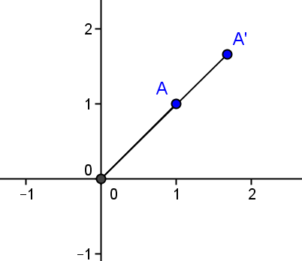

Explain the geometric effect of each matrix.
  - $\left[\begin{matrix}a & -b \\ b & a\end{matrix}\right]$
A rotation of $arctan\left(\frac{b}{a}\right)$ and a dilation with scale factor $\sqrt{a^{2}+b^{2}}$
MP.2
  - $\left[\begin{matrix}cos⁡(θ) & -sin⁡(θ) \\ sin⁡(θ) & cos⁡(θ)\end{matrix}\right]$
A pure rotation of $θ$

  - $\left[\begin{matrix}k & 0 \\ 0 & k\end{matrix}\right]$
A pure dilation of scale factor $k$

  - $\left[\begin{matrix}1 & 0 \\ 0 & 1\end{matrix}\right]$
The multiplicative identify matrix has no geometric effect.
  - $\left[\begin{matrix}0 & 0 \\ 0 & 0\end{matrix}\right]$
The additive identify matrix, maps all points to the origin
MP.2

  - $\left[\begin{matrix}a & c \\ b & d\end{matrix}\right]$
Transforms the unit square to a parallelogram with vertices $(0, 0), (a, b), (c, d)$, and $(a+c, b+d)$ with area of $\left|ad-bc\right|$

Example 1 (10 minutes)
In Example 1, students perform a transformation on the unit square, calculate and confirm the area of the image, and then solve a system of equations that would map the transformation to a given point. Students should complete this example in groups with guiding questions from the teacher as needed.
Example 1
Scaffolding:
- Give advanced students a single task: “Write a formula for the application of this transformation $n$ times.” Ask them to develop an answer without the questions shown.
- Provide labeled graphs for students who have difficulties with eye-hand coordination or fine motor skills.
Given the transformation $\left[\begin{matrix}k & 0 \\ k & 1\end{matrix}\right]$ with $k>0$:
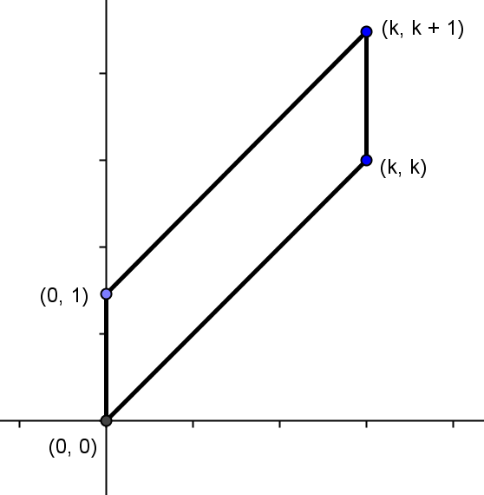
  - Perform this transformation on the vertices of the unit square. Sketch the image and label the vertices.
$\left[\begin{matrix}k & 0 \\ k & 1\end{matrix}\right]\left[\begin{matrix}0 \\ 0\end{matrix}\right]=\left[\begin{matrix}0 \\ 0\end{matrix}\right]$
$\left[\begin{matrix}k & 0 \\ k & 1\end{matrix}\right]\left[\begin{matrix}1 \\ 0\end{matrix}\right]=\left[\begin{matrix}k \\ k\end{matrix}\right]$
$\left[\begin{matrix}k & 0 \\ k & 1\end{matrix}\right]\left[\begin{matrix}0 \\ 1\end{matrix}\right]=\left[\begin{matrix}0 \\ 1\end{matrix}\right]$
$\left[\begin{matrix}k & 0 \\ k & 1\end{matrix}\right]\left[\begin{matrix}1 \\ 1\end{matrix}\right]=\left[\begin{matrix}k \\ k+1\end{matrix}\right]$

  - Calculate the area of the image using the dimensions of the image parallelogram.
The parallelogram is $1$ unit high, and the perpendicular distance between parallel bases is $k$ units wide, so the area is $1∙k=k square units$.

  - Confirm the area of the image using the determinant.
The area of the unit square is $1$ and the determinant of the transformation matrix is $\left|\left(k\right)\left(1\right)-(0)(k)\right|=k$. The area of the parallelogram is $1∙k=k square units$. The area is confirmed.

  - Perform the transformation on $\left[\begin{matrix}x \\ y\end{matrix}\right]$.
$\left[\begin{matrix}k & 0 \\ k & 1\end{matrix}\right]\left[\begin{matrix}x \\ y\end{matrix}\right]=\left[\begin{matrix}kx \\ kx+y\end{matrix}\right]$

  - In order for two matrices to be equivalent, each of the corresponding elements must be equivalent. Given that, if the image of this transformation is $\left[\begin{matrix}5 \\ 4\end{matrix}\right]$, find $\left[\begin{matrix}x \\ y\end{matrix}\right]$.
$\left[\begin{matrix}kx \\ kx+y\end{matrix}\right]=\left[\begin{matrix}5 \\ 4\end{matrix}\right]$
$kx=5$ $x=\frac{5}{k}$
$kx+y=4$ $k\left(\frac{5}{k}\right)+y=4$ $5+y=4$ $y=-1$
$\left[\begin{matrix}x \\ y\end{matrix}\right]=\left[\begin{matrix}\frac{5}{k} \\ -1\end{matrix}\right]$

  - Perform the transformation on $\left[\begin{matrix}1 \\ 1\end{matrix}\right]$. Write the image matrix.
$\left[\begin{matrix}k & 0 \\ k & 1\end{matrix}\right]\left[\begin{matrix}1 \\ 1\end{matrix}\right]=\left[\begin{matrix}k \\ k+1\end{matrix}\right]$

  - Perform the transformation on the image again, and then repeat until the transformation has been performed four times on the image of the preceding matrix.
$\left[\begin{matrix}k & 0 \\ k & 1\end{matrix}\right]\left[\begin{matrix}k \\ k+1\end{matrix}\right]=\left[\begin{matrix}k^{2} \\ k^{2}+k+1\end{matrix}\right]$
$\left[\begin{matrix}k & 0 \\ k & 1\end{matrix}\right]\left[\begin{matrix}k^{2} \\ k^{2}+k+1\end{matrix}\right]=\left[\begin{matrix}k^{3} \\ k^{3}+k^{2}+k+1\end{matrix}\right]$
$\left[\begin{matrix}k & 0 \\ k & 1\end{matrix}\right]\left[\begin{matrix}k^{3} \\ k^{3}+k^{2}+k+1\end{matrix}\right]=\left[\begin{matrix}k^{4} \\ k^{4}+k^{3}+k^{2}+k+1\end{matrix}\right]$

- What are the vertices of the image?
  - $\left(0, 0\right), \left(k, k\right), \left(0, 1\right)$, and $(k, k+1)$.
- What is the formula for the area of a parallelogram?
  - Area of a parallelogram is $base×height$.
- What is the base and height of the parallelogram that is the image of this transformation? How do you know?
  - The base is the length of one of the parallel sides, which is $1$ unit. The height is the perpendicular distance between parallel sides, and that is $k$ units.
- Using the formula, calculate the area of the parallelogram.
  - The area is $k$ square units.
- Now find the area using the determinant. Is the area confirmed?
  - $Area=\left|\left(k\right)\left(1\right)-\left(0\right)k\right|=k square units$. This is the same area.
- Now perform the transformation on a point $(x, y)$. What is the matrix that results?
  - $\left[\begin{matrix}kx \\ kx+y\end{matrix}\right]$
- If we want the image of this transformation on $(x, y)$ to map to $(5, 4)$, how could we find $(x, y)$?
  - We could write a system of equations and solve for $(x, y)$.
- Write the system of equations.
  - $kx=5$
  - $kx+y=4$
- Solve for $x$ and $y$ in terms of $k$. Which variable is easiest to solve for? Explain and solve for it.
  - It is easiest to solve for $x$ because the first equation only has $x$, not $y$. $x=\frac{5}{k}$
- Now solve for the other variable.
  - $y=4-k\left(\frac{5}{k}\right)=4-5=-1$
- So, $\left[\begin{matrix}x \\ y\end{matrix}\right]$ is equal to what?
  - $\left[\begin{matrix}\frac{5}{k} \\ -1\end{matrix}\right]$.

Exercise 1 (8 minutes)
This exercise should be completed in pairs and gives students practice solving for $\left[\begin{matrix}x \\ y\end{matrix}\right]$ and writing a general formula to represent $n$ transformations. Some groups may need the leading questions presented in Example 1 to help them.
Exercise 1
- Perform the transformation $\left[\begin{matrix}k & 0 \\ 1 & k\end{matrix}\right]$ with $k>1$ on the vertices of the unit square.
  - What are the vertices of the image?
$\left(0, 0\right), \left(k, 1\right), \left(0, k\right)$, and $(k,k+1)$

  - Calculate the area of the image.
$k^{2}$

  - If the image of the transformation on $\left[\begin{matrix}x \\ y\end{matrix}\right]$ is $\left[\begin{matrix}-2 \\ -1\end{matrix}\right]$, find $\left[\begin{matrix}x \\ y\end{matrix}\right]$ in terms of $k$.
$\left[\begin{matrix}k & 0 \\ 1 & k\end{matrix}\right]\left[\begin{matrix}x \\ y\end{matrix}\right]=\left[\begin{matrix}kx \\ x+ky\end{matrix}\right]=\left[\begin{matrix}-2 \\ -1\end{matrix}\right]$
$kx=-2$ $x=\frac{-2}{k}$
$x+ky=-1$ $\frac{-2}{k}+ky=-1$ $ky=-1+\frac{2}{k}$ $y=\frac{-1}{k}+\frac{2}{k^{2}}$
$\left[\begin{matrix}x \\ y\end{matrix}\right]=\left[\begin{matrix}\frac{-2}{k} \\ \frac{-1}{k}+\frac{2}{k^{2}}\end{matrix}\right]$

Example 2 (10 minutes)
In Lesson 26, we made the claim that a matrix transformation takes straight lines to straight lines. This example explores that claim, because students discover that matrix transformations are indeed linear, and sets the groundwork for the work of Lessons 27–30. Students should work in pairs with the teacher leading the discussion.

Example 2
Consider the matrix $L=\left[\begin{matrix}2 & 5 \\ -1 & 3\end{matrix}\right]$. For each real number $0≤t≤1$ consider the point $\left(3+t, 10+2t\right)$.
  - Find point $A$ when $t=0$.
$A(3, 10)$

  - Find point $B$ when $t=1$.
$B(4, 12)$

  - Show that for $t=\frac{1}{2}, (3+t, 10+2t)$ is the midpoint of $\overline{AB}$.
When $t=\frac{1}{2}$, point $M$ is $\left(3+\frac{1}{2},10+2\left(\frac{1}{2}\right)\right)$ or $(3.5, 11)$. The midpoint of $\overline{AB}=\left(\frac{3+4}{2},\frac{10+12}{2}\right)=\left(\frac{7}{2},11\right)$. The midpoint is at $t=\frac{1}{2}$.

  - Show that for each value of $t,(3+t, 10+2t)$ is a point on the line through $A$ and $B$.
The equation of the line through A and B is $y-10=\frac{12-10}{4-3}(x-3)$, or $y-10=2(x-3)$, or $y=2x+4$. If we substitute $(3+t, 10+2t)$ into the equation, we get $10+2t=2\left(3+t\right)+4$ or $10+2t=2t+10$, which is a statement that is true for all real values of $t$. Therefore, the point $(3+t, 10+2t)$ lies on the line through $A$ and $B$ for all values of $t$.

  - Find $LA$ and $LB$.
$LA=\left[\begin{matrix}2 & 5 \\ -1 & 3\end{matrix}\right]\left[\begin{matrix}3 \\ 10\end{matrix}\right]=\left[\begin{matrix}56 \\ 27\end{matrix}\right]$
$LB=\left[\begin{matrix}2 & 5 \\ -1 & 3\end{matrix}\right]\left[\begin{matrix}4 \\ 12\end{matrix}\right]=\left[\begin{matrix}68 \\ 32\end{matrix}\right]$

  - What is the equation of the line through $LA$ and $LB$?
The line through $LA$ and $LB$ is $y-27=\frac{32-27}{68-56}(x-56)$ or $y-27=\frac{5}{12}(x-56)$.

  - Show that $L\left[\begin{matrix}3+t \\ 10+2t\end{matrix}\right]$ lies on the line through $LA$ and $LB$.
$L\left[\begin{matrix}3+t \\ 10+2t\end{matrix}\right]=\left[\begin{matrix}2 & 5 \\ -1 & 3\end{matrix}\right]\left[\begin{matrix}3+t \\ 10+2t\end{matrix}\right]=\left[\begin{matrix}6+2t+50+10t \\ -3-t+30+6t\end{matrix}\right]=\left[\begin{matrix}12t+56 \\ 5t+27\end{matrix}\right]$
$(5t+27)-27=\frac{5}{12}((12t+56)-56)$
$5t=5t$, which is true for all real values of $t$, so $L\left[\begin{matrix}3+t \\ 10+2t\end{matrix}\right]$ and lies on the line through $LA$ and $LB$

- Will the midpoint always occur at $t=\frac{1}{2}$? Explain.
  - It will always occur at the $\frac{1}{2}(t_{1}+t_{2})$. Since $t_{1}+t_{2}=1$ in this problem, the midpoint occurred at $t=\frac{1}{2}$.

- Write an equation for the line through $A$ and $B$. Explain your work.
  - $A(3. 10)$ and $B(4. 12)$, so the slope is $m=\frac{12-10}{4-3}=2$. In point slope form, the equation is
$y-10=2\left(x-3\right)$ or $y-12=2(x-4)$. In slope-intercept form, the equation is $y=2x+4$.
- Substitute $x=3+t$ and $y=10+2t$ into this equation. What do you discover?
  - $10+2t=2(3+t)+4L$
  - $10+2t=6+2t+10$
  - $10+2t=10+2t$
  - We get a statement that is true for all real values of $t$.
- What does this mean?
  - The point $(3+t, 10+2t)$ lies on the line through $A$ and $B$ for all values of $t$.
- Write an equation for the line through $LA$ and $LB$.
  - $y-27=\frac{5}{12}\left(x-56\right)$ or $y-32=\frac{5}{12}(x-68)$
- Does every point on $L\left[\begin{matrix}3+t \\ 10+2t\end{matrix}\right]$ lie on the line through $LA$ and $LB?$ Explain.
  - Yes, $\left(5t+27\right)-27=\frac{5}{12}\left(\left(12t+56\right)-56\right)$.
  - $5t=5t$ which is true for all real values of $t$; therefore, $L\left[\begin{matrix}3+t \\ 10+2t\end{matrix}\right]$ lies on the line through $LA$ and $LB$.

Closing (4 minutes)
Have students explain to a neighbor everything that they learned about matrix transformations in Lessons 26 and 27; then, pull the class together to debrief.
- Explain to your neighbor everything that you learned about matrix transformations in Lessons 26 and 27.
  - The image of this transformation is a parallelogram with vertices
  - $(0, 0), (a, b), (c, d)$, and $(a+c, b+d)$.
  - The determinant of the $2×2$ transformation matrix is the area of the image of the unit square after the transformation.
  - A $2×2$ transformation can rotate, dilate, and/or change the shape of the unit square.
  - A $2×2$ transformation takes straight lines and maps them to straight lines.

Exit Ticket (5 minutes)

Name Date
Lesson 27: Getting a Handle on New Transformations

Exit Ticket

Given the transformation $\left[\begin{matrix}0 & k \\ 1 & k\end{matrix}\right]$ with $k>0$:
  - Find the area of the image of the transformation performed on the unit matrix.

  - The image of the transformation on $\left[\begin{matrix}x \\ y\end{matrix}\right]$ is $\left[\begin{matrix}1 \\ 5\end{matrix}\right]$; find $\left[\begin{matrix}x \\ y\end{matrix}\right]$ in terms of $k$. Show your work.

Exit Ticket Sample Solutions

Given the transformation $\left[\begin{matrix}0 & k \\ 1 & k\end{matrix}\right]$ with $k>0$:
  - Find the area of the image of the transformation performed on the unit matrix.
$$\left|\left(0\right)\left(k\right)-(k)(1)\right|=\left|-k\right|=k$$

  - The image of the transformation on $\left[\begin{matrix}x \\ y\end{matrix}\right]$ is $\left[\begin{matrix}1 \\ 5\end{matrix}\right]$; find $\left[\begin{matrix}x \\ y\end{matrix}\right]$ in terms of $k$. Show your work.
$\left[\begin{matrix}0 & k \\ 1 & k\end{matrix}\right]\left[\begin{matrix}x \\ y\end{matrix}\right]=\left[\begin{matrix}ky \\ x+ky\end{matrix}\right]=\left[\begin{matrix}1 \\ 5\end{matrix}\right]$
$ky=1$ $y=\frac{1}{k}$
$x+ky=5$ $x+k\left(\frac{1}{k}\right)=5$ $x+1=5$ $x=4$
$\left[\begin{matrix}x \\ y\end{matrix}\right]=\left[\begin{matrix}4 \\ \frac{1}{k}\end{matrix}\right]$

Problem Set Sample Solutions

- Perform the following transformation on the vertices of the unit square. Sketch the image, label the vertices, and find the area of the image parallelogram.
  - $\left[\begin{matrix}1 & 0 \\ 1 & 1\end{matrix}\right]$
$\left[\begin{matrix}1 & 0 \\ 1 & 1\end{matrix}\right]\left[\begin{matrix}0 \\ 0\end{matrix}\right]=\left[\begin{matrix}0 \\ 0\end{matrix}\right], \left[\begin{matrix}1 & 0 \\ 1 & 1\end{matrix}\right]\left[\begin{matrix}1 \\ 0\end{matrix}\right]=\left[\begin{matrix}1 \\ 1\end{matrix}\right], \left[\begin{matrix}1 & 0 \\ 1 & 1\end{matrix}\right]\left[\begin{matrix}1 \\ 1\end{matrix}\right]=\left[\begin{matrix}1 \\ 2\end{matrix}\right]$, and $\left[\begin{matrix}1 & 0 \\ 1 & 1\end{matrix}\right]\left[\begin{matrix}0 \\ 1\end{matrix}\right]=\left[\begin{matrix}0 \\ 1\end{matrix}\right]$
$Area=\left|k×1-k×0\right|=\left|1×1-1×0\right|=1 square unit$.
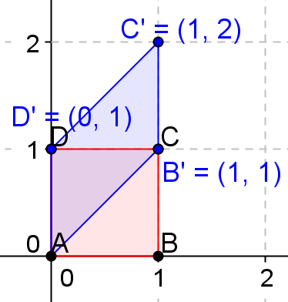

  - $\left[\begin{matrix}2 & 0 \\ 2 & 1\end{matrix}\right]$
$\left[\begin{matrix}2 & 0 \\ 2 & 1\end{matrix}\right]\left[\begin{matrix}0 \\ 0\end{matrix}\right]=\left[\begin{matrix}0 \\ 0\end{matrix}\right], \left[\begin{matrix}2 & 0 \\ 2 & 1\end{matrix}\right]\left[\begin{matrix}1 \\ 0\end{matrix}\right]=\left[\begin{matrix}2 \\ 2\end{matrix}\right], \left[\begin{matrix}2 & 0 \\ 2 & 1\end{matrix}\right]\left[\begin{matrix}1 \\ 1\end{matrix}\right]=\left[\begin{matrix}2 \\ 3\end{matrix}\right]$, and $\left[\begin{matrix}2 & 0 \\ 2 & 1\end{matrix}\right]\left[\begin{matrix}0 \\ 1\end{matrix}\right]=\left[\begin{matrix}0 \\ 1\end{matrix}\right]$
$Area=\left|k×1-k×0\right|=\left|2×1-2×0\right|=2 square units$.
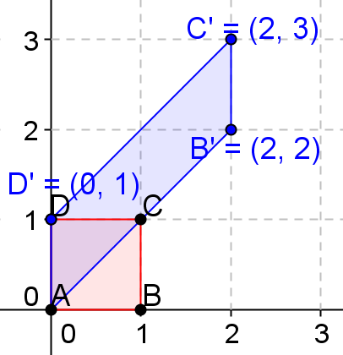

  - $\left[\begin{matrix}3 & 0 \\ 3 & 1\end{matrix}\right]$
$\left[\begin{matrix}3 & 0 \\ 3 & 1\end{matrix}\right]\left[\begin{matrix}0 \\ 0\end{matrix}\right]=\left[\begin{matrix}0 \\ 0\end{matrix}\right], \left[\begin{matrix}3 & 0 \\ 3 & 1\end{matrix}\right]\left[\begin{matrix}1 \\ 0\end{matrix}\right]=\left[\begin{matrix}3 \\ 3\end{matrix}\right], \left[\begin{matrix}3 & 0 \\ 3 & 1\end{matrix}\right]\left[\begin{matrix}1 \\ 1\end{matrix}\right]=\left[\begin{matrix}3 \\ 4\end{matrix}\right]$, and $\left[\begin{matrix}3 & 0 \\ 3 & 1\end{matrix}\right]\left[\begin{matrix}0 \\ 1\end{matrix}\right]=\left[\begin{matrix}0 \\ 1\end{matrix}\right]$
$Area=\left|k×1-k×0\right|=\left|3×1-3×0\right|=3 square units$.
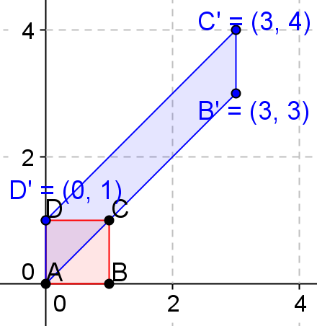

  - $\left[\begin{matrix}2 & 0 \\ 2 & 2\end{matrix}\right]$
$\left[\begin{matrix}2 & 0 \\ 2 & 2\end{matrix}\right]\left[\begin{matrix}0 \\ 0\end{matrix}\right]=\left[\begin{matrix}0 \\ 0\end{matrix}\right], \left[\begin{matrix}2 & 0 \\ 2 & 2\end{matrix}\right]\left[\begin{matrix}1 \\ 0\end{matrix}\right]=\left[\begin{matrix}2 \\ 2\end{matrix}\right], \left[\begin{matrix}2 & 0 \\ 2 & 2\end{matrix}\right]\left[\begin{matrix}1 \\ 1\end{matrix}\right]=\left[\begin{matrix}2 \\ 4\end{matrix}\right]$, and $\left[\begin{matrix}2 & 0 \\ 2 & 2\end{matrix}\right]\left[\begin{matrix}0 \\ 1\end{matrix}\right]=\left[\begin{matrix}0 \\ 2\end{matrix}\right]$
$Area=\left|k×1-k×0\right|=\left|2×1-2×0\right|=2 square units$.
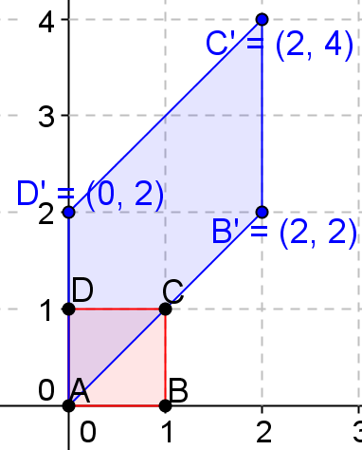

  - $\left[\begin{matrix}3 & 0 \\ 3 & 3\end{matrix}\right]$
$\left[\begin{matrix}3 & 0 \\ 3 & 3\end{matrix}\right]\left[\begin{matrix}0 \\ 0\end{matrix}\right]=\left[\begin{matrix}0 \\ 0\end{matrix}\right], \left[\begin{matrix}3 & 0 \\ 3 & 3\end{matrix}\right]\left[\begin{matrix}1 \\ 0\end{matrix}\right]=\left[\begin{matrix}3 \\ 3\end{matrix}\right], \left[\begin{matrix}3 & 0 \\ 3 & 3\end{matrix}\right]\left[\begin{matrix}1 \\ 1\end{matrix}\right]=\left[\begin{matrix}3 \\ 6\end{matrix}\right]$, and $\left[\begin{matrix}3 & 0 \\ 3 & 3\end{matrix}\right]\left[\begin{matrix}0 \\ 1\end{matrix}\right]=\left[\begin{matrix}0 \\ 3\end{matrix}\right]$
$Area=\left|k×1-k×0\right|=\left|3×1-3×0\right|=3 square units$.
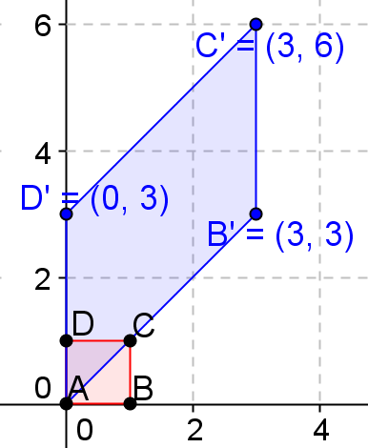

  - $\left[\begin{matrix}1 & 0 \\ 1 & 2\end{matrix}\right]$
$\left[\begin{matrix}1 & 0 \\ 1 & 2\end{matrix}\right]\left[\begin{matrix}0 \\ 0\end{matrix}\right]=\left[\begin{matrix}0 \\ 0\end{matrix}\right], \left[\begin{matrix}1 & 0 \\ 1 & 2\end{matrix}\right]\left[\begin{matrix}1 \\ 0\end{matrix}\right]=\left[\begin{matrix}1 \\ 1\end{matrix}\right], \left[\begin{matrix}1 & 0 \\ 1 & 2\end{matrix}\right]\left[\begin{matrix}1 \\ 1\end{matrix}\right]=\left[\begin{matrix}1 \\ 3\end{matrix}\right]$, and $\left[\begin{matrix}1 & 0 \\ 1 & 2\end{matrix}\right]\left[\begin{matrix}0 \\ 1\end{matrix}\right]=\left[\begin{matrix}0 \\ 2\end{matrix}\right]$
$Area=\left|k×1-k×0\right|=\left|1×2-1×0\right|=2 square units$.
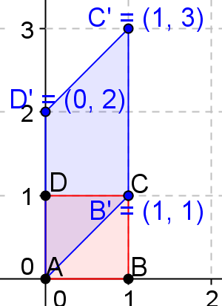
  - $\left[\begin{matrix}1 & 0 \\ 1 & 3\end{matrix}\right]$
$\left[\begin{matrix}1 & 0 \\ 1 & 3\end{matrix}\right]\left[\begin{matrix}0 \\ 0\end{matrix}\right]=\left[\begin{matrix}0 \\ 0\end{matrix}\right], \left[\begin{matrix}1 & 0 \\ 1 & 3\end{matrix}\right]\left[\begin{matrix}1 \\ 0\end{matrix}\right]=\left[\begin{matrix}1 \\ 1\end{matrix}\right], \left[\begin{matrix}1 & 0 \\ 1 & 3\end{matrix}\right]\left[\begin{matrix}1 \\ 1\end{matrix}\right]=\left[\begin{matrix}1 \\ 4\end{matrix}\right]$, and $\left[\begin{matrix}1 & 0 \\ 1 & 3\end{matrix}\right]\left[\begin{matrix}0 \\ 1\end{matrix}\right]=\left[\begin{matrix}0 \\ 3\end{matrix}\right]$
$Area=\left|k×1-k×0\right|=\left|1×3-1×0\right|=3 square units$.
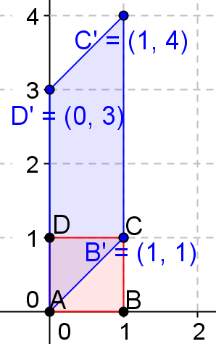

  - $\left[\begin{matrix}2 & 0 \\ 2 & 3\end{matrix}\right]$
$\left[\begin{matrix}2 & 0 \\ 2 & 3\end{matrix}\right]\left[\begin{matrix}0 \\ 0\end{matrix}\right]=\left[\begin{matrix}0 \\ 0\end{matrix}\right], \left[\begin{matrix}2 & 0 \\ 2 & 3\end{matrix}\right]\left[\begin{matrix}1 \\ 0\end{matrix}\right]=\left[\begin{matrix}2 \\ 2\end{matrix}\right], \left[\begin{matrix}2 & 0 \\ 2 & 3\end{matrix}\right]\left[\begin{matrix}1 \\ 1\end{matrix}\right]=\left[\begin{matrix}2 \\ 5\end{matrix}\right]$, and $\left[\begin{matrix}2 & 0 \\ 2 & 3\end{matrix}\right]\left[\begin{matrix}0 \\ 1\end{matrix}\right]=\left[\begin{matrix}0 \\ 3\end{matrix}\right]$
$Area=\left|k×1-k×0\right|=\left|2×3-2×0\right|=6 square units$.
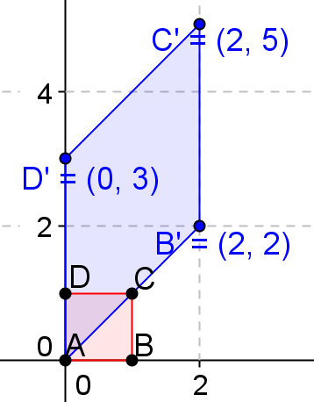

  - $\left[\begin{matrix}3 & 0 \\ 3 & 5\end{matrix}\right]$
$\left[\begin{matrix}3 & 0 \\ 3 & 5\end{matrix}\right]\left[\begin{matrix}0 \\ 0\end{matrix}\right]=\left[\begin{matrix}0 \\ 0\end{matrix}\right], \left[\begin{matrix}3 & 0 \\ 3 & 5\end{matrix}\right]\left[\begin{matrix}1 \\ 0\end{matrix}\right]=\left[\begin{matrix}3 \\ 3\end{matrix}\right], \left[\begin{matrix}3 & 0 \\ 3 & 5\end{matrix}\right]\left[\begin{matrix}1 \\ 1\end{matrix}\right]=\left[\begin{matrix}3 \\ 8\end{matrix}\right]$, and $\left[\begin{matrix}3 & 0 \\ 3 & 5\end{matrix}\right]\left[\begin{matrix}0 \\ 1\end{matrix}\right]=\left[\begin{matrix}0 \\ 5\end{matrix}\right]$
$Area=\left|k×1-k×0\right|=\left|3×5-3×0\right|=15 square units$.
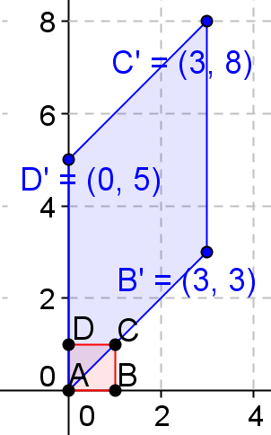

- Given $\left[\begin{matrix}k & 0 \\ k & 1\end{matrix}\right]\left[\begin{matrix}x \\ y\end{matrix}\right]=\left[\begin{matrix}kx \\ kx+y\end{matrix}\right]$. Find $\left[\begin{matrix}x \\ y\end{matrix}\right]$ if the image of the transformation is the following:
  - $\left[\begin{matrix}4 \\ 5\end{matrix}\right]$
$\left[\begin{matrix}kx \\ kx+y\end{matrix}\right]=\left[\begin{matrix}4 \\ 5\end{matrix}\right], kx=4, x=\frac{4}{k}$
$kx+y=5, k\frac{4}{k}+y=5 4+y=5 y=1$
$\left[\begin{matrix}x \\ y\end{matrix}\right]=\left[\begin{matrix}\frac{4}{k} \\ 1\end{matrix}\right]$
  - $\left[\begin{matrix}-3 \\ 2\end{matrix}\right]$
$\left[\begin{matrix}kx \\ kx+y\end{matrix}\right]=\left[\begin{matrix}-3 \\ 2\end{matrix}\right], kx=-3, x=-\frac{3}{k}$
$kx+y=2, k\frac{-3}{k}+y=2 -3+y=2 y=5$
$\left[\begin{matrix}x \\ y\end{matrix}\right]=\left[\begin{matrix}\frac{-3}{k} \\ 5\end{matrix}\right]$

  - $\left[\begin{matrix}5 \\ -6\end{matrix}\right]$
$\left[\begin{matrix}kx \\ kx+y\end{matrix}\right]=\left[\begin{matrix}5 \\ -6\end{matrix}\right], kx=5, x=\frac{5}{k}$
$kx+y=-6, k\frac{5}{k}+y=-6 5+y=-6 y=-11$
$\left[\begin{matrix}x \\ y\end{matrix}\right]=\left[\begin{matrix}\frac{5}{k} \\ -11\end{matrix}\right]$

- Given $\left[\begin{matrix}k & 0 \\ k & 1\end{matrix}\right]\left[\begin{matrix}x \\ y\end{matrix}\right]=\left[\begin{matrix}kx \\ kx+y\end{matrix}\right]$. Find value of $k$ so that:
  - $\left[\begin{matrix}x \\ y\end{matrix}\right]=\left[\begin{matrix}3 \\ -2\end{matrix}\right]$ and the image is $\left[\begin{matrix}24 \\ 22\end{matrix}\right]$
$\left[\begin{matrix}k & 0 \\ k & 1\end{matrix}\right]\left[\begin{matrix}3 \\ -2\end{matrix}\right]=\left[\begin{matrix}24 \\ 22\end{matrix}\right]$, $3k+0=24, k=8$ or $3k-2=22, k=8$

  - $\left[\begin{matrix}x \\ y\end{matrix}\right]=\left[\begin{matrix}27 \\ 3\end{matrix}\right]$ and the image is $\left[\begin{matrix}18 \\ 21\end{matrix}\right]$
$\left[\begin{matrix}k & 0 \\ k & 1\end{matrix}\right]\left[\begin{matrix}27 \\ 3\end{matrix}\right]=\left[\begin{matrix}18 \\ 21\end{matrix}\right]$, $27k+0=18,k=\frac{18}{27}=\frac{2}{3}$ or $27k+3=21, k=\frac{18}{27}=\frac{2}{3}$

- Given $\left[\begin{matrix}k & 0 \\ 1 & k\end{matrix}\right]\left[\begin{matrix}x \\ y\end{matrix}\right]=\left[\begin{matrix}kx \\ x+ky\end{matrix}\right]$. Find value of $k$ so that:
  - $\left[\begin{matrix}x \\ y\end{matrix}\right]=\left[\begin{matrix}-4 \\ 5\end{matrix}\right]$ and the image is $\left[\begin{matrix}-12 \\ 11\end{matrix}\right]$
$\left[\begin{matrix}k & 0 \\ 1 & k\end{matrix}\right]\left[\begin{matrix}-4 \\ 5\end{matrix}\right]=\left[\begin{matrix}-12 \\ 11\end{matrix}\right]$, $-4k+0=-12, k=3$ or $-4+5k=11, k=3$

  - $\left[\begin{matrix}x \\ y\end{matrix}\right]=\left[\begin{matrix}\frac{5}{3} \\ \frac{2}{9}\end{matrix}\right]$ and image is $\left[\begin{matrix}-15 \\ -\frac{1}{3}\end{matrix}\right]$
$\left[\begin{matrix}k & 0 \\ 1 & k\end{matrix}\right]\left[\begin{matrix}\frac{5}{3} \\ \frac{2}{9}\end{matrix}\right]=\left[\begin{matrix}-15 \\ -\frac{1}{3}\end{matrix}\right]$, $\frac{5}{3}k+0=-15, k=-9$ or $\frac{5}{3}+\frac{2}{9}k=-\frac{1}{3}, k=-9$

- Perform the following transformation on the vertices of the unit square. Sketch the image, label the vertices, and find the area of the image parallelogram.
  - $\left[\begin{matrix}2 & 0 \\ 1 & 2\end{matrix}\right]$
$\left[\begin{matrix}2 & 0 \\ 1 & 2\end{matrix}\right]\left[\begin{matrix}0 \\ 0\end{matrix}\right]=\left[\begin{matrix}0 \\ 0\end{matrix}\right], \left[\begin{matrix}2 & 0 \\ 1 & 2\end{matrix}\right]\left[\begin{matrix}1 \\ 0\end{matrix}\right]=\left[\begin{matrix}2 \\ 1\end{matrix}\right], \left[\begin{matrix}2 & 0 \\ 1 & 2\end{matrix}\right]\left[\begin{matrix}1 \\ 1\end{matrix}\right]=\left[\begin{matrix}2 \\ 3\end{matrix}\right]$, and $\left[\begin{matrix}2 & 0 \\ 1 & 2\end{matrix}\right]\left[\begin{matrix}0 \\ 1\end{matrix}\right]=\left[\begin{matrix}0 \\ 2\end{matrix}\right]$
$Area=\left|k×k-1×0\right|=k^{2}=4 square units$.
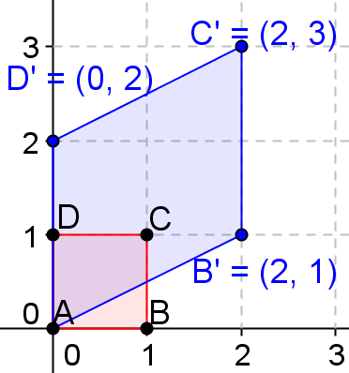

  - $\left[\begin{matrix}3 & 0 \\ 1 & 3\end{matrix}\right]$
$\left[\begin{matrix}3 & 0 \\ 1 & 3\end{matrix}\right]\left[\begin{matrix}0 \\ 0\end{matrix}\right]=\left[\begin{matrix}0 \\ 0\end{matrix}\right], \left[\begin{matrix}3 & 0 \\ 1 & 3\end{matrix}\right]\left[\begin{matrix}1 \\ 0\end{matrix}\right]=\left[\begin{matrix}3 \\ 1\end{matrix}\right], \left[\begin{matrix}3 & 0 \\ 1 & 3\end{matrix}\right]\left[\begin{matrix}1 \\ 1\end{matrix}\right]=\left[\begin{matrix}3 \\ 4\end{matrix}\right]$, and $\left[\begin{matrix}3 & 0 \\ 1 & 3\end{matrix}\right]\left[\begin{matrix}0 \\ 1\end{matrix}\right]=\left[\begin{matrix}0 \\ 3\end{matrix}\right]$
$Area=\left|k×k-1×0\right|=k^{2}=9 square units$.
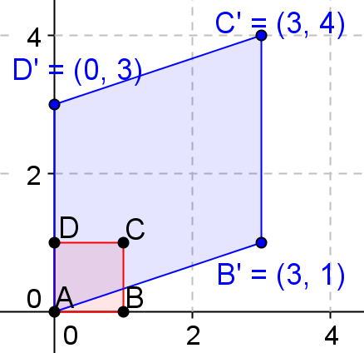

  - $\left[\begin{matrix}2 & 0 \\ 3 & 2\end{matrix}\right]$
$\left[\begin{matrix}2 & 0 \\ 3 & 2\end{matrix}\right]\left[\begin{matrix}0 \\ 0\end{matrix}\right]=\left[\begin{matrix}0 \\ 0\end{matrix}\right], \left[\begin{matrix}2 & 0 \\ 3 & 2\end{matrix}\right]\left[\begin{matrix}1 \\ 0\end{matrix}\right]=\left[\begin{matrix}2 \\ 3\end{matrix}\right], \left[\begin{matrix}2 & 0 \\ 3 & 2\end{matrix}\right]\left[\begin{matrix}1 \\ 1\end{matrix}\right]=\left[\begin{matrix}2 \\ 5\end{matrix}\right]$, and $\left[\begin{matrix}2 & 0 \\ 3 & 2\end{matrix}\right]\left[\begin{matrix}0 \\ 1\end{matrix}\right]=\left[\begin{matrix}0 \\ 2\end{matrix}\right]$
$Area=\left|k×k-1×0\right|=k^{2}=4 square units$.
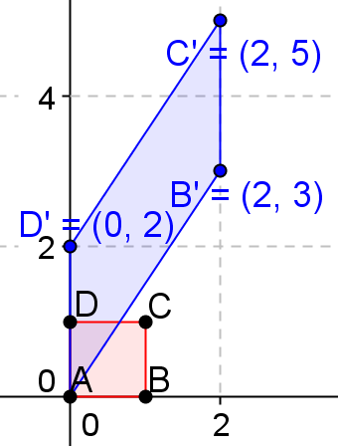

  - $\left[\begin{matrix}2 & 0 \\ 4 & 2\end{matrix}\right]$
$\left[\begin{matrix}2 & 0 \\ 4 & 2\end{matrix}\right]\left[\begin{matrix}0 \\ 0\end{matrix}\right]=\left[\begin{matrix}0 \\ 0\end{matrix}\right], \left[\begin{matrix}2 & 0 \\ 4 & 2\end{matrix}\right]\left[\begin{matrix}1 \\ 0\end{matrix}\right]=\left[\begin{matrix}2 \\ 4\end{matrix}\right], \left[\begin{matrix}2 & 0 \\ 4 & 2\end{matrix}\right]\left[\begin{matrix}1 \\ 1\end{matrix}\right]=\left[\begin{matrix}2 \\ 6\end{matrix}\right]$, and $\left[\begin{matrix}2 & 0 \\ 4 & 2\end{matrix}\right]\left[\begin{matrix}0 \\ 1\end{matrix}\right]=\left[\begin{matrix}0 \\ 2\end{matrix}\right]$
$Area=\left|k×k-1×0\right|=k^{2}=4 square units$.
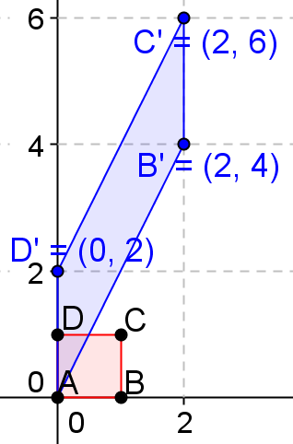

  - $\left[\begin{matrix}4 & 0 \\ 2 & 4\end{matrix}\right]$
$\left[\begin{matrix}4 & 0 \\ 2 & 4\end{matrix}\right]\left[\begin{matrix}0 \\ 0\end{matrix}\right]=\left[\begin{matrix}0 \\ 0\end{matrix}\right], \left[\begin{matrix}4 & 0 \\ 2 & 4\end{matrix}\right]\left[\begin{matrix}1 \\ 0\end{matrix}\right]=\left[\begin{matrix}4 \\ 2\end{matrix}\right], \left[\begin{matrix}4 & 0 \\ 2 & 4\end{matrix}\right]\left[\begin{matrix}1 \\ 1\end{matrix}\right]=\left[\begin{matrix}4 \\ 6\end{matrix}\right]$, and $\left[\begin{matrix}4 & 0 \\ 2 & 4\end{matrix}\right]\left[\begin{matrix}0 \\ 1\end{matrix}\right]=\left[\begin{matrix}0 \\ 4\end{matrix}\right]$
$Area=\left|k×k-1×0\right|=k^{2}=16 square units$.
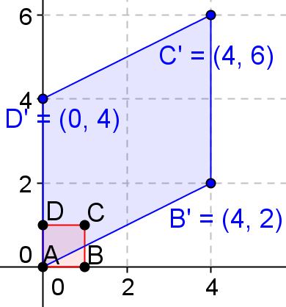

  - $\left[\begin{matrix}3 & 0 \\ 5 & 3\end{matrix}\right]$
$\left[\begin{matrix}3 & 0 \\ 5 & 3\end{matrix}\right]\left[\begin{matrix}0 \\ 0\end{matrix}\right]=\left[\begin{matrix}0 \\ 0\end{matrix}\right], \left[\begin{matrix}3 & 0 \\ 5 & 3\end{matrix}\right]\left[\begin{matrix}1 \\ 0\end{matrix}\right]=\left[\begin{matrix}3 \\ 5\end{matrix}\right], \left[\begin{matrix}3 & 0 \\ 5 & 3\end{matrix}\right]\left[\begin{matrix}1 \\ 1\end{matrix}\right]=\left[\begin{matrix}3 \\ 8\end{matrix}\right]$, and $\left[\begin{matrix}3 & 0 \\ 5 & 3\end{matrix}\right]\left[\begin{matrix}0 \\ 1\end{matrix}\right]=\left[\begin{matrix}0 \\ 3\end{matrix}\right]$
$Area=\left|k×k-1×0\right|=k^{2}=9 square units$.
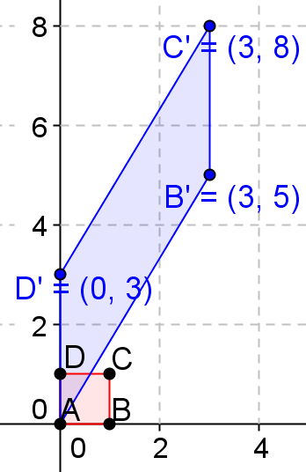

- Consider the matrix $L=\left[\begin{matrix}1 & 3 \\ 2 & 4\end{matrix}\right]$. For each real number $o≤t≤1$, consider the point $(3+2t, 12+2t)$.
  - Find the point $A$ when $t=0$.
$A(3, 12)$

  - Find the point $B$ when $t=1$.
$B\left(5, 14\right)$

  - Show that for $t=\frac{1}{2},$ $\left(3+2t, 12+2t\right)$ is the midpoint of $\overline{AB}$.
When $t=\frac{1}{2}$, the point $M=\left(3+1, 12+1\right)=(4, 13)$.
And the midpoint of $\overline{AB}=\left(\frac{3+5}{2},\frac{12+14}{2}\right)=\left(4, 13\right)$. Thus, the midpoint is at $t=\frac{1}{2}$.

  - Show that for each value of $t$, $\left(3+2t, 12+2t\right)$ is a point on the line through $A$ and $B$.
The equation of the line through $\overline{AB}$ is $y-12=\frac{12-14}{3-5}\left(x-3\right),y=x+9$.
If we substitute $(3+2t, 12+2t)$ into the equation, we get $12+2t=3+2t+9$, or $12+2t=12+2t$, which is a statement that is true for all real values of $t$. Therefore, the point $(3+2t, 12+2t)$ lies on the line through $A$ and $B$ for all values of $t$.

  - Find $LA$ and $LB$.
$LA=\left[\begin{matrix}1 & 3 \\ 2 & 4\end{matrix}\right]\left[\begin{matrix}3 \\ 12\end{matrix}\right]=\left[\begin{matrix}39 \\ 54\end{matrix}\right]$
$LB=\left[\begin{matrix}1 & 3 \\ 2 & 4\end{matrix}\right]\left[\begin{matrix}5 \\ 14\end{matrix}\right]=\left[\begin{matrix}47 \\ 66\end{matrix}\right]$

  - What is the equation of the line through $LA$ and $LB$?
$y-54=\frac{66-54}{47-39}\left(x-39\right), y-54=\frac{3}{2}\left(x-39\right)$

  - Show that $L\left[\begin{matrix}3+2t \\ 12+2t\end{matrix}\right]$ lies on the line through $LA$ and $LB$.
$L\left[\begin{matrix}3+2t \\ 12+2t\end{matrix}\right]=\left[\begin{matrix}1 & 3 \\ 2 & 4\end{matrix}\right]\left[\begin{matrix}3+2t \\ 12+2t\end{matrix}\right]=\left[\begin{matrix}3+2t+36+6t \\ 6+4t+48+8t\end{matrix}\right]=\left[\begin{matrix}39+8t \\ 54+12t\end{matrix}\right]$,
We substitute it into the equation in part (f): $54+12t-54=\frac{3}{2}(39+8t-39)$.
$12t=\frac{3}{2}\left(8t\right),12t=12t$, which is true for all real values of $t$,
So $L\left[\begin{matrix}3+2t \\ 12+2t\end{matrix}\right]$ lies on the line through $LA$ and $LB$.

