Lesson 26: Getting a Handle on New Transformations
Student Outcomes
- Students understand that the absolute value of the determinant of a $2×2$ matrix is the area of the image of the unit square.

Lesson Notes
This is day one of a two day lesson on transformations using matrix notation. Students begin with the unit square and look at the geometric results of simple transformations on the unit square. Students then calculate the area of the transformed figure and understand that it is the absolute value of the determinant of the $2×2$ matrix representing the transformation.

Classwork
Have students work on the Opening Exercise individually and then check solutions as a class. This exercise allows students to practice the matrix operations of addition and subtraction and prepares them for concepts they will need in Lessons 26 and 27.
In the next few exercises, matrices are represented with square brackets. Discuss with students that matrices can be represented with soft or square brackets. $\left[\begin{matrix}1 & 2 \\ 3 & 4\end{matrix}\right]$ and $\left(\begin{matrix}1 & 2 \\ 3 & 4\end{matrix}\right)$ represent the same matrix.

Opening Exercise (8 minutes)
Opening Exercise
Perform the following matrix operations:
Scaffolding:
- To aid students in matrix operations, ask questions such as, “How do we multiply matrices?” or “How do we add matrices?” The images below can be displayed in the classroom as guides.
- To multiply matrices:
$$\left[\begin{matrix}a & b \\ c & d\end{matrix}\right]\left[\begin{matrix}x \\ y\end{matrix}\right]=\left[\begin{matrix}ax+by \\ cx+dy\end{matrix}\right]$$
$$\left[\begin{matrix}a & b \\ c & d\end{matrix}\right]\left[\begin{matrix}x & y \\ z & w\end{matrix}\right]=\left[\begin{matrix}ax+bz & ay+bw \\ cx+dz & cy+dw\end{matrix}\right]$$
- To add matrices:
$$\left(\begin{matrix}a & b \\ c & d\end{matrix}\right)+\left(\begin{matrix}x & y \\ z & w\end{matrix}\right)=\left(\begin{matrix}a+x & b+y \\ c+z & d+w\end{matrix}\right)$$

  - $\left[\begin{matrix}3 & -2 \\ 1 & 5\end{matrix}\right]\left[\begin{matrix}-1 \\ 3\end{matrix}\right]$
$$\left[\begin{matrix}-9 \\ 14\end{matrix}\right]$$

  - $\left[\begin{matrix}3 & -2 \\ 1 & 5\end{matrix}\right]\left[\begin{matrix}1 & 0 \\ 0 & 1\end{matrix}\right]$
$\left[\begin{matrix}3 & -2 \\ 1 & 5\end{matrix}\right]$

  - $\left[\begin{matrix}3 & -2 \\ 1 & 5\end{matrix}\right]\left[\begin{matrix}1 & -3 \\ 2 & 4\end{matrix}\right]$
$$\left[\begin{matrix}-1 & -17 \\ 11 & 17\end{matrix}\right]$$

  - $\left[\begin{matrix}3 & -2 \\ 1 & 5\end{matrix}\right]\left[\begin{matrix}a & b \\ c & d\end{matrix}\right]$
$\left[\begin{matrix}3a-2c & 3b-2d \\ 1a+5c & 1b+5d\end{matrix}\right]$

  - $\left[\begin{matrix}3 & -2 \\ 1 & 5\end{matrix}\right]+\left[\begin{matrix}1 & 0 \\ 0 & 1\end{matrix}\right]$
$\left[\begin{matrix}4 & -2 \\ 1 & 6\end{matrix}\right]$

  - $\left[\begin{matrix}3 & -2 \\ 1 & 5\end{matrix}\right]+\left[\begin{matrix}1 & -3 \\ 2 & 4\end{matrix}\right]$
$\left[\begin{matrix}4 & -5 \\ 3 & 9\end{matrix}\right]$

  - $\left[\begin{matrix}3 & -2 \\ 1 & 5\end{matrix}\right]+\left[\begin{matrix}a & b \\ c & d\end{matrix}\right]$
$\left[\begin{matrix}3+a & -2+b \\ 1+c & 5+d\end{matrix}\right]$

  - Can you add the two matrices in part (a)? Why or why not?
No, the matrices do not have the same dimensions, so they cannot be added.

Exploratory Challenge (20 minutes)
In this Exploratory Challenge, students discover what matrix transformations do to a unit square geometrically. Students calculate the area of the image of the unit square and discover that the area is the absolute value of the determinant of the resulting $2×2$ matrix. In this challenge, let students work in pairs, but lead the class together from step to step. Students should have graph paper and a ruler.
Scaffolding:
- Some student pairs may need targeted one-to-one guidance on this challenge.
- For advanced students, give them the challenge without guiding questions, and allow them to work in pairs on their own, checking their steps periodically.
- Provide unlabeled graphs for students who have difficulties with eye-hand coordination or fine motor skills.
- We have seen that every matrix $\left[\begin{matrix}a & b \\ c & d\end{matrix}\right]$ corresponds to some kind of transformation of the plane, but it can be hard to see what the transformation actually does. For example, what does the matrix $\left[\begin{matrix}109 & 3 \\ 1 & -2\end{matrix}\right]$ do to points, shapes, and lines in the plane?
  - Allow students to share ideas. We will answer this question later after looking at more basic matrices.
- Let’s draw the unit square in the coordinate plane with each side $1$ inch long.
  - Students draw unit square. (Check to make sure the squares are $1$ inch $×$ $1$ inch.)
- Now label the vertices of the square.
  - Students label the vertices as shown.
- Write a set of matrices that represents the vertices of the unit square.
  - $\left[\begin{matrix}0 \\ 0\end{matrix}\right], \left[\begin{matrix}1 \\ 0\end{matrix}\right],\left[\begin{matrix}0 \\ 1\end{matrix}\right]$, and $\left[\begin{matrix}1 \\ 1\end{matrix}\right]$
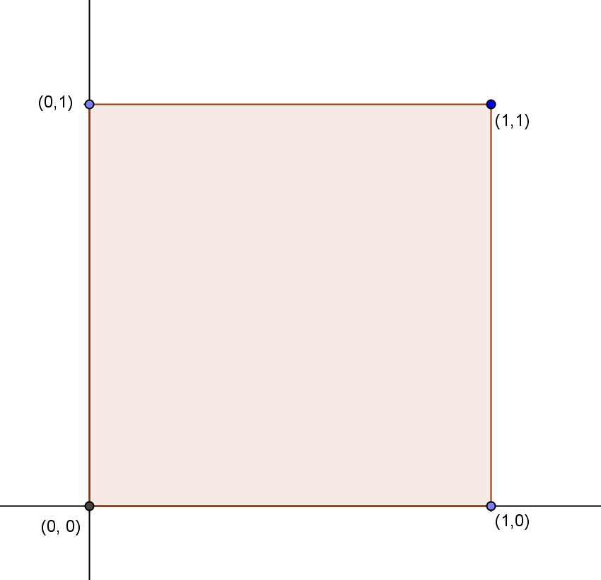
- As we learned in previous lessons, any matrix of the form $\left[\begin{matrix}a & -b \\ b & a\end{matrix}\right]$ is a rotation and a dilation. Perform this transformation on the vertices of the unit square if $a>0$ and $b>0$. Show your work.
  - $\left[\begin{matrix}a & -b \\ b & a\end{matrix}\right]\left[\begin{matrix}0 \\ 0\end{matrix}\right]=\left[\begin{matrix}0 \\ 0\end{matrix}\right], \left[\begin{matrix}a & -b \\ b & a\end{matrix}\right]\left[\begin{matrix}1 \\ 0\end{matrix}\right]=\left[\begin{matrix}a \\ b\end{matrix}\right], \left[\begin{matrix}a & -b \\ b & a\end{matrix}\right]\left[\begin{matrix}0 \\ 1\end{matrix}\right]=\left[\begin{matrix}-b \\ a\end{matrix}\right]$, and $\left[\begin{matrix}a & -b \\ b & a\end{matrix}\right]\left[\begin{matrix}1 \\ 1\end{matrix}\right]=\left[\begin{matrix}a-b \\ b+a\end{matrix}\right]$
- What are the coordinates of the image of $(1, 0)$ and $(0, 1)$?
  - $(1, 0)→(a, b)$
  - $\left(0, 1\right)→(-b, a)$
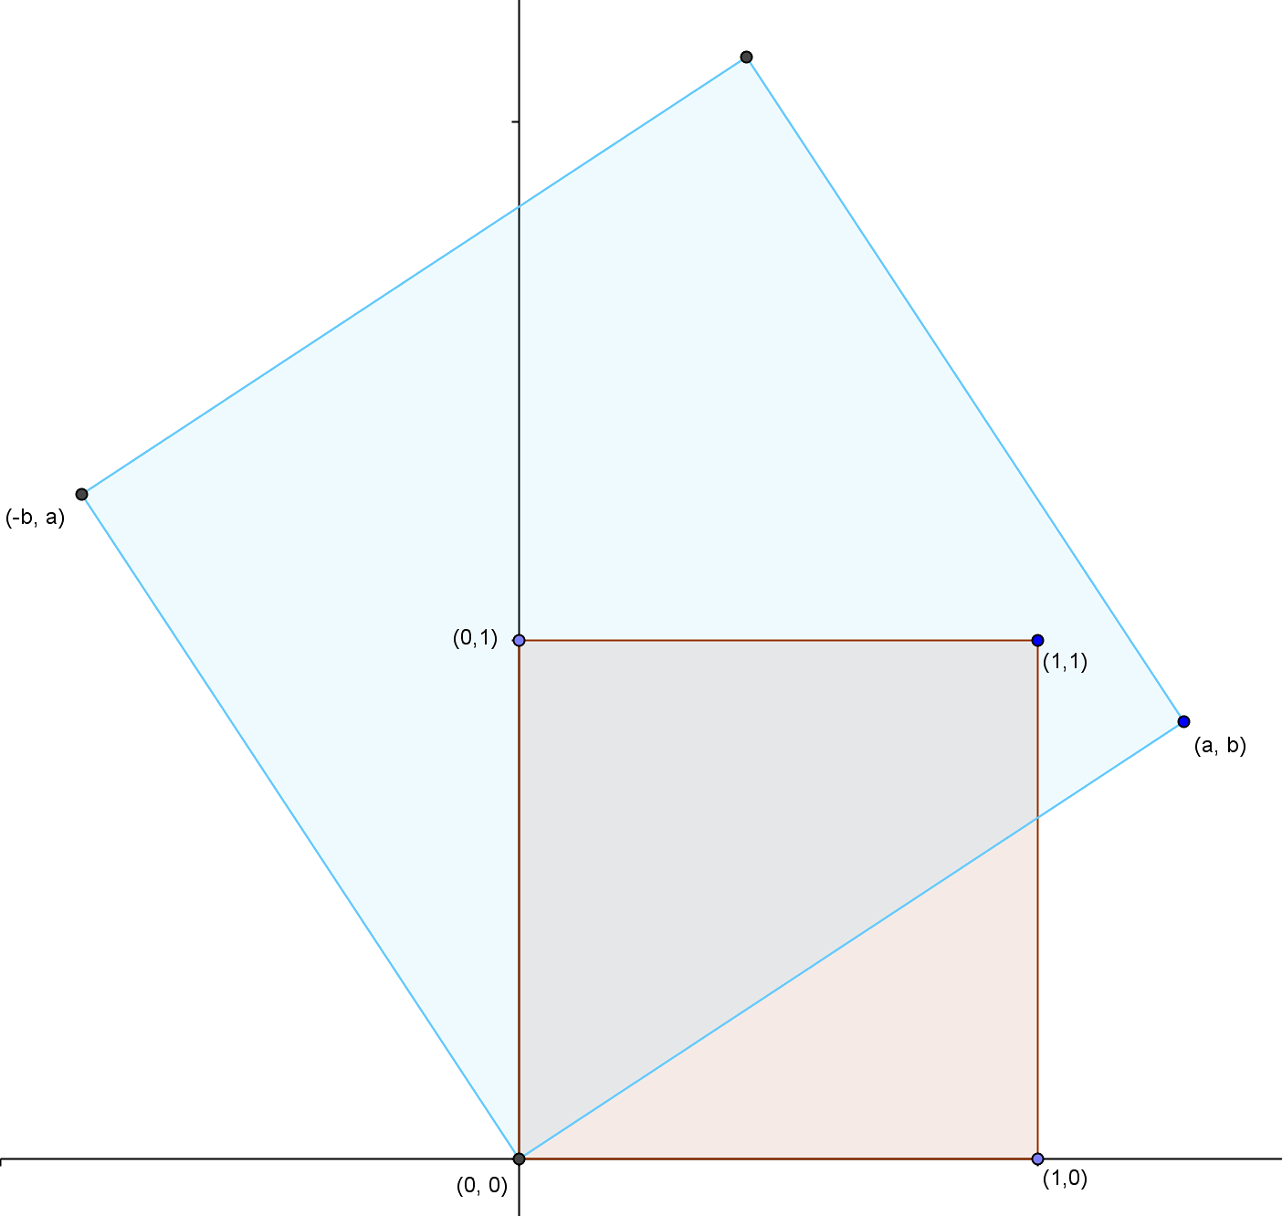
- Graph the image on the same graph as the original unit square in a different color.
  - See diagram at right.
- Label the coordinates of the vertices.
  - $\left(0, 0\right), \left(a, b\right), \left(-b, a\right)$, and
$(a-b, b+a)$
- This picture allows you to see the rotation and dilation that took place on the unit square. Let’s try another transformation.
- Draw another unit square with side lengths of $1$ inch.
  - Students draw a second unit square.
- Perform the general transformation $\left[\begin{matrix}a & c \\ b & d\end{matrix}\right]$ on the vertices of the unit square.
  - $\left[\begin{matrix}a & c \\ b & d\end{matrix}\right]\left[\begin{matrix}0 \\ 0\end{matrix}\right]=\left[\begin{matrix}0 \\ 0\end{matrix}\right]$
  - $\left[\begin{matrix}a & c \\ b & d\end{matrix}\right]\left[\begin{matrix}1 \\ 0\end{matrix}\right]=\left[\begin{matrix}a \\ b\end{matrix}\right]$
  - $\left[\begin{matrix}a & c \\ b & d\end{matrix}\right]\left[\begin{matrix}0 \\ 1\end{matrix}\right]=\left[\begin{matrix}c \\ d\end{matrix}\right]$
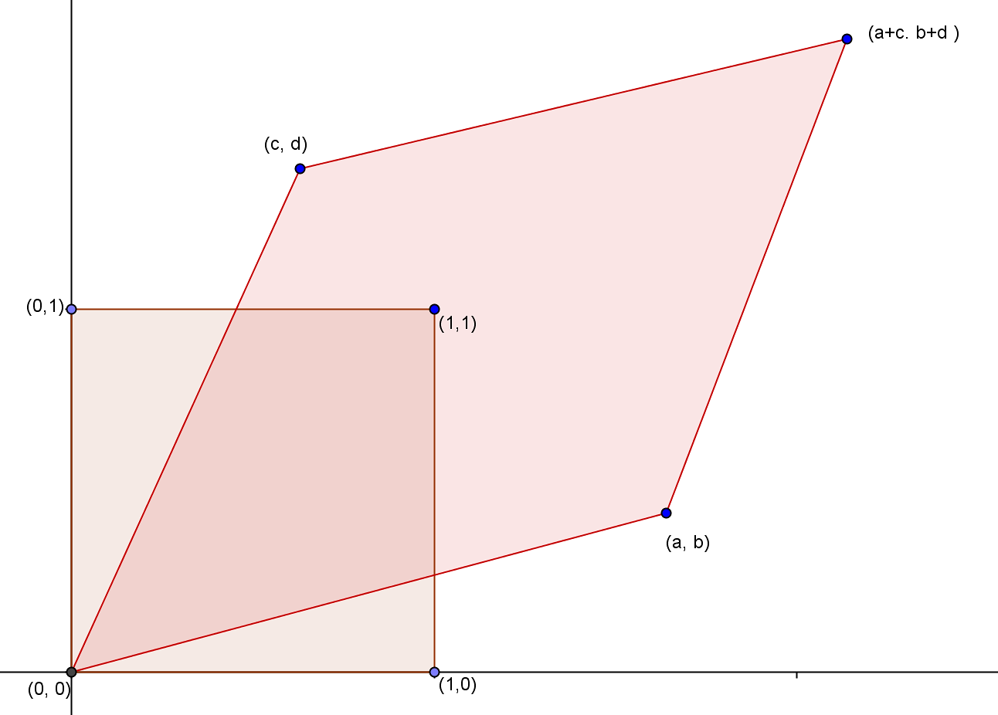
  - $\left[\begin{matrix}a & c \\ b & d\end{matrix}\right]\left[\begin{matrix}1 \\ 1\end{matrix}\right]=\left[\begin{matrix}a+c \\ b+d\end{matrix}\right]$
- What are the coordinates of the image of $(1, 0)$ and $(1, 1)$?
  - $(1, 0)→(a, b)$
  - $\left(1, 1\right)→(a+c, b+d)$
- Graph the image on the same graph as the second unit square in a different color, and label the vertices.
  - See diagram at right.
  - The vertices are $\left(0, 0\right), \left(a, b\right), \left(c, d\right)$, and
$(a+c, b+d)$.
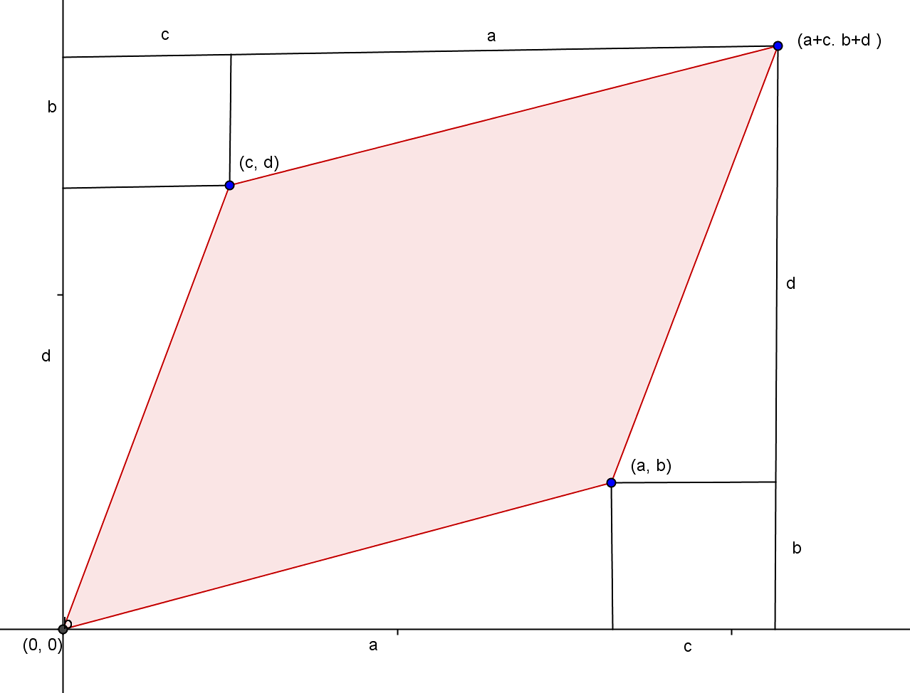
- Look at the two diagrams that we have created. The original unit square had four straight sides. After the transformations, were the straight segments mapped to straight segments? Was the square mapped to a square? Explain.
  - Straight segments were mapped to straight segments.
  - The square was mapped to a parallelogram.
- Does this transformation change the area of the unit square?
  - It seems to—yes.
- Let’s find the area of the image from the general transformation. Allow students to work in pairs to find the area of the image by enclosing the parallelogram in a rectangle and subtracting the areas of the right triangles and rectangles surrounding the parallelogram. The area of the first image may be slightly easier to find.
$Area=\left(a+c\right)\left(b+d\right)-2\left(\frac{1}{2}ab+\frac{1}{2}cd+bc\right)$$$Area=ab+ad+bc+cd-ab-cd-2bc \\ Area=ad-bc$$
Scaffolding:
- If students are struggling to understand the need for absolute value with variables, have them perform this activity using the following matrices.
- $\left[\begin{matrix}3 & 1 \\ 2 & 4\end{matrix}\right]$ has a determinant of $10$.
- $\left[\begin{matrix}1 & 3 \\ 4 & 2\end{matrix}\right]$ has a determinant of $-10$.
- Both give the same transformed figure, so to get the area, we must take the absolute value of the determinant (MP.2).
- When we drew the image, we kept the orientation of the vertices; in other words, we mapped $(1, 0)$ to $(a, b)$ and $(1, 1)$ to $(a+c, b+d)$. We could have switched the order of vertices $(a, b)$ and $(c, d)$. Redraw the picture and calculate the area of the parallelogram image. Do you get the same area? Explain.
  - The area is the opposite of what we calculated before. The area is
$bc-ad$.
- What could we do to ensure this formula always works for the area regardless of the orientation of the vertices?
  - Take the absolute value.
- Write the general formula for the area of the parallelogram that is the image of the transformation of the unit square.
MP.2
  - $Area=\left|ad-bc\right|$
- The determinant of a $2×2$ matrix $\left[\begin{matrix}a & c \\ b & d\end{matrix}\right]$ is $\left|ad-bc\right|$. Explain this geometrically to your neighbor.
  - The determinant of a $2×2$ matrix is the area of the image of the unit square that has undergone the transformation $\left[\begin{matrix}a & c \\ b & d\end{matrix}\right]$.
- Determinant: The area of the image of the unit square under the linear transformation represented by a $2×2$
matrix is called the determinant of that matrix.

Exercises 1–3 (10 minutes)
In Exercises 1 and 2, we revisit two problems discussed in the Exploratory Challenge and answer questions using what students have discovered. Exercise 3 revisits the pure dilation and rotation matrices to see their effect on area. Students should work on these exercises in pairs and then debrief as a class. Any problems not completed can be assigned for homework.

Exercises 1–3
- Perform the transformation $\left[\begin{matrix}109 & 3 \\ 1 & -2\end{matrix}\right]$ on the unit square.
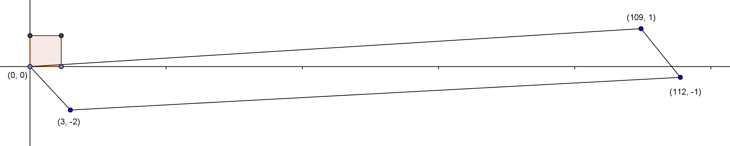
  - Sketch the image. What is the shape of the image?
The image is a parallelogram.

  - What are the coordinates of the vertices of the image?
$\left(0, 0\right), \left(3, -2\right), \left(109, 1\right)$, and $(112, -1)$

  - What is the area of the image? Show your work.
$Area=\left|\left(109\right)\left(-2\right)-(3)(1)\right|=\left|-221\right|=221$

- In the Exploratory Challenge, we drew the image of a general rotation/dilation of the unit square $\left[\begin{matrix}a & -b \\ b & a\end{matrix}\right]$.
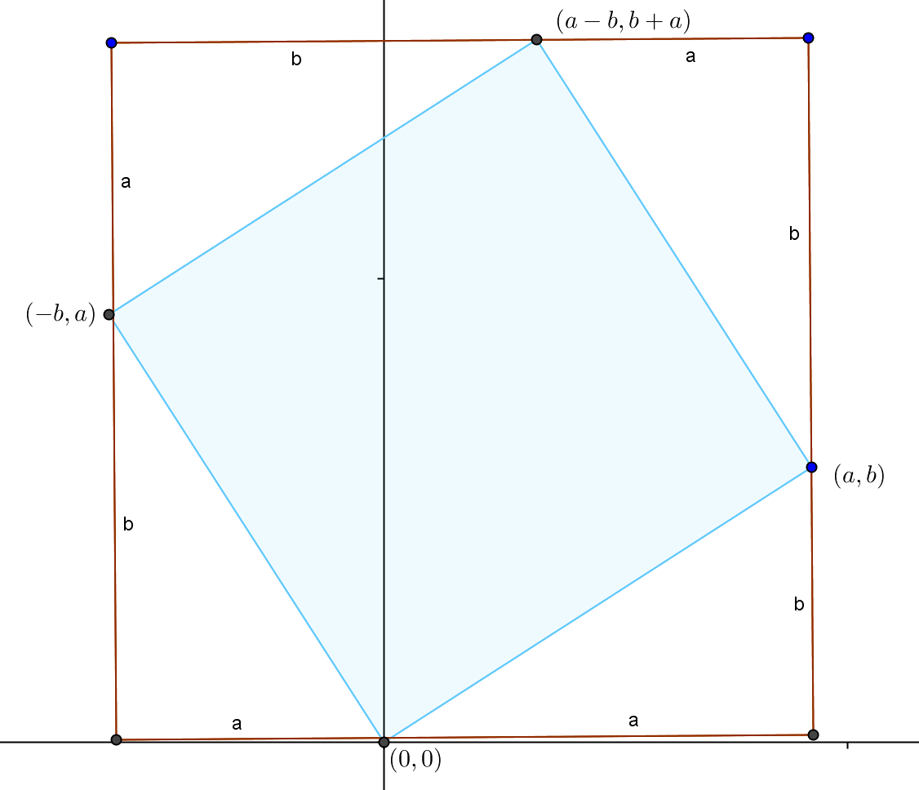
  - Calculate the area of the image by enclosing the image in a rectangle and subtracting the area of surrounding right triangles. Show your work.
$Area={(a+b)}^{2}-4(\frac{1}{2}ab)$
$Area=a^{2}+2ab+b^{2}-2ab$
$Area=a^{2}+b^{2}$

  - Confirm the area using the determinant of the resulting matrix.
$\left[\begin{matrix}a & -b \\ b & a\end{matrix}\right]$
$Area=\left|\left(a\right)\left(a\right)-(b)(-b)\right|=a^{2}+b^{2}$

- We have looked at several general matrix transformations in Module 1. Answer the questions below about these familiar matrices and explain your answers.
  - What effect does the identity transformation have on the unit square? What is the area of the image? Confirm your answer using the determinant.
The identity transformation does nothing to the unit square. The area is $1$, as is the determinant of the unit matrix.

  - How does a dilation with a scale factor of $k$ change the area of the unit square? Calculate the determinant of a matrix representing a pure dilation of $k$.
The dilation changes all areas by $k^{2}$. The pure dilation matrix is $\left[\begin{matrix}k & 0 \\ 0 & k\end{matrix}\right]$, which has a determinant of $k^{2}$.

  - Does a rotation with no dilation change the area of the unit square? Confirm your answer by calculating the determinant of a pure rotation matrix and explain.
A pure rotation does not change the area. The pure rotation matrix is $\left[\begin{matrix}cos(θ) & -sin(θ) \\ sin(θ) & cos(θ)\end{matrix}\right]$. Its determinant is $({cos(θ))}^{2}-{\left(-sin\left(θ\right)\right)}^{2}=\cos^{2}\left(θ\right)+\sin^{2}\left(θ\right)=1$, which confirms that the area does not change.
Closing (2 minutes)
Have students do a 30-second quick write on the following question, then debrief as a class.
- What effect does the general transformation $\left[\begin{matrix}a & c \\ b & d\end{matrix}\right]$ have on the unit square?
  - The image of this transformation is a parallelogram with vertices
$(0, 0), (a, b), (c, d)$, and $(a+c, b+d)$.
- What is the easiest way to calculate the area of the image of this transformation?
  - Calculate the determinant of the resulting matrix $\left|ad-bc\right|$.
Lesson Summary
Definition
- The area of the image of the unit square under the linear transformation represented by a $2×2$ matrix is called the determinant of that matrix.

Exit Ticket (5 minutes)

Name Date
Lesson 26: Getting a Handle on New Transformations

Exit Ticket

Perform the transformation $\left[\begin{matrix}-2 & 5 \\ 4 & -1\end{matrix}\right]$ on the unit square.
  - Draw the unit square and the image after this transformation.

  - Label the vertices. Explain the effect of this transformation on the unit square.

  - Calculate the area of the image. Show your work.

Exit Ticket Sample Solutions

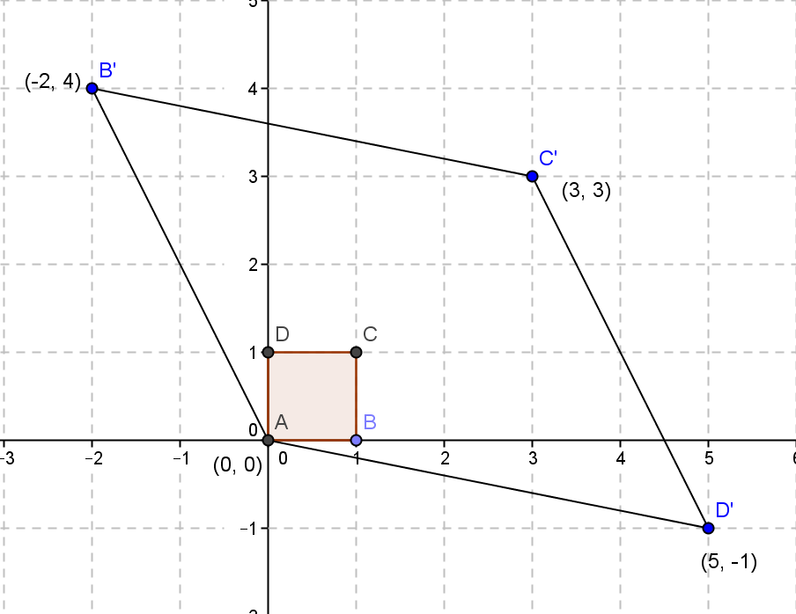
Perform the transformation $\left[\begin{matrix}-2 & 5 \\ 4 & -1\end{matrix}\right]$ on the unit square.
  - Draw the unit square and the image after this transformation.

  - Label the vertices. Explain the effect of this transformation on the unit square.
$$B\left(1, 0\right)→B'\left(-2, 4\right)$$
$$D\left(0, 1\right)→D'\left(5, -1\right)$$
$$C(1, 1)→C'(3, 3)$$
$$A(0, 0)→A(0, 0)$$

  - Calculate the area of the image. Show your work.
$\left|\left(-2\right)\left(-1\right)-(5)(4)\right|=\left|2-20\right|=\left|-18\right|=18$

Problem Set Sample Solutions

- Perform the following transformation on the unit square: sketch the image and the area of the image.
  - $\left[\begin{matrix}3 & -1 \\ 1 & 3\end{matrix}\right]$
$\left[\begin{matrix}3 & -1 \\ 1 & 3\end{matrix}\right]\left[\begin{matrix}0 \\ 0\end{matrix}\right]=\left[\begin{matrix}0 \\ 0\end{matrix}\right], \left[\begin{matrix}3 & -1 \\ 1 & 3\end{matrix}\right]\left[\begin{matrix}1 \\ 0\end{matrix}\right]=\left[\begin{matrix}3 \\ 1\end{matrix}\right], \left[\begin{matrix}3 & -1 \\ 1 & 3\end{matrix}\right]\left[\begin{matrix}1 \\ 1\end{matrix}\right]=\left[\begin{matrix}2 \\ 4\end{matrix}\right]$, and $\left[\begin{matrix}3 & -1 \\ 1 & 3\end{matrix}\right]\left[\begin{matrix}0 \\ 1\end{matrix}\right]=\left[\begin{matrix}-1 \\ 3\end{matrix}\right]$
$$Area=a^{2}+b^{2}=3^{2}+1^{2}=10 square units$$
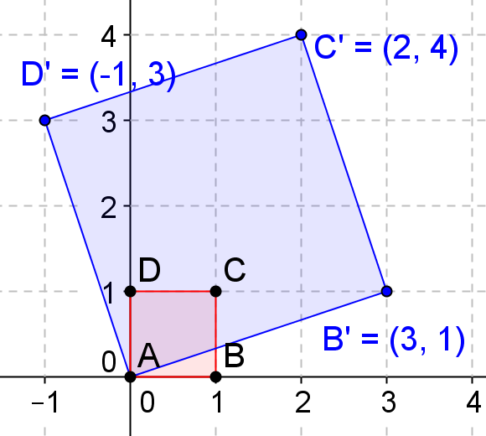

  - $\left[\begin{matrix}1 & -3 \\ 3 & 1\end{matrix}\right]$
$\left[\begin{matrix}1 & -3 \\ 3 & 1\end{matrix}\right]\left[\begin{matrix}0 \\ 0\end{matrix}\right]=\left[\begin{matrix}0 \\ 0\end{matrix}\right], \left[\begin{matrix}1 & -3 \\ 3 & 1\end{matrix}\right]\left[\begin{matrix}1 \\ 0\end{matrix}\right]=\left[\begin{matrix}1 \\ 3\end{matrix}\right], \left[\begin{matrix}1 & -3 \\ 3 & 1\end{matrix}\right]\left[\begin{matrix}1 \\ 1\end{matrix}\right]=\left[\begin{matrix}-2 \\ 4\end{matrix}\right]$, and $\left[\begin{matrix}1 & -3 \\ 3 & 1\end{matrix}\right]\left[\begin{matrix}0 \\ 1\end{matrix}\right]=\left[\begin{matrix}-3 \\ 1\end{matrix}\right]$
$$Area=a^{2}+b^{2}=1^{2}+3^{2}=10 square units$$
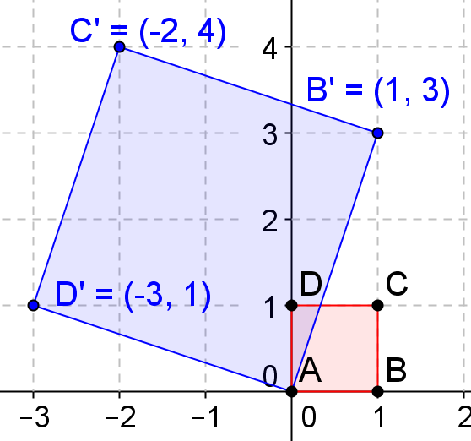

  - $\left[\begin{matrix}4 & -2 \\ 2 & 4\end{matrix}\right]$
$\left[\begin{matrix}4 & -2 \\ 2 & 4\end{matrix}\right]\left[\begin{matrix}0 \\ 0\end{matrix}\right]=\left[\begin{matrix}0 \\ 0\end{matrix}\right], \left[\begin{matrix}4 & -2 \\ 2 & 4\end{matrix}\right]\left[\begin{matrix}1 \\ 0\end{matrix}\right]=\left[2\right], \left[\begin{matrix}4 & -2 \\ 2 & 4\end{matrix}\right]\left[\begin{matrix}1 \\ 1\end{matrix}\right]=\left[\begin{matrix}2 \\ 6\end{matrix}\right]$, and $\left[\begin{matrix}4 & -2 \\ 2 & 4\end{matrix}\right]\left[\begin{matrix}0 \\ 1\end{matrix}\right]=\left[\begin{matrix}-2 \\ 4\end{matrix}\right]$
$$Area=a^{2}+b^{2}=4^{2}+2^{2}=20 square units$$
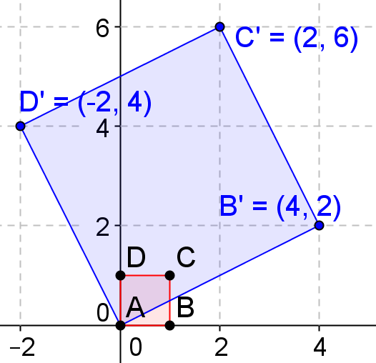

  - $\left[\begin{matrix}2 & -4 \\ 4 & 2\end{matrix}\right]$
$\left[\begin{matrix}2 & -4 \\ 4 & 2\end{matrix}\right]\left[\begin{matrix}0 \\ 0\end{matrix}\right]=\left[\begin{matrix}0 \\ 0\end{matrix}\right], \left[\begin{matrix}2 & -4 \\ 4 & 2\end{matrix}\right]\left[\begin{matrix}1 \\ 0\end{matrix}\right]=\left[\begin{matrix}2 \\ 4\end{matrix}\right], \left[\begin{matrix}2 & -4 \\ 4 & 2\end{matrix}\right]\left[\begin{matrix}1 \\ 1\end{matrix}\right]=\left[\begin{matrix}-2 \\ 6\end{matrix}\right]$, and $\left[\begin{matrix}2 & -4 \\ 4 & 2\end{matrix}\right]\left[\begin{matrix}0 \\ 1\end{matrix}\right]=\left[\begin{matrix}-4 \\ 2\end{matrix}\right]$
$$Area=a^{2}+b^{2}=2^{2}+4^{2}=20 square units$$
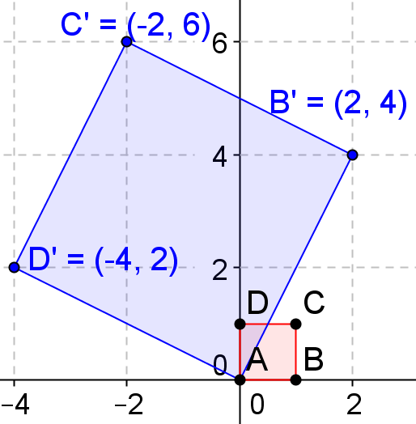

- Perform the following transformation on the unit square: sketch the image, find the determinant of the given matrix, and find the area the image.
  - $\left[\begin{matrix}1 & 3 \\ 2 & 4\end{matrix}\right]$
$\left[\begin{matrix}1 & 3 \\ 2 & 4\end{matrix}\right]\left[\begin{matrix}0 \\ 0\end{matrix}\right]=\left[\begin{matrix}0 \\ 0\end{matrix}\right], \left[\begin{matrix}1 & 3 \\ 2 & 4\end{matrix}\right]\left[\begin{matrix}1 \\ 0\end{matrix}\right]=\left[\begin{matrix}1 \\ 2\end{matrix}\right], \left[\begin{matrix}1 & 3 \\ 2 & 4\end{matrix}\right]\left[\begin{matrix}1 \\ 1\end{matrix}\right]=\left[\begin{matrix}4 \\ 6\end{matrix}\right]$, and $\left[\begin{matrix}1 & 3 \\ 2 & 4\end{matrix}\right]\left[\begin{matrix}0 \\ 1\end{matrix}\right]=\left[\begin{matrix}3 \\ 4\end{matrix}\right]$
Determinant: $ad-bc=4-6=-2$ $Area=\left|ad-bc\right|=\left|4-6\right|=2 square units$
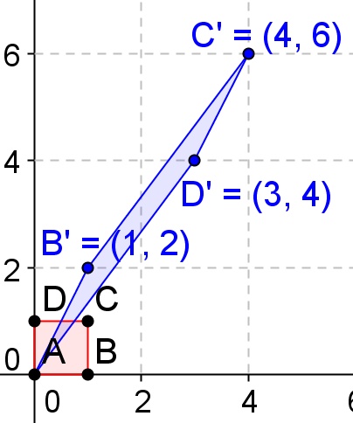

  - $\left[\begin{matrix}1 & 2 \\ 3 & 4\end{matrix}\right]$
$\left[\begin{matrix}1 & 2 \\ 3 & 4\end{matrix}\right]\left[\begin{matrix}0 \\ 0\end{matrix}\right]=\left[\begin{matrix}0 \\ 0\end{matrix}\right], \left[\begin{matrix}1 & 2 \\ 3 & 4\end{matrix}\right]\left[\begin{matrix}1 \\ 0\end{matrix}\right]=\left[\begin{matrix}1 \\ 3\end{matrix}\right], \left[\begin{matrix}1 & 2 \\ 3 & 4\end{matrix}\right]\left[\begin{matrix}1 \\ 1\end{matrix}\right]=\left[\begin{matrix}3 \\ 7\end{matrix}\right]$, and $\left[\begin{matrix}1 & 2 \\ 3 & 4\end{matrix}\right]\left[\begin{matrix}0 \\ 1\end{matrix}\right]=\left[\begin{matrix}2 \\ 4\end{matrix}\right]$
Determinant: $ad-bc=4-6=-2$ $Area=\left|ad-bc\right|=\left|4-6\right|=2 square units$
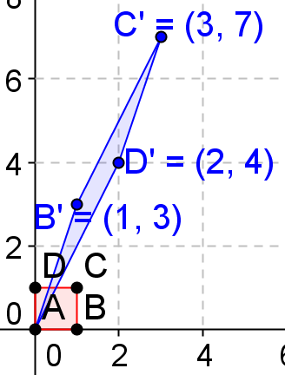
  - $\left[\begin{matrix}3 & 1 \\ 2 & 4\end{matrix}\right]$
$\left[\begin{matrix}3 & 1 \\ 2 & 4\end{matrix}\right]\left[\begin{matrix}0 \\ 0\end{matrix}\right]=\left[\begin{matrix}0 \\ 0\end{matrix}\right], \left[\begin{matrix}3 & 1 \\ 2 & 4\end{matrix}\right]\left[\begin{matrix}1 \\ 0\end{matrix}\right]=\left[\begin{matrix}3 \\ 2\end{matrix}\right], \left[\begin{matrix}3 & 1 \\ 2 & 4\end{matrix}\right]\left[\begin{matrix}1 \\ 1\end{matrix}\right]=\left[\begin{matrix}4 \\ 6\end{matrix}\right]$, and $\left[\begin{matrix}3 & 1 \\ 2 & 4\end{matrix}\right]\left[\begin{matrix}0 \\ 1\end{matrix}\right]=\left[\begin{matrix}1 \\ 4\end{matrix}\right]$
Determinant: $ad-bc=12-2=10$ $Area=\left|ad-bc\right|=\left|12-2\right|=10 square units$
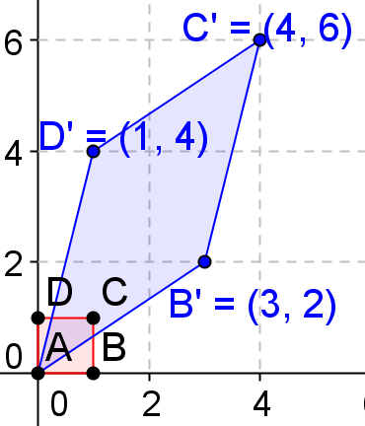

  - $\left[\begin{matrix}4 & 2 \\ 3 & 1\end{matrix}\right]$
$\left[\begin{matrix}4 & 2 \\ 3 & 1\end{matrix}\right]\left[\begin{matrix}0 \\ 0\end{matrix}\right]=\left[\begin{matrix}0 \\ 0\end{matrix}\right], \left[\begin{matrix}4 & 2 \\ 3 & 1\end{matrix}\right]\left[\begin{matrix}1 \\ 0\end{matrix}\right]=\left[\begin{matrix}4 \\ 3\end{matrix}\right], \left[\begin{matrix}4 & 2 \\ 3 & 1\end{matrix}\right]\left[\begin{matrix}1 \\ 1\end{matrix}\right]=\left[\begin{matrix}6 \\ 4\end{matrix}\right]$, and $\left[\begin{matrix}4 & 2 \\ 3 & 1\end{matrix}\right]\left[\begin{matrix}0 \\ 1\end{matrix}\right]=\left[\begin{matrix}2 \\ 1\end{matrix}\right]$
Determinant: $ad-bc=4-6=-2$ $Area=\left|ad-bc\right|=\left|4-6\right|=2 square units$
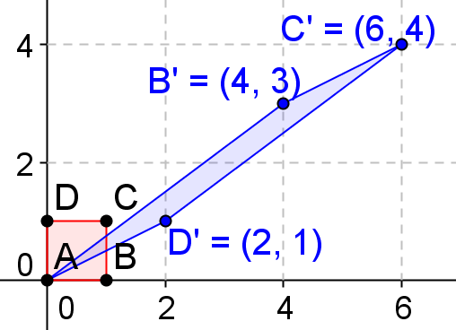

  - The determinants in parts (a), (b), (c), and (d) have positive or negative values. What is the value of the determinants if the vertices (b, c) and (c, d) are switched?
The value is negative.

- Perform the following transformation on the unit square: sketch the image, find the determinant of the given matrix, and find the area the image.
  - $\left[\begin{matrix}-1 & -3 \\ -2 & -4\end{matrix}\right]$
$\left[\begin{matrix}-1 & -2 \\ -3 & -4\end{matrix}\right]\left[\begin{matrix}0 \\ 0\end{matrix}\right]=\left[\begin{matrix}0 \\ 0\end{matrix}\right], \left[\begin{matrix}-1 & -2 \\ -3 & -4\end{matrix}\right]\left[\begin{matrix}1 \\ 0\end{matrix}\right]=\left[\begin{matrix}-1 \\ -3\end{matrix}\right], \left[\begin{matrix}-1 & -2 \\ -3 & -4\end{matrix}\right]\left[\begin{matrix}1 \\ 1\end{matrix}\right]=\left[\begin{matrix}-3 \\ -7\end{matrix}\right]$, and $\left[\begin{matrix}-1 & -2 \\ -3 & -4\end{matrix}\right]\left[\begin{matrix}0 \\ 1\end{matrix}\right]=\left[\begin{matrix}-2 \\ -4\end{matrix}\right]$
Determinant: $ad-bc=4-6=-2$ $Area=\left|ad-bc\right|=\left|4-6\right|=2 square units$
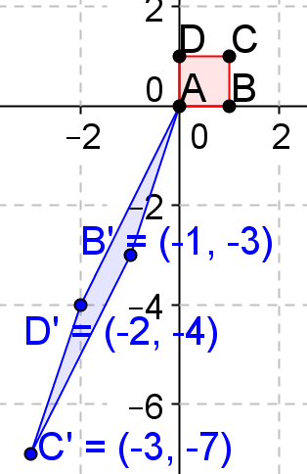

  - $\left[\begin{matrix}-1 & -3 \\ 2 & 4\end{matrix}\right]$
$\left[\begin{matrix}-1 & -3 \\ 2 & 4\end{matrix}\right]\left[\begin{matrix}0 \\ 0\end{matrix}\right]=\left[\begin{matrix}0 \\ 0\end{matrix}\right], \left[\begin{matrix}-1 & -3 \\ 2 & 4\end{matrix}\right]\left[\begin{matrix}1 \\ 0\end{matrix}\right]=\left[\begin{matrix}-1 \\ 2\end{matrix}\right], \left[\begin{matrix}-1 & -3 \\ 2 & 4\end{matrix}\right]\left[\begin{matrix}1 \\ 1\end{matrix}\right]=\left[\begin{matrix}-4 \\ 6\end{matrix}\right]$, and $\left[\begin{matrix}-1 & -3 \\ 2 & 4\end{matrix}\right]\left[\begin{matrix}0 \\ 1\end{matrix}\right]=\left[\begin{matrix}-3 \\ 4\end{matrix}\right]$
Determinant: $ad-bc=-4+6=2$ $Area=\left|ad-bc\right|=\left|-4+6\right|=2 square units$
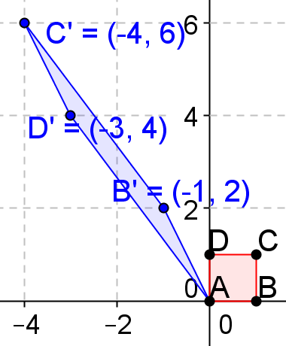

  - $\left[\begin{matrix}1 & 3 \\ -2 & -4\end{matrix}\right]$
$\left[\begin{matrix}1 & 3 \\ -2 & -4\end{matrix}\right]\left[\begin{matrix}0 \\ 0\end{matrix}\right]=\left[\begin{matrix}0 \\ 0\end{matrix}\right], \left[\begin{matrix}1 & 3 \\ -2 & -4\end{matrix}\right]\left[\begin{matrix}1 \\ 0\end{matrix}\right]=\left[\begin{matrix}1 \\ -2\end{matrix}\right], \left[\begin{matrix}1 & 3 \\ -2 & -4\end{matrix}\right]\left[\begin{matrix}1 \\ 1\end{matrix}\right]=\left[\begin{matrix}4 \\ -6\end{matrix}\right]$, and $\left[\begin{matrix}1 & 3 \\ -2 & -4\end{matrix}\right]\left[\begin{matrix}0 \\ 1\end{matrix}\right]=\left[\begin{matrix}3 \\ -4\end{matrix}\right]$
Determinant: $ad-bc=-4+6=2$ $Area=\left|ad-bc\right|=\left|-4+6\right|=2 square units$
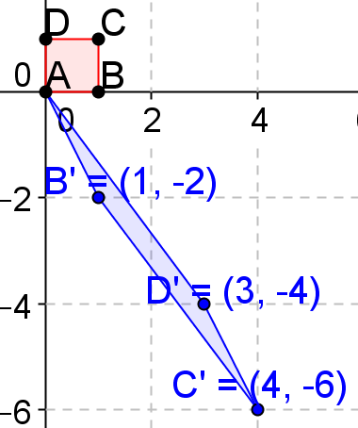

  - $\left[\begin{matrix}-1 & 3 \\ -2 & 4\end{matrix}\right]$
$\left[\begin{matrix}-1 & 3 \\ -2 & 4\end{matrix}\right]\left[\begin{matrix}0 \\ 0\end{matrix}\right]=\left[\begin{matrix}0 \\ 0\end{matrix}\right], \left[\begin{matrix}-1 & 3 \\ -2 & 4\end{matrix}\right]\left[\begin{matrix}1 \\ 0\end{matrix}\right]=\left[\begin{matrix}-1 \\ -2\end{matrix}\right], \left[\begin{matrix}-1 & 3 \\ -2 & 4\end{matrix}\right]\left[\begin{matrix}1 \\ 1\end{matrix}\right]=\left[\begin{matrix}2 \\ 2\end{matrix}\right]$, and $\left[\begin{matrix}-1 & 3 \\ -2 & 4\end{matrix}\right]\left[\begin{matrix}0 \\ 1\end{matrix}\right]=\left[\begin{matrix}3 \\ 4\end{matrix}\right]$
Determinant: $ad-bc=-4+6=2$ $Area=\left|ad-bc\right|=\left|-4+6\right|=2 square units$
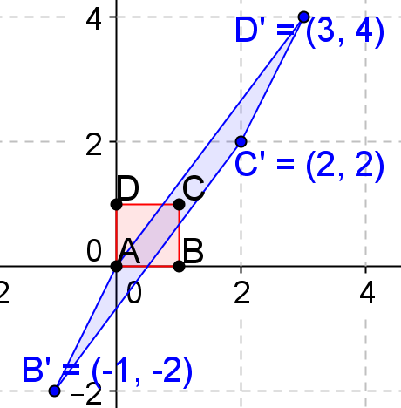

  - $\left[\begin{matrix}1 & -3 \\ 2 & -4\end{matrix}\right]$
$\left[\begin{matrix}1 & -3 \\ 2 & -4\end{matrix}\right]\left[\begin{matrix}0 \\ 0\end{matrix}\right]=\left[\begin{matrix}0 \\ 0\end{matrix}\right], \left[\begin{matrix}1 & -3 \\ 2 & -4\end{matrix}\right]\left[\begin{matrix}1 \\ 0\end{matrix}\right]=\left[\begin{matrix}1 \\ 2\end{matrix}\right], \left[\begin{matrix}1 & -3 \\ 2 & -4\end{matrix}\right]\left[\begin{matrix}1 \\ 1\end{matrix}\right]=\left[\begin{matrix}-2 \\ -2\end{matrix}\right]$, and $\left[\begin{matrix}1 & -3 \\ 2 & -4\end{matrix}\right]\left[\begin{matrix}0 \\ 1\end{matrix}\right]=\left[\begin{matrix}-3 \\ -4\end{matrix}\right]$
Determinant: $ad-bc=-4+6=-2$ $Area=\left|ad-bc\right|=\left|-4+6\right|=2 square units$
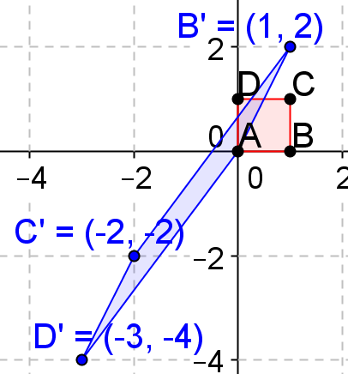
  - $\left[\begin{matrix}-1 & 3 \\ 2 & -4\end{matrix}\right]$
$\left[\begin{matrix}-1 & 3 \\ 2 & -4\end{matrix}\right]\left[\begin{matrix}0 \\ 0\end{matrix}\right]=\left[\begin{matrix}0 \\ 0\end{matrix}\right], \left[\begin{matrix}-1 & 3 \\ 2 & -4\end{matrix}\right]\left[\begin{matrix}1 \\ 0\end{matrix}\right]=\left[\begin{matrix}-1 \\ 2\end{matrix}\right], \left[\begin{matrix}-1 & 3 \\ 2 & -4\end{matrix}\right]\left[\begin{matrix}1 \\ 1\end{matrix}\right]=\left[\begin{matrix}2 \\ -2\end{matrix}\right]$, and $\left[\begin{matrix}-1 & 3 \\ 2 & -4\end{matrix}\right]\left[\begin{matrix}0 \\ 1\end{matrix}\right]=\left[\begin{matrix}3 \\ -4\end{matrix}\right]$
Determinant: $ad-bc=4-6=-2$ $Area=\left|ad-bc\right|=\left|4-6\right|=2 square units$
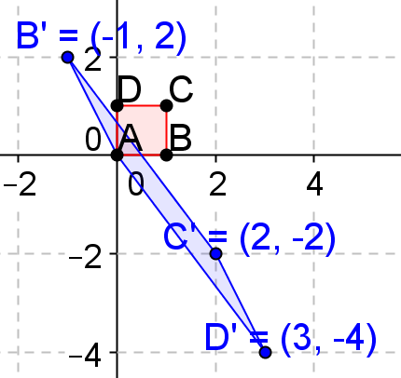

  - $\left[\begin{matrix}1 & -3 \\ -2 & 4\end{matrix}\right]$
$\left[\begin{matrix}1 & -3 \\ -2 & 4\end{matrix}\right]\left[\begin{matrix}0 \\ 0\end{matrix}\right]=\left[\begin{matrix}0 \\ 0\end{matrix}\right], \left[\begin{matrix}1 & -3 \\ -2 & 4\end{matrix}\right]\left[\begin{matrix}1 \\ 0\end{matrix}\right]=\left[\begin{matrix}1 \\ -2\end{matrix}\right], \left[\begin{matrix}1 & -3 \\ -2 & 4\end{matrix}\right]\left[\begin{matrix}1 \\ 1\end{matrix}\right]=\left[\begin{matrix}-2 \\ 2\end{matrix}\right]$, and $\left[\begin{matrix}1 & -3 \\ -2 & 4\end{matrix}\right]\left[\begin{matrix}0 \\ 1\end{matrix}\right]=\left[\begin{matrix}-3 \\ 4\end{matrix}\right]$
Determinant: $ad-bc=4-6=2$ $Area=\left|ad-bc\right|=\left|4-6\right|=2 square units$
