Lesson 23: Modeling Video Game Motion with Matrices

Student Outcomes
- Students use matrix transformations to model circular motion.
- Students use coordinate transformations to represent a combination of motions.

Lesson Notes
Students have recently learned how to represent rotations as matrix transformations. In this lesson, they apply that knowledge to represent dynamic motion, as seen in video games. Students analyze circular motion that involves a time parameter such as $G\left(t\right)=\left(\begin{matrix}\cos\left(\frac{π}{2}∙t\right) & -\sin\left(\frac{π}{2}∙t\right) \\ \sin\left(\frac{π}{2}∙t\right) & \cos\left(\frac{π}{2}∙t\right)\end{matrix}\right)$. The second part of the lesson involves modeling a combination of motions. For instance, students model motion along a circle followed by a translation, or motion along a line followed by a translation.

Classwork
The opening exercise allows students to practice matrix transformations and plot the results. This prepares students for skills needed in this lesson. Work through this as a whole class asking questions to assess student understanding. Use this as a way to clear up misconceptions.

Opening Exercise (5 minutes)
Opening Exercise
Let $R\left(\begin{matrix}x \\ y\end{matrix}\right)=\left(\begin{matrix}\cos\left(\frac{π}{3}\right) & -sin\left(\frac{π}{3}\right) \\ \sin\left(\frac{π}{3}\right) & \cos\left(\frac{π}{3}\right)\end{matrix}\right)\left(\begin{matrix}x \\ y\end{matrix}\right)$.
  - Describe the geometric effect of performing the transformation $\left(\begin{matrix}x \\ y\end{matrix}\right)→R\left(\begin{matrix}x \\ y\end{matrix}\right)$.
Applying $R$ rotates each point in the plane about the origin through $\frac{π}{3}$ radians in a counter-clockwise direction.

  - Plot the point $\left(\begin{matrix}1 \\ 0\end{matrix}\right)$, then find $R\left(\begin{matrix}1 \\ 0\end{matrix}\right)$ and plot it.
$$R\left(\begin{matrix}1 \\ 0\end{matrix}\right)=\left(\begin{matrix}cos\left(\frac{π}{3}\right) \\ sin\left(\frac{π}{3}\right)\end{matrix}\right)$$

  - If we want to show that $R$ has been applied twice to $\left(1,0\right)$, we can write $R^{2}\left(\begin{matrix}1 \\ 0\end{matrix}\right),$ which represents $R\left(R\left(\begin{matrix}1 \\ 0\end{matrix}\right)\right)$. Find $R^{2}\left(\begin{matrix}1 \\ 0\end{matrix}\right)$, and plot it. Then find $R^{3}\left(\begin{matrix}1 \\ 0\end{matrix}\right)=R\left(R\left(R\left(\begin{matrix}1 \\ 0\end{matrix}\right)\right)\right)$, and plot it.
$R^{2}\left(\begin{matrix}1 \\ 0\end{matrix}\right)=\left(\begin{matrix}cos\left(\frac{2π}{3}\right) \\ sin\left(\frac{2π}{3}\right)\end{matrix}\right)$; $R^{3}\left(\begin{matrix}1 \\ 0\end{matrix}\right)=\left(\begin{matrix}cos(π) \\ sin(π)\end{matrix}\right)$
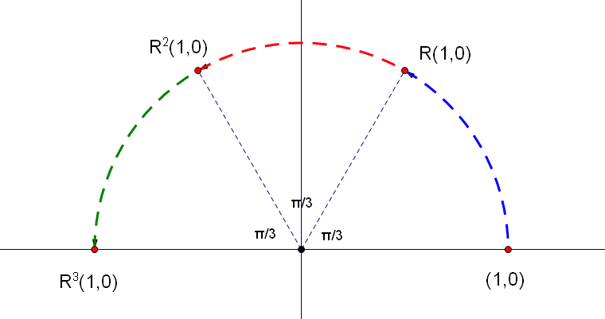
MP.7
  - Describe the matrix transformation $\left(\begin{matrix}x \\ y\end{matrix}\right)→R^{2}\left(\begin{matrix}x \\ y\end{matrix}\right)$ using a single matrix.
$R^{2}\left(\begin{matrix}x \\ y\end{matrix}\right)$ is the transformation that rotates points through $2∙\frac{π}{3}$ radians, so a formula for $R^{2}\left(\begin{matrix}x \\ y\end{matrix}\right)$ is $\left(\begin{matrix}cos\left(\frac{2π}{3}\right) & -sin\left(\frac{2π}{3}\right) \\ sin\left(\frac{2π}{3}\right) & cos\left(\frac{2π}{3}\right)\end{matrix}\right)\left(\begin{matrix}x \\ y\end{matrix}\right)$.

Discussion (3 minutes): Circular Motion over Time
Let $R\left(t\right)=\left(\begin{matrix}cos⁡t & -sin⁡t \\ sin⁡t & cos⁡t\end{matrix}\right)\left(\begin{matrix}1 \\ 0\end{matrix}\right)$.
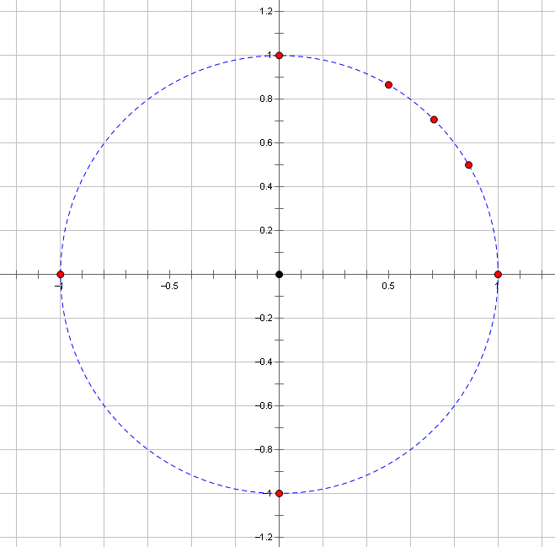
Suppose that $t$ is measured in degrees. Let’s place several input-output pairs for this function on a graph:
- $R\left(30\right)=(0.87,0.50)$ $R\left(45\right)=(0.71,0.71)$ $R\left(60\right)=(0.50,0.87)$
- $R\left(90\right)= (0,1)$ $R\left(180\right)= (-1,0)$ $R\left(270\right)= (0,-1)$ $R\left(360\right)= (1,0)$

- What do you notice about the points on the graph?
  - The points appear to lie on a circle.
- How could we be sure the points are actually on a circle?
  - If each point is the same distance from the origin, then the points form a circle.
- Now check and see if this is, in fact, the case. Have different students find the distance to the origin from given points.
  - Students check the distance from a given point to the origin and confirm using the distance formula. For example $R\left(30\right)=(0.87, 0.50)$. Its distance from the origin is $\sqrt{{(0.87-0)}^{2}+{(0.5-0)}^{2}}=1$.
- What is the result of $R(t)$?
  - $R\left(t\right)=\left(\begin{matrix}cos⁡t & -sin⁡t \\ sin⁡t & cos⁡t\end{matrix}\right)\left(\begin{matrix}1 \\ 0\end{matrix}\right)=\left(\begin{matrix}\cos{t} \\ \sin{t}\end{matrix}\right)$
- Does this result ensure points lie on a circle?
  - Yes, this would confirm that the points lie on the unit circle because the $x$-value corresponds to cosine of an angle $t$ and the $y$-value corresponds to sine of the same angle on the unit circle.

Exercise 1 (4 minutes)
This exercise provides students more practice with matrices representing rotations. This time, the angle is different in each function, allowing them to compare the results. Give students time to work on the following problems independently; then call on students to share their responses with the class.
Exercises
- Let $f\left(t\right)=\left(\begin{matrix}cos⁡(2t) & -sin(2t) \\ sin(2t) & cos(2t)\end{matrix}\right)\left(\begin{matrix}1 \\ 0\end{matrix}\right)$, and let $g\left(t\right)=\left(\begin{matrix}\cos\left(\frac{t}{2}\right) & -sin\left(\frac{t}{2}\right) \\ sin\left(\frac{t}{2}\right) & cos\left(\frac{t}{2}\right)\end{matrix}\right)\left(\begin{matrix}1 \\ 0\end{matrix}\right)$.
  - Suppose $f(t)$ represents the position of a moving object that starts at $(1,0)$. How long does it take for this object to return to its starting point? When the argument of the trigonometric function changes from $t$ to $2t$, what effect does this have?
The object will return to $(1,0)$ when $2t=2π$. Thus it will take $t=π$ seconds for this to happen. Changing the argument from $t$ to $2t$ causes the object to move twice as fast.

  - If the position is given instead by $g\left(t\right)$, how long would it take the object to return to its starting point? When the argument of the trigonometric functions changes from $t$ to $\frac{t}{2}$, what effect does this have?
The object will return to $(1,0)$ when $\frac{t}{2}=2π$. Thus it will take $t=4π$ seconds for this to happen. Changing the argument from $t$ to $\frac{t}{2}$ causes the object to move half as fast.

Example 1 (4 minutes)
Let $F\left(t\right)=\left(\begin{matrix}cos⁡t & -sin⁡t \\ sin⁡t & cos⁡t\end{matrix}\right)\left(\begin{matrix}3 \\ 2\end{matrix}\right)$.
- This time we’ll measure $t$ in radians. Find $F\left(\frac{π}{2}\right)$, $F(π)$, $F\left(\frac{3π}{2}\right)$, and $F(2π)$.
  - $F\left(\frac{π}{2}\right)= \left(\begin{matrix}cos⁡({\frac{π}{2}}) & -\sin\left(\frac{π}{2}\right) \\ \sin\left(\frac{π}{2}\right) & \cos\left(\frac{π}{2}\right) \end{matrix}\right)\left(\begin{matrix}3 \\ 2\end{matrix}\right)=\left(\begin{matrix}0 & -1 \\ 1 & 0\end{matrix}\right)\left(\begin{matrix}3 \\ 2\end{matrix}\right)=\left(\begin{matrix}0±2 \\ 3+0\end{matrix}\right)=\left(\begin{matrix}-2 \\ 3\end{matrix}\right)$
  - $F\left(π\right)= \left(\begin{matrix}\cos{(π}) & -\sin\left(π\right) \\ \sin\left(π\right) & \cos\left(π\right)\end{matrix}\right)\left(\begin{matrix}3 \\ 2\end{matrix}\right)=\left(\begin{matrix}-1 & 0 \\ 0 & -1\end{matrix}\right)\left(\begin{matrix}3 \\ 2\end{matrix}\right)=\left(\begin{matrix}-3+0 \\ 0+-2\end{matrix}\right)=\left(\begin{matrix}-3 \\ -2\end{matrix}\right)$
  - $F\left(\frac{3π}{2}\right)= \left(\begin{matrix}\cos{(}\frac{3π}{2}) & -\sin\left(\frac{3π}{2}\right) \\ \sin\left(\frac{3π}{2}\right) & \cos\left(\frac{3π}{2}\right) \end{matrix}\right)\left(\begin{matrix}3 \\ 2\end{matrix}\right)=\left(\begin{matrix}0 & 1 \\ -1 & 0\end{matrix}\right)\left(\begin{matrix}3 \\ 2\end{matrix}\right)=\left(\begin{matrix}0+2 \\ -3+0\end{matrix}\right)=\left(\begin{matrix}2 \\ -3\end{matrix}\right)$
  - $F\left(2π\right)= \left(\begin{matrix}\cos{(2π}) & -\sin\left(2π\right) \\ \sin\left(2π\right) & \cos\left(2π\right)\end{matrix}\right)\left(\begin{matrix}3 \\ 2\end{matrix}\right)=\left(\begin{matrix}1 & 0 \\ 0 & 1\end{matrix}\right)\left(\begin{matrix}3 \\ 2\end{matrix}\right)=\left(\begin{matrix}3+0 \\ 0+2\end{matrix}\right)=\left(\begin{matrix}3 \\ 2\end{matrix}\right)$
- When we plot points, we see once again that they appear to lie on a circle. Make sure this is really true.
  - $F\left(t\right)=\left(\begin{matrix}cos⁡t & -sin⁡t \\ sin⁡t & cos⁡t\end{matrix}\right)\left(\begin{matrix}3 \\ 2\end{matrix}\right)=\left(\begin{matrix}3 cos{t}-2 sin{t} \\ 3 sin{t+2 cos{t}}\end{matrix}\right)$
  - ${(3 cos{t}-2 sin{t)}}^{2}+{( 3 sin{t+}2 cos{t)}}^{2}$
  - ${9 cos}^{2}{t-12 cos{t\sin{t}}}+4 \sin^{2}{t }+9 \sin^{2}{t}+12 cos{t}\sin{t}+4 \cos^{2}{t}$
  - $9\left(\cos^{2}{t}+\sin^{2}{t}\right)+4\left(\sin^{2}{t}+\cos^{2}{t}\right)$
  - $9\left(1\right)+4\left(1\right)=9+4=13$
  - Thus each point is $\sqrt{13}$ units from the origin, which confirms that the outputs lie on a circle.
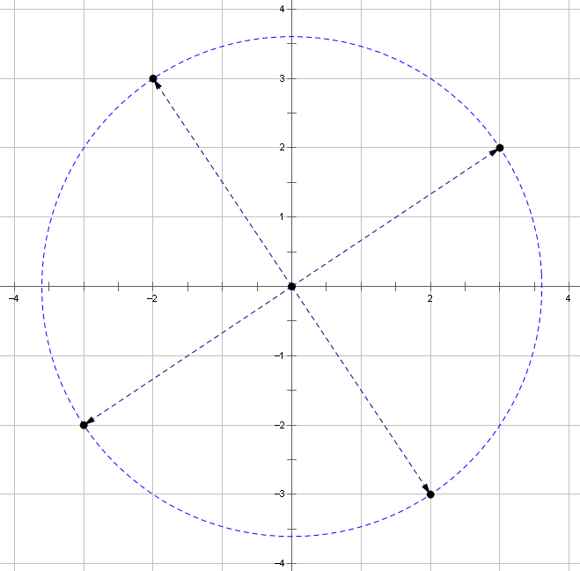
Discussion (4 minutes): Rotations that Use a Time Parameter
Let $F\left(t\right)=\left(\begin{matrix}\cos\left(\frac{π}{2}∙t\right) & -\sin\left(\frac{π}{2}∙t\right) \\ \sin\left(\frac{π}{2}∙t\right) & \cos\left(\frac{π}{2}∙t\right)\end{matrix}\right)\left(\begin{matrix}1 \\ 0\end{matrix}\right)$.
- Draw the path that $P=F(t)$ traces out as $t$ varies within each of the following intervals:
  - $0≤t≤1$
  - $1≤t≤2$
  - $2≤t≤3$
  - $3≤t≤4$
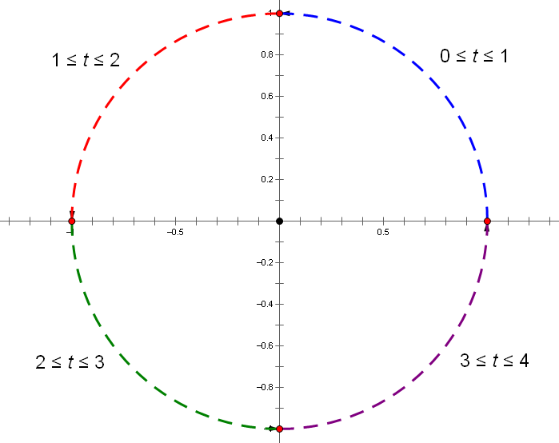
- Where will the object be located at $t=0.5$ seconds?
  - $f\left(0.5\right)=\left(\cos\left(\frac{π}{4}\right),\sin\left(\frac{π}{4}\right)\right)≈\left(0.71,0.71\right).$
- How long will it take the object to reach $(0.71,-0.71)$?
  - These coordinates represent $\left(\cos\left(\frac{7π}{4}\right),\sin\left(\frac{7π}{4}\right)\right)$, so $\left(\cos\left(\frac{π}{2}∙\frac{7}{2}\right),\sin\left(\frac{π}{2}∙\frac{7}{2}\right)\right)$. The object reaches this location at $t=\frac{7}{2}=3.5$ seconds.

Exercises 2–3 (5 minutes)
Give students time to complete the following exercises; then ask them to compare their responses with a partner. Call on students to share their responses with the class.

- Let $G\left(t\right)=\left(\begin{matrix}\cos\left(\frac{π}{2}∙t\right) & -sin\left(\frac{π}{2}∙t\right) \\ \sin\left(\frac{π}{2}∙t\right) & \cos\left(\frac{π}{2}∙t\right)\end{matrix}\right)\left(\begin{matrix}0 \\ 1\end{matrix}\right).$
  - Draw the path that $P=G(t)$ traces out as $t$ varies within the interval $0≤t≤1$.

  - Where will the object be at $t=3$ seconds?
$$G\left(3\right)=(1,0)$$

  - How long will it take the object to reach $(0,-1)$?
These coordinates represent $(\cos\left(π\right),\sin\left(π\right))$, so $\left(\cos\left(\frac{π}{2}∙2\right)\text{,}\sin\left(\frac{π}{2}∙2\right)\right)$, the object reaches this location at $t=2$ seconds. $G\left(2\right)=(0,-1)$, so it will take $2$ seconds to reach that location.
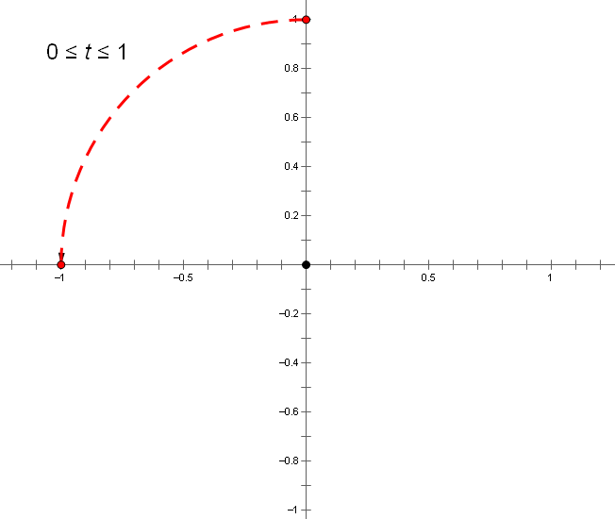

- Let $H\left(t\right)=\left(\begin{matrix}\cos\left(\frac{π}{2}∙t\right) & -sin\left(\frac{π}{2}∙t\right) \\ \sin\left(\frac{π}{2}∙t\right) & \cos\left(\frac{π}{2}∙t\right)\end{matrix}\right)\left(\begin{matrix}1 \\ 4\end{matrix}\right)$.
  - Draw the path that $P=H(t)$ traces out as $t$ varies within the interval $0≤t≤2$.

- Where will the object be at $t=1$ seconds?
$$H\left(1\right)=(-4,1)$$

- How long will it take the object to return to its starting point?
$H\left(4\right)=(1,4)$, so it will take $4$ seconds to return to its starting point.
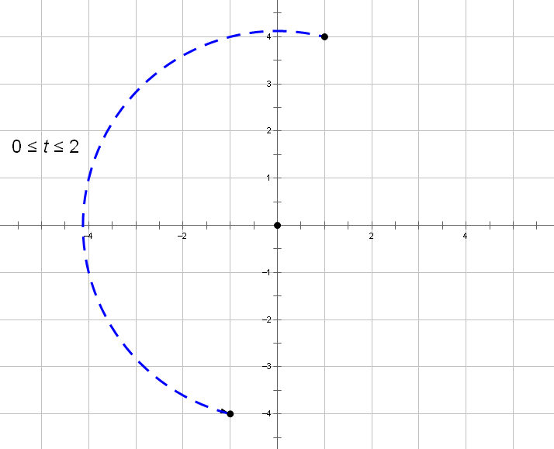
Example 2 (4 minutes)
Let $f\left(t\right)=\left(\begin{matrix}\cos\left(\frac{π}{6}∙t\right) & -\sin\left(\frac{π}{6}∙t\right) \\ \sin\left(\frac{π}{6}∙t\right) & \cos\left(\frac{π}{6}∙t\right)\end{matrix}\right)\left(\begin{matrix}6 \\ 2\end{matrix}\right)$.
- Draw the path that $P=f(t)$ traces out as $t$ varies within each of the following intervals:
  - $0≤t≤1$ $1≤t≤2$ $2≤t≤3$
  - $3≤t≤4$ $4≤t≤5$ $5≤t≤6$
- As an example, can you describe what happens to the object as $t$ varies within the interval $0≤t≤1$?
  - Since $f\left(0\right)=(6,2)$, the object starts its trajectory there. When $t=1$, the object will have moved through $\frac{π}{6}$ radians. So in the time interval $0≤t≤1$, the object moves along a circular arc as shown below.
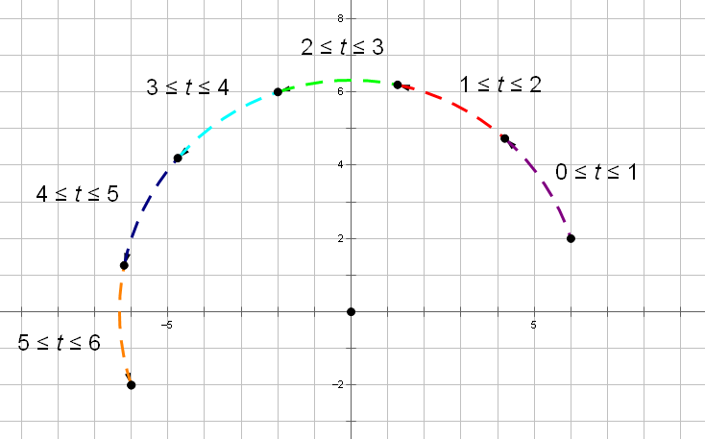
Exercises 4−5 (3 minutes)
Give students time to complete the following exercises; then ask them to compare their responses with a partner. Call on students to share their responses with the class, and use this as an opportunity to check for understanding.

- Suppose you want to write a program that takes the point $(3, 5)$ and rotates it about the origin to the point $(-3,-5)$ over a 1-second interval. Write a function $P=f(t)$ that encodes this rotation.
Let $f\left(t\right)=\left(\begin{matrix}cos⁡(π∙t) & -sin⁡(π∙t) \\ sin⁡(π∙t) & cos⁡(π∙t)\end{matrix}\right)\left(\begin{matrix}3 \\ 5\end{matrix}\right)$. We have $f\left(0\right)=(3,5)$ and $f\left(1\right)=(-3,-5)$, as required.

- If instead you wanted the rotation to take place over a 1.5-second interval, how would your function change?
Let $f\left(t\right)=\left(\begin{matrix}\cos\left(π∙\frac{t}{1}∙5\right) & -sin\left(π∙\frac{t}{1}∙5\right) \\ \sin\left(π∙\frac{t}{1}∙5\right) & \cos\left(π∙\frac{t}{1}∙5\right)\end{matrix}\right)\left(\begin{matrix}3 \\ 5\end{matrix}\right)$. We have $f\left(0\right)=(3,5)$ and $f\left(1.5\right)=(-3,-5)$, as required.

Example 3 (4 minutes)
Let’s analyze the transformation $g\left(t\right)=\left(\begin{matrix}3 \cos\left(\frac{π}{2}∙t\right) & -3 \sin\left(\frac{π}{2}∙t\right) \\ 3 \sin\left(\frac{π}{2}∙t\right) & 3 \cos\left(\frac{π}{2}∙t\right)\end{matrix}\right)\left(\begin{matrix}1 \\ 2\end{matrix}\right)$. In particular, we will compare $g(0)$ and $g(1)$.
- What is $g\left(0\right)?$ What geometric effect does $g(t)$ have on $\left(1, 2\right)$ initially?
  - We have $g\left(0\right)=(3, 6)$, which is a dilation of $(1, 2)$ using scale factor 3.
- What is $g(1)$? Describe what is going on.
- We have $g\left(1\right)=(-6, 3)$, which represents a quarter turn of the point $(3, 6)$ about the origin in a counterclockwise direction.
- Can you summarize the geometric effect of applying $g(t)$ to the point $(1, 2)$ during the time interval
$0≤t≤1$?
  - This transformation combines a quarter turn about the origin with a scaling by a factor of 3.
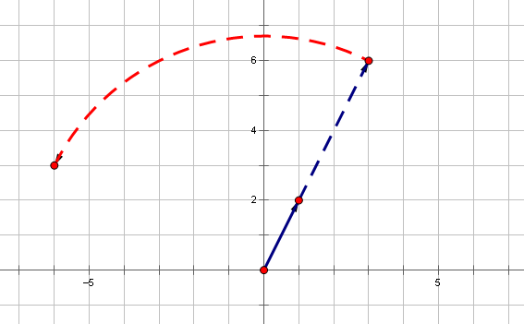
- What is $g(2)$? Describe what is going on.
  - We have $g\left(2\right)=(-3,-6)$, which represents a quarter turn of the point $(-6, 3)$ about the origin in a counterclockwise direction.
- What is $g(3)$? Describe what is going on.
  - We have $g\left(3\right)=(6,-3)$, which represents a quarter turn of the point $(-3, -6)$ about the origin in a counterclockwise direction.
- What is $g(4)$? Describe what is going on.
  - We have $g\left(1\right)=(3, 6)$, which represents a quarter turn of the point $(6, -3)$ about the origin in a counterclockwise direction.
- Compare $g(0)$ and $g(4)$. Does this make sense?
  - $g\left(0\right)=g(4)$, this makes sense because 4 quarter turns would be a full rotation, so this would bring you back to the starting point.

Closing (4 minutes)
- Write one to two sentences in your notebook describing what you learned in today’s lesson; then share your response with a partner.
  - We learned how to use matrices to describe rotations that happen over a specific time interval. We also discussed how to model multiple transformations, such as a rotation followed by a translation.

Exit Ticket (5 minutes)
Name Date
Lesson 23: Modeling Video Game Motion with Matrices

Exit Ticket

Write a function $f(t)$ that incorporates the following actions. Make a drawing of the path the point follows during the time interval $0≤t≤3$.
  - During the time interval $0≤t≤1$, move the point $(8, 6)$ through $\frac{π}{4}$ radians about the origin in a counter-clockwise direction.

  - During the time interval $1<t≤3$, move the image along a straight line to $(6,-8)$.

Exit Ticket Sample Solutions

Write a function $f(t)$ that incorporates the following actions. Make a drawing of the path the point follows during the time interval $0≤t≤3$.
  - During the time interval $0≤t≤1$, move the point $(8,6)$ through $\frac{π}{4}$ radians about the origin in a counter-clockwise direction.
$$f\left(t\right)=\left(\begin{matrix}cos\left(\frac{ πt }{ 4 }\right) & -sin\left(\frac{ πt }{ 4 }\right) \\ sin\left(\frac{ πt }{ 4 }\right) & cos\left(\frac{ πt }{ 4 }\right)\end{matrix}\right)\left(\begin{matrix}8 \\ 6\end{matrix}\right), 0≤t≤1$$
$$f\left(0\right)=\left(\begin{matrix}cos\left(0\right) & -sin\left(0\right) \\ sin\left(0\right) & cos\left(0\right)\end{matrix}\right)\left(\begin{matrix}8 \\ 6\end{matrix}\right)=\left(\begin{matrix}1 & 0 \\ 0 & 1\end{matrix}\right)\left(\begin{matrix}8 \\ 6\end{matrix}\right)=\left(\begin{matrix}8 \\ 6\end{matrix}\right)$$
$$f\left(1\right)=\left(\begin{matrix}cos\left(\frac{ π }{ 4 }\right) & -sin\left(\frac{ π }{ 4 }\right) \\ sin\left(\frac{ π }{ 4 }\right) & cos\left(\frac{ π }{ 4 }\right)\end{matrix}\right)\left(\begin{matrix}8 \\ 6\end{matrix}\right)=\left(\begin{matrix}\frac{\sqrt{2}}{2} & \frac{-\sqrt{2}}{2} \\ \frac{\sqrt{2}}{2} & \frac{\sqrt{2}}{2}\end{matrix}\right)\left(\begin{matrix}8 \\ 6\end{matrix}\right)=\left(\begin{matrix}\sqrt{2} \\ 7\sqrt{2}\end{matrix}\right) ≈\left(\begin{matrix}1.41 \\ 9.90\end{matrix}\right)$$

  - During the time interval $1<t≤3$, move the image along a straight line to $(6,-8)$.
The image is $\left(\begin{matrix}\sqrt{2} \\ 7\sqrt{2}\end{matrix}\right)→\left(\begin{matrix}6 \\ -8\end{matrix}\right)$ in $2$ seconds from $1<t≤3$.
$$\sqrt{2}-kt=6 \\ \sqrt{2}-2k=6 \\ k=\frac{\sqrt{2}-6 }{2}$$ | $$\sqrt{72}-mt=-8 \\ 7\sqrt{2}-2m=-8 \\ m=\frac{7\sqrt{2}+8 }{2}$$
$$h\left(t\right)=\left(\begin{matrix}\sqrt{2}-\frac{\left(\sqrt{2}-6\right)t }{3} \\ 7\sqrt{2}-\frac{\left(7\sqrt{2}+8\right)t }{3}\end{matrix}\right)$$

Problem Set Sample Solutions

- Let $R\left(\begin{matrix}x \\ y\end{matrix}\right)=\left(\begin{matrix}cos\frac{ π }{4} & -sin\frac{ π }{4} \\ sin\frac{ π }{4} & cos\frac{ π }{4}\end{matrix}\right)\left(\begin{matrix}x \\ y\end{matrix}\right)$, find the following.
  - $R^{2}\left(\begin{matrix}\sqrt{2} \\ \sqrt{2}\end{matrix}\right)$
$$R^{2}\left(\begin{matrix}\sqrt{2} \\ \sqrt{2}\end{matrix}\right)=R\left(R\left(\begin{matrix}\sqrt{2} \\ \sqrt{2}\end{matrix}\right)\right)=R\left(\left(\begin{matrix}cos\frac{π}{4} & -sin\frac{π}{4} \\ sin\frac{π}{4} & cos\frac{π}{4}\end{matrix}\right)\left(\begin{matrix}\sqrt{2} \\ \sqrt{2}\end{matrix}\right)\right)=R\left(\left(\begin{matrix}\frac{\sqrt{2}}{2} & -\frac{\sqrt{2}}{2} \\ \frac{\sqrt{2}}{2} & \frac{\sqrt{2}}{2}\end{matrix}\right)\left(\begin{matrix}\sqrt{2} \\ \sqrt{2}\end{matrix}\right)\right)$$
$$=R\left(\begin{matrix}0 \\ 2\end{matrix}\right)=\left(\begin{matrix}cos\frac{π}{4} & -sin\frac{π}{4} \\ sin\frac{π}{4} & cos\frac{π}{4}\end{matrix}\right)\left(\begin{matrix}0 \\ 2\end{matrix}\right)=\left(\begin{matrix}\frac{\sqrt{2}}{2} & -\frac{\sqrt{2}}{2} \\ \frac{\sqrt{2}}{2} & \frac{\sqrt{2}}{2}\end{matrix}\right)\left(\begin{matrix}0 \\ 2\end{matrix}\right)=\left(\begin{matrix}-\sqrt{2} \\ \sqrt{2}\end{matrix}\right)$$
  - How many transformations do you need to take so that the image returns to where it started?
It rotates by $\frac{π}{4}$ radians for each transformation; therefore, it takes $8$ times to get to $2π$, which is where it started.

  - Describe the matrix transformation $\left(\begin{matrix}x \\ y\end{matrix}\right)→R^{2}\left(\begin{matrix}x \\ y\end{matrix}\right),$and $R^{n}\left(\begin{matrix}x \\ y\end{matrix}\right)$ using a single matrix.
$R^{2}=\left(\begin{matrix}x \\ y\end{matrix}\right)$ is the transformation that rotates the point through $2×\frac{π}{3}$ radian, so a formula for${ R}^{2}\left(\begin{matrix}x \\ y\end{matrix}\right)$ is
$$\left(\begin{matrix}cos\frac{2π}{4} & -sin\frac{2π}{4} \\ sin\frac{2π}{4} & cos\frac{2π}{4}\end{matrix}\right)\left(\begin{matrix}x \\ y\end{matrix}\right)=\left(\begin{matrix}cos\frac{π}{2} & -sin\frac{π}{2} \\ sin\frac{π}{2} & cos\frac{π}{2}\end{matrix}\right)\left(\begin{matrix}x \\ y\end{matrix}\right)=\left(\begin{matrix}x∙cos\frac{π}{2}-y∙sin\frac{π}{2} \\ x∙sin\frac{π}{2}+y∙cos\frac{π}{2}\end{matrix}\right)\text{.}$$
$$R^{n}=\left(\begin{matrix}x \\ y\end{matrix}\right) \text{is} \left(\begin{matrix}x∙cos\frac{nπ}{4}-y∙sin\frac{nπ}{4} \\ x∙sin\frac{nπ}{4}+y∙cos\frac{nπ}{4}\end{matrix}\right)\text{.}$$

- For $f\left(t\right)=\left(\begin{matrix}cos(t) & -sin(t) \\ sin(t) & cos(t)\end{matrix}\right)\left(\begin{matrix}1 \\ 1\end{matrix}\right)$, it takes $2π$ to transform the object at $\left(\begin{matrix}1 \\ 1\end{matrix}\right)$ back to where it starts. How long does it take the following functions to return to their starting point?
  - $f\left(t\right)=\left(\begin{matrix}cos(3t) & -sin(3t) \\ sin(3t) & cos(3t)\end{matrix}\right)\left(\begin{matrix}1 \\ 1\end{matrix}\right)$
$$3t=2π, t=\frac{2π}{3}$$

  - $f\left(t\right)=\left(\begin{matrix}cos\left(\frac{ t }{3}\right) & -sin\left(\frac{ t }{3}\right) \\ sin\left(\frac{ t }{3}\right) & cos\left(\frac{ t }{3}\right)\end{matrix}\right)\left(\begin{matrix}1 \\ 1\end{matrix}\right)$
$$\frac{t}{3}=2π, t=6π$$

  - $f\left(t\right)=\left(\begin{matrix}cos\left(\frac{ 2t }{5}\right) & -sin\left(\frac{ 2t }{5}\right) \\ sin\left(\frac{ 2t }{5}\right) & cos\left(\frac{ 2t }{5}\right)\end{matrix}\right)\left(\begin{matrix}1 \\ 1\end{matrix}\right)$
$$\frac{2t}{5}=2π, t=5π$$

- Let $F\left(t\right)=\left(\begin{matrix}cos(t) & -sin(t) \\ sin(t) & cos(t)\end{matrix}\right)\left(\begin{matrix}2 \\ 1\end{matrix}\right)$, where $t$is measured in radians. Find the following:
  - $F\left(\frac{ 3π }{2}\right), F\left(\frac{ 7π }{6}\right)$ and the radius of the path.
$$F\left(\frac{3π}{2}\right)=\left(\begin{matrix}cos(\frac{3π}{2}) & -sin(\frac{3π}{2}) \\ sin(\frac{3π}{2}) & cos(\frac{3π}{2})\end{matrix}\right)\left(\begin{matrix}2 \\ 1\end{matrix}\right)=\left(\begin{matrix}0 & 1 \\ -1 & 0\end{matrix}\right)\left(\begin{matrix}2 \\ 1\end{matrix}\right)=\left(\begin{matrix}1 \\ -2\end{matrix}\right)$$
$$F\left(\frac{7π}{6}\right)=\left(\begin{matrix}cos(\frac{7π}{6}) & -sin(\frac{7π}{6}) \\ sin(\frac{7π}{6}) & cos(\frac{7π}{6})\end{matrix}\right)\left(\begin{matrix}2 \\ 1\end{matrix}\right)=\left(\begin{matrix}-\frac{\sqrt{3}}{2} & \frac{1}{2} \\ -\frac{1}{2} & -\frac{\sqrt{3}}{2}\end{matrix}\right)\left(\begin{matrix}2 \\ 1\end{matrix}\right)=\left(\begin{matrix}-\sqrt{3}+\frac{1}{2} \\ -1-\frac{\sqrt{3}}{2}\end{matrix}\right)$$
The path of the point from $0≤t≤2π$ is a circle with a center at $(0, 0)$.
Thus, the radius $=\sqrt{x^{2}+y^{2}}=\sqrt{{(1)}^{2}+{\left(2\right)}^{2}}=\sqrt{5}$ or
the radius $=\sqrt{x^{2}+y^{2}}=\sqrt{{\left(-\sqrt{3}+\frac{1}{2}\right)}^{2}+{\left(-1-\frac{\sqrt{3}}{2}\right)}^{2}}=\sqrt{5}$.

  - Show that the radius is always $\sqrt{x^{2}+y^{2}}$ for the path of this transformation $\left(t\right)=\left(\begin{matrix}cos(t) & -sin(t) \\ sin(t) & cos(t)\end{matrix}\right)\left(\begin{matrix}x \\ y\end{matrix}\right)$ .
$F\left(t\right)=\left(\begin{matrix}cos(t) & -sin(t) \\ sin(t) & cos(t)\end{matrix}\right)\left(\begin{matrix}x \\ y\end{matrix}\right)=\left(\begin{matrix}x cos\left(t\right)-y sin(t) \\ x sin\left(t\right)+y cos(t)\end{matrix}\right)$
$$\text{The radius}=\sqrt{{\left(x cos\left(t\right)-y sin(t)\right)}^{2}+{\left(x sin\left(t\right)+y cos\left(t\right)\right)}^{2}} \\ =\sqrt{x^{2}cos^{2}\left(t\right)-2xy cos\left(t\right)sin\left(t\right)+y^{2}sin^{2}\left(t\right)+x^{2}sin^{2}\left(t\right)+2xy sin\left(t\right)cos\left(t\right)+y^{2}cos^{2}\left(t\right)} \\ =\sqrt{x^{2}cos^{2}\left(t\right)+x^{2}sin^{2}\left(t\right)+y^{2}sin^{2}\left(t\right)+y^{2}cos^{2}\left(t\right)} \\ =\sqrt{x^{2}\left(cos^{2}\left(t\right)+sin^{2}\left(t\right)\right)+y^{2}\left(cos^{2}\left(t\right)+sin^{2}\left(t\right)\right)} \\ =\sqrt{x^{2}+y^{2}}$$

- Let $F\left(t\right)=\left(\begin{matrix}cos\left(\frac{ πt }{2}\right) & -sin\left(\frac{ πt }{2}\right) \\ sin\left(\frac{ πt }{2}\right) & cos\left(\frac{ πt }{2}\right)\end{matrix}\right)\left(\begin{matrix}4 \\ 4\end{matrix}\right)$, where $t$is a real number.
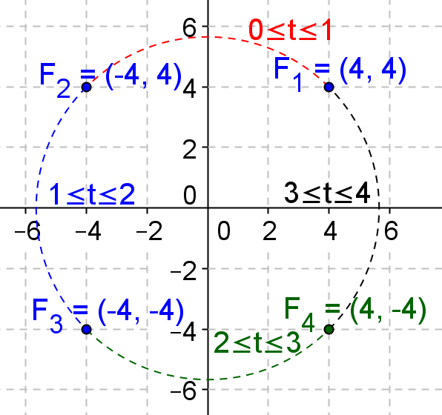
  - Draw the path that $P=F(t)$ traces out as $t$ varies within each of the following intervals:
    - $0≤t≤1$
    - $1≤t≤2$
    - $2≤t≤3$
    - $3≤t≤4$

  - Where will the object be located at $t=2.5$ seconds?
$$F\left(2.5\right)=\left(\begin{matrix}cos\left(\frac{5π}{4}\right) & -sin\left(\frac{5π}{4}\right) \\ sin\left(\frac{5π}{4}\right) & cos\left(\frac{5π}{4}\right)\end{matrix}\right)\left(\begin{matrix}4 \\ 4\end{matrix}\right)=\left(\begin{matrix}\frac{-\sqrt{2}}{2} & \frac{\sqrt{2}}{2} \\ \frac{-\sqrt{2}}{2} & \frac{-\sqrt{2}}{2}\end{matrix}\right)\left(\begin{matrix}4 \\ 4\end{matrix}\right)=\left(\begin{matrix}0 \\ -4\sqrt{2}\end{matrix}\right)$$

  - How long does it take the object to reach $\left(\begin{matrix}-8\sqrt{6} \\ 8\sqrt{2}\end{matrix}\right)$
The point $\left(\begin{matrix}-8\sqrt{6} \\ 8\sqrt{2} \end{matrix}\right)$ is in quadrant 2; the reference angle is $\frac{πt}{2}=arctan\left(\frac{ 8\sqrt{2} }{8\sqrt{6}}\right)=\frac{π}{6}, \frac{πt}{2}=\frac{π}{6}, t=\frac{1}{3}$ seconds.
It takes $1.5$ seconds to rotate the point to $π$; therefore, $1.5-\frac{ 1 }{3}=\frac{ 7 }{6}$ seconds.

- Let $F\left(t\right)=\left(\begin{matrix}cos\left(\frac{ πt }{3}\right) & -sin\left(\frac{ πt }{3}\right) \\ sin\left(\frac{ πt }{3}\right) & cos\left(\frac{ πt }{3}\right)\end{matrix}\right)\left(\begin{matrix}-1 \\ -\sqrt{3}\end{matrix}\right)$
  - Draw the path that $P=F(t)$ traces out as $t$ varies within the interval $0≤t≤1$.
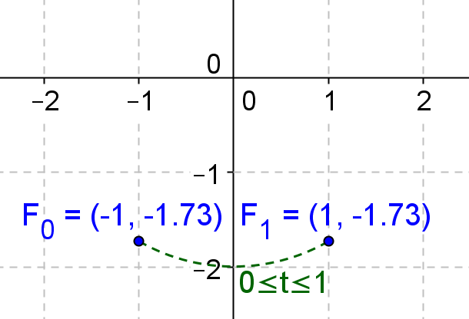

  - How long does it take the object to reach $\left(\sqrt{3},0\right)$
The point $\left(\sqrt{3}, 0\right)$ lies on the $x$-axis. Therefore, $t=2$ seconds to rotate to the point $\left(-1, -\sqrt{3}\right)$.

  - How long does it take the object to return to its starting point?
It takes $6$seconds.

- Find the function that will rotate the point $\left(4, 2\right)$ about the origin to the point $\left(–4,- 2\right)$ over the following time intervals.
  - Over a $1$-second interval
$f\left(t\right)=\left(\begin{matrix}cos\left(πt\right) & -sin\left(πt\right) \\ sin\left(πt\right) & cos\left(πt\right)\end{matrix}\right)\left(\begin{matrix}4 \\ 2\end{matrix}\right)$

  - Over a $2$-second interval
$f\left(t\right)=\left(\begin{matrix}cos\left(\frac{πt}{2}\right) & -sin\left(\frac{πt}{2}\right) \\ sin\left(\frac{πt}{2}\right) & cos\left(\frac{πt}{2}\right)\end{matrix}\right)\left(\begin{matrix}4 \\ 2\end{matrix}\right)$

  - Over a $\frac{1}{3}$-second interval
$f\left(t\right)=\left(\begin{matrix}cos\left(3πt\right) & -sin\left(3πt\right) \\ sin\left(3πt\right) & cos\left(3πt\right)\end{matrix}\right)\left(\begin{matrix}4 \\ 2\end{matrix}\right)$

  - How about rotating it back to where it starts over a $\frac{4}{5}$-second interval?
$$f\left(t\right)=\left(\begin{matrix}cos\left(\frac{5πt}{2}\right) & -sin\left(\frac{5πt}{2}\right) \\ sin\left(\frac{5πt}{2}\right) & cos\left(\frac{5πt}{2}\right)\end{matrix}\right)\left(\begin{matrix}4 \\ 2\end{matrix}\right)$$

- Summarize the geometric effect of the following function at the given point and the time interval.
  - $F\left(t\right)=\left(\begin{matrix}5 cos\left(\frac{ πt }{4}\right) & -5 sin\left(\frac{ πt }{4}\right) \\ 5 sin\left(\frac{ πt }{4}\right) & 5 cos\left(\frac{ πt }{4}\right)\end{matrix}\right)\left(\begin{matrix}4 \\ 3\end{matrix}\right), 0≤t≤1$
At $t=0$, the point $\left(\begin{matrix}4 \\ 3\end{matrix}\right)$ is dilated by a factor of $5$ to $\left(\begin{matrix}20 \\ 15\end{matrix}\right)$
At $t=1$, the image $\left(\begin{matrix}20 \\ 15\end{matrix}\right)$ then is rotated by $\frac{π}{4}$ radians counterclockwise about the origin.

  - $F\left(t\right)=\left(\begin{matrix}\frac{1}{2}cos\left(\frac{ πt }{6}\right) & -\frac{1}{2}sin\left(\frac{ πt }{6}\right) \\ \frac{1}{2}sin\left(\frac{ πt }{6}\right) & \frac{1}{2}cos\left(\frac{ πt }{6}\right)\end{matrix}\right)\left(\begin{matrix}6 \\ 2\end{matrix}\right), 0≤t≤1$
At $t=0$, the point $\left(\begin{matrix}6 \\ 2\end{matrix}\right)$ is dilated by a factor of $\frac{1}{2}$ to $\left(\begin{matrix}3 \\ 1\end{matrix}\right)$
At $t=1$, the image $\left(\begin{matrix}3 \\ 1\end{matrix}\right)$ then is rotated by $\frac{π}{6}$ radians counterclockwise about the origin.

- In programming a computer video game, Grace coded the changing location of a rocket as follows:
At the time $t$ second between $t=0$ seconds and $t=4$ seconds, the location $\left(\begin{matrix}x \\ y\end{matrix}\right)$ of the rocket is given by
$$\left(\begin{matrix}cos\left(\frac{π}{4}t\right) & -sin\left(\frac{π}{4}t\right) \\ sin\left(\frac{π}{4}t\right) & cos\left(\frac{π}{4}t\right)\end{matrix}\right)\left(\begin{matrix}\sqrt{2} \\ \sqrt{2}\end{matrix}\right).$$
At a time of $t$ seconds between $t=4$ and $t=8$ seconds, the location of the rocket is given by
$$\left(\begin{matrix}-\sqrt{2}+\frac{\sqrt{2}}{2} \left(t-4\right) \\ -\sqrt{2}+\frac{\sqrt{2}}{2} \left(t-4\right)\end{matrix}\right).$$
  - What is the location of the rocket at time $t=0$? What is its location at time $t=8$?
At $t=0, \left(\begin{matrix}cos\left(0\right) & -sin\left(0\right) \\ sin\left(0\right) & cos\left(0\right)\end{matrix}\right)\left(\begin{matrix}\sqrt{2} \\ \sqrt{2}\end{matrix}\right)=\left(\begin{matrix}1 & 0 \\ 0 & 1\end{matrix}\right)\left(\begin{matrix}\sqrt{2} \\ \sqrt{2}\end{matrix}\right)=\left(\begin{matrix}\sqrt{2} \\ \sqrt{2}\end{matrix}\right)$.
At $t=4, \left(\begin{matrix}-\sqrt{2}+\frac{\sqrt{2}}{2}\left(8-4\right) \\ -\sqrt{2}+\frac{\sqrt{2}}{2}\left(8-4\right)\end{matrix}\right)=\left(\begin{matrix}-\sqrt{2}+2\sqrt{2} \\ -\sqrt{2}+2\sqrt{2}\end{matrix}\right)=\left(\begin{matrix}\sqrt{2} \\ \sqrt{2}\end{matrix}\right)$.
  - Mason is worried that Grace may have made a mistake and the location of the rocket is unclear at time $t=4$ seconds. Explain why there is no inconsistency in the location of the rocket at this time.
At $t=4, \left(\begin{matrix}cos\left(π\right) & -sin\left(π\right) \\ sin\left(π\right) & cos\left(π\right)\end{matrix}\right)\left(\begin{matrix}1 \\ 1\end{matrix}\right)=\left(\begin{matrix}-1 & 0 \\ 0 & -1\end{matrix}\right)\left(\begin{matrix}\sqrt{2} \\ \sqrt{2}\end{matrix}\right)=\left(\begin{matrix}-\sqrt{2} \\ -\sqrt{2}\end{matrix}\right)$
At $t=4, \left(\begin{matrix}-\sqrt{2}+\frac{\sqrt{2}}{2}\left(4-4\right) \\ -\sqrt{2}+\frac{\sqrt{2}}{2}\left(4-4\right)\end{matrix}\right)=\left(\begin{matrix}-\sqrt{2} \\ -\sqrt{2}\end{matrix}\right)$
These are consistent.

  - What is the area of the region enclosed by the path of the rocket from time $t=0$ to $t=8$?
The path traversed is a semicircle with a radius of $2$; the area enclosed is $A=\frac{πr^{2}}{2}=\frac{4π}{2}=2π$ square units.

