Lesson 22: Modeling Video Game Motion with Matrices

Student Outcomes
- Students use matrix transformations to represent motion along a straight line.

Lesson Notes
This is the first of a two-day lesson where students use their knowledge of $2×2$ matrices and their transformations to program video game motion. Lesson 22 focuses on straight line motion. In Lesson 23, students extend that motion to include rotations. In programming students multiply matrices and vectors (N-VM.C.11) and use matrices to perform transformations in the plane (N-VM.C.12). This lesson focuses on MP.4 as students use mathematics (matrices and transformations) to model a real world situation (video game programming).

Classwork
Opening Exercise (2 minutes)
Opening Exercise
Let $D\left(\begin{matrix}x \\ y\end{matrix}\right)=\left(\begin{matrix}3 & 0 \\ 0 & 3\end{matrix}\right)\left(\begin{matrix}x \\ y\end{matrix}\right)$.
  - Plot the point $\left(\begin{matrix}2 \\ 1\end{matrix}\right)$.
  - Find $D\left(\begin{matrix}2 \\ 1\end{matrix}\right)$, and plot it.
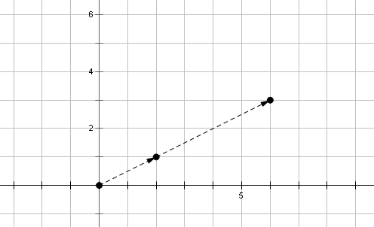

  - Describe the geometric effect of performing the transformation $\left(\begin{matrix}x \\ y\end{matrix}\right)→D\left(\begin{matrix}x \\ y\end{matrix}\right)$.
MP.2
Each point in the plane gets dilated by a factor of $3$. In other words, a point $P$ gets moved to a new location that is on the line through $P$ and the origin, but its distance from the origin increases by a factor of $3$.
Discussion (9 minutes): Motion along a Line
Scaffolding:
- Support students in understanding the functions defined by matrices using simpler examples.
- Let $f\left(t\right)=3t$. Find $f\left(0\right), f\left(1\right), f\left(2\right), f\left(3\right), f\left(4\right).$
- Explain how you determined your answer.
- Advanced learners can be given the following prompt without supporting questions.
- Suppose you were designing a computer game. You want an object to travel along a line from the origin to the point $(30, 10)$ in $20$ seconds. Can you design a function $h(t)$ that does this?
Let $f\left(t\right)=\left(\begin{matrix}t & 0 \\ 0 & t\end{matrix}\right)\left(\begin{matrix}3 \\ 1\end{matrix}\right)$.
- Find $f(0)$, $f(1)$, $f(2)$, $f(3)$, and $f(4)$.
  - $f\left(0\right)=\left(\begin{matrix}0 & 0 \\ 0 & 0\end{matrix}\right)\left(\begin{matrix}3 \\ 1\end{matrix}\right)=\left(\begin{matrix}0 \\ 0\end{matrix}\right)$.
  - $f\left(1\right)=\left(\begin{matrix}1 & 0 \\ 0 & 1\end{matrix}\right)\left(\begin{matrix}3 \\ 1\end{matrix}\right)=\left(\begin{matrix}3 \\ 1\end{matrix}\right)$.
  - $f\left(2\right)=\left(\begin{matrix}2 & 0 \\ 0 & 2\end{matrix}\right)\left(\begin{matrix}3 \\ 1\end{matrix}\right)=\left(\begin{matrix}6 \\ 2\end{matrix}\right)$.
  - $f\left(3\right)=\left(\begin{matrix}3 & 0 \\ 0 & 3\end{matrix}\right)\left(\begin{matrix}3 \\ 1\end{matrix}\right)=\left(\begin{matrix}9 \\ 3\end{matrix}\right)$.
  - $f\left(4\right)=\left(\begin{matrix}4 & 0 \\ 0 & 4\end{matrix}\right)\left(\begin{matrix}3 \\ 1\end{matrix}\right)=\left(\begin{matrix}12 \\ 4\end{matrix}\right)$.
- Plot each of these points on a graph. What do you notice?
  - Each point appears to lie on a straight line through the origin.
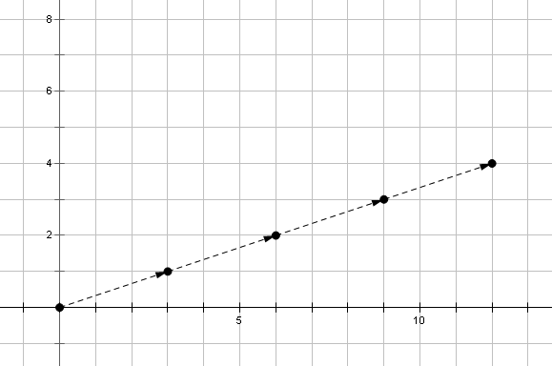
MP.7
&
MP.8
- Let $P=f(t)$. How can we be sure that $P$ actually does trace out a straight line as $t$ varies?
  - We could check to see if every pair of points forms a segment with the same slope.
- What is the slope of the segment that joins $f(1)$ and $f(4)$?
  - Since $f\left(1\right)=(3,1)$ and $f\left(4\right)=(12, 4)$, the slope is $\frac{4-1}{12-3}=\frac{3}{9}=\frac{1}{3}$.
- Now let’s check to see if every pair of points forms a segment with slope $\frac{1}{3}$ also. Let $t_{1}$ and $t_{2}$ be two arbitrary times in the domain of $f$. What is the slope of the segment that joins $f\left(t_{1}\right)$ and $f(t_{2})$?
  - Since $f\left(t_{1}\right)=(3t_{1}, t_{1})$ and $f\left(t_{2}\right)=(3t_{2},t_{2})$, the slope of the segment is $\frac{t_{2}-t_{1}}{3t_{2}-3t_{1}}=\frac{t_{2}-t_{1}}{3{(t}_{2}-t_{1})}=\frac{1}{3}$. Since the slope of every segment is constant, we can conclude that the path traced out by $P$ is indeed a straight line.
- Now suppose that $t$ represents time, measured in seconds, and $f(t)$ represents the location of an object at time $t$. How long would it take the object to travel from the origin to the point $(30, 10)$?
  - We need to find a value of $t$ such that $\left(\begin{matrix}t & 0 \\ 0 & t\end{matrix}\right)\left(\begin{matrix}3 \\ 1\end{matrix}\right)=\left(\begin{matrix}30 \\ 10\end{matrix}\right)$. Apparently $t=10$ works, which means it would take $10$ seconds for the object to reach this point.
- Now let $g\left(t\right)=\left(\begin{matrix}2t & 0 \\ 0 & 2t\end{matrix}\right)\left(\begin{matrix}3 \\ 1\end{matrix}\right)$. Do you think the object will reach $(30,10)$ faster or slower? Go ahead and find out.
  - If we choose $t$ so that $2t=10$, then we’d have $\left(\begin{matrix}10 & 0 \\ 0 & 10\end{matrix}\right)\left(\begin{matrix}3 \\ 1\end{matrix}\right)=\left(\begin{matrix}30 \\ 10\end{matrix}\right)$, so $t$ must be $5$. Therefore, the object reaches the desired location in $5$ seconds.
- Suppose you were designing a computer game. You want an object to travel along a line from the origin to the point $(30, 10)$ in $20$ seconds. Can you design a function $h(t)$ that does this?
  - We need to find a scale factor $k$ such that $h\left(20\right)=\left(\begin{matrix}k∙20 & 0 \\ 0 & k∙20\end{matrix}\right)\left(\begin{matrix}3 \\ 1\end{matrix}\right)=\left(\begin{matrix}30 \\ 10\end{matrix}\right)$. Seeing that we need to have $20k=10$ for this to work, we must have $k=\frac{1}{2}$. Thus $h\left(t\right)=\left(\begin{matrix}\frac{1}{2}t & 0 \\ 0 & \frac{1}{2}t\end{matrix}\right)\left(\begin{matrix}3 \\ 1\end{matrix}\right)$.
- Before we move on, try to make sense of the relationship between $f(t)$, $g\left(t\right),$ and $h(t)$. Take about half a minute to think about this for yourself, then share with a partner, and then we’ll discuss your responses as a whole class.
  - $f(t)$, $g(t)$, and $h(t)$ use scale factors of $t$, $2t$, and $\frac{1}{2}t$, respectively.
  - Since $g$ doubles the $t$-value, it makes sense that the object is moving twice as fast. For instance, to make the scale factor equal $10$, we can use $t=5$, since $2\left(5\right)=10$. So it takes $5$ seconds instead of $10$ to reach the desired point.
  - On the other hand, $h$ cuts the $t$-value in half, so it would make sense to say that the object should move only half as fast. In particular, to make the scale factor $10$, we have to use $t=20$, because $\frac{1}{2}\left(20\right)=10$. Thus it took $20$ seconds instead of $10$ to reach the desired point, which is twice as much time as it took originally.

Exercises 1–2 (3 minutes)
Give students time to perform the following exercises, then instruct students to compare their responses with a partner. Select students to share their responses with the whole class.
Exercises 1–2
- Let $f(t)=(\begin{matrix}t & 0 \\ 0 & t\end{matrix})(\begin{matrix}2 \\ 4\end{matrix}),$ where $t$ represents time, measured in seconds. $P=f(t)$ represents the position of a moving object at time $t$. If the object starts at the origin, how long would it take to reach $(12, 24)$?
$\left(\begin{matrix}t & 0 \\ 0 & t\end{matrix}\right)\left(\begin{matrix}2 \\ 4\end{matrix}\right)=\left(\begin{matrix}12 \\ 24\end{matrix}\right),t×2+0×4=12,2t=12,t=6$. or
$\left(\begin{matrix}t & 0 \\ 0 & t\end{matrix}\right)\left(\begin{matrix}2 \\ 4\end{matrix}\right)=\left(\begin{matrix}12 \\ 24\end{matrix}\right), 0×2+t×4=24,4t=24,t=6$

- Let $g(t)=(\begin{matrix}kt & 0 \\ 0 & kt\end{matrix})(\begin{matrix}2 \\ 4\end{matrix})$.
  - Find the value of $k$ that moves an object from the origin to $(12,24)$ in just $2$ seconds.
$t=2,\left(\begin{matrix}2k & 0 \\ 0 & 2k\end{matrix}\right)\left(\begin{matrix}2 \\ 4\end{matrix}\right)=\left(\begin{matrix}12 \\ 24\end{matrix}\right),2k×2+0×4=12, k=\frac{12}{4}=3,$ or
$t=2, \left(\begin{matrix}2k & 0 \\ 0 & 2k\end{matrix}\right)\left(\begin{matrix}2 \\ 4\end{matrix}\right)=\left(\begin{matrix}12 \\ 24\end{matrix}\right), 0×2k+2k×4=24, k=\frac{24}{8}=3$.
  - Find the value of $k$ that moves an object from the origin to $(12, 24)$ in $30$ seconds.
$t=30,\left(\begin{matrix}30k & 0 \\ 0 & 30k\end{matrix}\right)\left(\begin{matrix}2 \\ 4\end{matrix}\right)=\left(\begin{matrix}12 \\ 24\end{matrix}\right), 30k×2+0×4=12,k=\frac{12}{60}=\frac{1}{5},$ or
$t=30,\left(\begin{matrix}30k & 0 \\ 0 & 30k\end{matrix}\right)\left(\begin{matrix}2 \\ 4\end{matrix}\right)=\left(\begin{matrix}12 \\ 24\end{matrix}\right),0×30k+30k×4=24,k=\frac{24}{120}=\frac{1}{5}$.

Example 1 (3 minutes)
- Let’s continue our exploration of the function $f\left(t\right)=\left(\begin{matrix}t & 0 \\ 0 & t\end{matrix}\right)\left(\begin{matrix}3 \\ 1\end{matrix}\right)$. To get some practice with different ways of representing transformations, let’s write $f(t)$ in the form $\left(\begin{matrix}x(t) \\ y(t)\end{matrix}\right)$.
  - $f\left(t\right)=\left(\begin{matrix}t & 0 \\ 0 & t\end{matrix}\right)\left(\begin{matrix}3 \\ 1\end{matrix}\right)=\left(\begin{matrix}3t+0 \\ 0+t\end{matrix}\right)=\left(\begin{matrix}3t \\ t\end{matrix}\right)$.
- Let’s suppose that an object is moving in a straight line, with the $x$-coordinate increasing at $3$ units per second and the $y$-coordinate increasing at $1$ unit per second, as with $f(t)$ above. If the object starts at $(12, 4)$, how long would it take to reach $(30, 10)$?
  - The $x$-coordinate is increasing at $3$ units per second, so we have $12+3t=30$, which gives $t=6$ seconds.
  - The $y$-coordinate is increasing at $1$ unit per second, so we have $4+t=10$, which also gives $t=6$ seconds. So our results corroborate each other.
- Can you write a new function $g(t)$ that gives the position of the object above after $t$ seconds?
  - We have $x\left(t\right)=12+3t$ and $y\left(t\right)=4+t$, so that gives $g\left(t\right)=\left(\begin{matrix}12+3t \\ 4+t\end{matrix}\right)$.
- Can you find a way to write $g(t)$ as a matrix transformation?
  - $g\left(t\right)=\left(\begin{matrix}12+3t \\ 4+t\end{matrix}\right)=\left(\begin{matrix}3(4+t) \\ 1(4+t)\end{matrix}\right)$. This looks like a dilation of $(3, 1)$ with scale factor $4+t$, so the matrix representation of this transformation is $g\left(t\right)=\left(\begin{matrix}4+t & 0 \\ 0 & 4+t\end{matrix}\right)\left(\begin{matrix}3 \\ 1\end{matrix}\right)$.

Exercises 3–4 (3 minutes)
Give students a minute to perform the following exercises; monitor their responses. Then present the solutions, and ask students to check their answers.
Exercises 3–4
- Let $f(t)=(\begin{matrix}2+t & 0 \\ 0 & 2+t\end{matrix})(\begin{matrix}5 \\ 7\end{matrix})$, where $t$ represents time, measured in seconds, and $f(t)$ represents the position of a moving object at time $t$.
  - Find the position of the object at $t=0, t=1,$ and $t=2$.
$t=0,\left(\begin{matrix}2 & 0 \\ 0 & 2\end{matrix}\right)\left(\begin{matrix}5 \\ 7\end{matrix}\right)=\left(\begin{matrix}2×5+0×7 \\ 0×5+2×7\end{matrix}\right)=\left(\begin{matrix}10 \\ 14\end{matrix}\right)$ or $10+14i$
$t=1, \left(\begin{matrix}3 & 0 \\ 0 & 3\end{matrix}\right)\left(\begin{matrix}5 \\ 7\end{matrix}\right)=\left(\begin{matrix}3×5+0×7 \\ 0×5+3×7\end{matrix}\right)=\left(\begin{matrix}15 \\ 21\end{matrix}\right)$, or $15+21i$
$t=2, \left(\begin{matrix}4 & 0 \\ 0 & 4\end{matrix}\right)\left(\begin{matrix}5 \\ 7\end{matrix}\right)=\left(\begin{matrix}4×5+0×7 \\ 0×5+4×7\end{matrix}\right)=\left(\begin{matrix}20 \\ 28\end{matrix}\right)$, or $20+28i$
  - Write $f(t)$ in the form $\left(\begin{matrix}x(t) \\ y(t)\end{matrix}\right)$.
$\left(\begin{matrix}2+t & 0 \\ 0 & 2+t\end{matrix}\right)\left(\begin{matrix}5 \\ 7\end{matrix}\right)=\left(\begin{matrix}10+5t \\ 14+7t\end{matrix}\right)$

- Write the transformation $g\left(t\right)=\left(\begin{matrix}15+5t \\ -6-2t\end{matrix}\right)$ as a matrix transformation.
Answers vary based on factoring of factors. However, they start at different points that are all from the line, and they all end up having the same result: $g\left(t\right)=\left(\begin{matrix}15+5t \\ -6-2t\end{matrix}\right)$
$\left(\begin{matrix}15+5t \\ -6-2t\end{matrix}\right)=\left(\begin{matrix}5(3+t) \\ -2\left(3+t\right)\end{matrix}\right)=\left(\begin{matrix}3+t & 0 \\ 0 & 3+t\end{matrix}\right)\left(\begin{matrix}5 \\ -2\end{matrix}\right)$ or $\left(\begin{matrix}15+5t \\ -6-2t\end{matrix}\right)=\left(\begin{matrix}-5(-3-t) \\ 2\left(-3-t\right)\end{matrix}\right)=\left(\begin{matrix}-3-t & 0 \\ 0 & -3-t\end{matrix}\right)\left(\begin{matrix}-5 \\ 2\end{matrix}\right)$

Example 2 (4 minutes)
Let $f\left(t\right)=\left(\begin{matrix}1-t & 0 \\ 0 & 1-t\end{matrix}\right)\left(\begin{matrix}3 \\ 1\end{matrix}\right)$.
- Graph the path traced out by $P=f(t)$ with $0≤t≤3$.
  - We have $f\left(0\right)=(3,1)$, $f\left(1\right)=(0,0)$, $f\left(2\right)=(-3,-1)$, and $f\left(3\right)=(-6,-3)$.
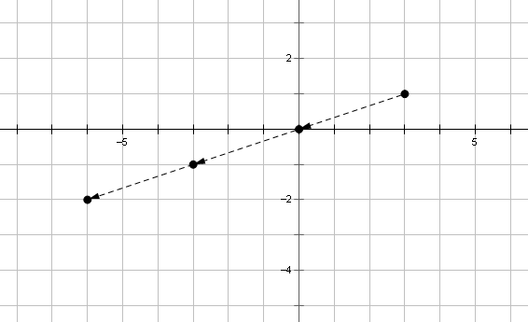
- Write $f(t)$ in the form $\left(\begin{matrix}x(t) \\ y(t)\end{matrix}\right)$.
  - $f\left(t\right)=\left(\begin{matrix}1-t & 0 \\ 0 & 1-t\end{matrix}\right)\left(\begin{matrix}3 \\ 1\end{matrix}\right)=\left(\begin{matrix}\left(1-t\right)\left(3\right)+0 \\ 0+(1-t)(1)\end{matrix}\right)=\left(\begin{matrix}3-3t \\ 1-t\end{matrix}\right)$.
- Now suppose that an object starts at $(20, 16)$ and moves along a line, reaching the origin in $4$ seconds. Write an equation $P=h(t)$ for the position of the object at time $t$.
  - Looking at the $x$-coordinates, we see that $20-k(4)=0$, which means that $k=5$. That is, the $x$-coordinate of the point is decreasing at $5$ units per second. Thus, $x\left(t\right)=20-5t$.
  - Looking at the $y$-coordinates, we see that 16$-m(4)=0$, which means that $m=4$. That is, the $y$-coordinate of the point is decreasing at $4$ units per second. Thus, $y\left(t\right)=16-4t$.
  - Putting these two results together, we get $h\left(t\right)=\left(\begin{matrix}20-5t \\ 16-4t\end{matrix}\right)$.
- Write $h(t)$ as a matrix transformation.
  - $h\left(t\right)=\left(\begin{matrix}20-5t \\ 16-4t\end{matrix}\right)=\left(\begin{matrix}5(4-t) \\ 4(4-t)\end{matrix}\right)=\left(\begin{matrix}4-t & 0 \\ 0 & 4-t\end{matrix}\right)\left(\begin{matrix}5 \\ 4\end{matrix}\right)$.

Exercise 5 (2 minutes)
Give students a minute to perform the following exercise, and monitor their responses. Have students compare their responses with a partner; then select students to share their responses with the whole class.
Exercise 5
- An object is moving in a straight line from $(18,12)$ to the origin over a $6$-second period of time. Find a function $f(t)$ that gives the position of the object after $t$ seconds. Write your answer in the form $f\left(t\right)=\left(\begin{matrix}x(t) \\ y(t)\end{matrix}\right)$, then express $f(t)$ as a matrix transformation.
For the $x$-coordinates, we have $18-6k=0, k=3$. The $x$-coordinate of the point is decreasing at $3$ units per second. Thus, $x\left(t\right)=18-3t$
For the $y$-coordinates, we have $12-6m=0, m=2$. The $y$-coordinate of the point is decreasing at $2$ units per second. Thus, $x\left(t\right)=12-2t$
$f\left(t\right)=\left(\begin{matrix}18-3t \\ 12-2t\end{matrix}\right)=\left(\begin{matrix}3(6-t) \\ 2(6-t)\end{matrix}\right)=\left(\begin{matrix}6-t & 0 \\ 0 & 6-t\end{matrix}\right)\left(\begin{matrix}3 \\ 2\end{matrix}\right)$.

Discussion (7 minutes): Translations
- In a video game, the player controls a character named Steve. When Steve climbs a certain ladder, his vertical position on the screen increases by $5$ units.
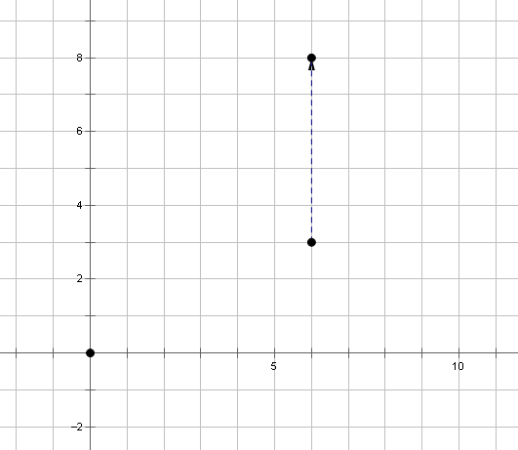
- Let $(x,y)→V(x,y)$ represent the change in Steve’s position when he climbs the ladder. The input represents his position before climbing the ladder, and the output represents his position after climbing the ladder. Find the outputs that correspond to each of the following inputs.
  - $\left(3,4\right)$
- $\left(3,4\right)→(3,9)$
  - $\left(10,12\right)$
- $\left(10,12\right)→(10,17)$
  - $\left(7,20\right)$
- $\left(7,20\right)→(7,25)$
- Let’s look more closely at that last input-output pair. Can you carefully explain the thinking that allowed you to produce the output here?
  - Climbing a ladder does not affect Steve’s horizontal position, so the $x$-coordinate is still $7$. To get the new $y$-coordinate, we add $5$ to $20$, giving $20+5=25$.
- To reveal the underlying structure of this transformation, let’s write $\left(7, 20\right)→(7, 20+5)$. Now let’s generalize: What is the output that corresponds to a generic input $(x,y)$?
  - $(x,y)→(x,y+5)$
- Now let’s write the transformation using the column notation that we have found useful for our work that involves matrices: $\left(\begin{matrix}x \\ y\end{matrix}\right)→\left(\begin{matrix}x \\ y+5\end{matrix}\right)$.
- Next let’s analyze horizontal motion. When the player presses the control pad to the right, Steve moves to the right $3$ units per second.
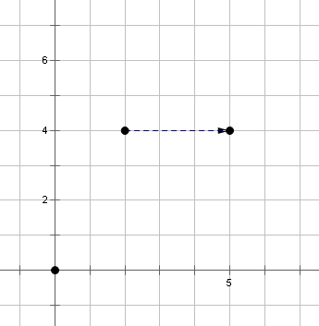
- Write a function rule that represents a translation that takes each point in the plane $3$ units to the right. Practice using the column notation.
  - $\left(\begin{matrix}x \\ y\end{matrix}\right)→\left(\begin{matrix}x+3 \\ y\end{matrix}\right)$
- When Steve jumps while running at super-speed, he moves to a new location that is $6$ units to the right and $4$ units above where he started the jump.
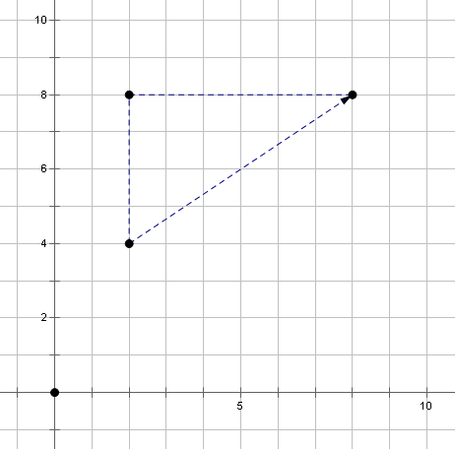
- Write a function rule that represents the change in Steve’s position when he does a jump while running at super-speed. Use column notation.
MP.4
  - $\left(\begin{matrix}x \\ y\end{matrix}\right)→\left(\begin{matrix}x+6 \\ y+4\end{matrix}\right)$
- Do you think there is a way we can represent a translation as a matrix transformation? In particular, can we encode the transformation $\left(\begin{matrix}x \\ y\end{matrix}\right)→\left(\begin{matrix}x+6 \\ y+4\end{matrix}\right)$ as a matrix mapping $\left(\begin{matrix}x \\ y\end{matrix}\right)→\left(\begin{matrix}a & b \\ c & d\end{matrix}\right)\left(\begin{matrix}x \\ y\end{matrix}\right)$?
Let students consider this question for a few moments.
- Here’s a hint: If we take the point $(0,0)$ as an input, what output is produced in each transformation above?
  - The map $\left(\begin{matrix}x \\ y\end{matrix}\right)→\left(\begin{matrix}x+6 \\ y+4\end{matrix}\right)$ takes $\left(\begin{matrix}0 \\ 0\end{matrix}\right)→\left(\begin{matrix}0+6 \\ 0+4\end{matrix}\right)=\left(\begin{matrix}6 \\ 4\end{matrix}\right)$.
  - On the other hand, the map $\left(\begin{matrix}x \\ y\end{matrix}\right)→\left(\begin{matrix}a & b \\ c & d\end{matrix}\right)\left(\begin{matrix}x \\ y\end{matrix}\right)$ takes $\left(\begin{matrix}0 \\ 0\end{matrix}\right)→\left(\begin{matrix}a & b \\ c & d\end{matrix}\right)\left(\begin{matrix}0 \\ 0\end{matrix}\right)=\left(\begin{matrix}0 \\ 0\end{matrix}\right)$.
A matrix transformation always maps the origin to itself, whereas a translation shifts every point in the plane, including the origin. Thus there is no way to encode a translation as a matrix transformation.

Exercises 6–9 (2 minutes)
Give students a minute to perform the following exercise, and monitor their responses. Have students compare their responses with a partner; then select students to share their responses with the whole class.
Exercises 6–9
- Write a rule for the function that shifts every point in the plane $6$ units to the left.
$\left(\begin{matrix}x \\ y\end{matrix}\right)→\left(\begin{matrix}x-6 \\ y\end{matrix}\right), f\left(x, y\right)=\left(\begin{matrix}x-6 \\ y\end{matrix}\right)$

- Write a rule for the function that shifts every point in the plane $9$ units upward.
$\left(\begin{matrix}x \\ y\end{matrix}\right)→\left(\begin{matrix}x \\ y+9\end{matrix}\right),f\left(x,y\right)=\left(\begin{matrix}x \\ y+9\end{matrix}\right)$

- Write a rule for the function that shifts every point in the plane $10$ units down and $4$ units to the right.
$\left(\begin{matrix}x \\ y\end{matrix}\right)→\left(\begin{matrix}x+4 \\ y-10\end{matrix}\right), f\left(x, y\right)=\left(\begin{matrix}x+4 \\ y-10\end{matrix}\right)$

- Consider the rule $\left(\begin{matrix}x \\ y\end{matrix}\right)→\left(\begin{matrix}x-7 \\ y+2\end{matrix}\right)$. Describe the effect this transformation has on the plane.
Every point in the plane is shifted $7$ units to the left and $2$ units upward.

Closing (2 minutes)
Have students take a minute to write a response to the following questions in their notebooks; then ask them to share their responses with a partner. Select two students to share their responses with the whole class.
- What did you learn today about representing straight-line motion? Give an example of a function that represents this kind of motion.
  - An example would be $f\left(t\right)=\left(\begin{matrix}10-2t \\ 3+5t\end{matrix}\right)$
- What did you learn about representing translations? Give an example of a function that represents this kind of motion.
  - An example would be $f\left(x,y\right)=\left(\begin{matrix}x \\ y\end{matrix}\right)+\left(\begin{matrix}3 \\ 4\end{matrix}\right)=\left(\begin{matrix}x+3 \\ y+4\end{matrix}\right)$.

Exit Ticket (8 minutes)

Name Date
Lesson 22: Modeling Video Game Motion with Matrices

Exit Ticket

- Consider the function $h\left(t\right)=\left(\begin{matrix}t+5 \\ t-3\end{matrix}\right)$. Draw the path that the point $P=h(t)$ traces out as $t$ varies within the interval $0≤t≤4$.

- The position of an object is given by the function $f\left(t\right)=\left(\begin{matrix}t & 0 \\ 0 & t\end{matrix}\right)\left(\begin{matrix}5 \\ 2\end{matrix}\right)$, where $t$ is measured in seconds.
  - Write $f(t)$ in the form $\left(\begin{matrix}x(t) \\ y(t)\end{matrix}\right)$.

  - Find how fast the object is moving in the horizontal direction and in the vertical direction.

- Write a function $f(x,y)$ which will translate all points in the plane $2$ units to the left and $5$ units downward.
Exit Ticket Sample Solutions

- Consider the function $h\left(t\right)=\left(\begin{matrix}t+5 \\ t-3\end{matrix}\right)$. Draw the path that the point $P=h(t)$ traces out as $t$ varies within the interval $0≤t≤4$.
$h\left(0\right)=\left(\begin{matrix}5 \\ -3\end{matrix}\right), h\left(1\right)=\left(\begin{matrix}6 \\ -2\end{matrix}\right),h\left(2\right)=\left(\begin{matrix}7 \\ -1\end{matrix}\right), h\left(3\right)=\left(\begin{matrix}8 \\ 0\end{matrix}\right), h\left(4\right)=\left(\begin{matrix}9 \\ 1\end{matrix}\right)]$
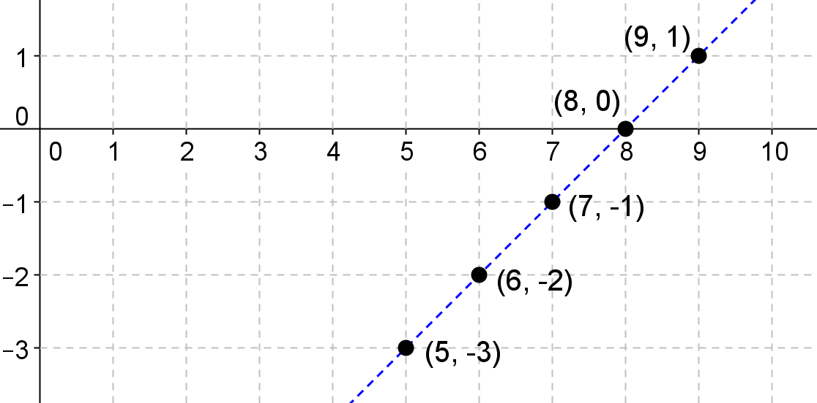

- The position of an object is given by the function $f\left(t\right)=\left(\begin{matrix}t & 0 \\ 0 & t\end{matrix}\right)\left(\begin{matrix}5 \\ 2\end{matrix}\right)$, where $t$ is measured in seconds.
  - Write $f(t)$ in the form $\left(\begin{matrix}x(t) \\ y(t)\end{matrix}\right)$.
$f\left(t\right)=\left(\begin{matrix}t & 0 \\ 0 & t\end{matrix}\right)\left(\begin{matrix}5 \\ 2\end{matrix}\right)=\left(\begin{matrix}5t+0×2 \\ 0×5+t×2\end{matrix}\right)=\left(\begin{matrix}5t \\ 2t\end{matrix}\right). f\left(0\right)=\left(\begin{matrix}0 \\ 0\end{matrix}\right),f\left(1\right)=\left(\begin{matrix}5 \\ 2\end{matrix}\right)$, and the slope of the line is
$m=\frac{2}{5}$.

  - Find how fast the object is moving in the horizontal direction and in the vertical direction.
The object is moving $2$ units upward vertically per second and $5$ units to the right horizontally per second.

- Write a function $f(x,y)$ which will translate all points in the plane $2$ units to the left and $5$ units downward.
$f\left(x,y\right)=\left(\begin{matrix}x-2 \\ y-5\end{matrix}\right)$.

Problem Set Sample Solutions

- Let $D\left(\begin{matrix}x \\ y\end{matrix}\right)=\left(\begin{matrix}2 & 0 \\ 0 & 2\end{matrix}\right)\left(\begin{matrix}x \\ y\end{matrix}\right)$ find and plot the following.
  - Plot the point: $\left(\begin{matrix}-1 \\ 2\end{matrix}\right)$ and find $D\left(\begin{matrix}-1 \\ 2\end{matrix}\right),$ and plot it.
$$D\left(\begin{matrix}-1 \\ 2\end{matrix}\right)=\left(\begin{matrix}2 & 0 \\ 0 & 2\end{matrix}\right)\left(\begin{matrix}-1 \\ 2\end{matrix}\right)=\left(\begin{matrix}-2 \\ 4\end{matrix}\right)$$ | 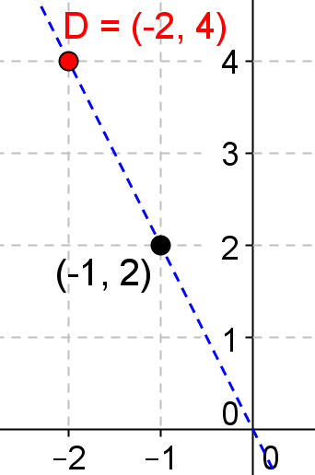

  - Plot the point: $\left(\begin{matrix}3 \\ 4\end{matrix}\right)$ and find $D\left(\begin{matrix}3 \\ 4\end{matrix}\right)$, and plot it.
$D\left(\begin{matrix}3 \\ 4\end{matrix}\right)=\left(\begin{matrix}2 & 0 \\ 0 & 2\end{matrix}\right)\left(\begin{matrix}3 \\ 4\end{matrix}\right)=\left(\begin{matrix}6 \\ 8\end{matrix}\right)$ | 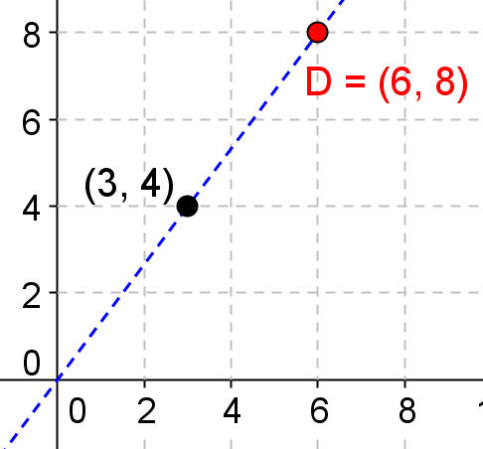

  - Plot the point: $\left(\begin{matrix}5 \\ 2\end{matrix}\right)$ and find $D\left(\begin{matrix}5 \\ 2\end{matrix}\right),$ and plot it.
$$D\left(\begin{matrix}5 \\ 2\end{matrix}\right)=\left(\begin{matrix}2 & 0 \\ 0 & 2\end{matrix}\right)\left(\begin{matrix}5 \\ 2\end{matrix}\right)=\left(\begin{matrix}10 \\ 4\end{matrix}\right)$$ | 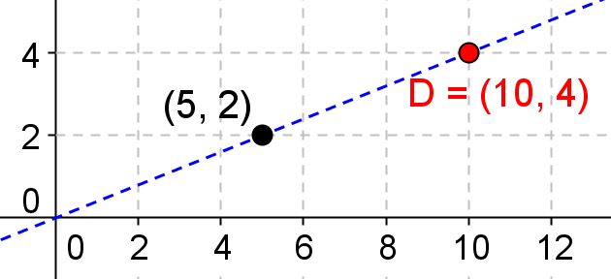

- Let $f\left(t\right)=\left(\begin{matrix}t & 0 \\ 0 & t\end{matrix}\right)\left(\begin{matrix}-1 \\ 2\end{matrix}\right)$, find $f\left(0\right), f\left(1\right), f\left(2\right), f\left(3\right),$ and plot them on the same graph.
$$f\left(0\right)=\left(\begin{matrix}0 & 0 \\ 0 & 0\end{matrix}\right)\left(\begin{matrix}-1 \\ 2\end{matrix}\right)=\left(\begin{matrix}0 \\ 0\end{matrix}\right),$$ | 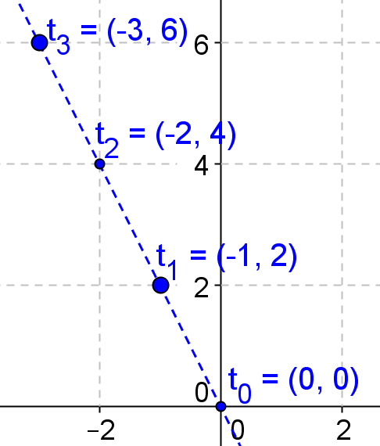
$$f\left(1\right)=\left(\begin{matrix}1 & 0 \\ 0 & 1\end{matrix}\right)\left(\begin{matrix}-1 \\ 2\end{matrix}\right)=\left(\begin{matrix}-1 \\ 2\end{matrix}\right),$$
$$f\left(2\right)=\left(\begin{matrix}2 & 0 \\ 0 & 2\end{matrix}\right)\left(\begin{matrix}-1 \\ 2\end{matrix}\right)=\left(\begin{matrix}-2 \\ 4\end{matrix}\right),$$
$$f\left(3\right)=\left(\begin{matrix}3 & 0 \\ 0 & 3\end{matrix}\right)\left(\begin{matrix}-1 \\ 2\end{matrix}\right)=(\begin{matrix}-3 \\ 6\end{matrix})$$

- Let $f\left(t\right)=\left(\begin{matrix}t & 0 \\ 0 & t\end{matrix}\right)\left(\begin{matrix}3 \\ 2\end{matrix}\right)$ represent the location of an object at time $t$ that is measured in seconds.
  - How long does it take the object to travel from the origin to the point $\left(\begin{matrix}12 \\ 8\end{matrix}\right)?$
$3t+0×2=12, t=4$ or $0×3+2t=8, t=4$.

  - Find the speed of the object in the horizontal direction and in the vertical direction.
$f\left(t\right)=\left(\begin{matrix}3t \\ 2t\end{matrix}\right)$. The object is moving $2$ units upward per second and $3$ units to the right per a second.

- Let $f\left(t\right)=\left(\begin{matrix}0.2t & 0 \\ 0 & 0.2t\end{matrix}\right)\left(\begin{matrix}3 \\ 2\end{matrix}\right), h\left(t\right)=\left(\begin{matrix}2t & 0 \\ 0 & 2t\end{matrix}\right)\left(\begin{matrix}3 \\ 2\end{matrix}\right)$. Which one will reach the point $\left(\begin{matrix}12 \\ 8\end{matrix}\right)$ first? The time $t$ is measured in seconds.
For $f\left(t\right),0.2t×3+0×2=12, t=\frac{12}{0.6}=20$ seconds.
For $h\left(t\right),2t×3+0×2=12, t=\frac{12}{6}=2$ seconds; therefore, $h(t)$ will reach the point $\left(\begin{matrix}12 \\ 8\end{matrix}\right)$ first.

- Let $f\left(t\right)=\left(\begin{matrix}kt & 0 \\ 0 & kt\end{matrix}\right)\left(\begin{matrix}3 \\ 2\end{matrix}\right),f$ind the value of $k$ that moves the object from the origin to $\left(\begin{matrix}-45 \\ -30\end{matrix}\right)$ in $5$ seconds.
$f\left(5\right)=\left(\begin{matrix}5k & 0 \\ 0 & 5k\end{matrix}\right)\left(\begin{matrix}3 \\ 2\end{matrix}\right)=\left(\begin{matrix}-45 \\ -30\end{matrix}\right), 5k×3+0×2=-45, k=-3$. Or $0×3+5k×2=-30, k=-3$

- Write $f(t)$ in the form $\left(\begin{matrix}x(t) \\ y(t)\end{matrix}\right)$ if
  - $f\left(t\right)=\left(\begin{matrix}t & 0 \\ 0 & t\end{matrix}\right)\left(\begin{matrix}2 \\ 5\end{matrix}\right)$.
$f\left(t\right)=\left(\begin{matrix}2t \\ 5t\end{matrix}\right)$

  - $f\left(t\right)=\left(\begin{matrix}2t+1 & 0 \\ 0 & 2t+1\end{matrix}\right)\left(\begin{matrix}3 \\ 2\end{matrix}\right)$.
$f\left(t\right)=\left(\begin{matrix}6t+3 \\ 4t+2\end{matrix}\right)$

  - $f\left(t\right)=\left(\begin{matrix}\frac{t}{2}-3 & 0 \\ 0 & \frac{t}{2}-3\end{matrix}\right)\left(\begin{matrix}4 \\ -6\end{matrix}\right)$.
$f\left(t\right)=\left(\begin{matrix}2t-12 \\ 3t-18\end{matrix}\right)$

- Let $f\left(t\right)=\left(\begin{matrix}t & 0 \\ 0 & t\end{matrix}\right)\left(\begin{matrix}2 \\ 5\end{matrix}\right)$ represent the location of an object after $t$ seconds.
  - If the object starts at $\left(\begin{matrix}6 \\ 15\end{matrix}\right)$, how long would it take to reach $\left(\begin{matrix}34 \\ 85\end{matrix}\right)$ ?
$f\left(t\right)=\left(\begin{matrix}2t \\ 5t\end{matrix}\right),$ it starts at $\left(\begin{matrix}6 \\ 15\end{matrix}\right)$; therefore, $f\left(t\right)=\left(\begin{matrix}2t+6 \\ 5t+15\end{matrix}\right)$.
$2t+6=34, t=14$ or $5t+15=85, t=14$.

  - Write the new function $f(t)$ that gives the position of the object after $t$ seconds.
$f\left(t\right)=\left(\begin{matrix}2t+6 \\ 5t+15\end{matrix}\right)$

  - Write $f(t)$ as a matrix transformation.
$f\left(t\right)=\left(\begin{matrix}2t+6 \\ 5t+15\end{matrix}\right)=\left(\begin{matrix}(t+3)2 \\ (t+3)5\end{matrix}\right)=\left(\begin{matrix}t+3 & 0 \\ 0 & t+3\end{matrix}\right)\left(\begin{matrix}2 \\ 5\end{matrix}\right)$
or $f\left(t\right)=\left(\begin{matrix}2t+6 \\ 5t+15\end{matrix}\right)=\left(\begin{matrix}\left(-t-3\right)(-2) \\ \left(-t-3\right)(-5)\end{matrix}\right)=\left(\begin{matrix}-t-3 & 0 \\ 0 & -t-3\end{matrix}\right)\left(\begin{matrix}-2 \\ -5\end{matrix}\right)$.
The answers vary; it depends on how the factoring is applied.

- Write the following functions as a matrix transformation.
  - $f\left(t\right)=\left(\begin{matrix}10+2t \\ 15+3t\end{matrix}\right)$
$f\left(t\right)=\left(\begin{matrix}10+2t \\ 15+3t\end{matrix}\right)=\left(\begin{matrix}(5+t)2 \\ (5+t)3\end{matrix}\right)=\left(\begin{matrix}5+t & 0 \\ 0 & 5+t\end{matrix}\right)\left(\begin{matrix}2 \\ 3\end{matrix}\right)$

  - $f\left(t\right)=\left(\begin{matrix}-6t+15 \\ 8t-20\end{matrix}\right)$
$f\left(t\right)=\left(\begin{matrix}-6t+15 \\ 8t-20\end{matrix}\right)=\left(\begin{matrix}\left(2t-5\right)(-3) \\ \left(2t-5\right)4\end{matrix}\right)=\left(\begin{matrix}2t-5 & 0 \\ 0 & 2t-5\end{matrix}\right)\left(\begin{matrix}-3 \\ 4\end{matrix}\right)$
or $f\left(t\right)=\left(\begin{matrix}-6t+15 \\ 8t-20\end{matrix}\right)=\left(\begin{matrix}\left(-2t+5\right)3 \\ \left(-2t+5\right)(-4)\end{matrix}\right)=\left(\begin{matrix}-2t+5 & 0 \\ 0 & -2t+5\end{matrix}\right)\left(\begin{matrix}3 \\ -4\end{matrix}\right)$

- Write a function rule that represents the change in position of the point $\left(\begin{matrix}x \\ y\end{matrix}\right)$ for the following.
  - $5$ units to the right and $3$ units downward.
$f\left(x,y\right)=\left(\begin{matrix}x+5 \\ y-3\end{matrix}\right)$

  - $2$ units downward and $3$ units to the left
$f\left(x,y\right)=\left(\begin{matrix}x-3 \\ y-2\end{matrix}\right)$

  - $3$ units upward, $5$ units to the left, and then it dilates by $2$
$f\left(x,y\right)=\left(\begin{matrix}x-5 \\ y+3\end{matrix}\right), f\left(x, y\right)=\left(\begin{matrix}2 & 0 \\ 0 & 2\end{matrix}\right)\left(\begin{matrix}x-5 \\ y+3\end{matrix}\right)$.

  - $3$ units upward, $5$ units to the left, and then it rotates by $\frac{π}{2}$ counterclockwise.
$f\left(x,y\right)=\left(\begin{matrix}x-5 \\ y+3\end{matrix}\right),f\left(x, y\right)=\left(\begin{matrix}cos\left(\frac{π}{2}\right) & -sin\left(\frac{π}{2}\right) \\ sin\left(\frac{π}{2}\right) & cos\left(\frac{π}{2}\right)\end{matrix}\right)\left(\begin{matrix}x-5 \\ y+3\end{matrix}\right)$.

- Annie is designing a video game and wants her main character to be able to move from any given point $\left(\begin{matrix}x \\ y\end{matrix}\right)$ in the following ways: right $1$ unit, jump up $1$ unit, and both jump up and move right $1$ unit each.
MP.4
  - What function rules can she use to represent each time the character moves?
$f\left(x,y\right)=\left(\begin{matrix}x+1 \\ y\end{matrix}\right)$; $g\left(x,y\right)=\left(\begin{matrix}x \\ y+1\end{matrix}\right)$; $h\left(x,y\right)=\left(\begin{matrix}x+1 \\ y+1\end{matrix}\right)$.

  - Annie is also developing a ski slope stage for her game and wants to model her character’s position using matrix transformations. Annie wants the player to start at $\left(\begin{matrix}-20 \\ 10\end{matrix}\right)$ and eventually pass through the origin moving $5$ units per second down. How fast does the player need to move to the right in order to pass through the origin? What matrix transformation can Annie use to describe the movement of the character? If the far-right of the screen is at $x=20$, how long until the player moves off the screen traveling this path?
If the player is moving $5$ units per second down, then they will reach $y=0$ in $t=2$ seconds. Thus, the player needs to move $10$ units per second to the right.
$$f\left(t\right)=\left(\begin{matrix}-20+10t \\ 10-5t\end{matrix}\right) \\ =\left(\begin{matrix}-10(2-t) \\ 5(2-t)\end{matrix}\right) \\ =\left(\begin{matrix}2-t & 0 \\ 0 & 2-t\end{matrix}\right)\left(\begin{matrix}-10 \\ 5\end{matrix}\right)$$
The player will leave the screen in $4$ seconds.

- Remy thinks that he has developed matrix transformations to model the movements of Annie’s characters in Problem 10 from any given point $\left(\begin{matrix}x \\ y\end{matrix}\right)$, and he has tested them on the point $\left(\begin{matrix}1 \\ 1\end{matrix}\right)$. This is the work Remy did on the transformations:
$\left(\begin{matrix}2 & 0 \\ 0 & 1\end{matrix}\right)\left(\begin{matrix}1 \\ 1\end{matrix}\right)=\left(\begin{matrix}2 \\ 1\end{matrix}\right)$ $\left(\begin{matrix}1 & 0 \\ 1 & 1\end{matrix}\right)\left(\begin{matrix}1 \\ 1\end{matrix}\right)=\left(\begin{matrix}1 \\ 2\end{matrix}\right)$ $\left(\begin{matrix}2 & 0 \\ 1 & 1\end{matrix}\right)\left(\begin{matrix}1 \\ 1\end{matrix}\right)=\left(\begin{matrix}2 \\ 2\end{matrix}\right)$
Do these matrix transformations accomplish the movements that Annie wants to program into the game? Explain why or why not.
MP.3
These do not accomplish the movements. If we apply the transformations to any other point in the plane, then they will not produce the same results of moving one unit to the right, one unit up, and one unit up and right.
As a counterexample, any of the three matrix transformations applied to the origin do nothing.

- Nolan has been working on how to know when the path of a point can be described with matrix transformations and how to know when it requires translations and cannot be described with matrix transformations. So far he has been focusing on the following two functions which both pass through the point $\left(2,5\right)$:
$f\left(t\right)=\left(\begin{matrix}2t+6 \\ 5t+15\end{matrix}\right)$ and $g\left(t\right)=\left(\begin{matrix}t+2 \\ t+5\end{matrix}\right)$
  - If we simplify these functions algebraically, how does the rule for $f$ differ from the rule for $g$? What does this say about which function can be expressed with matrix transformations?
$f\left(t\right)=\left(\begin{matrix}2\left(t+3\right) \\ 5\left(t+3\right)\end{matrix}\right)$. Thus, there is a common factor in both the $x$- and $y$-coordinate. Because there is a common factor, we can pull the factor out as a scalar and rewrite the scalar as a matrix multiplication. $g(t)$ does not have a common factor (other than $1$) between the $x$- and $y$-coordinate.

  - Nolan has noticed functions that can be expressed with matrix transformations always pass through the origin; does either $f$ or $g$ pass through the origin, and does this support or contradict Nolan’s reasoning?
At $t=-3$, the graph of $f$ passes through the origin. On the other hand, the graph of $g$ crosses the $x$-axis at $t=-2$ and the $y$-axis at $t=-5$, so it does not pass through the origin. This seems to support Nolan’s reasoning. This agrees with our response to part (a), since the common factor has the same zero and causes the function to cross the origin.

  - Summarize the results of parts (a) and (b) to describe how we can tell from the equation for a function or from the graph of a function that it can be expressed with matrix transformations.
If a function has a common factor involving $t$ that can be pulled out of both the $x$- and $y$-coordinates, then the function can be represented as a matrix transformation. If the graph of the function passes through the origin, then the function can be represented as a matrix transformation.

