21
Lesson 21: The Hunt for Better Notation

Student Outcomes
- Students represent linear transformations of the form $L\left(x,y\right)=\left(ax+by, cx+dy\right)$ by matrix multiplication
$L\left(\begin{matrix}x \\ y\end{matrix}\right)=\left(\begin{matrix}a & b \\ c & d\end{matrix}\right)\left(\begin{matrix}x \\ y\end{matrix}\right)$.
- Students recognize when a linear transformation of the form $L\left(\begin{matrix}x \\ y\end{matrix}\right)=\left(\begin{matrix}a & b \\ c & d\end{matrix}\right)\left(\begin{matrix}x \\ y\end{matrix}\right)$ represents rotation and dilation in the plane.
- Students multiply matrix products of the form$\left(\begin{matrix}a & b \\ c & d\end{matrix}\right)\left(\begin{matrix}x \\ y\end{matrix}\right)$.

Lesson Notes
This lesson introduces $2×2$ matrices and their use for representing linear transformation through multiplication
(N-VM.C.11, N-VM.C.12). Matrices provide a third method of representing rotation and dilation of the plane, as well as other linear transformations that the students have not yet been exposed to in this module, such as reflection and shearing.

Classwork
Opening Exercise (5 minutes)
Have students work on this exercise in pairs or small groups. Students will see how cumbersome this notation can be.
Opening Exercise
Scaffolding:
- Have struggling students evaluate $L_{1}\left(1,2\right)$ and $L_{2}(1, 2)$.
- Have advanced learners find $L_{2}\left(L_{1}\left(p,q\right)\right)$ and $L_{1}\left(L_{2}\left(p,q\right)\right)$ and determine values of $p$ and $q$ where $L_{2}\left(L_{1}\left(p,q\right)\right)$ and $L_{1}\left(L_{2}\left(p,q\right)\right)$ are equal.
Suppose that $L_{1}\left(x,y\right)=(2x-3y, 3x+2y)$ and $L_{2}\left(x,y\right)=(3x+4y, -4y+3x)$.
Find the result of performing $L_{1}$ and then $L_{2}$ on a point $(p,q)$. That is, find $L_{2}\left(L_{1}\left(p,q\right)\right)$.
$$L_{2}\left(L_{1}\left(p,q\right)\right)=L_{2}\left(2p-3q,3p+2q\right) \\ =\left(3\left(2p-3q\right)+4\left(3p+2q\right),-4\left(2p-3q\right)+3\left(3p+2q\right)\right) \\ =(6p-9q+12p+8q, -8p+12q+9p+6q) \\ =(18p-q, p+18q)$$

Discussion (6 minutes)
Use this discussion to review the answer to the Opening Exercise and to motivate and introduce matrix notation.
- What answer did you get to the Opening Exercise?
  - $L_{2}(L_{1}(p,q))=(18p-q,p+18q)$
- How do you feel about this notation? Do you find it confusing or cumbersome?
  - Answers will vary, but most students will find the composition confusing or cumbersome or both.
- What if I told you there was a simpler way to find the answer? We just have to learn some new mathematics first.
- In the mid $1800$’s and through the early $1900$’s, formulas such as $L(x,y)=(ax-by, bx+ay)$ kept popping up in mathematical situations, and people were struggling to find a simpler way to work with these expressions. Mathematicians used a representation called a matrix. A matrix is a rectangular array of numbers that looks like $\left(\begin{matrix}a \\ b\end{matrix}\right)$ or $\left[\begin{matrix}a \\ b\end{matrix}\right]$. We can represent matrices as soft or hard brackets, but a matrix is a rectangular array of numbers. These matrices both have $1$ column and $2$ rows. Matrices can be any size. A square matrix has the same number of rows and columns and could look like $\left[\begin{matrix}a & b \\ c & d\end{matrix}\right]$. We call this a $2×2$ matrix because it has $2$ columns and $2$ rows.
- A matrix with one column can be used to represent a point $\left(\begin{matrix}x \\ y\end{matrix}\right)$.
- It can also represent a vector from point A to point B. If $A\left(a_{1},a_{2}\right)$ and $B(b_{1},b_{2})$, then $\vec{AB}$ can be represented as $\left[\begin{matrix}b_{1}-a_{1} \\ b_{2}-a_{2}\end{matrix}\right]$. This translation maps $A$ to $B$.
- Explain what we have just said about a matrix and a vector to your neighbor.
- Let’s think about what a transformation $L(x,y)=(ax+by,cx+dy)$ does to the components of the point (or vector) $(x,y)$. It will be helpful to write a point $(x,y)$ as $\left(\begin{matrix}x \\ y\end{matrix}\right)$. Then the transformation becomes
$$L\left(\begin{matrix}x \\ y\end{matrix}\right)=\left(\begin{matrix}ax+by \\ cx+dy\end{matrix}\right)$$
- The important parts of this transformation are the four coefficients $a, b, c,$ and $d$. We will record them in a matrix: $\left(\begin{matrix}a & b \\ c & d\end{matrix}\right)$.
- A matrix is a rectangular array of numbers, symbols, or expressions, arranged in rows and columns.
- We can define a new type of multiplication so that $\left(\begin{matrix}a & b \\ c & d\end{matrix}\right)\left(\begin{matrix}x \\ y\end{matrix}\right)=\left(\begin{matrix}ax+by \\ cx+dy\end{matrix}\right)$.
- Based on this definition, explain how the entries in the matrix are used in the process of multiplication.
  - When we use matrix multiplication, we think of multiplying the first row of the matrix $(\begin{matrix}a & b\end{matrix})$ by the column $\left(\begin{matrix}x \\ y\end{matrix}\right)$ so that $\left(\begin{matrix}a & b\end{matrix}\right)⋅\left(\begin{matrix}x \\ y\end{matrix}\right)=ax+by$, and we write that result in the first row. (This multiplication $\left(\begin{matrix}a & b\end{matrix}\right)⋅\left(\begin{matrix}x \\ y\end{matrix}\right)=ax+by$ is called a dot product. You may choose whether or not to share this terminology with your students.) Then we multiply the second row of the matrix $(\begin{matrix}c & d\end{matrix})$ by the column $\left(\begin{matrix}x \\ y\end{matrix}\right)$ so that $\left(\begin{matrix}c & d\end{matrix}\right)⋅\left(\begin{matrix}x \\ y\end{matrix}\right)=cx+dy$, and we write that result in the second row, giving the final answer.
MP.7

Example 1 (6 minutes)
Do the following numerical examples to illustrate matrix-vector multiplication. You may need to do more or fewer examples based on your assessment of your students’ understanding.
- Evaluate the product $\left(\begin{matrix}1 & 2 \\ 3 & 4\end{matrix}\right)\left(\begin{matrix}5 \\ 6\end{matrix}\right)$.
  - $\left(\begin{matrix}1 & 2 \\ 3 & 4\end{matrix}\right)\left(\begin{matrix}5 \\ 6\end{matrix}\right)=\left(\begin{matrix}1⋅5+2⋅6 \\ 3⋅5+4⋅6\end{matrix}\right)=\left(\begin{matrix}17 \\ 39\end{matrix}\right)$
- Evaluate the product $\left(\begin{matrix}1 & 2 \\ 3 & 4\end{matrix}\right)\left(\begin{matrix}2 \\ -5\end{matrix}\right)$.
  - $\left(\begin{matrix}1 & 2 \\ 3 & 4\end{matrix}\right)\left(\begin{matrix}10 \\ -6\end{matrix}\right)=\left(\begin{matrix}1⋅10+2⋅(-6) \\ 3⋅10+4⋅(-6)\end{matrix}\right)=\left(\begin{matrix}-2 \\ 6\end{matrix}\right)$
- Evaluate the product $\left(\begin{matrix}1 & 2 \\ 3 & 4\end{matrix}\right)\left(\begin{matrix}x \\ y\end{matrix}\right)$.
  - $\left(\begin{matrix}1 & 2 \\ 3 & 4\end{matrix}\right)\left(\begin{matrix}x \\ y\end{matrix}\right)=\left(\begin{matrix}x+2y \\ 3x+4y\end{matrix}\right)$

Exercises 1–2 (6 minutes)
Have students work these exercises in pairs or small groups.
Exercises 1–2
- Calculate each of the following products.
  - $\left(\begin{matrix}3 & -2 \\ -1 & 4\end{matrix}\right)\left(\begin{matrix}1 \\ 5\end{matrix}\right)$
$$\left(\begin{matrix}3-10 \\ -1+20\end{matrix}\right)=\left(\begin{matrix}-7 \\ 19\end{matrix}\right)$$

  - $\left(\begin{matrix}3 & 3 \\ 3 & 3\end{matrix}\right)\left(\begin{matrix}4 \\ -4\end{matrix}\right)$
$$\left(\begin{matrix}3 & 3 \\ 3 & 3\end{matrix}\right)\left(\begin{matrix}4 \\ -4\end{matrix}\right)=\left(\begin{matrix}12-12 \\ 12-12\end{matrix}\right)=\left(\begin{matrix}0 \\ 0\end{matrix}\right)$$

  - $\left(\begin{matrix}2 & -4 \\ 5 & -1\end{matrix}\right)\left(\begin{matrix}3 \\ -2\end{matrix}\right)$
$$\left(\begin{matrix}2 & -4 \\ 5 & -1\end{matrix}\right)\left(\begin{matrix}3 \\ -2\end{matrix}\right)=\left(\begin{matrix}6+8 \\ 15+2\end{matrix}\right)=\left(\begin{matrix}14 \\ 17\end{matrix}\right)$$

- Find a value of $k$ so that $\left(\begin{matrix}1 & 2 \\ k & 1\end{matrix}\right)\left(\begin{matrix}3 \\ -1\end{matrix}\right)=\left(\begin{matrix}1 \\ 11\end{matrix}\right)$.
Multiplying this out, we have $\left(\begin{matrix}1 & 2 \\ k & 1\end{matrix}\right)\left(\begin{matrix}3 \\ -1\end{matrix}\right)=\left(\begin{matrix}1 \\ 3k-1\end{matrix}\right)=\left(\begin{matrix}1 \\ 11\end{matrix}\right)$ so $3k-1=11$, and thus $k=4$.

Example 2 (6 minutes)
Use this example to connect the process of multiplying a matrix by a vector to the geometric transformations of rotation and dilation in the plane we have been doing in the past few lessons.
- We know that a linear transformation $L\left(x,y\right)=(ax-by, bx+ay)$ has the geometric effect of a counterclockwise rotation in the plane by $\arg{(a+bi)}$ and dilation with scale factor $|a+bi|$. How would we represent this rotation and dilation using matrix multiplication?
  - $L\left(\begin{aligned}x \\ y\end{aligned}\right)=\left(\begin{matrix}a & -b \\ b & a\end{matrix}\right)\left(\begin{matrix}x \\ y\end{matrix}\right)$.

- What is the geometric effect of the transformation $L\left(\begin{matrix}x \\ y\end{matrix}\right)=\left(\begin{matrix}1 & -2 \\ 2 & 1\end{matrix}\right)\left(\begin{matrix}x \\ y\end{matrix}\right)?$
  - This corresponds to the transformation $L\left(x,y\right)=\left(ax-by, bx+ay\right)$ with $a=1$ and $b=2$, so the geometric effect of this transformation is counterclockwise rotation through $\arctan\left(\frac{2}{1}\right)$ and dilation with scale factor $\left|1+2i\right|=\sqrt{5}$.
MP.2
- Evaluate the product $\left(\begin{matrix}1 & -2 \\ 2 & 1\end{matrix}\right)\left(\begin{matrix}1 \\ 0\end{matrix}\right)$.
Scaffolding:
- Remember from Algebra II that $θ=\arctan{(\frac{b}{a})}$ means we are finding the angle $θ$ such that $\tan{(θ)}=\frac{b}{a}$.
- We know $\tan\left(\frac{π}{4}\right)=1$, so $\arctan\left(1\right)=\frac{π}{4}$.
  - $\left(\begin{matrix}1 & -2 \\ 2 & 1\end{matrix}\right)\left(\begin{matrix}1 \\ 0\end{matrix}\right)=\left(\begin{matrix}1⋅1+\left(-2\right)⋅0 \\ 2⋅1+1⋅0\end{matrix}\right)=\left(\begin{matrix}1 \\ 2\end{matrix}\right)$.
- The points represented by $\left(\begin{matrix}1 \\ 0\end{matrix}\right)$ and $\left(\begin{matrix}1 \\ 2\end{matrix}\right)$ are shown on the axes below. We see that the point $\left(\begin{matrix}1 \\ 2\end{matrix}\right)$ is the image of the point $\left(\begin{matrix}1 \\ 0\end{matrix}\right)$ under rotation by $arg\left(1+2i\right)=\arctan\left(2\right)≈63.435°$ and dilation by$\left|1+2i\right|=\sqrt{5}≈2.24$.
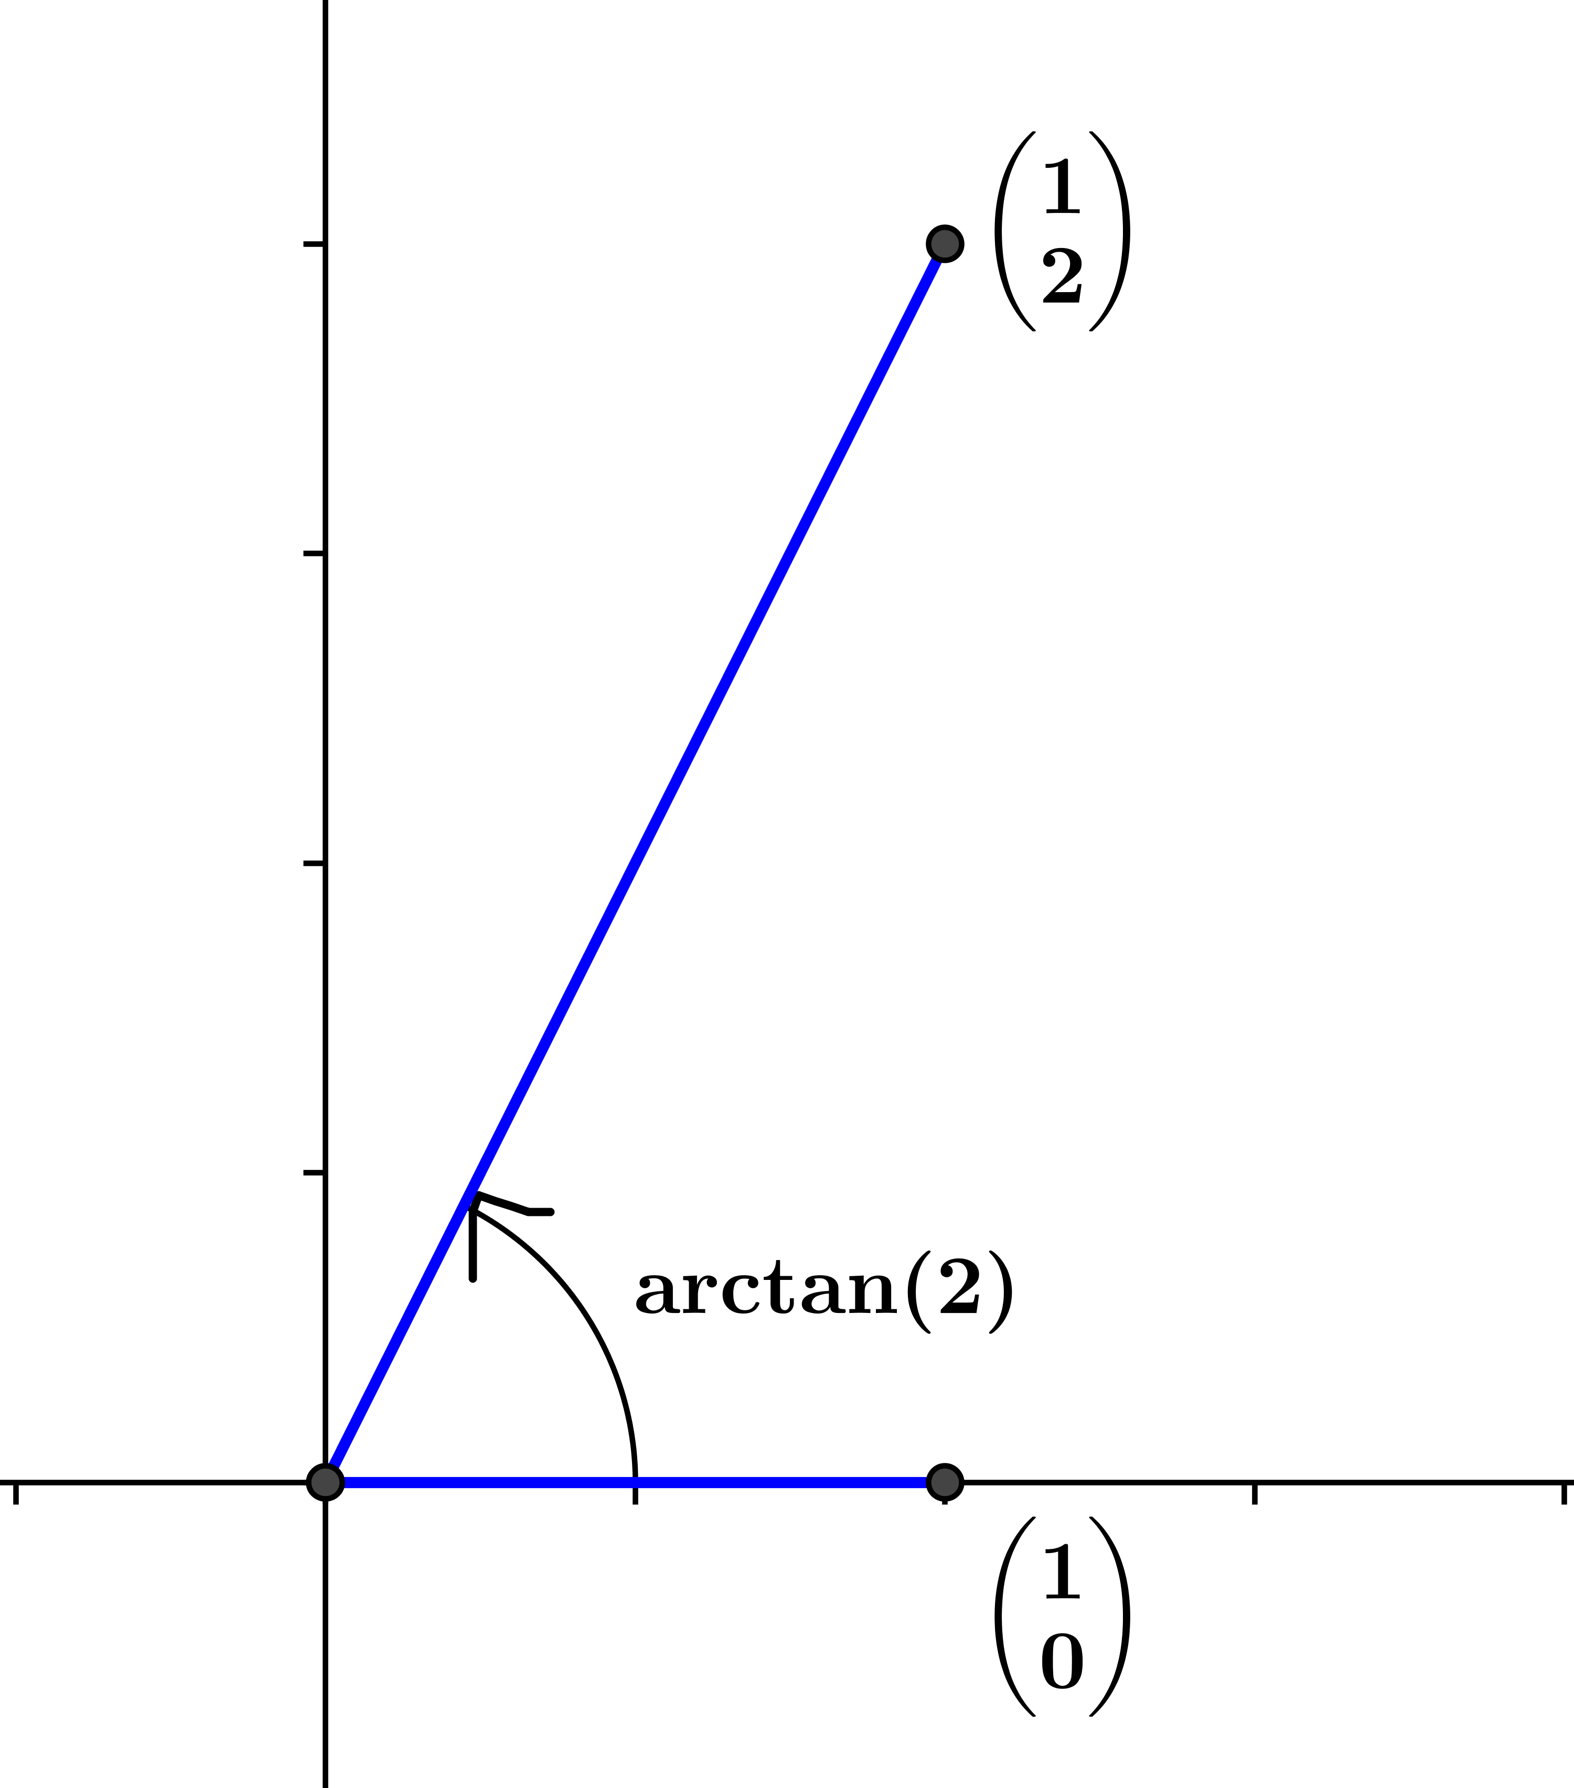

Exercises 3–9 (8 minutes)
Have students work in pairs or small group on these exercises.
Exercises 3–9
- Find a matrix $\left(\begin{matrix}a & b \\ c & d\end{matrix}\right)$ so that we can represent the transformation $L(x,y)=(2x-3y, 3x+2y)$ by
$L\left(\begin{matrix}x \\ y\end{matrix}\right)=\left(\begin{matrix}a & b \\ c & d\end{matrix}\right)\left(\begin{matrix}x \\ y\end{matrix}\right)$.
The matrix is $\left(\begin{matrix}2 & -3 \\ 3 & 2\end{matrix}\right)$.

- If a transformation $L\left(\begin{matrix}x \\ y\end{matrix}\right)=\left(\begin{matrix}a & b \\ c & d\end{matrix}\right)\left(\begin{matrix}x \\ y\end{matrix}\right)$ has the geometric effect of rotation and dilation, do you know about the values $a, b, c$, and $d$?
Since the transformation is $L(x,y)=(ax-by, bx+ay)$ has matrix representation $L\left(\begin{matrix}x \\ y\end{matrix}\right)=\left(\begin{matrix}a & -b \\ b & a\end{matrix}\right)\left(\begin{matrix}x \\ y\end{matrix}\right)$, we know that $a=d$ and $c=-b$.

- Describe the form of a matrix $\left(\begin{matrix}a & b \\ c & d\end{matrix}\right)$ so that the transformation $L\left(\begin{matrix}x \\ y\end{matrix}\right)=\left(\begin{matrix}a & b \\ c & d\end{matrix}\right)\left(\begin{matrix}x \\ y\end{matrix}\right)$ has the geometric effect of only dilation by a scale factor $r$.
The transformation that scales by factor $r$ has the form $L\left(x,y\right)=r\left(x,y\right)=\left(rx,ry\right)=(rx-0y, 0x+ry)$, so the matrix has the form $\left(\begin{matrix}r & 0 \\ 0 & r\end{matrix}\right)$.

- Describe the form of a matrix $\left(\begin{matrix}a & b \\ c & d\end{matrix}\right)$ so that the transformation $L\left(\begin{matrix}x \\ y\end{matrix}\right)=\left(\begin{matrix}a & b \\ c & d\end{matrix}\right)\left(\begin{matrix}x \\ y\end{matrix}\right)$ has the geometric effect of only rotation by $θ$. Describe the matrix in terms of $θ$.
The matrix has the form $\left(\begin{matrix}a & -b \\ b & a\end{matrix}\right)$, where $arg\left(a+bi\right)=θ$. Thus, $a=cos(θ)$ and $b=sin(θ)$, so the matrix has the form $\left(\begin{matrix}cos(θ) & -sin(θ) \\ sin(θ) & cos(θ)\end{matrix}\right)$.

- Describe the form of a matrix $\left(\begin{matrix}a & b \\ c & d\end{matrix}\right)$ so that the transformation $L\left(\begin{matrix}x \\ y\end{matrix}\right)=\left(\begin{matrix}a & b \\ c & d\end{matrix}\right)\left(\begin{matrix}x \\ y\end{matrix}\right)$ has the geometric effect of rotation by $θ$ and dilation with scale factor $r$. Describe the matrix in terms of $θ$ and $r$.
The matrix has the form $\left(\begin{matrix}a & -b \\ b & a\end{matrix}\right)$, where $arg\left(a+bi\right)=θ$ and $r=\left|a+bi\right|$. Thus, $a=r cos(θ)$ and $b=r sin(θ)$, so the matrix has the form $\left(\begin{matrix}r cos(θ) & -r sin(θ) \\ r sin(θ) & r cos(θ)\end{matrix}\right)$.

- Suppose that we have a transformation $L\left(\begin{matrix}x \\ y\end{matrix}\right)=\left(\begin{matrix}1 & 2 \\ 0 & 1\end{matrix}\right)\left(\begin{matrix}x \\ y\end{matrix}\right)$.
  - Does this transformation have the geometric effect of rotation and dilation?
No; the matrix is not in the form $\left(\begin{matrix}a & -b \\ b & a\end{matrix}\right)$, so this transformation is not a rotation and dilation.

  - Transform each of the points $A=\left(\begin{matrix}0 \\ 0\end{matrix}\right)$, $B=\left(\begin{matrix}1 \\ 0\end{matrix}\right), C=\left(\begin{matrix}1 \\ 1\end{matrix}\right)$, and $D=\left(\begin{matrix}0 \\ 1\end{matrix}\right)$ and plot the images in the plane shown.
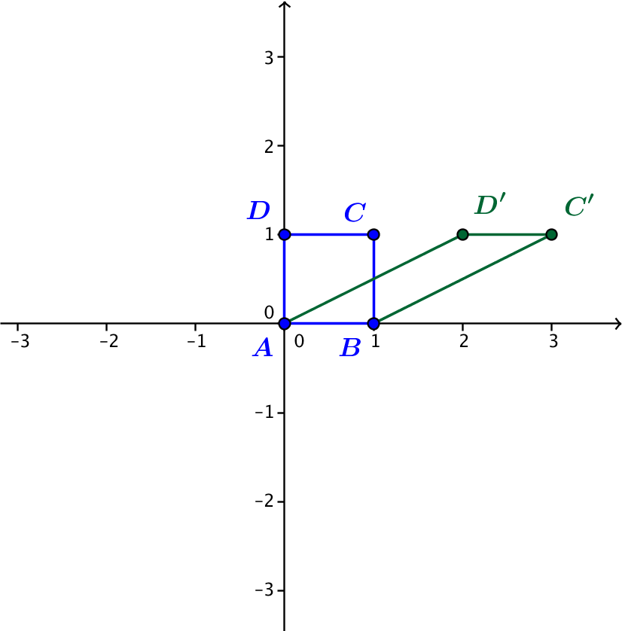

- Describe the geometric effect of the transformation $L\left(\begin{matrix}x \\ y\end{matrix}\right)=\left(\begin{matrix}1 & 0 \\ 0 & 1\end{matrix}\right)\left(\begin{matrix}x \\ y\end{matrix}\right)$.
This transformation does nothing to the point $(x,y)$ in the plane; it is the identity transformation.

Closing (3 minutes)
- Ask students to summarize the lesson in writing or orally with a partner. Some key elements are summarized below.
Lesson Summary
For real numbers $a, b, c$, and $d$, the transformation $L\left(x,y\right)=(ax+by, cx+dy)$ can be represented using matrix multiplication by $L\left(\begin{matrix}x \\ y\end{matrix}\right)=\left(\begin{matrix}a & b \\ c & d\end{matrix}\right)\left(\begin{matrix}x \\ y\end{matrix}\right)$, where $\left(\begin{matrix}a & b \\ c & d\end{matrix}\right)\left(\begin{matrix}x \\ y\end{matrix}\right)=\left(\begin{matrix}ax+by \\ cx+dy\end{matrix}\right)$ and the $\left(\begin{matrix}x \\ y\end{matrix}\right)$ represents the point $(x,y)$ in the plane.
- The transformation is a counterclockwise rotation by $θ$ if and only if the matrix representation is $L\left(\begin{matrix}x \\ y\end{matrix}\right)=\left(\begin{matrix}cos(θ) & -sin(θ) \\ sin(θ) & cos(θ)\end{matrix}\right)\left(\begin{matrix}x \\ y\end{matrix}\right)$.
- The transformation is a dilation with scale factor $k$ if and only if the matrix representation is
$L\left(\begin{matrix}x \\ y\end{matrix}\right)=\left(\begin{matrix}k & 0 \\ 0 & k\end{matrix}\right)\left(\begin{matrix}x \\ y\end{matrix}\right)$.
- The transformation is a counterclockwise rotation by $arg\left(a+bi\right)$ and dilation with scale factor
$|a+bi|$ if and only if the matrix representation is $L\left(\begin{matrix}x \\ y\end{matrix}\right)=\left(\begin{matrix}a & -b \\ b & a\end{matrix}\right)\left(\begin{matrix}x \\ y\end{matrix}\right)$. If we let $r=\left|a+bi\right|$ and $θ=arg(a+bi)$, then the matrix representation is $L\left(\begin{matrix}x \\ y\end{matrix}\right)=\left(\begin{matrix}r cos(θ) & -r sin(θ) \\ r sin(θ) & r cos(θ)\end{matrix}\right)\left(\begin{matrix}x \\ y\end{matrix}\right)$.

Exit Ticket (5 minutes)

Name Date
Lesson 21: The Hunt for Better Notation

Exit Ticket

- Evaluate the product $\left(\begin{matrix}10 & 2 \\ -8 & -5\end{matrix}\right)\left(\begin{matrix}3 \\ -2\end{matrix}\right)$.

- Find a matrix representation of the transformation $L\left(x,y\right)=\left(3x+4y, x-2y\right)$.

- Does the transformation $L\left(\begin{matrix}x \\ y\end{matrix}\right)=\left(\begin{matrix}5 & 2 \\ -2 & 5\end{matrix}\right)\left(\begin{matrix}x \\ y\end{matrix}\right)$ represent a rotation and dilation in the plane? Explain how you know.

Exit Ticket Sample Solutions

- Evaluate the product $\left(\begin{matrix}10 & 2 \\ -8 & -5\end{matrix}\right)\left(\begin{matrix}3 \\ -2\end{matrix}\right)$.
$$\left(\begin{matrix}10 & 2 \\ -8 & -5\end{matrix}\right)\left(\begin{matrix}3 \\ -2\end{matrix}\right)=\left(\begin{matrix}30-4 \\ -24+10\end{matrix}\right) \\ =\left(\begin{matrix}26 \\ -14\end{matrix}\right)$$

- Find a matrix representation of the transformation $L\left(x,y\right)=\left(3x+4y, x-2y\right)$.
$$L\left(\begin{matrix}x \\ y\end{matrix}\right)=\left(\begin{matrix}3 & 4 \\ 1 & -2\end{matrix}\right)\left(\begin{matrix}x \\ y\end{matrix}\right)$$

- Does the transformation $L\left(\begin{matrix}x \\ y\end{matrix}\right)=\left(\begin{matrix}5 & 2 \\ -2 & 5\end{matrix}\right)\left(\begin{matrix}x \\ y\end{matrix}\right)$ represent a rotation and dilation in the plane? Explain how you know.
Yes; this transformation can also be represented as $L\left(x,y\right)=(5x-\left(-2\right)y, -2x+5y)$, which has the geometric effect of counterclockwise rotation by $arg(5-2i)$ and dilation by $\left|5-2i\right|$.

Problem Set Sample Solutions

- Perform the indicated multiplication.
  - $\left(\begin{matrix}1 & 2 \\ 4 & 8\end{matrix}\right)\left(\begin{aligned}3 \\ -2\end{aligned}\right)$
$$\left(\begin{matrix}-1 \\ -4\end{matrix}\right)$$

  - $\left(\begin{matrix}3 & 5 \\ -2 & -6\end{matrix}\right)\left(\begin{aligned}2 \\ 4\end{aligned}\right)$
$$\left(\begin{matrix}26 \\ -28\end{matrix}\right)$$

  - $\left(\begin{matrix}1 & 1 \\ 1 & -1\end{matrix}\right)\left(\begin{aligned}6 \\ 8\end{aligned}\right)$
$$\left(\begin{matrix}14 \\ -2\end{matrix}\right)$$

  - $\left(\begin{matrix}5 & 7 \\ 4 & 9\end{matrix}\right)\left(\begin{aligned}10 \\ 100\end{aligned}\right)$
$$\left(\begin{matrix}750 \\ 940\end{matrix}\right)$$

  - $\left(\begin{matrix}4 & 2 \\ 3 & 7\end{matrix}\right)\left(\begin{aligned}-3 \\ 1\end{aligned}\right)$
$$\left(\begin{matrix}-10 \\ -2\end{matrix}\right)$$

  - $\left(\begin{matrix}6 & 4 \\ 9 & 6\end{matrix}\right)\left(\begin{aligned}2 \\ -3\end{aligned}\right)$
$$\left(\begin{matrix}0 \\ 0\end{matrix}\right)$$

  - $\left(\begin{matrix}cos(θ) & -sin(θ) \\ sin(θ) & cos\left(θ\right)\end{matrix}\right)\left(\begin{aligned}x \\ y\end{aligned}\right)$
$$\left(\begin{matrix}x cos\left(θ\right)-y sin(θ) \\ x sin\left(θ\right)+y cos(θ)\end{matrix}\right)$$

  - $\left(\begin{matrix}π & 1 \\ 1 & -π\end{matrix}\right)\left(\begin{aligned}10 \\ 7\end{aligned}\right)$
$$\left(\begin{matrix}10π+7 \\ 10-7π\end{matrix}\right)$$

- Find a value of $k$ so that $\left(\begin{matrix}k & 3 \\ 4 & k\end{matrix}\right)\left(\begin{aligned}4 \\ 5\end{aligned}\right)=\left(\begin{aligned}7 \\ 6\end{aligned}\right)$.
We have $\left(\begin{matrix}k & 3 \\ 4 & k\end{matrix}\right)\left(\begin{aligned}4 \\ 5\end{aligned}\right)=\left(\begin{aligned}4k+15 \\ 16+5k\end{aligned}\right)$, so $4k+15=7$, and $16+5k=6$. Thus, $4k=-8$, and $5k=-10$, so
$k=-2$.

- Find values of $k$ and $m$ so that $\left(\begin{matrix}k & 3 \\ -2 & m\end{matrix}\right)\left(\begin{aligned}5 \\ 4\end{aligned}\right)=\left(\begin{aligned}7 \\ -10\end{aligned}\right)$.
We have $\left(\begin{matrix}k & 3 \\ -2 & m\end{matrix}\right)\left(\begin{aligned}5 \\ 4\end{aligned}\right)=\left(\begin{aligned}7 \\ -10\end{aligned}\right),$ so $5k+12=7$ and $-10+4m=-10$. Therefore, $k=-1$ and $m=0$.

- Find values of $k$ and $m$ so that $\left(\begin{matrix}1 & 2 \\ -2 & 5\end{matrix}\right)\left(\begin{aligned}k \\ m\end{aligned}\right)=\left(\begin{aligned}0 \\ -9\end{aligned}\right)$.
Since $\left(\begin{matrix}1 & 2 \\ -2 & 5\end{matrix}\right)\left(\begin{aligned}k \\ m\end{aligned}\right)=\left(\begin{aligned}k+2m \\ -2k+5m\end{aligned}\right)$, we need to find values of $k$ and $m$ so that $k+2m=0$ and $-2k+5m=-9$. Solving this first equation for $k$ gives $k=-2m$, and substituting this expression for $k$ into the second equation gives $–9=-2\left(-2m\right)+5m=9m$, so we have $m=-1$. Then $k=-2m$ gives $k=2$. Therefore, $k=2$ and $m=-1$.

- Write the following transformations using matrix multiplication.
  - $L\left(x,y\right)=(3x-2y, 4x-5y)$
$$L\left(\begin{aligned}x \\ y\end{aligned}\right)=\left(\begin{matrix}3 & -2 \\ 4 & -5\end{matrix}\right)\left(\begin{matrix}x \\ y\end{matrix}\right)$$

  - $L\left(x,y\right)=\left(6x+10y,-2x+y\right)$
$$L\left(\begin{aligned}x \\ y\end{aligned}\right)=\left(\begin{matrix}6 & 10 \\ -2 & 1\end{matrix}\right)\left(\begin{matrix}x \\ y\end{matrix}\right)$$

  - $L\left(x,y\right)=\left(25x+10y,8x-64y\right)$
$$L\left(\begin{aligned}x \\ y\end{aligned}\right)=\left(\begin{matrix}25 & 10 \\ 8 & -64\end{matrix}\right)\left(\begin{matrix}x \\ y\end{matrix}\right)$$

  - $L\left(x,y\right)=\left(πx-y,-2x+3y\right)$
$$L\left(\begin{aligned}x \\ y\end{aligned}\right)=\left(\begin{matrix}π & -1 \\ -2 & 3\end{matrix}\right)\left(\begin{matrix}x \\ y\end{matrix}\right)$$
  - $L\left(x,y\right)=(10x,100x)$
$$L\left(\begin{aligned}x \\ y\end{aligned}\right)=\left(\begin{matrix}10 & 0 \\ 100 & 0\end{matrix}\right)\left(\begin{matrix}x \\ y\end{matrix}\right)$$

  - $L\left(x,y\right)=(2y,7x)$
$$L\left(\begin{aligned}x \\ y\end{aligned}\right)=\left(\begin{matrix}0 & 2 \\ 7 & 0\end{matrix}\right)\left(\begin{matrix}x \\ y\end{matrix}\right)$$

- Identify whether or not the following transformations have the geometric effect of rotation only, dilation only, rotation and dilation only, or none of these.
  - $L\left(\begin{aligned}x \\ y\end{aligned}\right)=\left(\begin{matrix}3 & -2 \\ 4 & -5\end{matrix}\right)\left(\begin{matrix}x \\ y\end{matrix}\right)$
The matrix $\left(\begin{matrix}3 & -2 \\ 4 & -5\end{matrix}\right)$ cannot be written in the form $\left(\begin{matrix}a & -b \\ b & a\end{matrix}\right)$ because $3≠-5$, so this is neither a rotation nor a dilation. The transformation $L$ is not one of the specified types of transformations.

  - $L\left(\begin{aligned}x \\ y\end{aligned}\right)=\left(\begin{matrix}42 & 0 \\ 0 & 42\end{matrix}\right)\left(\begin{matrix}x \\ y\end{matrix}\right)$
This transformation has the geometric effect of dilation by a scale factor of $42$.

  - $L\left(\begin{aligned}x \\ y\end{aligned}\right)=\left(\begin{matrix}-4 & -2 \\ 2 & -4\end{matrix}\right)\left(\begin{matrix}x \\ y\end{matrix}\right)$
The matrix $\left(\begin{matrix}-4 & -2 \\ 2 & -4\end{matrix}\right)$ has the form $\left(\begin{matrix}a & -b \\ b & a\end{matrix}\right)$ with $a=-4$ and $b=2$. Therefore, this transformation has the geometric effect of rotation and dilation.

  - $L\left(\begin{aligned}x \\ y\end{aligned}\right)=\left(\begin{matrix}5 & -1 \\ -1 & 5\end{matrix}\right)\left(\begin{matrix}x \\ y\end{matrix}\right)$
The matrix $\left(\begin{matrix}5 & -1 \\ -1 & 5\end{matrix}\right)$ cannot be written in the form $\left(\begin{matrix}a & -b \\ b & a\end{matrix}\right)$ because $-1≠-(-1)$, so this is neither a rotation nor a dilation. The transformation $L$ is not one of the specified types of transformations.

  - $L\left(\begin{aligned}x \\ y\end{aligned}\right)=\left(\begin{matrix}-7 & 1 \\ 1 & 7\end{matrix}\right)\left(\begin{matrix}x \\ y\end{matrix}\right)$
The matrix $\left(\begin{matrix}-7 & 1 \\ 1 & 7\end{matrix}\right)$ cannot be written in the form $\left(\begin{matrix}a & -b \\ b & a\end{matrix}\right)$ because $-7≠7$, so this is neither a rotation nor a dilation. The transformation $L$ is not one of the specified types of transformations.

  - $L\left(\begin{aligned}x \\ y\end{aligned}\right)=\left(\begin{matrix}0 & -2 \\ 2 & 0\end{matrix}\right)\left(\begin{matrix}x \\ y\end{matrix}\right)$
We see that $\left(\begin{matrix}0 & -2 \\ 2 & 0\end{matrix}\right)=\left(\begin{matrix}cos\left(\frac{π}{2}\right) & -\sqrt{2} sin\left(\frac{π}{2}\right) \\ \sqrt{2} sin\left(\frac{π}{2}\right) & cos\left(\frac{π}{2}\right)\end{matrix}\right)$, so this transformation has the geometric effect of dilation by $\sqrt{2}$ and rotation by $\frac{π}{2}$.

- Create a matrix representation of a linear transformation that has the specified geometric effect.
  - Dilation by a factor of $4$ and no rotation.
$$L\left(\begin{aligned}x \\ y\end{aligned}\right)=\left(\begin{matrix}4 & 0 \\ 0 & 4\end{matrix}\right)\left(\begin{matrix}x \\ y\end{matrix}\right)$$
  - Rotation by $180°$ and no dilation.
$$L\left(\begin{aligned}x \\ y\end{aligned}\right)=\left(\begin{matrix}cos\left(180°\right) & -sin\left(180°\right) \\ sin\left(180°\right) & cos\left(180°\right)\end{matrix}\right)\left(\begin{matrix}x \\ y\end{matrix}\right) \\ =\left(\begin{matrix}-1 & 0 \\ 0 & -1\end{matrix}\right)\left(\begin{matrix}x \\ y\end{matrix}\right)$$

  - Rotation by $–\frac{π}{2} rad$ and dilation by a scale factor of $3$.
$$L\left(\begin{aligned}x \\ y\end{aligned}\right)=\left(\begin{matrix}3 cos\left(-\frac{π}{2}\right) & -3 sin\left(-\frac{π}{2}\right) \\ 3 sin\left(-\frac{π}{2}\right) & 3 cos\left(-\frac{π}{2}\right)\end{matrix}\right)\left(\begin{matrix}x \\ y\end{matrix}\right) \\ =\left(\begin{matrix}0 & 3 \\ -3 & 0\end{matrix}\right)\left(\begin{matrix}x \\ y\end{matrix}\right)$$

  - Rotation by $30°$ and dilation by a scale factor of $4$.
$$L\left(\begin{aligned}x \\ y\end{aligned}\right)=\left(\begin{matrix}4 cos\left(30°\right) & -4 sin\left(30°\right) \\ 4 sin\left(30°\right) & 4 cos\left(30°\right)\end{matrix}\right)\left(\begin{matrix}x \\ y\end{matrix}\right) \\ =\left(\begin{matrix}2\sqrt{3} & -2 \\ 2 & 2\sqrt{3}\end{matrix}\right)\left(\begin{matrix}x \\ y\end{matrix}\right)$$

- Identify the geometric effect of the following transformations. Justify your answer.
  - $L\left(\begin{aligned}x \\ y\end{aligned}\right)=\left(\begin{matrix}-\frac{\sqrt{2}}{2} & -\frac{\sqrt{2}}{2} \\ \frac{\sqrt{2}}{2} & -\frac{\sqrt{2}}{2}\end{matrix}\right)\left(\begin{matrix}x \\ y\end{matrix}\right)$
Since $cos\left(\frac{3π}{4}\right)=-\frac{\sqrt{2}}{2}$ and $sin\left(\frac{3π}{4}\right)=\frac{\sqrt{2}}{2}$, this transformation has the form $L\left(\begin{aligned}x \\ y\end{aligned}\right)=\left(\begin{matrix}cos\left(\frac{3π}{4}\right) & -sin\left(\frac{3π}{4}\right) \\ sin\left(\frac{3π}{4}\right) & cos\left(\frac{3π}{4}\right)\end{matrix}\right)\left(\begin{matrix}x \\ y\end{matrix}\right)$, and thus represents counterclockwise rotation by $\frac{3π}{4}$ with no dilation.

  - $L\left(\begin{aligned}x \\ y\end{aligned}\right)=\left(\begin{matrix}0 & -5 \\ 5 & 0\end{matrix}\right)\left(\begin{matrix}x \\ y\end{matrix}\right)$
Since $cos\left(\frac{π}{2}\right)=0$ and $sin\left(\frac{π}{2}\right)=1$, this transformation has the form $L\left(\begin{aligned}x \\ y\end{aligned}\right)=\left(\begin{matrix}5 cos\left(\frac{π}{2}\right) & -5 sin\left(\frac{π}{2}\right) \\ 5 sin\left(\frac{π}{2}\right) & 5 cos\left(\frac{π}{2}\right)\end{matrix}\right)\left(\begin{matrix}x \\ y\end{matrix}\right)$, and thus represents counterclockwise rotation by $\frac{π}{2}$ and dilation by a scale factor $5$.

  - $L\left(\begin{aligned}x \\ y\end{aligned}\right)=\left(\begin{matrix}-10 & 0 \\ 0 & -10\end{matrix}\right)\left(\begin{matrix}x \\ y\end{matrix}\right)$
Since $cos\left(π\right)=-1$ and $sin\left(π\right)=0$, this transformation has the form $L\left(\begin{aligned}x \\ y\end{aligned}\right)=\left(\begin{matrix}10 cos(π) & -10 sin\left(π\right) \\ 10 sin\left(π\right) & 10 cos\left(π\right)\end{matrix}\right)\left(\begin{matrix}x \\ y\end{matrix}\right)$, and thus represents counterclockwise rotation by $π$ and dilation by a scale factor $10$.

  - $L\left(\begin{aligned}x \\ y\end{aligned}\right)=\left(\begin{matrix}6 & 6\sqrt{3} \\ -6\sqrt{3} & 6\end{matrix}\right)\left(\begin{matrix}x \\ y\end{matrix}\right)$
Since $cos\left(\frac{5π}{3}\right)=\frac{1}{2}$ and $sin\left(\frac{5π}{3}\right)=-\frac{\sqrt{3}}{2}$, this transformation has the form $L\left(\begin{aligned}x \\ y\end{aligned}\right)=\left(\begin{matrix}12 cos\left(\frac{5π}{3}\right) & -12 sin\left(\frac{5π}{3}\right) \\ 12 sin\left(\frac{5π}{3}\right) & 12 cos\left(\frac{5π}{3}\right)\end{matrix}\right)\left(\begin{matrix}x \\ y\end{matrix}\right)$, and thus represents counterclockwise rotation by $\frac{5π}{3}$ and dilation with scale factor $12$.

