Lesson 21: The Hunt for Better Notation

Classwork
Opening Exercise
Suppose that $L_{1}\left(x,y\right)=(2x-3y, 3x+2y)$ and $L_{2}\left(x,y\right)=(3x+4y, -4y+3x)$.
Find the result of performing $L_{1}$ and then $L_{2}$ on a point $(p,q)$. That is, find $L_{2}\left(L_{1}\left(p,q\right)\right)$.

Exercises 1–2
- Calculate each of the following products.
  - $\left(\begin{matrix}3 & -2 \\ -1 & 4\end{matrix}\right)\left(\begin{matrix}1 \\ 5\end{matrix}\right)$

  - $\left(\begin{matrix}3 & 3 \\ 3 & 3\end{matrix}\right)\left(\begin{matrix}4 \\ -4\end{matrix}\right)$

  - $\left(\begin{matrix}2 & -4 \\ 5 & -1\end{matrix}\right)\left(\begin{matrix}3 \\ -2\end{matrix}\right)$

- Find a value of $k$ so that $\left(\begin{matrix}1 & 2 \\ k & 1\end{matrix}\right)\left(\begin{matrix}3 \\ -1\end{matrix}\right)=\left(\begin{matrix}1 \\ 11\end{matrix}\right)$.

Exercises 3–9
- Find a matrix $\left(\begin{matrix}a & b \\ c & d\end{matrix}\right)$ so that we can represent the transformation $L(x,y)=(2x-3y, 3x+2y)$ by
$L\left(\begin{matrix}x \\ y\end{matrix}\right)=\left(\begin{matrix}a & b \\ c & d\end{matrix}\right)\left(\begin{matrix}x \\ y\end{matrix}\right)$.

- If a transformation $L\left(\begin{matrix}x \\ y\end{matrix}\right)=\left(\begin{matrix}a & b \\ c & d\end{matrix}\right)\left(\begin{matrix}x \\ y\end{matrix}\right)$ has the geometric effect of rotation and dilation, do you know about the values $a, b, c$, and $d$?

- Describe the form of a matrix $\left(\begin{matrix}a & b \\ c & d\end{matrix}\right)$ so that the transformation $L\left(\begin{matrix}x \\ y\end{matrix}\right)=\left(\begin{matrix}a & b \\ c & d\end{matrix}\right)\left(\begin{matrix}x \\ y\end{matrix}\right)$ has the geometric effect of only dilation by a scale factor $r$.

- Describe the form of a matrix $\left(\begin{matrix}a & b \\ c & d\end{matrix}\right)$ so that the transformation $L\left(\begin{matrix}x \\ y\end{matrix}\right)=\left(\begin{matrix}a & b \\ c & d\end{matrix}\right)\left(\begin{matrix}x \\ y\end{matrix}\right)$ has the geometric effect of only rotation by $θ$. Describe the matrix in terms of $θ$.

- Describe the form of a matrix $\left(\begin{matrix}a & b \\ c & d\end{matrix}\right)$ so that the transformation $L\left(\begin{matrix}x \\ y\end{matrix}\right)=\left(\begin{matrix}a & b \\ c & d\end{matrix}\right)\left(\begin{matrix}x \\ y\end{matrix}\right)$ has the geometric effect of rotation by $θ$ and dilation with scale factor $r$. Describe the matrix in terms of $θ$ and $r$.

- Suppose that we have a transformation $L\left(\begin{matrix}x \\ y\end{matrix}\right)=\left(\begin{matrix}1 & 2 \\ 0 & 1\end{matrix}\right)\left(\begin{matrix}x \\ y\end{matrix}\right)$.
  - Does this transformation have the geometric effect of rotation and dilation?

  - Transform each of the points $A=\left(\begin{matrix}0 \\ 0\end{matrix}\right)$, $B=\left(\begin{matrix}1 \\ 0\end{matrix}\right), C=\left(\begin{matrix}1 \\ 1\end{matrix}\right)$, and $D=\left(\begin{matrix}0 \\ 1\end{matrix}\right)$ and plot the images in the plane shown.
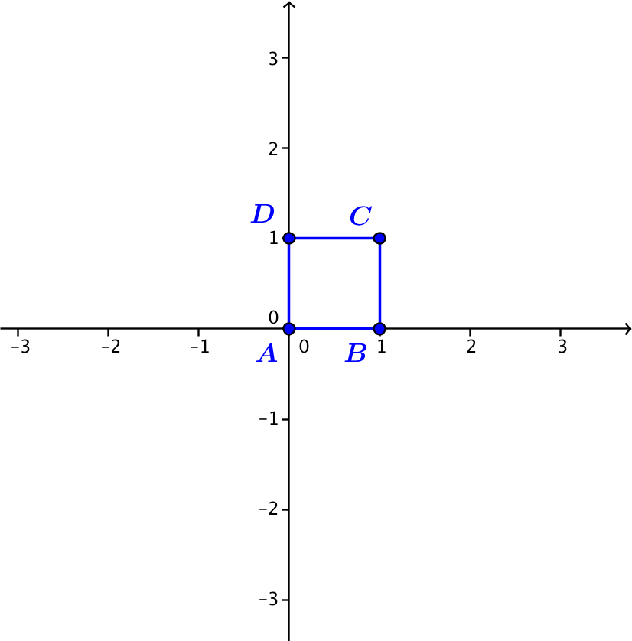

- Describe the geometric effect of the transformation $L\left(\begin{matrix}x \\ y\end{matrix}\right)=\left(\begin{matrix}1 & 0 \\ 0 & 1\end{matrix}\right)\left(\begin{matrix}x \\ y\end{matrix}\right)$.

Lesson Summary
For real numbers $a, b, c$, and $d$, the transformation $L\left(x,y\right)=(ax+by, cx+dy)$ can be represented using matrix multiplication by $L\left(\begin{matrix}x \\ y\end{matrix}\right)=\left(\begin{matrix}a & b \\ c & d\end{matrix}\right)\left(\begin{matrix}x \\ y\end{matrix}\right)$, where $\left(\begin{matrix}a & b \\ c & d\end{matrix}\right)\left(\begin{matrix}x \\ y\end{matrix}\right)=\left(\begin{matrix}ax+by \\ cx+dy\end{matrix}\right)$ and the $\left(\begin{matrix}x \\ y\end{matrix}\right)$ represents the point $(x,y)$ in the plane.
- The transformation is a counterclockwise rotation by $θ$ if and only if the matrix representation is
$L\left(\begin{matrix}x \\ y\end{matrix}\right)=\left(\begin{matrix}cos(θ) & -sin(θ) \\ sin(θ) & cos(θ)\end{matrix}\right)\left(\begin{matrix}x \\ y\end{matrix}\right)$.
- The transformation is a dilation with scale factor $k$ if and only if the matrix representation is
$L\left(\begin{matrix}x \\ y\end{matrix}\right)=\left(\begin{matrix}k & 0 \\ 0 & k\end{matrix}\right)\left(\begin{matrix}x \\ y\end{matrix}\right)$.
- The transformation is a counterclockwise rotation by $arg\left(a+bi\right)$ and dilation with scale factor $|a+bi|$ if and only if the matrix representation is $L\left(\begin{matrix}x \\ y\end{matrix}\right)=\left(\begin{matrix}a & -b \\ b & a\end{matrix}\right)\left(\begin{matrix}x \\ y\end{matrix}\right)$. If we let $r=\left|a+bi\right|$ and
$θ=arg(a+bi)$, then the matrix representation is $L\left(\begin{matrix}x \\ y\end{matrix}\right)=\left(\begin{matrix}r cos(θ) & -r sin(θ) \\ r sin(θ) & r cos(θ)\end{matrix}\right)\left(\begin{matrix}x \\ y\end{matrix}\right)$.

Problem Set

- Perform the indicated multiplication.
  - $\left(\begin{matrix}1 & 2 \\ 4 & 8\end{matrix}\right)\left(\begin{aligned}3 \\ -2\end{aligned}\right)$
  - $\left(\begin{matrix}3 & 5 \\ -2 & -6\end{matrix}\right)\left(\begin{aligned}2 \\ 4\end{aligned}\right)$
  - $\left(\begin{matrix}1 & 1 \\ 1 & -1\end{matrix}\right)\left(\begin{aligned}6 \\ 8\end{aligned}\right)$
  - $\left(\begin{matrix}5 & 7 \\ 4 & 9\end{matrix}\right)\left(\begin{aligned}10 \\ 100\end{aligned}\right)$
  - $\left(\begin{matrix}4 & 2 \\ 3 & 7\end{matrix}\right)\left(\begin{aligned}-3 \\ 1\end{aligned}\right)$
  - $\left(\begin{matrix}6 & 4 \\ 9 & 6\end{matrix}\right)\left(\begin{aligned}2 \\ -3\end{aligned}\right)$
  - $\left(\begin{matrix}cos(θ) & -sin(θ) \\ sin(θ) & cos\left(θ\right)\end{matrix}\right)\left(\begin{aligned}x \\ y\end{aligned}\right)$
  - $\left(\begin{matrix}π & 1 \\ 1 & -π\end{matrix}\right)\left(\begin{aligned}10 \\ 7\end{aligned}\right)$

- Find a value of $k$ so that $\left(\begin{matrix}k & 3 \\ 4 & k\end{matrix}\right)\left(\begin{aligned}4 \\ 5\end{aligned}\right)=\left(\begin{aligned}7 \\ 6\end{aligned}\right)$.

- Find values of $k$ and $m$ so that $\left(\begin{matrix}k & 3 \\ -2 & m\end{matrix}\right)\left(\begin{aligned}5 \\ 4\end{aligned}\right)=\left(\begin{aligned}7 \\ -10\end{aligned}\right)$.
- Find values of $k$ and $m$ so that $\left(\begin{matrix}1 & 2 \\ -2 & 5\end{matrix}\right)\left(\begin{aligned}k \\ m\end{aligned}\right)=\left(\begin{aligned}0 \\ -9\end{aligned}\right)$.

- Write the following transformations using matrix multiplication.
  - $L\left(x,y\right)=(3x-2y, 4x-5y)$
  - $L\left(x,y\right)=\left(6x+10y,-2x+y\right)$
  - $L\left(x,y\right)=\left(25x+10y,8x-64y\right)$
  - $L\left(x,y\right)=\left(πx-y,-2x+3y\right)$
  - $L\left(x,y\right)=(10x,100x)$
  - $L\left(x,y\right)=(2y,7x)$

- Identify whether or not the following transformations have the geometric effect of rotation only, dilation only, rotation and dilation only, or none of these.
  - $L\left(\begin{aligned}x \\ y\end{aligned}\right)=\left(\begin{matrix}3 & -2 \\ 4 & -5\end{matrix}\right)\left(\begin{matrix}x \\ y\end{matrix}\right)$
  - $L\left(\begin{aligned}x \\ y\end{aligned}\right)=\left(\begin{matrix}42 & 0 \\ 0 & 42\end{matrix}\right)\left(\begin{matrix}x \\ y\end{matrix}\right)$
  - $L\left(\begin{aligned}x \\ y\end{aligned}\right)=\left(\begin{matrix}-4 & -2 \\ 2 & -4\end{matrix}\right)\left(\begin{matrix}x \\ y\end{matrix}\right)$
  - $L\left(\begin{aligned}x \\ y\end{aligned}\right)=\left(\begin{matrix}5 & -1 \\ -1 & 5\end{matrix}\right)\left(\begin{matrix}x \\ y\end{matrix}\right)$
  - $L\left(\begin{aligned}x \\ y\end{aligned}\right)=\left(\begin{matrix}-7 & 1 \\ 1 & 7\end{matrix}\right)\left(\begin{matrix}x \\ y\end{matrix}\right)$
  - $L\left(\begin{aligned}x \\ y\end{aligned}\right)=\left(\begin{matrix}0 & -2 \\ 2 & 0\end{matrix}\right)\left(\begin{matrix}x \\ y\end{matrix}\right)$

- Create a matrix representation of a linear transformation that has the specified geometric effect.
  - Dilation by a factor of $4$ and no rotation.
  - Rotation by $180°$ and no dilation.
  - Rotation by $-\frac{π}{2}rad$ and dilation by a scale factor of $3$.
  - Rotation by $30°$ and dilation by a scale factor of $4$.

- Identify the geometric effect of the following transformations. Justify your answer.
  - $L\left(\begin{aligned}x \\ y\end{aligned}\right)=\left(\begin{matrix}-\frac{\sqrt{2}}{2} & -\frac{\sqrt{2}}{2} \\ \frac{\sqrt{2}}{2} & -\frac{\sqrt{2}}{2}\end{matrix}\right)\left(\begin{matrix}x \\ y\end{matrix}\right)$
  - $L\left(\begin{aligned}x \\ y\end{aligned}\right)=\left(\begin{matrix}0 & -5 \\ 5 & 0\end{matrix}\right)\left(\begin{matrix}x \\ y\end{matrix}\right)$
  - $L\left(\begin{aligned}x \\ y\end{aligned}\right)=\left(\begin{matrix}-10 & 0 \\ 0 & -10\end{matrix}\right)\left(\begin{matrix}x \\ y\end{matrix}\right)$
  - $L\left(\begin{aligned}x \\ y\end{aligned}\right)=\left(\begin{matrix}6 & 6\sqrt{3} \\ -6\sqrt{3} & 6\end{matrix}\right)\left(\begin{matrix}x \\ y\end{matrix}\right)$

