|  |
| --- |
| 20 |

Lesson 20: Exploiting the Connection to Cartesian Coordinates

Student Outcomes

* Students interpret complex multiplication as the corresponding function of two real variables.
* Students calculate the amount of rotation and the scale factor of dilation in a transformation of the form .

Lesson Notes

This lesson leads into the introduction of matrix notation in the next lesson. The primary purpose of this lesson is to formalize the idea that when we identify the complex number with the point in the coordinate plane, multiplication by a complex number performs a rotation and dilation in the plane. All dilations throughout this lesson and module are centered at the origin. When we write out the formulas for such rotation and dilation in terms of the real components and of , we see that the formulas are rather cumbersome, leading us to the need for a new notation using matrices in the next lesson. This lesson serves to solidify many of the ideas introduced in Topic B and link them to matrices. This lesson has a coherent connection to the standards within F-IF domain. For example, students connect operations with complex numbers to the language and symbols of functions.

Classwork

Opening Exercise (6 minutes)

*Scaffolding:*

* For struggling students scaffold part (a) by first asking them to write a complex number with modulus 1 and argument , then ask the question stated. This will help students see the connection. Do the same for part (b).
* Ask advanced students to find complex numbers so that:

a) the transformation  
 produces a clockwise rotation by about the origin with no dilation, and

b) the transformation  
 produces a dilation with scale factor with no rotation.

Opening Exercise

* 1. Find a complex number so that the transformation produces a clockwise rotation by about the origin with no dilation.

***Because there is no dilation, we need , and because there is rotation by , we need . Thus, we need to find the point where the terminal ray of a rotation intersects the unit circle. From Algebra II, we know the coordinates of the point are***

***so that the complex number is***

***.***

*(Students may use a calculator to find the approximation .)*

* 1. Find a complex number so that the transformation produces a dilation with scale factor with no rotation.

***In this case, there is no rotation so the argument of must be . This means that the complex number corresponds to a point on the positive real axis, so has no imaginary part; this means that is a real number, and . Thus, , so .***

**Discussion (8 minutes)**

This teacher-led discussion provides justification for why we need to develop new notation.

* We have seen that we can use complex multiplication to perform dilation and rotation in the coordinate plane.
* By identifying the point with the complex number , we can think of as a transformation in the coordinate plane. Then complex multiplication gives us a way of finding formulas for rotation and dilation in two-dimensional geometry.
* Video game creators are very interested in the mathematics of rotation and dilation. In a first-person video game, you are centered at the origin. When you move forward in the game, the images on the screen need to undergo a translation to mimic what you see as you walk past them. As you walk closer to objects they look larger, requiring dilation. If you turn, then the images on the screen need to rotate.
* We have established the necessary mathematics for representing rotation and dilation in two-dimensional geometry, but in video games we need to use three-dimensional geometry to mimic our three-dimensional world. Eventually, we’ll need to translate our work from two dimensions into three dimensions.
* Complex numbers are inherently two-dimensional, with our association . We will need some way to represent points in three dimensions.
* Before we can jump to three-dimensional geometry, we need to better understand the mathematics of two-dimensional geometry.
  1. First, we will rewrite all of our work about rotation and dilation of complex numbers in terms of points in the coordinate plane, and see what rotation and dilation looks like from that perspective.
  2. Then, we will see if we can generalize the mathematics of rotation and dilation of two-dimensional points to three-dimensional points .
* We will address point (1) in this lesson and the ones that follow and leave point (2) until the next module.
* Using the notation of complex numbers, if , then , and .
* Then, how can we describe the geometric effect of multiplication by on a complex number ?
  + *The geometric effect of multiplication is dilation by and counterclockwise rotation by about the origin.*
* Now, let’s rephrase this more explicitly as follows: Multiplying by rotates about the origin through and dilates that point from the origin with scale factor .
* We can further refine our statement: The transformation corresponds to a rotation of the plane about the origin through and dilation with scale factor .
* How does this transformation work on points in the plane? Rewrite it to get a transformation in terms of coordinate points .
  + *We have and , so we can rewrite this as the transformation .*
* Finally! This is the formula we want for rotation and dilation of points in the coordinate plane.

For real numbers and , the transformation corresponds to a counterclockwise rotation by about the origin and dilation with scale factor .

* We have just written a function in two variables. Let’s practice that. If , how can we find ? Explain this in words.
  + *We would substitute in for and for .*
* What is ?
* How can be interpreted?
  + *When is multiplied by , it is transformed to the point .*
* Returning back to our formula, explain how the quantity was derived and what it represents in the formula .

**MP.2**

* + *When multiplying by , the real component is . This represents the transformation of the component.*

Exercise 1–4 (12 minutes)

These exercises link the geometric interpretation of rotation and dilation to the analytic formulas. Have students work on these exercises in pairs or small groups. Use these exercises to check for understanding. The exercises can be modified and/or assigned as instructionally necessary.

Exercises 1–4

* 1. Find values of and so that has the effect of dilation with scale factor and no rotation.

*We need and . Since , the point corresponding to lies along the positive -axis, so we know that and . Then we have , so . Thus, the transformation has the geometric effect of dilation by scale factor .*

* 1. Evaluate , and identify the resulting transformation.

If we take , we are dilating the point with scale factor twice. This means that we are dilating with scale factor .

* 1. Find values of and so that has the effect of rotation about the origin by counterclockwise and no dilation.

***Since there is no dilation, we have , and means that the point lies on the negative -axis. Then and , so , so . Then the transformation has the geometric effect of rotation by without dilation.***

* 1. Evaluate , and identify the resulting transformation.

Thus, if we take , we are rotating the point by twice, which results in a rotation of and has the net effect of doing nothing to the point . This is the identity transformation.

* 1. Find values of and so that has the effect of rotation about the origin by counterclockwise and no dilation.

*Since there is no dilation, we have , and since the rotation is counterclockwise, we know that must lie on the positive imaginary axis. Thus, , and we must have . Then the transformation has the geometric effect of rotation by counterclockwise with no dilation.*

* 1. Evaluate , and identify the resulting transformation.

Thus, if we take , we are rotating the point by twice, which results in a rotation of . This is the transformation .

* 1. Find values of and so that has the effect of rotation about the origin by counterclockwise and no dilation.

*Since there is no dilation, we have , and since the rotation is counterclockwise, we know that the point lies on the line , and thus . Then , so and thus , so we also have . Then the transformation has the geometric effect of rotation by counterclockwise with no dilation.*

*(Students may also find the values of and by .)*

* 1. Evaluate , and identify the resulting transformation.

**We then have**

Thus, if we take , we are rotating the point by twice, which results in a rotation of . This is the transformation .

Exercise 5–6 (10 minutes)

These exercises encourage students to question whether a given analytic formula represents a rotation and/or dilation. Have students work on these exercises in pairs or small groups.

Exercises 5-6

1. The figure below shows a quadrilateral with vertices , , , and .
   1. Transform each vertex under , and plot the transformed vertices on the figure.

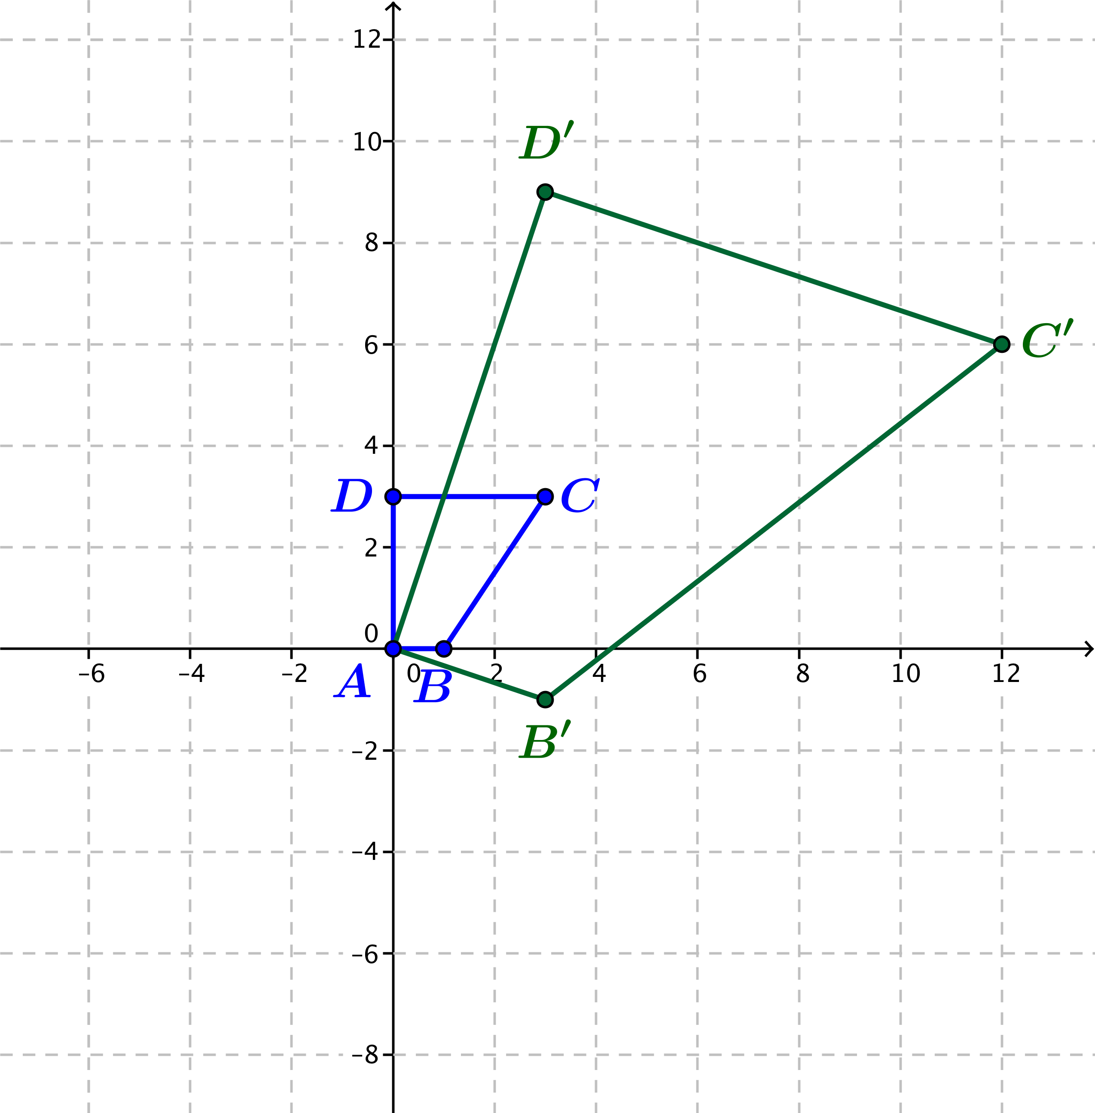

* 1. Does represent a rotation and dilation? If so, estimate the amount of rotation and the scale factor from your figure.

The transformed image is roughly three times larger than the original and rotated about clockwise.

* 1. If represents a rotation and dilation, calculate the amount of rotation and the scale factor from the formula for . Do your numbers agree with your estimate in part (b)? If not, explain why there are no values of and so that .

***From the formula, we have and . The transformation dilates by the scale factor , and rotates by .***

1. The figure below shows a figure with vertices , , , and .
   1. Transform each vertex under , and plot the transformed vertices on the figure.

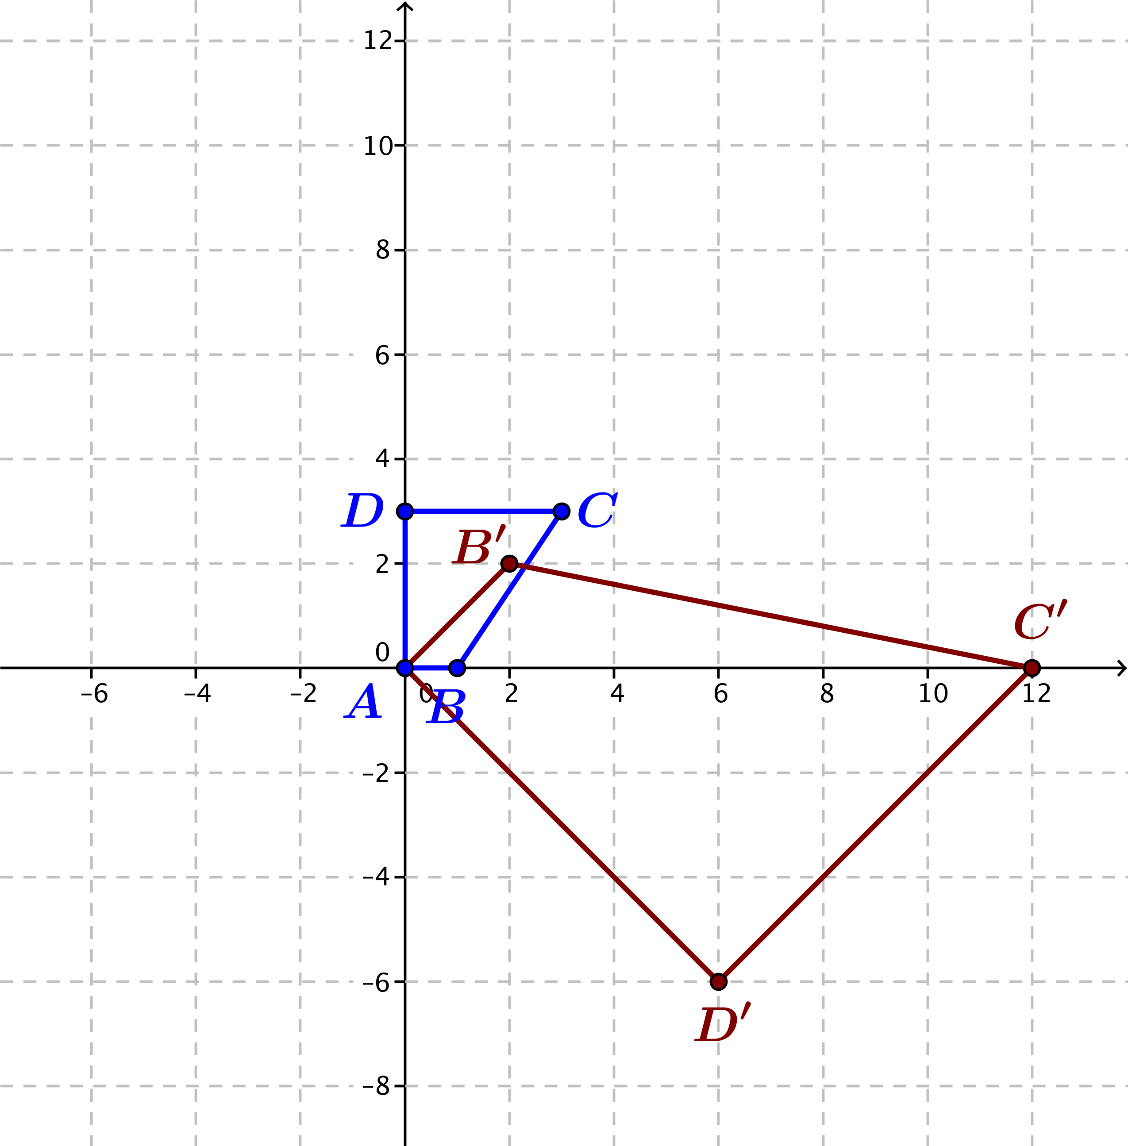

* 1. Does represent a rotation and dilation? If so, estimate the amount of rotation and the scale factor from your figure.

The transformed image is dilated and rotated but is also reflected, so transformation is not a rotation and dilation.

* 1. If represents a rotation and dilation, calculate the amount of rotation and the scale factor from the formula for . Do your numbers agree with your estimate in part (b)? If not, explain why there are no values of and so that .

Suppose that . Then and , which is not possible. This transformation does not fit our formula for rotation and dilation.

Closing (4 minutes)

* Ask students to summarize the lesson in writing or orally with a partner. Some key elements are summarized below.

Lesson Summary

For real numbers and , the transformation corresponds to a counterclockwise rotation by about the origin and dilation with scale factor .

Exit Ticket (5 minutes)

Name Date

Lesson 20: Exploiting the Connection to Cartesian Coordinates

Exit Ticket

1. Find the scale factor and rotation induced by the transformation .
2. Explain how the transformation of complex numbers leads to the transformation of points in the coordinate plane .

Exit Ticket Sample Solutions

1. Find the scale factor and rotation induced by the transformation .

*This is a transformation of the form with and . The scale factor is then .*

*The rotation is the .*

1. Explain how the transformation of complex numbers leads to the transformation of points in the coordinate plane .

First, we associate the complex number to the point in the coordinate plane. Then the point associated with the complex number is . Thus, we can interpret the original transformation of complex numbers as the transformation of points   
.

Problem Set Sample Solutions

1. Find real numbers and so that the transformation produces the specified rotation and dilation.
   1. Rotation by counterclockwise and dilation by scale factor .

We need to find real numbers and so that has modulus and argument . Then lies on the negative -axis, so and . We need , so this means that . Thus, the transformation will rotate by and dilate by a scale factor of .

* 1. Rotation by counterclockwise and dilation by scale factor .

We need to find real numbers and so that has modulus and argument . Thus, lies in the second quadrant on the diagonal line with equation , so we know that and . Since and , we have so ,and thus . It follows that . Then the transformation rotates by counterclockwise and dilates by a scale factor of .

* 1. Rotation by clockwise and dilation by scale factor .

We need to find real numbers and so that has modulus and argument . Thus lies in the first quadrant on the line with equation , so we know that and , . Since , we know that , and . Thus, the transformation rotates by counterclockwise and dilates by a scale factor of .

* 1. Rotation by counterclockwise and dilation by scale factor .

*Rotation by counterclockwise has the same effect as rotation by counterclockwise. Thus, we need to find real numbers and so that the argument of is and . Since   
, we know that the point lies on the negative -axis, and we have   
 and . We then have and , so the transformation will rotate by counterclockwise and dilate with scale factor .*

1. Determine if the following transformations represent a rotation and dilation. If so, identify the scale factor and the amount of rotation.



If is of the form, then and must be both and . Since this is impossible, this transformation does not consist of rotation and dilation.

***If we let and , then is of the form . Thus this transformation does consist of rotation and dilation. The dilation has scale factor ,   
and the transformation rotates through .***

***If we let and , then is of the form . Thus the transformation does consist of rotation and dilation. The dilation has scale factor , and the transformation rotates through .***

1. Grace and Lily have a different point of view about the transformation on cube that is shown above. Grace states that it is a reflection about the imaginary axis and a dilation of factor of . However, Lily argues it should be a counterclockwise rotation about the origin with a dilation of a factor of .
   1. Who is correct? Justify your answer.

Lily is correct because the vertices of the cube stay the same with respect to each other.

* 1. Represent the above transformation in the form .

*Rotating with a dilation of a factor of :*

*Therefore,*

1. Grace and Lily still have a different point of view on this transformation on triangle shown above. Grace states that it is reflected about the real axis first, then reflected about the imaginary axis, and then is dilated with a factor of . However, Lily asserts that it is a counterclockwise rotation about the origin with a dilation of a factor of .



* 1. Who is correct? Justify your answer.

Both are correct. Both sequences of transformations result in the same image.

* 1. Represent the above transformation in the form .

*Rotating with a dilation of a factor of 2: .*

*Therefore,*

1. Given .
   1. Find the complex number that will cause a rotation with the same number of degrees as without a dilation.

* 1. Can you come up with a general formula for any complex number to represent this condition?