Lesson 20: Exploiting the Connection to Cartesian Coordinates

Classwork

Opening Exercise

* 1. Find a complex number so that the transformation produces a clockwise rotation by about the origin with no dilation.
  2. Find a complex number so that the transformation produces a dilation with scale factor with no rotation.

Exercises 1–4

* 1. Find values of and so that has the effect of dilation with scale factor and no rotation.
  2. Evaluate , and identify the resulting transformation.
  3. Find values of and so that has the effect of rotation about the origin by counterclockwise and no dilation.
  4. Evaluate , and identify the resulting transformation.
  5. Find values of and so that has the effect of rotation about the origin by counterclockwise and no dilation.
  6. Evaluate , and identify the resulting transformation.
  7. Find values of and so that has the effect of rotation about the origin by counterclockwise and no dilation.
  8. Evaluate , and identify the resulting transformation.

Exercises 5–6

1. The figure below shows a quadrilateral with vertices , , , and .
   1. Transform each vertex under , and plot the transformed vertices on the figure.

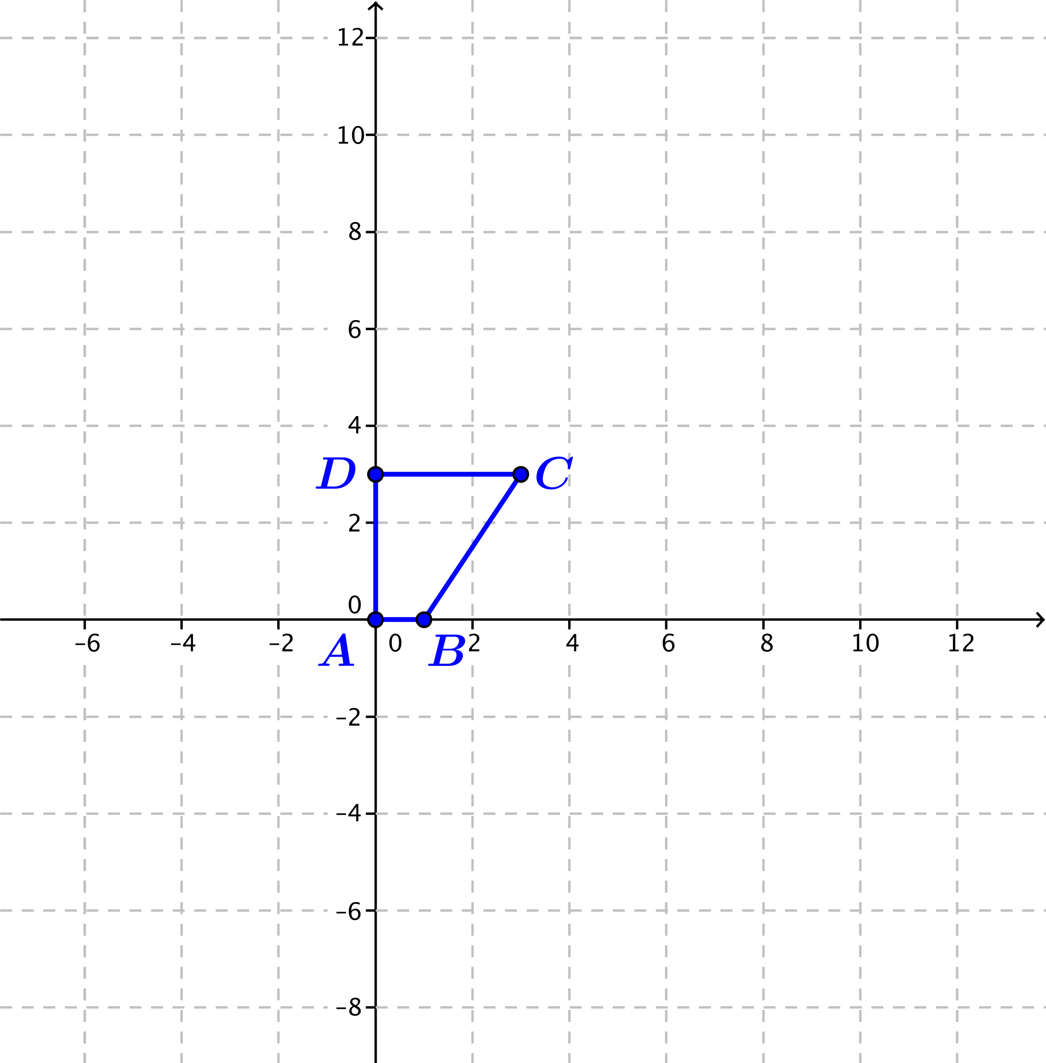

* 1. Does represent a rotation and dilation? If so, estimate the amount of rotation and the scale factor from your figure.
  2. If represents a rotation and dilation, calculate the amount of rotation and the scale factor from the formula for . Do your numbers agree with your estimate in part (b)? If not, explain why there are no values of and so that .

1. The figure below shows a figure with vertices , , , and .
   1. Transform each vertex under , and plot the transformed vertices on the figure.



* 1. Does represent a rotation and dilation? If so, estimate the amount of rotation and the scale factor from your figure.
  2. If represents a rotation and dilation, calculate the amount of rotation and the scale factor from the formula for . Do your numbers agree with your estimate in part (b)? If not, explain why there are no values of and so that .

Lesson Summary

For real numbers and , the transformation corresponds to a counterclockwise rotation by about the origin and dilation with scale factor .

Problem Set

1. Find real numbers and so that the transformation produces the specified rotation and dilation.
   1. Rotation by counterclockwise and dilation by scale factor .
   2. Rotation by counterclockwise and dilation by scale factor .
   3. Rotation by clockwise and dilation by scale factor .
   4. Rotation by counterclockwise and dilation by scale factor .
2. Determine if the following transformations represent a rotation and dilation. If so, identify the scale factor and the

amount of rotation.



1. Grace and Lily have a different point of view about the transformation on cube that is shown above. Grace states that it is a reflection about the imaginary axis and a dilation of factor of . However, Lily argues it should be a counterclockwise rotation about the origin with a dilation of a factor of .
   1. Who is correct? Justify your answer.
   2. Represent the above transformation in the form .
2. Grace and Lily still have a different point of view on this transformation on triangle shown above. Grace states that it is reflected about the real axis first, then reflected about the imaginary axis, and then is dilated with a factor of . However, Lily asserts that it is a counterclockwise rotation about the origin with a dilation of a factor of .



* 1. Who is correct? Justify your answer.
  2. Represent the above transformation in the form .

1. Given .
   1. Find the complex number that will cause a rotation with the same number of degrees as without a dilation.
   2. Can you come up with a general formula for any complex number to represent this condition?