Lesson 19: Exploiting the Connection to Trigonometry

Student Outcomes
- Students understand how a formula for the $n$^{th} roots of a complex number is related to powers of a complex number.
- Students calculate the $n$^{th} roots of a complex number.

Lesson Notes
This lesson builds on the work from Topic B by asking students to extend their thinking about the geometric effect of multiplication of two complex numbers to the geometric effect of raising a complex number to an integer exponent
(N-CN.B.5). It is part of a two day lesson that gives students another opportunity to work with the polar form of a complex number, to see its usefulness in certain situations, and to exploit that to quickly calculate powers of a complex number. In this lesson, students continue to work with polar and rectangular form and graph complex numbers represented both ways (N-CN.B.4). They examine graphs of powers of complex numbers in a polar grid, and then write the $n$^{th} root as a fractional exponent, and reverse the process from Day 1 to calculate the $n$^{th} roots of a complex number (N-CN.B.5). Throughout the lesson, students are constructing and justifying arguments (MP.3), using precise language (MP.6), and using the structure of expressions and visual representations to make sense of the mathematics (MP.7).

Classwork
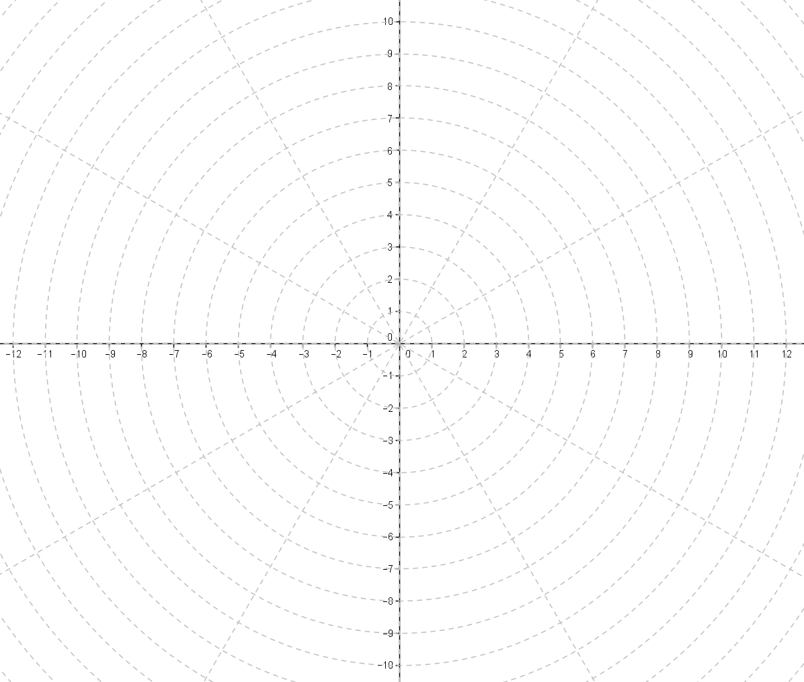
Opening (4 minutes)
Introduce the notion of a polar grid. Representing complex numbers in polar form on a polar grid will make this lesson seem easier for your students and emphasize the geometric effect of the roots of a complex number.
Display a copy of the polar grid at right and model how to plot a few complex numbers in polar form to illustrate that the concentric circles make it easy to measure the modulus and the rays at equal intervals and make representing the rotation of the complex number easy as well.
Plot a point with the given modulus and argument.
A: modulus = 1, argument = $0°$
B: modulus = 3, argument = $90°$
C: modulus = 5, argument = $30°$
D: modulus = 7, argument = $120°$
Explain to students that each circle represents a distance from the origin (the modulus). Each line represents an angle measure. To plot a point, find the angle of rotation, then move out to the circle that represents the distance from the origin given by the modulus.

Opening Exercise (7 minutes)
These exercises give students an opportunity to practice working with a polar grid and to review their work from the previous day’s lesson. Students should work individually or with a partner on these exercises. Monitor student progress to check for understanding and provide additional support as needed.
Scaffolding:
- For struggling students, encourage them to label the rays in the polar grid with the degrees of rotation.
- Provide additional practice plotting complex numbers in polar form. Some students may find working with degrees easier than working with radians.
Opening Exercise
A polar grid is shown below. The grid is formed by rays from the origin at equal rotation intervals and concentric circles centered at the origin. The complex number $z=\sqrt{3}+i$ is graphed on this polar grid.
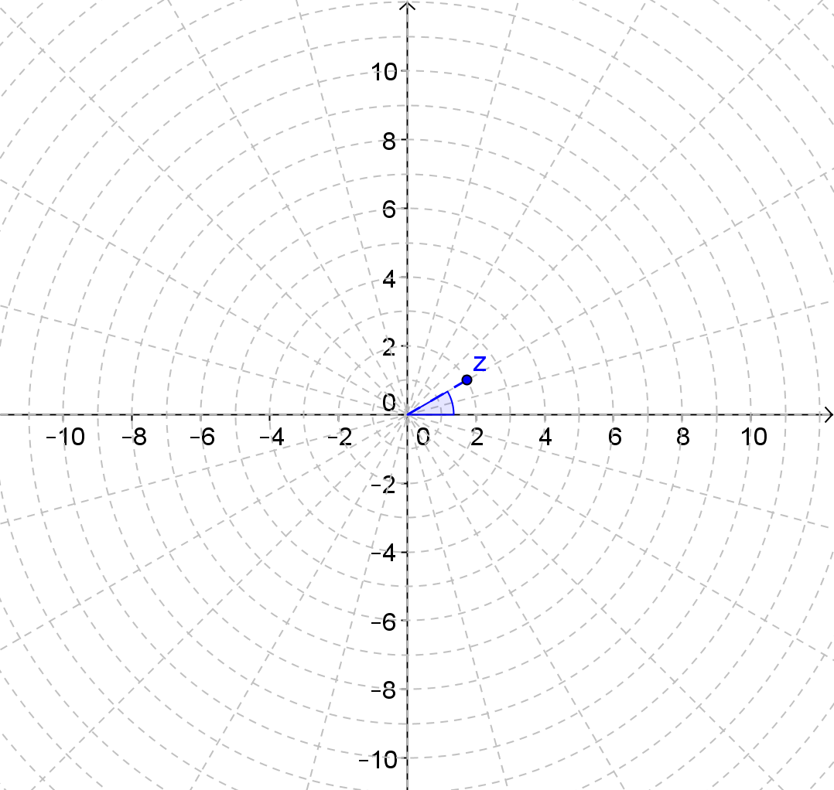
  - Use the polar grid to identify the modulus and argument of $z$.
The argument is $\frac{π}{6}$, and the modulus is $2$.

  - Graph the next three powers of $z$ on the polar grid. Explain how you got your answers.
Each power of $z$ is another $30°$ rotation and a dilation by a factor of $2$ from the previous number.
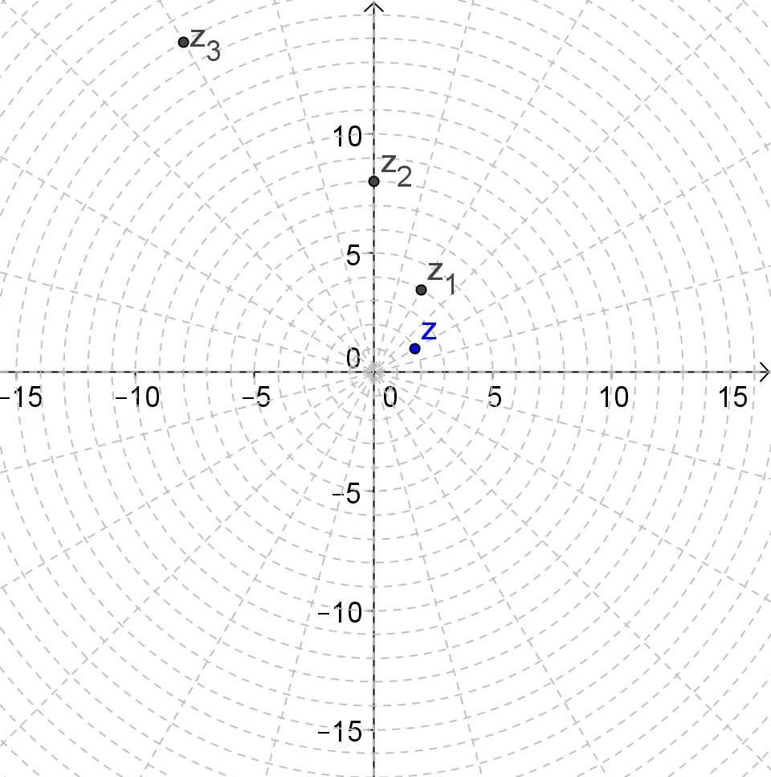
  - Write the polar form of the number in the table below, and then rewrite it in rectangular form.
Power of $z$ | Polar Form | Rectangular Form
$$\sqrt{3}+i$$ | $$2\left(\cos\left(\frac{π}{6}\right)+i sin\left(\frac{π}{6}\right)\right)$$ | $$\sqrt{3}+i$$
$${\left(\sqrt{3}+i\right)}^{2}$$ | $$4\left(\cos\left(\frac{π}{3}\right)+i sin\left(\frac{π}{3}\right)\right)$$ | $$2+2\sqrt{3}i$$
$${\left(\sqrt{3}+i\right)}^{3}$$ | $$8\left(\cos\left(\frac{π}{2}\right)+i sin\left(\frac{π}{2}\right)\right)$$ | $$8i$$
$${\left(\sqrt{3}+i\right)}^{4}$$ | $$16\left(\cos\left(\frac{2π}{3}\right)+i sin\left(\frac{2π}{3}\right)\right)$$ | $$8-8\sqrt{3}i$$

Have early finishers, check their work by calculating one or two powers of $z$ by expanding and then multiplying the rectangular form. Examples are shown below.
$${\left(\sqrt{3}+i\right)}^{2}=3+2\sqrt{3}i+i^{2}=2+2\sqrt{3}i$$
$${\left(\sqrt{3}+i\right)}^{3}=\left(\sqrt{3}+i\right)\left(2+2\sqrt{3}i\right)=2\sqrt{3}+6i+2i+2\sqrt{3}i^{2}=8i$$
Debrief by having one or two students explain their process to the class. Remind them again of the efficiency of working with complex numbers in polar form and the patterns that emerge when we graph powers of a complex number.
- Which way of expanding a power of a complex number would be quicker if you were going to expand
${\left(\sqrt{3}+i\right)}^{10}$?
  - Using the polar form would be far easier. It would be $2^{10}\left(\cos\left(\frac{5π}{3}\right)+i sin\left(\frac{5π}{3}\right)\right)$.
- How could you describe the pattern of the numbers if we continued graphing the powers of $z?$
  - The numbers are spiraling outward as each number is on a ray rotated $30°$ from the previous one and further from the origin by a factor of $2$.
Next, transition to the main focus of this lesson by giving students time to consider the next question. Have them respond in writing and discuss their answers with a partner.
- How do you think we could reverse this process, in other words undo squaring a complex number or undo cubing a complex number?
  - That would be like taking a square root or cube root. We would have to consider how to undo the rotation and dilation effects.

Exercises 1–3 (7 minutes)
In these exercises, students will explore one of the square roots of a complex number. Later in the lesson you will show students that complex numbers have multiple roots just like a real number has two square roots (e.g. the square roots of $4$ are $2$ and $-2$). Students should work these exercises with a partner. If the class is struggling to make sense of Exercise 3, work that one as a whole class.

Exercises 1–3
The complex numbers $z_{2}={\left(-1+\sqrt{3}i\right)}^{2}$ and $z_{1}$ are graphed below.
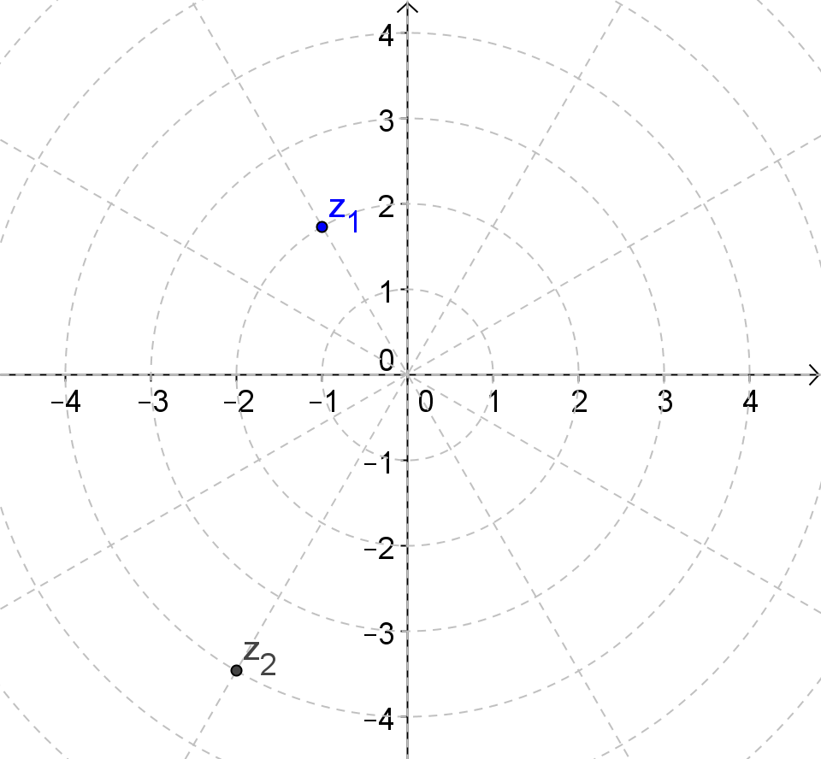
- Use the graph to help you write the numbers in polar and rectangular form.
$$z_{1}=2\left(\cos\left(\frac{2π}{3}\right)+i sin\left(\frac{2π}{3}\right)\right)=-1+\sqrt{3}i$$
$$z_{2}=4\left(\cos\left(\frac{4π}{3}\right)+i sin\left(\frac{4π}{3}\right)\right)=-2-2\sqrt{3}i$$

- Describe how the modulus and argument of $z_{1}=-1+\sqrt{3i}$ are related to the modulus and argument of
${z_{2}=\left(-1+\sqrt{3}i\right)}^{2}$.
The modulus and argument are both cut in half.
MP.3
- Why could we call $-1+\sqrt{3}i$ a square root of $-2-2\sqrt{3}i$?
Clearly, ${\left(-1+\sqrt{3}i\right)}^{2}=-2-2\sqrt{3}$. We can demonstrate this using the rectangular or polar form and verify it using transformations of the numbers when they are plotted in the complex plane. So it would make sense then that raising both sides of this equation to the $\frac{1}{2}$ power should give use the desired result.
Start with the equation, ${\left(-1+\sqrt{3}i\right)}^{2}=-2-2\sqrt{3}i$.
$${\left({\left(-1+\sqrt{3}i\right)}^{2}\right)}^{\frac{1}{2}}={\left(-2-2\sqrt{3}i\right)}^{\frac{1}{2}}$$
$$-1+\sqrt{3}i=\sqrt{-2-2\sqrt{3}i}$$
Alternately, using the formula from Lesson 17, replace $n$ with $\frac{1}{2}$.
$$z^{n}=r^{n}(\cos\left(nθ\right)+i sin\left(nθ\right))$$
$$z^{\frac{1}{2}}=r^{\frac{1}{2}}\left(\cos\left(\frac{1}{2}θ\right)+i sin\left(\frac{1}{2}θ\right)\right)$$
So, a square root of $-2-2\sqrt{3}i$ would be
$$4^{\frac{1}{2}}\left(\cos\left(\frac{1}{2}∙\frac{4π}{3}\right)+i sin\left(\frac{1}{2}∙\frac{4π}{3}\right)\right)=2\left(\cos\left(\frac{2π}{3}\right)+i sin\left(\frac{2π}{3}\right)\right)=-1+\sqrt{3}i$$
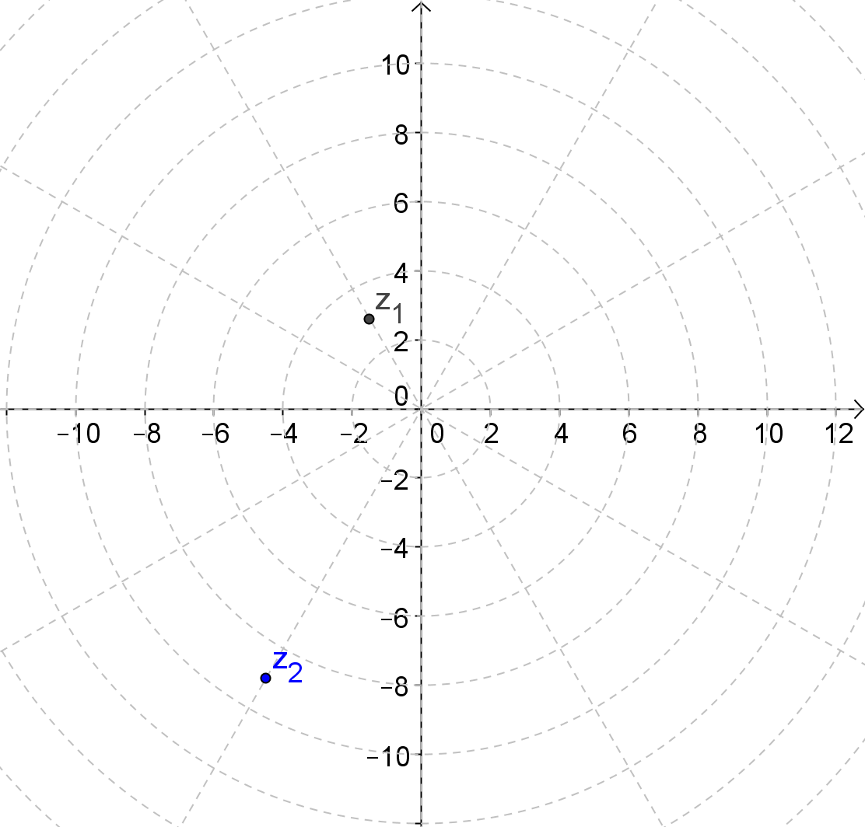
After giving students a few minutes to work these exercises with a partner, make sure they understand that the modulus is cut in half because $2∙2=4$ shows a repeated multiplication by $2$.
- How would this problem change if the modulus was $9$ instead of $4$? How would this problem change if the modulus was $3$ instead of $4$?
  - The new modulus would have to be a number that when squared equals $9$ so we would need the new modulus to be the square root of the original modulus.
If students seem to think that the modulus would always be divided by $2$ instead of it being the square root of the original modulus, then you can model this using Geogebra. A sample screen shot is provided below showing a complex number with the same argument and a modulus of $9$. Notice that the modulus of $z_{1}$ is $3$ while the argument is still cut in half.

Discussion (7 minutes): The $n$^{th} Roots of a Complex Number
In this discussion, you will model how to derive a formula to find all the $n$^{th} roots of a complex number. Begin by reminding students of the definition of square roots learned in Grade 8 and Algebra 1.
- Recall that each real number has two square roots. For example, what are the two square roots of $4$? The two square roots of $10$? How do you know?
  - They are $2$ and $-2$ because ${\left(2\right)}^{2}=4$, and ${\left(-2\right)}^{2}=4$. The two square roots of $10$ are $\sqrt{10}$ and $-\sqrt{10}$.
- How many square roots do you think a complex number has? How many cube roots? Fourth roots, etc.?
  - Since all real numbers are complex numbers, complex numbers should have two square roots as well. Since roots are solutions to an equation $x^{n}=r$, it would make sense that if our solution set is the complex numbers, then there would be three cube roots when $n=3$ and four fourth roots when $n=4$.
Thus complex numbers have multiple $n$^{th} roots when $n$ is a positive integer. In fact, every complex number has $2$ square roots, $3$ cube roots, $4$ fourth roots, etc. This work relates back to Module I and III in Algebra II where students learned that a degree $n$ polynomial equation has $n$ complex zeros and to previous work extending the properties of exponents to the real number exponents. Students should take notes as you present the work shown below.
Using the formula from Lesson 17, suppose we have an $n$^{th} root of $z$, $w=s(\cos\left(α\right)+i sin\left(α\right))$. Then for $r>0$, $s>0$ we have
$$w^{n}=z$$
$$s^{n}\left(\cos\left(nα\right)+i sin\left(nα\right)\right)=r\left(\cos\left(θ\right)+i sin\left(θ\right)\right)$$
Equating the moduli, $s^{n}=r$ which implies that $s=\sqrt[n]{r}$.

Equating the arguments, $nα=θ$. However, since the sine and cosine functions are periodic functions with period $2π$, this equation does not have a unique solution for $α$. We know that $\cos\left(θ+2πk\right)=\cos{(θ)}$ and $\sin{(θ+2πk)}=sin⁡(θ)$ for integer values of $k$ and real numbers $θ$.
Therefore,
$$nα=θ+2πk$$
Or, $α=\frac{θ}{n}+\frac{2πk}{n}$ for values of $k$ up to $n-1$. When $k=n$ or greater, we start repeating values for $α$.
Going back to your work in Example 1 and Exercise 6, we can find both roots of $-2-2\sqrt{3}i$ and all three cube roots of this number.

Example 1 (5 minutes): Find the Two Square Roots of a Complex Number
Example 1: Find the Two Square Roots of a Complex Number
Find both of the square roots of $-2-2\sqrt{3}i$.
The polar form of this number is $4\left(\cos\left(\frac{4π}{3}\right)+i sin\left(\frac{4π}{3}\right)\right)$. The square roots of this number will have modulus $\sqrt{4}=2$ and arguments given by $α=\frac{θ}{n}+\frac{2πk}{n}$ for $k=0,1$ where $θ=\frac{4π}{3}$. Thus,
$$α=\frac{1}{2}\left(\frac{4π}{3}+2π∙0\right)=\frac{2π}{3}$$
and
$$α=\frac{1}{2}\left(\frac{4π}{3}+2π∙1\right)=\frac{5π}{3}$$
The square roots are
$$2\left(\cos\left(\frac{2π}{3}\right)+i sin\left(\frac{2π}{3}\right)\right)=-1+\sqrt{3}i$$
and
$$2\left(\cos\left(\frac{5π}{3}\right)+i sin\left(\frac{5π}{3}\right)\right)=1-\sqrt{3}i$$

Have students go back and add the graph of the second square root to the graph at the beginning of Exercise 1.

Exercises 4–6 (7 minutes)
Students work with the formula developed in the discussion and presented in the Lesson Summary. Students can work individually or with a partner. If time is running short, you can assign these as problem set exercises as well.

Exercises 4–6
- Find the cube roots of $-2=2\sqrt{3}i$.
$$-2-2\sqrt{3}i=4\left(\cos\left(\frac{4π}{3}\right)+i sin\left(\frac{4π}{3}\right)\right)$$
The modulus of the cube roots will be $\sqrt[3]{4}$. The arguments for $k=0$, $1$, and $2$ are given by $α=\frac{θ}{n}+\frac{2πk}{n}$ where
$θ=\frac{4π}{3}$ and $n=3$. Using this formula, the arguments are $\frac{4π}{9}$, $\frac{10π}{9}$, and $\frac{16π}{9}$. The three cube roots of $-2-2\sqrt{3}i$
are
$$\sqrt[3]{4}\left(\cos\left(\frac{4π}{9}\right)+i sin\left(\frac{4π}{9}\right)\right)$$
$$\sqrt[3]{4}\left(\cos\left(\frac{10π}{9}\right)+i sin\left(\frac{10π}{9}\right)\right)$$
$$\sqrt[3]{4}\left(\cos\left(\frac{16π}{9}\right)+i sin\left(\frac{16π}{9}\right)\right)$$

- Find the square roots of $4i$.
$$4i=4\left(\cos\left(\frac{π}{2}\right)+i sin\left(\frac{π}{2}\right)\right)$$
The modulus of the square roots is $\sqrt{4}=2$. The arguments for $k=0$ and $1$ are given by $α=\frac{θ}{n}+\frac{2πk}{n}$ where $θ=\frac{π}{2}$
and $n=2$. Using this formula, the arguments are $\frac{π}{4}$ and $\frac{3π}{4}$. The two square roots of $4i$ are
$$2\left(\cos\left(\frac{π}{4}\right)+i sin\left(\frac{π}{4}\right)\right)=\sqrt{2}+\sqrt{2}i$$
and
$$2\left(\cos\left(\frac{3π}{4}\right)+i sin\left(\frac{3π}{4}\right)\right)=-\sqrt{2}+\sqrt{2}i$$

- Find the cube roots of $8$.
In polar form,
$$8=8\left(\cos\left(0\right)+i sin\left(0\right)\right)$$
The modulus of the cube roots is $\sqrt[3]{8}=2$. The arguments for $k=0$, $1$, and $2$ are given by $α=\frac{θ}{n}+\frac{2πk}{n}$ where
$θ=0$ and $n=3$. Using this formula, the arguments are $0$, $\frac{2π}{3}$, and $\frac{4π}{3}$. The three cube roots of $8$ are
$$2\left(\cos\left(0\right)+i sin\left(0\right)\right)=2$$
$$2\left(\cos\left(\frac{2π}{3}\right)+i sin\left(\frac{2π}{3}\right)\right)=-1+\sqrt{3}i$$
$$2\left(\cos\left(\frac{4π}{3}\right)+i sin\left(\frac{4π}{3}\right)\right)=-1-\sqrt{3}i$$

You may wish to point out to students that the answers to Exercise 9 are the solutions to the equation $x^{3}-8=0$.
$$x^{3}-8=0$$
$$\left(x-2\right)\left(x^{2}+2x+4\right)=0$$

One solution is $-2$, and the other two are solutions to $x^{2}+2x+4=0$. Using the quadratic formula, the other two solutions are given by
$$x=\frac{-2±\sqrt{2^{2}-4(1)(4)}}{2}$$
This expression gives the solutions $-1+\sqrt{3}i$, and $-1-\sqrt{3}i$. This connection with the work in Grade 11, Module 2 will be revisited in the last few exercises in the Problem Set.

Closing (3 minutes)
Ask students to respond to this question either in writing or with a partner. They can use one of the exercises above to explain the process. Then review the formula that was derived during the discussion portion of this lesson.
- How do you find the $n$^{th} roots of a complex number?
MP.6
  - Determine the argument and the modulus of the original number. Then the modulus of the roots is the $n$^{th} root of the original modulus. The arguments are found using the formula $α=\frac{θ}{n}+\frac{2πk}{n}$ for $k$ is the integers from $0$ to $n-1$. Write the roots in polar form. If you are finding the cube roots there will be three of them; if you are finding fourth roots there will be four, etc.
Review the formula students can use to find the $n$^{th} roots of a complex number.
Lesson Summary
Given a complex number $z$ with modulus $r$ and argument $θ$, the $n$^{th} roots of $z$ are given by
$$\sqrt[n]{r}\left(\cos\left(\frac{θ}{n}+\frac{2πk}{n}\right)+i sin\left(\frac{θ}{n}+\frac{2πk}{n}\right)\right)$$
for integers $k$ and $n$ such that $n>0$ and $0≤k<n$.

Exit Ticket (5 minutes)
Name Date
Lesson 19: Exploiting the Connection to Trigonometry

Exit Ticket

Find the fourth roots of $-2-2\sqrt{3}i$.

Exit Ticket Sample Solutions

Find the fourth roots of $-2-2\sqrt{3}i$.
The modulus is $4$, and the argument is $\frac{4π}{3}$. Use the formula, the modulus of the fourth roots will be $\sqrt[4]{4}$, and the arguments will be $\frac{1}{4}\left(\frac{4π}{3}\right)+\frac{1}{4}(2πk)$ for $k=0,1,2,3$. This gives the following complex numbers as the fourth roots of $-2-2\sqrt{3}i$
$$\sqrt[4]{4}\left(\cos\left(\frac{π}{3}\right)+i sin\left(\frac{π}{3}\right)\right)=\sqrt[4]{4}\left(\frac{1}{2}+\frac{\sqrt{3}}{2}i\right)$$
$$\sqrt[4]{4}\left(\cos\left(\frac{5π}{6}\right)+i sin\left(\frac{5π}{6}\right)\right)=\sqrt[4]{4}\left(-\frac{\sqrt{3}}{2}+\frac{1}{2}i\right)$$
$$\sqrt[4]{4}\left(\cos\left(\frac{4π}{3}\right)+i sin\left(\frac{4π}{3}\right)\right)=\sqrt[4]{4}\left(-\frac{1}{2}-\frac{\sqrt{3}}{2}i\right)$$
$$\sqrt[4]{4}\left(\cos\left(\frac{11π}{6}\right)+i sin\left(\frac{11π}{6}\right)\right)=\sqrt[4]{4}\left(\frac{\sqrt{3}}{2}-\frac{1}{2}i\right)$$

Problem Set Sample Solutions

- For each complex number what is $z^{2}$?
  - $1+\sqrt{3}i$
$-2+2\sqrt{3}i$

  - $3-3i$
$-18i$

  - $4i$
$-16$

  - $-\frac{\sqrt{3}}{2}+\frac{1}{2}i$
$\frac{1}{2}-\frac{\sqrt{3}}{2}i$

  - $\frac{1}{9}+\frac{1}{9}i$
$\frac{2}{81}i$

  - $-1$
$1$

- For each complex number, what are the square roots of $z$?
  - $1+\sqrt{3}i$
$z=1+\sqrt{3}i,r=2,arg\left(z\right)=\frac{π}{3},$
$α=\frac{1}{2}\left(\frac{π}{3}+2πk\right),k=0$ or $1$. $α=\frac{π}{6}$ or $\frac{7π}{6}$. Let the square roots of $z$ be $w_{1}$ and $w_{2}$.
$w_{1}=\sqrt{2}\left(cos\frac{π}{6}+i∙sin\frac{π}{6}\right)=\sqrt{2}\left(\frac{\sqrt{3}}{2}+\frac{1}{2}i\right)$
$w_{2}=\sqrt{2}\left(cos\frac{7π}{6}+i∙sin\frac{7π}{6}\right)=\sqrt{2}\left(\frac{-\sqrt{3}}{2}-\frac{1}{2}i\right)$

  - $3-3i$
$z=3-3i, r=\sqrt{18}, arg\left(z\right)=\frac{7π}{4},$
$α=\frac{1}{2}\left(\frac{7π}{4}+2πk\right), k=0$ or $1$. $α=\frac{7π}{8}$ or $\frac{15π}{8}$. Let the square roots of $z$ be $w_{1}$ and $w_{2}$
$w_{1}=\sqrt[4]{18}\left(cos\frac{7π}{8}+i∙sin\frac{7π}{8}\right)$
$w_{2}=\sqrt[4]{18}\left(cos\frac{15π}{8}+i∙sin\frac{15π}{8}\right)$

  - $4i$
$z=0+4i,r=4,arg\left(z\right)=\frac{π}{2},$
$α=\frac{1}{2}\left(\frac{π}{2}+2πk\right),k=0$ or $1$. $α=\frac{π}{4}$ or $\frac{5π}{4}$. Let the square roots of $z$ be $w_{1}$ and $w_{2}$
$w_{1}=\sqrt{4}\left(cos\frac{π}{4}+i∙sin\frac{π}{4}\right)=2\left(\frac{\sqrt{2}}{2}+\frac{\sqrt{2}}{2}i\right)=\sqrt{2}+\sqrt{2}i$
$w_{2}=\sqrt{4}\left(cos\frac{5π}{4}+i∙sin\frac{5π}{4}\right)=2\left(\frac{-\sqrt{2}}{2}+\frac{-\sqrt{2}}{2}i\right)=-\sqrt{2}-\sqrt{2}i$

  - $-\frac{\sqrt{3}}{2}+\frac{1}{2}i$
$z=\frac{-\sqrt{3}}{2}+\frac{1}{2}i, r=1, arg\left(z\right)=\frac{5π}{6},$
$α=\frac{1}{2}\left(\frac{5π}{6}+2πk\right),k=0$ or $1$. $α=\frac{5π}{12}$ or $\frac{17π}{12}$. Let the square roots of $z$ be $w_{1}$ and $w_{2}$
$w_{1}=\sqrt{1}\left(cos\frac{5π}{12}+i∙sin\frac{5π}{12}\right)=cos\frac{5π}{12}+i∙sin\frac{5π}{12}$
$w_{2}=\sqrt{1}\left(cos\frac{5π}{12}+i∙sin\frac{5π}{12}\right)=cos\frac{17π}{12}+i∙sin\frac{17π}{12}$

  - $\frac{1}{9}+\frac{1}{9}i$
$z=\frac{1}{9}+\frac{1}{9}i, r=\frac{\sqrt{2}}{9}, arg\left(z\right)=\frac{π}{4},$
$α=\frac{1}{2}\left(\frac{π}{4}+2πk\right), k=0$ or $1$. $α=\frac{π}{8}$ or $\frac{9π}{8}$. Let the square roots of $z$ be $w_{1}$ and $w_{2}$
$w_{1}=\sqrt{\frac{\sqrt{2}}{9}}\left(cos\frac{π}{8}+i∙sin\frac{9π}{8}\right)=\frac{\sqrt[4]{2}}{3}\left(cos\frac{π}{8}+i∙sin\frac{9π}{8}\right)$
$w_{2}=\sqrt{\frac{\sqrt{2}}{9}}\left(cos\frac{5π}{12}+i∙sin\frac{5π}{12}\right)=\frac{\sqrt[4]{2}}{3}\left(cos\frac{5π}{12}+i∙sin\frac{5π}{12}\right)$

  - $-1$
$z=-1+0i,r=1, arg\left(z\right)=π$
$α=\frac{1}{2}\left(π+2πk\right), k=0$ or $1$. $α=\frac{π}{2}$ or $\frac{3π}{2}$. Let the square roots of $z$ be $w_{1}$ and $w_{2}$
$w_{1}=1\left(cos\frac{π}{2}+i∙sin\frac{π}{2}\right)=i$
$w_{2}=1\left(cos\frac{3π}{2}+i∙sin\frac{3π}{2}\right)=-i$

- For each complex number, graph $z$, $z^{2}$, and $z^{3}$ on a polar grid.
  - $2\left(\cos\left(\frac{π}{3}\right)+i sin\left(\frac{π}{3}\right)\right)$
$r=2, θ=\frac{π}{3}$
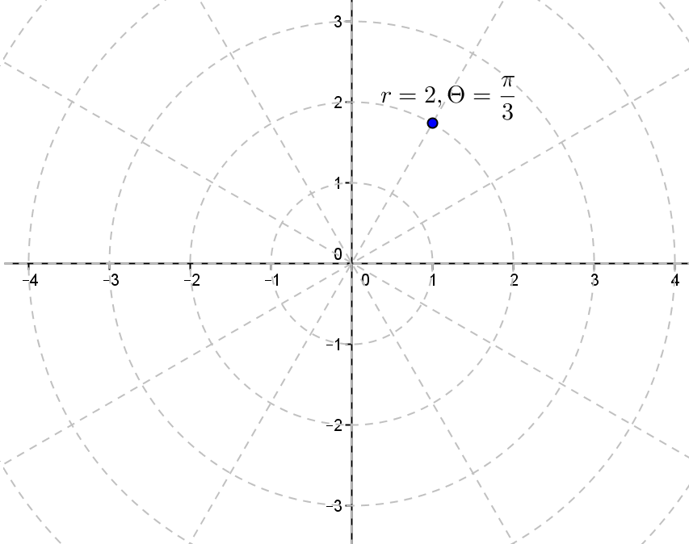

  - $3\left(\cos\left(210°\right)+i sin\left(210°\right)\right)$
$r=3, θ={210}^{°}$
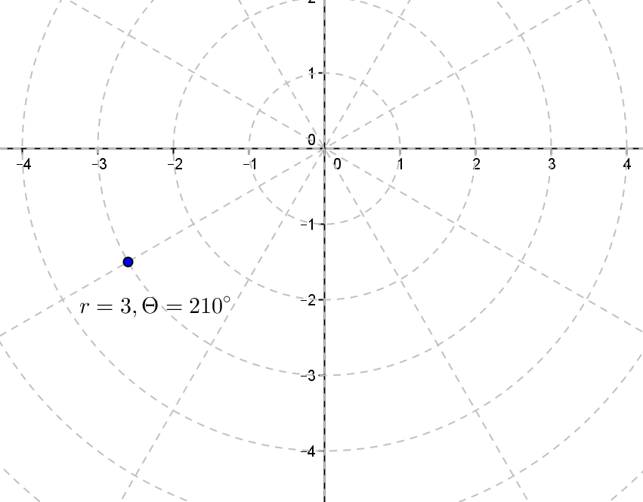

  - $2\left(\cos\left(\frac{π}{4}\right)+i sin\left(\frac{π}{4}\right)\right)$
$r=2,θ=\frac{π}{4}$
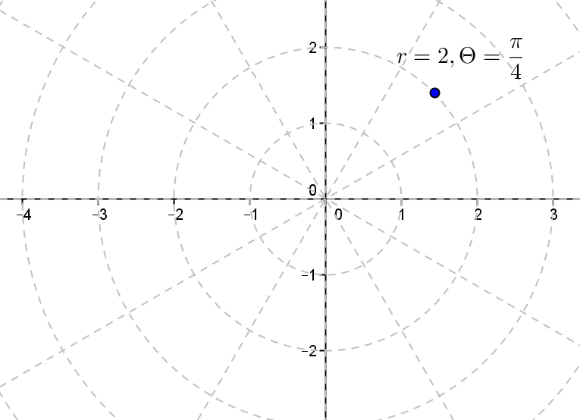

  - $\cos\left(π\right)+i sin\left(π\right)$
$r=1, θ=π$
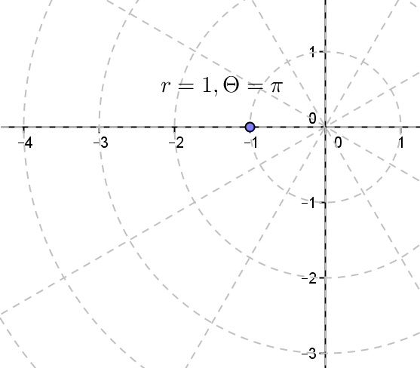

  - $4\left(\cos\left(\frac{3π}{4}\right)+i sin\left(\frac{3π}{4}\right)\right)$
$r=4, θ=\frac{3π}{4}$
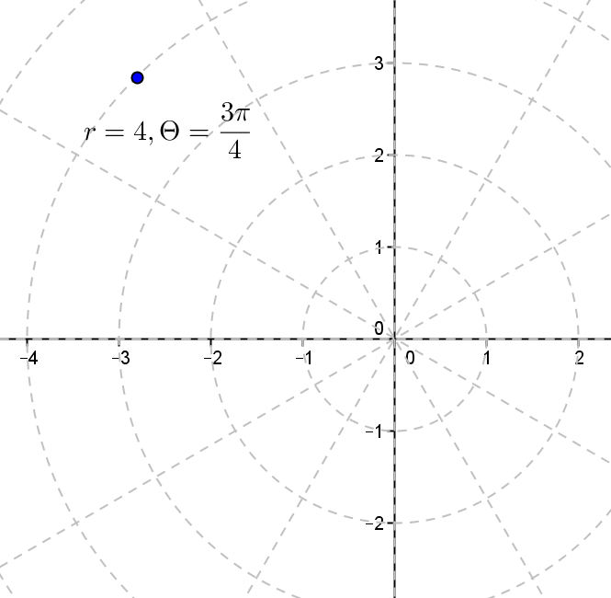

  - $\frac{1}{2}\left(\cos\left(60°\right)+i sin\left(60°\right)\right)$
$r=\frac{1}{2}, θ={60}^{°}$
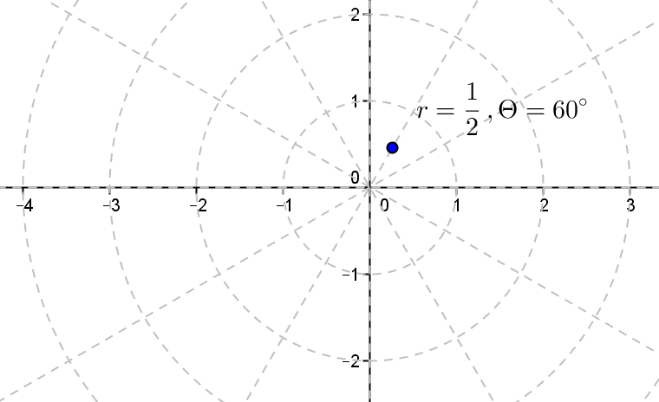

- What are the cube roots of $–3i?$
$z=0-3i, r=3, arg\left(z\right)=\frac{3π}{2},$
$α=\frac{1}{3}\left(\frac{3π}{2}+2πk\right), k=0, 1,$or $2$. $α=\frac{π}{2}, \frac{7π}{6}$ or $\frac{11π}{6}$. Let the cube roots of $z$ be $w_{1}, w_{2}$ and $w_{3}$
$w_{1}=\sqrt[3]{3}\left(cos\frac{π}{2}+i∙sin\frac{π}{2}\right)=\sqrt[3]{3}\left(0+i\right)=\sqrt[3]{3}∙i$
$w_{2}=\sqrt[3]{3}\left(cos\frac{7π}{6}+i∙sin\frac{7π}{6}\right)=\sqrt[3]{3}\left(\frac{-\sqrt{3}}{2}-\frac{1}{2}i\right)$
$w_{3}=\sqrt[3]{3}\left(cos\frac{11π}{6}+i∙sin\frac{11π}{6}\right)=\sqrt[3]{3}\left(\frac{\sqrt{3}}{2}-\frac{1}{2}i\right)$

- What are the fourth roots of $64?$
$z=64+0i, r=64, arg\left(z\right)=0,$
$α=\frac{1}{4}\left(0+2πk\right), k=0, 1, 2,$ or $3$. $α=0,\frac{π}{2}, π,$ or $\frac{3π}{2}$. Let the fourth roots of $z$ be $w_{1}, w_{2}, w_{3}$ and $w_{4}$
$w_{1}=\sqrt[4]{64}\left(cos0+i∙sin0\right)=2\sqrt{2}\left(1+0\right)=2\sqrt{2}$
$w_{2}=\sqrt[4]{64}\left(cos\frac{π}{2},+i∙sin\frac{π}{2}\right)=2\sqrt{2}\left(0+i\right)=2\sqrt{2}∙i$
$w_{3}=\sqrt[4]{64}\left(cosπ+i∙sinπ\right)=2\sqrt{2}\left(-1+0\right)=-2\sqrt{2}$
$w_{4}=\sqrt[4]{64}\left(cos\frac{3π}{2}+i∙sin\frac{3π}{2}\right)=2\sqrt{2}\left(0-i\right)=-2\sqrt{2}∙i$
- What are the square roots of $-4-4i$?
$z=-4-4i, r=4\sqrt{2}, arg\left(z\right)=\frac{5π}{4},$
$α=\frac{1}{2}\left(\frac{5π}{4}+2πk\right), k=0$ or $1$. $α=\frac{5π}{8}, π,$ or $\frac{13π}{8}$. Let the square roots of $z$ be $w_{1},$ and $w_{2}$
$w_{1}=2\sqrt[4]{2}\left(cos\frac{5π}{8}+i∙sin\frac{5π}{8}\right)$
$w_{2}=2\sqrt[4]{2}\left(cos\frac{13π}{8}+i∙sin\frac{13π}{8}\right)$

- Find the square roots of $-5$. Show that the square roots satisfy the equation $x^{2}+5=0$.
$z=-5+0i, r=5, arg\left(z\right)=π,$
$α=\frac{1}{2}\left(π+2πk\right), k=0$ or $1$. $α=\frac{π}{2}$ or $\frac{3π}{2}$. Let the square roots of $z$ be $w_{1},$ and $w_{2}$
$w_{1}=\sqrt{5}\left(cos\frac{π}{2}+i∙sin\frac{π}{2}\right)=\sqrt{5}\left(0+i\right)=\sqrt{5}∙i$
$w_{2}=\sqrt{5}\left(cos\frac{3π}{2}+i∙sin\frac{3π}{2}\right)=\sqrt{5}\left(0-i\right)=-\sqrt{5}∙i$
${\left(\sqrt{5}∙i\right)}^{2}+5=-5+5=0$
${\left(-\sqrt{5}∙i\right)}^{2}+5=-5+5=0$

- Find the cube roots of $27$. Show that the cube roots satisfy the equation$x^{3}-27=0$.
$z=27+0i, r=27, arg\left(z\right)=0,$
$α=\frac{1}{3}\left(0+2πk\right), k=0, 1,$ or $2$. $α=0, \frac{2π}{3}$ or $\frac{4π}{3}$. Let the cube roots of $z$ be $w_{1}, w_{2}$ and $w_{3}$
$w_{1}=\sqrt[3]{27}\left(cos0+i∙sin\right)=3\left(1+0\right)=3$
$w_{2}=\sqrt[3]{27}\left(cos\frac{2π}{3}+i∙sin\frac{2π}{3}\right)=3\left(-\frac{1}{2}+\frac{\sqrt{3}}{2}i\right)=-\frac{3}{2}+\frac{3\sqrt{3}}{2}i$
$w_{3}=\sqrt[3]{27}\left(cos\frac{4π}{3}+i∙sin\frac{4π}{3}\right)=3\left(-\frac{1}{2}-\frac{\sqrt{3}}{2}i\right)=-\frac{3}{2}-\frac{3\sqrt{3}}{2}i$
${\left(3\right)}^{3}-27=0$
${\left(3\left(-\frac{1}{2}+\frac{\sqrt{3}}{2}i\right)\right)}^{3}-27=-27\left(\frac{-1}{8}-\frac{3\sqrt{3}}{8}i+\frac{9}{8}+\frac{3\sqrt{3}}{8}i\right)-27=-27\left(1\right)-27=0$
${\left(3\left(-\frac{1}{2}-\frac{\sqrt{3}}{2}i\right)\right)}^{3}-27=-27\left(\frac{1}{8}+\frac{3\sqrt{3}}{8}i-\frac{9}{8}-\frac{3\sqrt{3}}{8}i\right)-27=-27\left(-1\right)-27=0$

