Lesson 19: Exploiting the Connection to Trigonometry

Classwork
Opening Exercise
A polar grid is shown below. The grid is formed by rays from the origin at equal rotation intervals and concentric circles centered at the origin. The complex number $z=\sqrt{3}+i$ is graphed on this polar grid.
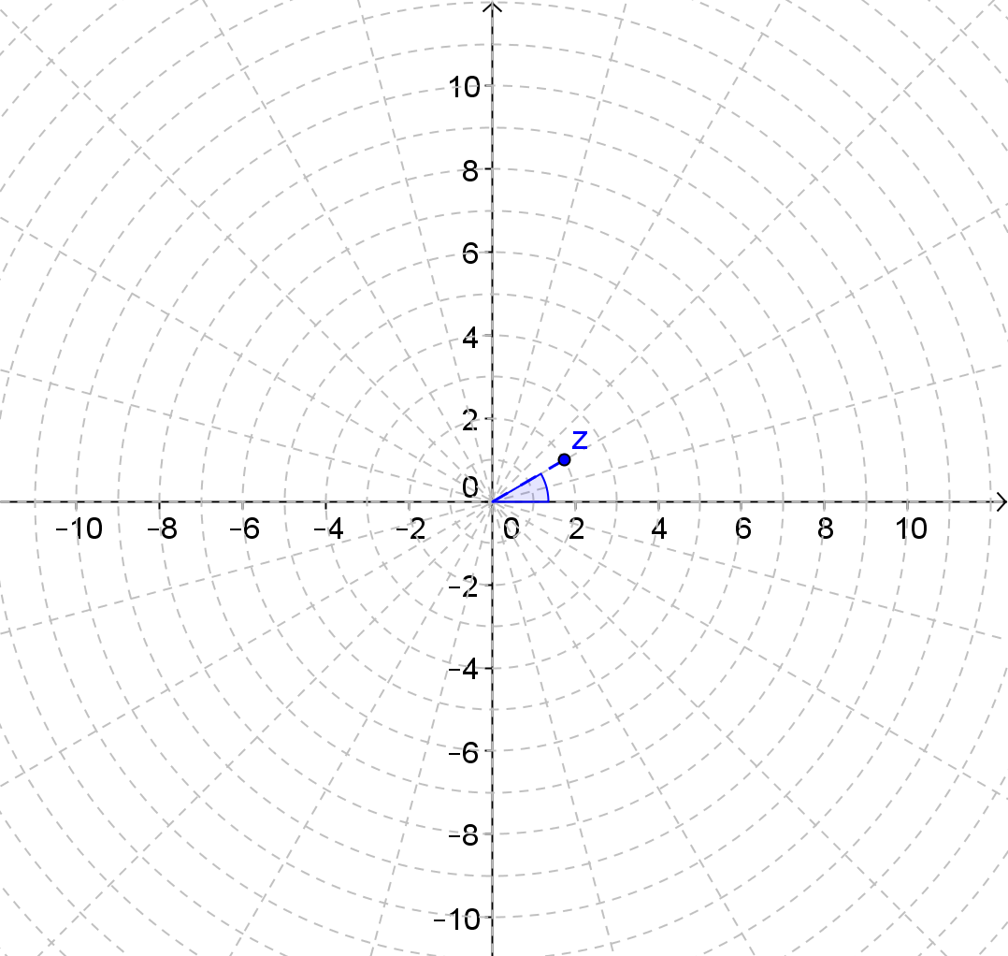
  - Use the polar grid to identify the modulus and argument of $z$.

  - Graph the next three powers of $z$ on the polar grid. Explain how you got your answers.

  - Write the polar form of the number in the table below, and then rewrite it in rectangular form.
Power of $z$ | Polar Form | Rectangular Form
$$\sqrt{3}+i$$
$${\left(\sqrt{3}+i\right)}^{2}$$
$${\left(\sqrt{3}+i\right)}^{3}$$
$${\left(\sqrt{3}+i\right)}^{4}$$

Exercises 1–3
The complex numbers $z_{2}={\left(-1+\sqrt{3}i\right)}^{2}$ and $z_{1}$ are graphed below.
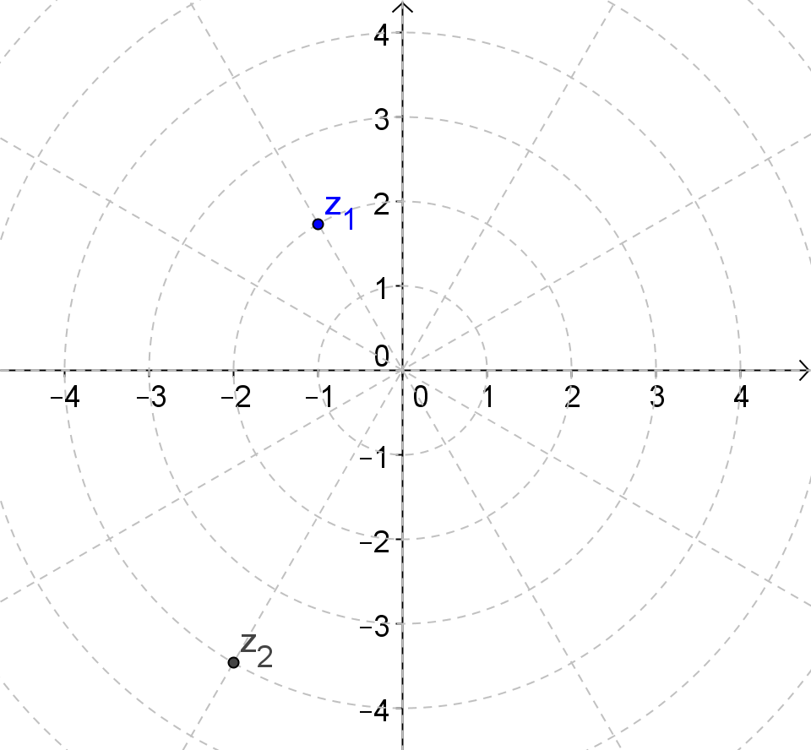
- Use the graph to help you write the numbers in polar and rectangular form.

- Describe how the modulus and argument of $z_{1}=-1+\sqrt{3i}$ are related to the modulus and argument of
${z_{2}=\left(-1+\sqrt{3}i\right)}^{2}$.

- Why could we call $-1+\sqrt{3}i$ a square root of $-2-2\sqrt{3}i$?

Example 1: Find the Two Square Roots of a Complex Number
Find both of the square roots of $-2-2\sqrt{3}i$.

Exercises 4–6
- Find the cube roots of $-2=2\sqrt{3}i$.

- Find the square roots of $4i$.

- Find the cube roots of $8$.

Lesson Summary
Given a complex number $z$ with modulus $r$ and argument $θ$, the $n$^{th} roots of $z$ are given by
$$\sqrt[n]{r}\left(\cos\left(\frac{θ}{n}+\frac{2πk}{n}\right)+i sin\left(\frac{θ}{n}+\frac{2πk}{n}\right)\right)$$
for integers $k$ and $n$ such that $n>0$ and $0≤k<n$.

Problem Set

- For each complex number what is $z^{2}$?
  - $1+\sqrt{3}i$
  - $3-3i$
  - $4i$
  - $-\frac{\sqrt{3}}{2}+\frac{1}{2}i$
  - $\frac{1}{9}+\frac{1}{9}i$
  - $-1$

- For each complex number, what are the square roots of $z$?
  - $1+\sqrt{3}i$
  - $3-3i$
  - $4i$
  - $-\frac{\sqrt{3}}{2}+\frac{1}{2}i$
  - $\frac{1}{9}+\frac{1}{9}i$
  - $-1$
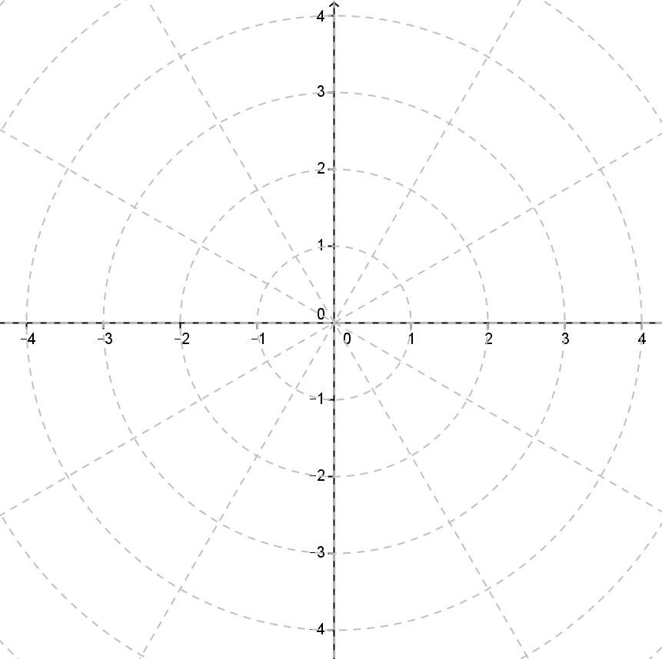
- For each complex number, graph $z$, $z^{2}$, and $z^{3}$ on a polar grid.
  - $2\left(\cos\left(\frac{π}{3}\right)+i sin\left(\frac{π}{3}\right)\right)$
  - $3\left(\cos\left(210°\right)+i sin\left(210°\right)\right)$
  - $2\left(\cos\left(\frac{π}{4}\right)+i sin\left(\frac{π}{4}\right)\right)$
  - $\cos\left(π\right)+i sin\left(π\right)$
  - $4\left(\cos\left(\frac{3π}{4}\right)+i sin\left(\frac{3π}{4}\right)\right)$
  - $\frac{1}{2}\left(\cos\left(60°\right)+ i sin\left(60°\right)\right)$

- What are the cube roots of $–3i?$

- What are the fourth roots of $64?$

- What are the square roots of $-4-4i$?

- Find the square roots of $-5$. Show that the square roots satisfy the equation${ x}^{2}+5=0$.

- Find the cube roots of $27$. Show that the cube roots satisfy the equation $x^{3}-27=0$.

