Lesson 18: Exploiting the Connection to Trigonometry

Student Outcomes
- Students derive the formula for $z^{n}=r^{n}(\cos\left(nθ\right)+i sin\left(nθ\right))$ and use it to calculate powers of a complex number.

Lesson Notes
This lesson builds on the concepts from Topic B by asking students to extend their thinking about the geometric effect of multiplication of two complex numbers to the geometric effect of raising a complex number to an integer exponent
(N-CN.B.5). This lesson is part of a two-day lesson that gives students another opportunity to work with the polar form of a complex number, to see its usefulness in certain situations, and to exploit that form to quickly calculate powers of a complex number. Students compare and convert between polar and rectangular form and graph complex numbers represented both ways (N-CN.B.4). On the second day, students examine graphs of powers of complex numbers in a polar grid and then reverse the process from Day 1 to calculate $n$^{th} roots of a complex number (N-CN.B.5). Throughout the lesson, students construct and justify arguments (MP.3), looking for patterns in repeated reasoning (MP.8), and use the structure of expressions and visual representations to make sense of the mathematics (MP.7).

Classwork
Opening (5 minutes)
Display two complex numbers on the board: $1+i$ and $\sqrt{2}(\cos\left(\frac{π}{4}\right)+i sin{(\frac{π}{4}))}$.
MP.3
- Do these represent the same number? Explain why or why not.
  - $\sqrt{2}\left(\frac{\sqrt{2}}{2}+i\frac{\sqrt{2}}{2}\right)=1+i$; yes, they are the same number. When you expand $\sqrt{2}(\cos\left(\frac{π}{4}\right)+i sin{(\frac{π}{4}))}$, you get $1+i$.
- What are the advantages of writing a complex number in polar form? What are the disadvantages?
  - In polar form, you can see the modulus and argument. It is easy to multiply the numbers because you multiply the modulus and add the arguments. It can be difficult to graph the numbers because you have to use a compass and protractor to graph them accurately. If you are unfamiliar with the rotations and evaluating sine and cosine functions, then converting to rectangular is difficult. It is not so easy to add complex numbers in polar form unless you have a calculator and convert them to rectangular form.
- What are the advantages of writing a complex number in rectangular form? What are the disadvantages?
  - They are easy to graph; addition and multiplication are not too difficult either. It is difficult to understand the geometric effect of multiplication when written in rectangular form. It is not so easy to calculate the argument of the number, and you have to use a formula to calculate the modulus.

Opening Exercise (5 minutes)
Tell students that in this lesson they are going to begin to exploit the advantages of writing a number in polar form and have them quickly do the Opening Exercises. Students should work these problems individually. These exercises will also serve as a check for understanding. If students are struggling to complete these exercises quickly and accurately, you may want to provide some additional practice in the form of Sprints.
Opening Exercise
  - Identify the modulus and argument of each complex number, and then rewrite it in rectangular form.
    - $2\left(\cos\left(\frac{π}{4}\right)+i sin\left(\frac{π}{4}\right)\right)$
Scaffolding:
- For struggling students, encourage them to work from a copy of a unit circle to quickly identify the sine and cosine function values.
- On Opening Exercise part (b), help students recall how to graph complex numbers, construct a triangle, and use special triangle ratios to determine the argument.
The modulus is $2$, and the argument is $\frac{π}{4}$. The number is $\sqrt{2}+i\sqrt{2}$.

    - $5\left(\cos\left(\frac{2π}{3}\right)+i sin\left(\frac{2π}{3}\right)\right)$
The modulus is $5$, and the argument is $\frac{2π}{3}$. The number is $-\frac{5}{2}+i\frac{5\sqrt{3}}{2}$.

    - $3\sqrt{2}\left(\cos\left(\frac{7π}{4}\right)+i sin\left(\frac{7π}{4}\right)\right)$
The modulus is $3\sqrt{2}$, and the argument is $\frac{7π}{4}$. The number is $3-3i$.

    - $3\left(\cos\left(\frac{7π}{6}\right)+i sin\left(\frac{7π}{6}\right)\right)$
The modulus is $3$, and the argument is $\frac{7π}{6}$. The number is $-\frac{3\sqrt{3}}{2}-\frac{3}{2}i$.

    - $1\left(\cos\left(π\right)+i sin\left(π\right)\right)$
The modulus is $1$, and the argument is $π$. The number is $-1$.

  - What is the argument and modulus of each complex number? Explain how you know.
    - $2-2i$
We have $\left|2-2i\right|=2\sqrt{2}$, and $\arg\left(2-2i\right)=\frac{7π}{4}$. The point $(2,-2)$ is located in the fourth quadrant. The ray from the origin containing the point is a rotation of $\frac{7π}{4}$ from the ray through the origin containing the real number $1$.

    - $3\sqrt{3}+3i$
We have$\left|3\sqrt{3}+3i\right|=6$, and $\arg\left(3\sqrt{3}+3i\right)=\frac{π}{6}$. The point $(3\sqrt{3},3)$ is located in the first quadrant. The ray from the origin containing the point is a rotation of $\frac{π}{6}$ from the ray through the origin containing the real number $1$.

    - $-1-\sqrt{3}i$
We have$\left|-1-\sqrt{3}i\right|=2$ and $\arg\left(-1-\sqrt{3}i\right)=\frac{4π}{3}$. The point $(-1,-\sqrt{3})$ is located in the third quadrant. The ray from the origin containing the point is a rotation of $\frac{4π}{3}$ from the ray through the origin containing the real number $1$.

    - $-5i$
We have$\left|-5i\right|=5$,and $\arg\left(-5i\right)=\frac{3π}{2}$. The point $(0,-5)$ is located on the imaginary axis. The ray from the origin containing the point is a rotation of $\frac{3π}{2}$ from the ray through the origin containing the real number $1$.

    - $1$
We have $\left|1\right|=1$, and $\arg\left(1\right)=0$. This is the real number $1$.

Exploratory Challenge/Exercises 1–12 (20 minutes)
Students will investigate and ultimately generalize a formula for quickly calculating the value of $z^{n}$. The class should work on these problems in teams of three to four students each. Use the discussion questions to help move individual groups forward as they work through the exercises in this exploration. Each group should have a graph paper for each group member and access to a calculator to check calculations if needed.
In Exercise 3, most groups will probably expand the number and perform the calculation in rectangular form. Here polar form offers little advantage. Perhaps when the exponent is a $4$, a case could be made that polar form is more efficient for calculating a power of a complex number.
Be sure to pause and debrief with the entire class after Exercise 5. All students need to have observed the patterns in the table in order to continue to make progress discovering the relationships about powers of a complex number.
Exploratory Challenge/Exercises 1–12
- Rewrite each expression as a complex number in rectangular form.
  - ${\left(1+i\right)}^{2}$
$\left(1+i\right)\left(1+i\right)=1+2i+i^{2}=1+2i-1=2i$

  - ${\left(1+i\right)}^{3}$
${\left(1+i\right)}^{3}={\left(1+i\right)}^{2}\left(1+i\right)=2i\left(1+i\right)=2i+2i^{2}=-2+2i$

  - ${\left(1+i\right)}^{4}$
${\left(1+i\right)}^{4}={\left(1+i\right)}^{2}{\left(1+i\right)}^{2}=2i∙2i=4i^{2}=-4$

- Complete the table below showing the rectangular form of each number and its modulus and argument.
Power of $(1+i)$ | Rectangular Form | Modulus | Argument
$${\left(1+i\right)}^{0}$$ | $$1$$ | $$1$$ | $$0$$
$${\left(1+i\right)}^{1}$$ | $$1+i$$ | $$\sqrt{2}$$ | $$\frac{π}{4}$$
$${\left(1+i\right)}^{2}$$ | $$2i$$ | $$2$$ | $$\frac{π}{2}$$
$${\left(1+i\right)}^{3}$$ | $$-2+2i$$ | $$2\sqrt{2}$$ | $$\frac{3π}{4}$$
$${\left(1+i\right)}^{4}$$ | $$-4$$ | $$4$$ | $$π$$
MP.8
- What patterns do you notice each time you multiply by another factor of $(1+i)$?
The argument increases by $\frac{π}{4}$. The modulus is multiplied by $\sqrt{2}$.

Before proceeding to the rest of the exercises in this Exploratory Challenge, check to make sure each group observed the patterns in the table required for them to make the connection that repeatedly multiplying by the same complex number causes repeated rotation by the argument, dilation, and by the modulus of the number.
You can debrief the first five exercises by having one or two groups present their findings on the board or document camera.

- Graph each power of $1+i$ shown in the table on the same coordinate grid. Describe the location of these numbers in relation to one another using transformations.
Starting with ${\left(1+i\right)}^{0}$, each subsequent complex number is a $45°$ rotation and a dilation by a factor of $\sqrt{2}$ of the previous one. The graph shows the graphs of $z_{n}={\left(1+i\right)}^{n}$ for $n=0,1,2,3,4,5$.
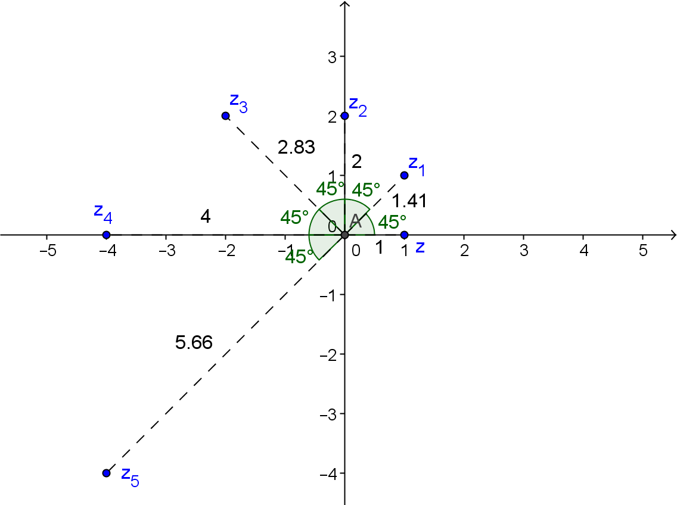

- Predict what the modulus and argument of ${\left(1+i\right)}^{5}$ would be without actually performing the multiplication. Explain how you made your prediction.
The modulus would be $4\sqrt{2}$, and the argument would be $π+\frac{π}{4}=\frac{5π}{4}$.

- Graph ${\left(1+i\right)}^{5}$ in the complex plane using the transformations you described in Exercise 5.
See solution to Exercises 4 and 5.
- Write each number in polar form using the modulus and argument you calculated in Exercise 4.
$${\left(1+i\right)}^{0}=1(\cos\left(0\right)+i sin\left(0\right))$$
$${\left(1+i\right)}^{1}=\sqrt{2}\left(\cos\left(\frac{π}{4}\right)+i sin\left(\frac{π}{4}\right)\right)$$
$${\left(1+i\right)}^{2}=2\left(\cos\left(\frac{π}{2}\right)+i sin\left(\frac{π}{2}\right)\right)$$
$${\left(1+i\right)}^{3}=2\sqrt{2}\left(\cos\left(\frac{3π}{4}\right)+i sin\left(\frac{3π}{4}\right)\right)$$
$${\left(1+i\right)}^{4}=4\left(\cos\left(π\right)+i sin\left(π\right)\right)$$

- Use the patterns you have observed to write ${\left(1+i\right)}^{5}$ in polar form, and then convert it to rectangular form.
$${\left(1+i\right)}^{5}=4\sqrt{2}\left(\cos\left(\frac{5π}{4}\right)+i sin\left(\frac{5π}{4}\right)\right)$$

- What is the polar form of ${\left(1+i\right)}^{20}$? What is the modulus of ${\left(1+i\right)}^{20}$? What is its argument? Explain why ${\left(1+i\right)}^{20}$ is a real number.
In polar form, the number would be ${\left(\sqrt{2}\right)}^{20}\left(\cos\left(20∙\frac{π}{4}\right)+i sin\left(20∙\frac{π}{4}\right)\right)$. The modulus is ${\left(\sqrt{2}\right)}^{20}=2^{10}=1024$.
The argument is the rotation between $0$ and $2π$ that corresponds to a rotation of $20∙\frac{π}{4}=5π$. The argument is $π$. This rotation takes the number $1$ to the negative real-axis and dilates it by a factor of $1024$ resulting in the number $-1024$ which is a real number.

Pause here to discuss the advantages of considering the geometric effect of multiplication by a complex number when raising a complex number to a large integer exponent. Lead a discussion so students understand that the polar form of a complex number makes this type of multiplication very efficient.
- How do you represent multiplication by a complex number when written in polar form?
  - The product of two complex numbers has a modulus that is the product of the two factor’s moduli and an argument that is the sum of the two factor’s arguments.
- How does understanding the geometric effect of multiplication by a complex number make solving Exercises 10 and 11 easier than repeatedly multiplying by the rectangular form of the number?
  - If you know the modulus and argument of the complex number, and you want to calculate $z^{n}$, then the argument will be $n$ times the argument, and these modulus will be the modulus raised to the $n$.
- In these exercises, you worked with powers of $1+i$. Do you think the patterns you observed can be generalized to any complex number raised to a positive integer exponent? Explain your reasoning.
  - Since the patterns we observed are based on repeatedly multiplying by the same complex number, and since the geometric effect of multiplication always involves a rotation and dilation, this process should apply to all complex numbers.
- How can you quickly raise any complex number of a large integer exponent?
  - Determine the modulus and argument of the complex number. Then multiply the argument by the exponent, and raise the modulus to the exponent. Then you can write the number easily in polar and then rectangular form.

This exploration largely relies on students using inductive reasoning to observe patterns in powers of complex numbers. The formula they write in Exercise 11 is known as DeMoivre’s formula (or DeMoivre’s theorem). More information and a proof by mathematical induction that this relationship holds can be found at http://en.wikipedia.org/wiki/De_Moivre's_formula.
If students have been struggling with this exploration, you can lead a whole class discussion on the next several exercises, or groups can proceed to work through the rest of this Exploratory Challenge on their own. Be sure to monitor groups and keep referring them back to the patterns they observed in the tables and graphs as they make their generalizations. Before students begin, announce that they will be generalizing the patterns they observed in the previous exercises. Make sure they understand that the goal is a formula or process for quickly raising a complex number to an integer exponent. Observe groups, and encourage students to explain to one another how they are seeing the formula as they work through these exercises.

- If $z$ has modulus $r$ and argument $θ$, what is the modulus and argument of $z^{2}$? Write the number $z^{2}$ in polar form.
The modulus would be $r^{2}$, and the argument would be a rotation between $0$ and $2π$ that is equivalent to $2θ$. $z^{2}=r^{2}(\cos\left(2θ\right)+i sin\left(2θ\right))$

- If $z$ has modulus $r$ and argument $θ$, what is the modulus and argument of $z^{n}$ where $n$ is a nonnegative integer? Write the number $z^{n}$ in polar form. Explain how you got your answer.
The modulus would be $r^{n},$ and the argument would be a rotation between $0$ and $2π$ that is equivalent to $nθ$. $z^{n}=r^{n}(\cos\left(nθ\right)+i sin\left(nθ\right)$

- Recall that $\frac{1}{z}=\frac{1}{r}(\cos\left(-θ\right)+i sin\left(-θ\right))$. Explain why it would make sense that formula holds for all integer values of $n$.
Since $\frac{1}{z}=z^{-1}$, it would make sense that the formula would hold for negative integers as well. If you plot $\frac{1}{z^{2}}$, $\frac{1}{z^{3}}$, etc. you can see the pattern holds.

In Exercise 14, students must consider why this formula holds for negative integers as well. Ask them how they could verify graphically or algebraically that these formulae could be extended to include negative integer exponents. You may want to demonstrate this using graphing software such as Geogebra or Desmos.
Close this section by recording the formula shown below on the board. Ask students to summarize to a partner how to use this formula with the number ${\left(1+i\right)}^{10}$ and to record it in their notes.
- Given a complex number $z$ with modulus $r$ and argument $θ$, the $n$^{th} power of $z$ is given by
$z^{n}=r^{n}(\cos\left(nθ\right)+i sin\left(nθ\right))$ where $n$ is an integer.

Exercises 13–14 (5 minutes)
Students should work these exercises in their small groups or with a partner. After a few minutes, review the solutions and discuss any problems students had with their calculations.
Exercises 13–14
- Compute ${\left(\frac{1-i}{\sqrt{2}}\right)}^{7}$ and write it as a complex number in the form $a+bi$ where $a$ and $b$ are real numbers.
The modulus of $\frac{1-i}{\sqrt{2}}$ is $1$, and the argument is $\frac{7π}{4}$. The polar form of the number is
$$1^{7}\left(\cos\left(7∙\frac{7π}{4}\right)+i sin\left(7∙\frac{7π}{4}\right)\right)$$
Converting this number to rectangular form by evaluating the sine and cosine values produces $\frac{\sqrt{2}}{2}+\frac{\sqrt{2}}{2}i$.

- Write ${\left(1+\sqrt{3}i\right)}^{6}$, and write it as a complex number in the form $a+bi$ where $a$ and $b$ are real numbers.
The modulus of $1+\sqrt{3}i$ is $2$, and the argument is $\frac{π}{6}$. The polar form of the number is
$$2^{6}\left(\cos\left(6∙\frac{π}{6}\right)+i sin\left(6∙\frac{π}{6}\right)\right)$$
Converting this number to rectangular form by evaluating the sine and cosine values produces $64\left(-1+0∙i\right)=-64$.

Closing (5 minutes)
Revisit one of the questions from the beginning of the lesson. Students can write their responses or discuss them with a partner.
- Describe an additional advantage to polar form that we discovered during this lesson?
  - When raising a complex number to an integer exponent, the polar form gives a quick way to express the repeated transformations of the number and quickly determine its location in the complex plane. This then leads to quick conversion to rectangular form.
Review the relationship that students discovered in this lesson.
Lesson Summary
Given a complex number $z$ with modulus $r$ and argument $θ$, the $n$th power of $z$ is given by
$z^{n}=r^{n}(\cos\left(nθ\right)+i sin\left(nθ\right))$ where $n$ is an integer.

Exit Ticket (5 minutes)

Name Date
Lesson 18: Exploiting the Connection to Trigonometry

Exit Ticket

- Write ${\left(2+2i\right)}^{8}$ as a complex number in the form $a+bi$ where $a$ and $b$ are real numbers.

- Explain why complex number of the form ${\left(a+ai\right)}^{n}$ will either be a pure imaginary or a real number when $n$ is an even number.

Exit Ticket Sample Solutions

- Write ${\left(2+2i\right)}^{8}$ as a complex number in the form $a+bi$ where $a$ and $b$ are real numbers.
We have $\left|2+2i\right|=2\sqrt{2}$ and $\arg\left(2+2i\right)=\frac{π}{4}$.
Thus ${\left(2+2i\right)}^{8}={\left(2\sqrt{2}\right)}^{8}\left(\cos\left(8∙\frac{π}{4}\right)+i sin\left(8∙\frac{π}{4}\right)\right)=2^{12}\left(\cos\left(2π\right)+i sin\left(2π\right)\right)=2^{12}\left(1+0i\right)=2^{12}+0i$.

- Explain why complex number of the form ${\left(a+ai\right)}^{n}$ where $a$ is a positive real number will either be a pure imaginary or a real number when $n$ is an even number.
Since the argument will always be $\frac{π}{4}$, any even number multiplied by this number will be a multiple of $\frac{π}{2}$. This will result in a rotation to one of the axes which means the complex number will either be a real number or a pure imaginary number.

Problem Set Sample Solutions

- Write the complex number in $a+bi$ form where $a$ and $b$ are real numbers.
  - $2\left(\cos\left(\frac{5π}{3}\right)+i sin\left(\frac{5π}{3}\right)\right)$
$$2\left(\cos\left(\frac{5π}{3}\right)+i sin\left(\frac{5π}{3}\right)\right)=2\left(\frac{1}{2}-\frac{\sqrt{3}}{2}i\right) \\ =1-\sqrt{3}i$$

  - $3\left(\cos\left(210°\right)+i sin\left(210°\right)\right)$
$$3\left(\cos\left(210°\right)+i sin\left(210°\right)\right)=3\left(-\frac{\sqrt{3}}{2}-\frac{1}{2}i\right) \\ =-\frac{3\sqrt{3}}{2}-\frac{3}{2}i$$

  - ${\left(\sqrt{2}\right)}^{10}\left(\cos\left(\frac{15π}{4}\right)+i sin\left(\frac{15π}{4}\right)\right)$
$${\left(\sqrt{2}\right)}^{10}\left(\cos\left(\frac{15π}{4}\right)+i sin\left(\frac{15π}{4}\right)\right)=32\left(cos\left(\frac{7π}{4}\right)+i sin\left(\frac{7π}{4}\right)\right) \\ =32\left(\frac{\sqrt{2}}{2}-\frac{i\sqrt{2}}{2}\right) \\ =16\sqrt{2}-16\sqrt{2}i$$

  - $\cos\left(9π\right)+i sin\left(9π\right)$
$$\cos\left(9π\right)+i sin\left(9π\right)=cos\left(π\right)+i sin\left(π\right) \\ =-1+0i \\ =-1$$

  - $4^{3}\left(\cos\left(\frac{3π}{4}\right)+i sin\left(\frac{3π}{4}\right)\right)$
$$4^{3}\left(\cos\left(\frac{3π}{4}\right)+i sin\left(\frac{3π}{4}\right)\right)=64\left(-\frac{\sqrt{2}}{2}+i\frac{\sqrt{2}}{2}\right) \\ =-32\sqrt{2}+32\sqrt{2}i$$

  - $6\left(\cos\left(480°\right)+i sin\left(480°\right)\right)$
$$6\left(\cos\left(480°\right)+i sin\left(480°\right)\right)=6\left(cos\left(120°\right)+i sin\left(120°\right)\right) \\ =6\left(-\frac{1}{2}+\frac{\sqrt{3}}{2}i\right) \\ =-3+3\sqrt{3}i$$

- Use the formula discovered in this lesson to compute each power of $z$. Verify that the formula works by expanding and multiplying the rectangular form and rewriting it in the form $a+bi$ where $a$ and $b$ are real numbers.
  - ${\left(1+\sqrt{3}i\right)}^{3}$
Since $z=1+\sqrt{3}i$, we have $\left|z\right|=\sqrt{1+3}=2$, and $θ=\frac{π}{3}$. Then
$${\left(1+\sqrt{3}i\right)}^{3}=2^{3}\left(cos\left(3⋅\frac{π}{3}\right)+i sin\left(3⋅\frac{π}{3}\right)\right)=8\left(cos\left(π\right)+i sin\left(π\right)\right)=-8. \\ {(1+\sqrt{3}i)}^{3}=\left(1+\sqrt{3}i\right)\left(1+2\sqrt{3}i-3\right)=\left(1+\sqrt{3}i\right)\left(-2+2\sqrt{3}i\right)=-2+2\sqrt{3}i-2\sqrt{3}i-6=-8$$

  - ${\left(-1+i\right)}^{4}$
Since $z=-1+i$, we have $\left|z\right|=\sqrt{1+1}=\sqrt{2}$, and $θ=\frac{3π}{4}$. Then
$${\left(-1+i\right)}^{4}={\left(\sqrt{2}\right)}^{4}\left(cos\left(4⋅\frac{3π}{4}\right)+i sin\left(4⋅\frac{π3}{4}\right)\right)=4\left(cos\left(3π\right)+i sin\left(3π\right)\right)=-4. \\ {\left(-1+i\right)}^{4}={\left(-1+i\right)}^{2}{(-1+i)}^{2}=\left(1-2i-1\right)\left(1-2i-1\right)=\left(-2i\right)\left(-2i\right)=-4$$

  - ${\left(2+2i\right)}^{5}$
Since $z=2+2i$, we have $\left|z\right|=\sqrt{2^{2}+2^{2}}=2\sqrt{2}$, and $θ=\frac{π}{4}$. Then
$${\left(2+2i\right)}^{5}={\left(2\sqrt{2}\right)}^{5}\left(cos\left(5⋅\frac{π}{4}\right)+i sin\left(5⋅\frac{π}{4}\right)\right)=128\sqrt{2}\left(-\frac{\sqrt{2}}{2}-\frac{\sqrt{2}}{2}i\right)=-128-128i. \\ {\left(2+2i\right)}^{5}={\left(2+2i\right)}^{2}{\left(2+2i\right)}^{2}\left(2+2i\right)=\left(4+8i-4\right)\left(4+8i-4\right)\left(2+2i\right)=\left(8i\right)\left(8i\right)\left(2+2i\right)=-64\left(2+2i\right)=-128-128i$$

  - ${\left(2-2i\right)}^{-2}$
Since $z=2-2i$, we have $\left|z\right|=\sqrt{2^{2}+2^{2}}=2\sqrt{2}$, and $θ=\frac{7π}{4}$. Then
$${\left(2-2i\right)}^{-2}={\left(2\sqrt{2}\right)}^{-2}\left(cos\left(-2⋅\frac{7π}{4}\right)+i sin\left(-2⋅\frac{7π}{4}\right)\right)=\frac{1}{8}\left(0+i\right)=\frac{1}{8}i. \\ {\left(2-2i\right)}^{-2}=\frac{1}{{(2-2i)}^{2}}=\frac{1}{4-8i-4}=\frac{1}{-8i}∙\frac{i}{i}=\frac{i}{8}=\frac{1}{8}i$$

  - ${\left(\sqrt{3}-i\right)}^{4}$
Since $z=\sqrt{3}-i$, we have $\left|z\right|=\sqrt{{\sqrt{3}}^{2}+1^{2}}=2$, and $θ=\frac{11π}{6}$. Then
$${\left(\sqrt{3}-i\right)}^{4}=2^{4}\left(cos\left(4⋅\frac{11π}{6}\right)+i sin\left(4⋅\frac{11π}{6}\right)\right)=16\left(cos\left(\frac{22π}{3}\right)+i sin\left(\frac{22π}{3}\right)\right)=16\left(-\frac{1}{2}-\frac{\sqrt{3}}{2}i\right)=-8-8\sqrt{3}i. \\ {\left(\sqrt{3}-i\right)}^{4}={(\sqrt{3}-i)}^{2}{(\sqrt{3}-i)}^{2}=\left(3-2\sqrt{3}i-1\right)\left(3-2\sqrt{3}i-1\right)=\left(2-2\sqrt{3}i\right)\left(2-2\sqrt{3}i\right)=4-8\sqrt{3}i-12=-8-8\sqrt{3}i$$

  - ${\left(3\sqrt{3}-3i\right)}^{6}$
Since $z=3\sqrt{3}-3i$, we have $\left|z\right|=\sqrt{{(3\sqrt{3})}^{2}+3^{2}}=\sqrt{36}=6$, and $θ=\frac{11π}{6}$. Then
$${\left(3\sqrt{3}-3i\right)}^{6}=6^{6}\left(cos\left(6⋅\frac{11π}{6}\right)+i sin\left(6⋅\frac{11π}{6}\right)\right)=46656\left(cos\left(11π\right)+i sin\left(11π\right)\right)=-46656. \\ {\left(3\sqrt{3}-3i\right)}^{6}={\left(3\sqrt{3}-3i\right)}^{2}{\left(3\sqrt{3}-3i\right)}^{2}{\left(3\sqrt{3}-3i\right)}^{2}=\left(27-18\sqrt{3}i-9\right)\left(27-18\sqrt{3}i-9\right)\left(27-18\sqrt{3}i-9\right)=\left(18-18\sqrt{3}i\right)\left(18-18\sqrt{3}i\right)\left(18-18\sqrt{3}i\right)=\left(324-648\sqrt{3}i-972\right)\left(18-18\sqrt{3}i\right)=\left(-648-648\sqrt{3}i\right)\left(18-18\sqrt{3}i\right)=-11,664+11,664\sqrt{3}i-11,664\sqrt{3}i-34,992=-46,656$$

- Given $z=-1-i$, graph the first five powers of $z$ by applying your knowledge of the geometric effect of multiplication by a complex number. Explain how you determined the location of each in the coordinate plane.
Multiplication by $–1-i$ will dilate by $\left|-1-i\right|=\sqrt{1+1}=\sqrt{2}$, and rotate by $arg\left(-1-i\right)=\frac{5π}{4}.$ Then the graph below shows $z=-1-i$, $z^{2}={\left(-1-i\right)}^{2}$, $z^{3}={\left(-1-i\right)}^{3}$, $z^{4}={\left(-1-i\right)}^{4}$, and $z^{5}={\left(-1-i\right)}^{5}.$
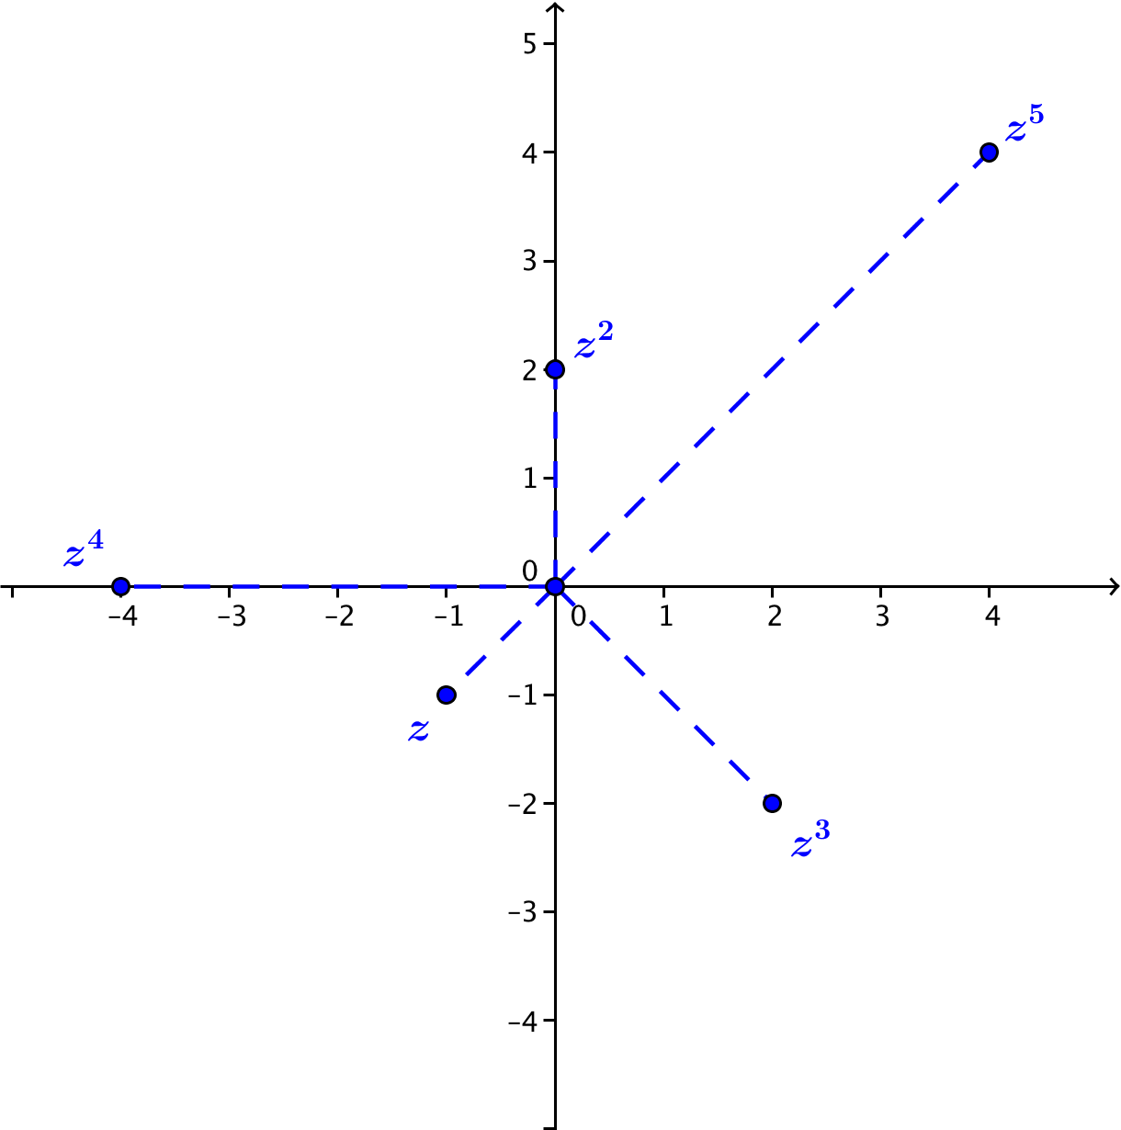
To locate each point, multiply the distance from the previous point to the origin by the modulus ($\sqrt{2}$), and rotate counterclockwise $\frac{5π}{4}$.

- Use your work from Problem 3 to determine three values of $n$ for which ${\left(-1-i\right)}^{n}$ is a multiple of $-1-i$.
Since multiplication by $-1-i$ rotates the point by $\frac{5π}{4}$ radians, the point ${\left(-1-i\right)}^{n}$ is a multiple of the original $z=-1-i$ every $8$ iterations. Thus, ${\left(-1-i\right)}^{9}$, ${\left(-1-i\right)}^{17}, {\left(-1-i\right)}^{25}$ are all multiples of $(1-i)$.
- Find the indicated power of the complex number, and write your answer in form $a+bi$ where $a$ and $b$ are real numbers.
  - ${\left[2\left(\cos\left(\frac{3π}{4}\right)+i sin\left(\frac{3π}{4}\right)\right)\right]}^{3}$
$${\left[2\left(\cos\left(\frac{3π}{4}\right)+i sin\left(\frac{3π}{4}\right)\right)\right]}^{3}=2^{3}\left(cos\left(3⋅\frac{3π}{4}\right)+i sin\left(3⋅\frac{3π}{4}\right)\right) \\ =8\left(cos\left(\frac{9π}{4}\right)+i sin\left(\frac{9π}{4}\right)\right) \\ =8\left(\frac{\sqrt{2}}{2}+\frac{\sqrt{2}}{2}i\right) \\ =4\sqrt{2}+4\sqrt{2}i$$

  - ${\left[\sqrt{2}\left(\cos\left(\frac{π}{4}\right)+i sin\left(\frac{π}{4}\right)\right)\right]}^{10}$
$${\left[\sqrt{2}\left(\cos\left(\frac{π}{4}\right)+i sin\left(\frac{π}{4}\right)\right)\right]}^{10}={\left(\sqrt{2}\right)}^{10}\left(cos\left(\frac{10π}{4}\right)+i sin\left(\frac{10π}{4}\right)\right) \\ =32\left(0+1i\right) \\ =32i$$

  - ${\left(\cos\left(\frac{5π}{6}\right)+i sin\left(\frac{5π}{6}\right)\right)}^{6}$
$${\left(\cos\left(\frac{5π}{6}\right)+i sin\left(\frac{5π}{6}\right)\right)}^{6}=cos\left(\frac{30π}{6}\right)+i sin\left(\frac{30π}{6}\right) \\ =cos\left(5π\right)+i sin\left(5π\right) \\ =-1$$

  - ${\left[\frac{1}{3}\left(\cos\left(\frac{3π}{2}\right)+i sin\left(\frac{3π}{2}\right)\right)\right]}^{4}$
$${\left[\frac{1}{3}\left(\cos\left(\frac{3π}{2}\right)+i sin\left(\frac{3π}{2}\right)\right)\right]}^{4}={\left(\frac{1}{3}\right)}^{4}\left(cos\left(4⋅\frac{3π}{2}\right)+i sin\left(4⋅\frac{3π}{2}\right)\right) \\ =\frac{1}{81}\left(cos\left(6π\right)+i sin\left(6π\right)\right) \\ =\frac{1}{81}$$

  - ${\left[4\left(\cos\left(\frac{4π}{3}\right)+i sin\left(\frac{4π}{3}\right)\right)\right]}^{-4}$
$${\left[4\left(\cos\left(\frac{4π}{3}\right)+i sin\left(\frac{4π}{3}\right)\right)\right]}^{-4}=4^{-4}\left(cos\left(-4⋅\frac{4π}{3}\right)+i sin\left(4⋅\frac{4π}{3}\right)\right) \\ =\frac{1}{256}\left(cos\left(-\frac{16π}{3}\right)+i sin\left(-\frac{16π}{3}\right)\right) \\ =\frac{1}{256}\left(-\frac{1}{2}+\frac{\sqrt{3}}{2}\right) \\ =-\frac{1}{512}+\frac{\sqrt{3}}{512}$$

