Lesson 17: The Geometric Effect of Multiplying by a Reciprocal

Student Outcomes
- Students apply their knowledge to understand that multiplication by the reciprocal provides the inverse geometric operation to a rotation and dilation.
- Students understand the geometric effects of multiple operations with complex numbers.

Lesson Notes
This lesson explores the geometric effect of multiplication by the reciprocal to construct a transformation that undoes multiplication. In this lesson, students verify that the transformation of multiplication by the reciprocal produces the same result geometrically as it does algebraically. This lesson ties together the work of Lessons 13–15 on linear transformations of the form $L:C→C$ by $L\left(z\right)=wz$ for a complex number $w$, and all such linear transformations having the geometric effect of rotation by $\arg{(w)}$ and dilation by $|w|$ to the work done in Lessons 6 and 7 on complex number division. In later lessons, when matrices are used to define transformations, we will revisit these and extend these topics. This lesson relies upon the foundational standards G-CO.A.2, G-CO.A.4, and G.CO.A.5, and strengthens student understanding of N-CN.A.3, N-CN.B.4, and N-CN.B.5.
This lesson is structured as a series of exploratory challenges that are scaffolded to allow students to make sense of the connections between algebraic operations with complex numbers and the corresponding transformations. The lesson concludes with students considering all the operations (and their related transformations) together and working with combinations of operations and describing them as a series of transformations of a complex number. In the Problem Set, students connect the work of this module back to linear transformations that they studied in Lessons 1 and 2.
Scaffolding:
Use these concrete examples to scaffold the opening as needed for your students:
In $x+2$ how do you ‘undo’ adding $2$?
You would subtract $2$. $x+2-2=x$

In $5x$, how do you ‘undo’ multiplication by $5?$
You would divide by $5$.
$$\frac{5x}{5}=x$$

In $x^{3}$, how do you undo the operation of cubing?
You would take the cube root.
$$\sqrt[3]{x^{3}}=x$$

Classwork
Opening (2 minutes)
Ask students to brainstorm real-world operations that ‘undo’ each other. For example, putting your shoes on and taking them off. Have each student briefly share ideas with their group mates. Next, have them think of mathematical operations that ‘undo’ each other. For example, division by $3$ will ‘undo’ multiplication by $3$. Remind students that we often use the word ‘inverse’ when talking about operations that undo each other. During this lesson, be sure to correct students that confuse the words opposite, reciprocal, and inverse.

Opening Exercise (3 minutes)
Scaffolding:
Throughout this lesson students will be working with friendly rotations and using their knowledge of special right triangles and proportional reasoning. In your classroom, display prominent visual reminders such as drawings of special triangles (see Lesson 12 of this module), a unit circle with benchmark rotations labeled in degrees and radians (see Algebra II Module 2), etc.
Students will be working with this complex number in the subsequent Exploratory Challenge. If students struggle to find the argument and modulus of $1+i$ in this exercise, take time to review notation and methods for determining the argument of a complex number written in rectangular form. All the actual complex numbers in this lesson will correspond to ‘friendly’ rotations such as $\frac{π}{4}$, $\frac{π}{3}$, $\frac{π}{2}$, etc.
Opening Exercise
Given $w=1+i$. What is $arg⁡(w)$ and $\left|w\right|$? Explain how you got your answer.
$\arg\left(w\right)=\frac{π}{4}$ and $\left|w\right|=\sqrt{2}$. I used the formula $\left|w\right|=\sqrt{a^{2}+b^{2}}$ to determine the modulus and since the point $(1,1)$ lies along a ray from the origin that has been rotated $45°$ from the ray through the origin that contains the real number $1$, the argument must be $\frac{π}{4}$.

Exploratory Challenge 1/Exercises 1–9 (10 minutes)
Students should complete the next nine exercises in small groups of 3–4 students. As teams work on these problems, circulate around the room to monitor progress. Some groups may get stuck on Question 3. Since we defined the argument of a complex number on an interval $0≤arg⁡(z)<2π$ students will need to figure a positive rotation on this interval that will be equivalent to $-arg⁡(z)$. You can lead a whole-class discussion at this point if needed before moving the groups on to complete the rest of the exercises in this Exploratory Challenge. After Exercise 6, have one or two students report out their group’s response to this item.
Exploratory Challenge 1/Exercises 1–9
- Describe the geometric effect of the transformation $L\left(z\right)=\left(1+i\right)z$.
Scaffolding:
Work with specific angle measures to help struggling students understand the answer to Exercise 3.
- Name a positive and negative rotation that take a ray from the origin containing the real number $1$ through each point.
$$(1,1)$$
$$(0,2)$$
$$(-1,\sqrt{3})$$
$$(-3,0)$$
$$(-2,-2)$$
The transformation rotates the complex number about the origin through $45°$ and dilates the number by a scale factor of $\sqrt{2}$.

- Describe a way to undo the effect of the transformation $L\left(z\right)=\left(1+i\right)z$.
Geometrically, we need to rotate in the opposite direction, $-45°$, and dilate by a factor of $\frac{1}{\sqrt{2}}$.

- Given that $0≤arg⁡(z)<2π$ for any complex number, how could you describe any clockwise rotation of $θ$ as an argument of a complex number?
$\arg\left(z\right)=2π-θ$ would result in the same rotation as a clockwise rotation of $θ$.

- Write a complex number in polar form that describes a rotation and dilation that will undo multiplication by $(1+i)$, and then convert it to rectangular form.
$\frac{1}{\sqrt{2}}\left(\cos\left(315°\right)+i sin\left(315°\right)\right)=\frac{1}{\sqrt{2}}∙\frac{1}{\sqrt{2}}+i∙\frac{1}{\sqrt{2}}∙-\frac{1}{\sqrt{2}}=\frac{1}{2}-\frac{1}{2}i$

- In a previous lesson you learned that to undo multiplication by $1+i$, you would multiply by the reciprocal $\frac{1}{1+i}$. Write the complex number $\frac{1}{1+i}$ in rectangular form $z=a+bi$ where $a$ and $b$ are real numbers.
$\frac{1}{1+i}=\frac{1-i}{(1+i)(1-i)}=\frac{1-i}{2}=\frac{1}{2}-\frac{1}{2}i$

- How do your answers to Exercises 4 and 5 compare? What does that tell you about the geometric effect of multiplication by the reciprocal of a complex number?
The geometric effect of rotation by $2π-arg(z)$ and dilation by $\frac{1}{\left|z\right|}$ appears to be the same as multiplication by the reciprocal when the problem is solved algebraically.

- Jimmy states the following:
Multiplication by $\frac{1}{a+bi}$ has the reverse geometric effect of multiplication by $+bi$ .
Do you agree or disagree? Use your work on the previous exercises to support your reasoning.
Geometrically undoing the effect of multiplication by $a+bi$ by rotating in the opposite direction by the argument and dilating by the reciprocal of the modulus gave us the same results as when we rewrote $\frac{1}{a+bi}$ in rectangular form. This statement appears to be true. In each case we got the same complex number.

- Show that the following statement is true when $z=2-2\sqrt{3}i$:
The reciprocal of a complex number $z$ with modulus $r$ and argument $θ$ is $\frac{1}{z}$ with modulus $\frac{1}{r}$ and argument $2π-θ$.
MP.3
Since $2-2\sqrt{3}i$ has modulus $4$ and argument $\frac{5π}{3}$, we must have
$\frac{1}{2-2\sqrt{3}i}=\frac{1}{4}\left(\cos\left(\frac{π}{3}\right)+i sin\left(\frac{π}{3}\right)\right)=\frac{1}{4}\left(\frac{1}{2}+\frac{\sqrt{3}}{2}i\right)=\frac{1}{8}+\frac{\sqrt{3}}{8}i.$
Multiplying by $1$ using the conjugate, we have
$\frac{1}{2-2\sqrt{3}i}=\frac{(2+2\sqrt{3}i)}{(2-2\sqrt{3}i)(2+2\sqrt{3}i)}=\frac{2+2\sqrt{3}i}{16}=\frac{1}{8}+\frac{\sqrt{3}}{8}i.$
Since both methods produce equivalent complex numbers, this statement is true when $z=2-2\sqrt{3}i$.

- Explain using transformations why $z∙\frac{1}{z}=1$.
The complex number $z$ can be thought of as a rotation of the real number $1$ by $arg(z)$ and a dilation by $\left|z\right|$. If we multiply this number by its reciprocal, then we rotate $arg(z)$ in the opposite direction and dilate by a factor of $\frac{1}{\left|z\right|}$. This will return the rotation to $0$ and the modulus to $1$, which describes the real number $1$.

Debrief this section by making sure that students are clear on the geometric effect of multiplication by the reciprocal of a complex number. Explain that this allows us to understand division of complex numbers as transformations as well. A proof that the geometric effect of multiplication by the reciprocal is the same as $\frac{1}{a+bi}$ is provided below.
Scaffolding:
As an alternative to presenting this proof, have students verify the geometric effect of multiplying by the reciprocal of a complex number with specific examples.
- Let $z=2+2i$. For each number below find $\frac{z}{w}$.
$$w=1-i$$
$$w=3i$$
$$w=-4-4i$$
$$w=-5$$
Let $a+bi=r(\cos\left(θ\right)+i sin{(θ))}$. Then a complex number whose modulus is $\frac{1}{r}$ and whose argument is $2π-θ$ would be $\frac{1}{r}(\cos\left(2π-θ\right)+i sin{(2π-θ))}$. We need to show that
$$\frac{1}{a+bi}=\frac{1}{r(\cos\left(θ\right)+i sin{(θ))}}$$
is equivalent to $\frac{1}{r}(\cos\left(2π-θ\right)+i sin{(2π-θ))}$.
$$\frac{1}{a+bi}=\frac{1}{r(\cos\left(θ\right)+i sin{(θ))}} \\ =\frac{1}{r(\cos\left(θ\right)+i sin{(θ))}}∙\frac{r(\cos\left(θ\right)-i sin{(θ))}}{r(\cos\left(θ\right)-i sin{(θ))}} \\ =\frac{r(\cos\left(θ\right)-i sin{(θ))}}{r^{2}\left({\cos^{2}\left(θ\right)-i^{2} sin}^{2}\left(θ\right)\right)} \\ =\frac{1}{r}∙\frac{(\cos\left(θ\right)-i sin{(θ))}}{{\cos^{2}\left(θ\right)+sin}^{2}\left(θ\right)}$$
By the Pythagorean Identity,
$$\frac{1}{a+bi}=\frac{1}{r}(\cos\left(θ\right)-i sin{(θ))}$$
By using identities $\cos{(-θ)}=cos⁡(θ)$ and $\sin\left(-θ\right)=-sin⁡(θ)$ and $\cos\left(2π-θ\right)=\cos{(-θ)}$ and
$\sin\left(2π-θ\right)=sin⁡(-θ)$, we substitute to get
$$\frac{1}{a+bi}=\frac{1}{r}\left(\cos\left(2π-θ\right)+i sin\left(2π-θ\right)\right)$$

Exploratory Challenge 2/Exercise 10 (15 minutes)
This second challenge is a culminating activity that gives students the opportunity to review all the transformations and operations on complex numbers studied in this Module. Students should continue working in groups on this activity. After groups have completed the graphic organizer, you may invite representatives from the different groups to summarize their findings one row per group. If time is an issue, you may have each group work on only one row. Depending on the size of your class, more than one group may be assigned the same row. Have students prepare and present a poster summarizing their work on their assigned operation. While each group is presenting, students can take notes.
MP.2
&
MP.7
In this section, students are making connections between the algebraic structure of complex numbers and the related geometric representations and transformations, which is MP.2 and MP.7.

Exploratory Challenge 2/Exercise 10
- Complete the graphic organizer below to summarize your work with complex numbers so far.
MP.2
&
MP.7
Operation | Geometric Transformation | Example. Illustrate algebraically and geometrically  Let $z=3-3i$ and $w=-2i$
Addition  $$z+w$$ | Translation of $z$ by $w$ | $$3-3i+\left(-2i\right)=3-5i$$  You can see that the point $(3,-3)$ has been translated down $2$ units.  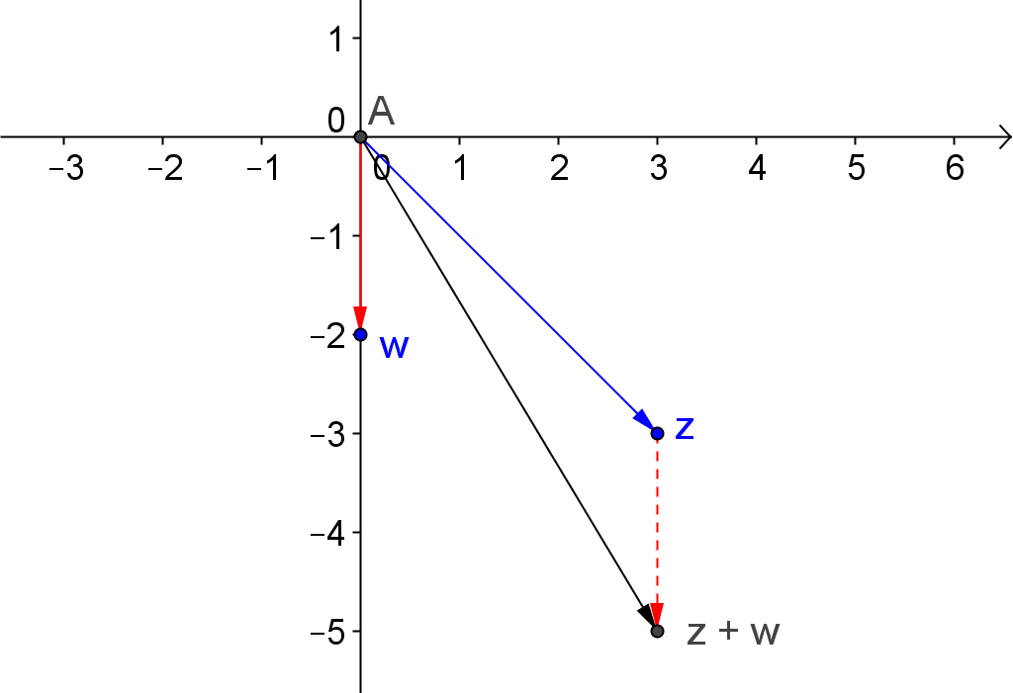
Subtraction  $$z-w$$ | Translation of $z$ by $w$ | $$3-3i-\left(-2i\right)=3-i$$  You can see that the point $(3,-3)$ has been translated up $2$ units.  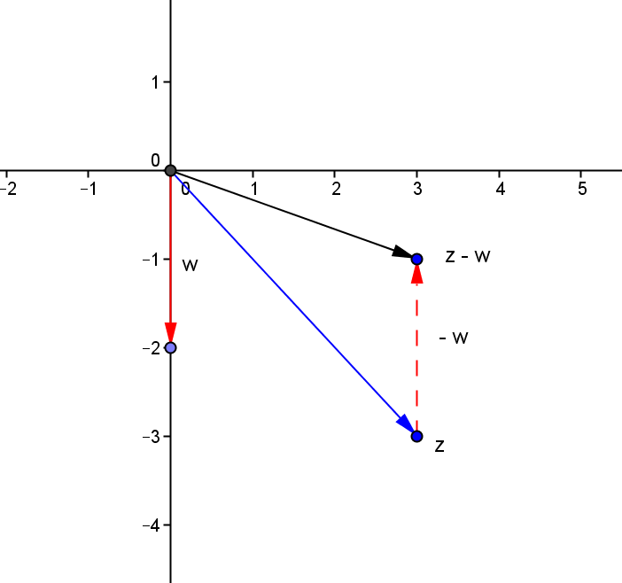
Conjugate of $z$ | Reflection of $z$ across the real axis | $\overline{z}=3+3i$. The point $(3,-3)$ is reflected across the real axis to the point $(3,3)$.  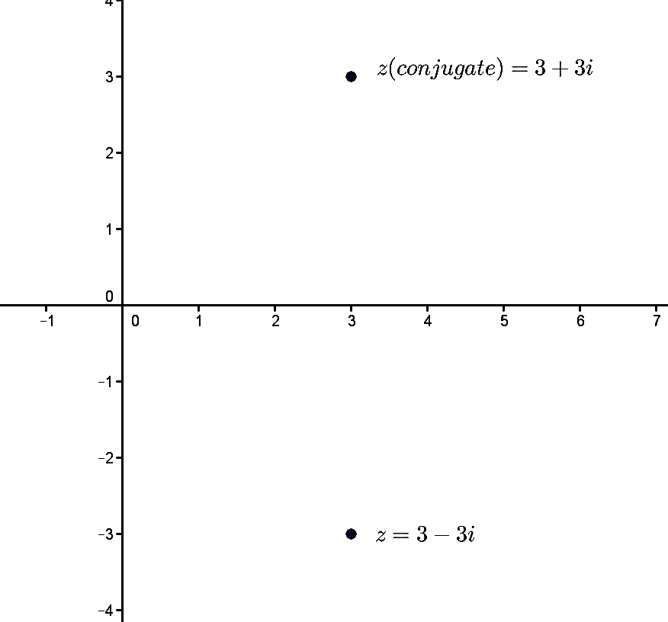

MP.2
&
MP.7
Multiplication  $$w∙z$$ | Rotation of $z$ by $arg⁡(w)$ followed by dilation by a factor of $\left|w\right|$ | $arg\left(w\right)=\frac{3π}{2}$ and $\left|w\right|=2$. Thus, $wz$ is $3-3i$ rotated $\frac{3π}{2}$ and dilated by a factor of $2$.  $3-3i=3\sqrt{2}\left(\cos\left(\frac{7π}{4}\right)+i\sin\left(\frac{7π}{4}\right)\right)$ so the new modulus will be $6\sqrt{2}$ and the new argument will be a number between $0$ and $2π$ that corresponds to a rotation of $\frac{7π}{4}+\frac{3π}{2}=\frac{13π}{4}$. The argument would be $\frac{5π}{4}$.  $-2i\left(3-3i\right)=-6i-6=-6-6i$ that does indeed have modulus $6\sqrt{2}$ and argument $\frac{5π}{4}$.  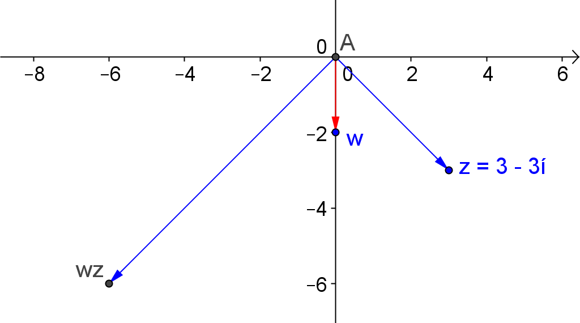
Reciprocal of $z$ | Rotates the real number 1 the opposite rotation of $z$ and a dilation by the reciprocal of the modulus of $z$ | $3-3i$ is a rotation of $\frac{7π}{4}$ and a dilation by $3\sqrt{2}$ of the real number $1$. The reciprocal would be rotation of $-\frac{7π}{4}$ and a dilation by $\frac{1}{3\sqrt{2}}$. The argument of the reciprocal would be $\frac{π}{4}$ and the modulus would be $\frac{\sqrt{2}}{6}$.  $\frac{1}{3-3i}=\frac{3+3i}{(3-3i)(3+3i)}=\frac{3+3i}{18}=\frac{1}{6}+\frac{1}{6}i$ with $arg\left(z\right)=\frac{π}{4}$ and $\left|z\right|=\frac{1}{6}\sqrt{2}$  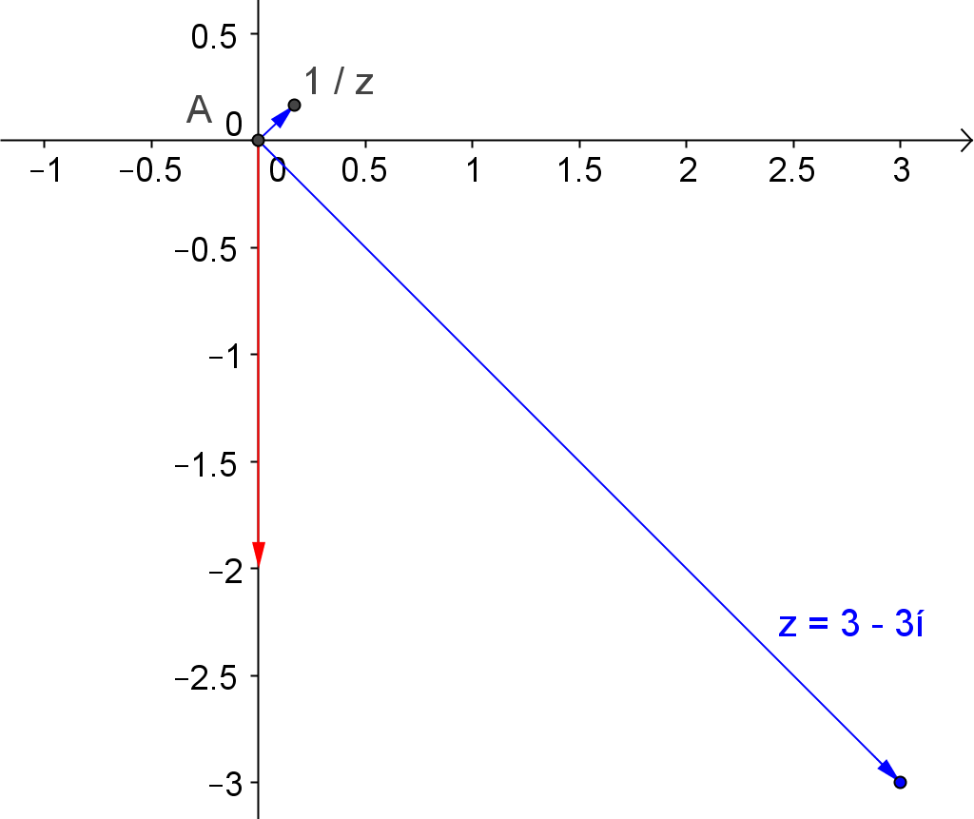
Division  $$\frac{w}{z}$$ | Rotates $w$ by $2π-arg⁡(z)$ and followed by a dilation of $\frac{1}{\left|z\right|}$. | Rotation of $w$ by $2π-arg\left(z\right)=\frac{π}{4}$ and dilation by $\frac{\sqrt{2}}{6}$ would result in a complex number whose argument was $\frac{3π}{2}+\frac{π}{4}=\frac{7π}{4}$ and a modulus of $\frac{\sqrt{2}}{6}∙2=\frac{\sqrt{2}}{3}$  $\frac{w}{z}=\frac{-2i}{3-3i}=\frac{-2i(3+3i)}{(3-3i)(3+3i)}=\frac{-6i+6}{18}=\frac{1}{3}-\frac{1}{3}i$  $\left|\frac{w}{z}\right|=\frac{1}{3}\sqrt{2}$ and $arg\left(\frac{w}{z}\right)=\frac{7π}{4}$.  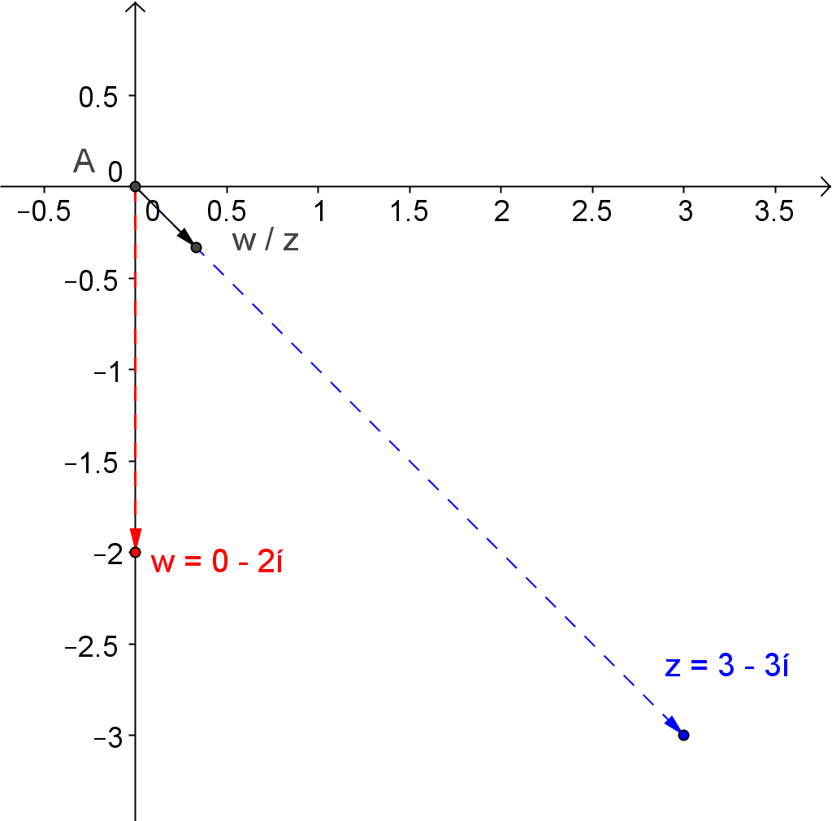

Exercises 11–13 (7 minutes)
Students should work on these problems with a partner. Ask each student to explain one problem to their partner to check for understanding. Then, invite one or two students to share their results on the board.
Exercises 11–13
Let $z=-1+i$ and let $w=2i$. Describe each complex number as a transformation of $z$ and then write the number in rectangular form.
- $w\overline{z}$
$z$ is reflected across the real axis, then that number is rotated by $arg⁡(w)$ and dilated by $\left|w\right|$.
$\arg\left(z\right)=\frac{3π}{4}$ and $\left|z\right|=\sqrt{2}$. $\arg\left(\overline{z}\right)=\frac{5π}{4}$ with the same modulus as $z$. Rotation by $\arg\left(w\right)=\frac{π}{2}$ and dilation by $2$ would give a complex number with argument of $\frac{5π}{4}+\frac{π}{2}=\frac{7π}{4}$ and modulus of $2\sqrt{2}$ which is the modulus and argument of the number shown below.
$w\overline{z}=2i\left(-1-i\right)=2-2i$.

- $\frac{1}{\overline{z}}$
$z$ is reflected across the real axis and then rotated $2π-\arg\left(\overline{z}\right)$ and dilated by $\frac{1}{\left|\overline{z}\right|}$. The result is a dilation of $z$.
Reflection of $z$ across the real axis results in a complex number with argument $\frac{5π}{4}$ and modulus of $\sqrt{2}$. The reciprocal has argument $2π-\frac{5π}{4}=\frac{3π}{4}$ and modulus $\frac{1}{\sqrt{2}}=\frac{\sqrt{2}}{2}$. This number has the same argument as $z$ and is a dilation by a factor of $\frac{1}{2}$.
$\frac{1}{\overline{z}}=\frac{1}{-1-i}=\frac{-1+i}{(-1-i)(-1+i)}=\frac{-1+i}{2}=-\frac{1}{2}+\frac{i}{2}$

- $\overline{w+z}$
$z$ is translated by $w$ vertically $2$ units up since the real part of $w$ is $0$ and the imaginary part is $2$. This new number is reflected across the real axis.
$$w+z=2i-1+i=-1+3i$$
$$\overline{w+z}=-1-3i$$

Closing (3 minutes)
The graphic organizer students made in Exploratory Challenge 2 will function as a summary for this lesson. Invite students to answer the following questions in writing or to discuss them with a partner.
Scaffolding:
If needed you may make the closing questions more concrete by specifying specific complex numbers for $z$ and $w$.
- What is the geometric effect of complex number division
(multiplication of $z$ by $1/w$)?
  - The number $z$ is rotated $2π-arg⁡(w)$ and dilated by $\frac{1}{\left|w\right|}$.
- How are the modulus and argument of the complex number $1/z$ related to the complex number $z$?
  - The modulus of $\frac{1}{z}$ is $\frac{1}{r}$ and the argument of $\frac{1}{z}$ is $2π-arg⁡(z)$, which is the same as rotation of $-arg⁡(z)$.

Exit Ticket (5 minutes)

Name Date
Lesson 17: The Geometric Effect of Multiplying by a Reciprocal

Exit Ticket

Let $z=1+\sqrt{3}i$ and $w=\sqrt{3}-i$. Describe each complex number as a transformation of $z$, and then write the number in rectangular form and identify its modulus and argument.
- $\frac{z}{w}$

- $\frac{1}{wz}$

Exit Ticket Sample Solutions

Let $z=1+\sqrt{3}i$ and $w=\sqrt{3}-i$. Describe each complex number as a transformation of $z$, and then write the number in rectangular form and identify its modulus and argument.
- $\frac{z}{w}$
$z$ is rotated by $-arg⁡(w)$ and dilated by $\frac{1}{\left|w\right|}$.
$\arg\left(z\right)=\frac{π}{3}$ and $2π-\arg\left(w\right)=2π-\frac{11π}{6}=\frac{π}{6}$. So, division by $w$ should rotate $z$ to $\frac{π}{2}$. $\left|z\right|=2$ and $\frac{1}{\left|w\right|}=\frac{1}{2}$, so the modulus of $\frac{z}{w}$ should be $2∙\frac{1}{2}=1$. This rotation and dilation describe the complex number $i$. Algebraically, we get the same number.
$$\frac{z}{w}=\frac{1+\sqrt{3}i}{\sqrt{3}-i}=\frac{1+\sqrt{3}i}{\sqrt{3}-i}∙\frac{\sqrt{3}+i}{\sqrt{3}+i}=\frac{4i}{4}=i$$

- $\frac{1}{wz}$
$z$ is rotated $arg(w)$ and dilated by $\left|w\right|$ then rotated $-arg(wz)$ and dilated by $\frac{1}{\left|wz\right|}$. For the given values of $z$ and $w$, this transformation results in a dilation of $w$ by a factor of $\frac{1}{4}$.
$\arg\left(z\right)=\frac{π}{3}$ and $\arg\left(w\right)=\frac{11π}{6}$. Adding these arguments and finding an equivalent rotation between $0$ and $2π$ gives a rotation of $\frac{π}{6}$ and $\left|wz\right|=2∙2=4$. This describes the complex number $2\sqrt{3}+2i$. The reciprocal of this number has argument $\frac{11π}{6}$ and modulus $\frac{1}{4}$, which describes the complex number $\frac{\sqrt{3}}{8}-\frac{1}{8}i$.
$$\frac{1}{wz}=\frac{1}{(\sqrt{3}-i)(1+\sqrt{3}i)}=\frac{1}{2\sqrt{3}+2i}=\frac{1}{2\sqrt{3}+2i}∙\frac{2\sqrt{3}-2i}{2\sqrt{3}-2i}=\frac{2\sqrt{3}-2i}{16}=\frac{\sqrt{3}}{8}-\frac{1}{8}i$$

Problem Set Sample Solutions

- Describe the geometric effect of multiplying $z$ by the reciprocal of each complex number listed below.
  - $w_{1}=3i$
$arg\left(w_{1}\right)=\frac{π}{2}$ and $\left|w_{1}\right|=3$
$z$ is rotated by $2π-arg(w_{1})$, which is $2π-\frac{π}{2}=\frac{3π}{2}$ and dilated by $\frac{1}{3}$.

  - $w_{2}=-2$
$arg\left(w_{2}\right)=π$ and $\left|w_{2}\right|=2$
$z$ is rotated by $2π-arg(w_{2})$, which is $2π-π=π$ and dilated by $\frac{1}{2}$.

  - $w_{3}=\sqrt{3}+i$
$arg\left(w_{3}\right)=\frac{π}{6}$ and $\left|w_{3}\right|=2$
$z$ is rotated by $2π-arg(w_{3})$, which is $2π-\frac{π}{6}=\frac{11π}{6}$ and dilated by $\frac{1}{2}$.

  - $w_{4}=1-\sqrt{3}i$
$arg\left(w_{4}\right)=\frac{5π}{6}$ and $\left|w_{4}\right|=2$
$z$ is rotated by $2π-arg\left(w_{4}\right)$, which is $2π-\left(\frac{5π}{3}\right)=\frac{π}{3}$ and dilated by $\frac{1}{2}$.

- Let $z=-2-2\sqrt{3}i$. Show that the geometric transformations you described in Problem 1 really produce the correct complex number by performing the indicated operation and determining the argument and modulus of each number.
  - $\frac{-2-2\sqrt{3}i}{w_{1}}$
$\frac{z}{w_{1}}=\frac{-2-2\sqrt{3}i}{3i}=\frac{-2-2\sqrt{3}i}{3i}∙\frac{-3i}{-3i}=\frac{-6\sqrt{3}+6i}{9}=-\frac{2\sqrt{3}}{3}+\frac{2}{3}i,\left|\frac{z}{w_{1}}\right|=\frac{4}{3},arg\left(\frac{z}{w_{1}}\right)=\frac{5π}{6}$.
$\left|z\right|=4$, so the result of division is a complex number whose modulus is $\frac{1}{3}$ of $4$.
$arg\left(z\right)=\frac{4π}{3}$, so the result of division by a complex number is whose argument represents the same rotation as $\frac{4π}{3}+\frac{3π}{2}=\frac{17π}{6}$, which would be $\frac{5π}{6}$.

  - $\frac{-2-2\sqrt{3}i}{w_{2}}$
$\frac{z}{w_{2}}=\frac{-2-2\sqrt{3}i}{-2}=1+\sqrt{3}i,\left|\frac{z}{w_{2}}\right|=2, arg\left(\frac{z}{w_{2}}\right)=\frac{π}{3}$
$\left|z\right|=4$ and $\frac{1}{2}$ of $4$ is $2$.
$arg\left(z\right)=\frac{4π}{3}$, so the result of division will rotate $z$ by $-\frac{π}{2}$ and $\frac{4π}{3}-\frac{π}{2}=\frac{π}{3}$.

  - $\frac{-2-2\sqrt{3}i}{w_{3}}$
$\frac{z}{w_{3}}=\frac{-2-2\sqrt{3}i}{\sqrt{3}+i}=\frac{-2\sqrt{3}-6i+2i-2\sqrt{3}}{4}=-\sqrt{3}-i,\left|\frac{z}{w_{3}}\right|=2,arg\left(\frac{z}{w_{3}}\right)=\frac{7π}{6}$
$\left|z\right|=4$ and $\frac{1}{2}$ of $4$ is $2$.
$arg\left(z\right)=\frac{4π}{3}$, so the result of division will rotate $z$ by $-\frac{π}{6}$ and $\frac{4π}{3}-\frac{π}{6}=\frac{7π}{6}$.

  - $\frac{-2-2\sqrt{3}i}{w_{4}}$
$\frac{z}{w_{4}}=\frac{-2-2\sqrt{3}i}{1-\sqrt{3}i}=\frac{-2-2\sqrt{3}i-2\sqrt{3}i+6}{4}=1-\sqrt{3}i,\left|\frac{z}{w_{4}}\right|=2,arg\left(\frac{z}{w_{4}}\right)=\frac{5π}{3}$
$\left|z\right|=4$ and $\frac{1}{2}$ of $4$ is $2$.
$arg\left(z\right)=\frac{4π}{3}$, so the result of division will rotate $z$ by $-\frac{5π}{3}$ and $\frac{4π}{3}-\frac{5π}{3}=-\frac{π}{3}$. A rotation of $-\frac{π}{3}$ will be the same as a rotation of $\frac{5π}{3}$, which is the argument of the quotient.

- In Exercise 12 of this lesson you described the complex number $\frac{1}{\overline{z}}$ as a transformation of $z$ for a specific complex number $z$. Show that this transformation always produces a dilation of $z=a+bi$.
$\overline{z}=a-bi$ and $\frac{1}{a-bi}=\frac{1}{a-bi}∙\frac{a+bi}{a+bi}=\frac{a+bi}{a^{2}+b^{2}}=\frac{1}{a^{2}+b^{2}}(a+bi)$. This complex number is the product of a real number and the original complex number $z$ so it will have the same argument as $a+bi$, but the modulus will be a different number.

- Does $L\left(z\right)=\frac{1}{z}$ satisfy the conditions that $L\left(z+w\right)=L\left(z\right)+L(w)$ and $L\left(mz\right)=mL(z)$ which makes it a linear transformation? Justify your answer.
$\frac{1}{z}=\frac{1}{a+bi}=\frac{a-bi}{a^{2}+b^{2}}$, which is a complex number whose real part is $\frac{a}{a^{2}+b^{2}}$ and whose imaginary part is $-\frac{b}{a^{2}+b^{2}}$. Since all complex numbers satisfy the conditions that make them a linear transformation and $\frac{1}{z}$ is a complex number, it will also be a linear transformation.

- Show that $L\left(z\right)=w\left(\overline{\frac{1}{w}z}\right)$ describes a reflection of $z$ about the line containing the origin and $w$ for $z=3i$ and
$w=1+i$.
$L\left(z\right)=\left(1+i\right)\left(\overline{\frac{1}{1+i}(3i)}\right)=\left(1+i\right)\left(\frac{-3i}{1-i}\right)=\frac{-3i(1+i)(1+i)}{(1-i)(1+i)}=\frac{6}{2}=3$, which is the image of the transformation z that is reflected about the line containing the origin and $w$.
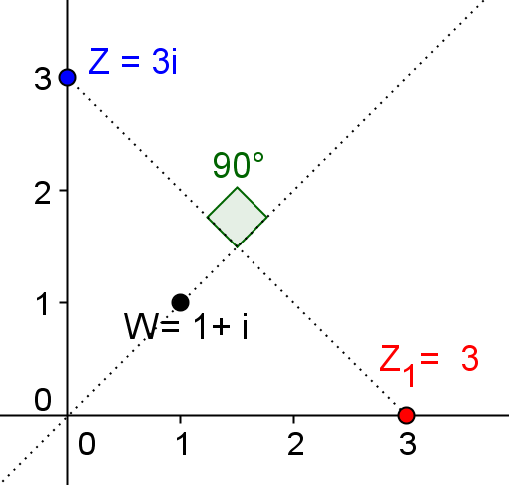

- Describe the geometric effect of each transformation function on $z$ where $z$, $w$, and $a$ are complex numbers.
  - $L_{1}\left(z\right)=\frac{z-w}{a}$
$z$ is translated by $w$, rotated by $2π-arg(a)$, and dilated by $\frac{1}{\left|a\right|}$.

  - $L_{2}\left(z\right)=\overline{\left(\frac{z-w}{a}\right)}$
$z$ is translated by $w$, reflected about the real axis, rotated by $2π-arg(a)$, and dilated by $\frac{1}{\left|a\right|}$, and reflected about the real axis.

  - $L_{3}\left(z\right)=a\overline{\left(\frac{z-w}{a}\right)}$
$z$ is translated by $w$, reflected about the real axis, rotated by $2π-arg(a)$ , and dilated by $\frac{1}{\left|a\right|}$, reflected about the real axis, rotated by $arg(a)$, and dilated by $\left|a\right|$.

  - $L_{3}\left(z\right)=a\overline{\left(\frac{z-w}{a}\right)}+w$
$z$ is translated by $w$, reflected about the real axis, rotated by $2π-arg(a)$, and dilated by $\frac{1}{\left|a\right|}$, reflected about the real axis, rotated by $arg(a)$, dilated by $\left|a\right|$, and translated by $w$.

- Verify your answers to Problem 6 if $z=1-i$, $w=2i$, and $a=-1-i$.
  - $L_{1}\left(z\right)=\frac{z-w}{a}$
$\left|z\right|=\sqrt{2}, arg\left(z\right)=\frac{7π}{4},\left|w\right|=2,arg\left(w\right)=π, \left|a\right|=\sqrt{2},arg\left(a\right)=\frac{5π}{4}=3.927$
$\frac{z-w}{a}=\frac{1-i-2i}{-1-i}=\frac{1-3i}{-1-i}=1+2i,\left|\frac{z-w}{a}\right|=\sqrt{5}, arg\left(\frac{z-w}{a}\right)=1.107$ radians.
$z-w=1-3i,\left|z-w\right|=\sqrt{10},arg\left(z-w\right)=5.034$ radians.
$\frac{1}{\left|a\right|}×\left|z-w\right|=\frac{1}{\sqrt{2}}×\sqrt{10}=\sqrt{5}=\left|\frac{z-w}{a}\right|,$
$arg\left(\frac{z-w}{a}\right)=arg\left(z-w\right)+\left(2π-arg\left(a\right)\right)=5.034+2π-3.927=1.107+2π=1.107$ radians.

  - $L_{2}\left(z\right)=\overline{\left(\frac{z-w}{a}\right)}$
$\overline{\left(\frac{z-w}{a}\right)}=\overline{\left(\frac{1-3i}{-1-i}\right)}=\overline{(1+2i)}=1-2i, \left|\overline{\left(\frac{z-w}{a}\right)}\right|=\sqrt{5}, arg\left(\overline{\left(\frac{z-w}{a}\right)}\right)=-1.107$ radians.
$\overline{\left(\frac{1}{\left|a\right|}\right)}×\overline{\left|z-w\right|}=\frac{1}{\sqrt{2}}×\sqrt{10}=\sqrt{5}=\left|\overline{\left(\frac{z-w}{a}\right)}\right|$
$arg\left(\overline{\left(\frac{z-w}{a}\right)}\right)=2π-\left(arg\left(z-w\right)+\left(2π-arg\left(a\right)\right)\right)=2π-5.034-2π+3.927=-1.107$ radians.

  - $L_{3}\left(z\right)=a\overline{\left(\frac{z-w}{a}\right)}$
$a×\overline{\left(\frac{z-w}{a}\right)}=\left(-1-i\right)\overline{\left(\frac{1-3i}{-1-i}\right)}=\left(-1-i\right)\overline{(1+2i)}=\left(-1-i\right)\left(1-2i\right)=-3+i,$
$\left|a×\overline{\left(\frac{z-w}{a}\right)}\right|=\sqrt{10},arg\left(\left(-1-i\right)\overline{\left(\frac{z-w}{a}\right)}\right)=π-0.322=2.820$ radians.
$\left|a\right|×\overline{\left(\frac{1}{\left|a\right|}\right)}×\overline{\left|z-w\right|}=\sqrt{2}×\frac{1}{\sqrt{2}}×\sqrt{10}=\sqrt{10}=\left|\left(-1-i\right)\overline{\left(\frac{z-w}{a}\right)}\right|$
$arg\left(a×\overline{\left(\frac{z-w}{a}\right)}\right)=arg\left(a\right)+\left(arg\left(z-w\right)+\left(2π-arg\left(a\right)\right)\right)$
$=3.927+2π-5.034-2π+3.927=2.280$ radians.

  - $L_{3}\left(z\right)=a\overline{\left(\frac{z-w}{a}\right)}+w$
$a×\overline{\left(\frac{z-w}{a}\right)}+w=\left(-1-i\right)\overline{\left(\frac{1-3i}{-1-i}\right)}+2i=-3+i+2i=-3+3i,$
$\left|a×\overline{\left(\frac{z-w}{a}\right)}+w\right|=3\sqrt{2}, arg\left(\left(-1-i\right)\overline{\left(\frac{z-w}{a}\right)}+w\right)=\frac{3π}{4}=2.356$ radians.
$\left|a×\overline{\left(\frac{z-w}{a}\right)}+w\right|=\left|-3+i+2i\right|=3\sqrt{2}=,$
$arg\left(a×\overline{\left(\frac{z-w}{a}\right)}+w\right)=arg\left(-3+i+2i\right)=arg\left(-3+3i\right)=2.356$ radians.

