Lesson 16: Representing Reflections with Transformations

Student Outcomes
- Students create a sequence of transformations that produce the geometric effect of reflection across a given line through the origin.

Lesson Notes
In this lesson, students apply complex multiplication from Lesson 14 to construct a transformation of the plane that reflects across a given line. So far, we have only looked at linear transformations of the form $L: C→C$by $L\left(z\right)=wz$ for a complex number $w$, and all such linear transformations have the geometric effect of rotation by $\arg{(w)}$ and dilation by $|w|$. In later lessons, when we use matrices to define transformations, we will see that reflection can be represented by a transformation of the form $L\left(\left[\begin{matrix}x \\ y\end{matrix}\right]\right)=A\left[\begin{matrix}x \\ y\end{matrix}\right]$ for a matrix $A$, which better fits the form that we are used to for linear transformations. This lesson relies upon the foundational standards G-CO.A.2, G-CO.A.4, and G.CO.A.5, and strengthens student understanding of N-CN.A.3 and N-CN.B.4. Students may need to be reminded of the following notations for transformations of the plane from Geometry:
- A rotation by $θ$ degrees about the origin is denoted by${ R}_{(0, θ°)}$.
- A reflection across line $l$ is denoted by $r_{l}$.

Classwork
Opening Exercise (6 minutes)
Students should work in pairs or small groups for these exercises. Students did problems identical or nearly identical to parts (a) and (b) in the Problem Set for Lesson 14, and they learned in Lesson 6 that taking the conjugate of $z$ produces the reflection of $z$ across the real axis.
Opening Exercise
  - Find a transformation $R_{(0, 45°)}:C→C$ that rotates a point represented by the complex number $z$ by $45°$ counterclockwise in the coordinate plane, but does not produce a dilation.
$$L(z)=\left(\frac{\sqrt{2}}{2}+i\frac{\sqrt{2}}{2}\right)z$$

  - Find a transformation $R_{\left(0, -45°\right)}:C→C$ that rotates a point represented by the complex number $z$ by $45°$ clockwise in the coordinate plane, but does not produce a dilation.
$$L\left(z\right)=\left(\frac{\sqrt{2}}{2}-i\frac{\sqrt{2}}{2}\right)z$$

  - Find a transformation $r_{x\text{-axis}}:C→C$ that reflects a point represented by the complex number $z$ across the
$x$-axis.
$L\left(z\right)=\overline{z}$, the conjugate of $z$.
Discussion (15 minutes)
This discussion sets up the problem for the day, which is finding a linear transformation that will reflect across a line through the origin. For familiarity and ease of calculation, we will begin with a reflection across the line with equation $y=x$. Students will need to know the results of the Opening Exercise, so be sure to verify that all groups got the correct answers before proceeding with the discussion. The circle with radius $z$ is shown lightly in the figure to help with performing transformations accurately.
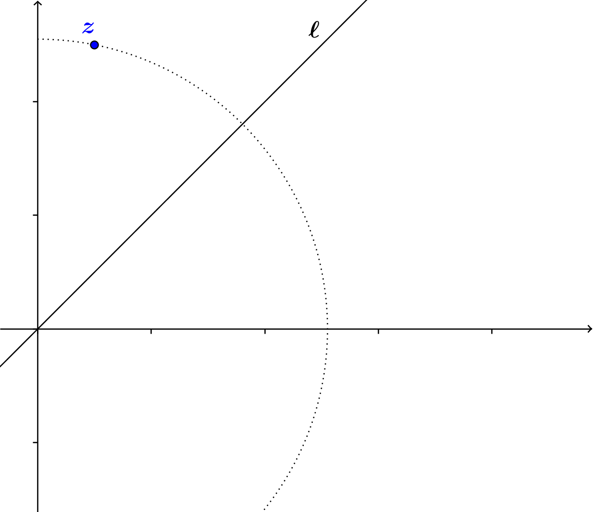
Discussion
We want to find a transformation $r_{l}:C→C$ that reflects a point representing a complex number $z$across the diagonal line $l$ with equation$y=x$.

Recall from Algebra II, Module 3 that the transformation $\left(x,y\right)→(y,x)$ accomplishes this reflection across the diagonal line in the coordinate plane, but we are now looking for a formula that produces this result for the complex number
$x+yi$. If students mention this transformation, praise them for making the connection to past work, and ask them to keep this response in mind for verifying the answer we will get with our new approach. The steps outlined below demonstrate that the reflection across a line other than the $x$-axis or $y$-axis can be accomplished by a sequence of rotations so that the line of reflection aligns with the $x$-axis, reflects across the $x$-axis, and rotates so that the line is back in its original position.
Display or reproduce the image above to guide students through this discussion as they take notes. Ask students to draw a point $r_{l}(z)$ where they think the reflection of $z$ across line $l$ will be. Draw it on your version also. Walk through the sequence of transformations geometrically before introducing the analytical formulas.
Scaffolding:
For struggling students, use transparency sheets to model the sequence of rotating by $-45°$, reflecting across the real axis, then rotating by $45°.$
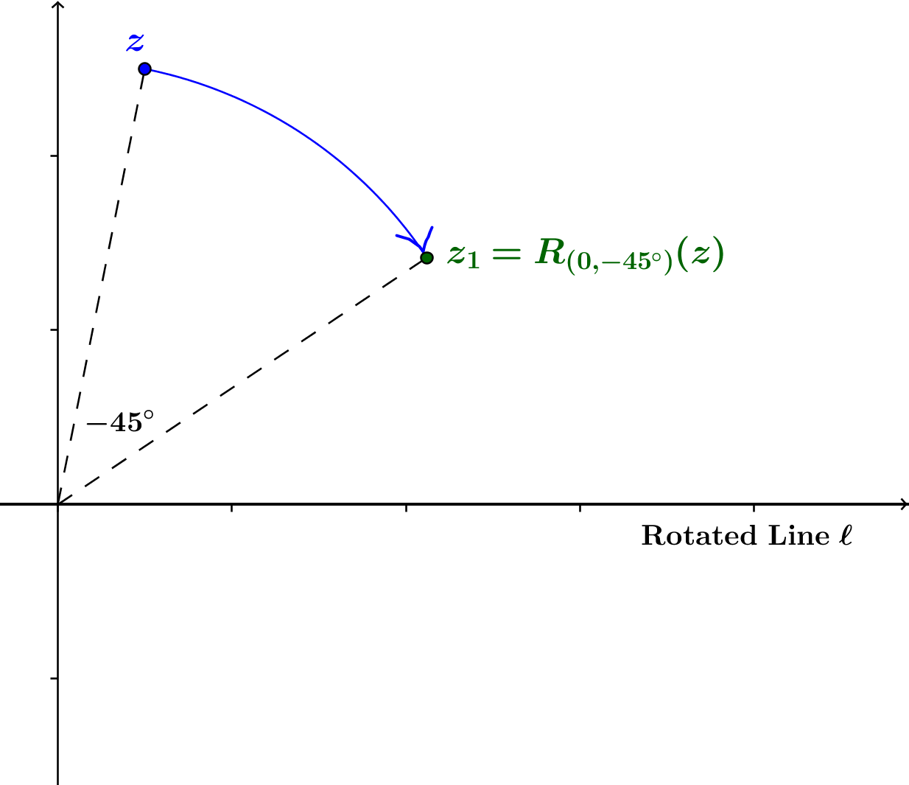
We know how to find transformations that produce the effect of rotating by a certain amount around the origin, dilating by a certain scale factor, and reflecting across the
$x$-axis or the $y$-axis. Which of these transformations will help us to reflect across the diagonal line? Allow students to make suggestions or conjectures.
- How much do we have to rotate around the origin to have line $l$ align with the positive $x$-axis?
  - We need to rotate $-45°$.
Draw the image of $z$ after rotation by $-45°$ about the origin. Label the new point $z_{1}$. Give students a quick minute to draw $z_{1}$ on their version before you display yours.
- Where is the original line $l$ now?
  - It coincides with the positive $x$-axis.

- Good! We know how to reflect across the $x$-axis. Draw the reflection of point $z_{1}$ across the $x$-axis, and label
it $z_{2}$.
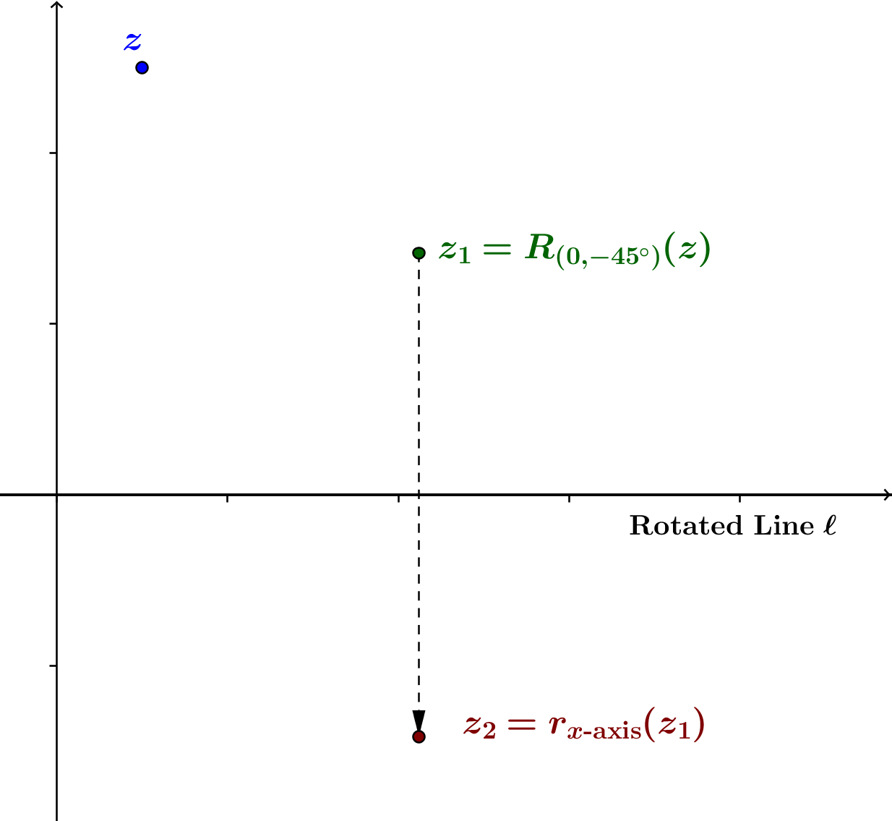

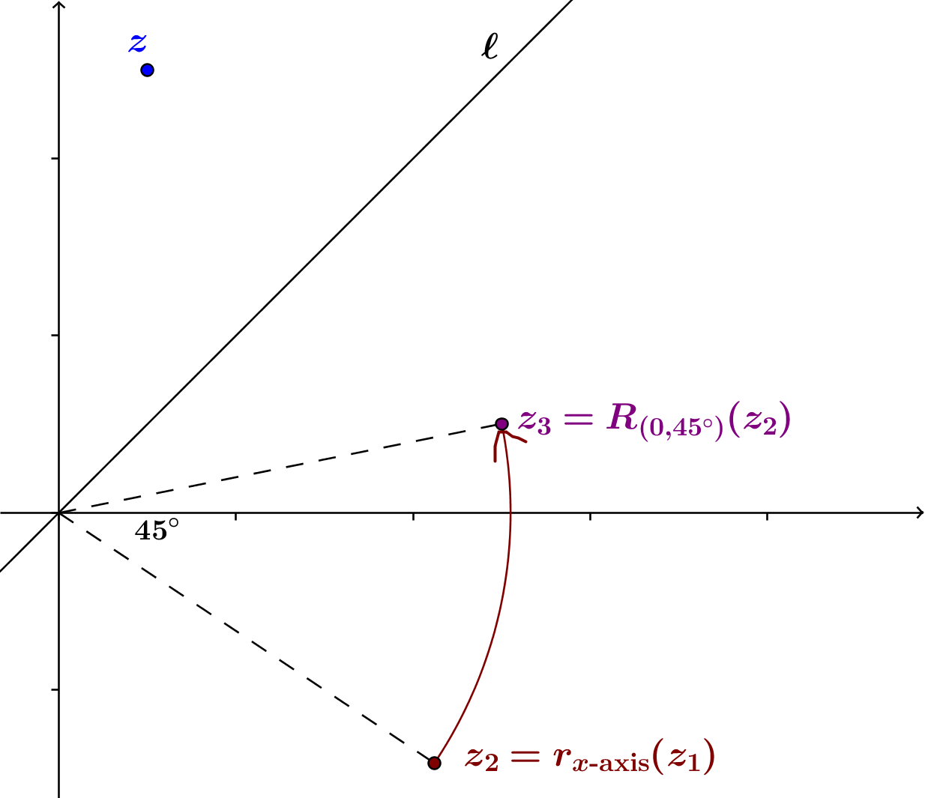
- Now that we have done a reflection, we need to rotate back to where we started. How much do we have to rotate around the origin to put line $l$ back where it originally was?
  - We need to rotate $45°$.
- Draw the image of $z_{2}$ under rotation by $45°$ about the origin. The image should coincide with the original estimate of $r_{l}(z)$.
Now that students have had a chance to think about the geometric steps involved in reflecting $z$ across diagonal line $l$, repeat the process using the formulas for the three transformations.
- What is the transformation that accomplishes rotation by $-45°$? Students answered this question in the Opening Exercise.
  - The transformation is $L\left(z\right)=\left(\frac{\sqrt{2}}{2}-i\frac{\sqrt{2}}{2}\right)z$.
- We will refer to this transformation using the notation we used in Geometry. We can also factor out the constant $\frac{\sqrt{2}}{2}$: $R_{\left(0,-45°\right)}\left(z\right)=\frac{\sqrt{2}}{2}\left(1-i\right)z$.
- After we rotate the plane so that line $l$ lies along the $x$-axis, we reflect the new point $z$ across the $x$-axis. What is the formula for the transformation $r_{x\text{-axis}}$we use to accomplish the reflection?
  - We use the conjugate of $z$, so we have $r_{x\text{-axis}}\left(z\right)=\overline{z}$.

- Now, we can rotate the plane back to its original position by rotating by $45°$ counterclockwise around the origin. What is the formula for this rotation?
  - From the Opening Exercise, using the notation from Geometry we have $R_{\left(0,45°\right)}\left(z\right)=\frac{\sqrt{2}}{2}\left(1+i\right)z$.
- We then have
$$z_{1}=R_{\left(0,-45°\right)}\left(z\right)=\frac{\sqrt{2}}{2}\left(1-i\right)z \\ z_{2}=r_{x\text{-axis}}\left(z_{1}\right)=\overline{z_{1}} \\ z_{3}=R_{\left(0,45°\right)}\left(z_{2}\right)=\frac{\sqrt{2}}{2}\left(1+i\right)z_{2}$$
- Putting the formulas together, we have
$$z_{3}= R_{\left(0,45°\right)}\left(z_{2}\right) \\ =R_{\left(0,45°\right)}\left(r_{x\text{-axis}}\left(z_{1}\right)\right) \\ =R_{\left(0,45°\right)}\left(r_{x\text{-axis}}\left(R_{\left(0,-45°\right)}\left(z\right)\right)\right)$$
Stop here before going forward with the analytic equations and ensure that all students understand that this formula means that we are first rotating point $z$by$-45°$ about the origin, then reflecting across the $x$-axis, then rotating by$45°$ about the origin. Remind students that the innermost transformations happen first.
- Applying the formulas, we have
$$z_{3}=R_{\left(0,45°\right)}\left(r_{x\text{-axis}}\left(R_{\left(0,-45°\right)}\left(z\right)\right)\right) \\ =R_{\left(0,45°\right)}\left(r_{x\text{-axis}}\left(\frac{\sqrt{2}}{2}\left(1-i\right)z\right)\right) \\ =R_{\left(0,45°\right)}\left(\overline{\frac{\sqrt{2}}{2}\left(1-i\right)z}\right) \\ =R_{\left(0,45°\right)}\left(\overline{\frac{\sqrt{2}}{2}\left(1-i\right)}⋅\overline{z} \right) \\ =R_{\left(0,45°\right)}\left(\frac{\sqrt{2}}{2}\left(1+i\right)\overline{z}\right) \\ =\frac{\sqrt{2}}{2}\left(1+i\right)\left(\frac{\sqrt{2}}{2}\left(1+i\right)\overline{z}\right) \\ =\frac{1}{2}{\left(1+i\right)}^{2}\overline{z} \\ =i\overline{z}$$Then, the transformation $r_{l}(z)=i\overline{z}$ has the geometric effect of reflection across the diagonal line $l$with equation$y=x$.

Exercises 1–2 (5 minutes)
Exercises
- The number $z$in the figure used in the discussion above is the complex number $1+5i$. Compute $r_{l}(1+5i)$ and plot it below.
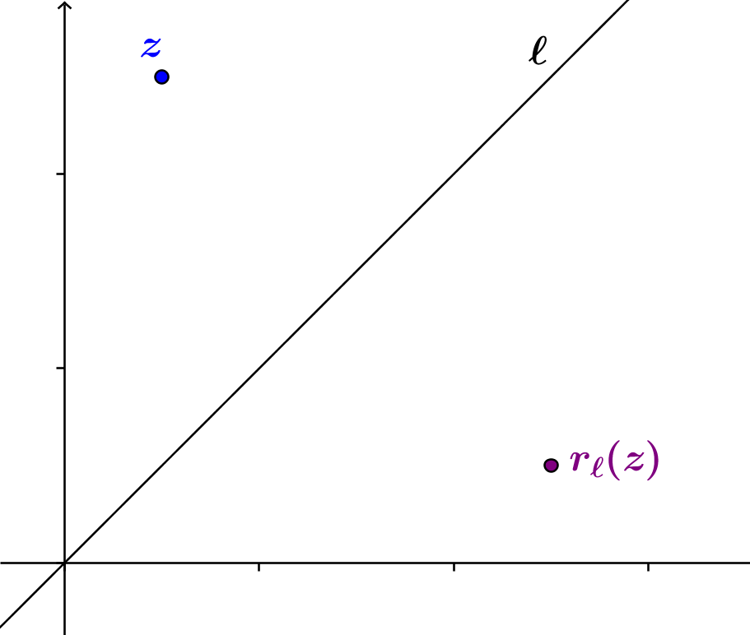

- We know from previous courses that the reflection of a point $\left(x,y\right)$ across the line with equation$y=x$is the point $\left(y,x\right)$. Does this agree with our result from the previous discussion?
Yes. We can represent the point $\left(x,y\right)$ by $z=x+iy$. Then
$$r_{l}\left(z\right)=r_{l}\left(x+iy\right) \\ = i \overline{\left(x+iy\right)} \\ =i \left(x-iy\right) \\ =y+ix,$$
which corresponds to the point $\left(y,x\right)$.

Exercise 3 (10 minutes)
In this Exercise, students repeat the previous calculations to find an analytic formula for reflection across the line $l$that makes a$60°$ angle with the positive $x$-axis.
Scaffolding:
Ask struggling students the following questions to guide their work in Exercise 3.
- What transformation will rotate line $l$so that it coincides with the$x$-axis?
  - $-60°$
- What transformation will reflect across the $x$-axis?
  - The conjugate
- What transformation will rotate the $x$-axis back to the original position of line $l$?
  - $60°$
- We now want to find a formula for the transformation of reflection across the line $l$ that makes a $60°$ angle with the positive $x$-axis. Find formulas to represent each component of the transformation, and use them to find one formula that represents the overall transformation.
The transformation consists of: rotating line $l$so that it coincides with the$x$-axis; reflecting across the $x$-axis; and rotating the $x$-axis back to the original position of line $l$. The components of the transformation can be represented by these formulas:
$$z_{1}=R_{\left(0,-60°\right)}\left(z\right)=\left(\frac{1}{2}-\frac{\sqrt{3}}{2}i\right)z \\ z_{2}=r_{x\text{-axis}}\left(z_{1}\right)=\overline{z_{1}} \\ z_{3}=R_{\left(0,60°\right)}\left(z_{2}\right)=\left(\frac{1}{2}+\frac{\sqrt{3}}{2}i\right)z_{2}$$
Putting the formulas together, we have
$$z_{3}= R_{\left(0,60°\right)}\left(z_{2}\right) \\ =R_{\left(0,60°\right)}\left(r_{x\text{-axis}}\left(z_{1}\right)\right) \\ =R_{\left(0,60°\right)}\left(r_{x\text{-axis}}\left(R_{\left(0,-60°\right)}\left(z\right)\right)\right)$$
Stop here before going forward with the analytic equations and ensure that all students understand that this formula means that we are first rotating point $z$by$-60°$ about the origin, then reflecting across the $x$-axis, then rotating by$60°$ about the origin. Remind students that the innermost transformations happen first.
Scaffolding:
Have early finishers repeat Exercise 3 for the line $l$ that makes a $-30°$ angle with the positive $x$-axis.
Applying the formulas, we have
$$r_{l}(z)=R_{\left(0,60°\right)}\left(r_{x\text{-axis}}\left(R_{\left(0,-60°\right)}\left(z\right)\right)\right) \\ =R_{\left(0,60°\right)}\left(r_{x\text{-axis}}\left(\left(\frac{1}{2}-\frac{\sqrt{3}}{2}i\right)z\right)\right) \\ =R_{\left(0,60°\right)}\left(\overline{\left(\frac{1}{2}-\frac{\sqrt{3}}{2}i\right)z}\right) \\ =R_{\left(0,60°\right)}\left(\overline{\left(\frac{1}{2}-\frac{\sqrt{3}}{2}i\right)}⋅\overline{z} \right) \\ =R_{\left(0,60°\right)}\left(\left(\frac{1}{2}+\frac{\sqrt{3}}{2}i\right)\overline{z}\right) \\ =\left(\frac{1}{2}+\frac{\sqrt{3}}{2}i\right)\left(\left(\frac{1}{2}+\frac{\sqrt{3}}{2}i\right)\overline{z}\right) \\ =\left(-\frac{1}{2}+\frac{\sqrt{3}}{2}i\right)\overline{z}$$Then, the transformation $r_{l}(z)=\left(-\frac{1}{2}+\frac{\sqrt{3}}{2}i\right)\overline{z}$ has the geometric effect of reflection across the line $l$that makes a $60°$ angle with the positive $x$-axis.

Closing (4 minutes)
Ask students to write in their journal or notebook to explain the sequence of transformation that will produce reflection across a line $l$ through the origin that contains the terminal ray of a rotation of the$x$-axis by $θ$. Key points are summarized in the box below.
Lesson Summary
Let $l$ be a line through the origin that contains the terminal ray of a rotation of the $x$-axis by $θ$. Then reflection across line $l$ can be done by the following sequence of transformations:
- Rotation by $-θ$ about the origin.
- Reflection across the $x$-axis.
- Rotation by $θ$ about the origin.

Exit Ticket (5 minutes)

Name Date
Lesson 16: Representing Reflections with Transformations

Exit Ticket

Explain the process used in the lesson to locate the reflection of a point $z$ across the diagonal line with equation $y=x$. Include figures in your explanation.

Exit Ticket Sample Solutions

Explain the process used in the lesson to locate the reflection of a point $z$ across the diagonal line with equation $y=x$. Include figures in your explanation.
First, we rotated the point $z$by $-45°$ to align the diagonal line with equation $y=x$ with the $x$-axis to get a new point $z_{1}$.
Then, we reflected the point $z_{1}$ across the real axis to find point $z_{2}$.
Finally, we rotated everything back by $45°$ to find the final point $z_{3}=r_{l}\left(z\right)$.
Problem Set Sample Solutions

- Find a formula for the transformation of reflection across the line $l$ with equation $y=-x$.
$z_{1}=R_{\left(0, {-135}^{°}\right)}\left(z\right)=\left(-\frac{\sqrt{2}}{2}-\frac{\sqrt{2}}{2}i\right)z$, if students cannot see it, you can say that
$R_{\left(0, {-135}^{°}\right)}\left(z\right)=R_{\left(0, {-45}^{°}\right)}\left(R_{\left(0, {-45}^{°}\right)}\left(R_{\left(0, {-45}^{°}\right)}z\right)\right)={\left(\frac{\sqrt{2}}{2}-\frac{\sqrt{2}}{2}i\right)}^{3}z=\left(-\frac{\sqrt{2}}{2}-\frac{\sqrt{2}}{2}i\right)z$.
$z_{2}=r_{x-axis}\left(z_{1}\right)=\overline{\left(-\frac{\sqrt{2}}{2}-\frac{\sqrt{2}}{2}i\right)z}=\left( \overline{-\frac{\sqrt{2}}{2}-\frac{\sqrt{2}}{2}i} \right)\overline{z}=\left(-\frac{\sqrt{2}}{2}+\frac{\sqrt{2}}{2}i\right)\overline{z}$
$z_{3}=R_{\left(0, {135}^{°}\right)}\left(z_{2}\right)=\left(-\frac{\sqrt{2}}{2}+\frac{\sqrt{2}}{2}i\right)\left(z_{2}\right)$
$$z_{3}=R_{\left(0, {135}^{°}\right)}\left(r_{x-axis}\left(z_{1}\right)\right)=R_{\left(0, {135}^{°}\right)}\left(r_{x-axis}\left(R_{\left(0, {-145}^{°}\right)}\left(z\right)\right)\right)=R_{\left(0, {135}^{°}\right)}\left(r_{x-axis}\left(\left(-\frac{\sqrt{2}}{2}-\frac{\sqrt{2}}{2}i\right)z\right)\right) \\ =R_{\left(0, {135}^{°}\right)}\left( \overline{\left(-\frac{\sqrt{2}}{2}-\frac{\sqrt{2}}{2}i\right)z} \right)=R_{\left(0, {135}^{°}\right)}\left(\left(-\frac{\sqrt{2}}{2}+\frac{\sqrt{2}}{2}i\right)\overline{z}\right)=\left(-\frac{\sqrt{2}}{2}+\frac{\sqrt{2}}{2}i\right)\left(-\frac{\sqrt{2}}{2}+\frac{\sqrt{2}}{2}i\right)\overline{z}=-i\overline{z}$$

- Find the formula for the sequence of transformations comprising reflection across the line with equation $y=x$ and then rotation by $180°$ about the origin.
$z_{1}=R_{\left(0, {-45}^{°}\right)}\left(z\right)=\left(\frac{\sqrt{2}}{2}-\frac{\sqrt{2}}{2}i\right)z$
$z_{2}=r_{x-axis}\left(z_{1}\right)=\overline{\left(\frac{\sqrt{2}}{2}-\frac{\sqrt{2}}{2}i\right)z}=\left( \overline{\frac{\sqrt{2}}{2}-\frac{\sqrt{2}}{2}i} \right)\overline{z}=\left(\frac{\sqrt{2}}{2}+\frac{\sqrt{2}}{2}i\right)\overline{z}$
$z_{3}=R_{\left(0, {45}^{°}\right)}\left(z_{2}\right)=\left(\frac{\sqrt{2}}{2}+\frac{\sqrt{2}}{2}i\right)\left(z_{2}\right)$
$z_{3}=R_{\left(0, {45}^{°}\right)}\left(z_{2}\right)=\left(\frac{\sqrt{2}}{2}+\frac{\sqrt{2}}{2}i\right)\left(z_{2}\right)=\left(\frac{\sqrt{2}}{2}+\frac{\sqrt{2}}{2}i\right)\left(\frac{\sqrt{2}}{2}+\frac{\sqrt{2}}{2}i\right)\overline{z}=i\overline{z}$
$z_{4}=-z_{3}=-i\overline{z}$

- Compare your answers to Problems 1 and 2. Explain what you find.
They have the same answer/formula that will produce the same transformation of $z$.

- Find a formula for the transformation of reflection across the line $l$ that makes a $-30°$ angle with the positive
$x$-axis.
$$z_{1}=R_{\left(0, {30}^{°}\right)}\left(z\right)=\left(\frac{\sqrt{3}}{2}+\frac{ 1 }{ 2 }i\right)z \\ z_{2}=r_{x-axis}\left(z_{1}\right)=\overline{\left(\frac{\sqrt{3}}{2}+\frac{ 1 }{ 2 }i\right)z}=\left( \overline{\frac{\sqrt{3}}{2}+\frac{ 1 }{ 2 }i} \right)\overline{z}=\left(\frac{\sqrt{3}}{2}-\frac{ 1 }{ 2 }i\right)\overline{z} \\ z_{3}=R_{\left(0, {-30}^{°}\right)}\left(z_{2}\right)=\left(\frac{\sqrt{3}}{2}-\frac{ 1 }{2}i\right)\left(z_{2}\right) \\ z_{3}=R_{\left(0, {-30}^{°}\right)}\left(z_{2}\right)=\left(\frac{\sqrt{3}}{2}-\frac{ 1 }{2}i\right)\left(z_{2}\right)=\left(\frac{\sqrt{3}}{2}-\frac{ 1 }{2}i\right)\left(\frac{\sqrt{3}}{2}-\frac{ 1 }{ 2 }i\right)\overline{z}=(\frac{ 1 }{2}-\frac{\sqrt{3}}{2}i)\overline{z}$$

- Max observed that when reflecting a complex number, $z=a+bi$ about the line $y=x$, that $a$ and $b$ are reversed, which is similar to how we learned to find an inverse function. Will Max’s observation also be true when the line $y=-x$ is used, where $a=-b$ and $=-a$ ? Give an example to show his assumption is either correct or incorrect.
Yes. To reflect a complex number $z=a+bi$ about the line $y=-x$, we need to do $R_{0,-{135}^{°}}, r_{x-axis}$, and then $R_{0,{135}^{°}}$, which will produce the answer to be $z=b+ai$.
The examples vary. This example will work: $z=1+i$.
$z=a+bi$
$$z_{3}=R_{0,{135}^{°}}(r_{x-axis}\left(R_{0,-{135}^{°}}\left(z\right)\right)=R_{0,{135}^{°}}(r_{x-axis}\left(\left(-\frac{\sqrt{2}}{2}-\frac{\sqrt{2}}{2}i\right)z\right)=R_{0,{135}^{°}}\left(\frac{\sqrt{2}}{2}\overline{\left(-1-i\right)z}\right) \\ =R_{0,{135}^{°}}\left(\frac{\sqrt{2}}{2}\left(-1+i\right)\overline{z}\right)=\frac{\sqrt{2}}{2}\left(-1+i\right)\frac{\sqrt{2}}{2}\left(-1+i\right)\overline{z}=\frac{2}{4}\left(-2i\right)\overline{z}=-i\overline{z}=-i\left(a+bi\right)=b-a$$$z=1+i, z_{3}=-i\left(1-i\right)=-1-i$
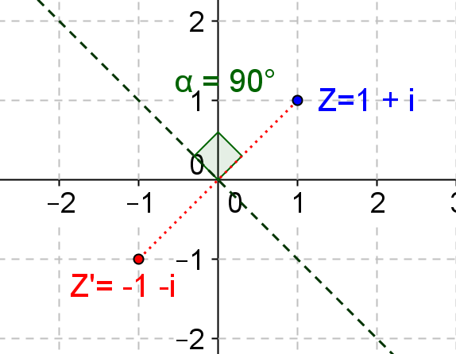

- For reflecting a complex number, $z=a+bi$ about the line $y=2x$, will Max’s idea work if he makes $b=2a$ and $a=\frac{b}{2}$? Use $z=1+4i$ as an example to show whether or not it works.
No, it will not work based on the example shown. $z_{1}=\frac{b}{2}+2ai=\frac{4}{2}+2×1i=2+2i$ . Since the angle $a≠90°$, this is not a reflection.
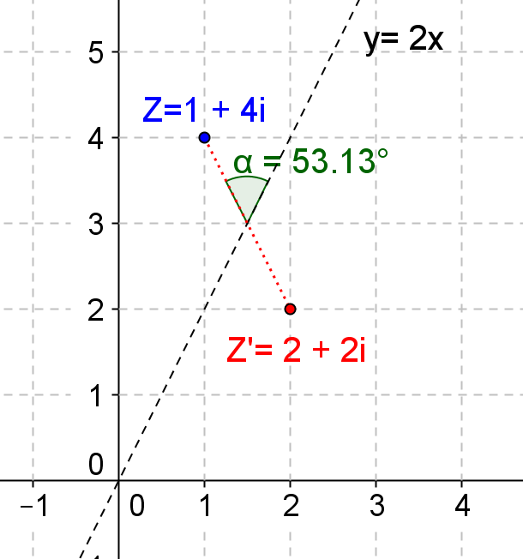

- What would the formula look like if you want to reflect a complex number about the line $y=mx$, where $m>0$?
For reflecting a complex number or a point about the line going through the origin, we need to know the angle of the line with respect to the positive $x$-axis to do rotations. So we can use the slope of the line to find the angle that we need to rotate, which is $arctan(m)$. Now we can come up with a general formula that can be applied onto reflecting about the line $y=mx$, where $m>0$.
$z_{3}=R_{0,arctan(m)}(r_{x-axis}\left(R_{0,arctan(-m)}\left(z\right)\right)$,
Where $R_{0,arctan(-m)}=cos\left(arctan\left(-m\right)\right)+i∙sin\left(arctan\left(-m\right)\right)$
$R_{0,arctan(m)}=cos\left(arctan\left(m\right)\right)+i∙sin\left(arctan\left(m\right)\right)$

