Lesson 16: Representing Reflections with Transformations

Classwork
Opening Exercise
  - Find a transformation $R_{(0, 45°)}:C→C$ that rotates a point represented by the complex number $z$ by $45°$ counterclockwise in the coordinate plane, but does not produce a dilation.

  - Find a transformation $R_{\left(0, -45°\right)}:C→C$ that rotates a point represented by the complex number $z$ by $45°$ clockwise in the coordinate plane, but does not produce a dilation.

  - Find a transformation $r_{x\text{-axis}}:C→C$ that reflects a point represented by the complex number $z$ across the
$x$-axis.

Discussion
We want to find a transformation $r_{l}:C→C$ that reflects a point representing a complex number $z$across the diagonal line $l$ with equation$y=x$.
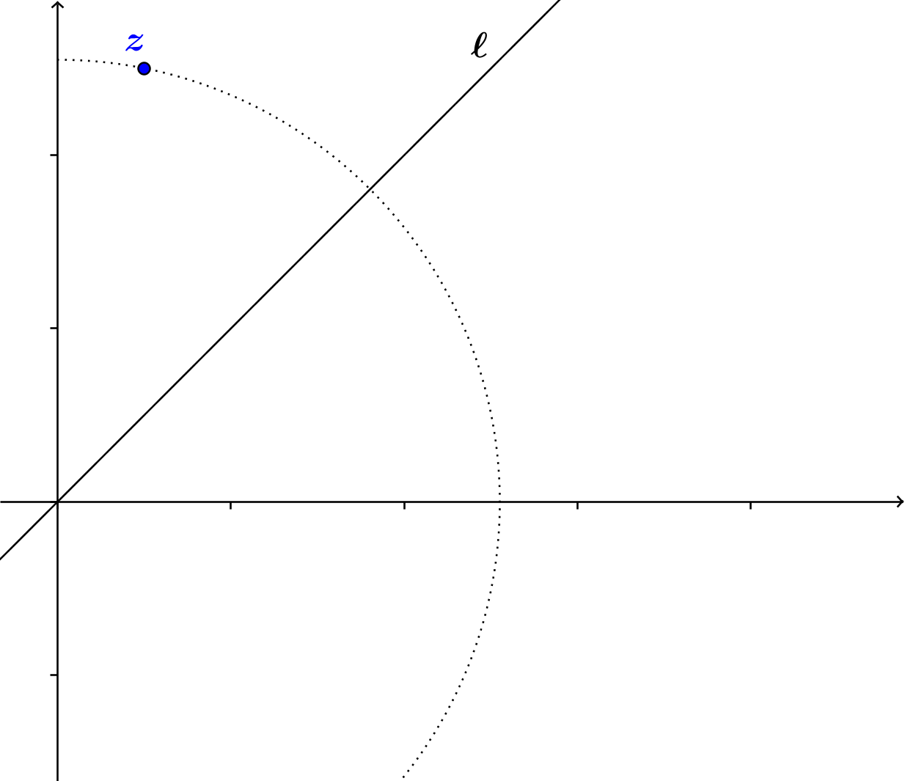

Exercises
- The number $z$in the figure used in the discussion above is the complex number $1+5i$. Compute $r_{l}(1+5i)$ and plot it below.

- We know from previous courses that the reflection of a point $\left(x,y\right)$ across the line with equation$y=x$is the point $\left(y,x\right)$. Does this agree with our result from the previous discussion?

- We now want to find a formula for the transformation of reflection across the line $l$ that makes a $60°$ angle with the positive $x$-axis. Find formulas to represent each component of the transformation, and use them to find one formula that represents the overall transformation.

Lesson Summary
Let $l$ be a line through the origin that contains the terminal ray of a rotation of the $x$-axis by $θ$. Then reflection across line $l$ can be done by the following sequence of transformations:
- Rotation by $-θ$ about the origin.
- Reflection across the $x$-axis.
- Rotation by $θ$ about the origin.

Problem Set

- Find a formula for the transformation of reflection across the line $l$ with equation $y=-x$.

- Find the formula for the sequence of transformations comprising reflection across the line with equation $y=x$ and then rotation by $180°$ about the origin.

- Compare your answers to Problems 1 and 2. Explain what you find.

- Find a formula for the transformation of reflection across the line $l$ that makes a $-30°$ angle with the positive $x$-axis.

- Max observed that when reflecting a complex number, $z=a+bi$ about the line $y=x$, that $a$ and $b$ are reversed, which is similar to how we learned to find an inverse function. Will Max’s observation also be true when the line
$y=-x$ is used, where $a=-b$ and $=-a$ ? Give an example to show his assumption is either correct or incorrect.

- For reflecting a complex number, $z=a+bi$ about the line $y=2x$, will Max’s idea work if he makes $b=2a$ and $a=\frac{b}{2}$? Use $z=1+4i$ as an example to show whether or not it works.

- What would the formula look like if you want to reflect a complex number about the line $y=mx$, where $m>0$?

