Lesson 15: Justifying the Geometric Effect of Complex Multiplication

Student Outcomes
- Students understand why the geometric transformation effect of the linear transformation $L\left(z\right)=wz$ is dilation by $|w|$ and rotation by the argument of $w$.

Lesson Notes (optional)
In Lesson 13, students observed that the transformation $L(z)=(3+4i)z$ has the geometric effect of a rotation by the argument of $3+4i$ and a dilation by the modulus $\left|3+4i\right|=5$. In this lesson, we generalize this result to a linear transformation $L\left(z\right)=wz$ for a complex number $w$, using the geometric representation of a complex number as a point in the complex plane. However, before they begin thinking about the transformation $L$, students first need to represent multiplication of complex numbers geometrically on the complex plane (N-CN.B.5), so that is where this lesson begins.
This lesson covers one of nine cases for the geometric position of the complex scalar $w$in the coordinate plane, and the remaining cases are carefully scaffolded in the Problem Set. Consider extending this to a two-day lesson, and having students work in groups on these remaining cases during the second day of class. You might choose to have groups present the remaining eight cases to the rest of the class.

Classwork
Opening Exercise (8 minutes)
In the Opening Exercise, students review complex multiplication and consider it geometrically to justify the geometric effect of a linear transformation $L\left(z\right)=(a+bi)z$ discovered in Lesson 13.

Opening Exercise
For each exercise below, compute the product $wz$. Then, plot the complex numbers $z$, $w$, and $wz$ on the axes provided.
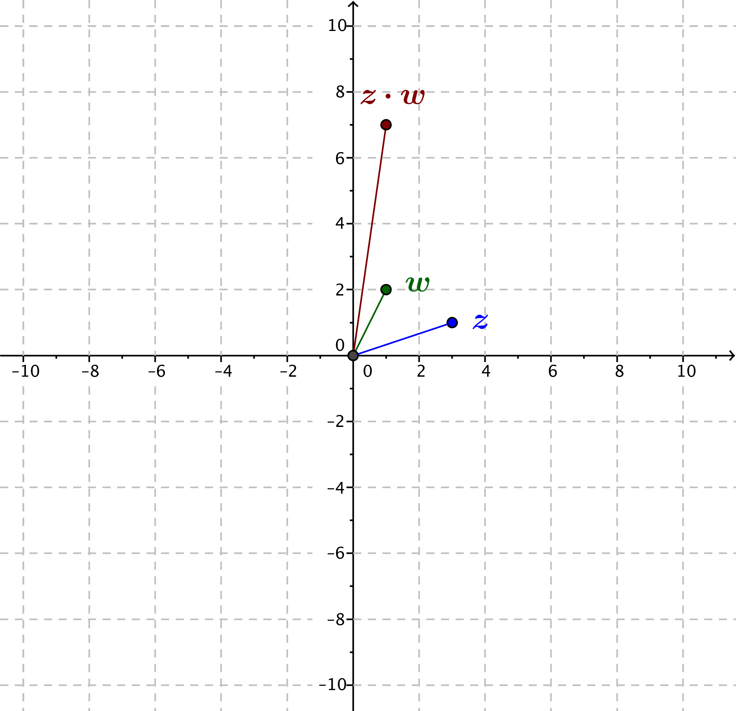
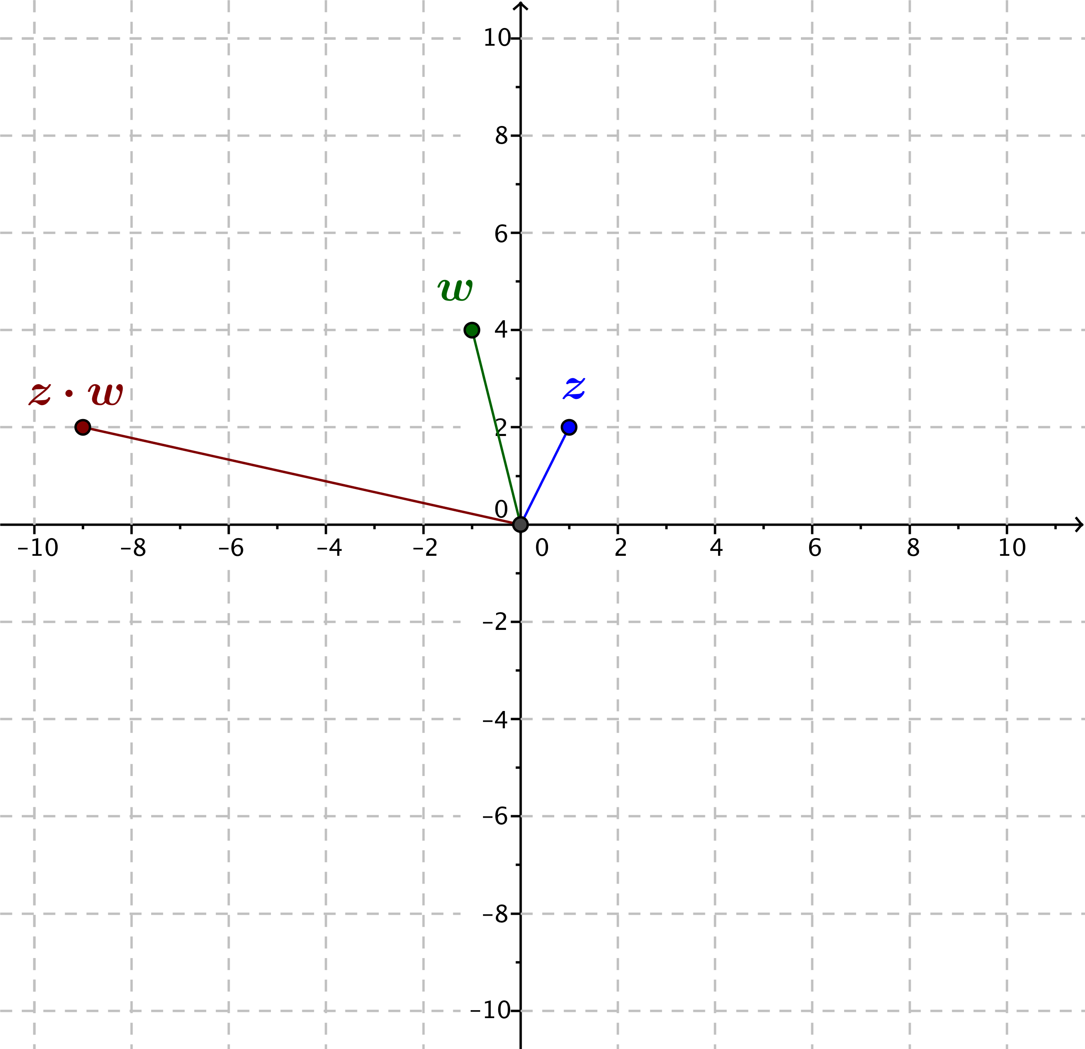
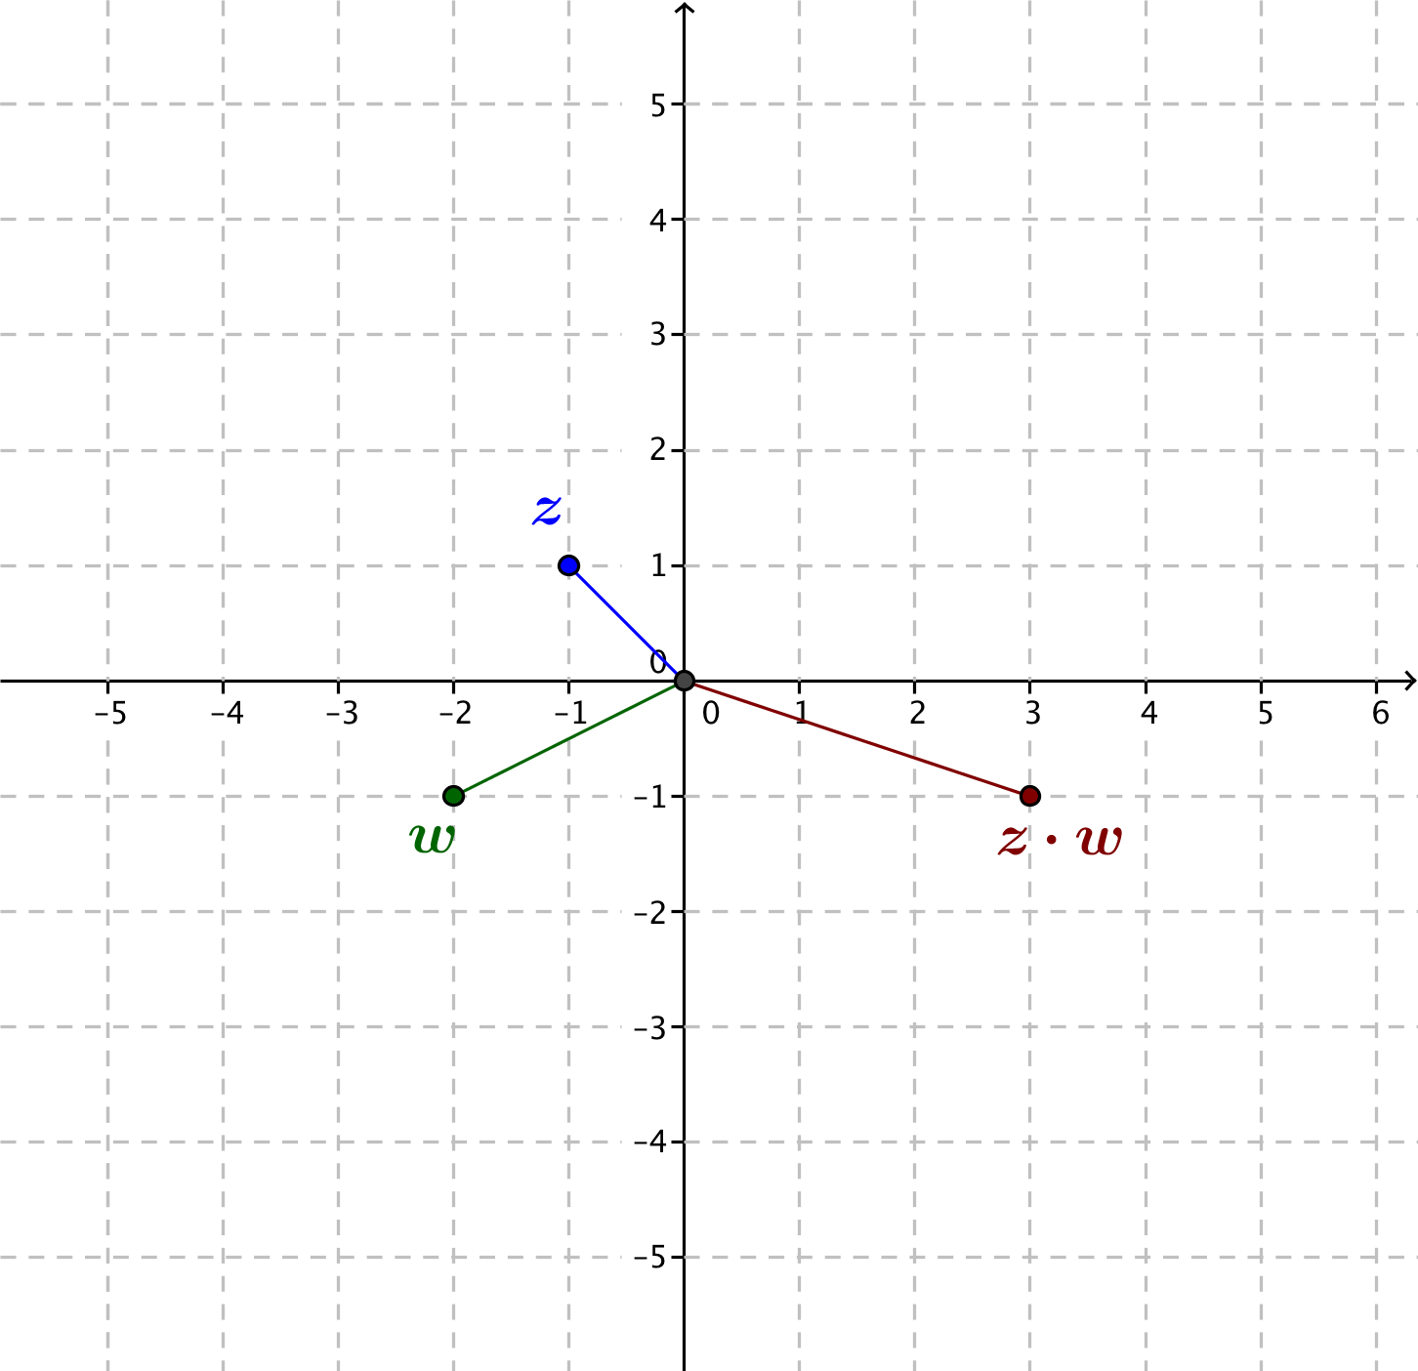
  - $z=3+i$, $w=1+2i$
$$wz=\left(3+i\right)\left(1+2i\right) \\ =3+6i+i+2i^{2} \\ =3-2+7i \\ =1+7i$$

  - $z=1+2i$, $w=-1+4i$
$$wz=\left(1+2i\right)\left(-1+4i\right) \\ =-1+4i-2i+8i^{2} \\ =-1-8+2i \\ =-9+2i$$

  - $z=-1+i$, $w=-2-i$
$$wz=\left(-1+i\right)\left(-2-i\right) \\ =2-2i+i-i^{2} \\ =2+1-i \\ =3-i$$

  - For each part (a), (b), and (c), draw line segments connecting each point $z$, $w$ and $wz$ to the origin. Determine a relationship between the arguments of the complex numbers $z$, $w$, and $wz$.
MP.8
It appears that the argument of $wz$ is the sum of the arguments of $z$ and $w$.

Discussion (5 minutes)
This discussion outlines the point of the lesson. We are claiming that the geometric effect of the linear transformation $L(z) = wz$ for complex numbers $w$ is twofold: a dilation by $|w|$ and a rotation by the argument of $w$. The teacher will then lead students through the justification for why these observations hold in every case. The observation was made in Lesson 13 using the particular examples $L_{1}\left(z\right)=\left(3+4i\right)z$, $L_{2}\left(z\right)=\left(-3+4i\right)z$, $L_{3}\left(z\right)=\left(-3-4i\right)z$, and
$L_{4}\left(z\right)=(3-4i)z.$ In the lesson itself, we only address the case of $L\left(z\right)=\left(a+bi\right)z$where $a>0$ and $b>0$. The remaining cases are included in the Problem Set.
- At the end of Lesson 13, what did you discover about the geometric effects of the transformations
$L_{1}\left(z\right)=(3+4i)z$, $L_{2}\left(z\right)=\left(-3+4i\right)z$, $L_{3}\left(z\right)=\left(-3-4i\right)z$, and $L_{4}\left(z\right)=\left(3-4i\right)z$?
  - These transformations had the geometric effect of dilation by $\left|3+4i\right|=5$ and rotation by the argument of $3+4i$ (or $3-4i$, $-3-4i$, $-3+4i$, as appropriate).
- Can we generalize this result to any linear transformation $L\left(z\right)=wz$, for a complex number $w$? Why or why not?
  - Yes, it seems that we can generalize this. We tried it for $L\left(z\right)=\left(2+i\right)z$ and it worked.
- For a general linear transformation $L\left(z\right)=wz$, what do we need to establish in order to generalize what we discovered in Lesson 13?
MP.6
Students may struggle with stating these ideas using proper mathematical terminology. Allow them time to grapple with the phrasing before providing the correct terminology.
  - We need to show that the modulus of $L(z)$ is equal to the product of the modulus of $w$ and the modulus of $z.$ That is, we need to show that $\left|L\left(z\right)\right|=\left|w\right|⋅\left|z\right|.$
  - We need to show that the angle made by the ray through the origin and $z$is a rotation of the ray through the origin and $L(z)$ by $arg(w)$. That is, we need to show that $\arg\left(L\left(z\right)\right)=\arg\left(w\right)+\arg\left(z\right)$.

Exercises 1–2 (5 minutes)
Exercises
- Let $w=a+bi$ and $z=c+di$.
Scaffolding:
- Allow struggling students to complete these exercises for concrete values of $z$ and $w$, such as $z=4-3i$ and
$w=5+12i$.
- Ask advanced students to think about the relationship between the arguments of $w$ and $z$.
  - Calculate the product $wz$.
$$wz=\left(a+bi\right)\left(c+di\right) \\ =(ac-bd)+\left(ad+bc\right)i$$

  - Calculate the moduli $\left|w\right|$, $\left|z\right|$, and $\left|wz\right|$.
$$\left|w\right|=\sqrt{a^{2}+b^{2}} \\ \left|z\right|=\sqrt{c^{2}+d^{2}} \\ \left|wz\right|=\sqrt{{\left(ac-bd\right)}^{2}+{\left(ad+bc\right)}^{2}} \\ =\sqrt{a^{2}c^{2}-2abcd+b^{2}d^{2}+a^{2}d^{2}+2abcd+b^{2}c^{2}} \\ =\sqrt{a^{2}\left(c^{2}+d^{2}\right)+b^{2}\left(c^{2}+d^{2}\right)} \\ =\sqrt{\left(a^{2}+b^{2}\right)\left(c^{2}+d^{2}\right)}$$

  - What can you conclude about the quantities $|w|$, $|z|$, and $|wz|$?
From part (b) we can see that $\left|wz\right|=\left|w\right|⋅|z|$.

- What does the result of Exercise 1 tell us about the geometric effect of the transformation $L\left(z\right)=wz$?
We see that $\left|L\left(z\right)\right|=\left|wz\right|=\left|w\right|⋅|z|$, so the transformation $L$dilates by a factor of $|w|$.

Discussion (15 minutes)
In this discussion, lead the students through the geometric argument that $arg(wz)$ is the sum of $arg(w)$and $arg(z).$ The images presented here show one of many cases, but the mathematics is not dependent on the case. The remaining cases will be addressed in the Problem Set.
- We have established half of what we need to show today, that is, that one geometric effect of the transformation $L\left(z\right)=wz$ is a dilation by the modulus of $w, |w|$. Now we will demonstrate that another geometric effect of this transformation is a rotation by the argument of $w$.
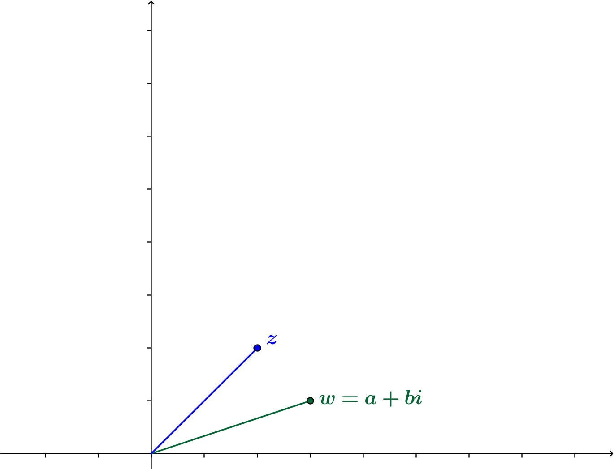
- Let $w=a+bi$, where $a$ and $b$ are real numbers. Representations of the complex numbers $z$and $w$ as points in the coordinate plane are shown below.

- Then $wz=\left(a+bi\right)z=az+\left(bi\right)z$. Recall from Lesson 13 that $az$ is a dilation of $z$ by $a$, and $\left(bi\right)z$ is a dilation of $z$ by $b$ and a rotation by $90°$. Let’s add the points $az$ and $(bi)z$ to the figure.
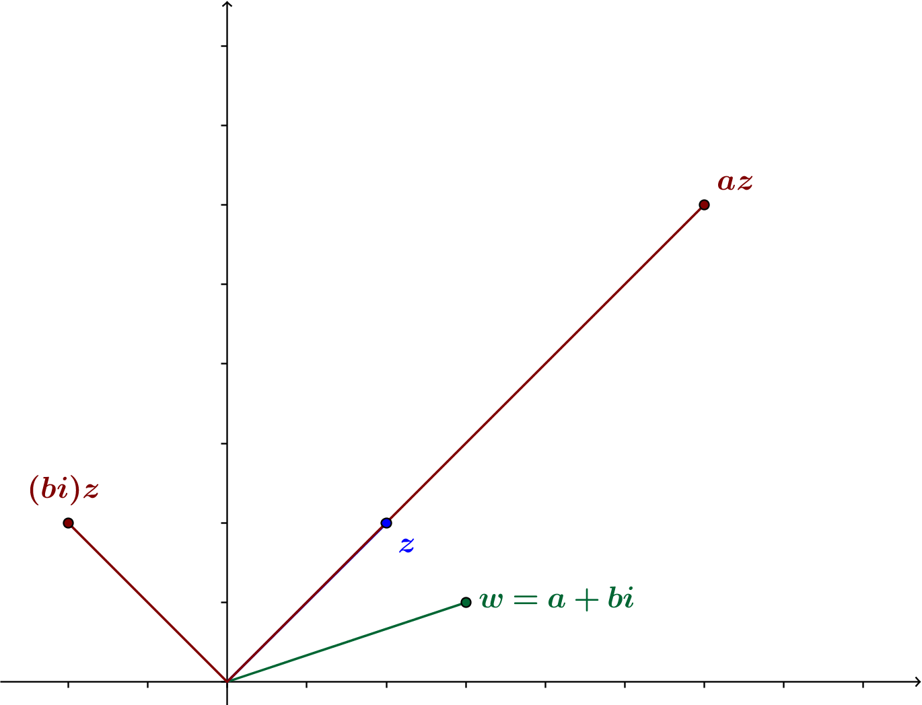

- We know that $wz=az+\left(bi\right)z$, so we can find the location of $wz$ in the plane by adding $az+\left(bi\right)z$ geometrically. (We do not need to find a formula for the coordinates of $wz$.)
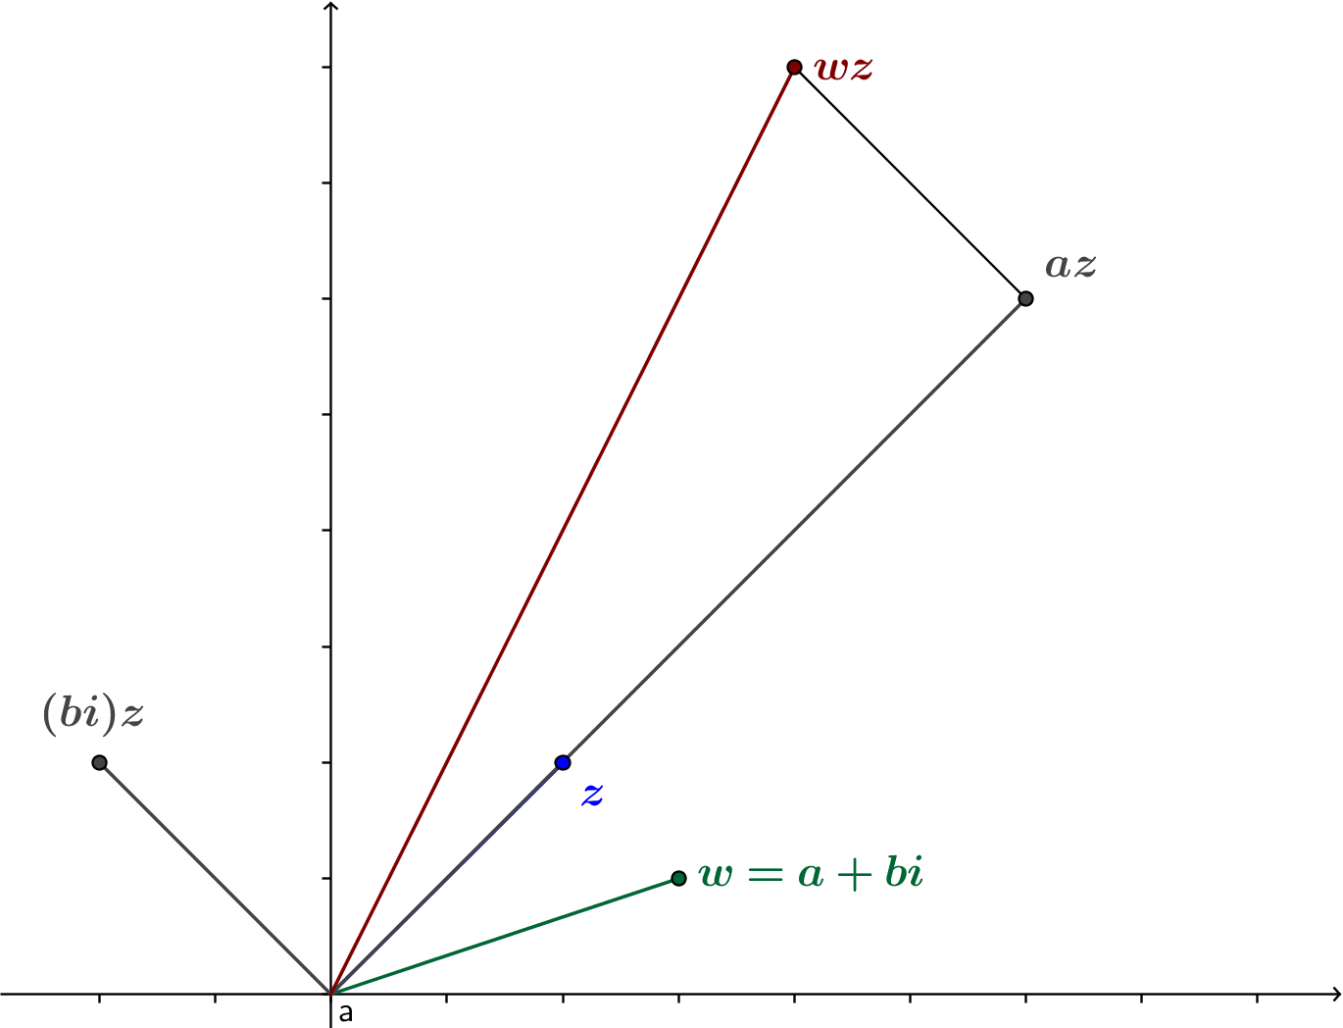

- Now, we can build a triangle with vertices at the origin, $az$ and $wz$. And we can build another triangle with vertices at the origin, $w$ and $a$.
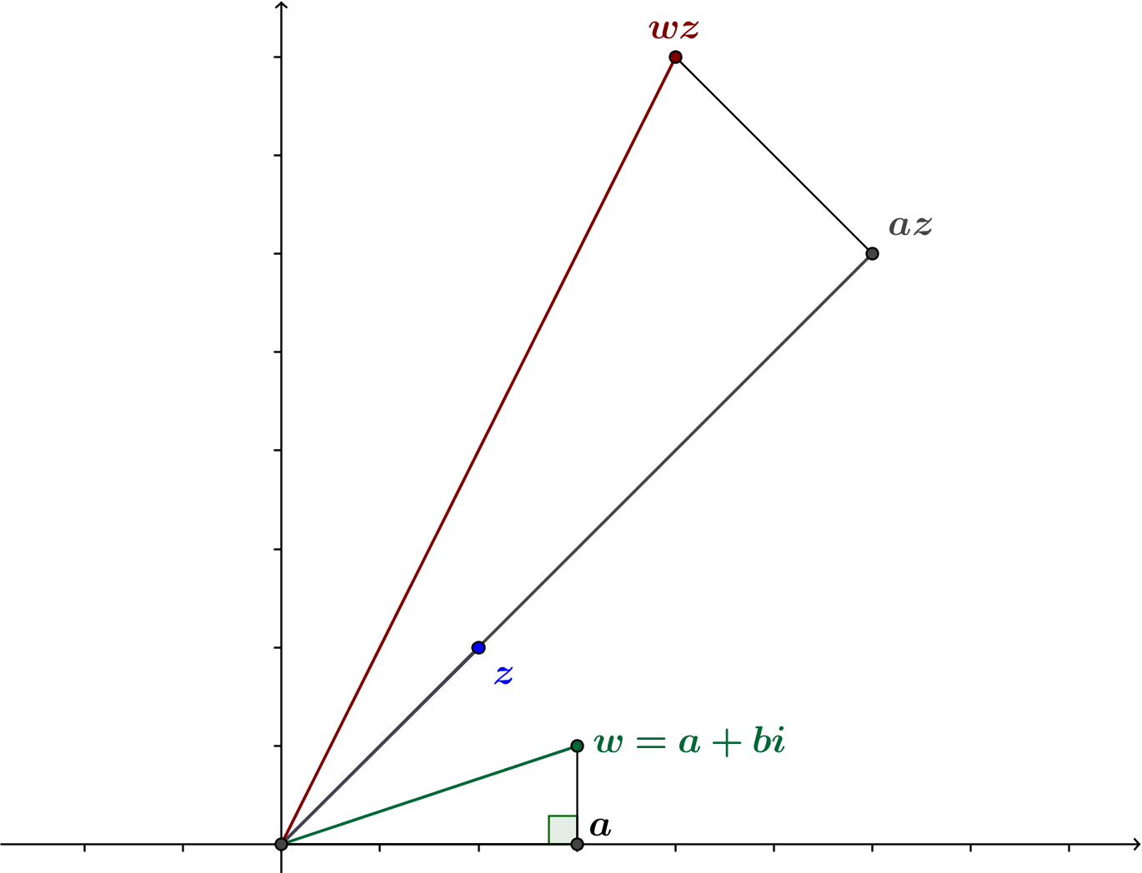

- What do we notice about these two triangles?
  - They appear to both be right triangles. They appear to be similar.
- For simplicity’s sake, let’s label the vertices of these triangles. Denote the origin by $O$, and let $P=w$, $Q=a$, $R=wz$, and $S=az.$
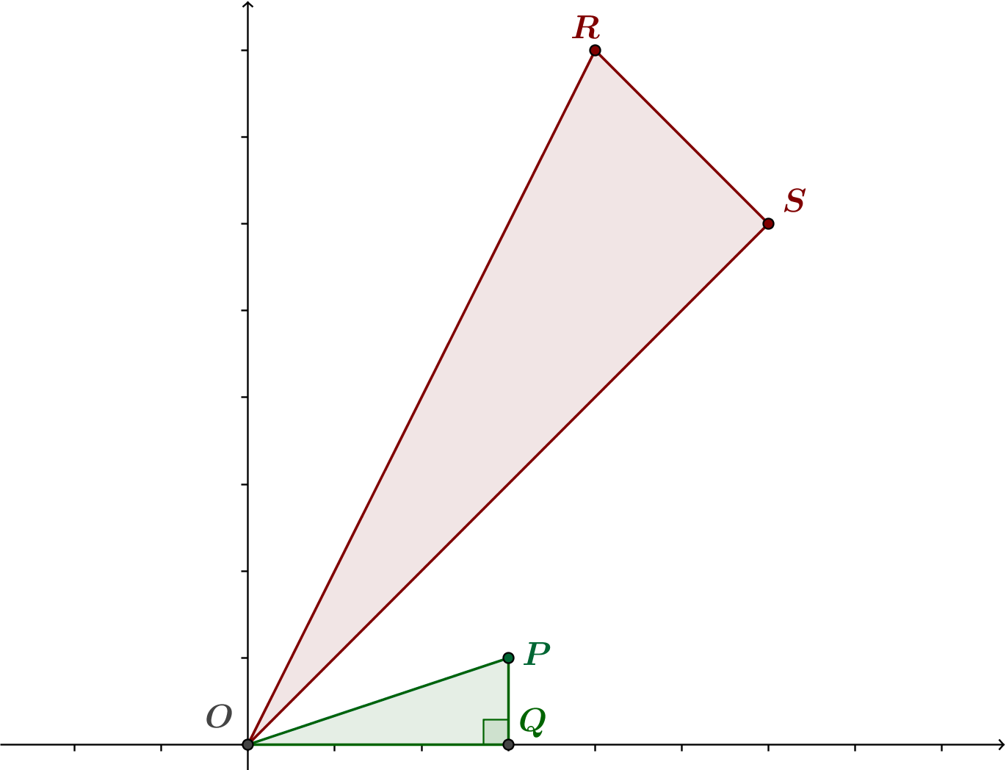

- What are the lengths of the sides of the small triangle, $△OPQ$?
  - We have
$$OP=\left|w\right| \\ OQ=\left|a\right| \\ PQ=\left|b\right|.$$
- What are the lengths of the sides of the large triangle,$△ORS$?
  - We have
$$OR=\left|wz\right|=\left|w\right|⋅\left|z\right| \\ OS=\left|az\right|=\left|a\right|⋅\left|z\right| \\ RS=\left|wz-az\right| \\ =\left|az+\left(bi\right)z-az\right| \\ =\left|\left(bi\right)z\right| \\ =\left|bi\right|⋅\left|z\right| \\ =\left|b\right|⋅\left|i\right|⋅\left|z\right| \\ =\left|b\right|⋅\left|z\right|.$$
- How do the side lengths of $△ORS$and $△OPQ$ relate?
  - We see that
$$\frac{OR}{OP}=\frac{\left|w\right|⋅\left|z\right|}{\left|w\right|}=\left|z\right|, \\ \frac{OS}{OQ}=\frac{\left|a\right|⋅\left|z\right|}{\left|a\right|}=\left|z\right|, \\ \frac{RS}{PQ}=\frac{\left|b\right|⋅\left|z\right|}{\left|b\right|}=\left|z\right|.$$
- What can we conclude about triangles $△ORS$and $△OPQ$?
  - We can conclude that $△ORS∼ △OPQ$ by SSS similarity.
- Now that we know $△ORS∼ △OPQ$, we can conclude that $∠ROS≅∠POQ.$ So, how can we use this angle congruence to help us answer the original question?

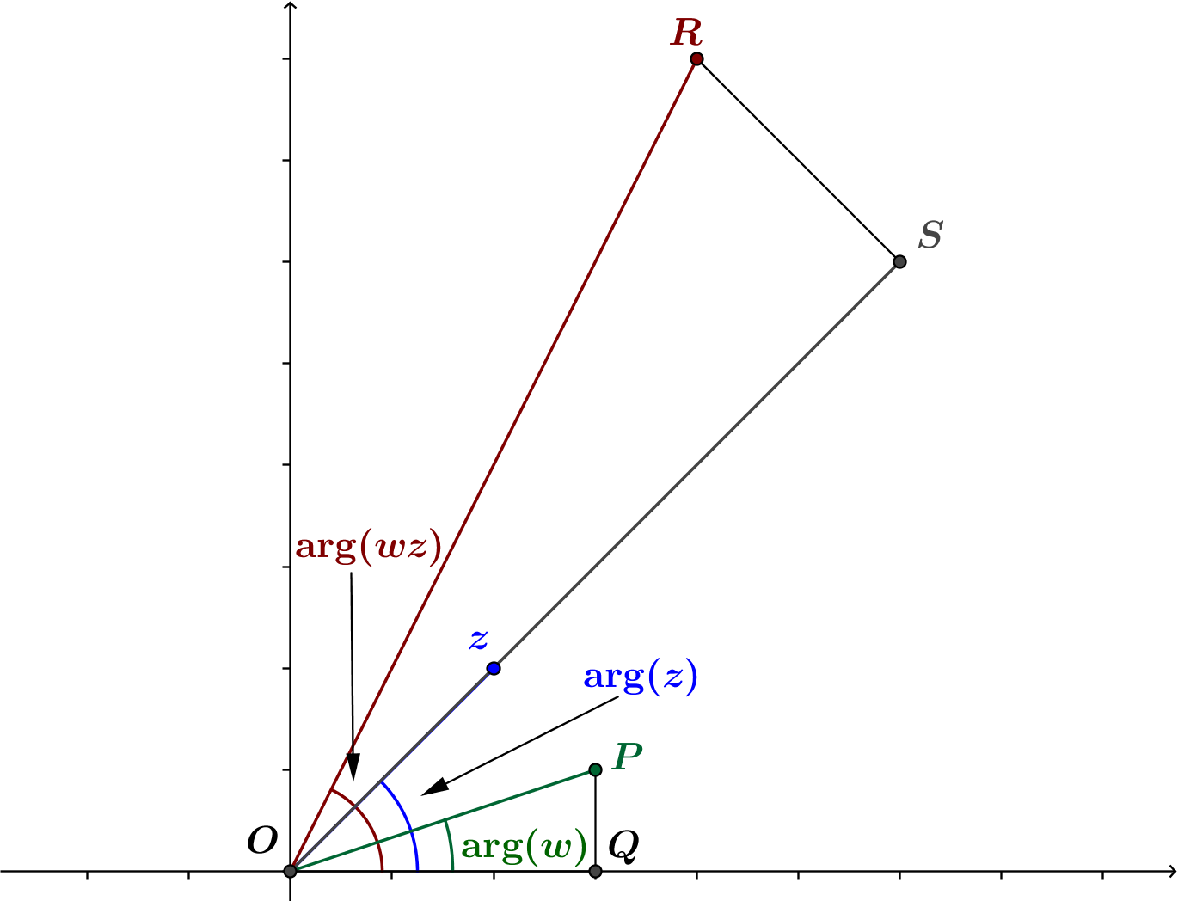
- Where are $\arg\left(z\right)$, $\arg\left(w\right)$, and $\arg\left(wz\right)$ in our diagrams? How do they relate to the angles in the triangles?

  - From the diagram,$\arg\left(w\right)=m\left(∠POQ\right)$, $\arg\left(z\right)=m\left(∠SOQ\right)$ and $\arg\left(wz\right)=m\left(∠ROQ\right).$
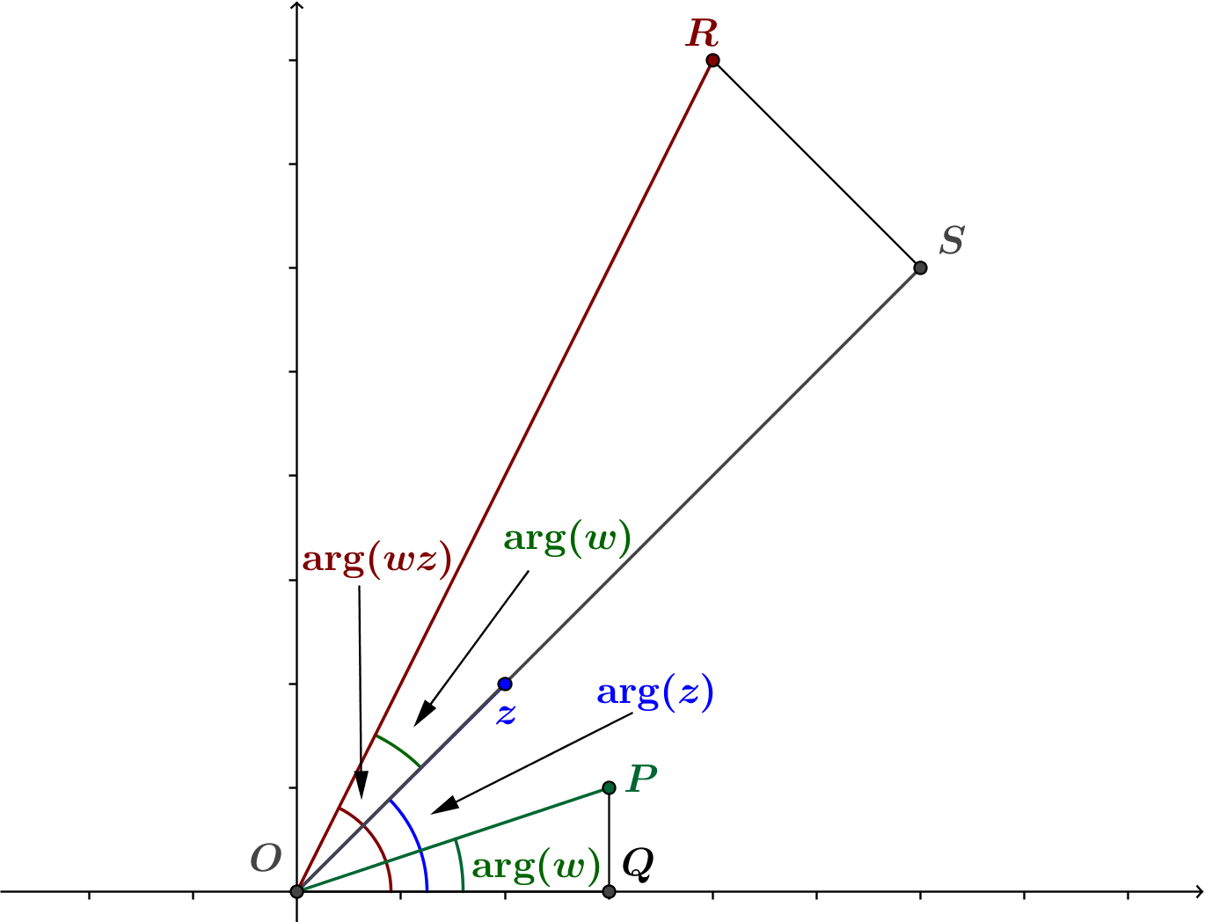
- However, we have shown that $m\left(∠POQ\right)=m(∠ROS)$.

- We see that
$$\arg\left(wz\right)=m\left(∠ROQ\right) \\ =m\left(∠ROS\right)+m\left(∠SOQ\right) \\ =\arg\left(z\right)+\arg\left(w\right)$$
- Then, since $\arg\left(L\left(z\right)\right)=\arg\left(wz\right)=\arg\left(z\right)+\arg\left(w\right)$, the point $L\left(z\right)=w(z)$ is the image of $z$ under rotation by $\arg\left(w\right)$ about the origin. Thus, the transformation $L\left(z\right)=wz$ also has the geometric effect of rotation by $\arg\left(w\right).$
- While our discussion only addressed the case where $w$ is represented by a point in the first quadrant, the result holds for any complex number $w.$ You will consider the other cases for $w$ in the Problem Set.

Exercise 3 (4 minutes)

- If $z$ and $w$ are the complex numbers with the specified arguments and moduli, locate the point that represents the product $wz$on the provided coordinate axes.
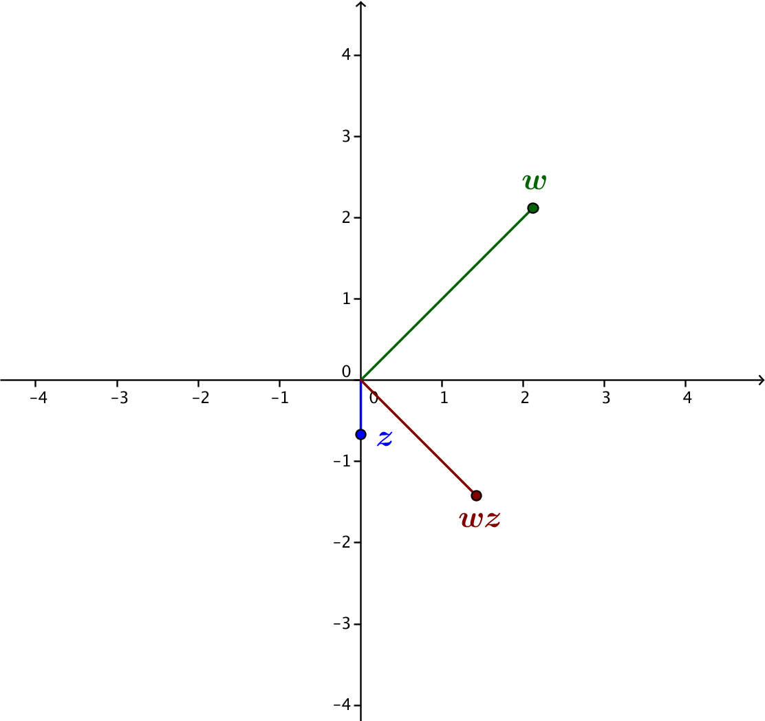
  - $\left|w\right|=3$, $arg\left(w\right)=\frac{π}{4}$
$\left|z\right|=\frac{2}{3}$, $arg\left(z\right)=-\frac{π}{2}$

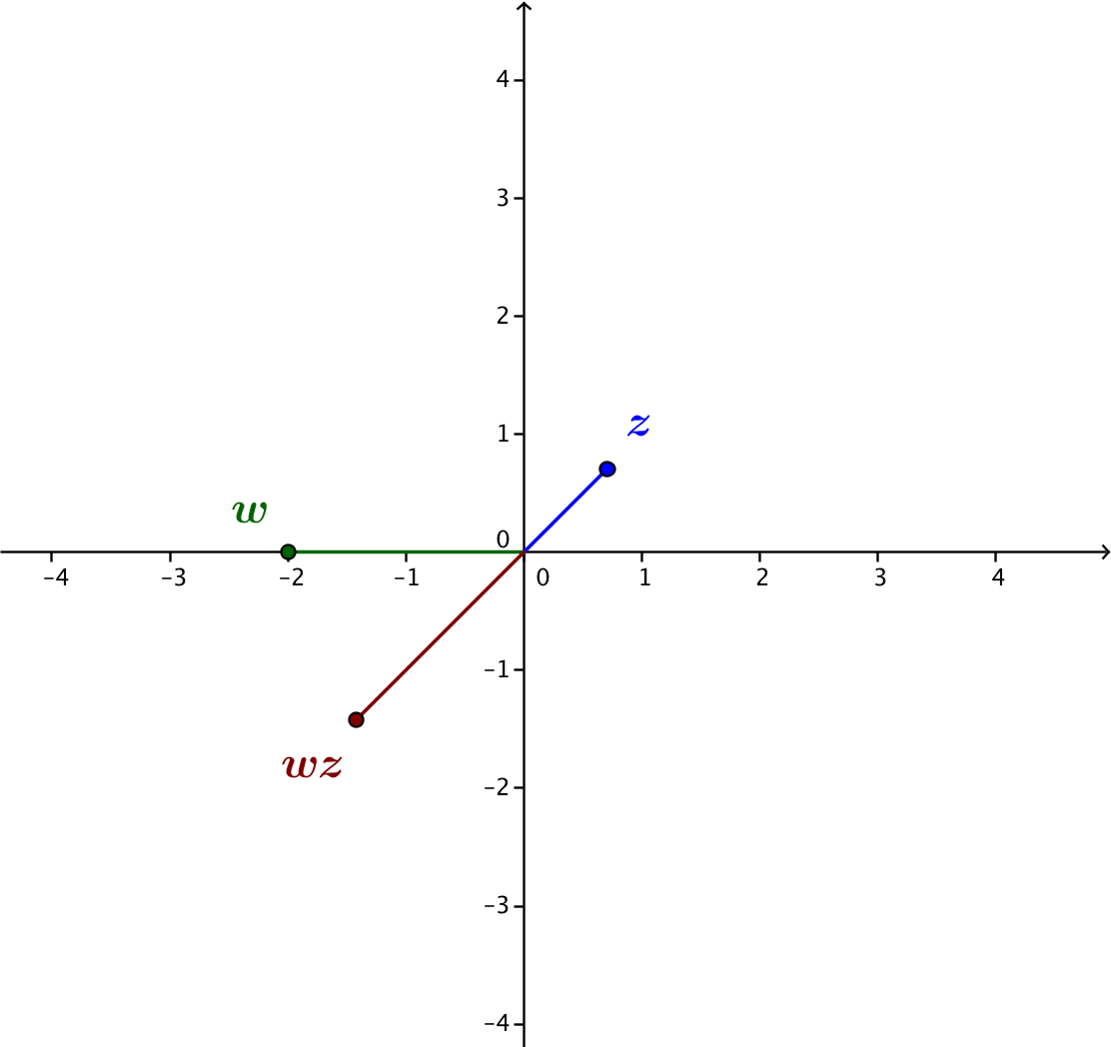
  - $\left|w\right|=2$, $arg\left(w\right)=π$
$\left|z\right|=1$, $arg\left(z\right)=\frac{π}{4}$

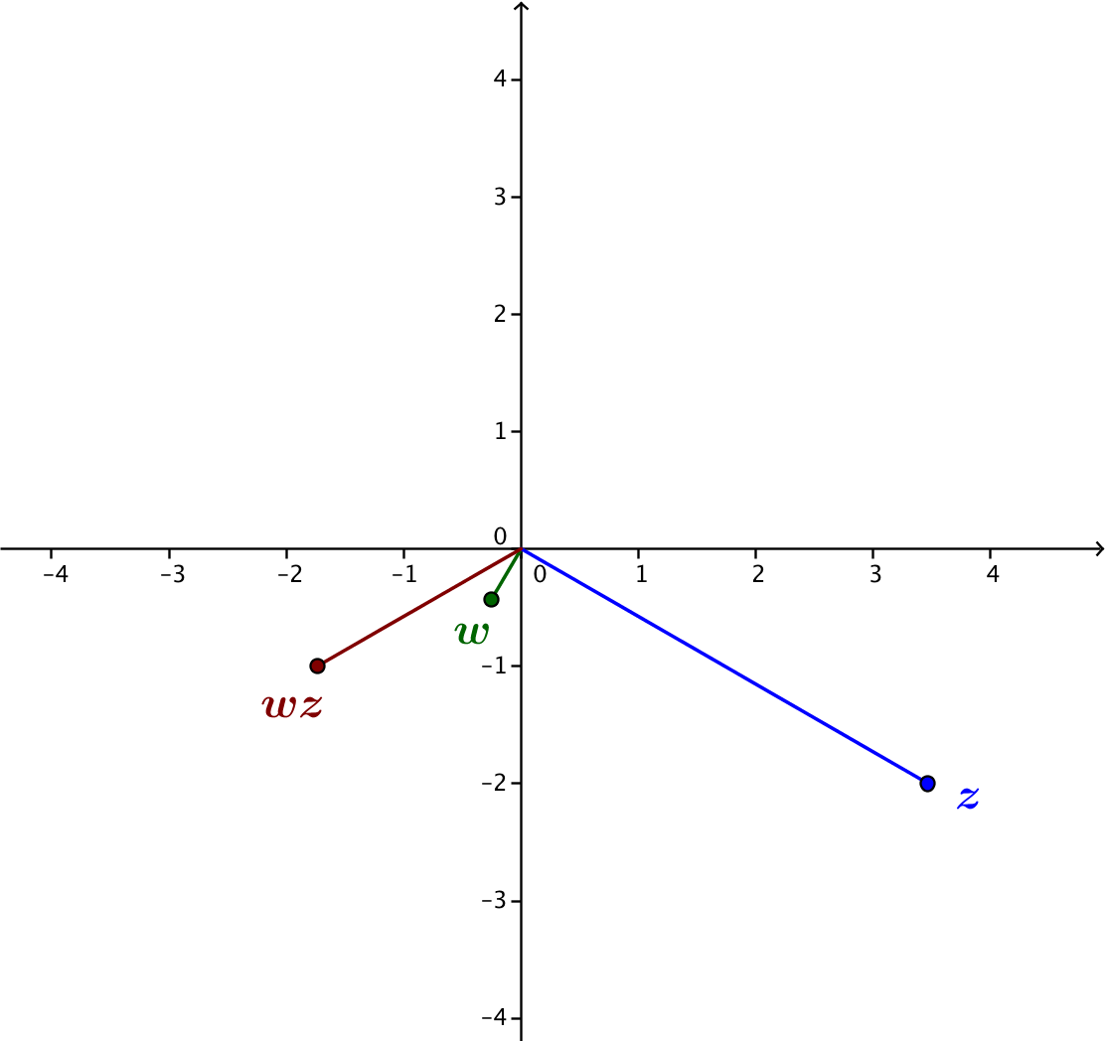
  - $\left|w\right|=\frac{1}{2}$, $arg\left(w\right)=\frac{4π}{3}$
$\left|z\right|=4$, $arg\left(z\right)=-\frac{π}{6}$

Closing (4 minutes)
Ask students to write in their journal or notebook to explain the process for geometrically describing the product of two complex numbers. Students should mention the following key points.
- For complex numbers $z$ and $w$, the modulus of the product is the product of the moduli:
$$\left|wz\right|=\left|w\right|⋅ |z|.$$
- For complex numbers $z$ and$w$, the argument of the product is the sum of the arguments:
Lesson Summary
For complex numbers $z$ and $w$,
- The modulus of the product is the product of the moduli:
$$\left|wz\right|=\left|w\right|⋅ \left|z\right|,$$
- The argument of the product is the sum of the arguments:
$$\arg\left(wz\right)=\arg\left(w\right)+\arg\left(z\right).$$

$$\arg\left(wz\right)=\arg\left(w\right)+\arg\left(z\right).$$

Exit Ticket (4 minutes)
Name Date
Lesson 15: Justifying the Geometric Effect of Complex Multiplication

Exit Ticket

- What is the geometric effect of the transformation $L\left(z\right)=\left(-6+8i\right)z$?

- Suppose that $w$ is a complex number with $\left|w\right|=\frac{3}{2}$ and $\arg\left(w\right)=\frac{5π}{6}$, and $z$ is a complex number with $\left|z\right|=2$ and $\arg\left(z\right)=\frac{π}{3}$.
  - Explain how you can geometrically locate the point that represents the product $wz$ in the coordinate plane.

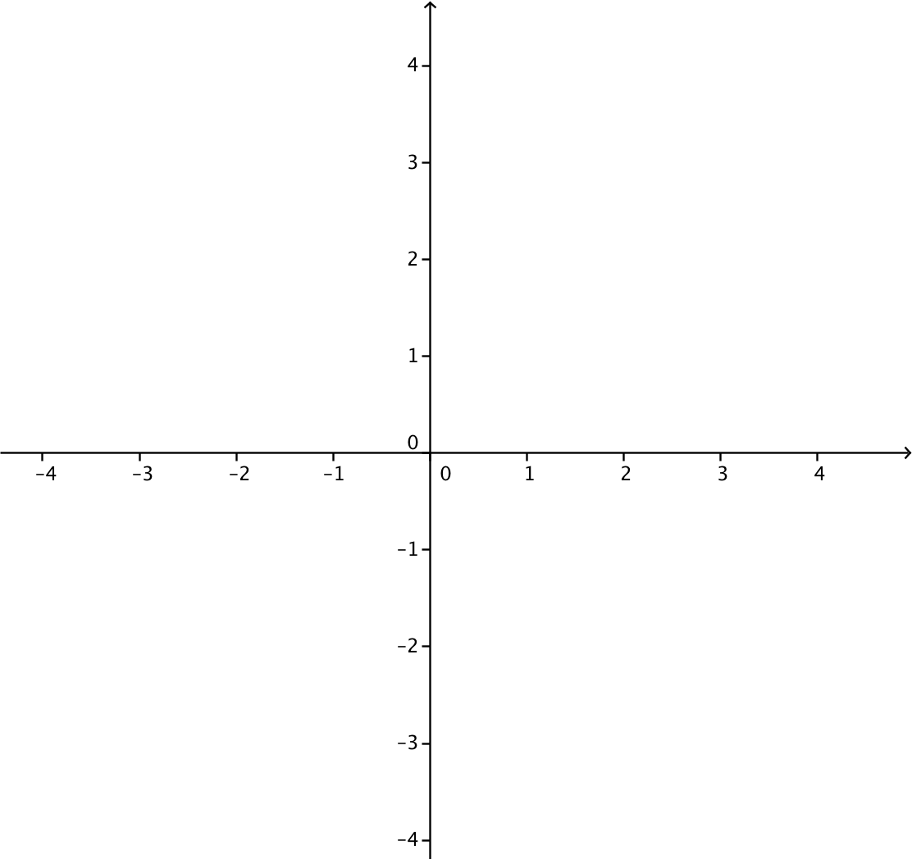
  - Plot $w$, $z$, and $wz$ on the coordinate grid.

Exit Ticket Sample Solutions

- What is the geometric effect of the transformation $L\left(z\right)=\left(-6+8i\right)z$?
For this transformation, $w=-6+8i$, so $\left|w\right|=\sqrt{{\left(-6\right)}^{2}+8^{2}}=\sqrt{100}=10$. The transformation $L$ dilates by a factor of$10$ and rotates counterclockwise by $arg(-6+8i)$.

- Suppose that $w$ is a complex number with $\left|w\right|=\frac{3}{2}$ and $\arg\left(w\right)=\frac{5π}{6}$, and $z$ is a complex number with $\left|z\right|=2$ and $\arg\left(z\right)=\frac{π}{3}$.
  - Explain how you can geometrically locate the point that represents the product $wz$ in the coordinate plane.
The product $wz$ has argument $\frac{5π}{6}+\frac{π}{3}=\frac{7π}{6}$ and modulus $\frac{3}{2}⋅2=3$. So we find the point that is distance
$3$ units from the origin on the ray that has been rotated $\frac{7π}{6}$ radians from the positive $x$-axis.

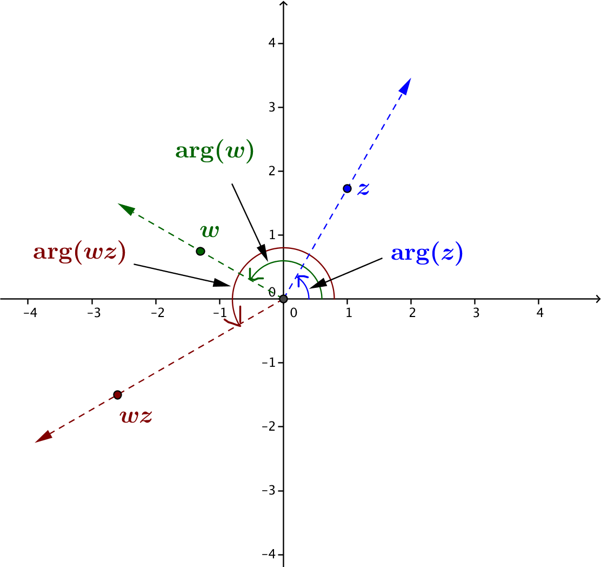
  - Plot $w$, $z$, and $wz$ on the coordinate grid.

Problem Set Sample Solutions
Problems 1 and 2 establish that any linear transformation of the form $L\left(z\right)=wz$ has the geometric effect of a rotation by $\arg\left(w\right)$ and dilation by $|w|$. Problems 3 and 4 lead to the development in the next lesson in which students build new transformations from ones they already know.

- In the lesson, we justified our observation that the geometric effect of a transformation $L\left(z\right)=wz$ is a rotation by $arg\left(w\right)$ and a dilation by $|w|$ for a complex number $w$ that is represented by a point in the first quadrant of the coordinate plane. In this exercise, we will verify that this observation is valid for any complex number $w$. For a complex number $w=a+bi$, we only considered the case where $a>0$ and $b>0$. There are eight additional possibilities we need to consider.
  - Case 1: The point representing $w$ is the origin. That is, $a=0$ and$b=0.$
In this case, explain why $L\left(z\right)=\left(a+bi\right)z$ has the geometric effect of rotation by $arg(a+bi)$ and dilation by $\left|a+bi\right|.$
If $a+bi=0+0i=0$, then $arg\left(a+bi\right)=0$, and $\left|a+bi\right|= 0$. Rotating a point $z$ by $0°$ does not change the location of $z$, and dilation by $0$ sends each point to the origin. Since $L\left(z\right)=0z=0$ for every complex number $z$, we can say that $L$ dilates by $0$ and rotates by $0$, so $L$ rotates counterclockwise by $arg(a+bi)$ and dilates by $|a+bi|.$

  - Case 2: The point representing $w$ lies on the positive real axis. That is, $a>0$ and $b=0$.
In this case, explain why $L\left(z\right)=\left(a+bi\right)z$ has the geometric effect of rotation by $arg(a+bi)$ and dilation by $\left|a+bi\right|.$
If $b=0$, then $L\left(z\right)=az$, which dilates $z$ by a factor of $a$ and does not rotate $z$. Since $a+bi$ lies on the positive real axis, $arg\left(a+bi\right)= 0$. Also, $\left|a+bi\right|=\left|a\right|=a$, since $a>0$. Thus, $L$ dilates by $|a+bi|$ and rotates counterclockwise by $arg\left(a+bi\right)$.

  - Case 3: The point representing $w$ lies on the negative real axis. That is, $a<0$ and $b=0.$
In this case, explain why $L\left(z\right)=\left(a+bi\right)z$ has the geometric effect of rotation by $arg(a+bi)$ and dilation by $\left|a+bi\right|.$
If $b=0$, then $L\left(z\right)=az$, which dilates $z$ by a factor of $|a|$ rotates $z$ by $180°$. Since $a+bi$ lies on the negative real axis, $arg\left(a+bi\right)= 180°$. Also, $\left|a+bi\right|=\left|a\right|$. Thus, $L$ dilates by $|a+bi|$ and rotates counterclockwise by $arg\left(a+bi\right).$

  - Case 4: The point representing $w$ lies on the positive imaginary axis. That is, $a=0$ and $b>0.$
In this case, explain why $L\left(z\right)=\left(a+bi\right)z$ has the geometric effect of rotation by $arg(a+bi)$ and dilation by $\left|a+bi\right|.$
If $a=0$, then $L\left(z\right)=(bi)z$, which dilates $z$ by a factor of $b$ and rotates $z$ by $90°$ counterclockwise. Since
$a+bi$ lies on the positive imaginary axis, $arg\left(a+bi\right)= 90°$. Also, $\left|a+bi\right|=b$. Thus, $L$ dilates by
$|a+bi|$ and rotates counterclockwise by $arg\left(a+bi\right).$

  - Case 5: The point representing $w$ lies on the negative imaginary axis. That is, $a=0$ and $b<0.$
In this case, explain why $L\left(z\right)=\left(a+bi\right)z$ has the geometric effect of rotation by $arg(a+bi)$ and dilation by $\left|a+bi\right|.$
If $a=0$, then $L\left(z\right)=(bi)z$, which dilates $z$ by a factor of $|b|$ and rotates $z$ by $270°$ counterclockwise. Since $a+bi$ lies on the negative imaginary axis, $arg\left(a+bi\right)= 270°$. Also, $\left|a+bi\right|=|b|$. Thus, $L$ dilates by $|a+bi|$ and rotates counterclockwise by $arg\left(a+bi\right).$
  - Case 6: The point representing $w=a+bi$ lies in the second quadrant. That is, $a<0$ and $b>0.$ Points representing $,$ $z$, $az$, $\left(bi\right)z$, and $wz=az+\left(bi\right)z$ are shown in the figure below.
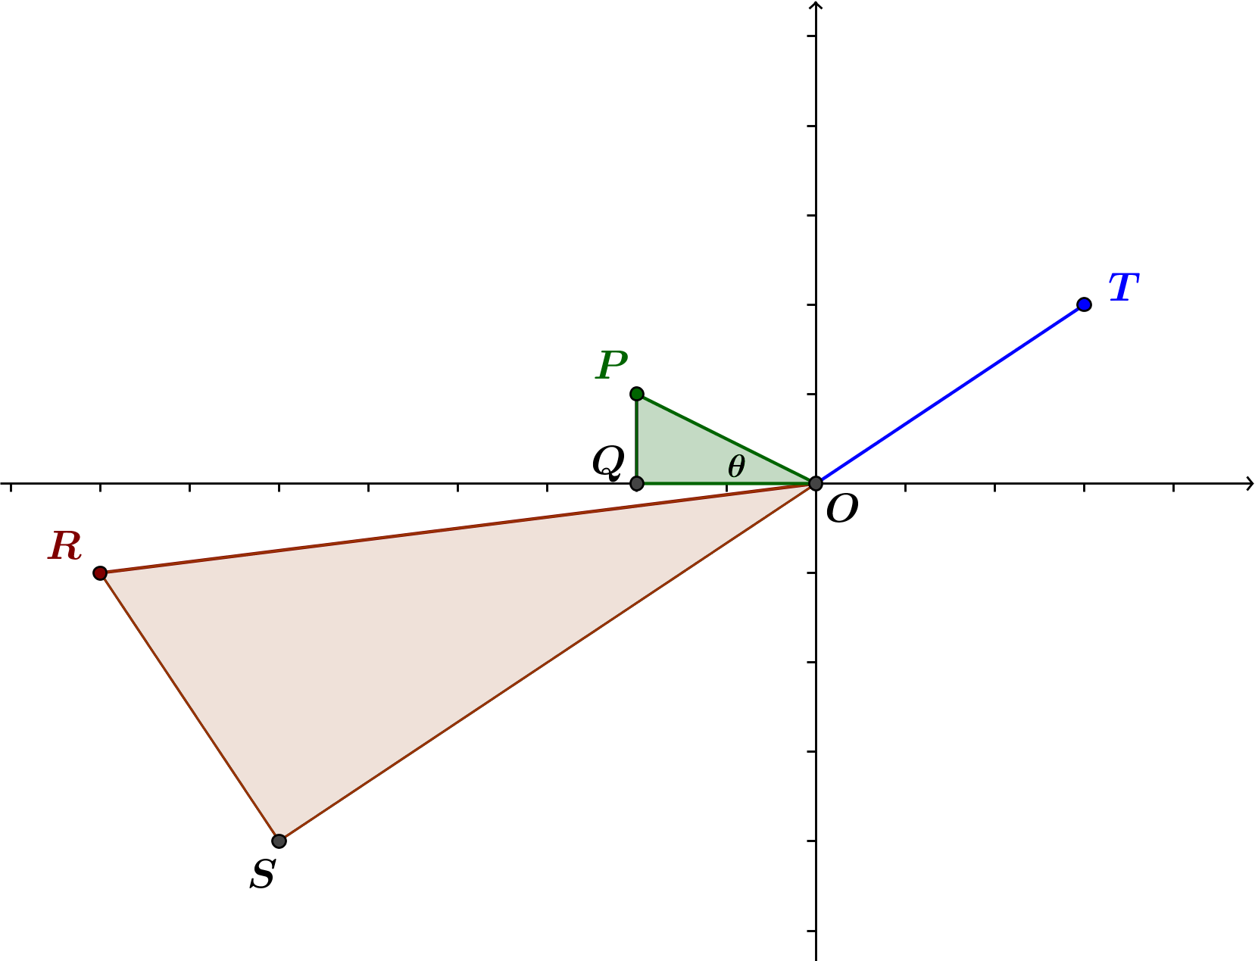
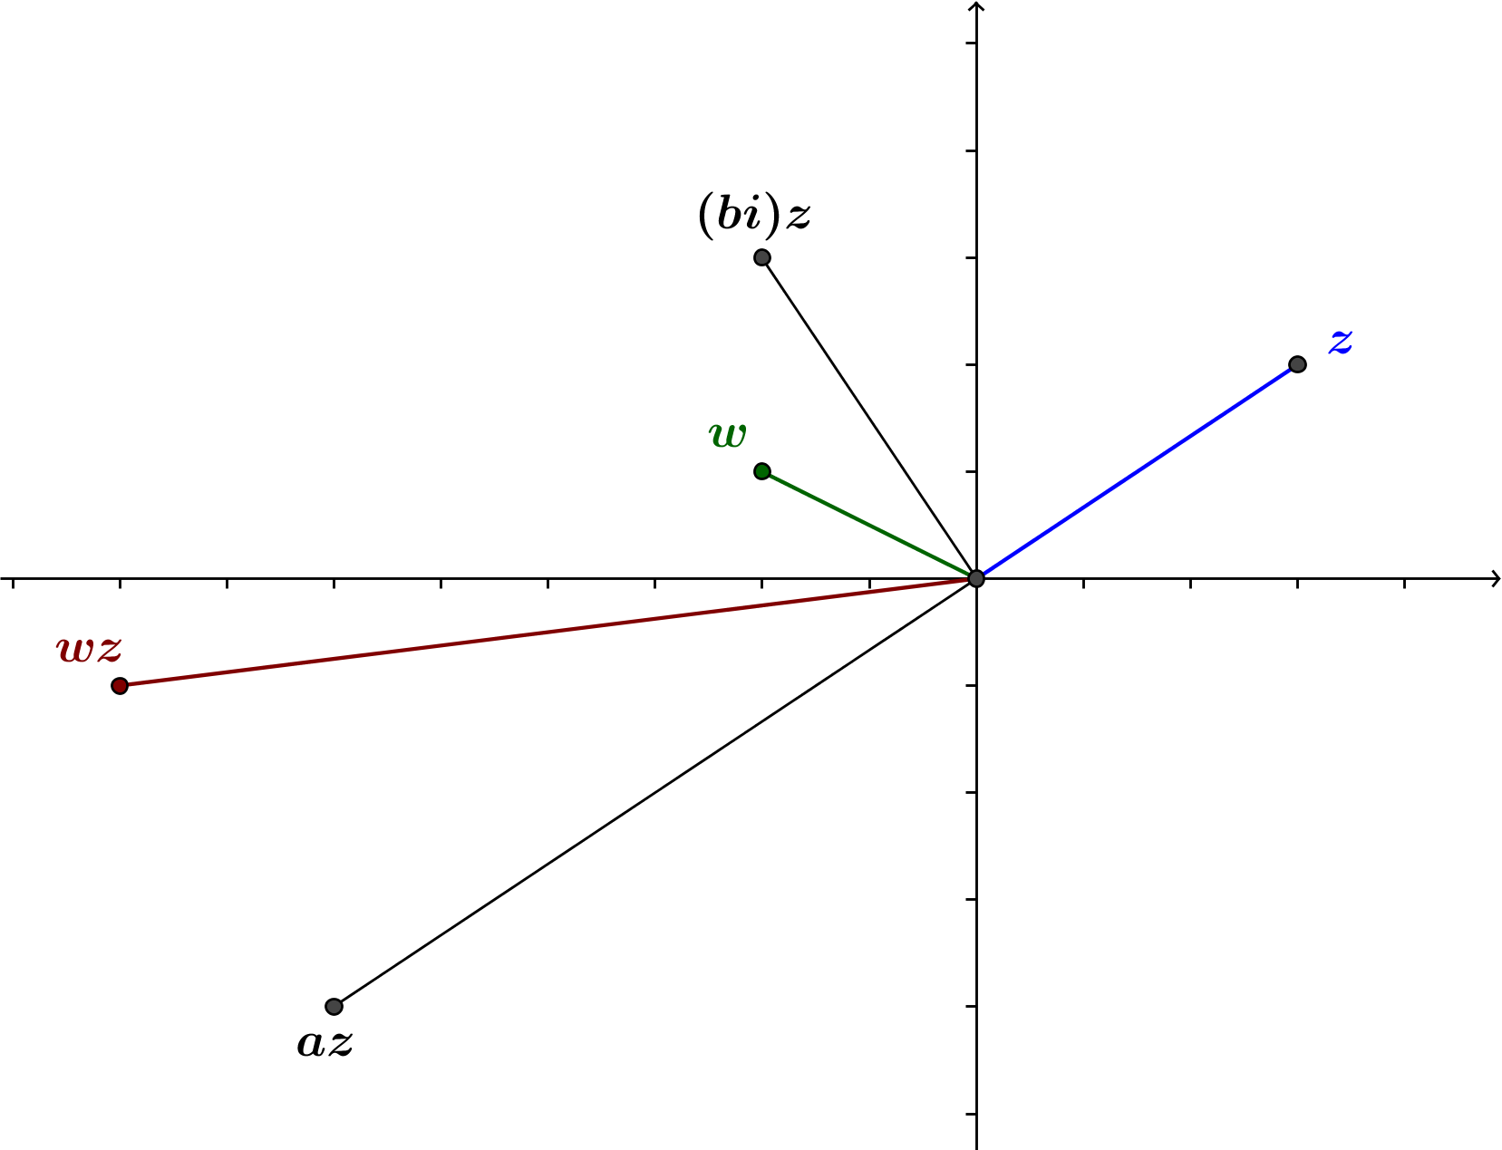
For convenience, rename the origin $O$ and let $P=w$, $Q=a$, $R=wz$, $S=az$, and $T=z$, as shown below. Let $m(∠POQ)=θ.$

    - Argue that $△OPQ∼ △ORS$.
The lengths of the sides of the triangles are the following:
$$OP=\left|w\right|$$ | $$OR=\left|w\right|⋅|z|$$
$$OQ=|a|$$ | $$OS=\left|a\right|⋅|z|$$
$$PQ=b$$ | $$RS=b⋅|z|$$
Thus, $\frac{OR}{OP}=\frac{OS}{OQ}=\frac{RS}{PQ}=|z|$, so $△OPQ∼ △ORS$.

    - Express the argument of $az$ in terms of $arg\left(z\right).$
$$arg\left(az\right)=180°+arg(z)$$

    - Express $arg(w)$ in terms of $θ$, where $θ=m\left(∠POQ\right).$
$$arg\left(w\right)= 180°-θ$$

    - Explain why $arg\left(wz\right)=arg\left(az\right)-θ.$
Because $△OPQ∼ △ORS$, $m\left(∠ROS\right)= m\left(∠POQ\right)=θ.$
$$arg\left(wz\right)=arg\left(az\right)-m\left(∠ROS\right) \\ =arg\left(az\right)-m\left(∠POQ\right) \\ =arg\left(az\right)-θ$$

    - Combine your responses from parts (ii), (iii) and (iv) to express $arg(wz)$ in terms of $arg(z)$ and $arg(w)$.
$$arg\left(wz\right)=arg\left(az\right)-θ \\ =\left(180°+arg\left(z\right)\right)-\left(180°-arg\left(w\right)\right) \\ =arg\left(z\right)+arg\left(w\right)$$

  - Case 7: The point representing $w=a+bi$ lies in the third quadrant. That is, $a<0$ and $b<0.$
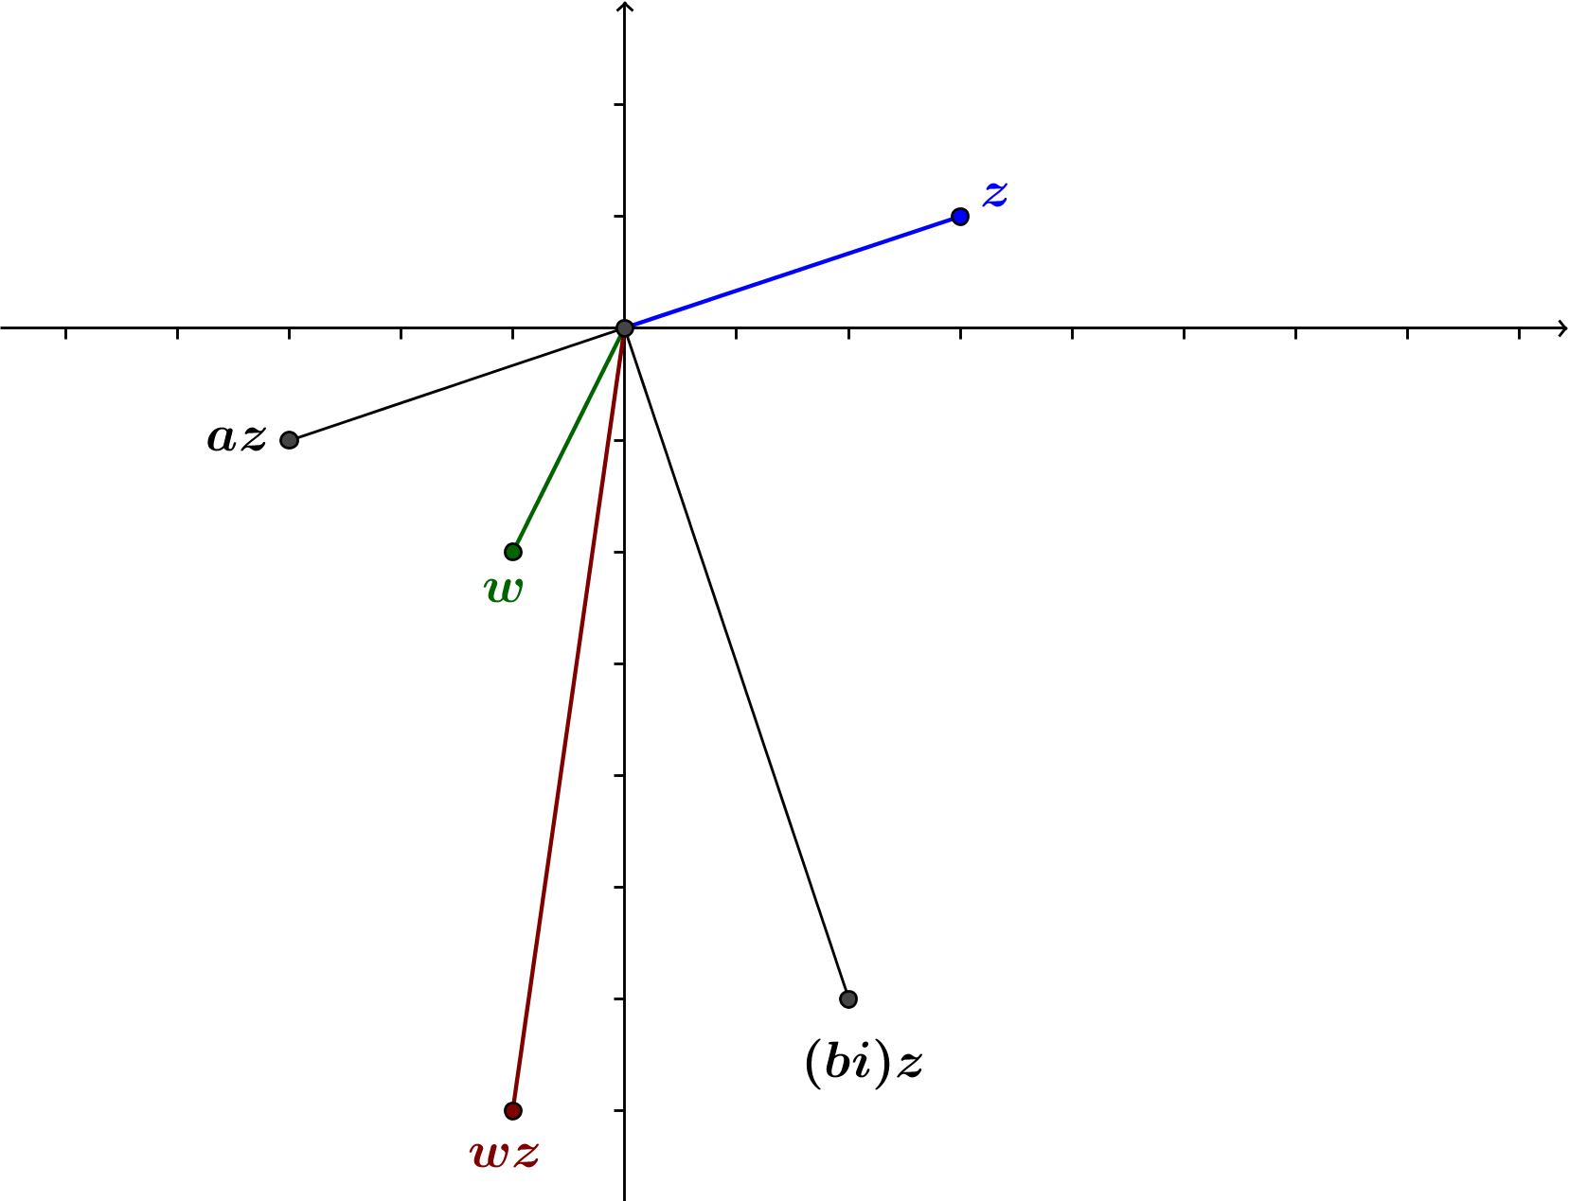
Points representing $,$ $z$, $az$, $\left(bi\right)z$, and $wz=az+\left(bi\right)z$ are shown in the figure below.

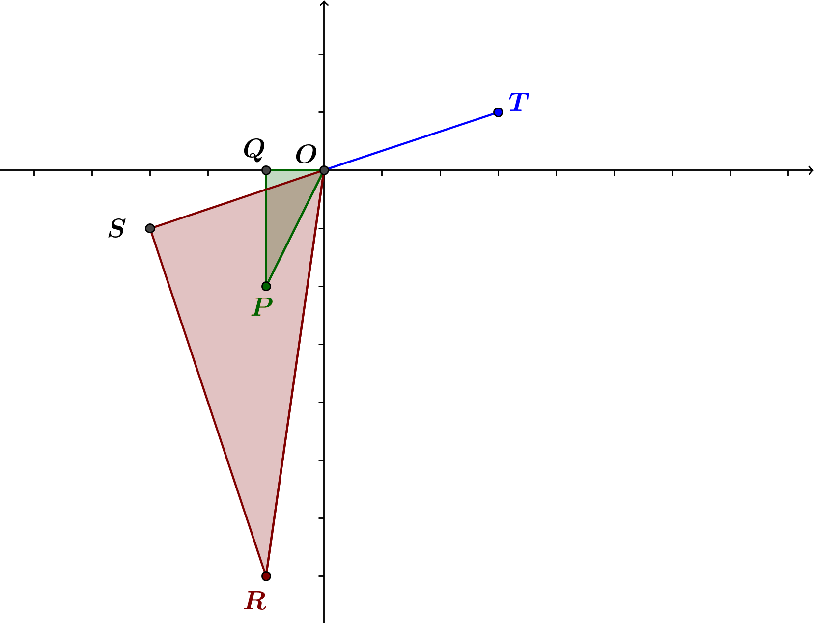
For convenience, rename the origin $O$ and let $P=w$, $Q=a$, $R=wz$, $S=az$, and $T=z$, as shown below. Let $m(∠POQ)=θ.$

    - Argue that $△OPQ∼ △ORS$.
The lengths of the sides of the triangles are as follows:
$$OP=\left|w\right|$$ | $$OR=\left|w\right|⋅|z|$$
$$OQ=|a|$$ | $$OS=\left|a\right|⋅|z|$$
$$PQ=|b|$$ | $$RS=|b|⋅|z|$$
Thus, $\frac{OR}{OP}=\frac{OS}{OQ}=\frac{RS}{PQ}=|z|$, so $△OPQ∼ △ORS$.

    - Express the argument of $az$ in terms of $arg\left(z\right).$
$$arg\left(az\right)=180°+arg(z)$$

    - Express $arg(w)$ in terms of $θ$, where $θ=m\left(∠POQ\right).$
$$arg\left(w\right)= 180°+θ$$

    - Explain why $arg\left(wz\right)=arg\left(az\right)+θ.$
Because $△OPQ∼ △ORS$, $m\left(∠ROS\right)= m\left(∠POQ\right)=θ.$
$$arg\left(wz\right)=arg\left(az\right)+ m\left(∠ROS\right) \\ =arg\left(az\right)+ m\left(∠POQ\right) \\ =arg\left(az\right)+ θ$$

    - Combine your responses from parts (ii), (iii), and (iv) to express $arg(wz)$ in terms of $arg(z)$ and $arg(w)$.
$$arg\left(wz\right)=arg\left(az\right)+θ \\ =\left(180°+arg\left(z\right)\right)+\left(arg\left(w\right)-180°\right) \\ =arg\left(z\right)+ arg\left(w\right)$$

  - Case 8: The point representing $w=a+bi$ lies in the fourth quadrant. That is, $a>0$ and $b<0.$
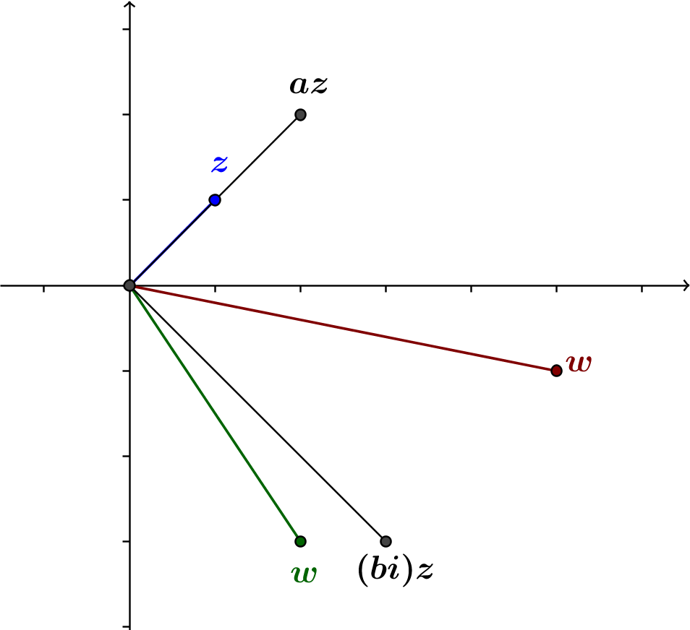
Points representing $,$ $z$, $az$, $\left(bi\right)z$, and $wz=az+\left(bi\right)z$ are shown in the figure below.

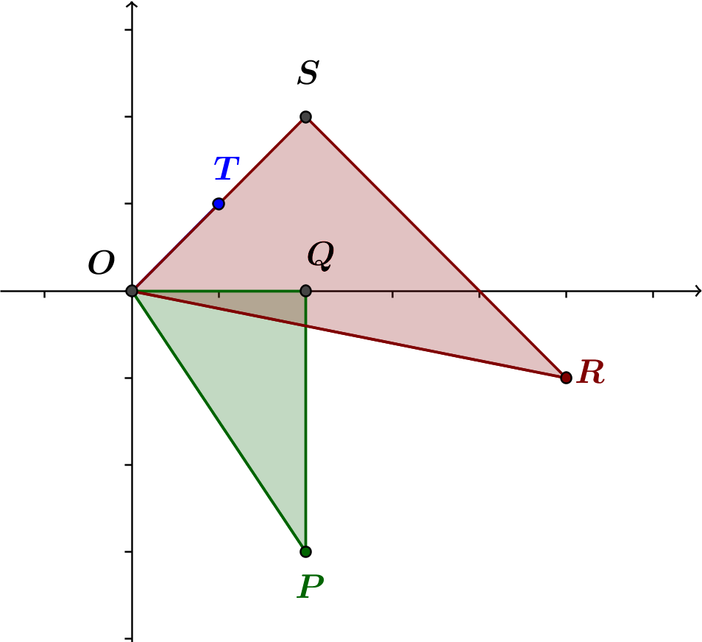
For convenience, rename the origin $O$, and let $P=w$, $Q=a$,$R=wz$, $S=az$, and $T=z$, as shown below. Let $m(∠POQ)=θ.$

    - Argue that $△OPQ∼ △ORS$.
The lengths of the sides of the triangles are the following:
$$OP=\left|w\right|$$ | $$OR=\left|w\right|⋅|z|$$
$$OQ=a$$ | $$OS=a⋅|z|$$
$$PQ=|b|$$ | $$RS=|b|⋅|z|$$
Thus, $\frac{OR}{OP}=\frac{OS}{OQ}=\frac{RS}{PQ}=|z|$, so $△OPQ∼ △ORS.$

    - Express $arg(w)$ in terms of $θ$, where $θ=m\left(∠POQ\right).$
$$arg\left(w\right)= 360°-θ$$

    - Explain why $m\left(∠QOR\right)=θ-arg(z).$
Because $△OPQ∼ △ORS$, $m\left(∠SOR\right)= m\left(∠POQ\right)=θ.$
$$m\left(∠QOR\right)=m\left(∠SOR\right)-m\left(∠SOQ\right) \\ =θ-m\left(∠SOQ\right) \\ =θ-arg\left(z\right)$$

    - Express $arg\left(wz\right)$ in terms of $m(∠QOR)$.
Because $△OPQ∼ △ORS$, $m\left(∠ROS\right)= m\left(∠POQ\right)=θ.$
$$arg\left(wz\right)=arg\left(az\right)+ m\left(∠ROS\right) \\ =arg\left(az\right)+ m\left(∠POQ\right) \\ =arg\left(az\right)+ θ$$

    - Combine your responses from parts (ii), (iii), and (iv) to express $arg(wz)$ in terms of $arg(z)$ and $arg(w)$.
$$arg\left(wz\right)=360°-m\left(∠QOR\right) \\ =360°-\left(θ-arg\left(z\right)\right) \\ =(360°-θ)+arg\left(z\right) \\ =arg\left(w\right)+ arg\left(z\right)$$

- Summarize the results of Problem 1, parts (a)–(h) and the lesson.
For any complex number $w$, the transformation $L\left(z\right)=wz$ has the geometric effect of rotation by $arg(w)$ and dilation by $|w|$.

- Find a linear transformation $L$ that will have the geometric effect of rotation by the specified amount without dilating.
  - $45°$ counterclockwise
We need to find a complex number $w$so that$\left|w\right|=1$ and $arg\left(w\right)= 45°$. Then $w$ can be represented by a point on the unit circle such that the ray through the origin and $w$ is the terminal ray of the positive $x$-axis rotated by $45°$. Then the $x$-coordinate of w is$cos\left(45°\right)$and the $y$-coordinate of$w$is$sin\left(45°\right)$, so we have$w=cos\left(45°\right)+i sin\left(45°\right)=\frac{\sqrt{2}}{2}+\frac{i\sqrt{2}}{2}$. Then $L\left(z\right)= \left(\frac{\sqrt{2}}{2}+\frac{i\sqrt{2}}{2}\right)z =\frac{\sqrt{2}}{2}(1+i)z$.
  - $60°$counterclockwise
$$L\left(z\right)=\left(cos\left(60°\right)+i sin\left(60°\right)\right)z \\ =\left(\frac{1}{2}+\frac{i\sqrt{3}}{2}\right)z$$

  - $180°$ counterclockwise
$$L\left(z\right)=\left(cos\left(180°\right)+i sin\left(180°\right)\right)z \\ =-z$$

  - 1$20°$ counterclockwise
$$L\left(z\right)=\left(cos\left(120°\right)+i sin\left(120°\right)\right)z \\ =\left(-\frac{1}{2}+\frac{i\sqrt{3}}{2}\right)z$$

  - $30°$ clockwise
$$L\left(z\right)=\left(cos\left(-30°\right)+i sin\left(-30°\right)\right)z \\ =\left(\frac{\sqrt{3}}{2}-\frac{1}{2}i\right)z$$

  - $90°$ clockwise
$$L\left(z\right)=\left(cos\left(-90°\right)+i sin\left(-90°\right)\right)z \\ =-iz$$

  - $180°$ clockwise
$$L\left(z\right)=\left(cos\left(-180°\right)+i sin\left(-180°\right)\right)z \\ =-z$$

  - $135°$clockwise
$$L\left(z\right)=\left(cos\left(-135°\right)+i sin\left(-135°\right)\right)z \\ =\left(-\frac{\sqrt{2}}{2}-\frac{i\sqrt{2}}{2}\right)z \\ =-\frac{\sqrt{2}}{2}\left(1+i\right)z$$

- Suppose that we have linear transformations $L_{1}$ and $L_{2}$ as specified below. Find a formula for $L_{2}\left(L_{1}\left(z\right)\right)$ for complex numbers $z$.
  - $L_{1}\left(z\right)=\left(1+i\right)z$ and $L_{2}\left(z\right)=\left(1-i\right)z$
$$L_{2}\left(L_{1}(z)\right)=L_{2}(\left(1+i\right)z) \\ =\left(1-i\right)\left(\left(1+i\right)z\right) \\ =\left(1-i\right)\left(1+i\right)z \\ =2z$$

  - $L_{1}\left(z\right)=\left(3-2i\right)z$ and $L_{2}\left(z\right)=\left(2+3i\right)z$
$$L_{2}\left(L_{1}(z)\right)=L_{2}((3-2i)z) \\ =\left(2+3i\right)\left(\left(3-2i\right)z\right) \\ =\left(2+3i\right)\left(3-2i\right)z \\ =(12+5i)z$$

  - $L_{1}\left(z\right)=(-4+3i)z$ and $L_{2}\left(z\right)=\left(-3-i\right)z$
$$L_{2}\left(L_{1}(z)\right)=L_{2}((-4+3i)z) \\ =(-3-i)\left(\left(-4+3i\right)z\right) \\ =\left(-3-i\right)\left(-4+3i\right)z \\ =(15-5i)z$$

  - $L_{1}\left(z\right)=(a+bi)z$ and $L_{2}\left(z\right)=\left(c+di\right)z$ for real numbers $a, b, c$ and $d$.
$$L_{2}\left(L_{1}(z)\right)=L_{2}((a+bi)z) \\ =(c+di)\left((a+bi)z\right) \\ =(a+bi)(c+di)z$$

