Lesson 14: Discovering the Geometric Effect of Complex Multiplication

Student Outcomes
- Students determine the geometric effects of transformations of the form $L\left(z\right)=az$, $L\left(z\right)=\left(bi\right)z$, and $L\left(z\right)=\left(a+bi\right)z$ for real numbers $a$ and $b$.

Lesson Notes
In this lesson, students observe the geometric effect of transformations of the form $L\left(z\right)=\left(a+bi\right)z$ on a unit square and formulate conjectures (G-CO.A.2). Today’s observations will be mathematically established in the following lesson. As in the previous lessons, in this lesson we will continue to associate points $(a,b)$ in the coordinate plane with complex numbers $a+bi$, where $a$ and $b$ are real numbers (N-CN.B.4). The Problem Set includes another chance to revisit the definition and the idea of a linear transformation. Showing that these transformations are linear also provides algebraic fluency practice with complex numbers.

Classwork
Exercises (10 minutes)
Exercises
The vertices $A(0,0)$, $B(1,0)$, $C(1,1)$, and $D(0,1)$ of a unit square can be represented by the complex numbers $A=0$, $B=1$, $C=1+i$, and $D=i$.
- Let $L_{1}\left(z\right)=-z$.
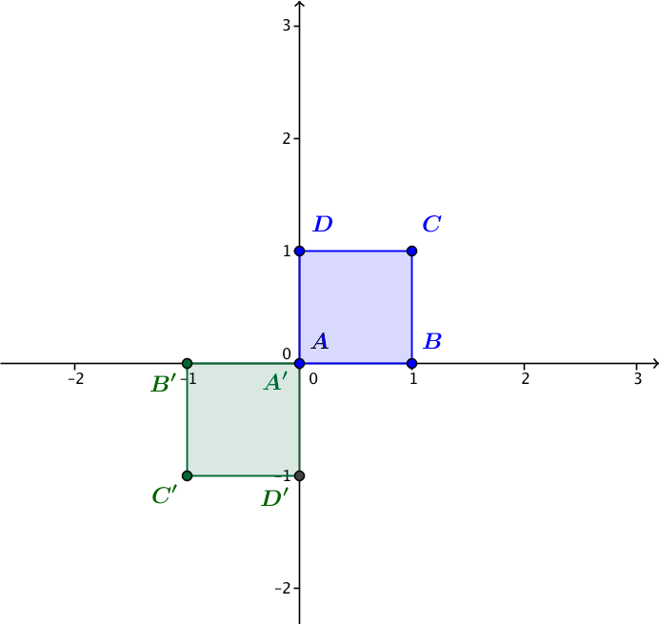
  - Calculate $A'=L_{1}(A)$, $B'=L_{1}\left(B\right)$,$C'=L_{1}\left(C\right)$, and $D'=L_{1}(D)$. Plot these four points on the axes.
  - Describe the geometric effect of the linear transformation $L_{1}\left(z\right)=-z$ on the square $ABCD$.
Transformation $L_{1}$ rotates the square $ABCD$ by $180°$ about the origin.

- Let $L_{2}\left(z\right)=2z$.
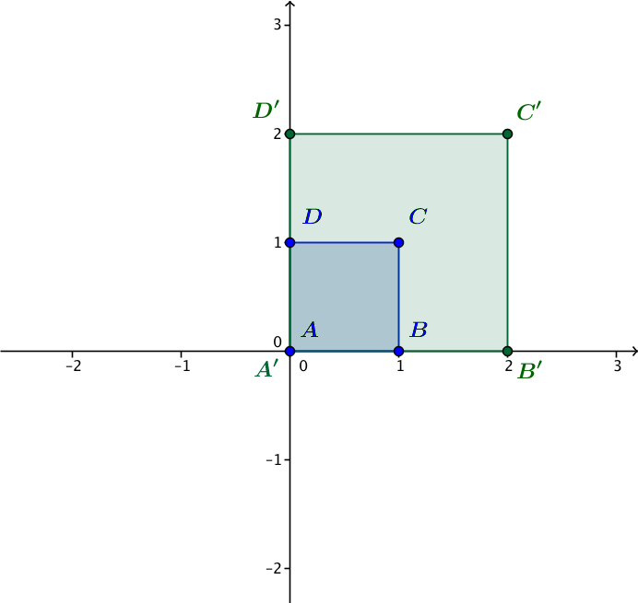
  - Calculate $A'=L_{2}(A)$, $B'=L_{2}\left(B\right)$,$C'=L_{2}\left(C\right)$, and $D=L_{2}(D)$. Plot these four points on the axes.
  - Describe the geometric effect of the linear transformation $L_{2}\left(z\right)=2z$ on the square $ABCD$.
Transformation $L_{2}$ dilates the square $ABCD$ by a factor of$2$.

- Let $L_{3}\left(z\right)=iz$.
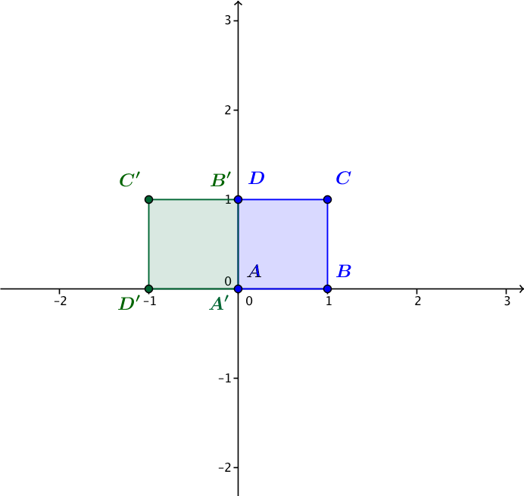
  - Calculate $A'=L_{3}(A)$, $B'=L_{3}\left(B\right)$,$C'=L_{3}\left(C\right)$, and $D'=L_{3}(D)$. Plot these four points on the axes.
  - Describe the geometric effect of the linear transformation $L_{3}\left(z\right)=iz$ on the square $ABCD$.
Transformation $L_{3}$ rotates the square $ABCD$ by $90°$ counterclockwise about the origin.

- Let $L_{4}\left(z\right)=(2i)z$.
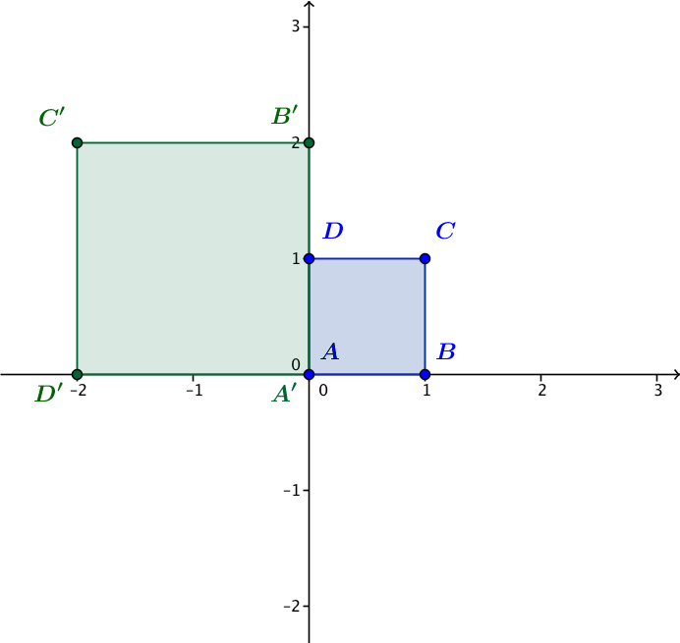
  - Calculate $A'=L_{4}(A)$, $B'=L_{4}\left(B\right)$, $C'=L_{4}\left(C\right)$, and $D'=L_{4}(D)$. Plot these four points on the axes.
  - Describe the geometric effect of the linear transformation $L_{4}\left(z\right)=(2i)z$ on the square $ABCD$.
Transformation $L_{4}$ rotates the square $ABCD$ by $90°$ counterclockwise about the origin and dilates by a factor of $2$.

- Explain how transformations $L_{2}$, $L_{3}$, and $L_{4}$ are related.
MP.7
Transformation $L_{4}$ is the result of doing transformations $L_{2}$ and $L_{3}$ (in either order).

Discussion (8 minutes)
- What is the geometric effect of the transformation $L\left(z\right)=az$ for a real number $a>0$?
  - The effect of $L$ is dilation by the factor $a$.
- What happens to a unit square in this case?
  - The orientation of the square does not change; it is not reflected or rotated, but the sides of the square are dilated by $a$.
- What is the effect on the square if $a>1$?
  - The sides of the square will get larger.
- What is the effect on the square if $0<a<1$?
  - The sides of the square will get smaller.
- What is the geometric effect of the transformation $L\left(z\right)=az$ if $a=0$?
  - If $a=0$, then $L\left(z\right)=0$ for every complex number $z$. This transformation essentially shrinks the square down to the point at the origin.
- What is the geometric effect of the transformation $L\left(z\right)=az$ for a real number $a<0$?
  - If $a<0$, then $L\left(z\right)=az=-|a|z$ , so $L$ is a dilation by $|a|$ and a rotation by $180°$. This transformation will dilate the original unit square and then rotate it about point $A$ into the third quadrant.
- What is the geometric effect of the transformation $L\left(z\right)=(bi)z$ for a real number $b>0$?
  - The transformation $L$ dilates by $b$ and rotates by $90°$ counterclockwise.
- What is the effect on the unit square if $b>1$?
  - The sides of the square will get larger.
- What is the effect on the unit square if $0<b<1$?
  - The sides of the square will get smaller.
- What is the effect on the unit square if $b<0$?
  - If $b<0$, then $L\left(z\right)=(bi)z=i(bz)$, so $L$ is a dilation by $|b|$ and a rotation by $180°$, followed by a rotation by $90°$. This transformation will rotate and dilate the original unit square and then rotate it about point $A$ to the fourth quadrant.

Exercise 6 (6 minutes)

- We will continue to use the unit square $ABCD$ with $A=0$, $B=1$,$C=1+I$,$D=i$ for this exercise.
  - What is the geometric effect of the transformation $L\left(z\right)=5z$ on the unit square?
By our work in the first five exercises and the previous discussion, we know that this transformation dilates the unit square by a factor of $5$.

  - What is the geometric effect of the transformation $L\left(z\right)=(5i)z$ on the unit square?
By our work in the first five exercises, this transformation will dilate the unit square by a factor of $5$ and rotate it $90°$counterclockwise about the origin.
  - What is the geometric effect of the transformation $L\left(z\right)={(5i}^{2})z$ on the unit square?
Since $i^{2}=-1$, this transformation is $L\left(z\right)=-5z$, which will dilate the unit square by $5$ and rotate it $180°$ about the origin.

  - What is the geometric effect of the transformation $L\left(z\right)={(5i}^{3})z$ on the unit square?
Since $i^{3}= -i$, this transformation is $L\left(z\right)=(-5i)z$, which will dilate the unit square by a factor of $5$ and rotate it $270°$counterclockwise about the origin.

  - What is the geometric effect of the transformation $L\left(z\right)=(5i^{4})z$ on the unit square?
Since $i^{4}={\left(i^{2}\right)}^{2}={\left(-1\right)}^{2}=1$, this transformation is the $L\left(z\right)=5z$, which is the same transformation as in part (a). Thus, this transformation dilates the unit square by a factor of $5$.

  - What is the geometric effect of the transformation $L\left(z\right)={(5i}^{5})z$ on the unit square?
Since $i^{5}=i^{4}⋅i=i$, this is the same transformation as in part (b). This transformation will dilate the unit square by a factor of $5$ and rotate it $90°$ counterclockwise about the origin.

  - What is the geometric effect of the transformation $L\left(z\right)={(5i}^{n})z$ on the unit square, for some integer
$n≥0$?
If $n$ is a multiple of $4$, then $L\left(z\right)=\left(5i^{n}\right)z=5z$ will dilate the unit square by a factor of $5$.
If $n$ is one more than a multiple of $4$, then $L\left(z\right)=\left(5i^{n}\right)z=\left(5i\right)z$ will dilate the unit square by a factor of $5$ and rotate it $90°$counterclockwise about the origin.
If $n$ is two more than a multiple of $4$, then $L\left(z\right)=\left(5i^{n}\right)z=-5z$ will dilate the unit square by $5$ and rotate it $180°$ about the origin.
If $n$ is three more than a multiple of $4$, then $L\left(z\right)=\left(5i^{n}\right)z=(-5i)z$ will dilate the unit square by a factor of $5$ and rotate it $270°$counterclockwise about the origin.

Exploratory Challenge (12 minutes)
Divide students into at least eight groups of two or three students each. Assign each group to the 1-team, 2-team,
3-team, or 4-team. There should be at least two groups on each team, so that students can check their answers against another group when the results are shared at the end of the exercises. Each team will explore a different transformation of the form $L\left(z\right)=(a+bi)z$.
Before students begin working on the Exploratory Challenge, ask the following:
Scaffolding:
- For struggling students, accompany this discussion with a visual representation of each transformation on the unit square $ABCD$.
- Omit this discussion for advanced students.
- What is the geometric effect of the transformation $L\left(z\right)=3z$?
  - This transformation will dilate by a factor of three.
- What is the geometric effect of the transformation $L\left(z\right)=-3z$?
  - This transformation will dilate by a factor of three and rotate by $180°$ about the origin.
- What is the geometric effect of the transformation $L\left(z\right)=4iz$?
  - This transformation will dilate by a factor of four and rotate by $90°$ about the origin.
- What is the geometric effect of the transformation $L\left(z\right)=-4iz$?
  - This transformation will dilate by a factor of four and rotate by $270°$ about the origin.
Exploratory Challenge
Your group has been assigned either to the 1-team, 2-team, 3-team, or 4-team. Each team will answer the questions below for the transformation that corresponds to their team number:
$$L_{1}\left(z\right)=\left(3+4i\right)z \\ L_{2}\left(z\right)=\left(-3+4i\right)z \\ L_{3}\left(z\right)=\left(-3-4i\right)z \\ L_{4}\left(z\right)=\left(3-4i\right)z.$$
The unit square unit square $ABCD$ with $A=0$,$B=1$, $C=1+I$,$D=i$ is shown below. Apply your transformation to the vertices of the square $ABCD$ and plot the transformed points $A'$, $B'$, $C'$, and $D'$ on the same coordinate axes.

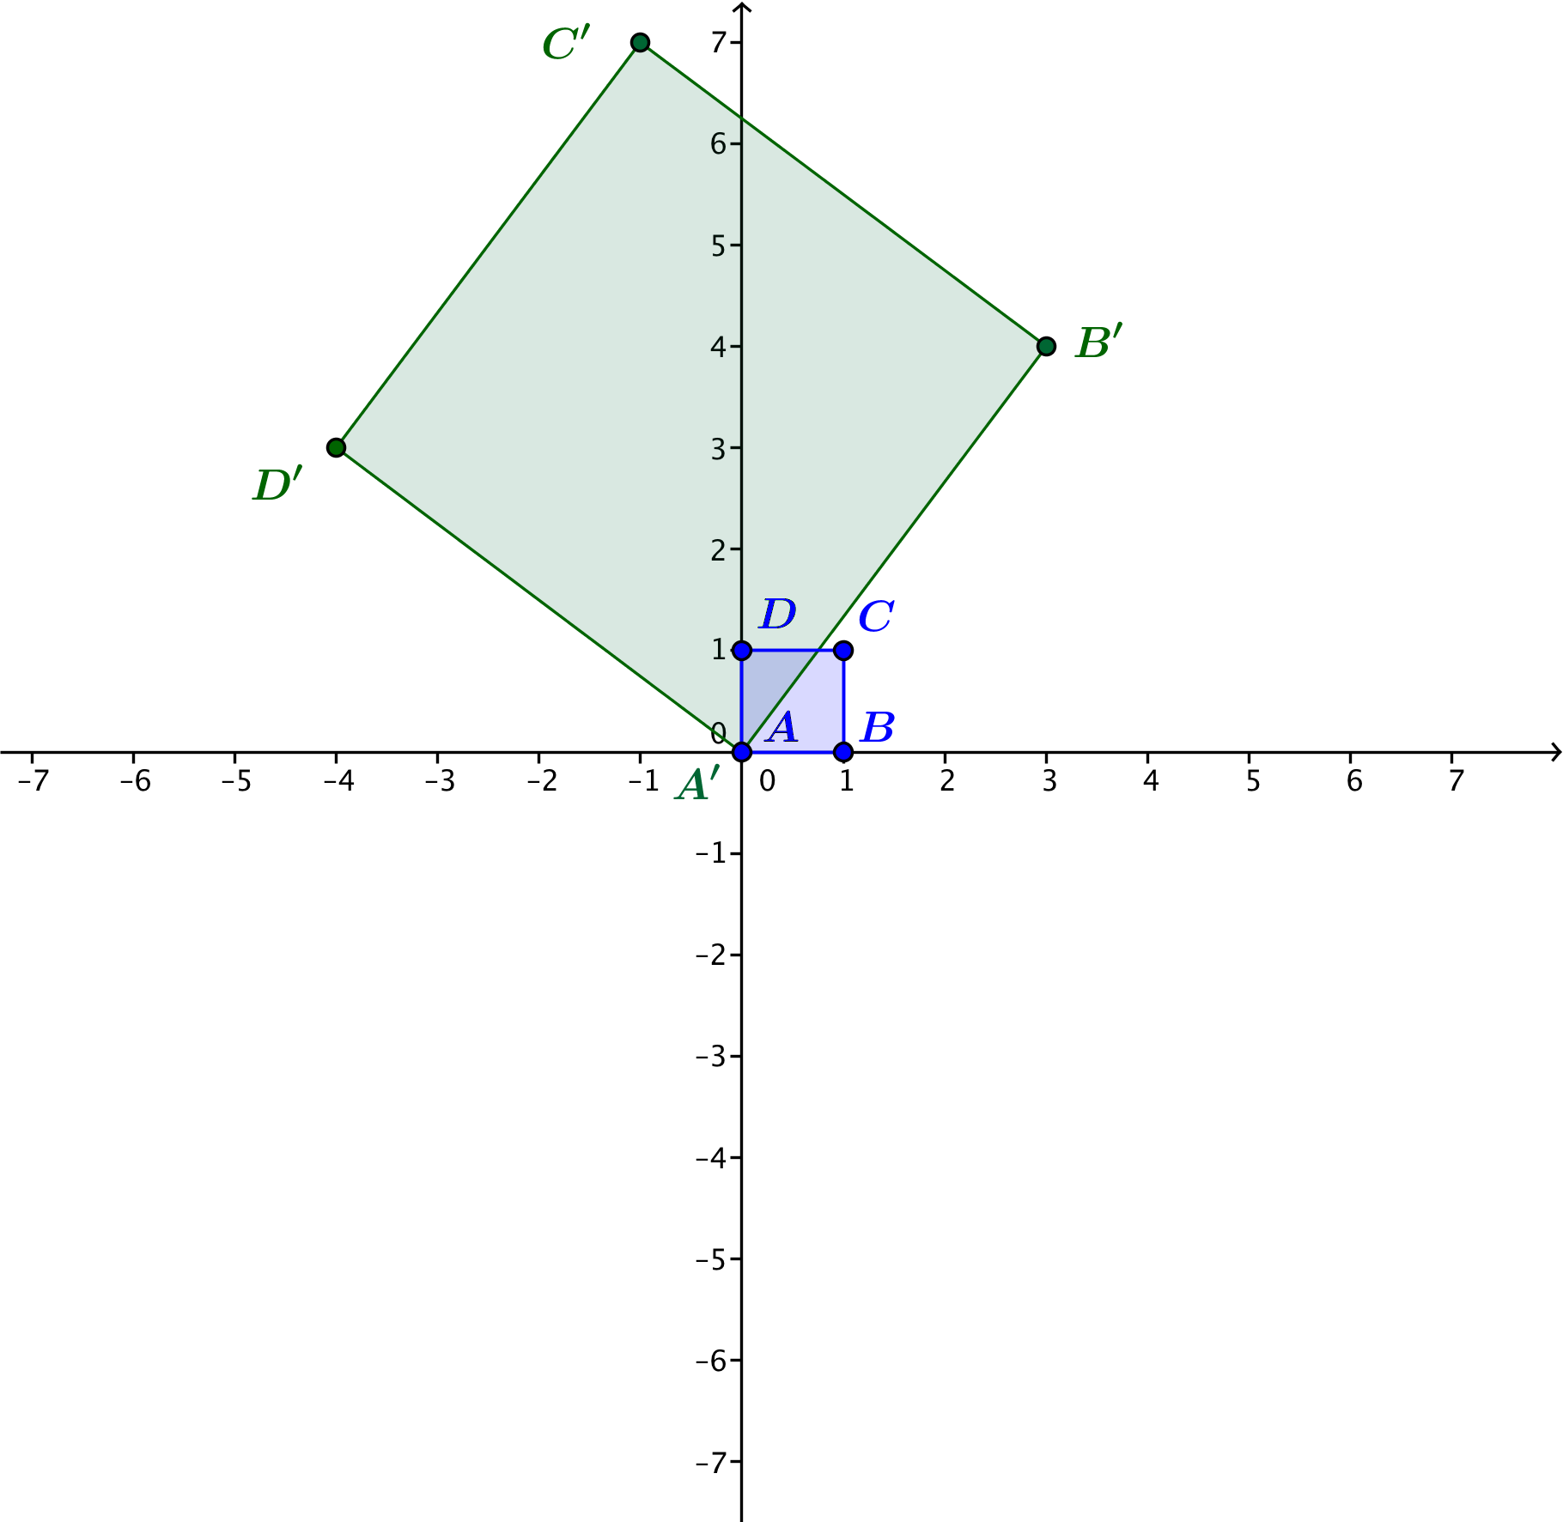
The solution shown below is for transformation $L_{1}$. The transformed square for $L_{2}$, $L_{3}$, and $L_{4}$ will be rotated $90°$, $180°$, and $270°$ counterclockwise about the origin from the one shown, respectively.

For the 1-team:
  - Why is $B^{'}=3+4i$?
Because $B=1$, we have $B^{'}=L_{1}\left(B\right)=\left(3+4i\right)\left(1\right)=3+4i$.

  - What is the argument of $3+4i$?
The argument of $3+4i$ is the amount of counterclockwise rotation between the positive $x$-axis and the ray connecting the origin and the point $(3,4)$.

  - What is the modulus of $3+4i$?
The modulus of $3+4i$ is $\left|3+4i\right|=\sqrt{3^{2}+4^{2}}=\sqrt{25}=5$.
For the 2-team:
  - Why is $B^{'}=-3+4i$?
Because $B=1$, we have $B^{'}=L_{2}\left(B\right)=\left(-3+4i\right)\left(1\right)=-3+4i$.

  - What is the argument of $-3+4i$?
The argument of $-3+4i$ is the amount of counterclockwise rotation between the positive $x$-axis and the ray connecting the origin and the point $(-3,4)$.

  - What is the modulus of $-3+4i$?
The modulus of $-3+4i$ is $\left|-3+4i\right|=\sqrt{{(-3)}^{2}+4^{2}}=\sqrt{25}=5$.
For the 3-team:
  - Why is $B^{'}=-3-4i$?
Because $B=1$, we have $B^{'}=L_{3}\left(B\right)=\left(-3-4i\right)\left(1\right)=-3-4i$.

  - What is the argument of $-3-4i$?
The argument of $-3-4i$ is the amount of counterclockwise rotation between the positive $x$-axis and the ray connecting the origin and the point $(-3,-4)$.

  - What is the modulus of $-3-4i$?
The modulus of $-3-4i$ is $\left|-3-4i\right|=\sqrt{{(-3)}^{2}+{(-4)}^{2}}=\sqrt{25}=5$.
For the 4-team:
  - Why is $B^{'}=3-4i$?
Because $B=1$, we have $B^{'}=L_{4}\left(B\right)=\left(3-4i\right)\left(1\right)=3-4i$.

  - What is the argument of $3-4i$?
The argument of $3-4i$ is the amount of counterclockwise rotation between the positive $x$-axis and the ray connecting the origin and the point $(3,-4)$.

  - What is the modulus of $3-4i$?
The modulus of $3-4i$ is $\left|3-4i\right|=\sqrt{3^{2}+{(-4)}^{2}}=\sqrt{25}=5$.

All groups should also answer the following:
  - Describe the amount the square has been rotated counterclockwise.
The square has been rotated the amount of counterclockwise rotation between the positive $x$-axis and ray $\vec{AB'}$.
  - What is the dilation factor of the square? Explain how you know.
First, we need to calculate the length of one side of the square. The length $AB^{'}$ is given by
$AB^{'}=\sqrt{{\left(4-0\right)}^{2}+{\left(3-0\right)}^{2}=5}.$Then the dilation factor of the square is $5$, because the final square has sides that are five times longer than the sides of the original square.

  - What is the geometric effect of your transformation $L_{1}$, $L_{2}$, $L_{3}$, or $L_{4}$ on the unit square $ABCD$?
MP.7
(Answered for transformation $L_{1}$.) The transformation rotates the square counterclockwise by the argument of $\left(3+4i\right)$ and dilates it by a factor of the modulus of $3+4i$.

  - Make a conjecture: What do you expect to be the geometric effect of the transformation $L\left(z\right)=\left(2+i\right)z$ on the unit square $ABCD$?
This transformation should rotate the square counterclockwise by the argument of $2+i$ and dilate it by a factor of $\left|2+i\right|=\sqrt{2^{2}+1^{2}}=\sqrt{5}$.

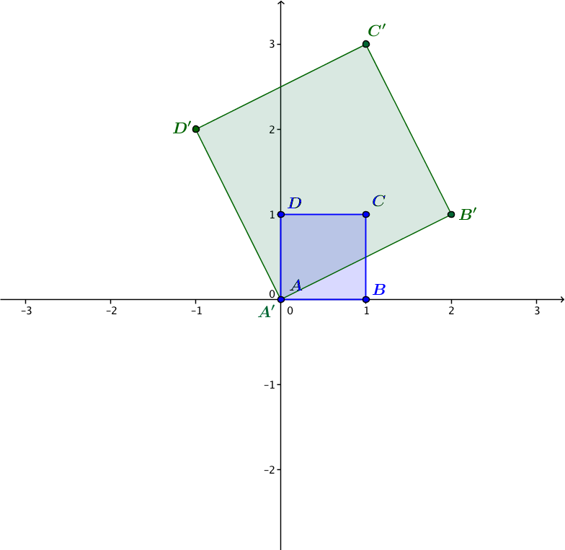
  - Test your conjecture with the unit square on the axes below.

Closing (5 minutes)
Ask one group from each team to share their results from the Exploratory Challenge at the front of the class. Be sure that each group has made the connection that if the transformation is given by $L\left(z\right)=\left(a+bi\right)z$, then the geometric effect of the transformation is to dilate by $|a+bi|$ and to rotate by $arg(a+bi)$.

Exit Ticket (4 minutes)

Name Date
Lesson 14: Discovering the Geometric Effect of Complex Multiplication

Exit Ticket

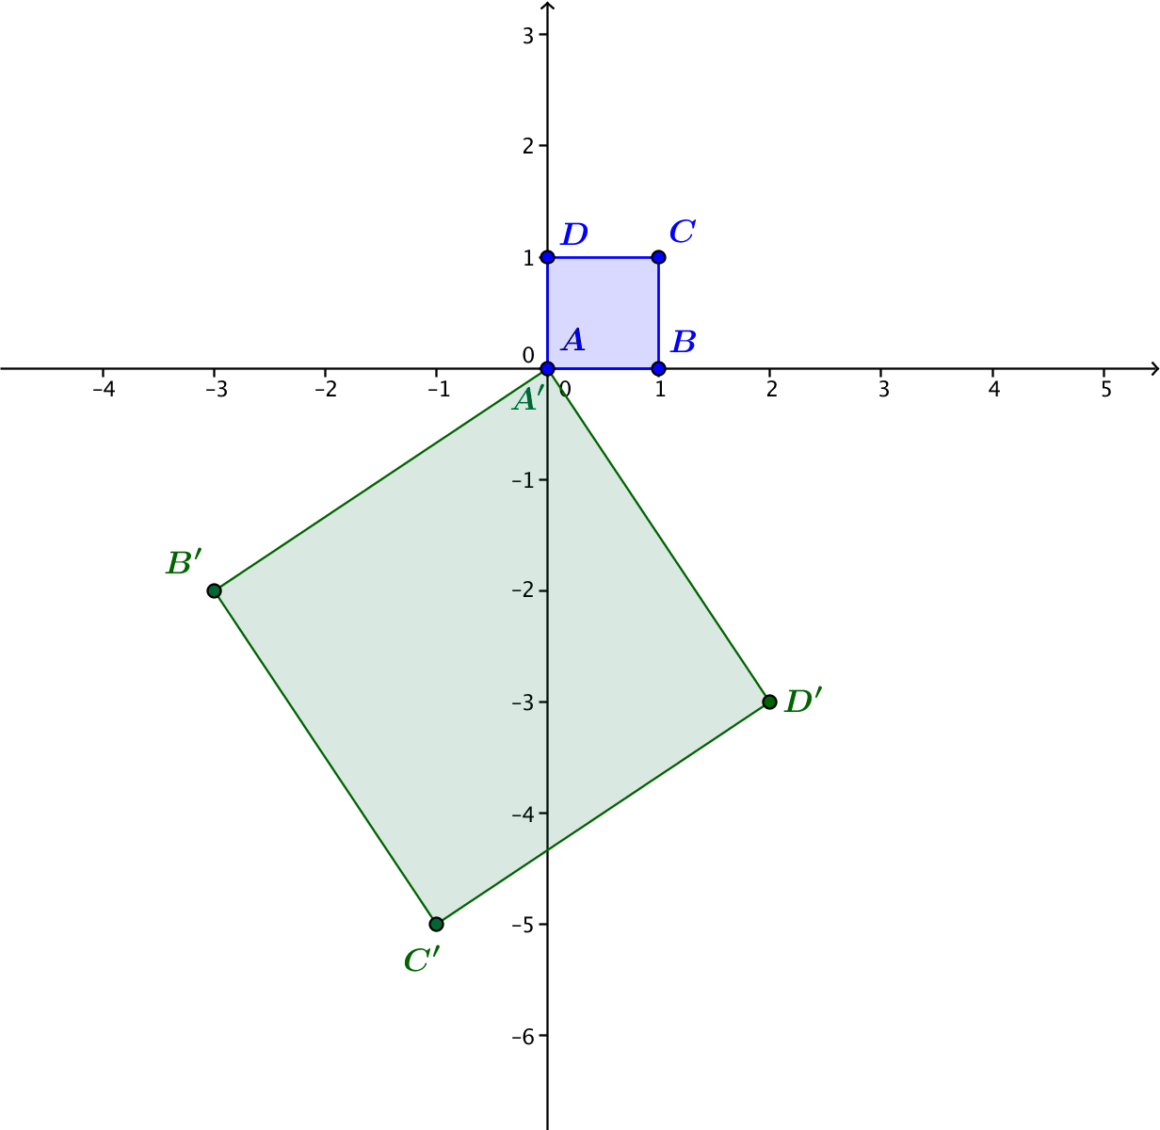
- Identify the linear transformation $L$ that takes square $ABCD$ to square $A'B'C'D'$ as shown in the figure on the right.

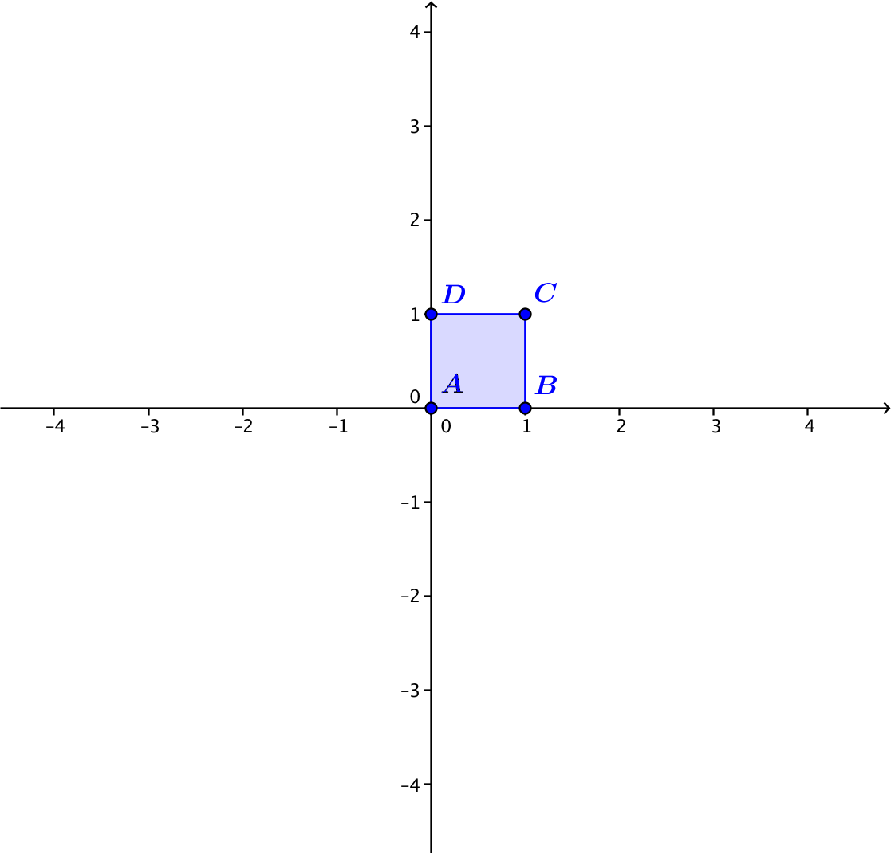
- Describe the geometric effect of the transformation $L\left(z\right)=(1-3i)z$ on the unit square $ABCD$, where
$A=0$, $B=1$, $C=1+i$, and $D=i$. Sketch the unit square transformed by $L$ on the axes at right.

Exit Ticket Sample Solutions

- Identify the linear transformation $L$ that takes square $ABCD$ to square $A'B'C'D'$ as shown in the figure on the right.
The transformation $L$ takes the point $B=1$ to the point $B^{'}=-3-2i$, so this transformation is given by
$L\left(z\right)=\left(-3-2i\right)z$.

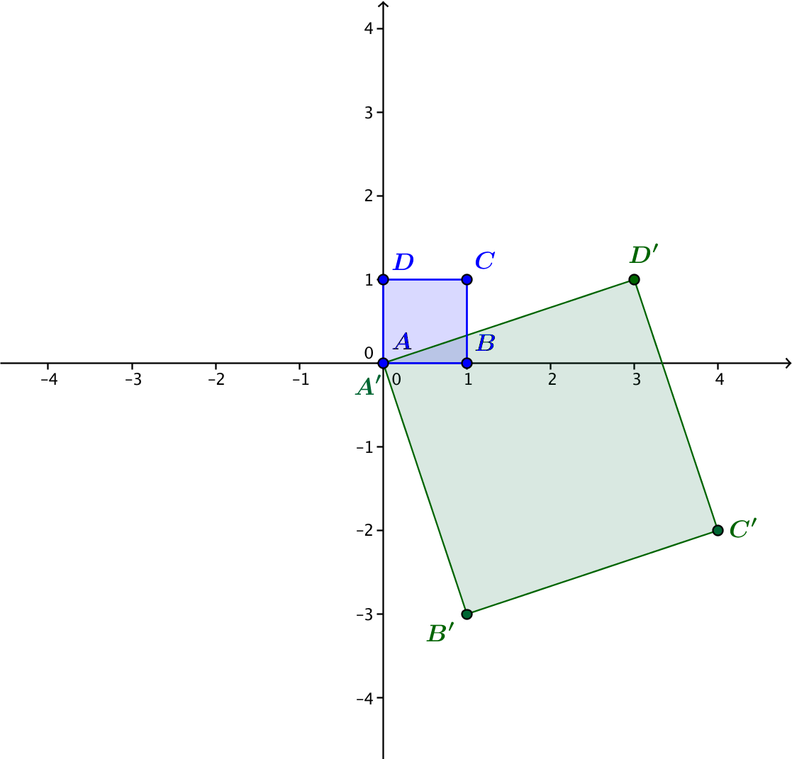
- Describe the geometric effect of the transformation $L\left(z\right)=(1-3i)z$ on the unit square $ABCD$, where
$A=0$, $B=1$, $C=1+i$, and $D=i$. Sketch the unit square transformed by $L$ on the axes at right.
This transformation dilates by $\left|1-3i\right|=\sqrt{1^{2}+3^{2}}=\sqrt{10}$, and rotates counterclockwise by $arg(1-3i)$.

Problem Set Sample Solutions

- Find the modulus and argument for each of the following complex numbers.
  - $z_{1}=\frac{\sqrt{3}}{2}+\frac{1}{2}i$
$\left|\frac{\sqrt{3}}{2}+\frac{1}{2}i\right|=1$, $z_{1}$is in quadrant $1$; thus, $arg\left(z_{1}\right)=arctan\left(\frac{\frac{ 1 }{ 2 }}{ \frac{\sqrt{3} }{ 2 } }\right)=30°=\frac{π}{6}rad$.

  - $z_{2}=2+2\sqrt{3}i$
$\left|2+2\sqrt{3}i\right|=4$, $z_{2}$is in quadrant$1$; thus, $arg\left(z_{2}\right)=arctan\left(\frac{2\sqrt{3} }{ 2 }\right)=60°=\frac{π}{3} rad$.

  - $z_{3}=-3+5i$
$\left|3+5i\right|=\sqrt{34}$, $z_{3}$ is in quadrant $2$; thus, $arg\left(z\right)=π-arctan\left(\frac{5}{3}\right)≈π-1.030≈2.112 rad$.

  - $z_{4}=-2-2i$
$\left|-2-2i\right|=2\sqrt{2}$, $z_{4}$ is in quadrant $3$; thus, $arg\left(z_{4}\right)=π+arctan\left(\frac{2}{2}\right)=π+\frac{ π }{ 4 } =\frac{ 5π }{ 4 } rad$.

  - $z_{5}=4-4i$
$\left|4+4i\right|=4\sqrt{2}$, $z_{5}$ is in quadrant $4$; thus, $arg\left(z_{5}\right)=2π-arctan\left(\frac{4}{4}\right)=2π-\frac{ π }{ 4 }=\frac{ 7π }{ 4 } rad$.

  - $z_{6}=3-6i$
$\left|3-6i\right|=3\sqrt{5}$, $z_{6}$ is in quadrant $4$; thus, $arg\left(z_{6}\right)=2π-arctan\left(\frac{6}{3}\right)=2π-1.107=5.176 rad$.

- For parts (a)–(c), determine the geometric effect of the specified transformation.
  - $L\left(z\right)=-3z$
The transformation $L$ dilates by $3$ and rotates by $180°$ about the origin.

  - $L\left(z\right)=-100z$
The transformation $L$ dilates by $100$ and rotates by $180°$ about the origin.

  - $L\left(z\right)=-\frac{1}{3}z$
The transformation $L$ dilates by$\frac{1}{3}$ and rotates by $180°$ about the origin.

  - Describe the geometric effect of the transformation $L\left(z\right)=az$ for any negative real number $a$.
The transformation $L$ dilates by $\left|a\right|$ and rotates by $180°$ about the origin.

- For parts (a)–(c), determine the geometric effect of the specified transformation.
  - $L\left(z\right)=\left(-3i\right)z$
The transformation $L$ dilates by $3$ and rotates counterclockwise by $270°$ about the origin.

  - $L\left(z\right)=\left(-100i\right)z$
The transformation $L$ dilates by $100$ and rotates by $270°$ about the origin.

  - $L\left(z\right)=\left(-\frac{1}{3}i\right)z$
The transformation $L$ dilates by$\frac{1}{3}$ and rotates counterclockwise by $270°$ about the origin.

  - Describe the geometric effect of the transformation $L\left(z\right)=\left(bi\right)z$ for any negative real number $b$.
The transformation $L$ dilates by $\left|b\right|$ and rotates by $270°$ counterclockwise about the origin.
- Suppose that we have two linear transformations $L_{1}\left(z\right)=3z$ and $L_{2}(z)=(5i)z$.
  - What is the geometric effect of first performing transformation $L_{1}$, and then performing transformation $L_{2}$?
The transformation $L_{1}$ dilates by $3$, dilates by $5$, and rotates by $90°$ counterclockwise about the origin.

  - What is the geometric effect of first performing transformation $L_{2}$, and then performing transformation$L_{1}$?
The transformation $L_{1}$ dilates by $5$, rotates by $90°$ counterclockwise about the origin, and then dilates by $3$.

  - Are your answers to parts (a) and (b) the same or different? Explain how you know.
The answers are the same.
$L_{2}\left(L_{1}(z)\right)=\left(5i\right)L_{1}(z)=\left(5i\right)(3z)=(15i)z$. $L_{1}\left(L_{2}(z)\right)=3L_{2}(z)=3\left(\left(5i\right)z\right)=(15i)z$.
For example, let $z=2-3i$.
$$L_{1}=3\left(2-3i\right)=6-9i$$
$$L_{2}=\left(5i\right)\left(2-3i\right)=15+10i$$
$L_{2}\left(L_{1}\right)=\left(5i\right)\left(6-9i\right)=45+30i$
$$L_{1}\left(L_{2}\right)=3\left(15+10i\right)=45+30i$$

- Suppose that we have two linear transformations $L_{1}\left(z\right)=\left(4+3i\right)z$ and $L_{2}\left(z\right)=-z$. What is the geometric effect of first performing transformation $L_{1}$, and then performing transformation $L_{2}$?
We have $\left|4+3i\right|=5$, and the argument of $4+3i$ is $arctan\left(\frac{3}{4}\right)≈0.644$ radians, which is about $36.87°$. Therefore, the transformation $L_{1}$followed by$L_{2}$ dilates with scale factor $5$, rotates by approximately $36.87°$ counterclockwise, and then rotates by $180°.$

- Suppose that we have two linear transformations $L_{1}\left(z\right)=(3-4i)z$ and $L_{2}\left(z\right)=-z$. What is the geometric effect of first performing transformation $L_{1}$, and then performing transformation $L_{2}$?
We see that $\left|3-4i\right|=5$, and the argument of $3-4i$ is $arctan\left(\frac{4}{3}\right)≈2π-5.356$ radians, which is about $306.87°$. Therefore, the transformation $L_{1}$ followed by$L_{2}$ dilates with scale factor $5$, rotates by approximately $306.87°$ counterclockwise, and then rotates by $180°$.

- Explain the geometric effect of the linear transformation $L\left(z\right)=\left(a-bi\right)z$, where $a$ and $b$ are positive real numbers.
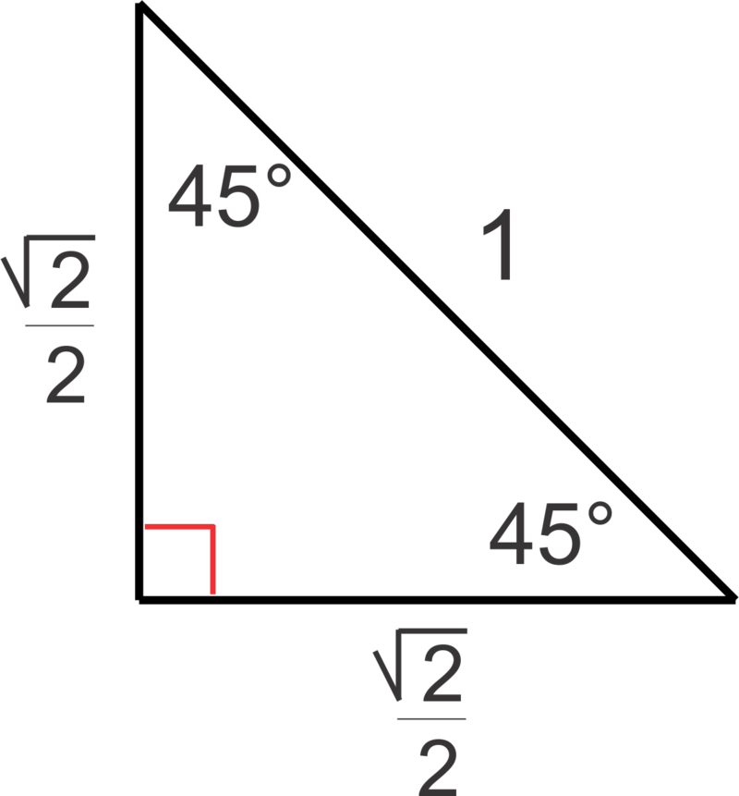
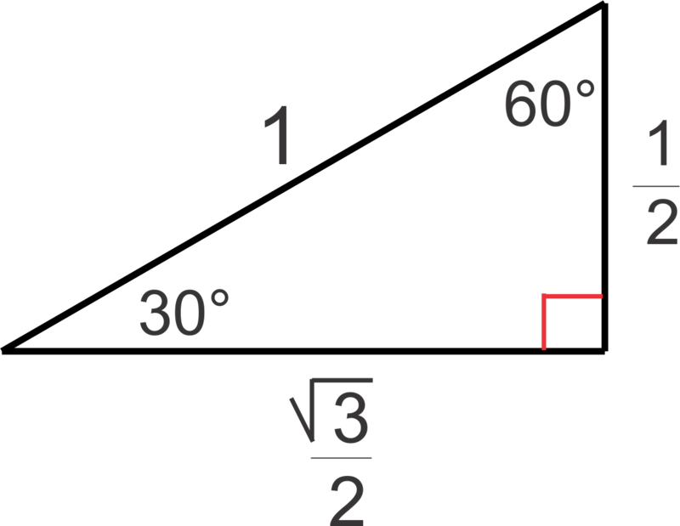
Note that complex number $a-bi$ is represented by a point in the fourth quadrant. The transformation $L$ dilates with scale factor $\left|a-bi\right|$ and rotates counterclockwise by $2π-arctan\left(\frac{b}{a}\right)$.

- In Geometry, we learned the special angles of a right triangle whose hypotenuse is $1$ unit. The figures are shown above. Describe the geometric effect of the following transformations.
  - $L_{1}(z)=\left(\frac{\sqrt{3}}{2}+\frac{1}{2}i\right)z$
$$\left|\frac{\sqrt{3}}{2}+\frac{1}{2}i\right|=1\text{, } arg\left(z\right)=30°=\frac{π}{6}rad$$
The transformation $L_{1}$rotates counterclockwise by $30°$.

  - $L_{2}(z)=\left(2+2\sqrt{3}i\right)z$
$$\left|2+2\sqrt{3}i\right|=4\text{,} arg\left(z\right)=60°=\frac{π}{3} rad$$
The transformation $L_{2}$dilates with scale factor $4$ and rotates counterclockwise by $60°$.

  - $L_{3}(z)=\left(\frac{\sqrt{2}}{2}+\frac{\sqrt{2}}{2}i\right)z$
$$\left|\frac{\sqrt{2}}{2}+\frac{\sqrt{2}}{2}i\right|=1\text{,} arg\left(z\right)=45°=\frac{π}{4} rad$$
The transformation $L_{3}$dilates by $1$ and rotates counterclockwise by $45°$.

  - $L_{4}(z)=\left(4+4i\right)z$
$$\left|4+4i\right|=4\sqrt{2}\text{, } arg\left(z\right)=45°=\frac{π}{4} rad$$
The transformation $L_{4}$dilates with scale factor $4\sqrt{2}$ and rotates counterclockwise by $45°$.

- Recall that a function $L$ is a linear transformation if all $z$ and$w$ in the domain of $L$ and all constants $a$ meet the following two conditions:
    - $L\left(z+w\right)=L\left(z\right)+ L(w)$
    - $L\left(az\right)=aL(z)$
Show that the following functions meet the definition of a linear transformation.
  - $L_{1}\left(z\right)=4z$
$$L_{1}\left(z+w\right)=4\left(z+w\right)=4z+4w=L_{1}\left(z\right)+L_{1}\left(w\right) \\ L_{1}\left(az\right)=4\left(az\right)=4az=a\left(4z\right)=aL_{1}\left(z\right)$$

  - $L_{2}\left(z\right)=iz$
$$L_{2}\left(z+w\right)=i\left(z+w\right)=iz+iw=L_{2}\left(z\right)+L_{1}\left(w\right) \\ L_{2}\left(az\right)=i\left(az\right)=iaz=a\left(iz\right)=aL_{2}\left(z\right)$$

  - $L_{3}(z)=(4+i)z$
$$L_{3}\left(z+w\right)=(4+i)\left(z+w\right)=(4+i)z+(4+i)w=L_{3}\left(z\right)+L_{3}\left(w\right) \\ L_{3}\left(az\right)=(4+i)\left(az\right)=(4+i)az=a\left((4+i)z\right)=aL_{3}\left(z\right)$$

- The vertices $A\left(0, 0\right)$,$B\left(1, 0\right)$,$C\left(1, 1\right)$,$D(0, 1)$ of a unit square can be represented by the complex numbers $A=0$, $B=1$,$C=1+i$,$D=i$. We learned that multiplication of those complex numbers by $i$ rotates the unit square by $90°$ counterclockwise. What do you need to multiply by so that the unit square will be rotated by $90°$ clockwise?
We need to multiply by $i^{3}=-i$.

