Lesson 14: Discovering the Geometric Effect of Complex Multiplication

Classwork
Exercises
The vertices $A(0,0)$, $B(1,0)$, $C(1,1)$, and $D(0,1)$ of a unit square can be represented by the complex numbers $A=0$, $B=1$, $C=1+i$, and $D=i$.
- Let $L_{1}\left(z\right)=-z.$
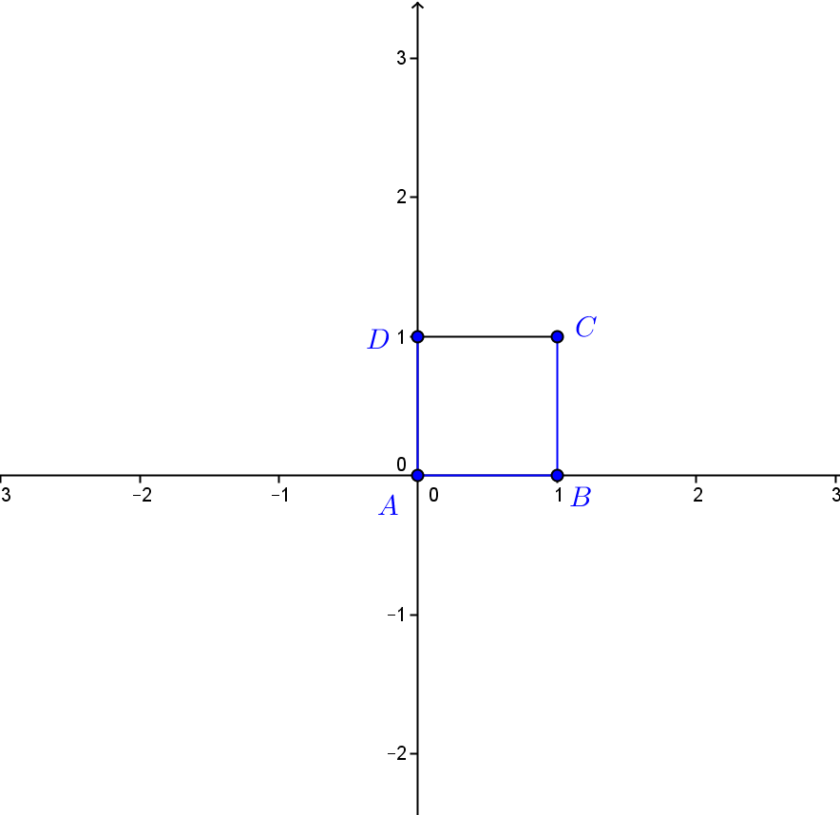
  - Calculate $A'=L_{1}(A)$, $B'=L_{1}\left(B\right)$,$C'=L_{1}\left(C\right)$, and $D'=L_{1}(D)$. Plot these four points on the axes.

  - Describe the geometric effect of the linear transformation $L_{1}\left(z\right)=-z$ on the square $ABCD$.

- Let $L_{2}\left(z\right)=2z.$
  - Calculate $A'=L_{2}(A)$, $B'=L_{2}\left(B\right)$,$C'=L_{2}\left(C\right)$, and $D'=L_{2}(D)$. Plot these four points on the axes.

  - Describe the geometric effect of the linear transformation $L_{2}\left(z\right)=2z$ on the square $ABCD$.

- Let $L_{3}\left(z\right)=iz.$
  - Calculate $A'=L_{3}(A)$, $B'=L_{3}\left(B\right)$,$C'=L_{3}\left(C\right)$, and $D'=L_{3}(D)$. Plot these four points on the axes.

  - Describe the geometric effect of the linear transformation $L_{3}\left(z\right)=iz$ on the square $ABCD$.

- Let $L_{4}\left(z\right)=(2i)z.$
  - Calculate $A'=L_{4}(A)$, $B'=L_{4}\left(B\right)$,$C'=L_{4}\left(C\right)$, and $D'=L_{4}(D)$. Plot these four points on the axes.

  - Describe the geometric effect of the linear transformation $L_{4}\left(z\right)=(2i)z$ on the square $ABCD$.

- Explain how transformations $L_{2}$, $L_{3}$, and $L_{4}$ are related.

- We will continue to use the unit square $ABCD$ with $A=0$,$B=1$, $C=1+I$, $D=i$ for this exercise.
  - What is the geometric effect of the transformation $L\left(z\right)=5z$ on the unit square?

  - What is the geometric effect of the transformation $L\left(z\right)=(5i)z$ on the unit square?

  - What is the geometric effect of the transformation $L\left(z\right)={(5i}^{2})z$ on the unit square?

  - What is the geometric effect of the transformation $L\left(z\right)={(5i}^{3})z$ on the unit square?

  - What is the geometric effect of the transformation $L\left(z\right)=(5i^{4})z$ on the unit square?

  - What is the geometric effect of the transformation $L\left(z\right)={(5i}^{5})z$ on the unit square?

  - What is the geometric effect of the transformation $L\left(z\right)={(5i}^{n})z$ on the unit square, for some integer
$n≥0$?

Exploratory Challenge
Your group has been assigned either to the 1-team, 2-team, 3-team, or 4-team. Each team will answer the questions below for the transformation that corresponds to their team number:
$$L_{1}\left(z\right)=\left(3+4i\right)z \\ L_{2}\left(z\right)=\left(-3+4i\right)z \\ L_{3}\left(z\right)=\left(-3-4i\right)z \\ L_{4}\left(z\right)=\left(3-4i\right)z.$$
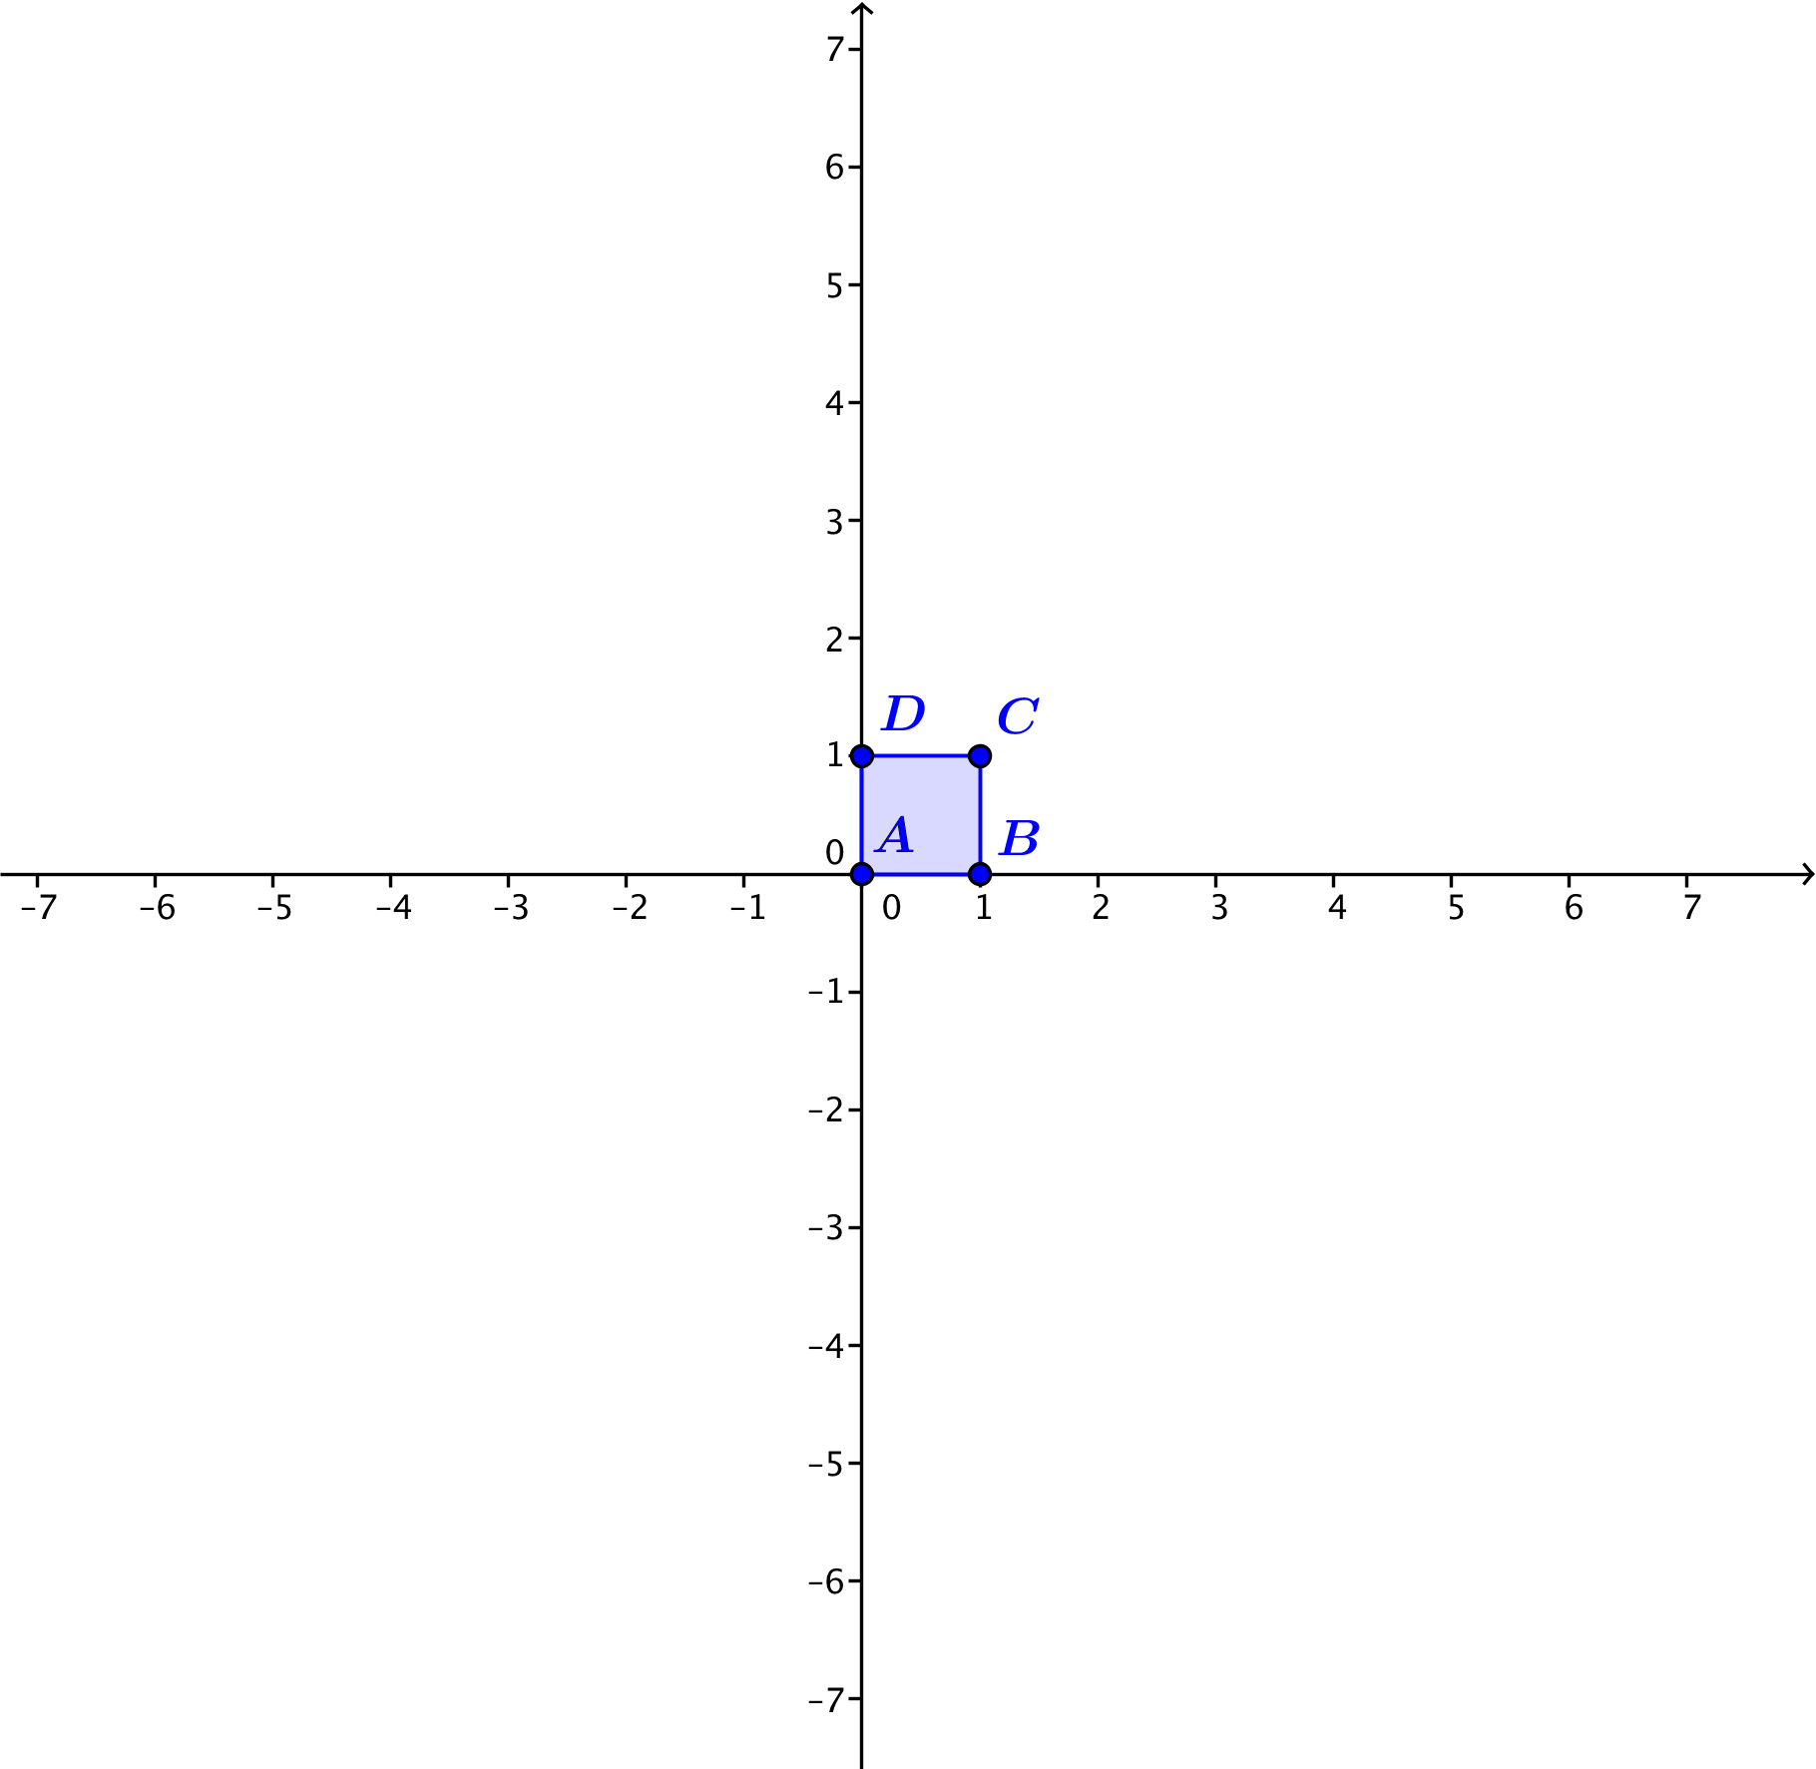
The unit square unit square $ABCD$ with $A=0$,$B=1$, $C=1+i$, $D=i$ is shown below. Apply your transformation to the vertices of the square $ABCD$ and plot the transformed points $A'$, $B'$, $C'$, and $D'$ on the same coordinate axes.

For the 1-team:  - Why is $B^{'}=3+4i$?  - What is the argument of $3+4i$?  - What is the modulus of $3+4i$? | For the 2-team:  - Why is $B^{'}=-3+4i$?  - What is the argument of $-3+4i$?  - What is the modulus of $-3+4i$?
For the 3-team:  - Why is $B^{'}=-3-4i$?  - What is the argument of $-3-4i$?  - What is the modulus of $-3-4i$? | For the 4-team:  - Why is $B^{'}=3-4i$?  - What is the argument of $3-4i$?  - What is the modulus of $3-4i$?
All groups should also answer the following:
  - Describe the amount the square has been rotated counterclockwise.

  - What is the dilation factor of the square? Explain how you know.

  - What is the geometric effect of your transformation $L_{1}$, $L_{2}$, $L_{3}$, or $L_{4}$ on the unit square $ABCD$?

  - Make a conjecture: What do you expect to be the geometric effect of the transformation $L\left(z\right)=\left(2+i\right)z$ on the unit square $ABCD$?

  - Test your conjecture with the unit square on the axes below.
Problem Set

- Find the modulus and argument for each of the following complex numbers.
  - $z_{1}=\frac{\sqrt{3} }{ 2 }+\frac{ 1 }{ 2 }i$
  - $z_{2}=2+2\sqrt{3}i$
  - $z_{3}=-3+5i$
  - $z_{4}=-2-2i$
  - $z_{5}=4-4i$
  - $z_{6}=3-6i$

- For parts (a)–(c), determine the geometric effect of the specified transformation.
  - $L\left(z\right)=-3z$
  - $L\left(z\right)=-100z$
  - $L\left(z\right)=-\frac{1}{3}z$
  - Describe the geometric effect of the transformation $L\left(z\right)=az$ for any negative real number $a$.

- For parts (a)–(c), determine the geometric effect of the specified transformation.
  - $L\left(z\right)=\left(-3i\right)z$
  - $L\left(z\right)=\left(-100i\right)z$
  - $L\left(z\right)=\left(-\frac{1}{3}i\right)z$
  - Describe the geometric effect of the transformation $L\left(z\right)=\left(bi\right)z$ for any negative real number $b$.

- Suppose that we have two linear transformations $L_{1}\left(z\right)=3z$ and $L_{2}(z)=(5i)z$.
  - What is the geometric effect of first performing transformation $L_{1}$, and then performing transformation $L_{2}$?
  - What is the geometric effect of first performing transformation $L_{2}$, and then performing transformation$L_{1}$?
  - Are your answers to parts (a) and (b) the same or different? Explain how you know.

- Suppose that we have two linear transformations $L_{1}\left(z\right)=\left(4+3i\right)z$ and $L_{2}\left(z\right)=-z.$ What is the geometric effect of first performing transformation $L_{1}$, and then performing transformation $L_{2}$?

- Suppose that we have two linear transformations $L_{1}\left(z\right)=(3-4i)z$ and $L_{2}\left(z\right)=-z.$ What is the geometric effect of first performing transformation $L_{1}$, and then performing transformation $L_{2}$?

- Explain the geometric effect of the linear transformation $L\left(z\right)=\left(a-bi\right)z$, where $a$ and $b$ are positive real numbers.
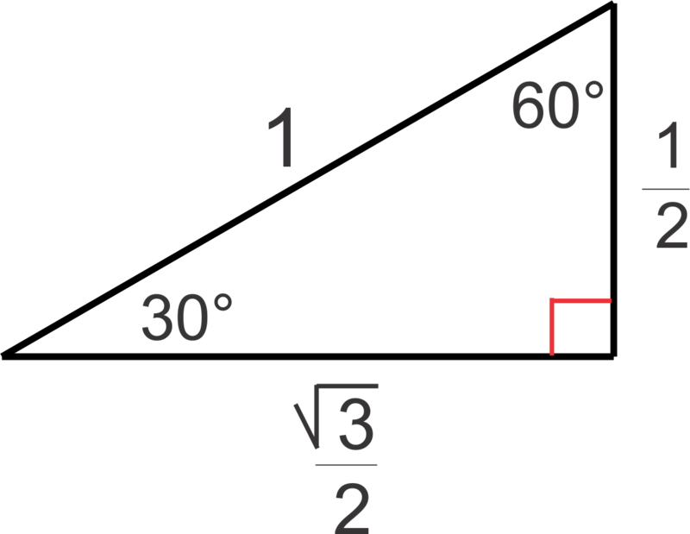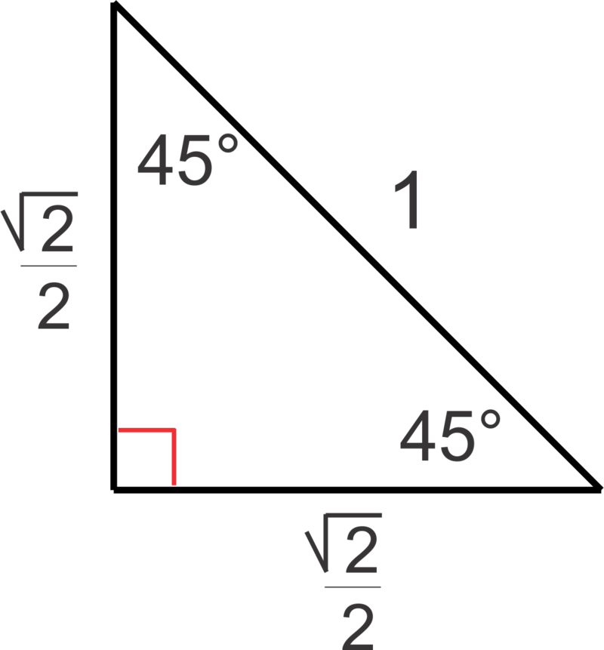

- In Geometry, we learned the special angles of a right triangle whose hypotenuse is $1$ unit. The figures are shown above. Describe the geometric effect of the following transformations.
  - $L_{1}(z)=\left(\frac{\sqrt{3}}{2}+\frac{1}{2}i\right) z$
  - $L_{2}(z)=\left(2+2\sqrt{3}i\right)z$
  - $L_{3}(z)=\left(\frac{\sqrt{2}}{2}+\frac{\sqrt{2}}{2}i\right)z$
  - $L_{4}(z)=\left(4+4i\right)z$

- Recall that a function $L$ is a linear transformation if all $z$ and$w$ in the domain of $L$ and all constants $a$ meet the following two conditions:
    - $L\left(z+w\right)=L\left(z\right)+ L(w)$
    - $L\left(az\right)=aL(z)$
Show that the following functions meet the definition of a linear transformation.
  - $L_{1}\left(z\right)=4z$
  - $L_{2}\left(z\right)=iz$
  - $L_{3}(z)=(4+i)z$

- The vertices $A\left(0, 0\right)$,$B\left(1, 0\right)$,$C\left(1, 1\right)$,$D(0, 1)$ of a unit square can be represented by the complex numbers $A=0$, $B=1$,$C=1+i$,$D=i$. We learned that multiplication of those complex numbers by $i$ rotates the unit square by $90°$ counterclockwise. What do you need to multiply by so that the unit square will be rotated by $90°$ clockwise?

