Lesson 13: Trigonometry and Complex Numbers

Student Outcomes
- Students represent complex numbers in polar form and convert between rectangular and polar representations.
- Students explain why the rectangular and polar forms of a given complex number represent the same number.

Lesson Notes
This lesson introduces the polar form of a complex number and defines the argument of a complex number in terms of a rotation. This definition aligns with the definitions of the sine and cosine functions introduced in Algebra II Module 2 and ties into work with right triangle trigonometry from Geometry. This lesson continues to emphasize the usefulness of representing complex numbers as transformations. Analysis of the angle of rotation and the scale of the dilation brings a return to topics in trigonometry first introduced in Geometry (G-SRT.C.6, G-SRT.C.7, G-SRT.C.8) and expanded on in Algebra II (FTF.A.1, F-TF.A.2, F-TF.C.8). This lesson reinforces the geometric interpretation of the modulus of a complex number and introduces the notion of the argument of a complex number. When representing a complex number in polar form, it is apparent that every complex number can be thought of simply as a rotation and dilation of the real number 1. In addition to representing numbers in polar form and converting between them, be sure to provide opportunities for students to explain why polar and rectangular forms of a given complex number represent the same number (N-CN.B.4).
You may need to spend some time reviewing with students the work they did in previous courses, particularly as it relates to right-triangle trigonometry, special right triangles and the sine and cosine functions. Sample problems have been provided after the Problem Set for this lesson. Specific areas for additional review and practice include the following:
- Using proportional reasoning to determine the other two sides in a special right triangle when given one side (Geometry, Module 2),
- Finding the acute angle in a right triangle using the arctangent function (Geometry, Module 2),
- Describing rotations in both degrees and radians (Algebra II, Module 2),
- Evaluating the sine and cosine functions at special angles in both degrees and radians (Algebra II, Module 2), and
- Evaluating the sine and cosine functions at any angle using a calculator (Geometry, Module 2 and Algebra II, Module 2).

Classwork
Opening (3 minutes)
Ask students to recall the special right triangles they studied in Geometry and revisited in Algebra II by showing them a diagram with the angles labeled but the side measurements missing. Have them fill in the missing side lengths and explain their reasoning to a partner. Check for understanding by adding the side lengths to the diagrams on the board, and then direct students to record these diagrams in their notes. Display these diagrams prominently in your classroom for student reference. Announce that these relationships will be very helpful as they work through today’s lesson.

Opening Exercise (5 minutes)
The Opening Exercise reviews two key concepts from the previous lesson: (1) each complex number$a+bi$ corresponds to a point $(a,b)$, and (2) the modulus of a complex number is given by $\sqrt{a^{2}+b^{2}}$. The last part of the Opening Exercise asks students to think about a rotation that will take a ray from the origin initially containing the real number $1$ to its image from the origin passing through the point $(a,b)$. The measurements of the rotation for the different points representing the different numbers should be fairly obvious to students. However, as they work, you may need to remind them of the special right triangles they just discussed. These exercises should be done with a partner or with a small group. Use the discussion questions that follow to guide students as they work.
- Describe the location of the ray from the origin containing the real number $1$.
  - It lies along the positive $x$-axis with endpoint at the origin.
- How can you determine the amount of rotation $z_{1}$ and $z_{2}$?
  - The points along the axes were one-fourth and one-half a complete rotation, which is $360°$.
Scaffolding:
- Provide additional practice problems working with special right triangles.
- Project the diagram on the board and draw in the rays and sides of a right triangle to help students see the geometric relationships for $z_{3}$ and $z_{4}$.
- Encourage students to label vertical and horizontal distances using the values of $a$ and $b$.

- How can you determine the amount of rotation for $z_{3}$ and $z_{4}$?
  - The values of $a$ and $b$ formed the legs of a special right triangle. From there, since $z_{3}$ was located in the first quadrant, the rotation was just $45°$. For $z_{4}$, you would need to subtract $60°$ from $360°$ to give a positive counterclockwise rotation of $300°$, or use a clockwise rotation of $-60°$.
- How did you determine the modulus?
  - The modulus is given by the expression $\sqrt{a^{2}+b^{2}}$.
When students are finished, have one or two of them present their solutions for each complex number. Emphasize the use of special triangles to determine the degrees of rotation for complex numbers not located along an axis. For additional scaffolding, you may need to draw in the ray from the origin containing the real number $1$ and the rotated ray from the origin that contains the point $(a,b)$ for each complex number.
Opening Exercise
For each complex number shown below, answer the following questions. Record your answers in the table.
  - What are the coordinates $(a,b)$ that correspond to this complex number?
  - What is the modulus of the complex number?
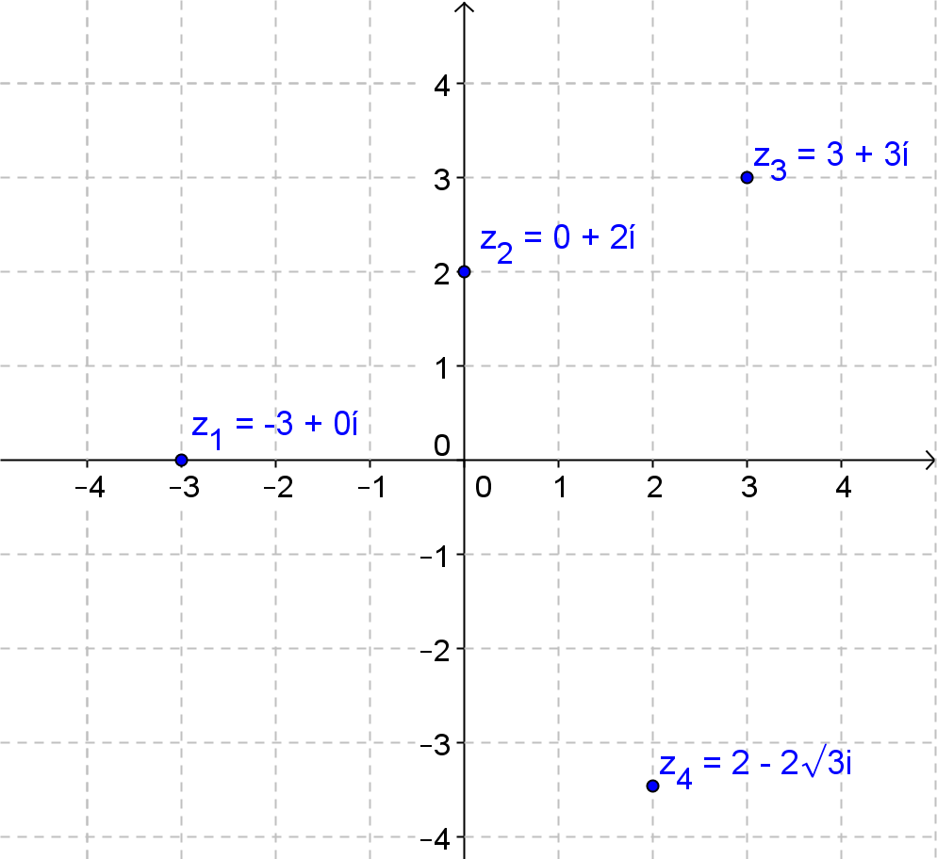
  - Suppose a ray from the origin that contains the real number $1$ is rotated $θ°$ so it passes through the point $(a,b)$. What is a value of $θ$?

Complex Number | $$(a,b)$$ | Modulus | Degrees of Rotation $θ°$
$$z_{1}=-3+0i$$ | $$(-3,0)$$ | $$3$$ | $$180°$$
$$z_{2}=0+2i$$ | $$(0,2)$$ | $$2$$ | $$90°$$
$$z_{3}=3+3i$$ | $$(3,3)$$ | $$3\sqrt{2}$$ | $$45°$$
$$z_{4}=2-2\sqrt{3}i$$ | $$(2,-2\sqrt{3})$$ | $$4$$ | $$300°$$

As students present their solutions, ask if anyone has a different answer for the number of degrees of the rotation and lead a discussion so students understand that the degrees of rotation has more than one possible answer and in fact there are infinitely many possible answers.
MP.3
- Another student said that a clockwise rotation of $270°$ would work for $z_{2}$? Do you agree or disagree. Explain.
  - I agree, this rotation also takes the initial ray from the origin to a ray containing the point $0+2i$. If a complete rotation is $360°$, then $270°$ clockwise would be the same as $90°$ counterclockwise.
At this point, you may remind students that positive rotations are counterclockwise and that rotation in the opposite direction is denoted using negative numbers.
Exercises 1–2 (5 minutes)
These exercises help students understand why the values of the argument of a complex number are limited to real numbers on the interval $0°≤θ<360°$. College-level mathematics courses make a distinction between the argument of a complex number between $0$ and $360$ and the set of all possible arguments of a given complex number.
Scaffolding:
Help students to generalize the expression by organizing the angles into a table (MP.8).
$$n$$ | Degrees of rotation
$$0$$ | $$45$$
$$1$$ | $$45+360$$
$$2$$ | $$45+360(2)$$
$$3$$ | $$45+360(3)$$

Exercises 1–2
- Can you find at least two additional rotations that would map a ray from the origin through the real number $1$ to a ray from the origin passing through the point $(3,3)$?
This is the number $z_{3}=3+3i$ from the Opening Exercise. Additional rotations could be $45°+360°=405°$ or $45°-360°=-315°$.

- How are the rotations you found in Exercise 1 related?
All rotations that take the initial ray to the ray described above must be of the form $45°+360°n$ for integer values of $n$.

After reviewing possible solutions to the questions above, pose this next question. You may want to write it on the board. Give students a few minutes to think about their response individually and then have them discuss it with their partner or group members before sharing responses as a whole class.
- Do you think it is possible to describe a complex number in terms of its modulus and the degrees of rotation of a ray from the origin containing the real number $1$? Justify your reasoning.
  - Student responses will vary. In general, the response should be yes but careful students should note the difficulty of uniquely defining degrees of rotation. The modulus will be a distance from the origin and if we want to be precise, we may need to limit the possible degrees of rotation to a subset of the real numbers such as $0°≤θ<360°$.

Discussion (3 minutes)
Exercises 2 and 3 show you that the rotation that maps a ray from the origin containing the real number $1$ to a ray containing a given complex number is not unique. If you know one rotation, you can write an expression that represents all the rotations of a given complex number $z$. However, if we limit the rotations to an interval that comprises one full rotation of the initial ray then we can still describe every complex number in terms of its modulus and a rotation.
Introduce the modulus and argument of a complex number.

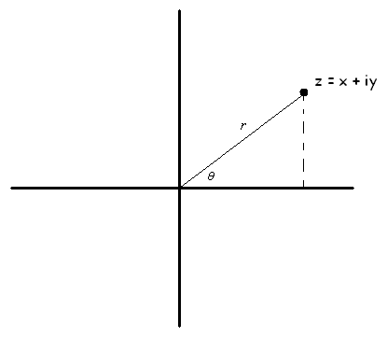
Every complex number $z=x+yi$ appears as a point on the complex plane with coordinates $(x,y)$ as a point in the coordinate plane.
$$z=x+yi$$
In the diagram above, notice that each complex number $z$ has a distance $r$ from the origin to the point $(x,y)$ and a rotation of $θ°$ that maps the ray from the origin along the positive real axis to the ray passing through the point $(x,y)$.
Argument of the complex number $z$: The argument of the complex number $z$ is the radian (or degree) measure of the counterclockwise rotation of the complex plane about the origin that maps the initial ray (i.e., the ray corresponding to the positive real axis) to the ray from the origin through the complex number $z$ in the complex plane. The argument of $z$ is denoted $\arg\left(z\right)$.
Modulus of a complex number $z$: The modulus of a complex number $z$, denoted $|z|$, is the distance from the origin to the point corresponding to $z$ in the complex plane. If $z=a+bi$, then $\left|z\right|=\sqrt{a^{2}+b^{2}}$.

- Is “modulus” indeed the right word? Does $r=\left|z\right|$ as we defined it in previous lessons?
  - Yes, since $r$ is the distance from the origin to the point $(x,y)$, which is $\sqrt{x^{2}+y^{2}}$, which is also how we define the modulus of a complex number.
- Why are we limiting the argument to a subset of the real numbers?
  - We only need these angles to sweep through all possible points in the coordinate plane. If we allowed the argument to be any real number, there would be many possible arguments for any given complex number.

Example 1 (4 minutes): The Polar Form of a Complex Number
This example models how the polar form of a complex number is derived using the sine and cosine functions that students studied in Algebra II. Use the questions on the student materials to guide your discussion. The definitions from Algebra II are provided below for teacher reference.
Sine function: The sine function, $\sin{: R→R}$, can be defined as follows:
Let $θ$ be any real number. In the Cartesian plane, rotate the initial ray by $θ$ radians about the origin. Intersect the resulting terminal ray with the unit circle to get a point $(x_{θ},y_{θ})$. The value of $\sin\left(θ\right)$ is $y_{θ}$.
Cosine function: The cosine function, $\cos{: R→R}$, can be defined as follows:
Let $θ$ be any real number. In the Cartesian plane, rotate the initial ray by $θ$ radians about the origin. Intersect the resulting terminal ray with the unit circle to get a point $(x_{θ},y_{θ})$. The value of $\cos{(θ)}$ is $x_{θ}$.
- What do you recall about the definitions of the sine function and the cosine function from Algebra II?
  - The sine function is the $y$-coordinate of a point and the cosine function was the $x$-coordinate of the intersection point of a ray rotated $θ$ radians about the origin and the unit circle.
- How can the sine and cosine functions help us to relate the point $(x,y)$ to modulus $r$ and the argument $θ$?
  - The coordinates $(x,y)$ can be expressed in terms of the cosine and sine using the definition of the sine and cosine functions and dilating them along the terminal ray by a factor of $r$.
- Why would it make sense to use these functions to relate a complex number in $a+bi$ form to one described by its modulus and argument?
  - The modulus is a distance from the origin to the point $(a,b)$ and the argument is the basically the same type of rotation described in the definitions of the sine and cosine functions.
Example 1: The Polar Form of a Complex Number
Derive a formula for a complex number in terms of its modulus $r$ and argument $θ$.
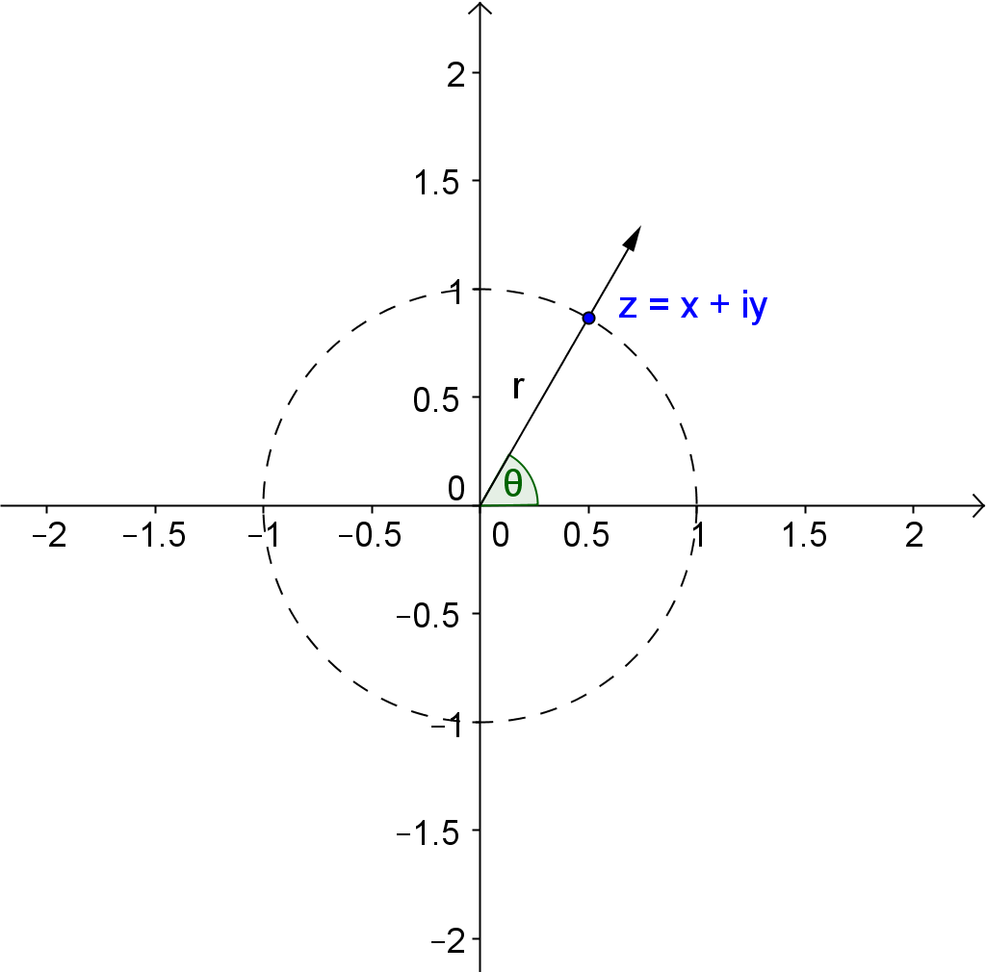
MP.2
&
MP.7
z = x + yi
Suppose that $z$ has coordinates $(x,y)$ that lie on the unit circle as shown.
  - What is the value of $r$ and what are the coordinates of the point $(x,y)$ in terms of $θ$? Explain how you know.
The value of $r$ is $1$. The coordinates of the point are $\left(\cos\left(θ\right), \sin\left(θ\right)\right)$. The definition of the sine and cosine function says that a point on the unit circle where a rotated ray intersects the unit circle has these coordinates.

  - If $r=2$, what would be the coordinates of the point $(x,y)$? Explain how you know.
The coordinates would be $\left(2 cos\left(θ\right), 2 sin\left(θ\right)\right)$ because the point lies along the same ray but are just dilated by a scale factor of two along the ray from the origin compared to when $r=1$.

  - If $r=20$, what would be the coordinates of the point $(x,y)$? Explain how you know.
The coordinates would be $(20\cos\left(θ\right), 20\sin\left(θ\right))$ because a circle of radius $20$ units would be similar to a circle with radius $1$ but dilated by a factor of $20$.

  - Use the definitions of sine and cosine to write coordinates of the point $(x,y)$ in terms of cosine and sine for any $r≥0$ and real number $θ$.
$x=r\cos\left(θ\right)$ and $y=r\sin\left(θ\right)$

  - Use your answer to part (d) to express $z=x+yi$ in terms of $r$ and $θ$.
$z=x+yi=r\cos\left(θ\right)+ir\sin\left(θ\right)=r\left(\cos\left(θ\right)+i\sin\left(θ\right)\right)$
MP.2
&
MP.7

Monitor students as they work in small groups to derive the polar form of a complex number from rectangular form. After a few minutes, ask for a few volunteers to share their ideas and then make sure to have students record the derivation shown below in their notes and revise their work to be accurate and precise.
Annotate the diagram above showing that the $x$- and $y$-values correspond to the points on a circle of radius $r$ that is a dilation of the unit circle. Thus, the point $(x,y)$ can be represented as $(r\cos\left(θ\right), r\sin\left(θ\right))$
- The diagram shown above makes us recall the definitions of sine and cosine. We see from the following from diagram:
$x=r\cos{(θ)}$ and $y=r\sin{(θ)}$
- Which means that every complex number can be written in the form:
$$z=x+iy=r\cos{(θ)}+ir\sin{(θ)}=r(\cos\left(θ\right)+i\sin\left(θ\right))$$
Review the definition shown below and then have students work in small groups to answer Exercises 3–6.
Polar form of a complex number: The polar form of a complex number $z$ is $r\left(\cos\left(θ\right)+ i\sin\left(θ\right)\right)$, where $r=|z|$ and
$θ=\arg\left(z\right)$.

Rectangular form of a complex number: The rectangular form of a complex number $z$ is $a+bi$, where $z$ corresponds to the point $(a,b)$ in the complex plane, and $i$ is the imaginary unit. The number $a$ is called the real part of $a+bi$, and the number $b$ is called the imaginary part of $a+bi$.

Use the graphic organizer below to help students make sense of this definition. A blank version is included in the student materials. The graphic organizer has space for up to three examples of complex numbers that can either be completed as a class or assigned to students. Have students work with a partner to provide the polar and rectangular forms of both numbers. Have partners take turns explaining why the polar and rectangular forms of the examples represent the same number.

General Form | Polar Form  $$z=r\left(\cos\left(θ\right)+i\sin\left(θ\right)\right)$$ | Rectangular Form  $$z=a+bi$$
Examples | $$3\left(\cos\left(60°\right)+i\sin\left(60°\right)\right)$$  $$2\left(\cos\left(\frac{π}{2}\right)+i\sin\left(\frac{π}{2}\right)\right)$$ | $$\frac{3}{2}+\frac{3\sqrt{3}}{2}i$$  $$0+2i$$
Key Features | Modulus  $$r$$  Argument  $$θ$$  Coordinate  $$\left(r\cos\left(θ\right), r\sin\left(θ\right)\right)$$ | Modulus  $$\sqrt{a^{2}+b^{2}}$$  Coordinate  $$(a,b)$$  $$a=r\cos\left(θ\right)$$  $$b=r\sin\left(θ\right)$$

Explain to students that this form of a complex number is particularly useful when considering geometric representations of complex numbers. This form clearly shows that every complex number $z$ can be described as a rotation of $θ°$ and a dilation by a factor of $r$ of the real number $1$.

Exercises 3–6 (8 minutes)
Students should complete these exercises with a partner or in small groups. Monitor progress as students work, and offer suggestions if they are struggling to work with the new representation of a complex number.
Exercises 3–6
- Write each complex number from the Opening Exercise in polar form.
Rectangular | Polar Form
$$z_{1}=-3+0i$$ | $$3\left(\cos\left(180°\right)+i\sin\left(180°\right)\right)$$
$$z_{2}=0+2i$$ | $$2\left(\cos\left(90°\right)+i\sin\left(90°\right)\right)$$
$$z_{3}=3+3i$$ | $$3\left(\cos\left(45°\right)+i\sin\left(45°\right)\right)$$
$$z_{4}=2-2\sqrt{3}i$$ | $$3\left(\cos\left(300°\right)+i\sin\left(300°\right)\right)$$

- Use a graph to help you answer these questions.
  - What is the modulus of the complex number $2-2i$?
If you graph the point $(2,-2)$, then the distance between the origin and the point is given by the distance formula so the modulus would be $\sqrt{{\left(2\right)}^{2}+{\left(-2\right)}^{2}}=2\sqrt{2}$.

  - What is the argument of the number $2-2i$?
If you graph the point $(2,-2)$, then the rotation that will take the ray from the origin through the real number $1$ to a ray containing that point will be $315°$ because the point lies on a line from the origin in Quadrant IV that is exactly in between the two axes. The argument would be $315°$. We choose that rotation because we defined the argument to be a number between $0$ and $360$.

  - Write the complex number in polar form.
$$2\sqrt{2}\left(\cos\left(315°\right)+i\sin\left(315°\right)\right)$$

  - Arguments can be measured in radians. Express your answer the answer to part (c) using radians.
In radians, $315°$ is$\frac{7π}{4}$, the number would be
$$2\sqrt{2}\left(\cos\left(\frac{7π}{4}\right)+i\sin\left(\frac{7π}{4}\right)\right)\text{.}$$

  - Explain why the polar and rectangular forms of a complex number represent the same number.
$2-2i$ is thought of as a point with coordinates $(2, -2)$ in the complex plane. The point can also be located by thinking of the ray extending from the origin rotated $315°$. The distance from the origin to the point along that ray is the modulus, which is $2\sqrt{2}$ units.

Debrief Exercises 3 and 4 by having one or two students volunteer their solutions. On Exercise 4, some students may use right-triangle trigonometry while others take a more geometric approach and reason out the value of the argument from the graph and their knowledge of special right triangles. You may need to pause and review radian measure if students are struggling to answer Exercise 4, part (d). When you review these first two exercises, be sure to emphasize why the work from Example 1 validates that the polar and rectangular forms of a complex number represent the same number.
Next, give students a few minutes to work individually on using this new form of a complex number. They will need to approximate the location of a few of these rotations unless you provide them with a protractor. If your class is struggling to evaluate trigonometric functions of special angles, they may use a calculator, a copy of the unit circle, or their knowledge of special triangles to determine the values of $a$ and $b$. Students will need a calculator to answer Exercise 6, part (c).

- State the modulus and argument of each complex number, and then graph it using the modulus and argument.
  - $4(\cos{(120°)}+i\sin{(120°}))$
$r=4$, $θ=120°$

  - $5\left(\cos\left(\frac{π}{4}\right)+i\sin\left(\frac{π}{4}\right)\right)$
$r=5$, $θ=\frac{π}{4}$

  - $3\left(\cos{(190°}\right)+i\sin{(190°}))$
$r=3$, $θ=190°$

- Evaluate the sine and cosine functions for the given values of $θ$, and then express each complex number in rectangular form, $z=a+bi$. Explain why the polar and rectangular forms represent the same number.
  - $4(\cos{(120°)}+i\sin{(120°}))$
$$4\left(-\frac{1}{2}+\frac{\sqrt{3}i}{2}\right)=-2+2\sqrt{3}i$$
The polar form of a complex number and the rectangular form represent the same number because they both give you the same coordinates of a point that represents the complex number. In this example, $4$ units along a ray from the origin rotated $120°$ corresponds to the coordinate $(-2,2\sqrt{3})$.
  - $5\left(\cos\left(\frac{π}{4}\right)+i\sin\left(\frac{π}{4}\right)\right)$
$$5\left(\frac{\sqrt{2}}{2}+\frac{\sqrt{2}i}{2}\right)=\frac{5\sqrt{2}}{2}+\frac{5\sqrt{2}i}{2}$$
The polar form and rectangular form represent the same number because the values of $5\cos\left(\frac{π}{4}\right)$ and $5\sin\left(\frac{π}{4}\right)$ are exactly$\frac{5\sqrt{2}}{2}$.

  - $3\left(\cos{(190°}\right)+i\sin{(190°}))$
Rounded to two decimal places, the rectangular form is $-2.95-0.52i$. This form of the number is close to, but not exactly, the same as the number expressed in polar form because the values of the trigonometric functions are rounded to the nearest hundredth.

Review the solutions to these exercises with the entire class to check for understanding before moving on to Example 2. Make sure students understand that in Exercise 6 they rewrote each complex number given in polar form as an equivalent complex number written in rectangular form. Emphasize that in part (c) the rectangular form is an approximation of the polar form.

Example 2 (8 minutes): Writing a Complex Number in Polar Form
This example gives students a way to convert any complex number in rectangular form to its polar form using the inverse tangent function. To be consistent with work from previous grades, we must limit our discussions of inverse tangent to the work students did in Geometry where they solved problems involving right triangles only. Students will develop the inverse trigonometric functions in Module 3.
Ask students to recall what they did in the Opening and Exercise 5 to determine the argument.
- How were you able to determine the argument in the Opening Exercises and in Exercise 5?
  - The complex numbers were on an axis or had coordinates that corresponded to lengths of sides in special right triangles so we could recognize the proper degrees of rotation.
The problems in the Opening and Exercise 5 were fairly easy because of special right triangle relationships or the fact that the rotations coincided with an axis.
- How can you express any complex number given in rectangular form in polar form?
  - The modulus, $r$, is given by $\sqrt{a^{2}+b^{2}}$. To determine the angle we would need a way to figure out the rotation based on the location of the point $(a,b)$.
Model how to construct a right triangle and use right triangle trigonometry relationships to determine a value of an acute angle, which we can then use to determine the argument of the complex number.
- What did you learn in Geometry about finding an angle in a right triangle if you know two of the side measures?
  - We applied the arctan, arcsin, or arccos to the ratios of the known side lengths.

Example 2: Writing a Complex Number in Polar Form
  - Convert $3+4i$ to polar form.
$$5\left(\cos\left(53.1°\right)+i\sin\left(53.1°\right)\right)$$

  - Convert $3-4i$ to polar form.
$$5\left(\cos\left(306.9°\right)+i\sin\left(306.9°\right)\right)$$

- What is the modulus of $3+4i$?
  - The modulus is $5$.
Draw a diagram like the one shown below and use trigonometry ratios to help you determine the argument. Plot the point $(3, 4)$ and draw a line segment perpendicular to the $x$-axis from the point to the $x$-axis. Draw the ray from the origin through the point $(3, 4)$ and the ray from the origin through the real number $1$. Label the acute angle between these rays $θ$.
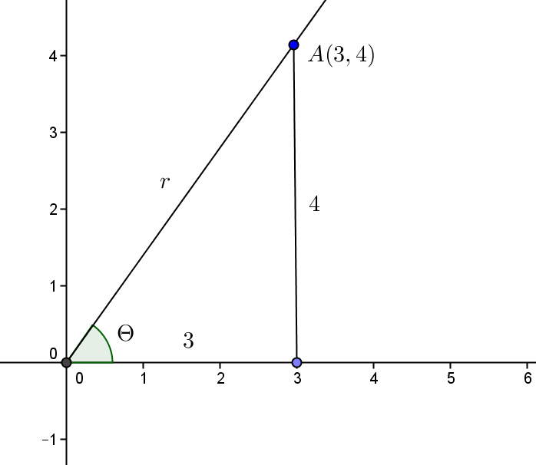

- The line segment from $(0, 0)$ to $(3, 0)$, the line segment we just drew, and the segment from the origin to the point form a right triangle. What is the tangent ratio of the acute angle whose vertex is at the origin?
  - The tangent is $\tan\left(θ\right)=\frac{4}{3}$
- Use a calculator to estimate the measure of this angle. What is the argument of $3+4i$?
  - We can use $θ=\arctan\left(\frac{4}{3}\right)$. Rounded to the nearest hundredth, $θ=53.1°$.
- Write $3+4i$ in polar form.
  - The polar form is $5(\cos\left(53.1°\right)+i\sin\left(53.1°\right))$ with the angle rounded to the nearest tenth.
Part (b) of this example shows how the process above needs to be tweaked when the complex number is not located in the first quadrant.
The modulus is $5$. When we plot the point $(3,-4)$ and draw a line segment perpendicular to the $x$-axis, we can see that the acute angle at the origin in this triangle will still have a measure equal to $\arctan\left(\frac{4}{3}\right)=53.1°$.
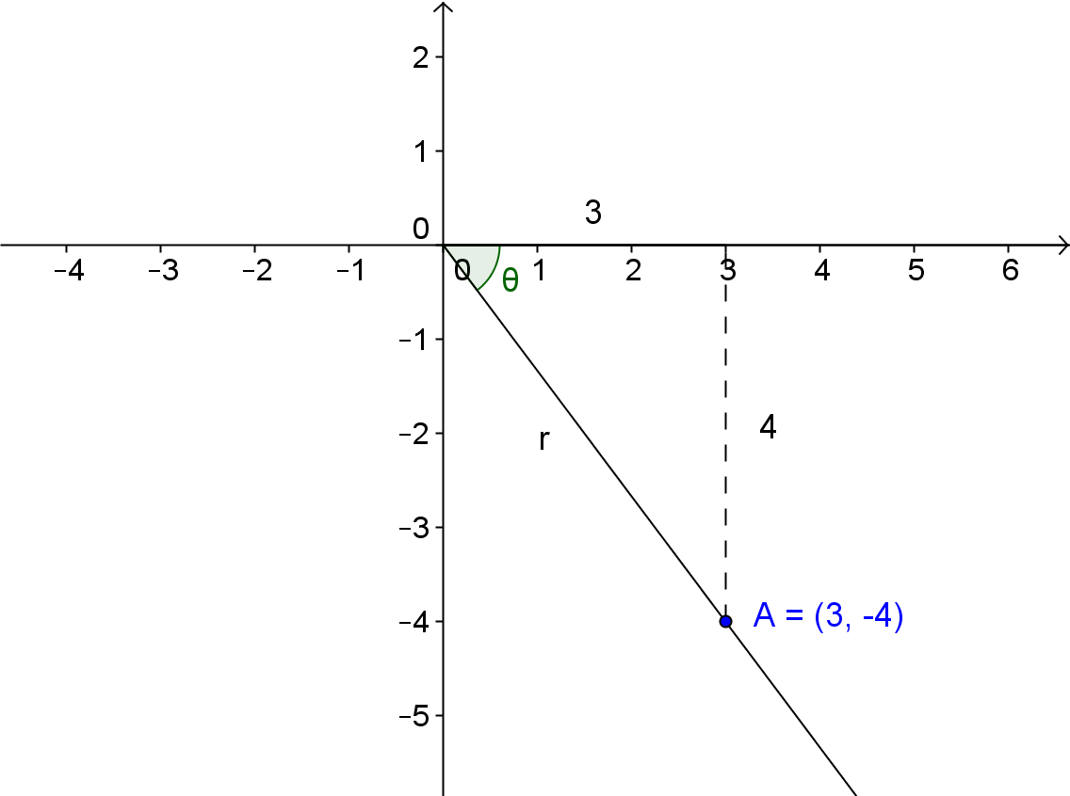
Model how to draw this diagram so students see how to use the arctangent function to find the measure of the acute angle at the origin in the triangle they constructed.

- Use your knowledge of angles to determine the argument of $3-4i$. Explain your reasoning.
  - An argument of $3-4i$ would be $360°-53.1°=306.9°$. The positive rotation of ray from the origin containing the real number $1$ that maps to a ray passing through this point would be $53°$ less than a full rotation of $360°$.
- What is the polar form of $3-4i$?
  - The polar form is $5(\cos\left(306.9°\right)+i\sin\left(306.9°\right))$.
- Why do the polar and rectangular forms of a complex number represent the same number?
  - $3-4i$ can be thought of as the point $(3, -4)$ in the complex plane. The point can be located by extending the ray from the origin rotated $306.9°$. The point is a distance of $5$ units (the modulus) from the origin along that ray.

Exercise 7 (4 minutes)
Have students practice the methods you just demonstrated in Example 2. They can work individually or with a partner. Review the solutions to these problems with the whole class before moving on to the lesson closing.

- Express each complex number in polar form. Round arguments to the nearest thousandth.
  - $2+5i$
$$\arg\left(2+5i\right)=\tan^{-1}\left(\frac{5}{2}\right)≈1.190 \\ \left|2+5i\right|=\sqrt{4+25}=\sqrt{29} \\ 2+5i≈\sqrt{29}\left(\cos\left(1.190\right)+i\sin\left(1.190\right)\right)$$

  - $-6+i$
$$\arg{(z)}=π-\tan^{-1}\left(\frac{1}{6}\right)≈2.976 \\ \left|-6+i\right|=\sqrt{37} \\ -6+i=\sqrt{37}\left(\cos\left(2.976\right)+i\sin\left(2.976\right)\right)$$

Closing (3 minutes)
Review the Lesson Summary and then ask students to describe to a partner the geometric meaning of the modulus and argument of a complex number. Then have the partner describe the steps required to convert a complex number in rectangular form to polar form. Encourage students to refer back to their work in this lesson as they discuss what they learned with their partner.
Lesson Summary
The polar form of a complex number $z=r\left(\cos\left(θ\right)+i\sin\left(θ\right)\right)$ where $θ$ is the argument of $z$ and $r$ is the modulus of $z$. The rectangular form of a complex number is $z=a+bi$.
The polar and rectangular forms of a complex number are related by the formulas $a=r\cos{(θ)}$, $b=r\sin{(θ)}$ and $r=\sqrt{a^{2}+b^{2}}$.
The notation for modulus is $\left|z\right|$ and the notation for argument is $\arg{(z)}$.

Exit Ticket (5 minutes)

Name Date
Lesson 13: Trigonometry and Complex Numbers

Exit Ticket

- State the modulus and argument of each complex number. Explain how you know.
  - $4+0i$

  - $-2+2i$

- Write each number from Problem 1 in polar form.

- Explain why $5\left(\cos\left(\frac{π}{6}\right)+i\sin\left(\frac{π}{6}\right)\right)$ and $\frac{5\sqrt{3}}{2}+\frac{5}{2}i$ represent the same complex number.

Exit Ticket Sample Solutions

- State the modulus and argument of each complex number. Explain how you know.
  - $4+0i$
The modulus is $4$ and the argument is $0°$. The real number $4$ is $4$ units from the origin and lies in the same position as a ray from the origin containing the real number $1$ so the rotation is $0°$.

  - $-2+2i$
The modulus is $2\sqrt{2}$ and the argument is $135°$. The values of $a$ and $b$ correspond to sides of a $45°$–$45°$–$90°$ right triangle so the modulus would be $2\sqrt{2}$ and the rotation is $45°$ less than $180°$.

- Write each number from Problem 1 in polar form.
- $4\left(\cos\left(0°\right)+i\sin\left(0°\right)\right)$
- $2\sqrt{2}\left(\cos\left(135°\right)+i\sin\left(135°\right)\right)$

- Explain why $5\left(\cos\left(\frac{π}{6}\right)+i\sin\left(\frac{π}{6}\right)\right)$ and$\frac{5\sqrt{3}}{2}+\frac{5}{2}i$ represent the same complex number.
$$5\left(\cos\left(\frac{π}{6}\right)+i\sin\left(\frac{π}{6}\right)\right)$$
If you evaluate $5\cos\left(\frac{π}{6}\right)$ and $5\sin\left(\frac{π}{6}\right)$, you get$\frac{5\sqrt{3}}{2}$ and$\frac{5}{2}$, respectively.
$$5\left(\cos\left(\frac{π}{6}\right)+i\sin\left(\frac{π}{6}\right)\right)=\frac{5\sqrt{3}}{2}+\frac{5}{2}i$$
$\frac{5\sqrt{3}}{2}+\frac{5}{2}i$ is thought of as a point with coordinates $\left(\frac{5\sqrt{3}}{2},\frac{5}{2}\right)$ in the complex plane. The point can also be located by thinking of the ray extending from the origin rotated$\frac{π}{6}$ radians. The distance from the origin to the point along that ray is the modulus, which is $5$ units.

Problem Set Sample Solutions

- Explain why the complex numbers $z_{1}=1-\sqrt{3}i$, $z_{2}=2-2\sqrt{3}i$, and $z_{3}=5-5\sqrt{3}i$ can all have the same argument. Draw a diagram to support your answer.
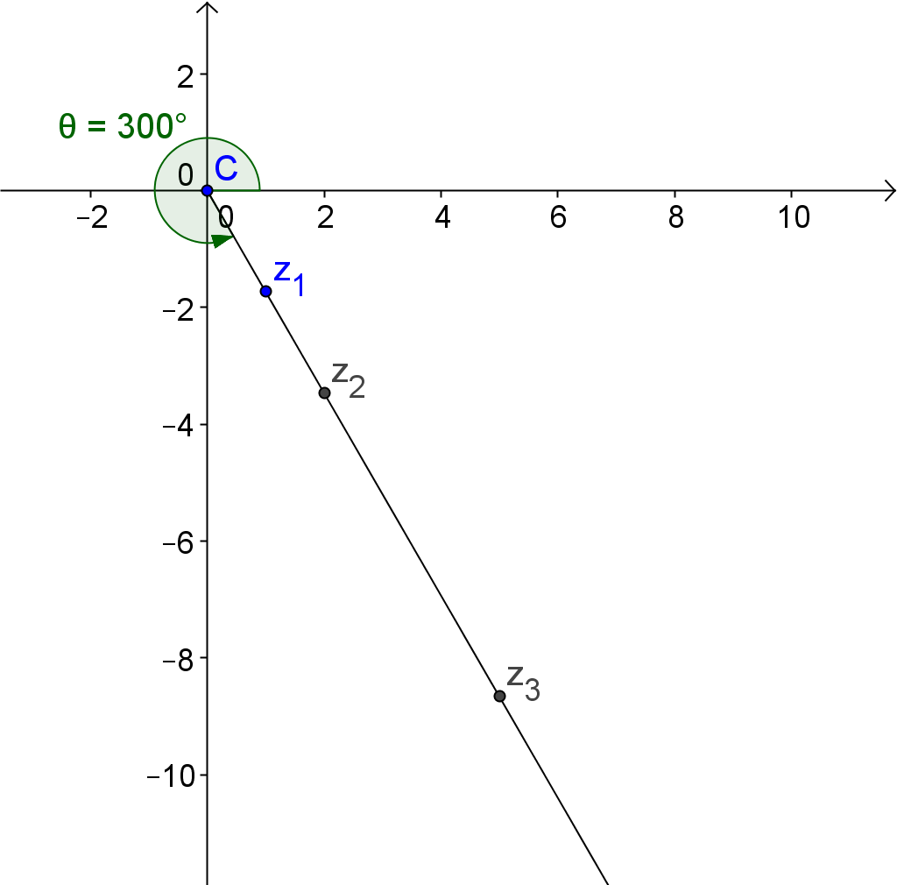
They all lie on the same ray from the origin that represents a $300°$ rotation.

- What is the modulus of each of the complex numbers $z_{1}$, $z_{2}$, and $z_{3}$ given in Problem 1 above.
The moduli are $2$, $4$, and $10$.

- Write the complex numbers from Exercise 1 in polar form.
$$z_{1}=2\left(\cos\left(300°\right)+i\sin\left(300°\right)\right)$$
$$z_{2}=4\left(\cos\left(300°\right)+i\sin\left(300°\right)\right)$$
$$z_{3}=10\left(\cos\left(300°\right)+i\sin\left(300°\right)\right)$$

- Explain why $1-\sqrt{3}i$ and $2\left(\cos\left(300°\right)+i\sin\left(300°\right)\right)$ represent the same number.
The point $\left(1,-\sqrt{3}\right)$ lies on a ray from the origin that has been rotated $300°$ rotation from the initial ray. The distance of this point from the origin along this ray is $2$ units (the modulus). Using the definitions of sine and cosine, any point along that ray will have coordinates $\left(2\cos\left(300°\right),2\sin\left(300°\right)\right)$.

- Julien stated that a given modulus and a given argument uniquely determine a complex number. Confirm or refute Julien’s reasoning.
Julien’s reasoning is correct. If you rotate a ray from the origin containing the real number $1$ and then locate a point a fixed number units along that ray from the origin, it will give you a unique point in the plane.

- Identify the modulus and argument of the complex number in polar form, convert it to rectangular form and sketch the complex number in the complex plane. $0°≤\arg\left(z\right)≤360°$or $0≤\arg{(z)}≤2π$(radians)
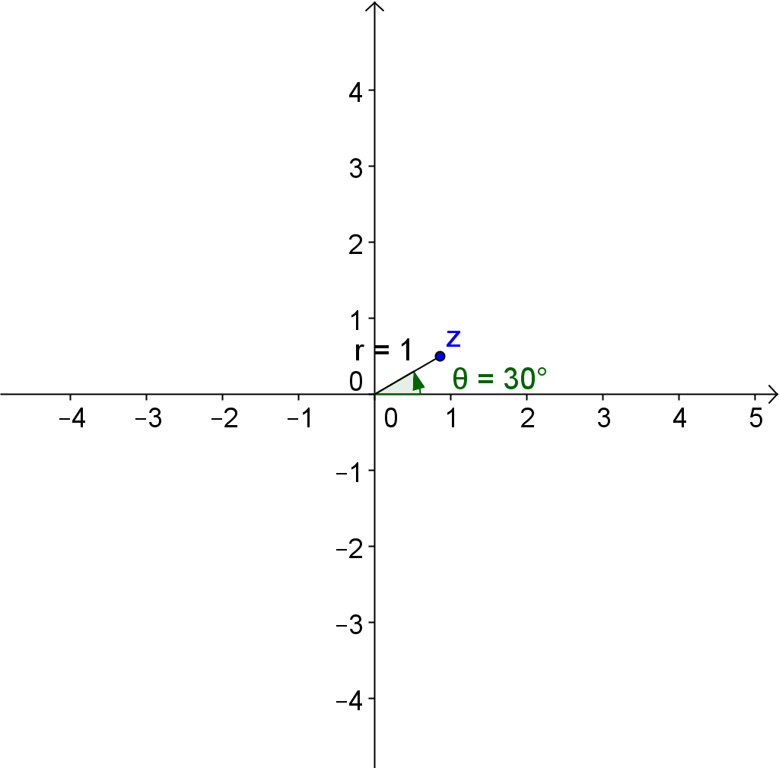
  - $z=\cos\left(30°\right)+i\sin\left(30°\right)$
$r=1$, $\arg{(z)}=30°$
$$z=\frac{ \sqrt{3} }{2}+\frac{ 1 }{2 }i$$

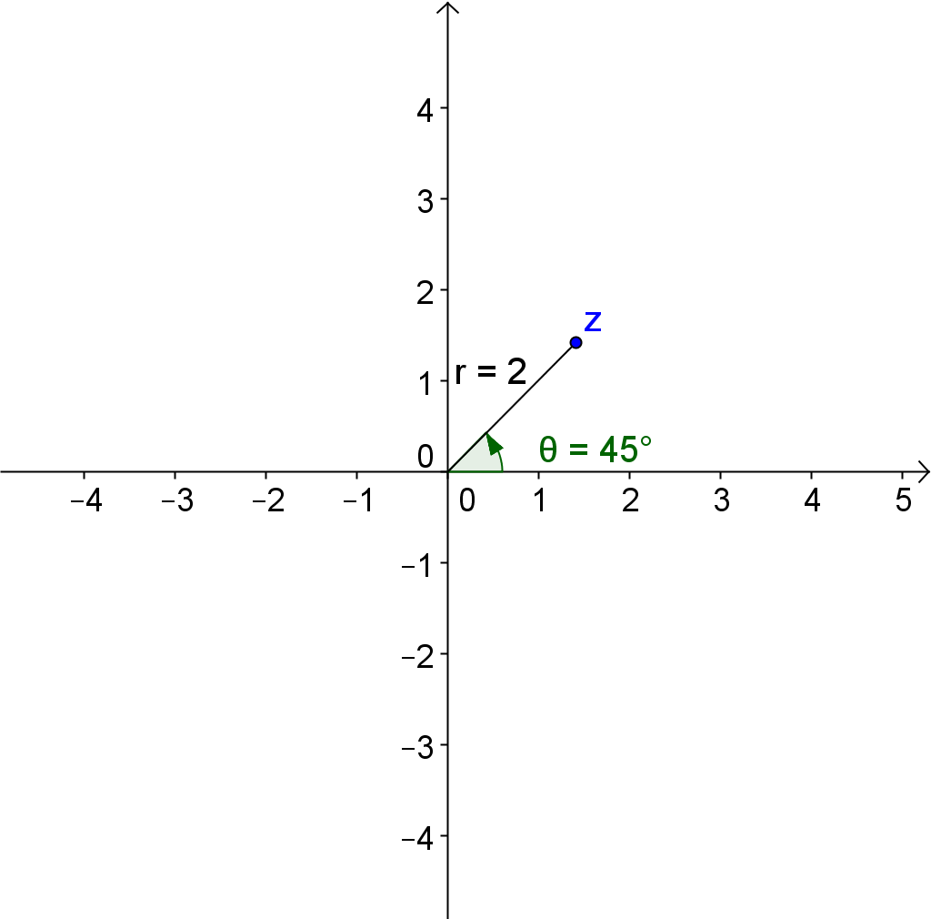
  - $z=2\left(\cos\left(\frac{π}{4}\right)+i\sin\left(\frac{π}{4}\right)\right)$
$$r=2\text{, }\arg{(z)}=\frac{π}{4} radians$$
$$z=\sqrt{2}+\sqrt{2}i$$

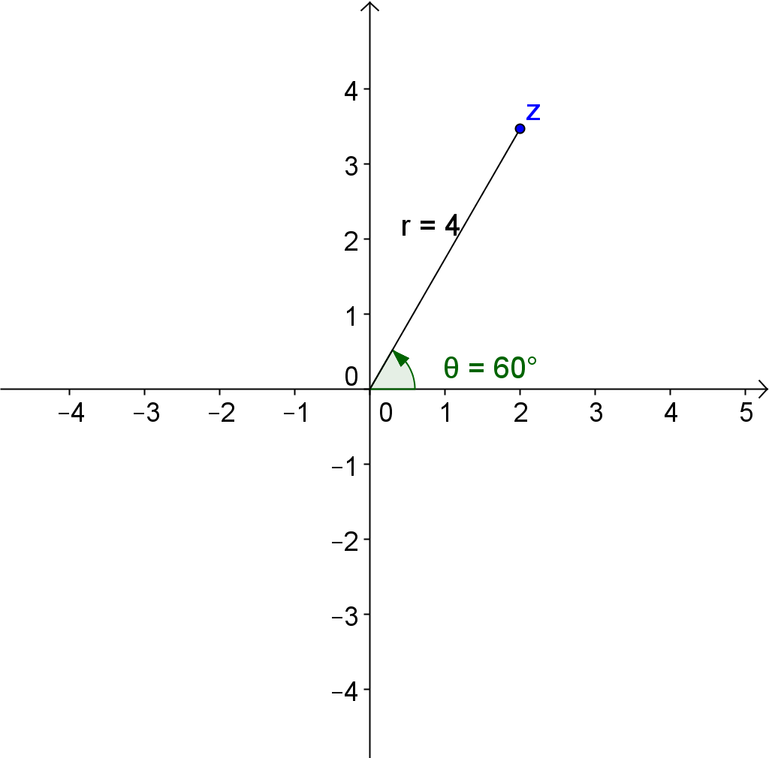
  - $z=4\left(\cos\left(\frac{π}{3}\right)+i\sin\left(\frac{π}{3}\right)\right)$
$$r=4\text{, }\arg{(z)}=\frac{π}{3}radians$$
$$z=2+2\sqrt{3}i$$

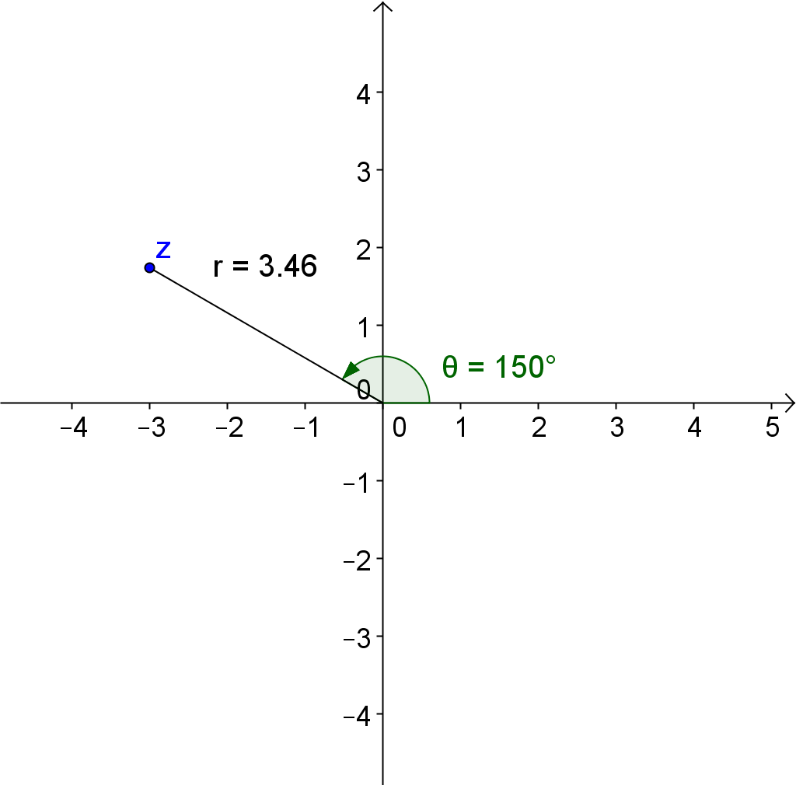
  - $z=2\sqrt{3}\left(\cos\left(\frac{ 5π }{6 }\right)+i\sin\left(\frac{ 5π }{6 }\right)\right)$
$$r=2\sqrt{3}\text{, }\arg{(z)}=\frac{5π}{6} radians$$
$$z=-3+\sqrt{3}i$$

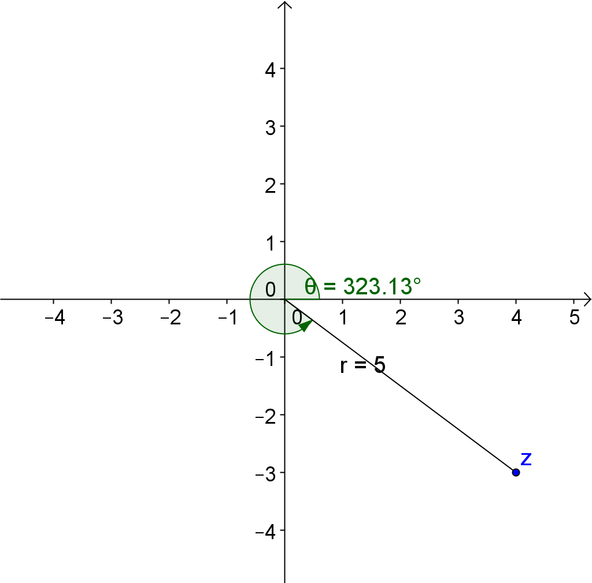
  - $z=5\left(\cos\left(5.637\right)+i\sin\left(5.637\right)\right)$
$$r=5\text{,} \arg{(z)}=5.637 radians$$
$$z=4-3i$$

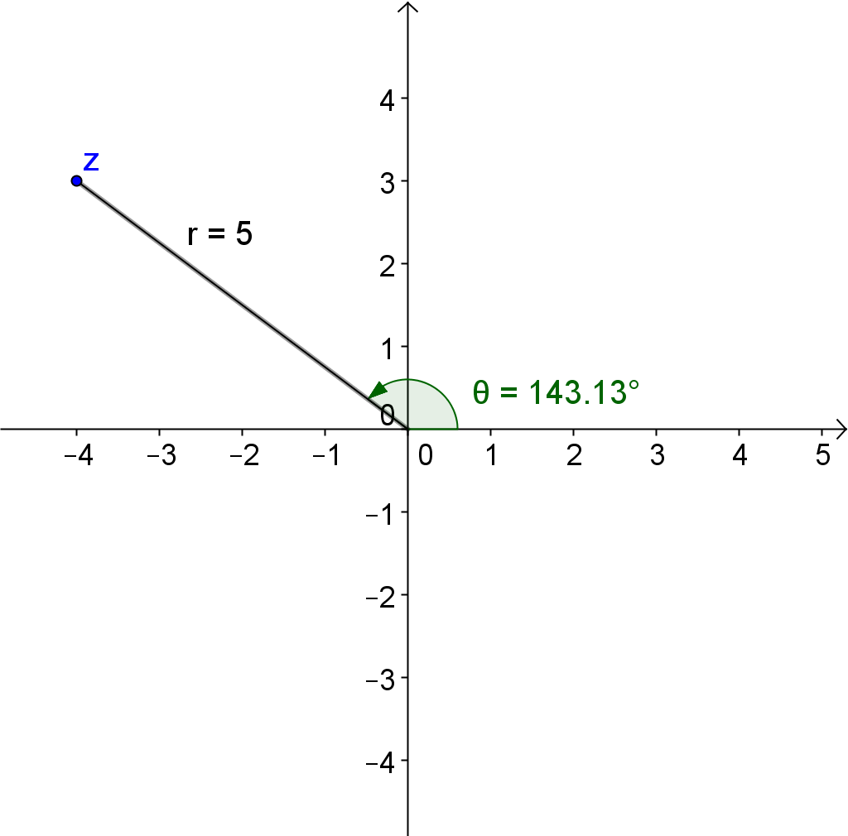
  - $z=5\left(\cos\left(2.498\right)+i\sin\left(2.498\right)\right)$
$$r=5\text{, } \arg{(z)}=2.498 radians$$
$$z=-4+3i$$

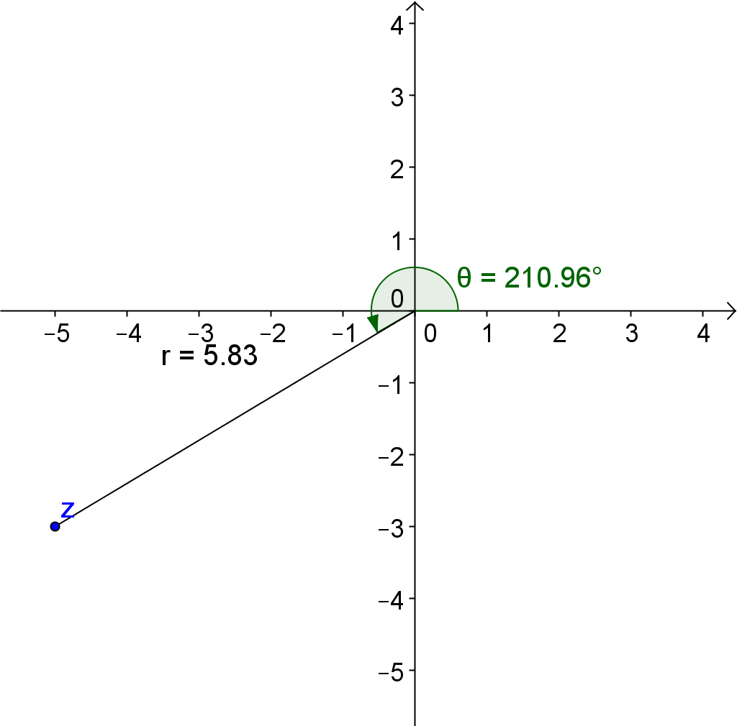
  - $z=\sqrt{34}\left(\cos\left(3.682\right)+i\sin\left(3.682\right)\right)$
$$r=\sqrt{34}\text{,} \arg{(z)}=3.682$$
$$z=-5-3i$$

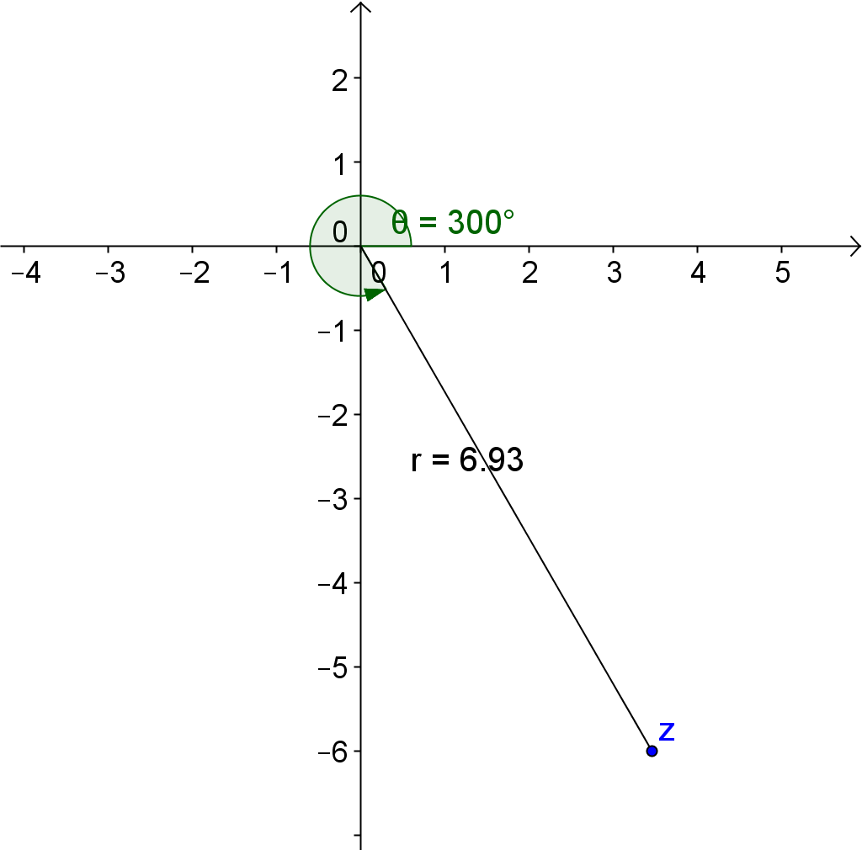
  - $z=4\sqrt{3}\left(\cos\left(\frac{ 5π }{3}\right)+i\sin\left(\frac{ 5π }{3}\right)\right)$
$$r=4\sqrt{3}\text{,} \arg{(z)}=\frac{ 5π }{3}$$
$$z=2\sqrt{3}-6i$$

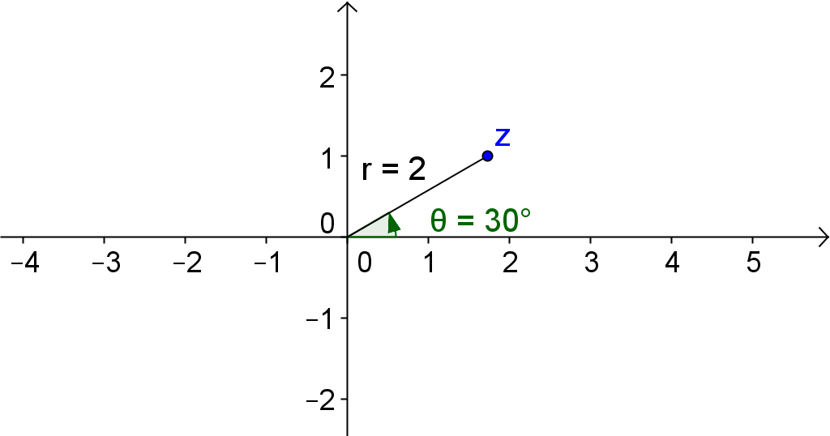
- Convert the complex numbers in rectangular form to polar form. If the argument is a multiple of $\frac{π}{6}$, $\frac{π}{4}$, $\frac{π}{3}$, or $\frac{π}{2}$, express your answer exactly. If not, use $\arctan\left(\frac{b}{a}\right)$ to find $\arg{(z)}$ rounded to the nearest thousandth,
$0≤\arg{(z)}≤2π$(radians).
  - $z=\sqrt{3}+i$
$\arg{(z)}$ is in quadrant one.
$$\arg\left(z\right)=\arctan\left(\frac{ b }{a }\right) \\ =\arctan\left(\frac{1}{ \sqrt{3} }\right) \\ =\frac{π}{6}$$
$$r=\left|z\right| \\ =\sqrt{{\left(\sqrt{3}\right)}^{2}+{\left(1\right)}^{2}} \\ =2$$
$$z=2\left(\cos\left(\frac{π}{6}\right)+i\sin\left(\frac{π}{6}\right)\right)$$

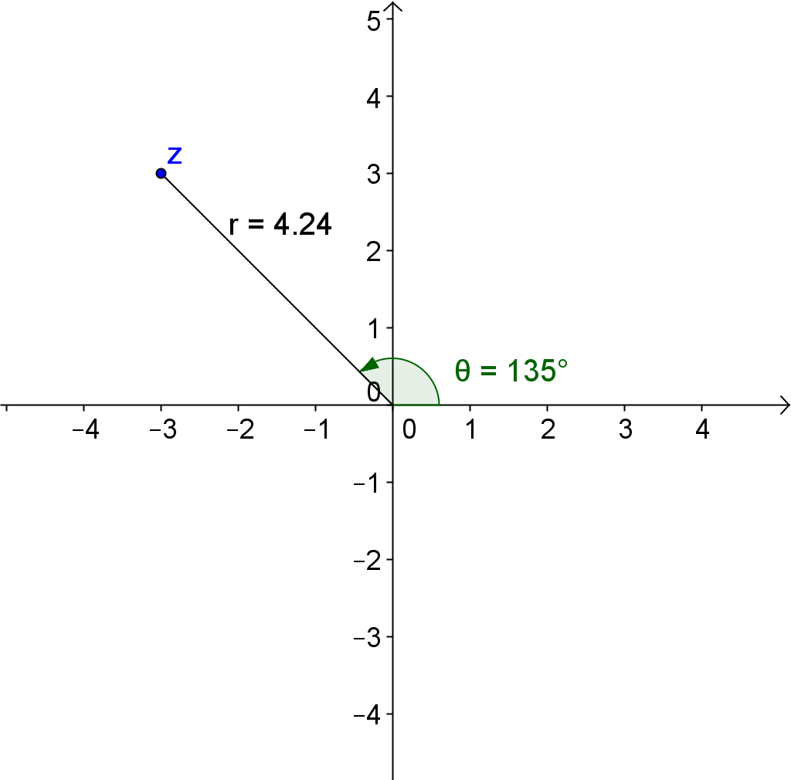
  - $z=-3+3i$
$\arg{(z)}$ is in quadrant two.
$$\arg\left(z\right)=π-\arctan\left(\frac{ b }{a }\right) \\ =π-\arctan\left(\frac{ 3 }{3}\right) \\ =π-\frac{ π }{4 } \\ =\frac{ 3π }{4}$$
$$r=\left|z\right| \\ =\sqrt{{\left(-3\right)}^{2}+{\left(3\right)}^{2}} \\ =3\sqrt{2}$$
$$z=3\sqrt{2}\left(\cos\left(\frac{3π }{4}\right)+i\sin\left(\frac{3π }{4}\right)\right)$$

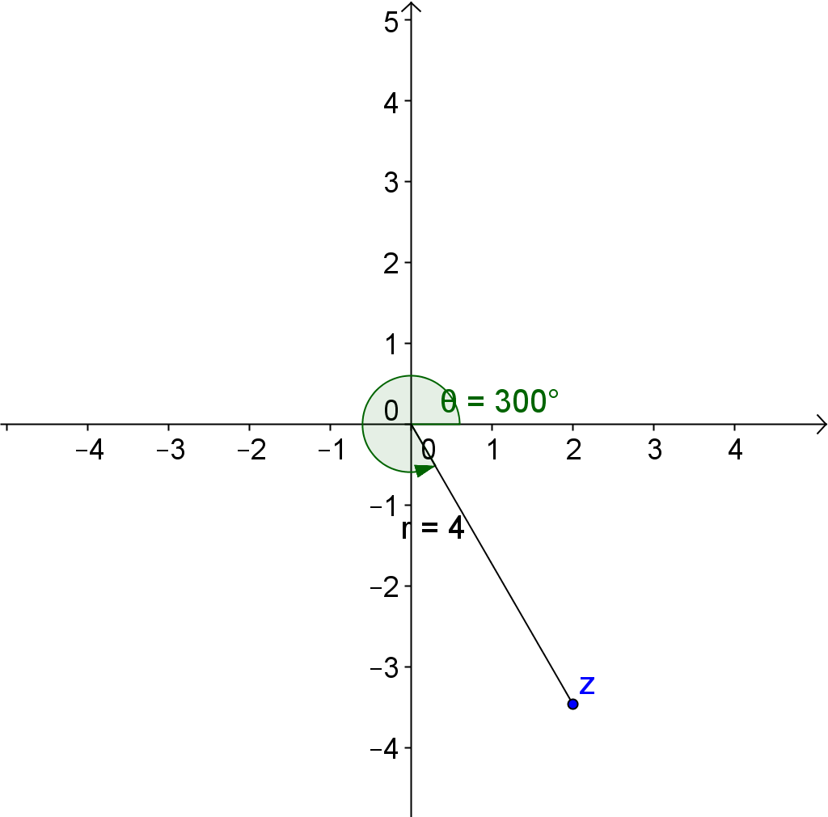

  - $z=2-2\sqrt{3}i$
$\arg{(z)}$ is in quadrant four.
$$\arg\left(z\right)=2π-\arctan\left(\frac{ b }{a }\right) \\ =2π-\arctan\left(\frac{2\sqrt{3} }{2}\right) \\ =2π-\frac{ π }{3 } \\ =\frac{ 5π }{3} radians$$
$$r=\left|z\right| \\ =\sqrt{{\left(2\right)}^{2}+{\left(-2\sqrt{3}\right)}^{2}} \\ =4$$
$$z=4\left(\cos\left(\frac{5π }{3 }\right)+i\sin\left(\frac{5π }{3 }\right)\right)$$

  - $z=-12-5i$
$\arg{(z)}$ is in quadrant three.
$$\arg\left(z\right)=π+\arctan\left(\frac{ 5 }{12 }\right) \\ =π+\arctan\left(\frac{1}{ \sqrt{3} }\right) \\ ≈3.536 radians$$
$$r=\left|z\right| \\ =\sqrt{{\left(-12\right)}^{2}+{\left(-5\right)}^{2}} \\ =13$$
$$z=13\left(\cos\left(3.536\right)+i\sin\left(3.536\right)\right)$$
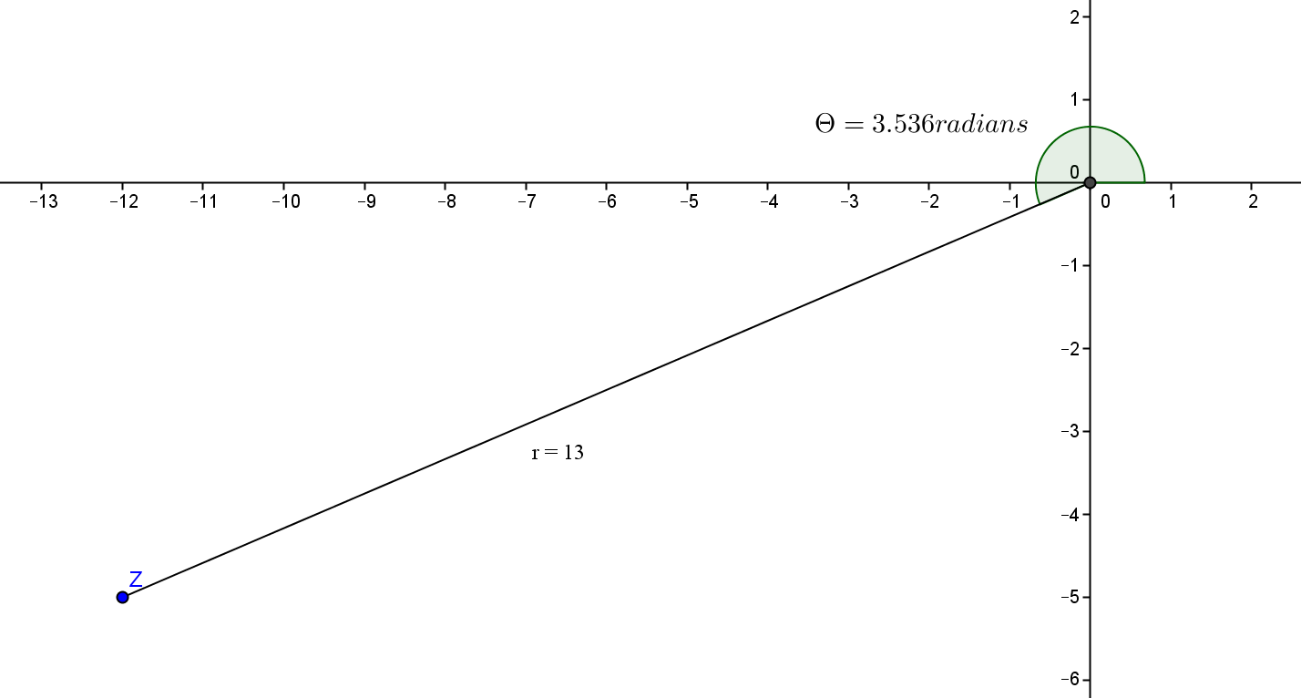
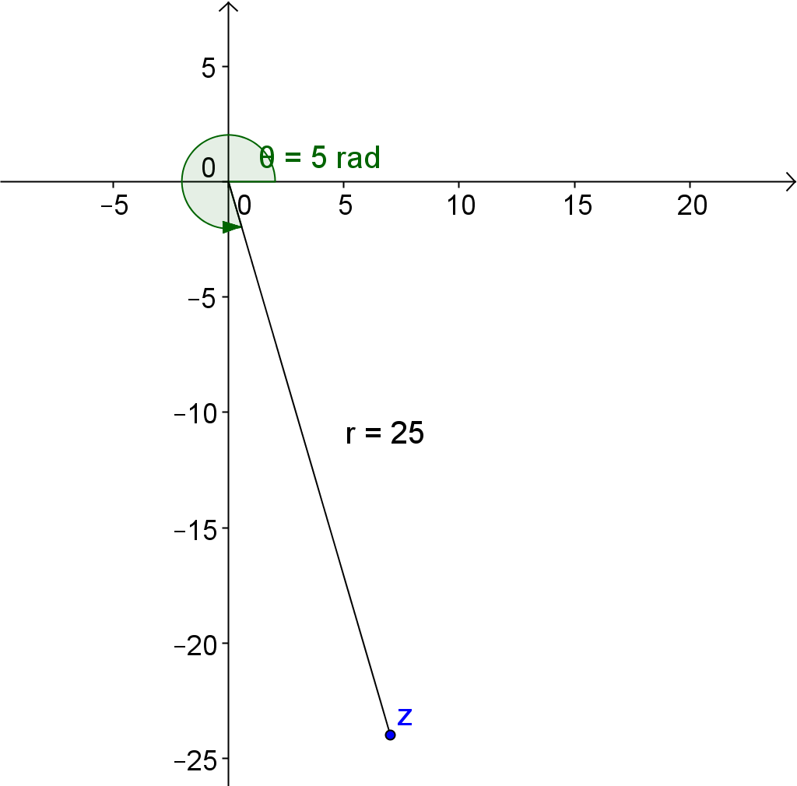
  - $z=7-24i$
$\arg{(z)}$ is in quadrant four.
$$\arg\left(z\right)=2π-\arctan\left(\frac{ b }{a }\right) \\ =2π-\arctan\left(\frac{24 }{7}\right) \\ ≈4.996 radians$$
$$r=\left|z\right| \\ =\sqrt{{\left(7\right)}^{2}+{\left(-24\right)}^{2}} \\ =25$$
$$z=25\left(\cos\left(4.996\right)+i\sin\left(4.996\right)\right)$$

- Show that the following complex numbers have the same argument.
  - $z_{1}=3+3\sqrt{3}i$ and$z_{2}=1+\sqrt{3}i$
$\arg{(z_{1})}=\arctan\left(\frac{3\sqrt{3}}{3}\right)=\frac{π}{3}$and $\arg{(z_{2})}=\left(\sqrt{3}\right)=\frac{π}{3}$

  - $z_{1}=1+i$and$z_{2}=4+4i$
$\arg{(z_{1})}=\arctan\left(\frac{1}{1}\right)=\frac{π}{4}$and $\arg{(z_{2})}=\arctan\left(\frac{4}{4}\right)=\frac{π}{4}$

- A square with side length of one unit is shown below. Identify a complex number in polar form that corresponds to each point on the square.
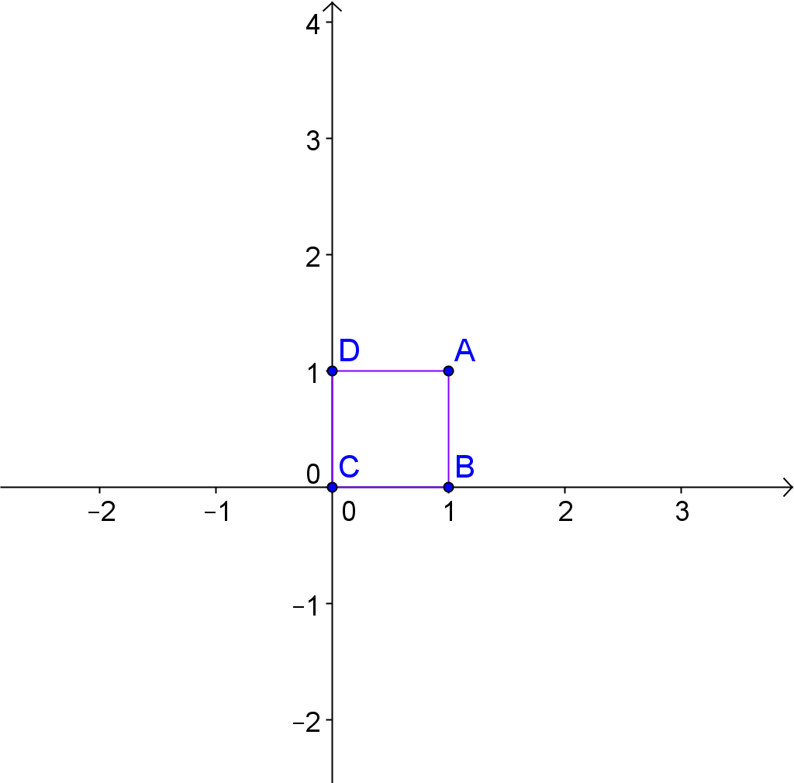
$$A=\sqrt{2}\left(\cos\left(45°\right)+i\sin\left(45°\right)\right)$$
$$B=1\left(\cos\left(0°\right)+i\sin\left(0°\right)\right)$$
$$C=0\left(\cos\left(0°\right)+i\sin\left(0°\right)\right)$$
$$A=1\left(\cos\left(90°\right)+i\sin\left(90°\right)\right)$$

- Determine complex numbers in polar form whose coordinates are the vertices of the square shown below.
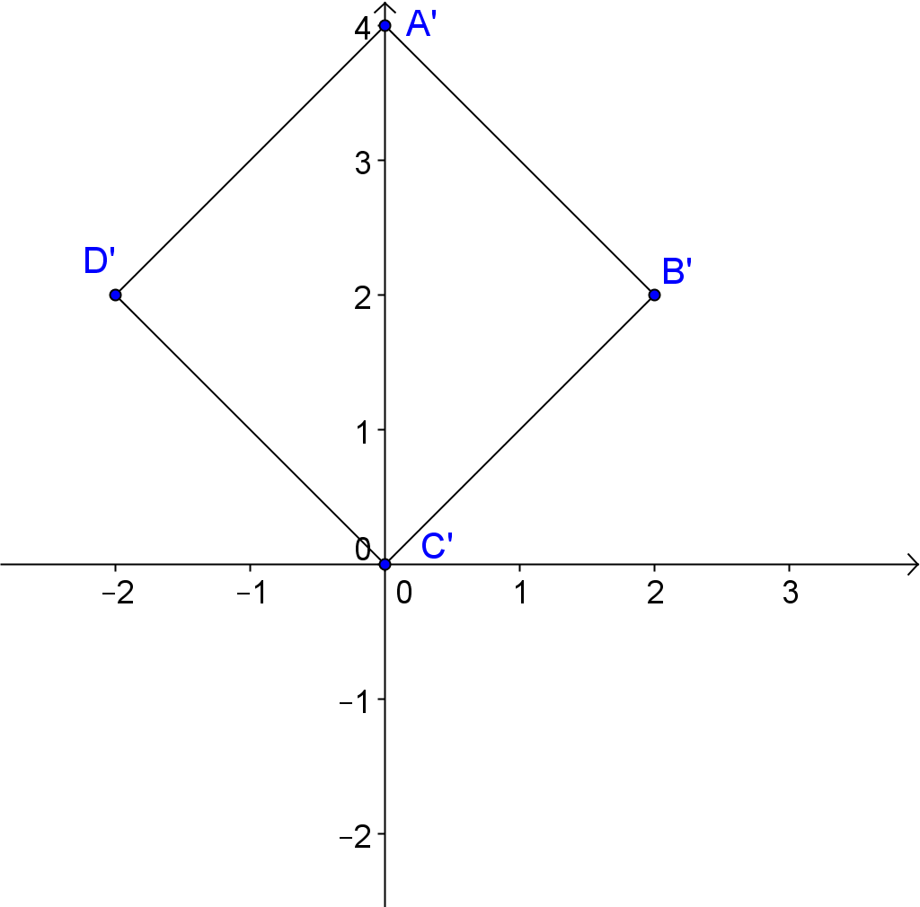

$$A'=4\left(\cos\left(90°\right)+i\sin\left(90°\right)\right)$$
$$B'=2\sqrt{2}\left(\cos\left(45°\right)+i\sin\left(45°\right)\right)$$
$$C'=0\left(\cos\left(0°\right)+i\sin\left(0°\right)\right)$$
$$D'=2\sqrt{2}\left(\cos\left(135°\right)+i\sin\left(135°\right)\right)$$

- How do the modulus and argument of coordinate $A$ in Problem 9, correspond to the modulus and argument of point $A'$in Problem 10? Does a similar relationship exist when you compare $B$ to$B'$, $C$ to $C'$, and $D$ to $D'$? Explain why you think this relationship exists.
The modulus multiplied by a factor of $2\sqrt{2}$ and the argument is $45°$ more. The same is true when you compare $B$ to $B'$ and $D$ to $D'$. The relationship could also be true for $C$ anad $C'$, although the argument of $C$ and $C'$ can really be any number since the modulus is $0$.

- Describe the transformations that map $ABCD$ to $A'B'C'D'$.
Rotate by $45°$ counterclockwise and then dilate by a factor of $2\sqrt{2}$.

Trigonometry Review: Additional Resources
- Evaluate the following.
- $\sin\left(30°\right)$ | - $\cos\left(\frac{π}{3}\right)$
- $\sin\left(225°\right)$ | - $\cos\left(\frac{5π }{6 }\right)$
- $\sin\left(\frac{5π }{3}\right)$ | - $\cos\left(330°\right)$
- Solve for the acute angle $θ$, both in radians and degrees, in a right triangle if you are given the opposite side, $O$, and adjacent side, $A$. Round to the nearest thousandth.
$$O$$
$$A$$
$$θ$$
  - $O=3$ and $A=4$

  - $O=6$ and $A=1$

  - $O=3\sqrt{3}$ and $A=2$

- Convert angles in degrees to radians, and convert angles in radians to degrees.
  - $150°$

  - $\frac{4π }{3}$

  - $\frac{3π }{4}$

Trigonometry Review: Additional Resources
- Evaluate the following.
- $\sin\left(30°\right)$  $$\frac{1}{2}$$ | - $\cos\left(\frac{π}{3}\right)$  $$\frac{1}{2}$$
- $\sin\left(225°\right)$  $$-\frac{\sqrt{2}}{2}$$ | - $\cos\left(\frac{5π }{6 }\right)$  $$-\frac{\sqrt{3}}{2}$$
- $\sin\left(\frac{5π }{3}\right)$  $$-\frac{\sqrt{3}}{2}$$ | - $\cos\left(330°\right)$  $$\frac{\sqrt{3}}{2}$$

- Solve for the acute angle $θ$, both in radians and degrees, in a right triangle if you are given the opposite side, $O$, and adjacent side, $A$. Round to the nearest thousandth.
$$O$$
$$A$$
$$θ$$
  - $O=3$ and $A=4$
$$\arctan\left(\frac{3 }{4 }\right)≈0.644 radians=36.898°$$

  - $O=6$ and $A=1$
$$\arctan\left(\frac{6 }{1 }\right)≈1.406 radians=80.558°$$

  - $O=3\sqrt{3}$ and $A=2$
$$\arctan\left(\frac{ 3\sqrt{3} }{3}\right)≈1.203 radians=68.927°$$

- Convert angles in degrees to radians, and convert angles in radians to degrees.
  - $150°$
$$\frac{5π }{6}$$

  - $\frac{4π }{3}$
$$240°$$

  - $\frac{3π }{4}$
$135°$

