Lesson 12: Distance and Complex Numbers

Student Outcomes
- Students apply distances between complex numbers and the midpoint of a segment.
- Students derive and apply a formula for finding the endpoint of a segment when given one endpoint and the midpoint.

Lesson Notes
In Lesson 10, students learned that it is possible to interchange between points on a coordinate plane and complex numbers. Therefore, all the work that was done in Geometry could be translated into the language of complex numbers, and vice versa. This lesson continues exploring the midpoint between complex numbers through an Exploratory Challenge in the form of a leapfrog game. In the Opening Exercise, students develop a formula for finding an endpoint of a segment when given one endpoint and the midpoint. Students then use this formula in the Exploratory Challenge that follows.

Classwork
Opening Exercise (5 minutes)
Allow students time to work on the Opening Exercise independently before discussing results as a class. The formula derived in part (b) will be used in the Exploratory Challenge.
Opening Exercise
  - Let $A=2+3i$ and$B=-4-8i$. Find a complex number $C$ so that $B$ is the midpoint of $A$ and $C$.
$$C=-10-19i$$

  - Given two complex numbers $A$ and $B$, find a formula for a complex number $C$ in terms of $A$ and $B$ so that $B$is the midpoint of $A$ and $C$.
$$C=2B-A$$

  - Verify that your formula is correct by using the result of part (a).
$$C=2B-A \\ -10-19i=2\left(-4-8i\right)-\left(2+3i\right) \\ =-8-16i-2-3i \\ =-10-19i$$

Exercise (7 minutes)
Give students time to work on the exercise in groups. Circulate the room to ensure students understand the problem. Encourage struggling students to try a graphical approach to the problem.
Scaffolding:
- Provide visual learners with a graph on the complex plane.
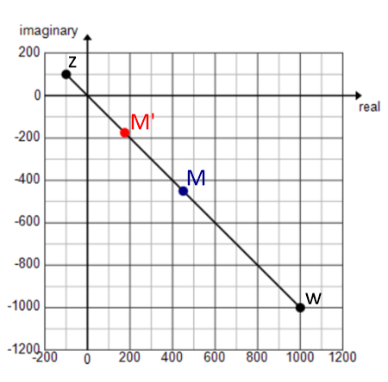
- If students need additional practice, use this example before moving on. Have some students find the answer using midpoint and some using the result from part (b).
- Find a point one quarter of the way along the line segment connecting segment connecting $z=8-6i$and $w=12+16i$ closer to $z$than to $w$.
  - $9-\frac{1}{2}i$

Exercise
Let $z=-100+100i$ and $w=1000-1000i$.
  - Find a point one quarter of the way along the line segment connecting $z$and $w$ closer to $z$than to $w$.
Let $M$ be the midpoint between $z$ and $w=450-450i$.
Let $M^{'}$ be the midpoint between $z$ and $M=175-175i$.
The complex number $175-175i$ represents a point on the complex plane that is one quarter of the way from $z$ on the segment connecting $z$ and $w.$

  - Write this point in the form $αz+βw$ for some real numbers $α$and $β$. Verify that this does in fact represent the point found in part (a).
$$\frac{3}{4}z+\frac{1}{4}w=\frac{3}{4}\left(-100+100i\right)+\frac{1}{4}\left(1000-1000i\right) \\ =\left(-75+250\right)+i\left(75-250\right) \\ =175-175i$$

  - Describe the location of the point $\frac{2}{5}z+\frac{3}{5}w$ on this line segment.
This point is located $\frac{3}{5}$ of the way from $z$ and $\frac{2}{5}$ of the way from $w$on$\overline{zw}$.

When debriefing, use the graph provided in the scaffold as needed.
- For part (b), did anyone have an answer that did not work when you tried to verify?
  - $\frac{1}{4}z+\frac{3}{4}w$ (Note: This could be a very common incorrect answer. If nobody offers it as an answer, perhaps suggest it.)
- Why isn’t $\frac{1}{4}z+\frac{3}{4}w$ the correct answer? After all, the point is $\frac{1}{4}$ of the way from $z$ and $\frac{3}{4}$ of the way from $w$.
  - It did not work when we tried to verify it.
$$\frac{1}{4}\left(-100+100i\right)+\frac{3}{4}\left(1000-1000i\right)=\left(-25+750\right)+i\left(25-750\right)=725-725i$$
- What point would this be on the segment?
  - It would be the point that is $\frac{3}{4}$ of the way from $z$ and $\frac{1}{4}$ of the way from $w$.
- You would think about this like a weighted average. To move the point closer to $z$, it must be weighted more in the calculation than $w$.

Exploratory Challenge 1 (15 minutes)
Have students work in groups on this challenge. Each group will need a full page of graph paper. Warn students that they need to put the three points $A$,$B$, and $C$ fairly close together in order to stay on the page. Allow students to struggle a little with part (g), but then provide them with help getting started if needed.
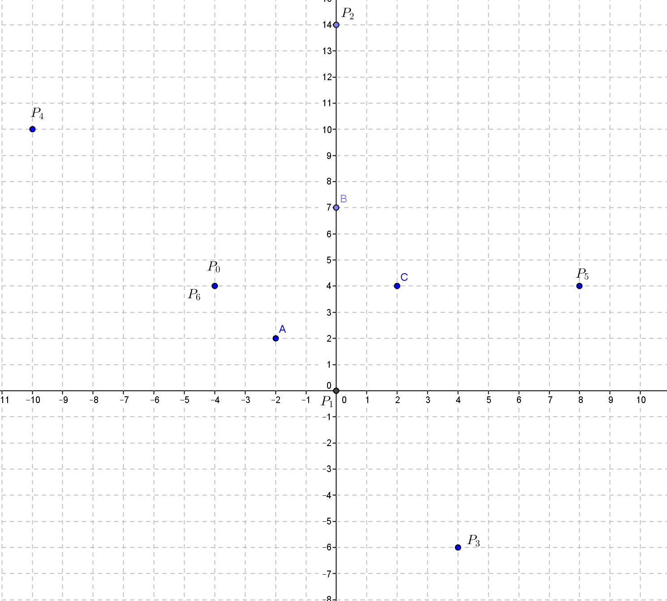
Exploratory Challenge 1

  - Draw three points $A$, $B$, and $C$ in the plane.

  - Start at any position $P_{0}$ and leapfrog over $A$ to a new position $P_{1}$ so that $A$ is the midpoint of $\overline{P_{0}P_{1}}$.

  - From $P_{1}$, leapfrog over $B$ to a new position $P_{2}$ so that $B$ is the midpoint $\overline{P_{1}P_{2}}$.

  - From $P_{2}$, leapfrog over $C$ to a new position $P_{3}$ so that $C$ is the midpoint $\overline{P_{2}P_{3}}$.

  - Continue alternately leapfrogging over $A$, then$B$, then $C$.

  - What eventually happens?
At the sixth jump, you end up at the initial point $P_{6}=P_{0}$.

  - Using the formula from Opening Exercise part (b), show why this happens.
$$P_{1}=2A-P_{0}$$
$$P_{2}=2B-P_{1}=2B-2A+P_{0}$$
$$P_{3}=2C-P_{2}=2C-2B+2A-P_{0}$$
$$P_{4}=2A-P_{3}=-2C+2B+P_{0}$$
$$P_{5}=2B- P_{4}=2C-P_{0}$$
$$P_{6}=2C-P_{5}=P_{0}$$
- What happened on the sixth jump?
  - We landed back at the starting point. (Note: Allow a couple of groups to share their graph. A sample is provided.)

Exploratory Challenge 2 (10 minutes)
Have students continue working in groups on this challenge.
Scaffolding:
Provide early finishers with this challenge.
- Repeat the activity with two points, $A$ and $B$. But this time, leapfrog at a $90°$ angle to the left over each point. Will you return to the starting point? After how many leaps?
  - You will return to the starting point after $4$ leaps.
Exploratory Challenge 2
  - Plot a single point $A$in the plane.

  - What happens when you repeatedly jump over $A$?
You keep alternating between landing on $P_{0}$ and landing on $P_{1}.$

  - Using the formula from Opening Exercise part (b), show why this happens.
$P_{1}=2A-P_{0}$
$P_{2}=2A- P_{1}=2A- 2A+P_{0}=P_{0}$

  - Make a conjecture about what will happen if you leapfrog over two points, $A$ and $B$, in the coordinate plane.
Answers will vary.

  - Test your conjecture by using the formula from Opening Exercise part (b).
MP.3
&
MP.4
Answers will vary.

  - Was your conjecture correct? If not, what is your new conjecture about what happens when you leapfrog over two points, $A$ and $B$, in the coordinate plane?
Answers will vary, but for the most part, students should have found that their conjecture was incorrect. In this game, you never return to the starting position. Instead the points continue to get further away from points $A$ and $B$. This can be seen by using the formula from Opening Exercise part (b).

  - Test your conjecture by actually conducting the experiment.

Closing (3 minutes)
Discuss the results of Exploratory Challenge 2.
- What was your initial conjecture about two points?
  - Answers will vary, but most students would have predicted that at some point you would return to the initial point.
- How did the formula prove that it was incorrect?
  - The formula never returned to $P_{0}$ because terms did not cancel out.
- What happened when you leapfrogged over two points?
  - We kept getting farther from the initial point.

Exit Ticket (5 minutes)
Name Date
Lesson 12: Distance and Complex Numbers

Exit Ticket

- Find the distance between the following points.
  - $(4, -9)$ and $(1, -5)$

  - $4-9i$ and $1-5i$

  - Explain why they have the same answer numerically in parts (a) and (b), but a different perspective in geometric effect.

2. Given point $A=3-2i$ and point $M=-2+i$, if $M$ is the midpoint of$A$ and another point $B$, find the coordinates of point $B$.

Exit Ticket Sample Solutions

- Find the distance between the following points.
  - $(4, -9)$ and $\left(1, -5\right)$
$$\overline{AB}=\sqrt{{\left(4-1\right)}^{2}+{\left(-9+5\right)}^{2}} \\ =\sqrt{9+16} \\ =5$$

  - $A=4-9i$ and $B=1-5i$
$$\left|A-B\right|=\left|4-9i-1+5i\right| \\ =\left|3-4i\right| \\ =\sqrt{{\left(3\right)}^{2}+{\left(-4\right)}^{2}} \\ =\sqrt{25} \\ =5$$

  - Explain why they have the same answer numerically in parts (a) and (b), but a different perspective in geometric effect
The length of the line segment connecting points $A$ and $B$ is $5$.
To find the distance between two complex numbers $A$ and $B$, we need to calculate $A-B=4-9i-1+5i$, which has the geometric effect of performing a translation—shifting one unit to the left and $5$ units upward from point $A=4-9i$. The result is $3-4i$. And $\left|3-4i\right|$ is the distance from the origin to the complex number $-4i$ , which is not exactly the same as $\overline{AB}$ in terms of their position. However, they all have the same numerical value in terms of distance, which is $5$.

- Given point $A=3-2i$ and point $M=-2+i$, if $M$ is the midpoint of$A$ and another point $B$, find the coordinates of point $B$.
$$-2+i=\frac{\left(3-2i\right)+M}{2} \\ -4+2i=3-2i+M \\ -7+4i=M$$

Problem Set Sample Solutions

- Find the distance between the following points.
  - Point $A(2, 3)$ and point $B(6,6)$
$$\overline{AB}=\sqrt{{\left(2-6\right)}^{2}+{\left(3-6\right)}^{2}} \\ =\sqrt{16+9} \\ =5$$

  - $A=2+3i$ and $B=6+6i$
$$\left|A-B\right|=\left|2+3i-6-6i\right| \\ =\left|-4-3i\right| \\ =\sqrt{{\left(-4\right)}^{2}+{\left(-3\right)}^{2}} \\ =\sqrt{16+9} \\ =5$$

  - $A=-1+5i$ and $B=5+11i$
$$\left|A-B\right|=\left|-1+5i-5-11i\right| \\ =\left|-6-6i\right| \\ =\sqrt{{\left(-6\right)}^{2}+{\left(-6\right)}^{2}} \\ =\sqrt{2{\left(6\right)}^{2}} \\ =6\sqrt{2}$$

  - $A=1-2i$ and $B=-2+3i$
$$\left|A-B\right|=\left|1-2i+2-3i\right| \\ =\left|3-5i\right| \\ =\sqrt{{\left(3\right)}^{2}+{\left(-5\right)}^{2}} \\ =\sqrt{9+25} \\ =\sqrt{34}$$

  - $A=\frac{1}{2}-\frac{1}{2}i$ and $B=-\frac{2}{3}+\frac{1}{3}i$
$$\left|A-B\right|=\left|\frac{ 1 }{ 2 }-\frac{ 1 }{ 2 }i+\frac{ 2 }{ 3 }-\frac{ 1 }{ 3 }i\right| \\ =\left|\frac{ 7 }{ 6 }-\frac{ 5 }{6}i\right| \\ =\sqrt{{\left(\frac{ 7 }{6}\right)}^{2}+{\left(\frac{-5 }{6}\right)}^{2}} \\ =\sqrt{\frac{49+25 }{{\left(6\right)}^{2}}} \\ =\frac{ \sqrt{74} }{6}$$

- Given three points $A$, $B$, $C$, where $C$ is the midpoint of $A$ and $B$.
  - If $A=-5+2i$ and $C=3+4i$, find $B$.
$$C=\frac{ A+B }{2}$$
$$B=2C-A \\ =2\left(3+4i\right)-\left(-5+2i\right) \\ =6+8i+5-2i \\ =11+6i$$
  - If $B=1+11i$ and $C=-5+3i$, find $A$.
$$C=\frac{ A+B }{2}$$
$$A=2C-B \\ =2\left(-5+3i\right)-\left(1+11i\right) \\ =-10+6i-1-11i \\ =-11-5i$$

- Point $C$ is the midpoint between $A=4+3i$ and $B=-6-5i$. Find the distance between points $C$ and $D$ for each point $D$ provided below.
  - $2D=-6+8i$
$$C=\frac{4-6}{2}+\frac{3-5}{2}i=-1-i$$
$$D=-3+4i$$
$$\left|C-D\right|=\left|-1-i+3-4i\right| \\ =\left|-2-5i\right| \\ =\sqrt{{\left(-2\right)}^{2}+{\left(5\right)}^{2}} \\ =\sqrt{29}$$

  - $D=-\overline{B}$
$$D=6-5i$$
$$\left|C-D\right|=\left|-1-i-6+5i\right| \\ =\left|-7+4i\right| \\ =\sqrt{{\left(-7\right)}^{2}+{\left(4\right)}^{2}} \\ =\sqrt{65}$$

- The distance between points $A=1+1i$ and $B=a+bi$ is $5$. Find the point $B$ for each value provided below.
  - $a=4$
$$5=\sqrt{{\left(1-4\right)}^{2}+{\left(1-b\right)}^{2}} \\ 25={9+\left(1-b\right)}^{2} \\ 1-b=±4 \\ b=-3, 5$$
$B=4-3i$ or $B=4+5i$

  - $b=6$
$$5=\sqrt{{\left(1-a\right)}^{2}+{\left(1-6\right)}^{2}} \\ 25={\left(1-a\right)}^{2}+25 \\ {\left(1-a\right)}^{2}=0 \\ 1-a=0 \\ a=1$$
$$B=1-6i$$

- Draw five points in the plane $A$,$B$,$C$,$D$,$E$. Start at any position, $P_{0}$, and leapfrog over $A$ to a new position, $P_{1}$ (so, $A$ is the midpoint of $\overline{P_{0}P_{1}}$). Then leapfrog over $B$, then $C$, then $D$, then $E$, then $A$, then $B$, then $C$, then $D$, then $E$, then $A$ again, and so on. How many jumps will it take to get back to the start position, $P_{0}$?
It takes $10$ Jumps to return to the starting position.
$$P_{1}=2A-P_{0}$$
$$P_{2}=2B-P_{1}=2B-2A+P_{0}$$
$$P_{3}=2C-P_{2}=2C-2B+2A-P_{0}$$
$$P_{4}=2D-P_{3}=2D-2C+2B-2A+P_{0}$$
$$P_{5}=2E-P_{4}=2E-2D+2C-2B+2A-P_{0}$$
$$P_{6}=2A-P_{5}=2A-2E+2D-2C+2B-2A+P_{0}=-2E+2D-2C+2B+P_{0}$$
$$P_{7}=2B-P_{6}=2B+2E-2D+2C-2B-P_{0}=2E-2D+2C-P_{0}$$
$$P_{8}=2C-P_{7}=2C-2E+2D-2C+P_{0}=-2E+2D+P_{0}$$
$$P_{9}=2D-P_{8}=2D+2E-2D-P_{0}=2E-P_{0}$$
$$P_{10}=2E-P_{9}=2E-2E+P_{0}=P_{0}$$
MP.3
&
MP.4
- For the leapfrog puzzle problems in both Exploratory Challenge 1 and Problem 5, we are given an odd number of points to leapfrog over. What if we leapfrog over an even number of points? Let $A=2$, $B=2+i$, and $P_{0}=i$. Will $P_{n}$ ever return to the starting position, $P_{0}$? Explain how you know.
No, we cannot get back to the starting position. For example, if we leapfrog over two given even points, $A$ and $B$.
$P_{1}=2A-P_{0}$
$P_{2}=2B-P_{1}=2B-2A+P_{0}$
$$P_{3}=2A-P_{2}=2A-2B+2A-P_{0}=4A-2B-P_{0}$$
$$P_{4}=2B-P_{3}=2B-4A+2B+P_{0}=4B-4A+P_{0}$$
$$P_{5}=2A-P_{4}=2A-4B+4A-P_{0}=6A-4B-P_{0}$$
If $n$ is even, $P_{n}=nB-nA+P_{0}=n\left(B-A\right)+ P_{0}$. Then, if $P_{0}=P_{n}$, we have $0=n(B-A)$, which would mean that $B=A$ which we know to be false. Thus, for even values of $n$, $P_{n}$ will never return to $P_{0}$.
If $n$ is odd, $P_{n}=\left(n+1\right)A-\left(n-1\right)B-P_{0}$. Then, if $P_{0}=P_{n}$ we have
$$2P_{0}=\left(n+1\right)A-\left(n-1\right)B \\ =\left(n+1\right)2-\left(n-1\right)\left(2+i\right) \\ =-4-\left(n-1\right)i \\ 2i=-4-\left(n-1\right)i \\ \left(n+1\right)i=-4.$$
Since $\left(n+1\right)i$ is an imaginary number and $-4$is a real number, it is impossible for$\left(n+1\right)i$ to equal $-4$. Thus, for odd values of $n$, $P_{n}$ will never return to $P_{0}$.
Therefore, it is not possible for $P_{n}$to ever coincide with$P_{0}$ for these values of $A$, $B$, and $P_{0}$.

