Lesson 11: Distance and Complex Numbers

Student Outcomes
- Students calculate distances between complex numbers as the modulus of the difference.
- Students calculate the midpoint of a segment as the average of the numbers at its endpoints.

Lesson Notes
In Topic A, students saw that complex numbers have geometric interpretations associated with them since points in the complex plane seem analogous to points in the coordinate plane. In Lesson 6, students considered complex numbers as vectors and learned to add them by the tip-to-tail method. In Lessons 8 and 9, students explored the idea that every complex operation must have some geometric interpretation, eventually coming to the realization that complex addition and subtraction has the geometric effect of performing a translation to points in the complex plane. The geometric interpretation of complex multiplication was left unresolved as students realized it was not readily obvious. Later in the module, students will continue to explore the question, “What is the geometric action of multiplication by a complex number $w$ on all the points in the complex plane?” To understand this, students will first explore the connection between geometry and complex numbers. The coordinate geometry we studied in Geometry was about points in the coordinate plane, whereas now we are thinking about complex numbers in the complex plane.

Classwork
Opening Exercise (5 minutes)
Give students time to work independently on the Opening Exercise before discussing as a class.
Opening Exercise
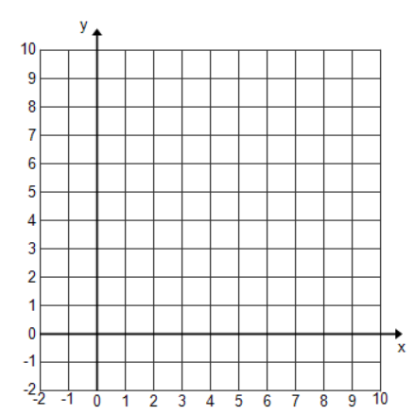
  - Plot the complex number $z=2+3i$ on the complex plane. Plot the ordered pair $(2,3)$ on the coordinate plane.

  - In what way are complex numbers “points”?
When a complex number is plotted on a complex plane, it looks just like the corresponding ordered pair plotted on a coordinate plane. For example, when $2+3i$ is plotted on the complex plane, it looks exactly the same as when the ordered pair $(2, 3)$ is plotted on a coordinate plane. We can interchangeably think of a complex number $x+yi$ in the complex plane as a point $(x,y)$ in the coordinate plane, and vice versa.
  - What point on the coordinate plane corresponds to the complex number$-1+8i$?
$$(-1, 8)$$

  - What complex number corresponds to the point located at coordinate$(0,-9)$?
$0-9i$ or $-9i$

Discussion (7 minutes)
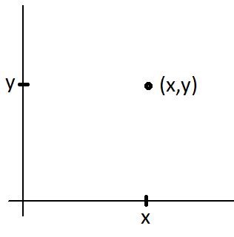
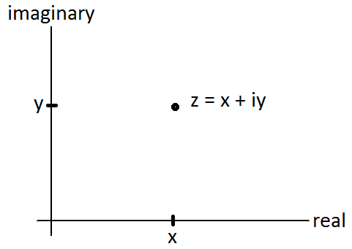
Draw the following on the board.

- When we say that complex numbers are points in the complex plane, what do we really mean?
  - When a complex number $x+yi$ is plotted on the complex plane, it looks exactly the same as when the ordered pair $(x,y)$ is plotted on a coordinate plane.
- What does this mean in terms of connecting the ideas we learned in Geometry to complex numbers?
  - Since we can interchangeably think of a complex number $x+yi$ in the complex plane as a point $(x,y)$ in the coordinate plane, and vice versa, all the work we did in Geometry can be translated into the language of complex numbers, and vice versa. Therefore, any work we do with complex numbers should translate back to results from Geometry.
- In Geometry, it did not make sense to add two points together. If $A(x_{1},y_{1})$ and $B(x_{2},y_{2})$are points, what would the geometric meaning of $A+B$ be?
Scaffolding:
If needed, provide students with an example using specific numbers rather than general parameters.
- If $A=3+4i$ and
$B=-1+6i$, then what is $A+B$?
  - $\left(3±1\right)+\left(4+6\right)i$
$$\text{or} 2+10i$$

  - It does not seem to have any meaning.
- It does make sense to add two complex numbers together. If $A=x_{1}+y_{1}i$ and $B=x_{2}+y_{2}i$, then what is $A+B$?
  - $(x_{1}+x_{2})+{(y}_{1}$+$y_{2})i$
- What is the geometric effect of transforming $A$with the function $f\left(z\right)=z+B$ for constant complex number $B$?
MP.7
  - Applying the transformation to $A$ has the geometric effect of performing a translation. So, adding $B$ to $A$ will shift point $A$ right $x_{2}$ units and
up $y_{2}$.
- If we view points in the plane as complex numbers, then we can add points in geometry.

Exercise 1 (3 minutes)
Have students work on Exercise 1 independently and then share results with a partner. If students do not recall how to find the midpoint, have them draw the line segment and locate the midpoint from the graph rather than providing them with the midpoint formula.
Exercises
- The endpoints of $\overline{AB}$ are $A(1,8)$ and $B(-5,3)$. What is the midpoint of $\overline{AB}$?
The midpoint of $\overline{AB}$ is $\left(-2,\frac{11}{2}\right)$.

- How do you find the midpoint of $\overline{AB}$?
  - You find the average of the $x$-coordinates and the $y$-coordinates to find the halfway point.
- In Geometry, we learned that for two points $A(x_{1},y_{1})$ and $B(x_{2},y_{2})$ the midpoint of $\overline{AB}$is $\left(\frac{x_{1} + x_{2}}{2},\frac{y_{1} + y_{2}}{2}\right)$.
- Now, view these points as complex numbers: $A=x_{1}+y_{1}i$ and $B=x_{2}+y_{2}i.$

Exercise 2 (7 minutes)
Allow students time to work on part (a) independently and then share results with a partner. Have them work in partners on part (b) before discussing as a class.
Scaffolding:
- Provide visual learners with a graph on the complex plane.
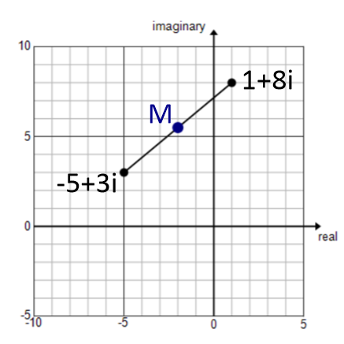
- If students need additional practice, use this example before completing part (b) of Exercise 2:
What is the midpoint of $A=-3+2i$ and $B=12-10i$?
  - $M=\frac{9}{2}-4i$

  - What is the midpoint of $A=1+8i$ and $B=-5+3i$?
MP.2
$$M=\frac{1+-5}{2}+\frac{\left(8+3\right)}{2}i=-2+\frac{11}{2}i$$

  - Using $A=x_{1}+y_{1}i$ and $B=x_{2}+y_{2}i$, show that in general the midpoint of points $A$ and $B$ is $\frac{A+B}{2}$, the arithmetic average of the two numbers.
$$M=\frac{x_{1}+x_{2}}{2}+\frac{y_{1}+y_{2}}{2}i \\ =\frac{x_{1}+y_{1}i+x_{2}+y_{2}i}{2} \\ = \frac{A+B}{2}$$

Exercise 3 (5 minutes)
As with Exercise 1, have students work on Exercise 3 independently and then share results with a partner. If students do not recall how to find the length of a line segment, have them draw the line segment and instruct them to think of it as the hypotenuse of a right triangle rather than providing them with the distance formula.

- The endpoints of $\overline{AB}$ are $A(1,8)$ and $B(-5,3)$. What is the length of $\overline{AB}$?
The length of $\overline{AB}$ is $\sqrt{61}$.

- How do you find the length of $\overline{AB}$?
  - You use the Pythagorean theorem which can be written as $AB=\sqrt{{\left(x_{2}-x_{1}\right)}^{2}+{\left(y_{2}-y_{1}\right)}^{2}}$ for two points $A(x_{1},y_{1})$ and $B(x_{2},y_{2}).$
- As we did previously, view these points as complex numbers: $A=x_{1}+y_{1}i$ and $B=x_{2}+y_{2}i.$

Exercise 4 (7 minutes)
As with Exercise 2, allow students time to work on part (a) independently and then share results with a partner. Have them work in partners on part (b) before discussing as a class.
Scaffolding:
- Provide visual learners with a graph on the complex plane.
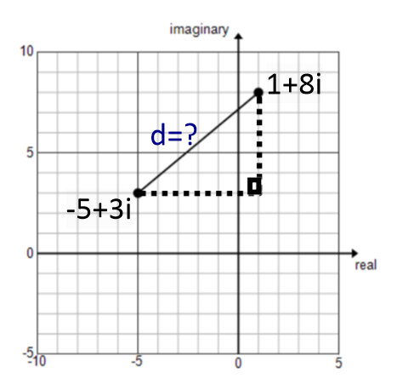
- If students need additional practice, use this example before completing part (b) of Exercise 4:
What is the distance between
$A=-3+2i$and$B=12-10i$?
  - $d=\sqrt{369}=3\sqrt{41}$

  - What is the distance between $A=1+8i$ and $B=-5+3i$?
$d=\sqrt{{\left(1-\left(-5\right)\right)}^{2}+{\left(8-3\right)}^{2}}=\sqrt{61}$
MP.2

  - Show that, in general, the distance between $A=x_{1}+y_{1}i$ and
$B=x_{2}+y_{2}i$ is the modulus of $A-B$.
$$A-B=\left(x_{1}-x_{2}\right)+\left(y_{1}-y_{2}\right)i$$
$\left|A-B\right|=\sqrt{{\left(x_{1}-x_{2}\right)}^{2}+{\left(y_{1}-y_{2}\right)}^{2}}=$ distance between $A$ and $B$.

Exercise 5 (3 minutes)
Allow students time to work either independently or with a partner. Circulate the room to ensure that students understand the concepts.

- Suppose $z=2+7i$ and $w=-3+i$.
Scaffolding:
Have struggling students create a graphic organizer comparing a coordinate plane and a complex plane.
 | Coordinate plane | Complex plane
 | $(-3,2)$ and $(1,3)$ | $-3+2i$ and $1+3i$
Graph
Midpoint
Distance

  - Find the midpoint $m$ of $z$ and $w$.
$$m=-\frac{1}{2}+4i$$

  - Verify that $\left|z-m\right|=\left|w-m\right|$.
$$\left|z-m\right|=\sqrt{{\left(2-\left(-\frac{1}{2}\right)\right)}^{2}+{\left(7-4\right)}^{2}} \\ =\sqrt{\frac{25}{4}+9} \\ =\sqrt{\frac{61}{4}}$$
$$\left|w-m\right|=\sqrt{{\left(-3-\left(-\frac{1}{2}\right)\right)}^{2}+{\left(1-4\right)}^{2}} \\ =\sqrt{\frac{25}{4}+9} \\ =\sqrt{\frac{61}{4}}$$

Closing (3 minutes)
Have students discuss each question with a partner. Then elicit class responses.
- In what way can complex numbers be thought of as points?
  - When a complex number is plotted on a complex plane, it looks just like the corresponding ordered pair plotted on a coordinate plane.
- Why is it helpful to interchange between complex numbers and points on a plane?
  - Unlike points on a plane, we can add and subtract complex numbers. Thus, we can use operations on complex numbers to find geometric measurements such as midpoint and distance.
Lesson Summary
- Complex numbers can be thought of as points in a plane, and points in a plane can be thought of as complex numbers.
- For two complex numbers $A=x_{1}+y_{1}i$ and $B=x_{2}+y_{2}i$, the midpoint of points $A$ and $B$ is $\frac{A+B}{2}$.
- The distance between two complex numbers $A=x_{1}+y_{1}i$ and $B=x_{2}+y_{2}i$is equal to $\left|A-B\right|.$

Exit Ticket (5 minutes)

Name Date
Lesson 11: Distance and Complex Numbers

Exit Ticket

- Kishore said that he can add two points in the coordinate plane like adding complex numbers in the complex plane. For example, for point $A(2, 3)$ and point $B(5, 1)$, he will get $A+B=\left(7, 4\right)$. Is he correct? Explain your reasoning.

- Consider two complex numbers $A=-4+5i$ and $B=4-10i$.
  - Find the midpoint of $A$ and $B$.

  - Find the distance between $A$ and $B$.

Exit Ticket Sample Solutions

- Kishore said that he can add two points in the coordinate plane like adding complex numbers in the complex plane. For example, for point $A(2, 3)$ and point $B(5, 1)$, he will get $A+B=\left(7, 4\right)$. Is he correct? Explain your reasoning.
No. Kishore is not correct because we cannot add two points in the rectangular plane. However, we can add two complex numbers in the complex plane, which has the geometric effect of performing a translation to points in complex numbers.

- Consider two complex numbers $A=-4+5i$ and $B=4-10i$.
  - Find the midpoint of $A$ and $B$.
$$M=\frac{ A+B }{2} \\ =\frac{-4+5i+4-10i }{2} \\ =\frac{-5i }{2} \\ =-\frac{5}{2}i \text{or} 0-\frac{5}{2}i$$

  - Find the distance between $A$ and $B$.
$$d=\sqrt{{\left(4-\left(-4\right)\right)}^{2}+{\left(-10-5\right)}^{2}}=17$$

Problem Set Sample Solutions

- Find the midpoint between the two given points in the rectangular coordinate plane.
  - $2+4i$ and $4+8i$
$$M=\frac{2+4}{2}+\frac{4+8}{2}i=3+6i$$

  - $-3+7i$ and $5-i$
$$M=\frac{-3+5}{2}+\frac{7-1}{2}i=1+3i$$

  - $-4+3i$ and $9-4i$
$$M=\frac{-4+9}{2}+\frac{3-4}{2}i=\frac{5}{2}-\frac{1}{2}i$$

  - $4+i$ and $-12-7i$
$$M=\frac{4-12}{2}+\frac{1-7}{2}i=-4-3i$$

  - $-8-3i$ and $3-4i$
$$M=\frac{-8+3}{2}+\frac{-3-4}{2}i=-\frac{ 5 }{2 }-\frac{ 7 }{2 }i$$

  - $\frac{2}{3}–\frac{5}{2}i$ and $-0.2+0.4i$
$$M=\frac{ \frac{2}{3}-\frac{5}{2}i-\frac{1}{5}+\frac{2}{5}i }{2} \\ =\frac{ \frac{2}{3}-\frac{1}{5}}{2}+\frac{ \frac{-5}{2}+\frac{2}{5}}{2}i \\ =\frac{ 10-3 }{30}+\frac{ -25+4 }{20}i \\ =\frac{ 7 }{30 }-\frac{ 21 }{20 }i$$

- Let $A=2+4i$, $B=14+8i$, and suppose that $C$ is the midpoint of $A$ and $B$, and that $D$ is the midpoint of $A$ and $C$.
  - Find points $C$ and $D$.
$$C=\frac{ A+B }{2 }=\frac{2+4i+14+8i }{2}=\frac{ 16+12i }{2}=8+6i$$
$$D=\frac{ A+C }{2}=\frac{ 2+4i+8+6i }{2}=\frac{ 10+10i }{2}=5+5i$$

  - Find the distance between $A$ and $B$.
$$\left|A-B\right|=\left|2+4i-14-8i\right| \\ =\left|-12-4i\right| \\ =\sqrt{{\left(-12\right)}^{2}+{\left(-4\right)}^{2}} \\ =\sqrt{144+16} \\ =\sqrt{160} \\ =4\sqrt{10}$$

  - Find the distance between $A$ and $C$.
$$\left|A-C\right|=\left|2+4i-8-6i\right| \\ =\left|-6-2i\right| \\ =\sqrt{{\left(-6\right)}^{2}+{\left(-2\right)}^{2}} \\ =\sqrt{40} \\ =2\sqrt{10}$$

  - Find the distance between $C$ and $D$.
$$\left|C-D\right|=\left|8+6i-5-5i\right| \\ =\left|3+i\right| \\ =\sqrt{{\left(3\right)}^{2}+{\left(1\right)}^{2}} \\ =\sqrt{10}$$
  - Find the distance between $D$ and $B$.
$$\left|D-B\right|=\left|5+5i-14-8i\right| \\ =\left|-9-3i\right| \\ =\sqrt{{\left(-9\right)}^{2}+{\left(-3\right)}^{2}} \\ =\sqrt{90} \\ =3\sqrt{10}$$

  - Find a point one quarter of the way along the line segment connecting segment $A$ and $B$, closer to $A$ than
to $B$.
The point is $D=5+5i$.

  - Terrence thinks the distance from $B$ to $C$ is the same as the distance from $A$ to $B$. Is he correct? Explain why or why not.
The distance from $B$ to $C$ is $2\sqrt{10}$, and the distance from $A$ to $B$ is $4\sqrt{10}$. The distances are not the same.

  - Using your answer from part (g), if $E$ is the midpoint of $C$ and $B$, can you find the distance from$E$ to $C$? Explain.
The distance from $B$ to $C$ is $2\sqrt{10}$, and the distance from $E$ to $C$ should be half of this value, $\sqrt{10}$.

  - Without doing any more work, can you find point $E$? Explain.
$B$ is $5+5i$, which is $3$units to the right of $A$ in the real direction and $1$ unit up in the imaginary direction. From $C$, you should move the same amount to get to $E$, so $E$ would be $11+7i$.

