Lesson 11: Distance and Complex Numbers

Classwork
Opening Exercise
  - Plot the complex number $z=2+3i$ on the complex plane. Plot the ordered pair $(2, 3)$ on the coordinate plane.
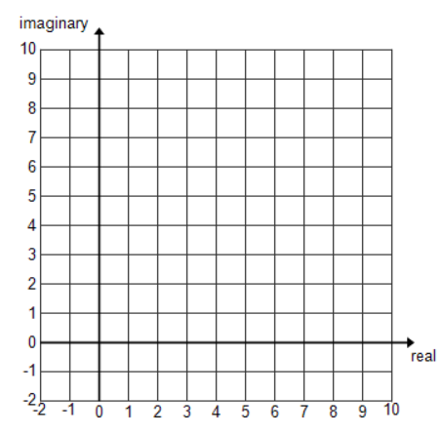
  - In what way are complex numbers “points”?

  - What point on the coordinate plane corresponds to the complex number$-1+8i$?

  - What complex number corresponds to the point located at coordinate$(0,-9)$?

Exercises
- The endpoints of a $\overline{AB}$ are $A(1, 8)$ and $B(-5, 3)$. What is the midpoint of $\overline{AB}$?

  - What is the midpoint of $A=1+8i$ and $B=-5+3i$?

  - Using $A=x_{1}+y_{1}i$ and $B=x_{2}+y_{2}i,$ show that in general the midpoint of points $A$ and $B$ is $\frac{A+B}{2}$, the arithmetic average of the two numbers.

- The endpoints of $\overline{AB}$ are $A(1, 8)$ and $B(-5, 3)$. What is the length of $\overline{AB}$?

  - What is the distance between $A=1+8i$ and $B=-5+3i$?

  - Show that, in general, the distance between $A=x_{1}+y_{1}i$ and $B=x_{2}+y_{2}i$ is the modulus of $A-B.$

- Suppose $z=2+7i$ and $w=-3+i$.
  - Find the midpoint $m$ of $z$ and $w$.

  - Verify that $\left|z-m\right|=\left|w-m\right|$.

Lesson Summary
- Complex numbers can be thought of as points in a plane, and points in a plane can be thought of as complex numbers.
- For two complex numbers $A=x_{1}+y_{1}i$ and $B=x_{2}+y_{2}i$, the midpoint of points $A$ and $B$ is $\frac{A+B}{2}$.
- The distance between two complex numbers $A=x_{1}+y_{1}i$ and $B=x_{2}+y_{2}i$is equal to $\left|A-B\right|.$

Problem Set

- Find the midpoint between the two given points in the rectangular coordinate plane.
  - $2+4i$ and $4+8i$
  - $-3+7i$ and $5-i$
  - $-4+3i$ and $9-4i$
  - $4+i$ and $-12-7i$
  - $-8-3i$ and $3-4i$
  - $\frac{2}{3}-\frac{5}{2}i$ and $-0.2+0.4i$

- Let $A=2+4i$, $B=14+8i$, and suppose that $C$ is the midpoint of $A$ and $B$, and that $D$ is the midpoint of $A$ and $C$.
  - Find points $C$ and $D$.
  - Find the distance between $A$ and $B$.
  - Find the distance between $A$ and $C$.
  - Find the distance between $C$ and $D$.
  - Find the distance between $D$ and $B$.
  - Find a point one quarter of the way along the line segment connecting segment $A$ and $B$, closer to $A$ than
to $B$.
  - Terrence thinks the distance from $B$ to $C$ is the same as the distance from $A$ to $B$. Is he correct? Explain why or why not.
  - Using your answer from part (g), if $E$ is the midpoint of $C$ and $B$, can you find the distance from$E$ to $C$? Explain.
  - Without doing any more work, can you find point $E$? Explain.

