|  |
| --- |
|  |

Lesson 9: The Geometric Effect of Some Complex Arithmetic

Student Outcomes

* Students represent addition, subtraction, and conjugation of complex numbers geometrically on the complex plane.

Lesson Notes

In the last few lessons, students have informally seen the geometric effects of complex conjugates and of multiplying by . This is the first of a two-day lesson in which students further explore the geometric interpretations of complex arithmetic. This lesson focuses on the geometric effects of adding and subtracting complex numbers.

Classwork

Opening (3 minutes)

Students have had previous exposure to some geometric effects of complex numbers. Ask them to answer the following questions and to share their responses with a neighbor.

*Scaffolding:*

* Use concrete examples such as asking students to describe the geometric effect of multiplying   
   by and by .
* Help students see the effect of multiplying by complex numbers by plotting ( and ) and ( and ) in the complex plane and asking how they are geometrically related.
* Describe the geometric effect of multiplying a complex number by .
* Describe the geometric effect of a complex conjugate.

**Discussion (5 minutes)**

The points in the complex plane are similar to points in the coordinate plane. The real part of the complex number is represented on the horizontal axis and the imaginary part on the vertical axis. In this and the next lesson, we will see that complex arithmetic causes reflections, translations, dilations, and rotations to points in the complex plane.

Begin the lesson by having students share their responses to the opening questions. As responses are shared, provide a visual depiction of each effect on the board. Use this as an opportunity to review notation as well.

* In coordinate geometry, what would happen to a point if we rotated it counterclockwise?
  + *The point would map to .*
* Describe the geometric effect of multiplying a complex number by .
  + *Multiplying a complex number by induces a rotation about the origin.*
* What would happen if we continued to multiply by ?
  + *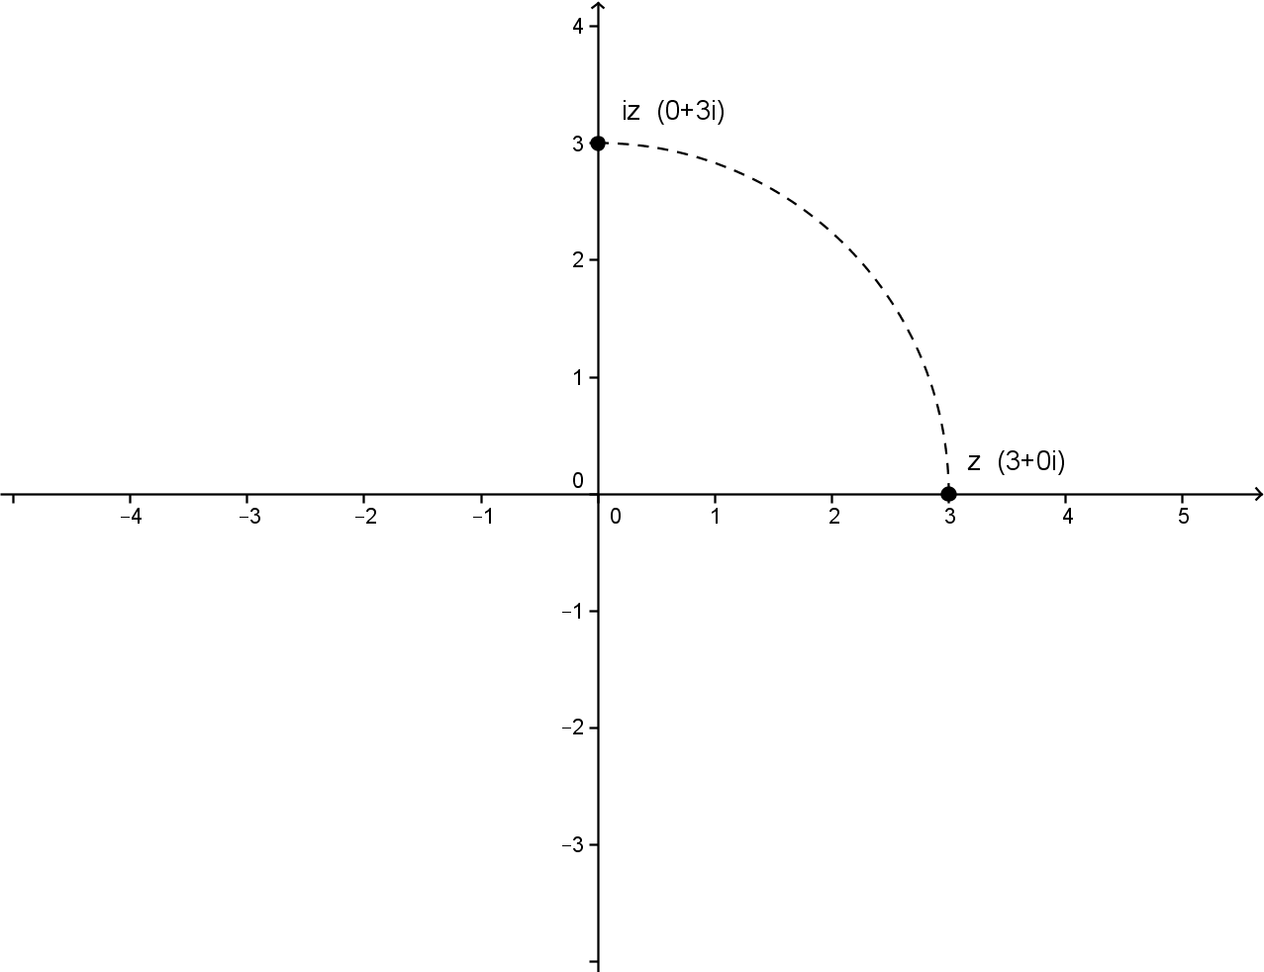Each time we multiply by results in another counterclockwise rotation of about the origin; for example, multiplying by twice results in a rotation about the origin, and multipliyng by four times results in a full rotation about the origin.*
* Describe the geometric effect of taking the complex conjugate.
  + *A complex conjugate reflects the complex number across the real axis*.

Remind students that the notation for the conjugate of is .

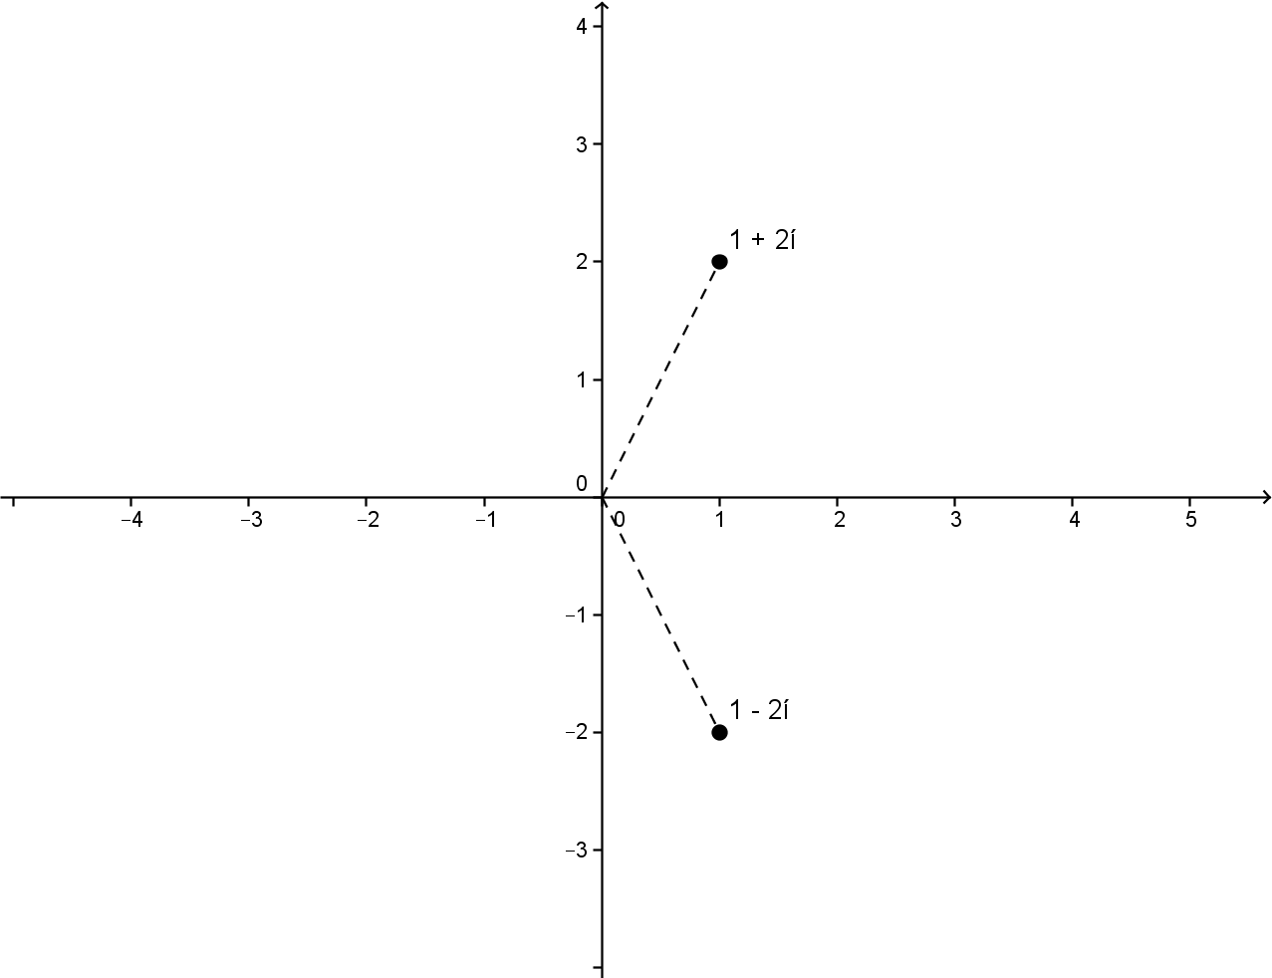

Exercise 1 (5 minutes)

Have students answer this exercise individually and share their response with a neighbor. Then, continue with the following discussion.

*Scaffolding:*

* Encourage advanced learners to write the general rule for Exercise 1.
* If students struggle to answer the question posed in Exercise 1, encourage them to plot a complex number like and to use it to find the reflection.

Exercises

1. Taking the conjugate of a complex number corresponds to reflecting a complex number about the real axis. What operation on a complex number induces a reflection across the imaginary axis?

For a complex number , the reflection across the imaginary axis is . Alternatively, for a complex number , the reflection across the imaginary axis is .

Students may have answered that the reflection of across the imaginary axis is  
. Discuss as a class how to write this in terms of the *conjugate* of the complex number.

* Is it possible to write another way? (Recall that the complex number can be written as .)
* Begin by factoring out : .
* Replace with : .

Exercises 2–3 (8 minutes)

In this exercise, students will explore the geometric effects of addition and subtraction to the points in the complex plane. Let students work in small groups. Before students begin, ask them to write a conjecture about the effect of adding a real number (e.g., ) to a complex number.

1. 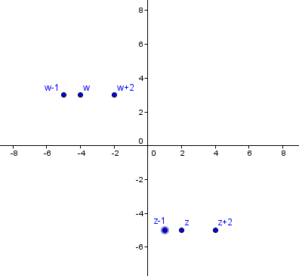Given the complex numbers and , graph each of the following:
2. Describe in your own words the geometric effect adding or subtracting a real number has on a complex number.

**MP.8**

Adding a real number to a complex number shifts the point to the right on the real (horizontal) axis, while subtracting a real number shifts the point to the left.

When students have finished the exercise, confirm as a class the answer to Exercise 3.

* Did your conjecture match the answer to Exercise 3?
  + *Answers will vary.*

Some students may no doubt have guessed that adding a positive real value (i.e., ) to the complex number would shift the point vertically instead of horizontally. They may be confusing the translation of a function, such as ,   
with that of a complex number. Make clear that even though we make comparisons between the complex and coordinate planes, the geometric effects are different. Use the following discussion points to clarify.

* What is the effect of adding a constant to a function like ? (For example, .)
  + *The graph of the parabola would shift upwards units.*
* How does this differ from adding the real number to a complex number?
  + *The point representing the complex number would shift two units to the right, not vertically like the function.*

**Exercises 4–5 (5 minutes)**

Students continue to explore the geometric effects of addition and subtraction to the points in the complex plane. Let students work in small groups.

1. 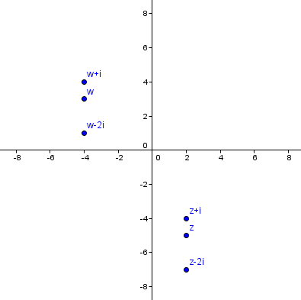Given the complex numbers and   
   , graph each of the following:
2. Describe in your own words the geometric effect adding or subtracting an imaginary number has on a complex number.

**MP.8**

Adding an imaginary number to a complex number shifts the point up the imaginary (vertical) axis, while subtracting an imaginary number shifts the point down.

Discussion (5 minutes)

Now that you have explored the effect of adding and subtracting real and imaginary parts to a complex number, bring both concepts together.

* Given the complex numbers and , how would you describe the translation of the point compared to ?
  + *The point would shift units to the right and units up.*

Represent the translation on the complex plane and point out that a right triangle is formed. Encourage students to think about how to describe the translation other than simply stating that the point shifts left/right or up/down.

Note: At this time do not explicitly state to students that the distance between the complex numbers is the modulus of the difference as that will be covered in a later lesson.

* In what other way could we describe or quantify the relationship between and ?
  + *The distance between the two points. We could use the Pythagorean theorem to determine the missing side of the right triangle.*

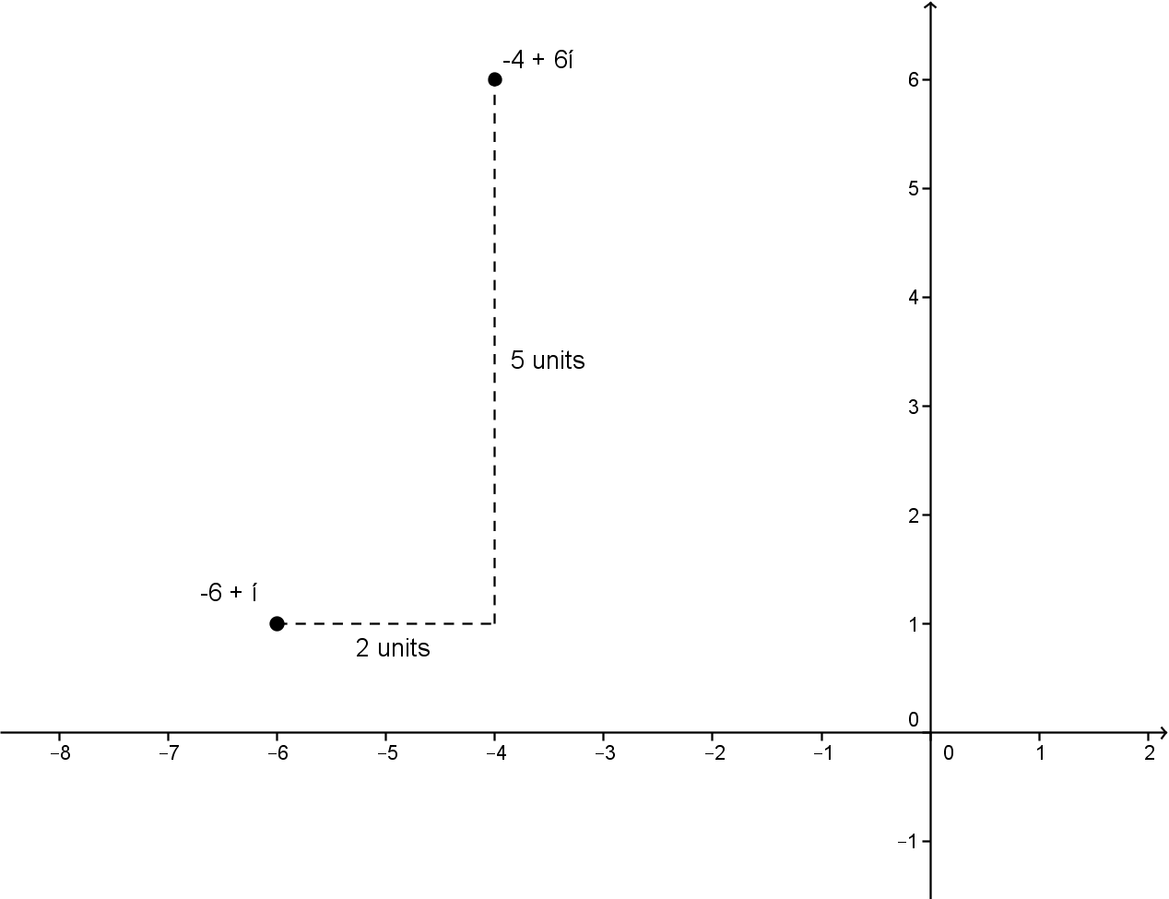

Example 1 (6 minutes)

Work through this example as a whole-class discussion. Encourage advanced learners to attempt the whole problem on their own.

**Example 1**

**Given the complex number , find a complex number such that is shifted units in a southwest direction.**

* 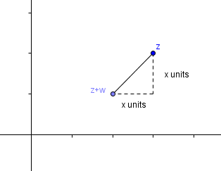Begin by plotting the complex number. What does it mean for the point to be shifted in a southwest direction?
  + *The point shifts to the left and down the same number of units.*
* A right triangle is formed. What are the values of the legs and the hypotenuse?
  + *The legs are both and the hypotenuse is .*

Give students an opportunity to solve for on their own and use the information to determine the complex number .

* + *, so*
  + *Since the point was shifted unit down and unit to the left, the complex number must be .*

Closing (3 minutes)

Have students summarize the key ideas of the lesson in writing or by talking to a neighbor. Take this opportunity to informally assess student understanding. The Lesson Summary provides some of the key ideas from the lesson.

Lesson Summary

* **The conjugate, , of a complex number, reflects the point across the real axis.**
* **The negative conjugate, , of a complex number , reflects the point across the imaginary axis.**
* **Adding or subtracting a real number to a complex number shifts the point left or right on the real (horizontal) axis.**
* **Adding or subtracting an imaginary number to a complex number shifts the point up or down on the imaginary (vertical) axis.**

Exit Ticket (5 minutes)

Name Date

Lesson 9: The Geometric Effect of Some Complex Arithmetic

Exit Ticket

1. 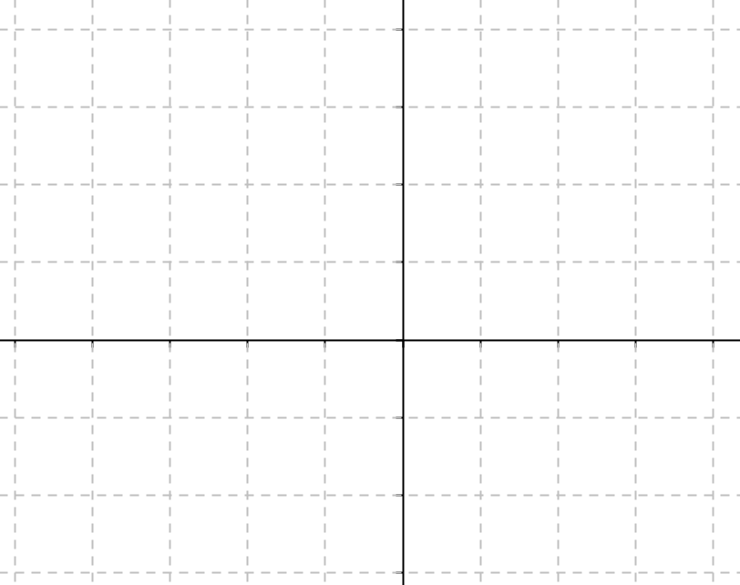Given and , plot the following in the complex plane:
2. Given , what complex number represents the reflection of about the imaginary axis? Give one example to show why.
3. What is the geometric effect of ?

Exit Ticket Sample Solutions

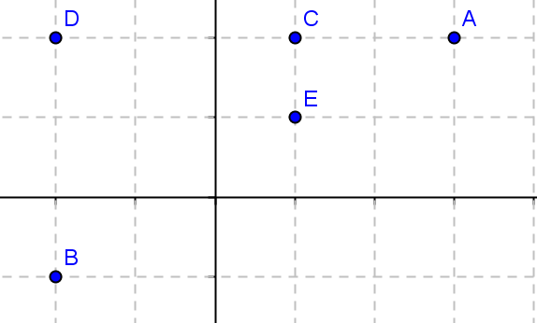

1. Given and , plot the following in the complex plane:
2. Given , what complex number represents the reflection of about the imaginary axis? Give one example to show why.

, the negative conjugate of . For example, , which is reflected about the imaginary axis.

1. What is the geometric effect of ?

shifts units to the right, and the units downward.

Problem Set Sample Solutions

1. Given the complex numbers and , graph each of the following:

1. Let , find for each case.
   1. is a counterclockwise rotation about the origin of .

; therefore, .

* 1. is reflected about the imaginary axis from .

; therefore, .

* 1. is reflected about the real axis from .

; therefore,

1. Let ,, simplify the following expressions.
2. **Given the complex number , find a complex number where is shifted**
   1. **units in a northeast direction.**

,, . Therefore, .

* 1. **units in a southeast direction.**

,, . Therefore, .