Lesson 8: Complex Number Division

Student Outcomes
- Students determine the modulus and conjugate of a complex number.
- Students use the concept of conjugate to divide complex numbers.

Lesson Notes
This is the second day of a two-day lesson on complex number division and applying this knowledge to further questions about linearity. In Lesson 7, students studied the multiplicative inverse. In this lesson, students study the numerator and denominator of the multiplicative inverse and their relationship to the conjugate and modulus. The lesson culminates with complex number division.

Classwork
Opening Exercise (3 minutes)
Students practice using the formula for the multiplicative inverse derived in Lesson 7 as a lead in to this lesson.
Opening Exercise
Use the general formula to find the multiplicative inverse of each complex number.
  - $2+3i$
$$\frac{2-3i}{13}$$

  - $-7-4i$
$$\frac{-7+4i}{65}$$

  - $-4+5i$
$$\frac{-4-5i}{41}$$

Discussion (2 minutes)
- Look at the complex numbers given in the Opening Exercise and the numerators of the multiplicative inverses. Do you notice a pattern? Explain.
Scaffolding:
Use a Frayer diagram to define conjugate. See Lesson 5 for an example.
  - The real term is the same in both the original complex number and its multiplicative inverse, but the imaginary term in the multiplicative inverse is the opposite of the imaginary term in the original complex number.
- If the complex number $z=a+bi$, what is the numerator of its multiplicative inverse?
  - $a-bi$
- Features of the multiplicative inverse formula often reappear in complex number arithmetic, so mathematicians have given these features names. The conjugate of a complex number $a+bi$ is $a-bi$. Repeat that with me.
  - The conjugate of $a+bi$ is $a-bi$.

Exercises 1–4 (2 minutes)
Have students quickly complete the exercises individually, and then follow up with the questions below. This would be a good exercise to do as a rapid white board exchange.
Exercises 1–4
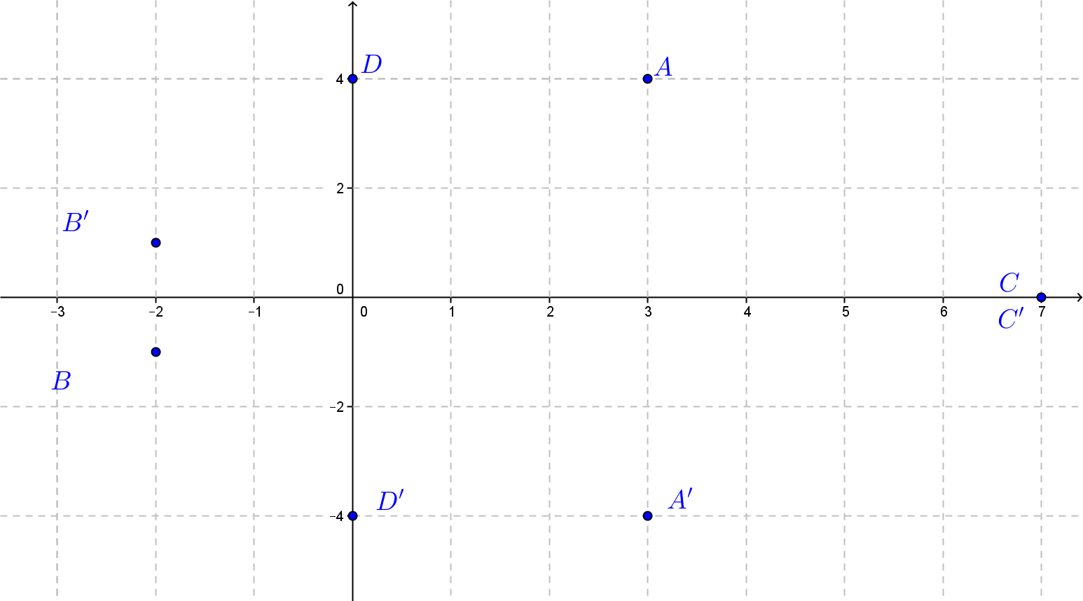
Find the conjugate, and plot the complex number and its conjugate in the complex plane. Label the conjugate with a prime symbol.
- $A$: $3+4i$
$A^{'}$: $3-4i$

- $B$: $-2-i$
$B^{'}$: $-2+i$

- $C$: $7$
$C^{'}$: $7$

- $D$: $4i$
$D^{'}$: $-4i$

Discussion (8 minutes)
- Does $7$ have a complex conjugate? If so, what is it? Explain your answer.
  - Yes, $7=7+0i$, so the complex conjugate would be $7-0i=7$.
- What is the complex conjugate of $4i$? Explain.
Scaffolding:
- Describe how $3+4i$ is related to $3-4i$.
- Describe how $-2-i$ is related to $-2+i$.
- In the Discussion, instead of using variables, use numbers.
  - $4i=0+4i$, the complex conjugate is $0-4i=-4i$.
- If $z=a+bi$, then the conjugate of $z$ is denoted $\overline{z}$. That means $\overline{z}=a-bi$.
- What is the geometric effect of taking the conjugate of a complex number?
MP.7
  - The complex conjugate reflects the complex number across the real axis.
- What can you say about the conjugate of the conjugate of a complex number?
  - The conjugate of the conjugate is the original number.

- Is $\overline{z+w}=\overline{z}+\overline{w}$ always true? Explain.
  - Yes, answers will vary. Students could plug in different complex numbers for $z$ and $w$ and show that they work or use a general formula argument. If $z=a+bi$ and $w=c+di$,
$z+w=\left(a+c\right)+\left(b+d\right)i$, and $\overline{z+w}=\left(a+c\right)-\left(b+d\right)i$. $\overline{z}=a-bi$, and $\overline{w}=c-di$, so
$\overline{z}+\overline{w}=\left(a+c\right)-\left(b+d\right)i$. Therefore, $\overline{z+w}=\overline{z}+\overline{w}$ is always true.
MP.3
- Is $\overline{z∙w}=\overline{z}∙\overline{w}$ always true? Explain.
  - Yes, answers will vary. Using the general formula argument: If $z=a+bi$ and $w=c+di$, then
$z∙w=ac+adi+bci-bd=\left(ac-bd\right)+\left(ad+bc\right)i$. $\overline{z∙w}=\left(ac-bd\right)-\left(ad+bc\right)i$.
$\overline{z}=a-bi$, and $\overline{w}=c-di$, so $\overline{z}∙\overline{w}=ac-adi-bci-bd=\left(ac-bd\right)-\left(ad+bc\right)i$. Therefore, $\overline{z∙w}=\overline{z}∙\overline{w}$ is always true.
- Now let’s look at the denominator of the multiplicative inverse. Remind me how we find the denominator.
  - $a^{2}+b^{2}$, the sum of the squares of the real term and the coefficient of the imaginary term.
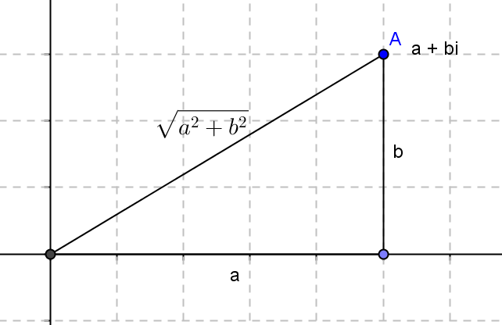
- Does this remind of you something that we have studied?
  - The Pythagorean theorem and if we take the square root, the distance formula.
- Mathematicians have given this feature a name too. The modulus of a complex number $a+bi$ is the real number $\sqrt{a^{2}+b^{2}}$. Repeat that with me.
  - The modulus of a complex number $a+bi$ is the real number $\sqrt{a^{2}+b^{2}}$.

Exercises 5–8 (4 minutes)
Have students quickly complete the exercises individually, and then follow up with the questions below. This would also be a good exercise to do as a rapid white board exchange.
Exercises 5–8
Find the modulus.
- $3+4i$
$$\sqrt{3^{2}+4^{2}}=\sqrt{25}=5$$

- $-2-i$
$$\sqrt{{(-2)}^{2}+{(-1)}^{2}}=\sqrt{5}$$

- $7$
$$\sqrt{7^{2}+0^{2}}=\sqrt{49}=7$$

- $4i$
$$\sqrt{0^{2}+{(4)}^{2}}=\sqrt{16}=4$$

Discussion (3 minutes)
- If $z=a+bi$, then the modulus of $z$ is denoted $\left|z\right|$. This means $\left|z\right|=\sqrt{a^{2}+b^{2}}$.
- If $z=a+bi$ is a point in the complex plane, what is the geometric interpretation of $\left|z\right|$?
  - The modulus is the distance of the point from the origin in the complex plane.
- The notation for the modulus of a complex number matches the notation for the absolute value of a real number. Do you think this is a coincidence? If a complex number is real, what can you say about its modulus?
  - The modulus is the number.
- Explain to your neighbor what you have learned about the conjugate and the modulus of a complex number.
- The conjugate of a complex number $a+bi$ is $a-bi$; taking the conjugate of a complex number reflects the number over the real axis.
- The modulus of complex number $a+bi$ is $\sqrt{a^{2}+b^{2}}$; the modulus represents the distance from the origin to the point $a+bi$ in the complex plane.

Exercises 9–11 (6 minutes)
Students should complete Exercises 9–11 in pairs. For advanced learners, assign all problems. Assign only one problem to other groups. Bring the class back together to debrief.
Exercises 9–11
Given $z=a+bi$.
- Show that for all complex numbers $z$, $\left|iz\right|=\left|z\right|$.
$$\left|iz\right|=\left|i(a+bi)\right|=\left|ai-b\right|=\left|-b+ai\right|=\sqrt{{(-b)}^{2}+a^{2}}=\sqrt{a^{2}+b^{2}}=\left|z\right|$$

- Show that for all complex numbers $z$, $z∙\overline{z}={\left|z\right|}^{2}$.
$$z∙\overline{z}=\left(a+bi\right)\left(a-bi\right)=a^{2}+b^{2} \\ {\left|z\right|}^{2}={\left(\sqrt{a^{2}+b^{2}}\right)}^{2}=a^{2}+b^{2} \\ z∙\overline{z}={\left|z\right|}^{2}$$

- Explain the following: Every nonzero complex number $z$ has a multiplicative inverse. It is given by $\frac{1}{z}=\frac{\overline{z}}{\left|z\right|}$.
The multiplicative inverse of $a+bi=\frac{a-bi}{a^{2}+b^{2}}=\frac{\overline{z}}{\left|z\right|}$.

Example 1 (5 minutes)
In this example, students divide complex numbers by multiplying the numerator and denominator by the conjugate. Do this as a whole class discussion.
Scaffolding:
- For advanced learners, assign this example without leading questions.
- Target some groups for individual instruction.
Example 1
$$\frac{2-6i}{2+5i}$$
$$\frac{-26-22i}{29}$$

- In this example, we are going to divide these two complex numbers. Complex number division is different from real number division, and the quotient will also look different.
- To divide complex numbers, we want to make the denominator a real number. We need to multiply the denominator by a complex number that will make it a real number. Multiply the denominator by its conjugate. What type of product do you get?
  - $\left(2+5i\right)\left(2-5i\right)=4-10i+10i-25i^{2}=4+25=29$. You get a real number.
- The result of multiplying a complex number by its conjugate is always a real number.
- The goal is to rewrite this expression $\frac{2 - 6i}{2 + 5i}$ as an equivalent expression with a denominator that is a real number. We now know that we must multiply the denominator by its conjugate. What about the numerator? What must we multiply the numerator by in order to obtain an equivalent expression?
  - We must multiply the numerator by the same expression, $2-5i$.
- Perform that operation, and check your answer with a neighbor.
  - $\frac{2 - 6i}{2 + 5i}∙\frac{2 - 5i}{2 - 5i}=\frac{4 - 10i - 12i + 30i^{2}}{4 - 25i^{2}}=\frac{4 - 22i - 30}{4 + 25}=\frac{-26 - 22i}{29}$
- Tell your neighbor how to divide complex numbers.
  - Multiply the numerator and denominator by the conjugate of the denominator.

Exercises 12–13 (5 minutes)
Have students complete the exercises and then check answers and explain their work to a neighbor.
Exercises 12–13
Divide.
- $\frac{3 + 2i}{-2 - 7i}$
$$\frac{3+2i}{-2-7i}∙\frac{-2+7i}{-2+7i}=\frac{-6+21i-4i-14}{4+49}=\frac{-20+17i}{53}$$

- $\frac{3}{3-i}$
$$\frac{3}{3-i}∙\frac{3+i}{3+i}=\frac{9+3i}{9+1}=\frac{9+3i}{10}$$
Closing (2 minutes)
Allow students to think about the questions below in pairs, and then pull the class together to wrap up the discussion.
- What is the conjugate of $a+bi$? What is the geometric effect of this conjugate in the complex plane?
  - $a-bi$, the conjugate is a reflection of the complex number across the real axis.
- What is the modulus of $a+bi$? What is the geometric effect of the modulus in the complex plane?
  - $\sqrt{a^{2}+b^{2}}$, the modulus is the distance of the point from the origin in the complex plane.
- How is the conjugate used in complex number division?
  - Multiply by a ratio in which both the numerator and denominator are the conjugate.

Exit Ticket (5 minutes)

Name Date
Lesson 8: Complex Number Division

Exit Ticket

- Given $z=4-3i$.
  - What does $\overline{z}$ mean?

  - What does $\overline{z}$ do to $z$ geometrically?

  - What does $\left|z\right|$ mean both algebraically and geometrically?

- Describe how to use the conjugate to divide $2-i$ by $3+2i$, and then find the quotient.

Exit Ticket Sample Solutions

- Given $z=4-3i$.
- What does $\overline{z}$ mean?
$\overline{z}$ means the conjugate of $z$, which is $4+3i$.

- What does $\overline{z}$ do to $z$ geometrically?
$\overline{z}$ is the reflection of $z$ across the real axis.

- What does $\left|z\right|$ mean both algebraically and geometrically?
$\left|z\right|$ is a modulus of $z$, which is a real number.
$\left|z\right|$ is the distance from the point $z=4-3i$ to the origin in complex plane.
$$\left|z\right|=\sqrt{a^{2}+b^{2}} \\ =\sqrt{{\left(4\right)}^{2}+{\left(-3\right)}^{2}} \\ =\sqrt{16+9} \\ =\sqrt{25} \\ =5$$

- Describe how to use the conjugate to divide $2-i$ by $3+2i$, and then find the quotient.
When $3+2i$ is multiplied by its conjugate of $3-2i$, the denominator is a real number, which is necessary. Multiply by $\frac{3-2i}{3-2i}$.
$$\frac{2-i}{3+2i}=\frac{(2-i)(3-2i)}{(3+2i)(3-2i)}=\frac{6-4i-3i-2}{9+4}=\frac{4-7i}{13}=\frac{4}{13}-\frac{7}{13}i$$

Problem Set Sample Solutions
Problems 1–3 are easy problems and allow students to practice finding the conjugate and modulus and dividing complex numbers. Problems 4–6 are more difficult. Students can use examples or a geometrical approach to explain their reasoning. Problem 5 is a preview of the effect of adding or subtracting complex numbers in terms of geometrical interpretations. Students need to find and compare the modulus, $r_{n}$, and $φ_{n}$ in order to come to their assumptions.

- Let $z=4-3i$ and $w=2-i$. Show that
  - $\left|z\right|=\left|\overline{z}\right|$
$$\left|z\right|=\sqrt{{\left(4\right)}^{2}+{\left(-3\right)}^{3}}=\sqrt{16+9}=\sqrt{25}=5$$
$$\overline{z}=4+3i, \left|\overline{z}\right|=\sqrt{{\left(4\right)}^{2}+{\left(3\right)}^{2}}=\sqrt{16+9}=\sqrt{25}=5$$
Therefore, $\left|z\right|=\left|\overline{z}\right|$.

  - $\left|\frac{1}{z}\right|=\frac{1}{\left|\overline{z}\right|}$
$$\frac{1}{z}=\frac{1}{4-3i}=\frac{\left(4+3i\right)}{\left(4-3i\right)\left(4+3i\right)}=\frac{4+3i}{25}=\frac{4}{25}+\frac{3}{25}i \text{; therefore, }$$
$$\left|\frac{1}{z}\right|=\sqrt{{\left(\frac{4}{25}\right)}^{2}+{\left(\frac{3}{25}\right)}^{2}}=\sqrt{\frac{16}{{\left(25\right)}^{2}}+\frac{9}{{\left(25\right)}^{2}}}=\sqrt{\frac{25}{{\left(25\right)}^{2}}}=\frac{1}{5}\text{.}$$
Since $\left|\overline{z}\right|=5$; therefore, $\frac{1}{\left|\overline{z}\right|}=\frac{1}{5}$, which equals $\left|\frac{1}{z}\right|=\frac{1}{5}$.

  - If $\left|z\right|=0$, must it be that $z=0$?
Yes. Let $z=a+bi$, and then $\left|z\right|=\sqrt{{\left(a\right)}^{2}+{\left(b\right)}^{2}}$. If $\left|z\right|=0$, it indicates that $\sqrt{{\left(a\right)}^{2}+{\left(b\right)}^{2}}=0$. Since ${\left(a\right)}^{2}+{\left(b\right)}^{2}$ both are positive real numbers, the only values of $a$ and $b$ that will make the equation true is that $a$ and $b$ have to be $0$, which means $z=0+0i=0$.

  - Give a specific example to show that $\left|z+w\right|$ usually does not equal $\left|z\right|+\left|w\right|$.
Answers vary, but $z=3+2i$ and $w=3-2i$ will work.
$$z+w=6+0i \\ \left|z+w\right|=\sqrt{{\left(6\right)}^{2}+{\left(0\right)}^{2}}=6$$
$\left|z\right|+\left|w\right|=\sqrt{{\left(3\right)}^{2}+{\left(2\right)}^{2}}+\sqrt{{\left(3\right)}^{2}+{\left(-2\right)}^{2}}=2\sqrt{13}$, which is not equal to $6$.

- Divide.
- $\frac{1 - 2i}{2i}$
$$\frac{(1-2i)(i)}{2i(i)}=\frac{2+i}{-2}\text{ or }-1-\frac{1}{2}i$$

- $\frac{5-2i}{5+2i}$
$$\frac{(5-2i)(5-2i)}{(5+2i)(5-2i)}=\frac{25-20i-4}{25+4}=\frac{21-20i}{29} \text{or} \frac{21}{29}-\frac{20}{29}i$$

- $\frac{\sqrt{3} - 2i}{-2 - \sqrt{3}i}$
$$\frac{(\sqrt{3}-2i)\left(-2+\sqrt{3}i\right)}{\left(-2-\sqrt{3}i\right)\left(-2+\sqrt{3}i\right)}=\frac{-2\sqrt{3}+3i+4i+2\sqrt{3}}{4+3}=\frac{7i}{7}=i$$

- Prove that $\left|zw\right|=\left|z\right|∙\left|w\right|$ for complex numbers $z$ and $w$.
Since ${\left|z\right|}^{2}=z⋅\overline{z}$; therefore, ${\left|zw\right|}^{2}=\left(zw\right)\left(\overline{zw}\right)=\left(zw\right)\left(\overline{z}\overline{w}\right)=z\overline{z}w\overline{w}={\left|z\right|}^{2}∙{\left|w\right|}^{2}$.
Now we have ${\left|zw\right|}^{2}={\left|z\right|}^{2}∙{\left|w\right|}^{2}$; therefore, $\left|zw\right|=\left|z\right|∙\left|w\right|$.

- Given $z=3+i$,$w=1+3i$.
  - Find $z+w$, and graph $z$, $w$, and $z+w$ on the same complex plane. Explain what you discover if you draw line segments from the origin to those points $z$,$w$, and $z+w$. Then draw line segments to connect $w$ to
$z+w$, and $z+w$ to $z$.
$$z+w=4+4i$$
Students should discover that the lines form a parallelogram. They then can graphically see that the lengths of the two sides are greater than the diagonal, $\left|z+w\right|≤\left|z\right|+\left|w\right|$.

  - Find $-w$, and graph $z$, $w$, and $z-w$ on the same complex plane. Explain what you discover if you draw line segments from the origin to those points $z$, $w$, and $z-w$. Then draw line segments to connect $w$ to $z-w$, and $z-w$ to $z$.
$$z-w=2-2i$$
Students should discover that the lines form a parallelogram. They then can graphically see that the lengths of the two sides are greater than the diagonal, $\left|z-w\right|≤\left|z\right|+\left|w\right|$.
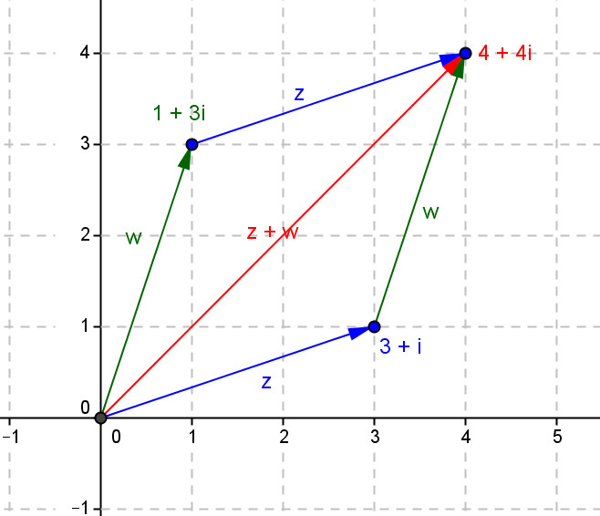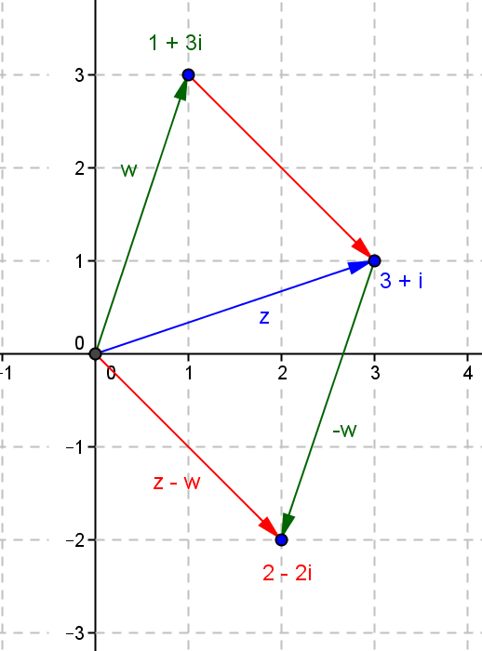

- Explain why $\left|z+w\right|≤\left|z\right|+\left|w\right|$ and $\left|z-w\right|≤\left|z\right|+\left|w\right|$ geometrically. (Hint: Triangle inequality theorem)
By using Example 5, we can apply the triangle inequality theorem into these two formulas.

