Lesson 6: Complex Numbers as Vectors

Classwork
Opening Exercises
Perform the indicated arithmetic operations for complex numbers $z=-4+5i$ and $w=-1-2i$.
  - $z+w$

  - $z-w$

  - $z+2w$

  - $z-z$

  - Explain how you add and subtract complex numbers.

Exercise 1
- The length of the vector that represents $z_{1}=6-8i$ is $10$ because $\sqrt{6^{2}+{\left(-8\right)}^{2}}=\sqrt{100}=10$.
  - Find at least seven other complex numbers that can be represented as vectors that have length $10$.

  - Draw the vectors on the coordinate axes provided below.

  - What do you observe about all of these vectors?

- In the Opening Exercises, we computed $z+2w$. Calculate this sum using vectors.

- In the Opening Exercises, we also computed $z-z$. Calculate this sum using vectors.

- For the vectors $u$ and $v$ pictured below, draw the specified sum or difference on the coordinate axes provided.
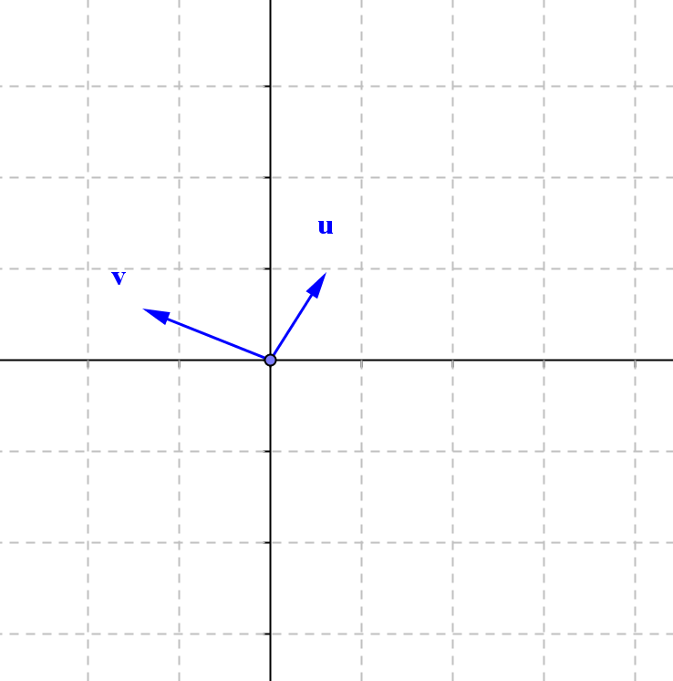
  - $u+v$
  - $v-u$
  - $2u-v$
  - $-u-3v$

- Find the sum of $4+i$ and $-3+2i$ geometrically.

- Show that $\left(7+2i\right)-\left(4-i\right)=3+3i$ by representing the complex numbers as vectors.

Problem Set

- Let $z=1+i$ and $w=1-3i$. Find the following. Express your answers in $a+bi$ form.
  - $z+w$
  - $z-w$
  - $4w$
  - $3z+w$
  - $-w-2z$
  - What is the length of the vector representing $z$?
  - What is the length of the vector representing $w$?

- Let $u=3+2i$, $v=1+i$, and $w=-2-i$. Find the following. Express your answer in $a+bi$ form, and represent the result in the plane.
  - $u-2v$
  - $u-2w$
  - $u+v+w$
  - $u-v+w$
  - What is the length of the vector representing $u$?
  - What is the length of the vector representing
$u-v+w$?

- Find the sum of $-2-4i$ and $5+3i$ geometrically.

- Show that $\left(-5-6i\right)-\left(-8-4i\right)=3-2i$ by representing the complex numbers as vectors.

- Let $z_{1}=a_{1}+b_{1}i$, $z_{2}=a_{2}+b_{2}i$, and $z_{3}=a_{3}+b_{3}i$. Prove the following using algebra or by showing with vectors.
  - $z_{1}+z_{2}=z_{2}+z_{1}$
  - $z_{1}+\left(z_{2}+z_{3}\right)=\left(z_{1}+z_{2}\right)+z_{3}$

- Let $z=-3-4i$ and $w=-3+4i$.
  - Draw vectors representing $z$ and $w$ on the same set of axes.
  - What are the lengths of the vectors representing $z$ and $w$?
  - Find a new vector, $u_{z}$, such that $u_{z}$ is equal to $z$ divided by the length of the vector representing $z$.
  - Find $u_{w}$, such that $u_{w}$ is equal to $w$ divided by the length of the vector representing $w$.
  - Draw vectors representing $u_{z}$ and $u_{w}$ on the same set of axes as part (a).
  - What are the lengths of the vectors representing $u_{z}$ and $u_{w}$?
  - Compare the vectors representing $u_{z}$ to $z$ and $u_{w}$ to $w$. What do you notice?
  - What is the value of $u_{z}$ times $u_{w}$?
  - What does your answer to part (h) tell you about the relationship between $u_{z}$ and $u_{w}$?

- Let $z=a+bi$.
  - Let $u_{z}$ be represented by the vector in the direction of $z$ with length $1$. How can you find $u_{z}$? What is the value of $u_{z}$?
  - Let $u_{w}$ be the complex number that when multiplied by $u_{z}$, the product is $1$. What is the value of $u_{w}$?
  - What number could we multiply $z$ by to get a product of $1$?

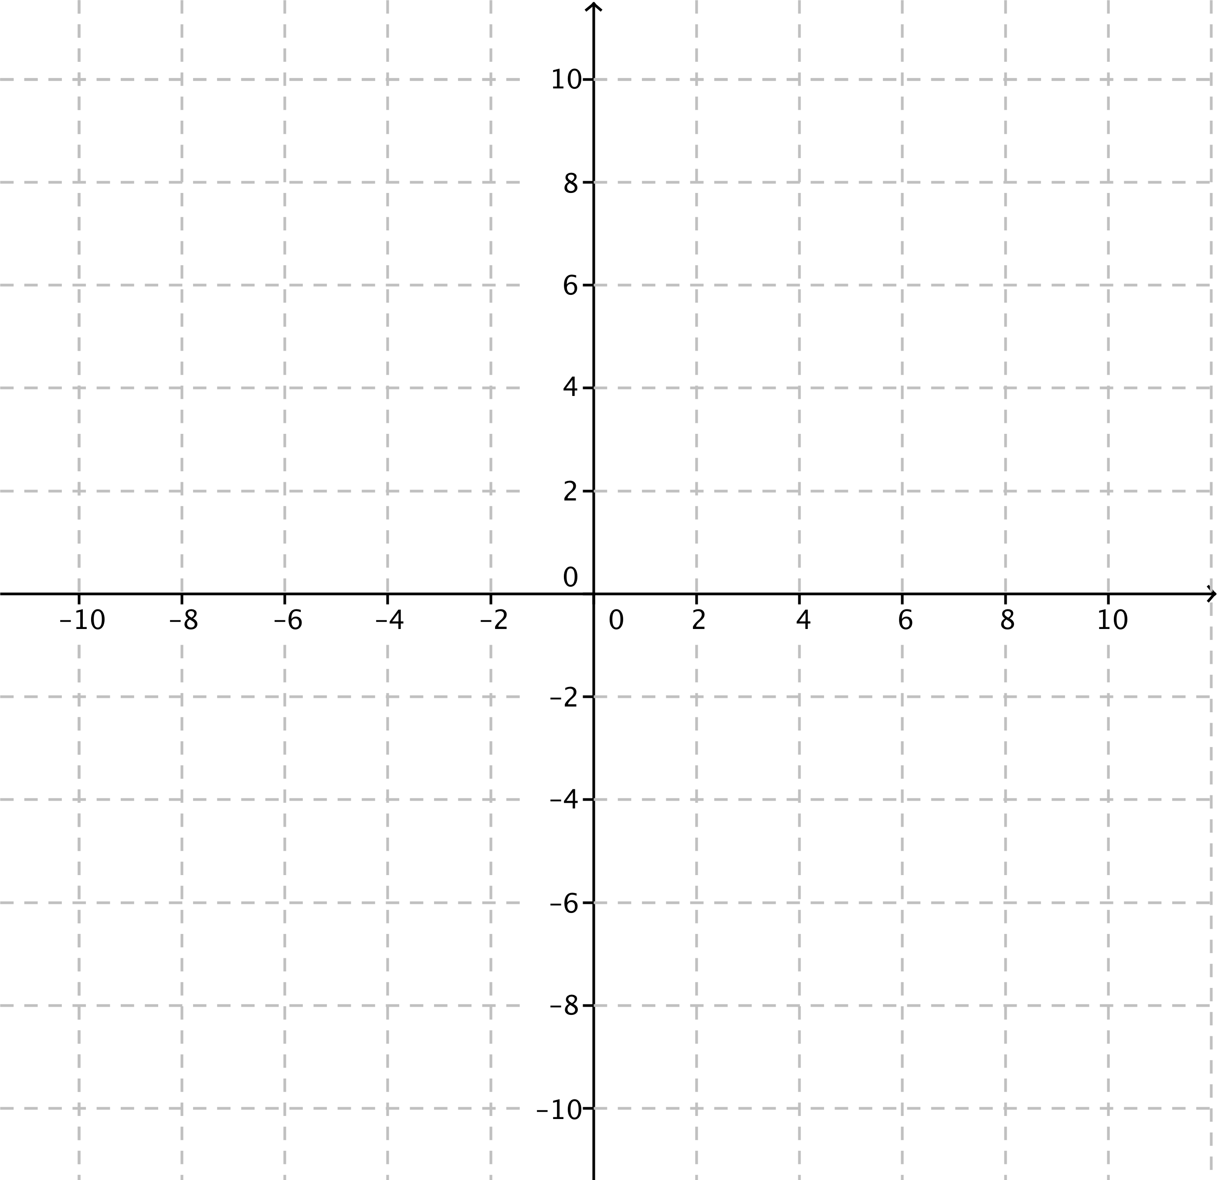
- Let $z=-3+5i$.
  - Draw a picture representing $z+w=8+2i$.
  - What is the value of $w$?

