Lesson 5: An Appearance of Complex Numbers

Student Outcomes
- Students describe complex numbers and represent them as points in the complex plane.
- Students perform arithmetic with complex numbers, including addition, subtraction, scalar multiplication, and complex multiplication.

Lesson Notes
In this lesson, complex numbers are formally described (N-CN.A.1), and students review how to represent complex numbers as points in the complex plane (N-CN.B.4). Students look for and make use of structure as they see similarities between plotting ordered pairs of real numbers in the coordinate plane and plotting complex numbers in the complex plane.
MP.7
Next, students review the mechanics involved in adding complex numbers, subtracting complex numbers, multiplying a complex number by a scalar, and multiplying a complex number by a second complex number. Students look for and make use of structure as they see similarities between the process of multiplying two binomials and the process of multiplying two complex numbers.
MP.7

Classwork
Opening Exercise (2 minutes)
Opening Exercise
Write down two fundamental facts about $i$ that you learned in the previous lesson.
Multiplication by $i$ induces a $90$-degree counterclockwise rotation about the origin. Also, $i$ satisfies the equation $i^{2}=-1$.

Discussion (5 minutes): Describing Complex Numbers
- What do you recall about the meanings of the following terms? Briefly discuss what you remember with a partner, providing examples of each kind of number as you are able. After you have had a minute to share with one another, we will review each term as a whole class.
  - Real number
  - Imaginary number
  - Complex number
After students talk in pairs, bring the class together, and ask a few individual students to share an example of each kind of number.

  - Examples of real numbers: $5$,$\frac{1}{2}$,$0.865$,$-4$,$0$
  - Examples of imaginary numbers: $3i$,$5i$,$-2i$
  - Examples of complex numbers: $3+4i$,$5-6i$
In the previous lesson, we reviewed the definition of the imaginary unit $i$. We can also form multiples of $i$, such as $2i, 3i, 4i, -10i$. The multiples of $i$ are called imaginary numbers. As you know, the term real number refers to numbers like $3$,$-12$,$0$, $\frac{3}{5}$,$\sqrt{2}$, and so forth, none of which have an imaginary component. If we combine a real number and an imaginary number, we get expressions like these: $5+2i$,$4-3i$,$-6+10i$. These numbers are called complex numbers. In general, a complex number has the form $a+bi$, where $a$ and $b$ are both real numbers. The number $a$ is called the real component, and the number $b$ is called the imaginary component.
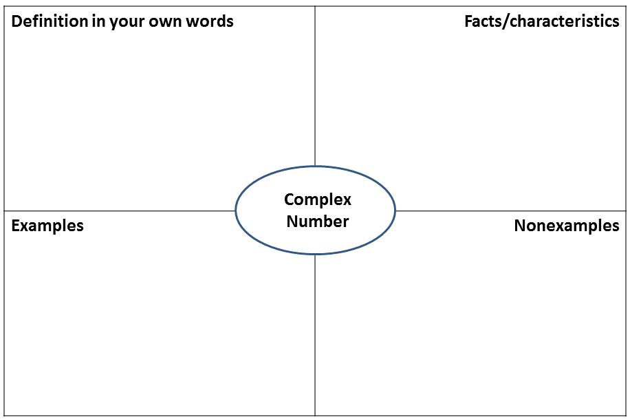
Discussion (5 minutes): Visualizing Complex Numbers
- Visualization is an extremely important tool in mathematics. How do we visually represent real numbers?
  - Real numbers can be represented as points on a number line.
- How do you suppose we could visually represent a complex number? Do you think we could use a number line just like the one we use for real numbers?
  - Since it takes two real numbers $a$ and $b$ to describe a complex number $a+bi$, we cannot just use a single number line.
In fact, we need two number lines to represent a complex number. The standard way to represent a complex number is to create what mathematicians call the complex plane. In the complex plane, the $x$-axis is used to represent the real component of a complex number, and the $y$-axis is used to represent its imaginary component. For instance, the complex number $5+2i$ has a real component of $5$, so we take the point that is $5$ units along the $x$-axis. The imaginary component is $2$, so we take the point that is $2$ units along the $y$-axis. In this way, we can associate the complex number $5+2i$ with the point $(5,2)$ as shown below. This seemingly simple maneuver, associating complex numbers with points in the plane, will turn out to have profound implications for our studies in this module.

−5
−4
−3
−2
−1
1
2
3
4
5
i
2i
3i
4i
5i
−i
−2i
−3i
−4i
−5i

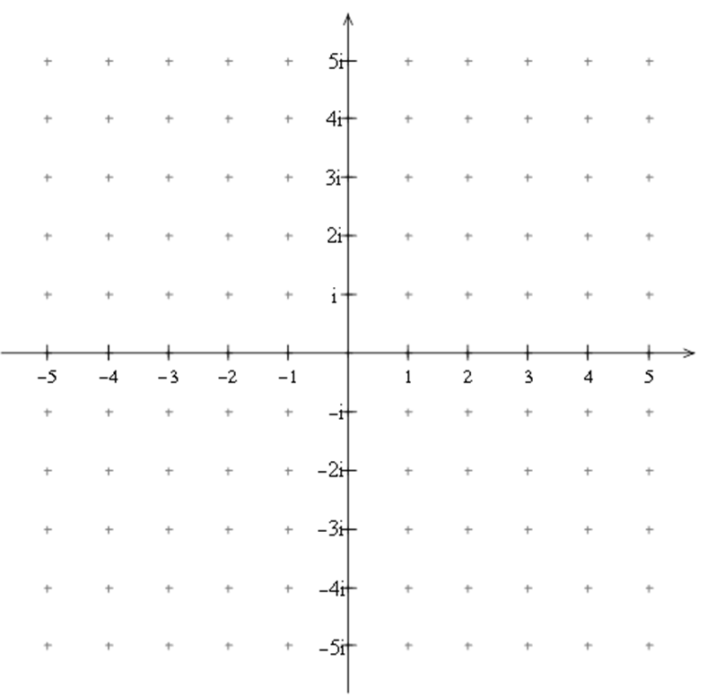
Discussion: Visualizing Complex Numbers

Exercises 1–3 (2 minutes)
Allow students time to respond to the following questions and to discuss their responses with a partner. Then bring the class together, and allow a few individual students to share their responses with the class.
Exercises
- Give an example of a real number, an imaginary number, and a complex number. Use examples that have not already been discussed in the lesson.
Answers will vary.

- In the complex plane, what is the horizontal axis used for? What is the vertical axis used for?
The horizontal axis is used to represent the real component of a complex number. The vertical axis is used to represent the imaginary component.

- How would you represent $-4+3i$ in the complex plane?
The complex number $-4+3i$ corresponds to the point $(-4,3)$ in the coordinate plane.

Example 1 (6 minutes): Scalar Multiplication
Let’s consider what happens when we multiply a real number by a complex number.
MP.7
$$9\left(-8+10i\right)$$
- Does this remind you of a situation that is handled by a property of real numbers?
  - This expression resembles the form $a(b+c)$, which can be handled using the distributive property.
- The distributive property tells us that $a\left(b+c\right)=ab+ac$, but the ordinary version of this property only applies when $a$, $b$, and $c$ are real numbers. In fact, we can extend the use of the distributive property to include cases that involve complex numbers.
$$9\left(-8+10i\right)=9\left(-8\right)+9\left(10i\right)=-72+90i$$
- Let’s explore this operation from a geometric point of view.
- If $w=3+i$, what do you suppose $2w$ looks like in the complex plane? Compute $2w$, then plot both $w$ and $2w$ in the complex plane.
  - $2w=2\left(3+i\right)=6+2i$
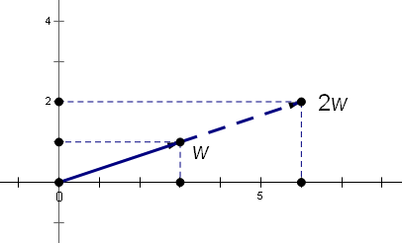
- How would you describe the relationship between $w$ and $2w$?
MP.7
  - The points representing $w$ and $2w$ are on the same line through the origin. The distance from $0$ to $2w$ is twice as long as the distance from $0$ to $w$.
- Notice that the real component of $w$ was transformed from $3$ to $2\left(3\right)=6$, and the imaginary component of $w$ was transformed from $1$ to $2$. We could say that each component got scaled up by a factor of $2$. For this reason, multiplying by a real number is referred to as scalar multiplication, and since real numbers have this kind of scaling effect, they are sometimes called scalars.

Example 2 (7 minutes): Multiplying Complex Numbers
- Let’s look now at an example that involves multiplying a complex number by another complex number.
Scaffolding:
Advanced learners may be challenged to perform the multiplication without any cues from the teacher.
$$\left(8+7i\right)\left(10-5i\right)$$
- What situation involving real numbers does this remind you of?
  - It resembles the situation where you are multiplying two binomials:
$(a+b)(c+d)$.
- Although we are working with complex numbers, the distributive property still applies. Multiply the terms using the distributive property.
$$\left(8+7i\right)\left(10-5i\right)=8\left(10-5i\right)+7i(10-5i)80-40i+70i-35i^{2}$$
- What could we do next?
Scaffolding:
The diagram below can be used to multiply complex numbers in much the same way that it can be used to multiply two binomials. Some students may find it helpful to organize their work in this way.
  - We can combine the two $i$-terms into a single term:
$$80-40i+70i-35i^{2}=80+30i-35i^{2}$$
- Does anything else occur to you to try here?
  - We know that $i^{2}=-1$, so we can write
$$80+30i-35i^{2}=80+30i-35\left(-1\right) \\ 80+30i-35\left(-1\right)=80+30i+35=115+30i$$
- Summing up: We started with two complex numbers $8+7i$ and $10-5i$, we multiplied them together, and we produced a new complex number $115+30i$.
 | $$8$$ | $$7i$$
$$10$$ | 80 | $$70i$$
$$-5i$$ | $$-40i$$ | $$-35i^{2}$$
Example 3 (5 minutes): Addition and Subtraction
- Do you recall the procedures for adding and subtracting complex numbers? Go ahead and give these two problems a try.
$$\left(-10-3i\right)+\left(-6+6i\right)$$
$$\left(9-6i\right)-\left(-3-10i\right)$$
Give students an opportunity to try these problems. Walk around the room and monitor students’ work, and then call on students to share what they have done.
$$\left(-10-3i\right)+\left(-6+6i\right)=\left(-10+-6\right)+\left(-3i+6i\right)=-16+3i$$
$$\left(9-6i\right)-\left(-3-10i\right)=\left[9-\left(-3\right)\right]+\left[-6i-\left(-10i\right)\right]=12+4i$$
- The key points to understand here are these:
- To add two complex numbers, add the real components and the imaginary components separately.
- To subtract two complex numbers, subtract the real components and the imaginary components separately.
- In the lesson today, we saw that when we multiply a complex number by a scalar, we get a new complex number that is simply a scaled version of the original number. Now, suppose we were to take two complex numbers $z$ and $w$. How do you suppose $z+w$, $z-w$, and $z∙w$ are related geometrically? These questions will be explored in the upcoming lessons.

Exercises 4–7 (4 minutes)
Tell students to perform the following exercises for practice and then to compare their answers with a partner. Call on students at random to share their answers.
For Exercises 4–7, let $a=1+3i$ and $b=2-i$.
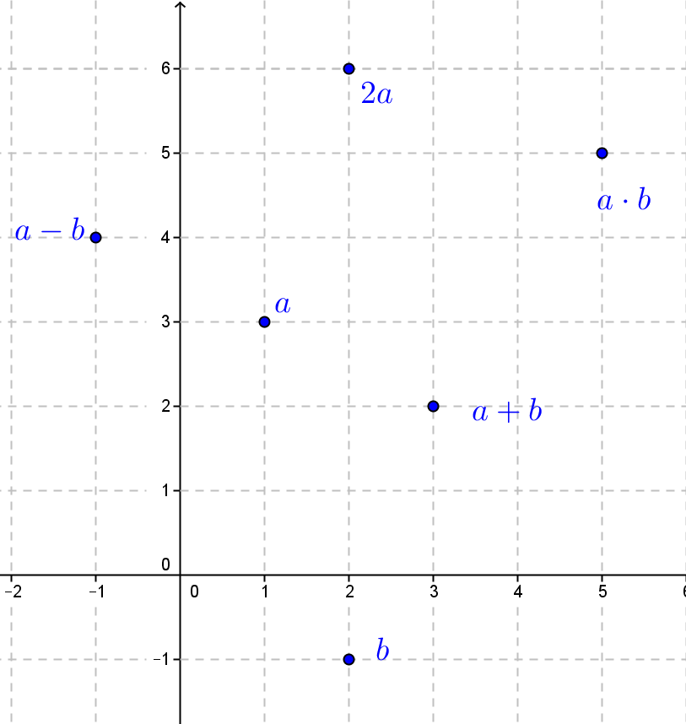
- Find $a+b$. Then plot $a$, $b$, and $a+b$ in the complex plane.
$$a+b=3+2i$$

- Find $a-b$. Then plot $a$, $b$, and $a-b$ in the complex plane.
$$a-b=-1+4i$$

- Find $2a$. Then plot $a$ and $2a$ in the complex plane.
$$2a=2+6i$$

- Find $a∙b$. Then plot $a$, $b$, and $a∙b$ in the complex plane.
$$a∙b=\left(1+3i\right)\left(2-i\right) \\ =2-i+6i-3i^{2} \\ =2+5i+3 \\ =5+5i$$

Closing (3 minutes)
Ask students to respond to the following questions in their notebooks, and then give them a minute to share their responses with a partner.
- What is the complex plane used for?
  - The complex plane is used to represent complex numbers visually.
- What operations did you learn to perform on complex numbers?
  - We learned how to add, subtract, and multiply two complex numbers, as well as how to perform scalar multiplication on complex numbers.
- Which of the four fundamental operations was not discussed in this lesson? This topic will be treated in an upcoming lesson.
  - We did not discuss how to divide two complex numbers.

Exit Ticket (6 minutes)

Name Date
Lesson 5: An Appearance of Complex Numbers

Exit Ticket

In Problems 1–4, perform the indicated operations. Write each answer as a complex number $a+bi$.
- Let $z_{1}=-2+i$,$z_{2}=3-2i$, and $w=z_{1}+z_{2}$. Find $w$, and graph $z_{1}$, $z_{2}$, and $w$ in the complex plane.

- Let $z_{1}=-1-i$, $z_{2}=2+2i$, and $w=z_{1}-z_{2}$. Find $w$, and graph $z_{1}$, $z_{2}$, and $w$ in the complex plane.

- Let $z=-2+i$ and $w=-2z$. Find $w$, and graph $z$ and $w$ in the complex plane.

- Let $z_{1}=1+2i$,$z_{2}=2-i$, and $w=z_{1}⋅z_{2}$. Find $w$, and graph $z_{1}$,$z_{2}$, and $w$ in the complex plane.

Exit Ticket Sample Solutions

In Problems 1–4, perform the indicated operations. Report each answer as a complex number $a+bi$.
- Let $z_{1}=-2+i$,$z_{2}=3-2i$, and $w=z_{1}+z_{2}$. Find $w$, and graph $z_{1}$, $z_{2}$, and $w$ in the complex plane.
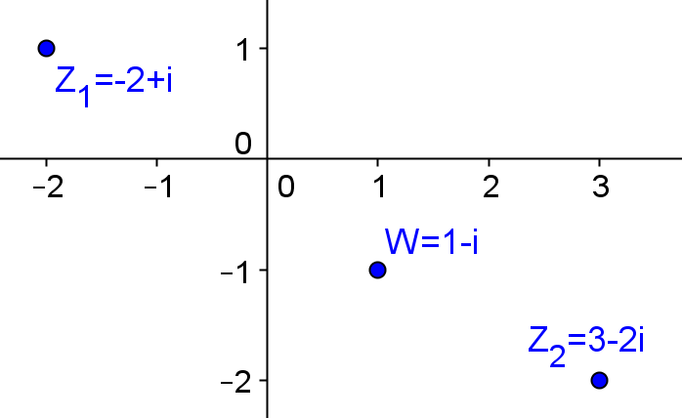
$$w=1-i$$

- Let $z_{1}=-1-i,z_{2}=2+2i$, and $w=z_{1}-z_{2}$. Find $w$, and graph $z_{1}, z_{2}$, and $w$ in the complex plane.
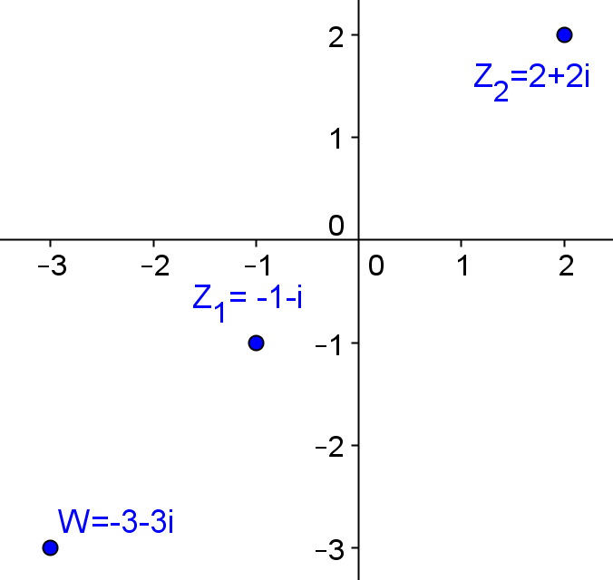
$$w=-3-3i$$

- Let $z=-2+i$ and $w=-2z$. Find $w$, and graph $z$ and $w$ in the complex plane.
$$w=4-2i$$

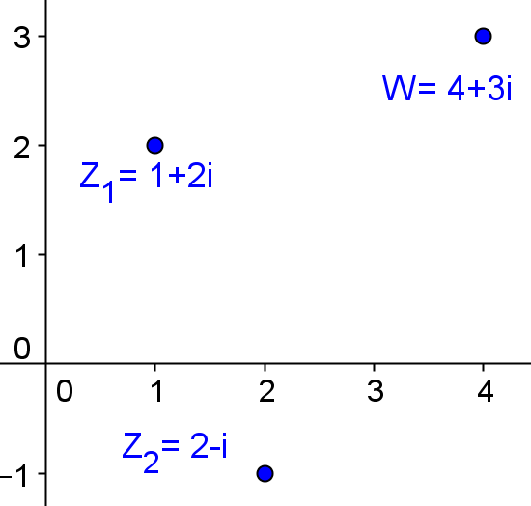
- Let $z_{1}=1+2i$, z_2$=2-i$, and $w=z_{1}⋅z_{2}$. Find $w$, and graph $z_{1}$,$z_{2}$, and $w$ in the complex plane.

$$w=\left(1+2i\right)\left(2-i\right) \\ =2-i+4i+2 \\ =4+3i$$

Problem Set Sample Solutions
Problems 1–4 involve the relationships between the set of real numbers, the set of imaginary numbers, and the set of complex numbers. Problems 5–9 involve practice with the core set of arithmetic skills from this lesson. Problems 10–12 involve the complex plane. A reproducible complex plane is provided at the end of the lesson should the teacher choose to hand out copies for the Problem Set.

- The number $5$ is a real number. Is it also a complex number? Try to find values of $a$ and $b$ so that $5=a+bi$.
Because $5=5+0i$, $5$ is a complex number.

- The number $3i$ is an imaginary number and a multiple of $i$. Is it also a complex number? Try to find values of $a$ and $b$ so that $3i=a+bi$.
Because $3i=0+3i$, $3i$ is a complex number.

- Daria says that “every real number is a complex number.” Do you agree with her? Why or why not?
For any real number $a$,$a=a+0i$, so Daria is correct.

- Colby says that “every imaginary number is a complex number.” Do you agree with him? Why or why not?
An imaginary number $bi=0+bi$, so Colby is correct.

In Problems 5–9, perform the indicated operations. Report each answer as a complex number $w=a+bi$, and graph it in a complex plane.
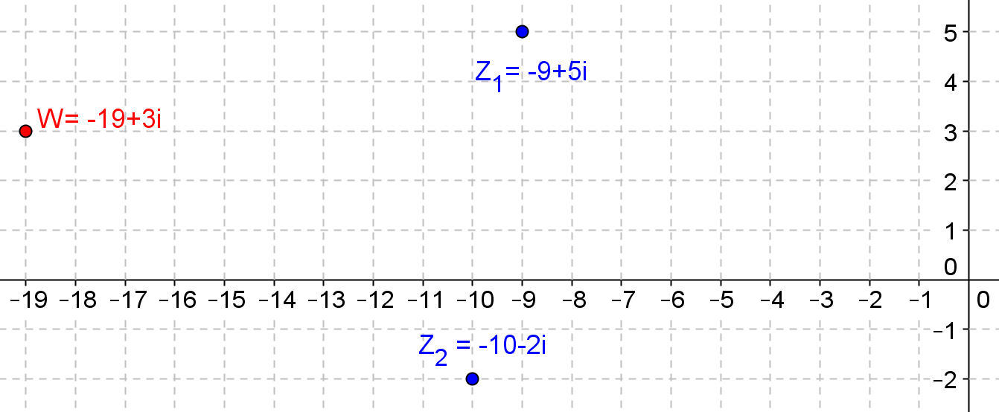
- Given $z_{1}=-9+5i$, $z_{2}=-10-2i$, find $w=z_{1}+z_{2}$, and graph $z_{1}$, $z_{2}$, and $w$.

$$w=-19+3i$$

- Given $z_{1}=-4+10i$,$z_{2}=-7-6i$, find $w=z_{1}-z_{2}$, and graph $z_{1}$,$z_{2}$, and $w$.

$$w=\left(-4+10i\right)-\left(-7-6i\right) \\ =3+16i$$

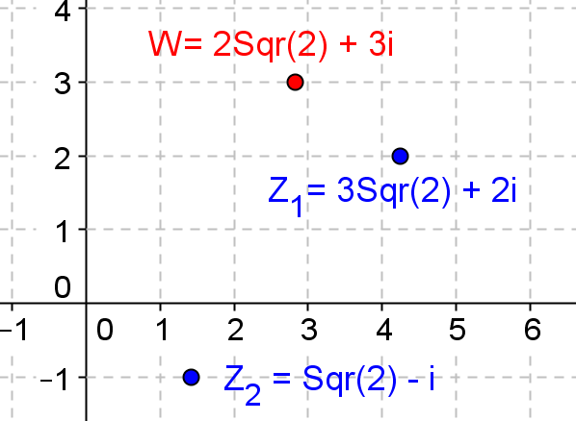
- Given $z_{1}=3\sqrt{2}+2i$, $z_{2}=\sqrt{2}-i$, find $w=z_{1}-z_{2}$, and graph $z_{1}$,$z_{2}$, and $w$.

$$w=\left(3\sqrt{2}+2i\right)-\left(\sqrt{2}-i\right) \\ =2\sqrt{2}+3i$$

- Given $z_{1}=3$, $z_{2}=-4+8i$, find $w=z_{1}⋅z_{2}$, and graph $z_{1}$,$z_{2}$, and $w$.
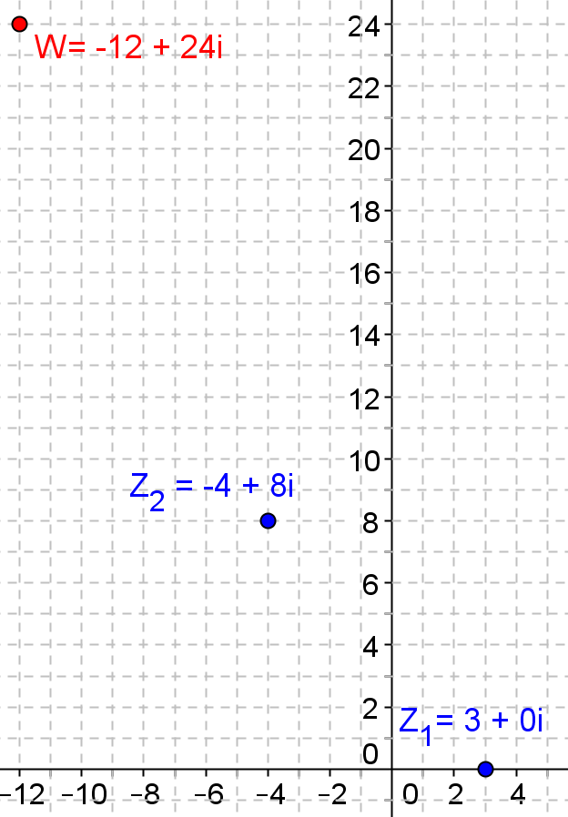
$$w=-12-24i$$

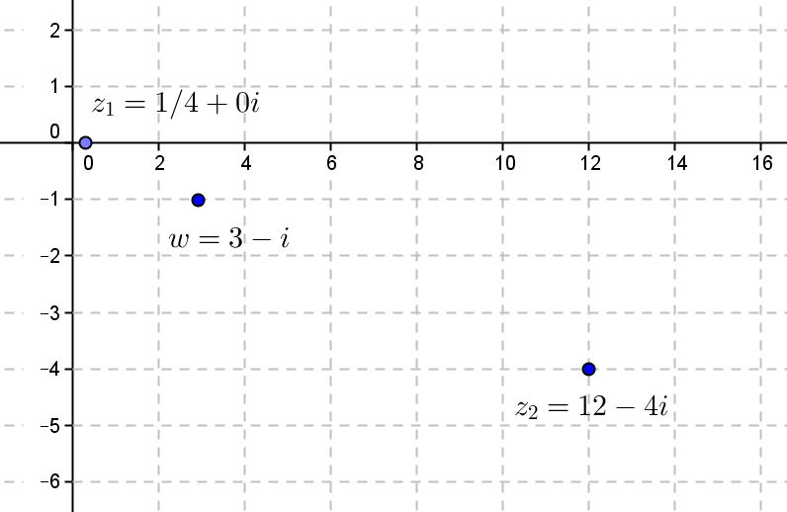
- Given $z_{1}=\frac{1}{4}$,$z_{2}=12-4i$, find $w=z_{1}⋅z_{2}$, and graph $z_{1}$, $z_{2}$, and $w$.

$$w=3-i$$

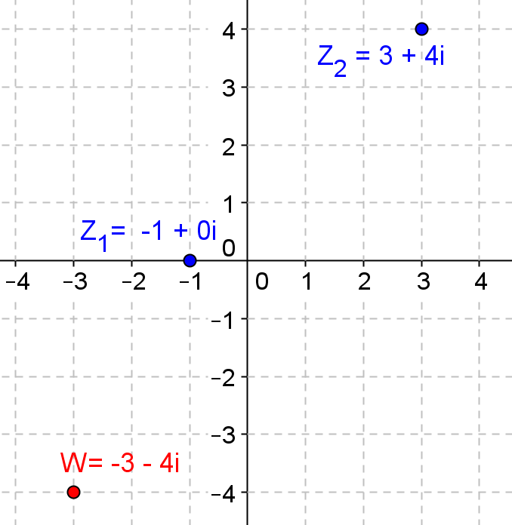
- Given $z_{1}=-1$, $z_{2}=3+4i$, find $w=z_{1}⋅z_{2}$, and graph $z_{1}$, $z_{2}$, and $w$.

$$w=-3-4i$$

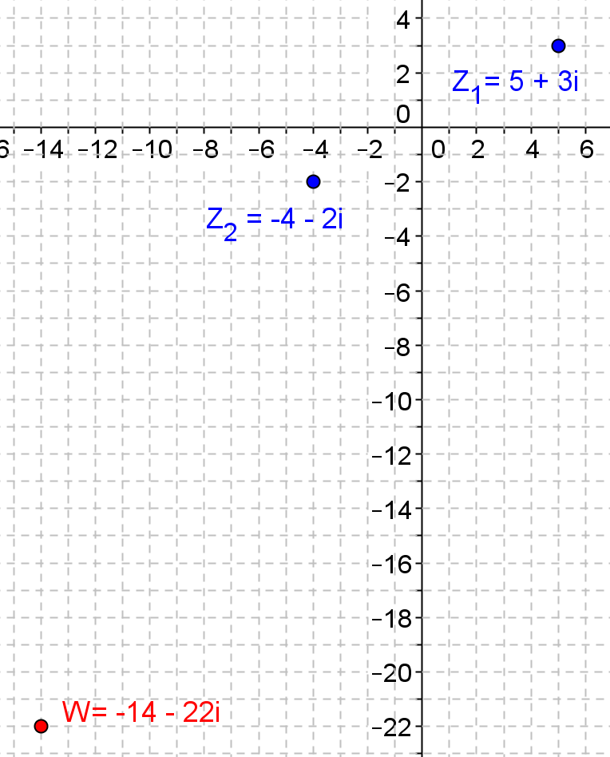
- Given $z_{1}=5+3i$,$z_{2}=-4-2i$, find $w=z_{1}⋅z_{2}$, and graph $z_{1}$,$z_{2}$, and $w$.

$$w=\left(5+3i\right)\left(-4-2i\right) \\ =-20-10i-12i-6i^{2} \\ =-20-22i-6\left(-1\right) \\ =-14-22i$$

- Given $z_{1}=1+i$, $z_{2}=1+i$, find $w=z_{1}⋅z_{2}$, and graph $z_{1}$,$z_{2}$, and $w$.
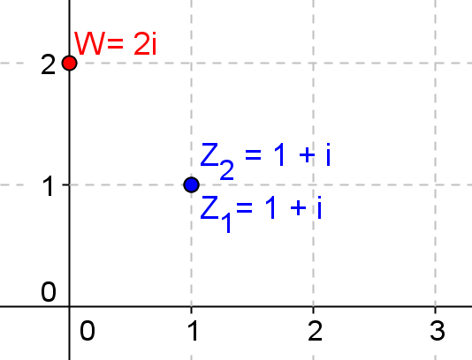
$$w=\left(1+i\right)\left(1+i\right) \\ =1+2i+i^{2} \\ =1+2i-1 \\ =2i$$

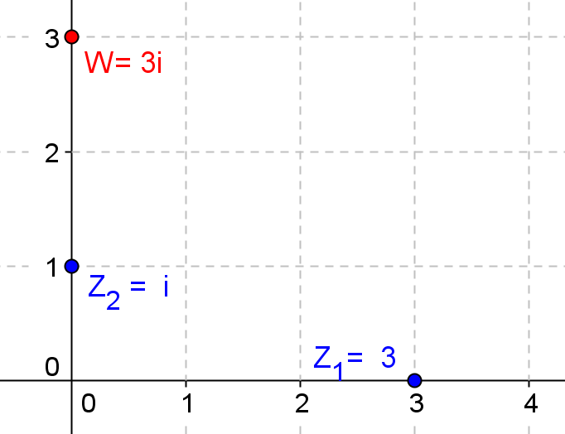
- Given $z_{1}=3$,$z_{2}=i$, find $w=z_{1}⋅z_{2}$, and graph $z_{1}$, $z_{2}$, and $w$.

$$w=i⋅3 \\ =3i$$

- Given $z_{1}=4+3i$,$z_{2}=i$, find $w=z_{1}⋅z_{2}$, and graph $z_{1}$, $z_{2}$, and $w$.
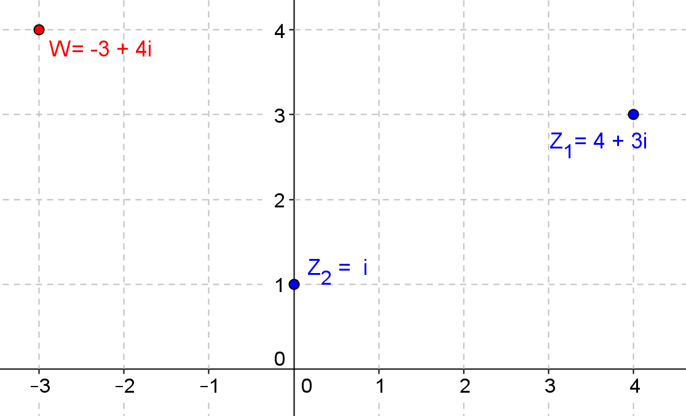
$$w=i\left(4+3i\right) \\ =-3+4i$$

- Given $z_{1}=2\sqrt{2}+2\sqrt{2}i$,$z_{2}=-\sqrt{2}+\sqrt{2}i$, find $w=z_{1}⋅z_{2}$, and graph $z_{1}$,$z_{2}$, and $w$.
$$w=\left(2\sqrt{2}+2\sqrt{2}i\right)\left(-\sqrt{2}+\sqrt{2}i\right) \\ =-4+4i-4i-4 \\ =-8$$

- Represent $w=-4+3i$ as a point in the complex plane.
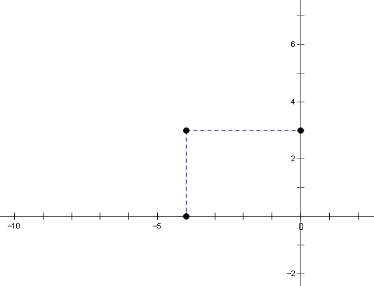

- Represent $2w$ as a point in the complex plane. $2w=2\left(-4+3i\right)=-8+6i$
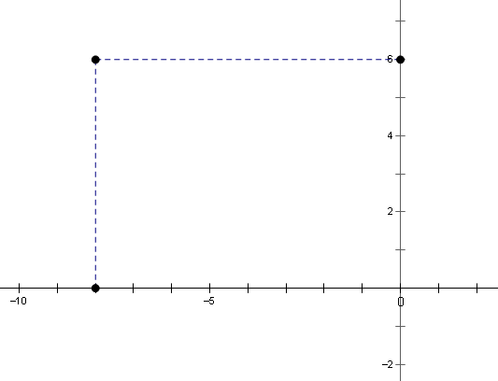

- Compare the positions of $w$ and $2w$ from Problems 10 and 11. Describe what you see. (Hint: Draw a segment from the origin to each point.)
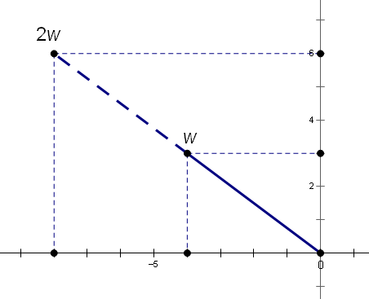
The points $0$, $w$, and $2w$ all lie on the same line. The distance from $0$ to $2w$ is twice as great as the distance from $0$ to $w$. The segment to $2w$ is a scaled version of the segment to $w$, with scale factor $2$.

Complex Plane Reproducible

