|  |
| --- |
| min |

Lesson 3: Which Real Number Functions Define a Linear Transformation?

Student Outcomes

* Students develop facility with the properties that characterize linear transformations.
* Students learn that a mapping is a linear transformation if and only if for some real number .

Lesson Notes

This lesson begins with two examples of functions that were explored in Lessons 1–2, neither of which is a linear transformation. Next, students explore the function , followed by the more general , proving that these functions satisfy the requirements for linear transformations. The rest of the lesson is devoted to proving that functions of the form are, in fact, the *only* linear transformations from to .

Classwork

Opening Exercises (4 minutes)

Opening Exercises

Recall from the previous two lessons that a linear transformation is a function that satisfies two conditions:   
(1) and (2) . Here, refers to any real number, and and represent arbitrary elements in the domain of .

1. Let . Is a linear transformation? Explain why or why not.

Let be and be . , but . Since these two values are different, we can conclude that is not a linear transformation.

1. Let . Is a linear transformation? Explain why or why not.

Let be and be . , but , which is not equal to . This means that is not a linear transformation.

**Discussion (9 minutes): A Linear Transformation**

* The exercises you just did show that neither nor is a linear transformation. Let’s look at a third function together.
* Let . Does satisfy the requirements for a linear transformation? Take a minute to explore this question on your own, and then explain your thinking with a partner.

**MP.3**

* + *First, we need to check the addition requirement: .*
  + *. Thus, we do indeed have : so far, so good.*
  + *Now, we need to check the multiplication requirement: .*
  + *. Thus, we also have .*
  + *Therefore, satisfies both of the requirements for a linear transformation.*
* So, now we know that is a linear transformation. Can you generate your own example of a linear transformation? Write down a conjecture, and share it with another student.
  + *Answers will vary.*
* Do you think that every function of the form is a linear transformation? Let’s check to make sure that the requirements are satisfied.
  + *Thus, , as required.*
  + *Thus, , as required.*
  + *This proves that , with any real number, is indeed a linear transformation.*
* What about ? Since the graph of this equation is a straight line, we know that it represents a linear function. Does that mean that it automatically meets the technical requirements for a linear transformation? Write down a conjecture, and then take a minute to see if you are correct.

**MP.3**

* + *If is a linear transformation, then it must have the addition property.*
  + *Clearly, these two expressions are not the same for all values of and , so fails the requirements for a linear transformation.*
* A bit surprising, isn’t it? The graph is a straight line, and it is correct to say that is a linear function. But at the same time, it does not meet the technical requirements for a linear transformation. It looks as though *some* linear functions are considered linear transformations, but not all of them are. Let’s try to understand what is going on here.
* Does anything strike you about the graph of as compared to the graph of ?
  + *The first graph passes through the origin; the second one does not.*
* Do you think it is necessary for a graph to pass through the origin in order to be considered a linear transformation? Let’s explore this question together. We have shown that every function of the form   
   is a linear transformation. Are there other functions that map real numbers to real numbers that are linear in this sense, or are these the only kind that do? Let’s see what we can learn about these questions.

Discussion (6 minutes): The Addition Property

* Suppose we have a linear transformation that takes a real number as an input and produces a real number as an output. We can write to denote this.
* Now, suppose that takes to and to ; that is, and .
* Where does take ? Can you calculate the value of ?
  + *Since , we know that . Since is a linear transformation, this must be the same as , which is . So, must be .*
* For practice, find out where takes and . That is, find and .
* What can we learn about linear transformations through these examples? Let’s dig a little deeper.
* We used the facts that and to figure out that . What is the relationship between the three inputs here? What is the relationship between the three outputs?
  + *, so the third input is the sum of the first two inputs.*
  + *, so the third output is the sum of the first two outputs.*
* Do these examples give you a better understanding of the property ? This statement is saying that if you know what a linear transformation does to any two inputs and , then you know for sure what it does to their sum . In particular, to get the output for , you just have to add the outputs and , just as we did in the example above, where we figured out that must be .
* What do you suppose all of this means in terms of the graph of ? Let’s plot each of the input-output pairs we have generated so far and then see what we can learn.



* What do you notice about this graph?
  + *It looks as though the points lie on a line through the origin.*
* Can we be absolutely sure of this? Let’s keep exploring to find out if this is really true.

Discussion (4 minutes): The Multiplication Property

* Let’s again suppose that .
* Can you figure out where takes ?
  + *Since , we know that . Since is a linear transformation, this must be the same as , which is . So, must be .*
* For practice, find out where takes and . That is, find and .
* We computed earlier using the addition property, and now we have computed it again using the multiplication property. Are the results the same?
  + *Yes, in both cases we have .*
* Does this work give you a feel for what the multiplication property is all about? Let’s summarize our work in the last few examples. Suppose you know that, for a certain input , produces output , so that . The multiplication property is saying that if you triple the input from to , you will also triple the output from to . This is the meaning of the statement , or more generally, .
* Once again, let’s see what all of this means in terms of the graph of . We will plot the input-output pairs we generated.



* Does this graph look like you expected it to?
  + *Yes, it is a straight line through the origin, just like before.*

Discussion (4 minutes): Opposites

* So, we used the fact that to figure out that , , and   
  .

*Scaffolding:*

If students are struggling to compute , point out that , and then ask them to apply the multiplication property for linear transformations.

* What about the negative multiples of ? Can you figure out ?
* For practice, find , , and .
* Look carefully at what does to a number and its opposite. For instance, compare the outputs for and , for and , etc. What do you notice?
  + *We see that and . We also see that and .*
* Can you take your observation and formulate a general conjecture?
  + *It looks as though .*
* This says that if you know what does to a particular input , then you know for sure that takes the opposite input to the opposite output, .
* Now, prove that your conjecture is true in all cases.
* Once again, let’s collect all of this information in graphical form.

**

* All signs point to a straight-line graph that passes through the origin. But we have not yet shown that the graph actually contains the origin. Let’s turn our attention to that question now.

Discussion (5 minutes): Zero

* If the graph of contains the origin, then must take to . Does this really have to be the case?
* How can we use the addition property to our advantage here? Can you form the number from the inputs we already have information about?
  + *We know that , so maybe that can help. Since and , we can now figure out . .*
* So, it really is true that . What does this tell us about the graph of ?
  + *The graph contains the point , which is the origin.*
* In summary, if you give the number as an input to a linear transformation , then the output is sure to be .
* Quickly: Is a linear transformation? Why or why not?
  + *No, it cannot be a linear transformation because , and a linear transformation cannot transform into .*
* For practice, use the fact that to show that .
  + *We already showed that , so .*
* We have used the addition property to show that . Do you think it is possible to use the multiplication property to reach the same conclusion?
  + *Yes. is a multiple of , so we can write .*
* So now, we have two pieces of evidence that corroborate our hypothesis that the graph of passes through the origin. We can now officially add to our graph.



* We originally said that the graph looks like a line through the origin. What is the equation of that line?
  + *The equation of the line that contains all of these points is .*

Discussion (3 minutes): The Complete Graph of

How can we be sure that the graph of is identical to the graph of ? In theory, there could be points on that are not on , or vice versa. Are these graphs in fact identical? Perhaps we can show once and for all that .

*Scaffolding:*

Advanced students could be challenged to pursue this question without specific guidance. In other words, ask students if the graph of is identical to the graph of , and then let them investigate on their own and justify their response.

* We know that . What is ?
  + .
* How might we use the multiplication property to compute for an arbitrary input ?
  + *Since , we have .*
* We have shown that, for any input , is a formula that gives the output under the linear transformation . So, the complete graph of looks like this:



**Discussion (2 minutes): General Linear Transformations**

* All of the work we did to reach the conclusion that was based on just one assumption: We took as a given, and the rest of our conclusions were worked out from the properties of linear transformations. Now, let’s show that *every* linear transformation has the form .
* Show that .
  + *Since , we have .*
* Since produces real numbers as outputs, there is some number corresponding to . So let’s define   
  . Now, we have that , which means that every linear transformation looks like . There are no other functions that can possibly satisfy the requirements for a linear transformation.

Closing (2 minutes)

* Write down a summary of what you learned in the lesson today, and then share your summary with a partner.
  + *Every function of the form is a linear transformation.*
  + *Every linear transformation corresponds to a formula .*
  + *Linear transformations take the origin to the origin, that is, .*
  + *Linear transformations are odd functions, that is, .*
  + *The graph of a linear transformation is a straight line.*

Exit Ticket (6 minutes)

Name Date

Lesson 3: Which Real Number Functions Define a Linear Transformation?

Exit Ticket

Suppose you have a linear transformation , where and .

1. Use the addition property to compute and .
2. Find and . Show your work.
3. Find and . Show your work.
4. Find . Show your work.
5. Find a formula for .
6. Draw the graph of the function .

Exit Ticket Sample Solutions

Suppose you have a linear transformation , where and .

1. Use the addition property to compute and .
2. Find and . Show your work.
3. Find and . Show your work.
4. Find . Show your work.
5. Find a formula for .

We know that there is some number such that , and since , the value of . In other words,   
. We can also check to see if is consistent with , which it is.

1. Draw the graph of the function .



Problem Set Sample Solutions

The first problem provides students with practice in the core skills for this lesson. The second problem is a series of exercises in which students explore concepts of linearity in the context of integer-valued functions as opposed to real-valued functions. The third problem plays with the relation , exchanging addition for multiplication in one or both expressions.

1. Suppose you have a linear transformation , where and .
   1. Use the addition property to compute , , , and .

* 1. Find , , and . Show your work.

* 1. Find , , and . Show your work.

* 1. Find a formula for .

We know these is some number such that , and since , then the value of .

In other words, . We can also check to see if is consistent with , which is.

* 1. Draw the graph of the function .

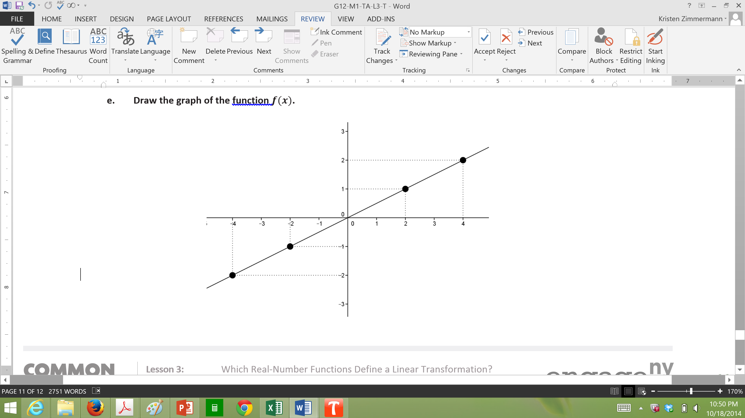

1. The symbol represents the set of integers, and so represents a function that takes integers as inputs and produces integers as outputs. Suppose that a function satisfies for all integers and . Is there necessarily an integer such that for all integer inputs ?
   1. Let . Compute and .
   2. Let be any positive integer. Compute .
   3. Now consider . Since , what can you conclude about ?

. By subtracting from both sides of the equation, we get .

* 1. Lastly, use the fact that to learn something about , where is any positive integer.

. Since we know that , we have . This tells us that .

* 1. Use your work above to prove that for every integer . Be sure to consider the fact that could be positive, negative, or .

We showed that if is a positive integer, then , where . Also, since and we showed that , we have . Finally, if is a negative integer, then is positive, which means . But, since , we have . Thus, in all cases .

1. In the following problems, be sure to consider all kinds of functions: polynomial, rational, trigonometric, exponential, logarithmic, etc.
   1. Give an example of a function that satisfies .

*Any logarithmic function works, for instance:* .

* 1. Give an example of a function that satisfies .

Any exponential function works, for instance .

* 1. Give an example of a function that satisfies .

Any power of works, for instance .