Name Date

  - Write ${(1+i)}^{7}-{(1-i)}^{7}$ in the form $a + bi$ for some real numbers $a$ and $b$.

  - Explain how Pascal’s Triangle allows you to compute the coefficient of $x^{2}y^{3}$ when ${(x-y)}^{5}$ is expanded.

- Verify that the fundamental theorem of algebra holds for the fourth-degree polynomial $p$ given by $p\left(z\right)= z^{4}+1$ by finding four zeros of the polynomial and writing the polynomial as a product of four linear terms. Be sure to make use of the polynomial identity given below.

$$x^{4}-a^{4}=(x-a)(x+a)(x-ai)(x+ai)$$

- Consider the cubic polynomial $p$ given $p\left(z\right)= z^{3}-8$.

  - Find a real number root to the polynomial.

  - Write $p(z)$ as a product of three linear terms.

Consider the degree-eight polynomial $q$ given by $q\left(z\right)=z^{8}-2^{8}$.

  - What is the largest possible number of distinct roots the polynomial $q$ could possess? Briefly explain your answer.

  - Find all the solutions to $q\left(z\right)=0$.

  - A right circular cylinder of radius $5 cm$ and height $5 cm$ contains half a sphere of radius $5 cm$ as shown.
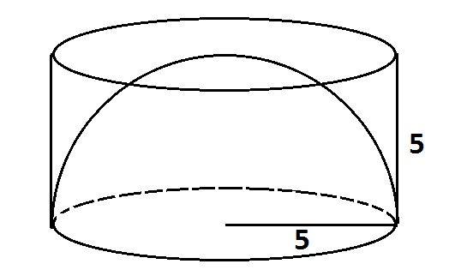
Use Cavalieri’s Principle to explain why the volume inside this cylinder but outside the hemisphere is equivalent to the volume of a circular cone with base of radius$5 cm$ and height $5 cm$.

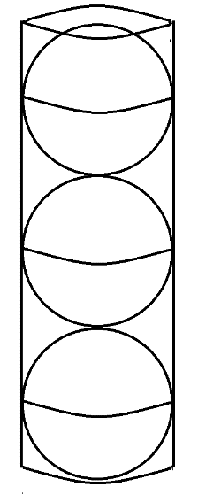
  - Three congruent solid balls are packaged in a cardboard cylindrical tube. The cylindrical space inside the tube has dimensions such that the three balls fit snugly inside that tube as shown.
Each ball is composed of material with density $15$ grams per cubic centimeter. The space around the balls inside the cylinder is filled with aerated foam with a density of $0.1$ grams per cubic centimeter.
    - Ignoring the cardboard of the tube, what is the average density of the inside contents of the tube?
    - If the contents inside the tube, the three balls and the foam, weigh $150$ grams to one decimal place, what is the weight of one ball in grams?

  - Consider the two points $F(-9, 0)$ and $G(9, 0)$ in the coordinate plane. What is the equation of the ellipse given as the set of all points $P$ in the coordinate plane satisfying $FP+PG=30$? Write the equation in the form $\frac{x^{2}}{a^{2}}+\frac{y^{2}}{b^{2}}=1$ with $a$ and $b$ real numbers, and explain how you obtain your answer.

  - Consider again the two points $F(-9, 0)$ and $G(9, 0)$ in the coordinate plane. The equation of the hyperbola defined by $\left|FP-PG\right|=k$ for some constant $k$ is given by $\frac{x^{2}}{25}-\frac{y^{2}}{56}=1$. What is the value of$k$?

A Progression Toward Mastery
Assessment  Task Item |  | STEP 1  Missing or incorrect answer and little evidence of reasoning or application of mathematics to solve the problem. | STEP 2  Missing or incorrect answer but evidence of some reasoning or application of mathematics to solve the problem. | STEP 3  A correct answer with some evidence of reasoning or application of mathematics to solve the problem, or an incorrect answer with substantial evidence of solid reasoning or application of mathematics to solve the problem. | STEP 4  A correct answer supported by substantial evidence of solid reasoning or application of mathematics to solve the problem.
1 | a  A-APR.C.5 | Student shows little or no understanding of the binomial theorem or Pascal’s Triangle. | Student expands one binomial correctly. | Student expands both binomials correctly but makes a mistake in calculating the final answer. | Student expands both binomials correctly and determines the correct final answer in $a + bi$ form.
 | b  A-APR.C.5 | Student shows little or no understanding of the binomial theorem or Pascal’s Triangle. | Student knows that the fifth row of Pascal’s Triangle is needed to complete the expansion. | Student shows the correct expansion but makes a sign error. | Student shows the correct expansion and identifies the correct coefficient.
2 | N-CN.C.8  N-CN.C.9 | Student shows little or no understanding of the fundamental theorem of algebra. | Student begins factoring the polynomial but makes mistakes. | Student finds the four zeros of the polynomial but does not show final factored form.  OR  Student shows final factored form of the polynomial but does not find the zeros. | Student finds the four zeros of the polynomial and writes the final factored form correctly.
3 | a  N-CN.C.8  N-CN.C.9 | Student shows little or no knowledge of roots of polynomials or factoring. | Student identifies a real root, but it is not correct. | Student identifies more than one real root with one being correct. | Student correctly identifies one real root.
 | b  N-CN.C.8  N-CN.C.9 | Student shows little or no knowledge of factoring polynomials. | Student factors into the correct binomial and trinomial. | Student factors into the correct binomial and trinomial but makes a minor mathematical mistake when factoring the trinomial further. | Student factors the polynomial correctly.
 | c  N-CN.C.8  N-CN.C.9 | Student shows little or no knowledge of the fundamental theorem of algebra. | Student shows some knowledge of the number of roots but does not state the correct number of roots. | Student states the correct number of roots but does not explain why based on the fundamental theorem of algebra. | Student states the correct number of roots and explains that this is a condition of the fundamental theorem of algebra.
 | d  N-CN.C.8  N-CN.C.9 | Student shows little or no knowledge of roots or factoring polynomials. | Student factors correctly but identifies fewer than four correct roots. | Student factors correctly but only identifies four correct roots. | Student factors correctly and identifies eight correct roots.
4 | a  G-GMD.A.2 | Student shows little or no knowledge of Cavalieri’s Principle. | Student attempts to explain using Cavalieri’s Principle but makes major mathematical mistakes. | Student uses Cavalieri’s Principle correctly but does not answer the question completely. | Student uses Cavalieri’s Principle correctly and fully answers the question.
 | b  G-GMD.A.2 | Student shows little or no knowledge of Cavalieri’s Principle. | Student attempts to explain using the results of part (a) and Cavalieri’s Principle but makes major mathematical mistakes. | Student uses the results of part (a) and Cavalieri’s Principle correctly but makes a small error in calculating the ratio. | Student uses the results of part (a) and Cavalieri’s Principle to correctly explain and calculate the ratio.
5 | a  G-GPE.A.3 | Student shows little or no knowledge of ellipses. | Student shows some knowledge of ellipses and determines the correct value of $k$ but does not write the equation of the ellipse. | Student determines $k$correctly and writes the equation of the ellipse but reverses $a$ and $b$. | Student determines $k$ correctly and writes the correct equation of the ellipse.
 | b  G-GPE.A.3 | Student shows little or no knowledge of hyperbolas. | Student shows some knowledge of hyperbolas but makes mistakes in determining points needed to write the equation. | Student writes the equation of the hyperbola but switches $x$ and $y$ or reverses $a$and $b$. | Student writes the correct equation of the hyperbola.

Name Date

  - Write ${(1+i)}^{7}-{(1-i)}^{7}$ in the form $a + bi$ for some real numbers $a$ and $b$.
The seventh row of Pascal’s Triangle is: $\text{1 7 21 35 35 21 7 1}$. Thus:
$${\text{(1} \text{+} \text{i)}}^{\text{7}} \text{=} \text{1} \text{+} \text{7i} \text{+} \text{21}{\text{i}}^{\text{2}} \text{+} \text{35}{\text{i}}^{\text{3}} \text{+} \text{35}{\text{i}}^{\text{4}} \text{+} \text{21}{\text{i}}^{\text{5}} \text{+} \text{7}{\text{i}}^{\text{6}} \text{+} {\text{i}}^{\text{7}} \\ \text{=} \text{1} \text{+} \text{7i} \text{-} \text{21} \text{-} \text{35i} \text{+} \text{35} \text{+} \text{21i} \text{-} \text{7} \text{-} \text{i}$$
and
$${\text{(1} \text{-} \text{i)}}^{\text{7}} \text{=} \text{1} \text{-} \text{7i} \text{+} \text{21}{\text{i}}^{\text{2}} \text{-} \text{35}{\text{i}}^{\text{3}} \text{+} \text{35}{\text{i}}^{\text{4}} \text{-} \text{21}{\text{i}}^{\text{5}} \text{+} \text{7}{\text{i}}^{\text{6}} \text{-}{ \text{i}}^{\text{7}} \\ \text{=} \text{1} \text{-} \text{7i} \text{-} \text{21} \text{+} \text{35i} \text{+} \text{35} \text{-} \text{21i} \text{-} \text{7} \text{+} \text{i.}$$
Their difference is
$${\text{(1} \text{+} \text{i)}}^{\text{7}} \text{-} {\left(\text{1} \text{-} \text{i}\right)}^{\text{7}} \text{=} \text{14i} \text{-} \text{70i} \text{+} \text{42i} \text{-} \text{2i} \text{=} \text{-16i.}$$
This answer is in the form $\text{a} \text{+} \text{bi}$ with $\text{a} \text{=} \text{0}$ and $\text{b} \text{=} \text{-16}$.

  - Explain how Pascal’s Triangle allows you to compute the coefficient of $x^{2}y^{3}$ when ${(x-y)}^{5}$ is expanded.
The fifth row of Pascal’s Triangle is: $\text{1 5 10 10 5 1}$. Thus:
$${\text{(x} \text{-} \text{y)}}^{\text{5}} \text{=} {\text{(x} \text{+} \left(\text{-y}\right)\text{)}}^{\text{5}} \\ \text{=}{ \text{x}}^{\text{5}} \text{+} \text{5}{\text{x}}^{\text{4}}\left(\text{-y}\right) \text{+} \text{10}{\text{x}}^{\text{3}}{\left(\text{-y}\right)}^{\text{2}} \text{+} \text{10}{\text{x}}^{\text{2}}{\left(\text{-y}\right)}^{\text{3}} \text{+} \text{5x}{\left(\text{-y}\right)}^{\text{4}} \text{+} {\left(\text{-y}\right)}^{\text{5}} \\ \text{=} {\text{x}}^{\text{5}} \text{-} \text{5}{\text{x}}^{\text{4}}\text{y} \text{+} \text{10}{\text{x}}^{\text{3}}{\text{y}}^{\text{2}} \text{-} \text{10}{\text{x}}^{\text{2}}{\text{y}}^{\text{3}} \text{+} \text{5x}{\text{y}}^{\text{4}} \text{-} {\text{y}}^{\text{5}}$$
The coefficient of ${\text{x}}^{\text{2}}{\text{y}}^{\text{3}}$ is $\text{-10}$.

- Verify that the fundamental theorem of algebra holds for the fourth-degree polynomial $p$ given by $p\left(z\right)= z^{4}+1$ by finding four zeros of the polynomial and writing the polynomial as a product of four linear terms. Be sure to make use of the polynomial identity given below.

$$x^{4}-a^{4}=(x-a)(x+a)(x-ai)(x+ai)$$

We have $\text{p}\left(\text{z}\right) \text{=} {\text{z}}^{\text{4}} \text{-} \text{(-1)}$ suggesting we need to find a number $\text{a}$ so that ${\text{a}}^{\text{4}} \text{=} \text{-1}$. This means ${\text{a}}^{\text{2}} \text{=} \text{i}$ or ${\text{a}}^{\text{2}} \text{=} \text{-i}$. Since we need to find only one value for $\text{a}$ that works, let’s select ${\text{a}}^{\text{2}} \text{=} \text{i}$.
Now $\text{i}$ has modulus $\text{1}$ and argument $\frac{\text{π}}{\text{2}}$, so a complex number $\text{a}$ with modulus $\text{1}$ and argument $\frac{\text{π}}{\text{4}}$ satisfies ${\text{a}}^{\text{2}} \text{=} \text{i}$. So, $\text{a} \text{=}\text{cos}\left(\frac{\text{π}}{\text{4}}\right) \text{+} \text{i}\text{sin}\left(\frac{\text{π}}{\text{4}}\right) \text{=} \frac{\text{1} \text{+} \text{i}}{\sqrt{\text{2}}}$. (And we check: ${\left(\frac{\text{1} \text{+} \text{i}}{\sqrt{\text{2}}}\right)}^{\text{2}} \text{=} \frac{\text{1} \text{+} \text{2i} \text{-} \text{1}}{\text{2}} \text{=} \text{i}$.
So, $\text{p}\left(\text{z}\right) \text{=} {\text{z}}^{\text{4}} \text{-} {\left(\frac{\text{1} \text{+} \text{i}}{\sqrt{\text{2}}}\right)}^{\text{4}} \text{=} \left(\text{z} \text{-} \frac{\text{1} \text{+} \text{i}}{\sqrt{\text{2}}}\right)\left(\text{z} \text{+} \frac{\text{1} \text{+} \text{i}}{\sqrt{\text{2}}}\right)\left(\text{z} \text{-} \frac{\text{i} \text{-} \text{1}}{\sqrt{\text{2}}}\right)\left(\text{z} \text{+} \frac{\text{i} \text{-} \text{1}}{\sqrt{\text{2}}}\right)$ following the polynomial identity given. Thus, we see that $\text{p}$ does indeed factor into four linear terms and has four roots: $\frac{\text{1} \text{+} \text{i}}{\sqrt{\text{2}}}\text{,} \text{-}\frac{\text{1} \text{+} \text{i}}{\sqrt{\text{2}}}\text{, }\frac{\text{i} \text{-} \text{1}}{\sqrt{\text{2}}}\text{,}$and $\text{-}\frac{\text{i} \text{-} \text{1}}{\sqrt{\text{2}}}$.

- Consider the cubic polynomial $p$ given $p\left(z\right)= z^{3}-8$.

  - Find a real number root to the polynomial.
$\text{z} \text{=} \text{2}$ is a root.

  - Write $p(z)$ as a product of three linear terms.
We have ${\text{z}}^{\text{3}}\text{-} \text{8} \text{=} \text{(}\text{z} \text{-} \text{2)(}{\text{z}}^{\text{2}} \text{+} \text{2}\text{z} \text{+} \text{4)}$.
Now ${\text{z}}^{\text{2}} \text{+} \text{2}\text{z} \text{+} \text{4} \text{=} \text{0}$ when $\text{z} \text{=} \frac{\text{-2±}\sqrt{\text{4} \text{-} \text{16}}}{\text{2}} \text{=} \text{-1} \text{±} \sqrt{\text{3}}\text{i}$ showing that ${\text{z}}^{\text{2}} \text{+} \text{2}\text{z} \text{+} \text{4}$ factors as $\text{(}\text{z} \text{+} \text{1} \text{+} \sqrt{\text{3}}\text{i}\text{)(}\text{z} \text{+} \text{1} \text{-} \sqrt{\text{3}}\text{i}\text{)}$.
Thus:
$\text{p}\left(\text{z}\right) \text{=} \text{(}\text{z} \text{-} \text{2)(}\text{z} \text{+} \text{1} \text{+} \sqrt{\text{3}}\text{i}\text{)(}\text{z} \text{+} \text{1} \text{-} \sqrt{\text{3}}\text{i}\text{)}$.

Consider the degree-eight polynomial $q$ given by $q\left(z\right)=z^{8}-2^{8}$.

  - What is the largest possible number of distinct roots the polynomial $q$ could possess? Briefly explain your answer.
By the fundamental theorem of algebra, a degree-eight polynomial has at most $\text{8}$ distinct roots.

  - Find all the solutions to $q\left(z\right)=0$.
We have
$$\text{q}\left(\text{z}\right) \text{=} {\text{z}}^{\text{8}} \text{-} {\text{2}}^{\text{8}} \\ \text{=} \text{(}{\text{z}}^{\text{4}} \text{-} {\text{2}}^{\text{4}}\text{)(}{\text{z}}^{\text{4}} \text{+} {\text{2}}^{\text{4}}\text{)} \\ \text{=} \left({\text{z}}^{\text{2}} \text{-} {\text{2}}^{\text{2}}\right)\left({\text{z}}^{\text{2}} \text{+} {\text{2}}^{\text{2}}\right)\left({\text{z}}^{\text{4}} \text{+} {\text{2}}^{\text{4}}\right) \\ \text{=} \left(\text{z} \text{-} \text{2}\right)\left(\text{z} \text{+} \text{2}\right)\left(\text{z} \text{-} \text{2i}\right)\left(\text{z} \text{+} \text{2i}\right)\left({\text{z}}^{\text{2}} \text{-} \text{4i}\right)\left({\text{z}}^{\text{2}} \text{+} \text{4i}\right).$$
We see the zeros:
$\text{z} \text{=} \text{2, z} \text{=} \text{-2, z} \text{=} \text{2i,}$ and $\text{z} \text{=} \text{-2i}$.
Going further, we need to also solve ${\text{z}}^{\text{2}} \text{-} \text{4i} \text{=} \text{0}$ and ${\text{z}}^{\text{2}} \text{+} \text{4i} \text{=} \text{0}$.

Now if ${\text{(a} \text{+} \text{bi)}}^{\text{2}} \text{=} \text{4i}$, we have ${\text{a}}^{\text{2}} \text{-} {\text{b}}^{\text{2}} \text{=} \text{0}$ (giving $\text{a} \text{=} \text{±b}$) and $\text{2ab} \text{=} \text{4}$ (i.e., $\text{ab} \text{=} \text{2}$). If $\text{a} \text{=} \text{b}$, we get ${\text{a}}^{\text{2}} \text{=} \text{2}$; so, $\text{a} \text{=} \text{b} \text{=} \sqrt{\text{2}}$ or $\text{a} \text{=} \text{b} \text{=} \text{-}\sqrt{\text{2}}$. If $\text{a} \text{=} \text{-b}$ we get ${\text{a}}^{\text{2}} \text{=} \text{-2}$, which has no solution. So we see
If ${\text{z}}^{\text{2}} \text{-} \text{4i} \text{=} \text{0}$, then $\text{z} \text{=} \sqrt{\text{2}} \text{+} \sqrt{\text{2}}\text{i}$ or $\text{z} \text{=} \text{-}\sqrt{\text{2}} \text{-} \sqrt{\text{2}}\text{i}$.

The same work shows the following:
If ${\text{z}}^{\text{2} }\text{+} \text{4i} \text{=} \text{0}$, then $\text{z} \text{=} \sqrt{\text{2}} \text{-} \sqrt{\text{2}}\text{i}$ or $\text{z} \text{=} \text{-}\sqrt{\text{2} }\text{+} \sqrt{\text{2}}\text{i}$.

We have thus identified the eight zeros of $\text{q}$.

  - A right circular cylinder of radius $5$ cm and height $5$ cm contains half a sphere of radius $5$ cm as shown.
Use Cavalieri’s principle to explain why the volume inside this cylinder but outside the hemisphere is equivalent to the volume of a circular cone with base of radius $5$cm and height $5$cm.
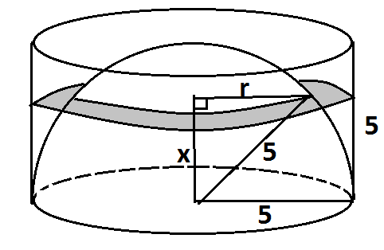
Look at a horizontal cross-section of the region inside the cylinder but outside the hemisphere. It is “ring” shaped—the region between two circular discs.
If the height of the cross-section is $\text{x}$ cm as shown ($\text{0} \text{≤} \text{x} \text{≤} \text{5}$), and the length $\text{r}$ is the distance from the vertical line of symmetry of the figure to the surface of the hemisphere as shown, then the area of the horizontal cross-section is $\text{π}{\text{5}}^{\text{2}} \text{-} \text{π}{\text{r}}^{\text{2}} \text{=} \text{π(25} \text{-} {\text{r}}^{\text{2}})$. By the Pythagorean Theorem (look at another radius of the sphere) this equals $\text{π}{\text{x}}^{\text{2}}$, which is the area of a circle of radius $\text{x}$.

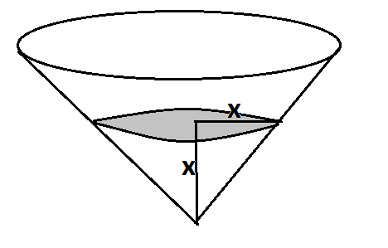
If we draw the solid figure whose horizontal cross-section at height $\text{x}$ cm for $\text{0} \text{≤} \text{x} \text{≤} \text{5}$ is a circle of radius $\text{x}$, we get a circular cone of height $\text{5}$ and base radius of $\text{5}$.
By Cavalieri’s principle, the volume of the region inside the cylinder but outside the hemisphere is equivalent to the volume of this circular cone.

  - Three congruent solid balls are packaged in a cardboard cylindrical tube. The cylindrical space inside the tube has dimensions such that the three balls fit snugly inside that tube as shown.
Each ball is composed of material with density $15$ grams per cubic centimeter. The space around the balls inside the cylinder is filled with aerated foam with a density of $0.1$ grams per cubic centimeter.
    - Ignoring the cardboard of the tube, what is the average density of the inside contents of the tube?
    - If the contents inside the tube, the three balls and the foam, weigh $150$ grams to one decimal place, what is the weight of one ball in grams?

From part (a), since the volume of a cone is one-third the volume of a cylinder with the same base and same height, the space inside the cylinder and outside the hemisphere in that question is one-third the volume of the cylinder. This means that the volume of the hemisphere is double the volume of this space.

For three balls packed in a cylinder, we have six copies of the situation analyzed in part (a). Thus, the volume of foam inside the package and outside of the balls is one-half the total volume of the balls.

Let ${\text{V}}_{\text{f}}$ denote the total volume of the foam and ${\text{V}}_{\text{b}}$ the total volume of the balls. Then we have ${\text{V}}_{\text{f}} \text{=} \frac{\text{1}}{\text{2}}{\text{V}}_{\text{b}}$, or ${\text{V}}_{\text{b}} \text{=} \text{2}{\text{V}}_{\text{f}}$.

Let ${\text{M}}_{\text{f}}$ be the total mass of the foam and ${\text{M}}_{\text{b}}$ the total mass of the balls. As density is mass per volume, we have: $\frac{{\text{M}}_{\text{f}}}{{\text{V}}_{\text{b}}} \text{=} \text{0.1}$ grams per cubic centimeter, and $\frac{{\text{M}}_{\text{b}}}{{\text{V}}_{\text{b}}} \text{=} \text{15}$ grams per cubic centimeter.

- The average density of the contents is
$$\frac{{\text{M}}_{\text{f}} \text{+} {\text{M}}_{\text{b}}}{{\text{V}}_{\text{f}} \text{+} {\text{V}}_{\text{b}}} \text{=} \frac{{\text{M}}_{\text{f}} \text{+} {\text{M}}_{\text{b}}}{\text{3}{\text{V}}_{\text{f}}} \\ \text{=} \frac{\text{1}}{\text{3}} \text{∙} \frac{{\text{M}}_{\text{f}}}{{\text{V}}_{\text{f}}} \text{+} \frac{{\text{M}}_{\text{b}}}{\text{3}{\text{V}}_{\text{f}}} \\ \text{=} \frac{\text{1}}{\text{3}}\left(\text{0.1}\right) \text{+} \frac{\text{2}}{\text{3}} \text{∙} \frac{{\text{M}}_{\text{b}}}{{\text{V}}_{\text{b}}} \\ \text{=} \frac{\text{1}}{\text{3}}\left(\text{0.1}\right) \text{+} \frac{\text{2}}{\text{3}}\left(\text{15}\right) \\ \text{=} \frac{\text{1}}{\text{30}} \text{+} \text{10} \text{≈} \text{10.033}\frac{\text{grams}}{{\text{cm}}^{\text{3}}}.$$

- As the weight of the foam is negligible, we expect each ball to weigh approximately $\text{50}$ grams. To get the exact weight, use
Total mass = total volume $\text{×}$ average density.

This gives
$$\left(\text{10} \text{+} \frac{\text{1}}{\text{30}}\right) \text{×} \left({\text{V}}_{\text{f}} \text{+} {\text{V}}_{\text{b}}\right) \text{=} \text{150} \\ \left(\text{10} \text{+} \frac{\text{1}}{\text{30}}\right) \text{×} \frac{\text{3}}{\text{2}}{\text{V}}_{\text{b}} \text{=} \text{150} \\ {\text{V}}_{\text{b}} \text{=} \frac{\text{100}}{\text{10} \text{+} \frac{\text{1}}{\text{30}}} \text{=} \frac{\text{3000}}{\text{301}}\text{.}$$

So, the volume of one ball is $\frac{\text{1}}{\text{3}} \text{×} \frac{\text{3000}}{\text{301}} \text{=} \frac{\text{1000}}{\text{301}}$ cubic centimeters.

As the density of each ball is $\text{15}$ grams per cubic centimeter, it follows that the weight of one ball is
$\text{15} \text{×} \frac{\text{1000}}{\text{301}} \text{≈} \text{49.8}$ grams.

  - Consider the two points $F(-9, 0)$ and $G(9, 0)$ in the coordinate plane. What is the equation of the ellipse given as the set of all points $P$ in the coordinate plane satisfying$FP+PG=30$? Write the equation in the form $\frac{x^{2}}{a^{2}}+\frac{y^{2}}{b^{2}}=1$ with $a$ and $b$ real numbers, and explain how you obtain your answer.
Suppose the ellipse described crosses the positive x-axis at $\text{x} \text{=} \text{a}$ and the positive y-axis at $\text{b}$. Let $\text{k}$ be the distance between $\text{G}$ and the positive x-intercept as shown.
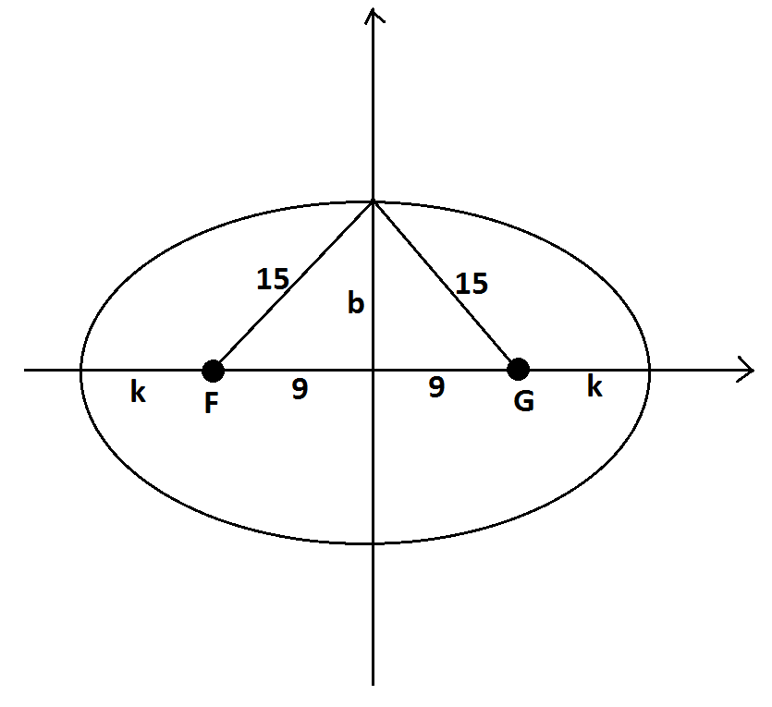
For the point $\text{P} \text{=} \text{(0, b)}$ on the ellipse, we have $\text{FP} \text{+} \text{PG} \text{=} \text{30}$. By symmetry, this means $\text{PG} \text{=} \text{15}$, and by the Pythagorean Theorem, $\text{b} \text{=} \sqrt{{\text{15}}^{\text{2}} \text{-} {\text{9}}^{\text{2}} }\text{=} \text{12}$.

For the point $\text{Q = (a, 0)}$ on the ellipse, we have $\text{GP} \text{+} \text{PF} \text{=} \text{18} \text{+} \text{2k} \text{=} \text{30}$, giving
$\text{k} \text{=} \text{6}$ and $\text{a} \text{=} \text{9} \text{+} \text{k} \text{=} \text{15}$. Thus, the equation of the ellipse is $\frac{{\text{x}}^{\text{2}}}{{\text{15}}^{\text{2}}} \text{+} \frac{{\text{y}}^{\text{2}}}{{\text{12}}^{\text{2}}} \text{=} \text{1}$.
OR
For any point $\text{P} \text{=} \text{(x, y)}$ on the ellipse:
$$\text{FP} \text{=} \sqrt{{\text{(x} \text{+} \text{9)}}^{\text{2}} \text{+} {\text{y}}^{\text{2}}}$$
$$\text{PG} \text{=} \sqrt{{\text{(x} \text{-} \text{9)}}^{\text{2}} \text{+} {\text{y}}^{\text{2}}}$$

and $\text{FP} \text{+} \text{PG = 30}$ reads
$$\sqrt{{\text{(x} \text{+} \text{9)}}^{\text{2}} \text{+} {\text{y}}^{\text{2}}} \text{+} \sqrt{{\text{(x} \text{-} \text{9)}}^{\text{2}} \text{+} {\text{y}}^{\text{2}} }\text{=} \text{30.}$$
This can be rewritten as follows:
$$\sqrt{{\text{(x} \text{-} \text{9)}}^{\text{2}} \text{+} {\text{y}}^{\text{2}} }\text{=} \text{30} \text{-} \sqrt{{\text{(x} \text{+} \text{9)}}^{\text{2}} \text{+} {\text{y}}^{\text{2}}}\text{.}$$

Squaring gives the following:
$${\left(\text{x} \text{-} \text{9}\right)}^{\text{2}} \text{+} {\text{y}}^{\text{2}} \text{=} \text{900} \text{+} {\left(\text{x} \text{+} \text{9}\right)}^{\text{2}} \text{+} {\text{y}}^{\text{2}} \text{-} \text{60}\sqrt{{\left(\text{x} \text{+} \text{9}\right)}^{\text{2}} \text{+} {\text{y}}^{\text{2}}} \\ \text{-18x} \text{=} \text{900} \text{+} \text{18x} \text{-} \text{60}\sqrt{{\left(\text{x} \text{+} \text{9}\right)}^{\text{2}} \text{+} {\text{y}}^{\text{2}}} \\ \text{60}\sqrt{{\text{(x} \text{+} \text{9)}}^{\text{2}} \text{+} {\text{y}}^{\text{2}} }\text{=} \text{900} \text{+} \text{36x} \\ \text{10}\sqrt{{\text{(x} \text{+} \text{9)}}^{\text{2}} \text{+} {\text{y}}^{\text{2}} }\text{=} \text{150} \text{+} \text{6x.}$$

Squaring one more time produces the following:
$$\text{100}\left({\left(\text{x} \text{+} \text{9}\right)}^{\text{2}} \text{+} {\text{y}}^{\text{2}}\right) \text{=} \text{22500} \text{+} \text{36}{\text{x}}^{\text{2}} \text{+} \text{1800x} \\ \text{100}{\text{x}}^{\text{2} }\text{+} \text{1800x} \text{+} \text{8100} \text{+} \text{100}{\text{y}}^{\text{2}} \text{=} \text{22500} \text{+} \text{36}{\text{x}}^{\text{2}} \text{+} \text{1800x} \\ \text{64}{\text{x}}^{\text{2}} \text{+} \text{100}{\text{y}}^{\text{2}} \text{=} \text{14400} \\ \frac{{\text{x}}^{\text{2}}}{\text{225}} \text{+} \frac{{\text{y}}^{\text{2}}}{\text{144}} \text{=} \text{1.}$$

Thus, any point $\text{P} \text{=} \text{(}\text{x}\text{, }\text{y}\text{)}$ on the ellipse must be a solution to the equation$$\frac{{\text{x}}^{\text{2}}}{{\text{15}}^{\text{2}}} \text{+} \frac{{\text{y}}^{\text{2}}}{{\text{12}}^{\text{2}}} \text{=} \text{1}.$$

  - Consider again the two points $F(-9, 0)$ and $G(9, 0)$ in the coordinate plane. The equation of the hyperbola defined by $\left|FP-PG\right|=k$ for some constant $k$ is given by $\frac{x^{2}}{25}-\frac{y^{2}}{56}=1$. What is the value of$k$?
Consider the equation $$\frac{{\text{x}}^{\text{2}}}{\text{25}} \text{-} \frac{{\text{y}}^{\text{2}}}{\text{56}} \text{=} \text{1}.$$
Setting $\text{y} \text{=} \text{0}$ shows that $\text{P}\text{(5, 0)}$ is a point on the hyperbola. Then $\text{FP} \text{=} \text{4}$ and $\text{PG} \text{=} \text{14}$; so, $\text{k} \text{=} \left|\text{FP} \text{-} \text{PG}\right| \text{=} \text{10}$.

