Name Date
- Let $C$ be the function that assigns to a temperature given in degrees Fahrenheit its equivalent in degrees Celsius, and let $K$ be the function that assigns to a temperature given in degrees Celsius its equivalent in degrees Kelvin.

We have $C\left(x\right)= \frac{5}{9}\left(x-32\right)$ and $K\left(x\right)=x+273$.

  - Write an expression for $K(C\left(x\right))$ and interpret its meaning in terms of temperatures.

  - The following shows the graph of $y=C(x)$.
According to the graph, what is the value of $C^{-1}(95)$?

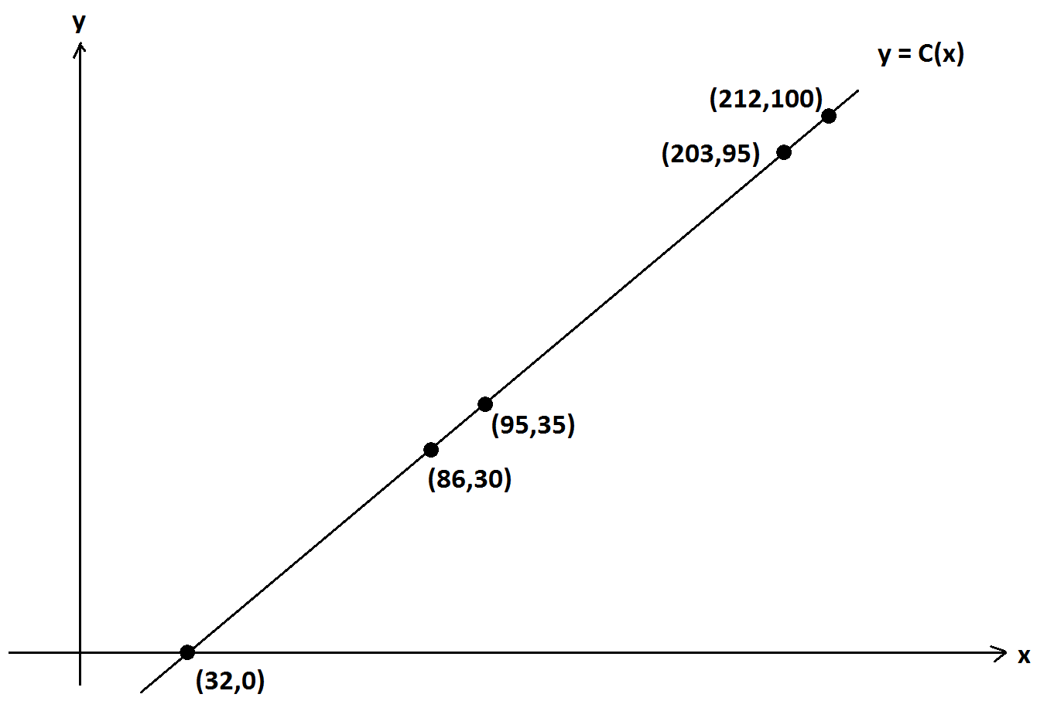

  - Show that $C^{-1}\left(x\right)=\frac{9}{5}x+32$.

A weather balloon rises vertically directly above a station at the North Pole. Its height at time $t$ minutes is $H\left(t\right)=500- \frac{500}{2^{t}}$ meters. A gauge on the balloon measures atmospheric temperature in degrees Celsius.

Also, let $T$ be the function that assigns to a value $y$ the temperature, measured in Kelvin, of the atmosphere $y$ meters directly above the North Pole on the day and hour the weather balloon is launched. (Assume that the temperature profile of the atmosphere is stable during the balloon flight.)

  - At a certain time $t$ minutes, $K^{-1}\left(T\left(H\left(t\right)\right)\right)=-20$. What is the readout on the temperature gauge on the balloon at this time?

  - Find, to one decimal place, the value of $H^{-1}\left(300\right)=-20$ and interpret its meaning.

- Let $f$ and $g$ be the functions defined by $f\left(x\right)= {10}^{\frac{x+2}{3}}$ and $g\left(x\right)=\log\left(\frac{x^{3}}{100}\right)$ for all positive real numbers, $x$. (Here the logarithm is a base-ten logarithm.)

Verify by composition that $f$ and $g$ are inverse functions to each other.

- Water from a leaky faucet is dripping into a bucket. Its rate of flow is not steady, but it is always positive. The bucket is large enough to contain all the water that will flow from the faucet over any given hour.

The table below shows$V(t)$, the total amount of water in the bucket, measured in cubic centimeters, as a function of time $t$, measured in minutes, since the bucket was first placed under the faucet.

  - Explain why $V$ is an invertible function.

  - Find $V^{-1}(63.2)$ and interpret its meaning in the context of this situation.

  - Draw a sketch of the graph of $y=\frac{1}{x}$.

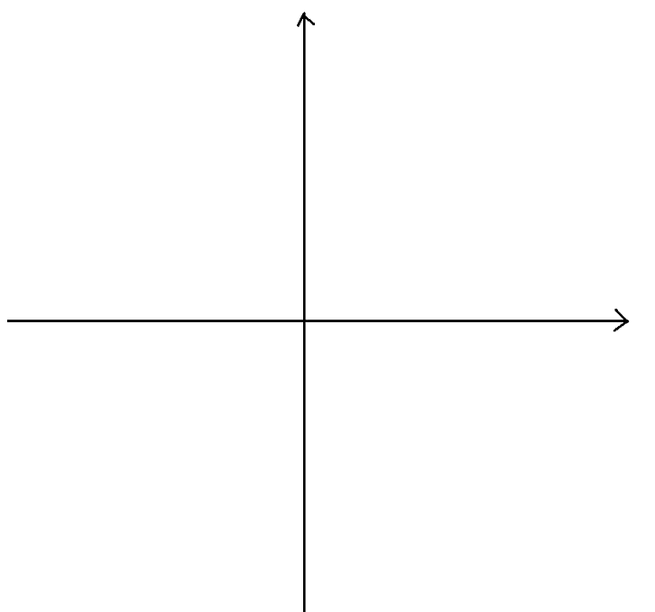

  - Sketch the graph of $y=\frac{x}{x-1}$, being sure to indicate its vertical and horizontal asymptotes.

Let be the function defined by $f\left(x\right)= \frac{x}{x-1}$ for all real values $x$ different from $1$.

  - Find $f(f\left(x\right))$ for $x$, a real number different from $1$. What can you conclude about $f^{-1}(x)$?

- Let $f$ be the function given by $f\left(x\right)= x^{2}+3$.

  - Explain why $f$ is not an invertible function on the domain of all real numbers.

  - Describe a set $S$ of real numbers such that if we restrict the domain of $f$to $S$, the function $f$ has an inverse function. Be sure to explain why $f$ has an inverse for your chosen set $S$.

- The graph of $y=x+3$ is shown below.

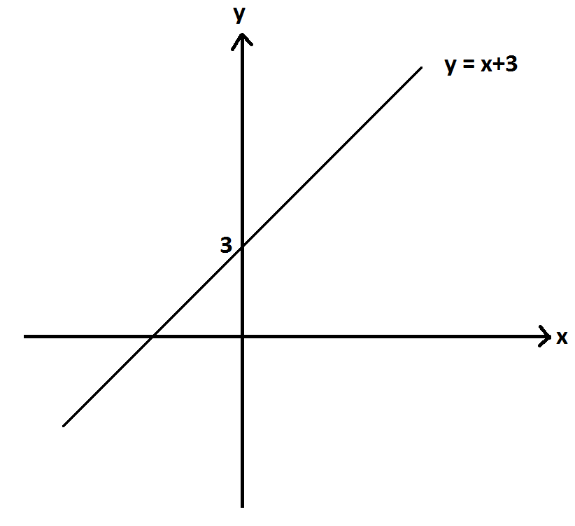

Consider the rational function $h$ given by $h\left(x\right)=\frac{x^{2}-x-12}{x-4}$.

Simon argues that the graph of $y=h(x)$ is identical to the graph of $y=x+3$. Is Simon correct? If so, how does one reach this conclusion? If not, what is the correct graph of $y=h(x)$? Explain your reasoning throughout.

- Let $f$ be the function given by $f\left(x\right)=2^{x}$ for all real values $x$, and let $g$ be the function given by $g\left(x\right)=\log_{2}(x)$ for positive real values $x$.

  - Sketch a graph of $y=f(g\left(x\right))$. Describe any restrictions on the domain and range of the functions and the composite functions.
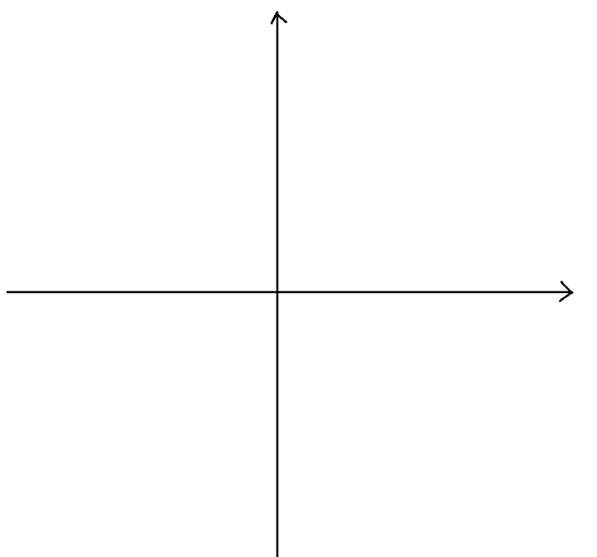

  - Sketch a graph of $y=g(f\left(x\right))$. Describe any restrictions on the domain and range of the functions and the composite functions.
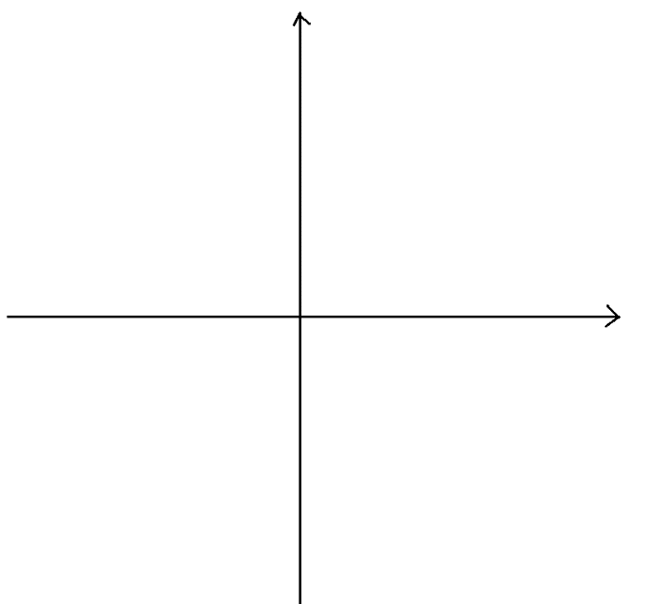

- Let be the rational function given by $f\left(x\right)= \frac{x+2}{x-1}$ and $g$ the rational function given by $g\left(x\right)=\frac{x-2}{x+1}$.

  - Write $f(x)÷g(x)$ as a rational expression.

  - Write $f\left(x\right)+g(x)$ as a rational expression.

  - Write $f\left(x\right)-g(x)$ as a rational expression.

  - Write $\frac{2f(x)}{f\left(x\right)+g(x)}$ as a rational expression.

  - Ronaldo says that $f$ is the inverse function to $g$. Is he correct? How do you know?

  - Daphne says that the graph of$f$ and the graph of $g$ each have the same horizontal line as a horizontal asymptote. Is she correct? How do you know?

Let $r\left(x\right)=f(x)∙g(x)$, and consider the graph of $y=r(x)$.

  - What are the $x$-intercepts of the graph of $y=r(x)$?

  - What is the $y$-intercept of $y=r(x)$?

  - At which $x$-values is $r(x)$ undefined?

  - Does the graph of $y=r(x)$ have a horizontal asymptote? Explain your reasoning.

  - Give a sketch of the graph of $y=r(x)$ which shows the broad features you identified in parts (g)–(j).
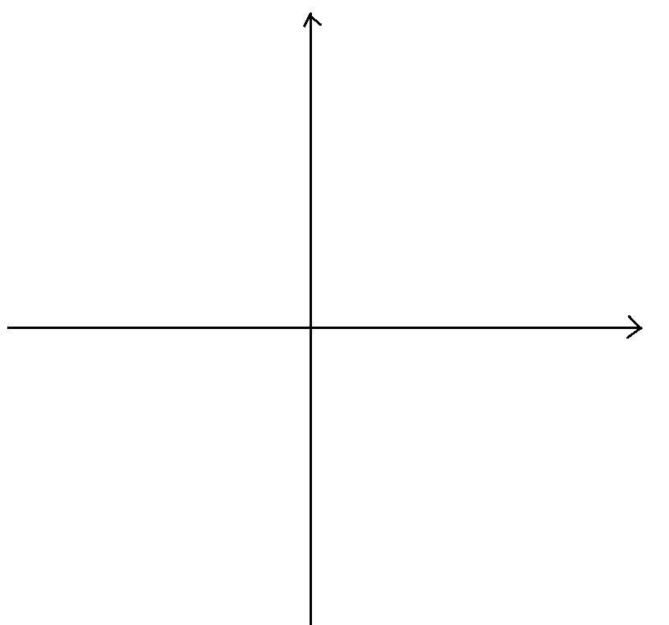

- An algae growth in an aquarium triples in mass every two days. The mass of algae was $2.5$ grams on June $21$, considered day zero, and the following table shows the mass of the algae on later days.

Let $m(d)$ represent the mass of the algae, in grams, on day $d$. Thus, we are regarding $m$ as a function of time given in units of days. Our time measurements need not remain whole numbers. (We can work with fractions of days too, for example.)

  - Explain why $m$ is an invertible function of time.

  - According to the table, what is the value of $m^{-1}(202.5)$? Interpret its meaning in the context of this situation.

  - Find a formula for the inverse function $m$, and use your formula to find the value of $m^{-1}(400)$ to one decimal place.

A Progression Toward Mastery
Assessment  Task Item |  | STEP 1  Missing or incorrect answer and little evidence of reasoning or application of mathematics to solve the problem. | STEP 2  Missing or incorrect answer but evidence of some reasoning or application of mathematics to solve the problem. | STEP 3  A correct answer with some evidence of reasoning or application of mathematics to solve the problem, or an incorrect answer with substantial evidence of solid reasoning or application of mathematics to solve the problem. | STEP 4  A correct answer supported by substantial evidence of solid reasoning or application of mathematics to solve the problem.
1 | a  F-BF.A.1c | Student shows little or no understanding of function composition. | Student attempts to compose functions but makes mathematical mistakes. | Student composes functions correctly but does not interpret meaning or interprets incorrectly. | Student composes functions and interprets meaning correctly.
 | b  F-BF.B.4c | Student shows little or no understanding of inverse functions. | Student finds the $y$-value or states the value does not exist. | Student attempts to find the $x$-value but makes a mathematical mistake when finding the value from the graph. | Student finds the correct value from the graph.
 | c  F-BF.B.4d | Student shows little or no understanding of inverse functions. | Student shows minimal understanding of inverse functions. | Student finds the inverse function but does not solve for $y$. | Student correctly finds the inverse functions, solving for $y$.
 | d  F-BF.A.1c | Student shows little or no understanding of the meaning of function composition. | Student shows minimal understanding of the meaning of function composition. | Student understands the meaning of $T(H(t))$ but does not answer question correctly. | Student understands the meaning of $T(H(t))$ and answers question correctly.
 | e  F-BF.A.1c | Student shows little or no understanding of the inverse of a function. | Student equates $H(t)$ to $300$ but does not solve for $t$. | Student equates $H(t)$ to $300$ and solves for $t$ but does not round correctly or does not explain meaning. | Student equates $H(t)$ to $300$ and solves for $t$, rounding correctly and explaining meaning.
2 | F-BF.B.4b | Student shows little or no understanding of inverse functions. | Student attempts to find $f(g(x))$ and $g(f(x))$, but both are incorrect. | Student attempts to find $f(g(x))$ and $g(f(x))$, but only one is correct. | Student finds $f(g(x))$ and $g(f(x))$ correctly, stating that they are inverses.
3 | a  F-BF.B.4c | Student shows little or no understanding of inverse functions. | Student attempts to explain why $V$ is invertible, but the explanation is flawed and incomplete. | Student attempts to explain why $V$ is invertible, but the explanation is incomplete. | Student fully and correctly explains why $V$ is invertible.
 | b  F-BF.B.4c | Student shows little or no understanding of inverse functions. | Student equates $V(5)$ to $63.2$ but cannot find or explain inverse. | Student finds $V^{-1}\left(63.2\right)=5$ but does not explain meaning in this context. | Student finds $V^{-1}\left(63.2\right)=5$ and correctly explains the meaning in this context.
4 | a  F-IF.C.7d | Student shows little or no knowledge of graphing rational functions. | Student graphs function incorrectly, including a point at $x=0$. | Student graphs function and has a vertical asymptote at$x=0$, but the graph is not correct. | Student graphs function correctly.
 | b  F-IF.C.7d | Student shows little or no knowledge of graphing rational functions. | Student attempts to graph the function but incorrectly includes a point at $x=0$. | Student graphs the function correctly but does not show asymptotes. | Student graphs the function correctly showing both asymptotes.
 | c  F-BF.B.4b | Student shows little or no understanding of inverse functions. | Student attempts to find $f(f(x))$ but makes major mathematical mistakes. | Student correctly finds $f(f(x))$ but does not explain that $f$ is an inverse of itself. | Student correctly finds $f(f(x))$ and states that $f$ is an inverse of itself.
5 | a  F-BF.B.4d | Student shows little or no understanding of invertible functions. | Student attempts to explain that the function is invertible but does not explain clearly or completely. | Student explains that the function is invertible but does not use a numerical example. | Student explains that the function is invertible using an example of function values.
 | b  F-BF.B.4d | Student shows little or no understanding of invertible functions. | Student incorrectly attempts to find $S$. | Student shows understanding of invertible functions and restricting the domain but does not explain completely. | Student shows understanding of invertible functions and restricting the domain and explains completely.
6 | F-IF.C.7d  F-IF.C.9 | Student shows little or no understanding of graphing rational functions. | Student factors the rational expression and gets $x+3$ but does not explain the discontinuity. | Student factors the rational expression and gets $x+3$, explains that there is a discontinuity at $x=4$, but graphs the function incorrectly. | Student factors the rational expression and gets $x+3$, explains that there is a discontinuity at $x=4$, and graphs the function correctly.
7 | a  F-BF.A.1c  F-BF.B.5 | Student shows little or no understanding of graphing rational functions. | Student graphs the function correctly but does not restrict domain and range or explain the meaning of $f(g(x))$. | Student graphs the function correctly and either restricts the domain and range correctly or explains the meaning of $f(g(x))$. | Student graphs the function correctly, restricts the domain and range, and explains the meaning of $f(g(x))$.
 | b  F-BF.A.1c  F-BF.B.5 | Student shows little or no understanding of graphing rational functions. | Student graphs the function correctly but does not restrict domain and range or explain the meaning of $g(f(x))$. | Student graphs the function correctly and either restricts the domain and range correctly or explains the meaning of $g(f(x))$. | Student graphs the function correctly, restricts the domain and range, and explains the meaning of $g(f(x))$.
8 | a  A-APR.D.7 | Student shows little or no understanding of rational functions. | Student attempts to find $f(x)/g(x)$ but makes major mathematical errors. | Student attempts to find $f(x)/g(x)$ but makes a minor mathematical error. | Student finds $f(x)/g(x)$ correctly.
 | b  A-APR.D.7 | Student shows little or no understanding of rational functions. | Student attempts to find $f(x)+g(x)$ but makes major mathematical errors. | Student attempts to find $f(x)+g(x)$ but makes a minor mathematical error. | Student finds $f(x)+g(x)$ correctly.
 | c  A-APR.D.7 | Student shows little or no understanding of rational functions. | Student attempts to find $f(x)-g(x)$ but makes major mathematical errors. | Student attempts to find $f(x)-g(x)$ but makes a minor mathematical error. | Student finds $f(x)-g(x)$ correctly.
 | d  A-APR.D.7 | Student shows little or no understanding of rational functions. | Student attempts to find $2f(x)/(f(x)+g(x))$ but makes major mathematical errors. | Student attempts to find $2f(x)/(f(x)+g(x))$ but makes a minor mathematical error. | Student finds $2f(x)/(f(x)+g(x))$ correctly.
 | e  F-BF.B.4b | Student shows little or no understanding of inverse functions. | Student shows minimal understanding of inverse functions and attempts to explain inverse functions but does not use composition. | Student attempts to explain inverse functions through composition but makes a minor error leading to an incorrect answer. | Student correctly explains inverse functions through composition and arrives at the correct answer.
 | f  A-APR.D.7  F-IF.C.7d | Student shows little or no understanding of horizontal asymptotes. | Student understands that horizontal asymptotes occur at very large or very small values of $x$ but cannot explain statement. | Student understands that horizontal asymptotes occur at very large or very small values of $x$ but makes a mathematical mistake leading to an incorrect answer. | Student understands that horizontal asymptotes occur at very large or very small values of $x$ and finds the correct asymptote.
 | g  A-APR.D.7  F-IF.C.7d | Student shows little or no understanding of $x$-intercepts of rational functions. | Student understands that $x$-intercepts occur when $y=0$. | Student finds one $x$-intercept correctly. | Student finds both $x$-intercepts correctly.
 | h  A-APR.D.7  F-IF.C.7d | Student shows little or no understanding of $y$-intercepts or rational functions. | Student understands that $y$-intercepts occur when $x=0$. | Student makes a minor mathematical mistake leading to an incorrect $y$-intercept. | Student finds the correct $y$-intercept.
 | i  A-APR.D.7  F-IF.C.7d | Student shows little or no understanding of the domain of a rational function. | Student understands that a function is undefined when the denominator is zero. | Student understands that a function is undefined when the denominator is zero and finds one $x$-value where the function is undefined. | Student understands that a function is undefined when the denominator is zero and finds both $x$-values where the function is undefined correctly.
 | j  A-APR.D.7  F-IF.C.7d | Student shows little or no understanding of horizontal asymptotes of rational functions. | Student attempts to find a horizontal asymptote but makes major mathematical mistakes. | Student correctly finds the horizontal asymptote but does not explain completely. | Student correctly finds and explains the horizontal asymptote.
 | k  A-APR.D.7  F-IF.C.7d | Student shows little or no understanding of graphing rational functions. | Student attempts to graph the function, showing the $x$- and $y$-intercepts correctly. | Student attempts to graph the function, showing the $x$- and $y$-intercepts and horizontal and vertical asymptotes correctly. | Student graphs the function correctly showing intercepts and asymptotes.
9 | a  F-BF.B.4d | Student shows little or no understanding of invertible functions. | Student attempts to explain that the function is invertible but makes errors in the explanation. | Student explains that the function is invertible, but the explanation is not complete. | Student explains that the function is invertible using an example completely and correctly.
 | b  F-BF.B.4c | Student shows little or no understanding of inverse functions. | Student shows some knowledge of invertible functions but does not find $m^{-1}\left(202.5\right).$ | Student finds $m^{-1}\left(202.5\right)$represents the number of days required for the algae to attain a mass of $202.5 kg$but calculates the answer incorrectly. | Student finds $m^{-1}\left(202.5\right)=8$represents the number of days required for the algae to attain a mass of $202.5 kg$, which is $8$ days.
 | c  F-BF.B.5 | Student shows little or no understanding of inverse functions. | Student attempts to find the inverse function but makes major mathematical mistakes. | Student finds the correct formula but calculates the answer incorrectly. | Student correctly finds the inverse function and calculates the answer, rounding correctly.

Name Date
- Let $C$ be the function that assigns to a temperature given in degrees Fahrenheit its equivalent in degrees Celsius, and let $K$ be the function that assigns to a temperature given in degrees Celsius its equivalent in degrees Kelvin.

We have $C\left(x\right)= \frac{5}{9}\left(x-32\right)$ and $K\left(x\right)=x+273$.

  - Write an expression for $K(C\left(x\right))$ and interpret its meaning in terms of temperatures.
$\text{K}\left(\text{C}\left(\text{x}\right)\right) \text{=} \text{C}\left(\text{x}\right) \text{+} \text{273} \text{=} \frac{\text{5}}{\text{9}}\left(\text{x} \text{-} \text{32}\right) \text{+} \text{273}$. This shows the arithmetic needed to convert a temperature given in Fahrenheit to its equivalent in Kelvin.

  - The following shows the graph of $y=C(x)$.
According to the graph, what is the value of $C^{-1}(95)$?

We see that $\text{C}\left(\text{203}\right) \text{=} \text{95;}$ so, ${\text{C}}^{\text{-1}}\left(\text{95}\right) \text{=} \text{203.}$

  - Show that $C^{-1}\left(x\right)=32+(9/5)x$.
If $\text{y} \text{=} \frac{\text{5}}{\text{9}}\text{(}\text{x} \text{-} \text{32)}$, then $\text{x} \text{=} \frac{\text{9}}{\text{5}}\text{y} \text{+} \text{32}$. This shows that ${\text{C}}^{\text{-1}}\left(\text{x}\right) \text{=} \frac{\text{9}}{\text{5}}\text{x} \text{+} \text{32}$.
OR
Let $\text{d}$ be the function given by $\text{d}\left(\text{x}\right) \text{=} \frac{\text{9}}{\text{5}}\text{x} \text{+} \text{32}$. Then
$\text{C}\left(\text{d}\left(\text{x}\right)\right) \text{=} \text{C}\left(\frac{\text{9}}{\text{5}}\text{x} \text{+} \text{32}\right) \text{=} \frac{\text{5}}{\text{9}}\left(\left(\frac{\text{9}}{\text{5}}\text{x} \text{+} \text{32}\right)\text{-32}\right) \text{=} \frac{\text{5}}{\text{9}} \text{∙} \frac{\text{9}}{\text{5}}\text{x} \text{=} \text{x}$
and
$\text{d}\left(\text{C}\left(\text{x}\right)\right) \text{=} \text{d}\left(\frac{\text{5}}{\text{9}}\left(\text{x} \text{-} \text{32}\right)\right) \text{=} \frac{\text{9}}{\text{5}}\left(\frac{\text{5}}{\text{9}}\left(\text{x} \text{-} \text{32}\right)\right) \text{+} \text{32} \text{=} \left(\text{x} \text{-} \text{32}\right) \text{+} \text{32} \text{=} \text{x}$,
which show that $\text{d}$ is indeed the inverse function to $\text{C}$.

A weather balloon rises vertically directly above a station at the North Pole. Its height at time $t$ minutes is $H\left(t\right)=500- \frac{500}{2^{t}}$ meters. A gauge on the balloon measures atmospheric temperature in degrees Celsius.

Also, let $T$ be the function that assigns to a value $y$ the temperature, measured in Kelvin, of the atmosphere $y$ meters directly above the North Pole on the day and hour the weather balloon is launched. (Assume that the temperature profile of the atmosphere is stable during the balloon flight.)

  - At a certain time $t$ minutes, $K^{-1}\left(T\left(H\left(t\right)\right)\right)=-20$. What is the readout on the temperature gauge on the balloon at this time?
$\text{T(H}\left(\text{t}\right)\text{)}$ is the temperature of the atmosphere, in Kelvin, at height $\text{H(t)}$, and ${\text{K}}^{\text{-1}}\text{(T}\left(\text{H}\left(\text{t}\right)\right)\text{)}$ is this temperature converted to Celsius, which now matches the gauge. So if ${\text{K}}^{\text{-1}}\left(\text{T}\left(\text{H}\left(\text{t}\right)\right)\right)\text{=-20}$, then the readout on the gauge is $\text{-20}$.

  - Find, to one decimal place, the value of $H^{-1}(300)$ and interpret its meaning.
Now $\text{300} \text{=} \text{500} \text{-} \frac{\text{500}}{{\text{2}}^{\text{t}}}$ if $\frac{\text{500}}{{\text{2}}^{\text{t}}} \text{=} \text{200}$, that is ${\text{2}}^{\text{t}} \text{=} \frac{\text{5}}{\text{2}}$. This means $\text{t}\text{log}{\text{(2)}} \text{=} \text{log(}\frac{\text{5}}{\text{2}}\text{)}$; so, $\text{t} \text{=} \frac{\text{log}{\text{(}\frac{\text{5}}{\text{2}}\text{)}}}{\text{log}{\text{(2)}}} \text{≈} \text{1.3}$ minutes. Thus, ${\text{H}}^{\text{-1}}\text{(300)} \text{≈} \text{1.3}$. This is the time, in minutes, at which the balloon is at a height of $\text{300}$ meters.
- Let $f$ and $g$ be the functions defined by $f\left(x\right)= {10}^{\frac{x+2}{3}}$ and $g\left(x\right)=\log\left(\frac{x^{3}}{100}\right)$ for all positive real numbers, $x$. (Here the logarithm is a base-ten logarithm.)

Verify by composition that $f$ and $g$ are inverse functions to each other.
Consider $\text{f(g(}\left(\text{x}\right)\text{)}$ for a positive real number $\text{x}$. We have
$$\text{f}\left(\text{g}\left(\text{x}\right)\right) \text{=} {\text{10}}^{\frac{\text{log}\left(\frac{{\text{x}}^{\text{3}}}{\text{100}}\right) \text{+} \text{2}}{\text{3}}} \text{=} {\text{(}{\text{10}}^{\text{log}\left(\frac{{\text{x}}^{\text{3}}}{\text{100}}\right)}\text{)}}^{\frac{\text{1}}{\text{3}}} \text{∙} {\text{10}}^{\frac{\text{2}}{\text{3}}} \\ {\text{=} \left(\frac{{\text{x}}^{\text{3}}}{\text{100}}\right)}^{\frac{\text{1}}{\text{3}}} \text{∙} {\text{10}}^{\frac{\text{2}}{\text{3}}} \\ \text{=} \frac{\text{x}}{{\text{100}}^{\frac{\text{1}}{\text{3}}}} \text{∙} {\text{10}}^{\frac{\text{2}}{\text{3}}} \\ \text{=} \frac{\text{x}}{{\text{10}}^{\frac{\text{2}}{\text{3}}}} \text{∙} {\text{10}}^{\frac{\text{2}}{\text{3}}} \text{=} \text{x.}$$

And we also have
$\text{g}\left(\text{f}\left(\text{x}\right)\right) \text{=} \text{log}\left(\frac{{\left({\text{10}}^{\frac{\text{x} \text{+} \text{2}}{\text{3}}}\right)}^{\text{3}}}{\text{100}}\right) \text{=} \text{log}\left(\frac{{\text{10}}^{\text{x} \text{+} \text{2}}}{\text{100}}\right) \text{=} \text{log}\left(\frac{\text{100} \text{∙} {\text{10}}^{\text{x}}}{\text{100}}\right) \text{=} \text{log}\left({\text{10}}^{\text{x}}\right) \text{=} \text{x}$.

Thus, $\text{f}$ and $\text{g}$ are inverse functions to each other.

- Water from a leaky faucet is dripping into a bucket. Its rate of flow is not steady, but it is always positive. The bucket is large enough to contain all the water that will flow from the faucet over any given hour.

The table below shows$V(t)$, the total amount of water in the bucket, measured in cubic centimeters, as a function of time $t$, measured in minutes, since the bucket was first placed under the faucet.

  - Explain why $V$ is an invertible function.
The volume in the bucket is always increasing. So for a given volume (in the range of volumes suitable for this context), there is only one time at which the volume of water in the bucket was that volume. That is, from a given value of the volume, we can determine a unique matching time for that volume. The function $\text{V}$ is thus invertible.

  - Find $V^{-1}(63.2)$ and interpret its meaning in the context of this situation.
From the table we see that $\text{V}\left(\text{5}\right) \text{=} \text{63.2}$; so, ${\text{V}}^{\text{-1}}\left(\text{63.2}\right) \text{=} \text{5}$. The time at which there were $\text{63.2}$ cubic centimeters of water in the bucket was $\text{5}$ minutes.

  - Draw a sketch of the graph of $y=\frac{1}{x}$.
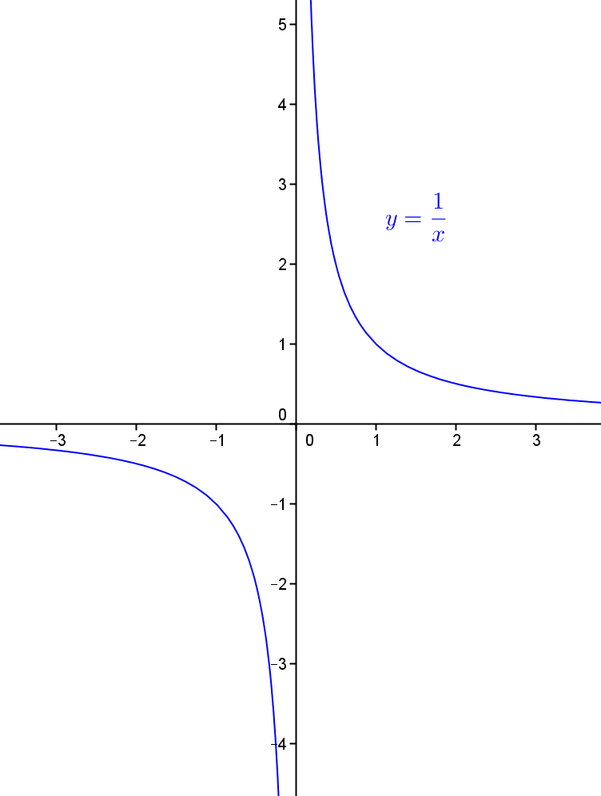

  - Sketch the graph of $y=\frac{x}{x-1}$, being sure to indicate its vertical and horizontal asymptotes.
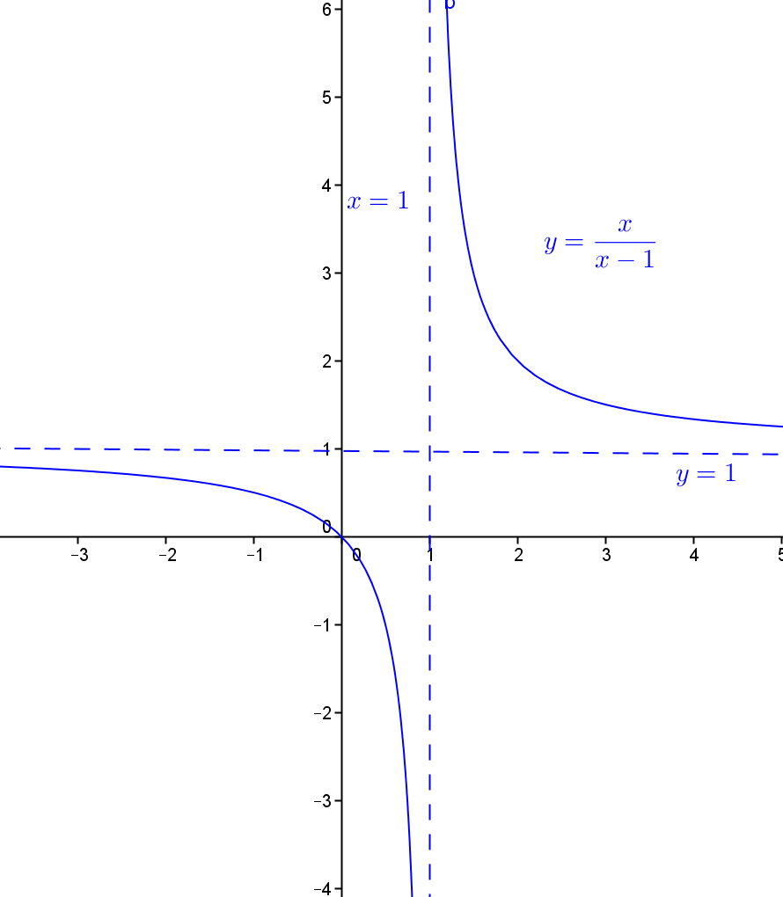
Let be the function defined by $f\left(x\right)= \frac{x}{x-1}$ for all real values $x$ different from $1$.

  - Find $f(f\left(x\right))$ for $x$, a real number different from $1$. What can you conclude about $f^{-1}(x)$?
Suppose $\text{x}$ is a real number different from $\text{1}$.
$$\text{f}\left(\text{f}\left(\text{x}\right)\right) \text{=} \text{f}\left(\frac{\text{x}}{\text{x} \text{-} \text{1}}\right) \text{=} \frac{\frac{\text{x}}{\text{x} \text{-} \text{1}}}{\frac{\text{x}}{\text{x} \text{-} \text{1} }\text{-1}} \\ \text{=} \frac{\text{x}}{\text{x} \text{-} \text{1(x} \text{-} \text{1)}} \\ \text{=} \frac{\text{x}}{\text{x} \text{-} \text{x} \text{+} \text{1}} \\ \text{=} \text{x}$$
This shows that the function $\text{f}$ itself is the inverse of the function $\text{f}$. We have
${\text{f}}^{\text{-1}}\left(\text{x}\right) \text{=} \text{f}\left(\text{x}\right) \text{=} \frac{\text{x}}{\text{x} \text{-} \text{1}}$.
NOTE: Notice that if $\text{x}$ is in the domain of $\text{f}$ (i.e., it is a real number different from $\text{1}$), then $\text{f(x)}$ is again a real number different from $\text{1}$ and so is in the domain of $\text{f}$. We are thus permitted to write $\text{f(f(x))}$.

- Let $f$ be the function given by $f\left(x\right)= x^{2}+3$.

  - Explain why $f$ is not an invertible function on the domain of all real numbers.
$\text{f}\left(\text{-7}\right) \text{=} \text{f(7)} \text{=} \text{52}$, for example, shows that some outputs come from more than one input for this function. The function is not invertible.

  - Describe a set $S$ of real numbers such that if we restrict the domain of $f$to $S$, the function $f$ has an inverse function. Be sure to explain why $f$ has an inverse for your chosen set $S$.
We need to choose a set of real numbers $\text{S}$ over which the function is strictly increasing or strictly decreasing.
Let’s choose $\text{S}$ to be the set of all nonpositive real numbers.
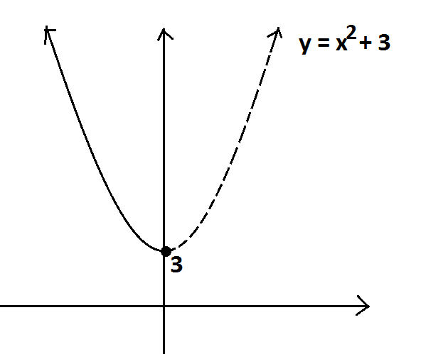
Now, the range of $\text{f}$ is the set of all real values greater than or equal to $\text{3}$. If $\text{y}$ is a value in this range, we see from the graph that there is only one nonpositive value $\text{x}$ such that $\text{f(x)} \text{=} \text{y}$. Thus, $\text{f}$ has an inverse function if we restrict $\text{f}$ to the set of nonpositive inputs.

NOTE: Many answers are possible. For example, $\text{S}$ could be the set of all positive real numbers, or the set of all real numbers just between $\text{-10}$ and $\text{-2}$, or the set consisting of the number $\text{-3}$ and all the real numbers greater than $\text{3}$, for example.

- The graph of $y=x+3$ is shown below.

Consider the rational function $h$ given by $h\left(x\right)=\frac{x^{2}-x-12}{x-4}$.

Simon argues that the graph of $y=h(x)$ is identical to the graph of $y=x+3$. Is Simon correct? If so, how does one reach this conclusion? If not, what is the correct graph of $y=h(x)$? Explain your reasoning throughout.
$\text{h}\left(\text{x}\right) \text{=} \frac{{\text{x}}^{\text{2}} \text{-} \text{x} \text{-} \text{12}}{\text{x} \text{-} \text{4}}$ is defined for all values $\text{x}$ different from $\text{4}$.
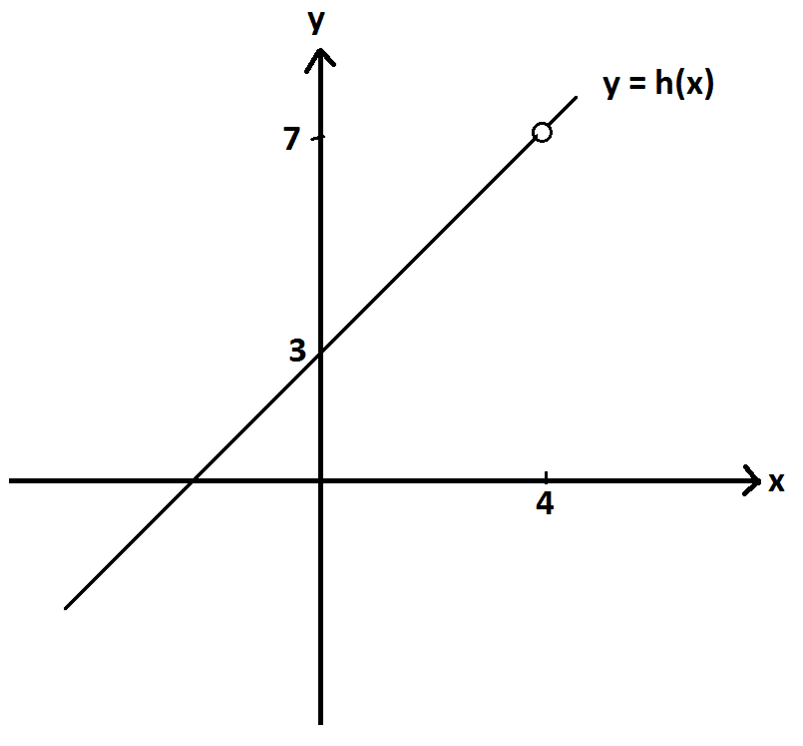
If $\text{x}$ is indeed different from $\text{4}$, we have
$\frac{{\text{x}}^{\text{2}} \text{-} \text{x} \text{-} \text{12}}{\text{x} \text{-} \text{4}} \text{=} \frac{\text{(x} \text{+} \text{3)(x} \text{-} \text{4)}}{\text{x} \text{-} \text{4}} \text{=} \text{x} \text{+} \text{3}$.
(Dividing the numerator and denominator each by $\text{x} \text{-} \text{4}$ is valid as this is a nonzero quantity in the case of $\text{x} \text{≠} \text{4}$.)
So we see that $\text{h}\left(\text{x}\right) \text{=} \left\{\begin{aligned} \text{x} \text{+3, }\text{if} \text{x} \text{is} \text{different} \text{from}\text{ 4} \\ \text{undefined}\text{, }\text{x} \text{=} \text{4 }\end{aligned}\right.$.
The graph of $\text{y} \text{=} \text{h(x)}$ is shown on the right.

- Let $f$ be the function given by $f\left(x\right)=2^{x}$ for all real values $x$, and let $g$ be the function given by $g\left(x\right)=\log_{2}(x)$ for positive real values $x$.

  - Sketch a graph of $y=f(g\left(x\right))$. Describe any restrictions on the domain and range of the functions and the composite functions.
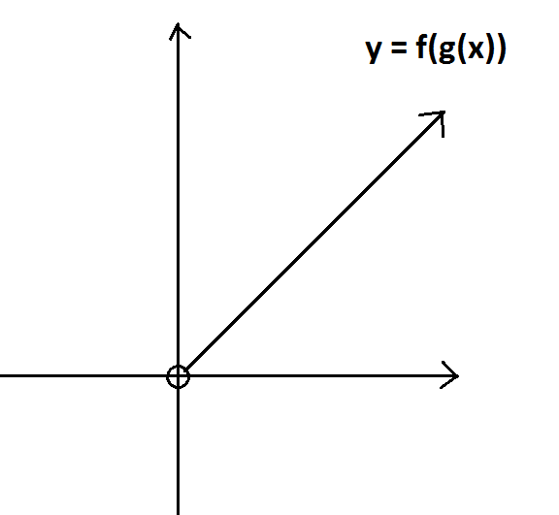
$\text{f(g(x))}$ is meaningful if $\text{x}$ is an appropriate input for $\text{g}$, that is, a positive real number, and its output, $\text{g(x)}$, is an appropriate input for $\text{f}$ (which it shall be, as all real values are appropriate inputs for $\text{f}$). Thus, ${\text{f}}_{\text{°}}\text{g}$ is defined only for positive real inputs.

If $\text{x}$ is a positive real number, then $\text{f}\left(\text{g}\left(\text{x}\right)\right) \text{=} {\text{2}}^{{\text{log}}_{\text{2}}\text{x}} \text{=} \text{x}$, as exponential functions and logarithmic functions (with matching bases) are inverse functions. The graph of $\text{y} \text{=} \text{f(g}\left(\text{x}\right)\text{)}$ is shown on the right.

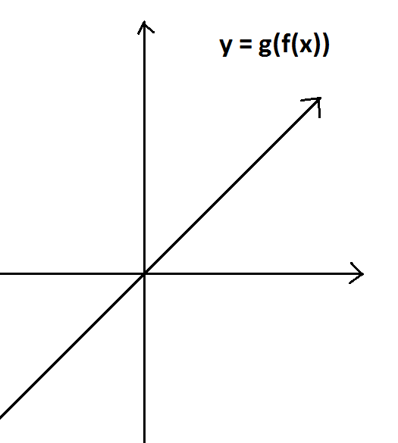
  - Sketch a graph of $y=g(f\left(x\right))$. Describe any restrictions on the domain and range of the functions and the composite functions.
$\text{g(f}\left(\text{x}\right)\text{)}$ is meaningful if $\text{x}$ is an appropriate input for $\text{f}$, which is the case for all real values $\text{x}$, and its output, $\text{f(x)}$, is an appropriate input for $\text{g}$, which it shall be as ${\text{2}}^{\text{x}}$ is a positive value. Thus, ${\text{g}}_{\text{°}}\text{f}$ is defined only for all real inputs.

If $x$ is a real number, then $\text{g(f}\left(\text{x}\right)\text{)} \text{=} {\text{log}}_{\text{x}}\left({\text{2}}^{\text{x}}\right) \text{=} \text{x}$ as exponential functions and logarithmic functions (with matching bases) are inverse functions. Thus, the graph of $\text{y} \text{=} \text{g(f}\left(\text{x}\right)\text{)}$ is as shown on the right.
- Let be the rational function given by $f\left(x\right)= \frac{x+2}{x-1}$ and $g$ the rational function given by $g\left(x\right)=\frac{x-2}{x+1}$.

  - Write $f(x)÷g(x)$ as a rational expression.
We have $\text{f}\left(\text{x}\right) \text{÷} \text{g}\left(\text{x}\right) \text{=} \left(\frac{\text{x} \text{+} \text{2}}{\text{x} \text{-} \text{1}}\right) \text{÷} \left(\frac{\text{x} \text{-} \text{2}}{\text{x} \text{+} \text{1}}\right) \text{=} \frac{\text{(}\text{x} \text{+} \text{1)(}\text{x} \text{+} \text{1)}}{\text{(}\text{x} \text{-} \text{1)(}\text{x} \text{-} \text{2)}}$.

  - Write $f\left(x\right)+g(x)$ as a rational expression.
We have $\text{f}\left(\text{x}\right) \text{+} \text{g}\left(\text{x}\right) \text{=} \frac{\text{x} \text{+} \text{2}}{\text{x} \text{-} \text{1}} \text{+} \frac{\text{x} \text{-} \text{2}}{\text{x} \text{+} \text{1}} \text{=} \frac{\left(\text{x} \text{+} \text{2}\right)\left(\text{x} \text{+} \text{1}\right) \text{+} \text{(}\text{x} \text{-} \text{2)(}\text{x} \text{-} \text{1)}}{\text{(}\text{x} \text{-} \text{1)(}\text{x} \text{+} \text{1)}} \text{=} \frac{\text{2}{\text{x}}^{\text{2}} \text{+} \text{4}}{{\text{x}}^{\text{2}} \text{-} \text{1}}$.

  - Write $f\left(x\right)-g(x)$ as a rational expression.
We have $\text{f}\left(\text{x}\right) \text{-} \text{g}\left(\text{x}\right) \text{=} \frac{\text{x} \text{+} \text{2}}{\text{x} \text{-} \text{1}} \text{-} \frac{\text{x} \text{-} \text{2}}{\text{x} \text{+} \text{1}} \text{=} \frac{\left(\text{x} \text{+} \text{2}\right)\left(\text{x} \text{+} \text{1}\right) \text{-} \left(\text{x} \text{-} \text{2}\right)\left(\text{x} \text{-} \text{1}\right)}{\left(\text{x} \text{-} \text{1}\right)\left(\text{x} \text{+} \text{1}\right)} \text{=} \frac{\text{6}\text{x}}{{\text{x}}^{\text{2}} \text{-} \text{1}}$.

  - Write $\frac{2f(x)}{f\left(x\right)+g(x)}$ as a rational expression.
We have $\frac{\text{2}\text{f}\text{(}\text{x}\text{)}}{\text{f}\left(\text{x}\right) \text{+} \text{g}\text{(}\text{x}\text{)}} \text{=} \left(\frac{\text{2(}\text{x} \text{+} \text{2_}}{\text{x} \text{-} \text{1}}\right) \text{÷} \left(\frac{\text{2}{\text{x}}^{\text{2} }\text{+} \text{4}}{{\text{x}}^{\text{2}} \text{-} \text{1}}\right) \text{=} \frac{\text{2(}\text{x} \text{+} \text{2)(}{\text{x}}^{\text{2}} \text{-} \text{1)}}{\text{(}\text{x} \text{-} \text{1)(2}{\text{x}}^{\text{2}} \text{+} \text{4)}}$.

  - Ronaldo says that $f$ is the inverse function to $g$. Is he correct? How do you know?
We have, for example, $\text{f}\left(\text{2}\right) \text{=} \frac{\text{4}}{\text{1}} \text{=} \text{4}$ but $\text{g}\left(\text{4}\right) \text{=} \frac{\text{2}}{\text{3}}$. That is, $\text{g(f}\left(\text{2}\right)\text{)}$ is not $\text{2}$. If $\text{f}$ were the inverse function to $\text{g}$, then we should see $\text{g}\left(\text{f}\left(\text{2}\right)\right) \text{=} \text{2}$. Ronaldo is not correct.

  - Daphne says that the graph of $f$ and the graph of $g$ each have the same horizontal line as a horizontal asymptote. Is she correct? How do you know?
We have $\text{f}\left(\text{x}\right) \text{=} \frac{\text{x} \text{+} \text{2}}{\text{x} \text{-} \text{1}} \text{=} \frac{\text{x}\left(\text{1} \text{+} \frac{\text{2}}{\text{x}}\right)}{\text{x}\left(\text{1} \text{-} \frac{\text{1}}{\text{x}}\right)}$. If $\text{x}$ is a real number large in magnitude, then $\frac{\text{2}}{\text{x}}$ and $\frac{\text{1}}{\text{x}}$ each have values close to zero, and, in this case, $\text{f}\left(\text{x}\right) \text{≈} \frac{\text{1} \text{+} \text{0}}{\text{1} \text{-} \text{0}} \text{=} \text{1}$ shows that the graph of $\text{f}$ has the horizontal line $\text{y} \text{=} \text{1}$ as an asymptote.
The same work shows that $\text{g}\left(\text{x}\right) \text{=} \frac{\text{x}\left(\text{1} \text{-} \frac{\text{2}}{\text{x}}\right)}{\text{x}\left(\text{1} \text{+} \frac{\text{1}}{\text{x}}\right)}$ also has the line $\text{y} \text{=} \text{1}$ as a horizontal asymptote.
Thus, Daphne is indeed correct.

Let $r\left(x\right)=f(x)∙g(x)$, and consider the graph of $y=r(x)$.

  - What are the $x$-intercepts of the graph of $y=r(x)$?
For $\text{y} \text{=} \text{r}\left(\text{x}\right) \text{=} \frac{\text{(}\text{x} \text{+} \text{2)(}\text{x} \text{-} \text{2)}}{\text{(}\text{x} \text{+} \text{1)(}\text{x} \text{-} \text{1)}}$, we have $\text{y} \text{=} \text{0}$ when $\text{x} \text{=} \text{-2}$ and $\text{x} \text{=} \text{2}$. The x-intercepts occur at the points $\text{(-2, 0)}$ and $\text{(2, 0)}$.

  - What is the $y$-intercept of $y=r(x)$?
$\text{r}\left(\text{0}\right) \text{=} \frac{\text{(2)(-2)}}{\text{(1)(-1)}} \text{=} \text{4}$. The y-intercept occurs at the point $\text{(0, 4)}$.

  - At which $x$-values is $r(x)$ undefined?
$\text{r(x)}$ is undefined at $\text{x} \text{=} \text{1}$ and at $\text{x} \text{=} \text{-1}$.

  - Does the graph of $y=r(x)$ have a horizontal asymptote? Explain your reasoning.
We have
$\text{y} \text{=} \text{r}\left(\text{x}\right) \text{=} \frac{{\text{x}}^{\text{2}} \text{-} \text{4}}{{\text{x}}^{\text{2}} \text{-} \text{1}} \text{=} \frac{{\text{x}}^{\text{2}}\left(\text{1} \text{-} \frac{\text{4}}{{\text{x}}^{\text{2}}}\right)}{{\text{x}}^{\text{2}}\left(\text{1} \text{-} \frac{\text{1}}{{\text{x}}^{\text{2}}}\right)}$.
If $\text{x}$ is a real positive number or a real negative number large in magnitude (and so certainly not zero), then
$\text{r}\left(\text{x}\right) \text{=} \frac{\text{1} \text{-} \frac{\text{4}}{{\text{x}}^{\text{2}}}}{\text{1} \text{-} \frac{\text{1}}{{\text{x}}^{\text{2}}}} \text{≈} \frac{\text{1} \text{-} \text{0}}{\text{1} \text{-} \text{0}} \text{=} \text{1}$.
This shows that the graph of $\text{y} \text{=} \text{r(x)}$ closely matches the horizontal line $\text{y} \text{=} \text{1}$ for large positive and large negative inputs. We have a horizontal asymptote, the line $\text{y} \text{=} \text{1}$.
Notice that for values of $\text{x}$ large in magnitude, ${\text{x}}^{\text{2}} \text{-} \text{1}$ and ${\text{x}}^{\text{2}} \text{-} \text{4}$ are positive, and
$\frac{{\text{x}}^{\text{2}} \text{-} \text{4}}{{\text{x}}^{\text{2}} \text{-} \text{1}} \text{<} \frac{{\text{x}}^{\text{2} }\text{-} \text{1}}{{\text{x}}^{\text{2}} \text{-} \text{1}} \text{=} \text{1}$, so the graph of $\text{y} \text{=} \text{r(x)}$ always lies below its horizontal asymptote in its long-term behavior.

  - Give a sketch of the graph of $y=r(x)$ which shows the broad features you identified in parts (g)–(j).
The broad features of the graph are indicated as so, with the dashed lines representing asymptotes:
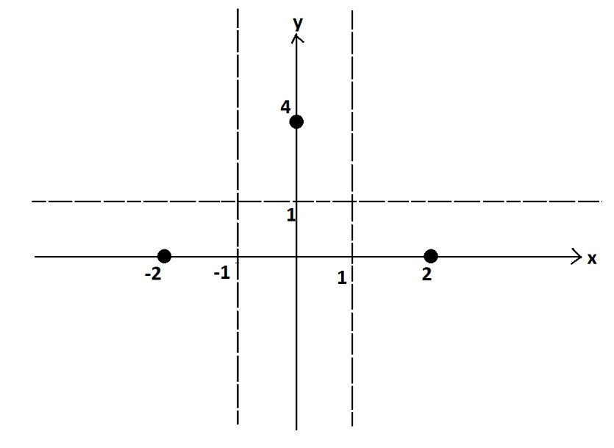
Given the graph of $\text{y} \text{=} \text{r(x)}$ crosses the x-axis only at $\text{x} \text{=} \text{-2}$ and $\text{x} \text{=} \text{2}$ and the y-axis only at $\text{y} \text{=} \text{4}$, we deduce that the graph of the curve can only be of the form:
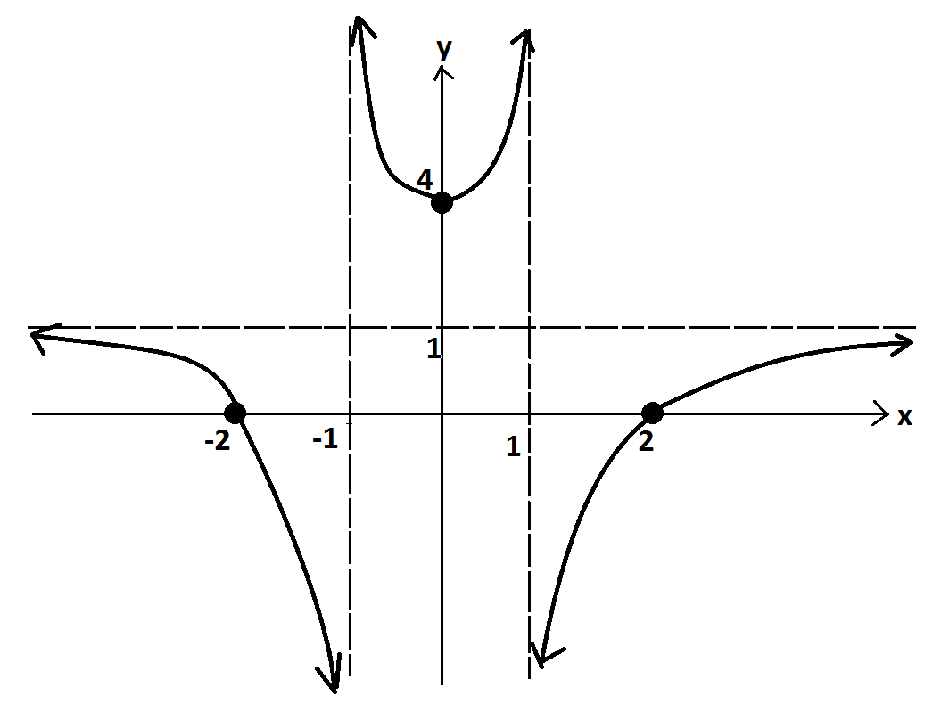

- An algae growth in an aquarium triples in mass every two days. The mass of algae was $2.5$ grams on June 21, considered day zero, and the following table shows the mass of the algae on later days.

Let $m(d)$ represent the mass of the algae, in grams, on day $d$. Thus, we are regarding $m$ as a function of time given in units of days. Our time measurements need not remain whole numbers. (We can work with fractions of days too, for example.)

  - Explain why $m$ is an invertible function of time.
The algae grows in mass over time, so its mass is an increasing function of time. For each possible value of mass (output), there is only one possible time (input) at which the growth has that mass. Thus, we can define an inverse function.

  - According to the table, what is the value of $m^{-1}(202.5)$? Interpret its meaning in the context of this situation.
${\text{m}}^{\text{-1}}\text{(202.5)}$ represents the number of days required for the algae to attain a mass of $\text{202.5}$ grams. According to the table, we have ${\text{m}}^{\text{-1}}\left(\text{202.5}\right) \text{=} \text{8}$ days.

  - Find a formula for the inverse function $m$, and use your formula to find the value of $m^{-1}(400)$ to one decimal place.
The growth is exponential. The initial mass is $\text{2.5}$ grams, and the mass triples every two days. We see that $\text{m}\left(\text{d}\right) \text{=} \text{2.5} \text{∙} {\text{3}}^{\frac{\text{d}}{\text{2}}}$. To find the inverse function to $\text{m}$, notice that

If $\text{y} \text{=} \text{2.5} \text{∙} {\text{3}}^{\frac{\text{d}}{\text{2}}}$, then
$$\text{log}\left(\text{y}\right) \text{=} \text{log}\left(\text{2.5}\right) \text{+} \frac{\text{d}}{\text{2}}\text{log}{\text{(3)}} \\ \text{log}\left(\text{y}\right) \text{-} \text{log}\left(\text{2.5}\right) \text{=} \frac{\text{d}}{\text{2}}\text{log}{\text{(3)}}$$

(using base-ten logarithms) giving
$\text{d} \text{=} \frac{\text{2}}{\text{log}\left(\text{3}\right)}\text{(}\text{log}\left(\text{y}\right) \text{-} \text{log}{\text{(2.5))} \text{=} \frac{\text{2}\text{log}\left(\frac{\text{y}}{\text{2.5}}\right)}{\text{log}{\text{(3)}}}}$.

This shows
${\text{m}}^{\text{-1}}\left(\text{y}\right) \text{=} \frac{\text{2}\text{log}\left(\frac{\text{y}}{\text{2.5}}\right)}{\text{log}{\text{(3)}}}$.

To finish, we see
${\text{m}}^{\text{-1}}\left(\text{400}\right) \text{=} \frac{\text{2}\text{log}\left(\frac{\text{400}}{\text{2.5}}\right)}{\text{log}{\text{(3)}}} \text{≈} \text{9.2}$days.

