Name Date

  - Find values for $a$, $b$, $c$, $d$, and $e$ so that the following matrix product equals the $3×3$ identity matrix. Explain how you obtained these values.
$$\left[\begin{matrix}a & -3 & 5 \\ c & c & 1 \\ 5 & b & -4\end{matrix}\right]\left[\begin{matrix}1 & b & d \\ 1 & c & e \\ 2 & b & b\end{matrix}\right]$$

  - Represent the following system of linear equations as a single matrix equation of the form $Ax=b$, where $A$ is a $3×3$ matrix, and $x$ and $b$ are $3×1$ column matrices.
$$x+3y+2z=8$$
$$x-y+z=-2$$
$$2x+3y+3z=7$$

  - Solve the system of three linear equations given in part (b).

- The following diagram shows two two-dimensional vectors $v$ and $w$ in the place positioned to both have endpoint at point $P$.
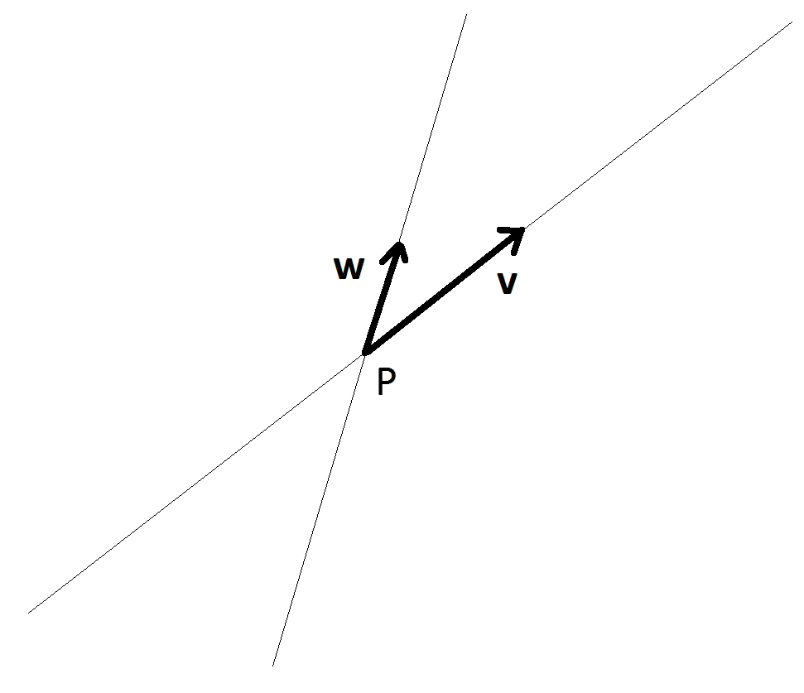
  - On the diagram, make reasonably accurate sketches of the following vectors, again each with endpoint at $P$. Be sure to label your vectors on the diagram.
    - $2v$
    - $-w$
    - $v+3w$
    - $w-2v$
    - $\frac{1}{2}v$

Vector $v$ has magnitude $5 units$, $w$ has magnitude $3$, and the acute angle between them is $45°$.

  - What is the magnitude of the scalar multiple $-5v$?

  - What is the measure of the smallest angle between $-5v$ and $3w$ if these two vectors are placed to have a common endpoint?

- Consider the two-dimensional vectors $v=〈2, 3〉$ and $w=〈-2, -1〉$.

  - What are the components of each of the vectors $v+w$ and $v-w$?

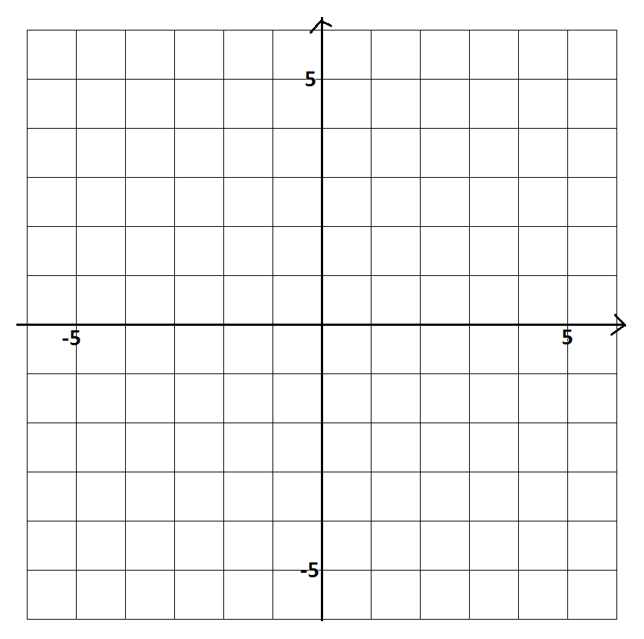
  - On the following diagram, draw representatives of each of the vectors $v$, $w$, and $v+w$, each with endpoint at the origin.

  - The representatives for the vectors $v$ and $w$ you drew form two sides of a parallelogram, with the vector $v+w$ corresponding to one diagonal of the parallelogram. What vector, directed from the third quadrant to the first quadrant, is represented by the other diagonal of the parallelogram? Express your answer solely in terms of $v$ and $w$, and also give the coordinates of this vector.

  - Show that the magnitude of the vector $v+w$ does not equal the sum of the magnitudes of $v$ and of $w$.

  - Give an example of a non-zero vector $u$ such that $\left\|v+u\right\|$ does equal $\left\|v\right\|+\left\|u\right\|$.

  - Which of the following three vectors has the greatest magnitude: $v+(-w)$, $w-v$, or
$\left(-v\right)-(-w)$?

  - Give the components of a vector one-quarter the magnitude of vector $v$ and with direction opposite the direction of $v$.

- Vector $a$ points true north and has magnitude $7 units$. Vector $b$ points $30°$ east of true north. What should the magnitude of $b$ be so that $b-a$ points directly east?

State the magnitude and direction of $b-a$.

- Consider the three points $A=\left(10,-3,5\right)$, $B=\left(0,2,4\right)$, and $C=\left(2,1,0\right)$ in three-dimensional space.
Let $M$ be the midpoint of $\overline{AB}$ and $N$ be the midpoint of $\overline{AC}$.

  - Write down the components of the three vectors $\vec{AB},\vec{BC}$, and $\vec{CA}$, and verify through arithmetic that their sum is zero. Also, explain why geometrically we expect this to be the case.

  - Write down the components of the vector $\vec{MN}$. Show that it is parallel to the vector $\vec{BC}$ and half its magnitude.

Let $G=\left(4,0,3\right)$.

  - What is the value of the ratio $\frac{\left\|\vec{MG}\right\|}{\left\|\vec{MC}\right\|}$?

  - Show that the point $G$ lies on the line connecting $M$ and $C$. Show that $G$ also lies on the line connecting $N$ and $B$.

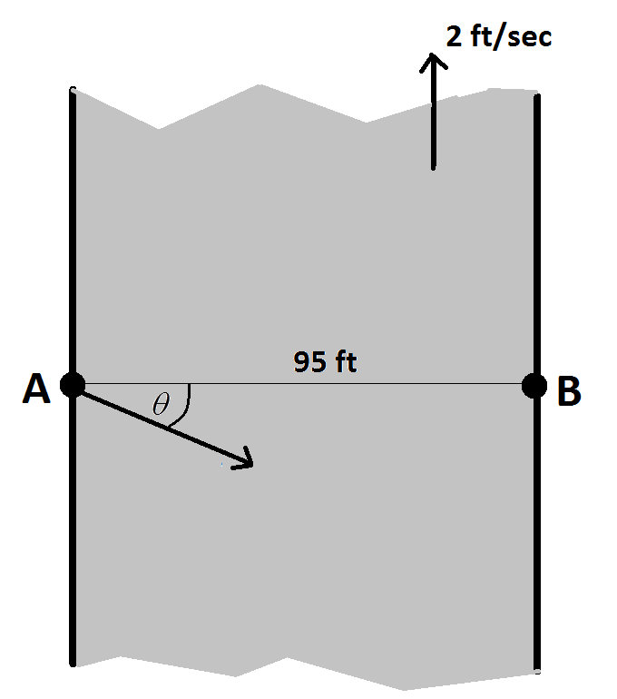
- A section of a river, with parallel banks $95 ft.$apart, runs true north with a current of $2 ft/sec$. Lashana, an expert swimmer, wishes to swim from point $A$ on the west bank to the point $B$ directly opposite it. In still water she swims at an average speed of $3 ft/sec$.

The diagram to the right illustrates the situation.

To counteract the current, Lashana realizes that she is to swim at some angle $θ$ to the east/west direction as shown.

With the simplifying assumptions that Lashana’s swimming speed will be a constant $3 ft/sec$ and that the current of the water is a uniform $2 ft/sec$ flow northward throughout all regions of the river (we will ignore the effects of drag at the river banks, for example), at what angle $θ$ to east/west direction should Lashana swim in order to reach the opposite bank precisely at point $B$? How long will her swim take?

  - What is the shape of Lashana’s swimming path according to an observer standing on the bank watching her swim? Explain your answer in terms of vectors.

  - If the current near the banks of the river is significantly less than $2 ft/sec$, and Lashana swims at a constant speed of $3 ft/sec$ at the constant angle $θ$ to the east/west direction as calculated in
part (a), will Lashana reach a point different from $B$ on the opposite bank? If so, will she land just north or just south of $B$? Explain your answer.

- A $5 kg$ ball experiences a force due to gravity $\vec{F}$ of magnitude $49$ Newtons directed vertically downwards. If this ball is placed on a ramped tilted at an angle of $45°$, what is the magnitude of the component of this force, in Newtons, on the ball directed $45°$towards the bottom of the ramp? (Assume the ball is of sufficiently small radius that is reasonable to assume that all forces are acting at the point of contact of the ball with the ramp.)
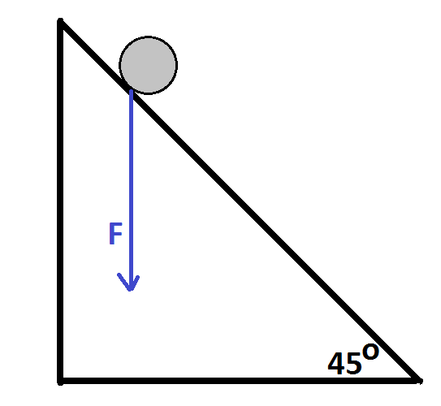

- Let $A$ be the point $\left(1, 1, -3\right)$ and $B$ be the point $(-2, 1, -1)$ in three-dimensional space.

A particle moves along the straight line through $A$ and $B$ at uniform speed in such a way that at time
$t=0$ seconds the particle is at $A$, and at $t=1$ second the particle is at $B$. Let $P(t)$ be the location of the particle at time $t$ (so, $P\left(0\right)=A$ and $P\left(1\right)=B$).

  - Find the coordinates of the point $P(t)$ each in terms of $t$.

  - Give a geometric interpretation of the point $P(0.5)$.

Let $L$ be the linear transformation represented by the $3×3$ matrix $\left[\begin{matrix}2 & 0 & 1 \\ 1 & 3 & 0 \\ 0 & 1 & 1\end{matrix}\right]$, and let $A^{'}=LA$ and
$B^{'}=LB$ be the images of the points $A$ and $B$, respectively, under $L$.

  - Find the coordinates of $A'$ and $B'$.

A second particle moves through three-dimensional space. Its position at time $t$ is given by $L\left(P\left(t\right)\right)$, the image of the location of the first particle under the transformation $L$.

  - Where is the second particle at times $t=0$ and $t=1$? Briefly explain your reasoning.

  - Prove that second the particle is also moving along a straight line path at uniform speed.

A Progression Toward Mastery
Assessment  Task Item |  | STEP 1  Missing or incorrect answer and little evidence of reasoning or application of mathematics to solve the problem. | STEP 2  Missing or incorrect answer but evidence of some reasoning or application of mathematics to solve the problem. | STEP 3  A correct answer with some evidence of reasoning or application of mathematics to solve the problem, or an incorrect answer with substantial evidence of solid reasoning or application of mathematics to solve the problem. | STEP 4  A correct answer supported by substantial evidence of solid reasoning or application of mathematics to solve the problem.
1 | a  A-REI.C.9 | Student shows little or no understanding of matrix operations. | Student attempts to multiply matrices, making major mistakes, but equates terms to the identity matrix. | Student calculates the correct values for $a, b, c, d,$ and $e$ but does not explain or does not clearly explain how values were obtained. | Student calculates the correct values for $a, b, c, d,$and $e$and clearly explains how values were obtained..
 | b  A-REI.C.8 | Student shows little or no understanding of matrices. | Students writes one matrix ($A$,$x$, or $b$) correctly. | Student writes two matrices ($A$, $x$, or $b$) correctly. | Student writes all three matrices correctly.
 | c  A-REI.C.9 | Student shows little or no understanding of matrices. | Student multiplies by the inverse matrix but makes mistakes in computations leading to only one correct value of $x$,$y$, or $z$. | Student multiplies by the inverse matrix but makes mistakes in computations leading to two correct values of $x$,$y$, or $z$. | Student multiplies by the inverse matrix arriving at the correct values of $x$,$y$, and $z$.
2 | a  N-VM.A.1  N-VM.B.4a  N-VM.B.4c  N-VM.B.5 | Student shows little or no evidence of vectors. | Student shows some knowledge of vectors drawing at least two correctly. | Student show reasonable knowledge of vectors drawing at least four correctly. | Student graphs and labels all vectors correctly.
 | b  N-VM.A.1  N-VM.B.5b | Student show little or no understanding of the magnitude of a vector. | Student understands that the magnitude is $5$ times the magnitude of the vector$v$ but calculates the magnitude of$v$ incorrectly. | Student calculates the magnitude of $v$ correctly but does not multiply by $5$. | Student calculates the magnitude of $-5v$ correctly.
 | c  N-VM.A.1 | Student shows little or no understanding of vectors and angles. | Student draws vectors with a common endpoint but does no calculations. | Student draws vectors with a common endpoint, but the angle identified is $45°$. | Student draws vectors with a common endpoint and identifies the angle between them as $135°$.
3 | a  N-VM.B.4a  N-VM.B.4c | Student shows little or no understanding of vectors. | Student identifies vector components but does not add or subtract the vectors. | Student identifies the vector components and either adds or subtracts the vectors correctly. | Student identifies the vector components and adds and subtracts the vectors correctly.
 | b  N-VM.A.1  N-VM.B.4a | Student shows little or no understanding of graphing vectors. | Student graphs either $v$ or $w$ correctly but does not graph $v+w$ or graphs $v+w$ incorrectly. | Student graphs $v$ and $w$ correctly but does not graph $v+w$ or graphs $v+w$ incorrectly. | Student graphs $v, w$, and $v+w$ correctly.
 | c  N-VM.B.4c | Student shows little or no understanding of vectors. | Student draws the vector correctly but does not write it in terms of $v$ and $w$ or identify the components. | Student draws the vector correctly and either writes the vector in terms of $v$ and $w$ correctly or identifies its components correctly. | Student draws the vector, writes it in terms of $v$ and $w$, and identifies its components correctly.
 | d  N-VM.B.4a | Student shows little or no understanding of vector magnitude. | Student finds one of the magnitudes of $v$,$w,$ or $v+w$ correctly. | Student finds two of the magnitudes of $v$,$w$, and $v+w$ correctly. | Student finds the magnitudes of $v$,$w$, and $v+w$ correctly and shows that the magnitude of $v$ plus the magnitude of $w$ does not equal the magnitude of the sum of $v$ and $w$.
3 | e  N-VM.B.4a | Student shows little or no understanding of vectors. | Student identifies a vector $u$, but it does not satisfy the conditions. | Student identifies a vector $u = v$ that satisfies the conditions but does not justify answer. | Student identifies a vector $u = v$ that satisfies the conditions and justifies the answer.
 | f  N-VM.B.4c | Student shows little or no understanding of vector magnitude. | Student finds two of the three magnitudes correctly. | Student finds the three magnitudes correctly but does not state that the magnitudes are all the same. | Student finds the three magnitudes correctly and states that the magnitudes are all the same.
 | g  N-VM.B.5a | Student shows little or no understanding of vectors. | Student either multiplies $v$ by $\frac{1}{4}$ or $-1$ but not by $-\frac{1}{4}$. | Student multiplies $v$ by $-\frac{1}{4}$ but does not identify the components of the resulting vector. | Student multiplies $v$ by $-\frac{1}{4}$ and identifies the components of the resulting vector.
4 | N-VM.B.4b | Student shows little or no understanding of vectors. | Student draws the vectors correctly and attempts to determine magnitude and direction, but both are incorrect. | Student draws the vectors correctly and either the magnitude or direction are correct, but not both. | Student draws the vectors correctly and determines the correct magnitude and direction.
5 | a  N-VM.A.2  N-VM.B.4a | Student shows little or no understanding of vectors. | Student identifies the components of all three vectors correctly. | Student identifies the components of all three vectors correctly and shows their sum is $0$. | Student identifies the components of all three vectors correctly, shows their sum is $0$, and explains geometrically why this is expected.
 | b  N-VM.A.2  N-VM.B.5b | Student shows little or no understanding of vectors. | Student determines the components of $\vec{MN}$ correctly. | Student determines the components of $\vec{MN}$ correctly and either shows that it is parallel to or half the magnitude of $\vec{BC}$. | Student determines the components of $\vec{MN}$ correctly and shows that it is parallel to and half the magnitude of $\vec{BC}$.
 | c  N-VM.A.2  N-VM.B.4a  N-VM.B.5b | Student shows little or no understanding of vector magnitude. | Student finds the components of $\vec{MG}$ and $\vec{MC}$. | Student finds the components of $\vec{MG}$ and $\vec{MC}$ and shows that $\vec{MC}=3\vec{MG}.$ | Student finds the components of $\vec{MG}$ and $\vec{MC}$ and shows the ratio is $\frac{1}{3}$.
 | d  N-VM.A.2  N-VM.B.4a  N-VM.B.5b | Student shows little or no understanding of vectors. | Student explains that $G$ must lie on $\vec{MC}$ since $\vec{MG}=\frac{1}{3}\vec{MC}$. | Student explains that $G$ must lie on $\vec{MC}$ and finds that  $\vec{NG}=\frac{1}{3}\vec{NB}$. | Student explains that $G$ must lie on $\vec{MC}$ and also $\vec{NB}$.
6 | a  N-VM.A.3 | Student shows little or no understanding of the shape of the path or vectors. | Student states or draws the correct shape of the path but does not explain using vectors. | Students states or draws the correct shape of the path and uses vectors to support answer but makes errors in reasoning. | Student states or draws the correct shape of the path and clearly explains using vectors.
 | b  N-VM.A.3 | Student shows little or no understanding of vectors. | Student states that she will not land at point$B$ but shows little supporting work and does not state the point will be south of point $B$. | Student states that she will land at a point south of $B$, but supporting work is not clear or has simple mistakes. | Student states that she will land at a point south of $B$ and clearly explains answer.
7 | N-VM.A.3 | Student shows little or no understanding of vector components or magnitude. | Student identifies the components of the vector. | Student identifies the components of the vector and attempts to find the magnitude of the force component down the ramp but makes calculation mistakes. | Student identifies the components of the vector and calculates the magnitude of the force component down the ramp correctly.
8 | a  N-VM.A.3  N-VM.C.11 | Student shows little or no understanding of vectors. | Student calculates the components of $\vec{AB}$. | Student calculates the components of vector $\vec{AB}$ and understands that $P(t)=A+tAB$ but does not determine $P(t)$ in terms of $t$. | Student calculates the components of $\vec{AB}$ and finds the coordinates of $P(t)$ in terms of $t$.
 | b  N-VM.C.8  N-VM.C.11 | Student shows little or no understanding of vectors. | Students states either $P(0)=A$ or $P(1)=B.$ | Students states that $P(0)=A$ and $P(1)=B.$ | Students states that $P(0)=A$,$P(1)=B$, and that $P(0.5)$ is the midpoint of segment $AB$.
 | c  N-VM.C.8  N-VM.C.11 | Student shows little or no knowledge of vectors and matrices. | Students sets up the matrices to determine $A'$and $B'$ but makes errors in calculating both. | Student sets up the matrices to determine $A'$and $B'$ and calculates one correctly. | Student sets up the matrices to determine $A'$and $B'$and calculates both correctly.
 | d  N-VM.C.8  N-VM.C.11 | Student show little or no knowledge of vectors and matrices. | Students understands that $L\left(P\left(t\right)\right)$ must be used to find the position of the second particle. | Student calculates either the position at $t=0$as $L\left(P\left(0\right)\right)$ or$t=1$as $L\left(P\left(1\right)\right)$ correctly. | Student calculates the position at$t=0$ as $L\left(P\left(0\right)\right)$ and $t=1$ as $L\left(P\left(1\right)\right)$ correctly.
 | e  N-VM.C.8  N-VM.C.11 | Student shows little or no understanding of vectors and matrices. | Student states the location of the second particle is $L\left(P\left(t\right)\right)$. | Student states the location of the second particle is $L\left(P\left(t\right)\right)$ and that $L\left(P\left(t\right)\right)=A'+t\vec{A'B'}$. | Student states the location of the second particle is $L\left(P\left(t\right)\right)$ and that $L\left(P\left(t\right)\right)=A'+t\vec{A'B'}$ and explains the particle is moving on a straight line from $A’$ to $B’$ at uniform velocity given by $\vec{A’B’}$.

Name Date

  - Find values for $a$, $b$, $c$, $d$, and $e$ so that the following matrix product equals the $3×3$ identity matrix. Explain how you obtained these values.
$$\left[\begin{matrix}a & -3 & 5 \\ c & c & 1 \\ 5 & b & -4\end{matrix}\right]\left[\begin{matrix}1 & b & d \\ 1 & c & e \\ 2 & b & b\end{matrix}\right]$$
The row 1, column 1 entry of the product is $\text{a}-\text{3} \text{+} \text{10}$. This should equal $\text{1}$, so
$\text{a} \text{=} -\text{6}$.
The row 2, column 1 entry of the product is $\text{c + c + 2}$. This should equal zero, so $\text{c} \text{=} -\text{1}$.
The row 3, column 1 entry of the product is $\text{5} \text{+} \text{b}-\text{8}$. This should equal zero, so $\text{b = 3}$.
The row 1, column 3 entry of the product is $\text{ad}-\text{3e} \text{+} \text{5b} \text{=} \text{-6d}-\text{3e} \text{+} \text{15}$, and this should equal zero. So, we should have $\text{6d + 3e = 15}$.
The row 2, column 3 entry of the product is $\text{cd + cd + b = -d}-\text{e + 3}$, and this should equal zero. So, we need $\text{d + e = 3}$.
Solving the two linear equation is $\text{d}$ and $\text{e}$ gives $\text{d = 2}$ and $\text{e = 1}$.
So, in summary, we have $\text{a} \text{=} \text{-6}$, $\text{b} \text{=} \text{3}$, $\text{c} \text{=} \text{-1}$, $\text{d} \text{=} \text{2}$, and $\text{e} \text{=} \text{1}$.

  - Represent the following system of linear equations as a single matrix equation of the form $Ax=b$, where $A$ is a $3×3$ matrix and $x$ and $b$ are $3×1$ column matrices.
$$x+3y+2z=8$$
$$x-y+z=-2$$
$$2x+3y+3z=7$$

We have $\text{Ax=b}$ with $\text{A=}\left[\begin{matrix}\text{1} & \text{3} & \text{2} \\ \text{1} & \text{-1} & \text{1} \\ \text{2} & \text{3} & \text{3}\end{matrix}\right]$ and $\text{x=}\left[\begin{matrix}\text{x} \\ \text{y} \\ \text{z}\end{matrix}\right]$ and $\text{b=}\left[\begin{matrix}\text{8} \\ \text{-2} \\ \text{7}\end{matrix}\right]$.

  - Solve the system of three linear equations given in part (b).
The solution is given by $\text{x} \text{=} {\text{A}}^{-\text{1}}\text{b}$, if the matrix inverse exists. But part (a) shows that if we set
$$\text{B=}\left[\begin{matrix}\text{-6} & \text{-3} & \text{5} \\ \text{-1} & \text{-1} & \text{1} \\ \text{5} & \text{3} & \text{-4}\end{matrix}\right],$$
then we have $\text{BA = I}$. We could check that $\text{AB = I}$, as well (in which case B is the matrix inverse of A), but even without knowing this, from
$$\text{Ax = b }\left[\begin{matrix}\text{1} & \text{3} & \text{2} \\ \text{1} & \text{-1} & \text{1} \\ \text{2} & \text{3} & \text{3}\end{matrix}\right]\left[\begin{matrix}\text{x} \\ \text{y} \\ \text{z}\end{matrix}\right]=\left[\begin{matrix}\text{8} \\ \text{-2} \\ \text{7}\end{matrix}\right],$$
we get
$$\text{BAx = Bb }\left[\begin{matrix}\text{-6} & \text{-3} & \text{5} \\ \text{-1} & \text{-1} & \text{1} \\ \text{5} & \text{3} & \text{-4}\end{matrix}\right]\left[\begin{matrix}\text{1} & \text{3} & \text{2} \\ \text{1} & \text{-1} & \text{1} \\ \text{2} & \text{3} & \text{3}\end{matrix}\right]\left[\begin{matrix}\text{x} \\ \text{y} \\ \text{z}\end{matrix}\right]\text{=}\left[\begin{matrix}\text{-6} & \text{-3} & \text{5} \\ \text{-1} & \text{-1} & \text{1} \\ \text{5} & \text{3} & \text{-4}\end{matrix}\right]\left[\begin{matrix}\text{8} \\ \text{-2} \\ \text{7}\end{matrix}\right]$$
$$\text{Ix = Bb} \left[\begin{matrix}\text{1} & \text{0} & 0 \\ 0 & \text{1} & 0 \\ 0 & 0 & 1\end{matrix}\right]\left[\begin{matrix}\text{x} \\ \text{y} \\ \text{z}\end{matrix}\right]\text{=}\left[\begin{matrix}\text{-6} & \text{-3} & \text{5} \\ \text{-1} & \text{-1} & \text{1} \\ \text{5} & \text{3} & \text{-4}\end{matrix}\right]\left[\begin{matrix}\text{8} \\ \text{-2} \\ \text{7}\end{matrix}\right]$$
$$\text{x = Bb} \left[\begin{matrix}\text{x} \\ \text{y} \\ \text{z}\end{matrix}\right]\text{=}\left[\begin{matrix}\text{-6} & \text{-3} & \text{5} \\ \text{-1} & \text{-1} & \text{1} \\ \text{5} & \text{3} & \text{-4}\end{matrix}\right]\left[\begin{matrix}\text{8} \\ \text{-2} \\ \text{7}\end{matrix}\right]$$
$$\left[\begin{matrix}\text{x} \\ \text{y} \\ \text{z}\end{matrix}\right]\text{=}\left[\begin{matrix}\text{-7} \\ \text{1} \\ \text{6}\end{matrix}\right];$$
that is, that $\text{x =-7}$, $\text{y = 1}$, $\text{z = 6}$ is a solution to the system of equations. (In fact, it can be the only solution to the system.)

- The following diagram shows two two-dimensional vectors $v$ and $w$ in the place positioned to both have endpoint at point $P$.
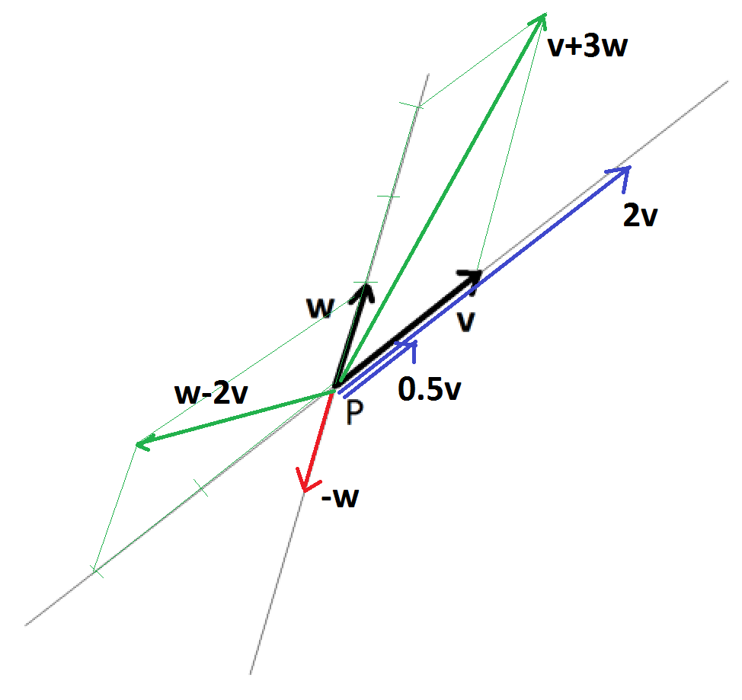

  - On the diagram, make reasonably accurate sketches of the following vectors, again each with endpoint at $P$. Be sure to label your vectors on the diagram.
    - $2v$
    - $-w$
    - $v+3w$
    - $w-2v$
    - $\frac{1}{2}v$

Vector $v$ has magnitude $5 units$, $w$ has magnitude $3$, and the acute angle between them is $45°$.

  - What is the magnitude of the scalar multiple $-5v$?
We have $\left\|\text{-5}\text{v}\right\| \text{=} \text{5}\left\|\text{v}\right\| \text{=} \text{5} \text{×} \text{5} \text{=} \text{25}$.

  - What is the measure of the smallest angle between $-5v$ and $3w$ if these two vectors are placed to have a common endpoint?
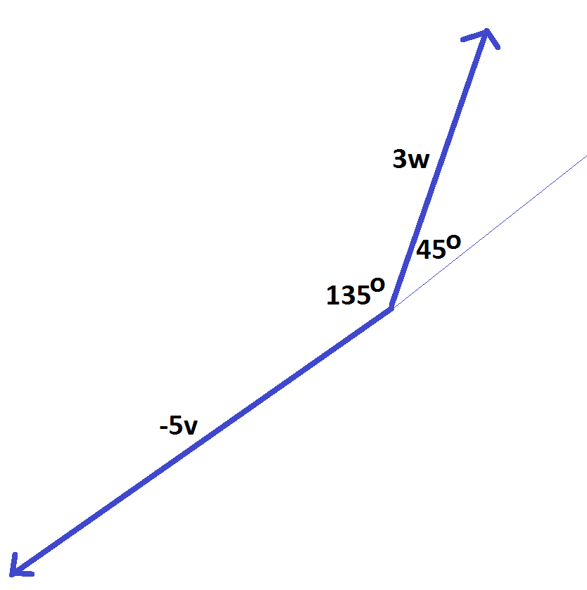

The two vectors in question have an angle of smallest measure 135° between them.

- Consider the two-dimensional vectors $v=〈2,3〉$ and $w=〈-2,-1〉$.

  - What are the components of each of the vectors $v+w$ and $v-w$?

$\text{v} \text{+} \text{w}=〈\text{2}+\left(-\text{2}\right), \text{3}+(-\text{1})〉=〈\text{0}, \text{2}〉$ and $\text{v}-\text{w}=〈\text{2}-\left(-\text{2}\right), \text{3}-\left(-\text{1}\right)〉=〈\text{4}, \text{4}〉$

  - On the following diagram, draw representatives of each of the vectors $v$, $w$, and $v+w$, each with endpoint at the origin.
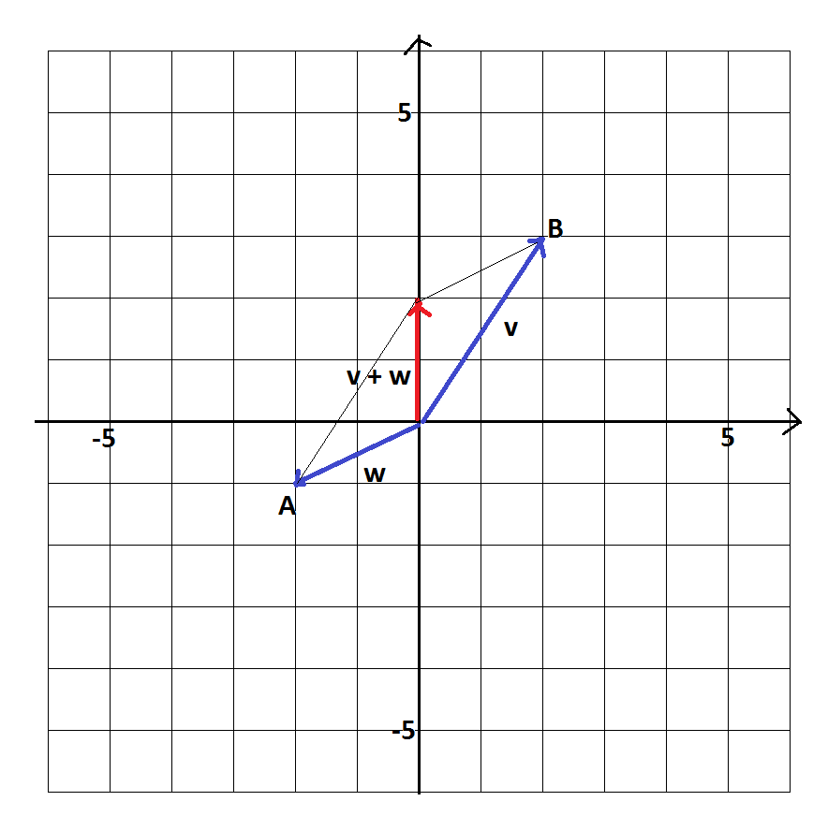

  - The representatives for the vectors $v$ and $w$ you drew form two sides of a parallelogram, with the vector $v+w$ corresponding to one diagonal of the parallelogram. What vector, directed from the third quadrant to the first quadrant, is represented by the other diagonal of the parallelogram? Express your answer solely in terms of $v$ and $w$, and also give the coordinates of this vector.
Label the points A and B as shown. The vector we seek is $\vec{\text{AB}}$. To move from A to B we need to follow $\text{-}\text{w}$ and then $\text{v}$. Thus, the vector we seek is $\text{–w + v}$, which is the same as $\text{v – w}$.
Also, we see that to move from A to B we need to move 4 units to the right and 4 units upward. This is consistent with $\text{v}-\text{w}=〈\text{2}-\left(-\text{2}\right), \text{3}-\left(-\text{1}\right)〉=〈\text{4}, \text{4}〉$.

  - Show that the magnitude of the vector $v+w$ does not equal the sum of the magnitudes of $v$ and of $w$.
We have $\left\|\text{v}\right\|=\sqrt{{\text{2}}^{\text{2}}+{\text{3}}^{\text{2}}}=\sqrt{\text{13}}$ and $\left\|\text{w}\right\|=\sqrt{{\left(-\text{2}\right)}^{\text{2}}+{\left(-\text{1}\right)}^{\text{2}}}=\sqrt{\text{5}}$, so $\left\|\text{v}\right\|+\left\|\text{w}\right\|=\sqrt{\text{13}}+\sqrt{\text{5}}$.
Now, $\left\|\text{v}+\text{w}\right\|=\sqrt{{\text{0}}^{\text{2}}+{\text{2}}^{\text{2}}}=\text{2}$. This does not equal $\sqrt{\text{13}}+\sqrt{\text{5}}$.

  - Give an example of a non-zero vector $u$ such that $\left\|v+u\right\|$ does equal $\left\|v\right\|+\left\|u\right\|$.
Choosing u to be the vector v works.
$$\left\|\text{v}+\text{u}\right\|=\left\|\text{v}+\text{v}\right\|=\left\|\text{2}\text{v}\right\|=\text{2}\left\|\text{v}\right\|=\left\|\text{v}\right\|+\left\|\text{v}\right\|$$
(In fact, $\text{u}=\text{k}\text{v}$ for any positive real number k works.)

  - Which of the following three vectors has the greatest magnitude: $v+(-w)$, $w-v$, or
$(-v)-(-w)$?
$\text{ (-v) – (-w) = -v + w = w – v}$ and
$\text{v + (-w) = v – w = -(w – v)}\text{.}$
So, each of these vectors is either $\text{w – v}$ or the scalar multiple $\text{(-1)(}\text{w – v}\text{)}$, which is the same vector but with opposite direction. They all have the same magnitude.

  - Give the components of a vector one-quarter the magnitude of vector $v$ and with direction opposite the direction of $v$.
$$-\frac{\text{1}}{\text{4}}\text{v} \text{= }-\frac{\text{1}}{\text{4}}〈\text{2,3}〉\text{ = }〈-\frac{\text{1}}{\text{2}}\text{,}-\frac{\text{3}}{\text{4}}〉$$

- Vector $a$ points true north and has magnitude $7 units$. Vector $b$ points $30°$ east of true north. What should the magnitude of $b$ be so that $b-a$ points directly east?

a. State the magnitude and direction of $b-a$.
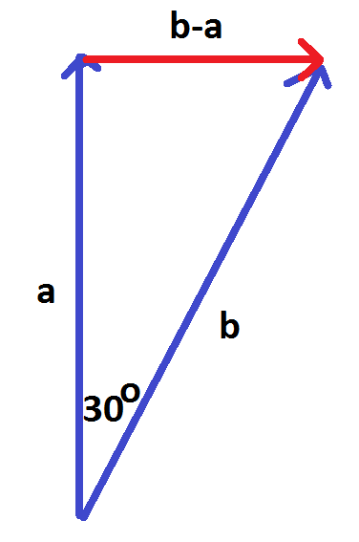
We hope to have the following vector diagram incorporating a right triangle.
We have $\left\|\text{a}\right\|=\text{7}$, and for this 30-60-90 triangle we need
$\left\|\text{b}\right\|=\text{2}\left\|\text{b}-\text{a}\right\|$ and $\text{7}=\left\|\text{a}\right\|=\sqrt{\text{3}}\left\|\text{b}-\text{a}\right\|$. This shows the magnitude of b should be $\left\|\text{b}\right\|=\frac{\text{14}}{\sqrt{\text{3}}}$.
The vector $\text{b – a}$ points east and has magnitude $\frac{\text{7}}{\sqrt{\text{3}}}$.

b. Write $b-a$ in magnitude and direction form.

$〈\frac{\text{7}}{\sqrt{\text{3}}}\text{, 0°}〉$; $\text{b – a}$ has a magnitude of $\frac{\text{7}}{\sqrt{\text{3}}}$ and a direction of $\text{0°}$ measured from the horizontal.

- Consider the three points $A=\left(10, -3, 5\right)$, $B=\left(0, 2, 4\right)$, and $C=\left(2, 1, 0\right)$ in three-dimensional space.
Let $M$ be the midpoint of $\overline{AB}$ and $N$ be the midpoint of $\overline{AC}$.

  - Write down the components of the three vectors $\vec{AB}$, $\vec{BC}$, and $\vec{CA}$, and verify through arithmetic that their sum is zero. Also, explain why geometrically we expect this to be the case.
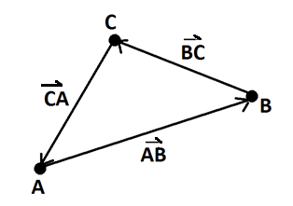
We have the following:
$$\vec{\text{AB}}=〈-\text{10}, \text{5}, -\text{1}〉$$
$$\vec{\text{BC}}=〈\text{2}, -\text{1}, -\text{4}〉$$
$$\vec{\text{CA}}=〈\text{8}, -\text{4}, \text{5}〉$$
Their sum is $〈-\text{10}+\text{2}+\text{8}, \text{5}-\text{1}-\text{4}, -\text{1}-\text{4}+\text{5}〉=〈\text{0}, \text{0}, \text{0}〉$.
This is to be expected as the three points A, B, and C are vertices of a triangle (even in three-dimensional space), and the vectors $\vec{\text{AB}}\text{, }\vec{\text{BC}}$, and $\vec{\text{CA}}$, when added geometrically, traverse the sides of the triangle and have the sum effect of “returning to start.” That is, the cumulative effect of the three vectors is no vectorial shift at all.

  - Write down the components of the vector $\vec{MN}$. Show that it is parallel to the vector $\vec{BC}$ and half its magnitude.
We have $\text{M}=\left(\text{5},-\frac{\text{1}}{\text{2}},\frac{\text{9}}{\text{2}}\right)$ and $\text{N}=\left(\text{6},-\text{1},\frac{\text{5}}{\text{2}}\right)$. Thus, $\vec{MN}=〈\text{1},-\frac{\text{1}}{\text{2}},-\text{2}〉$.
We see that $\vec{MN}=\frac{1}{2}〈\text{2},-\text{1},\text{4}〉=\frac{\text{1}}{\text{2}}\vec{BC}$, which shows that $\vec{MN}$ has the same direction as $\vec{BC}$ (and hence is parallel to it) and half the magnitude.

Let $G=\left(4,0,3\right)$.

  - What is the value of the ratio $\frac{\left\|\vec{MG}\right\|}{\left\|\vec{MC}\right\|}$?
$\vec{\text{MG}}=〈-\text{1},\frac{\text{1}}{\text{2}},-\frac{\text{3}}{\text{2}}〉$and $\vec{\text{MC}}=〈-\text{3},\frac{\text{3}}{\text{2}},-\frac{\text{9}}{\text{2}} 〉=\text{3}\vec{\text{MG}}$. Thus, $\frac{\left\|\vec{\text{MG}}\right\|}{\left\|\vec{\text{MC}}\right\|}\text{=}\frac{\left\|\vec{\text{MG}}\right\|}{\text{3}\left\|\vec{\text{MC}}\right\|}=\frac{\text{1}}{\text{3}}$.

  - Show that the point $G$ lies on the line connecting $M$ and $C$. Show that $G$ also lies on the line connecting $N$ and $B$.
That $\vec{\text{MG}}=\frac{\text{1}}{\text{3}}\vec{\text{MC}}$ means that the point G lies a third of the way along the line segment $\overline{\text{MC}}$.
Check: $\vec{\text{NG}}=〈\text{-2, 1,}\frac{\text{1}}{\text{2}}〉=\frac{\text{1}}{\text{3}}〈-\text{6},\text{3},\frac{\text{3}}{\text{2}}〉=\frac{\text{1}}{\text{3}}\vec{\text{NB}}$
So, G also lies on the line segment $\overline{\text{NB}}$ (and one-third of the way along, too).
- A section of a river, with parallel banks $95 ft.$apart, runs true north with a current of $2 ft/sec$. Lashana, an expert swimmer, wishes to swim from point $A$ on the west bank to the point $B$ directly opposite it. In still water she swims at an average speed of $3 ft/sec$.
The diagram to the right illustrates the situation.

To counteract the current, Lashana realizes that she is to swim at some angle $θ$ to the east/west direction as shown.

With the simplifying assumptions that Lashana’s swimming speed will be a constant $3 ft/sec$ and that the current of the water is a uniform $2 ft/sec$ flow northward throughout all regions of the river (we will ignore the effects of drag at the river banks, for example), at what angle $θ$ to east/west direction should Lashana swim in order to reach the opposite bank precisely at point $B$? How long will her swim take?

  - What is the shape of Lashana’s swimming path according to an observer standing on the bank watching her swim? Explain your answer in terms of vectors.
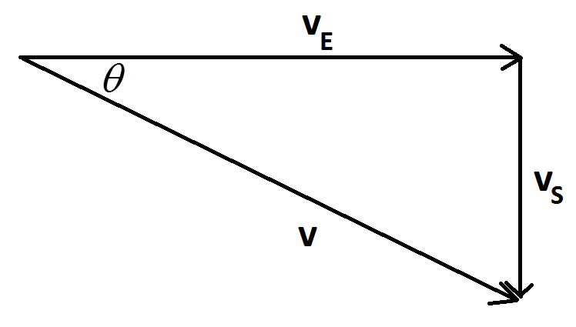
Lashana’s velocity vector $\text{v}$ has magnitude 3 and resolves into two components as shown, a component in the east direction ${\text{v}}_{\text{E}}$ and a component in the south direction ${\text{v}}_{\text{S}}$.
We see
$\left\|{\text{v}}_{\text{s}}\right\|=\left\|\text{v}\right\| \text{sinθ}=\text{3} \text{sinθ}$.
Lashana needs this component of her velocity vector to counteract the northward current of the water. This will ensure that Lashana will swim directly toward point B with no sideways deviation.
Since the current is $\text{2}$ ft/sec, we need $\text{3} \text{sinθ=2}$, showing that $\text{θ}={\text{sin}}^{\text{-1}}\left(\frac{\text{2}}{\text{3}}\right)≈\text{41.8°}$.
Lashana will then swim at a speed of $\left\|{\text{v}}_{\text{E}}\right\|=\text{3} \text{cosθ}$ ft/sec toward the opposite bank.
Since $\text{sinθ}=\frac{\text{2}}{\text{3}}$, $\text{θ}$ is part of a $\text{2}-\sqrt{\text{5}}-\text{3}$ right triangle, so $\text{cosθ}=\frac{\sqrt{\text{5}}}{\text{3}}$. Thus,
$\left\|{\text{v}}_{\text{E}}\right\|=\sqrt{\text{5}}$ ft/sec.
She needs to swim an east/west distance of $\text{95}$ feet at this speed. It will take her
$\frac{\text{95}}{\sqrt{\text{5}}}=\text{19}\sqrt{\text{5}}≈\text{42}$seconds to do this.
  - If the current near the banks of the river is significantly less than $2 ft/sec$, and Lashana swims at a constant speed of $3 ft/sec$ at the constant angle $θ$ to the east/west direction as calculated in part (a), will Lashana reach a point different from $B$ on the opposite bank? If so, will she land just north or just south of $B$? Explain your answer.
As noted in the previous solution, Lashana will have no sideways motion in her swim. She will swim a straight-line path from A to B.
If the current is slower than $\text{2}$ ft/sec at any region of the river surface, Lashana’s velocity vector component ${\text{v}}_{\text{S}}$, which has magnitude $\text{2}$ ft/sec, will be larger in magnitude than the magnitude of the current. Thus, she will swim slightly southward during these periods. Consequently, she will land at a point on the opposite bank south of B.

- A $5 kg$ ball experiences a force due to gravity $\vec{F}$ of magnitude $49$ Newtons directed vertically downwards. If this ball is placed on a ramped tilted at an angle of $45°$, what is the magnitude of the component of this force, in Newtons, on the ball directed $45°$towards the bottom of the ramp? (Assume the ball is of sufficiently small radius that is reasonable to assume that all forces are acting at the point of contact of the ball with the ramp.)
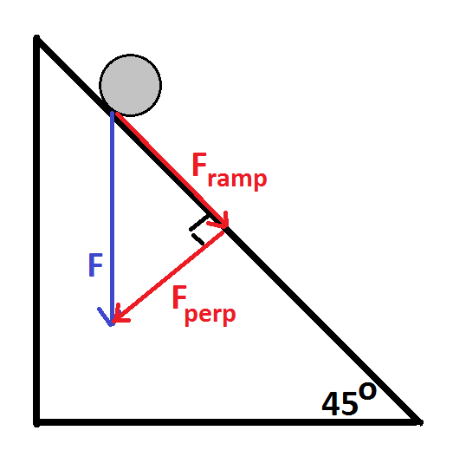
The force vector can be resolved into two components as shown: ${\text{F}}_{\text{ramp}}$ and ${\text{F}}_{\text{perp}}$.
We are interested in the component ${\text{F}}_{\text{ramp}}$.
We see a $\text{45-90-45}$ triangle in this diagram, with hypotenuse of magnitude 49 N. This means that the magnitude of ${\text{F}}_{\text{ramp}}$ is $\frac{\text{49}}{\sqrt{\text{2}}}≈\text{35 N}$.

- Let $A$ be the point $\left(1, 1, -3\right)$ and $B$ be the point $(-2, 1, -1)$ in three-dimensional space.

A particle moves along the straight line through $A$ and $B$ at uniform speed in such a way that at time
$t=0$ seconds the particle is at $A$, and at $t=1$ second the particle is at $B$. Let $P(t)$ be the location of the particle at time $t$ (so, $P\left(0\right)=A$ and $P\left(1\right)=B$).

  - Find the coordinates of the point $P(t)$ each in terms of $t$.

We will write the coordinates of points as $\text{3}×\text{1}$ column matrices, as is consistent for work with matrix notation.
The velocity vector of the particle is $\vec{\text{AB}}=〈-\text{3}, \text{0}, \text{2}〉$. So, its position at time $\text{t}$ is
$\text{P}\left(\text{t}\right)=\text{A}+\text{t}\vec{\text{AB}}=\left[\begin{matrix}\text{1} \\ \text{1} \\ -\text{3}\end{matrix}\right]+\text{t}\left[\begin{matrix}-\text{3} \\ \text{0} \\ \text{2}\end{matrix}\right]=\left[\begin{matrix}\text{1}-\text{3t} \\ \text{1} \\ -\text{3}+\text{2t}\end{matrix}\right]$.

  - Give a geometric interpretation of the point $P(0.5)$.

Since $\text{P(0) = A}$ and $\text{P(1) = B}$, $\text{P(0.5)}$ is the midpoint of $\overline{\text{AB}}$.

Let $L$ be the linear transformation represented by the $3×3$ matrix $\left[\begin{matrix}2 & 0 & 1 \\ 1 & 3 & 0 \\ 0 & 1 & 1\end{matrix}\right]$, and let $A^{'}=LA$ and
$B^{'}=LB$ be the images of the points $A$ and $B$, respectively, under $L$.

  - Find the coordinates of $A'$ and $B'$.

$\text{A'}=\left[\begin{matrix}\text{2} & \text{0} & \text{1} \\ \text{1} & \text{3} & \text{0} \\ \text{0} & \text{1} & \text{1}\end{matrix}\right]\left[\begin{matrix}\text{1} \\ \text{1} \\ -\text{3}\end{matrix}\right]=\left[\begin{matrix}-\text{1} \\ \text{4} \\ \text{-2}\end{matrix}\right]$ and $\text{B'}=\left[\begin{matrix}\text{2} & \text{0} & \text{1} \\ \text{1} & \text{3} & \text{0} \\ \text{0} & \text{1} & \text{1}\end{matrix}\right]\left[\begin{matrix}-\text{2} \\ \text{1} \\ -\text{1}\end{matrix}\right]=\left[\begin{matrix}-\text{5} \\ \text{1} \\ \text{0}\end{matrix}\right]$

A second particle moves through three-dimensional space. Its position at time $t$ is given by $L\left(P\left(t\right)\right)$, the image of the location of the first particle under the transformation $L$.

  - Where is the second particle at times $t=0$ and $t=1$? Briefly explain your reasoning.

We see $\text{L}\left(\text{P}\left(\text{0}\right)\right)=\text{L(A)}=\text{A'}$ and $\text{L}\left(\text{P}\left(\text{1}\right)\right)=\text{L}\left(\text{B}\right)=\text{B'}$. Since the position of the particle at time $\text{t}$ is given by $\text{L}\left(\text{P}\left(\text{t}\right)\right)$, to find the location at $\text{t = 0}$ and $\text{t = 1}$, evaluate $\text{L}\left(\text{P}\left(\text{0}\right)\right)$ and$\text{L}\left(\text{P}\left(\text{1}\right)\right)$.

  - Prove that the second particle is also moving along a straight line path at uniform speed.
At time $\text{t}$ the location of the second particle is
$$\text{L}\left(\text{P}\left(\text{t}\right)\right)=\left[\begin{matrix}\text{2} & \text{0} & \text{1} \\ \text{1} & \text{3} & \text{0} \\ \text{0} & \text{1} & \text{1}\end{matrix}\right]\left[\begin{matrix}\text{1}-\text{3t} \\ \text{1} \\ -\text{3}+\text{2t}\end{matrix}\right]=\left[\begin{matrix}\text{2}-\text{4t} \\ \text{4}-\text{3t} \\ -\text{2}+\text{2t}\end{matrix}\right]=\left[\begin{matrix}-\text{1} \\ \text{4} \\ -\text{2}\end{matrix}\right]+\text{t}\left[\begin{matrix}-\text{4} \\ -\text{3} \\ \text{2}\end{matrix}\right].$$
We recognize this as
$\text{L}\left(\text{P}\left(\text{t}\right)\right)=\text{A'}+\text{t} \vec{\text{A'B'}}$.
Thus, the second particle is moving along the straight line through $\text{A'}$ and $\text{B'}$ at a uniform velocity given by the vector $\vec{\text{A'B'}}=〈-\text{4},-\text{3}, \text{2}〉$.

