Lesson 28
Culminating Task – create a story problem and act it out in the Children’s Math Theater.

Suggested Lesson Structure
 Culminating Task (Duration to be determined by teacher.)
 Student Debrief (Duration to be determined by teacher.)
Total Time
Culminating Task (Duration to be Determined by Teacher)
Part 1: Concept Introduction
Materials: (T) White board or chart paper, completed invitation (Template) (S) white paper, crayons
Note: To create the Children’s Math Theater, students will need to develop and practice their word problems and create invitations for guests. Because of the possible duration of this task, consider allowing children to continue working during the first days of assessment, saving the last day for students to host a performance for families or other members of the school community.
- Tell students, “You have learned so much math this year! We are going create our own math stories to be acted out for our families and friends at the Children’s Math Theater. Each of you will have a chance to show and tell your own addition or subtraction story on stage!”
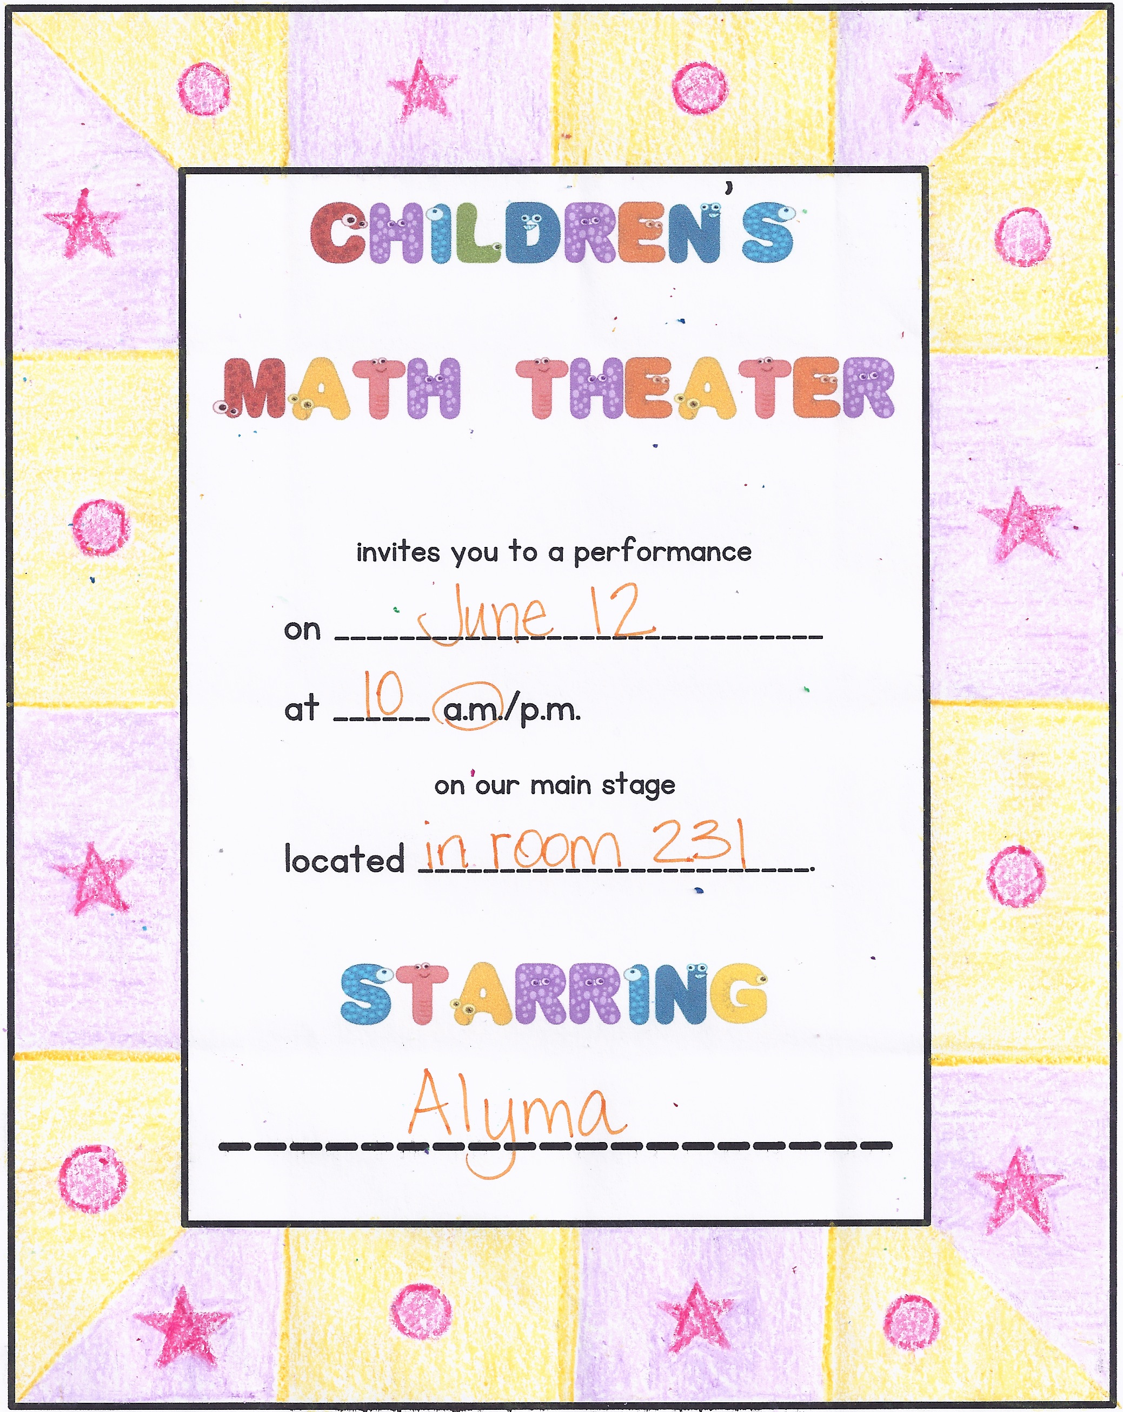
- Create an addition story, e.g., “There is a nest with 3 baby birds. One more baby bird hatched from an egg. How many baby birds are there now?” Ask students to create a math drawing of the story.
- Ask, “What number sentence matches our story?” On the back of your paper, write a number sentence to match the story,
3 + 1 = 4. Have students say, “3 plus 1 equals 4.”
- Have 4 students act out the story problem.
- Repeat Steps 2–4 with a subtraction story, e.g., a nest with 4 baby birds and two of them fly out of the nest (2 crossed out). As you write the matching number sentence on the back of the paper, have students say, “4 take away 2 is 2.”
Part 2: Practice
Materials: (S) Large piece of white construction paper (12″ x 18″), crayons, invitation (Template)
Send students to prepared tables to begin drawing their number stories. Fill out the performance details on the invitation before making copies for students.
- Assign each child an addition or subtraction story.
- Explain the directions: First, students will create their addition or subtraction story. Then, they will draw their story.
- As the students work, circulate and have them dictate their matching addition or subtraction story. Consider writing it on the back of the paper as a reference. Students should have a solid memory of their story and the accompanying question for the audience to solve.
- Support children as they tell their story and write a matching number sentence on the back of the paper. (This is so that an audience member can be called forward to write the matching number sentence and solve it on the day of the performance.) Check that students have a clear understanding of whether they have written an addition or subtraction sentence.
Two gorillas are swinging from trees. Two gorillas are on the ground. How many gorillas are there?
- Distribute the blank invitation. Guide students to think of a pattern and practice it before beginning to draw on the invitation.
- Circulate while students are working and have them explain the pattern on the invitation.
Display a completed invitation with a pattern drawn around the border. Have students create their own pattern. As soon as possible, send children home with their invitations. An additional reminder about the performance is in the Topics D–F Family Math Newsletter.
Student Debrief (Duration to be Determined by Teacher)
Lesson Objective: Culminating Task—create a story problem and act it out in the Children’s Math Theater.
Note: Begin the Student Debrief with student performances, inviting students and guests to enjoy the number stories and answer the questions. Then, invite children to the circle for discussion.
The Student Debrief is intended to invite reflection and active processing of the total lesson experience. It is also an opportunity for informal assessment. Consider taking anecdotal notes or using a simple checklist to note each child’s progress toward meeting the lesson objective. As students complete the performance, listen for evidence of student understanding that can be celebrated in the Debrief.

CENTER CONNECTION:
Children can use the dramatic play center as a chance to act out their number stories in preparation for the performance. If needed, consider creating a station for students to continue work on their invitation patterns during center time.

You may choose to use any combination of the questions below to help students express ideas, make connections, and use new vocabulary.
- Who told an addition story? How do you know it was an addition story?
- Who told a subtraction story? How do you know it was a subtraction story?
- When you were in the audience, how did you answer the questions?
- What was your favorite thing about the Children’s Math Theater?

_____________________________
invitation

’

invites you to a performance
on _________________________
at ______ a.m./p.m.
on our main stage
located .
___________________

